Internship Report
on

General Banking Operations of City Bank PLC
&
Customer Perception of Citytouch App

Sharmeen Akter Meem

This report is submitted to the School of Business and Economics, United International University, as a partial requirement for the degree fulfillment of Bachelor of Business Administration
General Banking Operations of City Bank PLC
&
Customer Perception of Citytouch App

Submitted to
Ms. Zinnatun Nesa
Assistant Professor
School of Business and Economics (SoBE)
United International University

Submitted by
Sharmeen Akter Meem
ID- 111 201 202
Major: Finance
Registered trimester: Spring 201


School of Business and Economics (BBA)
United International University

Date of submission: August 4, 2025

Letter of Transmittal

Date: August 4, 2025
Ms. Zinnatun Nesa
Assistant Professor
School of Business and Economics (SoBE)
United International University
Subject: Submission of internship report on “General banking operations of City Bank PLC & customer perception of Citytouch”.

Dear Ma’am,
I just completed my internship at City Bank Plc. I would like to thank you for giving me this opportunity to prepare this report on this subject. To prepare this report, I got the chance to explore General banking operations of City Bank PLC & customer perception of Citytouch.
I have worked in customer service section. It was a great learning experience. This report is based on my 3 months of working experience. This report contains a great study of various general banking activities of City Bank with a focus on customer satisfaction and the impact of fintech in banking services. I have tried and worked hard to do this report as per your instructions.
Thank you for your constant guidance and support.
Sincerely

Sharmeen Akter Meem
ID: 111 201 202
School of Business and Economics (SoBE)
United International University

Certification of Similarity Index

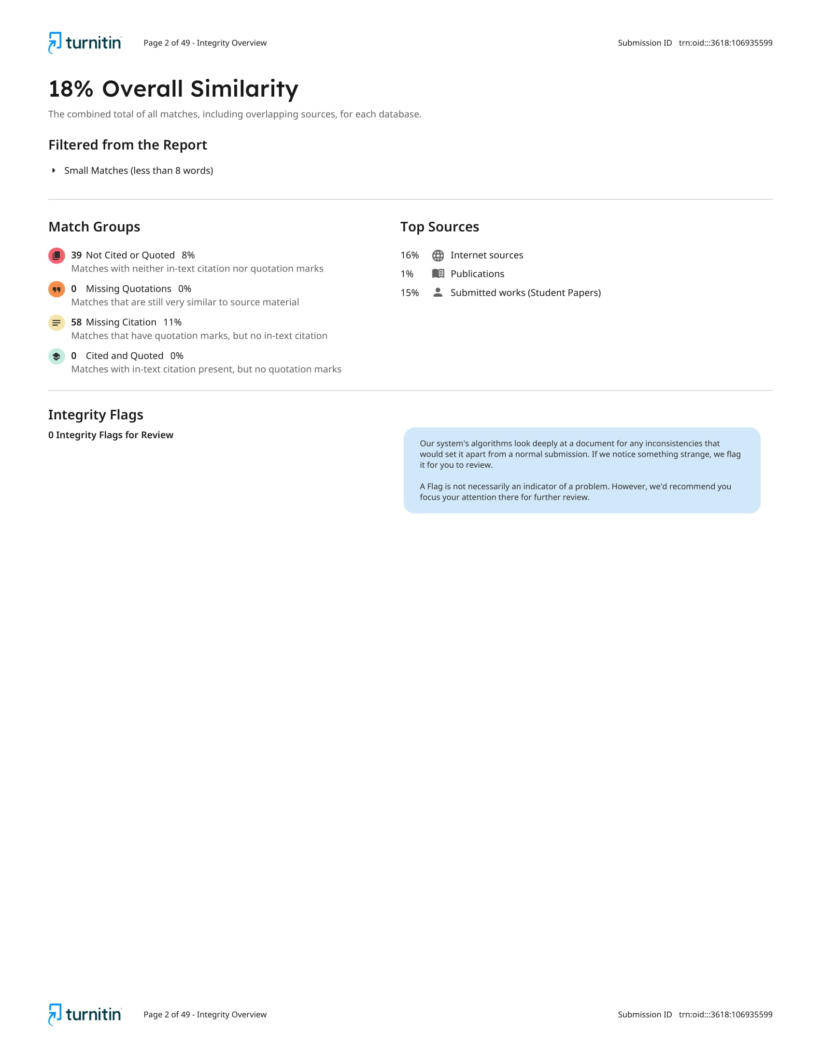

Declaration of the Student

I, Sharmeen Akter Meem, hereby declare that this report on “General banking operations of City Bank Plc & customer perception of Citytouch” is fully prepared by me and submitted as a part of the academic requirement for the degree of Bachelor of Business Administration (BBA).
I am also confirming that this report has been prepared based on my research, findings, and experiences while working as an intern at City Bank PLC. This report doesn’t contain any previously published material or written by a third party. I am ensuring that this report has not been submitted for any other university, degree, or any other academic purpose.

………………………………. ……………………………….
Sharmeen Akter Meem Ms. Zinnatun Nesa
ID: 111 201 202 Assistant Professor
Department: BBA (Finance) School of Business & Economics
United International University United International University

Corporate Evidence

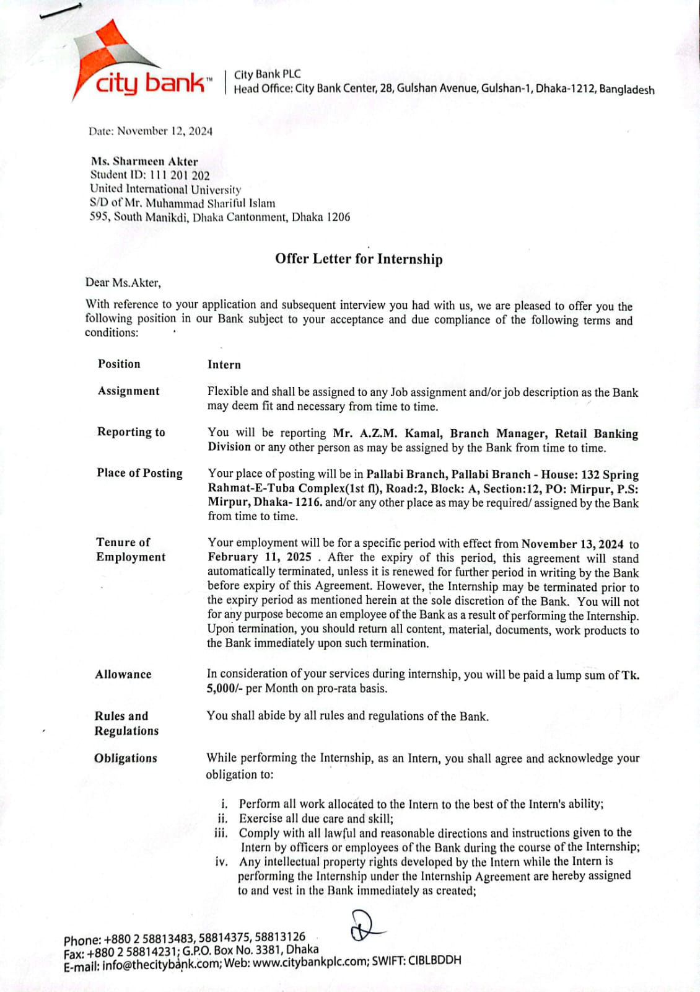

Acknowledgement

At first, I would like to extend my heartfelt thanks to my academic supervisor, Ms. Zinnatun Nesa Ma’am, assistant professor of SoBE at United International University, for providing me with proper guidelines and support to complete this report.
I would like to thank City Bank PLC for allowing me to do my internship at their organization. My sincere gratitude goes to A.Z.M. Kamal, VP & Branch Manager of Pallabi branch of City Bank PLC, for providing me with valuable information and helping me throughout my internship period. I am grateful to all my colleagues at Pallabi branch for their kind cooperation and for helping me to learn everything.
Additionally, I would like to thank my family and friends for their constant support and motivation throughout this journey.

Executive Summary

This report will aim to provide a detailed overview of the general banking operation and digital transformation of City Bank. This paper starts with an overview of the bank’s background and the variety of products and services it offers. Then I did a short industry analysis. This report will give you an idea about the branch operations activities. A major focus of the report is its digital products and finding out the current state of “Citytouch”, the biggest digital banking platform of the bank. A survey was conducted with 64 users to gather their experiences with the app. The result shows why it is the core digital banking platform of City Bank. This report will also provide you with information about other digital products of the bank. Additionally, this report will also share my personal internship experiences. Lastly, based on research and user feedback, the report concludes with specific recommendations aimed at improving service quality and keeping customer satisfaction high.

Contents
Letter of Transmittal i
Certification of Similarity Index ii
Declaration of the Student iii
Corporate Evidence iv
Acknowledgement v
Executive Summary vi
Chapter 1: INTRODUCTION 1
1.1 Background of the Report 1
1.2 Objective of the Report 1
1.3 Rationale of the Report 1
1.4 Scope of the Report 2
1.5 Methodology of the Report 2
1.6 Limitations of the Report 2
CHAPTER 2: COMPANY AND INDUSTRY PREVIEW 3
2.1 Company Analysis 3
2.1.1 Overview and History 3
2.1.2 Trend and Growth 5
2.1.3 Products and Services 7
2.1.4 SWOT Analysis 13
2.1.5 Branch Operations 14
2.1.6 City Bank at a Glance 16
2.1.7 Awards and Accolades (2021-2023): 17
2.2 Industry Analysis 18
2.2.1 Specification of the Industry 18
2.2.2 Size, Trend, and Maturity of the Industry 18
2.2.3 External Economic Factor 18
2.2.4 Technological factor 19
2.2.5 Threat of Substitute 19
Chapter 3: Internship Experience 20
Chapter 4: CUSTOMER PERCEPTION OF CITYTOUCH 22
4.1 Survey Questionnaire & Result: 22
4.2 Summary of the Survey 29
Chapter 5: FINDINGS AND CONCLUSION 31
5.1 Findings 31
5.2 Conclusion 32
References: 33
Appendix-A: Survey Questionnaire 34

Chapter 1: INTRODUCTION

Background of the Report
The banking sector plays a vital role in any country’s economic development. To ensure a stable economic environment, banks work with financial investments, provide financial services, and encourage savings. City Bank PLC is one of the oldest and most prominent private commercial banks in Bangladesh.
As per my academic requirement, I have completed my internship at City Bank PLC. During this period of internship, I got to know about corporate culture and gained knowledge about the general banking activities of a bank. As a reputed bank, it provides various digital services to its customers. So, I conduct survey research on customer satisfaction to understand how satisfied customers are with these digital services.

Objective of the Report
Primary objective:
The main objective of this report is to analyze customer satisfaction after using digital services offered by City Bank PLC.
Secondary objective:
- To understand the retail banking division of the bank.
- To acquire knowledge about the general banking activities of the bank.
- To understand day to day operation at the branch.
- To know what type of products and services City Bank offers.
- To know how City Bank provides services to its customers.
- To know about the digital services bank provides.

Rationale of the Report
This report mainly aims to understand customer perception of Citytouch. But as I was assigned to the retail banking section at Pallabi branch. So, this report will cover the work of the general banking section of City Bank Plc. Along with that, this report will cover retail banking activities like how they deal with account opening, deposit collection, clearing, receiving checks, and customer service. I have also shared the tasks I was involved in during this period.

Scope of the Report
This report mainly focuses on the general activities of City Bank and customer perception about Citytouch.
It will also provide detailed insights about the products and services of the bank, branch operations, and my internship experiences.

Methodology of the Report
To prepare this report, I used both primary and secondary data.
Primary data: First of all, I took an interview with my supervisor, Mr. A Z M Kamal, branch manager, Pallabi branch, City Bank PLC. I also talked with the customer service officers of the branch to gather insights on different sections. Besides that, I conducted a survey on customer perception of Citytouch. Both open-ended and closed-ended questions were included in the survey to gather customer’s feedback.
Secondary data: I have collected secondary data from City Bank's official website, City Bank's annual report- 2023, previously published internship report.

Limitations of the Report
- The report is based on a single branch of City Bank, which may not represent service quality, operational practice, and customer experiences of the organization as a whole.
- The duration of the internship was three months, but it was too short to learn everything about the branch activities.
- Direct communication with the customer was limited.
- Bank didn’t provide any internal information.
- The number of survey respondents was small.

CHAPTER 2: COMPANY AND INDUSTRY PREVIEW

2.1 Company Analysis

2.1.1 Overview and History
City Bank is one of the oldest and leading private commercial banks in Bangladesh, established in March 1983 by 12 local businessmen. City Bank started their journey with only BDT 34 million worth of capital, but as of 2023, it has become BDT 3.3 billion as capital and reserve. Deen Mohammad, chairman of Phoenix group, was the founder of City Bank. It began their journey by establishing their first branch in BB Avenue in Dhaka. First, it was listed on Dhaka Stock Exchange in 1986 and then in 1995 on Chittagong Stock Exchange.
This bank was previously known as The City Bank Limited. However, on its 25th anniversary in 2008, the bank renamed itself as City Bank Plc. On this happy occasion, they rebranded themselves with a new name, new logo (red – white box shape kite). They also introduced various new services, including City wallet (SMS Banking) service, brokerage house, and American Express (credit cards). It is one of the few banks in the banking industry that offers both conventional and Islamic banking services. In 2021, it introduced Shariah-based banking.
As a leading bank, it is committed to serving its customers with digitalized banking activities. To achieve this goal, the bank embraces the spirit of agility, digitality, versatility, and vitality. They introduced City Touch fully-fledged digital banking platform with rich features to ensure faster, smarter, and convenient services for its customers. It also provides first real-time virtual debit card and in 2015, became the sole issuer of American Express cards in Bangladesh. They also launched green financing options to support environmentally friendly, sustainable business.
City Bank has a total of 134 branches with 1 full-fledged Islamic banking branch, 40 sub-branches and 535 agent banks, 1 SME service center, and 415 atm booths all over the country. Additionally, it has international branches and one representative office in Malaysia and one subsidiary office in Hong Kong. Currently, City Bank has 4963 full-time employees. Among them, 1,044 were women employees. City Bank has maintained a strong credit rating of AA1, declared by the Credit Rating Agency of Bangladesh (CRAB). The bank operates several subsidiaries, including City Brokerage Limited (stock brokerage), City Bank Capital Resources Limited (Merchant Banking Operations), and CBL Money Transfer Sdn. Bhd, Malaysia (Remittance service), City Hong Kong Limited (International Trade). City bank reported total assets worth BDT 564,929 million and 2.5 million loyal customers.
Vision:
We are driven by our vision of emerging as a financial supermarket with a winning culture, while offering enjoyable experiences to our stakeholders.
Mission:
We are focused on our mission of becoming the financial services group of choice in Bangladesh. Towards this extent, we intend to:
- Offer wide array of products and services that differentiate and excite all customer segments.
- Be the “Employer of choice” by offering an environment where people excel and leaders are created.
- Continuously challenge processes and platforms to enhance effectiveness and efficiency.
- Promote innovation and automation with a view of guaranteeing and enhancing excellence in service.
- Ensure respect for community, good governance, compliance and everything we do.
Value:
- Result driven.
- Accountable and transparent.
- Courageous and respectful.
- Engaged and inspired.
- Focus on customer delight.
Line of business:
City bank’s business is broadly segmented into following division:
- Retail Banking
- City Alo
- SME Banking
- Agent Banking
- Islamic Banking
- Corporate Banking
- Digital Banking
- Employee Banking
- Offshore Banking
- City gem.

2.1.2 Trend and Growth
Despite a challenging economic environment, City Bank has shown positive growth in recent years. They also follow the new trend and lead the industry by exploring new digital products. City Bank has continuously adapted new market trend through adopting digital innovation. They launched virtual debit card as the first bank in bd. They also offer internet banking, payment solution like QR codes, mobile wallets, and are the only holder of City American Express. City Bank was the first bank to provide dual currency credit card in Bangladesh.
They have shown a significant growth in loans & advances and deposits, which has increased steadily over the last ten years. By the end of 2023, loans and advances grew from 354,774 to 396,078. Bank’s total deposits continuously increased every year. It increased to 392,510 mn by the end of 2023 from 331,890 mn. Which is more than 18% since last year. In 2022 bank’s net interest income was BDT 12359 mn, but by 2023 it rose to BDT 15,831 mn a growth of 28%. So, their profit also increased from 4508 to 6151 in 2023. City banks total asset increased by 10% and EPS also grew by 36% in the following year. Also, City Bank has been one of the top sustainable banks for the last 5 consecutive years by the Bangladesh Bank.

City Bank PLC Loans & Advances:
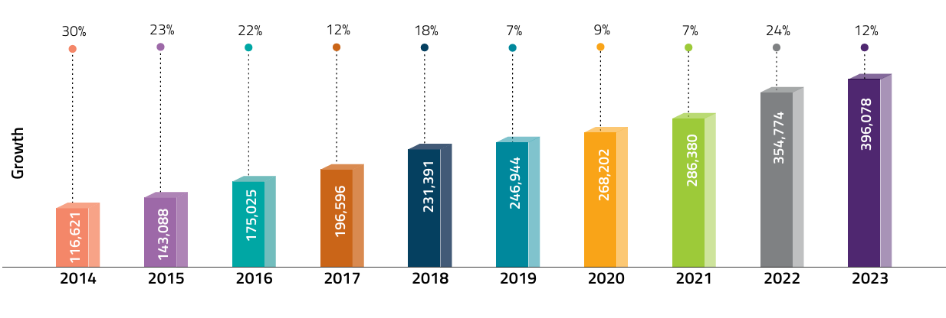

City Bank PLC Deposit:
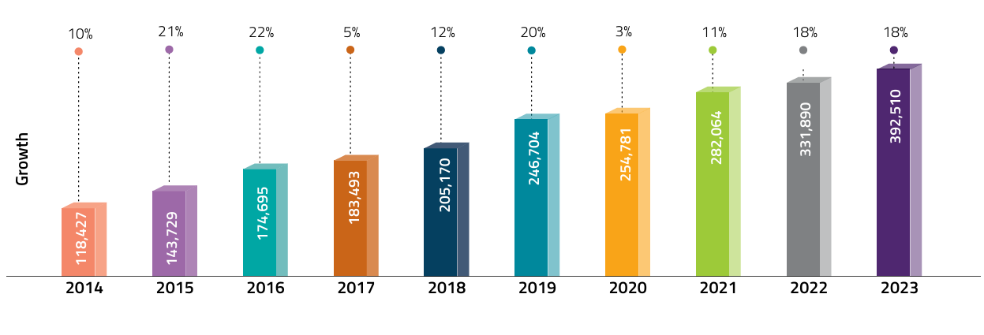

2.1.3 Products and Services
City Bank PLC offers a variety of financial products and services. Such as
Retail
Retail banking is one of the core banking areas for any bank. “Add a little city in your life” is the new brand mantra for City Retail. Retail banking also known as customer banking. Serving all general banking activities by meeting customers individually is the main aim of City Retail. For this reason, a bank's image depends mostly on its retail division. Retail division has multiple product offerings. They are:
- Deposits
  - Savings accounts – they offer various types of savings accounts so that customers can open an account according to their needs. They offer general savings accounts, high-value savings accounts, City Alo accounts specially for women, new born, freelancer, and basic savings accounts etc.
  - Current accounts
    - Current deposit
    - Easy current account
    - Easy current plus account
    - City Alo business acoount
  - DPS account
    - Goal based DPS
    - Insurance Backed DPS
  - FD Accounts
    - Fixed Deposits
    - Monthly Interest Paying FD
- Student Banking: under this product, City Bank offers services like-
  - Student file
  - Remittance
  - Student file certificate
- Priority Banking
  - Citygem unsecured overdraft & Term Loan Facility
  - Citygem preapproved credit card
- Loan products
  - Personal Loan
  - Auto Loan
  - Home Loan
  - Secured facilities
Corporate banking:
Corporate banking focuses on giving financial solutions to large organizations. Under this division, City Bank offers services like:
- Overdraft / secured overdraft
- Pre-shipment packing credit
- Post-shipment financing
- Bangladesh Bank Refinancing
- Long-term/ Mid-term/ short-term financing
- Invoice financing
- Letter of credit
- Tender/ Bid bond/Guarantee
Treasury:
City Bank’s treasury division plays a key role by giving shelter to the bank in any uncertainty. In this division, they offer services like-
- Money Market products – Call money, Term money, Notice money, Re-purchase agreement, Foreign Currency Placement, Foreign exchange swap, Reverse- repo.
- Fixed Investment products- Fixed Income & Capital Market investments, Corporate Bond, Bangladesh Government Ijarah Sukuk.
- Foreign Exchange Products- Foreign remittance, Cross Currency Swap, etc.
- Derivative products -Forward Contract, Interest Rate Swap (IRS)
SME:
SME services mainly cater to small and medium enterprises.
- Small and micro finance products
- Medium enterprise products.
- Agro SME services

Agent Banking:
City Bank started its agent banking service in 2017. It provides the same products of retail banking and SME banking to ensure that people in remote areas can get banking services easily.
- All deposits products of retail and SME’s
- All loan products of retail and SME’s
- City Digital Agri Loan
Islamic Banking:
City Islamic provides same products as City Retail offers. Customer’s demand Shariah-based banking system led to launch of this division. Customers can have same deposits and loan products but in Shariah-based format.
Cards:
- Credit card
  - American Express
    - Amex Blue/ Amex Islamic Blue
    - Amex Gold/ Amex Islamic Gold/ Amex Gold Corporate
    - Platinum
    - City Alo Credit
  - Visa
    - Visa platinum
- Debit card
  - American Express
    - City Maxx
    - Sapphire City Maxx
    - City gem
    - The City Islamic
  - Visa
    - Visa Debit Card
    - City Alo Visa Debit Card
  - Mastercard
    - Platinum International
    - City Gem Platinum Debit Card
  - UnionPay
    - Union Pay Gold Debit Card
- Prepaid card
  - American Express
  - Mastercard

Digital Products:
Digital banking has become a part of everyone's daily life. And City Bank has successfully convinced everyone to fit into this need. They provide introduced wide range of digital products and services to customers with a smooth, efficient, and secure banking experience. Through these fintech integrations, customers can easily complete their banking activities from anywhere, reflecting City Bank’s commitment to innovation.
- Citytouch- Digital banking:
Enjoy Banking on the Go
ANYTIME, ANYWHERE
City Bank always believes that it’s a digital bank with a physical presence. To fulfill this promise, they launched Citytouch- an online mobile banking app, offering an easy banking solution. Visiting a branch is time-consuming, but with this platform, customers get banking services digitally anywhere, anytime. Through this app, customers can do their banking chores like manage accounts, pay bills, transfer funds more seamlessly, securely, and instantly. This app allows customers from opening a DPS account to recharging their mobile phone, even collecting tax certificate by following just a few steps. Customers can manage their savings, current accounts, deposits, and loan accounts via Citytouch. Customers can pay utility bills-electric, gas, water, and digital TV via this app. This app also has features like allowing customers to get a virtual debit or prepaid card instantly against their accounts. You can do any type of transaction like withdrawal from ATM’s, buying daily essentials, or booking movie tickets with only one tap. City touch is also integrated with the mobile financing sector. Customers can transfer funds to Bkash, Nagad, Upay, and Tap. City Bank is continually working to develop more self-service features, like account opening process in Citytouch, to enhance digital banking experiences. Day by day, Citytouch users increased steadily. As per City Bank’s annual report-2023, 579,149 retail customers use Citytouch to have banking services. In 2023, the amount of transactions made through Citytouch is BDT 6,46,390, which is almost twice than 2022.
Main features are:
- Create virtual debit card and prepaid card instantly
- Fund transfer to bank and MFS app
- Open DPS and FD account
- Apply for quick Loan
- Tap and pay with CityTouch

- Ekhoni Account:
ব্যাংকে নয়, ঘরে বসেই
City Bank launched another revolutionary product called “Ekhoni Account” and made a digital transformation to the banking industry of Bangladesh. Going to the bank to open is a big hassle and very frustrating. You have to wait for a long time to open an account. But with this app, Customers can open a bank account even at their home, and start banking activities right away. You just need to download the app and go through a few steps to open an account. Customers can also apply for an instant cheque book and debit card against the account through this app.

- City Go: City Go is another digital payment solution for City customers.It is a technology chip that will be inserted into a wristband or strap loop to make easy payments with a tap. It is designed for their younger customers who want their banking to be a stylish lifestyle solution, trendy. They can wear it as a wristband or attach it to their watch strap. It is flexible to keep the chip and comfortable to carry anywhere in the world. You can make payments anywhere in the world at any NFC-enabled POS machine.

- City Pay: For making payment contactless, City Bank introduced a QR code-based payment solution,” CityPay”. Customers don’t need to carry any card or cash; rather, they can pay with their mobile phone. Customers just need to scan the QR code, select the card, and enter their PIN; then their payment will be processed within a few seconds.

- Google Pay: Sustaining the ongoing contribution to the digital sector, City Bank collaborates with Google Pay. Customers need to add their Mastercard or Visa card (both physical and virtual cards) to Google Wallet to enjoy a hassle-free, seamless digital payment solution. The benefit of using Google Pay is that customers can pay from home or abroad while making any purchase. They don’t need to share any card information, so it’s more secure.

- City Corp: City Bank launched this digital product as a digital banking solution to support business financial operations. Any organization that maintains a Current Account/Overdraft/ SDN Account with City Bank can use City Corp. City Corp provides services, including single or bulk payment, cheque, and pay order issuance, City Bank fund transfer, BEFTN, RTGS, NPSV, Prepaid Card Payment, Wallet Payment, Utility Payments for collection City Corp is eligible to collect funds from City Bank and other banks through BEFTN, Debit Service, and virtual account. Customers can also view and approve, and manage their transactions from City Crop.

- Smart IVR: Smart IVR is a digital response system. Customer can do their banking through the IVR menu on their mobile phone. Customer can avail services, including pin generation and card activation, account service, card service, fund transfer, bill payment, cheque-related service, and foreign exchange rate through smart IVR. A customer can do all these banking activities without going to the branch and without taking any help from a customer service officer.
Along with all these products, City Bank provides some other services such as Customer Service Portal, Call center, and one-click cash withdrawal.
Through these digital products, City Bank shows dedication to innovation and focus on what customers need. City Bank hopes to increase financial inclusion, improve convenience, and support Bangladesh’s move toward a cashless, digital economy.

2.1.4 SWOT Analysis
Strength:
- Among the largest private sector bank in Bangladesh with total balance sheet of BDT 555 bn.
- Strong 5-year CAGR of 9.4% in total assets (2019-2023)
- Amongst the fastest growth in CASA ratio at 50.0 % within peer group.
- One of the highest NIM (net interest margin) among peer group at 4.5%.
- Diversify business with low concentration on either the asset or liability side of the balance sheet.
- Conservative impairment provisioning policy, resulting in 110.1% provision coverage against loans and advances.
- Pioneering digital banking platforms focused on innovation and customer experiences.
- Robust remittance business with growing market share.
- Capable, motivated and loyal work force.
- Strong brand blended with Bangladeshi culture.
Weakness:
- Pressure on NPLs due to challenging economic conditions
- Less opportunities in corporate sector lending due to prevailing economic environment
- Challenging economic landscape limiting business opportunities
- Inflationary environment triggering frequent changes in policy rate.
Opportunities:
- Opportunity for market share gains through differentiated and single-stop offerings
- Leverage strategic partnerships, driving business growth and expanding offerings
- Opportunity to extend credit to new growth sectors in the economy, such as logistics, energy and power, and local industries supported by the government
- Deepen relationships with segments like high net-worth individuals and NRBs with new products and services
- Further digitize customer journeys to enhance customer experience
- Build data and analytics capabilities
- Look to target the rapidly growing capital market opportunities in Bangladesh
Threats:
- Strengthening mobile operator infrastructure capable of tapping into banking payments and deposit/lending business
- Emergence of Fin-Techs with potential to disrupt the financial services market
- Geopolitical events and upcoming national elections in major countries can heighten global uncertainty, having a disruptive impact on the global and local economy
- Weak near-term economic outlook in Bangladesh due to fiscal and external imbalances
- Challenging business environment with tight liquidity can impact repayment capacity of borrower segments
- Weak economic outlook can result in need for higher provisions against bad loans and NPLs
- Increased cybersecurity and AML & CFT threat.

2.1.5 Branch Operations
Branch operations activity is mainly built around serving customers. Branch basically incorporates with cash section, card section, customer service section, and loan section. So, customers are served through retail products and card products, and together these services are referred to as general banking.

Customer Service Section (CSS): CSS is the most vital section because it deals with maintaining customer satisfaction while ensuring smooth banking operations. Customer Service Officers try to solve every customer's query and provide services as needed.
They provide services like account opening and closing, giving them insights about each type of account, issuing and receiving cheque books, debit cards, updating customer’s information, pay order, cash dollar endorsement on their passport, giving bank statements, and customers come to send or receive their inward or outward remittance. CSS also helps them with digital services, like how to use City Touch and Ekhoni Account.
Customer Service Section handles all these requests and makes sure each customers receive bank offerings efficiently and correctly.
Cash Section: The Cash section is the most critical and sensitive part of a bank. cash officers start their day with cash in the vault. The opening amount of cash balance recorded in the register and end of the day after all transactions remain money also need to be registered. This department deals with customers for cash deposits, withdrawals, bill payments, and cheque encashment. Cash officers need to verify all the necessary documents for the transaction and maintain vouchers for each month.
While depositors deposit money in their accounts, cash officers need to check and count the amount and verify the writing information on deposit slips. This section also receives money for new accounts, cash for any pay order made by customers.
For cash withdrawals, customers need to submit a cheque, and cash officer will cross-check all the information, such as signature, NID, account number, and balance. Also, this section handles ATM Booth – preparing cash for ATM reloading cash into the machine.
Loan Section: This section handles the processing of home loans, auto loans, personal loans, and SME loans. Loan section officers help customers understand different loan products and require documentation. After submitting all the necessary documents, officers must review them. This section is also responsible for monitoring loan repayments, sending customers notifications about upcoming installments, all over maintaining loan accounts.
Card Section: This section provides all forms of card-related services to the customers. Assist customers in issuing new debit or credit cards, pin generation, card activation, and accepting requests for re-issuing cards in case of loss, damage, or expiration, blocking cards if its lost, and card dollar endorsement.

2.1.6 City Bank at a Glance
- Employees: 4,963
- Branches and sub branches: 174
- SME-S Unit Offices: 220
- No. of customers: 2.5 mn+
- Priority center: 7
- ATMs & RATMs: 415
- CBl Money Transfer Sdn.Bhd Malaysia (Branches): 15
- City Hong Kong Limited Hong Kong (Representative office): 1
- Agent Banking Outlets: 535
- No. of POS: 32,007
- Credit Cards Issued: 663,462+
- No of Merchants: 28,000 +
- Operating Profit: 13498 mn
- Net Profit:6151mn
- Earnings Per Share: TK.5.0
- Return On Equity: 17.6%

2.1.7 Awards and Accolades (2021-2023):
2021:
- Best Bank in Bangladesh (Global Finace World’s Best Banks)
- Best Digital Bank (Asiamoney Best Bank Awards)
- Best Consumer Digital Bank(Global Finace Award)
- Best CSR Bank in Bangladesh ( Asiamony Best Bank Awards)
- Best Retailers Bank( Bangladesh Retail Awards)
2022:
- Best Bank in Bangladesh ( Global Finance Best Bank Awards)
- Best Sustainable Finance Bank in Bangladesh( Global Finance’s Sustainable Finance Country Awards
- Best CSR Bank in Bangladesh ( Asiamony Best Bank Awards)
- Leading Partner Bank in Bangladesh( Asian Development Bank- Trade and Supply Chain Finance Program)

2023:
- Best Bank in Bangladesh ( Global Finance Best Bank Awards)
- Best Digital Bank (Asiamoney Best Bank Awards)
- Best Retailers Bank( Retail Banker Asia Trailblazer Awards)
- Best CSR Bank in Bangladesh ( Asiamony Best Bank Awards)
- Best Islamic SME Bank in Bangladesh( The Asset Triple A Islamic Finance Awards)

2.2 Industry Analysis

2.2.1 Specification of the Industry
Bangladesh has 49 banks that play a key role in the country's economic growth. However, many people in rural areas still struggle to access banking services. Programs like microfinance and microcredit have helped improve the financial situation for some, but resources are still unevenly distributed. More money and services tend to flow to urban areas. Despite some progress, the banking sector faces significant challenges. Issues like fraud, poor lending practices, and hiring unqualified people have slowed growth. Problems such as lending to those who should not receive loans, dishonestly report asset values, and employ staff without the right education have weakened the sector. To address these challenges, banks are now using smart technology to reduce bad loans and enhance their services. This approach helps build trust and supports the country's economic development more effectively.

2.2.2 Size, Trend, and Maturity of the Industry
There are currently 49 banks operating in our country. These banks are categorized into four segments: 4 nationalized commercial banks, 28 private banks, 12 foreign banks, and 5 specialized development financial institutions. Among the nationalized banks, Sonali Bank is the biggest bank, whereas Standard Chartered stands out among the foreign banks. With the revolution of the banking industry, agent banking, Islamic banking, and digital banking have been added to the banking industry.
This sector is now moving towards digitalization by introducing digital banking services, mobile banking, and fintech integration. To continue the digitalization process, Brac Bank introduced Astha, Eastern Bank Limited introduced EBL Sky banking, NexusPay by DBBL, and Citytouch by City Bank. Overall, the industry is growing.

2.2.3 External Economic Factor
- National Income: Income of the country affects the amount of capital can access by a bank.
- Consumer behavior: Consumer buying and spending patterns directly have an impact on bank operations.
- Inflation: inflation reduces currency value, which negatively affects the banking industry.
- Currency value: a strong currency attracts foreign investments, directly beneficial for the bank.
- Exchange rate: affects the whole country's banking system globally.

2.2.4 Technological factor
- Many banks in Bangladesh offer smartphone apps for banking transactions and services.
- Digital banking is becoming more popular across the country.
- Customers can perform various services from home, such as cheque issuance, fund transfers, bill payments, and mobile recharge, using apps like City Bank’s Citytouch.
- These services save time and improve customer satisfaction.
- ATM booths let customers deposit, withdraw, and check balances without needing bank staff; they only need a debit card.
- Customers can access basic banking services by visiting nearby ATM booths instead of branches.
- Credit cards reduce the need to carry cash and enable deferred payment.
- Many companies use banking technology to deposit salaries directly into employees' bank accounts.

2.2.5 Threat of Substitute
- The number of existing banks is high, so competition in the banking industry is always high.
- Interest rate is another substitute as the customer wants a lower interest rate.
- The number of ATM booths is also a threat because customers are attracted to the bank that has a huge number of ATM booths.

Chapter 3: Internship Experience

I began my internship at City Bank PLC on November 13, 2024. I was assigned to the customer service section. It’s a crucial part of the retail banking section. Customer service includes areas such as account opening, card division, dollar endorsement, cheque receiving, cheque issuing, delivery, pay order, and providing bank statements. During the first week of my internship, I closely observed how customer service officers fulfill customer requirements. I was actively involved
Account Opening: One of my key responsibilities was helping customers in the account opening process. I need to check all the required documents, such as photocopy of NID, income documents, residence documents, passport size photographs, etc. Every day, I filled up various types of forms, like different types of account opening forms, credit and debit card forms. I have filled up 10 to 15 account opening forms in a day, then I added seals on all the documents on behalf of customer service officers.
Managing Cheque Book: Every day after 4 pm, I need to organize all the received and undelivered cheque books and count the total cheque books to keep a record. In City Bank, they destroyed a cheque book if the cheque book holder didn’t collect it within 90 days. So, I was in charge of making a list of disposal cheque books in Excel for every week.
Checking Vouchers: Another key responsibility was reviewing and checking vouchers. The business operation manager of the branch assigned me to check at least two bundles of vouchers each day. These vouchers were included cheque for deposit or withdrawal, bill payment receipt for cards. I need to check that all the necessary documents are attached, date and amount written on the cheque are accurate. I made sure that the account number and phone number are written on the back of the cheque. It was the riskiest task for me.
Maintaining Register Book: I was responsible for updating the register book by recording all incoming letters and important correspondence.
Reloading ATM: I had the opportunity to go to the ATM booth with cash chief teller for reloading money to the ATM machine by following bank’s security protocol.
My 3 months of internship experience a lot. I learnt how to deal with corporate life, how to make a bond with co-workers, and how to work with different types of people. This 3-month experience surely helps me in my actual job.

Chapter 4: CUSTOMER PERCEPTION OF CITYTOUCH

As part of my internship report, a survey was conducted to gain insights into the customer perception and usage of City Bank’s digital banking platform, Citytouch. The objective of this survey was to understand how general users experience and evaluate this app, especially in the context of technological advancement in the banking sector.
The survey was designed and distributed using Google Forms and targeted a diverse group of general users. A total of 64 respondents participated in this survey. The questionnaire included both open-ended and close-ended questions, focusing on various aspects such as frequency of use, features accessed, whether it is easy to access and use or not, how they evaluate the performance, security, any difficulties they faced, and areas for improvement.
The original questionnaire used for this survey is attached in Appendix A.

4.1 Survey Questionnaire & Result:

Duration of using Citytouch:

The chart shows how long the customers have been using Citytouch. We can see that 39.1% users have been using Citytouch for more than 1 year, indicating that Citytouch has a well-established user base with long-term experiences. 23.4% people have been using the app for 6 months to 1 year, which represents both new and long-term users. The remaining 37.5% people have started using the app within the last 6 months, reflecting that Citytouch continuously attracts its customers and increases interest in digital banking.
Frequency of using Citytouch:

The chart shows that a significant portion of people use Citytouch daily and weekly. 14.1% people use it daily, and 31.3% respond that they are using the app weekly, showing that this has become a regular part of their banking activities. However, 29.7% people use the app monthly, indicating that they use the app occasionally may be for mobile recharge and bill payment type of financial activities. 25% people use it rarely, indicating they are not well aware of the features of the app.
Most used Features on Citytouch:
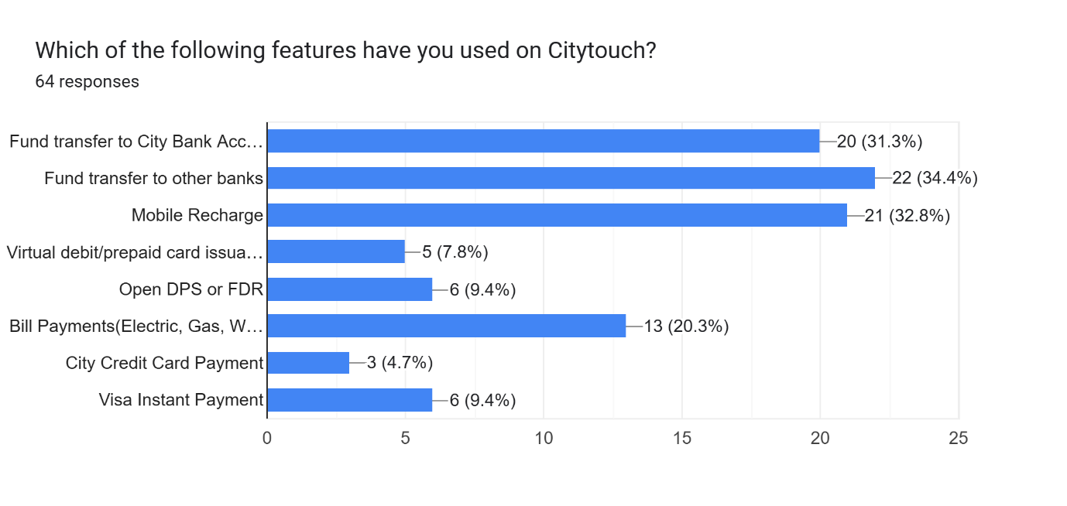
The majority of users say that they use the app mostly for fund transfer to a City Bank account and other bank accounts. 31.3% people transfer funds to a city bank account, and 34.4% to other bank accounts, showing that People rely on the app to transfer funds more than visiting a branch. As City Bank 2023, they also stated that the app handled funds of over BDT 1,770 million every day
Another most used feature is mobile recharge, 32.8% people use this feature. 20.3% people use Citytouch for paying their electricity, water, gas, and internet bills, indicating another popular feature of the app.
But only 7.5 % applied for instant debit and prepaid card via the app, which means users are still not aware or comfortable issuing a virtual card through the app. 9.4% people use the app to open a DPS or FDR, which indicates people are still comfortable with a branch to get this service. 4.7 % people responded to pay their credit card bill via the app, and 9.4% people responded to use Visa instant payment features.
So, we can say that less commonly used features are opening DPS or FDR, visa instant payment, credit card bill payment, and issuing a virtual card. These features require more improvement and publicity.
Most preferred mobile wallet for transfer from Citytouch:

Citytouch app integrates with MFS like bKash, Upay, Nagad, and Tap so that users can easily transfer funds from their bank account to their mobile wallet. From the survey, we got clear knowledge that bKash is the most trusted, popular, and widely used mobile wallet among others.81.3% people have been using Bkash. On the other hand, only 10.9% people use Nagad, and 7.8% users means only 5 people among 64 use Upay to transfer their funds. Additionally, no one uses Tap to transfer funds, which indicates limited or lower demand for this mobile wallet.
Use of Citytouch to pay credit card bill:

Among 64 respondents, 45.3% said they don’t have a City Bank credit card, which limits their engagement with these features of Citytouch. At the same time, 28.1% users said that they regularly use Citytouch app to pay their credit card bill, which indicates their strong level of trust and dependence on Citytouch. The remaining 26% mentioned that they use the app occasionally to pay their credit card bills.
Experienced any Technical issue while using Citytouch:

Most of the respondents stated that they don’t face any technical issues while using the app, which indicates that City Bank is continuously working to enrich Citytouch and maintain the app to keep it stable. However, 35.9% users responded that they face some issues.

Types of technical issues users faced while using Citytouch:
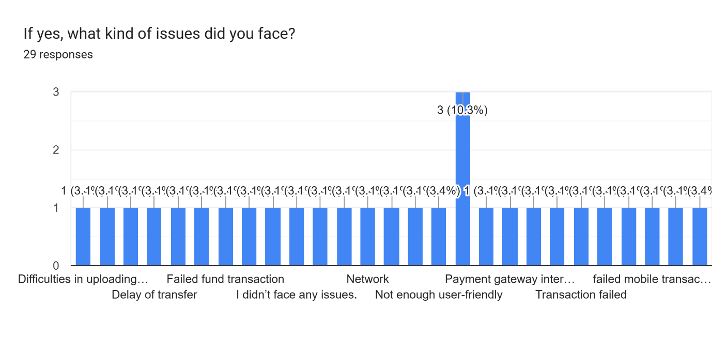
Among 64 respondents, 29 users mentioned they face issues like difficulties in uploading documents, delays in transactions, and failed fund transfers. One of the users stated that he paid Dps money but didn’t get any confirmation, and some of them said they didn’t find it user-friendly. A lot of them faced network issues, glitches.
User perception of security during online transactions:

In this chart, we can see that 89.1% users feel secure during online transactions. This strong majority shows that Citytouch can provide safe and trustworthy digital banking service. Whereas a very small portion, only 10.9% feel insecure while doing an online transaction.
Comparison of Citytouch with physical branch visit:

The majority of the users considered Citytouch more convenient and faster than visiting a branch. From the chart, we can say that almost 90 % people support digital banking. However, there are still a few people who find getting services from bank branches is more convenient.
Performance of Citytouch in terms of speed and responsiveness:
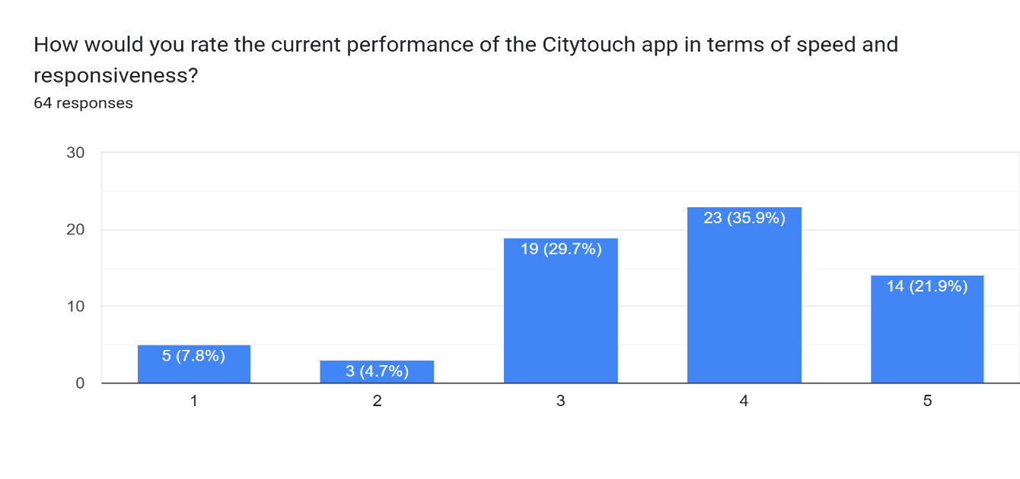
Most of the people rated the app 3 or above, indicating the majority of them is satisfied with app’s speed and responsiveness.
Satisfaction with Citytouch usability:
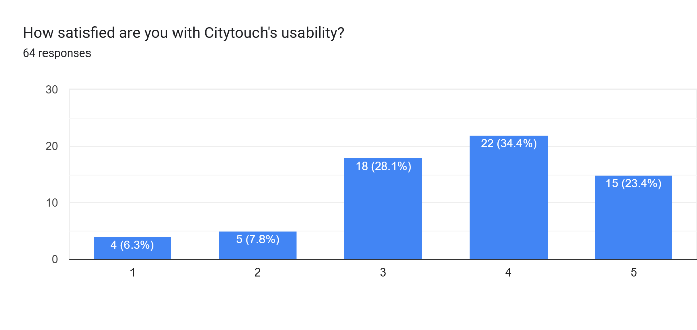
Most of the people responded that they are satisfied with the usability of Citytouch. The user finds the app easy to use and navigate. However, the presence of low ratings also points to the need to make some improvements.
Willingness to recommend Citytouch to others:

90 % respondents said they would recommend Citytouch, which shows a high level of trust and satisfaction with the app.
Suggestions for improvement or new features: Based on the open-ended responses from survey participants, I found several areas where the Citytouch app could be improved. The key suggestion that came up is listed below:
Account Opening features: Citybank has another account opening app named “Ekhoni account”, but it's not a very familiar app. So, many people express interest in having account opening features on Citytouch. It will reduce the need to go to physical branches. And as far as I know, City Bank is working on it.
Enhance speed and performance: A huge number of people recommended making the app faster, more secure, making the interface user-friendly, an easy way to sign up, polished and intuitive UI.
Addition of New Features: Some of the respondents recommended that they want features like closing Islamic FDR via Citytouch, an option to share account details ability to transfer funds to foreign accounts under the same ownership.
24/7 live chat: They also stated that adding 24/7 live chat will help them solve their issue easily while using the app
Fund transfer improvement: Some of them face some issues while fund transfer. So they recommended improving fund transfer functionality, fewer delays, and better transaction notification.

4.2 Summary of the Survey
To understand Citytouch’s current state and how customers perceive this digital banking app, a survey of 64 users was conducted. The responses provided a clear picture of user engagement, preferences, and expectations.
The findings show that a significant number of respondents have been using the app for over one year. This indicates long-term trust in the platform. Additionally, many of them joined the app in the last 6 months, which shows people’s willingness to conduct their banking activities digitally. In terms of frequency, some users use the app daily or weekly, and others do it monthly or occasionally, which is a sign to increase regular engagement.
Users mostly use features like transfer funds, mobile recharge bill payments. Other services like credit card bill payments, issuing virtual cards, and visa instant payments, opening DPS and FDR are less commonly used features. City Bank should increase promotion for these features. When transferring from Citytouch to the mobile wallet, bKash was the most preferred choice with 80% of respondents selecting it.
Among the participants, almost half of the participants said that, they don’t have City Bank’s credit card. Others' responses that some of them regularly pay card bills through the app, and some of them pay it occasionally.
The majority of the respondents stated that they didn’t face any technical error and found it secure for online transactions. A few pointed out some issues which already discussed in the corresponding section. Additionally, almost 90% users think that it's more convenient that visit a branch
However, the majority of users give positive responses about the app's speed and overall performance. Responded and recommended some improvements, such as adding new features, making it interface more user-friendly, smoother fund transfer, and so on.
The survey showed that Citytouch is widely accepted and valued by customers for its accessibility and functionality, also it identifies areas for further development.

Chapter 5: FINDINGS AND CONCLUSION

5.1 Findings

It is difficult to recommend anything to this well-established organization. However, based on my 3 months of observation at the Pallabi branch, and customer perception survey about Citytouch, I would like to recommend the following things.
To ensure enough customer service officers: The Pallabi branch is a very busy branch of City Bank PLC. Customers often have to wait too long to receive any services. Which is quite frustrating for them. So, they should increase the number of customer service officers in their busier branches to ensure more efficient service.
To have a faster software system: I often noticed can’t deliver the service timely because of slow software and server downtime. In Finacle software, they face difficulties logging in during the morning hours, and sometimes this software has buffering problems while uploading documents. So, I want to suggest them to fix this issue to ensure fast service.
Enhance Citytouch’s features: As of the survey findings, there is still some room to improve Citytouch app.
To do more publicity: City Bank should do more promotion of its digital products. People don’t have much idea about these products without Citytouch.
There should be and complaint box so that customer can share their end problems.

5.2 Conclusion

City Bank plc is one of the most popular private banks in Bangladesh. The bank offered both digital and conventional services. The bank has a strong physical presence and traditional workflow, and it is shifting towards digital banking through platforms like Citytouch, Ekhoni Account, Citycorp, Google Pay, City Pay, City go, smart IVR.
The survey showed that most of the users are satisfied with Citytouch’s services. But there is potential to make improvements in many areas and add new features. If these issues come up well, Citytouch will be the biggest digital platform in Bangladesh.
To maintain its current position in a competitive market, City Bank must continue to enhance its digital and traditional banking services.

References:
- Annual Report of City Bank Ltd. (2023). City Bank. Retrieved May 16, 2023, from https://www.thecitybank.com/report/annualreports
- Official Website of City Bank PLC – Used for gathering information on products, services, and information about Citytouch. https://www.citybankplc.com/
- Other Internship Report from United International University (UIU) DSpace. (n.d.). Retrieved from https://dspace.uiu.ac.bd/
- https://www.city.bank/bank/digital-banking

Appendix-A: Survey Questionnaire
