Internship Report
Md. Sakib Sadman
unITED iNTERNATIONAL UNIVERSITY

HRIS Practices and Performance Appraisal System at Radiant Pharmaceuticals Ltd.


United International University

Internship Report on
HRIS Practices and Performance Appraisal System at Radiant Pharmaceuticals Ltd.

Course Code: INT 4399

Supervised by
Md. Kazimul Hoque
Assistant Professor
School of Business & Economics
United International University

Prepared by
Md. Sakib Sadman
ID: 111 161 314

Date of Submission: 26th June, 2021

Letter of Transmittal
26th June, 2021
Mr. Md. Kazimul Hoque
Assistant Professor
School of Business & Economics
United International University
United City, Madani Avenue, Badda, Dhaka 1212
Subject: Submission of internship report on HRIS Practices and Performance Appraisal System at Radiant Pharmaceuticals Ltd.
Dear Sir,
I am very much pleased to inform you that, I have completed my 3 months’ internship at the Corporate Headquarter of Radiant Pharmaceuticals Ltd. Working under its Human Resource department that you have approved as a compulsory requirement of my bachelor program.
The topic of my internship report is HRIS Practices and Performance Appraisal System at Radiant Pharmaceuticals Ltd, which contains my full internship experience at RPL. During my internship, I got an understanding of how the Human Resource department, which is an important element of RPL performs to make sure the best usage of human resources within all the departments.
During my internship, I received a huge amount of support from the officials of HR department regarding any information. I was also able to communicate with employees working at other departments. It enabled me to get a better and clear understanding of corporate environment.
I have tried the best I could to include all the necessary information and prepare a comprehensive report. I am very thankful to you for your continuous support, guidelines and observations of my works throughout the trimester which made it easier for me to bring out the best of my practical learnings in my report. I believe, you will find this report interesting and it will fulfill your expectations.
Sincerely yours,
Md. Sakib Sadman
ID: 111161314
School of Business & Economics
United International University
Declaration of Authorship
I, Md. Sakib Sadman, bearing ID: 111161314 from School of Business & Economics, United International University, hereby declare that, apart from the specific references that are provided to the work of other authors, all the contents of this internship report are original and have not been submitted in whole or in part for consideration of any other degree or programs in this or any other universities. This internship report is a work of mine, containing my own findings and analysis. It does not contain anything which is the result of others’ work, except where specifically indicated in text.


_________________
Author’s Signature
Md. Sakib Sadman
ID: 111161314
School of Business & Economics
United International University
Acknowledgement
Firstly, I want to express my gratefulness to the almighty for providing me the strength to perform my duties and responsibilities during my internship and to complete this report within given period of time.
I am superficially thankful to my academic supervisor Mr. Md. Kazimul Hoque, Assistant Professor of School of Business & Economics, United International University for his constant support, guidelines and observations throughout my internship period. Without his support and direct guidance, this report could not be possible. I am also very grateful to my internship supervisor Mr. Syed Tanvir Ayaz (Manager, HR) for tolerating me as an intern and helping me at each stage of my new learning opportunity. I would like to thank Mr. Ashraful Islam (Senior Assistant Manager, HR) for helping me with all the necessary information. I am very much thankful to Mr. Mostafa Arif Mahmud (General Manager, HR) for his support and inspiration from the very beginning of my internship.
Besides, I want to convey my gratitude to all my colleagues, seniors at Radiant Pharmaceuticals Ltd. for their good advice, necessary information, support and motivation during the days of internship. Also, I must mention the excellent working environment, team commitment which has enabled me to get a clear understanding of corporate culture.
Last but not least, I am very much thankful to my family members and my friends for their continuous support and motivation throughout the period.

Executive Summary
Pharmaceuticals industry which is being considered as a multi-billion dollar scope for Bangladesh in the upcoming future. It has grown at a large rate in the past couple of years. Export is considered a big venue for the industry and it is growing significantly over the period of time.
Radiant Pharmaceuticals Limited is one of the fastest growing and most reliable pharmaceuticals company in Bangladesh. They are engaged in manufacturing and marketing of medicines for both local and foreign markets.
Their HR department is currently going through lots of changes at the moment which has a very positive impact on the overall performance of the organization. In this report, I have made an analysis about their HRIS practices, and also their Performance Appraisal process.
At the very beginning of the report, I have provided the preface part. In the first chapter, I tried to discuss about origin of the report, objectives of the report, the methodology I have used, scope of the report, and the limitations of the report that I have encountered while preparing the report.
The second chapter is about literature review which provides a clear understanding about Human Resource Information System, and Performance Appraisal.
In the third chapter, I have tried to provide some overviews of Radiant Pharmaceuticals Limited, their system of work, and their products in details.
The fourth chapter is all about my responsibilities towards the organization as an intern. Which shows my experiences that I have collected throughout my internship period.
The fifth and sixth chapters include the major part of this report which includes a brief discussion about the HRIS practices and Performance Appraisal process of Radiant Pharmaceuticals Limited. I have tried to include necessary information about how the whole process works, how it gives a new measure to the Human Resource Department to make it easier for getting a clear view of the organization’s practices in those two fields.
And the last part of this report contains analysis, findings, my recommendation to the organization, and the conclusion of my report.
Table of Content

Chapter One: Introduction 1
1.1 Origin of the report 2
1.2 Objectives of the report 2
1.3 Methodology 3
1.4 Scope of the report 4
1.5 Limitations of the report 5
Chapter Two: Literature Review 6
2.1 Human Resource Information System (HRIS) 7
2.2 Working Components of HRIS 8
2.3 Benefits of HRIS 9
2.4 HRIS Suppliers 10
2.5 Performance Appraisal 11
2.6 Purpose of Performance Appraisal 12
2.7 Objectives of Performance Appraisal 12
2.8 Performance Appraisal Process 13
2.9 Methods of Performance Appraisal 14
2.10 Advantages of Performance Appraisal 14
2.11 Problems with Performance Appraisal 15
Chapter Three: Company Overview 17
3.1 Industry Overview 18
3.2 Company Overview 20
3.3 Vision and Mission 20
3.4 Core Value 20
3.5 History 21
3.6 Location 23
3.8 Departments of Radiant Pharmaceuticals Ltd. 25
3.9 Products 26
3.10 Export Overview 28
3.11 International Business 28
Chapter Four: My Internship Experience 29
4.1 Overview of Internship 30
4.2 My Responsibilities 31
4.3 My Learnings from Internship 33
Chapter Five: HRIS Practices at Radiant Pharmaceuticals Ltd. 35
5.1 Implementation of HRIS at Radiant 36
5.2 Timeline of HRIS at Radiant Pharmaceuticals Ltd. 36
5.3 Factor influencing Radiant to use SAP rather than KORMEE 37
5.4 Introduction to SAP S/4 HANA 37
5.5 Solutions provided by SAP 38
5.6 SAP modules used by Radiant 38
5.7 Usage of SAP Human Capital Management at Radiant 40
5.8 Benefits of implementing SAP 41
Chapter Six: Performance Appraisal at Radiant Pharmaceuticals Ltd. 44
6.1 Purpose of Performance Appraisal 45
6.2 General Guideline for Initiation 46
6.3 Performance Report Schedule 46
6.4 Definition of General and Behavioral Competencies 46
6.5 Supervisor’s Preparation 48
6.6 Marking Criteria and Guideline 48
6.7 Biases to be avoided during Appraisal 48
6.9 Benefits Radiant gets from Performance Appraisal 49
6.10 Performance Evaluation Form Criteria 50
Chapter Seven: Findings, Recommendation and Conclusion 52
7.1 Findings 53
7.2 Recommendations 54
7.3 Conclusion 55

Chapter One: Introduction

1.1 Origin of the report
This report is prepared as a requirement for the completion of my Bachelor of Business Administration program from School of Business & Economics, United International University. The key purpose of the internship was to get an “on the job” experience and a scope for comparing theoretical concepts with real life scenarios.
As a compulsory part of my graduation, I was placed at Corporate Headquarters of Radiant Pharmaceuticals Ltd. under the Human Resource Department for my internship and was assigned to conduct study on their Human Resource Information System practices and Performance Appraisal process.
The report titled “HRIS Practices and Performance Appraisal System at Radiant Pharmaceuticals Ltd.” is made on the basis of my work experience of about three months. This report is made under the supervision of Mr. Md. Kazimul Hoque (Asst. Professor, UIU) and Mr. Tanvir Ayaz. (HR Manager, Radiant Pharmaceuticals Ltd.)

1.2 Objectives of the report
1.2.1 Broad Objective: The primary objective of the report is to get a clear understanding of the usage of HRIS at Radiant Pharmaceuticals Ltd. and also their Performance Appraisal process.
1.2.2 Specific Objectives:
- To get a clear and practical view about HRIS, how it helps Radiant’s HR department and its activities.
- To know about the shortcomings of their old HRIS and the benefits of new HRIS.
- To know the effectiveness of their HRIS and Performance Appraisal process.
- To identify the contributions of Performance Appraisal on reduction of turnovers.
- To identify the lacking of their current system and to recommend some changes that could come handy for their effectiveness.

1.3 Methodology
For the completion and fulfillment of this report, I have used both primary and secondary sources of data.
1.3.1 Primary Data: Primary data is collected through following process:
- Face-to-face interviews with the officials
- Observation
- Working experience
1.3.2 Secondary Data: Secondary data is collected through following process:
- Website of Radiant Pharmaceuticals Ltd.
- Different articles from the internet
- Different books related to Human Resource Management

1.3.3 Methods of Collecting Data: Firstly, I had to schedule a suitable time for the officials to conduct any interview. I have collected most of my primary data through the interviews which helped me getting a clear understanding of the desired topics. I have tried to observe each details of the organization to make sure all the data are correct and practical. My three months’ internship experience also helped me getting different kinds of secondary data through my own working experience. Whenever I got some free time, I went to the desks of my colleagues and tried to understand how they work, how they communicate with each other, and how information is transmitted into different departments throughout the organization.
I have got many necessary data from the website of Radiant Pharmaceuticals Ltd. which were very necessary for making the company profile. Radiant’s website is very rich and easily provides all the desired information.
I have also taken help from different articles from the internet which made it easier for me to allocate all the necessary data step by step and helped me understanding the right way of putting that information on my internship report.
I have also taken data from different HR related books. Thanks to Radiant because their HR department has a large collection of books and most of them are related to Human Resource.

1.4 Scope of the report
Radiant Pharmaceuticals Limited is one of the most reliable and renowned healthcare solutions provider in the country with highest business growth. One of its key divisions is Human Resource department. This report is a summary of my three months long internship experience at their Corporate Headquarters under HR department.
In this report, I have tried to bring a clear understanding of their HRIS practices for a better management, also their Performance Appraisal process and its impact on their overall organizational performance. I have tried to explain in details about Human Resource Information System, Performance Appraisal Process. I have tried to show the effectiveness of these two sectors in their organization, and also tried to recommend them my suggestions to overcome some limitations which they were facing.

1.5 Limitations of the report
Although this internship was an excellent opportunity for me to relate my theoretical academic learnings with real life scenarios here at Radiant Pharmaceuticals Limited, there were some issues which should be considered as limitations for the completion of this report. Some of them are discussed below:
- Lack of time: Lack of time was one of the major limitations for this report. As my primary focus was on understanding overall HRIS practices and also their Performance Appraisal process, I needed more time for observing these two different activities. Moreover, I had to complete my assigned work and other official activities too. Due to lacking of time, I did not have enough time to conduct more observation.
- Confidentiality of information: A lot of information regarding the organization, its products and activities were very much sensitive and confidential so I could not use them on this report. Many of the officials believed that they were leaking confidential information while talking to me which they were not meant to do.
- Lack of prior research studies on the topic: As HRIS is a very new topic in our country, I have found it difficult to find relevant articles or journals related to Human Resource Information System so it gave me a really tough time to collect secondary information for my report.
- Inexperience at corporate level: As this internship was my first access to the corporate world, lack of knowledge regarding corporate culture was one of the major barriers. It took me some time to adapt with the new environment.
- No access to HRIS: As I was an intern, I did not get the opportunity to access HRIS by myself. I had to rely on other officials to get any information. Because they were busy most of the times, I felt uncomfortable to ask them regarding any information quite a few times.
- Complicacy of Performance Appraisal: Performance Appraisal is a very complicated process, basically done by the top level of the organization. As an intern, it was quite difficult for me to poke the top management continuously in order to collect random information about their performance appraisal process.

Chapter Two: Literature Review
2.1 Human Resource Information System (HRIS)
HRIS or Human Resource Information System is an application or online solution which is used for many tasks including data entry, data tracking, and data management of all HR related activities of an organization. HRIS has become a very effective and important part of HR division now a days.
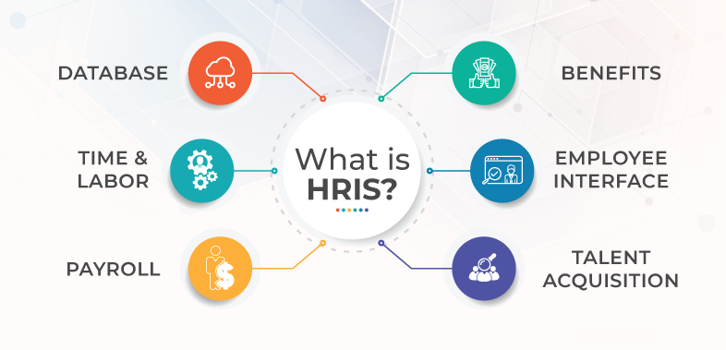
It is an accessible database that provides smooth operation of all HR programs. It can be hosted either on organization’s server, cloud, or vendor. HRIS is also effective on Human Resource Management and Planning too.
HRIS includes a wide range of systems that enable the organization to perform many important tasks in easier way. Some of them are: managing employee database, directory, tracking the applicant, administration of benefits, payroll management, scheduling the works, time and attendance, tracking the lists, protocols related to compliance, insight reports, self-service of the employees, performance management and so on.
To be more specific, here are some definitions by the author:
HRIS is a computerized system that enables human resource managers to gather, organize, store, update, and retrieve the information needed for managing employees. (Klyenhans, 2006)
As with other technologies, the aim of the HRIS is to increase the productivity of employees, in this case, to increase HR department efficiency. HRIS is a technology that has evolved over the last thirty years, moving from a simple data management system, to a management information system, to a real decision support system. (Waddill & Marquardt, 2011)
Human Resource Information Systems (HRIS) is a process that utilizes the information technology for the effective management of human resource functions and applications. It is a computerized system typically comprising a data base or inter related data base that track employees and their employment specific information. (Johnson, 2010)
(Tannenbaum, 1990) defines HRIS as a technology-based system used to acquire, store, manipulate, analyze, retrieve, and distribute pertinent information regarding an organization’s human resources. (Kovach, 1999) defined HRIS as a systematic procedure for collecting, storing, maintaining, retrieving, and validating data needed by organization about its human resources, personnel activities, and organization unit characteristics. Furthermore, HRIS shape an integration between human resource management (HRM) and Information Technology. It merges HRM as a discipline and in particular basic HR activities and processes with the information technology field (DeSanctics). As is the case with any complex organizational information system, an HRIS is not limited to the computer hardware and software applications that comprise the technical part of the system it also includes the people, policies, procedures, and data required to manage the HR function. (Hendrickson, 2003)
2.2 Working Components of HRIS
Every single interaction that a candidate or employee has with the organization is captured and kept as data. HRIS comes very handy in this situation. Most of the HRIS programs now offer customized programs based on the specific requirements and planning for the growth of the organization. Basically, most organizations use six key HRIS components.
- Database Management: The primary offering of most HRIS solutions is a ready-access database where all the information of employees can be stored and managed effectively. The operator can easily input the personnel data into HRIS. The aim is to access all the necessary data from this HRIS from any part of the world, at any time. Different types of data stored on HRIS can range from compensation information, employees’ emergency contact details, work history to present contact information, performance review marks, learning metrics etc. This database creates the heart of all HR related activities and it also provides the opportunity to be an effective paperless office.
- Time and Labor Management: Surveilling the check-in and check-out times of thousands of employees is a very much time consuming task. Most of the offices today allow employees to punch in biometrically. This data requires operative governance regularly. Supervisors can now formalize requests for leaves, and the input will be directly linked to the payroll. Effective HRIS can keep an eye on punctuality and attendance.
- Payroll Functions: Payroll is considered as one of the most important functions of Human Resources. Better HRIS can allow the manager to upload or download attendance information and employee data very easily. This allows the manager to be error-free and things get lot easier. It also helps improving tax compliance.
- Benefits Management: It does not always mean medical benefits or retirement benefits. It also includes data, queries, feedback, and communication regarding benefits. HRIS provides an “all-in-one” platform for benefits management.
- Employee Interface: HRIS allows the user to access employees. That self-service of employee creates an environment that allows employees to get more operational freedom. HRIS enables employees to update their individual information, review their pay scales, update any information, download documents, change retirement benefits program which is very easy, interesting, and time-saving.
- Employee Retention and Talent Acquisition: Acquiring and retaining the perfect talent is an important task that helps the organization to grow. Recruitment and retention are also assisted by the use of HRIS.
Employees also require training, career planning, and rewards to enable them growing, boosting confidence, creating happiness. HRIS helps the candidate experience to be improved and also makes it very easy for the manager to source, track, and recruit the best talent.

2.3 Benefits of HRIS
The use of HRIS has lots of benefits for the organization.
- Record Keeping: HRIS keeps track of any changes to anything that is related to the employees of the organization. It can be seen as the truest source when it comes to personnel data.
- Compliance: It includes materials for identifying the employees in case of fraud, theft, or misbehaviors, fast contact data in case of accidents, worker identification information, and the expire dates of different certificates. Each of these information can be found in HRIS within a fraction of time.
- Efficiency: Without HRIS, all these tasks will be very tough to manage and it wastes lots of times of the employees.
- HR Strategy: Tracking of data is very necessary to conduct HR and business strategy. HRIS enables the manager to do this in a short time. This is where HRIS comes very handy and effective.
- End of paper-based office: Use of HRIS largely reduces the use of papers at the office which makes the office look better, reduces the cost for the organization, and also helps the environment in a better way.
- Self-service HR: HRIS offers self-service to the manager and other employees. They become able to manage their own affairs. If they do it right, HRIS will offer a good experience to the employees.

2.4 HRIS Suppliers
Thousands of HRIS suppliers are there. Some of the most popular HRIS suppliers are: Workday, SAP, Cornerstone, Oracle, ADP, Kronos, Ceridian and many more. Some of them are introduced below:
- Cornerstone: It offers many suites including recruiting, performance management, learning, and e-learning LMS.
- Workday: It is considered as one of the best HRIS at the moment. It has become a global HRIS giant with more than 10,000 employees. It basically helps the mid to large businesses.
- SAP: SAP is also known as Enterprise Resource System (ERP). It keeps track of the resources of a company including financial assets, people, and orders. Basically, large companies use SAP.
- Oracle: It includes modules of talent management, workforce management, rewards, and work-life solutions.

2.5 Performance Appraisal
Performance Appraisal is a process of evaluating individual’s performance in a periodic and systematic way. Performance is measured against factors that are applicable to his quality and quantity of output. It is useful for the development of the employees which in turn helps to grow and develop the organization he serves.
It is the process of regularly reviewing an employee’s job performance and the overall contribution that he provides to the organization. It can also be called as performance review, performance evaluation, annual review etc. It evaluates the skills, achievements, growth or lack of an employee. Companies use performance appraisal to understand which of the employees have most contribution to the growth of the company. It is also used for rewarding the high-achieved employees.
Performance appraisal is an effective tool for supervisors to provide feedback about how well employees are performing and delivering their tasks. It also helps to match supervisor’s expectation and employee’s actual performance. It enables the supervisor to document the progress of each team member for their career development and training needs.
The most challenging aspect of a performance appraisal is measuring the actual performance and assessing behavioral competencies of the employee. This is a continuous process that has to be allocated in order to notice the performances throughout the appraisal process.
Here are some definitions by the authors:
Performance appraisal is the process of systematic in which the behavior and performance of an employee evaluated by the superior or manager in opposition to predescribed benchmarks, such as understanding of the employment,quality of productivity, management skills, manner toward work,attenadce,collaboration,opinion,adaptability,healthiness,initiative, and onwards. It is the unbroken practice.It is establishing the goals and evaluating individual and group accomplishments through limited time. (BusinessJargons)
Performance Appraisal evaluates the systematic performance of an individual concerning his/her performance on the job and his/her potential for development. (Beach)
Performance Appraisal is the systematic, periodic, and an impartial rating of an employee’s excellence. In matters about his/her present job and his/her potential for a better job. (Edwin B Flippo)
Performane appraisal is a formal system.He also include that it is a structure system,assessing an employees employment related performance results to find out why and how the employee is at the moment executing on the job and how the employee can perform more effevtively in the future so that the employees,organization and society all gets advantage. (Schular)
Performane appraisal is the process of assessing the performnace and qualification of the employees in terms of the obligations of the occupation for which he is in employment,for reason of administation. (Heyel)
Performane appraisal comprises all structural processes accustomed to evaluate behaviours and allocations and prospectives of group associates in a working organization.It is a continuous procedure to protect information essential for creating accurate and objective resolutions on employees. (Yoder)

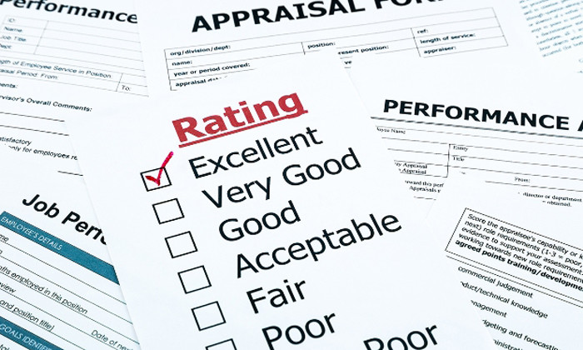

2.6 Purpose of Performance Appraisal
Performance Appraisal helps both the organization and its employees. It helps the organization determining the productivity and the value that employees are contributing. And it helps the organization’s employees to develop themselves in their own roles.

2.7 Objectives of Performance Appraisal
- To differentiate the employees, based on their performance.
- To identify necessary training and development needs.
- To take any important decision about payment, incentives etc.
- To keep records for compensation, wage etc.
- To improve the communication between supervisor and subordinate.
- To favor the working practices of the employees.
- To place employees to the right job.
- To let employees realize where they stand in case of performance.

2.8 Performance Appraisal Process
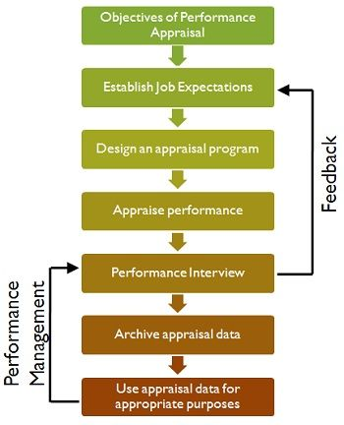
The above figure shows a common process of performance appraisal in an organization. Every step is very important and they are arranged in a respected manner. Performance Appraisal processes are arranged within a period of time which can be annually, semi-annually depending on the policy of the organization and their need for performance appraisal.

2.9 Methods of Performance Appraisal
Performance Appraisal methods can be divided into two categories as Traditional methods, and Modern methods.
2.9.1 Traditional Methods of Performance Appraisal
- Rating Scales Method
- Ranking Method
- Paired Comparison Method
- Critical Incident Method
- Checklist Method
- Graphic Rating Scale
- Forced Distribution
2.9.2 Modern Methods of Performance Appraisal
- Management by Objectives
- Behaviorally Anchored Rating Scales
- 360 Degree Assessment
- Cost Accounting Method
- Psychological Appraisal

2.10 Advantages of Performance Appraisal
Performance Appraisal is a favorable process for both the organization and its employees. It can help the organization to find out its best contributors, also it helps the employees to get the reward for their contribution to the organization.
  - 2.10.1 Benefits for Organization
- It helps the supervisor to perform promotion programs for efficient employees with most contributions to the organization. Also, employees with poor performance can be dismissed or demoted.
- It helps to determine compensation package for the employees. Performance Appraisal sorts out merit rating. It adds value to performance. Compensation package including bonus, allowances etc. should be dependent on merit instead of seniority.
- Performance Appraisal process helps the supervisor to set up the training programs for the employees. Helps in analyzing strength and weakness of employees and the new jobs become easier to design based on the employee strength.
- It also helps the supervisor to validate the selection process. Supervisor gets to know the validity, also the strength and weakness of selection program.
- Performance Appraisal promotes effective communication between the employer and the employees which is very much important. It also builds trust and confidence. It also boosts employees’ morale.
- It can also be called a motivational tool. Employees always try to improve their performance if they get worthy rewards. So, it directly affects the organization’s productivity and profit.
2.10.2 Benefits for Employees
- Performance Appraisal helps recognizing employees’ contribution and achievement.
- Allows employees to be a worthy candidate of promotion and bonus.
- Helps the employees to get enough training and development programs.
- Brings out particular areas where the employee can improve his skills.
- Makes the employee feel that they are involved and invested in career development.
- Points out the long term goals of employees.

2.11 Problems with Performance Appraisal


There are some problems that can arise while conducting a performance appraisal. These include:
- Central Tendency Error: In many cases, the rater fails to differentiate from many employees and rather than rating them regarding their skills, they have a tendency to rate maximum employees as “average.” It is a failure to distinguish either very good or poor performances.
- Leniency Error: This problem arises when the rater is very much strict while evaluating. They usually see maximum employees as under-performers. Like the central tendency, this is also a failure to distinguish between good and poor performers.
- Halo Effect: It happens when a rater gives the same rating to each or most of the factors of the employees. Like, an employee is rated below average on his quantity of performance may also be rated below average on other factors like quality of performance, attendance etc. Basically, the rater gives a global rating on all the factors for that particular employee.
- Personal Biases: Sometimes raters allow their personal biases to influence performance appraisal process. It includes like or dislike for someone, also sexual or racial biases. They are illegal and hurt the accuracy of evaluation.
- Recency Error: Sometimes evaluators focus on the most recent behavior of the employees. For example, an employee performed below average last week but his previous performance was great for about a year. But the evaluator rates him poor because of his below average performance in last week. It hampers the appraisal process and leads to unfair appraisal.

Chapter Three: Company Overview

3.1 Industry Overview
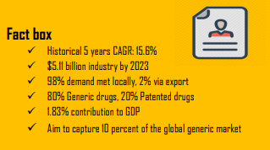
Pharmaceutical sector is currently one of the most advanced technology and knowledge based sectors in Bangladesh. It has been evolved and transformed over the last decades as one of the fastest growing sectors in the country. Bangladesh is now considered as emerging generic drug hub in the South Asian region. About 257 licensed manufacturers are currently operating and 150 of them are functional.

Almost 98% of the local demands are being fulfilled by these local companies. The remaining 2% includes specialized pharmaceuticals products like vaccines, anti-cancer products etc. which are being imported.
According to DGDA, Bangladeshi Pharmaceutical industry has 3,657 generic allopathy medicine, 2400 registered homeopathic drugs, 6389 registered Unani drugs, and 4025 registered Ayurvedic drugs.
At present, the Pharmaceutical Market in Bangladesh is over $3 billion where homeopathy, traditional and other drugs are not included. The market is growing rapidly with a CARG of 15% in recent years. Pharmaceutical market in Bangladesh is expected to grow to $6 billion by 2025. (GLOBE NEWSWIRE, 2020)
According to Bangladesh Bureau of Statistics, pharmaceutical industry has contributed 1.83% to the GDP in 2017-2018. Pharmaceutical industry is currently the second highest contributor to the national exchequer while at the same time, pharmaceutical industry offers the largest white collar intensive employment in Bangladesh.
Bangladesh is going to be a significant global player for high quality and low cost generic medicine and vaccine in the upcoming future. Bangladesh aims to capture 10% of the global market. Currently, Bangladesh exports pharmaceutical products to 147 countries
Bangladeshi pharmaceutical industry is strongly safeguarded from external competition as the government has restriction concerning the import of similar drugs that are being produced within the country.

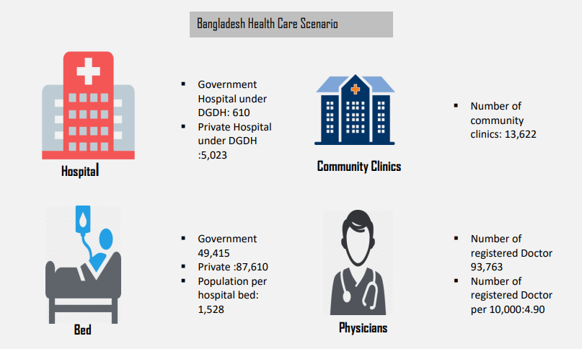

3.2 Company Overview
Radiant Pharmaceuticals Limited was established in 2005 which is now the country’s one of the most renowned, reliable and fastest-growing healthcare solution providers with the highest business growth. Radiant started producing medicines in 2008 to make a contribution to the promising pharmaceuticals sector of the country with its assurance of top-quality products. Radiant manufactures and markets medicines for both local and foreign markets.
Radiant Pharmaceuticals Limited has also formed another company in 20011 which is known as Pharmacil Limited aimed at manufacturing quality healthcare products. Radiant has been always trying to promote the transfer of technology by establishing collaborative relations with globally reputed companies. The license agreement between pharmaceuticals companies like L. Hoffmann-La Roche Limited, Switzerland can be taken as an example.
The future focus of Radiant Pharmaceuticals Limited is to provide world-class medications to the customers for better wellbeing.

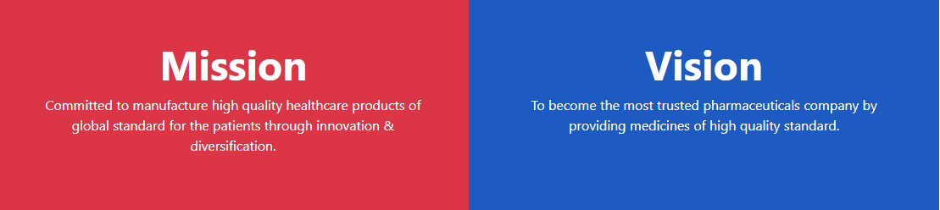
3.3 Vision and Mission

3.4 Core Value
Quality: Quality is their top priority which is ingrained in the work of their colleagues. Their relentless for the quality of product is the reflection in every work that they do.
Innovation: Innovation is the key to improving healthcare, sustaining Radiant’s growth, and enhancing their contribution to the society. They believe in raising the bar every time.
Teamwork: They believe in teamwork. They must work together to make a better workplace, eventually achieving their goal.
Integrity: Integrity is one of the top most attributes of an employee that they always look for.

3.5 History
2005
- Formation of Radiant Pharmaceuticals Limited.
- Licensee agreement with F. Hoffmann-La Roche Limited, Switzerland
- Renewal of Biological and non-biological product manufacturing license
2006
- Manufacturing and marketing of Roche licensed pharmaceutical brands
- GMP inspection according to AIDS Technology Transfer Initiative by Roche
2008
- Manufacturing and marketing of Radiant Brands
2009
- Compliance with cGMP according to the Compendium of guidelines and related materials
- Site transfer from Novartis (Bangladesh) Ltd. to Radiant Pharmaceuticals Ltd.
- Pharma Technical (PT) Good Manufacturing Practice (GMP) Audit by Roche

2010
- Recipient of ISO 9001:2008 Quality Standard certified by Orion Registrar Inc., USA
- Inspection of manufacturing plant by Medicines Control Authority of Zimbabwe
- Approval of GMP Compliance, Pharmacy and Poisons Board, Kenya
- Conduction of ISO (9001:2008) Surveillance Audit
- Recipient of ISO (9001:2008) Certification
- Renewal of biological and non-biological product manufacturing license
- Compliance with cGMP according to the Compendium of guidelines and related materials
2011
- Recipient of ISO 9001:2008 Quality Standard certified by Orion Registrar Inc., USA
- Inspection of manufacturing plant by Medicines Control Authority of Zimbabwe
- Approval of GMP Compliance, Pharmacy and Poisons Board, Kenya
- Conduction of ISO (9001:2008) Surveillance Audit
- Recipient of ISO (9001:2008) Certification
- Renewal of biological and non-biological product manufacturing license
- Compliance with cGMP according to the Compendium of guidelines and related materials
2012
- Approval of GMP for its manufacturing facilities by Medicines Control Authority of Zimbabwe (MCAZ)
2018
- Approval of GMP for its manufacturing facilities by Medicines Control Authority of Zimbabwe (MCAZ)
2019
- Inspection of manufacturing plant and approval of GMP by DIGEMID, Peru
- Inspection of manufacturing plant, approval of GMP and gaining of export approval from Ethiopian Food and Drug Administration (EFDA), Ethiopia
- Export approval from National Drug Authority (NDA), Uganda

3.6 Location
3.6.1 Corporate Headquarters:
Radiant Pharmaceuticals Limited
House: 22/1, Road: 2, Dhanmondi, Dhaka 1212
Tel: +88029612481-6, +88029660307
Email: info@radiant.com.bd
Web: www.radiantpharmabd.com

3.6.2 Manufacturing Plant:
Radiant Pharmaceuticals Limited
B-46, BSCIC Industrial Estate, Tongi, Gazipur 1710, Bangladesh
Tel: +88029815201-3

3.6.3 List of Depots:
Dhaka West | Jamalpur | Chandpur | Cox’s Bazar
Mymensingh | Naogaon | Faridpur | Brahmanbaria
Uttara | Kurigram | Madaripur | Dhaka East
Narayanganj | Jashore | Patuakhali | Savar
Kishoreganj | Khulna | Maizdee | Narsingdi
Gazipur | Satkhira | Bhola | Moulvibazar
Bogura | Pabna | Chattogram East | Sylhet
Dinajpur | Kushtia | Chattogram West | Habiganj
Rangpur | Rajshahi | Feni | Dhaka Biotech
Tangail | Barishal | Cumilla | Diagnostics

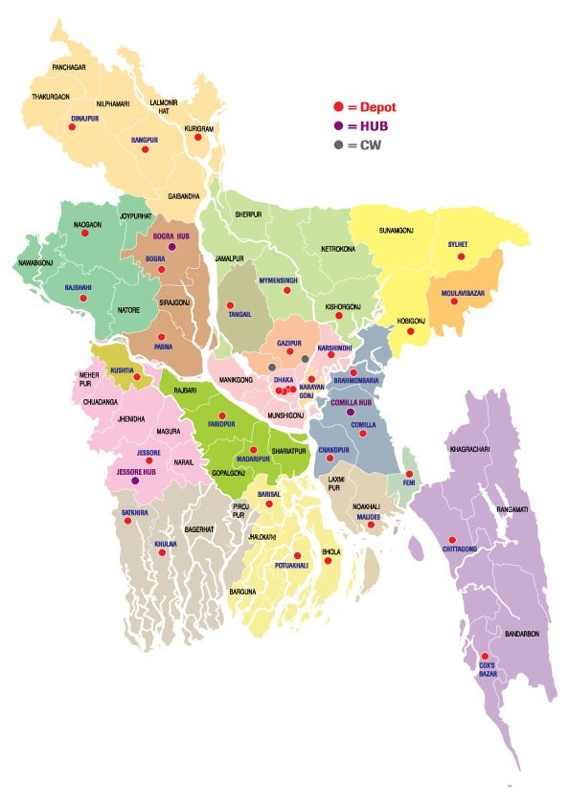
3.7 Business Units
Currently Radiant has six different business units:
- Radiant Pharmaceuticals Limited
- Radiant Nutraceuticals Limited
- Pharmacil Limited
- Radiant Business Consortium Limited
- Radiant Export Import Enterprise
- Radiant Distributions Limited

3.8 Departments of Radiant Pharmaceuticals Ltd.
Business Development | Market Research
Commercial | Production
Corporate Affairs | Product Development
Distributions | Promotional Marketing Management
Diagnostics | Production Planning and Inventory Control
Engineering | Pharmacovigilance
Finance and Accounting | Quality Assurance
Graphics and Design | Quality Control
General Services and Admin | Regulatory Affairs
Human Resources | Regulatory Compliance
Internal Audit | Sales
Information Management System | Strategic Marketing Department
Information & Communications Technology | Supply Chain
International Business | Warehouse

3.9 Products
Radiant Pharmaceuticals Limited is WHO cGMP obedient and ISO 9001:2015 certified manufacturer of generic formulations of Pharmaceuticals. Radiant Pharmaceuticals Limited is currently producing 51 brand medicines under its name. 20 brands under Radiant Nutraceuticals Ltd.’s name. Also, it is officially distributing 6 licensed brand medicines of Roche.
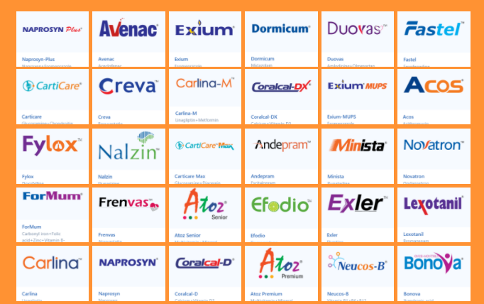
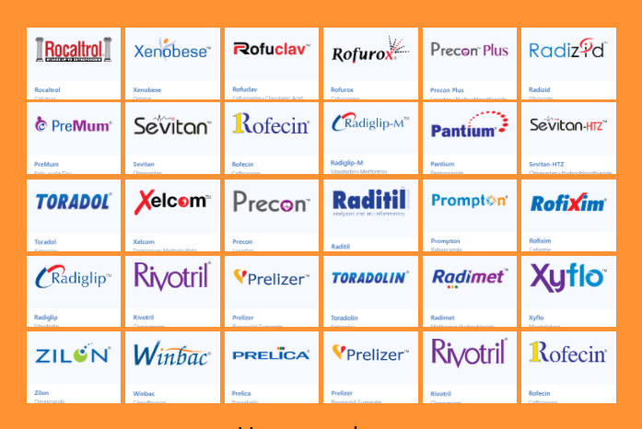

3.9.1 Brands under Radiant Pharmaceuticals Ltd.
Acos | ForMum | Radimet
Andepram | Frenvas | Raditil
Atoz Premium | Fylox | Radizid
Atoz Senior | Radiglip-M | Fastel
Avenac | Minista | Zilon
Bonova | Nalzin | Toradolin
Carlina | Naprosyn | Rofixim
Carlina-M | Naprosyn Plus | Rofuclav
Carticare | Neucos-B | Rofurox
Carticare Max | Novatron | Sevitan
Coracal-D | Pantium | Sevitan-HTZ
Coracal-DX | Precon | Winbac
Creva | Precon Plus | Xelcom
Exler | Prelica | Xenobese
Duovas | Prelizer | Xyflo
Efodio | PreMum | Exium
Exium MUPS | Prompton | Radiglip

3.9.2 Licensed Products from Roche
Lexotanil | Rivotril | Rocaltrol
Dormicum | Toradol | Rofecin

  - 3.9.3 Brands under Radiant Nutraceuticals Limited
Acteria | Floriz | Menaquin
ChiroCyst | Gastroaid | Menofemin
Cranbiotic | Ginoba | Natlax
Curnoid | Luzent | Panaseng
Pirulin | Radiflex | Radigel Sachet
Pycnogenol | Radigel | Radisil
Ubi-Q | Yohim

3.10 Export Overview
Currently Radiant Pharmaceuticals Limited is exporting products to these 20 countries after fulfilling the medicine needs in Bangladesh:
Canada | Guatemala
Costa Rica | Peru
Nicaragua | Sri Lanka
Panama | Philippines
Honduras | Myanmar
Dominican Republic | Nepal
Jordan | Cameroon
Kenya | Ghana
Zimbabwe | Ethiopia
Nigeria | Uganda

3.11 International Business
Radiant entered into a licensee agreement with F. Hoffmann-La Roche Ltd., Switzerland which gave them a boost in their drive for quality. Currently, Radiant is manufacturing some of Roche brands in Bangladesh with maintaining the international standards.
Radiant also produces and exports lots of generic medicines under its own name. By maintaining an aggressive price and better quality, Radiant is now competing against other product brands in Bangladesh. Radiant is very strict about its quality as it has to maintain standard quality to be in the race of international business.
In 2011, Radiant started their international operations and exported medicines to Nigeria and Kenya for the first time. From then, Radiant is making a good sight in the global market.

Chapter Four:
My Internship Experience

4.1 Overview of Internship
For a fresh graduate like me, Radiant Pharmaceuticals Limited is a perfect place to learn different elements of work life. Radiant is also an organization which allows an employee to have work life balance. Moreover, Radiant has a top class work environment which reduces the chances of stress at work. I joined Radiant as a Human Resource Intern on 10th January, 2021 at their Corporate Headquarters, Dhaka.
Since my first day at Radiant Pharmaceuticals Limited, I have been doing everything I was assigned to. I have worked at the Human Resource department and I was assigned to different HR related activities. The more I worked, the more efficient I have become and I was given more tasks for which I was very much happy. Every single day was a challenge for me to meet the deadlines, schedule my works, and cope up with the new environment and to gain organization’s satisfaction level.
Sometimes, I had works that I never did before. Each day I was assigned to different sort of HR related tasks and other basic office activities. I realized that the more I can be positive, the more I learn and gather new experiences which I need to survive in a corporate world. Day by day, I began to learn how to be proactive all the time and face different challenges, manage workloads, and become more productive. It seemed to work very well after some days. If I had leant it before, the primary days of my internship would have been much smoother.
After doing my internship at Radiant Pharmaceuticals Limited, I consider myself very different than before. I liked my job, any new experience, any complement, any criticism, every single moment of it. Every experience I gained from my internship at Radiant has helped me to shape my personality in one way or another. I have learned about corporate culture, different organizational practices, and developed new skills and improved my tactics. This internship has prepared me to handle different organizational situations better in the upcoming days.
I consider myself very lucky to join such an energetic and progressive team. They have inspired me to manage many difficult situations which were very tough for a fresh graduate. All of my colleagues have motivated me with their constant guidance and support. I was totally unaware of the corporate culture and a bit nervous when I joined Radiant. But luckily, The Human Resource department of Radiant Pharmaceuticals Limited welcomed me with open arms. They taught me so many things without any conditions. I am very thankful to be a part of that great team.
Going back to my university life, when I choose Human Resource Management as the major of my bachelor program, I had a dream to work under a fantastic HR team in a reputed organization. This internship has allowed me to be a part of that fantastic HR team even though for a very short period of time.

4.2 My Responsibilities
During my internship period, I was assigned to different HR related activities.
- Collection of employee data from documents: There are more than four thousand employees working at Radiant. Each employee has specific documents from where many information were needed to be collected for different purpose. As an intern, I often collected those necessary information from their provided documents like CV, copy of NID, Birth Certificate etc.
- Finding information gap: I had to find out the information gap of the employees. Sometimes, many of the important information like NID number, emergency contact number, date of birth, blood group etc. were not available in employee resume or other documents. I had to mark those information gap so that these can be collected easily. Without them, personal file cannot be fulfilled. Also, the HRIS will remain incomplete without these information.
- Maintaining employee filings with necessary documents: With many important documents like NID copy, Birth Certificate, Appointment Letter, Leave Form etc., a specific file is made for each employee which is considered very important and confidential. I had to make these files with necessary documents provided by the newly joined employees.
- Inputting necessary data on Microsoft Excel: All these necessary information from different types of documents are meant to be in the HRIS. As I did not have access to the HRIS of Radiant, my colleagues told me to input those information to Microsoft Excel. And later, I sent those excel files containing many information to my colleagues so that they can input them to the HRIS.
- Crosschecking and correction of necessary information: It is not very unusual for some mismatch of information to occur. I was assigned to crosscheck many documents, excel files and so on to find out the wrong information and then I had to highlight them and suggest some corrections that could be made.
- Employee ID card verification: During my internship, Radiant was planning to provide new ID cards to its employees with new SAP ID. So, I have checked all the IDs and made sure there were no mismatch of information.
- Assisting in recruitment: I had the opportunity to assist in recruitment process, mainly in written exam and VIVA. I had to invigilate in the written exam so that the examination can be very fair. I had to distribute and collect exam papers and other documents on time. I had to make a schedule for the VIVA, assist the applicant to different tasks.
- Collection and sorting of applicants’ resume and exam paper: After the written exam is over, I had to sort applicants’ exam paper, resume etc. together in order to make a proper documentation.
- Communicating with applicants: As many of the applicants were not from the internal side, they were not familiar to the organization. I had to communicate with them and answer their different queries.
- Preparing summary of applicants: After the VIVA is over, I had to input all the remarks that my senior colleagues provided regarding the applicants.
- Creating questionnaires for written test: I have prepared questionnaires that the applicants had to answer while attending their written test.
- Calling previous employees for settlement: I used to call the people over phone who previously worked for Radiant for the settlement of important issues like provident fund, gratuity, retirement benefits and other retirement related issues.
- General office activities: There were many other general office activities that I had to perform like printing and scanning necessary documents. I had spent hours on printing photos that used to be done for providing new ID cards to the employees.

4.3 My Learnings from Internship
Internship at Radiant Pharmaceuticals Limited was my first introduction to corporate culture. As a fresh graduate with zero experience, Working in a corporate environment for the first time was very difficult to cope up with. But fortunately, I was able to learn many new things during my internship period.
- New skills and how to apply them: One of the most precious things I have gained from this internship is newly obtained knowledge. I have learnt to perform many HR tasks that are related to my desired career path. It also helped me sharpening the skills that I already possess.
- Comparison of academic learning to real life experience: This internship was an opportunity to test out different sort of skills that I have developed in university and see how they work in real corporate world.
- Professional Communication: I have gained the ability to communicate with colleagues in a professional manner. Discussion with colleagues and bosses were very different from discussion with others.
- Importance of Networking: I think this internship at Radiant was an opportunity for me to meet seniors who are already very experienced at HR field. I did not wanted to end up creating memories only, I have tried to widen my professional network. I have tried to be proactive and meet new people so that they can remember me.
- Taking constructive criticism well: Although everyone at Radiant were very much helpful and I have tried to work with “zero errors”, I was open to constructive criticism from both my colleagues and bosses. I always believe constructive criticism is never personal and it is for my own good and growth which will improve my quality of work.
- Teamwork: I was very familiar to teamwork because I had to do lots of group projects every trimester in university. Unlike university projects where one person did all the work and the grades were shared among the others, teamwork is more important here at job. It is more professional and every team member needs to contribute to finish the project.
- Importance of Microsoft Excel: Excel is a very important component at work. Most of the important data based tasks are done using Excel. So, if someone is proficient in using Excel, he will definitely get advantage at the workplace. Many formulas of Excel make it easier to perform big tasks easily within a very short period of time.
- Problem solving skills: Internship provided me real-life work problems and developed my problem solving skills.
- Time management: Last but still as important as others, I have learnt to be proficient in time management. It is the beginning of my work life, so I have tried to manage time efficiently to prepare myself for the challenging future.

Chapter Five:
HRIS Practices at Radiant Pharmaceuticals Ltd.

5.1 Implementation of HRIS at Radiant
After a very detailed planning, Radiant Pharmaceuticals Limited has transformed its information system from the traditional manual way to advanced and digital HRIS. Before that, during the early days of Radiant, all the HR related activities and management were manual which required a huge amount of time. Information was incomplete and managing that information was a very difficult and time consuming work. As Radiant is a massive organization with a wide range of activities, it was very tough and time consuming to get all the information at once. Then later when Radiant started manufacturing in 2008, they implemented their first ever HRIS which was KORMEE. KORMEE was limited to Human Resource department only. So, Radiant needed something that could be used throughout all the departments.
Then later in 2020, Radiant choose to implement SAP as their primary HRIS. Still KORMEE is present at Radiant as a backup source.

5.2 Timeline of HRIS at Radiant Pharmaceuticals Ltd.

5.3 Factor influencing Radiant to use SAP rather than KORMEE
KORMEE is dedicated to be used in HR department only. All other departments of Radiant Pharmaceuticals Limited were unable to access any data stored by the HR department in KORMEE so all other departments had to go to HR department manually and ask them manually about particular information. That was one of the major lacking of KORMEE.
In order to implement a HRIS where all the departments would be able to access and share data, Radiant finally moved to SAP which allows all the departments to work under a same data sharing network. For example, HR department can now get necessary data from Accounts department within the same HRIS which was not possible back then. So, now Radiant is using SAP as their primary HRIS and kept KORMEE as a backup source.
The version of SAP being used at Radiant Pharmaceuticals Limited is SAP S/4 HANA 1909.

5.4 Introduction to SAP S/4 HANA
SAP S/4 HANA is an enterprise resource planning (ERP) system developed by German software company SAP which has built in exceptional technologies like AI, machine learning, selective advanced level analytics. It has ability to convert business procedure with super smart automation. SAP helps the organizations’ management to keep track of all of their inventories and assets. The company SAP started its operation in 1972 which is now currently world’s one of the largest software vendors.

SAP HANA is a database that provides real time processing speeds and a top class data model. SAP ERP is considered the rebranding of SAP R/3.

5.5 Solutions provided by SAP
SAP is combination of different modules which includes product design and development, utilities for marketing and sales, field service, human resources, production and inventory control, finance and accounting etc. SAP collects and gathers data from different modules and provides the Radiant with enterprise resource planning facilities. If implemented effectively, SAP can have cost benefits. An organization’s information system is best when the organization uses one vendor to supply all of its modules throughout the organization. This is where SAP comes very handy to Radiant compared to its usage of KORMEE which was limited to HR department only.

5.6 SAP modules used by Radiant
For the smooth operation throughout the whole organization, Radiant Pharmaceuticals Limited uses different SAP modules for particular departments. Generally, a particular department has access to a particular module only. But sometimes, a particular department can have access to more than one module, depending on the use and kind of the modules. All the SAP modules used by Radiant Pharmaceuticals Limited are:
- SAP Human Capital Management (HCM): HCM module helps in improving work procedure and administration of information in the HR department of Radiant Pharmaceuticals Ltd. It helps in building an organized management which starts from including an employee’s basic data to his execution. HR functions at Radiant are much beyond just appointing new employees; it assists the employees on various factors like payment, protons, employee engagement, motivation etc. SAP HCM module comes handy in managing all the HR related activities at Radiant. All the necessary works of HR are done by using this module. Sub-modules of HCM are: Payroll, Time Management, Personnel Administration, and Organizational Management.
- SAP Financial Accounting (FI): FI modules deals with management of all the financial transactions within the whole organization of Radiant. This module is very useful to the employees and managers to handle data related to any financial and business transactions. FI module performs very well for reporting any requirements. This module can be used in organizations of different size, in any economic condition. It helps Radiant to understand their present financial position in the competition by studying their financial reports. This module works with a very rich collection of financial activities including generating general journals, ledgers, reconciliation statements, statements of financial positions, and income statements. Sub-modules of FI are: General Ledger, Accounts Receivable, Accounts Payable, Budgeting and Monitoring, Bank and Cash Management, Withholding tax, Treasury Measurement, Asset Accounting.
- SAP Controlling (CO): The CO module assists the process of planning, reporting, monitoring operations of business at Radiant. This module includes different methods to see and settle costs that are necessary for monetary announcing. It helps to design, track, perform and report about any expenses in the organization. The CO module is basically used by the managers and top level officers of Radiant Pharmaceuticals Limited to understand the current scenario of operations. Sub-modules of CO are: Product Costing, Profitability Analysis, Cost Center Accounting, and Profit Center Accounting.
- SAP Materials Management (MM): MM module manages the required materials, processed materials, and produced materials at the manufacturing plant of Radiant Pharmaceuticals Ltd. Lots of procurement processes are managed by using the MM module. Sub-modules of MM are: vendor evaluation, purchasing, invoice verification, inventory management.
- SAP Sales and Distribution (SD): SD module deals with management of all transactions coming from proposals, enquiries, quotations, pricing etc. SD module is very much helpful for Radiant in inventory management and control. SD module has master data, transactions, and system configurations. This module is basically used by the Sales department and Distributions of Radiant. Sub-modules of SD are: Sales order processing and monitoring, Invoice Generation, Pricing and Discounts, Credit Management.
- SAP Production Planning (PP): PP module assists in programming outline for production planning and administration. PP module contains ace information, design of framework, and exchanges for the fulfillment of design methodology for planning. It helps Radiant by working with business module information and provides detailed data regarding deals and operations, asset arrangement, cost arrangement etc. This module is used by Production Planning and Inventory Control department of Radiant.
- SAP Plant Management (PM): PM module manages all the maintenance activities at the manufacturing plant of Radiant situated in Tongi. This module consists of key activities like inspection, notification, preventive and corrective maintenance, repairing etc. to form an ideal technical system. It is used for performing automatic repairs, facilitating maintenance requests in the plant. It allows to plan labor and material activities, to record different costs.
- SAP Supply Chain Management (SCM): SCM module assists the areas of production planning, demand planning, and business forecasting of Radiant Pharmaceuticals Ltd. This module comes very helpful in controlling information and product flow across the organization. It is also similar to other business activities like product discovery, material purchase process etc. Supply Chain helps Radiant to ensure maximum customer satisfaction with less costs. SCM module mainly divided in planning application and execution application. Sub-modules of SCM are: Demand Planning, Supply Network Planning, Detailed Scheduling, Production Planning, Vehicle Scheduling, Transport Load Builder etc.

5.7 Usage of SAP Human Capital Management at Radiant
SAP HCM is a major module in SAP with a major role in creating a systematic management at Radiant Pharmaceuticals Ltd. Many important tasks including recruiting, promotions, employee engagement, compensation etc. are taken care by the HR department. All these tasks for the whole organization’s employees are not very easy to do. This is where SAP HCM comes very handy.
Some of the following tasks are performed using SAP HCM at Radiant Pharmaceuticals Limited:
- Organizational Management: This is a common way of making sure that different people works within a common platform. It makes sure a smart time management and allocation of resources at Radiant Pharmaceuticals Ltd.
- Personnel Administration: It is a process that enables the management of human resources in any organization. Many HR functions like compensation, benefits, new employee orientation etc. are recorded and tracked by using personnel administration.
- Time Management: The impact of employees’ presence and absence at Radiant is assessed in this task. Attendance management, wage calculation, sign-in and sign-out reports can be accessed in this process.
- Payroll: Payroll is about pay-scale of Radiant and the compensation given to the employees. From basic compensation to overtimes payment, all the pay related processes are calculated in payroll.
- Reporting: It helps the HR department to share up to date information of all the employees working at Radiant. This function assists in following the hierarchal structure followed at Radiant Pharmaceuticals Limited.

5.8 Benefits of implementing SAP
SAP comes with lots of benefits for Radiant Pharmaceuticals Ltd. Instead of using traditional information system, SAP makes it easier for the managers to operate all the data based activities easily and it also enables the pace of the organization.
- One-stop Solution: SAP can be called the ocean of information. All the information can be stored and accessed from SAP anytime from anywhere. The user has to input or update any information once, and it will be automatically updated to the whole system including all other departments of Radiant Pharmaceuticals Ltd.
- Integrated Software: All the modules can communicate with each other and share necessary data if needed to be shared. One does not need to operate all the modules to collect information.
- Accuracy: Users are accurate, not the software. But SAP helps by ensuring that the data after being input does not get distorted or lost. If entered correctly, there is no chance for the data to be changed or altered. So, it is very beneficial for Radiant because it ensures that all the data remains safe and accurate.
- Customized Solution: Radiant Pharmaceuticals Ltd. is a large organization with lots of departments. Every big organization has different and customized needs, so does Radiant. It may include operational and departmental needs. SAP is very simple, flexible and universal solution. Organizations like Radiant can easily customize SAP according to their needs.
- Increased Productivity & Efficiency: Employees at Radiant get real-time information and it enables them to do more work faster. All the departments of Radiant can easily communicate effectively because all the information is up to date.
- Data Analysis & Reporting: Relying on people to provide accurate data and specific reports is very tough. Human errors can occur and it may cost the organization lots of money. SAP takes the risk out because there is no risk of providing misinformation.
- Self-service: Employees at Radiant can enter the system and change or update their data like address and others by themselves if they are authorized. And managers can enter or retrieve data without bothering the HR. So, it is very time saving.
- Automated Reminders: SAP can schedule events like performance evaluation, project deadlines automatically and notify the user in the given time.
- Integrated Report Generation: Managers at Radiant can generate real-time report by using necessary information which would be very hard and time consuming if done manually by the operator.
- Cost & Time Control: All the benefits above has one thing in common which is time saving. With time saving, it also reduces different costs for Radiant Pharmaceuticals Ltd. like printing and copying lots of documents.
5.9 Disadvantages of SAP
Although SAP is very useful and effective of Radiant in its daily activities, still there may be some factors that can be risky for any organization including Radiant Pharmaceuticals Ltd:
- Lack of Security: This is one of the biggest risks of HRIS, not only SAP. Users at Radiant Pharmaceuticals Ltd. input many sensitive and confidential data to SAP for its operation. But somehow if they get leaked, this may cause a disaster for Radiant. So, the system must be designed in a way that unauthorized access can be prevented and it has to be monitored in regular basis.
- Cost: SAP is a very costly system. Especially for smaller organizations, it can be a problem. Also with the installation of SAP, the cost of hiring IT Specialist arises to manage and operate the system.
- Complex Interface: The user interface of SAP S4HANA is very complex for the users which might lead to different mistakes while working.
- Demands Highly Trained Staff: SAP demands very highly trained staff. Although Radiant has provided different trainings on SAP for its employees, the risk of conducting mistakes or any mismatches are still there.
5.10 Some Screenshots of SAP
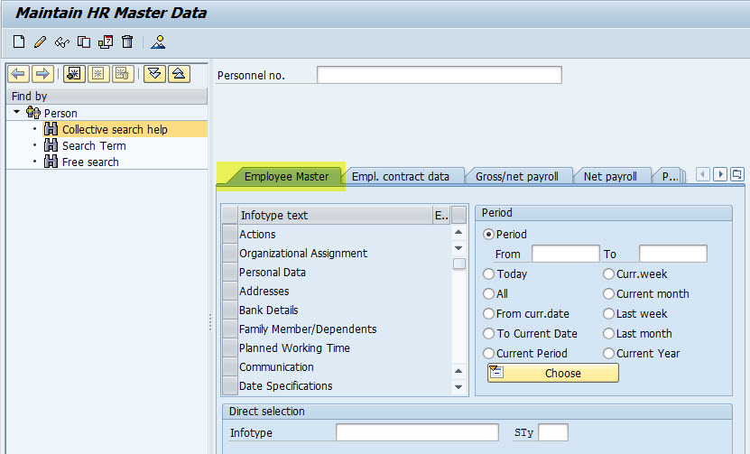
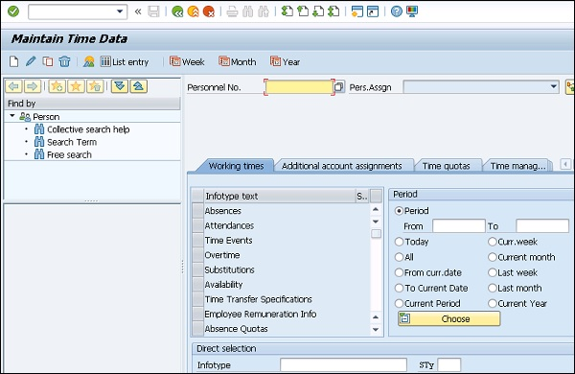

Chapter Six: Performance Appraisal at Radiant Pharmaceuticals Ltd.

Performance Appraisal is considered as a sacred responsibility of a supervisor because it affects employees’ career and their future development in the organization. A supervisor needs to be fair and prudent while conducting an appraisal. As a part of Radiant’s commitment to excellence, supervisors conduct appraisal ethically.
Radiant Pharmaceuticals Limited strictly follows its performance appraisal system. It is very essential to evaluate the employees based on their performances because each organization wants their employees to perform effectively.
Radiant has introduced a different and simple appraisal form for assessing employees’ performance which is very much related to Behaviorally Anchored Rating Scale (BARS). Career Advancement and Training Needs Assessment are tagged with the new appraisal system of Radiant Pharmaceuticals Limited. It requires optimum time to fill up the format. Appraisers have a scope to rate out of 100 based on responsibilities, tasks and behavioral competencies.


6.1 Purpose of Performance Appraisal
- Measuring performance of Radiant’s employees
- Identifying the and overcoming the shortcomings
- Rewarding the performers
- Assessing for increment, promotion, job rotation, upgradation etc.
- Clarifying expectations and responsibilities to be performed by the employees of Radiant
- Providing employee feedback related to their performance
- Identifying training and development needs at Radiant

6.2 General Guideline for Initiation
Performance Management System is a document which is much classified. Both the appraisee and appraiser at Radiant should know following do’s and don’ts:
- Appraisal form should preferably be handwritten and legible in all aspects
- Do not use fluid in appraisal hard copy
- Avoid overwriting and cut marks
- If the appraiser needs to correct any line or marks, he should put an initial beside the correction
- No part of appraisal form should be kept vacant
- Yearly appraisal should certify the reflection of quarterly appraisal
- Appraisal forms to be duly signed by appraiser, appraise, and other designated authorities
- Appraiser to forward filled up forms to his superior Supervisor/HOD
- Yearly appraisal completed in all respects to be forwarded to HRD

6.3 Performance Report Schedule
- Yearly appraisal duration will be September-October
- HOD of respected departments are to send Yearly Appraisal within the set time schedule to HRD. (No memo/mail will be sent from HRD in this regard)
- Yearly Appraisal will serve the purpose of July-September Quarterly Appraisal. There is no need to conduct additional quarterly appraisal for July-September quarter.

6.4 Definition of General and Behavioral Competencies
Term | Definitions
Quality of Output | Worth of performance and jobs done by the employee within a particular time period.
Efficiency and Effectivity at Work | Capability to accomplish jobs within a given time frame which has positive impact towards the attainment of departmental and organizational goals.
Punctuality  Time Engagement at Work | Punctuality: The habit of adhering to any time set by the management.  Time engagement: Productive utilization of office working hours.
Ability to Work under Pressure | Calmness and composed approach during demanding situations and focus on getting the job done to the employee’s best ability.
Communication | Process of trading facts, concepts, thoughts, feelings through speech, signals, writing or actions.
Initiative and Drive | Willingness to step forward and act without being guided to do a job.
Sincerity and Motivation | Sincerity: Being forwarded without any pretense, misinterpretation, and acts or performs accordingly.  Motivation: The stimulus, desire and energy in an employee to be continuously interested and committed to his job or responsibilities.
Attitude and Attire | Attitude: A tendency to respond positively or negatively towards certain idea, object, person or situation.  Attire: Dresses with which an employee present himself at the workplace.
Loyalty, Honesty, and Confidentiality | Loyalty & Honesty: Being truthful, candid, and straightforward; not cheating, intentionally misleading another by omission, half-truth or other means.  Confidentiality: Concern to protect the privacy and secrecy of the organization’s internal activities and information.
Leadership/Cooperation and Team Spirit | Leadership: The ability to make sound decisions, integrate influencing factors and inspire colleagues to perform well as a team in attaining organizational goals.  Cooperation and Team Spirit: An approach of work as a team or acting together for a common purpose.

6.5 Supervisor’s Preparation
- Gather documents including the job description goals and objectives set for the year and the previous year’s evaluation.
- Clarify any doubt regarding appraisal from competent authority.
- Check the remarks in own personal diary regarding the appraisee’s activity during the appraisal period.
- Set a date and time in advance that is mutually convenient for both.
- Ensure that there is enough time allotted and the place is free from interruptions.
- Inform that appraisee’s score may be moderated by the next supervisors for maintaining parity within the department or organization.

6.6 Marking Criteria and Guideline
- Appraiser must be impartial and judicious.
- Appraiser must follow Score Standard Table while scoring.
- Appraiser can use maximum one decimal if deemed appropriate.
- Second and Third level supervisor/HOD can keep appraiser’s score or moderate overall score comparing other appraiser’s score trend within his jurisdiction.

6.7 Biases to be avoided during Appraisal
- Halo Effect Error: When an appraiser really likes or dislikes and employee and allows his personal feelings, halo effect occurs. The appraisers at Radiant are strictly told to avoid this kind of errors while conducting performance appraisal.
- Central Tendency Error: It occurs when an appraiser intentionally marks all employees in the middle of the scale. Appraisers at Radiant are very much alert to avoid this error.
- Leniency Error: It occurs when an appraiser’s tendency is to rate all employees at the positive end of the scale or at the low end of the scale. Appraisers at Radiant follow the rules very strictly so there is no chance of leniency error.
- First Impression Error: When an appraiser tends to rate an employee based on his first impression, this error occurs. Appraisals are done at Radiant after observing an employee for a long time. So there is hardly any chance of this error.
- Recency Error: It occurs when an appraiser judges an employee based on his recent activity that does not justifies his whole working career in the organization. Appraisers at Radiant are very much trained, expert and are prohibited to judge someone according to his recent behavior.
6.8 Performance Appraisal and Promotion
Promotion at Radiant strongly depends on performance appraisal. Although, an individual’s promotion may depend on some other criteria including:
- Availability of vacant position.
- Approved service limit of a particular rank.
- Career record.
- Qualifying in standard tests for the post.
- Qualifying through interview board for promotion.
Not only just promotion, employees who perform better get increments, upgradations etc.

6.9 Benefits Radiant gets from Performance Appraisal
- Managers get clear understanding of the performance of their employees. Without conducting performance appraisal, it is quite impossible to get clear understandings about employees’ actual performance.
- The shortcomings of the employees become very clear to Radiant’s management.
- Employees with better performance get attractive rewards from Radiant. It motivates all the employees to perform better. Also, it increases job satisfaction and motivation.
- Performance Appraisal is very useful while determining or updating increments, promotions and other activities. Effective appraisal is a major reason of less turnover at Radiant Pharmaceuticals Limited.
- Not only just promotion, it also helps while doing succession planning. Sometimes well performed employees are not able to get promotion for some factors like unavailability of vacant position. But they are chosen for succession planning. Then will get promoted in the upcoming future.
- After the appraisal, feedback is provided to the employees. So, employees get a clear idea about their current performance, also the changes that should be implemented in order to be up to date.
- Performance Appraisal identifies the necessity of training and development activities. It helps the employees to be better skilled and confident. It also helps Radiant because if the employees become better skilled and confident, the overall organizational performance will be improved.

6.10 Performance Evaluation Form Criteria
Score Standard Table:
Unsatisfactory  (Does not meet requirement) | Needs Improvement  (Does not meet requirement in some aspects) | Fair  (Meets requirement marginally) | Good  (Meets requirement) | Excellent  (Meets requirement consistently, reliably and dependably) | Outstanding  (Performance exceeds expectation)
≥20 - ˂40 | ≥40 - ˂50 | ≥50 - ˂60 | ≥60 - ˂70 | ≥70 - ˂85 | ≥85 - ˂100

Scoring Table:
SL. | Performance Competencies | Rating (out of 10)
1. | Quality of Output
2. | Efficiency and Effectivity
3. | Punctuality and Time Engagement
4. | Ability to Work under Pressure
5. | Communication
6. | Initiative and Drive
7. | Sincerity and Motivation
8. | Attitude and Attire
9. | Loyalty, Honesty, and Confidentiality
10. | Leadership / Cooperation and Team Spirit
Total Score (out of 100)

Ten following competencies are measured in order to evaluate someone’s overall performance at Radiant Pharmaceuticals Limited. They hold 10 marks each. The total marking amount is 100 for all ten questions.
If an employee gets total score between 20 and 40, then his performance is unsatisfactory. Which means his overall performance does not meet Radiant’s requirement.
If an employee gets total score between 40 and 50, then his performance needs improvement. His performance does not meet Radiant’s requirement in some aspects.
If an employee gets total score between 50 and 60, then his performance is fair which meets the requirement marginally.
If an employee gets total score between 60 and 70, then his performance is considered as good which meets the requirement set by Radiant.
If an employee gets total score between 70 and 85, then his performance is excellent which means his performance meets requirement consistently, reliably, and dependably.
If an employee gets total score between 85 and 100, then his performance is outstanding. Which means his performance exceeds the expectation or requirement set by Radiant Pharmaceuticals Limited.

Chapter Seven: Findings, Recommendation and Conclusion

7.1 Findings
It was my first ever encounter with the corporate culture. So, my observation may lack accuracy while identifying the problems which may not be an actual problem in constant corporate world. Some of the findings that I have noted during my internship period contains:
- There are lots of paper-based works at Radiant Pharmaceuticals Limited. Especially the Human Resource department is full of papers including many necessary and unnecessary documents which might be an irritating issue and also a wastage of paper. Even the whole performance appraisal process is paper-based work.
- Radiant Pharmaceuticals Limited has a fantastic work environment which might influence the new comers to cope up with the new environment. Radiant considers its employees its most important asset.
- Most of the senior executives and managers are very much friendly and helpful to the juniors.
- Radiant Pharmaceuticals Limited prioritize quality over quantity.
- SAP improves the information management system in a great way and it is helping to minimize cost and time for the organization.
- Currently Radiant Pharmaceuticals Limited is using both SAP and KORMEE as HRIS. It is very costly to continue with both of these applications.
- Interns do not have access to HRIS which might be very reasonable for the organization but it gives the internee more trouble for gathering HRIS related information.
- SAP facilitates the speed of data sharing across the organization and delivers more detailed and structured information. It helps to enhance accuracy on planning, forecasting and decision making.
- SAP is a very critical application that requires hive level of knowledge. If employees do not acquire that level of understanding, then it will be very tough for him to use SAP modules. Although, Radiant has provided employees with training on the usage of SAP before implementing SAP at full gear.
- SAP is an interdependent application. If wrong information is given in one department, whole organization will get wrong information.
- The performance appraisal process at Radiant Pharmaceuticals Limited is very unique and very effective which is very much similar to Behaviorally Anchored Rating Scales (BARS).
- Increments, Promotions, and Grading is done based on the performance appraisal.
- The intension behind performance appraisal, training and benefit packages is to maintain a happy and motivated workforce.

7.2 Recommendations
Few things can be implemented and improved at Radiant Pharmaceuticals Limited in my opinion:
- The duties of an intern are very limited at Radiant Pharmaceuticals Limited. It would be a great opportunity to learn if interns were allowed to participate in more works. Especially, interns should have a little access to the HRIS so that they can get limited but practical experience on the latest and digital information system.
- Keeping both SAP and KORMEE is very much expensive. As SAP is a complete package for the whole organization, it is better to leave KORMEE which is hardly being used at Radiant Pharmaceuticals Limited.
- Radiant Pharmaceuticals Limited should minimize their paper-based works. It will not only provide a clean work environment, it will make all the works secured and easier to perform. Also, it will be very much cost effective.
- The performance appraisal process at Radiant is still paper-based which is not up to date. Radiant should link their performance appraisal with HRIS. It will be very effective and time saving for the organization.
- Radiant should implement a Talent Management section under the HR department. People working at HR department have different aspects of duties to perform beside the basic selection and requirement process. The Talent Management section should be able to provide its entire focus on hiring and retaining talents for Radiant Pharmaceuticals Limited.
- Job rotation, Job enlargement and Job enrichment should be followed properly at Radiant Pharmaceuticals Limited.

7.3 Conclusion
Human Resource department is a very obligatory part for any organization. Proper implementation of HR practices and activities help the organizations in the long run by improving employee performances. This is one of the reasons why Radiant Pharmaceuticals Limited gives high priority to its HR related activities.
During my internship, I got the opportunity to perform different HR related activities which I believe made me more skilled and confident for my future career. It was a great pleasure working with the team of experienced HR professionals.
Like many other HR practices, Human Resource Information System (HRIS) plays an important role in managing the organization. It plays a dynamic part to the total performance of the organization. Radiant has implemented HRIS over a decade ago which has given the opportunity to operate smoothly in any department. Outdated, ineffective paper-based traditional information system does not meet Radiant’s needs and is not effective anymore. Moreover, it also reduces the efficiency and effectiveness of the employees. HRIS brought cure of that. Radiant uses both SAP and KORMEE as its HRIS which turned out to be a worthy investment. It is linked with the advancement of the employees; and employee advancement has direct impact on organization’s overall performance. HRIS helps Radiant in managing the information system in an easier and effective way. All the information related tasks are now easier and it takes only a fraction of time that it used to require previously when the information system was manual and paper-based. Although SAP and other HRIS are very costly, it is very much beneficial for the long run.
The performance appraisal process followed at Radiant Pharmaceuticals Limited is very unique and very effective. Although currently it is paper-based, Radiant is planning to link performance appraisal with its HRIS to be more effective and secure. Very soon, Radiant will be having one of the best performance appraisal systems in the competition.

References
Aguinis, H. (2018). Performance Management 2nd Edition.
Beach. (n.d.).
Boateng, A.-A. A. (2007). The Role of Human Resource Information Systems (HRIS) in Strategic. Retrieved from management.ind.in: https://management.ind.in/forum/attachments/f2/26701d1456894975-mba-hr-project-hris-mba-hr-project-hris.pdf
Business Jargons. (2021, February 18). Performance Appraisal. Retrieved from www.businessjargons.com: https://businessjargons.com/performance-appraisal.html
DeSanctics, G. (n.d.).
Dessler, G. (2017). Human Resource Management 15th Edition. New York City: Pearson.
EBL Securities Ltd. (2019). Pharmaceuticals Industry of Bangladesh - The multi billion Dollar Industry. Dhaka: EBL Securities Ltd.
Edwin B Flippo. (n.d.).
Ghosh, P. (2019, September 19). What Is HRIS? System, Model, and Application. Retrieved February 17, 2021, from www.hrtechnologist.com: https://www.hrtechnologist.com/articles/performance-management-hcm/what-is-hris/
GLOBE NEWSWIRE. (2020). Bangladesh Pharmaceutical Market Future Opportunity Outlook 2025. Dublin, Ireland: GLOBE NEWSWIRE.
Hendrickson. (2003).
Johnson, G. a. (2010).
Klyenhans. (2006).
Kovach. (1999).
Radiant. (2021, February 22). Corporate Social Responsibility. Retrieved from radiantpharmabd.com/: http://radiantpharmabd.com/csr-our-commitment
RPL. (2021, February 17). About Us, Radiant Pharmaceuticals Ltd. Retrieved from www.radiantpharmabd.com: http://www.radiantpharmabd.com/about-us
SAP. (2021, February 24). SAP S/4HANA. Retrieved February 2021, 2021, from sap.com: https://www.sap.com/india/products/s4hana-erp.html?url_id=ctabutton-in-icon-s4hana-cloud
Tannenbaum. (1990).
VALAMIS. (2018, October 24). Performance Appraisal. Retrieved from www.valamis.com: https://www.valamis.com/workshop-packages
Verma, E. (2019, May 27). SAP Human Capital Management (HCM). Retrieved from simplilearn.com: https://www.simplilearn.com/sap-human-capital-management-hcm-rar107-article
Waddill & Marquardt. (2011).

