The practice and Clients’ Perception of Online Banking System in Bangladesh

Nasrin Akter

This report is submitted to the School of Business and Economics, United International University as a partial requirement for the fulfillment of Bachelor of Business Administration Degree.

The practice and Clients’ Perception of Online Banking System in Bangladesh

Prepared By
Nasrin Akter
ID – 111 132 258
School of Business and Economics (SoBE)
United International University

Supervised By
Dr. Kawsar Ahmmed
Associate Professor
School of Business and Economics (SoBE)
United International University

Submission Date: 10th March, 2019

Letter of Transmittal
To,
Dr. Kawsar Ahmmed
Associate Professor
School of Business and Economics (SoBE)
United International University

Subject: Submission of Project Report on ‘The Practice and clients’ perception of online banking system in Bangladesh’.
Dear Sir,
You will be happy to know that I have finally finished my project report on ‘The practice and clients’ perception of online banking system in Bangladesh’. The online banking often called Internet banking or E-banking (Electronic Banking) that enables clients of a financial institution to lead financial transactions on a secure website worked by the institution, which can be a retail or virtual bank, credit union or building society.
I have followed all the instruction you had provided to make my report a well piece of study. And working on online banking system of Bangladesh was very interesting learnings for me. I have analyzed all possible ways to get important information, visited few banks, and arranged a lot of journals on online banking of Bangladesh.
It was very enjoyable moments for me while preparing the project report and it has improved my practical knowledge from real life situations. I have been observed how well online banking serving for the betterment of the clients and minimized long waiting time of them.
I, therefore, pray and hope that your honor would be kind enough to accept my project report and oblige thereby.
Sincerely yours,
Name: Nasrin Akter
ID – 111 132 258
School of Business and Economics (SoBE)
United International University

Executive Summary
The aim of this report is to evaluate the practice and clients’ perception of the online banking system in Bangladesh. The report delivers a well noted application and utilization of online banking system in Bangladesh and the ways by which some famous commercial banks serve their clients through Online Banking. The report also consists of clients’ perception of the online banking system.

Online banking is provided to automate delivery of new and traditional banking products and services directly to the customers through online (internet) and electronic channels. It has systems that allow customers, individuals or business businesses to access accounts, manage commercial transactions, or get information on financial products and services through a private or private network. Including Internet. Customers access online banking using smart electronic devices using Personal Computer (PC), Personal Digital Assistant (PDA), Automatic Teller Machine (ATM) or touch-tone telephone. Online banking can include ATMs, wire transfers, telephone banking, wire transfers, debit cards, and credit cards. The process is simple: one must log in to your bank's website and follow the instructions. Before one starts online banking, one can take advantage of the recommendations of her preferred bank website. When selecting an online banking service, she will need to use the same business acumen for any transaction. The Internet is a convenient place to find offers on banking products and services. It is often possible to see savings account, credit card, loan, and other financial products and services rates.

The project reports start with the general discussion of the study that includes motivation, objectives, limitations, and significance of the study. Later on, the literature review shares the technical terms to clear the basic concepts of the online banking system to the reader for a better understanding of the study. The following chapter, the methodology of the study, describes the methods and techniques used to prepare the report. Next fourth chapter, analysis, and findings analyze the objectives of the report and share the findings of the practice and clients perception of the online banking system in Bangladesh.

The final chapter includes some suggestions to improve the condition of the online banking system so that clients can enjoy more benefits and banks can improve their services in Bangladesh.
Keywords: Customer perception, online banking, Personal Digital Assistant, Automatic Teller Machine, Bangladesh

Table of Content
Chapter 1: Introduction of the study
1.1 Motivation of the study 2
1.2 Objectives of the study 2
1.3 Limitations of the study 2
1.4 Significance of the study 3
1.5 Brief discussion of the remaining chapters 3
Chapter 2: Literature Review
2. Literature Review 5
2.1 Online Banking 5
2.2 Types of Online Banking 5
2.3 Why Online Banking is important 6
2.4 Different Features of online banking 7
2.5 Products of Online Banking 7
a. Automated Teller Machine (ATM) 8
b. Debit Card 8
c. Credit Card 8
d. Point of Sale (POS) 8
e. Retail Automated Clearing House Service 9
f. Corporate Automated Clearing House 9
Chapter 3: Methodology of the study
3. Methodology of the study 11
3.1 Population and Sample for the Present Study 11
3.2 Measurement 11
3.3 Data collection Procedures 11
3.4 Data Analysis 12
Chapter 4: Analysis and Findings
4.1 Online Banking in Bangladesh 14
4.2 Growth of Online Banking in Bangladesh 14
4.3 Comparative picture of Online services providing Banks in BD 15
4.4 Clients’ comments on online banking of Bangladesh 16
4.5 Major Online Banking Service Suppliers in Bangladesh 19
a. Standard Chartered Bank 19
b. City Bank 19
c. BRAC bank: 20
d. Eastern Bank Limited 20
e. Bank Asia 20
f. HSBC 20
g. Jamuna Bank 21
h. Dutch-Bangla Bank Limited 21
4.6 Barriers of Online Banking Growth 22
4.7 Initiatives of Bangladesh Government 22
Chapter 5: Recommendations and Conclusion
5.1 Recommendations 25
5.2 Conclusion 26
I. Reference 27
II. Appendices 28
Survey Questionnaire: 28

Chapter One
Introduction
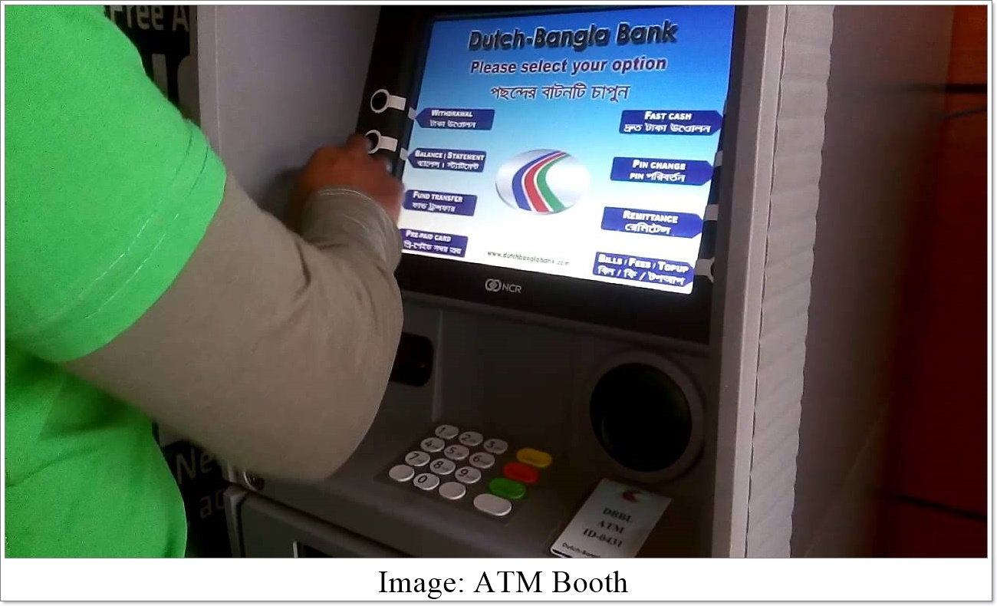

1.1 Motivation of the study
The project report on ‘The practice and clients’ perception of online banking system in Bangladesh’ is the pre-requirement to achieve the BBA degree from United International University. Every students require to complete 120 courses that are designed for business learnings and at the end of the 120 credits hours, student has to go through the internship or project/thesis program. In a project program, students usually observe any particular situation that they finds important part of business sectors for our country. My honorable project supervisor encouraged me to work on the topic and the report will deliver a well noted overview of the online banking system of Bangladesh and the ways by how some famous commercial banks serve their clients through online Banking.

1.2 Objectives of the study
The objectives of goals of the study are the important parts that carries the theme for what the report is prepared. The objectives can be divided by two accompanying parts below:
1.2.1 General Objectives: The report is prepared to achieve the BBA Degree as it is a pre-requirement of United International University.
1.2.2 Specific Objectives: This are more specific than the general objectives as it describes more specifically the reasons that the study is being conducted. The specific objectives of the study are:
- To analyze the scenario of online banking system in Bangladesh.
- To find out the roles played by major Bangladeshi commercial Banks that are serving their clients through online banking system.
- To analyze the different technology of online banking the commercial banks have implemented.
- To analyze the clients’ perception of online banking system.

1.3 Limitations of the study
The study was not so easy and I have to pass a lot of difficulties while gathering information of online banking system from various banks and also from their annual reports. The limitation or difficulties of the report are enlisting below:
- Difficulties of collecting data: I have to work on several commercial banks of Bangladesh to make my study reliable, but getting schedule to all the banks were so difficult. And the employees were so busy to provide me the necessary information.
- Restricted Time Period: Three month is not enough to create such an extensive study and share all the information on the broad field of online banking system of Bangladesh.
- Confidentiality and secrecy: Bank employees are not permitted to share all the confidential information of their online banking to me. They also requested me to share a few information that I have found during my observation of the banks as the information are highly related to their reputation.

1.4 Significance of the study
This report describes the general overview of online banking system of Bangladesh. A reader of this report can easily identify the difference between some major commercial banks online banking system of Bangladesh after reading the whole report carefully. The scope of the study is to share information of different bank’s online services so that the bank managers, employees and consumers can get the idea of services what other banks are offering currently. It might help them to choose or decide according to their benefit. The study will help university students to compare their educational learnings with the practical observations and findings of online banking of Bangladesh.

1.5 Brief discussion of the remaining chapters
The report starts from chapter 2, named as literature review shares the technical terms to clear the basic concepts of online banking system to the reader for better understanding of the study. The following chapter 3, Methodology of the study, describes the methods and techniques used to prepare the report. The fourth chapter, Analysis and findings, analyze the objectives of the report and share the findings of the practice and clients perception of online banking system in Bangladesh. The final chapter of the report includes some suggestion based on my academic knowledge to improve the condition of online banking system so that clients can be benefitted more and banks also can improve their services in Bangladesh.

Chapter Two
Literature Review
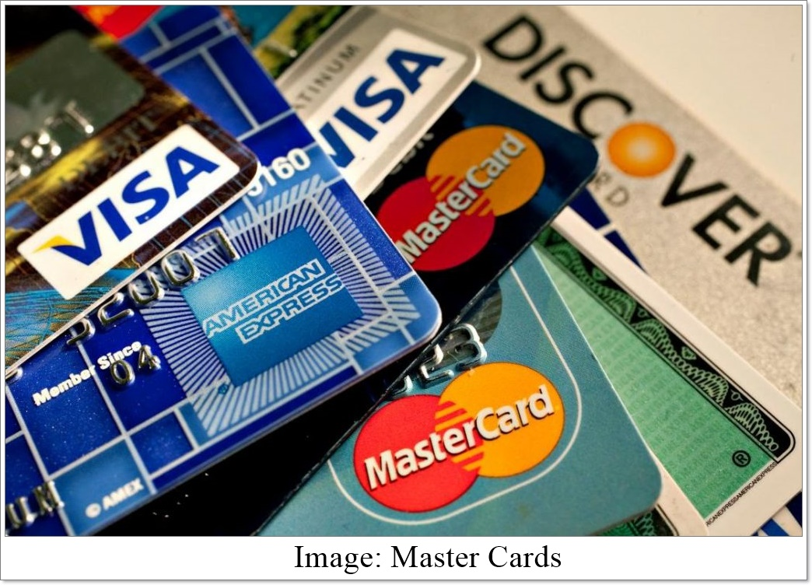

2. Literature Review
The chapter literature review is to help the short terms of the technical words to its reader. The author has tried in this chapter to encounter and to communicate all the related terminology and ideas that can create problems while going through the later part of the report.

2.1 Online Banking
According to Strader & Carter (2001), online banking (or Internet banking or E-banking) enables clients of a financial institution to lead financial exchanges on a secure website worked by the institution, which can be a retail or virtual bank, credit union or building society. It might incorporate any exchanges identified with online utilization. To access a financial institution's online banking facility, a client having individual Internet access must enlist with the institution for the service and set up some password (under different names) for client verification. The password for online banking is typically not equivalent to for phone banking. Financial institutions currently routinely dispense client numbers (likewise under different names), regardless of whether clients mean to access their online banking facility. Client numbers are ordinarily not equivalent to account numbers, in light of the fact that various accounts can be connected to the one client number. The client will connect to the client number any of those accounts which the client controls, which might be check, investment funds, loan, credit card, and different accounts. To access online banking, the client would go to the financial institution's website and enter the online banking facility utilizing the client number and password. Some financial institutions have set up extra security ventures for access, yet there is no consistency in the methodology received.

2.2 Types of Online Banking
There are two types of Online Banking:
- Electronic Banking: ATM- Automated Teller Machines, Telephones or Debit Cards are the examples of Electronic Banking.
- Internet Banking: This Banking is performed by a PC that connects to a banking through telephone line and modem or other telecommunication connection and ISP (internet service provider) or through using wireless technologies by Personal Digital Assistant (PDA) or mobile phones.
(Source: Troy J. Strader & Richard B. Carter, 2001, Book name: Electronic Banking: The Ultimate Guide to Business and Technology of Online Banking, Available in Google Scholar at: https://books.google.com.bd/books?id= 49UACAAAQBAJ&lpg)

2.3 Why Online Banking is important
Federal Deposit Insurance Corporation (2016) explains in an article on the importance of online banking and how consumer can utilize it and save their money. As a shopper, one can utilize online banking for various budgetary purposes. Some of them are given in below:
- Transfer funds: Individuals can without much of a stretch transfer starting with one account then onto the next or one place to another immediately.
- Review and pay bills: Purchaser can pay distinctive kinds of service bills with no inconvenience and in the meantime, the individual in question can review current market policies and position.
- Access account information: Anybody can his or her account's subtleties information without going to the bank physically.
- Online Shopping: Individuals can now effectively purchase things without going commercial center. It is very conceivable to purchase nearly anything from home due to the Online Banking Framework.
- Apply for credit: Purchasers can apply for credits in the event of a deficiency of balance.
- Compare insurance policies and prices: Customers can likewise compare insurance policies and prices and pick the correct one.
- Trade securities: As bank and customer are associated online and keep up everything online there are more trade securities for them two.
- Scan for the best loan rates: As information is more accessible than any time in recent memory one can without much of a stretch look for the best loan rates inside a bank or diverse banks.
- Apply for the mortgage: Customers can present every vital paper and apply for a mortgage for various purposes.
(Source: Federal Deposit Insurance Corporation (2016), Article name: Online Banking, Bill Paying and Shopping, Available at: https://books.google.com.bd/books?id=1mEISz7DtjkC&lpg)

2.4 Different Features of online banking
- Mobility: Now banking is conceivable is anyplace and anytime. A PC/portable and web association is all that could possibly be needed to work together.
- The paperless and eco-friendly banking: The entire world is currently energetically doing paperless and eco-friendly business. As there is no paper required for online banking there is no compelling reason to slash down trees for paper generation and there is likewise less contamination.
- Saves money and time: The expense per exchange all through the world is diminishing step by step. The accompanying figure demonstrates the correlation between various channels-
 | Bank Cost Per Transactions
Branch | 1.07
Mail | 0.73
Mobile Banking | 0.54
ATM | 0.27
Internet Banking | 0.05
Chart 1: Bank Cost per Transactions (Source: American Banking Association, 2017)

2.5 Products of Online Banking
Online Banking products and administrations can incorporate wholesale products for corporate clients and in addition retail and guardian products for individual clients. Eventually, the products and administrations acquired through internet banking may reflect products and administrations offered through other bank conveyance channels. A concise depiction of retail and wholesale products and administrations is given underneath:

Automated Teller Machine (ATM)
According to Wikipedia, an Automated Teller Machine (ATM) is a modernized telecommunications gadget that furnishes a financial foundation's clients with a strategy for financial transactions in an open space without the requirement for a human assistant or bank teller. It is otherwise called Automated Banking Machine (ABM).

Debit Card
According to Dennis Abrashevich (2004), a debit card is a plastic card which gives an elective installment technique to cash while making buys. The measure of an exchange is ordinarily shown on a card peruser, after which the client swipes the card at that point enters their Stick number. There is generally a short postponement while the Electronic Funds Transfer (EFTPOS) at Point of Sale terminal contacts the PC network (over a telephone line or versatile association) to confirm' and approve the exchange.

Credit Card
A credit card is an arrangement of instalment named after the little plastic card issued to clients of the framework. A credit card is not quite the same as a debit card in that it doesn't expel cash from the client's account after each exchange. On account of credit cards, the backer loans cash to the customer (or the client). It is likewise not quite the same as a charge card (however this name is sometimes utilized by people in general to portray credit cards), which requires the balance to be forked over the required funds every month. Interestingly, a credit card enables the buyer to 'rotate' their balance, at the cost of having interest charged.

Point of Sale (POS)
Dennis Abrashevich (2004) defines that Point of Sale (POS) is a truncation for point of service. This can mean a retail shop, a checkout counter in a shop, or a variable area where an exchange happens in this sort of condition. Additionally, point of sale sometimes alludes to the electronic cash enlist framework being utilized in a foundation. Point of sale frameworks are utilized in eateries, lodgings, arenas, gambling clubs, and in addition retail situations to put it plainly, if something can be sold, it can be sold where a point of sale framework is being used.

Retail Automated Clearing House Service
The Automated Clearing House (ACH) is an electronic network for financial transactions. ACH forms substantial volumes of both credit and debit transactions which are begun in clumps. ACH credit transfers incorporate direct-deposit payroll payments and payments to contractual workers and sellers. ACH debit transfers incorporate customer payments on protection premiums, mortgage loans, and different sorts of bills. Organizations are additionally progressively utilizing ACH to gather from clients' online, as opposed to tolerating credit or debit cards.

Corporate Automated Clearing House
The Automated Clearing House (ACH) is an electronic network for financial transactions. ACH forms vast volumes of both credit and debit transactions which are started in clusters. Other retail and guardian products and services may incorporate Balance inquiry, Funds transfer, Downloading exchange information, Bill presentment and installment, Loan application, Investment activity and other esteem included services.

(Source: Dennis Abrashevich, 2004, Research article name: Electronic Payment Systems: A user centered perspective and interaction design, Available at: https://books.google.com.bd/books?id =31svZpzcpg0C&lpg)

Chapter Three
Methodology of the Study

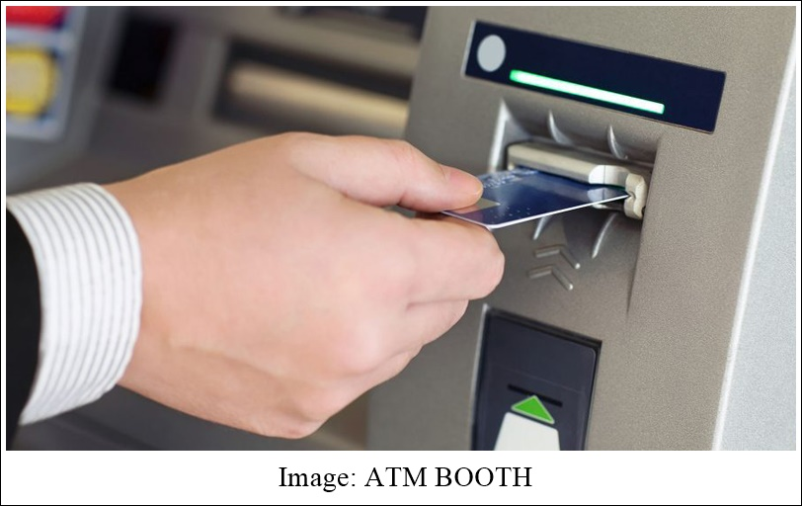

3. Methodology of the study
This chapter is to share the idea the methods and techniques used to prepare the entire report.

3.1 Population and Sample for the Present Study
The report consists an analysis of all the popular commercial banks those who are serving various online services to the people of Bangladesh. Total 10 respondents are chosen randomly for clients’ perception of online banking who has at least an account in any bank inside Bangladesh. Total six commercial banks are chosen based on their popularity in online banking service and shared a comparative analysis of different online services performed by these banks.

3.2 Measurement
The online banking of Bangladeshi commercial banks is going to be measured through comparative analysis of each banks online banking procedures. Clients’ perception will be measured through a survey questionnaire using Google forms, asking ten random people who have already an account in any bank through several online social media platform, for instance: Facebook, google+, LinkedIn and so on.

3.3 Data collection Procedures
Data and information are collected from several sources. The sources can be separated into two part given below:
- Primary sources:
- Formal and informal communication with several banks’ personnel.
- Practical observation of using different online banking services.
- From the guidelines on online banking provided by Bangladesh Bank.
- From the policies, leaflet, and brochures of several commercial banks.
- Secondary sources:
- Various published books and articles on online banking system.
- Through the help of internet, websites and various blogs.

3.4 Data Analysis
The report is based on exploratory research that consists of both quantitative and qualitative data. Several charts are going to be prepared to support the analysis using MS Word and MS excel tools. The clients perception is collected through the survey questionnaire that is created from google forms and comments collected by sending links through social media platform. The respondents can share their opinion just clicking the option they prefer. After all responds, the google form will provide the summary of the opinion of all the responses that describe the accurate clients’ perception using pie and bar charts with percentage. The percentage will help to analyze the perception and understand the situation.

Chapter Four
Findings and Analysis

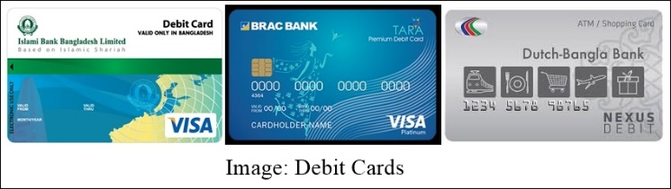
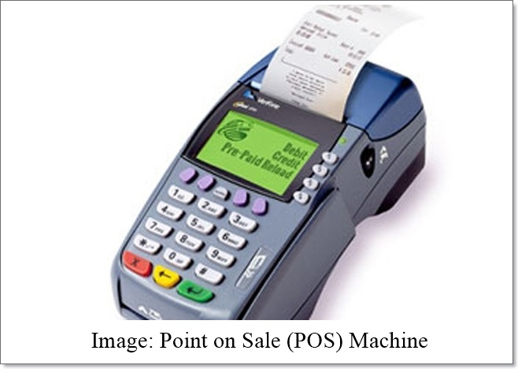

4.1 Online Banking in Bangladesh
Internet technology has brought a huge change in our traditional banking system. Presently it is a period of electronic banking. Electronic banking is the banking exercises performed through the electronic methods, i.e., utilizing telecommunications network, web technology, computers, cellular phones, and other electronic gadgets. In 1961, First National City Bank of New York presented effective electronic framework based transferable testimony authentication. With the progression of technology, the primary period of E-banking was Electronic Fund Transfer (EFT). The fundamental components of this EFT are-Automated Teller Machine (ATM), Point of Sale (POS), and Automated Clearing House (ACHs). In 1967, Barclays Bank of UK set up the primary Cash Dispenser. Following one year, in 1968, France, Sweden and Switzerland presented first "National cash dispenser network". In the year 1969, America and Japan started to run their independent dispenser machine. This machine worked off-line which was not connected with the computers of the bank. In 1972, Lloyd's Bank of UK set up the primary online "cash point" which was connected with the focal PC of the bank. Today's machines are the commitment of the research and development of the most recent 30 years which contain a Full Graphics Screen Monitor like a PC monitor. Clients can apply for the credit, confirm their record data, financial transactions and so on nonstop, even on ends of the week, through the electronic banking. Bangladesh is in the rudimentary phase of E-banking where the created nations are in the phase of 'Virtual banks' (No man Banks) that have no physical offices in the customary sense. The Internet can be viewed as a really worldwide marvel that has set aside a few minutes and separation insignificant to numerous transactions. This paper displays the execution, issues, and prospects of presenting online banking in Bangladesh.

4.2 Growth of Online Banking in Bangladesh
Various components including competitive cost, client administration, and statistic contemplations are propelling banks to assess their technology and evaluate their electronic business and Internet banking techniques. Numerous researchers expect fast growth in clients utilizing online banking products and administrations. Assessing a bank's information on the utilization of their Sites, may enable inspectors to decide the bank's strategic objectives, how well the bank is meeting its Internet banking item plan, and whether the business is relied upon to be profitable Examinations demonstrate that competitive weight is the head main impetus behind expanding utilization of Internet banking technology, positioning in front of cost decrease and income improvement, in second and third place individually. Banks see Internet banking as an approach to continue existing clients and pull in new ones to the bank. National banks can convey banking administrations on the Internet at exchange costs far lower than conventional brick-and-mortar branches. The real costs to execute an exchange will shift contingent upon the conveyance channel utilized. National banks have huge motivations to build up the advancements that will enable them to convey banking products and administrations by the most cost-effective channels.

4.3 Comparative picture of Online services providing Banks in BD
Types of services | DBBL | BRAC Bank | Eastern Bank | City Bank Limited | Bank Asia | Standard Chartered Bank
Mobile Banking | Yes | Yes | Not Available | Not Available | Not Available | Not Available
Mobile Banking | Name: Rocket Mobile Banking | Name: bKash
Automated Teller Machine | Yes | Yes | Yes | Yes | Yes | Yes
Automated Teller Machine | Total no. 4672 | Total no. Nearly 350 ATMs | Total no. 196 | Total no. 272 | Total no. 57 | Total no. 97
Internet Banking | Yes | Yes | Yes | Yes | Yes | Yes
Credit Card | Yes | Yes | Yes | Yes | Yes | Yes
Debit Card | Yes | Yes | Yes | Yes | Yes | Yes
Mobile/ Smartphone Application | Yes | Yes | Yes | Yes | Yes | Yes
Mobile/ Smartphone Application | Name: Nexus Pay | Name: BRAC Bank Mobile | Name: EBL SKY BANKING | Name: CITY TOUCH | Name: Bank Asia Smart App | Name: SC Mobile Bangladesh
Point of Sale (POS) | Yes | Yes | Yes | Yes | Yes | Yes

4.4 Clients’ comments on online banking of Bangladesh
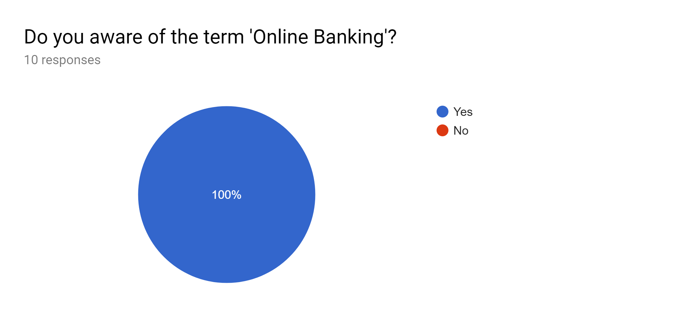
Interpretation:
From the 10 respondents, all are aware of online banking system provided by various banks in Bangladesh
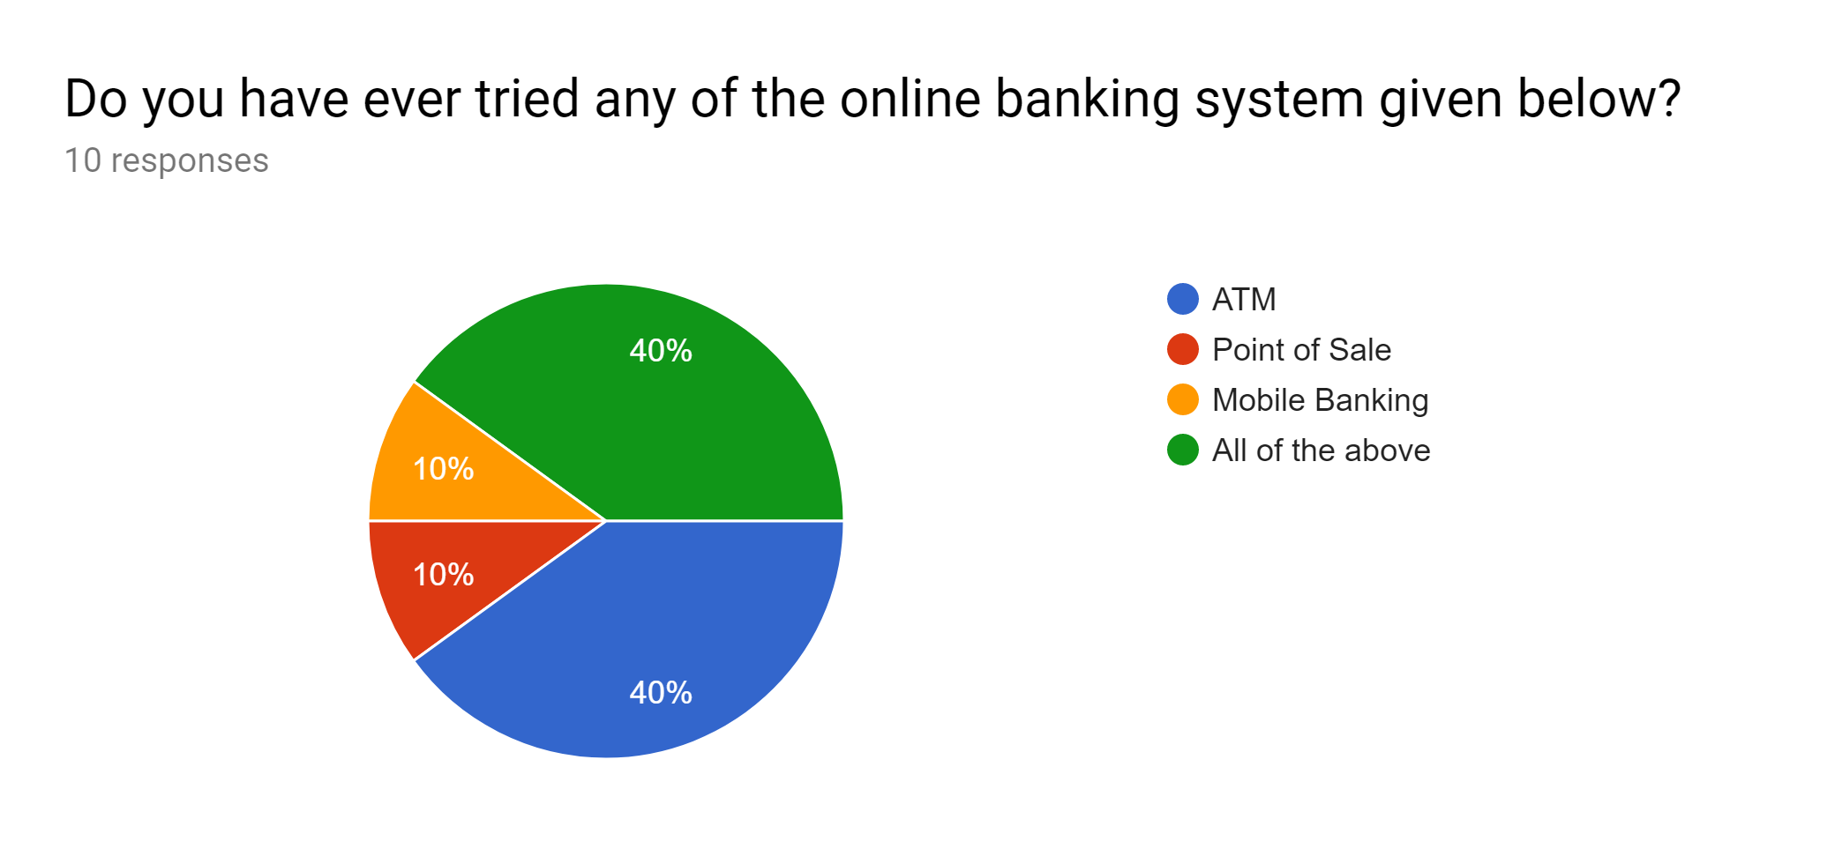
Interpretation:
From 10 respondents, 4 or 40% of the respondents have used ATM, and 4 have used all of the services of online banking.
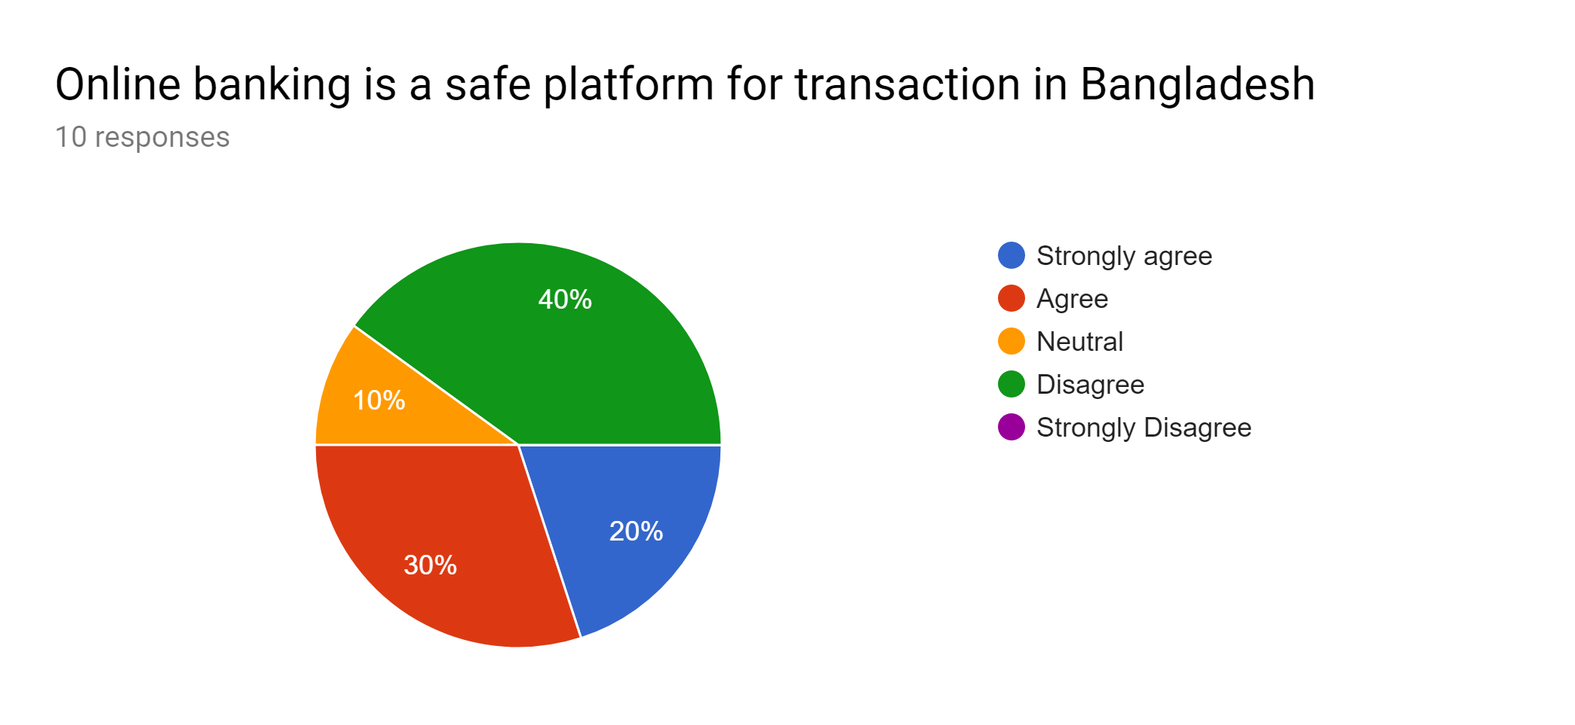
Interpretation:
40% or 4 respondents disagreed, 3 respondents agreed and 2 respondents strongly agreed out of 10 respondents that online banking is a safe platform for banking transactions in Bangladesh.
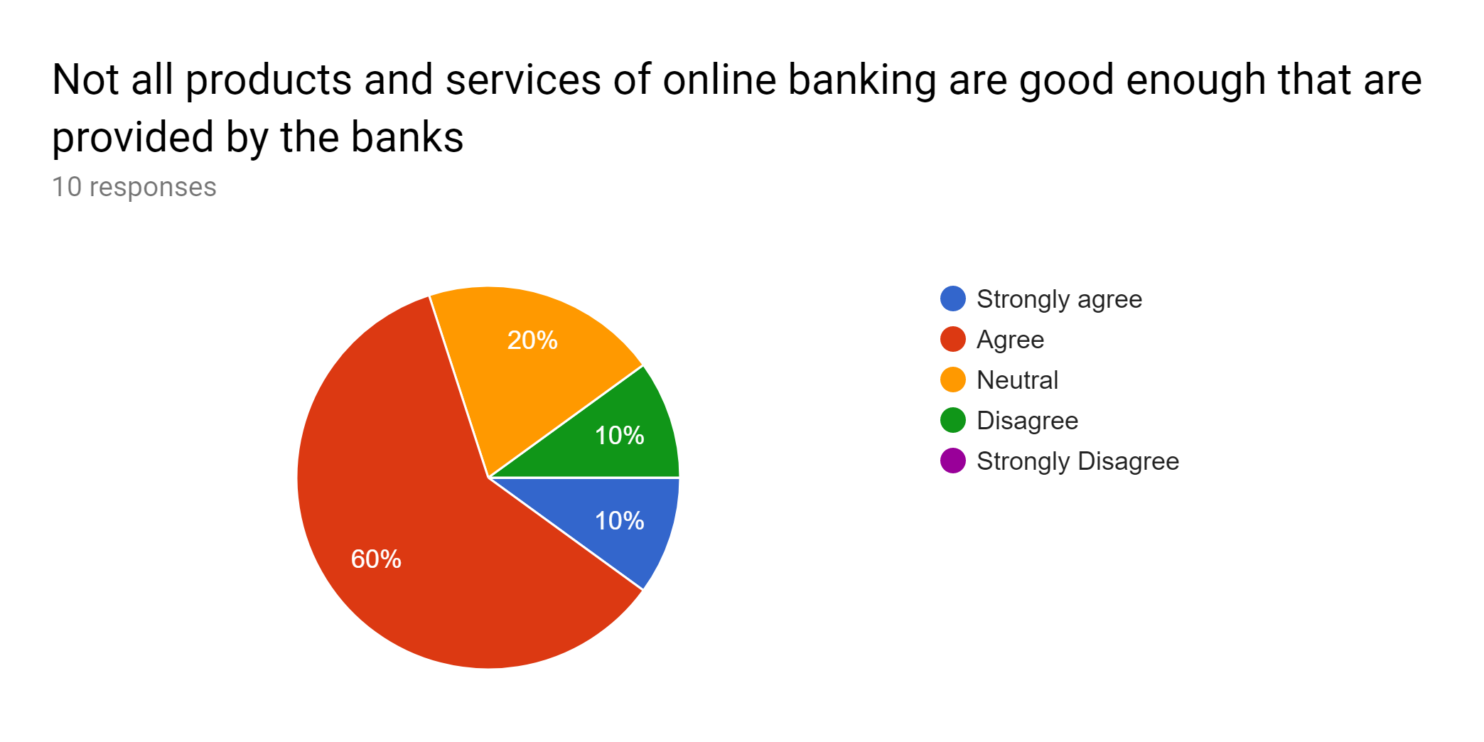
Interpretation:
Most of the respondents have agreed (60%) that all the products and services of online banking system provided by several banks in Bangladesh.

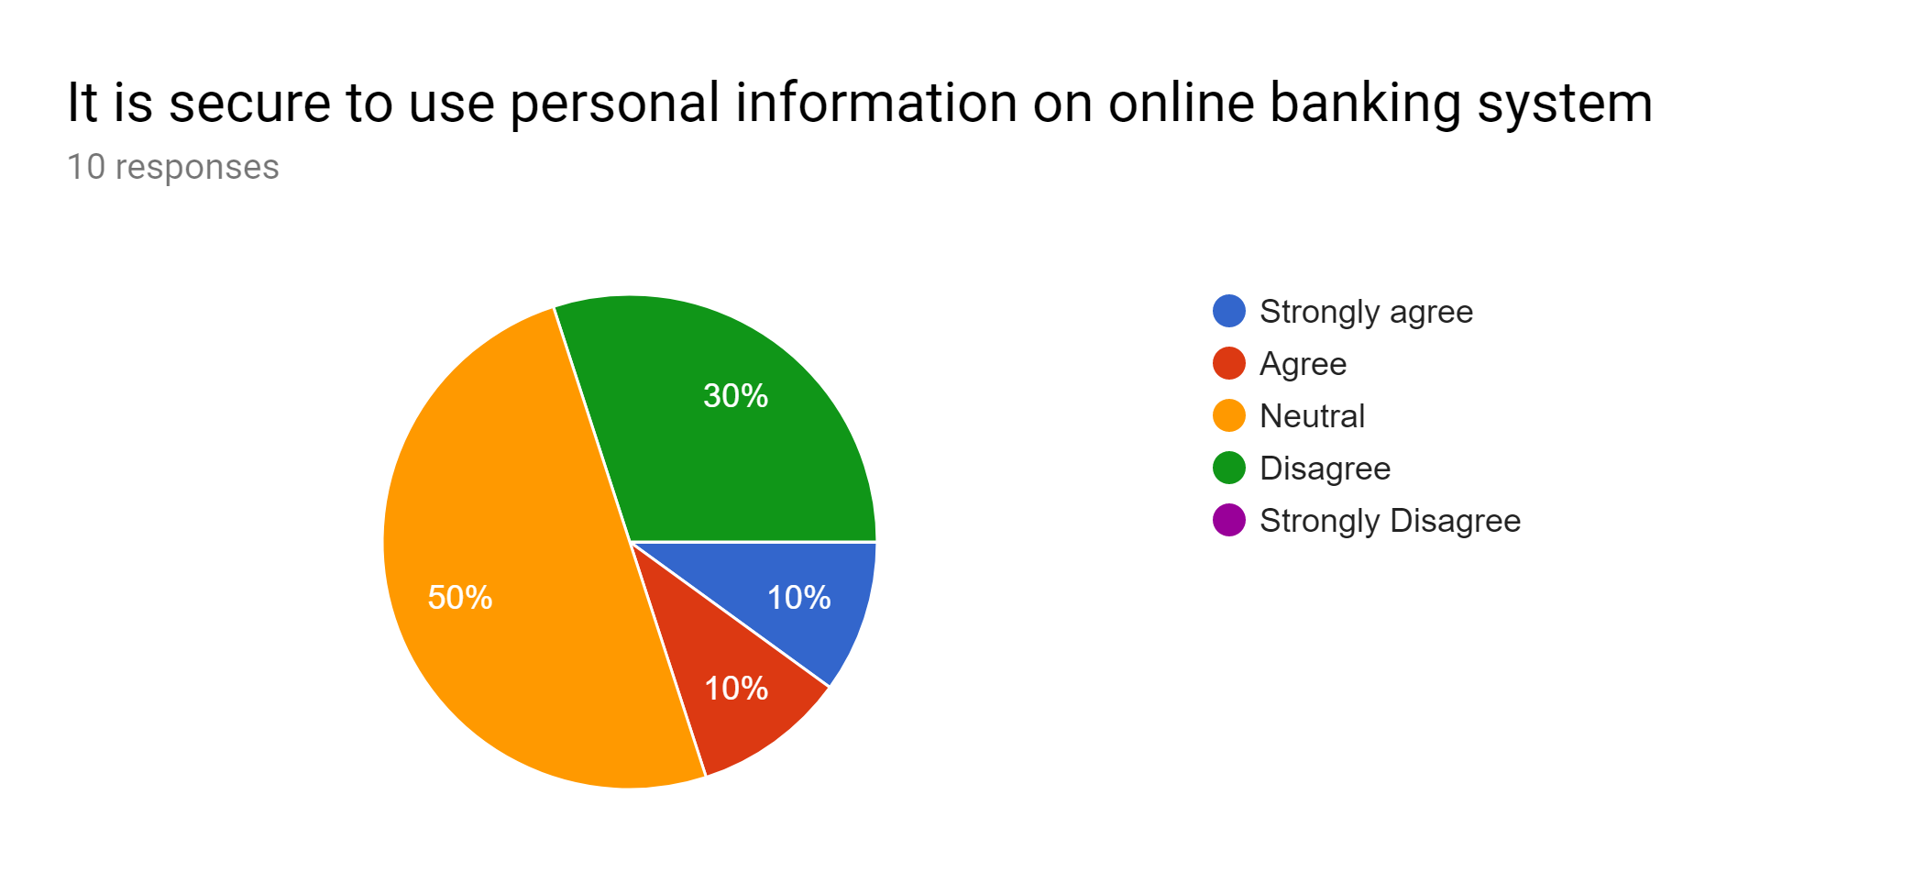
Interpretation:
Most of the people were neutral (50%) on the statement and 30% were disagreed that using personal information on online banking system is still not secured.
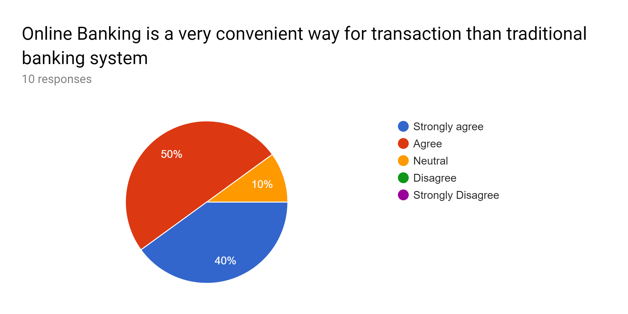
Interpretation:
50% or 5 of the respondents agreed and 40% or 4 strongly agreed with the statement that online banking is very convenient way for transaction than traditional banking system.

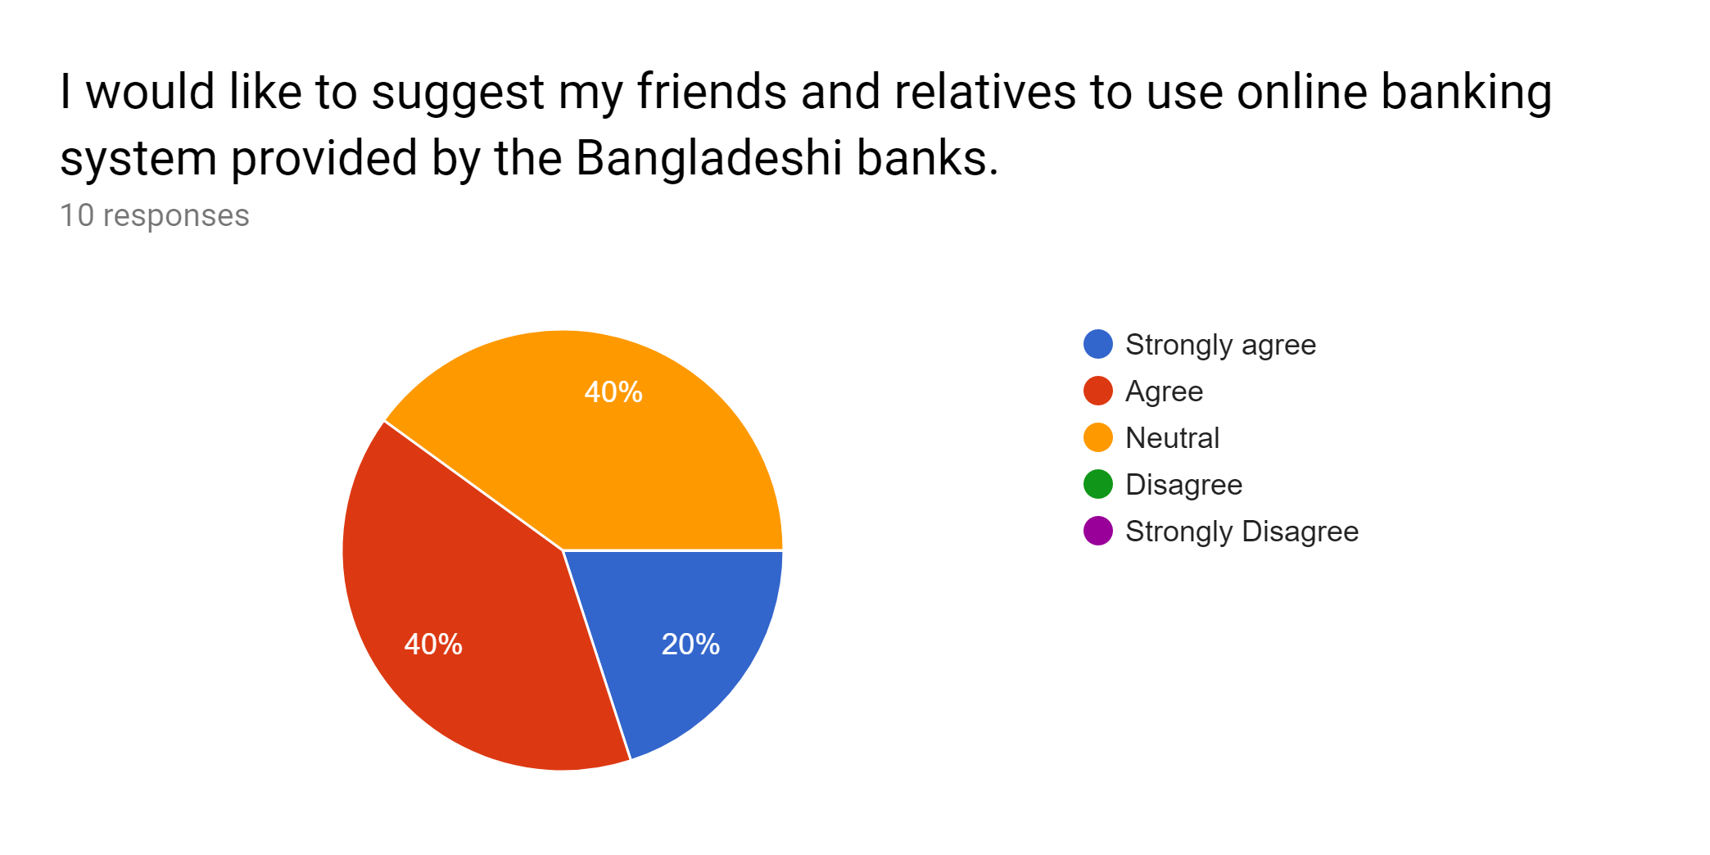
Interpretation:
Though 40% were neutral, the rest of all respondents replied that they want to suggest their friends and relatives to use online banking system for banking transaction.

4.5 Major Online Banking Service Suppliers in Bangladesh

Standard Chartered Bank
Standard Chartered offers the customer a complete scope of Cash Management services. Electronic Banking gives different kinds of help through a wide scope of working frameworks, clearing exchange extras with the arrangement of detailing highlights or other unique capacities.

City Bank
Citi-Direct is their unique service. To acquire power more than ones cash positions, one needs simple access to accounts and information progressively. One will require the comfort of local banking and the worldwide arrangements of an industry chief. The arrangement is Citi-Direct Online Banking. The proverb of Citi-Direct is "Cash isn't everything except for it can be all over the place".

BRAC bank:
BRAC Bank sent a layer of security framework for its Internet Banking. These measures reach out from information encryption to firewalls. BRAC Bank utilizes the most exceptional commercially accessible Secure Socket Layer (SSL) encryption technology to guarantee that the information trade between the client's PC and BRACBank.com over the internet is secure and can't be gotten to by any outsider. SSL has been all around acknowledged on the Internet for verified and scrambled correspondence between clients' computers and servers. bKash is their most recent item.

Eastern Bank Limited
Eastern Bank Limited Internet banking application tends to the requirements of little, individual and corporate account holders of the bank. This application gives a thorough scope of banking services that empower the client to meet a large portion of their banking prerequisites over the net. The transactions that are Account operations and Request, Fund Transfers and Payments, Utility Bill Payments, Deposits, Loans, Session Outline and so on.

Bank Asia
Bank Asia symbolizes present day banking with imaginative services in Bangladesh. It has brought together Database with online ATM, SMS and Internet query service. Bank Asia has 21 ATMs as an individual from ETN alongside eleven different banks. Bank Asia is keeping up its competitiveness by utilizing on its Online Banking Software and present day IT infrastructure. It is the pioneer among the local banks in presenting creative products like SMS banking, and under the ATM Network the Excellent Online Banking software empowers direct connecting of a customer's account, without the prerequisite for a different account.

HSBC
Business Banking Account empowers an individual to get credit of all the cash or check deposits alongside internal remittance and make every single local installment and give access to the wide scope of services for the business prerequisites. With Simple Pay Machines both HSBC and Non-HSBC clients can make deposits and pay their utility bills, credit card payments and so on.

Jamuna Bank
By dint of their online service any client will have the capacity to get the accompanying facilities: Cash withdrawal from any branch, Cash deposit into any branch, Encashment of pay-arrange from any branch, Articulation from any branch, ATMs and POS and SWIFT. Jamuna Bank Limited is the individual from SWIFT (Society for Worldwide Inter-bank Financial Telecommunication). SWIFT is a part claimed co-agent, which gives a quick and exact correspondence network for financial transactions, for example, Letters of Credit, Fund transfer and so on. By turning into an individual from SWIFT, the bank has opened up possibilities for uninterrupted connectivity with more than 5,700 client institutions in 150 nations around the earth.

Dutch-Bangla Bank Limited
Dutch-Bangla Bank Limited (DBBL) is a joint venture private commercial bank in Bangladesh. With more than 1000 of ATM booths everywhere throughout the nation, DBBL's has the biggest ATM networks in Bangladesh. DBBL is without offering access to its ATM network for its supporter. In 2010, Dutch-Bangla Bank Limited (DBBL) presented "Fast Track" in the nation which is the first of its sort in the nation that resembles a scaled down branch. Alongside the conventional ATM withdrawal service, it gives the client a chance to deposit little measures of cash to DBBL account with a limit of 20,000 BDT. Additionally, the Fast Track likewise gives some account opening service and loan information. By 2010, DBBL has introduced 50 Fast Tracks in Dhaka, Chittagong and Sylhet cities. Dutch-Bangla Bank Limited (DBBL) acquainted Internet Instalment Gateway with facilitates Web based business in Bangladesh. Any Visa/MasterCard card holder (local or abroad) can client their card to pay DBBL approved e-Vendors against their buy of merchandise and service. They can likewise pay DESCO electricity bills. DBBL is working with aircrafts, railroads, Utility organizations, instructive institutions and Stock Trades for facilitating buy of ticket, instalment of bills/charges and Initial public offering membership through the Internet Instalment Gateway. It is likewise attempting to make an interface with the prestigious PayPal instalment gateway. Once everything in task, this will change the instalment component in Bangladesh and will diminish open torment. It will likewise boost the Internet business and open the entryway for specialist and ICT Organization to acquire more remittance for the nation. Dutch-Bangla Bank Limited (DBBL) is the main bank in Bangladesh, who acquainted portable banking service with bring needy individuals from remote region under smart banking service. Bangladesh Bank has just permitted 10 banks to initiate versatile banking with the intention to interface the denied area of the society with the advanced banking framework; DBBL is the main sprinter among of them.

4.6 Barriers of Online Banking Growth
As a creating nation Bangladesh has a great deal of challenges in the growth of Online Banking. They are given beneath
- Absence of satisfactory Government subsidies
- Absence of satisfactory and learned specialized employee
- Absence of software copyright act
- Less investment and searching for fast return
- Absence of satisfactory physical facilities
- High implementation cost
- Poor telecommunication infrastructure
- Boundless poverty
- Absence of software and contents in Bangla.
- Low computer literacy.
- Limited number of skilled Internet service providers.

4.7 Initiatives of Bangladesh Government
- The Government of Bangladesh has taken some critical initiatives to build up our IT sector. Still we are waiting to see a fruitful change in our Information Technology. Be that as it may, some surprising strides of government are featured for information.
- BTTB's execution of Digital Information Network (DDN) service.
- Fast implementation of the suggestions of Joint Research Centre (JRC) reports (a powerful committee for software trade)
- IT sector has been declared as a pushed sector.
- Postponing all assessments and obligations from import of PC equipment and software.
- An independent regulatory body, Bangladesh Telecommunication Regulatory Commission (BTRC) has been set up, working since 2012.
- The govt. is changing telecom sector in stages, with expanded support of private sector.
- Choice to link Bangladesh to global highway through submarine cable link by next two years.
- Hundred percent remittances of profit and capital increases for remote financial specialists without any endorsement.
- National Information and Correspondence Technology (ICT) Arrangement has been endorsed in 2012.
- As of late began the foundation of ICT Park to boost up the nation's ICT activities.

Chapter Five
Recommendations and Conclusion

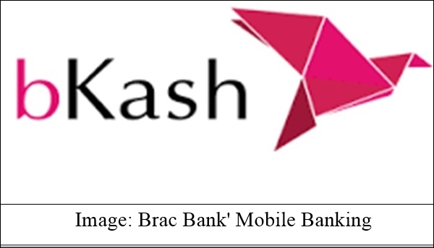
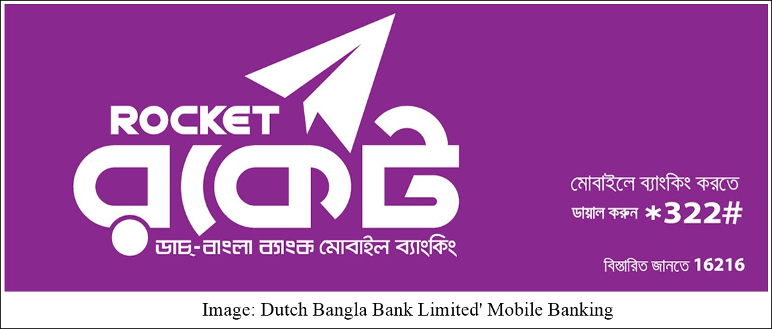

5.1 Recommendations
It’s proved that online banking services are highly accepted by the clients of the several banks as it is very time convenient and easy way than the traditional banking system. Still, there are few problem exists, for example: safety and security of online transaction are less, not all banks deliver the same services that creates confusion and so on. After all the analysis of the report, the chapter is going to share some suggestions that may help Bangladeshi banks to improve their online banking services. The suggestions are going to share according to my academic knowledge.
- Bangladesh Bank needs to deliver sufficient support and policies to all the banks so that all the banks can adopt and utilize all the services of online banking to provide more easy and convenient services to its clients’.
- Banks need to emphasize more on the security of online transaction and need to create a strong firewall for the sake of their clients.
- It is far better if all the banks use a particular ATM booth rather than serving separately. Clients can be benefitted by this and the spaces need for ATM booth around the country would be smaller.
- The charges of online banking defers from bank to bank that should be equal and minimized.
- Bangladesh government should reduce the barriers for online banking as it could be contributed highly in the country’s economy.
- The consumer awareness and literacy on online banking should be increased so that acknowledging the utilities they may get interested in banking more.
- Software copyright act and high technological infrastructure should be implemented all over the country so that banks can build their own environment for online banking services.

5.2 Conclusion
Private computers were more powerful, cheaper and available in 1989; Banks in Bangladesh are increasingly using them to create their own internal networks. In 30 years, the Internet becomes the most beautiful technological and social conquest of the 21st century. The rapid development of these new technologies will bring new levels of financial transactions to the world. Stay away from these contemporary technologies will improve at least in our developing countries, our international and national companies will have to face a complex situation. Foreign investors may be reluctant to invest here in the traditional framework of financial transactions. In our country, foreign banks use modern technologies and new online services for their customers, but our local banks are still behind. Only Dutch Bangla Bank offers complete online banking services to its customers. Other banks (above) offer a limited online service to their customers. The current situation indicates that every bank in Bangladesh will have to use new technologies to face the next challenge of the 21st century.

Reference
(1)Troy J. Strader & Richard B. Carter, 2001, Book name: Electronic Banking: The Ultimate Guide to Business and Technology of Online Banking, Available in Google Scholar at: https://books.google.com.bd/books?id= 49UACAAAQBAJ&lpg.

(2)Federal Deposit Insurance Corporation (2016), Article name: Online Banking, Bill Paying and Shopping, Available at: https://books.google.com.bd/books?id=1mEISz7DtjkC&lpg.

(3)Dennis Abrashevich, 2004, Research article name: Electronic Payment Systems: A user centered perspective and interaction design, Available at: https://books.google.com.bd /books?id =31svZpzcpg0C&lpg.

(4)Bhasin T.M. E-commerces in Indian Banking: P.H. Collin, Dictionary of Banking &Finance, Universal Book Stall, Reprint 1996.

(5)Derrick G Hanson, Dictionary of Banking & Finance, Pitmam Joseph P.T, E-commerce: a managerial perspective, Prentice Hall of India.

(6) M. Mizanur Rahman, Present status of E-Banking in Bangladesh, Journal of the institute of bankers of Bangladesh, Volume 50, Number #1, January - June 2003.

Appendices

Survey Questionnaire:
