
United International University

Internship Report
On

Impact of Covid-19 in overall Human Resource Practice of Footwear Industry

Submitted to:
Yeasmin Islam
Assistant Professor
School of Business and Economics
UIU

Submitted by:
Dewan Sanjida Rahman

ID: 111 162 021

Date of Submission: 26th September, 2021

LETTER OF TRANSMITAL

26th September, 2021
Yeasmin Islam
Assistant Professor,
School of Business and Economics
United City, Madani Avenue, Badda, Dhaka - 1212

Subject: Submission of Internship Report on “Impact of Covid-19 in overall HR Practice of footwear industry”.
Madam,
I am very fortunate to have the opportunity to submit my internship report on the topic "Covid-19 impact in overall HR Practices of Footwear Industry” which has been given to me as a prerequisite for a Bachelor of Business Administration (BBA) degree. I tried to describe my experience in Apex footwear Ltd which I gained during my internship. I gave my best to gather the valid information. There may be some drawbacks due to some constraint, if you find such weaknesses, I would be grateful if you consider those constraints. I tried to convert my practical knowledge into a written format honestly and I am very thankful to you for supporting me during my internship.
If you understand my limitations, and approve the paper, it will be a great pleasure.
Sincerely,
Dewan Sanjida Rahman
ID: 111 162 021
School of Business and Economics
United International University
ACKNOWLEDGEMENT

First of all, I would like to thank Almighty Allah for getting me this internship opportunity.
Then I would like to convey my gratitude to my honorable academic supervisor Yeasmin Islam, Assistant Professor, School of Business and Economics, United International University, for her valuable time, guidance, instructions and patronage for preparing this report in a right way.
I am extremely appreciative to the authority of Apex Footwear Ltd. for allowing me the chance to do my Internship at such a renowned organization. As an intern in the Human Resources department, where I received some competencies to assist me evolve my future profession knowledge. I would like to thank the entire HR Department for making this report a lot extra informative by means of presenting the information required.

Executive Summary

This internship report provides a detailed discussion about the impact of Covid-19 virus on the overall Human Resources Management practices of footwear industry. The purpose of the report is crystal clear, it aims to possess an insight about what's happening within the business organizations, how they're handling the Human Resource practices in their organization during this tough time. Data needed for the project report were collected from both the first and secondary sources. The chapter two of the report contains the literature review of the footwear industry and chapter three discusses the analysis and findings through a diagram where the data collected from various footwear organizations about the impact on the overall Human Resource practices is recorded. Chapter four is the recommendation and concluding chapter where the actual scenario of the Human Resource practices in the footwear industry has been found out and the result was not that impressive. Since the pandemic affected their normal task but the organizations managed to survive in this situation with a motto of not quitting and facing the challenges that came up with a new normal working environment.

No | Topics | Page no
 | Chapter 1 Introduction
1.0 | Introduction | 02
1.1 | Background of the report | 02
1.2 | Rational of the report | 02
1.3 | Scope of the report | 03
1.4 | Objective of the report | 03
1.5 | Methodology of the report | 04
1.5.1.1 | Sources of the information | 04
1.5.1.2 | Primary sources of data | 05
1.6 | Limitations of the report | 05
 | Chapter 2 – Literature Review | 07-09
 | Chapter 3 – Analysis &findings | 11-22
3.1 | Descriptive analysis with diagram/charts | 11-22
 | Chapter-4 Recommendations & Conclusion | 23
 | ***Reference  ***Appendix | 24-28
Table of Content
Chapter 1- Introduction

1.0 Introduction

The majority of industries have been negatively affected by Covid-19, export import sectors have been affected mostly. Amidst some reports of negative impact, many respondents from healthcare and supplementary benefit, public administration, finance and insurance and mining have reported a positive impact. As would be expected, the majorities of our respondents thus far have moved to remote working, but most haven't made positions redundant and have worked to retain staff without using government subsidies. In most of the organizations, some additional hiring has been undertaken while in most, hiring freezes, outdoor training session halted.
Covid-19 virus has had a significant effect on the functions of Human resource management since they are meeting to help their employees adjust and deal with the trade effects in the footwear industry.

Background of the report

Amid the pandemic organizations these days have to stay alert and adaptive to unanticipated, unprecedented events, such as external crisis, uncertainty, bankruptcy, crisis management, employee retrenchment which creates increased uncertainty among their workforce and pose immediate threats to the organization’s overall HR performance and viability. The conventional Human resource practice had also faced challenges in their prime functions. However, with the recent COVID-19 pandemic, organizations suddenly need to navigate the unprecedented and thereby find new solutions and ways to challenges arising across many areas of their operations. Therefore, this internship report may be a requirement for the Bachelor of Business Administration program of United International University.

1.2. Rational of the report
Ever since the pandemic Covid-19 breaks out happened the economy has had a huge impact and that is mostly negative. Due to the work experience in a corporate culture allows opportunities to learn and observe the change personally. Corona virus has hampered the economical sustainability of footwear industry and impacted the conventional HR practices. Recruitment process went online, training and development sessions went virtual, outdoor training sessions had to stopped, performance management faced difficulty in appraising performances in remotely work environment and compensation management had to restructure their system due to the increase of employee retrenchment and this retrenchment affected the mental wellbeing of the employees since their contemplation about job insecurity, financial loss also increased these are the significant areas of this report.

1.3 Scope of the report

This report focuses on the impacts of covid-19 pandemic on Human Resource Management practices of footwear industry. Throughout this report an insight shall provide about the evolvement that has been occurred due to Covid-19 and the challenges that have been faced by every individual organizations of the footwear industry also how they are dealing with the new changes. This report deals with the Covid-19 impact in the overall practice of Human resource department like Human Resource planning, recruiting and selection process, training and development process, compensation management, employee relationship, performance management of footwear industry. The study will allow new techniques and structure applied to make it more efficient to learn about HRM issues. It would help to get some valuable information of the activities doing by the country’s leading footwear manufacturing organizations. The study will additionally assist differentiate between the system and the principles that drive the appreciation of how HRM process have to be elevated by means of the organization.

1.4 Objective of the report
The impact of Covid-19 on and implications for working practices and human resource management (HRM), offering observations that seek to define what a ‘new normal’ might be. First, while the majority of industries have been negatively affected by Covid-19, Working in the HR department of a renowned footwear company experienced a lot of changes throughout the department from selection process to training and development, performance management and the way the department deal with the changing of HR practices. On the basis of that personal experience, witnessing the change and impact leading the new normal HR practices is the reason behind making this report.
    - General Objectives
General objective of this project is to analyze the impact of COVID-19 on Human Resource management of footwear industry.
    - Specific Objectives

- To identify the processes of recruitment and selection can be carried out during outbreak of the pandemic.
- Learning the detriments or expedience employees receive
- Learning the assessment process amid the outbreak of covid-19
- Analyzing the training and development process in the time of covid-19 footwear industry.
- Understand the HR affairs during the pandemic of a footwear company.
- Identify some drawbacks related to current roles and the system and provide some recommendations to increase efficiency.
- To understand the process of dealing with employee retrenchment.
- To understand the initiatives taken to patronage the employees to work in a digital platform
- Learning their process of dealing with employees working remotely

Methodology of the report

    - Sources of the information
Sources have been collected through the survey questionnaire. The survey questionnaire result is considered to be appropriate as it provides the room to explore the thoughts and reflections of experts. For the short expert interview after selecting the project topic I prepared the preparation and planning which followed by conducting an audio interview. The essential information gathered from the following sources:
- Face to face discussion with the people working in managerial level.
- Oral meeting with the officials involved in the department of human resources.
1.5.1.2. Primary Sources of the data
- Data collection from HR departments of footwear companies
- Different journals and study reports
- Official Websites of footwear companies
- Internet

1.6 Limitations of the report
There are some certain limitations while preparing a report based on data Therefore there were limitations for gathering data since covering the entire footwear industry and the impact of the pandemic in their overall HR practice is quite difficult. Some of the limitations are mentioned below:
- It has been a year only ever since the pandemic coronavirus became a major issue globally sources and data regarding this virus impact is not that available and some of the sources may not contain concrete information.
- Due to corona virus condition it could not be possible to discuss and to take short interview of the HR personnel by going physically in the organizations.
- Since the answers were given within a short time and during their business, therefore there may have lacking of accuracy
- Some given statement may not match with exact company rules and process because the confidentiality
- Had to face difficulties while collecting information because not all employees were helpful enough in providing information.

Chapter 2
Literature Review

2.0. Literature Review

HR plays a major role in shaping the entire organizational structure from the recruitment & selection process, training & development, human resource planning, performance management, compensation management these are the most practiced aspects of Human resource department. The outbreak of Covid-19 impacted the conventional functioning of human resources of the footwear industry.
The COVID-19 pandemic has revealed the significance of the HRM “Human Resources Management” in organizations and especially their new initiatives with the new challenges raised by the Coronavirus. The dilemma of losing job and financial insecurity get higher. The dependency on HR department increases more than the usual by the employers. Therefore, this report focuses on the various issues caused by the COVID-19 pandemics like the increasing percentage, the salary deduction, the psychological impact of COVID-19 on employees, managing the remote work, the working hours, tensions between employees, and thus the social distance. The HR professionals mainly felt challenged whilst applying a replacement HR strategy to adapt to the various challenges due to the outbreak of coronavirus; the new practices aren't fitting to all employees. For example, many families face big difficulties between staying with the youngsters reception during school pack up due to the pandemic of COVID- 19 and getting to their work or managing the remote work while their kids reception . So HR strategy couldn't be ideal for them. (MALA, 2020).
The finding from this article indicates that the pandemic’s impact on the psychological wellbeing of employees’ is huge due to job insecurity and also the application of HR strategy and practices have been modified to adapt with new requirements to maintain and overcome the critical period of pandemic. It elevated the challenge for the HR department to operate their activity along with taking the employees’ concern into account.
Recently the COVID-19 crisis impacted businesses around the globe as governments in various countries shut down borders and sealed down entire economic sectors. Although there is now a lot of debate about the effect of Covid-19 on and consequences for employment environment and human resource management (HRM), almost all of the discussion and comment on these subjects continues to be generic in nature, providing observations and/or recommendations that aim to describe what a 'new standard' would be. For instance, remote work will become the standard or work techniques will become more versatile. Although this can indeed be what happens, since Covid-19 is a global pandemic, in particular contexts we need to consider its impact on working practices, well-being and HRM. Many changes are likely to be widespread in national contexts; COVID-19 poses a challenge to both the public health crisis and the global economy.
Due to prevent the spread of the coronavirus, companies have switched to a remote work model at a rate and scale they've never experienced or encountered. As face-to-face collaboration have been replaced with e-mail and videoconferencing, virtual interviews and online training sessions. HR managers need to do difficult work under difficult circumstances. Not only are HR professionals concerned about employees' health and well-being during the pandemic, they're also under the strain of processing the paperwork and providing and tackle to the millions of workers were laid off. HR managers try to stay their employees productive, motivated, engaged and connected—all factors that are moving targets within the new normal. Therefore, the talents that are utilized during this point will likely still be built and developed. One of the strengths of that the professionals is building relationships and to still build those relationships because the nature of labor changes and because the nature of the HR role changes. (Lewis, 2020).
Since the businesses are handling the Covid-19 coronavirus pandemic by mandating or encouraging employees work from home. As the coronavirus spreads, performing from house is the new normal for workers. Face time will not be the measure of worker productivity. With having the ethnically diverse talent pool, managers will increasingly explore the way to make remote working a part of their culture. Today quite ever, the longer term of labor is that the way forward for worker wellbeing. With the expansion of the digital economy, our ‘always on’ way of working, the stresses in managing work-life integration, and now handling the coronavirus, assisting workers with their wellbeing has never been more important this focus on worker wellbeing is especially important, as workers experience anxiety in dealing with the coronavirus one of the architects of this document stated that the way designed the document to support our employees performing from home during this outbreak, some for the primary time and lots of with others reception also . Transforming their talent models and digitizing their talent value chains are going to be an enormous focus area. All of those experiments are going to be accelerated as business leaders disrupt their old practices which relied heavily on face to face learning and pivot to developing proof of concepts for learning on-the-job using the newest consumer technologies (Meister, 2020).
Employee willingness to collaborate with one another and with human resource professionals and departments in making changes, and employee willingness to be flexible and adaptable; complying with necessary changes to safety measures and; a willingness to find out and up skill quickly. Such positive behaviors have enabled some organizations to manage rapid change effectively. In terms of unhelpful behaviors, respondents have highlighted that managers have had problems with accepting remote working due to their perception that it negatively affects performance, which results in micro-management. HR professionals got to be expert at advising managers the way to effectively manage performance of a foreign workforce, while the difficulty of micro-management is usually a canopy for the lack of trust managers have towards their staff once they're ‘invisible’. (Aitken-Fox, Coffey, & Dayaram, 2020)
The issue of trust is clearly important; therein managers who lack trust within their staff in the office won't suddenly develop it when their staffs are working remotely. Provided that faith, trust and equality are the central tenets of effective management and employee performance, it's unsurprising that managers who micro-manage will see a fall in productivity. With a view to perceive the organizations in the longer run these are the issues that need to be addressed in a broader context. Respondents are indicating that they need to be far more ‘tech savvy’ in offering support and in other aspects of their support role as HR professionals. They shall have to develop new rules & policies, but most importantly, the new HR practices, aligned with performance management. Respondents also highlighted that to possess business and other people management continuity plans in place has now taken on much greater urgency for the longer term. As our international study develops and that we gather data from seven countries, also as continuing to collect data from Australia, we'll begin to urge an increasingly detailed and undoubtedly complex picture of the COVID-19 impact on the implications for working practices and conventional HRM systems. We might assume that a number of these issues are going to be common in many countries. (Aitken-Fox, Coffey, & Dayaram, 2020)

The footwear and have been hard hit by the COVID-19 pandemic. Government mandated while essential initiatives to reducing the spread of COVID-19, have had significant impact on workers. The devastating impact of COVID-19 has directly targeted the factory and the workers who are crucial to production. While the loss of regular working hours was, at least in some cases, mitigated through leave pay, the reduction in overtime hours can have a significant effect on workers. During the pandemic, factories took precautionary measures and enhanced health and safety protocols to reduce the risk of virus transmission. Overall, the factories visited had strong health and safety protocols in place. Since the identified the lack of feasibility and risk assessments as root causes. This recommends risk assessments to then be conducted to work out the risks related to COVID-19 and identify the acceptable ways to eliminate risks of transmission (COVID-19: Impact on Apparel, 2020).
Companies and industries have been locked down around the world and ordered to restrict the transmission of the virus. And that lockdown created a wide range of unique and inevitable challenges for both staff and employers around the globe. The drastic changes triggered by the COVID-19.
Recruiting & hiring process
The recruitment process is the most important & crucial work of HR department. Due to the outbreak of the pandemic corona virus this process had to face more challenges. Increase of employee retrenchment then commencing the selection process post few months in a virtual platform was quite a hectic task to accomplish for the HR department of footwear industry.
Training & development
Apex, Bata & Bay are the prominent companies in footwear industry who provides training to new hires and retained employees to develop their skills, increases efficiency however, the pandemic halted all physical training sessions which hampered the learning process of the employees. Incorporating online training sessions to the employees to stay connected with the unit.

Performance appraisal
Mainly for the promotion purpose the performance appraisals are done. This is a systematic approach to judge the KPI of an employee. Outbreak of the pandemic has created obstacles in the smooth process of performance management. An advantage of such appraisal mainly includes compensation, promotion, employee development etc.
Maintaining work atmosphere
HR is mainly responsible for maintaining a good and healthy working environment within the organization. Due to the impact of pandemic maintaining a corporate atmosphere working from home became difficult for the HR department.
Managing Disputes
Organization faces disputes on various subjects and to mitigate that HR department plays a vital role. It was difficult for the HR to play that role whilst home office working environment.
Developing Public Relations
Organizations develop association with different business party and HR plays a dynamic part in settling those public relations through business conferences, social occasions however the corona virus outbreak created hurdles for the HR department in developing public relation to follow the rule of social distance. This impact affected the normal exercise of HR practices within the footwear industry.
This major task of COVID-19 introduces management staff with a clear period for organizing research work to help companies solve one of the biggest problems of modern history and to turn them into actionable insights. Also it provides the authority to look at direction and inspiration in disciplines so that organizations that are currently facing specific HRM challenges can be handled in an absolute manner. The organizations should establish crisis management strategies in an abstract manner to face the unprecedented challenges.

Chapter 3
Analysis & Findings

3.0 Analysis & Findings

3.1 Descriptive Analysis with charts
The study attempts to identify the “Impact of Covid-19 in overall HR practice of footwear industry”. To conduct the study primary and secondary sources of data is used. Primary data are collected using questionnaire. 16 Question were prepared and 50 HR Officials were selected as a respondent. Out of 50 respondents 36 respondents were female and 14 respondents were male.
A structured questionnaire in a 5-point scale was developed for the variables “Impact of Covid-19 in overall HR practice of footwear industry”. A five-point scale ranging from 5 to 1 with 5 indicating strongly disagree and 1 indicating strongly agree was used in this regard
However, the table is not very informative so to come up with the conclusion considering pie chart with interpretation has been created.
Result and Discussion:
Statements | 5  (Strongly Disagree)  % | 4  (Disagree)  % | 3 (Neutral)  % | 2 (Agree)  % | 1 (Strongly Agree)  %
1. Due to the pandemic, HR is now utilizing virtual interviews, creating new dimensions in the recruiting process | 0% | 0% | 8% | 52% | 38%
2. The recruitment process is able to hold more video interviews in a shorter time span than the usual hiring timeline making the process faster and more efficient | 0% | 8% | 16% | 52% | 22%
3. HR department might lose skilled candidates due to the adaption to video interview process, as every skilled candidate might not have the technological advantage. | 0% | 10% | 22% | 46% | 22%
4. Due to the ongoing pandemic, hiring process witnessed some changes. Video interviews helped the hiring process to bring out the top candidates among the multiple ones to narrow down the field for a final in-person interview | 0% | 6% | 24% | 54% | 16%
5. The visual meeting technology create comfort and efficiency for the remote workers | 0% | 12% | 20% | 52% | 16%
6. It is difficult for the organization to trust the employees working remotely questioning their integrity, commitment & dedication | 0% | 8% | 28% | 40% | 20%
7. Training & development unit adopted the virtual training session to incorporate more interaction to stay connected with the employees | 0% | 0% | 32% | 54% | 12%
8. Absence of Outdoor training session makes it difficult for some training needs | 0% | 0% | 22% | 56% | 20%
9. As HR is depending more on tech savvy employees, HR personnel or other employees still in the learning process are struggling with technology | 0% | 0% | 18% | 68% | 10%
10. Standard attendance & leave policies does not work any longer due to the outbreak of COVID-19 | 0% | 8% | 18% | 56% | 18%
11. The COVID-19 negatively create impacted in the decision making structure of HR department due to the lack of communication | 0% | 8% | 10% | 58% | 24%
12. HR department rescheduled their working hours during this period of crisis resulting in irregular and unhealthy hours of office work. | 0% | 6% | 14% | 44% | 36%
13. Performance management system is was doing differently than before Covid-19 | 0% | 0% | 6% | 74% | 18%
14. COVID-19 affected the psychological well-being of the HR professionals specifically, since they deal with talent management through strict online procedures | 0% | 12% | 16% | 46% | 24%
15. Increase of employee retrenchment because of pandemic impacts employees negatively and serves as a demotivating factor among existing employees | 0% | 0% | 20% | 58% | 16%
16. HR department is currently facing a lot of backlash due to change in salary structure and other allowances because of the pandemic | 0% | 0% | 12% | 64% | 22%

HR practice analysis of footwear industry
Data analysis is essential for any study because it offers an overview of different ideas, hypotheses, approaches and methods involved. Ultimately, it helps to draw conclusions and prove the theory. For instance, quantitative analysis can help to explain qualitative assumptions. A Google form questionnaire which includes 16 questions relevant to the project topic which helped to find an insight about the current covid-19 impact on overall Human resource practices in Bangladesh footwear industry. 50 respondents have cooperated to get their opinions. Through that survey the findings of the result is basically about happening in the industry during this time due to Corona virus. The graphical method below have exhibited and explained the obtained information.

1. Due to the pandemic, HR is now utilizing virtual interviews, creating new dimensions in the recruiting process
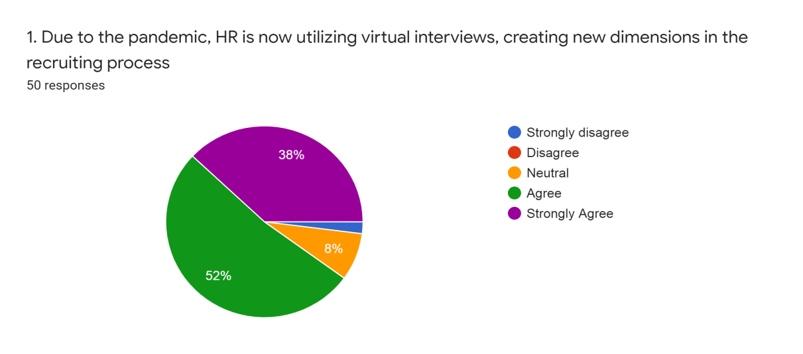
Figure: 01

- The recruitment process is able to hold more video interviews in a shorter time span than the usual hiring timeline making the process faster and more efficient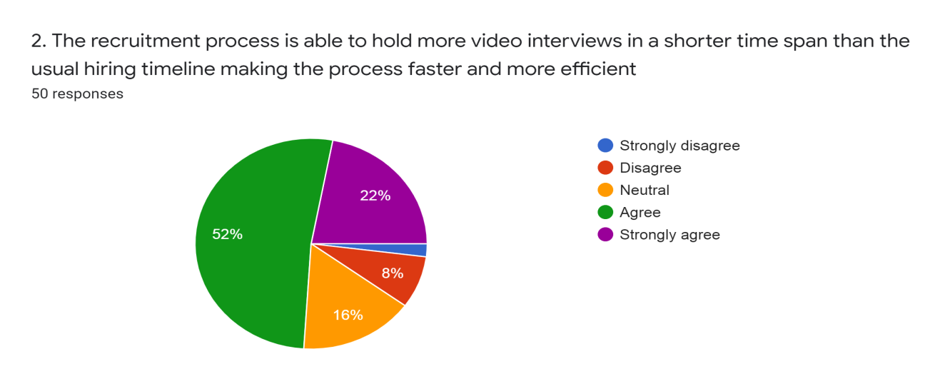Figure: 02

- HR department might lose skilled candidates due to the adaption to video interview process, as every skilled candidate might not have the technological advantage.

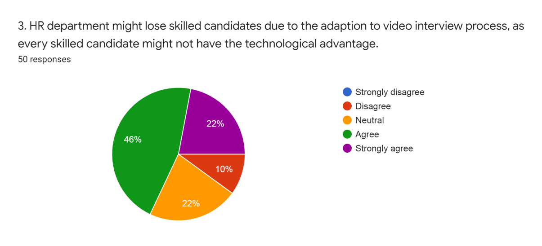
Figure: 03
.
4. Due to the ongoing pandemic, hiring process witnessed some changes. Video interviews helped the hiring process to bring out the top candidates among the multiple ones to narrow down the field for a final in-person interview.
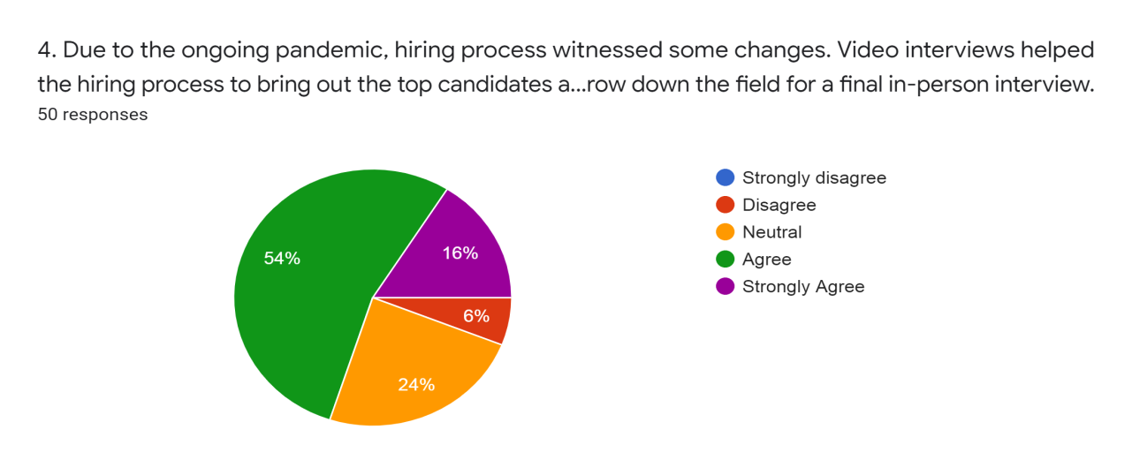
Figure: 04

5. The visual meeting technology create comfort and efficiency for the remote workers
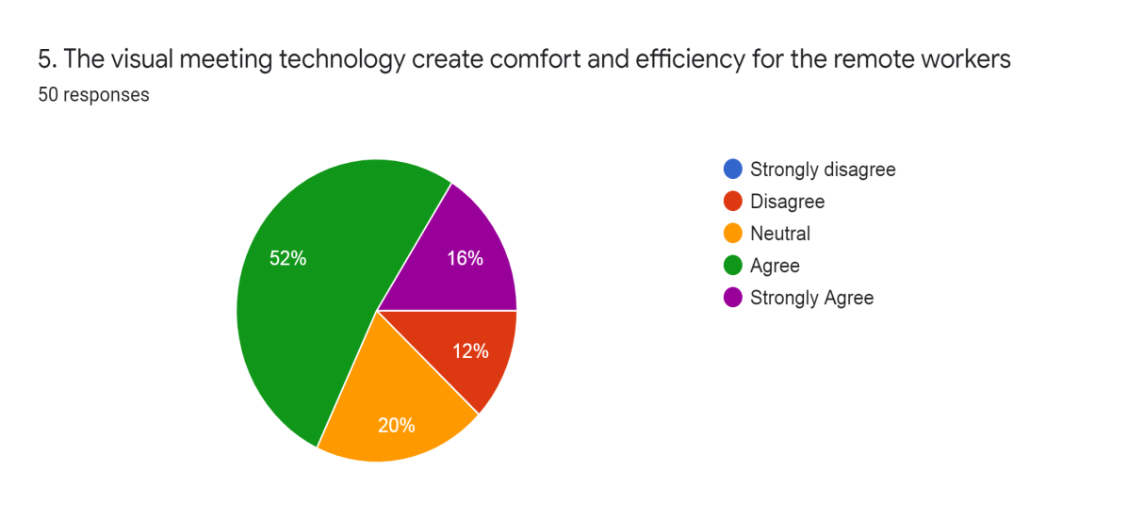
Figure: 05
6. It is difficult for the organization to trust the employees working remotely questioning their integrity, commitment & dedication
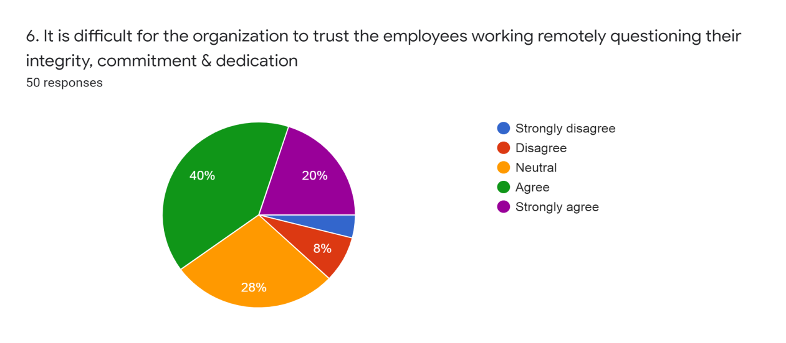
Figure: 06

7. Training & development unit adopted the virtual training session to incorporate more interaction to stay connected with the employees
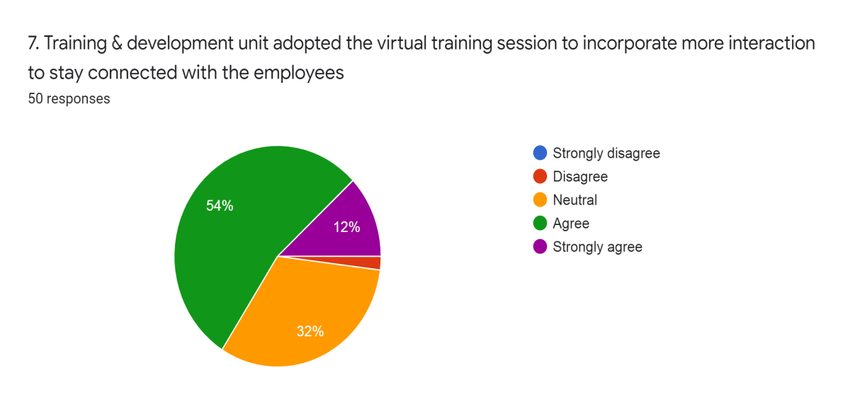
Figure: 07

8. Absence of Outdoor training session makes it difficult for some training needs
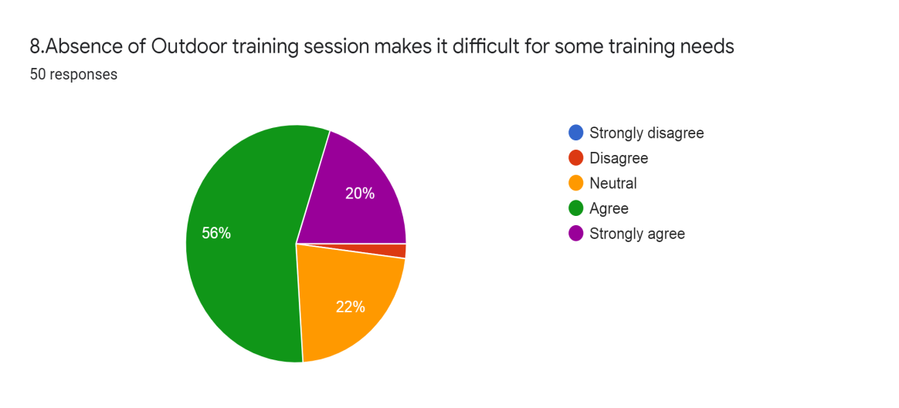
Figure: 08

9. As HR is depending more on tech savvy employees, HR personnel or other employees still in the learning process are struggling with technology
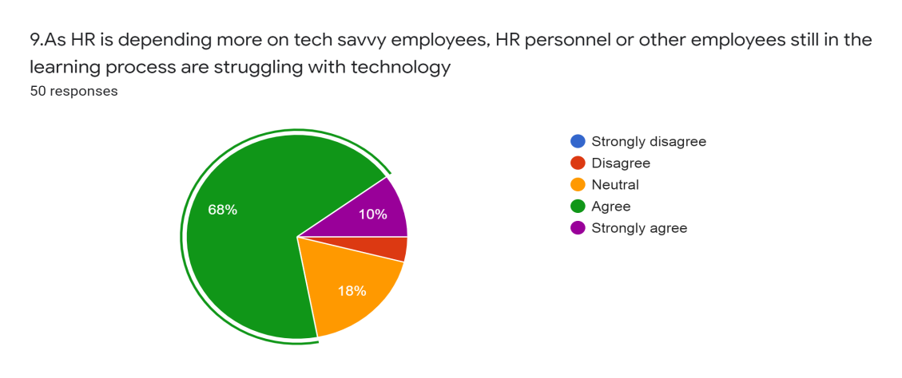
Figure: 09
10. Standard attendance & leave policies does not work any longer due to the outbreak of COVID-19
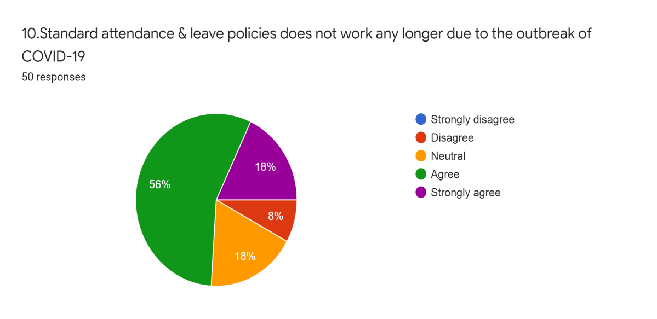
Figure: 10

11. The COVID-19 negatively create impacted in the decision making structure of HR department due to the lack of communication
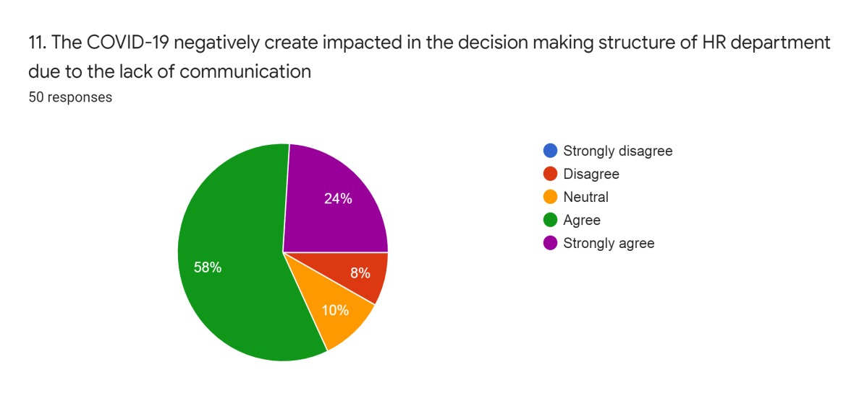
Figure: 11
12. HR department rescheduled their working hours during this period of crisis resulting in irregular and unhealthy hours of office work.
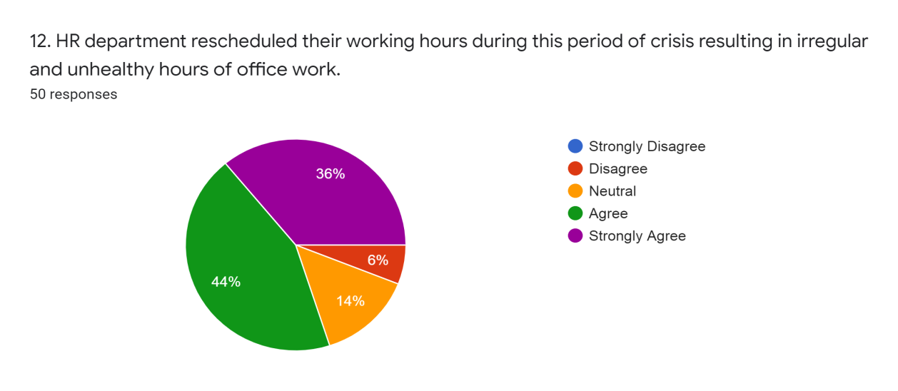
Figure: 12

13. Performance management system is was doing differently than before Covid-19

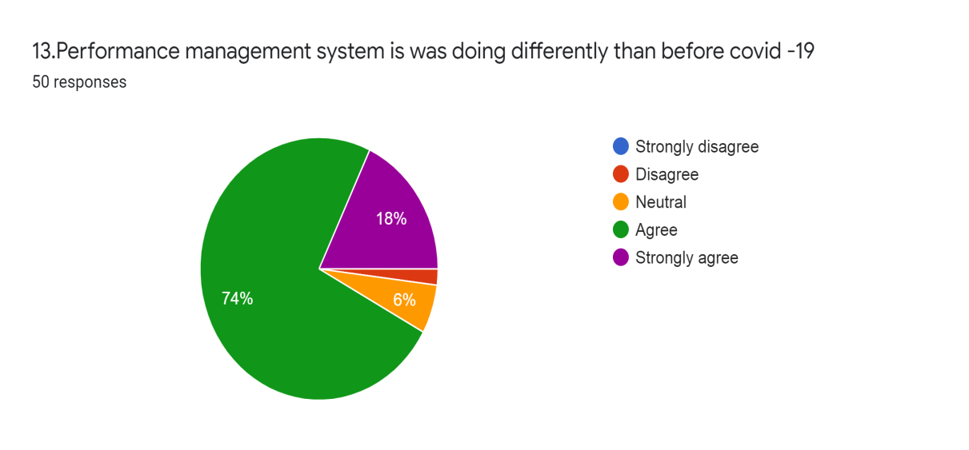
Figure: 13

14. COVID-19 affected the psychological well-being of the HR professionals specifically, since they deal with talent management through strict online procedures
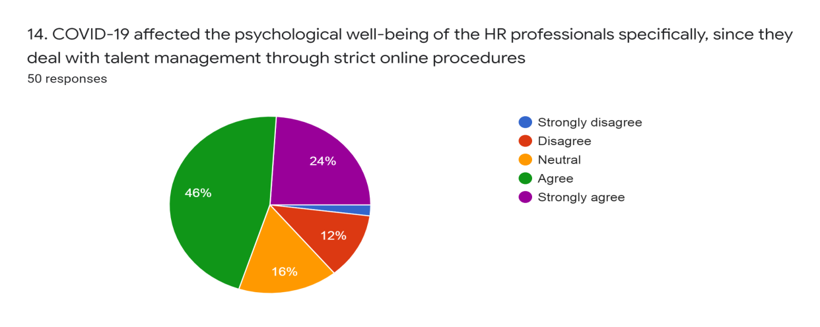
Figure: 14
.

15. Increase of employee retrenchment because of pandemic impacts employees negatively and serves as a demotivating factor among existing employees

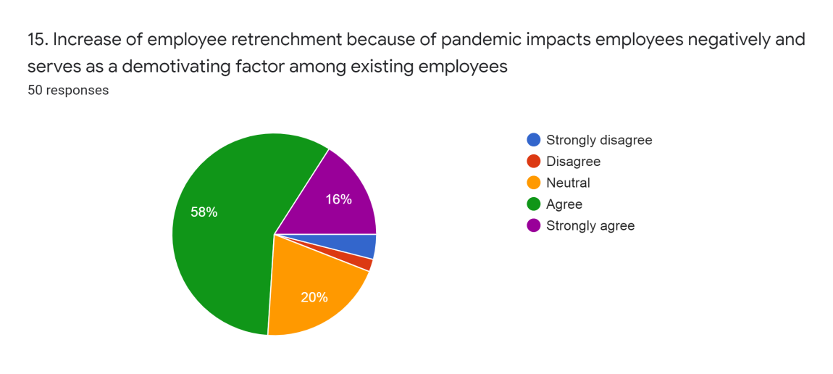
Figure: 15

16. HR department is currently facing a lot of backlash due to change in salary structure and other allowances because of the pandemic

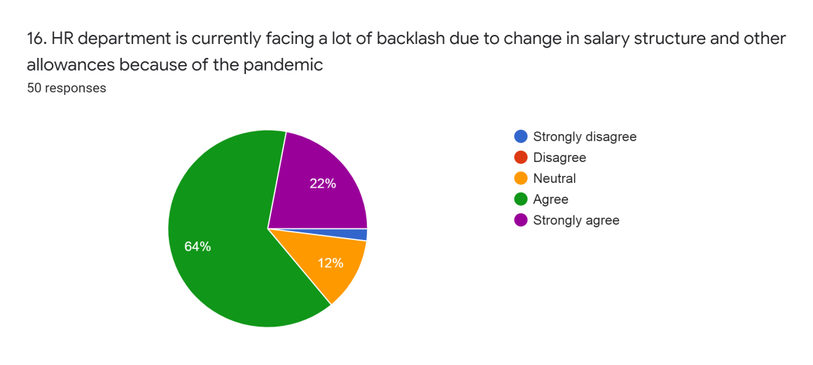
Figure: 16

Findings of the report
COVID-19 changed every person’s reality overnight. More or less every organization is facing the incoming business challenges during this covid-19 pandemic and so is the individual personnel related to those organizations. The panic of shutdown and the uncertainty of uncertain lockdown have been endured by people, cities, societies, countries and continents. In a very short period of time, administrators had to make several choices; choices over who should stay at work and how and when staff should be relocated to the virtual realm; and what the objectives are and how best to convey those preferences to workers. We barely found anything positive about the scenario achieved from the survey questionnaire. The findings were quite expected. The condition was mostly negative.
- The conventional practice of human resource department of footwear industry drastically changed the prime functions such as the recruitment unit and their way of hiring and selection process commenced their activity through the digital platform like zoom.
- Zoom, WebEx became prominent technological tool for video interviews and meetings. Even if employees are recruited, the new employees are facing socializing challenges due to work from home arrangement. However organizations are still not fully up to date to digital ways and so employee performance is being reduced, they are being pessimistic day by day, they are losing hope.
- Another prime unit of HR department is training and development that had to go through a lot as in outdoor training session came to halt, absence of such training hampered their work. Training and development of employees reconfigure for an online only mode. Employees are not being upgraded with different kind of skill development trainings since any kind of gatherings are abandoned.
- The communication system among employees is not working well, not everyone is available at every time they are needed and supervisors are not being able to reach out to every employees to help them bridging their performance gaps and for their any kinds of need. Larger remote workforces push organization to enable technology adoption & digitalization.
- Since the productivity is hampered and so is the business profitability and so many organizations have altered their pay structure that put the employees in misery. Salary and other allowances structural change of the existing employees and increase of employee retrenchment made the HR department encountering lots of questions.
SWOT Analysis
SWOT focuses on the organization’s strengths, weaknesses, opportunities and threats if they are analyzed, the long-term running of the business would be successful. Footwear industry’s potential growth is primarily due to having a very limited number of competitors in Bangladesh as the only Footwear Company based on exports. Due to the pandemic footwear industry suffered a lot and hindered the conventional HR practices. However, total dedication to understanding and fulfilling the customer’s desire with the right combination of traditional administration, unwavering efficiency, enhanced creativity and professional and committed work. Pandemic created a challenge for this industry and particularly for the HR functions.
Strengths | Weaknesses
1. Conducting video interview session and utilizing the shorter hiring timeline than the conventional process.  2. It has become easier to bring out the top candidates among multiple ones.  3. To keep the employees productive conducting online training to enhance their efficiency. | 1. Difficult to trust the integrity of the remotely working employees.  2. Absence of outdoor training sessions, virtual training sessions are not sufficient  3. Difficult for the non tech savvy employees to perform as per their work experience.  4. Lack of proper communication negatively impact the decision making structure.
Opportunities | Threats
1. Utilizing the visual meeting technology for the remote workers created comfort for both parties.  2. Technologically sound employees shifted their focus on them due to the digital working platform. | 1. Since the pandemic corona virus is on its way to become an endemic, many unprecedented factors may affect the industry and its HR functions  2. Remote work may become permanent or sometimes employees shall be required to be physically present  3. Price reductions, liquidity crisis, employee retrenchment, bankruptcy, currency risk, uncertainty and crisis management.  4. Employees, the suppliers, dealers they all have to take up the risk of this endemic and continue their work with a shield of vaccine to make livelihood better.

Chapter 4
Recommendations
&
Conclusion

4.0 Recommendations & Conclusion

From the findings and observations it clarifies that almost every footwear organizations are facing difficulties in running their operations and every organization’s profitability has been harmed. Many of the organizations are still opting out work from home for some employees and many already have started going office physically. Employees are becoming more stressed, they are becoming pessimistic. This thoughts and surroundings are giving them negative vibes and thus it is affecting their mental health which eventually results in poor performance as well as the
overall performance of the organization. Seeing the results of the survey there are some
suggestions they may follow and might help them running business effectively during this pandemic and the suggestions are following
- This is the most crucial time for business organizations and unprecedented too.
Time is not favorable right now but that does not mean they should give up. Rather this is the most appropriate time to stand out with their head held high among hundreds of business organizations. They need to work harder even and of course by following a solid plan keeping in mind the corona situation. Employees should feel free to reach anyone of their workplace at any time and for this everyone should be active and available in receiving phone calls or video conference or through chat. If not physically they should embrace the virtual communication media more strongly than ever before and should be stay connected always.

- Almost all the employees are being pessimistic about current situation. Their mental health is being hampered. Therefore it’s their responsibility to cheer them up and providing hope to not quit so easily. The HR department of the organization may arrange some virtual meeting sometimes to cheer up the employees. This shall make the employee motivated and energetic towards their respective jobs.
- If the organization is operating their official activities physically instead of remote work then they should ensure the safety of each employee’s health by assuring the hygiene from checking the temperature at the entrance door and compulsion of using the sanitizer before commencing their work. All surfaces, door handles and
every equipment should be sanitized before and post of each working day. Outsiders should not be allowed in the office premises without wearing mask. Lunch facility from catering service should not be allowed, bring food from home in the pandemic notice should be sent to each employee from HR.

- From one of the findings of the study and observation it clarifies that the new employees are being failed to socialize with the other employees due to work from home system. So the new employees need to have a swift connection to the key people of the organization. The recruit coordinator from the HR department should be in constant contact with the new employee during the recruiting and integration process. When the employee starts, the recruitment officer should send a list of all the key people with whom the employee should interact in their early days of operation, including direct reports, a mentor, key staff and the other key staff members.

- Companies should work with their suppliers to ensure that workers are directly involved in crisis management.
- The physical and mental well-being of employees should be the utmost concern of an organization during a pandemic. Therefore at the outset of the pandemic the organization’s first and foremost duty has to be the assurance of employee safety. It is essential for businesses to be able to control the situation, have a stable workplace and provide their employees with the help they require.

Conclusion
The success and stability of an organization mostly depends on the Human resource of that organization. Human resource department deals with the most complicated resources and that is human itself and their knowledge, skills and ability of work at their respective jobs.
Human resources are the most valuable asset of organization since they adds value to the organization with their knowledge and skills, easily movable to any better offers therefore it is quite difficult task to manage their talent, increase their efficiency of work to deliver effectively. The more effectively the human resources of an organization is handled the more successful and profitable the business is. However an inconceivable virus COVID-19 is now hampering the Human Resource Management practices of different organizations. It came out of nowhere and is demolishing the businesses.
The footwear industry affected badly due to the corona virus the retailers and suppliers of such industry. Despite the alarming situation they needed to operate their business the worst timing of the virus spread by overcoming any kind of barriers however the positive thing is that the organizations are getting adapted to it. They have changed their conventional way of operating the business, strategies. They are finding their alternative ways of business issues and solutions to continue the work.
Actually every organization should be prepared for such kind of uncertain threats and if not then get adapted to the situation as early as possible and keep up the work efficiently. It is a good thing that the footwear industry and their HR practices are catching up with the pandemic situation however from their performance during this Covid-19 pandemic we can assume and hope that they will be improving their HR works in more efficient and unique ways in the upcoming days.

References

COVID-19: Impact on Apparel. (2020). Retrieved from FairLabor Association: https://www.fairlabor.org/sites/default/files/documents/reports/covid-19_impact_on_workers_0.pdf
Aitken-Fox, E., Coffey, J., & Dayaram, K. (2020, May 22). The impact of Covid-19 on human resource management: avoiding generalisations. Retrieved from The London School of Economics and Political Science, LSE: https://blogs.lse.ac.uk/businessreview/2020/05/22/the-impact-of-covid-19-on-human-resource-management-avoiding-generalisations/
Lewis, N. (2020, April). HR Managers Rethink Their Role During the Coronavirus Pandemic. Retrieved from Society for Human Resource Management: https://www.shrm.org/hr-today/news/hr-news/pages/hr-managers-rethink-their-work-coronavirus-pandemic.aspx
MALA, W. A. (2020, November). Social Science Research Network. Retrieved from Social Science Research Network,SSRN: https://papers.ssrn.com/sol3/papers.cfm?abstract_id=3736719&fbclid=IwAR1VFKd7Ke7FSt5b4UaBU7dgyHUdTR-uqV2zJBUxRnpE8g_a8FsXTN0A3ws
Meister, J. (2020, March 31). The Impact Of The Coronavirus On HR And The New Normal Of Work. Retrieved from Forbes: https://www.forbes.com/sites/jeannemeister/2020/03/31/the-impact-of-the-coronavirus-on-hr-and-the-new-normal-of-work/?sh=32c402142b60
Singh, M. (2020, May). The Economic Times, HR WORLD. Retrieved from The Economic Times: https://hr.economictimes.indiatimes.com/news/industry/impact-of-covid-19-on-hr-practices-and-future-workforce/75653859

Appendix
Impact of COVID-19 in overall HR practice of footwear industry
This questionnaire is all about the pandemic corona virus what has disrupted organizations and caused human resource managers to face unexpected challenges, embracing those challenges and adopting the positive & negative impact into their talent management practices how the footwear industry keeps their employees productive, motivated and engaged towards their organization.
Name: ……..
Gender: a) Male b) Female
Age: a) 26-31 b) 32-37 c) 38-42
Job level: a) Entry level b) Mid-level c) High level
5- Strongly Disagree 4- Disagree 3- Neutral 2- Agree 1- Strongly Agree
Statements | 5 (SD) | 4(D) | 3 (N) | 2 (A) | 1 (SA)
1. Due to the pandemic, HR is now utilizing virtual interviews, creating new dimensions in the recruiting process
2. The recruitment process is able to hold more video interviews in a shorter time span than the usual hiring timeline making the process faster and more efficient
3. HR department might lose skilled candidates due to the adaption to video interview process, as every skilled candidate might not have the technological advantage.
4. Due to the ongoing pandemic, hiring process witnessed some changes. Video interviews helped the hiring process to bring out the top candidates among the multiple ones to narrow down the field for a final in-person interview
5. The visual meeting technology create comfort and efficiency for the remote workers
6. It is difficult for the organization to trust the employees working remotely questioning their integrity, commitment & dedication
7. Training & development unit adopted the virtual training session to incorporate more interaction to stay connected with the employees
8. Absence of Outdoor training session makes it difficult for some training needs
9. As HR is depending more on tech savvy employees, HR personnel or other employees still in the learning process are struggling with technology
10. Standard attendance & leave policies does not work any longer due to the outbreak of COVID-19
11. The COVID-19 negatively create impacted in the decision making structure of HR department due to the lack of communication
12. HR department rescheduled their working hours during this period of crisis resulting in irregular and unhealthy hours of office work.
13. Performance management system is was doing differently than before Covid-19
14. COVID-19 affected the psychological well-being of the HR professionals specifically, since they deal with talent management through strict online procedures
15. Increase of employee retrenchment because of pandemic impacts employees negatively and serves as a demotivating factor among existing employees
16. HR department is currently facing a lot of backlash due to change in salary structure and other allowances because of the pandemic

