Building Relationship: Focused on Female Customers and Digital Media Management


Nura Jannat Oishi

This report is submitted to the School of Business and Economics, United International University as a partial requirement for the degree fulfilment of the Bachelor of Business Administration.

Building Relationship: Focused on Female Customers and Digital Media Management

Submitted to:
Dr. Md. Shariful Alam
Professor
School of Business and Economics
United International University

Submitted by:
Name: Nura Jannat Oishi
ID: 111 203 003
Major: Marketing
Trimester: 14


School of Business and Economics
United International University

Date of submission: 26 July, 2025

Letter of transmittal
July 26, 2025
Dr. Md. Shariful Alam
Professor
School of Business and Economics
United International University
Subject: Submission of Internship Report on “Building Relationships: Focused on Female Customers and Digital Media Management.”
Dear Sir,
I am pleased to submit my internship report titled “Building Relationships: Focused on Female Customers and Digital Media Management.” I completed my internship at Sharee Centre Sarees, working in the Digital Media and Customer Service department under the guidance of the HR Admin and Customer Service Representative team.
Throughout my internship, I worked with dedication. I made every effort to carefully follow the guidelines provided by my supervisor to meet the course requirements and prepare this report. This experience has given me valuable insights into managing external communications and allowed me to put into practice many of the concepts I learned during my undergraduate studies.
I am grateful to the HR admin and customer service at Sharee Centre. I gained knowledge and experience; obviously, it’s a memorable part of my professional journey.
Finally, I would like to express heartfelt thanks for the support during my internship.
Thank you once again for your warm support.
Sincerely,
Nura Jannat Oishi
111 203 003

Declaration of the student

I, Nura Jannat Oishi (ID: 111 203 003), a student of the Bachelor of Business Administration program, majoring in Marketing at United International University, I am delighted to share that I have completed a four-month internship at Sharee Centre. My internship, which took place from January to April, allowed me to work exclusively with female customers, focusing primarily on the company's relationship with female customers and online management sectors.
During this period, I had the opportunity to interact with female customers, better understand their choices, and support the company's online customer service. My role is contributing to digital media management to improve the online shopping experience for female customers.
I am sincerely grateful to the entire Sharee Centre team for providing me with such a rewarding and insightful learning experience. I hereby declare that all the information provided in this statement is true and accurate to the best of my knowledge.

Acknowledgement

Firstly, I would like to thank Almighty Allah for giving me the strength to complete my internship successfully and prepare my internship report as per the requirements.
I convey my sincere gratitude to my honorable supervisor, Dr. Md. Shariful Alam, United International University. Without his kind direction and proper guidance, this report would not have been a success. His supervision and guidance shaped every phase of the report so that it was completed perfectly.
His constant guidance and readiness to help whenever I faced any difficulties made a significant difference in my learning experience. Whenever I struggled to understand something, he always took the time to patiently explain it to me. He is one of the most supportive faculty members I have had the privilege to learn from during my undergraduate studies. I also had the opportunity to take a course under his supervision, for which I am extremely grateful. His mentorship has been truly invaluable throughout my academic journey. Once again, thank you for your unwavering support. I look forward to staying connected and continuing to learn from your expertise.
I am also grateful to Sales Executive Mr. Anwar Hossain, who warmly welcomed me and introduced me to the customer representative and sales teams. They made me feel part of the team from the very beginning, involving me in creating, analyzing, and strategizing solutions as part of a collaborative team effort. My time as an intern at Sharee Centre taught me the importance of teamwork and how vital it is for the healthy and dynamic growth of a company.
I confirm that all the details shared above are true and accurate to the best of my knowledge.

Executive summary

The saree industry in Bangladesh is thriving, with customer demand growing rapidly across different segments. Since its establishment in 1996, Sharee Centre has operated with the mission of "bringing authentic Bangladeshi sarees to the masses." Guided by core values such as customer-centricity, innovation, craftsmanship, and integrity.
During my four-month internship at Sharee Centre, I worked with a specific focus on building strong relationships with female customers and managing the brand's digital presence.
The first part of the report outlines the company’s objectives and the strategies that have fueled its growth, with special emphasis on the implementation of innovative digital media techniques that have enhanced customer engagement and brand visibility.
The second section explains Sharee Centre's background and its journey of expansion, highlighting the process it has successfully attracted a loyal customer and a female customer.
The third section explains Bangladesh’s saree industry. Current market share data indicates that Sharee Centre holds approximately 22% of the market, while Aarong commands 44% and Jamdani Weaves 31%.
The fourth section of the report explains my personal internship experience. Here, my primary role was to develop and strengthen relationships with female clients. Handling the company’s digital media platforms. My responsibilities include promoting products through various online channels, creating digital content and Reels to attract and retain female customers, social media platforms.
Finally, the last part of the report presents my guidelines based on the knowledge gained during my internship.

.
Table of Contents
Letter of transmittal 3
Declaration of the student 4
Acknowledgement 5
Executive summary 6
CHAPTER I: INTRODUCTION 9
1.1 Background of the Report 9
1.2 Objectives of the Report 10
1.3 Motivation of the Report 13
1.4 Scope and Limitations of the Report 14
1.5 Definition of Key Terms 16
CHAPTER II: COMPANY AND INDUSTRY PREVIEW 17
2.1 Company Analysis 17
2.1.1 Overview and History 17
2.1.2 Trend and Growth 18
2.1.4 Product/Service Mix 20
2.1.5 Operations 22
2.1.6 SWOT Analysis 26
2.2 Industry analysis 30
2.2.1 Specification of the industry 30
2.2.2 Size, trend, and maturity of the industry 31
2.2.3 External economic factors 32
2.2.4 Technological factor 33
2.2.5 Barriers to entry 33
2.2.7 Supplier Power 34
2.2.8 Buyer Power 34
2.2.9 Threat of Substitutes 35
2.2.10 Industry Rivalry 36
CHAPTER III: INTERNSHIP EXPERIENCE 38
3.1 Position, duties, and responsibilities 38
3.2 Training 41
3.3 Contribution to departmental functions: 43
3.4 Evaluation 44
3.5 Skills Applied 45
3.6 New skills developed 46
3.7 Application of academic knowledge 48
CHAPTER IV: CONCLUSIONS AND KEY FACTS 50
4.1 Recommendations for Improving Departmental Operations 50
4.2 Key understanding 51
4.3 Conclusion 52
Reference 54
Appendices: 55

CHAPTER I: INTRODUCTION

1.1 Background of the Report
Sharee Centre stands as a well-known retailer in Bangladesh. Sharee Centre is concentrating on both traditional and modern sarees. The company is offering a variety of stylish, high-quality products to customers nationwide. Eventually, the brand established itself as a trusted household name by blending elegant designs that honor Bangladesh’s rich. Cultural tradition, with the ever-changing fashion preferences of today’s women.
Despite this progression, Sharee Centre, like many fashion retail brands, continues to struggle with expressing its proposition to a mass market. The fashion industry in Bangladesh is highly competitive, with both existing and emerging brands vying for customer attention.
In recent years, the Sharee Centre has also expanded its product lines. Offers an entirely new line of sarees, from handmade traditional silk sarees to contemporary fashion pieces. This brand also offers a wide range of fashion accessories, providing customers with a comprehensive shopping experience. Digital media platforms have been a central focus of their recent efforts to grow. A key part of this initiative has been launching their e-commerce website, which allows customers to explore and buy products from home.
In the future, Sharee Centre hopes to become more than just a place to buy sarees and become a brand that embodies that duality of old and new in fashion. It aims to increase its digital media management, integrate shopping experiences online and offline, and boost awareness in an organic way.
A major component of this digital media is the brand’s online store and mobile app, which offer customers access to the full product range and customized suggestions. To build stronger, good connections with its audience. Sharee Centre has also launched “Style Hub,” a digital content community (via a Facebook Group) where fashion lovers can explore styling tips, saree care advice, and stay updated on the latest trends in luxury Sharee.
Sharee Centre’s public relations efforts are directed by its Customer Relationships and Marketing Department, which has the responsibility for developing a strong identity for the brand. They work as well with fashion influencers, media outlets, and industry experts to raise awareness of the brand. To overcome issues of brand awareness and customer perception, PR initiatives focusing on the launch of the brand’s e-commerce platform, Style Hub, and exclusive luxury Sharee collections have also been undertaken by the PR team.
Primary and secondary research, the digital media team regularly collects insights to refine its messaging and stay in tune with customer expectations. This research-driven approach has helped Sharee Centre sustain its reputation. She has established herself as a leader in both traditional and contemporary saree fashion in Bangladesh.
This report is intended to offer insights into the process of building strong relationships with female customers and managing digital media in the fashion retail sector. Sharee Centre is an example of how a brand can successfully blend cultural heritage with modern innovation.

1.2 Objectives of the Report
- Explore Digital Media Strategies to Enhance Sharee Centre’s Online Presence: This report evaluates Sharee Centre’s current digital media platforms, focusing on how these approaches successfully promote the brand’s extensive product. By making use of various online platforms, Sharee Centre can reach and engage with tech-savvy female customers. Sharee Centre provides them with an accessible and convenient shopping experience that reflects both traditions.

- Provide Insights into the Fashion Retail Industry in Bangladesh: The fashion is slowly slow-changing industry in Bangladesh is a slowly retail industry. Digital media management has become very important for connecting with customers. Promoting the brand and building customer trust. As more and more people shop online and spend time on social media, fashion brands like Sharee Centre need to keep changing. They must understand what customers want and how their habits are changing, so they can serve them better and stay ahead in a highly competitive market.
- Analyse Sharee Centre’s Digital Media Approach to Customer Engagement: The main part of the study focuses on Sharee Centre’s use of Several digital platforms like Facebook, WhatsApp, their official website, mobile app, and email marketing to build strong customer connections. The personalised experiences offered to female customers make sure they feel comfortable and valued throughout the online purchasing process. The company’s focus on various customised content, exclusive offers, and digital communication allows for deeper interaction with its female clientele.

- Evaluate the Development and Execution of Digital Media Campaigns: This part looks into how Sharee Centre plans and runs its digital media campaigns. The process starts with concept development, creative ideas. They also team up with popular influencers and bloggers to reach more people and build trust. Through social media, they promote seasonal collections, new product launches, and limited-time offers. Everything social media to keep their customers excited and involved.
- Identify Key Success Factors in Sharee Centre’s Customer Relationship Management: The report highlights several factors contributing to Sharee Centre’s ability to build strong customer relationships in the long and short term. These include personalised, friendly communication strategies, culturally sensitive customer service, loyalty programs, and consistent collection of customer feedback. Extra care is taken to make sure that the religious and cultural sensitivities of female customers are respected. They feel a safe environment for them to engage with the brand.

- My learning and Experience from the Internship: My internship was primarily focused on developing strong relationships with female customers, specifically those who prefer not to be served by a male, therefore, not a very avid user of technology. This position also provided me with the opportunity to be a direct liaison with these types’ customers. I kept in contact with them through digital means, responded to their queries, helped them make purchase decisions, and made sure their cultural boundaries were respected.

- Highlight the Integration of Academic Courses with Practical Experience: During my internship, I have continuously been able to apply concepts from my academic courses, especially in Digital Marketing, Strategic Management, E-Business and Consumer Behaviour. I used these theories to gain insights into customer behaviour, informing the development of effective communications and digital marketing efforts, and participated in building a digital experience centred on the customer at Sharee Centre.

- Provide Recommendations for Enhancing Sharee Centre’s Digital Customer Relationship: With this experience in mind, I make the following recommendations to further pursue the digital customer relationship management of Sharee Centre. Have specially comprised teams of women customer service representatives online. Deploy sophisticated customer and data analytics and segment marketing messages by customer preferences, shopping habits, and religious sensitivities. Further use personal content in the form of virtual styling sessions, Sharecare tutorials, and fashion tips directed at women customers. Grow a loyalty program that rewards longevity with exclusive discounts, advance notice of new collections, and personalised offers.
Augment the “Style Hub” with features such as community discussions and live Q&As with female fashion consultants. Implement AI-based chatbots alongside female consultant scheduling options to provide immediate and culturally aware customer support while also preserving privacy and comfort.

1.3 Motivation of the Report
My internship with Sharee Centre started with a great interest in the impact of understanding and nurturing a relationship that is centred on female customers and guiding a brand’s identity through that to engage customers in a meaningful way. In addition, this internship is a step toward advancing my BBA in Marketing. The main motivations for this report:
- Understanding Sharee Centre’s Leadership in Digital Media and Marketing: Exploring how Sharee Centre's Marketing and Communications Teams utilise digital media. Organic ways boost customer engagement and strengthen the brand’s participation.
- Overview of Bangladesh’s Fashion Retail Industry: Offering a broad perspective on Bangladesh’s retail landscape, particularly within the saree and fashion sectors, as these industries increasingly integrate digital commerce into their business models.
- Formulating Recommendations for Other Retailers: offering useful insights and actionable advice for other fashion retailers seeking to build or enhance their digital media platforms. To more effectively market their products and interact with loyal customers.
- Evaluating Public Relations and Digital Media Partnerships: Analysing Sharee Centre’s collaborations with influencers, customers, and media outlets to assess how these partnerships contribute to the effectiveness of their public relations and digital campaigns.
- Reflecting on Key Takeaways from Sharee Centre’s Digital Media Strategies: Summarising the main lessons learned during my internship, particularly in terms of how Sharee Centre successfully manages its digital media and customer relationships.
- Fulfilling Academic Requirements for My BBA (Marketing) Degree: This report is a key part of the academic requirements for my undergraduate degree, bridging the gap between marketing theory and its real-world application at Sharee Centre.

I believe this report will serve as a useful resource for anyone interested in understanding how a fashion retail business can successfully implement digital media strategies and strong customer relationships. My inspiration for writing this report also comes from Sharee Centre’s deep cultural roots; Sharee’s are a significant part of Bangladesh’s tradition. Ultimately, this report not only supports my graduation requirements but also helped me gain important insights and lessons that will be valuable for my future profession.

1.4 Scope and Limitations of the Report

During my internship journey with Sharee Centre, I encountered both valuable learning opportunities and a few limitations while preparing this report. Fortunately, the learning scopes were far more extensive compared to the challenges I faced.

Key Learning Scopes:

- Understanding the Digital Landscape: I gained valuable experience in formulating and implementing productive digital media. Sharee Centre’s products on popular platforms among their target audience, such as Facebook, Instagram, and WhatsApp, where most of the target customers are active.
- Bonding with Women Customers: A big part of my role involved building good relationships with women customers who, for religious and cultural sensitivities, felt more comfortable with other women staff. By listening to their concern and even helping them with direct support. Created a feeling of comfort and respect for this type of customer in the shopping experience. This approach not only builds customer loyalty but is also reflective of Sharee Centre's values of being customer-centric.
- Customer Engagement: I had the chance to see how Sharee Centre connected with both existing and potential customers through social media and online platforms. Their company’s interactive communication methods helped maintain relationships and fostered customer satisfaction and trust, and customers feel valued and satisfied.

- Content Creation and Marketing: I played an active role in developing content that digital content to make sure the cultural beauty of saree style preference for the female audience. I helped create posts that showcased Sharee Centre’s identity.

- Monitoring Customer Sentiment and Activity: I used different digital tools to track customer feedback and sentiments regarding Sharee Centre’s products and services.

- Influencer Collaboration: I learned how impactful it can be to work with fashion influencers. Sharee is a centre promoting sarees online and in-store. These partnerships played a big role and brought more attention to the brand, engaging loyal customers.

- Customer Retention through Personalised Marketing: I explored how Sharee Centre personalised digital marketing strategies like targeted email campaigns, social content, and loyalty programs. Special offer that made their shopping experience feel more personal and enjoyable.

Key Limitations Faced:

- Restricted Access to Data: Since some customer information and internal digital strategies were confidential, I wasn’t given full access. As a result, it was challenging to explore certain areas in greater detail during my analysis.
- Time Limitations: Because the internship was short, I couldn’t fully observe how the digital strategies played out over time or measure their long-term success.
- Platform Dependency: Sharee Centre depends a lot on external platforms like Facebook and WhatsApp. Any sudden changes in their algorithms or policies sometimes affected how well the brand could reach and engage with its audience.
- Budget Constraints in Digital Marketing: Limited financial resources were restricted; the company didn’t have enough budget to use premium tools. This made some ideas complex to carry out.
- Restricted Participation in Internal Strategic Meetings: Due to confidentiality, I was not allowed to attend high-level management meetings where long-term digital marketing plans and strategies were discussed because those meetings were only for seniors.

Even with some challenges, my internship at Sharee Centre offered a unique and invaluable learning experience. I not only gained hands-on experience in digital media management and customer service in the fashion retail sector. More importantly, I also learned and developed specialised skills in building and nurturing strong customer relationships with female clients, which is very important in culturally aware markets like Bangladesh. This experience helped me understand how digital strategies need to be flexible and address cultural values while still helping businesses grow.

1.5 Definition of Key Terms
SC: Sharee Centre
PR: Public Relations
FB: Facebook

CHAPTER II: COMPANY AND INDUSTRY PREVIEW

2.1 Company Analysis

2.1.1 Overview and History

Sharee Centre is now one of the most well-known Sharee brands in Bangladesh. It has leading retail brands, renowned for offering a wide variety of both classic and modern Sarees. Over the years, it has grown rapidly, becoming a favored destination for Sharee lovers all over the country. However, the brand wasn’t always known as Sharee Centre; the brand started small and, over time, grew into the trusted name people know and rely on today.

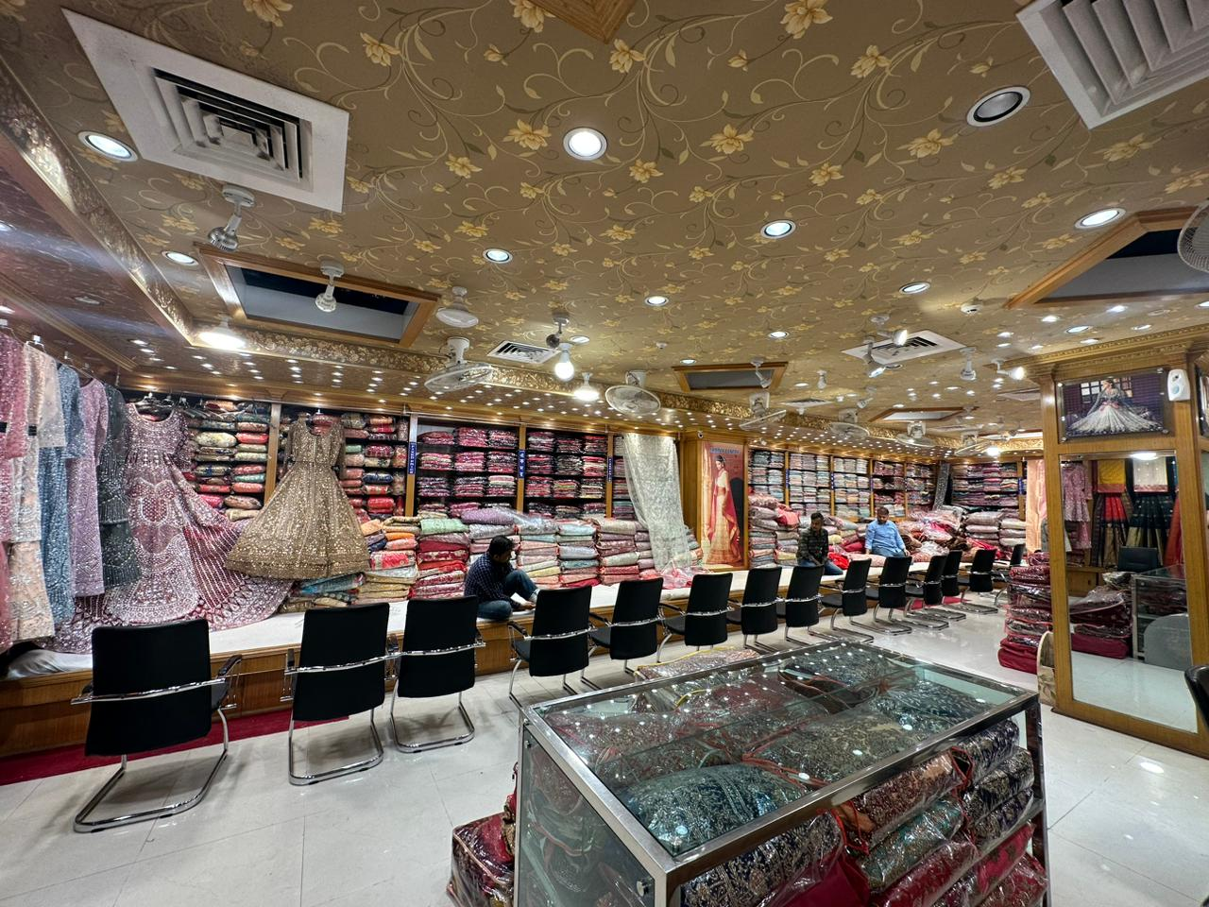
1996: Sharee Centre Ltd. began its journey by opening two stores in Munshi Ganj. The main goal at the time was to bring traditional sarees to customers living outside the big cities.

1997: To reach more people and provide better-quality sarees, the company entered into a joint venture with partners from both Bangladesh and India.

1998: Sharee Centre expanded its product line by launching GSM (Great Saree Market), which helped attract many new customers. Around the same time, the business moved its main operations from Munshi Ganj to Dhaka.
2005: Plaza A R and Bashundhara City are two new, well-known markets in Dhaka that Sharee Centre has entered. A crucial site for Sharee Centre was Bashundhara City, which is still home to one of the biggest and most well-known shopping centres in the nation. The business swiftly established a solid reputation after successfully acquiring six retail locations in Bashundhara City. Many retailers are still fighting for space in this coveted shopping complex today.

2008: The Plaza A R outlet underwent rebranding, changing its name. Sharee Centre to Kalanjali Sharee’s, marking the start of its wholesale business. At this stage, Sharee Centre began importing Sharee from India. Selling them wholesale across various markets throughout Bangladesh.

2.1.2 Trend and Growth

Sharee Centre has grown impressively, thanks to its growing customer base and strong position in the market. The consistent demand for sarees—especially during festive seasons and wedding events—has played a major role. By regularly launching new collections and offering exclusive designs. Sharee Centre has managed to attract customers, giving their sales an extra boost in an organic way. The brand’s expanding online engagement and well-planned marketing strategies have allowed. Sharee centre each customer, not just locally, but also from broader regions. This ongoing rise in revenue reflects the success of Sharee Centre’s growth approach. Sharee Centre highlights the growing popularity of sarees as a fashionable choice.

Sharee Centre’s sarees are becoming more popular because of the way the brand blends traditional with modern design elements. Their focus on using premium fabrics and paying close attention to their collections resonates deeply with modern women who appreciate traditional fashion that honors tradition while staying trendy and stylish and who enjoy ethnic fashion that remains true to its roots while also feeling current and stylish. This growth also mirrors a wider revival of interest in cultural fashion.
The growing trend of wearing sarees for special occasions like weddings and festivals has driven strong growth in the market. Sharee Centre stands out for its fresh designs and extensive variety. This growth also highlights a wider renewed interest in cultural fashion. Sharee Centre successfully reaches both locally and internationally.
2.1.3 Customer Mix

Sharee Centre has been able to increase its marketing reach. Enhance its offerings, and fortify its online presence by genuinely comprehending the needs and preferences of its customers. They can satisfy the various needs of their customers and keep up an active engagement on social media platforms like Facebook and WhatsApp. The brand can meet a variety of needs while keeping an active engagement on social media platforms like Facebook, thanks to its customer focus. Sharee Centre provides the following services to its various clientele:
- Bridal Client: In this sophisticated bride's case, their relatives and wedding guests often turn to Sharee Centre for beautiful and traditional sarees. the store is looking for attire that meets their high expectations. Sharee Centre offers exclusive collections that combine luxurious details with classic designs, meeting the high expectations of those shopping for wedding attire.

- Casual Customers: Many regular customers visit Sharee Centre looking for sarees. They are not stylish but also easy to wear. Whether they need something for work, a casual day out, or semi-formal events. Sharee stores offer a variety of casual items. Every day sarees that fit effortlessly into their daily lives.

- Seasonal Visitors: During festival seasons like Eid and Puja, customers look for vibrant, culturally rich designs that celebrate the occasion. Sharee Centre offers special festive collections filled with colorful, ethnic designs to match the happy mood. These holidays meet the seasonal demand for festive fashion.

Sharee Centre effectively uses its digital platform and media platforms like Facebook and WhatsApp to stay connected with all customers. The brand regularly shares updates, shares new collections, and directly interacts with customers. Through frequent promotions, holiday greetings, and special offers, they attract and retain a wide range of customers. This focus on both online and offline shopping makes sure that every customer segment has easy access to the products and services they are looking for, while the brand continues to grow its reach effectively.

2.1.4 Product/Service Mix

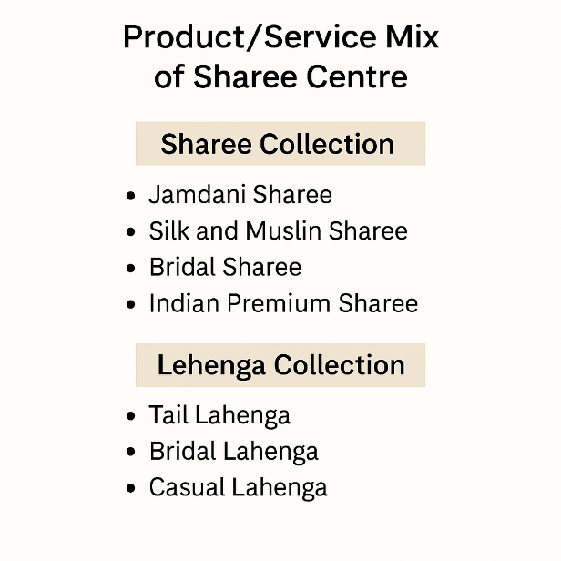

The following product-service mix diagram highlights Sharee Centre’s broad range of products and services, including bridal Sarees, Bridal Lehengas, Jamdani Sarees, Silk and Muslin Sarees, Tail Lehengas, Casual Lehengas, and Indian Premium Sarees.

Key Services Provided by Sharee Centre:

- Convenient Online Browsing and Ordering: Customers can comfortably browse Sharee Centre’s latest collections online via their Facebook page, which is regularly updated with new arrivals and seasonal collections. Customers can also place orders easily through the WhatsApp number. They receive personalised and private support every step of the way.

- Dedicated Support for Conservative Female Customers: The cultural and religious emotions of many female customers also engage social media. Sharee Centre has created special arrangements to ensure a comfortable shopping environment for women who prefer to engage with female staff. Whether in store or online, female sales representatives are available to help these customers with the customisation service. This thoughtful approach has played a significant role in building trust and loyalty among their conservative female clientele.

- Tailoring Services: To make shopping even better, Sharee Centre offers in-house tailoring services. Customers buying sarees or lehengas can get their blouses or lehengas stitched; they can get their blouses or outfits made to fit their size and style perfectly.

- Nationwide Courier Delivery: Sharee Centre offers reliable courier delivery services across Bangladesh, including remote and rural areas, to make sure that customers who are unable to visit physical stores can still enjoy timely delivery of their chosen products.

- Private Online Consultations for Female Clients: For conservative shoppers who prefer a more private shopping experience. Sharee Centre also offers online consultations with female staff. Through private chats and video calls on WhatsApp or Messenger, customers can get personalised help picking the selecting products without having to visit the store in person or engage with male staff.

- Specialised Customer Service Teams: Sharee Centre's commitment and ensuring customer comfort. Sharee Centre maintains dedicated customer service teams that include trained female staff. Female staff focus on those who specialise in assisting female shoppers. Sharee Centre ensures that every customer receives culturally appropriate and sensitive support.
- Exclusive Collections for Religious and Cultural Occasions: Recognising the importance of cultural and religious traditions, Sharee Centre thoughtfully curates exclusive collections. specifically for religious festivals, weddings, ceremonies, and cultural events. The importance of cultural and religious traditions: Sharee Centre thoughtfully curates exclusive luxury collections. Sharee Centre specifically focus on religious and cultural occasions. These collections feature modest designs and traditional styles. the values of conservative customers, and this allows women to find outfits that are both fashionable and appropriate for their personal beliefs.

2.1.5 Operations

Sharee Centre is dedicated to offering high-quality products alongside warm. They provide respectful service that makes customers feel comfortable, valued, and at home with delivery. A main part of the brand’s goal is its special focus on female customers, understanding their needs and cultural preferences, and making sure they have a positive shopping experience both online and offline. By offering affordable prices and a welcoming atmosphere, Sharee Centre successfully encourages repeat visits and long-term customer loyalty.

Below are the key operational areas and strategies with added emphasis on female customer engagement:

1. First-Time Buyer Engagement
- Expanding Product Variety: Sharee Centre continually enhances its collection with modern and stylish items. Sharee centre is adding new saree lehenga designs design’s inspired by various Indian regions. They are offering authentic and new styles that appeal to women with different tastes.

- Exclusive Fusion Sharee: Sharee Centre offers customised fusion sarees that mix heritage and modern looks. It especially attracts younger women who seek fashionable, unique attire while still honouring cultural traditions.

- Special Promotions During Festivals: The store features special festivals such as Eid, Puja, and weddings. Sharee Centre introduces time-limited offers, discounts, and exclusive collections that appeal to women preparing for these special occasions.

2. Enhancing the Female Experience
- Female Sales and Support Teams: Understanding that many female customers prefer to engage with female staff due to cultural or religious reasons, Sharee Centre ensures that trained female sales representatives are available to assist both in-store and online. This helps create a more private, comfortable, and respectful shopping experience.

- Private Online Consultations: For conservative female customers, Sharee Centre offers private consultations via WhatsApp, Messenger, or video calls handled exclusively by female staff. This allows women who are not comfortable visiting the store or interacting with male employees to receive personalised service from the comfort of their homes.

- Tailored Shopping Experience: The Staff are trained to understand individual customer preferences. They are allowing them to offer personalised service. They can give helpful advice that matches cultural values and fashion tastes.

3. Elevating Customer Care
- Loyalty Rewards: Regular customers, many of whom are special women shopping for themselves or their families, benefit from loyalty programs that include special discounts, exclusive previews of new collections, and early access to promotions.

- After-Sales Support: saree centre Services such as easy exchanges, tailoring, and quick delivery. To ensure a hassle-free experience that’s highly appreciated by female customers.
4. Importing Sarees from India
- Strategic Supplier Relationships: Sharee Centre works closely with Indian manufacturers and artisans’ source high-quality sarees. They appeal to a wide range of female customers, from brides to daily wear shoppers.

- Strict Quality Assurance: Sharee Centre ensures that every piece delivered to its female clientele meets. They have high standards of craftsmanship that they expect. Sharee Centre always keeps good quality.

5. Strengthening Customer Communication
- Active Digital Presence: Using Facebook, Instagram, and WhatsApp, Sharee Centre regularly updates its female audience about new collections, special offers, and styling tips through visually engaging content.

- Direct Engagement: Interactive posts, private messaging, and personal assistance help foster a sense of trust, comfort, and community among female customers.

- Listening to Customer Feedback: The company actively seeks and values feedback from female customers to continually improve its products, services, and shopping experience.

6. Retaining Customers & Festival Offers
- Culturally Relevant Collections: Seasonal and festive collections are specifically designed to meet the fashion needs of female customers during religious and cultural celebrations like Eid, Puja, and weddings.

- Exclusive Membership Programs for Women: Membership programs offer female shoppers exclusive privileges such as special discounts, access to limited editions, and personalised services, enhancing their overall shopping experience.

7. Marketing and Digital Strategy with a Female-Centric Focus
- Social Media Marketing for Women: Sharee Centre actively engages women. They use platforms like Facebook, WhatsApp, and Pinterest to share content that resonates with their female audience—highlighting stylised designs, sharing advice, and featuring real customer stories.

- Influencer Collaborations: Teaming up with female influencers, bloggers, and content creators helps Sharee Centre reach a variety of audiences of women who trust the opinions of these fashion voices.

- Email Campaigns with Personalisation: Email marketing campaigns are designed to feel personal. product recommendations based on the customer’s previous purchases and preferences, making female shoppers feel personally valued and connected.

By tailoring its operations and customer experience specifically to meet the customer wants cultural values, and comfort of female customers. Sharee Centre has not only built a loyal customer base but also set a highly competitive fashion retail market in Bangladesh. This focus continues to play a main role in the brand’s ongoing success and growth.

2.1.6 SWOT Analysis

Strengths | Weaknesses
- Diverse Saree Collection: Wide range of traditional and regional designs from India, catering to different female tastes.  - Fusion Styles: modern and traditional sarees, popular among younger women.  - Quality at Affordable Prices: High-quality fabrics and designs offered at reasonable prices, accessible to a broad female customer base.  - Personalized Service: Warm, respectful service with female staff to make sure comfort, mainly for conservative women.  - Private Consultations: Online support via female representatives. | - Limited international market reach.  - High dependence on platforms such as Facebook and WhatsApp.  - Lack of modern customer data analysis.  - Budget limitation in marketing and technology.  - Inventory management issues.  - Limited focus mainly on female customers.
Opportunities | Threats
- Expand into international markets (especially Bangladeshi diaspora).  - Launch mobile app for better customer experience.  - Introduce men’s and children’s ethnic wear.  - Use advanced data analytics for personalised marketing.  - Collaborate with more influencers to grow online reach.  - Offer virtual shopping or styling consultations. | - Rising competition from local and international brands.  - Fluctuating raw material prices are affecting production costs.  - Changes in social media algorithms are impacting digital reach.  - Economic instability is reducing consumer spending.  - Shifting fashion trends and customer preferences.

This table highlight strengths and weaknesses, along with the external opportunities and threats, providing a clear picture of where Sharee Centre stands.
Below more through overview of the SWOT analysis for Sharee Centre Sarees:
Strengths-
- Diverse Saree Collection: Sharee Centre offers a variety of saree collections like traditional, regional and seasonal. These modern sarees are sourced from different parts of India and Bangladesh, attracting a female customer base with varied tastes.

- Unique Fusion Designs: Sharee centre Customized fusion sarees combining modern fashion with traditional craftsmanship. They appeal strongly to younger women looking for unique fashion.

- Quality at Affordable Pricing: Sharee Centre always maintains high quality and keeps prices reasonable. Sharee Centre makes premium sarees and elegant sarees for a wide customer base.

- Personalised, Female-Focused Customer Service: Sharee Centre. Special attention is given to conservative female customers. They are offering services through trained female staff, both online and offline, to ensure comfort, privacy, cultural sensitivity and the latest collection.

- Digital Engagement: By staying active on platforms like Facebook and WhatsApp, Sharee Centre can directly engage with customers. Directly promote new collections effectively.

- Festival & Cultural Collections: The brand regularly launches exclusive collections. Especially major festivals (Eid, Puja, weddings), seasonal demands, and keeping customer loyalty.

Weaknesses-

- Limited International Expansion: Although Sharee has a strong local presence. Sharee Centre has limited awareness of international markets. This means it is missing growth opportunities, particularly among the Bangladeshi living abroad.

- Dependence on External Platforms: The brand assurance on third-party platforms (Facebook, WhatsApp) makes the brand vulnerable, which can be risky due to changes in algorithms and platform policies.

- Limited Data Analytics: without advanced customer data analysis tools, C) restricts personalised marketing and gains a deeper understanding of customer presence.

- Budget Constraints: Narrow financial resources restrict the company’s ability to experiment with developed marketing tools, premium advertising, and technological innovations.

- Inventory Management Issues: Handling a large and wide product range. sometimes leads to a stock lack or delayed orders.

- Narrow Customer Segment: Focusing on female customers may limit opportunities to expand into broader segments such as men's or children’s wear.

Opportunities-

- International Market Expansion: There is a big chance to target the Bangladeshi dispersed people worldwide and markets interested in South Asian ethnic wear.

- Development of a Mobile App: An easy-to-use mobile app can improve the online shopping experience and offer customised features, and customers will enjoy it.

- Expansion into New Product Lines: Traditional clothes for men, children, and family-oriented traditional wear can help extend new customer segments.

- Use of Advanced Data Analytics: Understanding customer data analytics can allow for better customisation and stronger customer retention.

- Influencer Collaborations: In time, people will be more involved with social media, so working with more fashion influencers can increase brand visibility and attract a younger, online-addicted audience.

- Virtual Shopping Support: Offering virtual discussions and styling services can attract busy or conservative people. So, customers prefer private shopping experiences.

Threats-

- Rising Competition: Day by day, Bangladesh is getting crowded with fashion markets. Local competitors and international brands entering the Bangladeshi fashion market create a highly challenging environment.

- Raw Material Cost Fluctuations: Day-by-day increase in fabric and production costs. This is greatly affecting the price and reducing profit.

- Social Media Algorithm Changes: Social media platform algorithms may reduce digital reach day by day to reach customers organically.

- Economic Uncertainty: When economic downturns occur, consumers cut back on non-essential spending.
- Changing Fashion Trends: Fashion changes quickly, so saree centre preferences may lead to declining interest in certain product lines if the brand fails to adapt.

2.2 Industry analysis

2.2.1 Specification of the industry

The sarees and cultural wear industry plays a vital role in the larger fashion industry. It is strongly connected to cultural heritage; mainly in South Asia, sarees carry symbolic significance for weddings, religious festivals, and vital life events. Day by day, it is becoming a part of everyday fashion choices, both within South Asia and among global communities, thanks to the widespread South Asian diaspora.
What makes this industry particularly unique is its strong focus on female customers. Sarees and most ethnic wear are primarily designed for women, who are the key decision-makers and primary consumers in this market. Brands like Sharee Centre have recognised this, tailoring their product offerings, designs, customer service, and shopping experience specifically to meet the tastes, cultural sensitivities, and comfort of female buyers. This includes providing personalised assistance, maintaining modesty and privacy during shopping experiences, and creating collections that cater to various life stages and cultural milestones of women, from bridal collections to festive attire and everyday wear.
By deeply understanding the needs of their female clientele, brands in this sector will be able to build strong emotional connections with customers, fostering loyalty and long-term engagement.

2.2.2 Size, trend, and maturity of the industry

- Global Demand for Cultural & Heritage Clothing: The global market for ethnic wear continues to experience steady growth, as interest in traditional clothing extends beyond South Asian countries like India and Bangladesh to diaspora communities in regions such as the United States, the UK, Canada, and the Middle East. Sarees remain a significant component of this market, contributing billions of dollars in revenue each year. As ethnic fashion gains international attention, brands are increasingly catering to women who seek to maintain cultural ties while embracing modern trends, making the market largely female-driven.

- Bangladesh Saree Market: In Bangladesh, sarees continue to be one of the most favoured forms of attire for women, deeply embedded in cultural and social traditions. The domestic market is large and highly competitive, with demand surging during key festive periods like Eid, Pohela- Boishakh, and Durga Puja, as well as during the wedding season. This growth is fueled by rising disposable incomes, greater fashion awareness among women, and the availability of a wide range of saree designs that cater to different tastes and preferences. As sarees are primarily worn by women, businesses like Sharee Centre have developed highly female-focused strategies, offering personalized services, culturally sensitive shopping environments, and collections that reflect the evolving fashion needs of modern Bangladeshi women while respecting traditional values.

2.2.3 External economic factors
- Inflation and Purchasing Power:
  - Rising inflation can decrease the income of middle-income female customers. To reduce spending on nonessential fashion items
premium sarees.
  - Sharee Centre must always balance maintaining quality to remain attractive to customers and economic slowdowns.
- Seasonal Demand Variability: Economic conditions always increase seasonal sales (e.g., Eid, Puja, and wedding seasons); female customers typically shop more seasonal times.
- Currency Fluctuations and Import Costs: Sharee Centre imports many of its premium sarees from India. Import duties can increase product costs, reducing margins or compelling price hikes, and that affects price-sensitive female customers.

2.2.4 Technological factor

Digital adoption mainly focuses on tech-savvy women, creating opportunities for Sharee Centre. To reach a wider audience through its online platforms, like its website and social media channels like Facebook and WhatsApp.

- Use of Digital Tools for Personalisation:
Customer management systems and data analytics allow Sharee Centre to offer customised products. Focus on female customers based on their shopping history and customisation. This improves interaction and customer loyalty.

- Mobile Accessibility and Social Media Engagement:
Day by day, increasing mobile internet access allows Sharee Centre. To reach female customers through mobile-friendly websites, WhatsApp ordering, and social media interaction. This offers helpful and cultural privacy.

Barriers to entry

- Barriers to entry within an industry serve as obstacles for new competitors trying to enter the industry market. Such barriers usually aid businesses in protecting themselves from new marketplaces. The more these barriers exist, the less competition a business faces. The most common identified include:
- Government Regulation – Legal restrictions or industry standards that must be met pose significant access limitations.
- Brand Loyalty and Customer Preference – Competing with established brands that have a strong customer base is incredibly difficult.
- Economies of Scale – The existing firm,s massive production lowers the operational costs; a pricing edge is therefore availed.

2.2.7 Supplier Power

Sharee Centre sources products from a diverse group of suppliers, ranging from fabric manufacturers to wholesalers. Due to the large number of available suppliers in Bangladesh’s garment industry, any single supplier holds limited bargaining power, as Sharee Centre can easily switch to alternative sources if necessary. While certain suppliers, especially those offering exclusive designs or high-demand items like Banarasi silk sarees, may have slightly more leverage, this risk can be minimised by maintaining a diverse supplier base. Additionally, the low cost of switching suppliers and the option of backwards integration—working directly with local weavers—further reduces supplier influence. Since most suppliers are small to medium-sized businesses, their overall power in negotiations with Sharee Centre remains limited.

2.2.8 Buyer Power

Sharee Centre caters to a wide and varied customer base, offering everything from bridal collections to everyday sarees. This diversity helps reduce any single customer’s influence over pricing and product decisions. However, the mid-to-low price segments remain highly price-sensitive, with many customers actively comparing options across different retailers, which increases buyer bargaining power.

Since switching costs are minimal, customers can easily explore alternative sellers, while the rise of online shopping provides greater price transparency and access to reviews, further strengthening buyers' influence. Nevertheless, Sharee Centre’s strong brand identity, product variety, and customer loyalty help counterbalance this pressure. In the premium segment, especially for weddings and festivals, customers often purchase in larger quantities and expect customised service and exclusive designs, which allows for some price flexibility and stronger retailer control in negotiations.

2.2.9 Threat of Substitutes

  - Modern Ethnic Styles: Besides sarees and lehengas, other ethnic wear options such as salwar kameez, Kurtis, and gowns are highly popular among women for both casual and formal occasions. These alternatives often offer greater comfort and ease of movement, making them an attractive option for female customers who seek variety beyond traditional sarees, especially for daily wear and semi-formal events.

  - Western Fashion: Expanding Consumer Base: Western fashion continues to gain popularity among younger Bangladeshi women, who often prefer dresses, jeans, tops, and work-friendly Western attire for everyday use. The practicality and modern appeal of Western wear can reduce the frequency with which younger women choose sarees, particularly in professional and casual settings.

  - Ready-to-Wear Options: For busy female customers juggling work, family, and social commitments, pre-stitched sarees and ready-made lehengas offer a convenient alternative. These options save time and effort, eliminating the need for tailoring, which is especially appealing to working women and young brides managing tight schedules before events.

  - Casual Fusion Wear: The rise of fusion fashion, blending ethnic elements with modern cuts and fabrics, offers women versatile clothing that can be worn on both casual and formal occasions. Many women, especially younger professionals and urban dwellers, are drawn to fusion wear that maintains cultural identity while offering modern comfort.

  - Expanding Market for Western Wear: Online marketplaces provide female shoppers with easy access to a wide range of both ethnic and western wear, often accompanied by detailed images, customer reviews, and competitive pricing. The privacy and convenience of online shopping are especially appealing to conservative female customers who may prefer to avoid crowded markets or male sales staff.

  - Local Boutiques and Tailoring Services: Many women appreciate the flexibility of custom tailoring offered by local boutiques. Personalised designs allow female customers to select fabrics, cuts, and embellishments according to their taste and modesty requirements, making boutiques a strong substitute option for women who want a fully customised outfit.

  - Overall Threat Level: The threat of substitutes for Sharee Centre is moderate to high, as female customers now have a wide range of alternatives that combine convenience, personalisation, cultural relevance, and modern trends.

2.2.10 Industry Rivalry

Sharee Centre operates in a highly challenging market where it faces strong competition from well-established companies.

- Monerekho Sharee’s
One of the most well-known and long-standing saree retailers, Monerekho Sharee’s enjoys a strong brand reputation. Challenging such a cultural brand is social media. Many customers have built trust and familiarity with Monerekho over the years. Sharee Centre must focus on identifying its products, offering exclusive collections, and delivering highly personalised customer service. Female customers who value both heritage and a personal shopping experience.

- Nibir Sharee’s
Nibir Sharee’s mainly focus on digital media to build its brand and reach younger, tech-savvy customers. A newer entrant in the market an active online presence allows them to connect directly with a modern female audience. Nibir’sharee digital advantage, Sharee Centre needs its own digital marketing strategies by actively using social media, collaborating with influencers, producing video content, and creating digital storytelling that relates to today’s female shoppers. Nibir Sharee always make reels and posts Facebook and reach out in an organic way.

- Gulshan Sharee Museum
Gulshan Sharee Museum Relatively new, Gulshan Sharee Museum has quickly positioned itself in the high-end segment. There are exclusive collections of premium sarees. Competing with this high-end boutique experience will require Sharee Centre to not only introduce unique, high-quality saree designs. They also elevate the overall shopping experience for female customers seeking luxury and exclusivity.

- Adi Mohan Kanjilal
Another competitor, Adi Mohan Kanjilal, has built a strong reputation for its unique designs. They mainly focus on craftsmanship. To stay competitive, Sharee Centre should have trendy, design-forward collections, cooperate with talented designers, and highlight the detailed craftsmanship involved in its sarees through its marketing. Female customers are looking for uniqueness and luxury.

Sharee Centre still faces competition from both classic market leaders like Monerekho Sharees and newer, dynamic players such as Nibir Sharees, Gulshan Sharee Museum, and Adi Mohan Kanjilal. The competitive landscape is driven by a combination of long-standing brand loyalty, growing digital engagement, and premium product offerings. To sustain its market position, Sharee Centre must continue to innovate, personalize its customer experience for female shoppers, enhance its digital presence, and focus on unique product differentiation.

CHAPTER III: INTERNSHIP EXPERIENCE

3.1 Position, duties, and responsibilities

Managing Director: Shabana Imran
|
CEO: Imam Hossain Imran
|
---------------------------------------------------
| |
HR Admin: Ashraful Islam Sales Executive: Anwar Hossain
|
Intern: Nura Jannat Oishi

My responsibilities at Sharee Centre as a Building Relationships: Focused on Female Customers and Digital Media Management intern include:
Building Relationships Focused on Female Customers:
- Assisted female customers both online and offline, ensuring a comfortable and culturally sensitive shopping experience.

- Provided personalized support to conservative female customers who preferred not to interact with male staff, maintaining their comfort and privacy.

- Handled customer inquiries, styling advice, and product selection through WhatsApp, Messenger, and direct calls, primarily managed by female representatives.

- Helped build long-term trust and loyalty by maintaining consistent, respectful, and friendly communication with female clients.

- Actively participated in promoting exclusive saree collections specifically designed for weddings, festivals, and daily wear that cater to women’s diverse fashion needs.

- Gathered customer feedback from female shoppers to help improve service quality and product offerings.

- Cooperate with female staff and create a supportive, safe, and welcoming environment for all women consumers.

Digital Media Management:
- Handled and updated Sharee Centre’s social media platforms like Facebook and WhatsApp, and promoted new collections and seasonal provides.

- Created attractive digital platforms like posts, stories, reels, and product highlights to attract, organically retain online customers.

- Supported in planning. performing online marketing campaigns, festival promotions, making reels, discounts, and sales.

- Cooperated with influencers and content creators. Nowadays, influencers expand a brand’s reach and interaction among younger, tech-savvy customers.

- Observed customer interactions and responded. inquiries, messages, and comments. They maintain active interactions and build trust online.

- Evaluated digital platforms (likes, shares, engagement rates). campaign performance and suggest improvements.

- Supported video content, customer testimonials, and digital platforms. Sharee Centre reflected brand values and connected with female audiences.

- Helped maintain brand consistency, organic growth, and visual charm across all digital platforms.

This internship offers a hands-on experience in both building relationships and focusing on female customers and digital media management, allowing me to develop practical skills that are essential in today's digital marketing landscape.

3.2 Training

My training at Sharee Centre was not a typical formal process but rather a personalized and supportive experience. From the beginning, the team, especially the HR Admin, Mr. Ashraf Islam, took time to understand my skills, interests, and career aspirations, particularly how I could contribute to serving Sharee Centre’s predominantly female customer base through digital media management. This flexible and open approach made the training feel comfortable, homely, and engaging, allowing me .

- Training Focused on Female Customer Interaction: I received specialized guidance on how to communicate effectively with female customers, particularly those who, due to cultural and religious reasons, preferred interaction with female staff. I was trained to handle inquiries through private, female-only channels such as WhatsApp and Messenger, ensuring that these customers felt respected, secure, and valued throughout their shopping experience. I also learned how to build long-term trust and relationships by providing personalized support, styling suggestions, and product recommendations tailored to their specific preferences and needs.

- Training in Digital Media Management for Female Audiences: Under Mr. Ashraf Islam’s guidance, I received extensive training in various digital marketing tools and techniques that are highly relevant for engaging female customers:

- Social Media Marketing: Learned to manage platforms like Facebook and Instagram, focusing on curating content that appeals to different groups of female customers — from young women seeking fusion styles to older women looking for traditional sarees.

- Content Creation: Sharee Centre’s collections in ways that resonate with female customers. For bridal collections, festival promotions, and everyday wear, suitable for women of all age groups.

- Social Media Management Tools: Achieved hands-on experience using tools like Hootsuite, Buffer, and Grow Social to schedule posts and monitor involvement. Evaluate interactions, focusing on content and reels that speak directly to women’s fashion engagement.

- SEO and Digital Advertising: Gained experience on how to apply SEO strategies and managing Google Ad campaigns, and targeting female customers who are looking for heritage wear online.

- Email Marketing: Mr. Ashraf Islam provided elaborate training on crafting effective email campaigns. specifically tailored for female customers, added segmenting mailing lists dependent on shopping history, purchase frequency, and personal customization to deliver highly targeted messages.

- Training in Customer Relationship Management: Through the support of Mr. Anwar Hossain, Sales Executive and Customer Service Officer, I also learned valuable insights into building stronger relationships with female clients:

- Customer Segmentation for Women: I learned how to segment the customer base by demographics, fashion preferences, and cultural needs. tailoring offers and content for various female age groups.

- Handling Inquiries with Sensitivity: I was trained to address female customers’ questions and handled issues professionally,to make sure privacy and cultural comfort were always maintained during interactions.

- Feedback and Retention: I gained experience and collected feedback from female customers using surveys, polls, and social media interactions; this helped improve services. I also learned to design loyalty programs, exclusive offers, and social media interaction strategies to retain female clients.

- Overall Outcome of My Training: This expert training prepared me with both technical and interpersonal skills. To serve Sharee Centre’s female-focused customer base while managing digital platforms effectively. I gained a strong foundation in balancing creative content creation, customer handling, and data-driven marketing. These are all essential for building lasting relationships with women customers in a highly sensitive and digitally fashionable industry.

3.3 Contribution to departmental functions:

At Sharee Centre, lasting relationships with female customers are at the heart of the business strategy. The majority of the customers are women, many of whom prefer heretically sensitive, private, and personalized service. The company has a strong relationship management approach that caters specifically to the needs, preferences, and comfort of its female customers. Whether for conservative customers who prefer to avoid interaction with male staff or modern women seeking fashion guidance. Sharee Centre has created an environment where female customers feel comfortable, respected, understood, and valued.

To enhance these relationships, Sharee Centre combines customized customer service with digital platforms.Through various online platforms like Facebook and WhatsApp. The company directly interacts with female customers, offering them a handy and private space to explore products, receive assistance, and make purchases. customer interaction is comfortable and culturally appropriate.

At once, Sharee Centre’s Digital Media platform team plays a key role in expanding. It's online appearance and reaching a wider female audience. Through carefully designed social media content, influencer cooperation, search engine optimization (SEO), and targeted digital marketing platforms. The company successfully presents its diverse saree collections to women across various age groups and backgrounds. The digital media constantly monitors customer attitudes, collects data, and adjusts marketing strategies to better serve its female customer base and keep them engaged.

Relationship-building efforts with a strong digital media strategy. Sharee Centre has been able to create a unique and customer-focused business. Not only does it attract new female customers but also existing ones through trust, comfort, and customized experiences.

3.4 Evaluation

Throughout an internship at Sharee Centre, my performance was analyzed by the HR Admin, Digital Media Management, and Customer Service sections. The feedback was very helpful to my dedication and the quality of my work all over the internship period.

The HR Admin team appreciated my punctuality and strong sense of responsibility. My ability to work effectively within a team. They acknowledge helping me follow company procedures and adapt to the organizational environment.

The Digital Media management admired my creativity and contributions in managing online campaigns. My thoughts for improving content, enhancing audience interaction, and supporting digital platforms.

The Customer Service Section complimented my efforts in managing customer feedback and solving questions effectively. It provides timely support to female customers, particularly in situations that require essential cultural sensitivity and customized attention.

On the whole, the feedback highlighted my consistent commitment to producing high-quality work, my willingness to learn, and my continuous efforts to improve in every task. I was truly grateful to receive positive recognition from the entire team. Especially from the HR Admin, whose encouragement was highly motivating during my internship journey.

3.5 Skills Applied

During my internship at Sharee Centre, I had the opportunity to apply a wide range of skills that allowed me to contribute effectively.

- Communication Skills: My skill to communicate clearly and confidently helped me collaborate with team members, handle all customer requests, and share ideas during meetings and discussions.

- Technical Skills: I used my knowledge of social media management and basic graphic design. Create and schedule content, support digital marketing management, and upgrade the Centre’s online presence.

- Fashion Awareness: My perception of fashion trends and customer preferences helped me. It creates relevant and attractive content that is adjusted to Sharee Centre’s brand identity and style-focused initiatives, specifically for female customers.

- Data Analysis and Research: I learned analytical skills to research industry trends, analyse customer feedback, and study social media. This hands-on experience helped me optimize campaign performance and assist future marketing strategies.

- Presentation Skills: When highlighting campaign results and proposing new ideas, I used my presentation skills to convey information in a clear, professional, and confident manner.

These skills not only allowed me to contribute meaningfully during my internship but also provided valuable real-world experience that will benefit my future career in digital media and customer relationship management.

3.6 New skills developed

During my internship at Sharee Centre, I had the opportunity to develop several new skills, especially in the areas of building relationships focused on female customers and digital media management. These skills have strengthened my understanding of both customer service and digital marketing in a culturally sensitive retail environment.

- Customer Relationship Management (Female-Focused): Learned how to communicate with female customers in a respectful, comfortable, and culturally appropriate manner, especially for conservative clients who prefer female assistance. Developed the ability to handle customer inquiries and concerns with empathy and professionalism, ensuring a positive shopping experience for women. Gained experience in building long-term customer loyalty by offering personalized assistance, understanding individual customer preferences, and providing recommendations based on their specific needs. Improved my ability to segment female customers based on demographics, shopping behavior, and cultural sensitivities to better target and serve different customer groups.

- Digital Media Management: Enhanced my content creation skills by designing digital campaigns tailored specifically for female audiences, with content that reflects their fashion preferences and cultural values. Gained hands-on experience in managing social media platforms like Facebook and Instagram to promote collections, engage with female customers, and increase brand visibility. Learned to analyze social media metrics and customer engagement data to refine content strategies and improve campaign effectiveness. Developed skills in influencer collaboration and digital storytelling to better connect with female audiences through relatable and inspiring content.

- Technical & Analytical Skills: Acquired basic skills in SEO, Google Analytics, and email marketing, which helped me track customer behavior, optimize digital marketing performance, and enhance targeted communication. Learned how to collect and analyze customer feedback through digital surveys, social media polls, and reviews to continuously improve both service quality and product offerings.

- Problem Solving & Adaptability: Gained confidence in addressing challenges related to customer concerns, digital content issues, and campaign adjustments, developing quick problem-solving and decision-making skills. Learned how to adapt my communication and marketing approaches depending on the unique needs of female customers across different age groups and cultural backgrounds.
These newly established skills have provided me with a solid foundation in digital media. Specifically, a female-focused customer relationship plan, which will be highly valuable for my future career in marketing.

3.7 Application of academic knowledge

I evaluate myself as very lucky. Because of some of the finest and most supportive faculty members at my university. They have been more than just instructors, serving as mentors and guardians who helped me with both academic knowledge and hands-on advice. Without their continuous support and guidance, my journey would not have been smooth.

As a marketing major, I have always found great joy in analyzing and learning new things in this field. Several courses in particular have played a key role in shaping my skills and getting me ready for my internship at Sharee Centre:

BUS 2112 – Business Communication
This course significantly improved my ability to communicate clearly and professionally. Like written emails, content creation, or direct customer interactions. It guided me on how to adjust my communication style based on the audience. This was important for managing customer questionnaires and cooperating effectively with colleagues during my internship. This course also enhanced my presentation skills, writing skills, and relationship-building techniques. All of which were directly suitable for my work in both digital media management and customer service.

MKT 3336 – Marketing Management
Marketing management suggested a strong foundation in core marketing principles, including audience targeting, positioning, and market trends. This knowledge was especially important when contributing to digital marketing campaigns at Sharee Centre, online content, and suggesting strategies to enhance customer interactions. Moreover, the insights gained on consumer attitudes helped me better understand and address the needs of female customers, ultimately improving my role in relationship management.

MKT 4311 – Brand Management
The Brand Management course played an important role during my internship. It trained me how to maintain a brand value and effectively communicate the brand’s values across digital media management. I used these skills while creating social media posts, digital campaigns, and customer procedure strategies that aligned with Sharee Centre’s identity. Also helped me understand the importance of brand loyalty and positioning, allowing me to contribute more meaningfully.
MKT 4313 – Digital Marketing
The digital marketing course played an important role in my internship. I learned many things, such as meta-ad. Google ad, google Analytics, SEO. This all applied to my internship period. Moreover, the insights gained on consumer attitudes helped me better understand and address the needs of female customers, ultimately improving my role in digital media platforms.

MGT 4356 – Strategic Management
Taken during my final trimester, Strategic Management had a deep impact on my approach. This course prepared me with the skills to analyze situations, set realistic goals, and formulate strategies to achieve them. This knowledge was instrumental in contributing to the planning of digital marketing management and improving customer engagement. It also allowed me to think critically about the long-term implications of our initiatives and ensure that my work aligned with Sharee Centre. Overall objectives: making my contributions more proficient and strategically focused.

These courses helped me with a well-rounded academic foundation, enabling me to confidently apply my learning in real-world situations and perform successfully during my internship at Sharee Centre.

CHAPTER IV: CONCLUSIONS AND KEY FACTS

4.1 Recommendations for Improving Departmental Operations

- Strengthen Female-Focused Customer Service: Maintain female-only customer support teams, both online and offline. To ensure privacy and comfort for conservative female customers and stylish customers. suggested customization is suggested to be handled by female staff, offering private shopping experiences via video calls or chats.

- Expand Product Line: Offer supported products such as blouses, saree accessories, petticoats, and jewelry. It creates a complete one-stop shopping experience. Launch exclusive designer collections, luxury collections, or limited-edition series to attract fashion-conscious female customers seeking unique styles.
- Enhance Digital Media and E-Commerce: Created a dedicated mobile app with features like virtual try-ons, wish lists, and personalized suggestions to improve online shopping convenience. Applied advanced data analytics to better understand customers attitudes. Cooperate with female influencers and bloggers to increase digital interaction and strong branding among younger customers.

- Strengthen Loyalty Programs: Create exclusive membership programs that offer early access to new collections, birthday discounts, and special promotions for loyal female customers. Additionally, introduce programs to encourage new customers to bring in new female customers.

- Invest in Training and Staff Development: Offer ongoing training sessions for sales and customer service teams on handling female customers with cultural sensitivity. Implement regular workshops on the latest digital marketing trends to keep digital media management.

- Explore International Market Opportunities: Focus on Bangladeshi communities by offering international shipping, region-specific promotions, and stylized customer services. Participate in international showcases and collaborate with diaspora retailers to expand the brand’s global engagement.

- Support Sustainability and Ethical Practices: Collaborate with local female artisans and weavers to promote handcrafted sarees. Sharee Centre supports women’s empowerment. Launch eco-friendly fabric options to appeal to environmentally conscious female customers.

4.2 Key understanding

Throughout my internship at Sharee Centre, I focused on building strong relationships with female customers and managing digital media management. I gained hands-on experience and several important things, including my qualified knowledge and applicable skills.

During my experience in digital media management, I learned how crucial it is to have a well-planned digital marketing strategy and boost organic customer engagement. I learned an understanding of how to use social media platforms, and Reels, create engaging content, and tailor messages to attract different segments of the target audience in an organic way. I also learned the importance of maintaining persistent, high-quality content to keep the brand’s online presence consistent and customers' connection strong

In the area of female-focused customer relationship management, I learned how to play a role actively engaging with customers, responding to feedback, and addressing issues promptly. I learned that strong, good customer relationships are built not only by resolving concerns but also by understanding customers’ unique needs, accepting their expectations, and personalizing communication based on their cultural and personal needs. This method was important when working with conservative female customers who highly value personal space and more personalized experiences.

During these experiences, I learned how closely digital media management and customer service are connected. Both of these areas must work together to achieve a company’s main goals. The internship supported the idea of effective digital encouragement. It is not just about marketing but also about building trust, brands, uniqueness, and lasting relationships with clients.

In summary, this internship has prepared me with valuable communication, resolving, and strong relationship-building skills. These abilities are not only important for my qualified growth but will also serve me well in navigating today’s digital-driven, customer-focused business environment.

4.3 Conclusion

Sharee Centre holds great promise to continue growing and succeeding in the competitive markets. Digital media strategies, the store can expand its online engagement and customer base and stay relevant in an emerging digital shopping context.

What truly sets Sharee Centre apart is its empathetic and customer-centred approach, female customers. Sharee centre understands the cultural sensitivities and needs of many women, especially those who value privacy and personalized attention, and stylised. To make sure female staff are available to help, offering private online sessions, and creating a comfortable shopping experience. Sharee Centre really has genuine care and respect for its female customers. This kind-hearted service fosters strong trust and loyalty, making customers feel appreciated, valued, and understood.

At once, Sharee Centre’s commitment to adapting to market trends. Developing customer needs will allow it to continuously refine its offerings. its position as trusted, culturally aware, and customer-centric. These combined efforts will not only drive long-term growth but also make sure Sharee Centre remains competitive and relevant in the ever-changing retail landscape.

Reference
https://shardaassociates.in/pr-samples/saree-business/
https://knowingfabric.com/saree-of-bangladesh-an-overview-of-the-traditional-attire-in-bangladeshi-culture/
https://balaramsaha.com/blogs/news/the-history-and-heritage-of-dhakai-sarees-an-in-depth-look
https://www.thedailystar.net/life-living/fashion-beauty/news/draping-through-time-contemporary-twists-the-classic-sari-3522371
https://bangladeshiheritage.com/
https://en.prothomalo.com/opinion/editorial/bohssclllv
https://www.facebook.com/shareecentre/about/
https://books.google.com.bd/books?hl=en&lr=&id=iHWxeT7X5YYC&oi=fnd&pg=PT8&dq=kotler+marketing+mix&ots=ej9OAV7HKP&sig=MhAK2xx5GV_1eAeW9zap2uTkDaw&redir_esc=y#v=onepage&q=kotler%20marketing%20mix&f=false
https://books.google.com.bd/books?hl=en&lr=&id=iHWxeT7X5YYC&oi=fnd&pg=PT8&dq=kotler+marketing+mix&ots=ej9OAV7HKP&sig=MhAK2xx5GV_1eAeW9zap2uTkDaw&redir_esc=y#v=onepage&q=kotler%20marketing%20mix&f=false

Appendices:

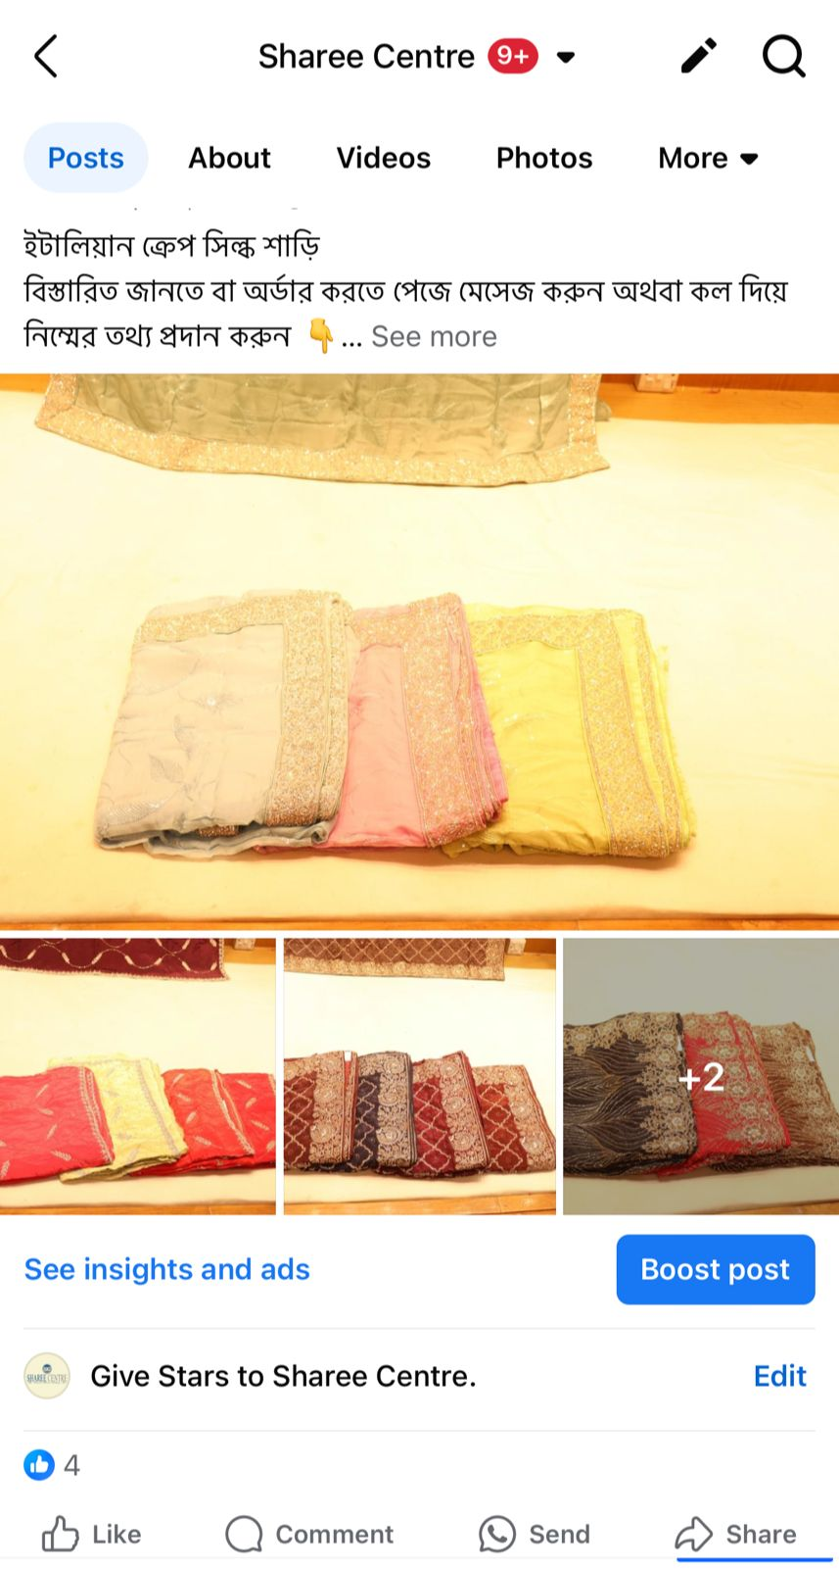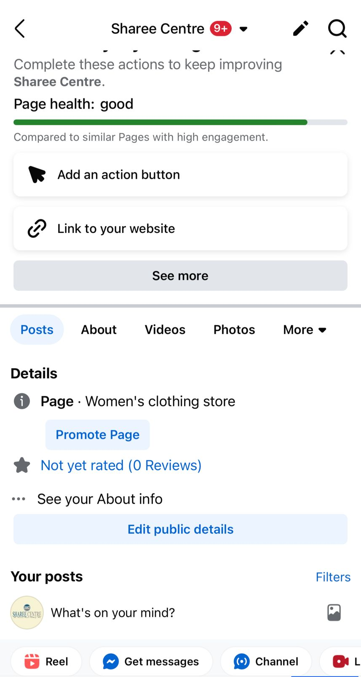
Appendix A: Digital representation of Sharee Centre Facebook page
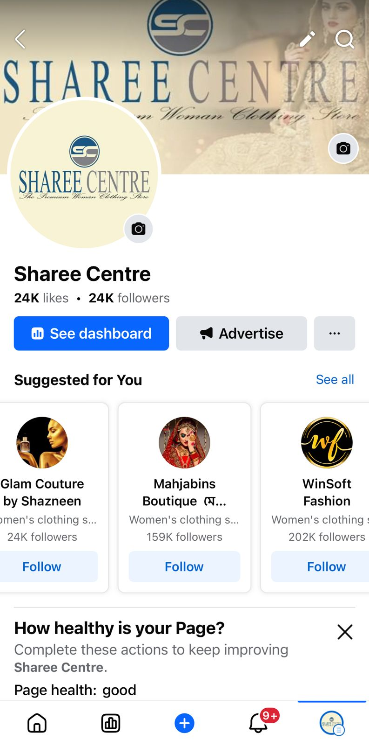
Appendix B: My Internship experience at Sharee Centre

