
Internship Report
Financial Performances of Advanced Chemical Industries Limited

Submitted To:
Rana Mazumder
Assistant Professor
School of Business & Economics

Submitted By:
MD. Asif Hassan
ID: 111 142 106

Date of Submission: 3rd August, 2019
Letter of Transmittal
3rd August, 2019
Mr. Rana Mazumder
Assistant Professor
School of Business & Economics
United International University

Subject: Application for accepting the Internship Report on “Advanced Chemical Industries Limited”

Respected Sir,
With due respect, I MD. Asif Hassan, would like to inform you that with the gratitude of the Almighty and your kind help I have finished the report according to your guidelines.
It was a matter of incredible joy to prepare this report. To set up the report, I gathered and examined materials and investigated to conclude some findings based on the issue of concern. I have put my level best efforts to prepare this report. So I would profoundly oblige if the substance of the report have been worthy to you.
Although I have put my best attempts, yet it is likely that the report may have a few problems or misunderstandings regarding the instructions given by you that are unexpected. Thus, I trust that the report will deserve your thoughts of concern.

Sincerely yours,
MD. Asif Hassan
ID: 111 142 106

Contents
Acknowledgement 3
Executive Summary: 4
Objective of the report 5
Scope of the report 5
Limitations of the report 5
Methodology 5
Industry Overview: 6
Development of Pharmaceuticals industry: 6
Major Pharmaceuticals companies: 6
Company Overview: 7
Important Events: 8
Mission: 8
Vision: 8
Values: 9
SWOT Analysis: 10
Finance and Planning Department of ACI Ltd. : 11
Corporate Finance: 11
Treasury: 12
Planning: 13
Costing: 14
Taxation and VAT: 15
General Accounting and Reporting: 16
Duties and responsibilities as an intern: 17
Financial Statements of ACI Ltd. : 20
Financial Analysis: 32
Profitability Analysis: 32
Liquidity Analysis: 37
Asset Management Analysis: 39
Recommendations: 41
Conclusion: 42
References: 42

Acknowledgement

I would like to thank cordially all the parties who have supported me to prepare and complete this elaborated and extremely insightful report. It wouldn’t be possible to execute this report without the assistance of the related parties.
First and foremost I would like to offer my gratitude to the Almighty who has given the blessing, strength and patience needed to process and complete the report. I would not forget the extraordinary support, guidance and knowledge provided by my instructor for the internship, Mr. Rana Mazumder, Assistant Professor, School of Business and Economics, United International University. His valuable guidelines and clear instructions has motivated me to work hard and implement the learning of the courses that I have been studying throughout my BBA life in this report.
I would also like to thank “Advanced Chemical Industries Limited” to provide me with the opportunity to work with them as intern. In this regard, I would like to thank specially my internship instructor from ACI Ltd. Mr. Tajnim Kabir Sakif, Deputy Manager of Accounts, for such valuable and helpful guidelines for completing any assinged task.
Honorary mention goes to my family, friends and colleagues for supporting me throughout and comforting me while I faced difficulties.

Executive Summary:
Bangladesh has a growing economy where the competition is immense. People’s purchasing power is increasing alongside the number of businesses in the market. To sustain in such competitive market a company must have to be profitable. To be profitable, achieving operational efficiency is a must, proper finance and planning procedure can help an organization to achieve that goal. Finance and planning activities of ACI Ltd. is very complex as strict rules are required to be followed and the number of SBU’s of the company is a many. With a well-organized finance and planning department, ACI Ltd. is quite successful in doing so. By working as an intern in this company, there were numerous things to learn as the culture of the company considers the intern as one of their employee.
At the end of the analysis of the financial aspects of ACI Ltd. it clearly proves that the organization is growing at a steady rate. It is generating enough profit, which acts as a financial strength to expand its business in future. Some of the reason behind such success would definitely be the well-structured departments of ACI Ltd., the most efficient workforce and coordination among them.

Objective of the report

The primary objective of the report is to understand the various components of “Advanced Chemical Industries Limited” and gain practical knowledge about the operations of the organization and how those affects its performance. The specific objectives include providing an introduction of ACI Ltd, brief introduction of its businesses, analysis of its financial performane etc. While preparing the report I have encountered lessons learned in the course and implemented those to evaluate the performance of a real life organization. This report emphasizes on quantitative and qualitative data in order to evaluate and conclude the performance of ACI Ltd.

Scope of the report

- Introduction of ACI Ltd. and its businesses.
- Duties and responsibilities as an intern
- Performance measurement of ACI Ltd using various ratio analysis such as profitability, liquidity etc.

Limitations of the report

- Vast amount of complex data
- Lack of in depth understanding of some of the topics
- Time constraint
- Use of assumed data

Methodology

I have extracted data from the annual reports of ACI Ltd. and used it to analyze the performance of the company as in the ratio analysis. Also I have taken data from the company itself from my area of work. Beside that there are plenty of information I have found over the internet to accumulate into this report.

Industry Overview:
In Bangladesh, Pharmaceuticals industry is one of the most developed and technologically advanced industry till todays date. The growth of this industry in last few decades is considerably impressive and still growing at a considerable rate. This sector is providing almost 97% of the domestic medicinal needs of this country. This industry does not only produce medicines to meet up the domestic needs, but it is also successfully exporting these medicines throughout different continents and sub-continents of the world though a small percentage of the total production. At present, this industry is exporting 3% of its pharmaceutical products amount to 1,200 products, to a total of 79 countries all over the world. This industry is also contributing to the development of the economy through contributing to the GDP.

Development of Pharmaceuticals industry:
The key factors for the development of this industry are as follows:
- Economic growth of the country
- Population growth rate
- Increased income level of the people
- Increase in modern healthcare facilities
- Health awareness of the mass people of the country
- Changing lifestyle
- High life-expectency rate
These are some of the main reasons behind the development of the pharmaceuticals industry of Bangladesh.

Major Pharmaceuticals companies:
The top ten pharmaceutical industries of Bangladesh are as follows:
- Square Pharmaceuticals Ltd.
- Beximco Pharmaceuticals Ltd.
- Opsonin Pharmaceuticals Ltd.
- Aristopharma Ltd.
- Incepta Pharmaceuticals Ltd.
- Eskayef Pharmaceuticals Ltd.
- Healthcare Pharmaceuticals Ltd.
- Renata Ltd.
- ACI Ltd.
- ACME Laboratories Ltd.

Company Overview:
Before the liberation of Bangladesh, a British multinational Imperial Chemical Industries, ICI, established one of its branch in the then East Pakistan in 1968. It was converted into ICI Bangladesh Manufacturers Limited after the liberation of Bangladesh. It was incorporated as a public company in 24 January 1973. In 1992, ICI divested its invstment to the management of Bangladesh and changed its name into Advanced Chemical Industries Limited, ACI Ltd. ACI Ltd. is now one of the biggest and well reknowned conglomerates in Bangladesh. ACI Ltd. is operating with a multinational heritage throughout the country with its four strategic business units such as ACI Pharmaceuticals, ACI Consumer Brands, ACI Agribusinesses and ACI Retail Chain.
ACI Pharmaceuticals is dedicated to introduce reliable and innovative pharmaceuticals products in order to improve the health of the mass people of Bangladesh. On the other hand, ACI Consumer Brands is working towards adding value to the consumers day to day life through its wide range of product offerings such as toiletries, hygiene, salt, flour, rice, edible oil, tea, home care, electronics, electrical, mobile, foods, paints and international businesses.
ACI Agribusinesses is well known because of its large integration in agriculture, fisheries, farm mechanization, livestock, infrastructure development services and motorcycles. ACI Retail Chain is the largest retail chain in Bangladesh. It is operating through its 73 ‘Shopno’ outlets throughout the country so far which is touching the daily lives of over 35,000 households each day.
ACI Ltd. has also contributed to the national economy with a huge amount in corporate taxes, custom duties and value added taxes (VAT), showing its immense importance in the growth of the economy as well as the growth of the country as a whole. ACI Ltd. contributed a total of 3,625 million taka to the national exchequer in the form of corporate taxes, custom duties and VATs during the financial year of 2017-2018.

Important Events:
Some of the important events of ACI Ltd. is as follows:
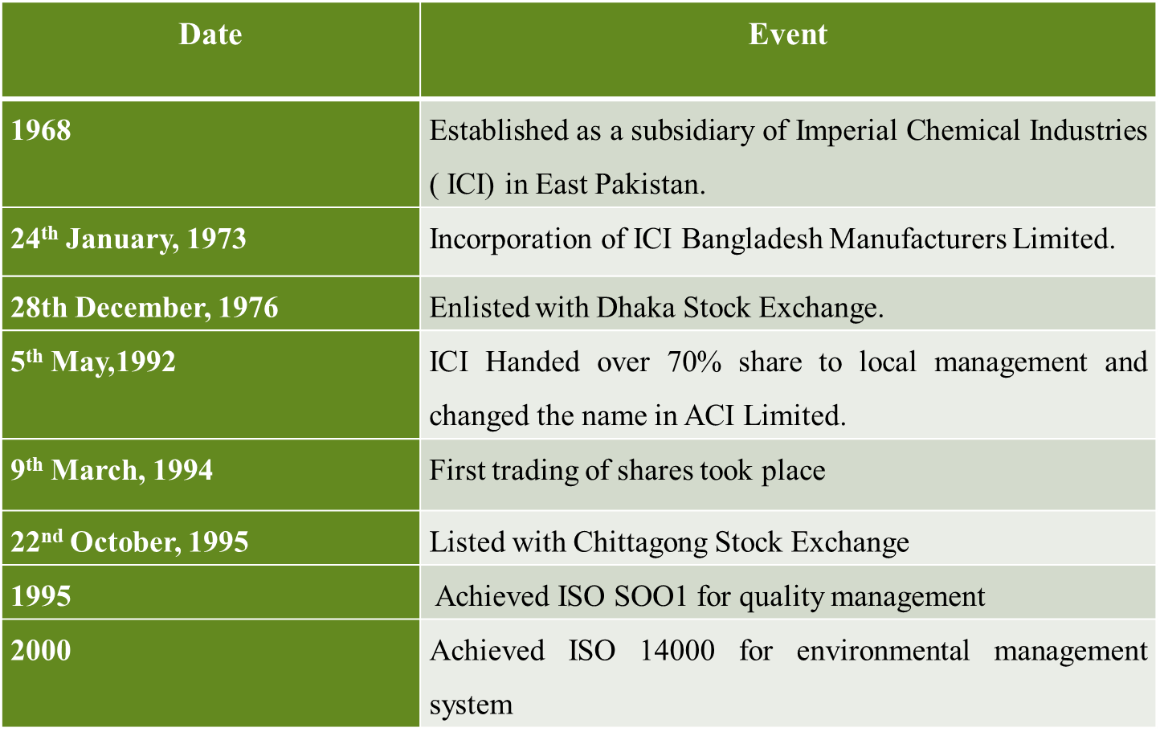

Mission:
ACI Ltd.’s mission is, through responsible application of technology, skills and knowledge, enrich the quality of life of the people of the country. ACI Ltd. is committed to pursue excellence through world-class products, empowered employees and innovative processes in order to provide the maximum level of satisfaction to its customers.

Vision:
To realise its Mission, ACI Ltd. will:
- Provide products and services of high and consistent quality, ensuring value for money to our customers
- Endeavour to attain a position of leadership in each category of our businesses
- Develop our employees by encouraging empowerment and rewarding innovation
- Promote an environment for learning and personal growth
- Attain a high level of productivity in all our operations through effective utilisation of resources and adoption of appropriate technology
- Promote inclusive growth by encouraging and assisting our distributors and suppliers in improving efficiency
- Ensure superior return on investment through judicious use of resources and efficient operations, utilising our core competencies

Values:
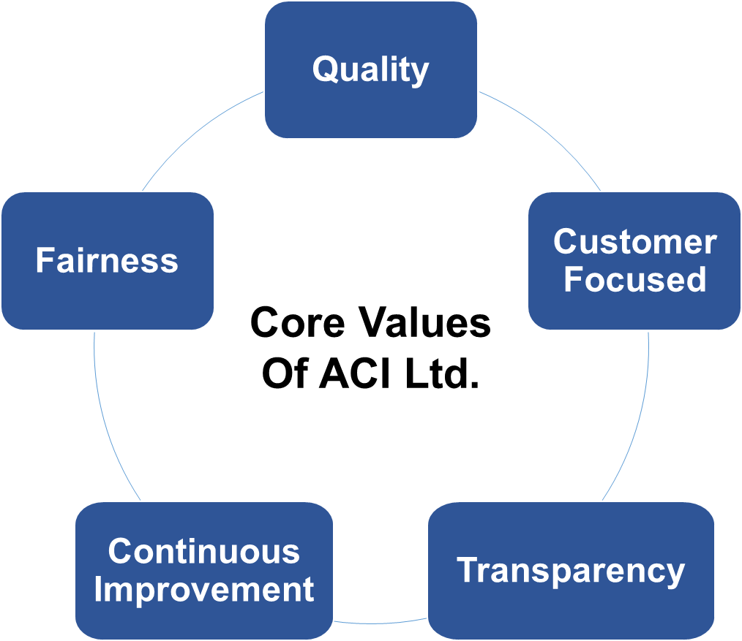

Employees of ACI Ltd. shares a specific set of core company values. The values are considered as the basic driving force of the organization. In ACI Ltd. whatever the business is the unit is that must instil all the core value in their operation.
- Quality
- Customer Focus
- Fairness
- Transparency
- Continuous Improvement
- Innovation
ACI Ltd. aims at delivering the best quality products to satisfy the overall customer demand along with bringing innovative products and processes to ensure future sustainability.

SWOT Analysis:
SWOT stands for Strengths Weaknesses Opportunities and Threats. This analysis is conducted to know about the actual scenario of the company regarding how it is positioned in the market. The SWOT analysis of ACI Ltd. is presented below according to my observation as an intern:
Strengths | Weaknesses
Very strong brand image. | High employee turnover rate.
Highly qualified workforce. | Weak inventory management.
Good number of loyal customer base. | Weak inventory management.
Decentralized decision-making structure. | Weak inventory management.
Good work environment and company culture. | Weak inventory management.
Opportunities | Threats
Exporting products to the foreign markets. | Strong competitors.
Online marketing and selling of products. | Entry of new competitors.
Capturing the market through extensive marketing. | Increased baraining power of the customers.
Making more inventments for faster technologies. | Increased bargaining power of the buyers and also of the suppliers.
Making more inventments for faster technologies. | Political instability.

Finance and Planning Department of ACI Ltd. :
A big conglomerate like ACI Ltd. needs to maintain its all department efficiently to survive into the market and it is doing just as it needs to do. It has very efficient departments like Finance and Planning, HR, Administration, MIS etc. As I have worked at the Finance and Planning department and saw its activities closely so I would elaborate this department in this upcoming segment. This department has very capable and efficient group of people as worforce and they are performing a really good job regarding the growth of this company. This deparment also have some custom made softwares for the most efficient conduct of the said department. Some of the major functional segments of this department are-
- Corporate Finance
- Treasury
- Business Intelligence
- Costing
- Planning
- Taxation and VAT
- Inventory Management
- Asset Management
- Credit and Payable Management
- General Accounting and Reporting
- Insurance and Claims
These are some of the main functional segments of Finance and Planning Department. Among these functional segements, some of them are briefly elaborated below:

Corporate Finance:
This segment provides with the required strategic directions to the company for the future betterment or growth of the company. Corporate Finance Manager (CFM) is the head of this segment and he works with Financial Reporting Manager, Corporate Reporting Manager and Financer Managers for performing the required activities of this segment.

Key activities of this segement are given below:
- Identifying the opportunities for process optimization.
- Monitoring the financial reporting process and evaluating the bookkeeping frameworks periodically.
- Adjusting the key objective of the organization as per the changing business environment.
- Assisting the Financial Director to make correct decisions regarding the organization’s operational activities.
- Supervising every step of the preparation of the annual report for the stakeholders.
- Maintaining an efficient communication with the business departments in terms of changes in arrangement, method and framework of accounting.
- Analyzing long-term and short-term financial data and the projected cash-flow statements provided by the business accountants. And combining all those to prepare the statement for the whole organization.
- Helping financial controller in preparing taxation planning and tax management.
- Assessing every new software tools before introducing it to the general operation.
- Evaluating the performance of every business to identify for any possible anomalies.

Treasury:
As one of the largest conglomerates in Bangladesh ACI has suppliers and customers from both home and abroad. Thus, ACI requires to perform a huge number of transactions every day which make the task of treasury very vital for this organization.

Key activities of this segment are given below:
- Arranging all bank transactions including electronic fund transfer activities.
- Ensuring all the transaction activities are running smooth and not hampered and take necessary precaution against any unfavourable situation.
- Preparing the fund management report of the organization.
- Preparing a daily bank reconciliation and maintaining debt cash and balances.
- Reviewing the existing policies regarding treasury of the organization.
- Suggesting any changes to ensure process optimization.
- They arrange both short-term and long-term borrowings as per the requirement of the business following the group policy.
- Handling the Letter of Credit (LC) related issues with the respective banks.
- Maintaining the availability of funds to ensure smooth operation.
- Monitor the exchange rate of foreign currencies.

Planning:
ACI Ltd. has different strategic business units so it requires a lot of planning activities to ensure proper coordination among them. As the company is still growing at a faster rate, planning section is playing a very influential role within the organization.

Key activities of this segment are given below:
- Preparing short- & long-term strategic plans to achieve the projected goals
- Preparing a projection for the long term investment decisions of the organization.
- Preparing the periodical projected business growth report.
- Judging the prospects of proposed business investment.
- Ensuring the proper segmentation of duties and goals.
- Realizing any future opportunities and proposing it to the business director.
- Preparing the optimal course of action for each of the operational units.
- Conduct a risk analysis depending on the historical data.

Costing:
This segment is responsible for the cost related issues of the products of ACI Ltd. It is also a very important segment for the organization and also contributing to the organizational success.

Key activities of this segment are given below:
- Preparing the cost of RM, PM, FG for the bookkeeping purpose.
- Conducting costing activities for the manufacturing purpose.
- Making sure that all the products are priced competitively with the market competitors.
- Finding out ways to support growth alongside increasing productivity.
- Looking into the financial reports for cost management.
- Managing the variability of different costs.
- Looking for ways to increase profitability by reducing the cost.
- Assisting business accountants to prepare different business reports.
- Prepare the inventory values for further accounting purposes.

Taxation and VAT:
ACI has a separate segment of employees to handle its VAT and tax issues which made the billing process of this company more accurate.

Key activities of this segment are given below:
- Ensuring proper application of the government Tax and VAT rule in every transaction of the organization.
- Revising the existing policies and make any changes if required.
- Ensuring that all the VAT or tax are paid in the due time.
- Preparing the income tax return for the tax authorities.
- Resolving issues with National Board of Revenue (NBR) when required.
- Checking all the bills to ensure that the due Tax and VAT are paid properly.

General Accounting and Reporting:
The success of any business depends largely on the business accountants. ACI Ltd has different strategic business units. It is the duty of the respective business accountant to keep track of the performance of each business. He records all the transactions, analyzes them, prepare different summary sheets and communicate it with the higher authority. Accounts section is divided as per different SBUs.

Key activities of this segment are given below:
- Preparing the various financial reports as per the requirement of Corporate Finance.
- Making sure all the financial guidelines are followed within the organization.
- Preparing necessary financial reports as per the requirements of higher authority.
- Keeping records of the RM, PM, FG purchase and bill payment.
- Preparing the ledger books for the month-end report.
- Processing and monitoring all the necessary transactions for daily operation.
- Preparing month end accounts report and submit it to the management body.
- Maintain the bookkeeping process and keeps the records using the software “Accounting Mirror”.
- Preparing sales forecast and cash-flow projection for the group.
- Preparing the annual, quarterly financial and consolidate reports by the guidelines of IAS or IFRS and other necessary regulation policies.
- Assisting the Commercial department to process new order contract.
- Acting as the linking point of the operational units and the decisional entities.

Business accountants of ACI Ltd. uses different softwares to perform their inventory management activities. It has specific software to record the movement of the inventory. Matplan software is used to issue purchase orders. It is also used to keep track of total RM, PM, FG purchase. FG software is used to know about the current stock statement in each depot. It also records inter-depot stock transfer.

Duties and responsibilities as an intern:
While working with ACI Ltd. as an intern I was assigned with several tasks or jobs by my internship instructor Deputy Manager of Accounts Md. Tajnim Kabir Sakif, from ACI Ltd. I have performed all the required tasks in time and coordinated the outcomes with my instructor. I was assigned to the business “Animal Health” during the internship period. Listed below are the tasks that I have performed throughout the internship period at ACI Ltd. :

- Yearly reconciliation: First of all, I downloaded all the required ledgers from the “Accounting Mirror” software of ACI Ltd. Animal Health Business. Then I reconciled the purchase, provision, openning stocks and closing stocks of 7 years starting from 2012 and ended on 2018. I was assigned to do this job to findout any mismatch or any sort of odd transations during these years. I reconciled these data based on the raw materials, packing materials and finished goods category of the business. There were local purchases and imports of the raw materials, packing materials and finished good purchases of the business as well that I reconciled. After the completion of the work, I coordinated all the outcomes with my instructor. He carefully reviewed my work and provided me with the feedback or any further extension of the assigned work.

- Monthly reconciliation: After the yearly reconciliation, I was asked to prepare the monthly reconciliation of the 7 years data based on the same parameters.

- Graphical Presentation: After all the reconciliation, I was asked to prepare all the graphs for the yearly reconciliation and monthly reconciliation as well. I prepared all the graphs for the raw materials, packing materilas and finished goods based on the local purchases, imports, provisions and others. I have prepared the graphs by year and month for the parameters.

- Powerpoint Presentation: After preparing all the required graphs, I was asked to prepare the slides according to the graphs. There were 7 powerpoint files for showing yearly reconciliation graphical slides based on the parameters and 84 powerpoint files for showing monthly reconciliation graphical slides of 7 years based on the parameters.

- Incentive Claims Validation: Incentives were given to the sales agents of ACI Ltd. Animal Health business based on several criteria at or out-reaching the budgeted sales for the specific agent for that particular month. I was required to check whether all the incentive claims were upto the incentive parameters. If there were any over-claims or under-claims then I had to discuss it with my instructor and he had provided me with the necessary actions or solutions for that aroused circumstance.

- Gathering Cost Cards: Cost cards are the cost information of a particular product such as raw materials requirement and costs, packing materials requirement and costs etc. I was given the task to gather some cost cards of the listed products that were burnt during an fire incident at the central warehouse of ACI Animal Health. I searched thouands of folders to gather those cost cards and found most of them. I listed the found product cost cards and also listed the missing product cost cards and coordinated it with my instructor for further process.

- Preparing Cost Cards: Among the missing product cost cards, there were some products whose cost card information was present but the cost card was not available. I prepared such products cost cards in the standard cost card format of the business.

- Searching for Missing Data: There were some information missing of the burnt products such as product codes, service charge etc. I searched for these data on several places and files and filled the missing data up.

- Voucher Requisition: After I have prepared the complete scenario of the burnt product list, I searched the purchase order numbers and goods receive note numbers of those products. Then after finding the purchase order numbers and goods receive note numbers of the products by different ways, I searched for their voucher numbers and date of the vouhers. This was necessary because of the collection of bills for those products that were burnt, so that the bills were presented to the insurance company for getting the insurance claims of those products.

- Maintaining and Processing Vouchers: I was responsible for the maintenance of the vouchers that were required for the burnt products and recording the updates of the voucher requisition. I was also responsible for the sorting of documents needed for the insurance claims by photocopying the documents such as bills, VAT challans, purchase orders and goods receive notes.

- Others: Except from the above activities I was also assigned some other works such as preparing minutes sheet, balance sheet variance calculation for two months, preparing ledger sheet, providing entry into the system regarding daily sales and some other small tasks.

Financial Statements of ACI Ltd. :
In this segment of the report, some year to year analysis of the financial statements of ACI Ltd. has been included. There are statements from the year 2012 to June 2018 of ACI Ltd. which has been analyzed below:
 | 2012 | 2013 | 2014 | 2015 | 2016 | 2017 | 2018
Non-Current Assets | 4,871,795,802 | 5,232,140,478 | 5,599,031,232 | 8,398,969,797 | 8,500,123,507 | 10,420,619,755 | 11,799,025,532
Current Assets | 8,334,671,204 | 9,325,114,983 | 9,927,161,551 | 10,959,604,714 | 12,606,552,622 | 16,635,915,968 | 23,887,594,556
Total Assets | 13,206,467,006 | 14,557,255,461 | 15,526,192,783 | 19,358,574,511 | 21,106,676,129 | 27,056,535,723 | 35,686,620,088
Total Equity | 5,081,286,160 | 5,637,252,251 | 6,606,685,402 | 11,715,154,000 | 11,949,320,001 | 12,992,476,616 | 14,299,505,906
Non-Current Liabilities | 1,023,498,102 | 955,165,854 | 560,716,324 | 1,095,446,134 | 1,112,584,338 | 1,176,530,562 | 1,069,711,660
Current Liabilities | 7,101,682,744 | 7,964,837,356 | 8,358,791,057 | 6,547,974,378 | 8,044,771,790 | 12,887,528,544 | 20,317,402,522
Total Liabilities | 8,125,180,846 | 8,920,003,210 | 8,919,507,381 | 7,643,420,512 | 9,157,356,128 | 14,064,059,106 | 21,387,114,182
Revenue | 9,680,061,562 | 10,683,600,712 | 12,318,723,190 | 14,566,843,648 | 22,508,056,043 | 18,305,730,559 | 21,387,105,125
COGS | 6,089,878,323 | 6,426,070,148 | 7,147,881,434 | 8,304,836,601 | 12,685,263,589 | 10,109,829,839 | 12,144,878,812
Gross Profit | 3,590,183,239 | 4,257,530,564 | 5,170,841,756 | 6,262,007,047 | 9,822,792,454 | 8,195,900,720 | 9,242,226,313

Non-Current Assets:
2012 | 2013 | 2014 | 2015 | 2016 | 2017 | 2018
4,871,795,802 | 5,232,140,478 | 5,599,031,232 | 8,398,969,797 | 8,500,123,507 | 10,420,619,755 | 11,799,025,532

Here, we can see that the non-current assets of ACI Ltd. is gradually increasing over the year starting from the year 2012. It indicates that the company is investing in its fixed assets more as it is growing over the years.

Current Assets:
2012 | 2013 | 2014 | 2015 | 2016 | 2017 | 2018
4,871,795,802 | 5,232,140,478 | 5,599,031,232 | 8,398,969,797 | 8,500,123,507 | 10,420,619,755 | 11,799,025,532
Here, we can see that the current assets of ACI Ltd. is increasing from the year 2012 but in a very small amount. But in the year 2018, it has increased dramatically more compared to other years which is beacuse the company has more inter company receivables as we an see in the financial statement of the company.

Total Assets:
2012 | 2013 | 2014 | 2015 | 2016 | 2017 | 2018
13,206,467,006 | 14,557,255,461 | 15,526,192,783 | 19,358,574,511 | 21,106,676,129 | 27,056,535,723 | 35,686,620,088

In this graph above, we can see that the total assets of ACI Ltd. is increasing gradually over the years except for the year 2018. In that year the current assets increased more compared to the non-current assets of the company.

Total Equity:
2012 | 2013 | 2014 | 2015 | 2016 | 2017 | 2018
5,081,286,160 | 5,637,252,251 | 6,606,685,402 | 11,715,154,000 | 11,949,320,001 | 12,992,476,616 | 14,299,505,906

The total equity of ACI Ltd. has taken a steady growth from the year 2012 to the year 2014. But it took a sudden hike from the year 2015 to the year 2018 which is a good sign for the growth of the company.

Non-Current Liabilities:
2012 | 2013 | 2014 | 2015 | 2016 | 2017 | 2018
1,023,498,102 | 955,165,854 | 560,716,324 | 1,095,446,134 | 1,112,584,338 | 1,176,530,562 | 1,069,711,660

In this graph we can see that the non-current liabilities of ACI Ltd. has gone through ups and downs and never took a increasing or decreasing pattern. But the non-current liabilities of the year 2014 has been drastically lower. The reason behind it, was the lower amount of deffered tax liabilities and lower long term loans as well.

Current Liabilities:
2012 | 2013 | 2014 | 2015 | 2016 | 2017 | 2018
7,101,682,744 | 7,964,837,356 | 8,358,791,057 | 6,547,974,378 | 8,044,771,790 | 12,887,528,544 | 20,317,402,522

Here, the current liabilities of ACI Ltd. is seen to be steady over the years from 2012 to 2017, but for the year 2018, it has taken an unusual hike. The reason behind such hike is the increased amount of loans and borrowings of the compay as we can see in its annual report.
Total Liabilities:
2012 | 2013 | 2014 | 2015 | 2016 | 2017 | 2018
8,125,180,846 | 8,920,003,210 | 8,919,507,381 | 7,643,420,512 | 9,157,356,128 | 14,064,059,106 | 21,387,114,182

In this graph we can see that the current liabilities of ACI Ltd. is way greater than the non-current liabilities of the company. It is not a good sign for the company because the total liabilities of the company would be much higher as we can see in this case and also it would cause some opportunity costs.

Current Assets VS Current Liabilities:
Here we can see that ACI Ltd. has more current assets than its current liabilities for all of the years. This is a good sign for any company and ACI Ltd. should maintain this ratio to efficiently meet up its current liabilities or short time liabilities.

Non-Current Assets VS Non-Current Liabilities:
In this graph we can see that ACI Ltd. has way more non-current assets than its non-current liabilities for all of the year. This is a very good sign for the company and by maintaining this ratio they availed themselves for any further greater amount of long term borrowings for growth of the company or any other reasons.
Revenue:
2012 | 2013 | 2014 | 2015 | 2016 | 2017 | 2018
9,680,061,562 | 10,683,600,712 | 12,318,723,190 | 14,566,843,648 | 22,508,056,043 | 18,305,730,559 | 21,387,105,125

Here we can see that ACI Ltd. has a steady amount of revenue growth from the year 2012 to the year 2015. But in the year 2016 it took a dramatic hike in revenue collection and again fell from that hike in the year 2017. Again the comany recovered from that fall and is growing revenue figure in the year 2018.
Revenue VS Cost of Goods Sold:
In this figure we can see that ACI Ltd. has a decent ratio of cost of goods sold and revenue collection over the years. But from the year 2016, the ratio has started to increase and the cost of goods sold is now less than it was for the other previous years. It is a good indication for the company because the company is now generating more revenue and incurring less costs. ACI Ltd. is becoming more efficient in production using latest technologies and they have achieved economies of scale for their increased production due to the increased demand for their product in the market.

Financial Analysis:
To analyze the financial condition of any company or entity we need to use financial ratios. These ratios helps us to evaluate the financial condition of an entity such as profitability, liquidity, returns etc. Here I would use different ratios to evaluate the financial condition of ACI Ltd.

Profitability Analysis:
In profitability analysis the ratios explain the ability to generate profit against costs of the entity. If the value is higher than the previous years, then the entity is doing well. Some profitability ratios are mentioned below:
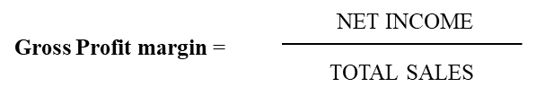
Gross margin, alone, indicates how much profit a company makes after paying off its cost of goods sold. It is a measure of the efficiency of a company using its raw materials and labor during the production process. It varies from industry to industry.
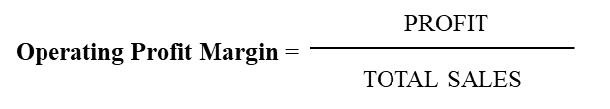
Operating profit margin ratio indicates to the proportion of the revenue after the operating costs. This ratio is important to both creditors and investors because it helps to show how strong and profitable a company’s operations are.
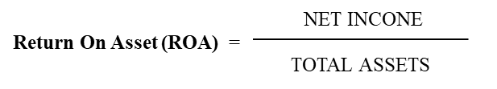
Return on Asset is a measurement of the ability of a company to turn the assets into profit. This is a very useful measure of comparison within an industry. A low return on asset ratio compared to industry may mean that the organization is operating less efficiently than the competitors.

Return on equity measures a corporation's profitability by revealing how much profit a company generates with the shareholders invested money.

The portion of a company's profit is allocated to each outstanding share of common stock. Earnings per share serves as an indicator of a company's profitability. It is very important ratio for the investors, as they use it to compare the company’s performance.

The profitability analysis of ACI Ltd. has been given below:
Years | 2012 | 20 13 | 2014 | 2015 | July 2016 – June 2017 | July 2017 – June 2018
Gross Profit Margin | 0.37 | 0.40 | 0.42 | 0.43 | 0.45 | 0.43
Operating Profit Margin | 0.10 | 0.11 | 0.14 | 0.10 | 0.08 | 0.07
Net Profit Margin | 0.06 | 0.07 | 0.08 | 0.22 | 0.06 | 0.09
ROA | 0.04 | 0.05 | 0.06 | 0.16 | 0.04 | 0.06
ROE | 0.11 | 0.14 | 0.14 | 0.27 | 0.09 | 0.14

Gross Profit Margin:
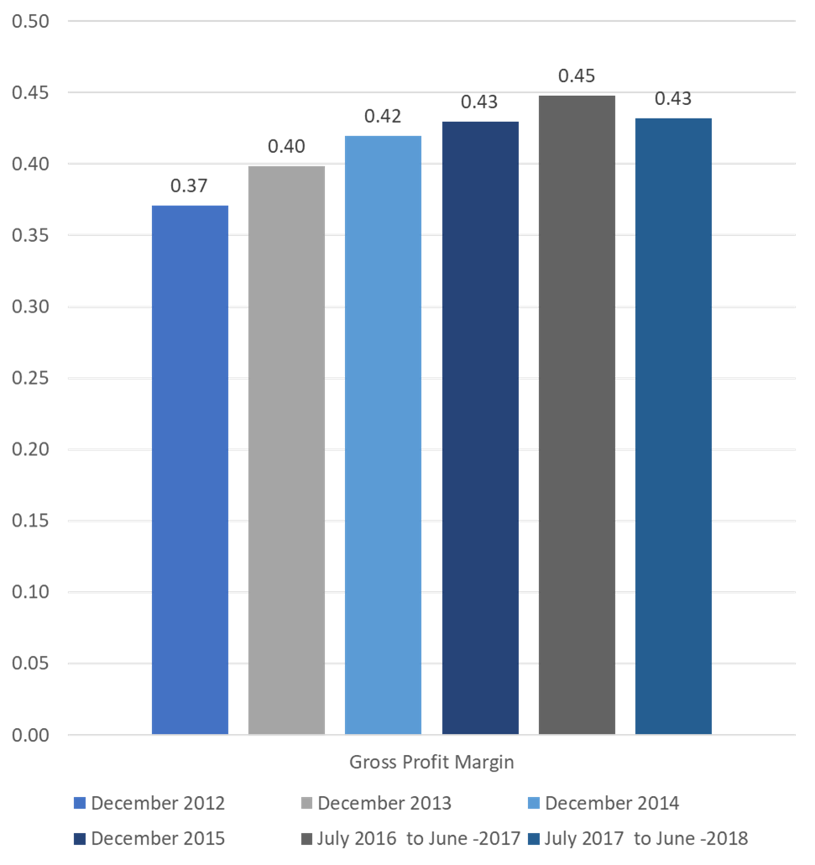
The calculation of gross profit margin shows that ACI Ltd. has performed better gradually over time, except for this year. Gross Profit Margin was increasing steadily from the year 2012 to 2017 which shows the companies commitment towards achieving operational efficiency.

Operating Profit Margin:
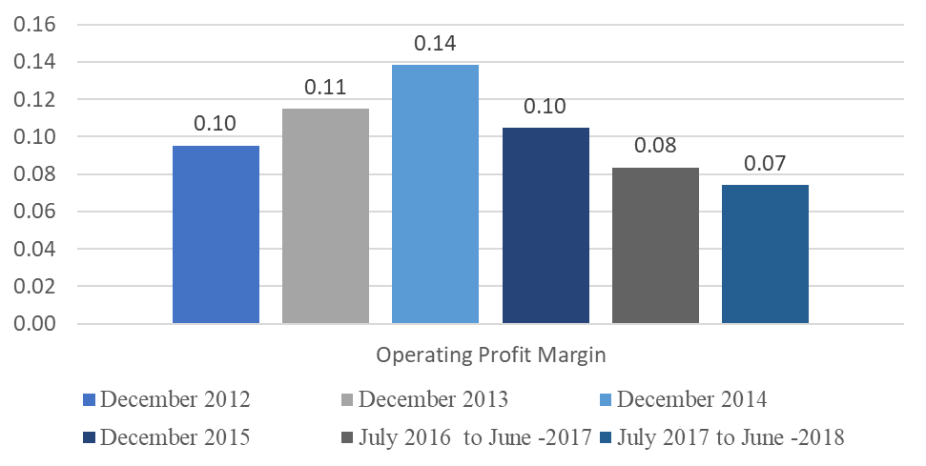
The calculation of operating profit margin shows the ratio of operating profit and the sales of ACI Ltd. Here, ratio from 2012 to 2018 shows that the ratio was highest on the year 2014. And last year the ratio was lowest which is not favorable for the organization.
Net Profit Margin:
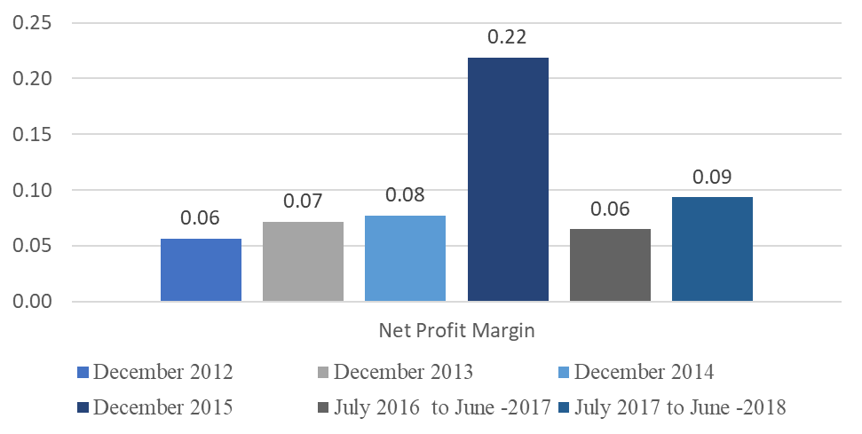Calculation of net profit margin shows the ratio of profit after tax and the sales of ACI Ltd. Here, ratio from 2012 to 2018 shows that the ratio was highest on the year 2015. Net profit margin changes for different reasons such as corporate tax policy and the price fluctuations of raw materials.
Return on Asset (ROA):
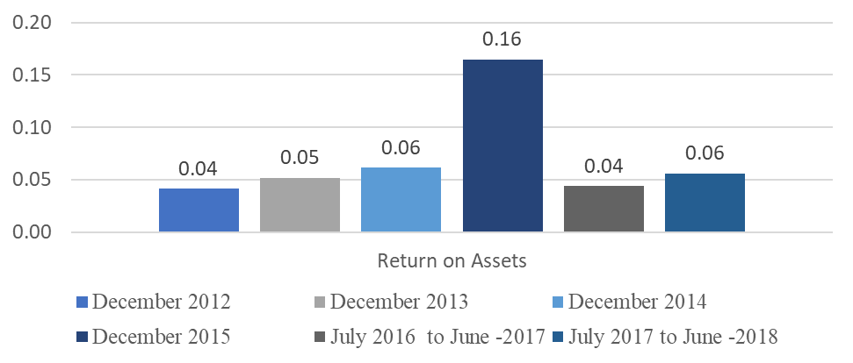
Return on assets is a measure of how productive a company is relative to its resources. After calculating the ROA for ACI Ltd. it is clearly seen that the company had the highest ROA on the year 2015. But it dropped drastically for the next year and again it has lifted up a bit for the last year.
Return on Equity (ROE):
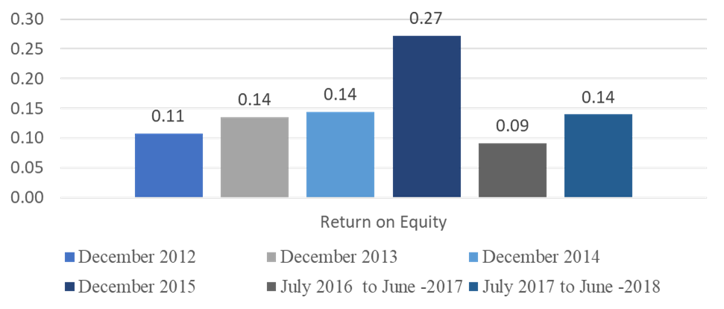
Return on equity acts as an indicator of operational efficiency. Calculation shows that ACI Ltd. has the highest ROE on the year 2015. Then it dropped in the next year and again the ROE is increasing over the next year.

Liquidity Analysis:
Liquidity ratios are used to evaluate the ability of a firm to handle its monetary issues in the shorter run. Here the ratios used to evaluate the liquidity condition of ACI Ltd. are mentioned below:
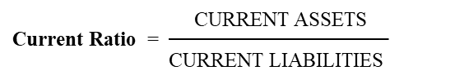
The current ratio is used to measure a company’s short-term liquidity position and to provide a quantitative relationship between its current assets (CA) and current liabilities (CL). When CA>CL, then the ratio would be greater than 1 which is a desirable situation for the organization. As it signifies that the current assets are more than enough to meet up its short-term obligations. If CA=CL, then the ratio would be equal to 1 which signifies that the current assets of the company are just enough to meet up its short-term obligations. But when, CA<CL, then the ratio would be less than 1 which is an unfavorable situation for the company because it does not have enough to pay for its short-term obligations.

Quick ratio is an indicator of company's short-term liquidity. It specifies whether the assets that can be quickly converted into cash are sufficient to cover its current liabilities. Quickly convertible assets or liquid assets include cash, marketable securities, and accounts receivables. The ideal quick ratio would be 1:1 but it varies according to the industry where the company belongs.
The liquidity analysis of ACI Ltd. has been given below:
Years | 2012 | 20 13 | 2014 | 2015 | July 2016 – June 2017 | July 2017 – June 2018
Current Ratio | 1.17 | 1.17 | 1.19 | 1.67 | 1.29 | 1.18
Quick Ratio | 0.87 | 0.85 | 0.83 | 1.07 | 0.92 | 0.92
Current Ratio: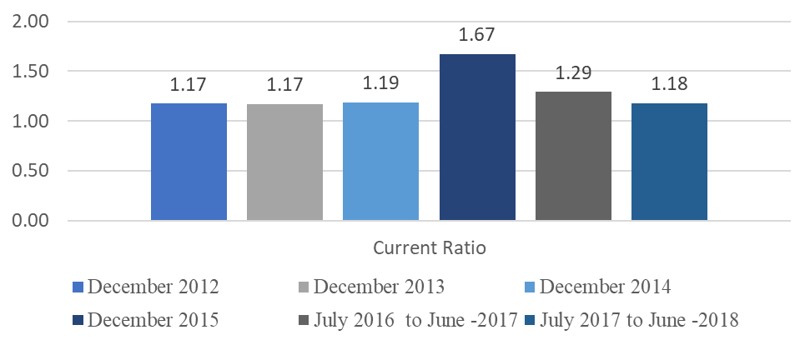
From the above presented graph it can be told that, in 2017 the current asset was 1.29 times compared to the current liabilities whereas, in 2015 it was 1.67 times. So it shows that the current liability is increasing against the current asset which indicates an unfavorable position for ACI Ltd.
Quick Ratio:
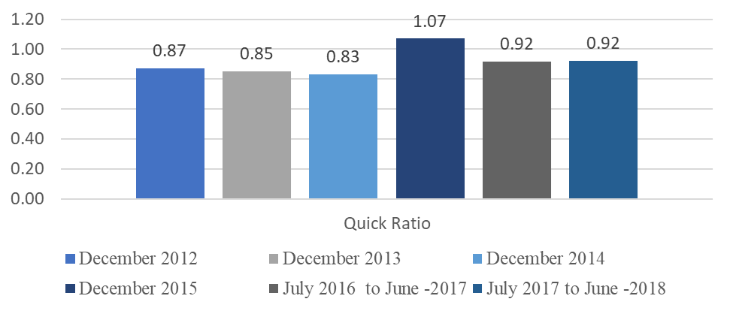
This ratio indicates that the current assets, except for the inventories, is .92 times compared to current liabilities which is lower than 1.07 times in 2015. So it can be said that, the inventories are increasing and lowering the rate of current assets compared to its current liabilities, which is not a good indication for ACI Ltd.

Asset Management Analysis:
Asset management ratios indicate the degree of entent of the company's capability in managing its resources for produce products. These ratios are mostly known as Activity or Turnover ratios. For this report purpose, the used asset management ratios are given below:
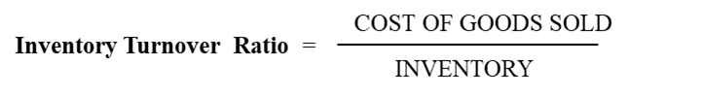
Inventory turnover ratio indicates the number of times the inventory is turned over into sales during the year or how many days does it take to sell the inventory of the company. This is a good indication of the production and the purchasing efficiency.
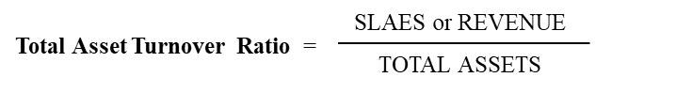
Total asset turnover ratio represents the value of goods and services provided to customers during a specified time period, usually one year. It signifies the efficiency that a business have in generating sales on each currency of assets it has. Increase in this ratio indicates that the organization in gaining in organizational efficiency.
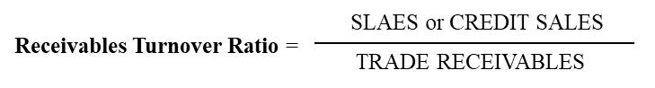
Receivable turnover ratio indicates a company’s use of its assets to generate revenue. The Accounts receivable turnover ratio is also an indication of the quality of credit sales and receivables. A company with a higher ratio shows that the credit sales are more likely to be collected than a company with a lower ratio. Since accounts receivable are often posted as collateral for loans, quality of receivables is important.
Days inventory outstanding (DIO) indicates the average number of days that a company holds its inventory before selling it. The DIO shows how quickly a company can turn its inventory into cash and is also used to determine the liquidity of the company’s inventory.
Days receivables outstanding (DRO) is a measurement of the average number of days that a company takes to collect the revenue after a sale has been made. A low DRO indicates that it takes fewer days for a company to collect its accounts receivable. A high DRO indicates that a company is selling its products to customers on credit and is taking a longer time to collect money.
Days payables outstanding (DPO) depends on several factors. Among them few are:
- Type of industry.
- Competitive positioning of a company – A market leader with significant purchasing power can negotiate favorable terms with its supplier and thus having a very high DPO.
- Competitiveness – if there are many suppliers in the market with a very little differentiation, then they would have to offer longer payment cycles to the client for gaining business.

The profitability analysis of ACI Ltd. has been given below:
Years | 2012 | 20 13 | 2014 | 2015 | July 2016 – June 2017 | July 2017 – June 2018
Total Asset Turnover | 0.73 | 0.73 | 0.79 | 0.75 | 0.68 | 0.60
Inventory Turnover | 2.86 | 2.52 | 2.41 | 2.10 | 2.10 | 2.38
Receivables Turnover | 7.49 | 6.76 | 9.12 | 7.47 | 5.35 | 4.40
Payables Turnover | 19.10 | 14.32 | 19.73 | 10.97 | 15.14 | 15.30
DIO | 126 | 143 | 149 | 171 | 171 | 152
DRO | 48 | 53 | 39 | 48 | 67 | 82
DPO | 19 | 25 | 18 | 33 | 24 | 24

Total Asset Turnover:
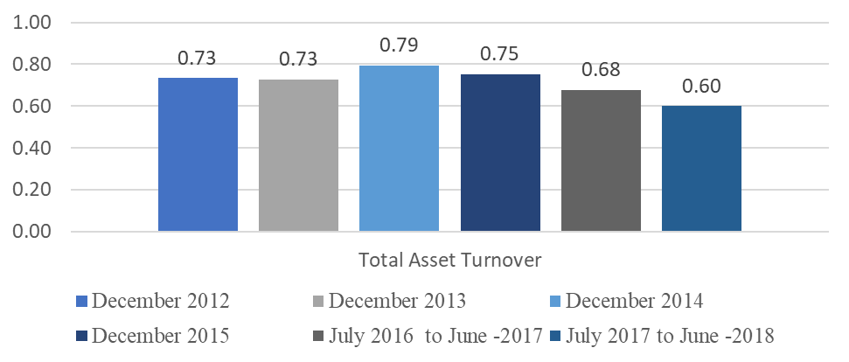
In 2018, for the total asset of each BDT1, ACI Ltd. has generated BDT 0.6 worth of sales. Total asset turnover decreased by BDT 0.08 than the year 2017. Total asset was a lot higher than the revenue in 2018. It indicates that, ACI Ltd. is gaining less sales by utilizing the same amount of assets compared to last years.

Inventory Turnover Ratio:
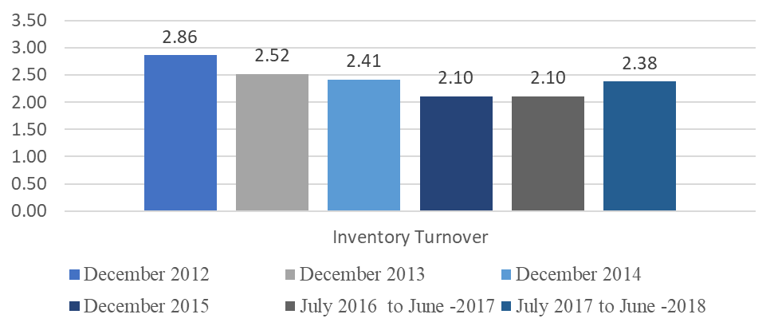
In 2018, for 1 tk of cost of goods sold, ACI Ltd. had BDT 2.38 worth of inventory. Inventory turnover ratio increased by BDT 0.18 than the year 2017. It indicates that, ACI Ltd. is keeping higher amount of inventory compared to the earlier years.

Receivables Turnover Ratio:
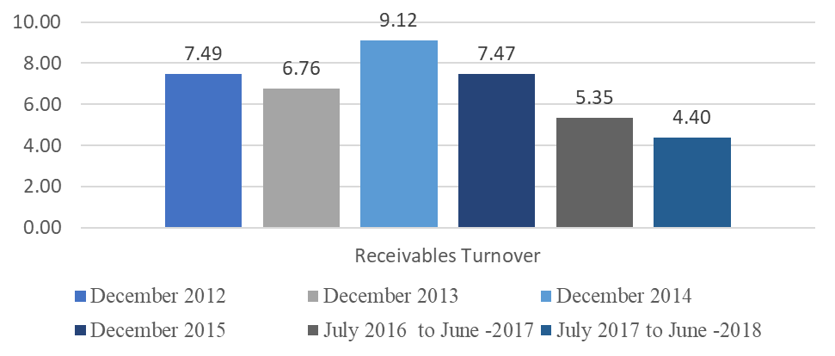
The receivables turnover ratio is showing a declining trend since the year 2014. It also indicates that the sales is mostly trade receivables which means to have unnecessary credit sales thus results in lower performance.

Payables Turnover Ratio:
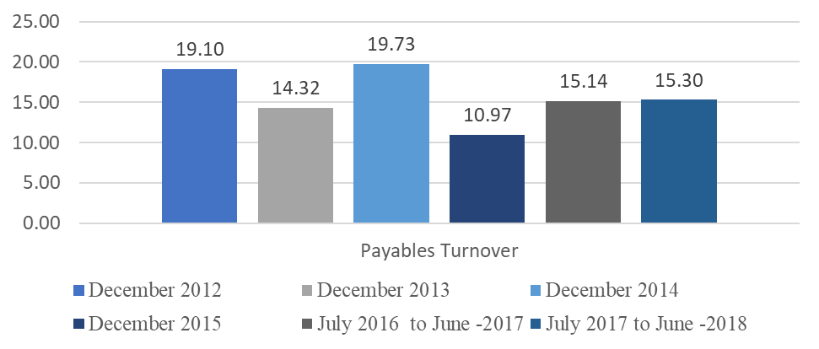
This ratio is showing a decreasing scenario since 2014 as well. It indicates that, the cost of goods sold for the years were lower than the amount of trade payables. It indicates that, ACI Ltd. is taking more time to pay to the suppliers, which is a good scenario for ACI Ltd. from the financial point of view but it could also damage the relationship between ACI Ltd. and its suppliers.
Days Inventory Outstanding (DIO):
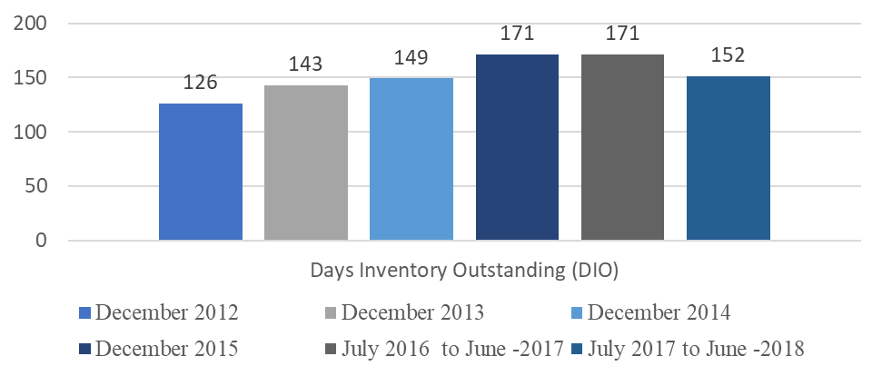
The DIO for 2018 is lower than the previous year which was 171 days,in 2018 it was 152 days. This means that on an average it took ACI Ltd. 152 days to sell the inventories. But compared to other years performance it is not the best scenario for ACI Ltd. As it took on an average 126 days to sell the inventory in the year 2012 which was the best case for ACI Ltd. in terms of selling inventories.
Days Receivables Outstanding (DRO):
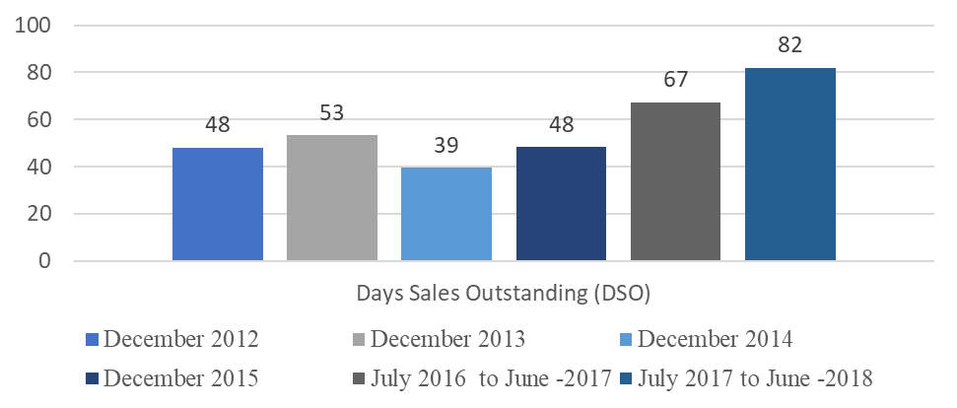
The DRO is highest in 2018 than the previous years. This ratio indicates that the trade creditors and the other creditors will take more time to pay their debts to ACI Ltd. But waiting for a longer period of time to get the required payments from the customers is an unfavorable for any organization. So ACI Ltd. is showing an unfavourable scenario in this case.
Days Payable Outstanding (DPO):
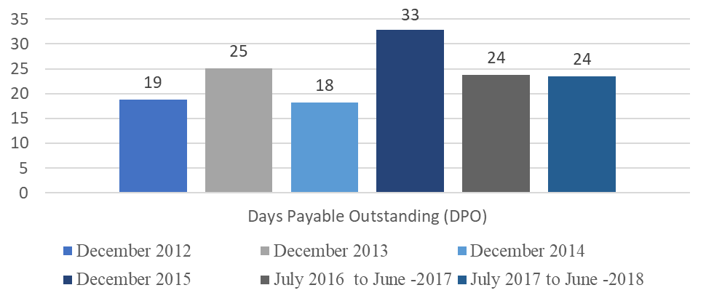
The DPO is same in 2018 as for the previous year which is 24 days. It indicates the number of days to pay ACI Ltd.’s accrued expenses.

Recommendations:
By working inside ACI Ltd, I was able to oversee the business of ACI Ltd. and have learnt a great deal from this company. This company has immense potential of becoming the market leader within a very short time and retain that position. Here are some recommendations I would like to draw which could be followed for the betterment of the company as I have observed working inside the company.

- There is still scope for automation, which will reduce the workload drastically. And also it will reduce the chances of error.
- ACI could introduce some global standard accounting softwares like Quick Book or SAP.
- ACI could offer more facilities to the customers such as online markets for buying, to be ahead in the competition.
- ACI could arrange marketing campaigns into different schools, colleges or universities to gain more publicity and customers as well.
- The recruitment process of the employees should be more organized, unbiased and competitive for hiring the best match for the company.
- ACI could provide justified salaries and compensations to increase the work motivation among the employees.
- ACI could reduce the number of paper-works and could strictly monitor any wastages of paper in their offices to contribute for saving the environment.
- ACI could manage their past documents digitally to be more efficient in work and to reduce the need for extra spaces as well.
- ACI could keep their office equipments up to date or always stable to reduce the wastage of valuable times of the employees.
- The MIS department needs to be more quick and alert to handle any sort of inconsistencies in the office.

These are some of the recommendations that I would like to make for the better future of the company.

Conclusion:
ACI Ltd. is one of the largest conglomerates in Bangladesh. It mainly operates in the pharmaceuticals industry, which is highly competitive in Bangladesh. ACI Ltd. is also competing in the market with its consumer products. But it is facing tough competition in the consumer brands as the number of players in the market is increasing every other day. And the customer’s perception is also changing rapidly. To sustain in this competitive market a company have to be profitable in the long run. Looking at the ratios of ACI Ltd., we can say that the overall performance of the company is low compared to the average industry performance. ACI Ltd. should ensure that all the resources are used optimally and the top management should think about the high costs that would reduce the profit margin of the company.

References:
- http://www.aci-bd.com/
- https://en.wikipedia.org/wiki/
- https://www.dsebd.org/displayCompany.php?name=ACI
- https://www.dhakatribune.com/business/stock/2019/05/18/most-pharmaceutical-companies-report-higher-eps
- https://www.dhakatribune.com/business/stock/2018/11/03/bangladesh-s-burgeoning-pharmaceutical-sector-ruling-local-market-stock-business-and-expanding-abroad

