Internship Report On

Overall Profitability of Greenland Technologies Limited


A concern of GETCO Group

Internship Report On
Overall Profitability of Greenland Technologies Limited

Supervised By:
Lamia Alam
Assistant Professor
School of Business & Economics
United International University

Submitted By:
Syed Aiman Ahmed Akash
ID: - 111-161-128
Major in Accounting
School of Business & Economics
United International University

Date of Submission: 04.02.2021

Letter of Transmittal
February 4, 2021
Lamia Alam
Assistant Professor
School of Business & Economics
United International University
Subject: Submission of Internship Report.
Dear Madam,
It is my enormous joy to submit you my internship report through which I have presented my generally day to day work insight during my internship period with the accounting department at Greenland Technologies LTD.
It has been a wonderful experience for me as I got the chance to work at Greenland Technologies limited as well as while preparing this report for you. Through this report, I have attempted to mirror my general everyday work experiences in GTL and other coupled points according to your prerequisites. I have talked about my duties as an intern, the company overview and my overall perception for Greenland Technologies Ltd.
I request your kind excuse for any mistakes which will take place in this report rather than my best exertion.
Thank you.
Sincerely

Syed Aiman Ahmed Akash
ID: 111 161 128
Acknowledgement

Firstly, I am thankful to the Almighty for giving me this opportunity and simultaneously, I want to precise my greatest appreciation to my academic supervisor Ms. Lamia Alam for providing me correct instructions and directions while preparing this report, without her assist this would have been a total failure.
I am also thankful to my senior manager of accounting department at Greenland Technologies Limited Md. Sheikh Abu Khaled and Assistant accounting manager Mamunur Rashid who gave me all the essential information that I required. They have helped me a lot in every single point, from topic selection to information collection and data analysis.
I am also very thankful to my fellow colleagues of Greenland Technologies Ltd. Who have been exceptionally encouraging and gave me their important time and sufficient data to effectively make this report.
Last but not the least; I want to thank my family member and friends, especially Syed Sajid Ahmed for his valuable time and too much help in completing this report as a fruitful one.

Executive Summary

Greenland Technologies Limited is a sister concern company of GETCO group. It is an exchanging organization who imports AED (Agricultural Division), IED (Industrial Division), additionally give administrations for the tractors. GTL moreover have a tender division who give benefit after getting any delicate for Government or privately owned businesses. GTL began its commerce from 2011, however it began its operational movement in 2014. Mr. Golam Ahram Kibria is the CEO of GTL, he is the noticeable choice creator of this organization who proceeding his process by taking proficient choices from 2011. He is key person of this organization.

Greenland Technologies Limited has 11 showrooms and has numerous dealer points all over the nation. They offer AED items like Tractors, Rotavators, Power tiller and IED items are KARCHER and INGCO. All of those items as of now ended up well known for its quality and service.

GTL gives farmers agrarian business arrangements by giving qualitative items and make their operational process easier. These days the rural commerce is being the beneficial commerce agriculturist, which is exceptionally supportive for our economy and the country.

Within the 3-month internship period, I have learned numerous utilizations of financial and accounting terms. In this internship report, I have talked about the SWOT analysis, financial position, profitability, selling methods and so on.

In comprehension, I realize that internship is a learning process. As a student I have acquired information and involved in Accounts department which benefitted me to think about the numerous business process essentially. Now I can execute my academic knowledge into the practice.

Table of Contents:
Chapter- 1: Introduction 1
1.1 Origin of the report 2
1.2 Objective of the report: 2
1.2.1 General Objective 2
1.2.2 Specific Objective: 2
1.3 Methodology 3
1.4 Scope of the study 3
1.5 Limitations of the study 3
Chapter 2: Company Profile 5
2.1 Background of Greenland Technologies Limited 5
2.2 Group History 7
2.3 Mission 7
2.4 Vision 8
2.5 The Board of Directors of Greenland Technologies Limited 10
2.6 Company policies 10
2.7 Division of GTL 11
2.8 Products of GTL 14
2.9 SWOT Analysis: 25
Chapter 03: Job Responsibility as an Intern at Greenland Technologies Limited 27
3.1 Accounting Department of GTL 27
3.2 Job Responsibilities 28
Chapter 4: Selling system of the Product 29
4.1 Selling procedure of products 29
Chapter 5: Financial Performance Analysis 30
5.1 Financial ratios: 30
5.2 Liquidity ratio 31
5.2.1 Current Ratio: 31
5.2.2 Quick Ratio: 32
5.3 Profitability Ratio: 33
5.3.1 Gross profit 33
5.3.2 Net Profit Ratio: 34
5.3.3 Return on Asset 34
5.4 Activity Ratio: 35
5.4.1 Inventory turnover ratio: 35
5.4.2 Asset turnover ratio: 36
5.5 Debt to equity ratio: 37
Chapter 6: Findings 39
6.1 Liquidity Ratio 39
6.2 Activity Ratios 39
6.3 Debt Ratios: 40
6.4 Profitability Ratio: 40
Chapter 7: Recommendations 41
Chapter 8: Conclusion 41
Chapter 9: Appendix 42
Chapter 10: Bibliography 43

Chapter- 1: Introduction

Bangladesh's Economy is greatly relied upon farming. Amid money related year 2017-2018 farming part alone had a commitment of 21.03% in the GDP progress. Major macroeconomic components like business age, dejection diminish, HR headway and prosperity of sustenance’s by and large depend upon the execution of the agribusiness part since it includes about 32% of the country's GDP and using around 65% of the outright work urge. Time to time inquiries about are being done in order to achieve flow propels with the objective that new yields can be made and water framework, gathering and such walks of improvement can be arranged even more perfectly so we, as a country, can ensure food security. Agribusiness based region is continuing to create with the usage of front-line advancement and present-day equipment. In Bangladesh agrarian division suggests trim turn of events (basically paddy, jute, wheat, sugarcane, cotton, vegetable, tea, tobacco, etc.).
To insist persevering improvement in this division, we need to give the farmers pushed devices to the turn of events. Thinking about it, Greenland Technologies Limited began its action with a thing extent of provincial devices like ranch hauler, power tiller, diesel motor, water siphon. These mechanical assemblies have a tremendous response from farmers.
GTL motors is getting this equipment from India, China, Germany and various countries. GTL Motors works their business practices by developing arrangements and organization center in various bits of the country and assigning venders wherever all through the Bangladesh. The certified business is for each situation incredibly engaged and complex, along these lines, each business needs to defy the extraordinary test and viably work inside this forceful condition. To remain and construct the speed in the business track, the perception and brand care is basic. Perhaps two or three things like Tractor, Power Tiller, Rotavator are logically expensive so customer not prepared to buy in genuine cash. In this position, GTL Motors empowers them to get them in credit where they can pay the portion over the time frame in bit.

1.1 Origin of the report
Internship is very important and the ending period in a student’s life. It is the arena where an understudy meets the real working environment and, obtain the way of working with official teach. They got to choose to memorize modern things and official undertaking. One student acquires hypothetical understanding in his/her long 4 years’ study period however useful information are acquired through the internship program. It is the significant and a time of full quality for an understudy just to utilize that hypothetical information in down to earth existence. During the entire temporary job period while preparing report, a student can get familiar with the useful method to utilize their hypothetical information.
I completed my internship program at Greenland Technologies Limited also known as GTL under the department of accounting. I focused on the significance in the profitability of GTL for that I named the topic of my report “Overall Profitability of Greenland Technologies Limited”. The supervisor of the organization Md. Sheikh Abu khaled (senior Manager, accounts receivable, GTL) and the supervisor of United International University institutions, Assistant Professor, Lamia Alam mam accepted it.

1.2 Objective of the report
1.2.1 General Objective: Main goal this report is to accumulate down to earth information and experience for speaking to the genuine circumstance of the farming hardware and variety of apparatuses business in Bangladesh.
1.2.2 Specific Objective: I mainly discussed about:
- The GTL drew closer to the agricultural and modern apparatuses business.
- To comprehend the financial performance of GTL on various zones, for example, liquidity, benefit and correctness.
- Evaluating the organization's viability and shortcoming the fragments.
- Making suggestions for improving in these zones where it is needed.
- Distinguishing the significance of AED item in the farming area.
- Knowing the portion and renting cycle of AED item.
- To think about the results of default in AED area.

1.3 Methodology
To prepare a report two types of data are being used. And those are-
1) Primary data
2) Secondary data
- Primary sources of data: The primary sources of data are collected directly by observations and conversations. In the period of internship, I have observed many activities of GTL.
- Secondary sources of data: The secondary sources of data are gathered from outside sources like websites, newspapers and books, annual report of GTL etc.

1.4 Scope of the study
While GTL is a privately owned business, they don't unveil their financial data. I gather the information and important data via looking in the web, gathering data structure the organization's site, individual meeting with predominant. By this procedure I collect data to set up this report.

1.5 Limitations of the study
I worked in the Greenland Technologies LTD for 3 months as a trainee which was a very short time. But because of the environment of Greenland Technologies LTD is very congenial so it was a very big opportunity for me to work under them. I was always treated very well by every one of my department. Though its known to every one of us that there has some regulations in every organization. That’s why It was very difficult for me to collect the data in short time for preparing this report.
- Proper search isn't feasible for the time limit.
- Company do not unveil their financial report. It’s a limitation to collect financial information.
- External individuals like an intern can't discover information and reports which is disallowed by the organization.
- As a new comer I also didn’t understand some terms, policies and so on.
- In a private company the employees are always busy to do their tasks as a result I faced many difficulties to collect information from all.
- Distance is also limitations because many showrooms are situated outside of Dhaka, so it’s difficult to collect proper authentic information and understand that.
- Because of the hierarchical confidentiality, Relevant information and archives assortment were troublesome.

Chapter 2: Company Profile

2.1 Background of Greenland Technologies Limited
Begun with just a single sales representative, Head of activity additionally figured out how to bring the newborn child organization to an average size organization where there are presently Greenland Technologies Limited (GTL), a concern of GETCO Group was set up in 2011. GTL is claimed by K.M. Khaled (Chairman), K.M. Rakib Hasan (Managing Director) & K.M. Mobarak Hossain (Director) & it was built up in 2011 however begun its activity in 2013. Being motivated and coordinated by Chairman, Chief Executive Officer Golam Arham Kibria overseen to induce merchandiser of

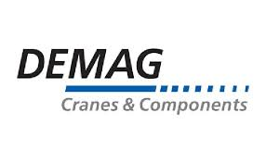 | 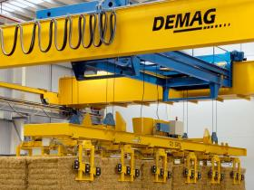
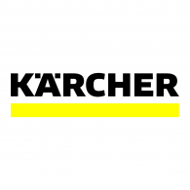 | 
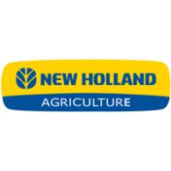 | 
 | 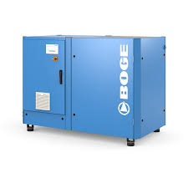
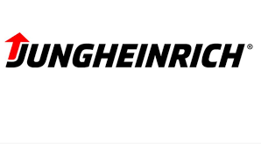 | 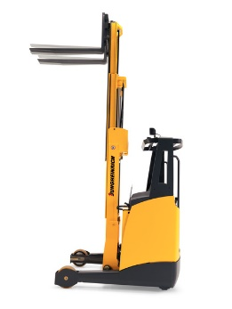
And some multinationals equipment companies.

There are presently in excess of 200 workers, with 11 showrooms, 2 distribution centers, Main office is in Chittagong. We are administered by Enterprise Resource Planning. Sales groups are operating the call centers. All the equipment’s are provided to the showrooms to operate the work in a beautiful way. Greenland Technologies Limited have selected most reputable audit firm ACNABIN as an external auditor who is appoint to audit GTL’s entire operation framework, simply to guarantee that GTL will be globally certified organization for its activity strategies by the end of 2019.
GETCO Group is one of the valuable and presumed organization in our country. Throughout the most recent forty-five years it has changed itself through a little exchanging organization into a driving expanded company in BD. GETCO Group comprises of nine sisters concern and Greenland Technologies Limited is one of the significant parts of the group. GTL is operating productively in numerous business region. The workers are exceedingly committed for their organization. There are lots of workers who have the knowledgeable and proficient quality to operate an organization. The workers continuously help the administration in great & terrible condition. They are additionally offering the types of assistance subsequent to selling the item. The organization has association with giant course producer who will give excessive course item to them & furthermore has area specialist who will give the item after sale services and they are huge talented to tackle any sort of specialized issue in the item by taking a least benefit charge. Greenland Technologies Limited was set up in 2011 which provides in domestic economy through economical soluble to the agrarian segment and Industrial Division. Their vital business units are agriculture machineries for farmer, cleaning equipment for household for industrial cleaning apparatuses gives exceptionally effective items to satisfy the vast hole in the market. Their point is to give this country a superior present and future with absolute answer for the farmer, families and industrial area throughout motivating developments & sharp attention on innovative work.
They have the skill & apparatus to supply their customers with a total extend of facilities essential to exaggerate their agrarian speculation. Their group member has continuously been at the front line to figure out interest of producers just as the need of last clients within the target showcase. They accept that for the beneficial of today’s worldwide farming and industry, it is fundamental to help to the grower’s advantage, interest and joy, in addition to satisfying desires of the ultimate customer, cost and quality wise.

2.2 Group History
Presently, GETCO has become GETCO Group under which there are following organizations
- GREENLAND ENGINEERS & TRACTORS COMPANY LIMITED
- GETCO TELECOMMUNICATIONS LIMITED
- GETCO LIMITED
- HRC TECHNOLOGIES LIMITED
- GETCO BUSINESS SOLUTION LIMITED
- GETCO DIGITAL LIMITED
- GETCO ELEVATOR LIMITED
- GETCO AGRO VISION LIMITED
- GETCO AGRI- TECHNOLOGIES LIMITED
- GREENLAND TECHNOLOGIES LIMITED

2.3 Mission
To reach our vision, we have taken the underneath attributes as our mission:
- Transparency: We do not give up trustworthiness for benefit. We are responsible to our group individuals, clients and investors for accomplishing our objectives whereas ensuring our reliability & resources.
- Veneration: We offer secure & sound surroundings for our group individuals. We serve all individuals with respect & honor. We esteem the distinctions in person’s considering, foundations and societies. We are resolved to group part improvement.
- Headway: We consistently look for new and superior methods of getting things done, disposing of waste and constantly improving.
- Customer Service: After the quality of the product, we give more priority to the customer. Customers get proper services from us even after buying the product.
- Valor: We have the individual and proficient strength to do the correct thing and face challenges that may make us win just as to fall flat occasionally. We make choices and take action.

2.4 Vision
Our commitment is to give the most straightforward arrangement to create and feel life simpler. Our company has continuously focused on client fulfillment with uncompromising judgment. Client is the primary goal in any case.
We persuade to cultivate a culture that values diligence and reliable advancement towards end of the objective of the organization. We attempt to create green our nation is our vision 2020.

Management and focus of the Greenland Technologies Ltd
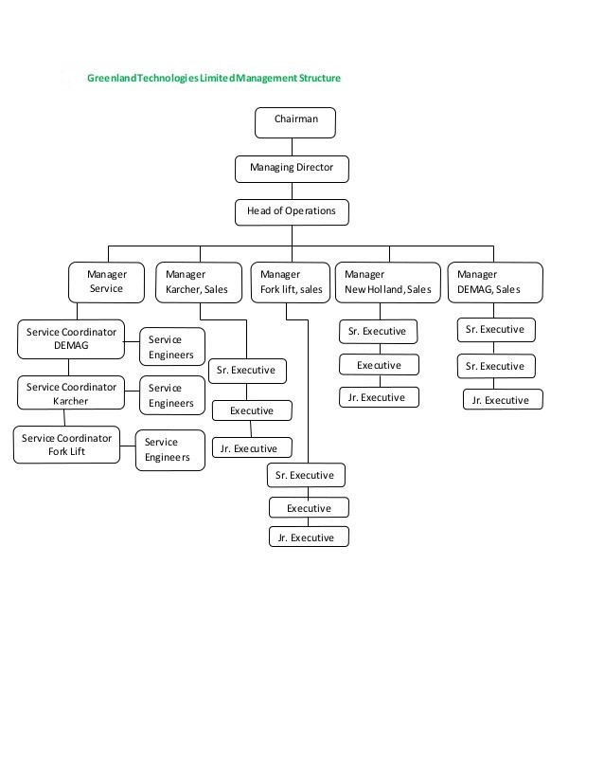
Distribution Network
GTL has a huge warehouse in Shyamoli. Without it, GTL has 11 showrooms over the country and 4 dealers in different areas.
- Bogra
- Comilla
- Dinajpur
- Hobiganj
- Gazipur
- Rangpur
- Thakurgaon
- Jamalpur
- Mymensingh
- Jessore
- Chuadanga
They convey their all the vehicles and apparatus equipment by these showrooms. Besides, they also are conveying their equipment through
- Bikroy.com
- Ajkerdeal.com
- Pickabo.com

2.5 The Board of Directors of Greenland Technologies Limited

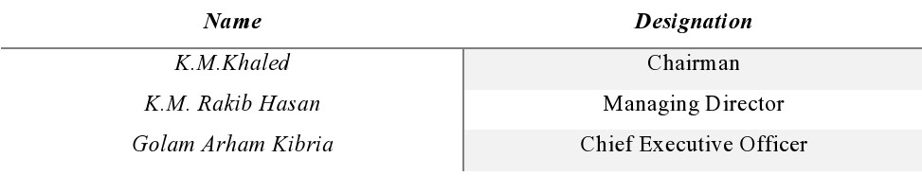

2.6 Company policies
EMI Payment
The customer pays the said entirety in proportionate EMI, which are known as an agreement purchase portions and at the end they are needed to pay all to have the Tractor.

Fees and Charges
Interest system
The total entirety the customer repay to the money organization is known as the contract price tag. It is included:
• The money measurement of the tractor, in addition to
• Interest, in addition to
• Expenses to set up and conclusion the understanding.
Price of Tractor | Depends of Tractor Model
On time payment | 30%
Interest | 15%
Time | 36 Months or 24 months
Registration Fees | 16,000/-

Other conditions:
- The spot and season of transport and the hirer's commitment to suffer movement charges are consolidating into the agreement.
- All information with (name, address) of the first and second assembling that is the GTL Company and the buyer.
- The understanding will be endorsed by both the party.
- If the buyer ends up unsuitable to pay the segment need to give 100 tk. late costs each day. For the present circumstance association decision will be indisputable.
- Other costs and charges other than interest, for instance, enlistment cost, insurance costs, credit check costs, and security valuation costs, default expenses that is, costs customer ought to pay on the off.

2.7 Division of GTL
GTL works with the accompanying divisions:
- Sales Division
- Service Division
- Finance and Accounts Division
- HR and Admin Division

SALES DIVISION
1. Agricultural Equipment Department (AED) - as agricultural exercises takes put all over Bangladesh, so we got to offer our Tractors, Rotavator, Power Tiller and Diesel Motor in each corner of Bangladesh. Accordingly, we have presently seven showrooms and twenty-five sub dealers selling our items. Our primary ware house of tractors is in Jessore.
2. Industrial Equipment Department (IED) - The industrial center points of Bangladesh are primarily found around Dhaka and Chittagong. We cover these regions from our Head Office in Dhaka, Gazipur and Chittagong office.
3. Sub-Dealer Department - This office is locked in to create and oversee sub vendors all over Bangladesh. This additionally incorporates online business channels.

SERVICE DIVISION
1. Agricultural Service Division- To supply amazing aftermarket benefit, GTL has service group under each showroom. Each group is administered by a service engineer. As each group must cover huge ranges, each group part is equipped with calculated instruments, bikes and tab.
GTL is planning to build up two state- of the art tractor service centers as proposed and directed by New HOLLAND.
Industrial Service Division- There are two service divisions under industrial service division.
KARCHER: We have KARCHER endorsed state of the art service center in our Head office in Dhaka which is reviewed annually by KARCHER Germany office. The entire KARCHER service group is very much prepared by KARCHER Singapore office.
JUNGHEINRICH: We have JUNGHEINRICH endorsed state of the art service center in our Head office in Dhaka which is additionally inspected annually by JUNGHEINRICH Germany office. The total JUNGHEINRICH service group is all around prepared by JUNGHEINRICH Singapore office.

FINANCE AND ACCOUNTS DIVISION
Headed by a qualified Chartered Accountant with more than fifteen years’ involvement in accounting and finance has the duty to operate this division. This office controls the records and all monetary issues of the organization. It keeps up associations with the managing an account and non –banking money related institutions within the nation as needed every now and then. This office has likewise the duty to take care of the business and strategic capacities regarding import of equipment and materials by the organization.

HR AND ADMIN DIVISION
HR DEPARTMENT: A Manager who has 18 years of involvement with organization & human asset advancement is supervising this division. This Department takes care of all the authoritative capacity, Human Resource (HR) including security necessities of the organization and is likewise answerable for the prosperity of the representatives.

ADMIN DEPARTMENT: Our Administration office is the foundation and also spine of our association. It gives the viable connect between our organization's numerous sectors and it assures the well-ordered passage of data from one sector to the another and furthermore guarantees the smooth running of our organization.
Beside that there are some other department as well.

SALES SUPPORT DEPARTMENT
GTL has an exceptionally proficient Call community which serves to deal the items and furthermore to construct a decent connection with clients. The Company also take clients criticism from their clients by calling them or within the time of offering company’s items. In the event that clients have any inquiries about the company or item at that point the community right away give data based on client require.
R&D and BUSINESS DEVELOPMENT DEPARTMENT
Greenland Technologies Ltd. draws in Research and Development (R&D) exercises by interfacing with corporate or legislative advancement helping in commercialization of new items. Research and development division of the organization consistently attempt to growing new items for our developing business sector and furthermore attempt to welcome minor departure from existing items. GTL consistently need to bring the better arrangement of any issue which they can settle by their items. That is the reason the little organization become an average size organization by putting forth a valiant effort.
IT DEPARTMENT
GTL has their own IT Division. IT is capable for giving the framework for mechanization. This office executes the administration for the utilize of organize and working frameworks.
CORPORATE SOCIAL RESPONSIBILITY
Greenland Technologies Ltd. contributes in different Corporate Social Responsibility (CSR). The Company works throughout the long time which incorporate the cleaning of Shahid Minar and different statues and memorabilia inside the Dhaka University Campus. They have also put forward a mammoth assignment of cleaning whole Bashundhara locale right after Eid-Ul-Azha.

2.8 Products of GTL

Agricultural Equipment
Name of The Principal | Product
New Holland | Agricultural Tractors
Agriculture Masque | Rotavator
Jiang Dong | Power Tiller
Spark Minda | Starter Motor & Alternator
Petronas | Oil & Lubricants
Industrial Equipment
Name of The Principal | Product
Karcher | Cleaning Equipment Material
Jugheinrich | Handling Equipment Hand
Ingco | Power Tools
Tvh | Spare Parts
Construction | Equipment Generator
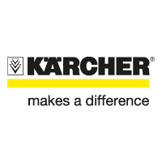
Greenland Company has a few sorts of Karcher items which are totally imported.
Home & Garden


Cleaning Solution from Germany





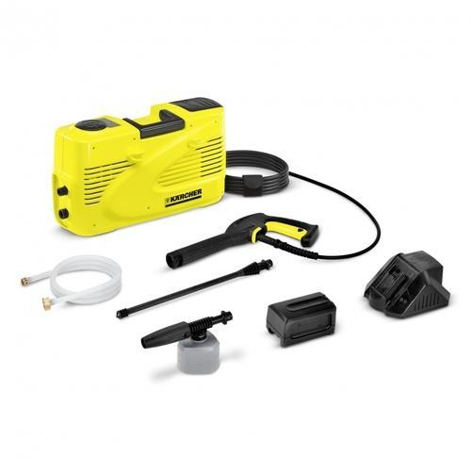
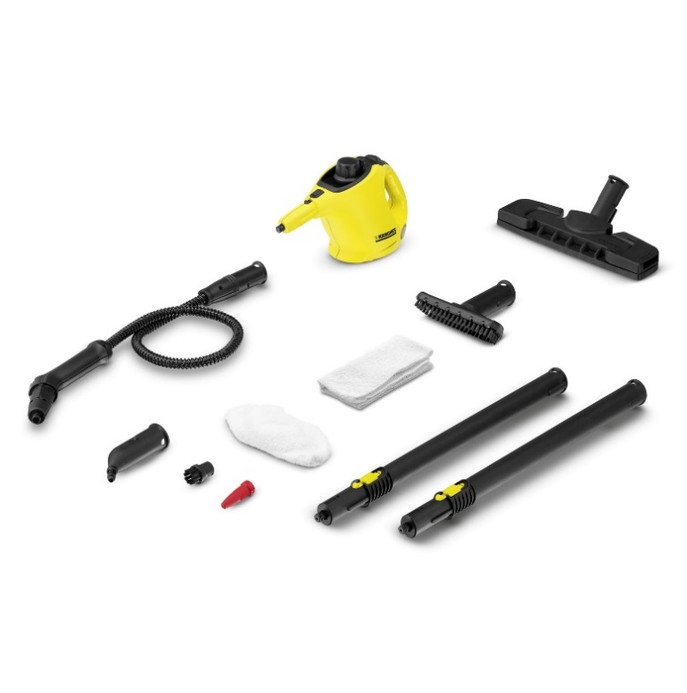

Karcher
Industrial cleaner
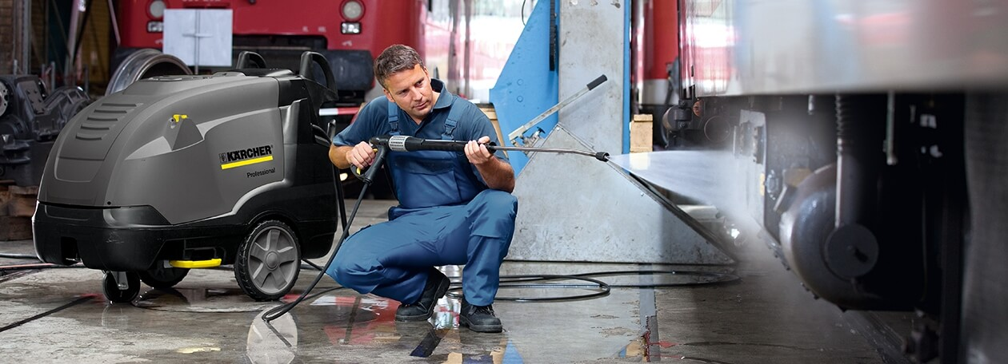
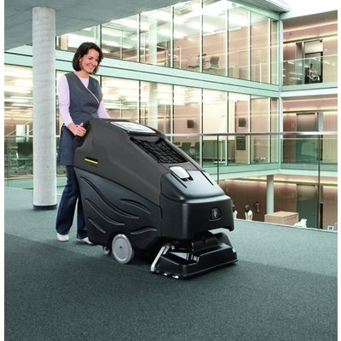




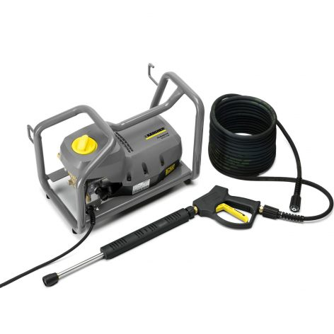



Water Purifier
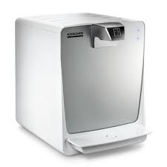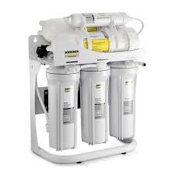
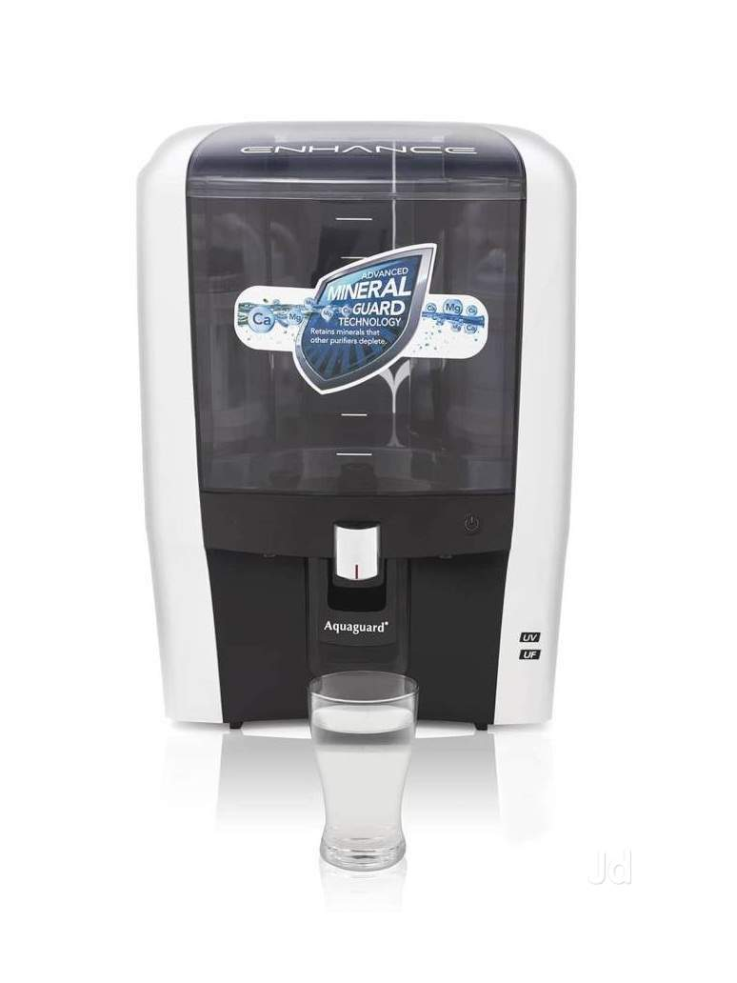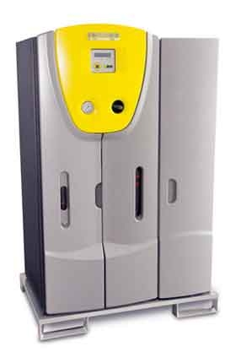

Air Purifier
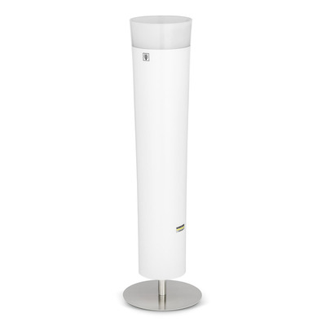



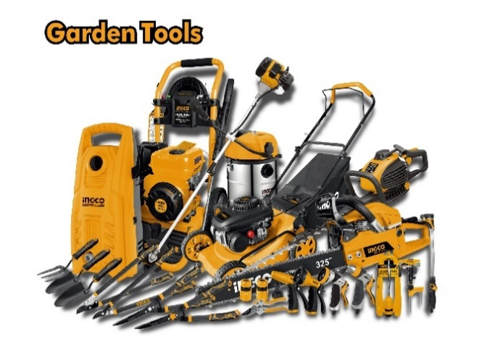
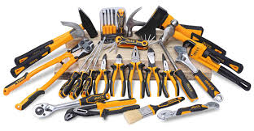
The organization has INGCO Power tools and extras, welding machine, Generators, Hand apparatuses & Equipment, Measuring instruments & Security items, Small constructions machine, Air devices, Water pumps & Plant devices.
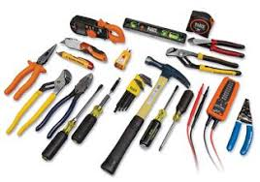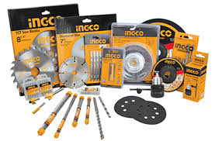
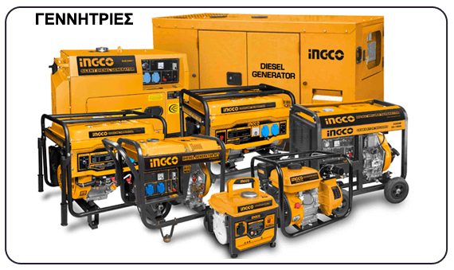
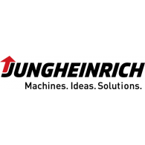
Greenland additionally has JUNGHEINRICH items to hold material equipment's.
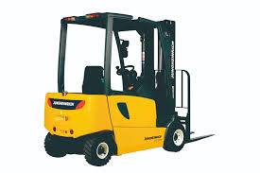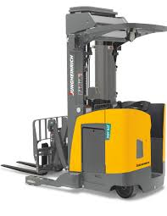
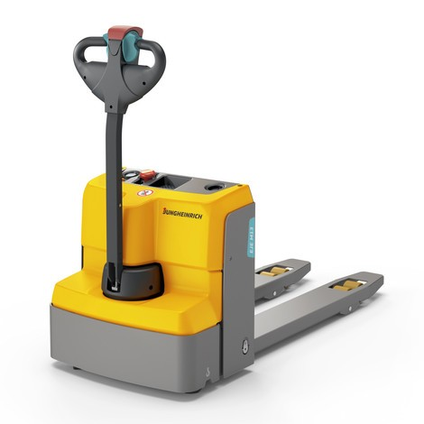

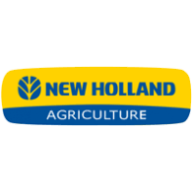
The principle business of Greenland Company is offer tractor and tractor’s extras to the clients on credit. Further they gather their offering cost with interest by portion. All the tractor’s they import from the other nation are:
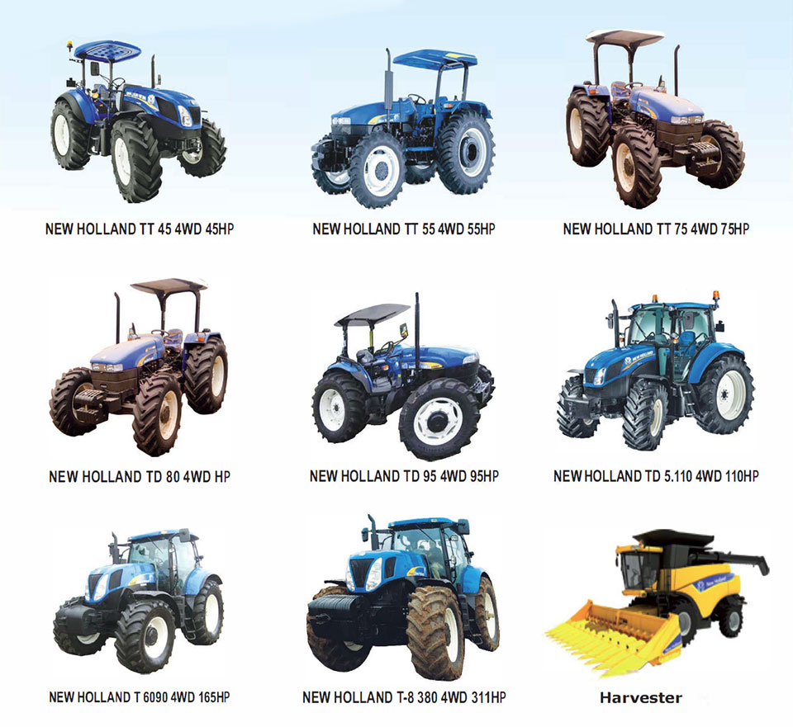
The company also has Power tiller and accessories.

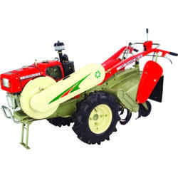

2.9 SWOT Analysis:
SWOT analysis is vital for each organization. SWOT analysis assist an organization with knowing their solidarity and openings for proceed onward and it additionally tells about the shortcoming which the Company need to survive and their dangers which comes from their rivals.

SWOT analysis of Greenland Technologies Limited is given underneath:
Strengths:
- Image of the organization.
- Solid Monetary abilities as a modern organization.
- Recognized client demand.
- Full-time sales group.
- Modern innovation.

Weaknesses:
- Current section in Importing.
- Need more experience in lease financing.
- Overnight dynamic making issue.
- Manpower arrangement issue.
- Well dissemination arrange issue.

Opportunities:
- Improve development works in rustic regions.
- Speedy automation in agriculture segment.
- Return on investment is significant.
- Extension of changeability of item.
- Assure Market inclusion in case of contender's item.
- Add incentive to engage client.
- Advertising and focusing on the Target client.
- Government uphold for cultivation.
- Escalate farmer’s mindfulness.
- Technology utilized in cultivation.

Threats:
- Worldwide financial downturn.
- Relying on unfamiliar supply.
- Risk figure.
- Credit form trade.
- Too much rivalry.
- Lots of public and international organization in the market.
- Absence of high quality item within the showcase.
- Expanding deals.

Chapter 03: Job Responsibility as an Intern at Greenland Technologies Limited

3.1 Accounting Department of GTL
In GTL there is a group consisted of ten people and the accounting department was being looked after by them. All the trade exchanges acclimating the company approaches and hones are managed by this team Also, they get ready the outside and inside reports for all partners as per company prerequisites. There is a responsibility of the employee of this department which is to oversee and control future cash collections and dispensing, utilizing the assets viably and productively to create more cash influx. VANGUARD & TALLY software are used to gather the data. although, these types of cash flows are quite risky for them. Reasonable accounting frameworks should be utilized in this segment since organization's monetary outcome relies upon these exchanges. If there are any data which is erroneously entered into the method GTL have to be endure for this. As a result, all the workers of this sector have to be very smart and aware. Thus, GTL’s Accounting sector are expert at avoiding various, market, credit, liquidity etc. risks by taking assistance from Financial department and managing the treasury adequately. Even though the department being very small with very less workers but their contribution is very high. Under this department These are some following major activities:

- Almost every day funds are transferred from one bank account to another bank account, from one showroom to another showroom and the records of all these transactions are kept by the Accounts Department.
- Observing the assortments of day-by-day deals continues and store them in financial balances.
- Calculating devaluation costs for permanent resources. Deducting charge at source, settle the payments of LC, retaining charge.
- Providing financial reports in every 6 months and 1 year.
- Managing cash flows to manage the operation smoothly.
- Keeping up solid connection with bank and other financial institution.

3.2 Job Responsibilities
It’s an honor for me that I had the opportunity to complete my internship period at the corporate head office of GTL. There is an extremely great communication between employees and each one of them had the expertise and efficiency in numerous activities. They taught me many things. There was a supervisor who guided and monitored me yet I got the chance working with others as well. That’s why, I have used my time effectively and efficiently. My internship at GTL started on 10th October 2020 and ended up on 8th January 2021. It was a very friendly work environment. Before assigning any task, I was understood from the scrap by them and firstly they inspected and monitored weather I was going along with the instructions properly or not. Throughout my internship period, I have completed different kinds of activities in Accounting sector and I gave my level best to finish every positions precisely. These are the accompanying undertakings I was dependable during my temporary job in the association:
1. Compiling of all products for clients for posting in accounting software.
2. Gathering detailed data about supplier & client organization.
3. Arranging price rate differentiation report of the product among numerous organization.
4. Documenting the invoice for the sale and delivering the monthly basis challan and preparing report of collecting the invoice of sales and delivering challan based on previous sales.
5. Assisting forwarding with lettering information about past due installment of client organization.
6. Inspecting attestation & system of LC records.
7. Posting journal voucher in TALLY and update journal entry time to time.
8. Computation, examination & announcing of procurement request (PO).
9. Small amount of money count, examination, detailing etc.
10. Bank Deposit calculation voucher, reporting and analysis.
11. Dining VANGUARD with various factor for example request section and invoicing, buy request the board, records of sales, deals investigation, general record, creditor liabilities, money book primary menu.
12. Corporate bank account process.
13. Data posting in Tally.

Chapter 4: Selling system of the Product

4.1 Selling procedure of products
- Cash sales
- Credit sale
- Installment
- Leasing
Cash sale: Cash sale is specifically deals to client on cash payment. There are numerous chances for client within the strategy of cash deals. Since client can get numerous rebates and offer through cash payment. Cash installment is exceptionally great for company since it’s doesn’t make any issues.
Credit sale: In credit deal strategy client make deferred payments. Credit deal is typically not permitted to deal to all the client. A sales representative needs some endorsement to make a credit deal. Credit deal are permitted to those clients who is very familiar in market and has a solid connection with GTL.
Installment: GTL gives EMI payment opportunity to client. In this system client get the items in 0% premium for a year. At that point 12% premium following a year. This method can be utilized as it were by credit card. Only these highlights are given to client in IED items.
Leasing: GTL gives leasing opportunity to client. Client can purchase items by giving a few sum of deposit but there's a few strategies to lease the items. Client needs to give all public data and financial data, a few clear cheques and ought to pay remaining sum by installment.

Chapter 5: Financial Performance Analysis

5.1 Financial ratios: Financial ratios are detailed and demonstrate the financial exhibition and financial situation of an organization. GTL additionally examination their proportion to quantify execution. To make ratio organization need to create a few conditions. Some financial statement is given underneath:

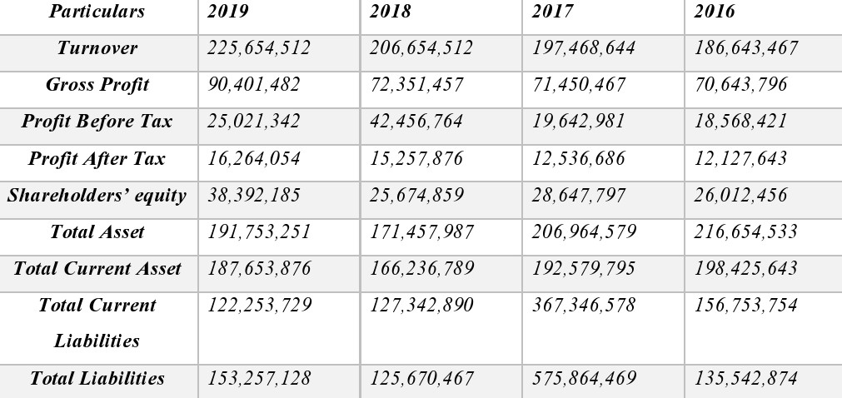

Types of Ratio:
- Liquidity Ratio
- Profitability Ratio
- Activity Ratio
- Debt to Equity Ratio
5.2 Liquidity ratio is really referring to approximately a few proportions which is examined to think about the organization's capacity to pay the risk on schedule. This is often estimating the banks and lenders. A few liquidity proportions are given underneath:
5.2.1 Current Ratio: Current ratio is for measure the transient liquidity of an organization. It’s demonstrated the connection between current resource and current liabilities.
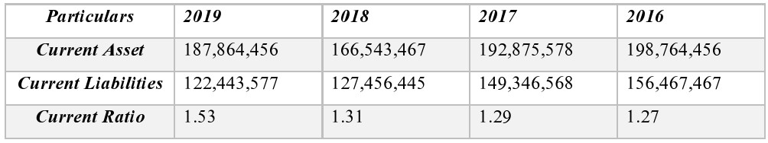
Greenland Technologies Limited’s 2016-2019 Current ratio:

Interpretation: The standard of current ratio is 2:1. While GTL has 1.27 in 2016. Which isn't standard. Indeed, in 2019 it isn't come to a standard position. However, the situation of the ratio is expanded step by step. In 2017 it has been expanded at 1.29 from 1.27 which isn't standard but calculable for a modern company. In 2018 it’s expanded to 1.31 and in 2019 it’s expanded to 1.53. So that we are able to trust that one day it'll be come to at the standard position.

5.2.2 Quick Ratio:
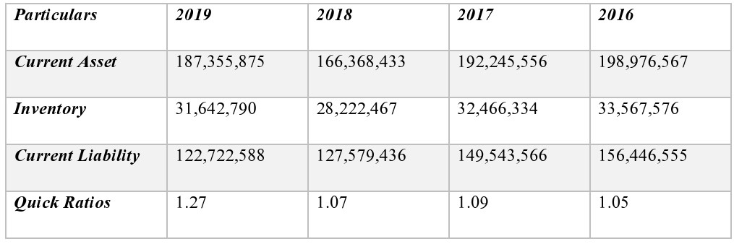
Greenland Technologies Limited’s 2016-2019 Quick ratio:

Interpretation: The standard of current ratio is 1, though GTL has 1.05 in 2016. Which is above the standard. In 2017 it’s expanded to 1.09 and in 2018 it’s diminished to 1.07 and in 2019 it’s increments to 1.27 which could be a tremendous accomplishment for GTL and most noteworthy for the GTL.
5.3 Profitability Ratio: Profitability ratio is degree for total income. Profitability ratio is really alluding to a few proportion which is given underneath. To calculate those proportions, we require the information of profit and loss report.

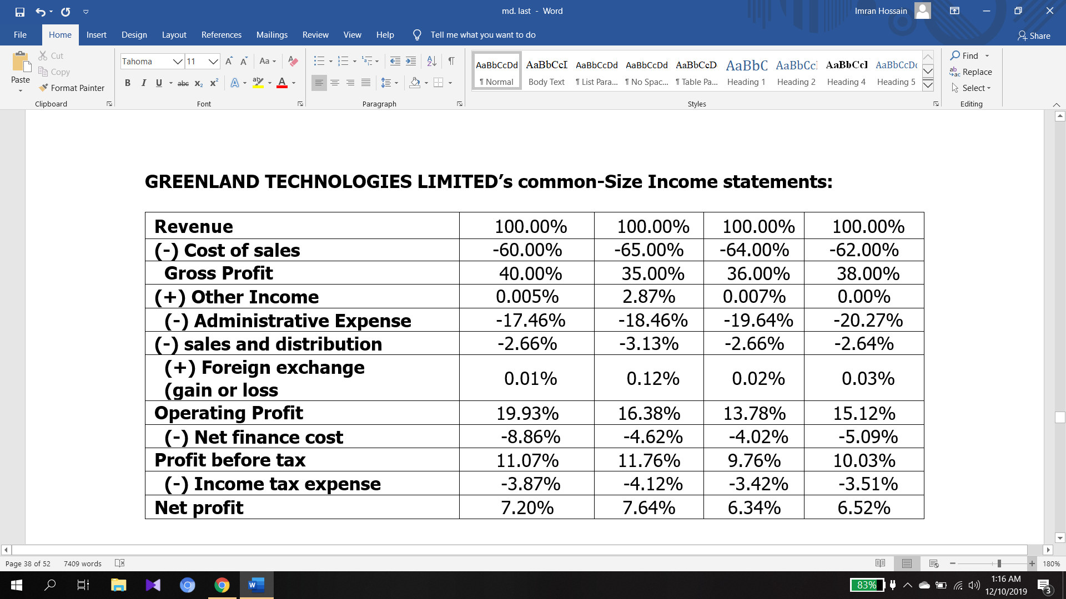

5.3.1 Gross profit
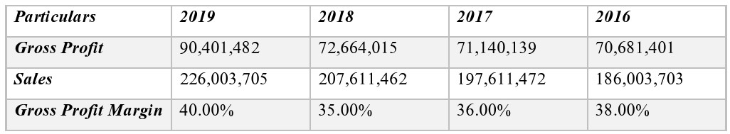
Greenland Technologies Limited’s 2016-2019 Gross Profit Margin:

Interpretation: Gross profit ratio shows that how an organization can deliver or import and offer the item. The gross profit ratio is acceptable when it is higher. In 2016 Gross profit is 38% and in 2017 gross profit diminished 36% and in 2018 gross profit is diminished to 35%. In 2019 the gross profit is 40% which is most noteworthy for the GTL.

5.3.2 Net Profit Ratio:
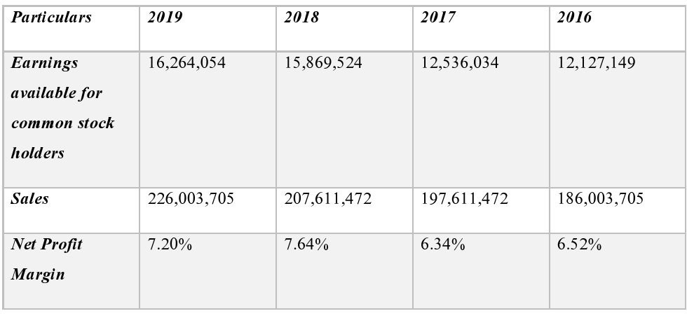
Greenland Technologies Limited’s 2016-2019 Net Profit Ratio:

Interpretation: The net profit margin quantifies the organization's financial wellbeing. In 2016 the net profit is 6.52% and in 2017 net profit is diminished to 6.34%, in 2018 net benefit has most elevated increment of 7.64.

5.3.3 Return on Asset
Greenland Technologies Limited’s 2016-2019 Return on Asset:
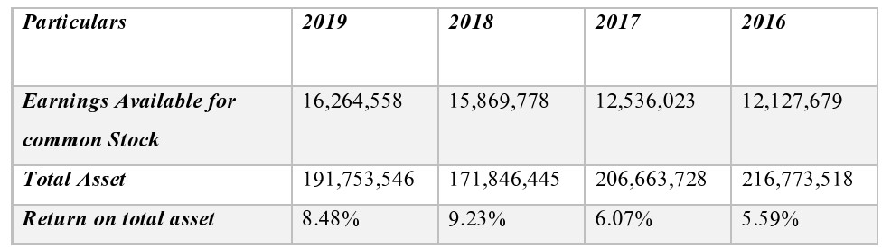
5.4 Activity Ratio: Activity ratio is estimating how the organization is maintaining their trade and the company is utilizing their resource to produce income. The activity ratio is really alluding a few others proportion which are given underneath:
5.4.1 Inventory turnover ratio: Inventory turnover ratio is really detailing how much the organization is producing their income. It’s additionally estimates the stock of the inventory in hand, work in cycle and finished products.
Greenland Technologies Limited’s 2016-2019 Inventory Turnover:
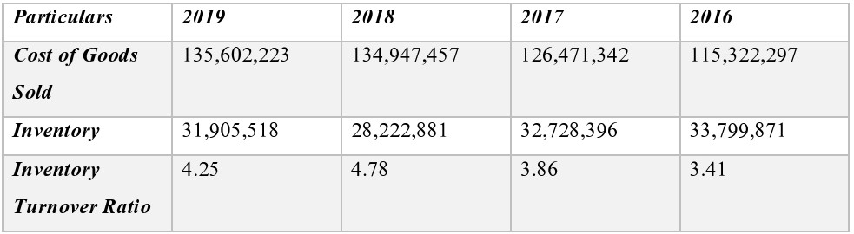

Interpretation: The inventory turnover ratio of GTL is showing that in the organization is acquiring increasing speeds day by day. In 2016 the inventory turnover proportion was 3.41 which is GTL was offering their item 3.41 times in a year. In 2017 inventory turnover proportion expanded to 3.86 and in 2018 it’s expanded to 4.78 which was most noteworthy inventory turnover ratio for GTL.
5.4.2 Asset turnover ratio: The asset turnover ratio is detailing that how much sale is producing from organizations’ resource. It additionally appears how adequately company is utilizing their resources. The asset turnover ratio is alluding a few other proportions which are given underneath:
Greenland Technologies Limited’s 2016-2019 Total Asset Turnover Ratio:
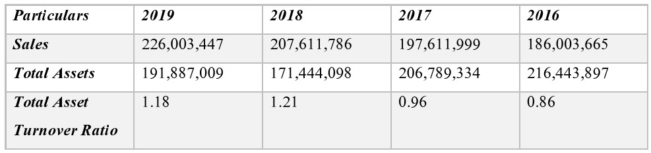

Interpretation: The asset turnover ratio is really estimating how much an organization procures by contributing 1 taka. Here the GTL’s asset turnover ratio is appearing that they had 0.86-taka turnover against 1 taka. In 2017 it expanded to 0.96 and in 2018 its expanded to 1.21 which is the most elevated accomplishment of the organization. But in 2019 the asset turnover ratio of the company is diminished by 1.18.

5.5 Debt to equity ratio:
Greenland Technologies Limited’s 2016-2019 Debt Ratio:
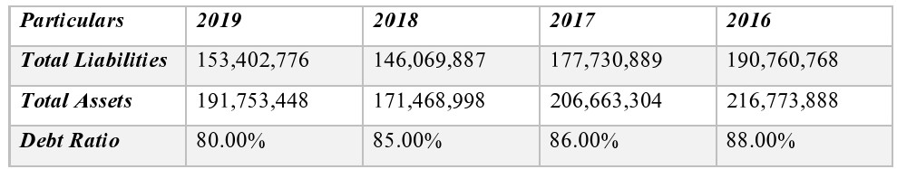

Interpretation: Debt to equity ratio estimates the financial development of an organization. By debt to equity ratio we are able to center on long term obligation. The Debt equity of 2016 is 88% which is diminished in 2017 to 86% and in 2018 it diminished to 85% and in 2019 it’s diminished to 80% which may be an incredible accomplishment for GTL.

Chapter 6: Findings

There is a variety of proportions, but couple of them are important to the business, which are the current ratio, return on asset, return on equity, inventory turnover and debt equity ratio. These are the firm 's primary ratio. But it doesn’t mean that other ratios are less relevant since a company's output is further calculated. All the positive and negative outcomes expected are reviewed by the financial performance. The general finding that we noticed from the above ratio of Greenland Technologies Limited analysts is given underneath:

6.1 Liquidity Ratio
- Current Ratio: it may not reach 2:1 requirement, but it does not mean negative all the time to adjust every year and lower current ratio. That could prove a good sign. It depends on the structure of associations.
- Quick Ratio: it Follows the 1:1 requirement. Accordingly, business is happy to counterbalance existing liabilities with current resources.

6.2 Activity Ratios
- Inventory turnover ratio Complies with 2019 and 2018 standards. Despite the fact that in 2017 and 2016 it was beneath assumptions. However, we can outwardly notice the change.
- Average ratio of amassment period: the criteria is not fulfilled. But it is somewhat changed every year.
- Average ratio of payment periods: It is basically like assumptions. In spite of the fact that it was unfortunate first and foremost, it was sufficiently close to the assumptions in 2019.
- Total asset turnover ratio: It's excellent because it does produce extra revenue apart form the amount of assets invested.

6.3 Debt Ratios:
- Debt ratio: Debt ratio of the company is not that good.
- Time interest earned ratio: It is fine but it ought to be enhanced.

6.4 Profitability Ratio:
- A growing pattern is shown in the last year’s gross profit margin.
- Net profit margin: proposes designs that are developing, which is useful. Despite the fact that it was scarcely decremented a year ago.
- The return on total assets tells that patterns are growing, and it is beneficial. But it was hardly decremented last year.
- The profit for ordinary value proposes fluctuating costs, however it was positive.1 year ago gross net revenue indicated a developing example.
- The operating profit margin shows fluctuating value, in any case, it very well may be recognized as it has been positive consistently.
- Net profit margin: suggests that patterns are growing, which is very helpful.
- The return on total assets suggests that patterns are growing, which is advantageous. Be that as it may, it was scarcely decremented a year ago.
- The profit for ordinary value recommends fluctuating costs, however it was positive.
Others:
  - The business should not be versatile with respect to the payment of agricultural product installments.
  - Do not engage in ads for the citizens of agricultural goods as a result.
  - If they skipped three installments, they will not give them any chance.

Chapter 7: Recommendations

- There should be a quality management system established in GTL to ensure the quality of the products. They should realize the importance of TQM for a company.
- GTL ought to diminish the utilization of paper to lessen the expenses.
- They should import assortments of items.
- Company should take care their representatives who are turning out dedicatedly for GTL.
- They should make some preparation to their administration payer.
- Greenland should give more significance on their deals.
- Employees need all the more well preparing for better execution.
- Their fundamental business is deal items using a loan. That is the reason they should give more significance in the hour of gathering portion.
- As GTL is a midsize company for their rapid growth, they need better financial form now.
- Experienced employees need to perform high so that the company can expect more from their senior.
- In order to become a market leader company, they must maintain their standard level of quality of their product with lower price.
- Greenland Technologies Ltd. put stock in better arrangement that is the reason they must be ideal for any issue for giving better arrangement.
- Company needs to concern about farmer’s struggle and give them easiest solution.
- GTL can spread their business by contributing their other business from which they procure better benefit.
- GTL should give the significance perhaps the main pieces of current resource. What's more, it is that they should screen the borrower's assortment time frame.
- They can add an incentive with their imported items like packaging, etc.

Chapter 8: Conclusion

Greenland Technologies Limited is presently a familiar and renowned company in Bangladesh. They supporting the farmers with the trade of tractors. Which contribute to the nation’s economy. GTL is additionally serving to the nation by giving industrial and domestic and cultivate item which makes the individuals life simpler. GTL has more than 300 workers who are investing their capacity by serving this organization. Organization additionally award numerous advantages to them. One day Greenland Technologies Limited will be a listed company in Bangladesh. They have numerous occasions to snatch the market and Govt. is additionally giving numerous opportunities for making trade.
In my three months’ internship I had learned numerous things from GTL and furthermore acquired numerous down to earth information. I hope this knowledge will offer assistance to reach in my objectives.
Ultimately, I am extremely appreciative to them for giving me the occasions to work with them.

Chapter 9: Appendix

Abbreviations Elaborations
GTL GREENLAND TECHNOLOGIES LIMITED
TO TURN OVER
PBIT PROFIT BEFORE INTEREST AND TAX
UIU UNITED INTERNATIONAL UNIVERSITY
ROI RETURN ON ASSET
ROE RETURN ON EQUITY
BBA BACHELOR OF BUSINESS ADMINISTRATION
LC LETTER OF CREDIT

Chapter 10: Bibliography

- Publications:
- Greenland Technologies Limited - (2020). Retrieved from https://getco.com.bd/docs/getco-profile.pdf.

- Internet:
- Bundle, W. (2014). Investment Banking & Financial Modeling Online Certification Courses. Retrieved from https://www.wallstreetmojo.com/.
- Greenland – A Concern of GETCO. (2016). Retrieved from https://greenland-bd.com/.
- Investopedia. (2002). Retrieved from https://www.investopedia.com/.

