Internship report on
Performance Measurement of Non-Banking Financial Institutions in Bangladesh
Course title: Internship
Course code: INT 4399/AIS 4441

Submitted to
Dr. Mofijul Hoq Masum, ACMA
Associate Professor - AIS
School of Business & Economics
United International University

Submitted by
Mahir Rahman Khan Niloy
ID: 114191004
BBA in AIS

Date of submission: 30th January, 2024
United International University



Acknowledgement

First and foremost, I am grateful to Allah. Without his blessings I wouldn’t be able come here. With Allah’s support I am able to complete this report and internship. Also, I am thankful to my parents and the teachers I have met in my life who supported me for every moment in my life.

I am also grateful to Dr. Mofijul Hoq Masum sir, ACMA, Associate Professor - AIS of United International University who deserve a special appreciation from me. With his guidance and constructive comments I am able to complete the report on “Performance Measurement of Non-Banking Financial Institutions in Bangladesh”.

Lastly, I would like to thank my intern supervisor MD. Emran Khan, FAGM, Corporate Business, IPDC Finance Limited. I am thankful to him for providing me the opportunity to work in corporate business (asset) sector which is one of the prominent sectors in IPDC Finance Ltd. Under his supervision, I learned a lot of things about the NBFI sector and the corporate cultures. Also, I am grateful to other seniors in the department who shared their valuable knowledge to me.

Letter of Transmittal

30th January, 2024
Dr. Mofijul Hoq Masum, ACMA
Associate Professor - AIS
School of Business & Economics
United International University

Subject: Submission of Internship Report on “Performance Measurement of Non-Banking Financial Institutions in Bangladesh”.

Dear Sir,
With due respect, It is my pleasure to present the report under your supervision that is given by you. I am much thankful for giving me the opportunity to do the formal report. Thank you for your supportive consideration. I have done my internship from IPDC Finance Ltd. which is a renowned non-banking financial institution in Bangladesh. I have tried to give my all knowledge about the non-banking financial institutions sector which I learned from my academic and internship.
Finally, working on this report was a fantastic experience that I saw as an opportunity to expand my knowledge about non-banking financial institutions in Bangladesh. Despite my best efforts, errors may occur; for this, I seek your forgiveness and hope you will accept my apologies.

Sincerely yours,
Mahir Rahman Khan Niloy
Id: 114191004, BBA in AIS, United International University.

Abstract
The objective of the study is to evaluate the Non-Banking Financial Institution (NBFI) sector in Bangladesh. This study represents the overall sector and specifically 10 non-banking financial institutions operational activities in Bangladesh from 2018 to 2022. To analyze the sector this study has focused on strategic evaluation, evaluation of the current state of the market, financial performance evaluation of non-banking financial institution sector. In strategic evaluation of the NBFI sector the Porters Five Forces Model was discussed to assess the sector. In the current state of the market total loans and deposits was reported 1st quarter of the 2023. Lastly, in the financial performance evaluation of non-banking financial institution sector the ratios like, ROA, ROE, ROC, EPS, current ratio, leverage ratio, capital adequacy ratio, debt equity ratio, cost to income ratio, non-performing loans, trends in assets, liabilities and deposits, trends in total loan/lease and classified loan/lease, and trends in profitability of non-banking financial institutions. The outcomes of this study tell us that the non-banking should be more concern about collecting their classified loans to keep the non-performing loans ratio low of this sector. Then to generate more income they should give focus on their operational expenses and rather than depending only on deposits they should invest more in the innovations like other sectors of this country which will later help them to generate more income. The non-banking financial institutions has to play a vital role for Bangladesh economic growth to become a developed country in the world.

Keywords: Non-Banking Financial Institutions (NBFI), Strategic evaluation, Financial Performance, Profitability.
Table of Contents
Chapter-1: Introduction 1
1.1 Introduction 1
1.2 Rationale of the Study 2
1.3 Background of the Study 3
1.4 Limitations of the Study 4
Chapter-2: Objectives of the Study 5
2.1 Broad Objectives 5
2.2 Specific Objectives 5
Chapter-3: Methodology 6
3.1 Data Design 6
3.2 Sample Design 6
Chapter-4: Literature Review 8
Chapter-5: Findings & Evaluation of the Study 9
5.1 Sector Overview 9
5.1.1 Sector specifications 9
5.1.2 Sector size, trend, and maturity: 11
5.1.3 Regulation, Supervision, and Performance of Non-Banking Financial Institutions 13
5.1.4 Earning Per Share (EPS) of NBFI’s 14
5.1.5 Effectiveness of Management 15
5.2 Strategic evaluation of the sector 16
5.2.1 Competition amongst already operating businesses 16
5.2.1.2 Buyers' negotiating power: 17
5.3 Evaluation of the Current State of the Sector 20
5.3.1 An Examination of NBFI Deposits and Advances 20
5.4 A summary of limitations and potential 20
5.5 Evaluation of the Financial Performance of Non-Banking Financial Institutions in Bangladesh 21
5.5.1 Return on Assets (ROA) 21
5.5.2 Return on Equity (ROE) 22
5.5.3 Return on Capital (ROC) 23
5.5.4 Earnings Per Share (EPS) 23
5.5.5 Current Ratio 24
5.5.6 Leverage Ratio 25
5.5.7 Capital Adequacy Ratio (CAR) 26
5.5.8 Debt Equity Ratio 27
5.5.9 Cost to Income Ratio 28
5.5.10 Non-Performing Loans (NPL) 29
5.6 Trends in Assets, Liabilities and Deposits of NBFIs 30
5.7 Trends in Total loan/lease and 31
5.8 Trends in Profitability of NBFIs 32
5.9 NBFI Investment Pattern as of 30 June 2022 33
5.10 Evaluation of the IPDC 33
5.10.1 IPDC Business Philosophy 34
5.10.2 IPDC’s Products and Services 34
5.10.3 IPDC’s Footprints 35
5.10.4 The Shareholding Structure of IPDC 35
5.10.5 Highlights between NBFI Sector and IPDC 36
5.10.6 Governance Structure 36
5.10.7 Corporate Governance Framework 37
5.10.8 Organogram of IPDC 38
Chapter-6: Internship Experience in IPDC 39
6.1 Department 39
6.2 How the Corporate Business (Asset) sector work? 39
6.3 Internship Job Description 39
Chaper-7: Recommendations 41
Chapter-8: Conclusion 43
Chapter-9: References 44
Chapter-10: Appendix 46

Chapter-1: Introduction

1.1 Introduction
Non-bank financial institutions (NBFI) are crucial for every country financial sector. While there may be other organizations that function as a non-banking financial institutions but here the focus of this research is financial businesses. NBFI includes finance companies as members. As opposed to banks, they don't take deposits. They sold their shares to raise money, which they then invested by making direct and indirect loans. A percentage of the money is also invested in the stock market by them. Because of this, finance corporations have a big impact on how well the capital markets function. In the NBFI sector here the majority of financial institutions are vertically integrated businesses. The main objective of this report is to evaluating the non-banking financial sector from 2018 to 2022 in Bangladesh.
Financial ratios and other relevant financial measures are the foundation for evaluating the sector research on NBFIs. So, the main purpose of this study is to compare the relative market positions of the chosen NBFI in Bangladesh and analyze the financial performance of NBFI. A number of financial performance ratios like, ROA, ROE, ROC, current ratio, capital ratio, leverage ratio, capital adequacy ratio, debt equity ratio, cost to income ratio, non-performing loans (NPL), earnings per share (EPS) are used to analyze the financial performance. The financial performance of certain finance companies (NBFI) in Bangladesh will be examined in this study. It will then determine their competitive standing in Bangladesh depending on the outcome.

1.2 Rationale of the Study
In an exceedingly challenging and unstable economic environment, financial institutions are playing a larger role. These essentially inject idle cash into the many productive uses of the economy. Therefore, having strong financial institutions is essential to the long-term prosperity of any nation. By providing a range of financial services, NBFIs cover the gaps in financial intermediation left by commercial banks. They also compete with banks, pushing them to improve their effectiveness and sensitivity to the needs of their clients. The degree of development of a country's financial system as a whole is generally well-represented by the status of NBFI development. Nonetheless, financial sustainability and economic advancement are the two main reasons why NBFIs are significant. Generally speaking, NBFIs carry out a number of tasks that banks do not, including lending money, being fungible, being informationally efficient, and delivering risk aggregation services, all of which increase the dangers that venture capitalists are exposed to. In this way, they promote and raise the efficiency of savings and investments. Second, in a financial sector where non-bank financial institutions are relatively underdeveloped, banks will inevitably have to take on risks that would otherwise be carried by the stock market, collective investment schemes, or insurance companies. In their evaluation of the lessons learnt from the Asian currency crisis, authorities have largely accepted that, for instance, NBFIs are extremely important to Bangladesh's financial market development and economic expansion. Leasing businesses help manufacturers maintain a smooth production run by offering lease financing services. Insurance firms offer various company businesses risk protection services so they can be reimbursed in the event that any valuable item is lost or damaged. Venture capitalists receive funding from finance businesses in order to acquire assets for their company ventures. Many firms obtain long-term funding from NBFIs.

1.3 Background of the Study
In the nation’s financial system, not only the banks but also the NBFIs are growing very rapidly. The non-banking financial institutions are helping the people and the companies by providing the good quality and quantity of their services. In Bangladesh's financial sector, the NBFIs are increasing day by day. NBFIs have shown a good trend in advances, income, assets, and other financial components throughout the years. Till now they are contributing significantly to Bangladesh's GDP growth.
In the 2019, it was an annual terrible for the non-bank financial institutions sector. In 2019, a company's debt increased 17.19% to Taka 6,399 crore which resulted of an institution's collapse, which lowered confidence in the sector. A central bank official stated that, “if the defunct People's Leasing and Financial Services (PLFS), which owed between Tk. 600 crore and Tk. 700 crore, had been on the list, the total amount would have been much higher”. On June 27, 2016, the ministry of finance issued an command to the Bangladesh Bank to close the NBFI, a first for the country's financial sector.
The total amount of loans disbursed by the non-banking financial institutions at the end of September in 2022 was Tk. 70,416 crore. Among these loans, Tk. 17,372 crore (24.61%) of the total loans, were in default. There were roughly Tk. 13,000 crore in outstanding loans as of December 2021. Defaults are increasing as loans are not being paid back on time.
The Covid-19 pandemic of 2020-2021 resulted in a significant reduction of debt repayment terms. The absence of these incentives contributed to an increase in loan defaults. By the end of June 2022, NBFIs had disbursed a total of Tk. 69,313 crore in loans. Approximately Tk. 15,936 (or 23% of total loans) are past due. By the end of September 2022, loans totaling Tk. 70,416 crore had been disbursed; default loans had climbed by more than Tk. 1,000 crore in just three months. Former Bangladesh Bank governor Salehuddin Ahmed asserted that since the establishment of these organizations, qualified employees have not been appointed. According to BB data, NPLs in the NBFI sector increased by over 25% to Tk 17,855 crore in March of last year from Tk 14,232 crore the previous year. Approximately 25% of the total credits disbursed were bad loans.
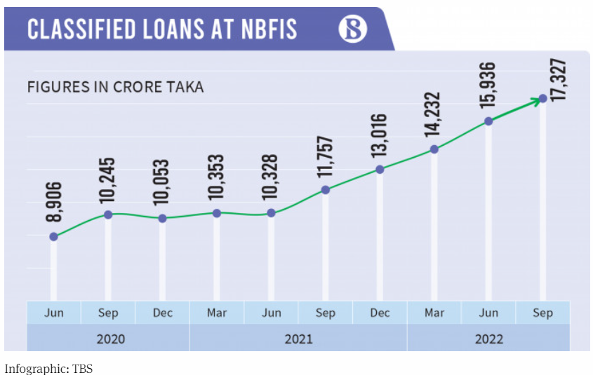
Fig. 1.1 (Classified Loan at NBFIS)

1.4 Limitations of the Study
In order to accomplish the study, there are few limitations which are illustrated below:
- The yearly reports are a crucial component of finishing the study, and it appears that in a few fiscal years, some of the material was not presented in a way that was easy to understand. Also, the annual report for 2022-2023 aren’t published yet.
- There are some time constraints for completing the study.

Chapter-2: Objectives of the Study

2.1 Broad Objectives
The broad objective highlights the major objective of the selected report. It demonstrates the aim of the experiment that is being conducted. The following lists the research's broad objectives:
- To fulfill the requirements of United International University's Bachelor of Business Administration (BBA) program, one must follow the general regulations outlined in the university policy.
- To analyze the NBFIs sector in Bangladesh.
- To gain a perception about the designated company, IPDC Finance Limited.

2.2 Specific Objectives
The following are the report's specific objectives:
- To overview the non-bank financial institutions sector.
- To evaluate the strategies of the NBFI of the country
- To analyze the current state of the market.
- To evaluate the financial performance of this sector.
- To explain the understanding and tasks of an internship.
- To identify the initiatives and actions that brings the improvement to assist both the management and the investor in making decisions.

Chapter-3: Methodology

3.1 Data Design
To get the best results, this study used a quantitative research methodology. The study's only source of secondary data of the five years (2018–2022) worth of reports from the corresponding non-banking financial institutions that are listed on Bangladesh's Dhaka Stock Exchange (DSE). It also made use of comparison evaluation of the non-banking financial institutions respective financial results.

3.2 Sample Design
35 listed non-banking financial institutions, or the total population, were in operation during the study period. Using the judgmental sampling method, 10 non-banking financial institutions were chosen as samples based on their operating soundness and market share. Because the sample size of 10 NBFIs accurately represents the population size of the 35 specified non-banking financial institutions, the results from the observations of the sample may be generalized to the entire population observations. The time frame for data evaluation is from 2018–2022. These details were gathered from the company's websites and annual report. The following is a list of the 10 non-banking financial institutions that were sampled:
SL. No | Name of NBFI
1 | IPDC Finance Limited (IPDC)
2 | DBH Finance PLC. (DBH)
3 | First Finance Limited (FIRSTFIN)
4 | Bay Leasing & Investment Limited (BAYLEASING)
5 | IDLC Finance Ltd. (IDLC)
6 | MIDAS Financing Ltd. (MIDASFIN)
7 | Bangladesh Finance Limited (BDFINANCE)
8 | LankaBangla Finance PLC. (LANKABAFIN)
9 | National Housing Finance PLC. (NHFIL)
10 | United Finance Limited (UNITEDFIN)

Indicators for Measuring Performance: The following ratios are used to gauge the financial performance:
- The profitability ratios, which include earnings per share (EPS), return on equity (ROE), return on assets (ROA), Return on capital (ROC).
- Current Ratio
- Capital Ratio
- Leverage Ratio
- Capital Adequacy Ratio (CAR)
- Debt Equity Ratio
- Cost to Income Ratio
- Non-Performing Loans (NPL)

Chapter-4: Literature Review
From the very beginning the non-banking financial institutions have played a significant part in the economic and infrastructure growth of Bangladesh since their inception. According to Goldsmith (1969), NBFIs, along with the banking sector, play a significant role in influencing and mobilizing savings for investment. According to Sufian (2007), as the health of NBFIs improves, so does the condition of the stock sector. He further stated that as a vital role in the development of the stock market that are effective and profitable, NBFIs are driving the competitive economy ahead.
Here, the study focused on strategic evaluation, evaluation of the current state of the market, financial performance evaluation of non-banking financial institution sector. In strategic evaluation of the NBFI sector the Porters Five Forces Model was discussed to assess the sector. In the current state of the market total loans and deposits was reported 1st quarter of the 2023. Lastly, in the financial performance evaluation of non-banking financial institution sector the ratios like, ROA, ROE, ROC, EPS, current ratio, leverage ratio, capital adequacy ratio, debt equity ratio, cost to income ratio, non-performing loans, trends in assets, liabilities and deposits, trends in total loan/lease and classified loan/lease, and trends in profitability of non-banking financial institutions from 2018 to 2022 for 10 different NBFI from their published audit report in the website. Only certain researches have been completed with non-bank financial institutions that are important to our nations economic progress. As a result, an area of need in research has emerged. As a result, this report focus on non-banking financial institutions sector in Bangladesh.

Chapter-5: Findings & Evaluation of the Study

5.1 Sector Overview

5.1.1 Sector specifications
The Financial Institutions Act of 1993 governs and grants licenses to non-bank financial institutions, or NBFIs. Loans and advances are provided by non-banking financial institutions to businesses, sectors, trade, housing, and agriculture. They additionally make an investment in or reinvestment in government or local authority issued shares, bonds, stocks, debentures, or debenture stock. They further make investments in or invest again in government or local authority-issued shares, stocks, bonds, debentures, or debenture stock. It also conducts hire-purchase transactions, such as leasing equipment and machinery. It provides loans for house development and real estate purchases, finances venture capital, and invests in businesses.
The major distinction between commercial banking institutions and non-bank financial institutions (NBFIs) is that they cannot deal in foreign currencies, whereas the first party is unable to accept deposits that are demandable by the depositor's cheques, drafts, or orders. There are 35 non-banking financial institutions in the nation; the IPDC is one of them and was established in 1981. There are currently 23 identified non-banking financial institutions on the Dhaka Stock Exchange (DSE).
The country's financial system is divided into three categories. areas.:
- Formal Sector
- Semi-Formal Sector
- Informal Sector
The sectors have been categorized according to the level of regulation.
- The Formal Sector: The formal sector is made up of all regulated organizations, including insurance companies, banks, and NBFIs are non-bank financial institutions. Brokerage firms and merchant banks are examples of capital market intermediaries.
- The Semi-Formal Sector: Institutions that have been somewhat regulated but do not come under the purview of the Securities and Exchange Commission, the Insurance Authority, the Central Bank, or any other financial regulator are included in the semi-formal sector. This sector is dominated by financial institutions that are specialized such as the Palli Karma Sahayak Foundation (PKSF), House Building Finance Corporation, Grameen Bank, Samabay Bank, and other non-governmental organizations (NGOs).
- The Informal Sector: The informal sector consists of unregulated informal third parties. Non-bank financial institutions (NBFIs) are supervised and overseen by the Bangladesh Bank under the Financial Institutions Act of 1993. In Bangladesh, there are now 35 FIs in operation; the first was founded in 1981. Two are entirely controlled by the government, one is a SOCB subsidiary, 19 are the result of domestic private initiative, and 13 are the result of joint venture effort. The major sources of funding for FIs are term deposits (with a minimum three-month duration), credit facilities from banks and other FIs, call money, bonds, and securitization. The fundamental distinctions between banks and non-bank financial institutions are as follows:
  - Demand drafts, pay orders, and checks cannot be issued by NBFIs.
  - The non-banking financial institutions do not take demand deposits.
  - The non-banking financial institutions are not allowed to receive financing in foreign currencies.
  - The non-banking financial institutions have access to a range of funding sources, such as private equity placement, securitization instruments, lease financing, syndicated lending, and bridge financing.
Non-banking financial organizations contribute to economic progress by facilitating resource rotation, asset distribution, and income control. It helps the economy mobilize capital and resources by facilitating the conversion of savings into investments. A non-banking financial institution (NBFI) is a financial institution that does not have a full banking license and cannot take public deposits. Non-banking financial institutions enable alternative financial services such as risk sharing, check cashing, money transfer, brokering, and individual and group investing. Consumer credit originates from the non-banking financial institutions (as well as from the licensed banks). Non-banking financial institutions include insurance companies, venture capitalists, currency exchanges, some microloan groups, and pawn stores.

5.1.2 Sector size, trend, and maturity:
Non-banking financial institutions (NBFIs) are recent to Bangladesh's financial system, especially when compared to banking financial institutions. As of right now, there are 25 NBFIs in the nation, having started with the IPDC in 1981. 24 NBFIs had a combined paid-up capital and reserve of Taka 6901.8 million as of June 30, 2001 (Bangladesh Bank, 2002). The majority of Bangladesh's NBFI sector is made up of leasing, development financial institutions companies, investment firms, merchant bankers, and other NBFIs.
Long-term funding modes are the ones that non-banking financial institutions employ. Financial institutions affiliated with the banks have consistently engaged in term loan transactions, the vast majority of that is unfamiliar to them. There are already a significant number of outstanding loans in our country as a result of BFIs' inadequate long-term loan management. In this context, NBFIs are essential to the economy since they guarantee the supply of term loans and close the credit gap. In addition, the non-bank financial industry plays an important role in enhancing long-term savings mobilization and providing investment market support services. The goal of this paper is to highlight the importance of non-bank financial institutions (NBFIs) in developing the necessary financial infrastructure for the country's rapid economic growth.
Considering a ten-year survey since the years 2000 to 2010, certain information is provided to examine both revenue and expenditure data in order to estimate the rise in important financial components of the non-banking financial institutions over time. The annual report of the Ministry of Finance,"Bank and Financial Institutions' Activities," was the source of the material, which was collected from multiple editions.
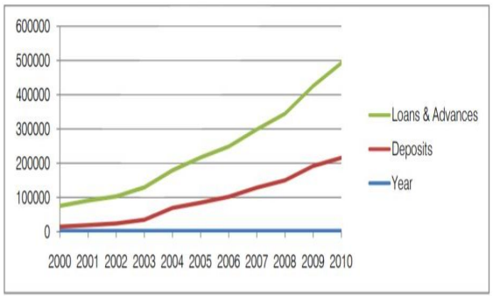
Fig 5.1 ((Deposit and advance growth)
As shown in Figure 5.1, the difference between deposits and loans and advances has widened recently, suggesting that non-banking financial institutions are becoming more effective at utilizing their deposits for investments.
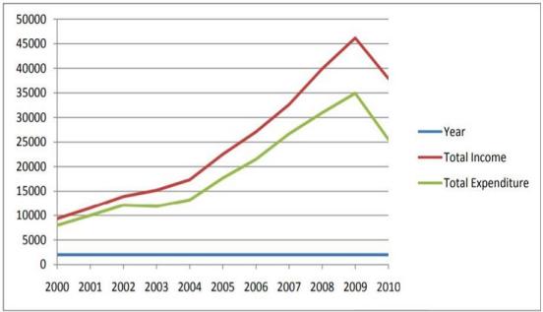
Fig 5.2 ((Income and expense growth overall)
Figure 5.2 shows the potential of the sector over time. The gap between income and expenses over time was used to gauge how efficiently NBFIs operated.

5.1.2.1 The History of Non-Banking Financial Institutions in the Bangladesh
Financial services such as banking are provided by non-banking financial institutions despite the fact that they lack a license for banking. There are several institutions that do not accept public deposits. In Bangladesh, the use of non-bank financial institutions as mediators in financial transactions support commercial banking institutions has increased. Since its start in 1981, the nonbanking sector has sector has grown in both absolute and relative terms. Conversely, the research conducted in this sector is essentially irrelevant. The literature on the growth of the non-banking sector and its role in economic development has, most notably, been lacking. The intent of this study is to investigate how the sector has expanded as well as changed over time using economic development measures based on statistics on assets, loans, revenue, and spending from 2000 to 2010. According to the study non-banking financial institutions have contributed significantly to Bangladesh's GDP growth and have expanded favorably over time in terms of advances, income, assets, and other financial characteristics.
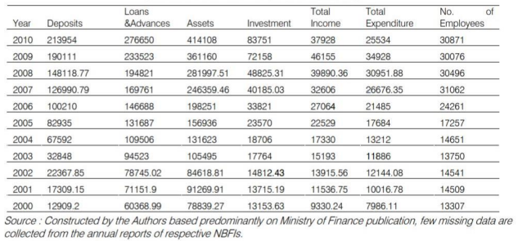
Fig 5.3 (Comparative evaluation of NBFIs' financial standing)
Figure 5.3 illustrates a collation out of financial conditions since different periods as growth indicators during the provided time period. The table clearly shows that the non-bank financial institutions financial component has become better with time.

5.1.3 Regulation, Supervision, and Performance of Non-Banking Financial Institutions
Bangladesh's financial system has benefited greatly from the involvement of non-bank financial institutions (NBFIs). This sector of the economy has risen significantly as the need for equity-type services and long-term financing has increased. Non-banking financial institutions revitalized country’s financial sector of bank-based. Together with the oversupply of the banking sector, the inevitable rise of non-banking financial institutions has ushered in a new era of nation-building. As a result of this, this sector has grown to be regarded as critical to the long-term viability of both the economic and financial sectors. Non-bank financial organizations play an important role in bridging gaps in the financial intermediation system in Bangladesh by offering a diverse variety of securities and risk-sharing services. Conversely, the research conducted in this sector is essentially irrelevant. a summary of the report, non-bank financial institutions (NBFIs) have considerably contributed to Bangladesh's GDP growth and have expanded favorably over time in terms of advances, income, assets, and other financial features. According to the Financial Organization Law of 1994, the minimum amount of paid-up capital for non-bank financial organizations is currently Taka 1.0 billion.

5.1.4 Earning Per Share (EPS) of NBFI’s
Financial stability is a prerequisite for the long-term existence and expansion of any sector. The purpose of this paper is to find and evaluate the key financial elements determining the profitability of Bangladesh's non-banking financial institutions operation, keeping in mind the importance of profitability. Data was gathered for 10 selected distinct NBFIs in Q1 of 2023.
NBFI’s | EPS (in BDT)
IPDC | 0.26
DBH | 2.46
FIRSTFIN | (2.61)
ICB | 0.58
IDLC | 1.74
ILFSL | (2.76)
BDFINANCE | 0.24
LANKABAFIN | 0.32
NHFIL | 1.05
UNITEDFIN | 0.06
Fig 5.4 (EPS of NBFIs in Q1 of 2023)

5.1.5 Effectiveness of Management
Sound management is the most important requirement for the growth and success of any NBFI. In Fig. 5.5, prominent ratios used to analyze managerial success include total spending to overall income, operational expenditures to total expenses, earnings and operational expenses per employee, and the interest level gap.
Type | No. of NBFIs | Total Branches
Public Non-Banking Financial Institutions | 3 | 56
Private Non-Banking Financial Institutions | 32 | 251
Non-Scheduled Banks:  - Karmashangsthan Bank  - Ansar VDP Unnayan Bank | 2 | 516
Co-operative Society (Bangladesh Samabaya Bank  Limited) | 1 | 2
Total | 38 | 825
Figure 5.5 (Management Effectiveness of Operating NBFI Organizations)

The percentage of all financial institutions in Bangladesh is shown in Fig. 5.6. About 82% of the market is made up of private non-banking financial institutions and 18% is made up of public non-banking financial institutions
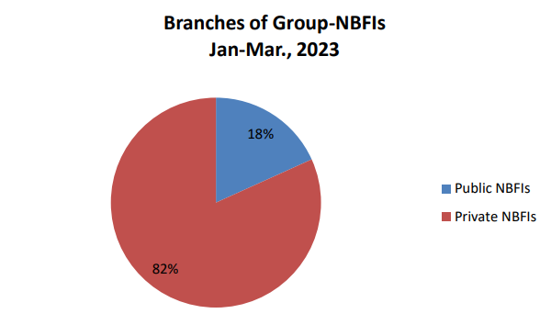
Figure 5.6 (Branches of Group-NBFIs)

5.2 Strategic evaluation of the sector

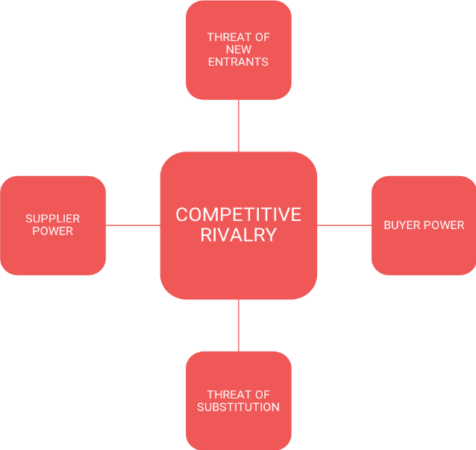
An sector's operations are taken into account during strategic evaluation. Within the economic sector, IPDC operates in a very competitive atmosphere. Five elements affect a company's average profitability in a business setting, according to the Porters Five Forces Model.. A longer discussion of the model connected to IPDC will follow. The diagram produced by Porter is depicted in Fig. 5.7.

Figure 5.7 (Porters Five Forces Model)

5.2.1 Competition amongst already operating businesses
Bangladesh's financial services sector is highly competitive, with 62 banks and 35 non-banking financial institutions operating in the market.
- Switching expenses: Because there are many service providers, switching costs are low.
- Distinction in service quality: IPDC is a top-tier supplier in terms of service quality, but there aren't many banks that compare.
- Customer loyalty: Although customers have historically been devoted, the current problems of excessive liquidity and fierce price rivalry have significantly decreased loyalty.
Taking everything into consideration, it is proven that sector competition within the sector matters in this area. The combination of lower switching costs, differentiation in service quality from competitors, and decreased customer loyalty limits an organization's ability to retain consumers because they have numerous other providers to choose from. Any NBFI operating in this competitive environment must offer a novel value, proposition, and significantly improved service to draw clients away from the competitors.

5.2.1.1 New entrants pose a threat:
- Advantage of the first mover: Being first to market helps the banking sector. Early companies therefore enjoy a unique competitive advantage over more recent ones. New competitors hence don't provide much of a risk.
- Huge economic scale: There is little risk of new entrants because the scale-economic sector is highly efficient.
- Legal obstacles: The threat of new competitors is limited as a result of legislative constraints. The regulatory bodies in Bangladesh strictly regulate the approval and operations of non-bank financial institutions, therefore the threat of new entrants is negligible. Establishing a financial organization in Bangladesh is difficult due to the stringent regulations enforced by the government.

5.2.1.2 Buyers' negotiating power:
- Production costs: Customers have a lot of negotiation power and are aware of what they are spending.
- Product differentiation: Most of the offerings are essentially the same as those made by rivals in the sector. Consequently, the buyer is in a strong negotiation position for this scenario.
Overall, it was revealed that buyers had significant negotiating power in the both the banking and non-banking financial sectors. The clients' strong negotiating position enables them to purchase goods and services for less than they would typically pay. Given that the customers have the power to negotiate and are aware of what they are paying, and the things that are offered are identical to the customers, it is conceivable.

5.2.1.3 Suppliers’ negotiating power
- Provider enterprise percentage: Sellers have plenty of negotiating power, and depositors are scarce.
- Concentration level: Due to the suppliers' extreme specialization, this company has significant negotiating power.
- In this market, switching providers is costly and time-consuming. Suppliers therefore have a great deal of negotiating power.
The suppliers have more negotiating power because the market and pricing are so concentrated, they are conscious of all prices options, as well as the facilities offered are most likely relatively similar. As a result, they can charge more than usual for the services. The fact that there are fewer depositors and more negotiating power makes this feasible.

5.2.1.4 Threat of substitutes
- It is necessary to determine whether sector-producing substitutes is profitable. In the financial sector, both banking and non-banking, substitute goods might be profitable.
- Alternative product price-performance relationships improve in banking, non-banking financial institutions, substitute products, as well as facilities.
Alternative goods' price-performance connection improves in the banking, non-banking financial institutions, alternative product, and services sectors. Because the items offered by NBFI groups are so comparable, there are a lot of readily available alternatives on the market. This situation raises the possibility of substitute products entering the market.
The following list includes some of IPDC's competitor's names:
- IDLC Finance Limited
- Delta Brac Housing Finance Corporation (DBH)
- Lanka Bangla Finance
- UNITED Finance
- Bangladesh Finance
The NBFI logo, which features IPDC Finance Limited as one of its pioneering companies, is shown in Fig. 5.8.


Fig 5.8 (A list of a few of the NBFI Sector's competitors)

These non-banking financial institutions are non-Depository among all of the non-banking financial institutions mentioned above:
- Bangladesh Infrastructure Finance Fund Limited (BIFFL)
- Agrani SME Finance Company Limited
- Saudi Bangladesh Industrial and Agricultural Investment Company Limited
- The UAE- Bangladesh Investment Company Limited
- Infrastructure Development Company Limited

5.3 Evaluation of the Current State of the Sector

The data tables in this issue were constructed using the returns that each individual NBFI submitted as of March 31, 2023, the last day of the quarter. There were 288 NBFIs with reported branches nationwide at the end of the study period.

5.3.1 An Examination of NBFI Deposits and Advances
Deposits:
In comparison to Oct.-Dec., 2022, the total deposits of the NBFIs (apart from inter-NBFIs) fell by Tk.5386 lac, or 0.12 percent, to Tk.4369878 lac in Jan.-Mar., 2023.
Advances:
Compared to October–December 2022, the total advances made by NBFIs increased by Tk.91772 lac, or 1.31%, to Tk.7123939 lac in January–March 2023. In contrast, between January and March of 2023, advances in private NBFIs climbed by Tk. 39605 lac, or 0.65%, to Tk. 6110251 lac, while in public NBFIs increased by Tk. 52166 lac, or 5.43%, to Tk. 1013688 lac.

5.4 A summary of limitations and potential
For a nation like Bangladesh, granting financial access to all entrepreneurship, sector, and individual levels should be a primary priority. A dependable financial system is necessary for the prosperity of every nation. Non-banking financial institutions were created to meet the distinct and growing financial demands of the nation. Few non-banking financial institutions are really running their businesses. One of the listed non-banking financial institutions, People's Leasing, is presently in liquidation as a result of its financial situation collapsing during the past few years. Numerous other non-banking financial institutions are already in danger and may soon have to take similar actions, such as liquidation. After going over every non-banking financial institution, that were mentioned, this report found that new non-banking financial institutions, like the PLFSL, would soon have to deal with the same kinds of regulatory risk. Additionally, the interest rate spreads (IRS) of certain non-banking financial institutions are negative. Banks and non-banking financial institutions are now directly competing with one another, particularly since banks entered the leasing market. The GDP to total asset ratio decreased to 2.75% in 2018 from 3% in 2017, however because to government backing, EPS has improved recently. Therefore, this sector has the potential to be sustainable if it gets enough support to overcome their position.

5.5 Evaluation of the Financial Performance of Non-Banking Financial Institutions in Bangladesh

In order to measure the outcomes and obtain a trustworthy financial performance evaluation, this study used time series data evaluation for a number of ratios, including Return on Assets (ROA), Return on Equity (ROE), Return on Capital (ROC), Earnings Per Share (EPS), Current Ratio, Leverage Ratio, Capital Adequacy Ratio (CAR), Debt Equity Ratio, Cost to Income Ratio, and Non-Performing Loans (NPL). A discussion of the results follows.

5.5.1 Return on Assets (ROA)
Return on asset refers to the amount of return that may be obtained by using one unit of assets. It denotes the earning capacity of the NBFI by exploiting its assets (Rose, 2016). By dividing net income by total assets, it is computed. In the last 5 years computed average of ROA (2018-2022) indicates that, DBH creates the best return on assets (ROA) for its shareholders (1.71%), while FIRSTFIN earns the lowest ROA (-8.97%). Overall, the ROA trend decreased from 2018 to 2022. [See Appendix A: Table-1 Return on Asset (ROA)]. It shows that NBFIs have a weaker earning capacity due to after pandemic situations and dollar reserve crisis in the country.

Figure 5.8 (Return on Assets)

5.5.2 Return on Equity (ROE)
According to Rose (2016), return on equity is a metric used to assess a company's financial success. It is computed by dividing shareholders' equity by net income. In the last 5 years computed average of ROE (2018-2022) indicates that, for its shareholders, DBH delivers the best ROE (16.06%) and FIRSTFIN generates the lowest ROE (-51.02%). [See Appendix B: Table-2 Return on Equity (ROE)]. Overall, the ROE shows a decreasing trend between 2018 to 2022. It doesn’t indicate a good indicator for NBFIs.

Figure 5.9 (Return on Equity)

5.5.3 Return on Capital (ROC)
Return on Capital (ROC) is a financial term used to evaluate how profitable and efficient a business is at making returns on its capital assets. The ROC is calculated by the net income is divided by the (equity+debt). It offers information on how well a business makes use of its capital to produce profits. While some NBFIs show good capital use and steady return on capital (ROC), others have difficulties, with large variances and unfavorable trends. With FIRSTFIN's 2021 performance taken out of the picture, the sector's average ROC would be positive, which contributes significantly to the negative sector average. When assessing the performance and financial standing of these NBFIs should take these tendencies into account. In the last 5 years computed average of ROC (2018-2022) indicates that, DBH delivers the best ROC (7.66%) and FIRSTFIN generates the lowest ROC (-112.64%). [See Appendix C: Table-3 Return on Capital (ROC)].

Figure 5.10 (Return on Capital)

5.5.4 Earnings Per Share (EPS)
Earnings per share refers to the amount of profit the company makes for each share. According to Besley (2017), it gauges a business's operational effectiveness. In the last 5 years computed average of EPS (2018-2022) indicates that there was an overall decreasing trend because of FIRSTFIN and BAYLEASING in the computed result for EPS, with IDLC generating the greatest EPS (4.19) and FIRSTFIN generating the lowest EPS (-7.93). For NBFIs sector other than that two FIRSTFIN and BAYLEASING rest of the companies EPS is good which is encouraging. [See Appendix D: Table-4 Earnings Per Share (EPS)].

Figure 5.11 (Earnings Per Share)

5.5.5 Current Ratio
The current ratio is calculated by the current liabilities is divided by the current assets. According to Besley (2017) it analyzes the financial health of a company based on its liquidity. In the last 5 years computed average of current ratio (2018-2022) indicates that BAYLEASING has the highest current ratio (1.21) and DBH has the lowest current ratio (0.07). The overall pattern indicates fluctuations between 2016 and 2019. For NBFIs, it is not encouraging. NBFIs as a whole have an average current ratio of 0.65. The sector as a whole may face difficulties meeting short-term liabilities with short-term assets if the current ratio is, on average, less than 1.00. [See Appendix E: Table-5 Current Ratio (Times)].

Figure 5.12 (Current Ratio)

5.5.6 Leverage Ratio
As a measure of the ratio of equity to total assets, the leverage ratio provides insight into the financial makeup of non-bank financial institutions. The leverage ratio is calculated by the capital is divided by the total assets. Higher leverage ratio companies depend more on debt to fund their operations, which can both raise financial risk and maximize earnings. For all NBFIs combined, the average leverage ratio is 10.51%. This points to a moderate degree of sector-wide financial leverage. But in 2021 and 2022, FIRSTFIN's negative values have a big effect on the sector average. In the last 5 years computed average of leverage ratio (2018-2022) indicates that IPDC has the lowest leverage ratio of 7.40% and BDFINANCE has the highest leverage ratio of 16.52%. [See Appendix F: Table-6 Leverage Ratio].

Figure 5.13 (Leverage Ratio)

5.5.7 Capital Adequacy Ratio (CAR)
An understanding of NBFIs' financial health and regulatory compliance can be gained from the Capital Adequacy Ratio. It is generally regarded as advantageous when the ratio is robust and stable since it shows that the institution has sufficient capital to cover losses and potential hazards. Concerns regarding capital shortage are raised by negative numbers, such as those found in FIRSTFIN in 2018. This ratio is frequently used by regulators and investors to evaluate the stability of financial institutions' finances and their capacity to handle risk. 15.99% is the average Capital Adequacy Ratio across all NBFIs. This shows that, on average, these NBFIs maintain a reasonable degree of capital adequacy to cover their risk-weighted assets. In the last 5 years computed average of leverage ratio (2018-2022) indicates that, DBH has the highest CAR (23.65%) and FIRSTFIN has the lowest (0.10%). [See Appendix G: Table-7 Capital Adequacy Ratio].

Figure 5.14 (Capital Adequacy Ratio)

5.5.8 Debt Equity Ratio
To calculate the debt equity ratio a company's debt is divided by its equity. An understanding of how businesses balance debt and equity in their capital structures can be gained from the Debt Equity Ratio. Greater reliance on debt is indicated by a higher ratio, which both increases investment risk and amplifies benefits. A lower percentage, however, indicates a more conservative strategy that depends more on equity. All NBFIs have an average debt-to-equity ratio of 5.25. This explains how largely reliant on debt funding the sector is as a whole. Overall, the tendency is declining, which is encouraging for the sector. The computed average debt equity ratio for the last five years, from 2018 to 2022, reveals that DBH has the highest ratio (8.35), indicating that debt financing plays a major role in DBH's capital structure as opposed to equity, and MIDASFIN has the lowest ratio (1.30), indicating that MIDASFIN adopts a more cautious approach and prefers equity financing over debt. [See Appendix H: Table-8 Debt Equity Ratio (Times)].

Figure 5.15 (Debt Equity Ratio)

5.5.9 Cost to Income Ratio
Here cost to income ratio is calculated by operating costs is divided by operating income. By using the cost to income ratio, it reflects the efficiency of a financial institution that how well it manages its operating costs in relation to its revenue. All NBFIs have an average Cost to Income Ratio of 29.5%, which shows how effectively costs are managed overall in relation to income. Although the trend is up-warding and in 2022 the growth for the sector is almost 10% which is a bit concerning for the NBFI sector. The computed average cost to income ratio for the last five years, from 2018 to 2022, reveals that UNITEDFIN has the highest cost to income ratio (61.8%) and BAYLEASING has the lowest cost to income ratio (10.2%). [See Appendix I: Table-9 Cost to Income Ratio].

Figure 5.16 (Cost to Income Ratio)

5.5.10 Non-Performing Loans (NPL)
Investors, regulators, and financial institutions keep a careful eye on non-performing loans because they are a crucial sign of credit risk and stability. Non-performing loans are loans for which the borrower has ignored repayment commitments. The NPL is calculated by the classified loan is divided by the total loan. A moderate amount of non-performing loans exists throughout the business, as seen by the average NPL ratio of 10.14% for all NBFIs. Investor confidence and regulatory oversight may be impacted by an increased average non-performing loan ratio, which could also raise questions about the sector's general health. High non-performing loan ratios for particular institutions, like FIRSTFIN, may raise concerns across the sector and intensify regulatory oversight. Rising non-performing loan (NPL) percentages might make it harder for financial institutions to be profitable and capital adequacy compliant. To preserve the general health of the non-banking financial sector, sector players may need to cooperate on best practices for credit risk management because in the NBFI their main target is keeping the NPL ratio as much as possible. In the last 5 years computed average of NPL ratio (2018-2022) indicates that, FIRSTFIN has the highest NPL ratio of 58.55% and DBH has the lowest NPL ratio of 0.53%. Overall, the trend is up-warding which is a concerning for an sector like non-banking financial institutions. [See Appendix J: Table-10 Non-Performing Loan].

Figure 5.17 (Non-Performing Loans)

5.6 Trends in Assets, Liabilities and Deposits of NBFIs
From 2018 t0 2022 the total assets of NBFIs have a shown upward trend increasing from BDT 851.6 billion to BDT 973.24 billion. Which indicates that the NBFIs are expanding their business over the years which is a positive sign for the sector. But here also the total liabilities have increased BDT 739.6 billion in 2018 to BDT 929.9 billion in 2022. That’s why the liabilities-assets ratio was increasing over the years.
In 2018-2022 the deposit as a percentage of total liabilities has shown declining trend which indicates that the NBFIs are becoming less dependent on deposits as funding. [See Appendix K: Table-11 Trends in Assets, Liabilities and Deposits of NBFIs].

Figure 5.18 (Trends in Assets, Liabilities and Deposits of NBFIs)

5.7 Trends in Total loan/lease and
The data shows an increase in risk in NBFI loan portfolios, stressing the significance of proactive risk management techniques to ensure financial stability and long-term growth. The NBFIs should give more attention to their credit risk management and the Bangladesh Bank should more emphasize on its regulatory. [See Appendix L: Table-12 Trends in Total loan/lease and Classified Loan/Lease].

Figure 5.18 (Trends in Assets, Liabilities and Deposits of NBFIs)

5.8 Trends in Profitability of NBFIs
The overall trend in profitability of NBFIs are not satisfactory level. Both the ROE and ROE trend is downward. From 2018 to 2022 it has decreases from positive to negative. This is the sign of that the sector is facing some challenges and externals factors like after pandemic affect, Russia-Ukraine war, and the dollar crisis in the country. The Bangladesh Bank should come forward and regulate and mitigate the risks for this sector. [See Appendix M: Table- 13 Trends in Profitability of NBFIs].

Figure 5.19 (Trends in Profitability of NBFIs)

5.9 NBFI Investment Pattern as of 30 June 2022
The NBFIs has invested a lot in the sector sector then in housing sector. But it is not a good sign for the economics for the country that they have invested only 2.53% in the agricultural sector out of all of their investing in different sectors. They should invest more in this agriculture sector.

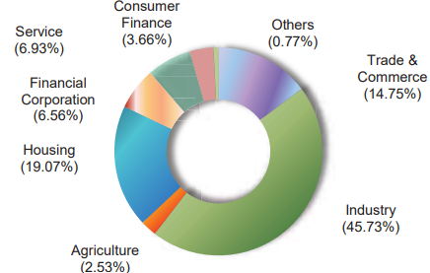
Figure 5.20 (NBFI Investment Pattern)

5.10 Evaluation of the IPDC
According to the official website, IPDC Finance Ltd. was founded in 1981 by a prominent group of stockholders. It is the first private sector financial institution. Since its founding, the corporation has played an important part in the nation's financial progress and growth. It is a NBFI which offer a range of financial services including FDR, individual loans, leases, and various investment options to support businesses, sectors, and SME’s. According to several studies and analyses, it has played an essential role in the growth of the private sector in Bangladesh. According to the website, the company works in 15 offices, has 860 employees, 25220 customers, a loan portfolio of 69.5 billion, and a deposit of 58.4 billion until March 31, 2022.
Throughout its inception, the corporation has played a critical role in the development of the country's private sector. Several projects were carried out during the initial stage. IPDCs typically focus on diversifying monetary generation, such as Corporate, Finance & Accounts, SME, Retail, Operations, and so on. They recently launched the DANA project, which is the only sole digital retail financing platform in Bangladesh.

5.10.1 IPDC Business Philosophy
In their annual report they have said about their vision that by giving focus on youth and women they want to become the best financial brand.
Their mission is to serve their customers to live unbound and by exploring new innovative solutions they want to unleash the full potential among the customers and communities.
They have a very strong and efficient guiding principles and core values.

5.10.2 IPDC’s Products and Services

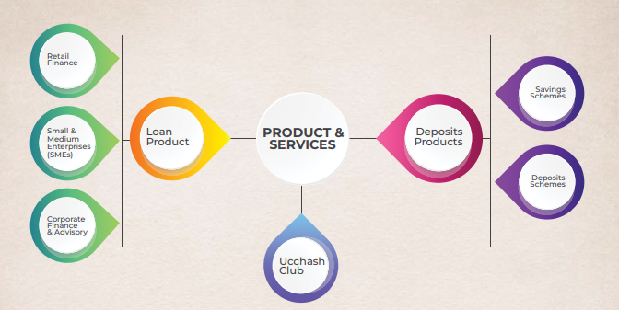
Figure 5.21 (Products & Services)

5.10.3 IPDC’s Footprints
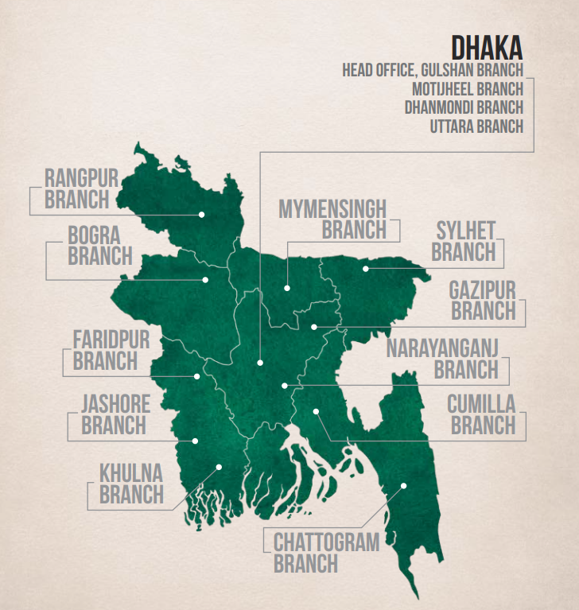
Figure 5.22 (IPDC’s Footprints)

5.10.4 The Shareholding Structure of IPDC

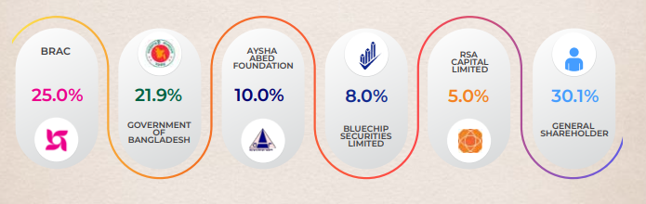
Figure 5.23 (IPDC’s Shareholding Structure)

5.10.5 Highlights between NBFI Sector and IPDC

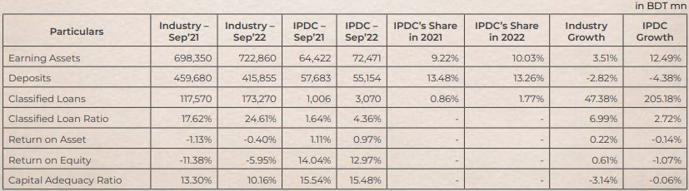
Figure 5.24 (Highlights between NBFI Sector and IPDC)

5.10.6 Governance Structure

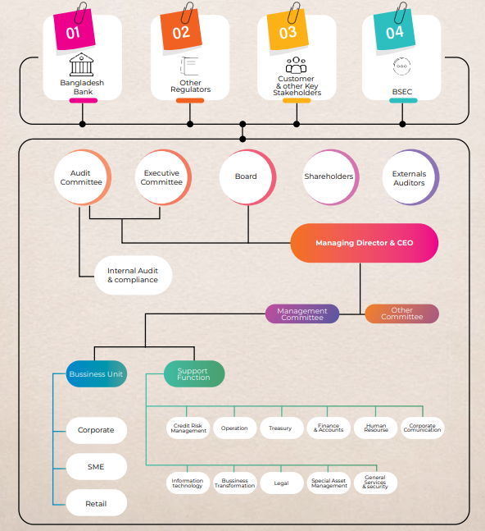
Figure 5.25 (Governance Structure)

5.10.7 Corporate Governance Framework

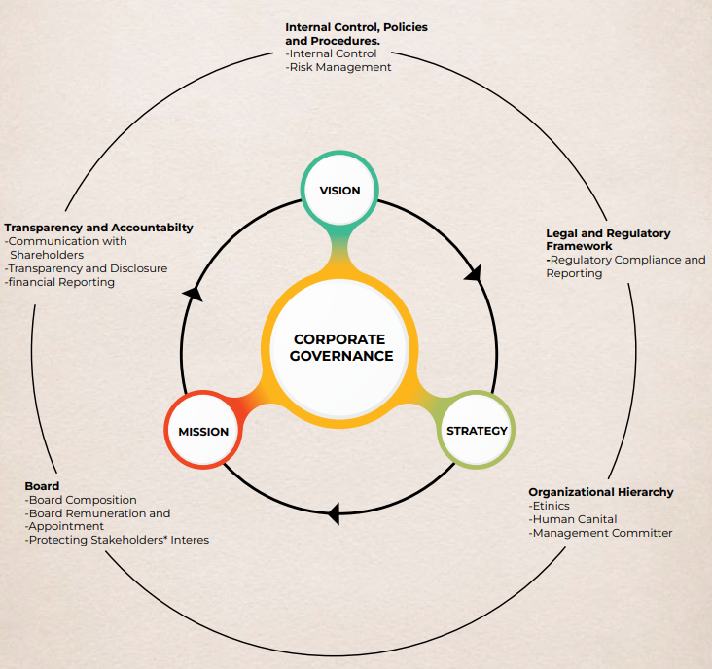
Figure 5.26 (Corporate Governance Framework)

5.10.8 Organogram of IPDC

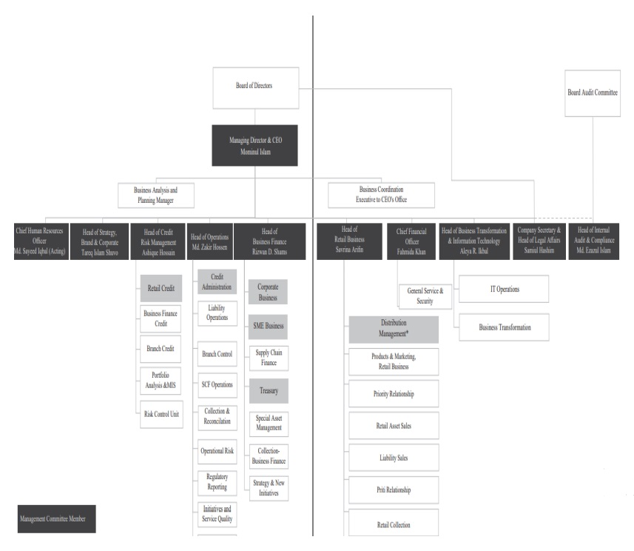
Figure 5.27 (Organogram of IPDC)

Chapter-6: Internship Experience in IPDC

6.1 Department
In IPDC my department was in corporate business (asset) sector. In corporate business sector there are 2 part – a) Asset & b) Liabilities. Corporate business (asset) sector is most important sector in the company.

6.2 How the Corporate Business (Asset) sector work?
In the corporate business (asset) sector their only customers are the corporate/company in Bangladesh. Here a different company give them a loan request letter then, a Financial Analyst (FA) works on it. They make a Executive Committee (EC)/MCC/Board paper which they provide it into their management. If the amount is certain then the management can take the decision. But if the amount is more than the certain amount than the EC committee take the decision. In that management credit committee, the members are HO, CFO, Head of CRM, AOB, AMD, MD&CEO. After that they give the offer letter to the company with their terms and conditions (T&C) and the amount of loan they are willing to give. Then in the company meeting if they agree with the offer letter then they have to provide the board reporting to the corporate business along with all of the charge documents.

6.3 Internship Job Description
My Internship in IPDC was started in 8th October,2023 and ended on 8th January,2024. It was a three month of internship period. I am very grateful to my almighty that I get the opportunity to work with one of the best NBFI in Bangladesh. Here, I get the opportunity learn so many things and apply the academic knowledge. My intern supervisor was MD. Emran Khan who is a FAGM of the company.
- Here, my role was like almost the work of their FA’s (Financial Analyst) as I am a student from the AIS background. At first, I analyzed Financials for the corporate clients using ratios and CRG score (Credit Risk Grading) which they taught me how to do this. Then I learned how to fill and check the AOF (Account Opening Form), CAF (Customer Acknowledgement Form), KYC (Know Your Customer), RBA (Risk Based Assessment).
- Then I learned AML (Anti-Money Laundering) & CFT (Combating the Financing of Terrorism) through training.
- Analyzed the different sectors of the market.
- Learned how to do DVC (Document Verification Code) verification from an annual report.
- Analyzed the different sectors of market.
- Learned how to do CIB (Credit Information Bureau) summary which is a very important things to see the client current status.
- Learned how to do Memos which is the most essential task in the corporate sector. Prepared credit proposal for STF facility in favor of for Tosrifa Sectors Limited a sister concern of Northern Tosrifa Group Limited was presented to the EC meeting and the proposal was passed.
- Visited the ACI Limited company’s Head Office as part of the sector visit task with a RM (Relationship Manager).
- Learned the most important thing like how to deal or get blend with the corporate culture. Then learned some additional skills like, how to use scanner, photocopy machine, and file management etc.
It was a good ride for me in the IPDC. There were some drawbacks but I always believe that there is always a positive and negative side in the company.

Chaper-7: Recommendations
NBFIs are one of the key providers of capital for companies, they provide a significant impact to the prosperity of the nation. The functioning of the sector has been developing in Bangladesh day by day. According to the computed results which is done by excel, the performance of the majority of NBFIs is satisfactory except few.
The financial performance of NBFIs sector shows a decreasing trend based on ROA, ROE, ROC, EPS, leverage ratio, capital ratio from 2018-2022 is not a good sign for this sector. But here is a thing to keep in mind that only because of some of the NBFIs horrible financial performance over the years has been affecting this sector. There are some reasons for that like the after COVID-19 pandemic situations, world economic recession, inflation in the country because of dollar reserve issue, Russia-Ukraine War, political issues, and so on.
To keep the good health for this sector the government and they all should come together to mitigate the risks they are facing. Here are some recommendations for the NBFIs sector that they can follow to make the downward trend better-
- They should be less dependent on the debt. It’s clearly showing from their debt equity ratio trend that over the years they are borrowing more money. As a result, their total liabilities are also increasing over the years which resulted the downward trend in deposit as % of total liabilities.
- They should be aware of their operational cost. Their operational costs against to their operational income are getting increased year by year. Which is affecting their EPS, ROA, CAR and cost to income ratio. For this their management have to work efficiently, Also, this reflects the inefficiency their corporate governance of NBFI sector.
- Regarding the after pandemic issue the Bangladesh Bank has implemented a number of policy steps to reduce the effects of COVID-19 on NBFIs and their customers. Some of the important policies are: loan/lease/advance classification relaxation, lowering the CRR from the rate of 2.5% from 1.5% every two weeks and from 2% to 1% percent daily, easing the T&C of restructuring and revolving loan renewal advantages, and other measures.
- Their profitability trend is also downward from 2018 to 2022. Although these is happening for some of the financial institutions but the other major players in this sector their growth is also not up warding. To increase the profitability, they should come up with the more innovations in their investing rather than just depending on deposits from their customers.
- One of the major things for this sector is to keep the non-performing loans (NPL) ratio low as much as possible. If the NPL is low then they can give more loans and their liquidity and assets will also be increased. So, for keeping NPL low they have to give more attention to their credit risk management. After the loan disbursement and they have to maintain a proper step for collecting the classified loans.
The primary sources of income for these financial institutions are loans and investments in the capital market. While, the stock market has performed well recently, it nevertheless experiences significant notable fluctuations in Bangladesh. They need to follow other methods for investing funds and generating longer-term income to give a healthy competition with banks on Bangladesh.

Chapter-8: Conclusion
The non-banking financial institutions play a vital for Bangladesh’s constant growth. The purpose of this research is to analyze the NBFI sector in Bangladesh from 2018-2022 as the 2023 audited report still not published yet. To analyze the sector, it has done the strategic evaluation, evaluation of the current state of the market, financial performance evaluation of this sector. According to this report, in Bangladesh currently the NBFIs are facing some challenges to keep their growth in upward trend. They need to improve in every sector of their company specially they need to improve in their loan selection which will result a good ratio of NPL in the overall sector if all of the NBFIs give more attention to this. In the meantime, they should keep searching for the investments which will later generate more revenue to become more competitive in the sector.
Despite the sector are facing some challenges but they have enormous potential for growth. From a under developing country to become a developing country for Bangladesh is possible only with the help of non-banking financial institutions. But still in this country there are so many countries who are unwilling to get the service from a NBFI company. To break this mindset from a customer they must establish a solid reputation as a brand by providing effective services to their clients. As a result, they’ve got enormous potential to produce in the next years. Due to lack of time and data, this aggregates the findings of only 10 NBFIs out of 35 NBFIs listed on DSE, resulting in a significant weakness of this study. The results of this research will assist managers in making better operational judgements, as well as shareholders in making stock market investing judgements.

Chapter-9: References
Akber, s. M. (n.d.). A COMPARATIVE EVALUATION OF FINANCIAL PERFORMANCE OF NON-BANK FINANCIAL INSTITUTIONS IN BANGLADESH. Retrieved from ResearchGate: https://www.researchgate.net/publication/356580106_A_COMPARATIVE_EVALUATION_OF_FINANCIAL_PERFORMANCE_OF_NON-BANK_FINANCIAL_INSTITUTIONS_IN_BANGLADESH
Bangladesh Bank. (2023, Jan-March). Retrieved from NBFIs Statristics: https://www.bb.org.bd/pub/quaterly/nbfistat/nbfis%20statistics_january_march_2023.pdf
Bangladesh finance. (n.d.). Retrieved from bd.finance: https://bd.finance/financial-reports/
Banks & FIs. (n.d.). Retrieved from Bangladesh Bank: https://www.bb.org.bd/en/index.php/financialactivity/bankfi
Bay Leasing & Investment Limited. (n.d.). Retrieved from blilbd: https://blilbd.com/annual-report/
DBH. (n.d.). Retrieved from dbhfinance: https://dbhfinance.com/financial-reports
EBL Securities. (n.d.). Retrieved from EBL: https://research.eblsecurities.com/Content/EBSLAdmin/images/ResearchReport/3/8c4cee88-914e-48ad-b80e-41e84b80a18c03092023063300.pdf
First Finance Limited. (n.d.). Retrieved from first-finance: https://www.first-finance.com.bd/annual-reports/
IDLC Finance PLC. (n.d.). Retrieved from idlc: https://idlc.com/financial-reports
Ahmed, H., Uddin, M. M., Masum, M. H., & Uddin, M. H. (2021). The inclination of corporate voluntary environmental disclosure in Bangladesh: Effect of size, Industry, and operating performance. Academy of Strategic Management Journal.
Babu, M. A., & Masum, M. H. (2019). Crucial Factors for the Implementation of Activity- Based Costing System: A Comprehensive Study of Bangladesh. ABC Research Alert, 7(1), Bangladesh.
Bhuiyan, M. N. U., & Masum, M. H. (2010). Balanced scorecard: A multi-stream performance measurement tool for public sector corporations in Bangladesh. The Cost and Management, 38(5), 19-25.
Hasan, K.L. Masum, M.H. and Islam, M.N. (2010) “The impact of dividend on share price: A multivariate analysis of listed banking companies in Bangladesh.” Journal (ISSN: 2218-5283) of Green University of Bangladesh; Volume I, 2nd Issue; p.p. 88-101.
Hassan, N., Masum, M., & Sarkar, J. (2022). Ownership Structure and Corporate Tax Avoidance: Evidence from the Listed Companies of Bangladesh. Polish Journal of Management Studies, 25(1).
Masum, M. H., Latiff, A. R. A., & Osman, M. N. H., Sarker J.B., Rahman M.M, Khan S, (2023). Impact of Corporate Characteristics on voluntary disclosure: A managerial Insight. Polish Journal of Management Studies. 28(4).
Hoque, M.K., Masum, M.H., & Babu, A. (2022). Impact of financial performance on green banking disclosure: Evidence from the listed banking companies in Bangladesh. Universal Journal of Accounting and Finance.
IPDC FInance Limited. (n.d.). Retrieved from ipdcbd: https://www.ipdcbd.com/aboutus/investorrelations
LankaBangla Finance. (n.d.). Retrieved from lankabangla: https://www.lankabangla.com/investor-relations/
List of Companies Selected Sector: Financial Institutions. (n.d.). Retrieved from DSE: List of Companies Selected Sector: Financial Institutions
MIDAS FINANCING LIMITED. (n.d.). Retrieved from mfl: https://www.mfl.com.bd/home/annual_reports
National Housing. (n.d.). Retrieved from nationalhousingbd: https://www.nationalhousingbd.com/financial-report
NBFIs Statistics. (2023, Jan-Mar). Retrieved from Bangladesh Bank: https://www.bb.org.bd/pub/quaterly/nbfistat/nbfis%20statistics_january_march_2023.pdf
Rahman, M. M. (2023, 02 14). Determinants of efficiency of non-bank financial institutions: an empirical evidence from Bangladesh. Retrieved from emerald insight: https://www.emerald.com/insight/content/doi/10.1108/AJEB-07-2022-0092/full/html#sec003
UNITED FINANCE. (n.d.). Retrieved from unitedfinance: https://www.unitedfinance.com.bd/en/Home/FinancialReports

Chapter-10: Appendix

Appendix A: Table-1 Return on Asset (ROA)
Name of NBFI | 2018 | 2019 | 2020 | 2021 | 2022 | Average
IPDC | 1.00% | 1.00% | 1.00% | 1.10% | 1.05% | 1.03%
DBH | 1.82% | 1.82% | 1.52% | 1.73% | 1.65% | 1.71%
FIRSTFIN | -3.64% | 1.37% | -4.94% | -21.26% | -16.40% | -8.97%
BAYLEASING | 1.66% | 1.04% | 1.29% | -0.48% | -5.73% | -0.44%
IDLC | 1.61% | 1.4% | 1.85% | 1.21% | 1.15% | 1.44%
MIDASFIN | 0.09% | 0.84% | 1.01% | 0.72% | 0.10% | 0.55%
BDFINANCE | 1.56% | 1.30% | 1.41% | 1.64% | 1.13% | 1.41%
LANKABAFIN | 0.89% | 0.91% | 1.06% | 0.76% | 0.21% | 0.77%
NHFIL | 1.31% | 1.30% | 1.81% | 1.37% | 1.43% | 1.44%
UNITEDFIN | 1.15% | 1.13% | 0.98% | 0.86% | 0.53% | 0.93%
Average | 0.75% | 1.21% | 0.70% | -1.23% | -1.49% | -0.0142%

Appendix B: Table-2 Return on Equity (ROE)
Name of NBFI | 2018 | 2019 | 2020 | 2021 | 2022 | Average
IPDC | 13.10% | 11.50% | 12.10% | 14.20% | 13.70% | 12.92%
DBH | 20.79% | 18.53% | 13.85% | 14.41% | 12.72% | 16.06%
FIRSTFIN | -45.95% | -22.82% | -71.74% | -95.97% | -18.65% | -51.02%
BAYLEASING | 8.21% | 5.52% | 5.73% | -5.54% | -46.89% | -6.59%
IDLC | 14.73% | 13.68% | 18.89% | 12.49% | 11.87% | 14.33%
MIDASFIN | 0.77% | 6.29% | 6.95% | 4.92% | 0.71% | 3.93%
BDFINANCE | 12.30% | 8.72% | 8.37% | 9.34% | 6.45% | 9.04%
LANKABAFIN | 7.44% | 7.23% | 8.07% | 5.66% | 1.60% | 6.00%
NHFIL | 15.60% | 12.96% | 16.12% | 12.21% | 11.82% | 13.74%
UNITEDFIN | 9.01% | 7.77% | 6.62% | 6.90% | 4.43% | 6.95%
Average | 5.60% | 6.94% | 2.50% | -2.14% | -0.22% | 2.53%

Appendix C: Table-3 Return on Capital (ROC)
Name of NBFI | 2018 | 2019 | 2020 | 2021 | 2022 | Average
IPDC | 4.61% | 4.39% | 4.16% | 5.14% | 4.73% | 4.60%
DBH | 9.42% | 8.37% | 7.42% | 7.78% | 5.33% | 7.66%
FIRSTFIN | -3.55% | -2.08% | -20.77% | -461.59% | -75.23% | -112.64%
BAYLEASING | 1.10% | 0.86% | 0.99% | -0.95% | -7.56% | -1.11%
IDLC | 1.51% | 1.33% | 1.79% | 1.15% | 1.13% | 1.38%
MIDASFIN | 0.35% | 2.82% | 3.09% | 2.20% | 0.27% | 1.75%
BDFINANCE | 2.33% | 1.98% | 2.06% | 2.27% | 1.56% | 2.04%
LANKABAFIN | 0.83% | 1.02% | 1.17% | 0.81% | 0.23% | 0.81%
NHFIL | 1.35% | 1.33% | 1.81% | 1.37% | 1.56% | 1.48%
UNITEDFIN | 1.15% | 1.13% | 0.98% | 0.86% | 0.53% | 0.93%
Average | 1.91% | 2.11% | 0.27% | -44.10% | -6.75% | -9.31%

Appendix D: Table-4 Earnings Per Share (EPS)
Name of NBFI | 2018 | 2019 | 2020 | 2021 | 2022 | Average
IPDC | 1.59 | 1.07 | 1.90 | 2.37 | 2.43 | 1.87
DBH | 0.21 | 0.19 | 0.14 | 0.14 | 0.13 | 0.16
FIRSTFIN | -3.49 | 1.16 | -4.31 | -18.47 | -14.52 | -7.93
BAYLEASING | 1.6 | 1.09 | 1.14 | -0.99 | -5.88 | -0.61
IDLC | 4.28 | 3.66 | 5.30 | 3.79 | 3.90 | 4.19
MIDASFIN | 0.08 | 0.70 | 0.81 | 0.87 | 0.08 | 0.51
BDFINANCE | 1.82 | 1.30 | 1.27 | 1.42 | 1.03 | 1.37
LANKABAFIN | 1.33 | 1.37 | 1.53 | 1.13 | 0.33 | 1.14
NHFIL | 2.36 | 2.02 | 2.75 | 2.23 | 2.25 | 2.32
UNITEDFIN | 1.48 | 1.31 | 1.13 | 1.19 | 0.76 | 1.17
Average | 1.13 | 1.39 | 1.17 | -0.63 | -0.95 | 0.42

Appendix E: Table-5 Current Ratio (Times)
Name of NBFI | 2018 | 2019 | 2020 | 2021 | 2022 | Average
IPDC | 1.00 | 1.00 | 1.00 | 1.00 | 1.00 | 1.00
DBH | 0.10 | 0.04 | 0.06 | 0.08 | 0.06 | 0.07
FIRSTFIN | 0.25 | 0.28 | 0.22 | 0.13 | 0.08 | 0.19
BAYLEASING | 1.05 | 1.18 | 1.3 | 1.29 | 1.25 | 1.21
IDLC | 0.63 | 0.27 | 0.99 | 1.40 | 0.92 | 0.84
MIDASFIN | 0.36 | 0.35 | 0.35 | 0.39 | 0.36 | 0.36
BDFINANCE | 1.21 | 1.14 | 1.16 | 1.16 | 1.20 | 1.17
LANKABAFIN | 1.21 | 0.97 | 1.12 | 1.14 | 1.11 | 1.11
NHFIL | 0.47 | 0.35 | 0.19 | 0.32 | 0.20 | 0.31
UNITEDFIN | 0.51 | 0.51 | 0.12 | 0.12 | 0.12 | 0.28
Average | 0.68 | 0.61 | 0.65 | 0.70 | 0.63 | 0.65

Appendix F: Table-6 Leverage Ratio
Name of NBFI | 2018 | 2019 | 2020 | 2021 | 2022 | Average
IPDC | 6.80% | 8.20% | 7.40% | 7.10% | 7.50% | 7.40%
DBH | 8.77% | 9.80% | 10.97% | 12.02% | 12.95% | 10.90%
FIRSTFIN | 7.70% | 10.05% | 4.85% | -16.49% | -32.58% | -5.29%
BAYLEASING | 14.49% | 16.04% | 16.50% | 14.60% | 11.03% | 14.53%
IDLC | 10.49% | 9.80% | 9.82% | 9.60% | 9.84% | 9.91%
MIDASFIN | 12.03% | 13.43% | 14.47% | 15.18% | 14.04% | 13.83%
BDFINANCE | 13.67% | 16.29% | 17.49% | 17.67% | 17.47% | 16.52%
LANKABAFIN | 12.61% | 12.65% | 13.60% | 13.42% | 13.00% | 13.06%
NHFIL | 8.40% | 10.37% | 11.79% | 11.45% | 12.33% | 10.87%
UNITEDFIN | 12.96% | 14.62% | 14.85% | 12.51% | 11.74% | 13.34%
Average | 10.79% | 12.12% | 12.17% | 9.71% | 7.73% | 10.51%

Appendix G: Table-7 Capital Adequacy Ratio
Name of NBFI | 2018 | 2019 | 2020 | 2021 | 2022 | Average
IPDC | 14.01% | 19.30% | 18.51% | 15.65% | 15.92% | 16.68%
DBH | 18.90% | 21.92% | 23.14% | 25.94% | 28.37% | 23.65%
FIRSTFIN | -46.30% | 18.73% | 6.12% | 11.37% | 9.59% | -0.10%
BAYLEASING | 15.98% | 18.25% | 21.37% | 18.38% | 12.42% | 17.28%
IDLC | 15.47% | 14.82% | 14.59% | 15.27% | 15.99% | 15.23%
MIDASFIN | 16.14% | 17.40% | 17.53% | 18.43% | 17.83% | 17.47%
BDFINANCE | 15.46% | 15.53% | 16.57% | 18.26% | 17.75% | 16.71%
LANKABAFIN | 15.49% | 16.40% | 18.76% | 16.89% | 15.78% | 16.66%
NHFIL | 16.39% | 17.45% | 19.06% | 18.69% | 19.89% | 18.30%
UNITEDFIN | 16.33% | 18.17% | 18.93% | 19.10% | 17.47% | 18.00%
Average | 9.79% | 17.80% | 17.46% | 17.80% | 17.10% | 15.99%

Appendix H: Table-8 Debt Equity Ratio (Times)
Name of NBFI | 2018 | 2019 | 2020 | 2021 | 2022 | Average
IPDC | 1.60 | 1.30 | 1.80 | 1.70 | 1.80 | 1.64
DBH | 10.41 | 9.21 | 8.11 | 7.32 | 6.72 | 8.35
FIRSTFIN | 1.32 | 9.95 | 2.45 | -0.72 | -0.33 | 2.53
BAYLEASING | 6.48 | 5.4 | 4.79 | 4.86 | 5.52 | 5.41
IDLC | 8.54 | 9.21 | 9.19 | 9.42 | 9.17 | 9.11
MIDASFIN | 1.18 | 1.23 | 1.25 | 1.23 | 1.60 | 1.30
BDFINANCE | 3.97 | 3.21 | 2.93 | 2.99 | 3.08 | 3.24
LANKABAFIN | 7.29 | 6.23 | 5.73 | 5.80 | 5.98 | 6.21
NHFIL | 10.62 | 8.4 | 7.48 | 7.73 | 6.44 | 8.13
UNITEDFIN | 6.72 | 5.84 | 5.73 | 6.99 | 7.52 | 6.56
Average | 5.81 | 6.00 | 4.95 | 4.73 | 4.75 | 5.25

Appendix I: Table-9 Cost to Income Ratio
Name of NBFI | 2018 | 2019 | 2020 | 2021 | 2022 | Average
IPDC | 40.1% | 45.3% | 40.6% | 36.0% | 45.8% | 41.6%
DBH | 24.8% | 27.0% | 24.4% | 22.8% | 28.6% | 25.5%
FIRSTFIN | -68.62% | -141.05% | -77.32% | -16.38% | -23.81% | -65.4%
BAYLEASING | 7.9% | 7.9% | 9.0% | 8.8% | 17.5% | 10.2%
IDLC | 40.7% | 41.8% | 38.3% | 37.8% | 43.9% | 40.5%
MIDASFIN | 63.3% | 57.9% | 61.0% | 29.2% | 63.0% | 54.9%
BDFINANCE | 39.90% | 38.57% | 32.89% | 27.41% | 48.31% | 37.4%
LANKABAFIN | 57.5% | 54.3% | 64.2% | 56.6% | 63.7% | 59.3%
NHFIL | 24.9% | 33.2% | 26.9% | 27.7% | 34.7% | 29.5%
UNITEDFIN | 49.2% | 57.1% | 64.5% | 67.3% | 71.0% | 61.8%
Average | 28.0% | 22.2% | 28.5% | 29.7% | 39.3% | 29.5%

Appendix J: Table-10 Non-Performing Loans
Name of NBFI | 2018 | 2019 | 2020 | 2021 | 2022 | Average
IPDC | 2.14% | 1.57% | 1.38% | 3.15% | 4.14% | 2.48%
DBH | 0.30% | 0.45% | 0.41% | 0.63% | 0.86% | 0.53%
FIRSTFIN | 47.60% | 36.58% | 35.35% | 86.79% | 86.45% | 58.55%
BAYLEASING | 1.39% | 2.07% | 1.38% | 3.73% | 18.72% | 5.46%
IDLC | 2.20% | 3.07% | 1.79% | 3.05% | 3.81% | 2.78%
MIDASFIN | 12.49% | 9.92% | 11.39% | 14.88% | 16.46% | 13.03%
BDFINANCE | 4.42% | 4.84% | 3.22% | 2.54% | 5.56% | 4.12%
LANKABAFIN | 3.60% | 5.59% | 4.70% | 6.57% | 7.22% | 5.54%
NHFIL | 6.93% | 5.88% | 5.33% | 5.16% | 4.21% | 5.50%
UNITEDFIN | 2.96% | 4.05% | 3.14% | 3.56% | 3.44% | 3.43%
Average | 8.40% | 7.40% | 6.81% | 13.01% | 15.09% | 10.14%

Appendix K: Table-11 Trends in Assets, Liabilities and Deposits of NBFIs
 |  |  |  |  | (B'BDT)
Period | 2018 | 2019 | 2020 | 2021 | 2022
Total assets | 851.6 | 871.5 | 902.16 | 896.56 | 973.24
Total liabilities | 739.6 | 753.12 | 815.84 | 823.96 | 929.9
Liabilities-assets ratio | 86.8 | 86.4 | 90.43 | 91.9 | 95.55
Total deposit | 466.2 | 451.93 | 453.2 | 444.2 | 478.08
Deposit as % of Total Liabilities | 63.03% | 60.01% | 55.55% | 53.91% | 51.41%
As on 30 June 2022.
Source: Department of Financial Institutions and Markets, Bangladesh Bank

Appendix L: Table-12 Trends in Total loan/lease and Classified Loan/Lease
 |  |  |  |  | (B'BDT)
Period | 2018 | 2019 | 2020 | 2021 | 2022
Loan/lease | 641.9 | 678.1 | 670.21 | 671.2 | 693.32
Classified loan/lease | 59.2 | 80.4 | 89.05 | 103.28 | 159.36
Classified loan/ lease as % of total loan/lease | 9.2% | 11.9% | 13.3% | 15.4% | 23.0%

Appendix M: Table- 13 Trends in Profitability of NBFIs
 |  |  |  |  | (%)
Particulars | 2018 | 2019 | 2020 | 2021 | 2022
Return on equity (ROE) | 7.45 | -25.2 | -1.99 | -2.79 | -9.91
Return on asset (ROA) | 0.98 | -2.56 | -0.19 | -0.23 | -0.44

