
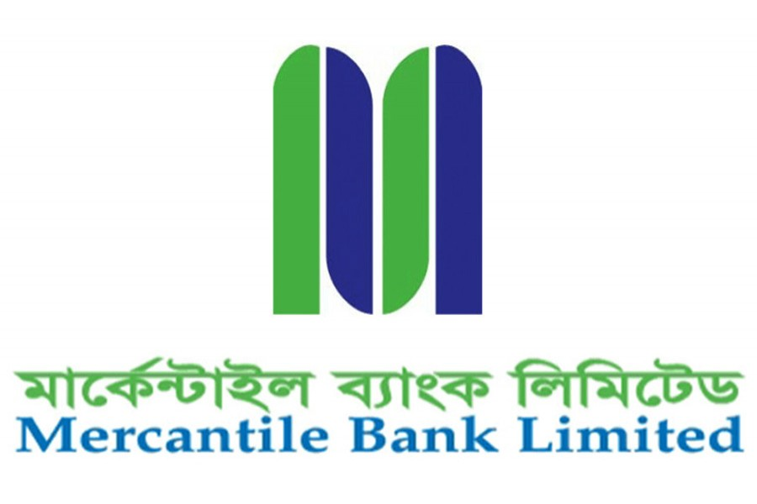
This report is submitted to the school of Business and Economics, United International University as a partial requirement for the degree fulfillment of Bachelor of Business Administration.

SWOT ANALYSIS OF MERCANTILE BANK LIMITED
INTERNSHIP REPORT
Internship Report
On
SWOT Analysis of Mercantile Bank Limited
Course code: INT 4399
Submitted To
Dr. Khandoker Mahmudur Rahman
Professor
School of Business and Economics
United International University
Submitted By
Amina Tarannum Samia
ID: 111 161 101
BBA Program, Major in Marketing
School of Business and Economic
United International University
Date of Submission: October 11, 2022

Letter of Transmittal
October 11, 2022
Dr. Khandoker Mahmudur Rahman
Professor,
School of Business and Economics,
United International University
Subject: Submission of Internship Report on SWOT Analysis of Mercantile Bank Limited.
Dear Sir,
With all due respect, my name is Amina Tarannum Samia, and I am notifying to you that, I have completed the report for the requirements of INT 4399 course.
I would like to express my gratitude to you for giving me the chance to get acquainted with the atmosphere of the organization as well as the formal academic report. Both of these things have been very helpful to me. The goal of my work was to ensure that it was easy to grasp.
I have the utmost confidence that this report will not only meet, but also exceed the needs and expectations that you have. If you could give the report your thoughtful evaluation and acceptance, I would be very grateful to you.

Student Name: Amina Tarannum Samia
ID: 111 161 101
BBA Program, Major in Marketing
School of Business and Economic
United International University

Declaration of the Student
I, Amina Tarannum Samia, a student in the Department of BBA (Marketing) in the School of Business and Economics at United International University, certify that the work described in this report has been done only for academic purposes. This report was written for INT 4399 at the requirements of the university.
I also declare that I have gathered and compiled all the information in this report myself. It does not include any previously published or written material that has been approved for credit toward a degree from United International University or any other academic institution. This report uses information from a reputable source that has been properly cited.
Student Name: Amina Tarannum Samia
ID: 111 161 101
BBA Program, Major in Marketing
School of Business and Economic
United International University

Acknowledgement
To begin, I would want to express my gratitude to Allah for the favor with which I was successful in completing my internship report on time and successfully.
On the other hand, I would like to express my gratitude to Dr. Khandoker Mahmudur Rahman, Professor, School of Business and Economics, United International University. It will be quite difficult for me to prepare this report by myself without his instructions, guidelines and direction.
In conclusion, I would like to express my gratitude to all of the employees of the Mercantile Bank Limited (Bijoynagar Branch), particularly those in the general banking and customer relationship (CRM) department, for the time and effort that they put into participating in the interview sessions. In particular, I would like to thank those employees who worked in the marketing and sales department. I was successful in acquiring a deeper awareness of the nature of the company's culture and identifying the most qualified individual for the position.

Table of Contents

Executive Summary vi
Chapter 01: Introduction
1.1 Introduction of the Report 2
1.2 Topic of the Report 2
1.3 Objectives of the Report 2
1.3.1 Broad Objectives 2
1.3.2 Broad Objectives 2
1.4 Scope of the Report 3
1.5 Methodology of the Report 3
1.5.1 Primary Sources 3
1.5.2 Secondary Sources 3
1.6 Limitations of the Report 4
Chapter 02: Literature Review
2.1 Literature Review 6
2.1.1 Marketing 6
2.1.2 Concept of SWOT Analysis in Banking Industry 6
a) Strengths 7
b) Weakness 7
c) Opportunities 7
d) Threats 7
Chapter 03: Overview of the Organization
3.1 About Mercantile Bank Limited (MBL) 9
3.1.1 World Range of Banking Services 9
3.1.2 MBL’s Resilience 10
3.1.3 Sustainable Business Practices 10
3.2 Mission, Vision and Core Values 11
3.3 Strategic Objectives 13
3.4 Organizational Chart 14
3.5 Products and Services at MBL 14
3.5.1 Corporate Banking Division 14
3.5.2 Credit Management Risk Division 15
3.5.3 Retail Banking Division 15
3.5.4 Card and ADC Division 16
3.5.5 SME Financial Division 16
3.5.6 Agriculture Credit Division 17
3.5.7 Mobile Banking Services 17
3.5.8 Agent Banking 18
3.6 Operational Activities and Environment 18
Chapter 04: Analysis Part
4.1 SWOT Analysis of Mercantile Bank Limited 21
4.1.1 Strengthen (Internal Factor) 21
4.1.2 Weakness (Internal Factor) 22
4.1.3 Opportunities (External Factor) 23
4.1.4 Threats (External Factor) 24
Chapter 05: Findings, Recommendations and Conclusion
5.1 Findings of the Study 27
5.2 Recommendations 28
5.3 Conclusion 28
References 30

Executive Summary
The purpose of doing a SWOT analysis is to have a better understanding of the position that your firm has in the market. The collecting of intelligence and its use in tactical settings go hand in hand, and this method excels at both of these tasks. Your ability to beat your competitors and keep consumers may be greatly improved by including a competitive study in your business strategy. The process of purchasing assets is simplified, a better understanding of the plan for acquiring new customers is achieved, and investment finance is made more easily accessible. In addition to this, there is a possibility that it will have a positive impact on the performance and profitability of the organization. The objective of the study is to find out what factors, both internal and external, have an effect on the rate of expansion of Mercantile Bank Limited's competitive market edge within the bank business in Bangladesh. The use of a SWOT analysis enables Mercantile Bank Limited to get an understanding of the factors that impact not just the market for banking services but also the factors that influence Mercantile Bank Limited's own company. It is necessary to detect the most significant components that may assist firms identify risks and opportunities in a competitive marketplace by doing a SWOT analysis. This may be done in a number of different ways. According to the findings of many studies, competing financial institutions in Bangladesh are now in the lead. In addition, Mercantile Bank Limited is going to need to take on extra marketing difficulties in order to not only build the firm but also dominate the sector. The primary drivers for the expansion of Mercantile Bank Limited that have been taken into consideration in this research are the inability to provide services to clients in accordance with the demands of those consumers and the provision of digital banking services by other businesses. On the other hand, when the report was going to be completed, certain recommendations were made in order to improve Mercantile Bank Limited's position in the banking market of Bangladesh.

Introduction of the Report
Commercial banks are at the forefront of delivering the whole range of services required by consumers, corporations, and governments. Currently, commercial banks in Bangladesh are the country's primary contributors or sources of revenue. Internships in the banking business may provide students with real-world exposure, an introduction to a potential career path, and the opportunity to build marketable skills.
Preparing this report fulfilled as a prerequisite for my internship program at United International University and as a requirement for my BBA in Business Administration. This report was prepared using the skills I learned and the information I received while studying for my Bachelor of Business Administration degree. Financial needs in Bangladesh may be met by the Mercantile Bank Limited. For that reason, I see it as a great fortune to have been given the chance to participate in this internship program. I have been an intern here for three months now, and I have been using this time to get ready for my courses at United International University, where I want to get a bachelor's degree in business administration.

Topic of the Report
A review of the banking industry in Bangladesh would benefit from having access to this report. The report's title as a "SWOT Analysis of Mercantile Bank Limited” is thus determined.

Objectives of the Report
The purpose of this study is to analyze the internal and external environment of the banking services market in Bangladesh by comparing Mercantile Bank Limited to other financial institutions there. In contrast, the study's aims may be broken down into the two broad classes described below:

Broad Objectives
- General objective is to study on SWOT Analysis of Mercantile Bank Limited.

Broad Objectives
- The purpose of this study is to analyze the existing scenario of the banking service industry in Bangladesh.
- To find out the Mercantile Bank Limited’s strengths, weaknesses, opportunities, and threats (SWOT).
- To make recommendations on how Mercantile Bank Limited may overcome the obstacles that are keeping it from expanding and becoming a market leader in the banking sector of Bangladesh.

Scope of the Report
The study's overarching goal is to help Mercantile Bank Limited improve its performance, productivity, and development in the internet delivery services industry by providing a more in-depth analysis of the company's marketing plans, activities, and advertising approaches. Finding out why the organization takes the measures it does to manage its online clientele was the driving force for our research. The report of the study and analysis also identifies to provide light on the question of how successful the company's initiatives have been so far at keeping its current clientele. The goal of this study is to provide a comprehensive list of the marketing department's tasks and to identify areas for improvement. Further, the research looks at competitors from the perspective of the consumers and assesses how the consumers feel about the rivals.

Methodology of the Report
The data used in this study and analysis came from both primary and secondary sources. Here is a rundown of the particulars:

Primary Sources
- Formal and informal discussions with the employees of Mercantile Bank Limited resulted in the creation of this report.
- On the basis of my own personal experience while working as an intern at Mercantile Bank Limited (Bijoynagar Branch).

Secondary Sources
- From academic books for understanding the concepts of SWOT analysis and marketing strategies.
- Online blogs, articles, business news etc.
- Annual Report of Mercantile Bank Limited.

Limitations of the Report
- The length of time spent participating in the internship was inadequate to enable the development of relevant practical skills.
- Due to the constraints that come with being a financial institution, the company was not capable of collecting any thorough data.
- During the phase of my internship at Mercantile Bank Limited, which lasted for three months, I was in charge of all of the company's operations. Due to this, doing the study and writing the report at this time proved to be challenging.

Literature Review

Marketing
The organized effort that is put forth in marketing in order to guide the distribution of products and services from producers to end users is referred to as marketing (Kotler, 2018). Managing customer relationships profitably, acquiring new customers while maintaining and growing existing ones, and managing customer acquisitions are all crucial to a company's marketing success. To attract and retain more customers, businesses use marketing strategies that aim to increase the perceived value of their interactions with the brand. The motivation might be expanding the company's market (Armstrong, 2007).

Concept of SWOT Analysis in Banking Industry
Your company's SWOT analysis is simpler to do than you would imagine. Taking this step won't take long, but it will compel you to think about your business in a different light. If you're trying to come up with a good plan for your company, a SWOT analysis may help you make sure you've considered all of the opportunities and threats that exist. Performing a SWOT analysis may be beneficial for firms since it can highlight both risks and potential gains. Using a SWOT analysis may help you see the forest for the trees, so to speak. In industries like healthcare, where it's important to weigh the risks and rewards of many options in order to offer the best care possible, this can be invaluable. Firms may become more competitive in their sectors, which will benefit their clients in the form of reduced prices and higher quality service, by doing a SWOT analysis (Berry, 2020).
Banking markets are among the world's oldest sectors still functioning today. Trade and commerce have come a long way since the days of barter. In spite of this, there is much more work to be done. Despite the fact that most banks now allow you to perform much of your banking online, from the comfort of your own home, this sector is still behind the times. It does not use modern information technology or adapt to changing customer preferences (FRUE, 2019)
This SWOT analysis of the banking business, however, will show that there are numerous advantages to working in this field. In this section, the banking business will be evaluated from four perspectives: its strengths, weaknesses, opportunities, and threats.

Strengths
A company's strengths are the advantages it has over its competitors on the basis of its internal resources and capabilities (Sharplin, 1986) .It encompasses the skills of the bank as well as the internal positive attitudes that make it possible for the bank to own strategic position in order to acquire strategic power in the competitive market. Banks are able to devise and carry out plans that will allow them to outperform their competitors thanks to the competencies and capabilities that make up their organizational strengths (Barney, 1992).

Weakness
Weaknesses are shortages of internal capabilities that have a negative influence on service value and prevent the organization from achieving its objectives in a competitive market. In competitive analysis, a company's weaknesses serve as a central topic of conversation, and they also help to pinpoint potential opportunities for growth (Sharplin, 1986).

Opportunities
One way to describe opportunities is as a collection of circumstances that make it possible to accomplish one's objectives at the appropriate moment, with the right product, at the right price, and in the right market. Opportunity is a favorable perspective that confers some form of relative advantage onto a business, which in turn favorably impacts that firm's ability to deliver excellent services in a competitive environment (Barney, 1992).

Threats
A risk is defined as any undesirable occurrence in an organization's external environment that poses a risk to the strategy of the business (Rowe, 1994). It is referred to as challenge cost when there is a negative attitude toward the shared norms of the organizations (Armstrong, 2007).

About Mercantile Bank Limited (MBL)
Some forward-thinking businesspeople in Bangladesh set out to improve the country's economy in 1999. The realization of that dream is Mercantile Bank Limited (MBL). The Bank has been establishing its reputation and winning the confidence of its clients since June 2, 1999. The bank's aggressive transformation plan, energetic leadership, and decisive management interventions have provided it with a solid foundation from which to seize new opportunities as they arise. MBL's cluster specialists use cutting-edge technology to provide excellent customer support, and the company is always innovating to meet the changing demands of its clientele. In order for Bangladesh's banking sector to grow, it is crucial that the public have faith in the financial system. With this in mind, MBL fosters a strong tradition of ethical business practices. MBL encourages its employees to make decisions with better efficiency, responsibility, and openness. Similarly important to MBL is aligning our values, norms, and culture with those of our employees, customers, and other stakeholders, as well as the broader Bangladeshi economy. Through its extensive branch network, the Bank provides services to a diverse clientele that includes both people and businesses.
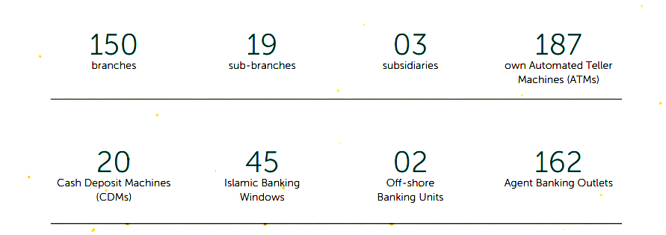
Figure 3.1: Take a look at MBL

World Range of Banking Services
MBL has been able to establish itself as a prominent third generation private commercial bank as a result of its conservative policy guidelines in conjunction with good execution, a greater choice of banking products, and exquisite client services. The provision of a wide range of commercial banking services, such as deposits mobilization, corporate banking, small and medium-sized enterprise (SME) and retail business banking, discounting of bills, foreign exchange business, offshore banking, treasury functions, card business, mobile banking (My Cash), internet banking, locker service and Islamic banking, agent banking, and so on, are at the heart of the Bank's operations. MBL provides a wide range of card services to its clientele, including a VISA dual prepaid card, credit card, debit card, medical card, student card, hajj card, and international/dual card, all of which have cutting-edge features. With the launch of the MBL Contact Center 16225, Mercantile Bank is now able to provide convenient financial services right to the doorsteps of its clients, any time of day or night.

MBL’s Resilience
The social, economic, and business sectors throughout the world have all been shaken by the COVID-19 outbreak in ways that no one could have predicted. In the face of adversity, Mercantile Bank Limited was able to adapt by changing the culture and values of its workforce and emerging even more robust than before. As part of its effort to adapt to the "new normal," the Bank has created and deployed a number of efficient strategies in a timely and adaptable manner.
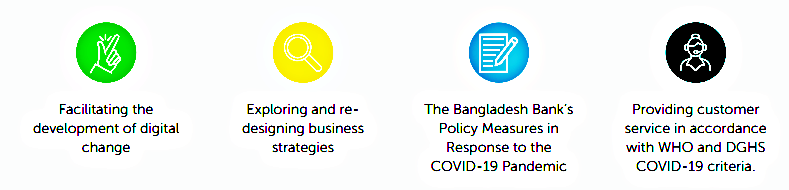
Figure 3.2: Development of Business Strategy and Cultures

Sustainable Business Practices
Great anxiety has been inflicted on individuals all across the globe because of the massive COVID-19 problem. Throughout the crisis, MBL has shown a serious dedication to implementing sustainable business practices. It does this by including consideration for the United Nations' Sustainable Development Goals (SDGs) into its business strategy development and by placing a premium on asset expansion supported by a plan for ensuring the safe, dependable, and efficient management of its operations. Also, despite the unstable state of the macro economy, MBL is dedicated to the growth of its business model in order to keep its financials in good shape.
In the meanwhile, MBL aspires to establish itself as a formidable market player by consistently spending money on systems, processes, and governance mechanisms to construct a firm groundwork for enhancing efficiency and effectiveness. To accomplish these aims, MBL plans to cultivate an army of dedicated employees that are passionate about delivering value and who embody the company's vision.
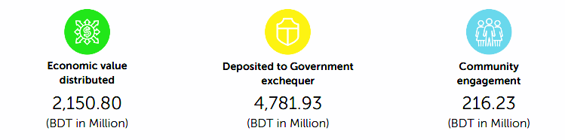
Figure 3.2: MBL’s contribution to the economy during the year 2021 through

Mission, Vision and Core Values

Vision
- Would be the model of corporate citizenship.

Mission
- Will transform into a bank that cares the most, prioritizes fair development based on the diverse deployment of resources, and, despite this, will continue to be a healthy and gainfully profitable institution.
Core Values
The seven guiding principles that guide their organization serve as the basis for their culture, our brand, and their overall approach to doing business. These Core Values encapsulate who they are as a Company, serve as the basis for their choices, and motivate them to continue moving forward.
- Customer Delight: Customer satisfaction infuses all their efforts. They are aware that the satisfaction of their customers is directly proportional to the achievement of the organizational objectives.
- Innovation: Encouraging creative problem solving to strengthen their company. They think change is the only constant and want to be at the forefront of its creation as a means to achieve excellence.
- Ethical Values: In both their thoughts and deeds, they will continue to behave in a responsible, ethical, truthful, and transparent manner.
- Caring for Human Resource: Potentials of workers, treating each one with respect for their own unique value and dignity, and focusing on their well-being as a priority in HRM policy and practice.
- Commitment: Maintaining their reputation as a reliable custodian for their valued depositors is a top priority, as is doing the same for all of their other stakeholders.
- Socially Responsible: Make a consistent effort to behave and react in a socially responsible way, keeping society and their nation in mind at all times. To care for their environment.
- Shareholders Values: The creation of new value and the optimization of existing value for their shareholders

Figure 3.3: Core Values of MBL

Strategic Objectives
To Achieve Economic Value Addition
To rank among Bangladesh's top three most productive financial organizations.
To Increase Share Holders’ Values

To Be Market Leader in Product Innovation
They want to grow their market share to the point to be among the top five financial institutions in Bangladesh

Figure 3.4: Strategic Objectives
Their concentration is evenly split between its consumers, personnel, and stockholders. Through Financial Inclusion, they want to achieve robust business growth. They contribute to the well-being of both personnel and shareholders by providing solutions at a low cost based on a high degree of satisfaction across all segments of consumers. They are dedicated to meeting the requirements of our consumers in a way that is both convenient and effective; consequently we are always working to improve both services and product solutions to meet those goals. For their staff, they provide a state-of-the-art benefits package and pleasant place to work. They always keep their shareholders' interests and the growth of their stock value in mind. This has provided a means through which they may develop and advance.

Organizational Chart
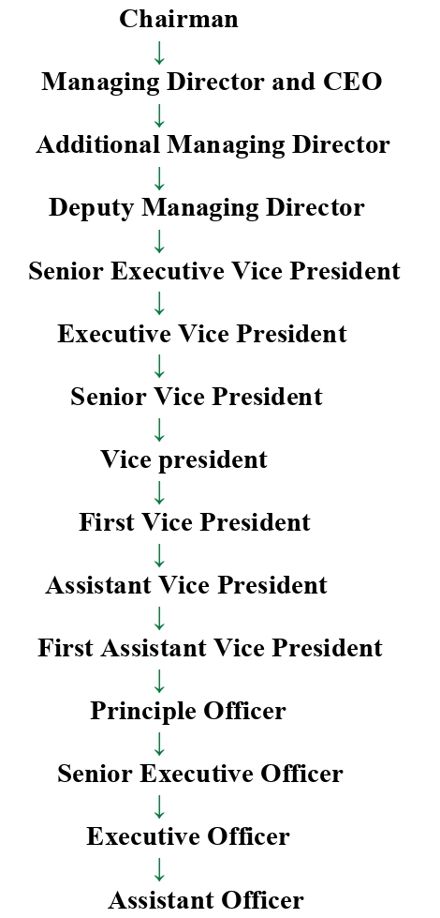
Figure 3.5: Organizational Chart of Mercantile Bank Limited

Products and Services at MBL

Corporate Banking Division
Mercantile bank's Corporate Banking Division (CBD) has been providing large and well-known businesses in industries including ready-made garments (RMG), textiles, commerce, construction, cement, ceramics, communication, infrastructure, power, and pharmaceuticals with the loans and advances they need to grow.
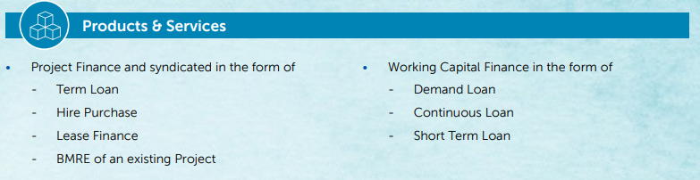

Credit Management Risk Division
An efficient risk management process of the credit facilities brings up steady development regardless of the state of the market. This is why Credit Risk Management is so important to financial institutions. In accordance with the standards set forth in Bangladesh Bank's Guidelines on Credit Risk Management (CRM) for Banks, Mercantile Bank Limited has established a nine-member Credit Risk Management Committee to provide direction and oversight for CRM and to monitor the bank's credit risks in their entirety. This includes a look at the bank's underwriting policies, lending practices, collection procedures, and past-due loans.
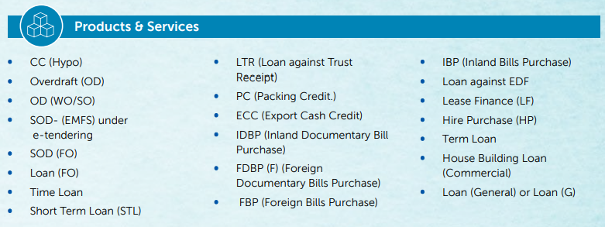

Retail Banking Division
With the widespread use of financial technology, consumer tastes in Bangladesh are fast changing. The future of banking is being shaped by novel developments in product design, distribution, and customer service. In keeping with its concept of serving the client as a one-stop financial service provider, Mercantile Bank has tackled the issue of customer need understanding and concentrated on solution creation.
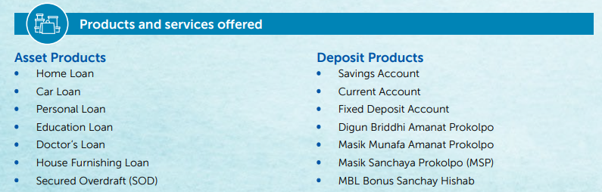

Card and ADC Division
Using a Local Network Q-Cash Consortium, MBL began card operations in 2002 and ATM operations in 2004 to provide its clients with convenient, up-to-date financial services. MBL began issuing Visa cards in 2006, when it joined Visa International as its primary member. At present, MBL operates 187 ATMs in conjunction with its Branches and other strategic sites around the nation, in addition to 20 CDMs (Cash Deposit Machine).
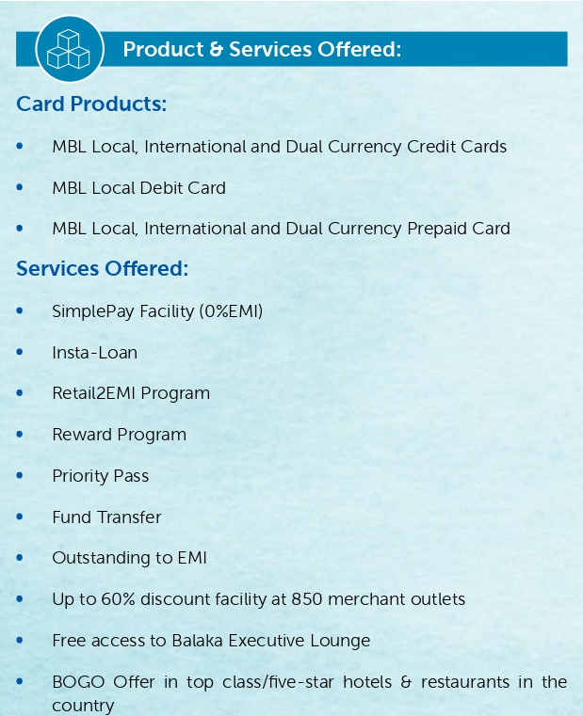
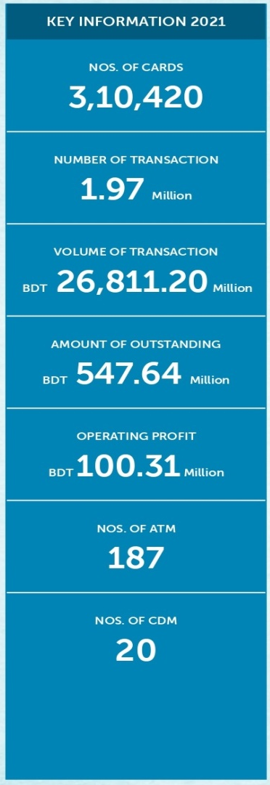

SME Financial Division
From September 3, 2006, MBL has had a division dedicated to SME finance, operating under the prudential norms set out by the Bangladesh Bank. MBL has launched a massive campaign to enhance its lending exposure to small and medium-sized enterprises. File preparation, document collection, site visit, verification, credit approval, credit monitoring and recovery, and credit administration are all handled by an in-house staff at Headquarters to aid regional offices. Consequently, the bank's small and medium-sized enterprise (SME) portfolio has grown substantially during the last five years. As a result, the SME Financing Division helps the bank expand in the long run.
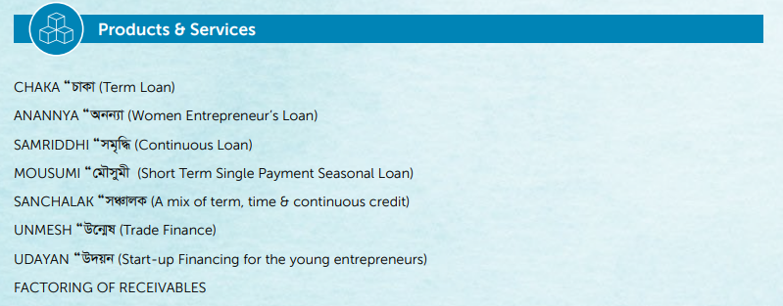

Agriculture Credit Division
To a large extent due to government policy backing and the innovative role and contributions of its farmers, Bangladesh has achieved effective and durable achievements in agriculture. During the last decade, Mercantile Bank Limited provided credit finance for farmers. From the beginning, this department's farm credit operations have followed the following guidelines established by Bangladesh Bank's policy and programme:
- Directly to farmers (Individual/Group-wise)/Concerns
- To farmers through partnership with MFIs/NGOs (MRA Certified only)
- To farmers through Contract Farming with reputed Companies

Mobile Banking Services
Since 2012, customers of MBL have had access to the company's mobile banking services. MYCash is dedicated to providing a variety of banking services to the people of Bangladesh through mobile device. This method of sending and receiving money is quick, safe, and cheap. It offers a whole ecosystem where individuals can make the most of money, not just the ability to "give and receive." Making it possible for individuals to take part in the financial system even if they do not have access to the services offered by traditional banks. MYCash has made a commitment to becoming the most forward-thinking company in Bangladesh's growing mobile financial services sector.

Agent Banking
Agent banking is a very effective method for expanding MBL's visibility nationwide. It's a brilliant strategy for bringing Bangladesh's unbanked population into the fold of financial inclusion. On December 28, 2019, we opened our first Agent Banking location after receiving permission from Bangladesh Bank.
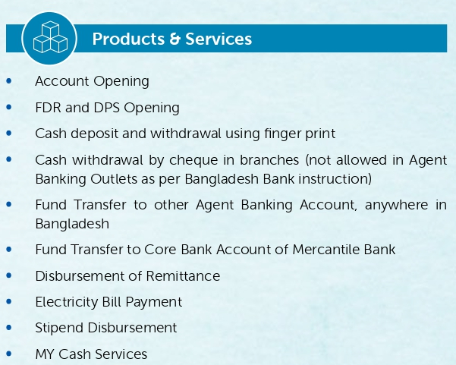
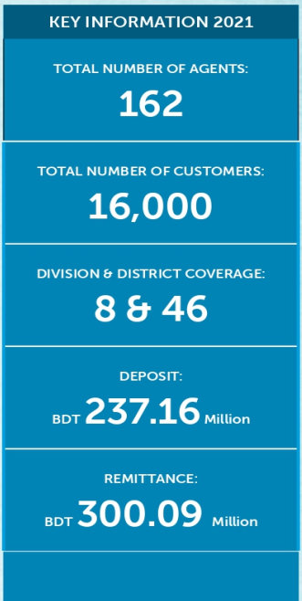

Operational Activities and Environment
Front Office and Back Office are the two main divisions of Mercantile Bank Securities Limited. Both of these functions are crucial to the whole. In addition, Front Office responsibilities cover the full gamut of customer management activities, such as opening new beneficiary accounts, keeping in touch with current and prospective clients, acquiring buy and sell orders, and promptly and accurately executing them in coordination with other divisions. The front desk also handles incoming calls, schedules meetings, and disseminates time-sensitive and market-moving updates from the Bangladesh stock exchange.
Another duty of the front desk is to provide the daily portfolio to the customers. As part of front office operations, the transaction report is saved at Headquarters after trading hours. Moreover, cash and check reception and payment, as well as data input of newly established BO Account's information, are all handled by the back office operation at the Main branch of Mercantile Bank Securities Limited, with data also being held in the front office. The back office also handles tasks like documenting transactions and creating vouchers.
The Main Office's back office also handles things like accounting, reconciliation, verification of transactions, rectification, obtaining client authorization, and following up with customers, in addition to providing payment and settlement services. The Head Office is also responsible for ensuring that all relevant registers, such as the Client Register, the Complaint Register, and the Attendance Register, are properly documented. Mercantile Bank Securities Limited, based out of the main branch, also provides a number of additional services. As an example, modern communication tools make it possible for officials from every department to participate in morning meetings. Furthermore, representatives from each office remain in constant contact with customers and update them on the status of their portfolios.
All branches' officials work together with those from other branches as well. Checks written by customers of other branches and given to the main branch are also cleared there. The monitoring department keeps an eye on everything, and they report back to the higher-ups every day with their findings. Their central branch's administrative offices only handle withdrawals and requisitions through BEFTN/RTGS/Fund Transfer. Despite this, employees from Mercantile Bank Securities Limited would go after a customer whose Head Office account has negative portfolio equity in order to coerce the client into turning things around.

SWOT Analysis of Mercantile Bank Limited
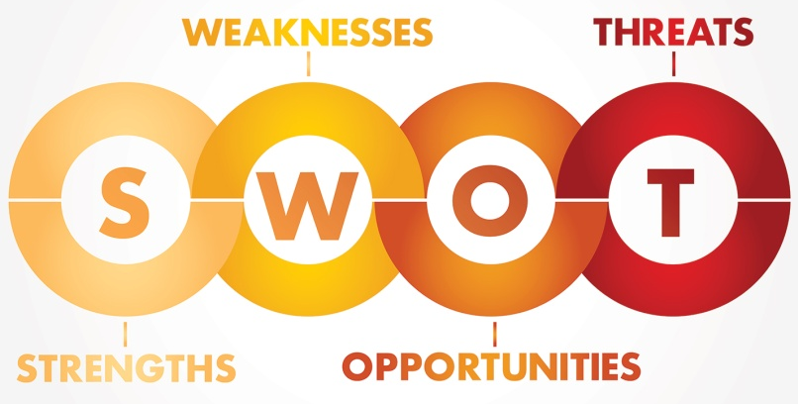
Based on the findings of a SWOT analysis, we know that both internal (Strength, Weakness) and external (Opportunity, Threat) forces are at play in the company's environment, which presents challenges for maintaining business as usual. According to Mercantile Bank's point of view, the SWOT analysis must take into account the essential aspects that are outlined below, and they are presented in alphabetical order for your convenience.

Strengthen (Internal Factor)

Increased Liquidity and Strengthening of the Capital Base
Mercantile Bank was able to effectively keep their CRAR (Capital-to-Risk Weighted Assets Ratio) at 13.64 percent, and their cost-to-income ratio was decreased to a level that was appropriate.

Good Corporate Governance
The board of directors of the bank regularly evaluates the bank's compliance with the Central Bank and works to ensure that the company operates ethically. The Board of Directors acknowledges the importance of good corporate governance standards in creating value for shareholders and safeguarding the company's interests overall.

Enriched Human Capital
They have a healthy work atmosphere, as well as a well-developed pool of human resources, which enables them to provide the most potential value to the firm.
- In order to gather information on the effectiveness of the use of human resources,
- In order to offer information on the state of a human asset, such as whether or not it is being maintained efficiently and whether or not it is appreciating or depleting, and in order to provide information on the condition of a human resource and
- The development of effective HRM practices may be aided by classifying the monetary consequences of different human resource management strategies.
Human capital is appraised most often via the use of the following strategies.

Diversified Products and Services
Mercantile Bank offers its esteemed clientele a wide variety of cutting-edge corporate, retail, and small and medium-sized enterprise (SME) products, in addition to a full complement of regulatory services.

Stronger Branch Network
It's not just a slogan for them; "Service First" is their core value. The service is fundamental to their business and is provided via a network of 150 branches, 19 sub branches, 187 automated teller machines, and 162 agent banking locations in both populated and lightly populated areas.

Performer of Regulatory Compliance
Since the very beginning, Mercantile Bank has always operated in a manner that is entirely compliant with all tax and VAT requirements imposed by the Bangladesh Bank and the National Board of Revenue.

Weakness (Internal Factor)
- Credit Concentration
Financing is their primary line of business, which puts us at risk for a wide variety of credit-related issues, most notably the default on repayments and the accumulation of non-performing loans. Their credit portfolio consists of retail loans as well as business loans, both of which are susceptible to the dangers that the economy poses. The ongoing epidemic of the COVID-19 virus raises the stakes for these hazards.
- Limited SME and Retail Exposures
Mercantile Bank's exposure to the retail and small and medium-sized company (SME) industries is quite low when seen in comparison to that of other market leaders.
- Dependence on Core Banking Line Up
Since Mercantile Bank does not have any other significant revenue sources, the bank's interest revenue income and total income declined as a consequence of the lower deposit-loan proportion of 6-9 percent. This is because Mercantile Bank does not have any other considerable revenue streams.
- The Lack of Access to Cutting – Edge Technology
The quantity of funds that Mercantile Bank invests in the information technology sector to improve software and build physical infrastructure is inadequate, and the bank also places limitations on the software upgrading process. It is now working on steps to improve its cyber security, but there is still more work to be done in this area.

Opportunities (External Factor)
- Governments Initiatives Towards Development
The government of Bangladesh is now making investments in the construction of infrastructure projects such as the Metro rail system, four-lane motorways, the Padma Bridge, and the Big Port. These investments are being made in addition to a variety of other development initiatives. As a result of these advancements, Mercantile Bank is ready to work together with the many important stakeholders to address any potential challenges that may develop.
- Women Entrepreneurship in Rising
In recent years, a growth in women's entrepreneurship has been seen with an increase in both literacy and educational attainment levels. At Mercantile Bank for Women Entrepreneurs, there are service desks that are geared specifically for female customers. Women who own businesses may depend on our knowledgeable Relationship Managers and on solutions that are adapted specifically to their needs in order to fulfill all of their banking obligations.
- GDP Growth along with other Business Development
Bangladesh's ascent to prominence in the world of industry and trade is due to the country's consistently high GDP growth (with the exception of the COVID-19 era) and its emergence from the category of low-income countries. As a direct consequence of this, the banking industry in Bangladesh is witnessing new growth potential as a direct result of the country's rising GDP and income per capita.
- Exploring New Avenue of Business Like Islamic Banking
As a result of the majority of the people being Muslim, an Islamic economy that is based on shariah law is practiced. These days, a growing number of people in the banking industry are opting for Shariah-compliant products and services, as well as Islamic financial services. To this purpose, Mercantile Bank, an Islamic banking subsidiary, is being developed as a component of the larger shariah-based financial system. This will allow for more financial transactions to be conducted in accordance with shariah. The Prepaid Hajj Card from Mercantile Bank is an innovative solution for your financial needs when you are traveling to the Holy Lands in Saudi Arabia in order to do the Hajj.

Threats (External Factor)
- Reshaping Geo Political Outlook Due to Russia- Ukraine War
Because of the conflict and the sanctions that followed it, key transportation links between Russia and Ukraine and the rest of the globe have been broken, which has disrupted commerce more generally. Bangladesh is already feeling the effects of the conflict between Russia and Ukraine, with inflation reaching 7%, the highest level in decades, a reduction in exports to Russia and Ukraine, as well as an increase in import bills, primarily for oil and food. These effects are already having a negative impact on the bank industry of Bangladesh.
- Recent COVID 19 Pandemic Effects
The lengthy lockdown that occurred during the pandemic led to a decrease in GDP growth of 5.20%, which was originally projected to be 8.20%. Due to the fact that bank loan disbursement and loan recovery were at such low levels, interest income was severely reduced, which had a detrimental influence on the business sector as a result..
- Non-Cooperation from Bad Customer
Due to effects of covid-19, the Bangladesh Bank decided to give loans without interest for a certain period of time. A customer made the decision to forego future interest charges after they were successful in meeting their obligation to make interest payments on schedule. In addition, some clients take advantage of the loan that was provided to them by submitting fake papers.
- Cyber Security
Hacking and other cybercriminals have access to the most cutting-edge tools and technologies available in the information technology world today. A rapid rise in the amount of cybercrime might cause consumers to lose trust in the safety of their banks.

- Exchange Rate Fluctuation
A maximum interest rate of 9% has been established by the government for loans of all kinds, with the exception of credit cards. As a direct consequence of this, there had a detrimental impact on the viability of the immediate future.

Findings of the Study
Financing is an essential part of Bangladesh's stimulus package, and the banking industry will need to be actively involved in the implementation of this plan in the year 2021. Administration of the stimulus package in a way that is efficient is critical not just for Bangladesh's economy but also for the nation's banks and other financial institutions. The open-rationalization strategy involves the identification and selection of the firms that will be affected, as well as the monitoring of the whole process, in order to ensure that appropriate supervision is provided. The Corporate Banking Division of Mercantile Bank Limited is more meticulous and systematic when it comes to finding and choosing the affected firms that are more likely to profit from the stimulus packages. This ensures that the most favorable outcomes are achieved. The Russia and Ukraine war and Covid-19 poses severe difficulties to the traditional banking business model because to low interest rates, large capital requirements, growing competition from shadow banks, and new digital entrants.
Based on the current state of the banking industry in Bangladesh, the competitive market environment, internal and external variables, and other considerations, a number of obstacles have been identified that threaten Mercantile Bank Limited's growth plans for its bank service business in Bangladesh:
- Mercantile Bank Limited provides its employees with incentives, advantages, and other perks such as performance bonuses, profit-sharing, and risk-sharing incentives in order to motivate them to perform well within the context of a salary-based compensation structure.
- It's likely that customers and clients won't be able to satisfy their needs on time since there aren't enough ATM booths, which is inconvenient and delays the process.
- Due to the fact that many or several customers are unable to visit the bank during the banking transaction time, the bank inevitably loses a certain number of customers who are preoccupied with their professional responsibilities.
- The lack of a marketing department has been one of the most obvious shortcomings in the Account Opening and Dispatch sector. The job at the bank might have been made a lot easier if there had been a marketing department that was entirely distinct and kept apart from other departments.
- The technical instrument has not undergone any recent updates for a very long time. Take, for instance, the fact that the Matuail location does not have either a copy machine or a telephone that can connect to other lines.

Recommendations
- The banking industry may be broken down into six distinct but interrelated subsectors. Therefore, the GB sector has to be further segmented. A rate hike by the bank is necessary. The company's GB division should do great job of creating friendly, personal ties with its customers.
- In order to give superior support to its clientele, Mercantile Bank Limited should increase the number of employees working in its various locations.
- Complaints should be sent to a "Complaint Box" by both customers and employees alike. It is essential to have an understanding of some aspects of internal politics since they contribute to unfavorable conditions.
- The number of automated teller machine booths should be increased, and the services that are offered at such booths should see an improvement.
- It is recommended that Mercantile Bank Limited establish a marketing department that is separate from the rest of the organization. It is essential to provide the bank with the suitable technical instrument at the earliest possible opportunity.

Conclusion
There has been a proliferation of commercial banks in recent years, raising the stakes in the banking business Mercantile Bank Limited is moving forward with plans to bring in foreign services at now. Mercantile Bank Limited is committed to developing all of its activities and services to the highest standards of quality.
I am grateful to have had the opportunity to work at the Mercantile Bank Limited (Bijoynagar Branch) during my internship. During the course of my time working at the bank, I was educated on a variety of different types of financial systems, the most of which I had never encountered before. I need to put what I have learned into practice so that I can put theory into action. I believe that the experience I gain during my internship over the next three months will help me improve my professional abilities and provide me the ability to make an educated choice about the direction my future career will take.
In general, I believe that any sector has both good and bad characteristics, and if I think about Mercantile Bank Limited, the positive aspect is that they are dedicated to enhancing their current strategy and introducing new, useful items to win the choice and loyalty of their clients.

References

Armstrong, P. K. (2007). Principles of Marketing . South Asia: Manipal Press Pvt Ltd.
Barney, J. B. (1992). The management of organization: strategy, structure and behavior. Boston.
Berry, T. (2020, September 14). How to Do a SWOT Analysis for Better Strategic Planning. Retrieved from Bplans: https://articles.bplans.com/how-to-perform-swot-analysis/
FRUE, K. (2019, June 05). SWOT Analysis of the Banking Industry. Retrieved from SWOT AND BUSINESS ANALYSIS TOOLS: https://pestleanalysis.com/swot-analysis-of-the-banking-industry/
Kotler, P. (2018). Principles of Marketing. South Asia: Manipal Press Pvt Ltd.
Rahman, K. M. (2016). Strategic Planning and Marketing Models. In Strategic Marketing Management in Asia. Emerald Group Publishing Limited.
Sharplin, A. (1986). Strategic management. Mc Graw Hill .
Tapash Chandra Paul, P. (2021). Annual Report . Bangladesh: Mercantile Bank Limited.

Tapash Chandra Paul, P. (2021). Annual Report . Bangladesh: Mercantile Bank Limited.
Tapash Chandra Paul, P. (2021). Annual Report . Bangladesh: Mercantile Bank Limited.
Tapash Chandra Paul, P. (2021). Annual Report . Bangladesh: Mercantile Bank Limited.
Tapash Chandra Paul, P. (2021). Annual Report . Bangladesh: Mercantile Bank Limited.
Tapash Chandra Paul, P. (2021). Annual Report . Bangladesh: Mercantile Bank Limited.

