Optimizing the Salesforce Using Route to Market at Arla Foods Bangladesh Ltd.
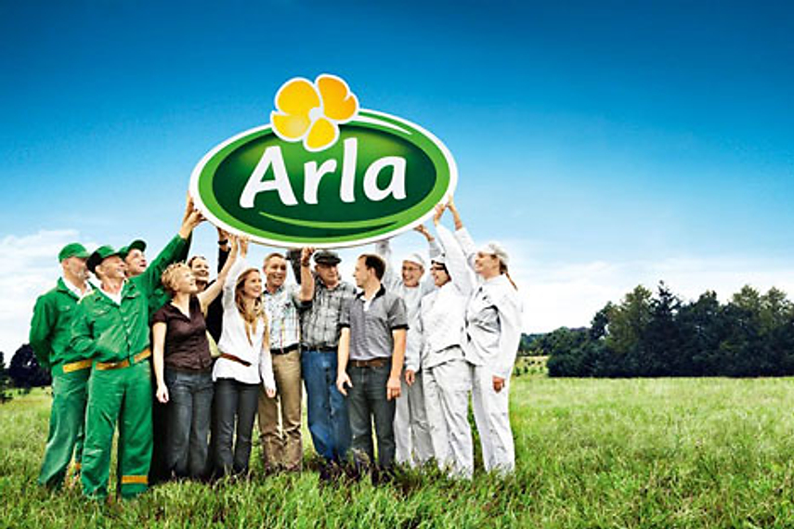

United International University
A REPORT ON
Optimizing the Salesforce Using Route to Market at Arla Foods Bangladesh Ltd.
SUBMITTED BY
QUAZI RUHUL AFZAL
ID:111152250
COURSE CODE: INT 4399
SCHOOL OF BUSINESS AND ECONOMICS
SUBMITTED TO
MD. SHARIFUL ALAM
ASSOCIATE PROFESSOR
SCHOOL OF BUSINESS AND ECONOMICS
DATE OF SUBMISSION: 23/11/2019

Letter of Transmittal
November 23, 2019
MD. SHARIFUL ALAM
Associate Professor
School of Business and Economics
United International University

Subject: Submission of report on “Optimizing the Salesforce Using Route to Market at Arla Foods Bangladesh Ltd.”
Dear Sir,
It is a real pleasure for us to be able to submit a report on Optimizing the Salesforce Using Route to Market at Arla Foods Bangladesh Ltd.. I complete my internship period with a Route to the market department which is under the sales department. I worked very diligently and did my best to follow all the guidelines my supervisor provided to meet the course requirements and prepare the report.
I followed the instructions of my organization supervisor while at the same moment I also tried to follow the guideline. Creating this report was a great learning experience as I was able to learn various area such as marketing, sales and communication skills etc.I would be happy to clarify any significance raised in the overall report.
I am very grateful to you for your precious advice and continuous attention during my internship and when necessary in the preparation of this study. Thank you.

Sincerely,
________________________
Quazi Ruhul Afzal
ID: 111152250
Acknowledgment
First, I would like to thank Almighty Allah for successfully prepare my report. In my 5 month internship period I work in a sales team. Thought out my journey I learned many things. Based on my learning process I prepare reports base on optimized sales at Arla foods Bangladesh.
I am thankful & grateful to my academic supervisor Mr. MD. SHARIFUL ALAM; Associate Professor, School of Business and Economics United International University for giving me all the essential help for finishing this report. Much grateful to you sir for all the help and guidelines in recent Four months. I am additionally appreciative for your persistence that you have appeared all through the Internship period.All my University courses I try to implement in this report.
I would like to thank Mr. Hussein MD RuhinSabbir, Root to MarketManager, Arla Foods Bangladesh for enlisting me for this important responsibility andIncidentally it enabled me to act like a role model. Many thanks for thatThe guidance and care that has given me the ability to sharpen my inclination towards a higher level of studyI want to thank you for all the education. Besides, I wouldThank you to Mr. Md. Mahbubur Rahman, Senior Executive - Project Management and KaziAshrafulHaque Sales Information Specialist.Numerous tips and tricks help meto prepare this report. Lastly, I want to thank everyonePart of what made my journey with ARLA memorable. Thanks for such a great generosity for me and my studies
I am grateful to the many people who helped organize this report and helped me For this, their kind advice and cooperation. I have received a lot of advice and support The number of people I want to take the opportunity to thank them for.

Executive Summary
Arla Foods arepresently the world's fourth-largest dairy manufacturing company, having begun its journey in Sweden about a year and a half ago. Arla collects pure cow's milk daily from 12.8 own farms in six European countries, including Denmark, Sweden, England, and Germany. Farms, transportation, and production systems are totally their own, from the inception to the end. Arla can secure the quality and quality of all products! Nowadays, Arla'smultiple delicious and nutritious milk and dairy products are existing sold in more than 7 countries around the world.Arla is a global dairy cooperative owned by 12,700 farmers in seven European countries. Arla is currently in the process of improvingthe business in Bangladesh.
Arla has put up with a strong vision of establishing a future of dairy "naturally, to bring health and impulse to the world." With the driving Good Growth Strategy for 2021, company aim to develop our position as a prominent global dairy company and increase our existence in the international growth market. Company goal is to build the highest value for our farmers' milk and the only way we can do that is by expanding value to our customers and our customers by assuring that we do it in a reliable, natural, cooperative and healthy way.
In Bangladesh, Arla products are mostly sold under the ArlaDano brand, which is the second leader in the milk powder sector and was rewarded the "Best Brand 19" in the milk sector by the Bangladesh Brand Forum.
I am work on route to market which is under the sales department.The key objective of this study is to provide a depth analysis on the Route to market of Arla Foods Bangladesh Limited. In addition, the study also mentions about the develop the salesforces of Route to Market Function, Field Force management, Sales Force automation with Distribution Management.This reports also includes the ATL and BTL strategies so that the correlation can be proved.The study is divided into several parts including introduction, objective of studies, methodology of study, limitation of study, company overview and implementation part, finding of the study, recommendations and conclusion. From the report we find the factors behind the Coverage expansion, increase of sales and developing the salesforce.

Table of Contents
Chapter 1 1
1.1 introduction of the organization 2
1.2 Objectives of the Study – Broad Objective & Specific Objective 3
1.2.1 Broad Objective 3
1.2.2 Specific Objective 3
1.2.3 Scope of the study 3
1.3 The methodology of the Study 4
1.3.1 Primary data Source: 4
1.3.2 Secondary Source of Data Collection 4
1.3.3 Analytical tools: 4
Chapter 2 5
2.1 Organizational Background and Industry Perspective 6
2.1.1 Industry Scenario: 6
2.1.2 Historical Background of the organization: 7
2.1.3 Arla in Bangladesh 8
2.1.4 Mission, Strategies, and Vision 8
2.2 Organogram of Arla foods Bangladesh 10
2.3 Arla Products 11
Chapter 3 16
3.1 Division of Arla foods 17
3.2 Branding and promotion tools 17
3.2.1 Above the line 17
3.2.2 Below the line 18
3.2.3 Digital Marketing 18
3.3 Channels of sales and distributors 19
Chapter 4 21
4.1 Route to market analysis 22
4.1.1 Field Market Operation: 22
4.1.2 Development and inspiration for salesforce: 23
4.2 SalesForce Automation (SFA): 26
4.2.1 Compass Vs Non-Compass Distributor: 28
4.3 Compass rollout 28
4.3.1 How to compass rollout. 29
4.4 increase of retail stores/Outlets 30
4.5 Develop salesforce by using RTM training session 32
4.6 Route to market VS Go to market 35
4.7 Strategy to RTM 36
Chapter 5 38
5.1 Financial Condition: 39
5.2 Marketing and Route to marketing 40
5.3 SWOT analysis 40
5.4 Findings 42
5.5 Recommendation 43
5.6 Conclusion 44
5.7 References 45

Chapter 1

1.1 introduction of the organization
Arla foods one of the largest dairy farms in the world. They produce the product in a European standard. They are certified in a European standard. Arla Foods is operating in Denmark and there are 34, nations to operate one of them in Bangladesh. Arla food starts his journey in 1990. In the very beginning, they consider customer satisfaction. There are many products produce and one of the products is milk power. Arla Foods is the leading position in a competitive market. They use advanced technology to produce their products not harm anyone. The priority gives to their customers. There are over 30k employees work in the world. The biggest operation is to operate in China. And most upcoming growth region is Bangladesh. According to Arla, Foods CEO says, in the south Asian region most productive market and most growing market in Bangladesh. We are creating more facilities to move next forward to reach the highest level.
One of the prominent nutritional organizations including a tagline "close to nature". The company offers customers a wide range of best-tasting and quality food choices. The dairy department. Arla's real meaning in the morning is that which is fresh and natural.
Arla continues to improve its business actions in Bangladesh, our long-term success needs to achieve development in an accountable way that will not adversely affect the local dairy sector, its associated farmers and the community as well as consumers. As part of Arla'sresponsibility to respecting human rights, we have a responsibility to evaluate, avoid, and resolve the real and potentially adverse effects of our human rights.

1.2 Objectives of the Study – Broad Objective & Specific Objective

1.2.1 Broad Objective
The main objective was to optimize the sales force, cost minimalization, and tracking the performance and understand the role of Route to Market. How RTM is improving the overall performance of the company. Moreover, how really the Route to market provides to improving sales.

1.2.2 Specific Objective
To analyze the alignment between Arla's route-to-market and marketing departments at ArlaFoodsBangladesh Ltd.
To find out how route to market helps marketing at all levels.
To find out how RTM organized the market.
To find out how RTM change the KPI and incentive modality.
To complete the required academic need.
To locate out the marketing planning methods of Arla Foods Bangladesh.
To be aware of the advertising and marketing manipulate of Arla Foods Bangladeshin Bangladesh.

1.2.3 Scope of the study
Arla Foods Bangladesh is one of the growing and leading products in Bangladesh. The scope of the study is constrained to Arla Foods Bangladesh and Mutual Milk Products Ltd. The report covers the organizational structure, sales factions, route to market faction, marketing faction, tread marketing, background, functions and the performance of the organization.
Limitations of the study: There is some limitation I face preparing the report.
- Time: For a short time to prepare a report I can't collect more relevant data. There is a lack of time observation of the RTM and sales and the company.
- Data: Arla provides lots of data but in some data, they not shear because of the company policy. Some confidential data they not shear.
- Face challenges to analysis the data

1.3 The methodology of the Study
Data design:This study should be a nature of the qualitative. This study of the methodology includes face to face discussion with the customer, sales representative, promoter and direct observation in the market bases.

1.3.1 Primary data Source:
To collect primary data sources in various types.
- Collect data from field force and Arla employees.
- Visit the market
- Observations that maytake directly from Route to marketmanager.
- Personal observation
- Get feedback from Sales representatives and Territory officers.
- Consumer Feedback.
- Collect data from various sales reports.

1.3.2 Secondary Source of Data Collection
Secondary data are collected in 3 ways. They are-
- Arla Foods Bangladesh Official website
- Internal Website of ArlaFoodsBangladesh.
- Manage files of Arla Foods Bangladesh
- Different dairy sector papers and Journals.

1.3.3 Analytical tools:
- In my internship period, I amAnalyzing many excel le which is helpful for management decision.
- I used sales automation software call Qlikview V2. This software will analysis big data and shorting what we want. It a very user-friendly and easy to operate.Using business intelligence software call QlikView V2 to shot the big data andgenerating the sales report.
- Use Arla's own sales software Arla Compass V2.
- Analysis of the Compass report.

Chapter 2

2.1 Organizational Background and Industry Perspective

2.1.1 Industry Scenario:
Bangladesh authorities have a powerful focal point on the improvement of the dairy sector for the latter to gain independence with the aid of increasing milk production with qualified quality. The presently authorized Livestock and Dairy Development Project (LDDP) may want to be a sturdy reflection of the government'sattempted to increase the sector. The Department of Livestock Services (DLS) has been enforcing this mega project. The current DLS has surprisingly environment-friendly personnel who are working hard to improve the dairy sector however the DLS wishes true data and partnership from all stakeholders of the dairy cost chain. Keeping this in mind, the current developments with tariff expand via a section of the dairy farmers and their activities (demonstration in the streets) are the key worries for the dairy quarter at present.
Recently, many news published news associatedwith growing dairy tariffs which happened to be their sole concern. However, tariff-related things to do have been not relatedto the actual developments. There is a discussion surrounding the dairy chain—whether tariff discount or tariff increase is a high-quality way to improve the dairy sector.
International dairy businesses and dairy importers need to center of awareness on the improvement of the available dairy sector on the one hand and the other, the authorities have to make sure ethical business growth. At the equal time, the government's first importance has to be to hold nearby interests.
The milk market is a very competitive market. There are lots of competitors running their business. In the milk market, there are more than 10 companies existing in the market. Arla food Bangladesh's most close competitor is “Marks” and “Diploma”. Thought Dano is the market leader. But Dano introduces new technology new software that makesDano market leader. Here the other competitor details in the milk market.

NO. | Brand Name | Country of Origin | Marketing By
1. | MARKS | Australia | AbulKairBhuiyan
2. | DANO | Denmark | Arla Foods & MMPL
3. | Diploma | Australia | New Zealand Dairy Products Ltd.
4. | NIDO | New Zealand | Nestle Bangladesh
5. | Red Cow | Australia | New Zealand Dairy Products Ltd.
6. | Fresh | China | Tanvir Foods  ( Meghna Group)
7. | Kwality | Australia | Sanowara Corporation
8. | Anchor | New Zealand | New Zealand Dairy Products Ltd.
9. | Farmland | New Zealand | New Zealand Dairy Products Ltd.
10. | Starship | China | AbulKairBhuiyan
11. | Milk Vita | Bangladesh | Bangladesh

2.1.2 Historical Background of the organization:

In the 1880s, the farmer of Sweden and Denmark establish an idea to collaborate and invest in a dairyfacility. In 1881,ArlaMejeriförening's first dairy used to be established inSweden and in 1882, the second one established in Denmark.Arla Foods is a large milk producer in Europe.They maintain the European standard to mass-produce the product.The organization was established inthe130 years. In the past a cooperativeendeavor to establish a structure for current dairy farms. The continuous monitoring and improvement made Arla Foods as one of the biggestorganizations in the world. Day by day at Arla foods is a new opportunity to assume the current product and establishingnew ideas for the future. The organization focused on the quality and make more corporate social responsibility for healthy foods to the consumers. In a global policy, Arla foods try toattemptto make the overall world a stronger place for a better life

2.1.3 Arla in Bangladesh

Arla Foods Bangladesh is a renowned milk powder product in Bangladesh.Arla came to Bangladesh as a powered byDano when the company wasunder MD foods Bangladesh. Dano milkpowder was imported from 1962-1970 by using several businessmen whenthe country wastreated as a part of Pakistan. Md foods identified the market achievable so, they are gathering information of the workplace to monitor the market activity of Bangladesh Market, butfinally, a letter ofcredit being approved from Bangladesh to Denmark. In 1995, MutualTrading was given the fulllegal importerproductDano. In 1998, theyset up the manufacturingfacility in Bangladesh to meet worldwide quality standards. In 2011, 15th December Arla foods separated from MutualTrading and starting to facilitate the product as Arla Foods Bangladesh. Now it’s under the Danish managementand managed globally. Arla is improving the product line very fast to make sure the existenceof eachdairy product. The brand name of the milk powder is ‘DANO'. Which is distributed over the country.

2.1.4 Mission, Strategies, and Vision

Mission
“The mission is to ensure the highest value for the farmer's links along with creating opportunitiesfor their growth. As a cooperative milk producing company, our task is to ensure that we can make as much value as possible for the milk producers and thereby achieve the best price for their milk for both owners and other suppliers.”
Vision
“The vision is to be the leading dairy company in the world by creating considerable value andproactive market leadership to obtain the highest available milk price. We aim to maximize the price that gets into the owner's hand. To fulfilling the objective, we are determined to create the added value and demonstrate proactive market leadership. Being a market leader means a verystrong negotiation position. We want to be the most attractive dairy milk company for both our owners and employees and for our customers and suppliers.”

2.2 Organogram of Arla foods Bangladesh

2.3 Arla Products
The only dairy milk prepared is Arla's own firm's cow's milk in Europe, in compliance with strict European standards. Any milk in the market, only Dano can give the highest quality, safety and purity ensure from the beginning of production to your glass.Dano is comprehended as the best milk brand in Bangladesh for the 4th time in its loyalty and acceptance. Dano has been enabling the Bangladeshi generation to grow with intelligence, physical ability, and confidence for the last six years.Dano has all the nutritional value of pure milk, so Dano helps your baby grow out and develop a Strong. Hundreds of millions of people from more than one hundred countries in America, Europe, the Middle East, Africa, and Asia are consuming the same milk that is being sold in Bangladesh.Dano has been giving nutritious milk to our three men for the last 3 years. According to the Consumers, the best and most trusted milk brand in Bangladesh is now 'Dano'.Danocontains Vitamin A, B2, B12, D, Phosphorus, Calcium, Iron, Sodium, Potassium, Magnesium, and Zinc.
The modern technique is made by adding other natural creams to decrease the amount of fat from pure cow's milk so that all nutrients and flavors of pure milk are the same but the price is much lower than full cream, which normal people can buy very easily.
'Dano Daily Nutrition' is BSTI approved as nutritious milk for the common people and is recognized by the Ministry of Commerce of the Government of Bangladesh and the National Board of Revenue.
More protein is now added to Dano Daily Nutrition; Which enhances the taste of tea-sweet-semai-yogurt made with this milk even more! Now you get more nutrients and flavors but at the same lower prices!
Dano Full Cream Milk Powder:
Dano Full Cream Milk PowderGive your family the essential vitality and sustenance they require with Dano full cream milk powder. This is the most sold and nurtured product of the company. Arla sees this as their mother product though they also concentrate on the product as well. It can be established in both regular and instant forms. This highly famous product has a similar composition of cow’s milk-not to remember the creamy flavor. FCMP is also rich in vitamin A and d3 which include a high level of Calcium which is required for growth, development, and maintenance of human bone and teeth.
Dano Daily Pushti(DDP):
Dano Daily Pushti(DDP)Dano daily Pushti is a reasonable nutrition answer,vital families. It includes Calcium, Protein, and vital vitamins, and minerals which are essential for family health. It’s more reasonable for tea and milk-based products. One glass of nutrition cost 10 Taka.

Dano Captain
This is the new addition to Arla foods in Bangladesh. A chocolate milk powder specially prepared for growing kids. These are the first of its type in Arla history. It’s a combination of sugar and chocolate milk.
Dano MOM:
Dano mom for women who are readying to be a mother, who is pregnant and who is still breastfeeding a baby.
It is a milk supplement that if a pregnant woman consumes 2 glasses / 1 gram daily, 5% iron, vitamin D and folic acid are consumed daily.
The product must be completed within 20 days after opening the tin.
Dilac 1, Dilac 2:
If a baby does not get breast milk, Deilak will substantiate the proper nutrition of the baby so that it can get out properly.
For children under 6 months - Dilac 1, 6 months to 2-year-olds - Dilac 2
It contains PREBIOTIC, which is not available in any other infant formula in the market. It increases the number of PROBIOTIC in the body, which helps enhance the body's immunity.
Dilla has 5 types of vitamins and 5 types of minerals
It is the most affordable of the formulas available in the market
Delac comes directly from Denmark
Dano Fit:
• Dano Fit contains only 0% fat.
• Fats are high in calcium, vitamin A and high levels of vitamin D.
• Dano fit helps keep the body fit.
Dano Sterilized Cream:
Dano Sterilized Cream is made from beef fresh milk and vegetable oil.In addition to the power production of the company, Arla also sells cream which names Dano sterilizedcream. It’s a regular product with rich flavor. This cream can be used to make cakes, faluda,kormaand all kinds of sweets that Bangladeshis love very much.
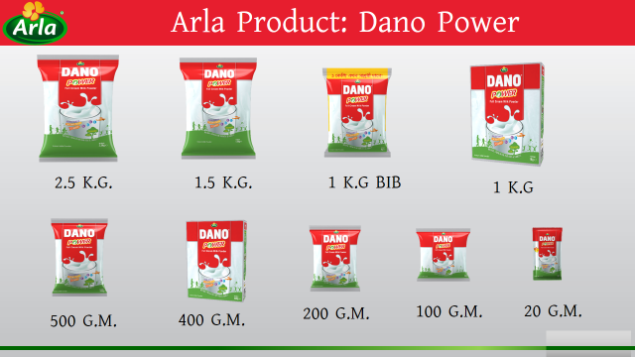
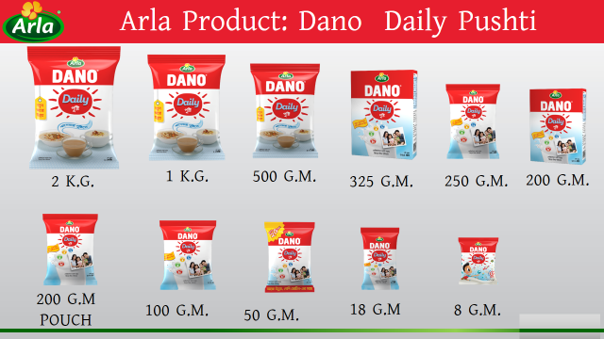
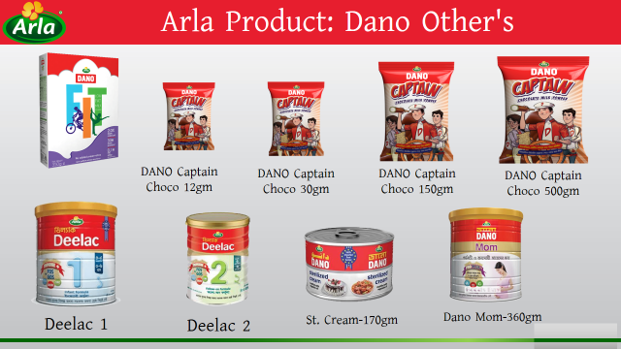

Brands | SKU Name | MRP / SKU
Dano | Dano Power - 2.5 Kg | 1,600.00
Dano | Dano Power - 1.5 Kg | 950.00
Dano | Dano Power - 1 Kg | 650.00
Dano | Dano Power 1 Kg Pillow Pack | 630.00
Dano | Dano Power - 500 Gm | 320.00
Dano | Dano Power Classic - 400 Gm | 275.00
Dano | Dano Power - 400 Gm | 275.00
Dano | Dano Power - 200 Gm | 140.00
Dano | Dano Power - 100 Gm | 70.00
Dano | Dano Power - 20 Gm | 15.00
ST. Cream | 170gm St. Cream | 95.00
Daily Pushti | Dano Daily Pushti - 2 Kg | 800.00
Daily Pushti | Dano Daily Pushti - 1 Kg | 410.00
Daily Pushti | Dano Daily Pushti - 550 Gm | 240.00
Daily Pushti | Dano Daily Pushti - 500 Gm | 220.00
Daily Pushti | Dano Daily Pushti - 325 Gm | 160.00
Daily Pushti | Dano Daily Pushti - 200 Gm Pouch | 100.00
Daily Pushti | Dano Daily Pushti - 100 Gm | 50.00
Daily Pushti | Dano Daily Pushti - 50 Gm | 30.00
Daily Pushti | Dano Daily Pushti - 20 Gm V | 10.00
Daily Pushti | Dano Daily Pushti - 8 Gm | 5.00
 | Dano Daily Pushti - 7 Gm | 5.00
Dano Captain | Dano Captain Choco 500 Gm | 250.00
Dano Captain | DANO Captain Choco 150gm | 75.00
Dano Captain | DANO Captain Choco 30gm | 15.00
Dano Captain | DANO Captain Choco 12gm | 8.00
Dano Captain | Dano Captain Choco 500 Gm FS | 223.20
Choice | Dano Slim 350 Gm | 295.00
Choice | Dano Mom 360 Gm | 450.00
Deelac | Deelac 1 BIB - 180 Gm | 220.00
Deelac | Deelac 1- 400 Gms | 530.00
Deelac | Deelac 2- 400 Gms | 530.00
UHT | Full Cream UHT Milk 3.5% | 198.00
UHT | Low-Fat UHT Milk 1.5% | 198.00
UHT | Skimmed UHT Milk 0.3% | 198.00
UHT | Lactofree UHT Milk 3.5% | 248.00
UHT | Organic UHT Milk 3.5% | 248.00

Chapter 3

3.1 Division of Arla foods
Organizing the structure of a large fast-moving consumer product company has never been easier. Originally Arlaallocated the whole country into 9 regions. Central Dhaka, Dhaka South, Dhaka North, Chittagong, Comilla, Barisal, Sylhet, Bogra, and Khulna. There are 145 private distribution houses that sell at a certain percentage for our percentage. The sales team has 5 territory officers, 1 regional sales manager, a route-to-market manager, trade marketing manager and two sales heads. The structure helps the organization provide products efficiently and efficiently. Arla always tries to ensure the nutrition of the elders of all Bangladesh. The first step is to take the product from the distributor company and sell it as the primary phrase, the second level is secondary sales, which means sales from the distributor to the customer. Arla is trying to target using different marketing strategies to reach customers. Below are a few marketing strategies.

3.2 Branding and promotion tools
Promotion is animportantcomponent of marketing that gives the company, brand or product message to target the customer.Traditional methods of advertising, such as print and television advertising, are nowadays linked, YouTube, Facebook, and other social media to new ways of communicating feasible through digital communication. Companies use a number of tools to deliver both paid and paid promotional methods.Each tool contributes differently to reaching customers and achieving communication objectives.

3.2.1 Above the line
Television advertisement:
Arla foods Bangladesh broadcast TVC as a Continuous basis. Arla foods Bangladesh never stops the broadcast TVC because it engages the customer consistently. The advertisement should target family persons. The ROI is very high on creative advertisements. We work with many different agencies to make our advertisement.
Radio
Those advertisements are differentcontain that kind of advertisement broadcast on Radio to send the message to the customer. There are different slogan for each product to know the customer benefit. Different radio partners broadcast our advertisement.

Newspaper
Arla foods Bangladesh is very consistent in publishing an advertisement in the newspaper. We gain a very good response through it. We mainly put our advertisement on the front page if a new product comes. We also give an advertisement in different magazines to increase our branding. Above the line, advertisement is broadcasted nationally and we are very consistent in promoting our brand all the time. We try to focus on our quality assurance and preciousness.

3.2.2 Below the line
Campaign Arla conducts several campaigns all the time in the year. For example-Arla recently launched Dano Captain 8 months back. From then on, the campaign is continuing on a regular basis in front of schools and colleges as our target is children. We contacted the vendor to do the campaign. They arranged the campaign with technical help from the marketing department. They went to almost every school in Dhaka city. They sold the captain as per glass. Then after a certain time, we calculated the return on investment and see the impact on the market. If the response is satisfactory then we continue the campaign, or we move to another segment. Poster, Hanger, Dangler Our sales force always carries these items to the local shops for doing the marketing. Posters are often pasted in front of the shops so that people can see the new exciting offer or what the product is offering. The hanger is used to hanging our trial packs so that it can be visible to everyone. People tend to buy more products if there is any hanger or supporting materials. The retailer also becomes happy to see Hanger because it makes more space than before. Dangler is used for promoting directly. We normally place a dangler near the shops. It attracts customer and makes interest to buy the product. We also do public relations, meetings, and another engagement program that enhances our brand name.

3.2.3 Digital Marketing
Digital Marketing Facebook, YouTube Arla is focusing on Digital marketing most importantly. It’s easy to reach the target people. We make our advertisement short and try to give the message by doing search engine optimization. For example- Dano captain is made for children. So, we try to show them the advertisement by doing the appropriate filter. Sometimes we focus on some specific areas to let our consumers know about what we are offering. The rate of return is very good. People respond to these messages very much. Arla also updates Facebook very frequently. There are different types of quizzes for the consumer online. Dano Power Class Recently Arla have started the Dano power class for the JSC, PSC examinee. It conducted by AymanSadique who is very influential among teenage kids. He tries to talk about the different objectives of the exam. He gives tips about how they can handle the pressure, do better results during the exam. The response is tremendous from the students. Dano is getting featured in their minds.
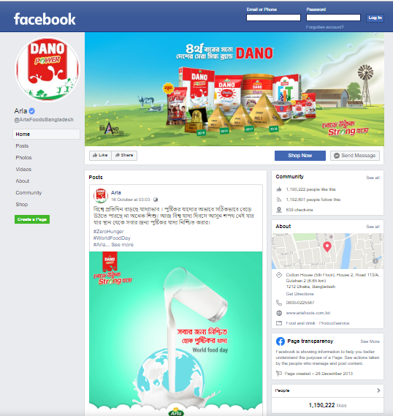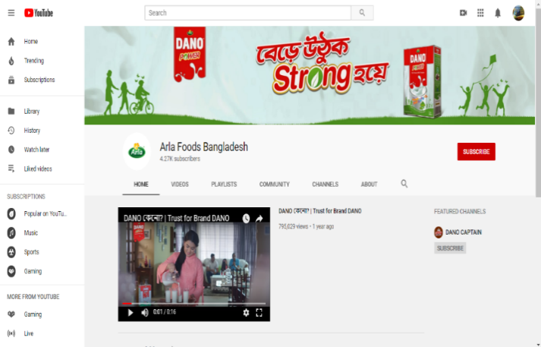

3.3 Channels of sales and distributors
Arla Foods Bangladesh Limited works with 115 distributors and these distributors have 83 sub-dealers or sub DB houses throughout Bangladesh. There are 9 regions in Bangladesh, and they are –
• Bogra Region
• Cumilla Region
• Dhaka Central Region
• Dhaka South Region
• Dhaka North Region
• Chittagong Region
• Barishal Region
• Khulna Region
• Sylhet Region

In these 9 regions, 115 distributors are supervising 53 territory officers. However, these distributors are the main business partners of Arla Foods Bangladesh Limited. Distribution houses are also briefly known as DB House. Each distributor has a DB house manager, a DB operator.
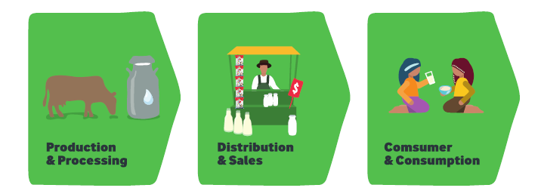

Sales Representatives who take orders from retail stores, DSRs, Bicycle Panniers who sell products directly to the retailer without pre-ordering like SRS. Each DB home has an SR supervisor who works under the Territory Officers and supervises the SR, DSR, CPs. Each DB home has a warehouse for storing products. Usually, DB house owners hire a DB house manager who works with Territory Officers and manages every aspect and situation of DB house. Distribution management is one of the cores and key functions of Arla food in the FMCG industry. Officially, the route-to-market dept manages DB operations. As mentioned in the previous photo, we understand that distribution houses collect or take goods from the depot and then distribute the product to retail stores in their own region through sales reps and bike panniers.
Role of Distributors:
• Ensure consistency of Distributors with their individual jobs and Responsibilities
• Manage and develop distributor in a functioning and productive way'
• Take part in delegating and retiring of Distributors.
• Ensure the best possible and right execution of offers, rebate and exchanging terms dictated by the organization 24
• Monitor and limit the dimension of bad products returns
• Develop solid business association with distributors, trade and key record in their territories.

Chapter 4

4.1 Route to market analysis
Route to market was well-establishedto increase sales forces automation by using different modules. It is a branch under the sales department and directly controlled by the head of sales. To some extent, RTM has not entered Bangladesh but it is exclusively integrated around the world. It can create another opportunity to understand the market. Route to market activity reduces the gap between sales forces and end customers. It enhances the profitability of the organization and guarantees quality spread structure.Furthermore, Arla Foods Bangladesh Limited does not usually deliver products directly to customers. In order to gain a deeper understanding of RTM, we must know the arrangements for promoting fast-moving consumer products. We need to know the fast-moving delivery system to know the best market routes for Consumer goods first. Basically, Arla does not sell the product directly to the customer.
There are two initiatives to sell items:
- Primary Sales
- Secondary Sales
Primary Sales: In the beginning, the initial sale refers to the sales that occur between the company and the distributor. As we discussed earlier, companies do not provide products directly to customers. DB Homes first buy the product from the company. For a variety of price levels Distributors. Distributors are the people who buy the product in the company and the sales market to the end customer that called Primary sales.
Secondary Sales: Secondary sales situation refers to when distributors sell the product to outlets in the market Outlet refers to retail outlets in the market.A sale occurs when distributors sell the product to retailers. The purpose of the route to market is to ensure quality delivery and ensure the transportation of goods while reducing costs. There are various marketing activities on the route to market for ARLA national foods they are:

4.1.1 Field Market Operation:
RTM's major challenge is to monitor the distribution house and distribution-related employees who is work directly in the field. To establish a strong distribution channel that the products of Arla Foods Bangladesh Limited deliver the Territories and regionally.As per assigning the task to visit the field market, I have spent 2 days in Khilgaon territory work with TO and SR to get some experience. I am learning many things and observed how they face challenges. All my observation will describe below:

Role of Territory Officer:
As a territory officer, they face many challenges and they can overcome his own strategy. In the morning TO will arrange a meeting to all SR every day and get feedback on the market. If SR will face any problem, then TO will solve it and give some tips to overcome the problem and take some strategical sales. Then they will send the daily summary reportalso manage the distribution house. Is there any problem face TO try to solve it. Then TO will visit the market and observed the market and observed the SR how they work. Then TO will physically order the product to show SR how to conduct the order.
Role of SR Supervisor:
SR supervisor will maintain all SR work as well as make updates to the SR. As an SR supervisor, they also take orders in the market. But if TO will not available then SR supervisor will be done the work. Any kind of excel update observed the SR tracker.
Role of SR:
As an SR they will go to the outlet and give some the order in the market. They will push the outlet owner to as much as SKU and memo order thought the compass.
Role of DB Operator:
Basically, DB operator work is print out the memo after SR will do their work.Healso, conform the sales after delivery man delivered the product.
Role of Delivery Man:
After SR will collect the order in the market next day delivery man will deliver the product base on the memo and collect the money to the outlet owner. They play an important role because they deal with the money so it a sensitive issue.

4.1.2 Development and inspiration for salesforce:
The sales job is quite exciting and challenging but it is very tiring and the sales force is facing a lot of stress when it comes to generating revenue. They spend most of the time in the market and often they work until 8/9 at night. Many FMCG offers the company Salesforces incentives for sales. It motivates the sales forces to work more dedicatedly. Arla food Bangladesh also has many incentive plans and also some special incentives that will motivate the SR’s. Arla not only gives incentive they give loan facilities, advance salary, give a donation, etc. Arla's main focuses are to develop a strong sales force that they can get the highest sales revenue.
Territory officers, SR’s supervisors, SR’s, CP’s, are usually encouraged to meet their goals monthly.
Here I show a modality which is EID incentive for SR’s. Besides this incentive, there are add regular incentivesthatadd their salary. RTM has monitored this incentive modality in which SR’s are achieved this incentive. Mostly every SR”s reach their target and get the incentive. The territory office also hasa special inventive modality set by RTM. This incentive motivates all the field force to work hard. Not only field force Arla give some gift to the distributor to take a good relationship with there delivery channel.
Key reasons for encouraging:
- Sales target of Dano Power+ Dano Daily Pushti
- Danocaptain placement and sales.
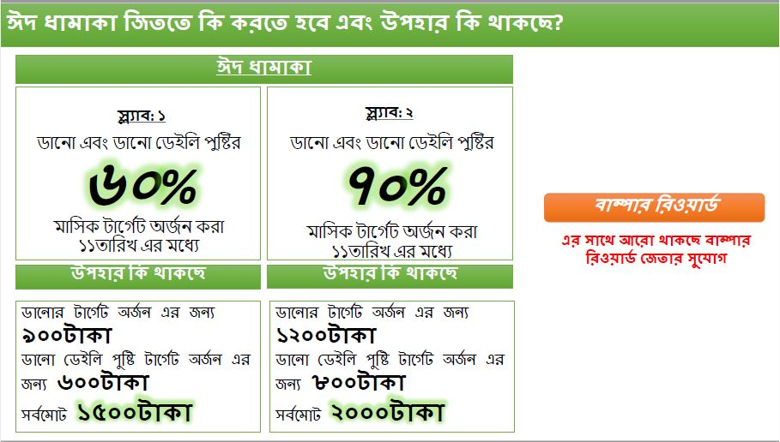
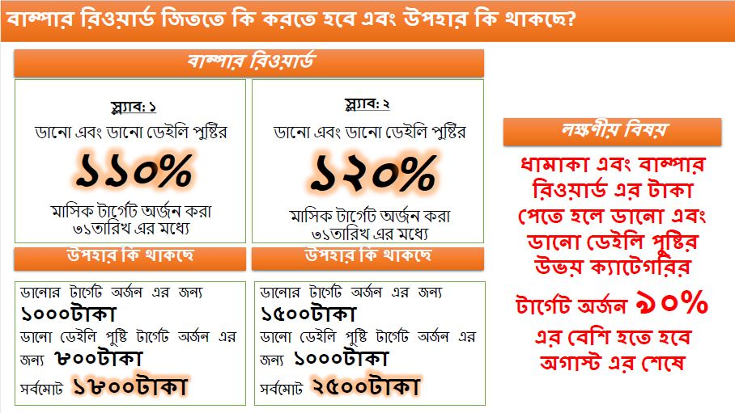

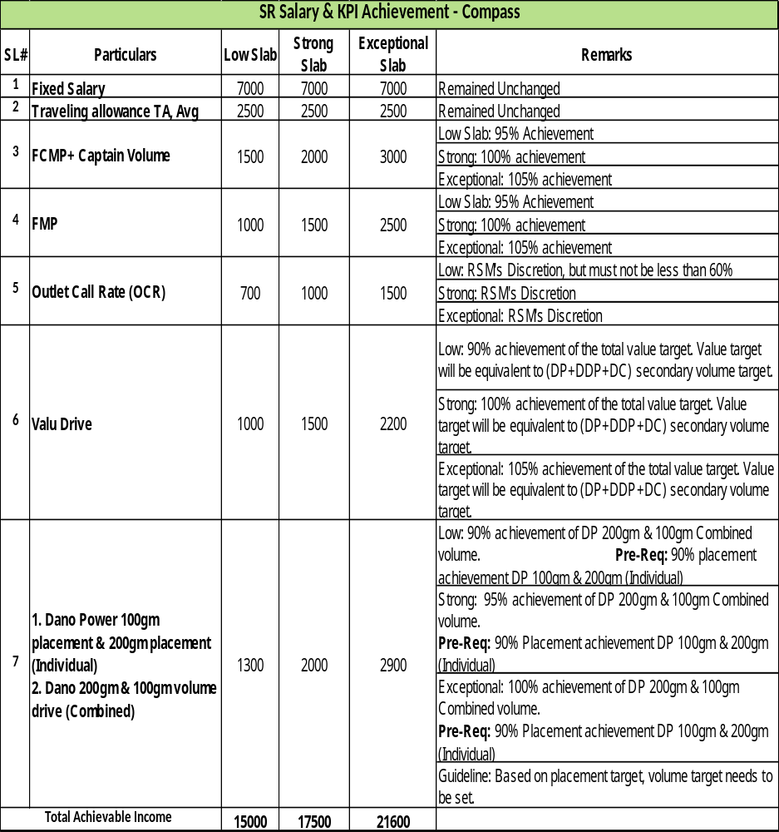

4.2 SalesForce Automation (SFA):
Technology can changeeverything. Now a day every company tries to develop a strong technology that takesan extra advantage to one step ahead in the competitor. This technology can increase revenue and reduce costs.
Arla foods Bangladesh also develops strong sales force automation that makes increases sales also reduces the cost. Thesales force automation software name is Arla compass. In 2017 Arla foods Bangladesh launched SFA technology call “ARLA COMPASS APPS”. Recently Arla foods Bangladesh has updated this software and launched Compass Version 2.0. Over the 85 Distribution houses of Arla are using Compass software successfully. RTM has acquired a contract of innovation to guarantee better administrations. Arla compass changed the element of sales power and accuracy nourishes by bringing sales speed and innovation. It's basically worked in field force. In traditional we see that one SR's will take an order in the manual book. It takes more time to take order also it will change to damage the book. Also difficult to analyze the data report. But now Arla foods Bangladesh move forward and take the help of technology. They create software which is callingArla Compass to take the hole traditional process in one hand. Mainly Arla compass work in a takes an order to the phone. SR's will take order thought any Android phone. All the information will be exciting in this software. It varies user-friendly. Anyone can easily understand how to work. Such an example: one SR's go-to korim store, SR open Arla compass apps and go to korim store and see what type of sales he gives past. Then he started to negotiate and take orders like Dano 500gm 6 pice. Then the compass aromatically calculates the amount ER will be told the store owner. Next day the delivery man delivery the product and take money to the outlet owner. This is the process of Arla product Dano placement in every market.
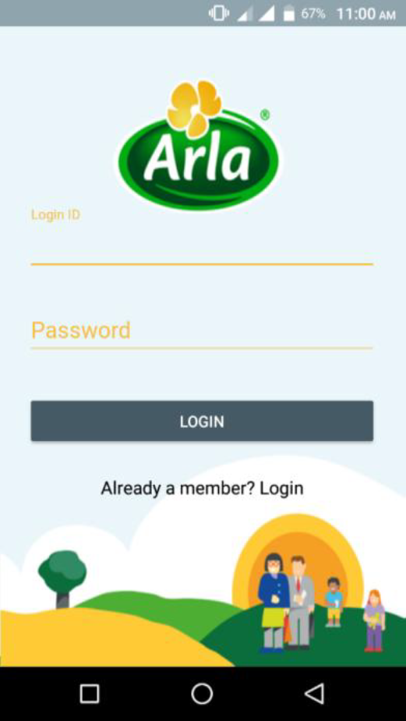
Compass benefit: After Arla introduce this SFA technology the organization takes huge benefit to improve performance tracking and other KPI. What kind of benefit we give in this SFA technology:
- Performance tracking:In compass apps, we will track done the SR’s work also we will see any time how any SR’s work in the market thought his sales order.
- Sales report: Thought compass Territory officer can any time how much sales have also see the sales report against each SR’s.
- Target Set: How much an SR’s sales in one day and every month that are defined in this software.
- Display modality: To capture a photo of display and upload the web, those are analysis display modality they have the benefit to this survey.
- Identify KPI: This software automatically analysis the SR’s KPI and the track did to told which SR’s we look more to improved this KIP.
Compass helps create all types of reports, including annual and month-to-month reports. However, the compass covers seventy points out of 125 points in Bangladesh. We accept manual requests outside the city area; however, we are trying to guarantee full inclusion in the coming years. It also costs for additional cash resources. The advent of Imagination is not equivalent but we are expanding product offerings in a way that will enable our region's Compass applications to cover all.

4.2.1 Compass Vs Non-Compass Distributor:
Non-Compass Distributors mentions that DB House have not adopted SFA technology and have not digitized their work system. They still operate in a traditional and manual manner. Compass Distributors refers to DB House, which has adapted to the sales force automation technology. To adapt to SFA technology and DB houses need to design their working system for DB houses for SRS, hardware, computers, smartphones, dot-matrix printers, mammopapers with 24 hour high-speed internet connection with at least 1 Mbps internet.

4.3 Compass rollout
Today Arla compass plays a vital role in generating sales. Nowadays every competitor company was trying to develop the technology. So Arla also develops their new technology was called 'Arla compass' which is generating the sales order confirmations and others report which is seen by the territory officer.
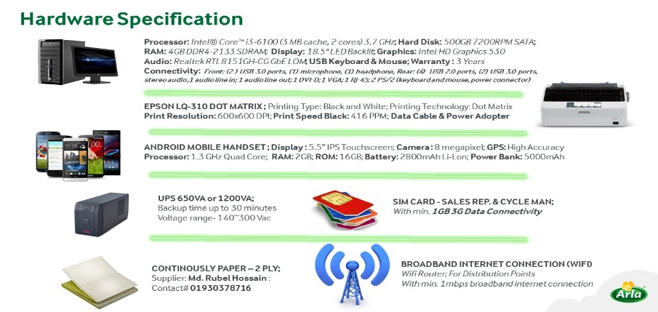

4.3.1 How to compass rollout.
To begin the process of rollout Arla compass, we need data that is coming from field force. Territory officer collects the data which is come from field force. In this data, there is information about outlets and outlet owners' details. There is an also segment in that which SR visits that outlets that route. After creating this data from territory officers send this data for me. As an intern, I was analyzing this data that there are any wrong things or any mistakes happen or not. If any mistake I found then I will communicating the territory officers that they will solve this problem and send it properly. After all the feedbacks and all the problem solving done the data will be locked. Now, this data will be uploaded by compass software. This compass software was monitor by Arla foods Bangladesh RTM manager. They will upload this data and take it to test that the data will be e perfect or not. They take two or three days for a test live that all these data will be coming valid or not after this data come from perfectly then they can go for the initial rollout.
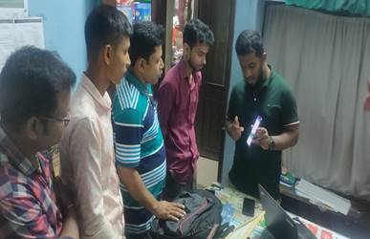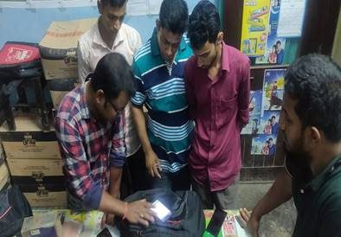
Compass is a new technology on new software that every SR didn't know how to operate this software. So SR's need some training to operate this software. Route to marketing manager trains all the SR's that they can operate the software smoothly. After train all, the RTM manager visits the market and monitors the SR's how they can operate the software. If sales representatives doing well they roll out the final compass data. After rollout, the compass territory officer can see all the sales reports as well as territory officer scene SR's KPI, and see how they work in the market. Rollout this compass software territory officer can see all the report and also analyze this report that makes easier to take the next strategy to work in the market.

4.4 increase of retail stores/Outlets
With the help of the Route to market, Arla made a drastic change in promoting inclusion. DANO products were routinely sold for a total of 86000 outlets in 2015. Then, Route to market offered a motivational model. It incorporates an extraordinary motivation for deal with agent forces for taking requests from new stores. The strategy worked very well for Arla Foods as it expanded to around 350000 outlets in 2019. RTM rewarded the incentive motivation model for business capabilities. It was transformed into a huge open door for them and inclusion has been expanded in unbroken proportions.

Distribution in the city is much simpler than the provincial or rural side, and it is not an easy task to achieve all levels of customers without proper method assign. We made arrangements with neighborhood little wholesalers who have just the inclusion of 60-70 shops. They take items from everyone in the organization to a small extent still. This allocation is changing the lives of many in the country and abroad and guarantees sustenance for the country-level people. Arla has set an alternative value level to guarantee her benefits from the business.

4.5 Develop salesforce by using RTM training session
In my internship period, I have attained several meeting which is organized by the RTM manager. Basically, this meeting was to train territory offices SR's and all the field forces develop the new strategy on how we can sales more in the market. In my internship period, I have assigned a new project which is called reorganized the RTM. This project is thoroughly reorganized the whole route to marketing process each and everything looks forward. To check all the data come from field force and then analyze it then take a strategy on how to reorganize the route to market. In my observation the reorganization project was the main key part was it will be a cost minimization to route to marketing process. To analyze all the field force data the RTM team will be making a decision on which route will be more profitable and which not more than profitable in this modality. After analyzing the profit and nonprofit route the RTM managers and all the ASM, RSM and 72 territory officers take a decision on which route will be more profitable and which will be nonprofitable. The nonprofitable route will be stopping by this time. those routes are more profitable that routes SR will take more training to increase their sales increase the effective selling process and other things. After this RTM reorganization project, the wholesale was increased at least 3% which is a big impact on nationality.
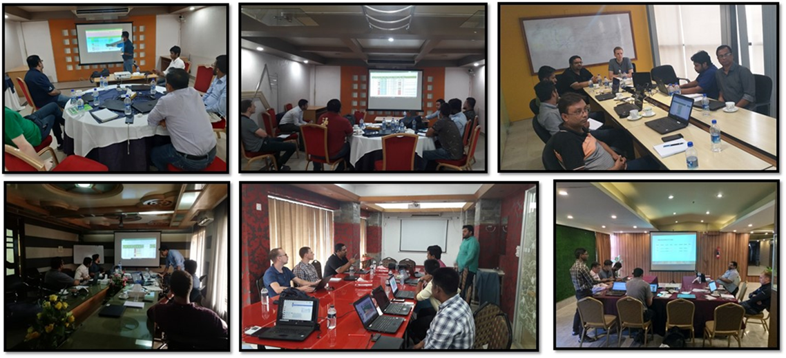

To work more efficiently we need motivation. After reorganization about RTM, there are several changes come.
1. Incentive modality
2. Outlets and route shift
3. Identify the profitable outlets and get activation that outlets.
4. Rearrange the data collection.
5. Authentic data come to fieldwork
6. Effective using Arla compass apps.
7. Successful tracking and monitoring of SR's activity.
8. Base on compass set an SR's salary modality.

There is a huge impact on the organization for reorganizing the route to the market. Not only the sales department it impacts, directly and indirectly, each department.

After completing 1st phrase of the reorganization of RTM the expected sales growth looks like that. In this diagram, we see that how to increase sales. Most increasing sales are Dhaka central which is more contribution to nationally. Now every region tries to increase its sales because after reorganization they know which market is more profitable and where we are a focus on it. Now we can see the gap in product availability so we are improving product availability that can increase our sales. They use of low-cost channels will have a positive impact on profitability. There is a balance between market penetration and control.

4.6 Route to market VS Go to market
A Go-to-Market strategy is usually relatedto the launch of a new product. GTM Strategy covers the choice of product, the target market, the customer need that would be fulfilled, the competition, the positioning, the pricing, the distribution, the marketing. It is the roadmap established on which a company will launch a product.
Route-to-Market mainly deals with reaching the product to the end customer. Once a product has been developed it will only sell if the customer has entrance to it. Depending upon the product, you may select to sell online, through your own sales team or through distributors and retailers.
A go-to-market strategy (GTM strategy) is an activity plan that establishes how a company will achieve target customers and achieve a competitive advantage. The purpose of a GTM strategy is to provide a strategy for providing a product or service to the end customer, taking into report such factors as pricing and distribution. A GTM strategy is relatively similar to a business plan, although the latter is broader in scope and considers such factors as funding.
Routes-to-Market (RTM) is a simple but very powerful process for driving profitable growth. RTM provides a quick and authentic methodology for aligning marketing, sales, and distribution, and for optimizing spending in these areas, which can total 30% or more of operating expenses. Optimizing spending in these areas gives the next step for efficient growth because most companies have already attained as much benefit as they can from optimizing their supply chains, manufacturing, and finance.
Go-to-marketing is operating the company resource to achieve customer requirements such as quality, pricing, and competitive advantage. This strategy concentrated on the entire life cycle of a product. The company has to decide the target market, mode of distribution channel, advertising, and sales strategy to penetrate the product into the market.
Route- to- marketing has arisen undergrowth and decline period of the product life cycle. It mainly focused on strengthening the distribution channel to reach the targeted customer, segmentation of products to reach various markets. Direct and 3rd party distributor is part of the route marketing strategy to deliver to targeted customer and segmented market to achieve the short and long terms objectives of the company.

4.7 Strategy to RTM
At this stage, the specific steps that the RtM strategy provides should be designed. These include classifying each point of sale or sales center against the criteria chosen, dividing it into channels, creating regions to cover the market, designing the RTM framework required to deliver it.
The right data and metrics need to be available. A sales incentive program should be developed to support RTM goals and need to be equipped with the necessary toolkit to provide sales force. Finally, a trade incentive program is required to partner with your customers and the right technology should be.
Review Current RtM Performance – To make a strong strategy we need to understand the current situation of the market. To develop our RTM strategy how the market will running where the gap we need to fulfill. Find out the Opportunity, Work Practices, Metrics, Portfolio Analysis (Pricing & SKU Segmentation) & effect on RtM, advanced RtM Data Analytics, etc
Outlet Classification - Levels, Criteria, Resources
Channel Classification - Define reviews, priorities, channels, sub-channels, management, and resources.
Territory Planning - Geography, Link to Market Mapping, Trade Coverage, Resource FTE
RTM Structure - Define Field Force and Back Office - Distribution, Merchandising, Promotion, Telemarketing, Customer Services, Events, Trade Marketing, etc.
Trade Incentive Program (TIP) - Review success, promote loyalty and develop options
The overall approach of the RTM is aligned with the Business goals
Describe what success looks like
Direct, indirect, mixing and everything in between RTM.
Requirements across between distribution, display, dialogue, digital
Link RTM goals to the goals of the organization
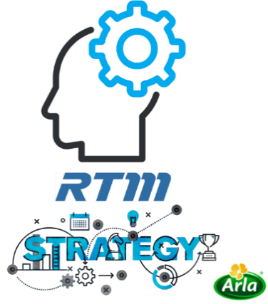
Consumer & Market mapping – After analysis the current performance we need to understand Consumer Behavior & Trends. Find out which market will be a more profitable focus on that market, Mention geographical reality, Trade Landscape, Point of Sales and distribution.
Functional integration - Map out and execute RTM links to other functions, especially marketing and supply chains (beyond sales forecasting/inventory management/stock outages). Include finance, operations, IT and HR. Integrate new RTMs with sales and operational planning (S&OP).
Distributor Assessment (Direct-Indirect-3rd Parties) – Distributor plays a vital role to make a profit. It is important to distributor assessment that which distributor is more profitable for our company. Arla foods Bangladesh chose the distributor very carefully and also check the performance background of the distributor. If the distributor is capable to supply the product then the company will contact the distributor.
Distributor Partnership Program - Develop model distributors, strategies, procedures, development plans and execution for each distributor. Read more and see a distributor partnership program
Key Account Management (KAM) - Develop and implement business terms, subject to KAM requirements, relationship management and negotiation, Train KAMs
Competitor Analysis – Competitive, Non-Competitive
- Current Competitor performance – A-Z analysis Current Competitor Performance.
- Portfolio and Pricing Analysis - A summary of the brand's portfolio, pricing, portfolio, and SKU segmentation, pricing strategy and performance.
Data & Metrics - Define maximum revenue with current capabilities, new data requirements, revenue management models (e.g. efficient area planning, route optimization, sales targets, incentives, etc.), the new KPI.

Chapter 5

5.1 Financial Condition:

Arla Foods is a multinational companythat’s why they published their financial statements globally. As per company policy they didn’t disclose any country-wise financial statement. But as a global report analysis, there is a hypothetical number that might be not matched in this diagram. In globally Arla Food Bangladesh has an impact on 5% overall profit. The most impact has china by over 35%. As it is a multinational company the can shear this profit with the employee. Over a thousand employees work in this company to reach their goal. Here I set a diagram to show a view of how this company getsits profit in which zone. Here Dhaka central is the most profit earning zone. Most sailing products of Dano and most of the promotion activities happen in this zone. East and West are similar to get the profit. One of the most upcoming profitable zones was the East zone because all the strategy works here. Arla Food Bangladesh more focus on the growth area and they get a special strategy that might help to company growth. Nowadays Arla food Bangladesh's biggest challenge to creating a profitable zone and look forward to the opportunity that makes one step ahead to the other competitor. They are set a milestone vision 2020 and 2022 to create the highest number of profitable areas as well as the most profitable companies in the dairy sector. This company givesthe highest number of donations in the prod people. In the most highlight news was when the Rohiga issue come toArla food Bangladesh a significant number of donations give them. Because they believe in the proper nutrition all the children and young people.

5.2 Marketing and Route to marketing
Marketing department alignment with the route to market department to facilitates direct sales in the market but it has a great connection both department to the marketing process. Implementing a marketing plan requires a lot of data. The route to market helps the marketing department with all that data.
For example. Arla wants to lunch a new campaign Rampura area. But before going to the campaign they want to know how much outlet in this area how much potential customer is there. Route to market also helps the marketing department in setting target customers and branding strategies. RTM also helps to identify the display modality tracking. Route to market is also affiliated with the marketing team about the POSM materials. RTM gives all kind of information that helps to market to create a new strategy to increase the sales

5.3 SWOT analysis

Arla Foods has of the world's 4th largest corporate dairy they have some of the strengths, weaknesses, opportunities, and threats. After analyzing a number of reports and sample suites provided by ARLA Food, we learn about strengths, weaknesses, opportunities, and threats.
STRENGTHS:
- As Arla Foods Bangladesh is a global company with its own accreditation and is therefore universally accepted by the customers and customers of our country.
- As a global company, ARLA food products are of high quality. The value is also centrally maintained.
- There is goodwill for ARLA foods and as a result, the company's products are widely used by customers and consumers.
- The brand Dano Milk Powder has continued its journey in Bangladesh since 1961. That time and now a day’s both time it will be the market leader.
- Since ARLA Foods is a multinational company, many talented employees will join ARLA Foods as their future career would have provided huge bonuses to ARLA Foods employees even allowing employees to purchase shares from ARLA Foods for a fixed price.

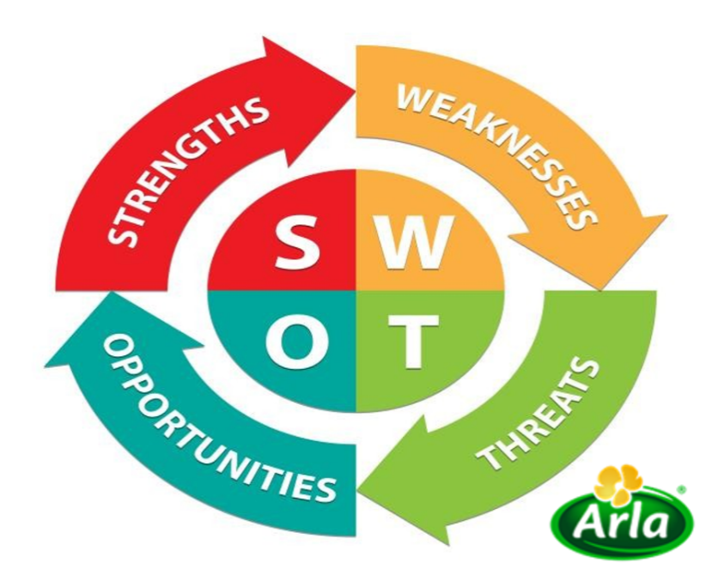
WEAKNESS:
- Arla Foods Bangladesh hasvery limited product line sales in Bangladesh.
- Arla Foods Bangladesh is an import-based company. Thus, the cost of goods is higher due to transportation costs.
- Arla Foods Bangladesh has a short portfolio.
- Arla doing his business in a retailer and as per company policy, they never give any credit in retailers. In other company gives some credit products.

OPPORTUNITIES:
- Bangladesh is a very populated country so people can buy more products.
- Bangladesh has high economic growth. So, more people can afford the products.
- Arla Foods is going to launch new products to market and a group of people can easily afford to buy those products.
- Arla foods expand their business in a rural area with a low cost.

THREATS:
- Apart from other organizations, ARLA Foods is also facing some transportation issues due to political instability and government policy.
- ARLA Foods faces unfair competition in Bangladesh.

.

5.4 Findings
There are a lot of changes in Arla food Bangladesh limited when they are introducing the route to market. Alignment with the marketing department has helped to grow the business and expand more area in the market. Here are some of the topics in my analysis.

- Provided proper guidelines in the field-force that they send good and authentic information.
- Give more attractive incentive modality that field force work more effectively
- Arranging more training sessions to train then, and track them whether the training effect on the market or not.
- Using compass more utilization
- More user-friendly in the compass and more training to know about compass apps in the field force
- Using advanced software to analyze the sales report.
- Give more motivation tools toa comparatively other company.
- Compass save more time to taking order also gives live report access to anyone. To track employees how they work at a particular time.

5.5 Recommendation

While working in Arla Food Bangladesh, I have observed some of the company's internal work and learned a lot about the business. Here are some suggestions based on my limited experience. Occasionally, work hours are left between 9am and 6am due to work stress. Overtime pay can be a great incentive for him. Dano is not getting market share like other competitors. Prices need to be more competitive. Regular distributors need to have gifts and incentives so they can be more active in selling our products. The display system should be handled more effectively. Other products need to be advertised so that we can ensure the sale of the Focused. Most customers buy milk powder at the nearest convenience. When the favorite brand is not available, they find another shop. Thus, the availability of the product at the agency's pocket outlets should be ensured as most outlets are under the company's distributor but are not fully covered. Distribution policies need to be developed. Send the sales data more acutely by filed forces. The data can be more authentic, and analysis the report more easy way, find out new technology to analyze the report. Run the arla compass properly every distribution house. More training in new joiners and existing employees to work more productively.

5.6 Conclusion
Arla Foods has made a strong impression in Bangladesh. Arla is going to Bangladesh with full steam. Arla is a well-established company and with continuous development focusing on its core skills and duties for quality forward the people of Bangladesh accepted Dano as a standout among the most trusted brands. I work in the sales team to see how arla satisfy the customer because they will give the highest priority to the customer. They ensure the highest quality to become a market leader. Any kind of suggestion of any customer Arla take it seriously also communicate many customers. Each and every employee region leads, territory officer, sales representative every one work to give customer premium product with high satisfaction. Not only customer Arla also motivate every employee as the highest incentive and awarded the best employee or best team which is very effective to work under pressure. If Arla foods Bangladesh performed well then they can contribute to a global.

5.7 References
- Origins of Arla Foods. (2018, November 1) retrieved from http://www.companyhistories.com/Arla-Foods-amba-Company-History.html
- Our Mission and strategies(2018, November 1) retrieved from https://www.arla.com/company/strategy/mission/
- Our Vision (2017,November1) retrieved from https://www.arla.com/company/strategy/vision/
- Company Overview. (2018, November1) retrieved from https://www.arlafoods.com.bd/company/unser-unternehmen/history/
- Route to Market and market structure (2018, November 1) Retrieved from Internal Website of Arla Foods Bangladesh.
- 8. Marketing structure (2018, November 1) Retrieved from https://www.facebook.com/pages/Arla-Foods-Bangladesh/363660620819285
- . Hossain, Robiul. (2018). Route to Market, BRAC University. URI: http://hdl.handle.net/10361/11031
- Abosag, Ibrahim (11 May 2010). "Dancing with macro boycotters: the case of Arla Foods". Marketing Intelligence & Planning. 28 (3): 365–373. doi:10.1108/02634501011041471. ISSN 0263-4503.
- 20 Steps to Route to Market Excellence. (n.d.). Retrieved from https://www.enchange.com/services/20-steps-to-route-to-market-excellence/.
- Internal sources and archives or Arla Foods Bangladesh Limited & accessible to employees of the organization.
- What is difference between Go-to-market strategy and Route-to-market strategy? (n.d.). Retrieved from https://www.quora.com/What-is-difference-between-Go-to-market-strategy-and-Route-to-market-strategy

