
An Internship Report
on
The Prospect of the Industrial Gases Sector in Bangladesh:
Evidence and Role of Linde Bangladesh Limited

Prepared by:
Imad Mustafiz Ifaz
Id- 111 191 101
United International University

Internship Supervisor:
Dr. Mofijul Hoq Masum, ACMA
Associate Professor
School of Business and Economics
United International University

Date of Submission:
30 May, 2023

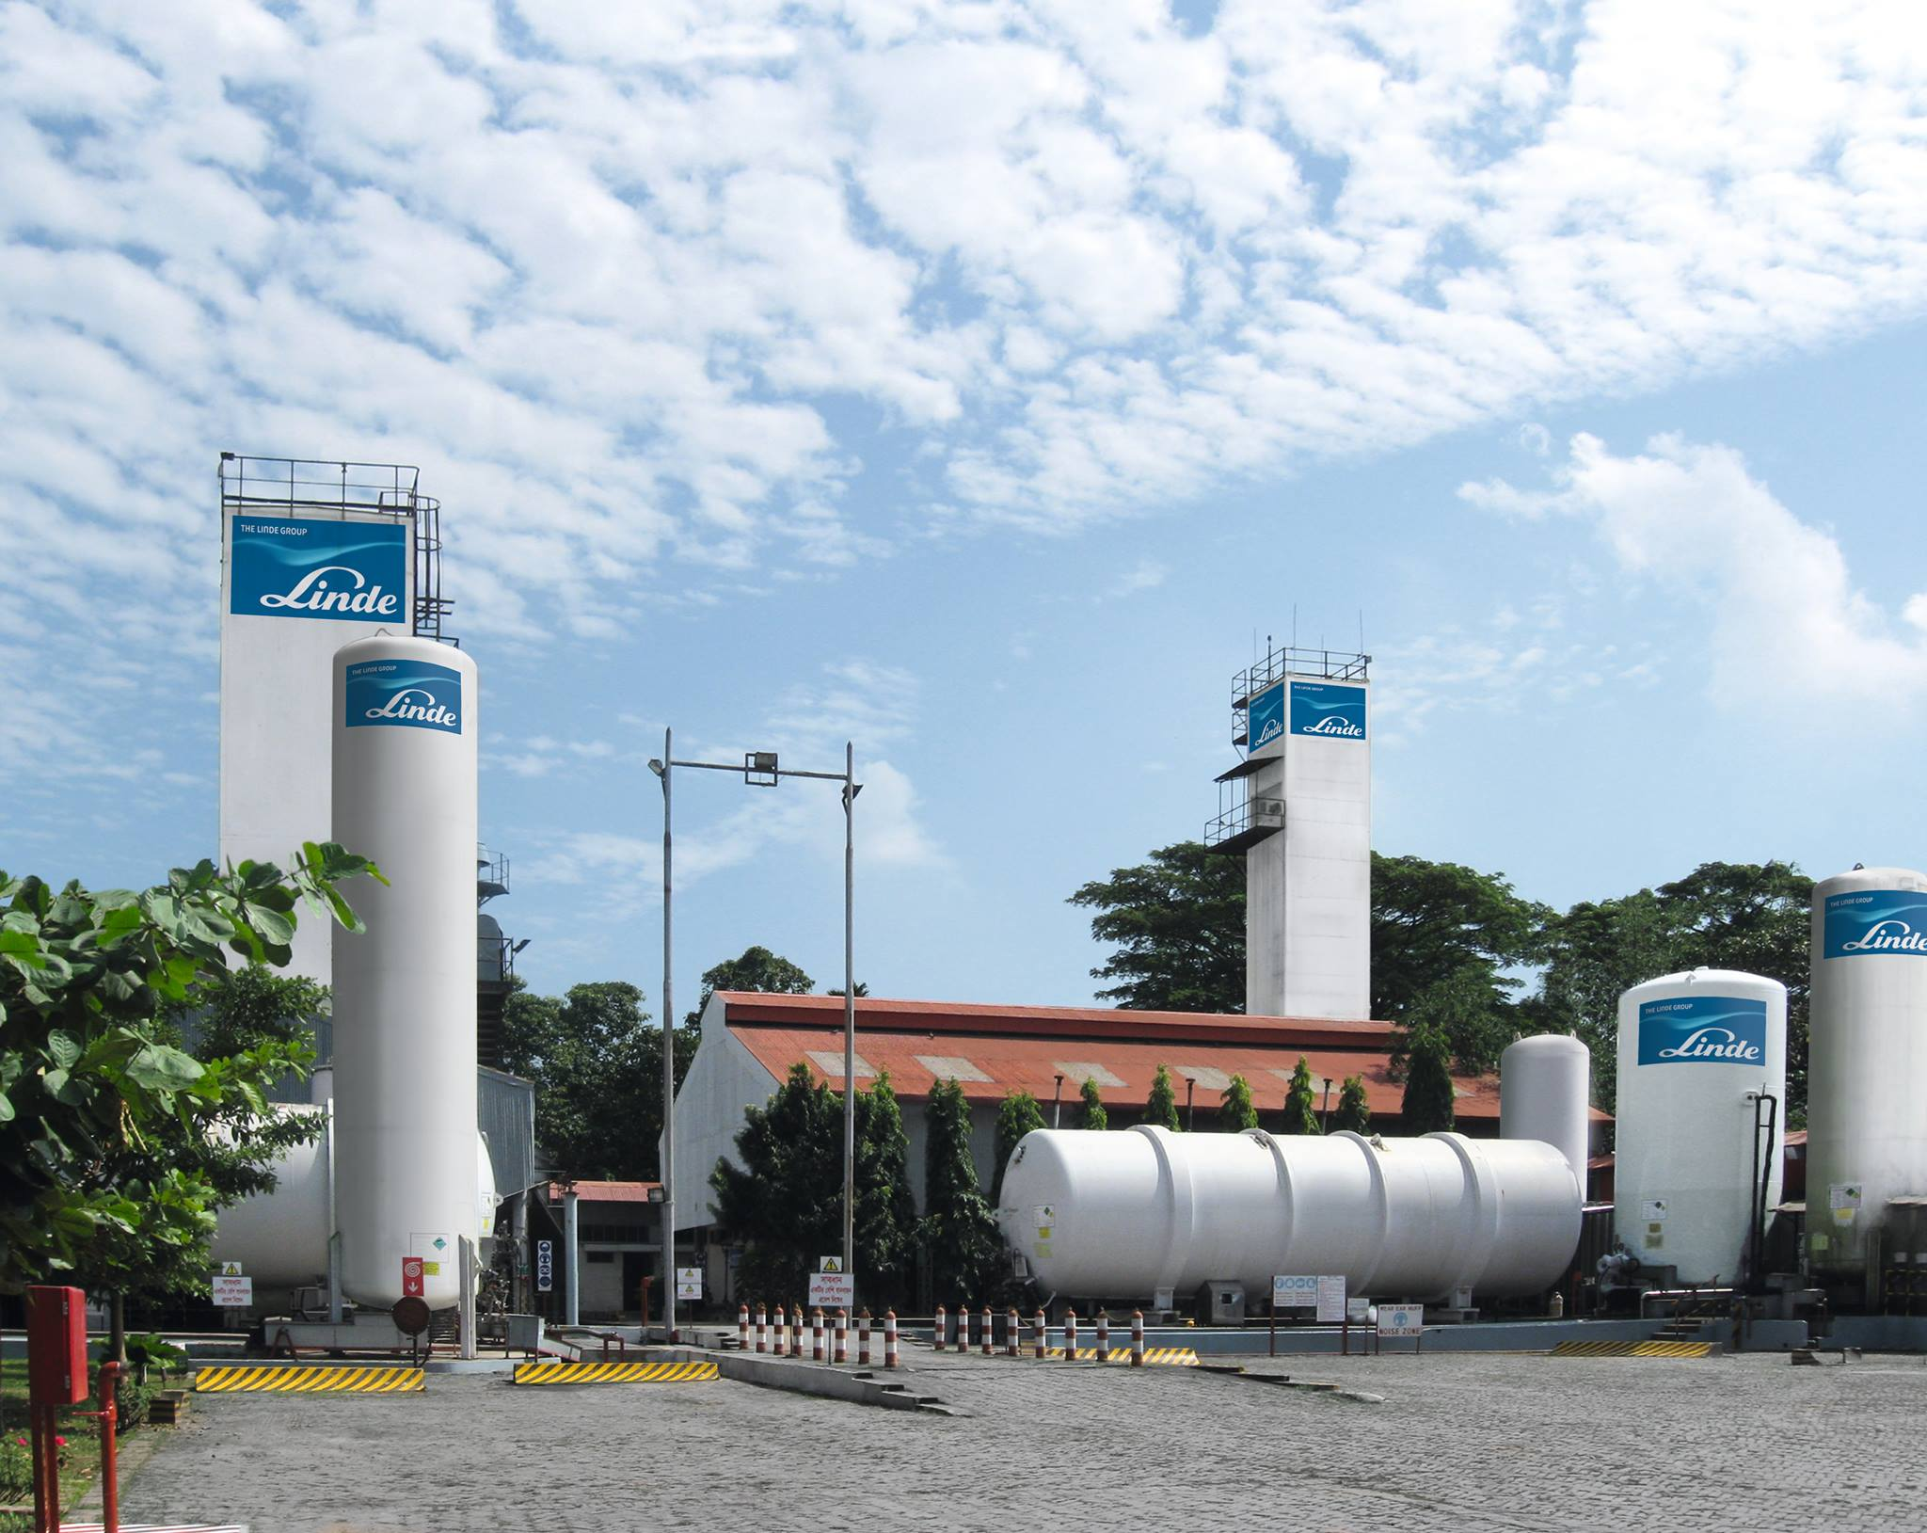


The Internship Report is submitted to United International University as a requirement for the fulfillment of the Bachelor of Business Administration Program

Table of Contents
Letter of Acknowledgement 1
Letter of Transmittal 2
Abstract 3
Key Words 3
Chapter 1: Introduction 4
1.1 Role of Linde Bangladesh Limited in the Industrial gases sector of Bangladesh 4
1.2 Industrial Gases Sector of Bangladesh 6
1.3 Rationale of the Study 8
1.4 Background of the Study 10
History of the Industrial Gas Sector in Bangladesh 10
History of Linde Group and Linde Bangladesh Limited 10
1.5 Limitations of the Study 13
Chapter 2: Objectives of the Study 14
2.1 Broad Objectives 14
2.2 Specific Objectives 14
Chapter 3: Methodology of the Study 15
3.1 Data Design 15
Data Collection Process 15
Secondary data collection process 15
Qualitative Research 15
Quantitative Research 16
Content Analysis 16
Type of Data 16
Analytical Report 16
3.2 Sample Design 17
Sampling Techniques 17
Sample Size 17
3.3 Analytical Tools 17
Microsoft Excel 17
SPSS 18
3.4 Variable Design 18
Dependent Variable 18
Independent variable 18
3.5 Model Specification 19
Chapter 4: Literature Review 20
4.1 Demand of Gas and GDP 21
4.2 Demand of gas and FDI 21
4.3 Demand of Gas and the Population of Bangladesh 22
Chapter 5: Findings and Analysis of the Study 23
5.1 Descriptive Statistics 23
5.2 Model Summary 24
5.3 Correlations 24
5.4 Supporting Charts 25
5.5 SWOT Analysis of Linde Bangladesh Limited 28
Strengths 28
Weaknesses 29
Opportunities 29
Threats 29
5.6 Financial Analysis of Linde Bangladesh Limited 30
Liquidity Ratios 30
Profitability ratio 31
Leverage Ratio 34
Valuation Ratio 35
Activity Ratio 36
Analysis of Financial Ratios 38
5.8 Internship Experience 39
Details 39
Job Responsibilities 40
Personal Remarks 40
Chapter 6: Conclusion and Recommendations 41
Chapter 7: Appendix 42
References 42

Letter of Acknowledgement

First and foremost I would like to show my gratitude to The Almighty Allah for making me able to prepare this internship report. Next, I would like to thank my parents and my entire family for supporting me all the way through. Then I would like to thank the esteemed supervisor of my company for assisting me throughout my internship. My colleagues also helped me to familiarize myself with the company affairs. Most importantly I would like to thank my esteemed faculty Mofijul Hoq Masum sir for helping me in every way possible, even if it was through the in-person sessions during counseling hours or the constant contact he kept online to guide me and helping me come up with such a professional report for the completion of my BBA program. I am thankful to each and every one.

Letter of Transmittal
May 30, 2023
Dr. Mofijul Hoq Masum, ACMA
Associate Professor
School of Business and Economics
United International University
Dhaka- 1212

Subject: Submitting an internship report on “The Prospect of the Industrial Gases Sector in Bangladesh: Evidence and Role of Linde Bangladesh Limited”

Dear Sir,
With due respect, I would like to draw your kind attention to the fact that I, Imad Mustafiz Ifaz, bearing Id. No. 111 191 101, would like to submit an internship report on “The Prospect of the Industrial Gases Sector in Bangladesh: Evidence and Role of Linde Bangladesh Limited”. I have attempted to prepare the report by your guidelines and to the best of my knowledge tried to portray the industrial gases sector of Bangladesh and how Linde Bangladesh Limited played a big role during and after the COVID-19 pandemic. During my internship, I was assigned as an Intern in the Secretarial and Legal department and I learned a great deal about the organizational culture, prospects, and activities of the company and understood its mechanics.
I have outlined my observations and analysis and provided a detailed report on the findings and recommendations through secondary data collection.
I am grateful to you for supporting me as my internship supervisor and also to Linde Bangladesh Limited for their guidance and encouragement throughout my internship. I hope you find the report insightful and informative and I have tried to make it as error-free as possible. Hope and pray that you accept my report and oblige thereby.

Sincerely yours,
Imad Mustafiz Ifaz
Id-111 191 101

Abstract

The study portrays both the current and prospects of the industrial gases sector of Bangladesh, focusing on the role of Linde Bangladesh Limited in this regard. Many factors are assessed such as regulatory frameworks, micro-macroeconomic factors, industry trends, etc. by which the supply and demand of the market is measured. The study highlights the rapid growth of the demand for industrial gases due to the expansion of infrastructure, manufacturing, and healthcare sectors. According to the perspective of Linde Bangladesh Limited, this report discusses its market position and how it stands out against competitors. The brand image, unique solutions, and diversified portfolio of Linde Bangladesh have enabled it to become a market leader in this sector. In fine, this report provides recommendations for the company to uphold its market position and utilize the growth opportunities amidst the new challenges of the free world. Bangladesh is moving into an uncertain future due to ongoing crises like the post-COVID world, inflation, the Russia-Ukraine war, and an upsurge in fuel prices. So this report provides important insights as to how the future is shaped for Bangladesh and how it affects the future of Linde Bangladesh Limited in this country. Through the secondary data collection process, some analyses were done to find out the positive and negative impacts in the industrial gases sector and based on factual evidence the recommendations were made. There were some limitations pointed out so that no confusion remains. And the report was concluded with my personal hands-on experience in the company including my duties and responsibilities, observations, and other activities such as celebrating global events and festivals and the culture of a multinational corporation.

Key Words: Gas, Linde Bangladesh Limited, Relationship, Demand, Bangladesh

Chapter 1: Introduction

Role of Linde Bangladesh Limited in the Industrial gases sector of Bangladesh

Linde Bangladesh Limited is a pioneer in the industrial gas sector of Bangladesh. Operating for over 50 years, they have become the market leader in the country by supplying a wide range of industrial gases including Hydrogen, Helium, Oxygen, Nitrogen, Argon, Carbon dioxide, Acetylene, etc. They supply gases to customers of different industries like construction, chemicals, glass, steel, electronics, food processing, etc. Their offerings include services like gas cylinder installation, welding services, training, repair, maintenance, etc.
Having a unique and diverse portfolio, they don’t have a similar type of competitor in this field so the peer industry scenario cannot be defined accurately. There are other companies supplying industrial gas like BGFCL, TITASGAS, KPCL, JAMUNA OIL, INTRACO, UPGDL, SUMITPOWER, etc. but no two companies can be compared fully with Linde Bangladesh Limited. Thus they have a competitive edge and play an important role in this sector in Bangladesh.
Linde Bangladesh Limited is known for its safety standards and environmental safety practices. They have a safety policy known as SHEQ (Safety, Health, Environment, and Quality), followed by the entire group worldwide. Linde Bangladesh Limited is always committed to reducing its carbon footprint and ensuring that no ecological damage occurs in the process of its work. They are not only limited to international corporate safety standards but also practice these policies in their daily life. For example, they hold a safety meeting at the start of every month where the employees share their safety issues and incidents that they have seen in their regular lives and they talk about the ways to prevent these hazards from happening again. Thus they show responsible behavior that benefits the country and a greener world.
Besides corporate social responsibility, Linde Bangladesh Limited has shown expertise in the field of technological innovations. They have found adopted methods that have enabled them to become more efficient in production and make a profit by ensuring quality. They have found innovative technologies to reduce environmental damage and produce high-quality gases so that the other sectors can ramp up their production and can perform their work properly.
In fine, Linde Bangladesh Limited plays a huge role in the economy of Bangladesh as they earn a huge amount of revenue every year by offering pure, high-quality gases, and services to Bangladesh. They also contributed last year by providing free toolkits to the underserved people of Ukhiya Upazila.
Linde Bangladesh has installed plants for increasing their rate of production across many parts of Bangladesh such as a CO2 plant in Rupganj, a welding production line in Rupganj, an LPG plant in Shitalpur, an LPG plant in Bogra, etc.

Industrial Gases Sector of Bangladesh

According to the Corporation for Oil, Gas, and Minerals in Bangladesh known as PetroBangla, Bangladesh has a reserve of only 8.68 Trillion Cubic Feet of natural gas left in the form of natural sources which is surely to exhaust in a few years.
This is puzzling because according to the study of the US Geological Survey and PetroBangla, Bangladesh has undiscovered natural gas of about 32 trillion cubic feet. So if they are discovered, Bangladesh can easily sustain itself for at least 30 more years. But the scenario is not the same in Bangladesh. We can see that in the last year, we have faced terrible load shedding throughout the country. The government conducted routine load-shedding and many industries were affected. That wasn’t supposed to happen. It still happened because experts say that due to a lack of exploration and seismic assessments, Bangladesh was unable to discover its natural gas fields as a result a lot of the resources remain unused. So, we get to know that fossil fuel is exhausting, and due to the Russia-Ukraine war, gas prices are on a constant rise. So, the people of our country are in a dilemma.
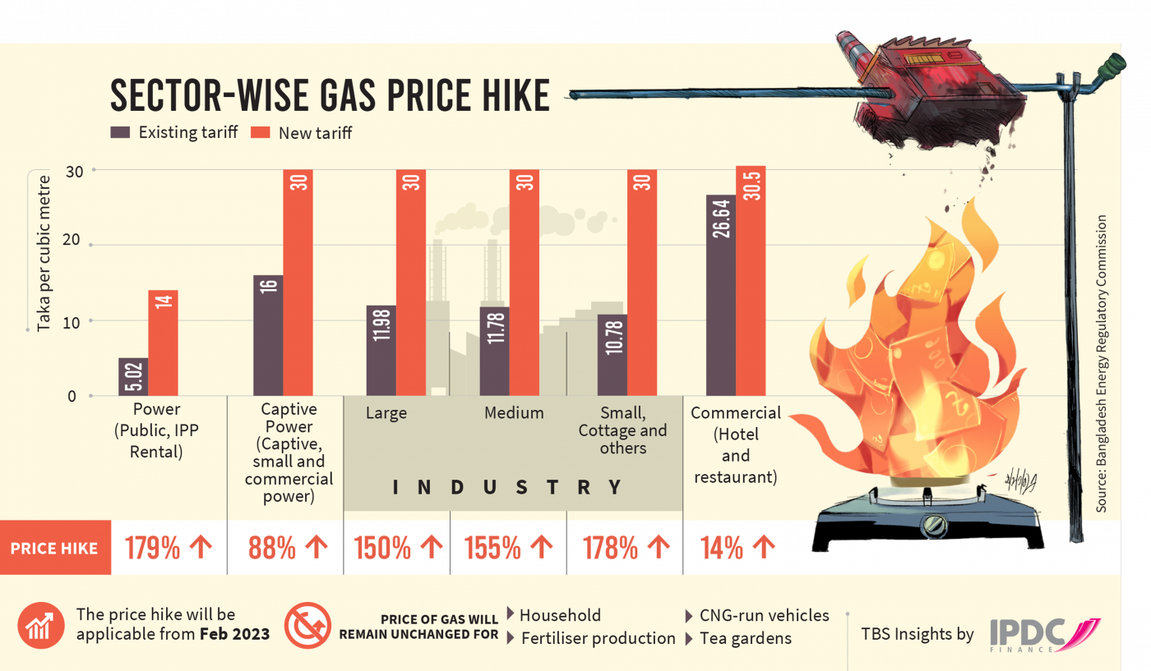

This is the current scenario of the gas sector of Bangladesh. But according to the company’s perspective, there are many offering varieties of gases like hydrogen, helium, carbon, nitrogen, acetylene, oxygen, propane, methane, etc. according to the needs of different sectors. The two main use of gas is heat generation and electricity. About 41% of natural gas is used in these sectors. Moreover, there are other fields such as the food and beverage industry, welding, machine repair and maintenance, technological pieces of equipment, and so on.
In fine, the demand for the gas sector is at an ever-increasing rise and the prices are increasing day by day. The market condition is volatile as the cost of production has increased and govt. has imposed additional charges for production. So the companies cannot keep their costs lower. The national reserves are becoming exhausted and imports are increasing. This is hampering the economy of Bangladesh as the foreign reserves are also being emptied out and thus creating inflation. The war is affecting Bangladesh along with other countries as well and the overall situation is under threat. So, the companies operating inside Bangladesh should find alternate ways to face these challenges and overcome them to minimize the losses and turn them into a sustainable business model.

Rationale of the Study

There are currently 28 gas fields running in Bangladesh. But according to different reports, these gas fields aren’t producing enough according to their capacity. This is happening due to a lack of technical planning and utilization of technology. The govt. is also reluctant to take measures and the slow bureaucratic process makes them lag. As a result, the power generation capacity is decreasing. Moreover, we know about LPG (Liquid Petroleum Gas) as an alternative source of fuel for cars, used for heating, cooking, and other agricultural and industrial purposes.
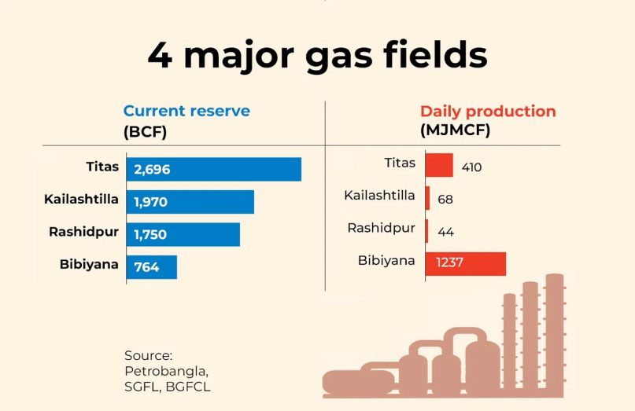

LPG import has been reduced for saving foreign currency as a result gas prices are rising. 75% of the total gas production comes from 4 main fields including Titas in Brahmanbaria, Kailashtilla, Rashidpur, and Bibiyana gas fields in Habiganj. Some of these fields are using contemporary technologies and methods. The lack of drilling more developed wells is causing production to decrease.
For these reasons, this study will not only help to find appropriate solutions to the production and distribution problem but also will help to determine alternative ways to minimize cost and maximize production through effective technologies and logistical models. My internship at Linde Bangladesh Limited helps me to observe the problems in gas production, installation, and delivery services as well as helped me to build insight into the costs associated with it. Furthermore, one of the main problems as we move on to the scorching hot summer is electricity, and Bangladesh is prone to increased load shedding. So, if the fuel for electricity is fixed then this problem can be minimized.
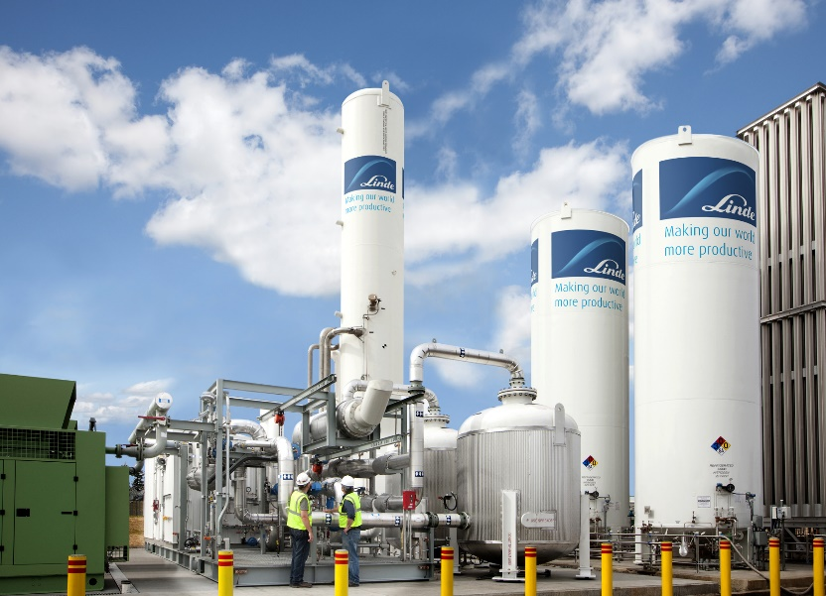
Being the global market leader in the industrial gases sector, Linde Group is an expert in many services including Aquaculture, electronics, food and beverages, metal fabrication, metals, waste and wastewater treatment, clean hydrogen production, additive manufactured components for aerospace, energy and industrial applications, separating, purifying and liquefying gases, turbo machinery, and so on. Their sophisticated projects like PLANTSERV, ADDvanceTM O2 precision, NITROBOOST, LINDOFLAMM, PLASTINUM, etc. are run continuously to make people’s lives better. Due to my internship, I learned about these technologies. I truly believe that this report can help implement these types of innovation in Bangladesh so we can develop ourselves accordingly and compete in the global market.

Background of the Study

History of the Industrial Gas Sector in Bangladesh
Bangladesh is 16th in producing gas in the entire Asian continent. After the Liberation War, the Bangladesh Petroleum Act was passed in 1974. National mineral resource company Petrobangla was then formed. In the 1980s Petrobangla started exploring the gas fields and discovered 9 major fields. The first commercial oil factory was established in Haripur in 1986. In the 1990s, multinational oil and gas companies started tapping into the Maulvi Bazar, Jalalabad, and Bangura-Lalmai gas fields. Then came the gas giant Chevron in the 2000s. In 1974 govt. offered 7 shallow water offshore blocks in Bangladesh to some international oil companies because oil was their main target. But due to political instability, these companies left. But this early exploration resulted in the finding of gas rather than oil which attracted other companies. According to the Professor Imam Badrul of Dhaka University, Bangladesh is not running out of gas soon. Bangladesh's natural gas is considered almost fully pure, ranging up to 95-99% purity. Bangladesh Petroleum Exploration Company (BAPEX) is in charge of exploration and Petrobangla is the principal energy company. The international oil companies have to sell their natural gas to Petrobangla and there are many bars imposed by the govt. in selling it to the customers directly. According to Worldometer, Bangladesh produces 948,609 million cubic ft. of gas every year and is ranked 32nd in the world.

History of Linde Group and Linde Bangladesh Limited

Linde PLC, a global multinational company, was formed by a merger between Linde AG of Germany, founded in 1879, and Praxair of the United States, founded in 1907. Later a merger Its main portfolio includes services in healthcare, petroleum refining, manufacturing, food and beverage carbonation, fiber optics, steel making, aerospace, material handling equipment, chemical, electronics, and water treatment industries. The company is ranked 187th in the Forbes Global 2000. The company first started its journey by developing mechanical refrigeration systems for the brewing and food industries. Due to success, in 1895, a patent was formed on the liquefaction of air. The air separation process was further patented in 1902 and moved on to large-scale operations.
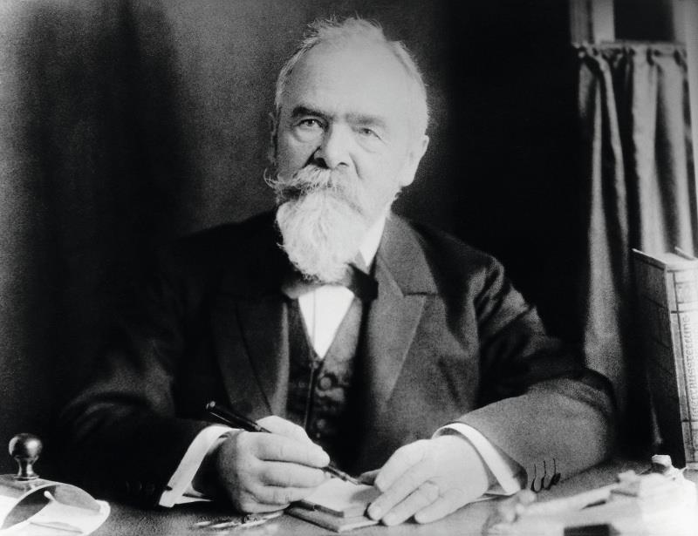

In 1906, the founder Carl Von Linde decided to expand his oxygen separation business overseas. During the World War, as it was a German company, it benefitted from it by doing a monopoly business. They were engaged in armaments production during World War II. Progressing to the 2000s, they kept on acquiring many big companies like Lansing Bagnall, AGA AB, The BOC Group, Ceylon Oxygen Limited, and many more. Finally, it went on to acquire Bangladesh Oxygen Company (BOL).
Pakistan Oxygen was formed in 1958. Later after the Liberation War, in 1971 its name was changed to Bangladesh Oxygen Company. In 1995, the company changed its name to BOC Bangladesh Limited. It opened the first CO2 plant in Bangladesh. The ASU plant in Rupganj was formed in 1997. It also formed ASPEN and LPG Bottling plants in 2000.

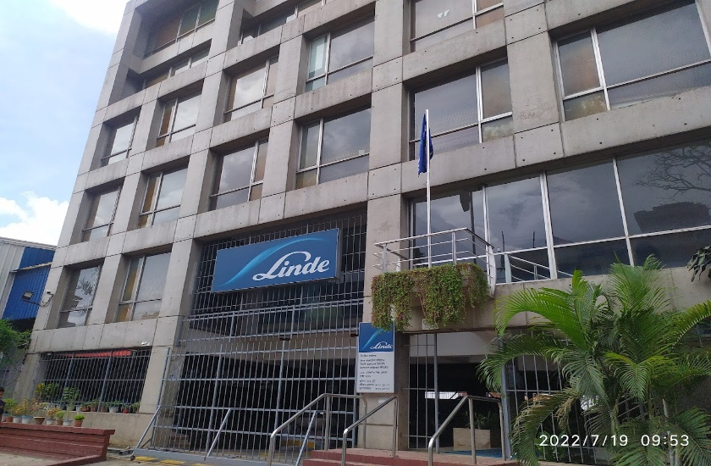

Linde Group acquired Bangladesh Oxygen Company in 2006 and was named Linde Bangladesh Limited in 2011. Before the Liberation War, Linde Bangladesh Limited was present as a partner of Bangladesh and they have been conducting business for a very long time. Its commitment to its customers is never to be broken by its strong work integrity and ethics. Its employees and Board of Directors are always aware of the value, vision, and mission of the Company and it emphasizes the core values which are quality, safety, health, and sustainability of the environment.

Limitations of the Study

- The report was prepared with a secondary data collection process. It was not possible to go to all the gas plants in Bangladesh and collect data. So, I had to rely on the data available on the internet, on the company’s website, or from Google.
- The information I collected was within a short period. The time duration was only 3 months. So, in 3 months it is not possible to collect vast amounts of information about the company so the entirety of the information may not be found in this report.
- It was not possible to go to the Rupganj plant and see the gas plant of Linde Bangladesh Limited as I was just an intern and only permanent employees were allowed on those premises.
- There may be events that happened after the submission of this report which is material to any changes to the company or to the industrial gas sector in Bangladesh which cannot be recorded.
- As this was my only workplace, so there might be a potential for biases according to my own experiences and not from an objective point of view of the organization as a whole.
- The entire data might not be completely relevant.
- There might be a lack of feedback from the organization in a short amount of time which may cause a slight impact on the report.
- The data is collected from both govt. records and international records. So they might not be 100% accurate.

Chapter 2: Objectives of the Study

2.1 Broad Objectives
The study is conducted to
- Determine the supply and demand of Industrial gases in Bangladesh
- Determine the role of Linde Bangladesh Limited in the market of Bangladesh
- Identify the products and service offerings of Linde Bangladesh Limited and the strategies they use for expansion, growth, and sustainability
- Identify the challenges faced in the industrial gas sector and provide recommendations to interested parties for overcoming these challenges

2.2 Specific Objectives
The study is conducted to
- Determine the relationship between the demands for gas with certain factors that affect the demand for gas.
- Find out the threats and challenges and finding out opportunities and solutions to rectify those in turn fixing issues of the industrial gas sector of Bangladesh.
- Perform a Financial Analysis to find out the financial performance of Linde Bangladesh Limited to come up with growth strategies and to intertwine with the macro-economic conditions of the gas sector in Bangladesh.
- Portray my experience in Linde Bangladesh Limited as an intern and provide valuable insights into the company.
- Provide recommendations in solving industrial gas related challenges

Chapter 3: Methodology of the Study

3.1 Data Design

Data Collection Process

The data was collected with the help of 3 data collection processes which fall under the secondary data collection method. The processes are respectively: qualitative research, quantitative research, and content analysis. First, we are required to know about the secondary data collection process. Then we will get to know about the other 3 subcategories under the secondary data collection process.

Secondary data collection process

The secondary data collection process means the process of collecting data that has already been collected and published on the internet or physically through different sources. It can come from various sources including journals, books, articles, magazines, annual reports, general reports, newspapers, questionnaires, experiments, surveys, govt. records etc. The data in these sources have already been published and collecting the relevant information takes time and expertise. I had to go through several of these sources to find out the appropriate data and performed meaningful analyses with the help of analytical tests. Data sorting and arranging are two difficult tasks. For that to be done properly the study objectives need to be clear and concise.

Qualitative Research

Qualitative research means analyzing qualitative data which are not numeric. It means obtaining information from journals, reports, and other published sources and building concepts, understandings, and recommendations from it. A non-numeric data may be a case study, someone’s experience, graphs, charts, tables, blog posts, articles, opinions, etc. from which factual information can be gathered. These descriptive data are found by building keywords of the research topic. In this report, qualitative data was found with the help of the internet by searching keywords like industrial gas, Bangladesh, Linde Bangladesh Limited, prospect, supply, demand, etc. The resulting articles, journals, and reports were analyzed and relevant factual information was taken into consideration.

Quantitative Research

Quantitative research means searching and analyzing numeric data. The numeric data includes figures, numbers, units, etc. The numeric data is then sorted out and used to find patterns, equations, and logic for providing recommendations according to the results. In this report, the numeric data were collected from different websites, and reports and were sorted according to relevance to perform the analytical tests.

Content Analysis

Content Analysis means analyzing pictures, tables, videos, and other motion content that can be found on YouTube, documentaries, videos, news media, etc. It can be in many formats like pictures, audio, video, etc. The study of these documents and artifacts leads to certain findings that are beneficial for attaining the objectives of this study.
In fine, the data collection process included a combination of these 3 types of data which helped to determine results and provide appropriate recommendations to the users.

Type of Data
This report falls under the category of an analytical report. We will know about the analytical report-

Analytical Report
Analytical reports convert qualitative and quantitative data into meaningful assumptions and models and further propose solutions to some problems. The main objective of this report is to facilitate the decision-making process and come up with strategies and solutions that are based on the analytical evidence. It uses different forecasting techniques and accurate predictive analysis techniques to predict the future outcome.
The same can be seen in this report. In this report, some analytical tests among others provide some recommendations that will help to develop the industrial gas sector of Bangladesh and helps to determine the factors that most affect the growth of this field.

3.2 Sample Design

Sampling Techniques
In this report, the systematic sampling technique has been used. It is a technique where the sample is taken from a large population having a random starting point but each data of the data set has a fixed periodic interval. As there is a large metadata in the population but it isn’t exposed to manipulation, for this reason, the systematic sampling technique has been chosen and the years of the test are sequential from 1980-2021.

Sample Size

The sample size is 42. In the regression analysis, the variable data has been given for 42 years starting from 1980 to 2021. All the data has been collected from different sources which will be provided in the reference section of the report. There is a mix of sourcing for the data as all the data are not available in a single source for which the findings will never be 100% accurate. All the variables have been organized properly and converted to a homogenous unit so that the regression model runs properly and we can bring out results.

3.3 Analytical Tools

Microsoft Excel

Microsoft Excel is the most common tool for conducting analytical tests and performing numeric calculations and interpreting data. For organizing the data I used Microsoft Excel and arranged the data according to a specific and homogenous order. I then made a chart to explain the relationship of the dependent variable with the independent variable over the years. The required proof/ evidence of data is available in the Excel file which can be provided upon request.

SPSS

Statistical Package for the Social Sciences or also known as SPSS is the most widely known quantitative analysis software for researchers. It can analyze complex data in multifarious ways. The data from Excel was imported into this software and all the settings of the variables were adjusted such as the data type, the measure, the decimal value, the label, etc. After all the settings were adjusted, the regression analysis was done and the required results were extracted for evaluation and interpretation.

3.4 Variable Design

Some variables were taken into consideration by acknowledging some factors like geography, economy, political condition, the standard of living, and other macroeconomic factors. The variables are grouped into two categories namely dependent and independent variables.

Dependent Variable

The Demand for Gas is the dependent variable in the regression equation. In the basic linear regression equation, the dependent variable depends on factors that are termed independent variables that do not depend on any factors and are independent irrespective of any conditions. By assessing the Demand for Gas, we can get to know about the potential market of the Industrial gases sector in Bangladesh and will be able to determine certain paths that will lead to the economic and financial development of our country and will be able to access the pool of our countries’ resources accordingly. With development in mind, the relationship between the demand for gas and other independent variables is considered.

Independent variable

4 independent variables were taken for conducting a regression analysis. The variables are respectively Gross Domestic Product or GDP, Foreign Direct Investment or FDI, GDP growth rate, and the Population of Bangladesh.
Among these 4, the two variables consisting of the GDP in total and the GDP growth rate indicate the same factor. For this reason, the GDP growth rate was taken as it was more accurate among the two and it is easier to forecast the direction of this sector with this factor as a variable. An independent variable is a variable that does not depend on any other factors.

3.5 Model Specification

The model that has been generated for this analysis is the Linear Regression model. This model is used to figure out the relationship between the dependent variable and independent variables and to make a predictive analysis of the future outcomes based on the data after grouping them according to the variables. Since the relationship is linear, the data that has been collected will form a linear relationship if plotted on a graph. The equation that we came up with to compute the demand for gas is as follows:
COMPUTE Dmd_Gas=-721.962 + .101 * FDI + 83.496 * Pop + 1.905 * GDP_tk.
EXECUTE.

Chapter 4: Literature Review

From the previous research, we saw that there are many analyses regarding the relationship between the demand of gas and other factors. There is a sector-wise analysis of the consumption and supply of different types of gas according to sectors in the report of PetroBangla. Data was sourced for a period of 10 years and the supply-demand of various gases was determined for sectors like industry, transport, power, tea garden, etc. In another research conducted by students of the University of Leeds, I found the modeling and forecasting of natural gas demand in Bangladesh. In the research, the relationship between the demand of gas and the real price of natural gas at time t, real GDP at time t, and the population at time t were determined and it was found that there was a positive relationship between all the variables.
Although most of the studies are following a trend of extrapolation for forecasting the demands of gas in the future. There are also growth rate methods that are simpler. Wood Mackenzie (2005) used an econometric model where he forecasted the demand of gas with only one independent variable which is GDP. Quader and Gomes (2002) estimated the demand of gas based on the expansion of two sectors that uses gas. This had no theoretical logic and was aimless. Uddin and Ahsan (2004) forecasted the peak demand of gas with only the power sector as an independent variable using the bottom-up approach. This doesn’t give a complete picture of the model and no single variable can be hypothesized in this approach. Asaduzzaman and Billah (2008) followed the same metric approach of forecasting using a sector-based approach which is not useful policy-wise. They used power as a determinant but it alone cannot be a determinant since power itself depends on other independent factors. Technology comes into play here so it is not very useful as well.
Due to the elementary explanation and proposition of models by others in the previous research. I have proposed a model that uses the factors that have a direct positive relationship for forecasting the demand for gas. As we all know that previous research failed to provide, the demand for natural gas depends on some external factors. These factors include the income of consumers, the price of goods that consume energy, the environment, policies, and rule changes, the enactment of new laws, new technological breakthroughs, the structure of the economy, the population of the country, etc. We saw the positive relationship between gaseous energy and GDP in many pieces of research (Cleveland et al. 2000, Brown et al. 2000, Ayres and Warr 2005, Ayres et al. 2007). The impact between the price and demand of petroleum in the transportation sector is also found (Gately and Huntington 2002, Graham and Glaister 2002, Wadud et al. 2010). But the information available on the internet in the distant past isn’t readily available and the authenticity of the information from the source cannot be assured. In developing countries, we found the forecasting model of gas using only two variables. (Ibrahim and Hurst 1990).
Since aggregate demand is the most important in determining the policies related to the supply and demand of gas we can see that the aggregate demand, GDP, and population are more accurate and effective for determining the direction of this issue.

4.1 Demand of Gas and GDP

The relationship between the demand of gas and is positive. As we can see from the test of regression the demand of gas is proportional to the change in aggregate GDP. For this variable to work properly in the equation, I converted the GDP amount in Billion taka which was in million taka in the report of PetroBangla and the Energy report of the Bangladesh govt. Data going back to the 1980s and 1990s were impossible to be found in the govt. websites so I took those data from the World Bank and other websites such as Macrotrends, IMF’s website, etc. Combining all these data I made a set of data to compare it with the demand of gas and found that for every unit increase in GDP, the demand of gas increases by Billion Cubic Feet which is the unit for determining the demand of gas.
COMPUTE Dmd_Gas=-721.962 + .101 * FDI + 83.496 * Pop + 1.905 * GDP_tk.
EXECUTE.
Here we can see that the coefficient of GDP (Billion Taka) is positive.

4.2 Demand of gas and FDI

The relationship between the demand of gas and that of Foreign Direct Investment is positive as well. Foreign direct investment means when the company of a foreign country of a foreign economic standpoint invests in that country then that investment is known as foreign direct investment. The amount of foreign direct investment indicates the potential for economic development in that country. It helps in the development of foreign exchange rates by bettering the relationship between outsider countries. Here, according to our model, although the relationship is in a smaller proportion, it is positive. We found out the amount of FDI done in our country with the help of the data from the World Bank and converted it into the form of Billion taka from the US dollar as a unit. So, according to the model, we can conclude that for every unit increase of Foreign Direct Investment in our country, the demand of gas increases by per unit Billion Cubic feet.
COMPUTE Dmd_Gas=-721.962 + .101 * FDI + 83.496 * Pop + 1.905 * GDP_tk.
EXECUTE.
Here we can see that the coefficient of FDI (Billion Taka) is positive.

4.3 Demand of Gas and the Population of Bangladesh

According to my model, the relationship between the demand of gas and the population of Bangladesh is the strongest. According to our common knowledge, the population is the main reason behind the increase in demand. Be it any product or service. The population uses these products and services in their daily lives. So as the living standard and lifestyle develop, the demand increases in parallel with the development of the country. Bangladesh has a huge population compared to its size and the growth is increasing rapidly. Due to favorable conditions and fertile lands, it is easier to populate in Bangladesh. So for considering population as a metric, I took the data/consensus of the population (in crore) from the govt. portal of Bangladesh as well as the World Bank data and combined them to find the total data about the population of Bangladesh from the year 1980-2021. And it is safe to say that for the increase in the population of Bangladesh, the increase in the demand of gas is directly proportional.
COMPUTE Dmd_Gas=-721.962 + .101 * FDI + 83.496 * Pop + 1.905 * GDP_tk.
EXECUTE.
Here we can see that the coefficient of Population (Crore) is positive.

Chapter 5: Findings and Analysis of the Study

5.1 Descriptive Statistics

Table 1: Descriptive Statistics
 | Mean | Std. Deviation | N
Demand of gas | 451.7690 | 326.16503 | 42
FDI (Billion Taka) | 829.7886 | 1044.50091 | 42
Population (Crore) | 12.8564 | 2.55605 | 42
GDP (Billion Taka) | 8.5955 | 8.02422 | 42

Here, we can see in Table 1 that the mean value of the model stands at 451.7690 which means the average demand for gas in the years through 1980-2021 is 451.7690 BCF. The value of the normality is 42. The N denotes normality and we know that at least 20-30 valid observations are required to run the model properly and get good results out of the mode. Here, we have 42 valid observations which make it a good fit for forecasting the demand of gas. The mean value of the independent variable is also respectively, 829.7886, 12.8564, and 8.5955. We can see the values of standard deviation from this table. So, we can determine that the value of FDI deviates from the actual mean value which means that the amount of foreign direct investment in Bangladesh is uncertain as a lot of factors depend on the FDI. Those factors can include economy, politics, finance, and other factors. So the value of FDI deviates from the average value. The demand of gas also deviated up to a certain extent but it was less than that of FDI.
But, we can see that Population and GDP have significantly lower values of standard deviation. It denotes that over the 42 years, the GDP and Population have had a steady change in parallel to the mean/average value. There hasn’t been a drastic change and both GDP and population are at a steady rise.

5.2 Model Summary

Table 2: Model Summary
Model | R | R Square | Adjusted R Square | Std. The error in the Estimate | Change Statistics
 |  |  |  |  | R Square Change | F Change
1 | .987 | .974 | .972 | 55.02395 | .974 | 467.546

Here we can see from the model summary that the linear regression model that we have generated has an adjusted r-square value of .972. We know that any model having an adjusted r-square value of more than .7 will show a high level of correlation. And the proposed model has a 97.2% accuracy in predicting the correct demand of gas.

5.3 Correlations

Table 3: Correlations
 |  | Demand of gas | FDI (Billion Taka) | Population (Crore)
Pearson Correlation | Demand of gas | 1.000 | .923 | .968
Pearson Correlation | FDI (Billion Taka) | .923 | 1.000 | .849
Pearson Correlation | Population (Crore) | .968 | .849 | 1.000
Pearson Correlation | GDP (Billion Taka) | .888 | .933 | .824

Here, we can see that the relationship among the variables is strong. All the independent variables have a correlation coefficient of more than .85 which means that they have a highly positive correlation with the dependent variable which is the demand of gas. Moreover, each of the independent variables has a highly positive correlation with themselves as well. From these values, we can conclude that the factors that we have set (GDP, FDI, and Population) for determining the demand of gas are highly material.

5.4 Supporting Charts

Table 4

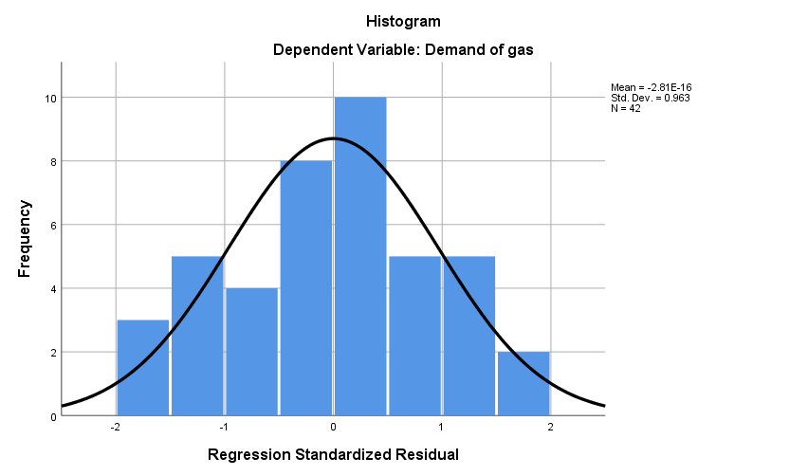
From the histogram that we have prepared by making the frequency the y-axis and the regression standardized residual the x-axis. We can see that due to the sample size being more than 30, the histogram shows a proper curve, and the mean and standard deviation provide data that is divided into an equal proportion. In fine, the histogram supports evidence that the data that has been used to form the regression model is accurate.

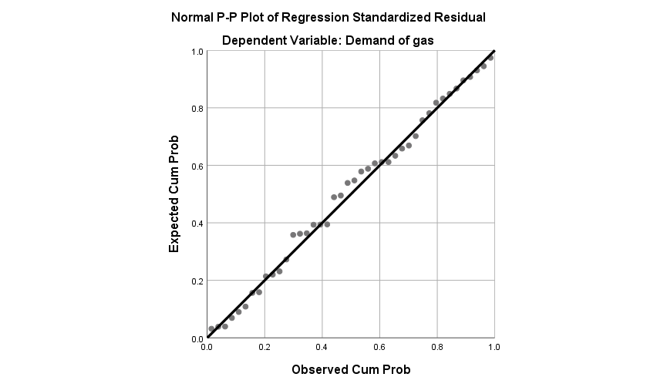
Table 5

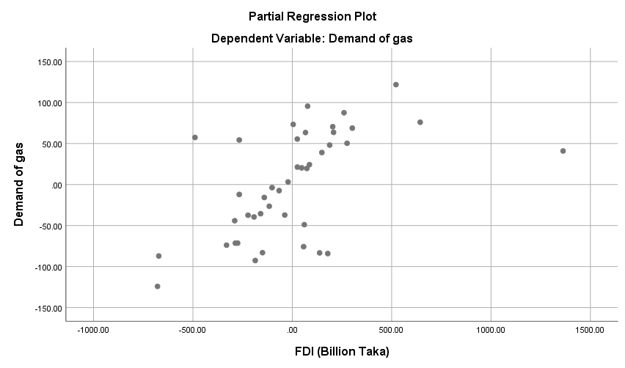
Table 6
Table 7
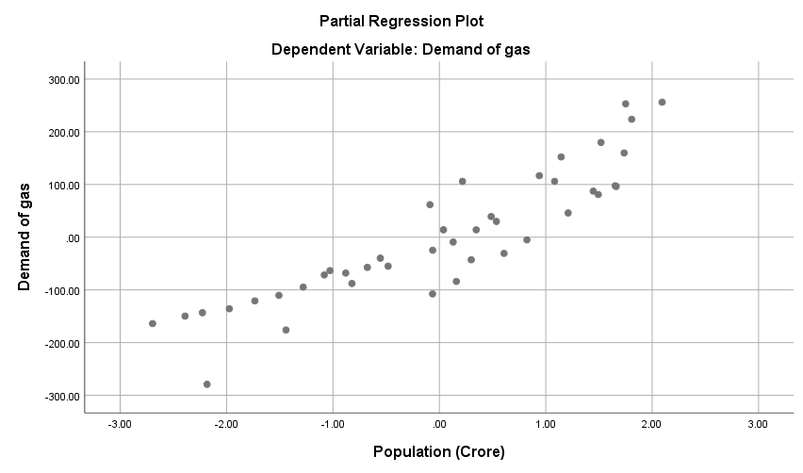
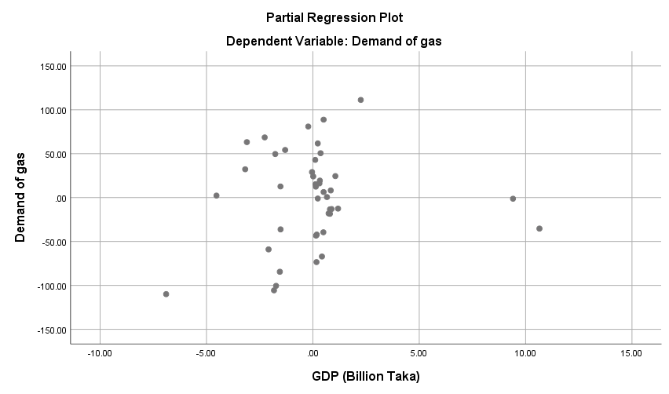
Table 8

From the scatter charts plotting our data above we get to know the relationship between the demand of gas and the independent variables GDP, FDI, and the Population of Bangladesh.

5.5 SWOT Analysis of Linde Bangladesh Limited

With the help of a SWOT analysis of Linde Bangladesh Limited, we will get to know about the strategies and methods that help them hold a superior position in the market and to tackle the challenges that are common to the industrial gases sector.

Strengths

- They have a strong brand image and a good reputation in the market that has been built over years of hard work and resilience.
- The business portfolio of Linde Bangladesh Limited is diverse and no other companies in this industry provide such a variety of products and services to their customers. Moreover, they have an extensive use of advanced technology as mentioned previously that its competitors cannot provide.
- They are very strong financially. As we know, during the COVID-19 pandemic, the demand of medical oxygen surpassed estimates and Linde Bangladesh stepped up to provide it to hospitals, homes, and other institutions. During that period the financial performance of Linde Bangladesh reached astronomical proportions. So having a sound financial performance, the capacity to maintain and develop is endless.
- As we know that they have a large distribution network and have opened many warehouses they can meet the deadlines. Moreover, the Rupganj site is their main production house and the Tejgaon head office compound is their main distribution center inside Dhaka. So the distribution system is convenient.

Weaknesses

- Since Linde Bangladesh Limited has a diverse portfolio, there aren’t exactly a lot of customers that match their criteria. Their main customers are big companies and govt. organizations. So their mode of business is B2B. Thus not having a lot of customers can be a weakness as they have to satisfy the little number of customers that match their client criteria.
- Their debt levels are high as seen from the data on the internet. Moreover, according to the recent news about the demerger of their hardgoods business and 420% dividend declared in the AGM, we can presume that their profit has decreased compared to the previous years for which they have to increase their debt financing to pay off their shareholders.

Opportunities

- As we can see from our regression model and the graphs the demand for industrial gas is growing, and due to rapid industrialization in Bangladesh, there is a huge opportunity for Linde Bangladesh to expand and get new customers.
- As there is a rising demand for healthcare gases, emphasis on sustainable solutions and focus on renewable energy, Linde Bangladesh’s offerings match the goals and vision of our country. They can provide renewable energy like hydrogen, they can focus on sustainable solutions reduce carbon footprint, and provide medical-grade gases to satisfy the needs of the customers.

Threats

- Competition is always a threat to every company. The increase in competition in the natural gas sector and the invention of cost-effective products by competitors are a constant threat to Linde Bangladesh Limited. With the presence of foreign companies alongside domestic companies, the competition is on the rise.
- With elections nearing, economic and financial vulnerability is evident. For easing these burdens, the govt. will start imposing and modifying the compliances, laws, and policies for the private companies which might be dangerous for Linde Bangladesh Limited in the long run. The uncertainties and adaptations will be of utmost importance in these circumstances.
- The reputation alongside the market share that Linde Bangladesh Limited holds is under a greater threat. Moreover, fluctuations in raw material prices can also pose a threat.
- The change in Management will change some course of action and the time taken by these new personnel to adapt to our country might pose some sort of a threat to the company.

5.6 Financial Analysis of Linde Bangladesh Limited

With the financial analysis of Linde Bangladesh Limited, we will determine their financial performance and assess how they maintain their performance. To do that we need to consider the 5 types of ratios. These are liquidity, leverage, efficiency, profitability, and market value ratios respectively.

Liquidity Ratios

The liquidity ratio determines how easily the assets of a company can be converted into cash. Liquid means cash and the more a company is liquid, the better it is capable to pay off its liabilities. There are 3 types of Liquidity ratios namely quick ratio, current ratio, and cash ratio.

Current Ratio

The current ratio indicates the ability of a company to meet its short-term obligations. The higher the current ratio, the higher the liquidity.
Table 9
 | Current ratio
year | Current asset | Current Liability | Current Ratio
2018 | 3,301,233 | 1,645,529 | 2.01
2019 | 3,919,097 | 1,747,439 | 2.24
2020 | 4,462,253 | 1,736,159 | 2.57
2021 | 4,938,373 | 1,592,593 | 3.10
2022 | 5,007,162 | 1,589,264 | 3.15

Quick Ratio

The quick ratio determines how quickly a company can convert its liquid assets into cash to meet short-term liabilities.
Table 10
 | Quick ratio
year | Current asset | Inventory | Current Liability | Quick ratio
2018 | 3,301,233 | 842,895 | 1,645,529 | 1.49
2019 | 3,919,097 | 831,800 | 1,747,439 | 1.77
2020 | 4,462,253 | 873,442 | 1,736,159 | 2.07
2021 | 4,938,373 | 912,468 | 1,592,593 | 2.53
2022 | 5,007,162 | 1,124,890 | 1,589,264 | 2.44

Cash Ratio

It determines the amount of cash that a company has to pay off its short-term debts.
Table 11
 | Cash ratio
year | Cash and cash equivalent | Current Liability | Cash ratio
2018 | 1,604,201 | 1,645,529 | 0.97
2019 | 1,004,626 | 1,747,439 | 0.57
2020 | 1,145,006 | 1,736,159 | 0.66
2021 | 2,998,826 | 1,592,593 | 1.88
2022 | 2,520,475 | 1,589,264 | 1.59

Profitability ratio

It denotes a company’s ability to earn profits from its day-to-day operations and activities. The profitability ratios include gross profit margin, operating profit margin, net profit margin, return on assets, and return on capital employed.

Gross Profit Margin

It is the amount that surpasses the cost of goods sold. It indicates the percentage of profit that a company attains in the form of revenue that exceeds the production cost.
Table 12
Gross Profit Margin
Year | Gross Profit | Sales | Gp margin = Gp/ Sales
2018 | 2,283,093 | 5,460,190 | 41.81%
2019 | 2,512,512 | 5,683,441 | 44.21%
2020 | 2,227,845 | 4,711,417 | 47.29%
2021 | 2,321,817 | 5,082,840 | 45.68%
2022 | 2,006,363 | 4,873,004 | 41.17%

Operating Profit Margin

It denotes the revenue before all operating expenses thus showing the profitability of core operations.
Table 13
Operating Profit Margin
Year | Operating Profit | Sales | Op margin = Op/ Sales
2018 | 1,406,953 | 5,460,190 | 25.77%
2019 | 1,675,934 | 5,683,441 | 29.49%
2020 | 1,448,291 | 4,711,417 | 30.74%
2021 | 1,528,994 | 5,082,840 | 30.08%
2022 | 1,197,987 | 4,873,004 | 24.58%

Net Profit Margin

Offers a view of the company’s future profitability.
Table 14 Table 15
Net Profit Margin
Year | Net Profit | Sales | Np margin = Np/ Sales
2018 | 1,003,774 | 5,460,190 | 18.38%
2019 | 1,231,588 | 5,683,441 | 21.67%
2020 | 1,073,609 | 4,711,417 | 22.79%
2021 | 1,225,776 | 5,082,840 | 24.12%
2022 | 883,295 | 4,873,004 | 18.13%

Return of Assets (ROA)

Denotes the return earned by a company on its assets

Table 16

Return of Assets(ROA)
Year | Net Profit | Total Asset | ROA= Np/Ta
2018 | 1,003,774 | 6,849,247 | 14.66%
2019 | 1,231,588 | 7,651,824 | 16.10%
2020 | 1,073,609 | 8,004,514 | 13.41%
2021 | 1,225,776 | 8,406,626 | 14.58%
2022 | 883,295 | 8,410,755 | 10.50%

Return on Capital Employed (ROCE)

Profitability and efficiency of a company’s capital investments.
Table 17
Return On Capital Employed (ROCE)
Year | Operating Profit | Shareholders' Equity | Long term liabilities | ROCE = Op/(Equity+Ncl)
2018 | 1,406,953 | 4,472,692 | 731,028 | 27.04%
2019 | 1,675,934 | 5,108,709 | 795,676 | 28.38%
2020 | 1,448,291 | 5,413,837 | 854,518 | 23.10%
2021 | 1,528,994 | 6,019,662 | 794,371 | 22.44%
2022 | 1,197,987 | 6,048,313 | 773,178 | 17.56%

Leverage Ratio

It denotes the measure of a company’s debt in proportion to its equity. Leverage ratios include debt to asset, debt to equity, and financial leverage ratios respectively.

Debt to Asset Ratio

Percentage of total assets financed with debt.
Table 18
Debt to Asset Ratio
Year | Current Liabilities | Non-current Liabilities | Total Asset | (NC+NCl)/TA
2018 | 1,645,529 | 731,028 | 6,849,247 | 34.70%
2019 | 1,747,439 | 795,676 | 7,651,824 | 33.24%
2020 | 1,736,159 | 854,518 | 8,004,514 | 32.37%
2021 | 1,592,593 | 794,371 | 8,406,626 | 28.39%
2022 | 1,589,264 | 773,178 | 8,410,755 | 28.09%

Debt to Equity Ratio

Percentage of total assets financed with equity
Table 19
Debt to Equity Ratio
Year | Current Liabilities | Non-current Liabilities | Total equity | (NC+NCl)/Equity
2018 | 1,645,529 | 731,028 | 4,472,692 | 53.13%
2019 | 1,747,439 | 795,676 | 5,108,709 | 49.78%
2020 | 1,736,159 | 854,518 | 5,413,837 | 47.85%
2021 | 1,592,593 | 794,371 | 6,019,662 | 39.65%
2022 | 1,589,264 | 773,178 | 6,048,313 | 39.06%

Financial Leverage Ratio

Supports the amount of total assets financed for each monetary unit of equity.
Table 20
Financial Leverage Ratio
Year | Total Asset | Total equity | Ta/Te
2018 | 6,849,247 | 4,472,692 | 1.531347788
2019 | 7,651,824 | 5,108,709 | 1.497799933
2020 | 8,004,514 | 5,413,837 | 1.478528814
2021 | 8,406,626 | 6,019,662 | 1.396527911
2022 | 8,410,755 | 6,048,313 | 1.390595196

Valuation Ratio

Denotes the relative value of a company’s stock or capital investments. Valuation ratios include earnings per share and price-to-earnings ratio.

Earnings per share ratio

Denotes the company’s profit in proportion to the number of outstanding shares.
Table 21
Earnings per share
Year | (in times)
2018 | 65.96
2019 | 80.93
2020 | 70.55
2021 | 80.55
2022 | 58.04

Price-to-earnings ratio

Denotes the ratio of the share price of the stock to its earnings per share.
Table 22
P/E ratio
Year | (in times)
2018 | 18
2019 | 16
2020 | 18
2021 | 20
2022 | 24

Activity Ratio

Effectiveness of a company’s utilization or efficiency in the use of its assets in generating revenue. Activity ratios include working capital turnover, fixed assets, and total asset turnover.

Working capital turnover

It measures the efficiency of a company in utilizing its working capital
Table 23
Working Capital Turnover
Year | Sales | Current Asset | Current Liability | Sales/ (CA-CL)
2018 | 5,460,190 | 3,301,233 | 1,645,529 | 3.297805646
2019 | 5,683,441 | 3,919,097 | 1,747,439 | 2.617097628
2020 | 4,711,417 | 4,462,253 | 1,736,159 | 1.728266523
2021 | 5,082,840 | 4,938,373 | 1,592,593 | 1.519179384
2022 | 4,873,004 | 5,007,162 | 1,589,264 | 1.425731254

Table 24

Fixed asset turnover

The efficiency of a company in using its fixed assets.
Table 25
Fixed Asset Turnover
Year | Sales | Fixed Asset | sales/ FA
2018 | 5,460,190 | 3,548,014 | 1.538942631
2019 | 5,683,441 | 3,732,726 | 1.522597962
2020 | 4,711,417 | 3,542,261 | 1.330059247
2021 | 5,082,840 | 3,468,253 | 1.465533224
2022 | 4,873,004 | 3,403,593 | 1.431723476

Total asset turnover

Company’s ability to generate sales by utilizing its assets.
Table 26
Total Asset Turnover
Year | Sales | Total Asset | sales/ Ta
2018 | 5,460,190 | 6,849,247 | 0.7971956625
2019 | 5,683,441 | 7,651,824 | 0.7427563676
2020 | 4,711,417 | 8,004,514 | 0.5885950103
2021 | 5,082,840 | 8,406,626 | 0.6046230676
2022 | 4,873,004 | 8,410,755 | 0.5793777134

Analysis of Financial Ratios

We conducted a financial analysis of Linde Bangladesh Limited. From the analysis of the ratios, we can state that Linde Bangladesh Limited is in a good position compared to its peers. From the graphs of the net profit margin ratio and working capital turnover ratios, we can see that according to the rule of thumb, a 10% net profit margin is considered average and anything equal to or more than 20% is considered good. So from the graph, we can see that up to 2021 their net profit margin was good and last year it was still average alongside other companies. But overall we can see that they are maintaining a margin of more than 10%. Moreover, from the dividend distribution, we can see that they provide their shareholders a good amount of return as dividends for each 10 taka share value.
The working capital turnover graph indicates that in all 5 years of data, the working capital turnover is over 1.5 and since we know that any value between 1.5 to 2 is considered good, so, Linde Bangladesh Limited has a good working capital turnover ratio which means that they get a good return by utilizing their free cash flows i.e, working capital. In fine, by analyzing all 5 standard ratios, we can conclude that Linde Bangladesh Limited has good Profitability, liquidity, leverage, valuation, and activity ratios which conclude that they conduct their business operations smoothly and efficiently.

5.8 Internship Experience

Details

Table 27

Name of the Company | Linde Bangladesh Limited
Address | 285 Tejgaon Industrial Area, Dhaka 1208
Designation | Intern: Secretarial and Legal Department
Joining Date | February 1, 2023
Completion Date | April 30, 2023
Department | Secretarial
Supervisor | Abu Mohammad Nisar FCS
Designation of Supervisor | Company Secretary

Job Responsibilities

- Communicating with customers, shareholders, news media, and other departments.
- Maintaining compliance with regulatory authorities like auditors.
- Assisting the company secretary directly with Annual Report Preparation including editing, proofreading, and printing.
- Assisting in preparing AGM minutes, venue, and advertisements.
- Data entry in Supplier Relationship Management software and conducting purchase orders.
- Preparing and holding Margin account list and reconciliation.
- Disbursing annual reports to BSEC, ICMAB, ICAB, and other authoritarian bodies.
- Processing unpaid dividends to shareholders through BEFTN and assisting CMSF.
- Preparing monthly reports of security exchange market summary and the required indexes.

Personal Remarks

The 3 months internship journey at Linde Bangladesh Limited has been short and ecstatic. As it was my first work experience I learned a great deal from my superiors, colleagues, and other respectable members of the company. I have learned about the corporate culture, work environments, work ethics, and how every member performs their duties with utmost diligence. I have learned to meet deadlines, new techniques, and ideas to not only work hard but work smart. Although it felt like a painstaking task with mammoth proportions of work every single day, being here has taught me how to handle them with ease and peace of mind. My superiors have guided me very humbly and helped me a lot in attaining the corporate attitude I should have in this place. Everybody was very well-behaved and kind. So, to sum up, my entire journey, I would like to say that I am grateful to the entire family of Linde Bangladesh Limited for grooming me in the best way possible.

Chapter 6: Conclusion and Recommendations

Analyzing all the data, I can summarize that Linde Bangladesh Limited tackles its challenges by proper utilization of its assets and by properly managing its debts. As the prices of raw materials are increasing, the dividend declared by the company is lower than in the previous period. This indicates that in the future it will be even more difficult to conduct business and the govt. will keep imposing many restrictions. Due to the emerging issues of the Russia-Ukraine war, inflations, the dollar crisis, and the upcoming election, Bangladesh is in an uncertain position and the result is an irregular price hike and an uncontrollable way of doing business. A lot of businesses are at a loss and from the business perspective, the situation is a nightmare.
In the industrial gases sector, the demand for gas is on the rise. So, for the entire industry to shine, Linde Bangladesh Limited’s practice of efficiency should be followed by every company. The govt. should ramp up gas exploration in the country and increase production. Moreover, the interest of foreign countries will attract foreign investors and help them earn valuable foreign currency. This will in turn develop the economic condition of Bangladesh. Moreover, the factors that we have determined such as FDI, GDP, and Population are directly relevant to the demand for gas which goes to show that the demand will keep increasing and following the footsteps of Linde Bangladesh Limited, the govt. can find possible techniques to make production and distribution more convenient and should discover effective technologies like Linde to become more cost-effective and earn more profit.
This report will help the readers get a better understanding of the prospect of the industrial gas sector of Bangladesh and the role of one of the pioneers in this sector Linde Bangladesh Limited. The readers will be benefitted by observing the important factors that change the ever-increasing demand for gas in our country and how Bangladesh can develop its economic condition by utilizing its undiscovered resources. They can also find out the strategies of Linde Bangladesh and be benefitted by following these steps properly.

Chapter 7: Appendix

References

- Asian Development Bank. (2016). Natural Gas Infrastructure and Efficiency Improvement Project: Report and Recommendation of the President. Retrieved from https://www.adb.org/projects/documents/ban-natural-gas-infrastructure-and-efficiency-improvement-rrp
- Sajid, E. (2022). We have gas reserve for 10 years only – then what? Retrieved from https://www.tbsnews.net/bangladesh/energy/we-have-gas-reserve-10-years-only-then-what-405470
- Nasrul. (2022). Bangladesh has gas reserves for over 11 years. Retrieved from https://www.thedailystar.net/environment/natural-resources/energy/news/gas-supply-floating-lng-terminals-restored-after-9-days-3325866
- Rahman, M. M. (2019). Present status of Bangladesh gas fields and future development: A review. Retrieved from https://www.researchgate.net/publication/337649783_Present_status_of_Bangladesh_gas_fields_and_future_development_A_review
- Hydrocarbon Unit, Energy and Mineral Resources Division, Ministry of Power, Energy and Mineral Resources. (2021). Energy Scenario of Bangladesh 2019-20. Retrieved from https://hcu.portal.gov.bd/sites/default/files/files/hcu.portal.gov.bd/publications/753d455d_3c37_43df_9ce6_6f80bdc0e982/2021-03-16-11-10-66fbccf16c104e594c24f303097aa65f.pdf
- PETROBANGLA Bangladesh Oil Gas and Mineral Corporation. (2022). Annual Report 2020-21. Retrieved from http://www.petrobangla.org.bd/sites/default/files/files/petrobangla.portal.gov.bd/annual_reports/3b3b53fd_e70e_48b8_92af_5be5175204b2/2023-01-31-07-06-99efbacbbfc26604c626ad01eae57322.pdf
- Wadud, Z., Dey, H. S., Kabir, M. A., Khan, S. I. (2011). Modeling and forecasting natural gas demand in Bangladesh. Retrieved from https://www.researchgate.net/publication/260554870_Modeling_and_forecasting_natural_gas_demand_in_Bangladesh
- Malek, M. I., Hossain, M. M., Sarkar, M. A. R. (2015). Production and utilization of natural gas in Bangladesh. Retrieved from https://www.researchgate.net/publication/289374730_PRODUCTION_AND_UTILIZATION_OF_NATURAL_GAS_IN_BANGLADESH
- Hasan, M. M., & Liu, K. (2022). Decomposition analysis of natural gas consumption in Bangladesh using an LMDI approach. Retrieved from https://www.sciencedirect.com/science/article/pii/S2211467X21001103
- Rahman, M., & Tamim, M. (2012). Analysis of Natural Gas Consumption by the Industrial Sector of Bangladesh. Journal of Civil Engineering, 40(1), 45-56. Retrieved from https://www.banglajol.info/index.php/JCE/article/view/15846/11233
- Bangladesh Bureau of Statistics (BBS), Statistics and Informatics Division (SID), Ministry of Planning. (2021). Bangladesh Statistics 2020. Retrieved from http://bbs.portal.gov.bd/sites/default/files/files/bbs.portal.gov.bd/page/a1d32f13_8553_44f1_92e6_8ff80a4ff82e/2021-06-30-09-23-c9a2750523d19681aecfd3072922fa2c.pdf
- Bangladesh Bureau of Statistics (BBS), Statistics and Informatics Division, Ministry of Planning. (2021). Statistical Pocketbook 2020. Retrieved from https://bbs.portal.gov.bd/sites/default/files/files/bbs.portal.gov.bd/page/d6556cd1_dc6f_41f5_a766_042b69cb1687/2021-06-30-09-25-67bbe4c5c15d7773d82c86adbd26bba9.pdf
- Imam, B. (2023). Bangladesh’s chronicle of shoddy gas exploration. Retrieved from https://www.thedailystar.net/opinion/views/news/bangladeshs-chronicle-shoddy-gas-exploration-3256946
- Alam, F., Saleque, K., Alam, Q., Mustary, I., Chowdhur, H. (2019). Indigenous and imported natural gas and the economic growth of Bangladesh: The challenges ahead. Retrieved from https://doi.org/10.1016/j.egypro.2019.02.113
- Das, N. K., Chakrabartty, J., Dey, M., Sen Gupta, A. K., Matin, M. A. (2020). Present energy scenario and future energy mix of Bangladesh. Energy Reports, 6, 2157-2168. Retrieved from https://doi.org/10.1016/j.esr.2020.100576
- Amuda, Y. J., Hassan, S., Subramaniam, U. (2023). Comparative Review of Energy, Crude Oil, and Natural Gas for Exchange Markets in Nigeria, India and Bangladesh. Energies, 16(7), 3151. Retrieved from https://doi.org/10.3390/en16073151
- Chen, X., Rahaman, M. A., Hossain, M. A., Chen, S. (2022). Is there a relationship between natural gas consumption and the environmental Kuznets curve? Empirical evidence from Bangladesh. Environmental Science and Pollution Research, 29(32), 42447-42461. https://link.springer.com/article/10.1007/s11356-022-19207-w
- Alam MJ, Begum IA, Buysse J, Huylenbroeck GV (2012) Energy consumption, CO2 emissions and the economic growth nexus in Bangladesh: cointegration and dynamic causality analysis. Energy Policy 45:217–225. https://doi.org/10.1016/j.enpol.2012.02.022
- Uddin, N. (2020). How to increase the depth of the share market in Bangladesh: An application of the multinational companies. International Journal of Management, 11(7), 256-269. Retrieved from https://www.academia.edu/download/66041652/IJM_11_07_026.pdf
- Barua, A., & Parveen, S. (2014). Assessment of competitiveness and country conditions for LPG market of Bangladesh: By Porter's (1998) five forces and national diamond model. International Journal of Innovation and Economic Development, 1(2), 47-55. Retrieved from https://www.academia.edu/download/32939507/IE-12-ASSESSMENT_OF_COMPETITIVENESS_AND_COUNTRY_CONDITIONS_FOR_LPG_MARKET_OF_BANGLADESH..pdf

