
A Study on Training And Development Practices in Banking Sector Of Bangladesh
Submitted To
Shayla khanam
Assistant Professor
School Of Business and Economics
United International University
Submitted By
Marzia Lamia
ID -111161289
Date of submission -02/12/20

United International University

Letter of Transmittal
Date-02/12 /20
Shayla Khanam
Assistant Professor
School of Business and Economics
United International University
Subject: Submission of the Project report on Training and Development practices in banking sector of Bangladesh
Dear Ma’am,
In accordance with the requirements to complete the Project Report I have prepared this report on the "Training and Development" practices in banking sector of Bangladesh. The report focuses on the essential practices of Training and Development and is prepared on the basis of the HR lessons learned from my undergraduate courses at United International University. However, I want to thank you for the help and direction you have given me during setting up this report.
Subsequently, I am presenting my report, trusting that you will value my useful and definite methodology. In the event of any further explanation or elaboration or any sort of inquiries about the report, you are generally free to have conversations with me about those.
Sincerely Yours,
Marzia Lamia
ID- 111 161 289
Program: BBA
Major: Human resource Management

Acknowledgement
All the commendations are for Almighty ALLAH who awards me with His gifts to make this report finished inside the given time-frame. An undertaking over a period can be effective just with the exhortation and support of well-wishers. I acknowledge this open way to offer my thanks and appreciation to all of the people who encouraged me to complete this undertaking. Above all else I am incredibly obliged to my temporary job Supervisor Shayla Khanam not just for allowing the chance to set up the report yet in addition for giving me a great deal of help to improve the components of this report. Without her backings and proposals this examination would not have been conceivable in any case and for giving significant exhortation in the fruitful fulfillment of this undertaking. The help that she gave genuinely enables the movement and perfection of the Project to program. The collaboration is much undoubtedly valued. I might to express gratitude toward her for giving me such significant subject as my Project report. I am likewise obliged to Md MahbuburRahaman guideline who is official HR manager in janata Bank motijheel Branch and Azizulhoq head officer of motijheel branch of prime bank for helping me during this difficult pandemic circumstance to finish my project.
At long last, I express thankfulness to every one of them for giving significant recommendations and data to set up this report and in the event that I have erroneously neglected to incorporate giving credits need to acknowledge the unassuming conciliatory sentiment on the grounds that without their help this report would be deficient.

.
Table of Contents
Executive Summary 6
Chapter 1 (Introduction) 7
Background of the study 8
Sampling method 9
Limitation of the report 10

Chapter 2(Company Overview) 11
Vision 11
Mission 11
Important of T &D in PB( Prime Bank) 13
Training cycle 13
Methods of prime bank 14
T&D policies of prime bank 15
How Prime Bank Arrange Training Program 16
Steps of T&D of prime bank 17
Problems identified 17

Chapter 3 (Company Profile) 18
Mission 19
Vision 19
Important of T& D of Janata bank 20
T&D practice of Janata bank 21
Methods used in Janata bank 22
Problem identified 24

Chapter 4 (Literature Review) 25
Introduction 25
Worldwide practices of T& D 27
T&D practices in banking Bangladesh 28
Import of COVID-19 in Bangladesh 30

Chapter 5(Findings and Analysis) 31
Findings 31
Analysis of data 33
Recommendation 49
Conclusion 50

Chapter 6(Appendix) 51
Chapter 7(References) 55

Executive Summary
The project report represents training and development practices in banking sector of Bangladesh. The study is conducted to provide a clear idea of ​​Janata bank and Prime bank training activities and their practices. However, the aim of making the report is to analyze the necessity of training practices in the banking area. The main objective of this report is to generate an overall understanding of both Banks’ training and development practices. This report is mainly categorized into seven parts .The main part depends on the presentation of the report, which includes topics such as the backgrounds, objectives, methodologies, and limitations of the study. The second and third chapters include a short history of the company and their banking activities and also include the Importance of training and development practices of both banks. Chapter four is basically the literature review part here I describe briefly about the national and international training process and also include the benefit and importance of training and development in banking sector. Chapter 5 contains the main findings and the analysis of training practices of both bank and finally, chapter six and seven indicates the recommendation and summarizes the study with a conclusion.

Chapter 1 Introduction
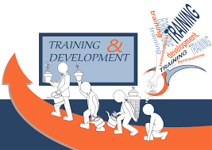

Chapter 1 Introduction
Training and development is an important sector of the human asset advancement. Training and development plays a vital role in the ever growing competitive global market , where peoples expectation and interest is raising for the quality, service and subsequently the lower costs due to the advance of technological enhancement, Though many types of inexpensive advantage exist they are not enough good and sustainable in quality . Very few sustainable competitive advantages are as good as human resources of an organization because it develops , reinforces and changes the culture of an organization .Training and development is the major factor for an organization having a crucial impact on retaining superior human resources to achieve sustainable competitiveness in the market .Training and development program should be designed in such a way that it can enhance employees capabilities up gradation of existing knowledge and helps to acquire new skills and learning by creating inner and outside justice. These papers on training and development make for bank sector exploiting generally used procedures and events

Background of the Study
This report mainly reviews the different sides of the Training and Development process and practices of the organizations. Training and Development is a sector which influences every area of an organization from creativity, production level to accounts sector Organizations are always continuously trying to gain a competitive advantage because they always try to focus on how to compete with the competitors .it is essential for them to identify the necessity of Training and Development practices in the association. It is really essential because the organizations need to address every employee’s needs of Training and Development practices in the association. So the total aspect of this research discussed sequential stages of the organization might experience so as to guarantee to give the correct preparing to each applicant is picked for the work. Then again, the primary side of this report focuses on to survey how precisely this should be possible

Objective of study
The main reason behind preparing this report is to distinguish training strategies applied in the bank and for this .Basically my general objective is to complete the bba course at united international university.
Primary information:
Due to this Covid 19 it was hard to collect primary data cause in the bank sector the corona cases are increasing day by day that’s why I mainly gathered data through a survey which contains questions that were open and close means optional and direct type questions. I have gathered the Primary Data for my investigation of project by utilizing call, email and online instant message measure and that is the manner by which I took my meeting
Secondaryinformation:-
1) These data mainly collected from published sources such as, Google website and also from the help of other sources. Like: Bank
2) Annual report of both banks
3) Online articles /website of both banks
4) Various reports
5) Some articles on banking sectors.

Methodology
This report is prepared by gathering and assembling essential and subordinate information. This analysis is basically a contribution of primary and secondary data. The main source of data is with the help of the officer and the manager of both JBL and PBL LTD. To collect information I try to ask them questions and they responded to my questions and for that reason that information was very much restrictive with the organization as they want to keep these confidential. So as to lead such an investigation this report follows some specific particular techniques. The report basically is illustrative in nature. Information was gathered from both essential and auxiliary sources.

Sampling Method:
Essentially I arranged 5 inquiries questions for interview and 20 overview survey type questions for both bank. So I select two organization (JBL PBL) for my report and the sampling size is 7. And the sampling process is the survey is done through online survey questions and it is basically a convenient sampling process. The survey data is introduced in type of Tables graph and Charts toward the finish of the report.

Scope/Extent of the Study
This report has been prepared through online conversation with bank officer. Plan gave by the bank additionally assists with setting up the report. At the hour of preparing the report, I had an extraordinary chance to have almost various type of information on almost various hr training practices rehearsed by the both Bank

Limitations/restrictions of the report:-
● Major constraint of this report is the circumstance going on now a days which is Corona virus in view of this circumstance its truly hard for me to head outside and gather significant information
● While gathering information, they didn't reveal data due to the privacy of the association
● Every association has some mystery, which can't ought not be unveiled to the untouchable.

Limitations of the Study
The officials are very co-employable however they are too occupied to even consider giving personal chance to get information about the bank. Each assignment has a few restrictions.
- Busy working climate:
- The authorities had a few times been not able to give data due to their gigantic routine work.
- I needed to confront a lot of trouble to gather this data because of their busy office timing schedule they unable to manage time.
- Insufficient information:
- Some ideal data couldn't be gathered due to secretly of business

CHAPTER 2ORGANIZATION OVERVIEW


Chapter 2 COMPANY PROFILE:
Prime Bank Limited is a private concern bank in Bangladesh. Its set up at the day of April 17, 1995with Tk.1000 million of attested capital and Tk. 100 million of settled up capital by a party of suitable money related authorities. It is starting at now one of the banks in Bangladesh which sticks to overall norm in banking and fund. Prime Bank was made and beginning of business began on 17 April 1995. The partners are accepted characters in the field of exchange and business and their stake goes from transportation to material and money to energy etc.Prime Bank offers a wide extent of Commercial Corporate and Personal Banking associations covering all sections of society. Overhaul of things and associations merge Corporate Banking, Retail Banking and Consumer Banking really from industry to developing, and land to programming. Prime Bank is the title partner of the 2013 appearance of Bangladesh Premier League cricket tournament.
Vision
To be a standout amongst other Private Commercial Bank in Bangladesh as for benefit, capital bounty fullness, resource quality, sound association and preferred position of having solid liquidity
Mission
To join Prime Bank Limited with a gainful opportunity market-driven, client center foundation with extraordinary corporate value organization structure. Constant improvement of our business courses of action, framework and capability through compromise of advancement at levels. Our Efforts mainly are Focused On movement of significant worth advantages in each part of banking practices with the intend to expand the estimation of financial specialists adventure and offer most important expected focal points to our customers
Slogan:―A Bank with a difference

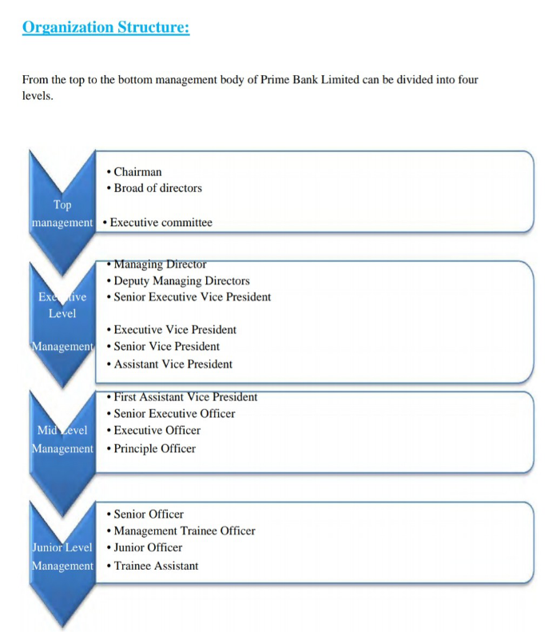

Importance and necessity of Human Resource Training & Development In Prime Bank
- Here HR is basically give guarantees and the idea of TQM-all out quality Management
- Here this Department ensures EEO-Equal Employment Opportunity
- This kind of office mainly deals with the preparation framework for the new selected workers, representative and if any new innovation or hypothesis is embraced.
- Also takes care of dealing with worker's remuneration and advantages.
- Serves with most recent and best modules and subjects of preparing offering significance to the changing innovation and recently embraced strategies in this association.
- Helps building KSAOs to the employees. This division cares for the exhibition examination, advancement, and move.
- Establish and keep up levels of leadership and the executive’s progression.
- This office attempts to improve the inspirational degree of representative.
- To set up a wide range of acts with respect to worker, association and so forth
- To improve the representatives' abilities.
- To set up and guarantee appropriate hierarchical conduct and climate.
- Mainly it empowers the representatives to get productive and accomplish the ideal stage.

Prime bank Training cycle

- Training and development training for individuals: Some training is designed only for the individuals, for those the employees are individually responsible for their own development.
- Training for teams: Trainings served for teams, when team performance is necessary.
- Training for organizations: Organizational training that may contain creating fair and productive organizational environment, developing knowledge sharing culture inside the organization.

Methods used in Prime Bank
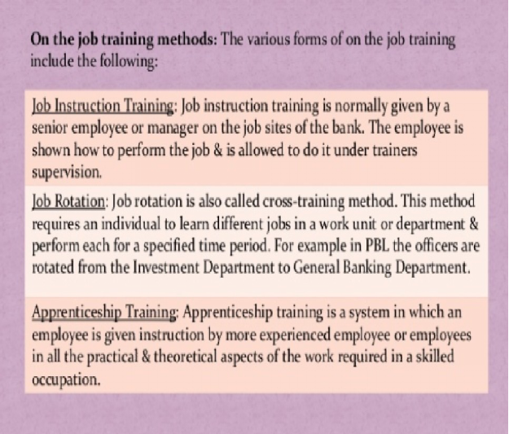

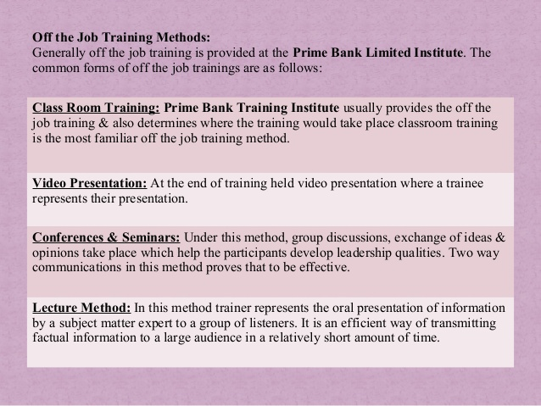

Training & Development policies of Prime Bank Limited:-
Prime Bank Limited accepts that a legitimate type of preparing adds to the advancement of HR and HR can be created by the method of overhauling the activity understanding and capability. It is generally a planned, steady learning measure and by the board to improve representatives competency levels and accordingly to build up the individual capacity to perform at work, the more data and training the bank will provide for representatives, the more ready they will be to progress inside the bank.
Preparing strategies of Prime Bank Limited are given beneath:
- A preparation file distinguishing the needs of an apparent multitude of representatives, it is seen structure the workers' perspective just as from the individual divisions perspective
- Training and improvement is a planned movement. Human Resource Department of PBL sets the preparation, arranging and financial plans for all the offices based need and evaluation and gets it confirmed and allowed by the separate office heads toward the start of consistently.
- The instructional meeting will be led by inside or by remotely.
- The particular office heads are the subject of the different training programs or a particular division.
- Once a representative has been chosen for this program they will undoubtedly go to the program, any exemption ought to have allowed by the separate planned faculty.
- Training input would be produced for the members and their individual bosses. In view of the rating got, the choice will be taken to proceed with the program in future.
- Prime Bank Limited advances inward mentors too outer. Senior representatives with skill in a specific region and having the craving to prepare would be roused to hold such projects at normal spans.

How Prime Bank Arrange Training Program
Creating training list distinguishing the needs of the considerable number of representatives, it is seen from the Workers perspective just as from the separate office's perspective.
Education and improvement is an organized action. The HR branch of the PBL decides the plans and spending plans all things considered according to their requirements and estimates. It shall then be audited at the beginning of each year by the heads of the relevant departments.
A PBL training program is drawn up for each employee. The curriculum includes the number of daily trainings of each employee in different areas where the training is given.
The instructional meeting would be coordinated either by inside or by distance. The specific division heads are the committed for the planning programs. The individuals what employees' identity is chosen for the preparation they will undoubtedly go to the polluting program, any exemption ought to have allowed by the separate planned staff. Preparing input would be created from the members. In view of the preparation got, choice will be taken to proceed with the program in future. The need evaluation of training programs are finished through a three stage measure which are-
- Individual examination Personalization is a method that chooses if employees need getting ready for training and are ready for planning training programs. The Bank sees the data, capacities and limits that individuals ought to starting at now go to getting ready for training.
- Authoritative investigation It includes deciding the business suitability of creating any training program, given the bank's business methodology.
- Investigation of occupation prerequisite In work investigation the bank work on examining work prerequisite for getting ready for the training program by making sure that everything works properly
.

Steps Of Training and Development In Prime Bank Ltd:

- Firstly the HR- gives the training to the new employees about the basic
- Information of banking corporation.
- After that they evaluate the training needs of the existing employees about the new programs.
- HR-TDC collects the information from different branches about their employees ‘performance and evaluates the needs so that they can give proper training to them.
- HR-TDC selects the employees from different branches.
- After collecting the information of the training needs of the employee the HR-TDC make a training plan or structure.
- HR-TDC collects the proper data, information, tools to execute the plan.

Problems identified
There are some significant discoveries are recognized with respect to THIS TRAINING projects of The Prime Bank Ltd. Those discoveries are given underneath:
1 Prime Bank HR sometimes faces shortage of manpower for supporting training programs and the management.
2. As reputed organization Prime Bank doesn’t provide variety of training opportunities to improve employee’s skills, etiquettes, disciples, motivational & communication.
3. Prime Bank doesn’t provide efficient number of training.
4. Training materials of Prime Bank are not sufficient and not understandable to all employees.

CHAPTER 3ORGANIZATIONAL OVERVIEW



Chapter 3 Organization profile:
Janata Bank Limited is mainly the second mostly critical state ensured business bank in Bangladesh. It was spread out under the Bank Nationalization Ordinance of 1972 (President's association 26) which had recognized control in excess of 2 assorted business bank, United Bank Limited and Union Bank Limited by the (Janata Bank Limited", n.d). Happening to expecting request over the pieces of these two private banks which were serving class banking the country over, it was named then as a Janata Bank. After the open entryway conflict of Bangladesh in 1971, janata bank was beginning late outlined for mass dealing with a record with so unique surprising workplaces from the relationship as a nationalized business bank in the country. Working as nationalized business bank, its devotion widened and it changed into the second most unmistakable business bank all through the country with 906 branches which additionally recalls 4 abroad branches for United Arab Emirates for its better introduction inside barely any years. This bank is associated with 1239 new administrators around the world. Incidentally,

Vision
To change into the powerful most prominent business bank in Bangladesh to help and maintain money related progress of the nation and to become a fundamental bank in country like South Asia
Slogan .A committed partner in progress
Mission
Janata Bank Limited would be an incredible business bank and they keeping up a steady headway strategy and stable advancement framework, passing on phenomenal money related things, giving unbelievable client care or customer care through a developed authoritative group and guaranteeing inconceivable corporate association in each development of banking system
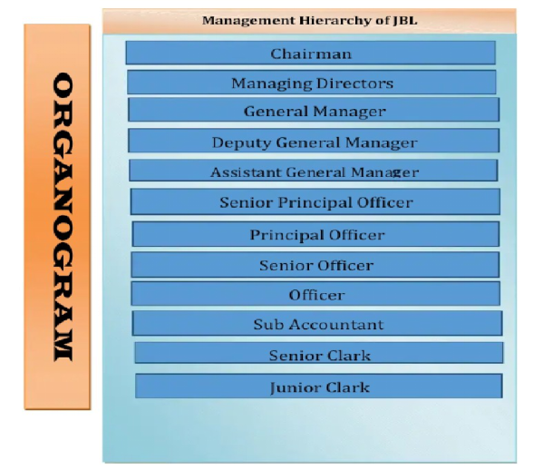

Importance of training in janata bank
It has unbelievable effect on relationship to drive the association achievement. To have consistent progress, company should prepare and build up their agents. So if the company doesn’t set up their worker, they may not change in up the inconvenient condition where rivalry is getting all the more truly. Significance of the planning and headway are given underneath
1. Helps to achieve new way of improving of improving knowledge
2. It helps association with driving association movement and help tp decrease employees turnover.
3. Training and advancement serves to improving laborer execution which unavoidably improving the association picture.
4. Increasing authoritative advancement development
5. Increase authoritative productivity
6. Training program helps in increasing quality and quantity of yield
7. It encourages each representative to use or build up their maximum capacity
8. Employees feel that they are being dealt with by the administration and these outcomes in increasing their confidence.
9. By preparing training the laborer is empowered to make the more affordable and best utilization due to that training helps employees to change their behavior toward the job
10. Training and development practices help the employees to become the better performer
11. Training helps to get self actualization
12, the specialists are presented to the most recent ideas, data and procedures. They become very much qualified by this and the expansion beneficiary market esteem and gaining power

Training and development practice in Janata Bank
In this Janata Bank,it is in like way base on training and progression measure for the update of aptitudes, information and cutoff points of workers. Their focal network is to broaden the worker's aptitudes and laborers progression. Janata Bank the board zeroed in additional on future and preparing the administrative pros instead of zeroing in on single execution improvement. It will be even clearer if their goal concerning training measure is appeared. Janata Bank has some target with respect to both alliance and individual getting ready and development achievement. So this goal can be confining into 2 one of a kind ways. Here are some objective related with bank:
➢It would enable the Janata bank to improve its competency in affiliation limits
➢ It assists with accomplishing better strategy for improving information
➢in Janata Bank the board should think about the new technique
➢ It expanding development and makes it second most noteworthy public bank
➢ It increment authoritative productivity and serving quality and service quality
➢ Helps representatives to getting self confident
➢ Training and improvement help the agents to change into the better performer
➢ Due to the readiness laborers lead have changed toward the work
➢ offer occasion to self assessment Design measure
➢ It furthermore helps with decreasing the cost of the components of Janata Bank Individual related objective:

Techniques used in Janata Bank
There are different methodology are utilized in this financial segment. It prompts the best way to deal with plan workers. Janata Bank utilizes different techniques which reviews for the activity training and off the development getting ready . Subordinate upon the circumstance and goal, procedures are separated into 2 classes. Janata Bank all around usesboth the techniques for relying on the necessities of the specialists
.ON THEJOB TRAINING METHOD
Practical training in relationship is given by higher kevel staff and managers. Workers are directed to exactly what to do or not to do and how to finishDedication. Janata Bank practices various strategies while using this method, .
1)JobRotation-.It is a structure that requires an expert to know the different situations of the different offices of the job sector. Missing someone in another office for small period of time can lead to failure. Janata Bank uses this technology to make the director more diverse
2) Internship-draft summary of the coordination of the time frame established in collaboration. Workers receive a supervisor under whom they will discover some methods to further manage the fund development process.
3) Apprenticeship-it is in like way like the entry level position where representatives are given a norm by a capable workers or bosses to apply the hypothetical idea in the alliance where it is required.
4) Assignment of Special Projects: Sometimes, as a technique for preparing some exceptional undertaking is allocated to a student leader. For instance, he might be soliciting to build up a framework from cost portion in the creation of specific products for which a request has been gotten by the organization. While taking a shot at such venture, the learner procures information about them, yet in addition figures out how to function with and identify with others holding various perspectives.
5) Conference and Seminars: Often a leader is deputed to go to a meeting, class or workshop to get a snappy direction in different regions of Management with which he may be new. One preferred position of this sort of preparing is that all the members originating from various associations get an occasion to pool their thoughts and involvement with endeavoring to take care of common issues. The mentality is one of joint investigation.
6) Role playing: In this strategy, the teacher allots parts taken from case materials to gather individuals. The circumstance is normally one including strife between individuals. The job players endeavor to act the parts as they would carry on in a genuine circumstance, working without a content or retained lines and extemporizing as they play the parts. The improvement of compassion and affectability is one of the essential goals of pretending
7) Orientations for New Employees: The underlying a couple of days on the work are basic in the accomplishment of new agents. This point is illustrated by the way that 60% of all laborers who quit do as such in the underlying ten days. Course getting ready should pressure the going with subjects: The association's arrangement of encounters and mission.. The people in the department, and how the division fulfills the mission of the association. Staff rules and rules.
8) Coaching: Coaching is a pattern of provide one-on-one guidance and direction to improve the work execution of the individual being told in a specific zone. It contrasts from other OJT procedures in that the understudy starting at now has been working at the particular work for a long time. By and large, preparing is focused on delegates with execution deficiencies, anyway it can moreover fill in as an influential mechanical assembly for those performing enough. Regularly the chief goes probably as the guide. Like the OJT coach, the guide must be skilled both in how to play out the task(s) and how to set others up to do them. 37
Off the job training
Off the occupation arranging recommends the game plan that isn't given in the alliance at any rate outside of the affiliation which zeros in extra on correspondence to make social cutoff points. There are various ways to deal with oversee do off the movement organizing at Janata Bank.
1)Class room arranging-Arrange the classroom at Janata Bank, use the assessment lobby in the readiness function where a large group of delegates can experience and develop their capabilities using Television video and slideshows related to discussion content. It's a surprisingly basic technique of preparation that's especially essential for new authorities with little or no idea about the topic.

2) Behavioral model-by using this model the master can quickly develop another important Janata Bank that makes amazingly good sense for workers.

3)Case assessment-by assessing the situation In this system the delegates are given a verifiable condition where they need to find problems and present the methodology. A teacher at Janata Bank gives this methodology to working on wellness selection

Problems identified
- Lack of practical training programs
- Less trainers are hired from outside
- Insufficient duration of training.

Chapter 4 LITERATURE REVIEW



Chapter 4 INTRODUCTION
TRAINING AND DEVELOPMENT is one of the main key elements of human resources. Most associations view the organization and improvement as an essential part of human resource progress. At the turn of the century, there was an expanded focus on undefined relationships around the world. Various partnerships prepared the organization of hours outside reliably for professionals who thought how movement will lead workers at brilliant speeds. Planning can be seen as an effort expected to improve or develop additional competencies or talents in the hands of the administrator at one beginning, in disposition, talents, or information about an individual with resultant improvement in leadership. For preparation for rationality to be necessary, it must be resolved by progress made after a careful needs assessment and focus on express limits; mostly this training and progress are essentially learning and improvement.
The definition of training development as follows
"It is a learning cycle that incorporates the making sure about of data, sharpening of aptitudes, thoughts, rules, or changing of mindsets and practices to improve the show of laborers." The need of getting ready and headway is cemented by the delegate's introduction need.
What is Training or Preparing?
Getting ready is highlighted indicating rapidly relevant data, aptitudes, and mindsets to be used in a specific work. Planning May focuses on passing on better execution in the present place of employment or to overcome future changes.
What is Development/Advancement?
IT is a subset of hr plans to improve individual execution and group performance by expanding aptitudes knowledge .information. On a practical level individual responsible for talent development and must identify the skill gaps among groups and teams Development is an important part of training process It is the central point for an association, crucially affecting holding better HR than accomplishes supportable intensity in the market. It is planned so that it can improve representative's capacities, up degree of existing information and assists new aptitudes and learning by making inward and outside equity..development is a cycle of learning, where accentuation is given for work guidance, work connection, and employment information programs notwithstanding administrative abilities.
According to the Michel Armstrong, “Preparing is deliberate advancement of the information, abilities and perspectives needed by a person to perform satisfactorily a given assignment or work". (Source: A Handbook of Human Resource Management Practice, Kogan Page, eighth Ed.,2001)
According to the Edwin B Flippo, "Preparing is the demonstration of expanding information and abilities of a worker for making a specific showing." (Source: Personnel Management, McGraw Hill; sixth Edition, 1984)
The term 'preparing' shows the cycle associated with improving the aptitudes, aptitudes and capacities of the representatives to perform explicit positions. Preparing helps in refreshing old abilities and growing new ones. 'Fruitful applicants set on the positions need preparing to play out their obligations successfully (Source: Aswathappa, K. Human resource and Personnel Management, New Delhi: Tata Mcgraw-Hill Publishing CompanyLimited,2000, p.189)

GLOBAL PRACTICES OF TRAINING AND DEVELOPMENT

With more and more companies are hiring talent from around the globe Training employees has become quite challenging .Companies that employ a global training and development methods to be an integral part of the business.noy only that these companies also need to choose the best strategies in order to balance learning needs of their global work force with that of the companies specific needs and interests.
What is global training –if anyone worked for multinational company they get global training .While the term itself is very self explanatory Global training and development focus on the strategies that address the learning needs of all learners basically they try to designed effective training and development approaches for a diverse workforce , they focus on various strategies sp that they can effectively train the global workforce
Issues and challenges of training global workforce- The American Society of Training and Development (ASTD) reported that most organizations train about 74% of their agents Moreover, a continuous review of getting ready practices in U.S. firms battled that readiness has gotten periphery to relationship rather than joined into organizations..
There are various difficulties when you train representatives from various piece of the world .While the benefit of having an variety labor force will consistently go its downside, for example things do not work properly when employees global training and development strategies for eg- sending a distinct message through global training and development programs is quite a risky task cause global employees speak different language and come from different countries and also live in different time zones
There is a obstacle for high training cost and the cost will always be higher then that of training employees locally and technology is also a factor cause not every region has their own capacity to handle online courses and training materials .So for global training they gave to focus on the training team strategy needs to ensure jet everyone get the chance to under=stand the training process in a well manner .By creating a successful training program its easier for the participants to identify colleagues from other countries and it will be easy for them to share new ideas and experiences about work
Most worldwide mentors are homegrown coaches who increase global experience through their association's abroad members. These coaches have figured out how to adjust their own styles and preparing training plans to various societies while introducing a similar data that is given to the nation of origin representatives. Now and again, coaches are given abroad living encounters simply like the supervisors who are prepped for leader posts. Global tasks permit these workers to pick up or sharpen the intercultural affectability and nation information so essential for being a worldwide coach.

TRAINING AND DEVELOPMENT PRACTICES IN BANKING SECTOR IN BANGLADESH

Preparing training exercises in Bangladesh presently can't seem to be deliberate and ready to satisfy the requirements of the economy and industry. The public instructive and preparing framework neglected to give satisfactory information to the labor force. In any case, private area associations are attempted various activities to adapt to the business ability necessities and are attempting to build up their own representatives. Late government activities appear to be empowering for future preparing training program exercises in Bangladesh. For the public area representatives, the legislature, through the Ministry of Establishment, chooses the students and decides preparing programs singularly, with no conference from the particular services The Ministry of Establishment decides the substance of the instructional classes and vests the duty there are preparing establishments in Bangladesh that training help officials and different authorities of the administration's self-ruling associations
Here I am going to discuss the impact of training in banking region. The rapidly changing business atmosphere in banking zone and the reliable troubles it stances to affiliations and associations make it fundamental to continually update and improve data and scopes of capacities over the affiliation. The Bank has made solid capacities in preparing trainingto construct skills across different areas. Preparing on items and tasks is conferred through web - based preparing modules. Uncommon projects on practical and administration advancement are directed to construct information just as the board capacity at a devoted preparing office. Human Resource Management is one of the hugest determinants of various leveled execution or capability. certain limits, for instance, the compensation and getting ready and improvement, the private region seemed to have grasped a valuable approach, for instance, screening and testing of occupation contender to find the applicants work health, planning need assessment, getting ready appraisal, etc Effect of Training and Development practices in Banking Sector The huge impacts of fruitful getting ready and headway in the budgetary territory is given as underneath:
I. Motivating the workforce -Due to the advancement of the overall market, a mechanical edge maintained by a capacity pool has become a vital factor for perseverance in the market. Due to the clarification gives essential need to advancement progress programs. HR directors are presently having out the influence of aides for their knowledge workers to grasp new changes
ii. Administering people -In light of the growing competition there is a need in the relationship for data workers, subsequently the associations reliably look for individual who can have any sort of impact.
iii. Competency Development -HR is the important asset for any organization, and this makes the HR work basic in picking, planning, and holding the best. Competency development is mainly qualities of a work, job, or capacity. A representative's capacity to apply the center abilities of their occupation is a vital factor in effective presentation and worker commitment.
iv. Making Trust factor Low degrees of trust or exposing organization secret is really harmful for an particular organization. It is really important that company takes more strict activities to improve the security levels of the representatives

Impact of COVID-19 [n Bangladesh

THREAT OF UNEMPLIEMENY IN THE ECONOMY
A number of studies have researched that the pandemic has created adverse impact on the country’s economy especially on the employment The COVID-19 has caused huge damage and create negative impact in the economy and because of this millions of employees lost there job almost around 50 million individuals in the casual area in Bangladesh. The point of the examination is to give an overview of this situation and how this massively impact on unemployment and it also effect on enormous joblessness that will emerge in future after lock-down. it is exceptionally difficult to locate any quantitative examination on the degree of the extending cost for joblessness in the results of Corona infection in Bangladesh. Pressure is filling quickly in the economy because of the fast spread phase of Covid-19 in Bangladesh. The investigation secures that huge position misfortunes will occur in both formal and casual areas, as the entirety of the areas in Bangladesh for example RMG, Remittance, fare and import, transportation, the travel industry, banking and protection, instruction are in weak position as a result of the overwhelming impact of Corona infection.
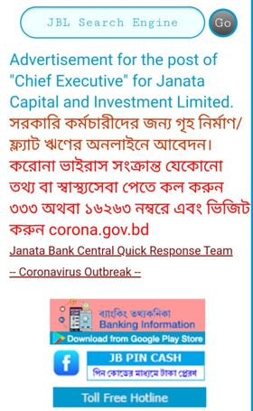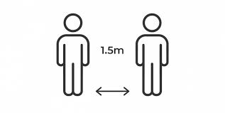

Chapter 5Findings And Analysis

Chapter 5 Findings
After doing my research and after analyzing everything I come to know that the whole thing has positive and negative both side. when I observe it and started to explore for the report I got both positive and negative sides of preparing training in bank sector instance of the Janata Bank and prime bank While doing the evaluation I generally found that -
- They utilize traditional method to measure training program
- Some people think that getting ready for training is completely waste of their time.
- Prime bank follows almost all HR training practices where janata bank can't practice all HRM planning rule. The HRM have a couple of objections yet the bank can't follow all of those objectives.
- Both provide good working environment and attractive compensation benefit for their employees
- The relation between employee and management level are very good
- Prime bank is a private bank and its is much advance in their training process then janata bank
- Janata bank face problem in evaluating employees
- PBL follow a decent policy of training and believe regular training program is essential to develop performance level and increase skill
- JBL doesn’t follow the structural policy of training
- PBLabd JBL ensure effective feedback sysetm
Comparison
Bank Name | Productivity | Benefit | Need | Frequency of Training
Janata bank |  |  | Organization try to give the training according to the employees need | 1 to 60 days
  They said that some time some training are not affect their productivity but most of the time it increase their productivity
  they give more facility for the best employee and provide special benefit to their best employee on the basis of training
+Prime bank |  |  | They analyze the performance of the employees & provide special training program to less efficient employees | 1 to 30 days
  According to the manager,an effective training enhance their productivity.
  they give promotion, bonus for their best productive employee on the basis of training
Analysis
Prime Bank
The Manager of Prime Bank Limited stated, representative got time for training for a week ago. It is important to get the tanning,. There are loads of advantages, became they can learn new things. They get money related help from association. Toward the end, I can feel Training is necessary for both the association and furthermore worker. Diagram given underneath the Appendix.
Janata bank
Representative’s increment their work profitability and they get enough time for training to do work appropriately, they couldn't found that much impact for their profession or advancement. Truly, at whatever point they get the chance to learn new thing, new expertise then they attempt to mirror those aptitude in their work. The preparation for training are normally held in a specific day of which they are educated previously with the goal that they can keep up their work life equalization and they give reward yet not frequently

Analysis of data
Interpretation of Data
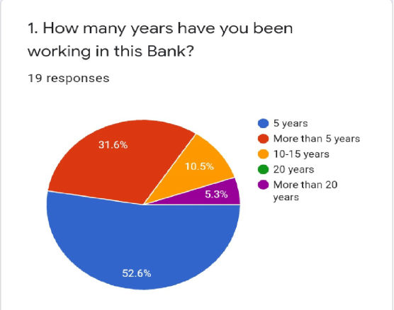

Here most of the experts express that maximum 5 years they working in the company .31.5% says that they working here for around 5 years, 5.3% was working in this company for basically more then 20 years and other 10.5% are working here fpr 10 to 15 years.
.
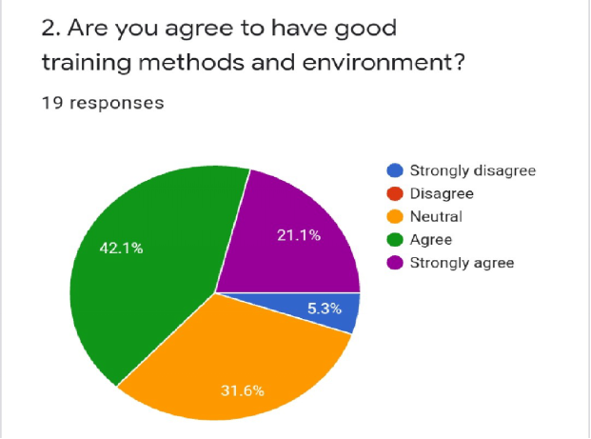

.About maximum 42.1% says they are consent to have the great preparing climate in this preparation foundation and 5.3% firmly concurs and 31. 5% state climate was nonpartisan

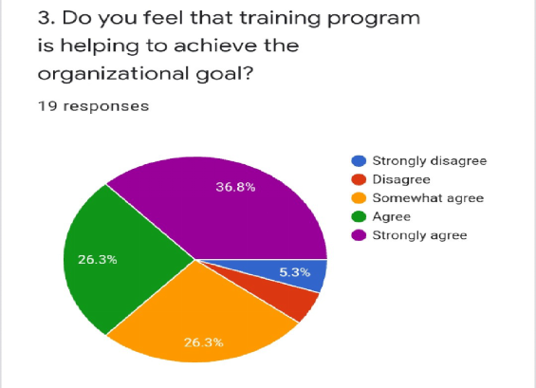

36,8% they said that they are strongly agree it has strong impact. 5.3% ate can't resist negating that and 26.3% says that they are agree about this thin

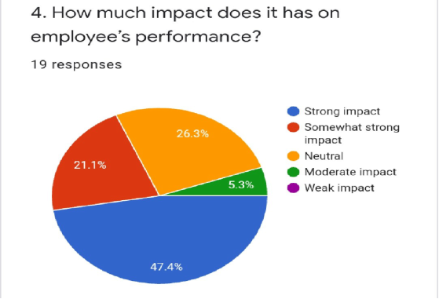

Training has impact on employee’s performance and majority says 47.4% it has strong impact. 21.1% says it is somewhat strong impact and 26.3% are neutral on performance and 5.3% says moderate.
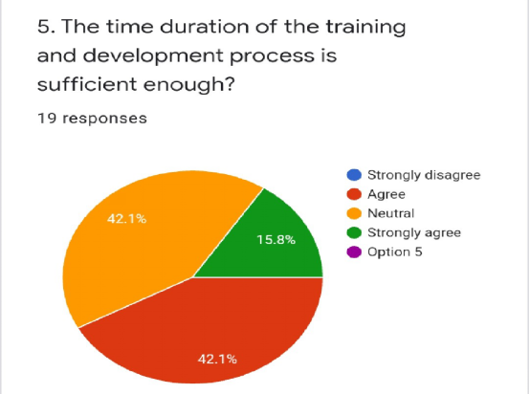

Here 42. 1% representatives are concur and 15.8% individuals are strongly agree with this and think time length was sufficient for preparing program while others have distinctive assessment. Like 42.1% individuals are basically agree with that

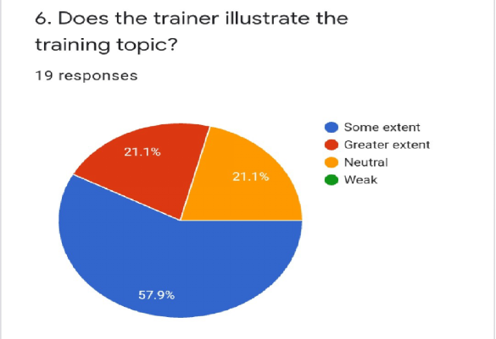

About 57.9% were concurred with some degree and 21.1% people are concurred with more prominent degree that coaches give appropriate clarification of the subject. Though 21.1% are neutral about their feeling

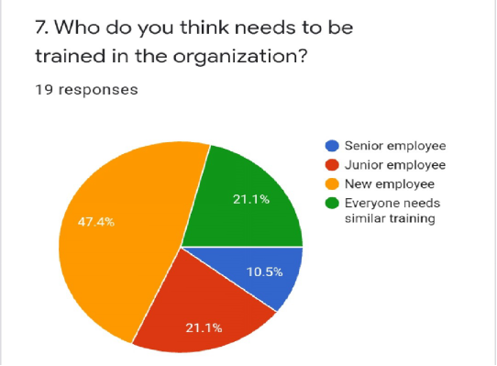

About 47.4% said new workers should sent in this training program as they are have little data about this definitive process.21. 1% express that lesser laborers needs this training program and a comparable rate people says that everyone needs same training process which I honestly do not agree with their evaluation and 10.5% people says that senior employees need planning training program.

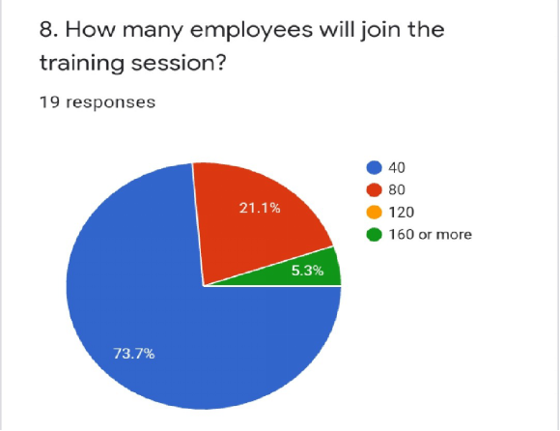
As the association utilizes diverse training system they take less measure of workers in preparing training program so they can understand the whole thing in a legitimate manner that is the reason 73.7% agree to it. 21.1% says about 80 or more employee in training program 5.3% didn't agree with it to them yet state about at least or more 160 workers.

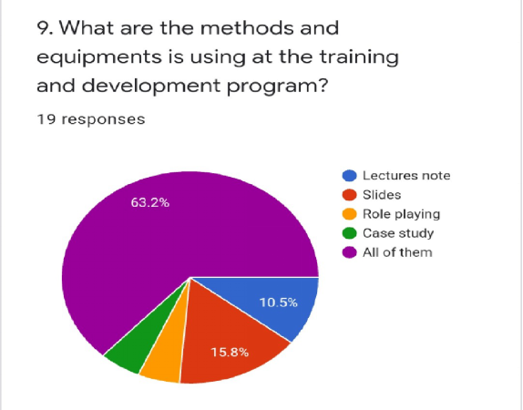

Around 63.2% workers state association utilizes all the assets, 15.8% says that association use slides more often than not other 10.5% says that association use address note and others have diverse in conclusion about it.

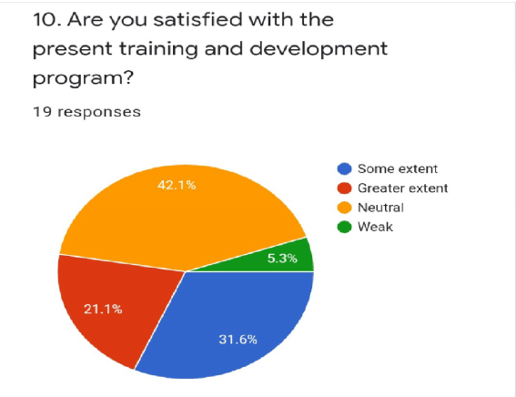

Majority or maximum 42.1% says their fulfillment level actually was impartial on the grounds that preparing training program in both Bank are very moderate and 31.6% individuals satisfaction level is some degree and 21.1% individuals has more prominent degree fulfillment level 5.3% individuals has weak satisfaction
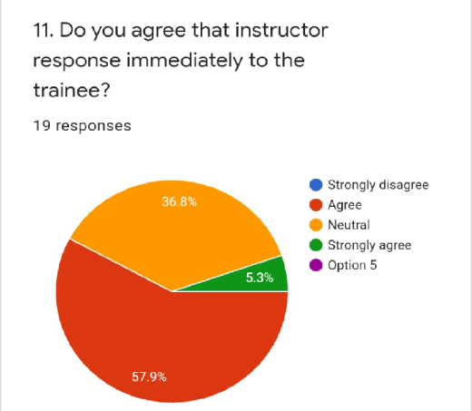

57.9% representatives that mean dominant part of individuals says that guidance reaction quickly they are agree with that and 36.8% individuals assessment was moderate and 5.3% was firmly concede to it

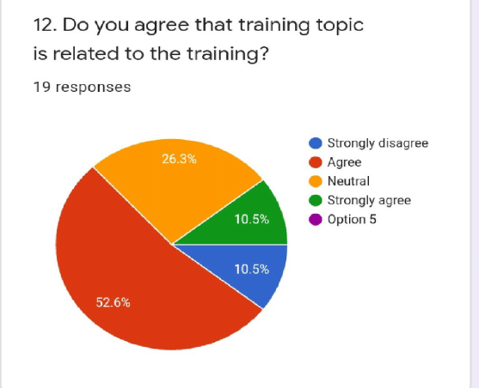

Majority of them 56.2% people are agreeing with that. 26. 3% people groups opinion is neutral. 10.5% individuals are strongly agree about this thing

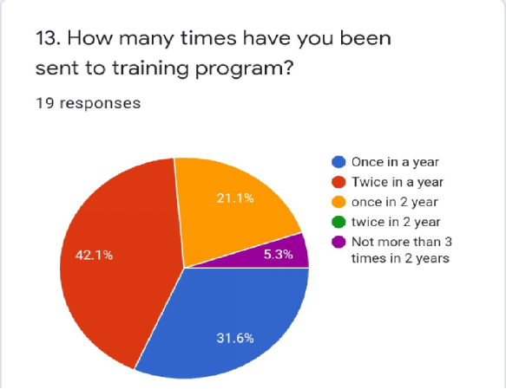

In any organization it is compulsory, that 42. 1% said that they sent twice in a year. What’s more, 31.6% people say they have been sent once in a year. In preparing training programs. Other 21.1% people say that they have been sent training once in long haul. 5.3% people says that they have been sent on programs not more then 3 time's in 2 years
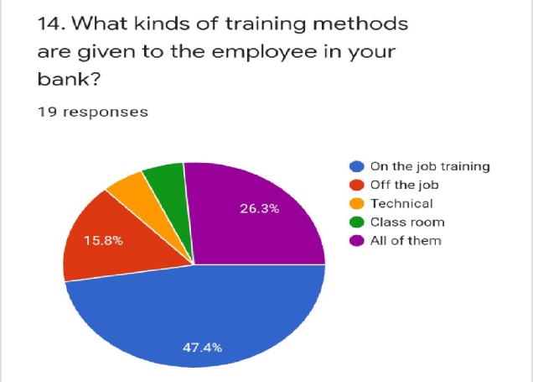
47. 4% workers which imply greater part of representatives said that their association follows on the job method and 15.8% individuals says that their association follows off the training technique and rest of the 26. 3% individuals says that their association follows a wide range of strategy, for example, and specialized technique training , based on representatives need which helps accomplishing goal uf the company in a better way
15.How well trained are your bank staff?
Answer-Organizations representatives said that the bank staff are very much prepared and clarify that various sorts of methods are composed through employing numerous asset individual from inside and outside banks. Every one of them attempt to provide their greatness knowledge so that they can become more talented and productive

16.How have you measured the training program to be successful?
Answer some people says that Based on proper execution and effective performance t and providing legitimate guidelines and other people says that by taking assessment and contextual analysis bunch conversation thus numerous procedure
17. Why Training and Development exercises are not influencing worker fitness just as execution? What could be the purpose for it?
Answer based on worker perceptions they said that, few people's conclusion is that might be the preparing training isn't adequate or not successful for the specific issue that employees face in the workplace. The reason may be absence of occupation information, eagerness to the work or others Lack of understanding or inappropriate practice or time Lack of Effective rules or Poor training program
18 How Will You Guaranty That The Training Is Important For An Employee inside The Company?
Answer employees give distinctive opinion on that and says that giving the correct training on which employee have low performance. Training can be successful by guaranteeing experienced and exceptionally proficient individual will direct instructional course and the meeting must be open and furthermore says that by taking surveys, Performance redesigns,, Giving appropriate rules Proper training by improving performance
19. What Is The Role Of A Trainer In your Company?
Answer. The function of a mentor is to create ranges of abilities in a person to perform efficiently and productively in the work place. Both mentor and learners meet and discuss in a basic manner with one another about what they anticipate from preparing training . The mentor is an important part and plays important function from begin to end of the preparation. So he is big asset. are standard help holder, function as a coach
20 What Do you believe that The Key Criteria For Training To Be more Effective?
Answer., learn new abilities, thoughts and information. The cycle improves representative confidence and inspiration. The members can move adequately what has been they learn into the workplace. Sp basically training helps the representative's to fulfill their needs and satisfies the association's objectives and goals.

INTERVIEW QUESTIONS
Question 1. What Are the Objectives Of Training Department in your affiliation?
Answer: In our association the goals is to recognize the necessary and needs of training in an association and fill the hole with a large group by using training strategies
Question 2.Does your association make Long Training Session and on the off chance that they does, is it Boring To The Employees?
Answer: Yes we follow long session and to make the long instructional course not exhausting to the students/representatives like, Give lunch breaks, include different board games like ice breakers and so forth to empower the entire group
Question 3 What Is The Role Of A Trainer In A Company?
Answer: The job is to build up a competency and extents of limits in a person to work out successfully and efficiently in the work place. .
Question 4.. What is Your Opinion about The Key Criteria For Training To Be Effective?
Answer: Successful preparing training implies the workers are occupied with the learn new abilities, thoughts and information. The cycle upgrades worker confidence and imparts certainty and inspiration. The members can move viably what has been realized into the workplace. T
Question 5 .Do you face any Difficulty in your Training time?
Answer: Training representatives can introduce numerous difficulties. Some regular challenges incorporate absence of inspiration from the worker, absence of commitment from members

Recommendation
Bank should organize various trainings (authoritative trainings, English language/examining/making planning, quick customer uphold trainings, etc.) rather than simply standard budgetary trainings for its laborers. Proposals are given to improve the lacking found in the examination so association can work on it easily. The important proposals are given beneath.
- Training need assessment should be conducted more strictly
- Training practice time must have to expand
- The authority of both bank should male an effective reward system which encourage employees for attending the training program
- Organization should offer more different leveled training program
- Banks should work on advance methods of training
- Banks need to complete need assessment for its laborers.
- The organization need to focus on outside trainings more than in house trainings.
- Janata bank need to follow new training and advancement strategy instead of utilizing traditional one
- Introduction of more training program will be effective for sustaining professional growth and development of employees

Conclusion
Banks assume significant function in the advanced economy; Human Resource Management issues assume a significant part in each association and in the banks. Expect an immense limit in each connection and in the banks. No organization can accomplish its objectives or can be sufficient, until or beside if it fulfills delegates. Setting up the norm of reasonableness, work satisfaction and business progress are essential in the bank. The movement satisfaction of the laborers is more than moderate. The bank is moreover content with its workers. Banks pay is high yet not for the most part critical in relationship with various business banks. Still pleasing workplace, unprecedented social relationship, and the benefit of the representatives of the PBL are additionally satisfactory. At last, the bank must present a forefront banking framework, handle new turn of events, start new thing, and train its representatives reasonably to do their commitment and keep fulfilled.. The bank's HRM procedures are obviously better; it has had the decision to fulfill the worker. Banks are exceptionally valuable in Bangladesh. The achievement of a bank relies on the best client help of the vendors. This can grow remarkably capable examiners who can work splendidly for customers and accomplish customer dependability through proper preparing training and improvement measure.. So this is the ideal time for Bangladeshi money related HR working environments to start practical worker preparing training and movement programs, viably executing HR. There is sufficient proof to show that workers who were masterminded continually are the ones who give additionally stunning associations to the clients. To build up an arranged and proactive structure there is need of reasonable corporate culture. In a help planned industry, for example, banking, individuals are among the most basic resources and a bank should competently deal with its workers during each season of work in this drew in field. I banks handle arrange training programs for their representatives to develop their ability. Banks give preparing exercises to refresh their comprehension and abilities to fulfill the clients demand. Progression of banking an area in Bangladesh is the result of talented work which is the outcome of setting up an improvement. The training data of JBL, PBL, is quite difficult to gather. I was not permitted to have all the data. The report was set up with the limited data which I got from the bank managers and from, the help of the online website. I have faced different challenges in my Task report, Finally, I truly recognize that the information I have gotten from my undertaking reports would be useful for my future occupations up considering everything.

Chapter 6Appendix
Survey Questionnaires
1. How long are you working in Janata Bank?
1. 5 years
2. More than 5 years
3. 10-15 years
4. 20 years
5. More than 20 years
2. Is it true that you are consent to have great preparing strategies and climate?
1. Insistently contradict this thought
2. Contradict this thought
3. Neutral
4. Agree
5. Insistently agree
3. What do you think that preparation program is assisting with accomplishing the hierarchical objective?
1. Insistently contradict this thought
2. Contradict this thought
3. Reasonably agree
4. Agree
5. Insistently agree
4. What amount sway does it has on representative's presentation?
1. Solid effect
2. to some degree solid effect
3. Impartial
4. Moderate effect
5. Powerless effect
5. The time term of the preparation and improvement measure is sufficiently adequate?
1. Unequivocally oppose this idea
2. Concur
3. Impartial
4. Unequivocally concur
5. Concur
6. Does the mentor show the preparation point?
1. Some degree
2. More noteworthy degree
3. Impartial
4. Powerless
7. According to you whom do you accept ought to set up in this affiliation?
1. Senior laborer
2. Junior laborer
3. New laborer
4. Everyone needs similar planning
8. What number of workers will join the instructional course?
1. 40
2. 80
3. 120
4. at least 160
9. What type off methodologies and kinds of apparatus is using at the planning and headway program?
1. Talks note
2. Slides
3. Imagining
4. Relevant examination
5. All of them
10. Is it accurate to say that you are happy with the current preparing and advancement program?
1. Some degree
2. More noteworthy degree
3. Impartial
4. Powerless
11. Do you concur that educator reaction promptly to the learner?
1. Unequivocally oppose this idea
2. Concur
3. Impartial
4. Unequivocally concur
5. Concur
12. Do you concur that preparation theme is identified with the preparation?
1. Unequivocally oppose this idea
2. Concur
3. Impartial
4. Unequivocally concur
5. Concur
13. How as often as possible have you been transported off planning program?
1. Once in a year
2. Twice in a year
3. once in long haul
4. twice in long haul
5. Not various events in 2 years
14. What kinds of getting ready methodologies are given to the delegate by the Janata Bank?
1. Hands on preparing
2. Off the work
3. Specialized
4. Study hall
5. Every one of them
15.How all around prepared are your staff?
16.How have you estimated the preparation program to be fruitful?
17 why Training and Development exercises are not influencing worker capability just as execution? What could be the explanation for it?
18 How Will You Guaranty That The Training Is Important For An Employee inside The Company?
19. What Is The Role Of A Trainer In your Company?
20 What Do you believe that The Key Criteria For Training To Be more Effective?

CHAPTER 7References

UKEssays. (November 2018). Training And Development In Hrm Management Essay. Retrieved from https://www.ukessays.com/essays/management/training-and-development-in-hrm-management-essay.php?vref=1

Internship Report on the General Banking Operation of Prime Bank Ltd - Assignment Point. Retrieved 28 November 2020, from https://www.assignmentpoint.com/business/internship-report-on-the-general-banking-operation-of-prime-bank-ltd.html

Irish, K. (2019). A Guide to Creating an Employee Training and Development Program. Retrieved 28 November 2020, from https://www.ej4.com/blog/guide-to-creating-employee-training-and-development-program

UKEssays. (November 2018). Issues Related To Global Training And Development Management Essay. Retrieved from https://www.ukessays.com/essays/management/issues-related-to-global-training-and-development-management-essay.php?vref=1

Janata Bank Limited. Retrieved 28 November 2020, from https://www.jb.com.bd

Kang, H., & Shen, J. (2017). International Training and Development Policies and Practices. Retrieved 28 November 2020, from

Keenan McBride, C. (2020). Training and Development in a Post-COVID-19 Workplace. Retrieved 28 November 2020, from https://trainingindustry.com/blog/strategy-alignment-and-planning/training-and-development-in-a-post-covid-19-workplace/?fbclid=IwAR1GTH3v-

Mahmood, M., & Akhter, S. (2011). International Briefing 24: Training and Development in Bangladesh. Retrieved 28 November 2020, from https://www.researchgate.net/publication/228253694_International_Briefing_24_Training_and_Development_in_Bangladesh

Prime Bank Limited. Retrieved 28 November 2020, from https://www.primebank.com.bd/index.php/home/hr_principles

Prime Bank Limited. Retrieved 28 November 2020, from https://www.primebank.com.bd/index.php/home/mission

The Importance of Training & Development in the Financial Sector. (2017). Retrieved 28 November 2020, from https://bizfluent.com/about-6500249-importance-training-development-financial-sector.html

Ather& Shah. (2015, November). “Impact of Training on Employee Performance (Banking Sector Karachi)”, Journal of Business and Management (IOSR-JBM) Vol.17, Issue 11 .Ver. I PP 58-67.

Janata Bank Limited. (n.d). Retrieved from BANGLAPEDIA: http://en.banglapedia.org/index.php?title=Janata_Bank_Limited

Training and Development - A Key HR Function. Retrieved 28 November 2020, from https://www.managementstudyguide.com/training-development-hr-function.htm

Hasan. Training and development program of Prime Bank Ltd. Retrieved 28 November 2020, from https://www.slideshare.net/MahmudulSohag/training-and-development-program-of-prime-bank-ltd?fbclid=IwAR3FvGtLFhmt8Se67yfKARm1SUA9lL1OdkAuD-d07hM0rtlaeB992i8y5Bo

Armstrong, M. (n.d.). Handbook of Human Resource Management Practice. Kogan Page.

Monappa, A., &Saiyadain, M. S. (1997). Personnel management. New Delhi: Tata McGraw-Hill.

Aswathappa, K. (2005). Human resource and personnel management: Text and cases. New Delhi: Tata McGraw-Hill.

