An Evaluation of Business Development & Digital Marketing Activities of Mistri Mama

MD. Taiyeb Ahmed Bhuiya

This report is submitted to the School of Business & Economics, United International University as a partial requirement for the fulfillment of Bachelors of Business Administration Degree.

An Evaluation of Business Development & Digital Marketing Activities of Mistri Mama

Submitted to:
Kawsar Ahmmed, PhD
Associate Professor- Marketing

Submitted by:
MD. Taiyeb Ahmed Bhuiya
ID: 111 151 349

Date of Submission: August 24, 2019
School of Business & Economics
United International University

Letter of Transmittal
Date: August 24, 2019

Kawsar Ahmmed, PhD
Associate Professor- Marketing
School of Business & Economics
United International University

Subject: Submission of report titled An Evaluation of Business Development & Digital Marketing Activities of Mistri Mama.

Dear Sir,
I am glad to tell you that for the partial accomplishment of my BBA program I have completed my internship program at Mistri Mama-a sister concern of Super Star Group. I am submitting the internship report on An Evaluation of Business Development & Digital Marketing Activities of Mistri Mama. I have put my best efforts into gathering comprehensive knowledge and gathering about the topic. I am submitting the report for your kind depth of thought and recognition. While preparing this report, I have learned a lot that will assist me in my practical life.
If you kindly acknowledge this report, I will be compelled. I would be pleased if this study could serve its aims and if you think it is essential, I will be accessible to clarify your queries.

Sincerely Yours,

_______________________
MD. Taiyeb Ahmed Bhuiya
ID: 111 151 349

Letter of Acceptance

I am pleased to acknowledge the internship report on An Evaluation of Business Development & Digital Marketing Activities of Mistri Mama prepared by MD. Taiyeb Ahmed Bhuiya, major in Marketing in bachelor of Business Administration (BBA), United International University (UIU). I shall gladly certify that this report was prepared solely by him using the appropriate records relating to the subject material allocated.

_______________________
Kawsar Ahmmed, PhD
Associate Professor- Marketing

Declaration

I am MD. Taiyeb Ahmed Bhuiya, a student of United International University, BBA program. ID: 111 151 349, major in Marketing, declares the internship report on An Evaluation of Business Development & Digital Marketing Activities of Mistri Mama was organized after the completion of my internship at Mistri Mama, Sky View Oceans, (1st floor), 38 Segun Bagicha, Dhaka, Bangladesh. I also declare that the internship report is ready for an educational purpose and has not been presented to any degree by me.

__________________
MD. Taiyeb Ahmed Bhuiya
ID: 111 151 349

Certification

This is accredited to MD. Taiyeb Ahmed Bhuiya, ID: 111 151 349, Student of BBA program United International University, School of Business & Economics, the internship program has been effectively finished for three months between May 02, 2019 to July 31, 2019 from Mistri Mama, Sky View Oceans Towers (1st floor), 38 Segun Bagicha, Dhaka, Bangladesh. He has attained practical understanding of the service industry and its working process from this field during the internship period.

_______________________
Kawsar Ahmmed, PhD
Associate Professor

Dedication

I would like to dedicate my internship report to Almighty Allah, who fortunate me to complete my internship period and wrap up my internship report very peacefully and very comfortable with a friendly environment with facing any problem or persecution. I would like to thank my academic Supervisor, Kawsar Ahmmed Sir for giving me an opportunity to work during the internship with his guidance. Because of the advice, help and recommendations he gave me in every convenient way, I was able compile and finish this report in an extensive way. Another, I would like to dedicate this report to the family of Mistri Mama and also Super Star Group (SSG).

Acknowledgement

All praise is due to Almighty Allah, who provides me confidence to finish this report. In carrying out this research paper me, MD. Taiyeb Ahmed Bhuiya would like to express my appreciation and regard for some person cooperation to accomplish my internship report on An Evaluation of Business Development & Digital Marketing Activities of Mistri Mama.
First and foremost, I owe a debt of gratitude to my internship course supervisor Kawsar Ahmmed, PhD School of Business & Economics, United International University for his astute advice and infinite endurance throughout the semester without which this internship report has not flourished to his advantageous guidance and encouragement.
Secondly, I acknowledge my appreciation to Mr. Hasibur Rahman, (Deputy Manager, E-Commerce & Digital Marketing, Super Star Group) to be my supervisor in the Super Star Group (SSG) and for his tremendous help and precious recommendations for the accomplishment of my internship program and for the preparation of the document. I would also like to thank to Tausif Ahmed (Senior Manager, E-Commerce) for his kind appreciations and cooperation. Also, thanks to Sheikh Sadi (Director- Super Star Group)
I am also very grateful to all the Mistri Mama & Super Star Group (SSG) representatives for their graciousness and friendliness. The senior officers assisted me a lot to get the data I needed in time. I would also want to thank the Super Star Group (SSG) Human Resources Department that created the Super Star Group door wide open to me.

Executive Summary

Business development is about to create long term sustainable value for a company which can range from a large organization to a small startup. Such value is generated from the customer group(s), market(s) and relationships with stakeholders. No other medium of marketing other than digital marketing can be a suitable choice to develop business for a newly started company. Digital marketing is about the use of digital technology, such as mobile, display advertising, search engine optimization and many other products and services to reach customers in this digital era. Mistri Mama is a newly launched home-service startup and is a sister concern of Super Star Group, which began operating in 2018. This report is based on my three-month real-life experience with Mistri Mama where I performed my roles in business development and digital marketing. This internship program assisted me a lot in acquiring a practical understanding of a start-up on-demand home service company growth strategies and procedures. The online on-demand home service company is a vibrant, fast-growing home service solution marketplace across the country. Online home service demand is increasing rapidly and in the latest times, the amount of businesses is also increasing. Mistri Mama offers now Electrical services, Plumbing services, AC services, It and CCTV services. This report aims to: categorize digital marketing situations, classify digital marketing difficulties and constraints as observed by me on my experience with Mistri Mama. It also aims to figure out techniques of tactical digital marketing and various policy forms and their implementations and calculation of duties. To achieve this aim, data have been gathered through both primary sources (survey analysis, personal interview with business development professionals of Mistri Mama, observation from my experience) and secondary sources (company website, blog, internal records). All these are discussed in the continued sections of the study.

Key Words: Home Service, Mistri Mama, Business Development, Digital Marketing, Super Star Group.

Contents
Chapter 1: Introduction
Letter of Transmittal iii
Letter of Acceptance iv
Declaration v
Certification vi
Dedication vii
Acknowledgement viii
Executive Summary ix
Table of Figure 12
Chapter- one 14
Introduction 14
Motivation of the Study 15
Objective of the Study 16
Limitations of the Study 17
Company Profile 19
Super Star Group (SSG) Business units 20
Business Information of Super Star Group 20
Company Mission, Vision and Values 21
Super Star Group Board of Directors 22
Products of Super Star Group (SSG) 23
27
The Job and Digital Marketing Activities 27
Job Responsibilities as an Intern 27
Digital Marketing 30
Digital marketing Activities Performed by Mistri Mama 31
Role of Business Development Department of Mistri Mama 34
Introduction 36
Population and Sample for the Present Study 36
Data Collection Procedures 36
Sources of Data for this Report 37
Primary Sources of Data 37
Secondary Source of Data 37
Analysis and Interpretation 38
Recommendation 53
Conclusion 55
Reference 57
Appendix 58
Survey Questionnaire 58

Table of Figure
Figure 1: Company Logo of Super Star Group 18
Figure 2: Business Units of Super Star Group 19
Figure 3: Business Information of Super Star Group 19
Figure 4: Company Mission, Vision & Values of Super Star Group 20
Figure 5: Products of Super Star Group (SSG) 22
Figure 6: Logo of I.R. Bulb Company Ltd. 23
Figure 7: Logo of SSG Agro 23
Figure 8: Logo of Mistri Mama 24
Figure 9: Business Information of Mistri Mama 25
Figure 10: Services of Mistri Mama 26
Figure 11: Orlee Campaign Page 27
Figure 12: Orlee Cricket Quiz Engagement 28
Figure 13: Official Page of Mistri Mama 30
Figure 14: Official Website of Mistri Mama 31
Figure 15: Official Instagram Page of Mistri Mama 31
Figure 16: Official LinkedIn Page of Mistri Mama 32
Figure 17: Official Mistri Mama Twitter Page 32
Figure 18: Data Collection Sources 36
Figure 19: Gender of the respondents 37
Figure 20: Age of the respondents 38
Figure 21: Responses against Question 1 38
Figure 22: Responses against Question 2 39
Figure 23: Responses against Question 3 39
Figure 24: Responses against Question 4 40
Figure 25: Responses against Question 5 40
Figure 26: Responses against Question 6 41
Figure 27: Responses against Question 7 41
Figure 28: Responses against Question 8 42
Figure 29: Responses against Question 9 42
Figure 30: Responses against Question 10 43
Figure 31: Responses against Question 11 43
Figure 32: Responses against Question 12 44
Figure 33: Responses against Question 13 44
Figure 34: Responses against Question 14 45
Figure 35: Responses against Question 15 46
Figure 36: Comments on Question 16 46
Figure 37: Comments on Question 17 47
Figure 38: Comments on Question 18 47
Figure 39: Comments on Question 19 48
Figure 40: Responses against Question 20 48
Figure 41:Michael Porter's Five Forces for Online On-Demand Home-based Service Marketplace 50

Chapter- one

Introduction

Introduction

The recent increase of “Digital Marketing” concepts nowadays in Bangladesh has taken the nation beyond the traditional marketing perspectives. Digital Marketing offers Bangladeshi marketers’ better strategies to find out about things and monitor customers and to develop the product and services customized to each customers’ needs. Although the word “Digital Marketing” invented in the 1990s but recently in Bangladesh, the practicing of digital marketing increased rapidly. It turned out that digital media was common to the extent that anybody could get information from anywhere.
Organization like Mistri Mama Limited, which understands the strength of digital ability, which promote collaborative interactions between company and customer and also those that will continue to implement digital marketing in their techniques. Digital marketing has introduced a new dimension of promotion through the technological elements.

Motivation of the Study

The reason for developing this report is that it is component of my B.B.A curriculum recognized as internship. The organization where I completed my internship is Mistri Mama. I learned about the actual application of marketing policies during my internship. This report has been drafted on the overall concept of how Mistri Mama implies its Digital marketing in Bangladesh. The report title is – Business Development & Digital Marketing Activities Performed by Mistri Mama.

Objective of the Study

Traditional marketing was the only way to reach prospective clients in the past. However, a new marketing tool called Digital Marketing has created its way with the emergence of digital platforms. This has modified the marketing strategy guidelines. Now, by communicating with marketers and providing needed feedback clients are more engaged. With the use of digital Marketing, the overall field of marketing policies has modified and improved a lot. The reason for this study is to do an in-depth analysis of the marketing strategies of Mistri Mama and to build a stronger view on how it interacts with its customers.
Recognizing the present scenario of digital marketing and clients approaching Mistri Mama’s digital marketing campaigns and finding alternative to make them more established in this atmosphere. There are some particular objectives are listed below:
- To Classifying Digital marketing difficulties.
- To indicate the measures that are crucial to the marketing department being digitized.
- To categorize digital marketing situation in Mistri Mam.
- To assess the current digital marketing situation in Mistri Mama.
- To digitalize marketing infringement of the basic strategy in Mistri Mama.
- To discover various constraints and provide digital marketing techniques.
- To reveal the technique of tactical digital marketing and various policy forms and their implementations and calculation of duties.

Limitations of the Study

An internship report derived from a three months limited experience in a whole new organization culture includes some drawbacks too. No exception is seen while making this study report too. Limitations faced while making this study report includes:
- Time was the key barrier to this study. It took some more time to see and observe the real situation, the methods of working and everything.
- As an intern, I’m not dealing with all the company’s digital marketing operations. So, writing about the entire digital marketing activity was a bit hard for me.
- Another issue has been privacy. Company never wants to reveal any and all outside. Although my seniors have helped and cooperated so much with me to make this report more informative, but as I am not a permanent employee here, there have been some obligations to reveal to me all confidential matters.

Chapter- Two

An Overview of the Organization and Literature Review

Company Profile


Super Star Group has been a major and leading producer, importer and marketer of electrical equipment and accessories under the brand name of "Super Star" for last two centuries. The company began its voyage in 1994 by creating its first venture at Narayanganj, A Glowing light factory. For residential, commercial and other unique needs, the Super Star group provides a broad variety of lighting and other electrical solutions. The group offers its wide-ranging client high-quality lighting solutions without considering the performance that makes them number one in Bangladesh’s lighting industry. The product lines are Compact Fluorescent Lamp (CFL), Incandescent Lamp (GLS), Light Emitting Diode (LED), Fluorescent Tube Light (T8, T5), Switches and Sockets, Fan, Fluorescent Lighting Fixture, PVC Insulating Tape, Electronic Ballast, and Distribution Board. Moreover, the group is the best wholesaler of Kawamura Electric Inc. of Japan and Federal Electric of Turkey to promoting their Circuit Breaker and other electrical wellbeing related items in Bangladesh. What's more having their very own image named as Super Star Fan, they turn into the first-class wholesaler of Khaitan Fan of India in Bangladesh. The quality of these products is ensured and there is no question of their durability. Each of these products have both inherent and aesthetic value that we are proud of and are truly happy with in providing our valued and prospective customers and customer with the quality goods.
Figure 1: Company Logo of Super Star Group
Super Star Group has multiple number of sister concerns under the group name of Super Star and many other global exporters. This organization consists of 13 concerns at present where they initiated verities of product and service line through the whole country. A very newly initiated service marketing startup is about to be launched as a pilot project within 2019 with a mass Dhaka coverage for both of the residents and commercial clients.

Super Star Group (SSG) Business units
Super Star Electronics Ltd | Super Star Electrical Accessories Ltd
IR Bulb Co Ltd | Super Star Distribution Ltd
Professional lightings | Super Star Renewable Energy Ltd
Super Star Group (SSG) Engineering | Super Star Group (SSG) Properties
Grupel Generator | Super Star Group (SSG) Agro
Super Star Group (SSG) Papers Ltd | Super Phone
Mistri Mama
Figure 2: Business Units of Super Star Group

Business Information of Super Star Group
Company Name | Super Start Group (SSG)
Logo | 
Slogan | Future Is Bright
Types of Industry | Manufacturing Company of Electrical and Electronic Accessories.
Company Start-up | 1994
Location | 3rd Floor, UCEP Cheyne Tower, 25 Segun Bagicha Road, Dhaka 1000.
Website | www.ssgbd.com
Email | info@ssgbd.com

Figure 3: Business Information of Super Star Group

Company Mission, Vision and Values

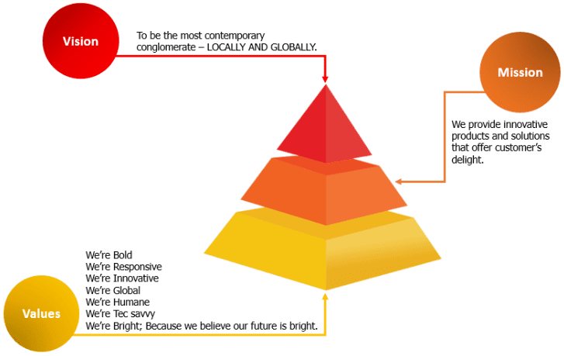
Figure 4: Company Mission, Vision & Values of Super Star Group

Super Star Group Board of Directors




Super Star Group is run by a team of experienced and highly skilled experts with such a strong corporate culture. They are guided by the vibrant and diverse leadership of an extremely, enthusiastic, proactive and visionary management team. They all are working ceaselessly for the group’s growth and development.
Mohammed Ibrahim
MD and CEO
Super Star Group
Joynal Abedin
Chairman
Super Star Group
Md. Mohiuddin
Vice Chairman
Super Star Group



MD. Jalal Uddin
DMD (Supply Chain)
Super Stat Group
MD. Harun Ar Rashid
DMD (Operations)
Super Star Group

Products of Super Star Group (SSG)

Figure 5: Products of Super Star Group (SSG)


I.R. Bulb Company Limited is a sister concern of Super Star Group. I.R. bulb produces long-lasting, eye-friendly, Mercury-free, High Lumen, Steady Performance, Energy Saver and high-efficiency lights. I.R. Bulb’s products are: Super Star- Fixture. Super Star Incandescent lamp (Crystal, Midnight. Regular), Super Star FTL- LUMINUX SERIES etc. http://www.ssgbd.com/ir-bulb
Figure 6: Logo of I.R. Bulb Company Ltd.


SSG Agro Fish Culture project is set up in 350 Bigha water body located in the district of Moulovibazar. In the undertaking, selected assortment of freshwater fish is refined by adopting very specific and sensible methods for achieving the highest return on quality.
Figure 7: Logo of SSG Agro


Mistri Mama is one of the newly established, rapidly expanding and promising service platform of Super Star Group (SSG). It is an online service platform in Bangladesh that offers household services facilities in all region of Dhaka City. Mistri Mama connects customers to finest repair and service experts in their region either through the website or mobile phone calls for quality repair, installation. To reduce the everyday hassle for such an experienced and high-quality expert to fix your chores with high-quality service experts and receive after-service support.
Figure 8: Logo of Mistri Mama
Mistri Mama Services are easily available between 8 am to 8 pm. It also offers services in Emergency circumstance. It serves the entire thana of the Dhaka city. Mistri Mama will be introduced in all Bangladesh’s divisional towns. Customers can order services on the www.mistrimama.com websites or by calling 09610-222-111 directly.
Mistri Mama ensure quality customer service by offerings our technicians with training that also prioritizes safety and cognitive aspects. Along with the home service, Mistri Mama also offers regular, one-time subscription for corporate houses. Our extremely qualified and skilled technicians are always a CALL away to provide Electrical, AC, Plumbing, IT, Generator, CCTV etc.
During holidays, midnights or your(customers) free hours, we are also open to providing our services.

Business Information of Mistri Mama:
Name | Mistri Mama
Logo
Types of Business | Online based service platform that offers home services in all areas of Dhaka City.
Founding Date | 2018
Location | Sky View Ocean Tower (1st Floor), 38 Segun Bagicha, Dhaka Bangladesh 1000.
Website | www.mistrimama.com
Email | info@mistrimama.com

Figure 9: Business Information of Mistri Mama

Services of Mistri Mama
Figure 10: Services of Mistri Mama

The Job and Digital Marketing Activities

Job Responsibilities as an Intern
The job I was given in the department of marketing and business development at Mistri Mama, my core assignment was to respond and assist to the three principals’ brands official websites- Mistri Mama, Orlee and SSG Eshop. I had to collaborate with our marketing and business develop team. I worked under Hasibur Rahman, who is a Deputy Manager of E-Commerce & Digital marketing. Sometimes I also worked with Tausif Ahmed- Senior Manager of E-Commerce and MD. Shams Tibris Kushal (Supply Chain Management, Super Star Group). Here I mentioned some of my duties and responsibilities; I used to do it at Mistri Mama.
- Continuous email maintenance to perform assigned duties
- Allocated documents processing, writing, printing
- Allocated excel processing, writing and printing

- Allocated power point slides processing, writing and printing
- Collects the information and activities of competitors from the various market areas
- Collect all the data from various website and sort out need data for Misti Mama
- Provide concepts and resources for the campaign on digital platform
- Purchase the campaign gift
- Handover the Campaign gift to the winners of different campaign quiz.

Brainstorming: During special occasions we had to conduct multiple campaigns likes; Orlee World Cup Cricket Quiz, SSG Eshop World Cup Quiz, SSG ke hobe aajker Super Star etc. During my internship, our one of the most effective campaigns was Orlee World Cup Cricket Quiz. The whole questionnaire was made by me.
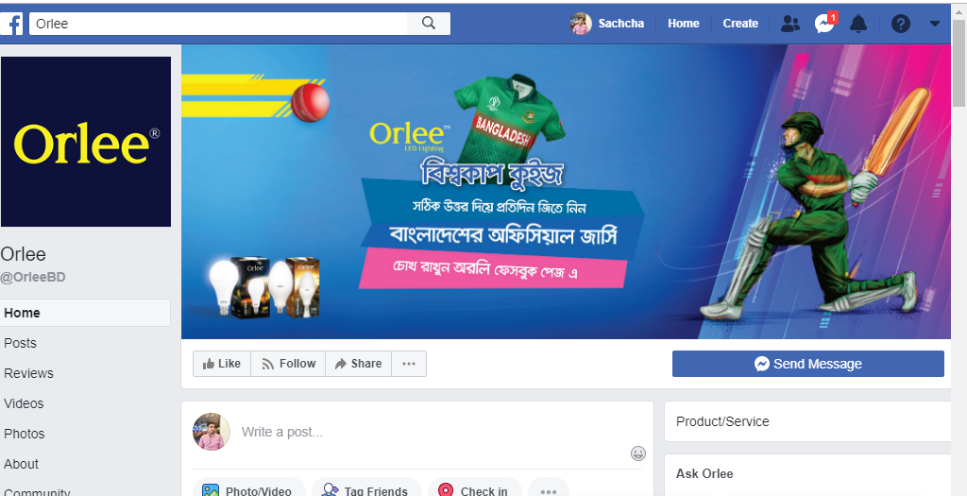

Figure 11: Orlee Campaign Page
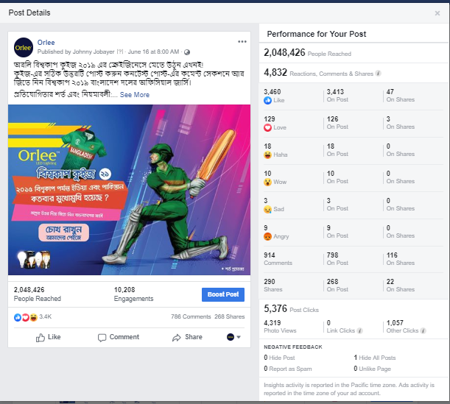
Campaign Running: I used to run the campaign through the help of brand manager and executive on the official Facebook page. I take my campaign goal through the manager, schedule the campaign time and operate the campaign.
Figure 12: Orlee Cricket Quiz Engagement
UAT (User Acceptance Test): We developed a new Mistri Mama website for user, ESP, FSP and Comrade. It is more user friendly rather than the previous one. So, every day we check the UAT along with the other work.
Update the information for the New Website: After go through the UAT check we find some major and minor problem, immediately we update the website through the help of our inhouse web developer.
Some Other Work: Beside all my daily responsibilities, I prepared excel sheet about the competitor’s information what they offer, how much they charge for their service etc. After each campaign, sort out the winners list and communicate with them and also handover the gift to the winners. I particularly enjoyed my job for the friendly atmosphere that I received from my workplace. We were helping each other in every way we could.

Digital Marketing

Digital Marketing is the marketing of goods or services utilizing new technologies, primarily on the internet, but also mobile phones, displays advertising and any other digital media. The growth of digital marketing since 1990s and 2000s. As digital platforms are progressively integrated into marketing plans and daily life, individuals are using digital appliances rather than visiting physical stores. Digital marketing campaigns are becoming more widespread and more effective. Digital marketing methods such as Search Engine optimization (SEO), Search Engine Marketing (SEM). Content Marketing, Influencer Marketing, Content Automation, Campaign Marketing, Data-Driven marketing, E-Commerce Marketing, Social Media Marketing, Social Media Optimization, Email Direct Marketing, Display Advertising, E-Books and Optical Disks& Games are becoming more common in our advancing technology. In fact, digital marketing now extends to non-internet channels that provide digital media. For example – mobile phone SMS and MMS.
Here’s a quick look at the most popular strategies of digital marketing:
Email Marketing: Email marketing is the act of sending a promotional message using email, usually to a group of individuals. Any email sent to a future or present customer could be regarded as email marketing in its broadcast sense.
Search Engine Optimization (SEO): SEO uses organic search engine outcomes to boost the quality and quantity of traffic on your website.
Pay Per Click (PPC): An internet marketing model where advertisers pay a price every time they click on of their advertisements. Essentially, it’s a way to buy visit to your site instead of trying to organically “gain” those visits.
Social Media: Social media marketing (SSM) is a type of internet marketing used as a marketing tool by social networking websites. SMM’s a business boost brand exposure and expand client reach.
Online Advertising: Online advertising is a marketing strategy that includes using the internet as a means of obtaining traffic and target page and delivering marketing messages to the correct clients.

Digital marketing Activities Performed by Mistri Mama
Mistri mama has its own websites (www.mistrimama.com) and updates its website with trendy statistics from time to time.
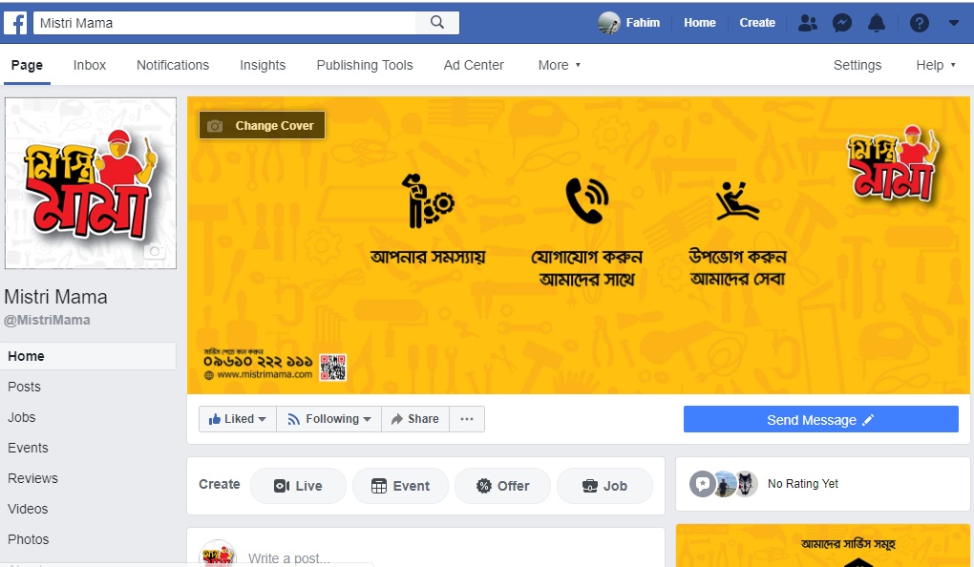
Social Media Marketing: Mistri Mama created a Facebook page where they upload photos in their services and publish post that describe information about Mistri Mama services.
Figure 13: Official Page of Mistri Mama
Email Marketing: Email marketing is now one of the digital marketing’s essential tools for selling offers and retaining a strong client connection. Mistri Mama is involved in email advertising a little bit. At some point in the first phase of the launch of the service providers, they follow this tool most efficient.
Search Engine Optimization: To optimize the search engine, a business requires to have its own website. Following a few algorithms, they can optimize their website in a unique search engine to demonstrate their website in the first location of the search list.
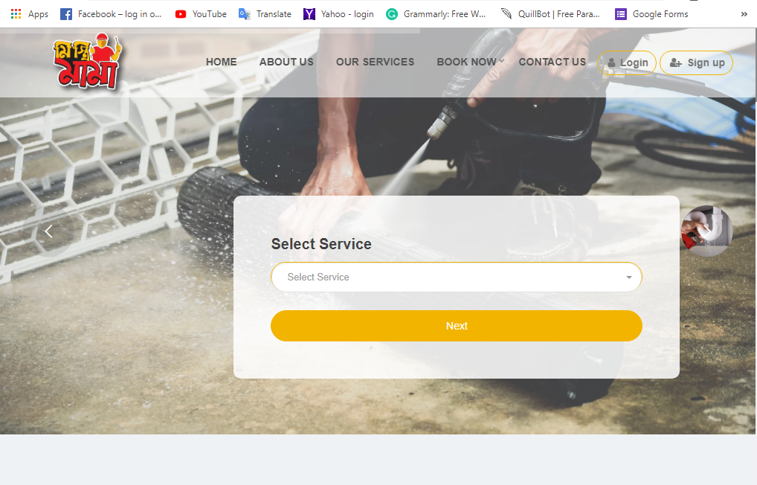
Figure 14: Official Website of Mistri Mama
Instagram marketing:
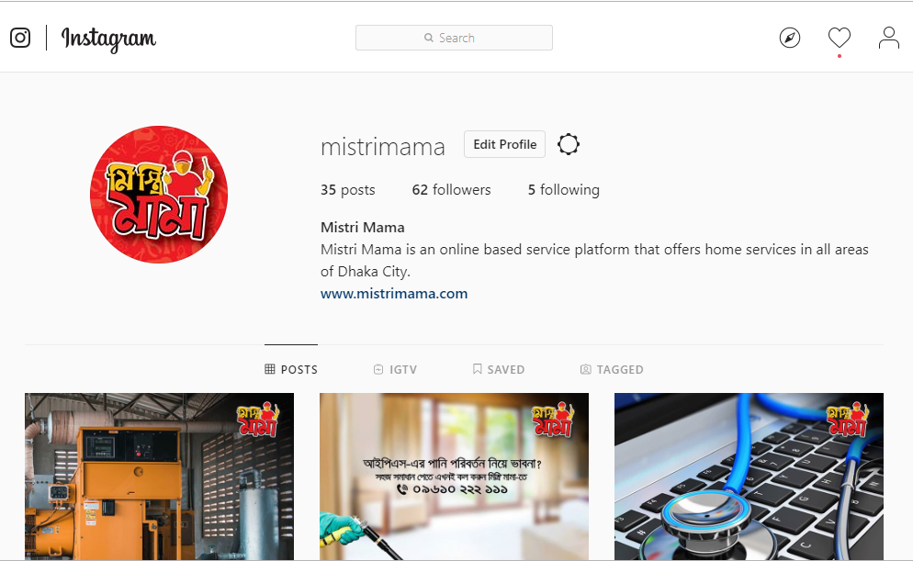
Figure 15: Official Instagram Page of Mistri Mama
LinkedIn Marketing:
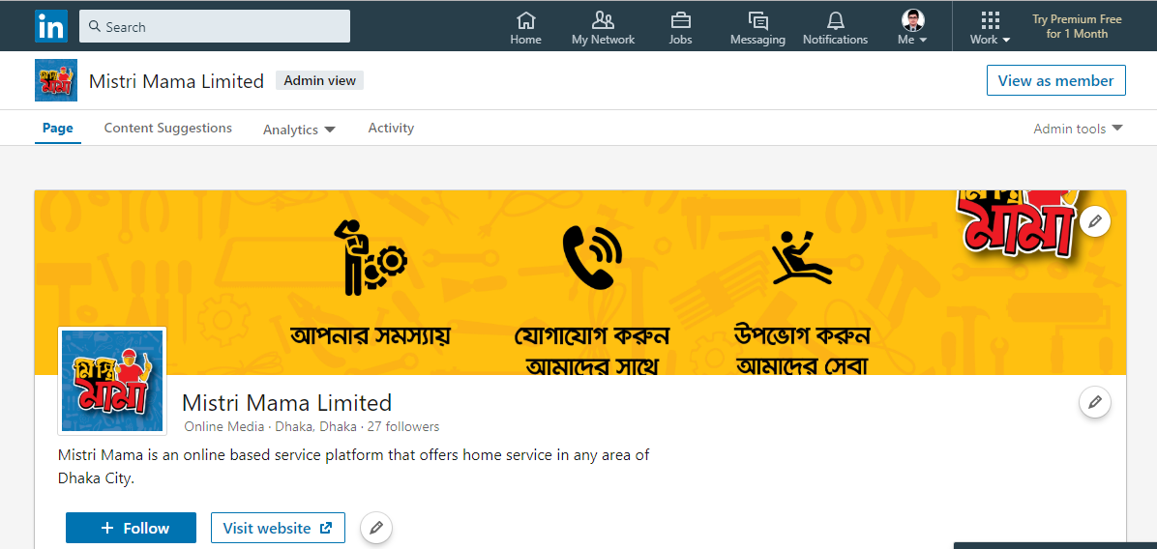
Figure 16: Official LinkedIn Page of Mistri Mama

Twitter Marketing:
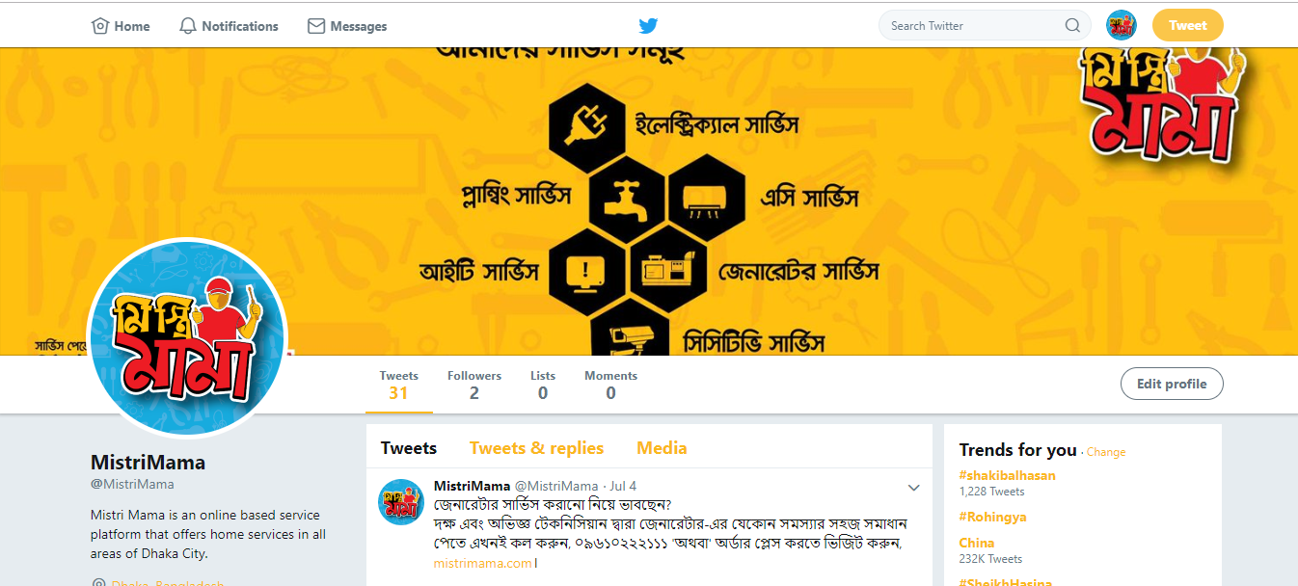
Figure 17: Official Mistri Mama Twitter Page

Role of Business Development Department of Mistri Mama

Administrative work: The main activities of the Mistri Mama business development department is organizing meeting with different persons or group, writing letters are some of the daily duties that an office administrator proposes.
Marketing and Branding: This department advertises and promotions all the services. It can be integrated with the sales features in some cases. This department is also engaged in the few operations, such as designing and creating promotional services, arranging marketing events, probable launches and campaigns, developing websites as digital marketing system.
Brand Recognition: Business Development department doing brand recognition activities in social medias through digitally and offline. Like; Facebook, Instagram, LinkedIn, Twitter. In offline through physically visit the service provider shop.

Chapter – Three

Methodology, Data analysis and Discussion

Introduction

In Bangladesh, almost every person who owns a smartphone uses online web/application-based services. That can be online servicing platforms for home or offices, food delivery services platform, ride sharing services platform and many other. Keeping that on mind this study considers customers/potential customers who had/going to have home/office services through online platform in the near future. Then a number of respondents (40) who are randomly chosen for the study to conduct can be considered as samples for this study. At the data collection process, it can be seen that data used in the study is collected from both primary and secondary sources. Data collected here is further analyzed and interpreted with the help of supporting graphs and charts for proper understanding. The reporter then presented his findings as a result of the analysis conducted during the process. From the findings, the reporter here with inclusion of his own depth of understanding have presented some recommendations too. All these are explained and described in the continued parts.

Population and Sample for the Present Study

A total of 40 respondents were used as a database for research studies. Most of the young individuals answered the survey questions and showed how familiar they are with the internet home service platforms. Total sampling was used and all participants were chosen for data analysis.

Data Collection Procedures

In this section, this will give a brief introduction to the various techniques. These different types of investigation techniques will also be rationalized as they will be implemented to obtain the relevant, valid and precise information to be prepared with the goals of the earlier set project. Mitigating the research method used to collect accurate data to accomplish research goals within its constraints.

Sources of Data for this Report
It necessary to know the background data on different types of methodologies before deciding to select a research method and design. To carry out this research, I used both primary and secondary data as information sources. I have talked to the senior employees at Mistri Mama as a source of primary data and as a source of secondary data I have visited various websites on the associated online marketing topic. I have prepared survey questionnaires and targeted most young individuals to get response because they are more conscious of the technological innovation and understand very well about online marketing.

Primary Sources of Data
Primary data relates to the researcher’s own collection of first-hand information, which will be real-time information. This report based on the experience of my daily internship work. Other than developing this report from the data given by-
Hasibur Rahman- Deputy manager, E-Commerce & Digital Marketing
Fahim Sadd Mamoon- Executive- Mistri Mama

Secondary Source of Data
Secondary data relates to information gathered by someone other than the individual. Because this report is descriptive and also research based. This report developed on the basis of daily experience, internal documents and online information search are used to discuss certain subjects.
Figure 18: Data Collection Sources

Data processing usually involves collecting and manipulating data items to generate significant information. Data analysis is the method of monitoring, cleaning, converting and analyzing data in order to discover helpful information, to inform findings and to support the decision-making. In terms of report making, data processing and assessment is very essential. It mostly relies on efficient report. Proper working method helps to generate right information during the periods of research and ultimately fulfills the report’s objective. As stated before, it is a descriptive and research-based report. Online information search is mostly used to clarify the terminology’s theoretical point of view. And other information was collected from everyday work experience and in the office with the help of seniors.
Use of Questionnaire: At first, there were 20 question in total. Both close-ended and open-ended issues questions used for information collection, including a 5- point Likert scale. By using proportion in pie chart and bar charts, all the answers were displayed in the data analysis portion.

Analysis and Interpretation

There are 40 participants in total who responded 20 questions during the survey for data analysis and interpretation. Few questions analysis is interpretation given below.
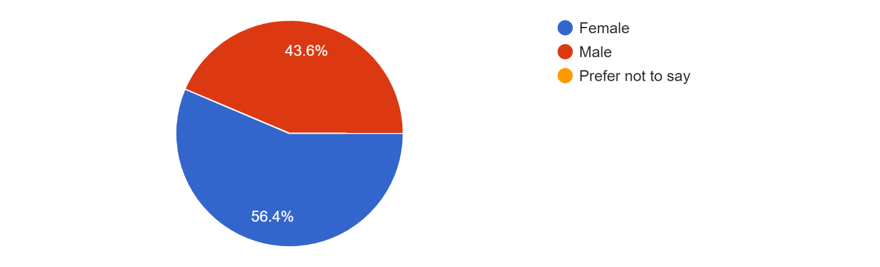
Gender: The following graph shows 43.6% of total male participants and 56.4% of total female participants who participated in the online on-demand home service marketplace survey.
Figure 19: Gender of the respondents

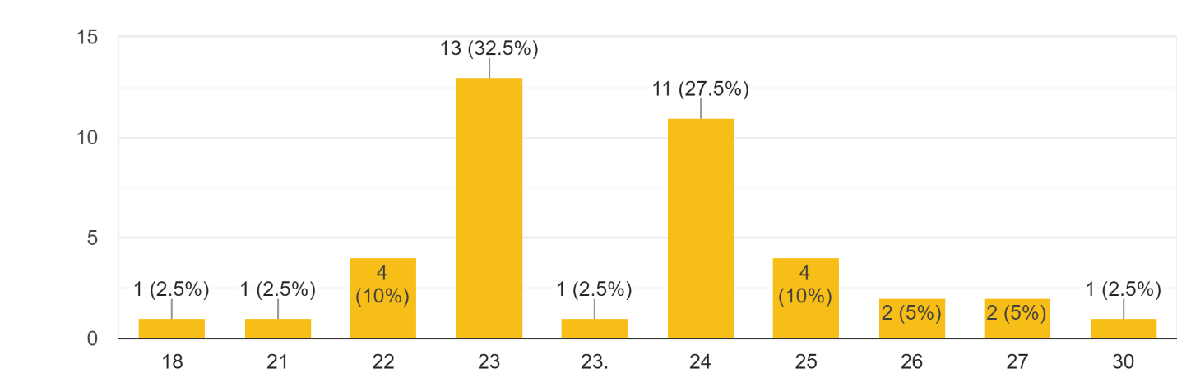
Age: The majority of the respondents are young and millennium. Approximately 32.5% of participants are in the 23 years and the remaining 27.5% are in the 24 years old. The following graph demonstrates the respondents’ age proportion.
Figure 20: Age of the respondents

Q1- It is much simpler to find plumbers in a mobile app/ website than to look for them from shop to shop.
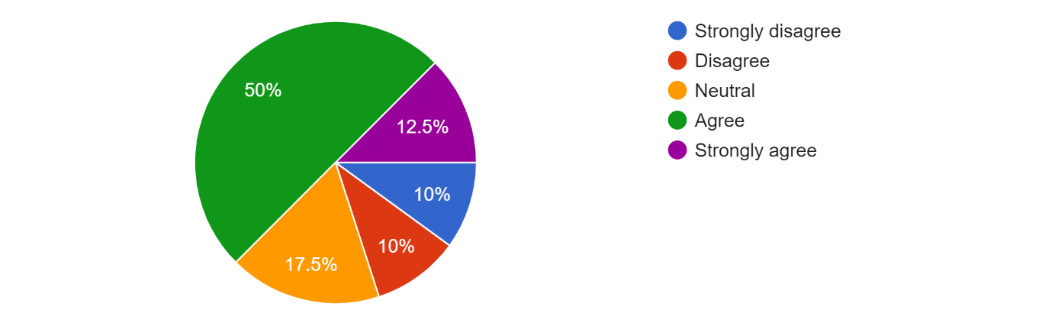
- 5 individuals strongly agreed with the statement, where 20 agreed, 7 participants took neutral stance and 4 individuals strongly disagreed. The graph below demonstrates it in detail.
Figure 21: Responses against Question 1

Q2- It is much simpler to find Electric technicians in a mobile app/ website than to look for them from shop to shop.
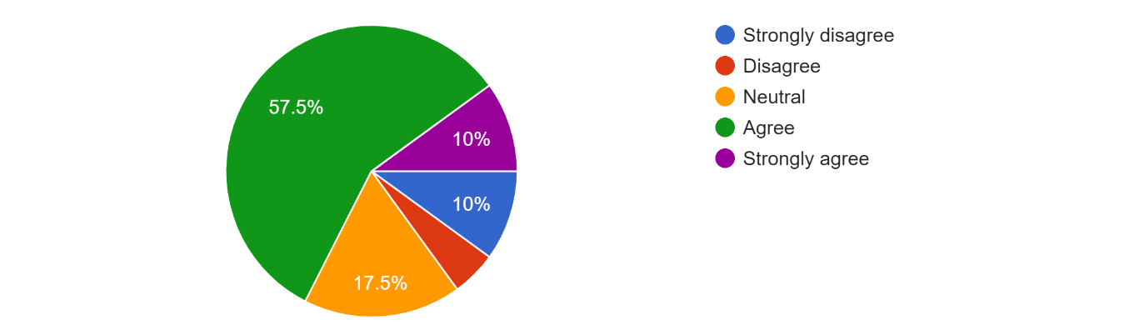
- 4 individuals were strongly agreed with the survey, 23 people said they were agreed with it, 7 were neutral and 2 others strongly disagreed with the above statement. The following diagram shows it properly.
Figure 22: Responses against Question 2

Q3- It is much simpler to find AC technicians in a mobile app/ website than to look for them from shop to shop
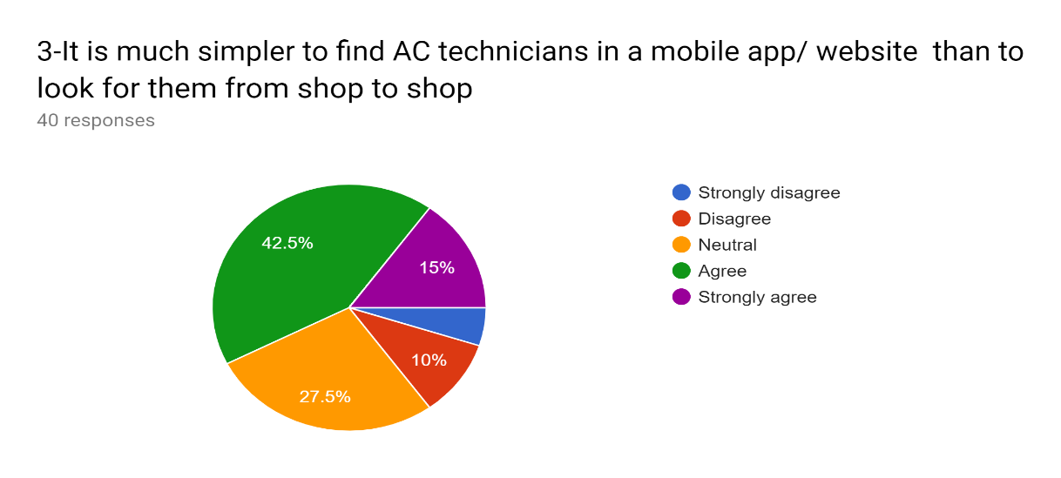
- 6 individuals were strongly agreed with the survey, 17 people said they were agreed with it, 11 were neutral and 2 others strongly disagreed with the above statement. The following diagram shows it properly.
Figure 23: Responses against Question 3

Q4- It is much simpler to find Generator technicians in a mobile app/ website than to look for them from shop to shop.
- 6 respondents were strongly agreed with the survey, 18 respondents said they were agreed with it, 8 were neutral and 3 others strongly disagreed with the above statement. The following diagram shows it properly.
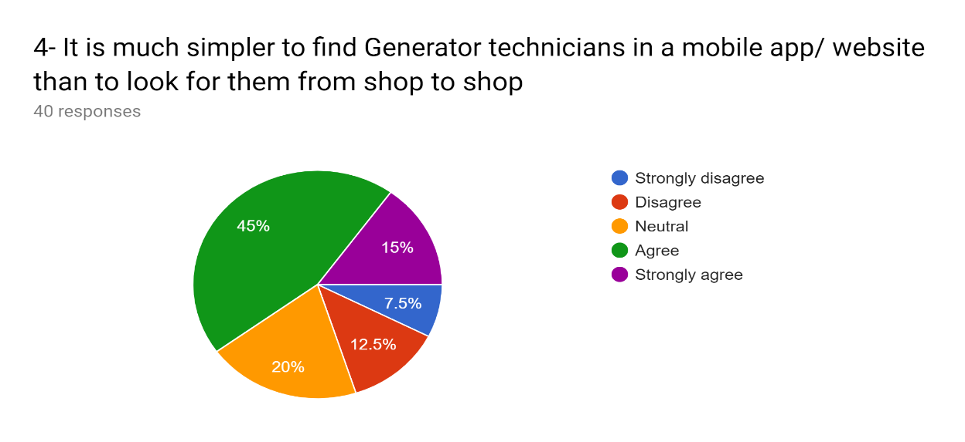
Figure 24: Responses against Question 4

Q5- It is much simpler to find CCTV technicians in a mobile app/ website than to look for them from shop to shop.
- 5 respondents were strongly agreed with the survey, 25 respondents said they were agreed with it, 4 were neutral and 3 others strongly disagreed with the above statement. The following diagram shows it properly.
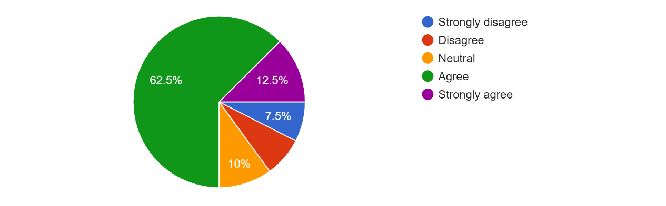
Figure 25: Responses against Question 5

Q6- Increasing use of smartphones and a growing online service portal help to grow on demand online services.
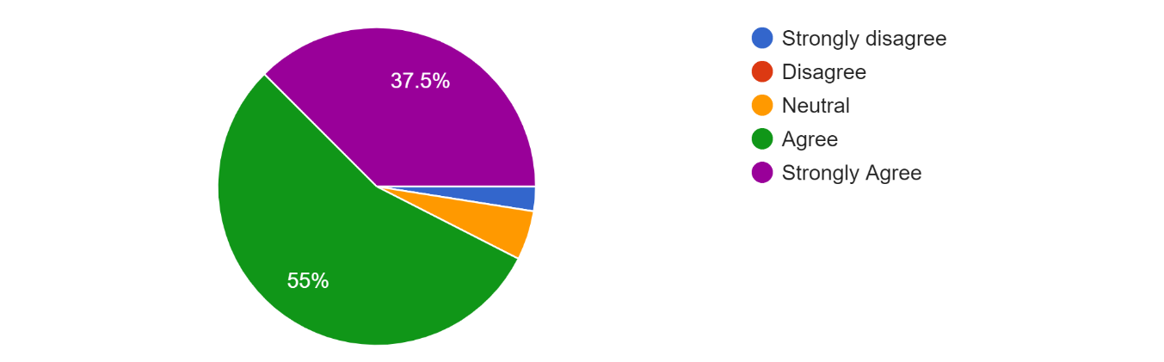
- 15 Respondents strongly agreed, 22 individuals agreed and 2 participate took neutral position with the declaration. The graph below demonstrates this in detail.
Figure 26: Responses against Question 6

Q7- Time saving is a major issue to deciding to take online services.
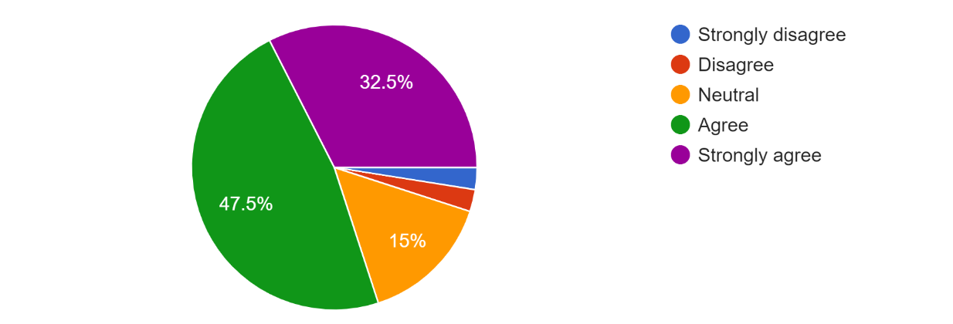
- Total 13 people were strongly agreed with the above statement where 19 agreed and 6 people took a neutral stance. The graph below demonstrates the answers to the above declaration.
Figure 27: Responses against Question 7

Q8- Adequate varieties of services attract customers to take online services
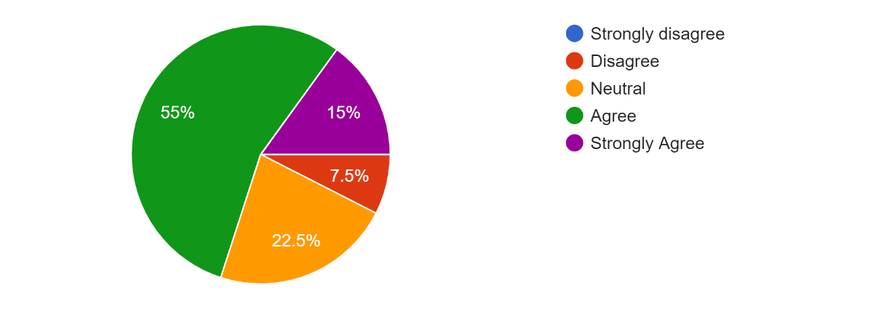
- 6 participants strongly agreed, 9 neutral, 22 agreed and 3 people disagreed with the survey that adequate varieties of services attract customers to take online services. Following diagram shows it properly.
Figure 28: Responses against Question 8

Q9- Website design/ function draws customers to take online services
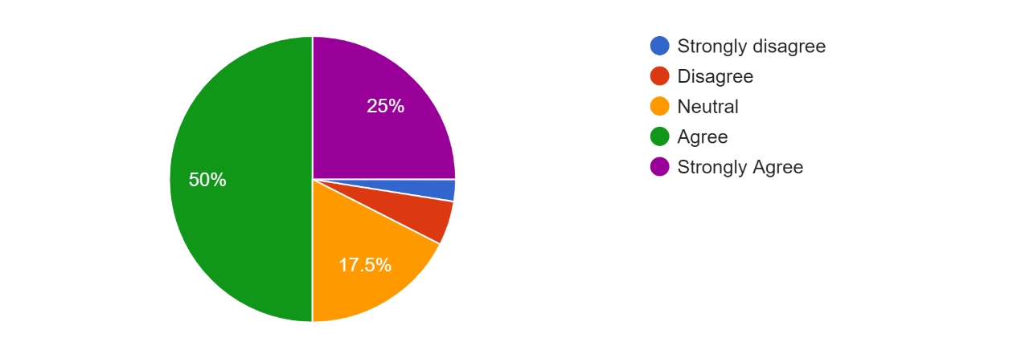
- 10 participants strongly agreed, 7 neutral, 20 agreed and 2 people disagreed with the survey. Following diagram shows it properly.
Figure 29: Responses against Question 9

Q10- An online home services company guarantees a simple lifestyle by offering home services at a decent cost and the comfort and time of customers
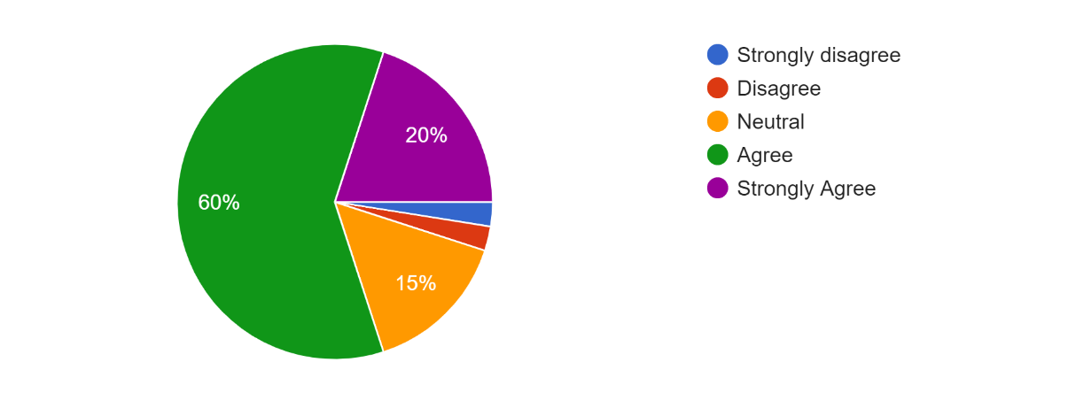
- 8 individuals were strongly agreed with the survey, 24 people said they were agreed with it, 6 were neutral and only 1 strongly disagreed with the above statement. The following diagram shows it properly.
Figure 30: Responses against Question 10

Q11- Increasing urbanization with increasing traffic problems, encourage individuals to take online services.
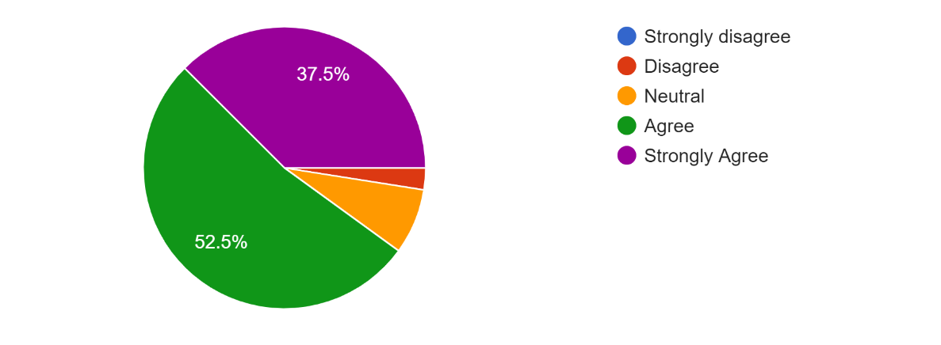
- 15 participants strongly agreed, 3 neutral, 21 agreed and 1 participant disagreed with the survey. Following diagram shows it properly.
Figure 31: Responses against Question 11

Q12- Busy urban lifestyle triggers customers to take online services.
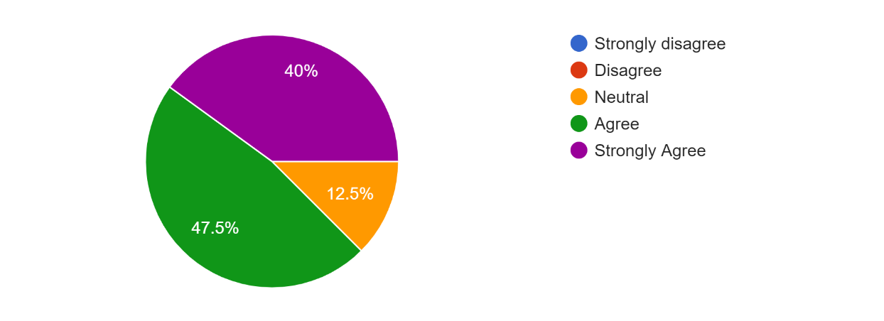
- 16 participants strongly agreed, 5 neutral, 19 agreed with the survey. Following diagram shows it properly.
Figure 32: Responses against Question 12

Q13- The need for online home facilities for consumer satisfaction contributes to the growth of the online home service marketplace
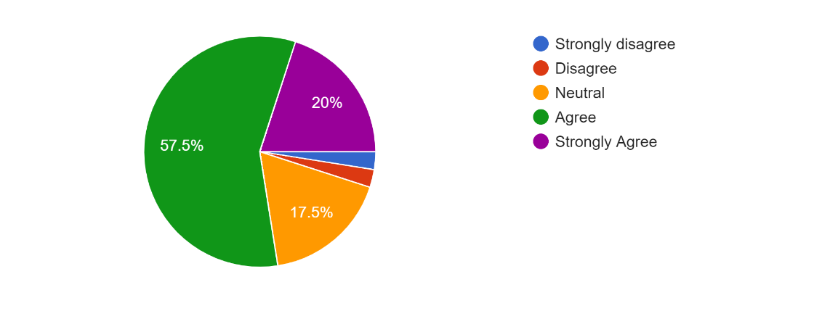
- 8 participants strongly agreed, 7 neutral, 23 agreed and 1 participant disagreed with the survey. Following diagram shows it properly.
Figure 33: Responses against Question 13
Q14- The busy urban lifestyle encourages consumers to prefer online services, resulting in an increase in the growth of the online market in the coming years.
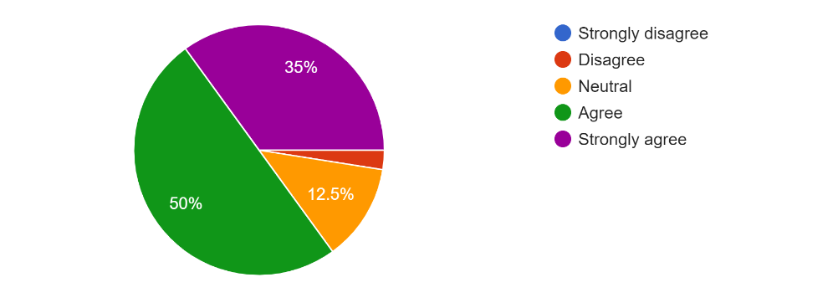
- 14 respondents were strongly agreed with the survey, 20 respondents said they were agreed with it, 5 were neutral and only 1 strongly disagreed with the above statement. The following diagram shows it properly.
Figure 34: Responses against Question 14
Q15- Consumer accessibility on-the-online home services needs is contributing to the increase of online on demand home service marketplace.
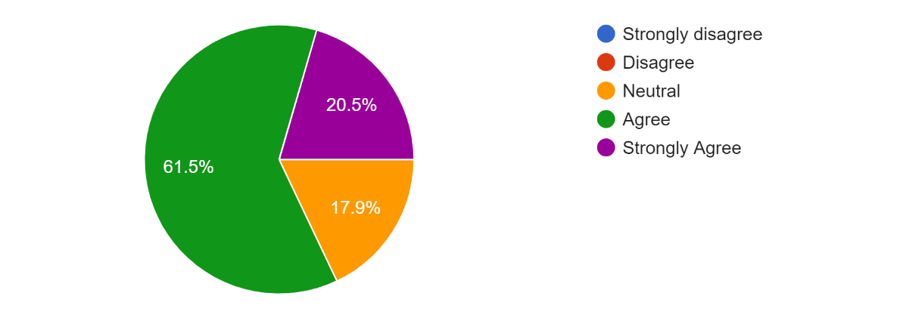
- 8 participants strongly agreed, 7 neutral, 24 agreed with the survey. Following diagram shows it properly.
Figure 35: Responses against Question 15

Q16- What do you do to find any kind of home service technicians?
Few comments of the participants are given below.
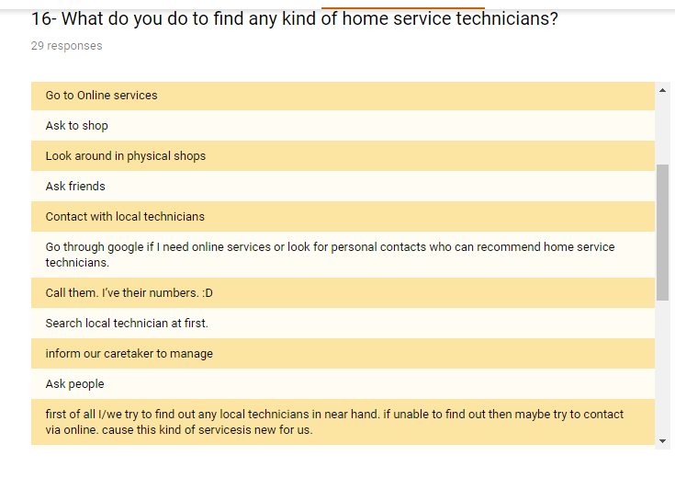
Figure 36: Comments on Question 16

Q17- What obstacles do you see when you pick up online services?
Few respondents’ comments on the on-demand home service marketplace difficulties;
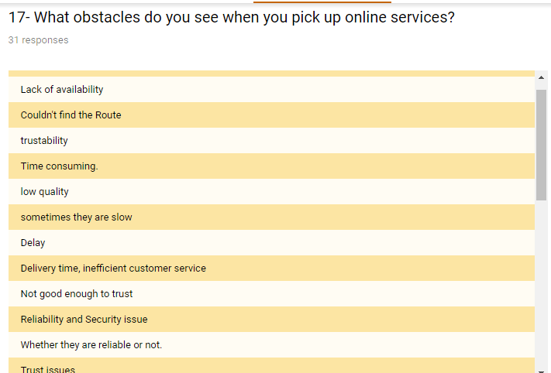
Figure 37: Comments on Question 17

Q18- What opportunities do you see in Bangladesh’s online home service companies?
Few comments of the participants about opportunities of online service in Bangladesh:
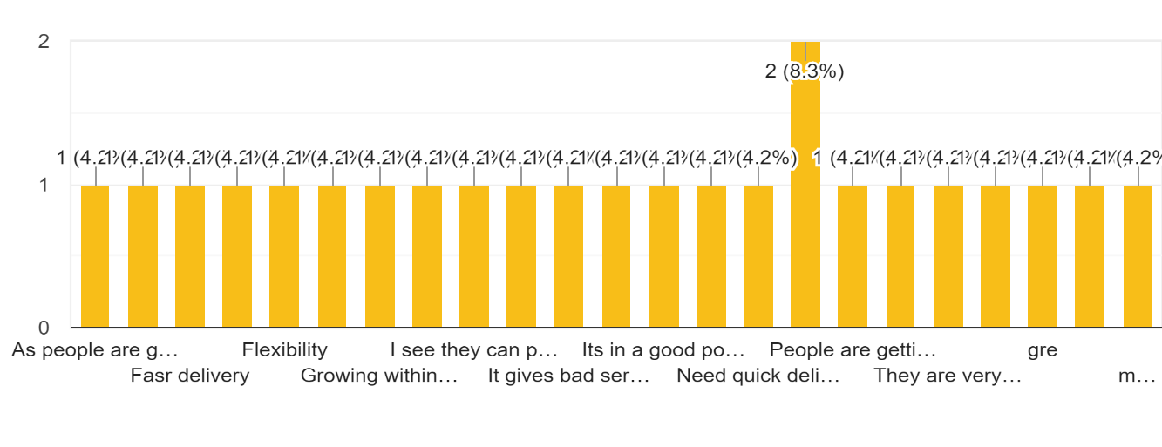
Figure 38: Comments on Question 18

Q19- What are the key advantages of taking home based online services according to you?
Few comments of the participants about advantages of taking online home-based services.
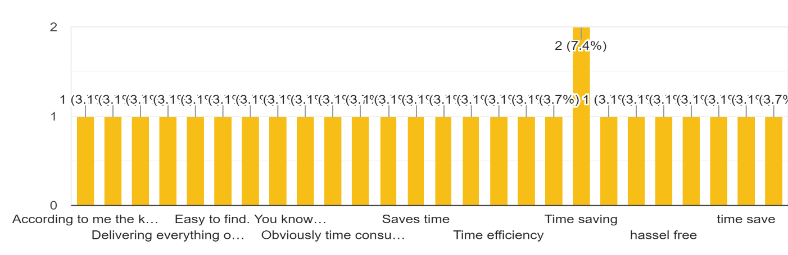
Figure 39: Comments on Question 19

Q20- After all the benefits have been realized, what proportion of the extra percentage can you pay for taking advantage of the online home-based service marketplace on demand?
For example; if a local store plumber charges 200 taka for kitchen sink blockage removal then clients will pay 240 takas with an extra 20 percent sum to take the service from online. The participants stated here how much they are ready to pay for taking online services as an additional charge are showing the below table.
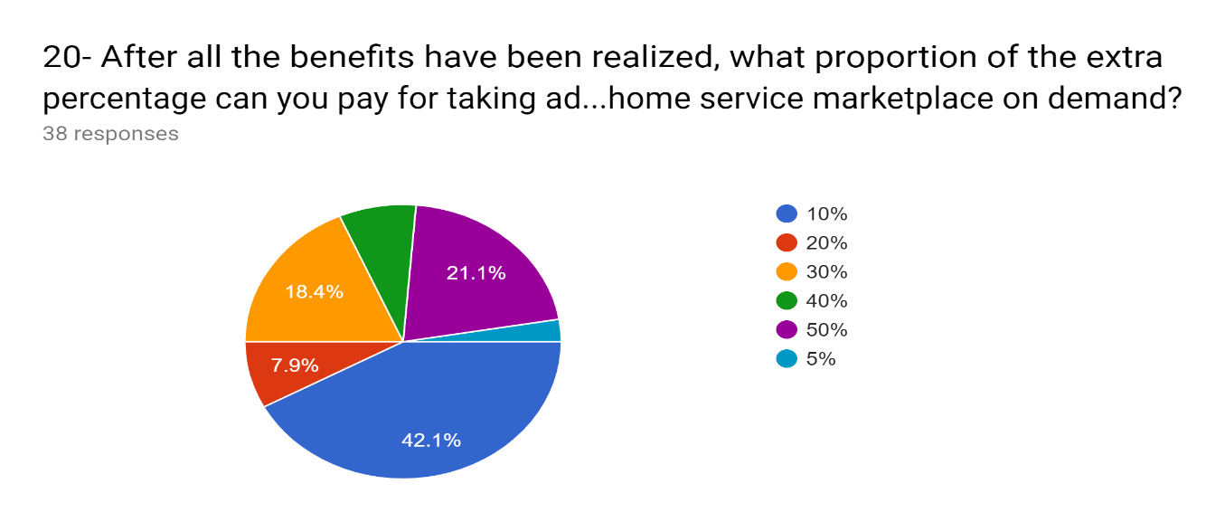
Figure 40: Responses against Question 20

Findings
Major findings of the research;
- Leading suppliers on the local on-demand market for home service.
- Key advantages, difficulties or constraints make the service platform expansion.
- Market has grown up surrounding the city.
- The result of the five- force assessment of the local online on-demand home services platform by Michel Porter.
Therefore, increasing internet and smartphone stimulation has altered customer behavior while purchasing product or taking service from anywhere in the town. It has become the simplest way to verify the appropriate pricing of the services and submit a home service on request at the doorway. People acknowledge ordering services from the website or mobile app is the simplest way to find a service provider from store to store.
Because of the simple accessibility and greater availability of extensive data with adequate category of service and comprehensive pricing, customers now consider taking services through a website or mobile apps to be more convenient for them.

Few key drivers from these findings can be identified;
- A busier lifestyle and urbanization with traffic troubles.
- Accelerating the consumption rate of smartphones and internet.

Key advantages for online home-based service market development;
- Service can be taken at any time
- No negotiation with the technicians
- The verified service providers provide quality service
- Service warranty given by the service provider etc.

Key Challenges to the Growth of Online Service Market
- Insecurity due to the possibility of unknown people inside the home
- Service quality may not be up to the limit
- Problem of technician illiteracy impacts customer satisfaction
- Internet connection may create the problems while placing the order of the service
- Both the client and the technicians need a smartphone
- System failure can impact and distract the mind of the customer to take the rivals services
- Unskilled technicians can harm brand value by giving poor services
- Many people cannot afford expensive online home-based services

Leading companies in Bangladesh local on-demand home-based services marketplace:
- Sheba.xyz
- Amar Sheba
- Handy mama
- Drooto etc.
Michael Porter’s Five Forces
Figure 41:Michael Porter's Five Forces for Online On-Demand Home-based Service Marketplace

Threats of New Entrants:
The threat to this online service industry is high for new entrants. Based on-demand home services, there are many companies run their business across the country. At the starting point, any business can target an area and start offering services with a very small investment and take all of the technicians into their service zone. There are also no obstacles to opening an online market in Bangladesh under the public laws and regulations. As a consequence, there is currently a strong risk for new entrants to this service industry.

Threats of Substitutes:
Local technicians, repair stores, technical mechanics are the primary replacements where customers can go straight to take services from them. Until now, there is a large group of individuals who have no intention of taking services from an online business. Furthermore, most of the senior citizens are not technologically sophisticated and used to hire a neighboring
technician to solve any issue. As a consequence, the risk of replacement is also high owing to the constrained coverage of online service industries and the absence of technological understanding of most urban family decision-makers.

Bargaining Power of Buyers:
Most of the service consumers are targeted according to their lifestyle and financial situation. People with a high standard of living and the ability to afford online ordering facilities are the target clients of online business. A busy lifestyle is mainly a significant problem to take an online service with extra price to save previous time and trouble finding local store technicians. As a consequence, negotiating power will be modest for service recipients as they do not have as many choices as the current online home service suppliers to get a better home service in their comfort and time.

Bargaining Power of Suppliers:
The negotiating power of the supplier is always high since they have their current business in their locally and most individuals are used to go straight to their stores or call them directly when they need a repair or maintenance service. Suppliers can provide home services with a cost negotiation chance from their current source. There is always a fixed price list in an online service market based on the choice of the individual service provider. In addition, service suppliers must retain the company’s terms and conditions while providing services on their behalf. In addition, service suppliers must retain the company’s terms and condition’s while providing service on behalf of them. As a consequence, service supplier may alter their choice not to work with any organization to ensure flexibility in their job and avoid company-specified laws and regulations. On the other side, service suppliers may alter their minds for more advantages and move to another organization. For an online home service business in Bangladesh, the bargaining power of the supplier is always high.

Rivalry among Existing Competitors:
A major competitor named Sheba.xyz, along with other smaller business named Handy Mama, Amar Sheba and Drooto etc. has been around so far. Sheba.xyz is the biggest industry on the market among all rivals and the majority of target clients are familiar with it. Sheba.xyz has benefit of a recognized brand value with a larger market share with a first mover advantage.
Other rivals have comparatively restricted advertising and target market coverage along with many other local service suppliers. So, a new business still has a strong chance to take the possibility to make the best use of the opportunity to correctly brand and effectively capture market share.

Recommendation

I observed some of the shortcomings during my internship time period and faced some obstacles. So, there’s something to recommend for improvement at the end of this report.
The organization’s most significant recommendation is to keep connected to the clients on a periodic basis since most clients are targeted with a huge-income rate depending on the medium to high standard of living, they need to deeply involve with the internet and smartphones. Besides, most clients are baby boomer and will lead the upcoming future market that will be based entirely on online sources. So, it is also necessary to connect online markets with clients through various online media and channels. Using email, messengers and social media will be the best way to communicate and involve target clients with the online services. According to a previous research (Jungleworks.com), 56% of clients either text or call service suppliers directly. Facebook will therefore play a crucial role in communicating and reaching customers. In addition, it is also necessary to maintain Facebook page and advertising to maintain clients in contact.
For the respondents, the price list benchmark for the specific services should be sustained. So, the client never thinks they’re getting costly services that are far costlier than the rates of the local technicians.
Users’ ae concerned about the quality problem. Therefore, adequate high-quality service should be sustained in order to benefit clients by taking the services. Service guarantee should be provided to clients as part of quality assurance, so that they feel secure while receiving the services.
Clients feel unsecured because of the technicians’ absence of professional behavior or standards. So, adequate training needs the service provider to be provided to satisfy the clients decently.
Unskilled technicians can damage the company’s reputation and according to the results, even clients are also concerned about inexperienced technicians. It should be regarded that well-trained and experienced technicians are enrolled in the service system with adequate verification of their efficiency, skills and past work experience.
Smartphone and internet are the main difficulties for technicians and clients, according to most of the participants. Therefore, it should be guaranteed that all the technicians have good understanding of using the smartphone and internet when on board them into the service system, in addition to stimulating clients to use internet service through appealing advantages.
Respondents also indicated that system failure is also a difficulty to interrupt the online platforms service during elevated online home service provider’s dependence. System failure may influence the intention of the service user to prevent taking the company’s services and switching to others.
An excellent website performance and user-friendly app design and full-time web developer recruitment are therefore most essential to the organization in order to prevent system risks.
Customers feel that it is simpler and beneficial to call online service rather than to call local technicians, therefore, it should be established in a very particular manner that clients are benefitting from taking the service online.
As most participants referenced that they know the name and services and also infrastructure of an established Sheba.xyz. So, the Mistri Mama needs adequate branding as there are plenty of other tiny business on nearly every location to beat the company every moment. In addition, for branding purpose, SMS, email, leaflet, and door name plate, uniform as well as many other branding techniques can yield an excellent outcome.
As part of expanding marketing strategies, collaboration with regional partners can be a useful way to occupy a new region within short period of time and cover the entire target zones.
With regard to the industry analyst, targeting caretakers can be a great way to reach more clients by referring service to rentals or house owners.
Instead of referring a service to a person, referrals such as caretaker and random people can also be provided advantages so they feel motivated to refer services to benefit the business.

Conclusion

The report is mainly describing the Business development and Digital marketing activities that are performed by Mistri Mama. It is also containing my job responsibilities as an intern. I was delighted to have completed my internship in Mistri Mama. I have tried to define all of the business development and digital marketing activities that are generally being performed and also the activities that will be performed by Mistri Mama. In order to connect clients with the brands, digital marketing is very essential. It’s the most efficient and continuous way for now for a few days. It’s cheaper than any other activity. It is the simplest and most effective way of paying attention to clients by offering their required service and making them happy. At the conclusion of the report, it can be stated that the online on-demand home service industry in Bangladesh has discovered many possibilities and constraints.
Growing internet and smartphone percolation are the major trend behind this online service channel and shows as many company possibilities as possible since most of the millennials are the users of advanced techniques including internet and smartphone. Key factors of this marketplace are fast urbanization and busy lifestyle with simple access to state-of-the-art technologies and convenient service needs. Having considered both the beneficial and the adverse elements of the online on-demand home service industry, it can be said that in order to make life simpler and to get all the facilities at the door-step in the comfort and time of a customer. The need for an online on-demand home service platform is highly desirable and is a most common service platform among urban individuals. It therefor obviously shows a significant change in urban people’s lifestyle owing to the effect of the online platform. And that’s the ultimate evolution of urban residents’ lifestyle in the web and smartphone era.

Reference

- Retrieved June 20, 2019, from https://www.ssgbd.com/
- Vision, Mission & Values. (n.d.). Retrieved from https://www.ssgbd.com/vision-mission-values/
- Mistri Mama. (n.d.). Retrieved from https://www.facebook.com/MistriMama/
- Orlee. (n.d.). Retrieved from https://www.facebook.com/OrleeBD/
- Door step service provider. (n.d.). Retrieved from http://www.mistrimama.com/
- Digital marketing. (2019, July 25). Retrieved from https://en.wikipedia.org/wiki/Digital_marketing
- Email marketing. (2019, January 16). Retrieved from https://en.wikipedia.org/wiki/Email_marketing
- Mistri Mama (@mistrimama) • Instagram photos and videos. (n.d.). Retrieved from https://www.instagram.com/mistrimama/
- On-Demand Home Services: Next Big Trend. (2019, July 04). Retrieved from https://jungleworks.com/next-big-trend-on-demand-home-services/
- What is Online Advertising? - Definition from Techopedia. (n.d.). Retrieved from https://www.techopedia.com/definition/26362/online-advertising
- What Is PPC? Learn the Basics of Pay-Per-Click (PPC) Marketing [PPC U]. (n.d.). Retrieved from https://www.wordstream.com/ppc
- What is SEO? Search Engine Optimization Meaning. (n.d.). Retrieved from https://moz.com/learn/seo/what-is-seo
- What is social media marketing (SMM)? - Definition from WhatIs.com. (n.d.). Retrieved from https://whatis.techtarget.com/definition/social-media-marketing-SMM
- Business Development & Digital Marketing Activities Performed by Mistri Mama. (n.d.). Retrieved from https://docs.google.com/forms/d/15Vu0Y9w3fGZKqdwLfdPNyjWP_VpqUE27apoTKXhx0hM/edit#responses

Appendix

Survey Questionnaire
Your Name/ Email (Optional)
……………………………………..
Gender:
- Female
- Male
- Prefer not to say
- Others
Age: ………………
What is/are the preferred online company you may want to take services from
- Mistri Mama
- Sheba.xyz
- Handy Mama
- Amar Sheba
- Other…………...

Please Put Your Valuable Responses below (1-20)

- It is much simpler to find Plumbers in a mobile/website than to look for them from shop to shop

- Strongly disagree
- Disagree
- Neutral
- Agree
- Strongly Agree

- It is much simpler to find electrician technicians in a mobile app/website than to look for them from shop to shop

- Strongly Disagree
- Disagree
- Neutral
- Agree
- Strongly Agree

- It is much simpler to find AC technicians in a mobile app/ website than to look for them from shop to shop
- Strongly Disagree
- Disagree
- Neutral
- Agree
- Strongly Agree

- It is much simpler to find Generator technicians in a mobile app / website than to look for them from shop to shop

- Strongly Disagree
- Disagree
- Neutral
- Agree
- Strongly Agree

- It is much simpler to find CCTV technicians in a mobile app / website than to look for them from shop to shop

- Strongly Disagree
- Disagree
- Neutral
- Agree
- Strongly Disagree

- Increasing use of smartphones and a growing online service portal help to grow on demand online services

- Strongly Disagree
- Disagree
- Neutral
- Agree
- Strongly Agree

- Time saving is a major issue to deciding to take online services

- Strongly Disagree
- Disagree
- Neutral
- Agree
- Strongly Agree

- Adequate verities of services attract customers to take online services

- Strongly Disagree
- Disagree
- Neutral
- Agree
- Strongly agree

- Website designs/ functions draws customers to take online sevice

- Strongly Disagree
- Disagree
- Neutral
- Agree
- Strongly Agree

- An online home services company guarantees an simple lifestyle by offering home services at a decent cost and the comfort and time of customers

- Strongly Disagree
- Disagree
- Neutral
- Agree
- Strongly Agree

- Increasing urbanization with increasing traffic problems, encourages individuals to take
online services.
- Strongly Disagree
- Disagree
- Neutral
- Agree
- Strongly Agree
- Busy urban lifestyle triggers customers to take online services

- Strongly Disagree
- Disagree
- Neutral
- Agree
- Strongly Agree

- The need for online home facilities for consumer satisfaction contributes to the growth of
the online home services marketplace.
- Strongly Disagree
- Disagree
- Neutral
- Agree
- Strongly Agree

- The busy urban lifestyle encourages consumers to prefer online services. Resulting in an
increase in the growth of the online market in the coming years
- Strongly Disagree
- Disagree
- Neutral
- Agree
- Strongly Agree

- Consumer accessibility on-the-online home services need is contributing to the increase
of online on demand home services market place.
- Strongly Disagree
- Disagree
- Neutral
- Agree
- Strongly Agree

- What do you do to find any kind of home service technicians?
- What obstacles do you see when you pick up online services?
- What opportunity do you see in Bangladesh’s online home service companies?
- What are the key advantages of taking home based services according to you?
- After all the benefits have been realized, what proportion of the extra percentage can you
Pay for taking advantage of the online home service marketplace on demand?
- 10%
- 20%
- 30%
- 40%
- 50%

