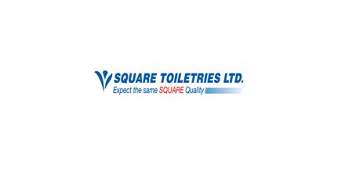


Internship Report On
Understanding the Grooming Habit of Women in Bangladesh

Submitted By:
Syeda Fairuz Raisa
University Id: 111 151 436
Trimester: Summer, 2019
Intern, Marketing Department
Square Toiletries Ltd.

Submitted To:
Dr. Md. Shariful Alam
Associate Professor
School of Business and Economics
United International University

Date of Submission: 26th August, 2019
Acknowledgement
Report making is a very important part of BBA along at the successful completion of internship period. It is not an easy task to do a report on “Understanding the Grooming Habit of Women in Bangladesh” and it is almost impossible to do it alone without the proper guidance. Finishing this report consumed huge amount of work, research and dedication. Still, implementation would not have been possible if I didn’t have enough support of my supervisor Dr. Md. Shariful Alam Sir. First of all, I would like to show my gratefulness to my supervisor Dr. Md. Shariful Alam (Associate Professor, SOBE, United International University) for making me successful to complete this challenging task and for giving proper instruction to complete this analytical report. There is no doubt about without his help and instruction I would not be able to make this report happen. Then I would like to convey thanks to many other people from the STL Marketing Team who provided me with valuable information which was much needed for the completion of this report successfully.

26th August, 2019
To
Dr. Md. Shariful Alam
Associate Professor
School of Business and Economics
United International University
United City, Madani Avenue, Dhaka 1212
Subject: Submission of Report on “Understanding the Grooming Habit of Women in Bangladesh”.
Dear Sir,
This is to inform you that I have completed the report on “Understanding the Grooming Habit of Women in Bangladesh” for the trimester of summer 2019.
In writing this report, I have followed the instruction that you have given me on your counseling hour and have also applied relevant concepts that I have learned throughout my various academic course of Marketing. I have defined the introduction and the findings and analysis results in this report. The information provided in this report is all analyzed, though some information and references have been taken from different source to facilitate this report.
However, I will be glad to clarify any discrepancy that may arise. Finally, I would love to express my gratitude for your supportive thoughts and kind consideration throughout the internship period.

Yours Sincerely,
_____________
Syeda Fairuz Raisa

Table of Contents
Content | Page Numbers
Chapter 01: Introduction  - Background of the Study  - Scope of the Study  - Objective of the Study  - Methodology  - Type of Paper  - Type of Information  - Source of Data  - Method of Data Collection  - Scaling and Questionnaire Design  - Sampling Design  - Method of Data Analysis  - Tools Used for Data Analysis  - Limitation of the Study  Chapter 02: Company Overview  2.1 Square Group  2.1.1 Other Concerns of Square Group  2.1.2 Associate Companies and Concerns of Square  2.2 Square Toiletries Limited  2.2.1 Vision, Mission  2.2.2 Quality Policy  2.2.3 Major Brands of Square Toiletries Limited  2.2.4 Media and Research Team  Chapter 03: Personal Grooming Habit of Women  3.1 Grooming Habit  3.1.1 Personal Grooming  3.1.2 Importance of Personal Grooming  3.1.3 Personal Hygiene Tips for Women  3.2 Personal Care Habits practiced by Bangladeshi Women  3.3 Personal Care Habits practiced by the Western Country Women  Chapter 04: Personal Care Product and Brands for Women  4.1 Personal Care Product Categories  4.2 Personal Care Product Brands by Square Toiletries  Chapter 05: Quantitative Data Analysis on Brand Equity of Different Personal Care Products  5.1 Samples for the Study  5.2 Analysis on the Usage Habit and Brand Usage of Different Personal Care Products  5.3 Analysis on the Brand Equity of each Product Category  5.4 Analysis on the Opportunities in Establishing Brands by Square Toiletries for Personal Care  Chapter 06: Findings and Recommendations  6.1 Key Findings  6.2 Recommendations  Chapter 07: Conclusion | (1-5)  2-2  2-3  3-3  3-4  5-5  (6-10)  7-8  8-10  (11-14)  12-13  13-14  14-14  (15-20)  16-16  17-20  (21-52)  22-22  23-45  45-50  50-52  (53-56)  54  55-56  (57-58)

Executive Summary
Brand is all about uniqueness and thus a continuous process. It is all about creating and capturing mindshare by establishing positive image in the minds of consumers. As our report was about understanding the grooming habit of women in Bangladesh, so from this report we were able to find out the positions of brands which is considered as the Brand Equity of Square Toiletries and its competitor companies. We got a clear understanding of women’s daily life personal care. Although, the habit differs from person to person, but there are some general habits that every person does, like- brushing teeth, taking shower, washing face etc. For each of these activities, the brand usage was identified. Brand usage was categorized by- “Most Often Used Brand” and “Currently Used Brand”. And then, the Brand Equity was found of Square Toiletries for personal care product categories. Here, it was identified by some of the attributes depending on the category of products. One brand was of STL and two other brands were of competitors. Respondents were asked to rank the brands in terms of those attributes. Also, we found some of the opportunities for STL where they can start operating their business. From our conducted survey we found, women use such product that STL doesn’t manufacture, like- shower gel, hair conditioner, hair serum and face cream. So STL can take these opportunities to run their business in near future. Though few of the brands were not well accepted by the users but most of them were. The brands of Square Toiletries overall holds a good impression in the minds of consumer. Some of the recommendation was also given to improve their few of the brands to capture a big portion of market share. As the day passes, STL will more improve and develop with their brands.

Chapter 01 (Introduction)
  - Background of the Study
  - Scope of the Study
  - Objective of the Study
  - Methodology
  - Limitations of the Study

1.1 Background of the Study
Present business world is more concerned with introducing new various subsidiaries rather just being stuck with the primary concern of the business. Business enterprise has become now a great source to give employment to various people and give the opportunity to utilize their skills along with the profit maximization. Beside with various international organizations, in Bangladesh there are some local companies who are serving the local customers by providing them the superior value of the products. Square Group is one of the companies in Bangladesh which has become the pioneers in this local arena.
For organization to be successful, creating a brand image of the products is a must. Brand expression can be considered as a benchmark for success. Now a day, customers have become savvier, so brand managers need to increase their role to ensure that customers can get a great experience by using the products. Brand development is all about creating a unique identity and perception of a product in the mind of the consumer.
Brand identity needs to be aligned with the customer’s perception, differentiate the brand with a unique identity from the competitors. Organizational mission and what they are going to deliver to its customers must be represented by the brand name. One key to successful brand- building is to understand how a brand identity and perception is being developed, to know for which purpose the brand stands for and how well the brand identity is being expressed.
Positive image of a brand and brand personality helps a brand to be distinguished from other competitors when the brand faces aggressive competition. Competitive offerings can make the brand unique to its customers and from the competitors as well. This can help to gain customer loyalty. When customers will understand the brand appropriately, the trust towards the brand will get stronger also the brand credibility will get higher. Therefore, company needs to establish a clear brand identity by linking brand attributes with the way they are communicated which can be easily understood by the customers.
My topic is “Understands the Grooming Habit of Women in Bangladesh”. Throughout this report it will help to understand the daily routine of personal care of a women also the category or usage of the brand, the factors or key points that needs to be understood while choosing a brand. Women now days are much more with their health care and hair care. So they have become very savvy in choosing the brands for personal care. Personal care does include- health care, hygiene care and skin care. We tried to find out the grooming habit of women in three different class, they are- college students, single working women and married working women.

  - Scope of the Study
The primary purpose for choosing the topic “Understanding the Grooming Habit of Women in Bangladesh” is to understand the personal care routine in the daily life of a woman. At present, women have become much more concerned about their personal care, they are now not only consigned within the household chores rather they know how to make time for their own personal care. Previously, women just used to put on hair oil, or some regular soap, but today beside with these hair oil and other regular stuffs like oil and soap, they now use shampoo, body wash gel, petroleum jelly, powder and many more. Personal care does include- health care, skin care and hygiene care. They also now have become very much brand conscious. Different product category has different brand. In this report, it has been tried to find out the brand usage and frequency of certain products. So now it has become very crucial for the personal care brands to know the current personal care habit of women. Hair care, health care and skin care brands should develop and cope with the time and develop suitable new products as well as renew the current products to become convenient for the current customers.
Secondary purpose is to fulfill the academic requirements for completion of BBA degree and being a Marketing major student to gather hands on experience in the developing the process of brand development. Another purpose is to reduce the gap between the academic learning and professional career in order to fit myself into the corporate world to get a full time employment.

1.3 Objective of the Study

- Finding out the daily routine of personal care of women
- Knowing the usage frequency of brands used for personal care
- Identifying the triggers and barriers for not being able to use a specific brand
- Understanding the brand awareness/ consciousness of a certain product category of the personal care
- Understanding the brand perception of the product category of certain brands

  - Methodology of the Study

    - Type of Paper: The paper can be both conclusive and exploratory in nature. Exploratory research has been done for the purpose of understanding the current brand situation and to get the insight of the research. Exploratory research is done basically by the experts. It is also called the expert survey. This research was done by consulting with the experts within the office and getting suggestions from the brand manager. Then comes the most important survey which is the customer survey. Some customer sample has been collected depending on the requirement of preparing the report. By doing customer survey it is understood what are the current need, want and demand of them in using personal care products considering the brands.

    - Type of Information: In this report both the qualitative data and quantitative data has been obtained. By doing face to face interview qualitative data has been obtained and by doing market survey quantitative data has been obtained.

    - Source of Data: Both primary and secondary data has been taken for the purpose of conducting the analysis. In this report, more emphasize has been given to the primary data to get the accurate data. As primary data is more authentic to conduct a report.

Primary Data: Primary data is observed and collected directly from first-hand experience. In this report, primary data has been collected by-

- One to one interview with the respondent

Secondary Data: Secondary data is collected by a source where the data already exists. The secondary data source for this report purpose are-

- Square Toiletries website
- Square Toiletries brochure
- Relevant websites

    - Method of Data Collection: For collecting the data accurately the best way that has been followed is doing survey by developing some structured questionnaire. Questionnaires were distributed to the respondents and they were asked to provide their perception on the brands. Personal interview technique has been the best way to collect the data to get the accurate data for conducting the report.

    - Scaling and Questionnaire Design: The survey data is obtained by non- comparative scaling techniques.

Questionnaire is designed by different types of questions:
- Basic Questions
- Classification Questions
- Identification Questions

    - Sampling Design:

- Target Population: Women of three categories. They are- College/ University students, Working women (single), working women (married).

Time | June 2019
Sampling Unit | Female
Sampling Area | Dhanmondi, Gulshan, Badda,
Element | Age, Occupation, Education, Income

- Sampling Technique: Random sampling technique; as women of different class has been chosen depending on their occupation and sample is selected based who spares time for their personal care.
- Sample Size: Sample size is 30 respondents.

    - Method of Data Analysis: Quantitative data has been analyzed by descriptive statistics using frequency distribution, and the results are presented by bar diagram, pie diagram, column diagram.
    - Tools Used for Data Analysis: Tools that are used to analyze the data are- SPSS, MS Word and MS Excel.

  - Limitation of the Study: During the collection of data there were some obstacles that we faced. Some of the limitations are:

- Unavailability of information
- Short time period of conducting the report
- Limited access to specific information
- Unwillingness of respondents to provide information
- Inconsistent type of information

Chapter 02 (Company Overview)
2.1 Square Group
2.2 Square Toiletries Limited

2.1 Square Group
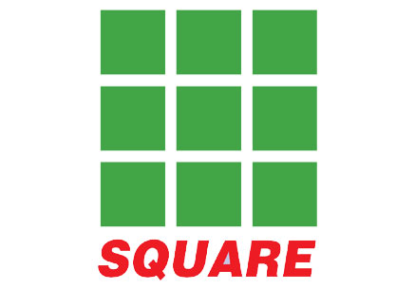
SQUARE today symbolizes a name – a state of mind. But its journey to the growth and prosperity has been no bed of roses. From the inception in 1958, it has today burgeoned into one of the top line conglomerates in Bangladesh. Square Pharmaceuticals Ltd., the flagship company, is holding the strong leadership position in the pharmaceutical industry of Bangladesh since 1985 and is now on its way to becoming a high performance global player.
SQUARE today is more than just an organization, it is an institute. In a career spanning across four and half decades it has pioneered the development of the local business in fields as diverse as Pharmaceuticals, Toiletries, Garments, Textile, Information Technology, Health Products, Food Products, Hospital, etc. With an average Annual turnover of over US$ 200 million and a workforce of about 3500 the SQUARE Group is a true icon of the Bangladesh business sector.
    - Some other concerns of Square Group

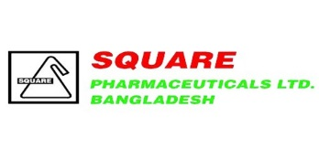
- Square Pharmaceuticals Limited
- Square Hospitals Limited
- Square Food and Beverage Limited
- Square Toiletries Limited
- Square Textiles Limited
- Square Herbal and Nutraceuticals Limited
- Square Informatix Limited




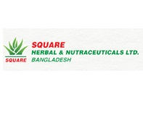



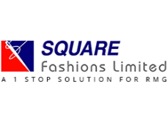
- Maasranga Communications Limited
- Square Fashions Limited
- Mediacom Limited
- Square Informatix Limited
- Sabazpur Team Company Limited
- Aegis Securities Limited

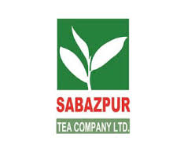



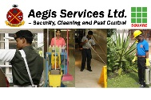
    - Associate Companies and Concerns of Square
As part of vast diversification, square has the following associated companies:
- Sheltech (Pvt.) Limited.
- Pioneer Insurance Co. Ltd.
- Mutual Trust Bank Ltd.
- National Housing Finance and Investments Ltd.

2.2 Square Toiletries Limited
Square Toiletries Ltd. is a part of the highly renowned local conglomerate in Bangladesh- Square Group. It is one of the largest and leading FMCG Company in Bangladesh with a turnover of USD 75 million. With their relentless innovation, STL is the pioneer for bringing in new products and packaging concepts in Bangladesh. They have gained the expertise and eagerness in fulfilling customers’ expectations with their quality product ranges through utmost sincerity. STL consider people as unique in terms of their needs, and to satisfy individual needs, they always try to maintain consistent quality of their unique products. Only for their customers, they are relentlessly striving to be "as unique as you".
STL debuts its journey in 1988 based on trust of Bangladeshi consumers, sound marketing and technical experience, square embarked upon a challenging journey into the toiletries market. Square Toiletries Limited was first merely a division of SQUARE Pharmaceuticals Ltd (SPL) and became a separate private Ltd in 1994. STL started journey with Jui which virtually pioneered the branded coconut oil market in country. Now it markets more than 30 product lines and an annual sale exceeding 1 billion taka and has now become one of the leading local Toiletries Companies in Bangladesh. STL manufactures and markets a wide array of consumer toiletries products ranging from-
- Dental Care
- Fabric Care
- Shaving Products
- Hygiene Products

- Bath soap
- Hair Oil
- Toilet Cleaner
- Baby Care

2.2.1 Vision, Mission and Quality Policy
Vision: Square attempt to understand the unique needs of the consumer and translate that needs into products which satisfies them in the form of quality products, high level of service and affordable price range in a unique way.

Mission:
- To treasure consumer understanding as one of our most valued assets and thereby exerting every effort to understand consumers' dynamic requirements to enable us in offering maximum satisfaction.
- To offer consumer products at affordable price by strictly maintaining uncompromising stance with quality. With continuous R&D and innovation we strive to make our products complying with international quality standards.
- To maintain a congenial working environment to build and develop the core asset of STL – its people. As well as to pursue for high level of employee motivation and satisfaction.
- To sincerely uphold the responsibility towards the government and society with utmost ethical standards as well as make every effort for a social order devoid of malpractices, anti-environmental behaviors, unethical and corruptive dealings.

Quality Policy: Dedicated to make every effort to understand consumer needs to provide maximum satisfaction and to achieve market leadership.
Strive to continuously upgrade manufacturing technology and to maintain optimum level of quality measures in conformity with the international standard – ISO 9001: 2008.Committed to achieve quality objective through continuous employee training and maintaining congenial working environment.

2.2.3 Major Brands of Square Toiletries Limited
Brands | Product Category | Brands | Product Category
 | - Meril Splash Beauty Soap  - Meril Milk Soap Bar  - Meril Baby Gel Toothpaste  - Meril Baby Lotion  - Meril Baby Powder  - Meril Baby Olive Oil  - Meril Baby Soap  - Meril Glycerin  - Meril Olive Oil  - Meril Petroleum Jelly  - Meril Chap stick  - Meril Lip gel  - Meril Conditioning Nail Polish Remover | 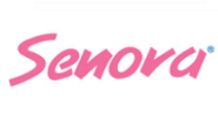 | - Senora Confidence Ultra  - Senora Confidence  - Senora Regular  - Femina Antibacterial  - Senora Confidence Super Long  - Senora Eco Belt  - Senora Eco Panty
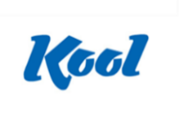 | - Kool After Shave Lotion  - Kool After Shave Gel  - Kool Deodorant Body Spray  - Kool Shaving Foam  - Kool after Shaving Cream  - Kool Deo Talc Powder | 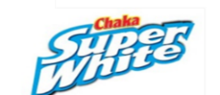  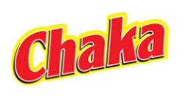 | - Chaka Ball Soap  - Chaka Laundry Soap  - Chaka Super White Washing Powder
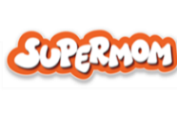 | - Baby Diaper  - Baby Wipes |  | - Jui Pure Coconut Oil  - Jui Hair Care Oil
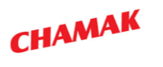 | - Chamak Fabric Whitener |  | - Shakti Liquid Toilet Cleaner
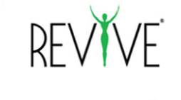 | - Revive Perfect Fairness Talcum Powder  - Revive Pimple Free Brightening Facewash  - Revive Enhance & Repair Shampoo | 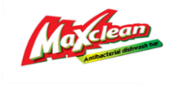 | - Maxclean Dishwash Bar  - Maxclean Dishwash Liquid
 | - Select Plus Shampoo |  | - Sepnil Hand Sanitizer  - Sepnil Hand wash
 | - Spring Air Freshener |  | - White Plus Toothpaste
 | - Xpel Aerosol |  | - Zerocal Sachet  - Zerocal Tablet

Chapter 03 (Personal Grooming Habit of Women)
3.1 Grooming Habit
3.2 Personal Care Habits Practiced by Bangladeshi Women
3.3 Personal Care Habits Practiced by the Western Country Women

3.1 Grooming Habit
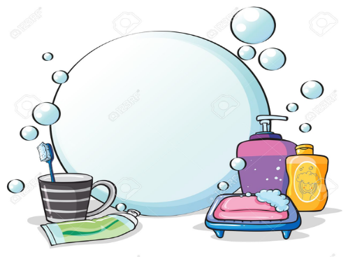
The things that one does to make their appearance clean and neat are basically referred to as Grooming Habit.
3.1.1 Personal Grooming
Personal Grooming refers to an art which helps individuals to clean and maintain their body parts.
Personal grooming is important for a positive self- image and every effort should be made to encourage and assist the resident to maintain a pleasing and attractive appearance. Personal grooming is also called preening. Individuals regularly clean themselves and put their fur, feathers or other skin coverings in term of hygiene.
3.1.2 Importance of Personal Grooming
Personal grooming is important in an individual’s life by its three aspects. The three aspects are-
- Professional Appearance: Professional appearances are more focused and tend to satisfy personal grooming. The working men especially want to maintain a professional appearance and thus this is very much true to them. Groomed personality really does matter, because it helps individuals to present him in a very good manner. Practicing personal grooming result in a more healthy body as well as result in looking better.

- Hygiene: Practicing personal grooming can also involve wearing fresh clothes, flossing teeth and maintaining a clean body. If one individual does this fewer things then they might not need to use any cologne to look and smell fresh, carrying hygiene to the next level also implies taking special care of the facial skin with quality products.

- Skin and Hair Care: Skincare and Hair care focuses on treatments and services for all kind of skin and hair, and to be groomed well personally these two things need to be cared much. This is why skincare and hair care is important.
Moreover, in today’s society to look fit and functional women must make sure that personal grooming care is up to the standard. Some basic things that women must not forget to take care of.
- Hair: Hair is the most noticeable thing that people see while meeting at the very first time. One must take care of her hair. In order to take care of the hair, one must apply shampoo and conditioner frequently. Also, to keep the hair set one can apply hair serum.

- Nails: Nails both the finger and toe must be cleaned and trimmed. This gives an important factor to notice that one takes care of every single detail of the personal care. Clean finger nails are important in the professional workplace as well as at any casual lunch or dinner.

- Skin: Skin is the most exposed part of a body that needs to be taken care of with utmost effort. There are lots of skin care products, like- body washes, moisturizers and many more. To keep the skin looking fresh and clean. When the skin looks good, at that time it gives an individual a confidence and gives a positive effect on the attitude.

- Teeth: It is said that clean teeth resembles healthy teeth. In order to maintain a good oral care, it is necessary to brush twice at least in a day. For fresh breath it is also necessary to use mouth wash.

3.1.3 Personal Hygiene Tips for Women
In order to be in a healthy mind and comfortable all day long it is necessary to maintain a good personal hygiene.
Personal Hygiene: Personal hygiene is not only about brushing, bathing, flossing and deodorizing which is basically monotonous activity.
Being women, they should take care of special care on feminine hygiene care. Some personal hygiene tips for women are given below:
- Cleansing: Women must take care of their private parts of the body. It is important to keep vagina protected against infections. To properly cleanse the external genitals what is required is warm water and mild soap, and also one must remember to rinse the soap suds thoroughly. One must need to avoid cleaning the internal genitalia.

- Menstrual Care: During menstruation, it is natural that women feel uncomfortable due to the wet and the bad smell feeling. What women must do during her period days is to cleanse the genitalia with warm water and normal soap just like normal days. While choosing pads, it is wise to choose unscented products to avoid exposing the genitalia to lot of chemicals.

- Eating and Hygiene: Eating and drinking also effects the feminine hygiene. Junk food and fried foods may taste good but internal body suffers a lot. Healthy food will keep the private parts smell good.

3.2 Personal Care Habits Practiced by Bangladeshi Women
Recently, Bangladeshi women are getting concerned about their personal habit. They are improving themselves in certain habits which they were not used to do before. They have become conscious about their hair, skin and hygiene.
From this report, we found a general grooming practice of Bangladeshi women that they do for their personal care. In our country, mostly women who are service holder, student and housewife they differ from their personal grooming habit.
Women in this country naturally brush their teeth once in a day, in most cases two or three times, and they prefer using toothpaste over tooth powder. Tooth powder might be used in rural areas. They cleanse their face two or three times in a day or sometimes in situational basis. Every women put hair oil more or less. In country perspective, women mostly use Parachute, Jui, Kumarika, Emami 7 Oil. They mostly puts oil three or four times in a week. Body lotion and Face cream is mostly used on seasonal basis. Menstruation is a major thing for every woman. So, to remain hygiene and safe during the days of period, women in Bangladesh mostly prefer using Sanitary Napkin than Menstrual Cup. And they are becoming very conscious about this day by day.
Though, the grooming practice differs from person to person. But this was the general overview of a women’s grooming habit in Bangladesh.
3.3 Personal Care Habits Practiced by Western Country Women
Women around the world spend a considerable time of time, money and effort on improving the personal appearance. According to a Personal Care Survey by Euromonitor International, women spend 42 minutes on beauty routines and personal grooming each day.
For personal care, marketers are targeting consumers internationally. It is essential to understand the contexts in which grooming takes place in which target market and if this differs within different market places.
Globally, women are most likely to engage in personal care routines at 7:30 am and 9:30 pm. However, in France and Australia the morning peak is a bit later, at 8 am. Each country also has smaller peaks during the day. But in Mexico, the amount of women grooming stays relatively high throughout the day.
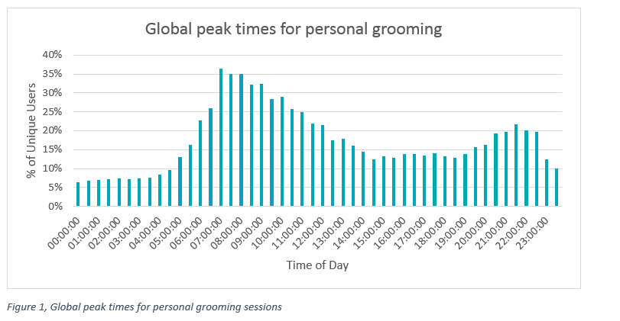

Chapter 04 (Personal Care Product and Brands for Women)
4.1 Personal Care Product Categories
4.2 Personal Care Product Brands by Square Toiletries

4.1 Personal Care Product Categories
Personal Care can basically be divided into three parts. Like:
Skin Care: Skincare is basically a range of practices that is practiced by both male and female in order to give the skin complete protection, enhance the appearance of the skin conditions. Skin care is a routine daily procedure. In this report, women skin care is the focused part. Some of the common skin care products are:
- Moisturizers: Moisturizers are products that are intended to hydrate the skin. Moisturizers are used to give skin a smooth appearance. Moisturizers help to protect the skin against the loss of the moisture from the skin. This contains special ingredient that helps to replace the oil contained in the skin. Moisturizers include both the face cream and body lotion.

- Cleansers: Cleansers include face wash, beauty soap and much other cleansing material to clean the face. Cleansers remove dirt, oil, makeup and dead skin cells. They help to unclog the pores, and to prevent the skin from drying out. Cleansers help the skin to look fresh and clean.

- Sprays: These are the body sprays that are being applied on the skin. These are used to prevent one from smelling bad.

Hair Care: Hair care is all the things that people do to keep their hair clean, healthy- looking and attractive. Hair care includes- Hair oil, hair shampoo, hair conditioner and many other things.
- Hair Oil: Hair oil is used to prevent hair fall also promotes the hair growth. Hair oil improves the look of hair by giving the hair more shinny and attractive look.

- Hair Shampoo and Conditioner: Shampoos are used to clean the hair. This also helps to make the hair silkier. Conditioner makes the hair smooth. Quality and the safety of the products are ensured through the selection of the ingredients for the products.

Hygiene Care: Hygiene care includes all the products that help to clean the body. But in this report, the primary concern in hygiene care is focused on the sanitary napkin.
- Sanitary Napkin: It is an absorbent item which is worn by women during menstruation. These pads are made from a range of materials depending on style, country of origin and brand.

4.2 Personal Care Product Brands by Square Toiletries Limited
The personal care product brands by STL are given below with a brief review.
Skincare Product Brands
Skin care product brands of Square Toiletries Limited include- Meril and Revive.
- Meril: Under the brand Meril, some of the products that they manufacture for skin care targeting the women are:
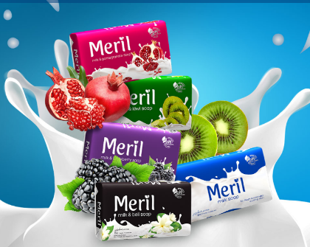
- Meril Milk Soap Bar: Meril Milk Soap Bar creates a link between the skin and milk. Meril milk soap bar is the soap which introduced five different variants to make the skin attractive, fresh, smooth and bright. This works as 6 times more moisturizer which removes dryness of the skin. The five variants of Meril Milk Soap Bar are: Milk, Blackberry, Kiwi, Pomegranate and the smell of Beli.

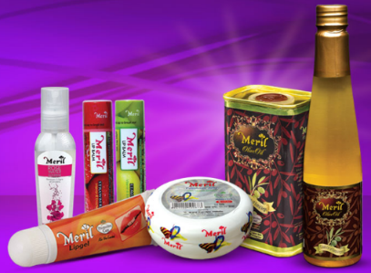
- Meril Protective Care: This includes Meril Petroleum Jelly, Meril Lip Care, Meril Glycerin, Meril Rose water Glycerin, Meril Olive Oil and Meril Conditioning Nail Polish Remover. Meril Petroleum Jelly protects the skin from being rough by giving protection up to five layers of moisture. Meril Lip gel and Lip balm gives the lips complete smoothness during the time of winter. It also gives long lasting protection against the sun. Meril Glycerin keeps the skin healthy and bright by balancing the humidity of the skin during winter. Meril Rose Water Glycerin removes the dry skin and the paleness of the skin and makes the skin smooth and soft. The anti-oxidant of Meril Olive Oil holds the younger looking vibe on the skin. By holding the normal humidity of the nail, Meril Nail Polish Remover keeps the nail beautiful.

- Revive: Another skin care brand of Square Toiletries is Revive. The products under this brand name are:

- Revive Moisturizing Lotion: Revive Moisturizing Lotion locks the humidity of skin and keeps the skin looks fresh. Also the growing herbs keeps the skin bright by removing the damaged skin.

- Revive Talcum Powder: Revive talcum powder contains active sunblock which protects the skin from sun and ensures complete fairness. It also protects from bad smell of skin and gives a smooth feeling because it is fulfilled with the smell of Jesmin.

- Revive Body Spray: This body spray gives the individual complete freshness for 24 hours. This does no harm to the skin.

- Revive Face Wash: Revive Face wash is specially produced for pimple free skin. The neem essence of it protects the skin from bacteria and keeps the skin clean. The sandal gives the brightness to the skin.
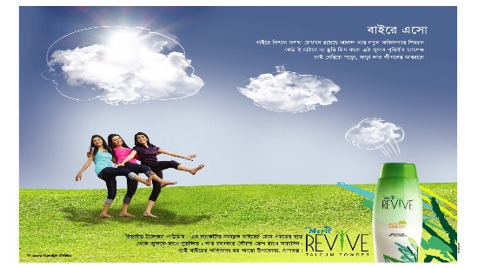
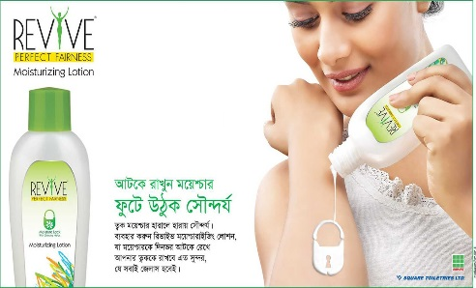

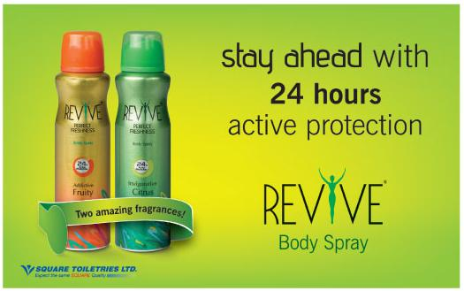
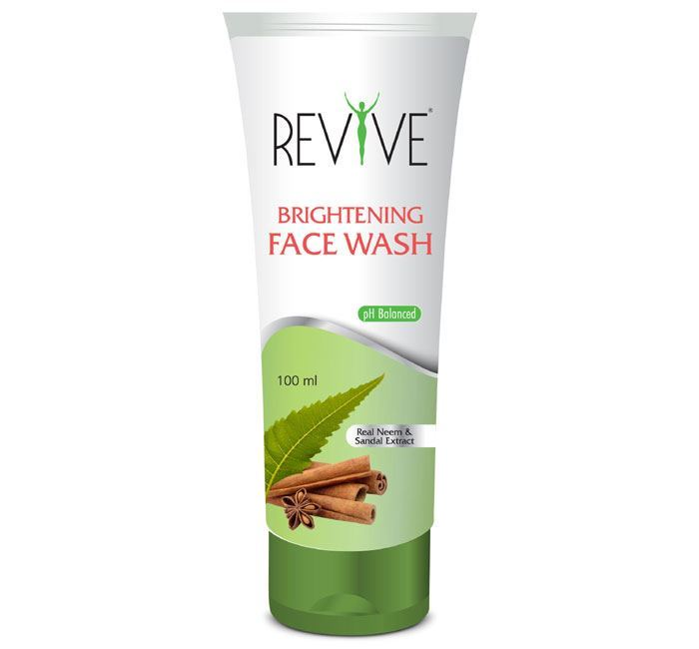

Hair Care Product Brands
Hair care product brands of Square Toiletries include- Jui and Revive.
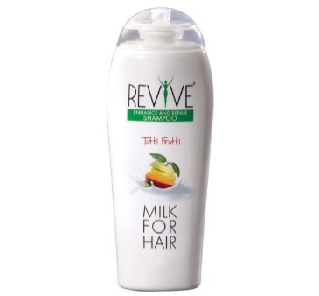
- Revive: The brand Revive also have hair care product. Which is Revive Shampoo?

- Revive Shampoo: Revive Shampoo contains the nutrition of milk with some best characteristics of nature. This has the fragrance of fruit and milk which gives the hair complete nutrition. It also removes damaged hair.

- Jui: Jui is basically a hair oil product which is manufactured by Square Toiletries Limited. The products under this brand name are-

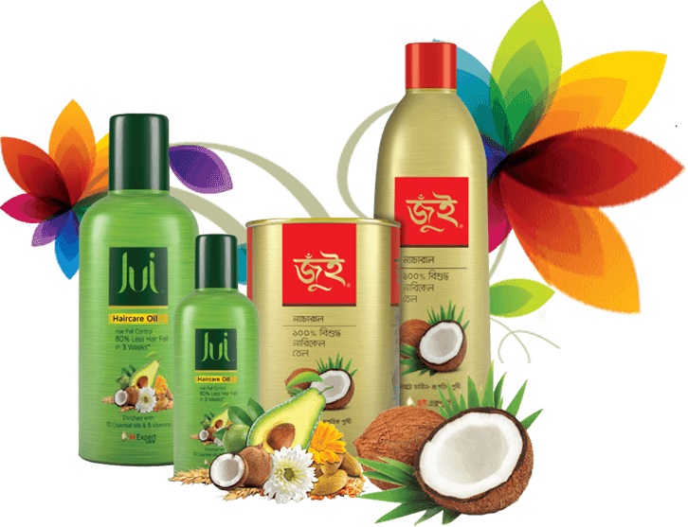
- Jui Pure Coconut Oil: This is an extra virgin coconut oil. Using this hair oil keeps the hair healthy, beautiful and shiny. The oil contains Vitamin E. This is made from absolutely 100% Natural Coconut oil.

- Jui Hair Care Oil: Jui Hair Care Oil prevents hair fall only in 3 weeks up to 80%. This is made of 10 important oil and 5 necessary vitamin. This ensures complete nutrition of hair and it is absolutely non sticky. Vitamin A that contains in this oil helps and protects the hair from UV damage. Vitamin B helps to increase the cells of hair. Vitamin C reduces the amount of iron from the scalp and gives healthy strong hair. Vitamin E increases the blood circulation. Vitamin F makes the hair soft and healthy by protecting the hair from dryness and damage.

Hygiene Care Products
Hygiene Care brands of Square Toiletries are- Senora and Femina.
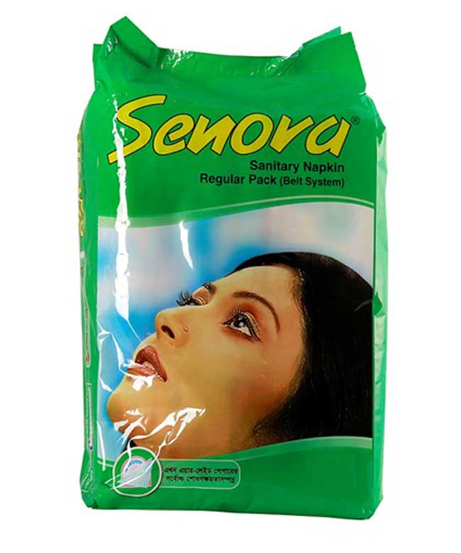
- Senora Sanitary Napkin: Senora Sanitary Napkin is the most healthy, absorbent and comfortable sanitary napkin. This is an antibacterial sanitary napkin. Some of the products under this brand are listed below:

- Senora Belt
- Senora Economy Belt
- Senora Panty
- Senora Economy Panty

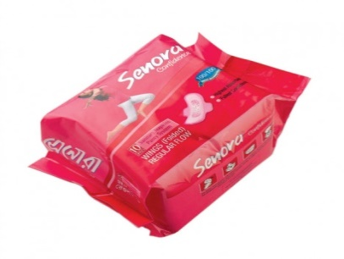
- Senora Confidence Sanitary Napkin: Senora Confidence is an Air Laid Paper that gives highest absorbency. The PPF gives the complete feeling. The wings of both side gives extra protection. The product list under this brand are-

- Senora Confidence Ultra
- Senora Confidence Super Long

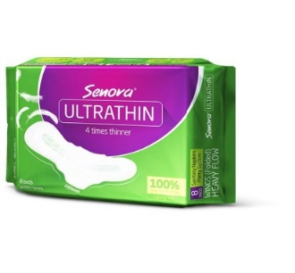
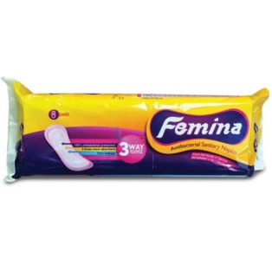
- Femina: Femina is a subsidized product from Square in hygiene category. This is a three way balanced sanitary napkin that gives complete protection and healthy life. It is 3 times more absorbent than using normal cloth.

- Senora Ultra-Thin: It is the most new product from Senora. It gives 4 times thinner experience during the heavy flow days. It is 280 mm long and giver 100% absorbency.

Chapter 05 (Quantitative Data Analysis on Brand Equity of Different Personal Care Products)
5.1 Samples for the Study
5.2 Analysis on the Usage Habit and Brand Usage of Different Personal Care Products
5.3 Analysis on the Brand Equity of Each Product Category
5.4 Analysis on the Opportunities in Establishing Brands by Square Toiletries for Personal Care

This chapter is all about the research that was conducted to get a clear understanding of the grooming habit that is practiced by Bangladeshi women. This chapter will include the findings, analysis of those findings and the interpretation of those findings. Also the category of different brands is being compared with the brands of Square Toiletries Limited in this chapter.

5.1 Samples for the Study
The target women for conducting the survey were: Students and Service Holder categorized by their Age and Marital Status. The ratio is shown below:

From above the charts it can be seen that, maximum portion of the target is student which represents 53.3% of the total and 46.7% is service holder. The target is also divided according to the marital status of the women. The ratio is shown below:

5.2 Analysis on the Usage Habit and Brand Usage of Different Personal Care Products
In this survey, firstly it is being tried to identify the usage habit of different personal care products based on their grooming habit. The products included- Toothpaste, Facewash/ Beauty Soap, Bath soap, Lip gel/ Petroleum Jelly, Sanitary Napkin/ Menstrual Cup and many more.
The habits for all this personal care has been identified by: Daily Once, 2/3 times in a day, once/ twice in a week, ¾ times in a week, Seasonal, Situational.
Also we tried to understand the brand usage of different product category in two different bases, one is “Mostly Used Brand” and another one is “Currently Used Brand”. Also, from the survey we found that, why the respondent prefers any other brand in the product category over the brands of Square Toiletries Limited. The Brand preference of the respondent is identified by three attributes. Those are: Price, Quality, and Brand Name.
An individual’s daily routine of personal care for different product category is shown below along with the brand usage and brand preference:
Toothpaste/ Toothpowder
From the survey, it is found that, all of the respondents of the target uses toothpaste rather tooth powder. They found using toothpaste more reliable for taking care of their teeth. The daily habit of brushing the teeth of the respondents is shown below with a column chart:
From the chart, we can see that 56.7% of the total respondents brush their teeth daily once and 43.3% brushes their teeth 2 or 3 times in a day. Also, they have mentioned that their brushing habit varies depending on the food habit. When they eat any sort of sweet items at that times they brush their teeth after having the item so that they can protect their teeth from cavity.

Brand Usage of Toothpaste
For the product category toothpaste five most common and popular brands were selected from where the Mostly Used Brand and Currently Used Brand (s) were identified. The following chart shows the Brand Equity of the brand White Plus, a Square Toiletries Brand in terms of the competitor brands. The competitor brands are- Colgate, Pepsodent, Close Up and Sensodyne and others mentioned by the respondent.

Most Often Used
From the column chart, it can be seen that, among all the respondents 20% uses Whiteplus as their regular toothpaste. But here the ratio of Pepsodent user is higher, which is 30% of the total respondent. Closeup users are almost 23%, Colgate users are about 13% and both the Mediplus and Sensodyne have 7% of the total user.

Total Respondent: 30
Currently Used
Currently used brands state the fact, which of the brand respondents are using now. Pepsodent users hold 33% of the total respondent and Whiteplus user’s rate is 20%. Closeup has 23% users of the total users, Colgate has been used by 17% of the users and 7% users used Mediplus recently.

Total Respondent: 30

The respondents were asked to state the reason for not using the brand Whiteplus. Some most common reasons and their ratio are shown below:

Total Respondent: 30

We can see that, 23% of the total respondents said that it is unavailable in many physical stores. 20% didn’t know that the brand Whiteplus exists as they don’t see any advertisement of it or any sort of promotion. 10% of the respondent raised question about the quality of the paste and 10% didn’t find it credible as it is not suggested by doctor.

Face Wash/ Beauty Soap
For washing face, people basically use two products. One is beauty soap and another one is face wash. But while doing survey, we found that maximum women use facewash to clean their face than beauty soap. Their saying was, using facewash is more convenient then using beauty soap. In any situation if face cleansing is required then facewash is easier to use. Few of the respondents mentioned that, carrying facewash is also travel friendly. The category usage for both the products for washing face is shown below:

From the chart, we can see that among the total respondent 96.7% women uses face wash 2/3 times in a day to clean their face from dirt and only 3.3% practices this habit in a situational basis

Brand Usage of Face Wash
Some of the most common and popular brands of face wash that has been selected are- Ponds’, Himalaya, Dove, Tea Tree, Garnier, Neutrogena. These all the brands are considered as the competitor brands of Revive Face wash, which is a brand of Square Toiletries. The following chart shows the Brand Equity of the brands in terms of “Most Often Used” and “Currently Used”.
Most Often Used
The following chart shows that, Himalaya is the most often used brand comparing to others. Whereas, Revive Face wash user is 0%. Garnier, Dove, Tea tree, Lotus, Ponds’, Neutrogena, Harmony, Charcoal black have respectively 17%, 13%, 13%, 10%, 7%, 3% and 3% of users.

Total Respondent: 30
Currently Used
In the category of Currently Used Brand, here also the result shows that, the currently used brand is also the Himalaya. But in this case, we found that 3% of the total respondent is using Revive Face wash as their currently used brand. Thus, Garnier has 20% of the users, Dove 13% of the total users, Tea Tree and Lotus have 10% of the users respectively, 7% of the users are using Ponds currently and 3% are using Neutrogena and Harmony.
Respondents mentioned some of the reasons for not using Revive face wash. The reasons are shown in the following column chart:

Total Respondent: 30

The results show that, 50% respondents are not aware of the brand. They said, if they see any sort of promotion for Revive then they might consider using it. 20% said the unavailability of the product. It is available in online store but not in physical store. Online shopping for face wash is not convenient. 10% said it doesn’t suit the skin. 10% had doubt regarding the quality issue and 7% got negative review from others about the product.
Hair Oil
Hair oil is one of the most crucial things of personal care. Almost every woman more or less applies hair oil on their hair to make the hair look beautiful, shiny and smooth. The usage rate of hair oil in personal care is shown below:
The chart shows that, 76.2% of the total respondent applies hair oil once or twice in a week, 14.3% applies oil three or four times in a week and 14.3% applies hair oil on situational basis depending on the hair condition.
Brand Usage of Hair Oil
In the product category of hair oil, Square Toiletries manufactures Jui Hair Oil. In the report, we tried to find the position of the Jui brand comparing to other competing hair oil brands. The most popular hair oil brands are- Parachute. Kumarika, Vatika, Herbal Oil, Rapunzel’s Secret and others. The results for the Mostly Used Hair Oil and Currently Used Hair Oil are shown below:

Most Often Used
The result shows us that, maximum respondents use the Parachute Hair Oil, which is 27% of the total respondents whereas 23% of the respondents use Jui hair oil. Users of Kumarika and Herbal oil have 13% respondents of the total respondent. And 3% respondents use Vatika and Emami 7 oil.

Total Respondent: 30
Currently Used
In the segment of currently used brand, we can see that 27% respondents used Parachute Hair Oil recently and comparing to that Jui has been used currently by 17% of the total respondents. 13% used Kumarika recently, 10% are using herbal oil, Vatika and Emami 7 oil is been used by 10% of the total respondent accordingly and 3% used Rapunzel’s Secret currently.

Total Respondent: 30

Also from the survey, we found that there are few respondents those who don’t apply hair oil. 17% of the total respondent doesn’t apply oil on their hair.
There are also some respondent who stated the reasons for not using Jui.

Total Respondent: 30

30% of the total respondent stated jui as a poor quality. They faced some sort of problems after using the hair oil, like- hair fall seemed mostly common from the respondents. Jui hair oil didn’t suit the hair of 10% of the respondents. And 7% of the respondent doesn’t use Jui hair oil as it is not herbal. Recently most of the women rely on herbal oil.

Bath Soap
In this report, shower has been considered as an important factor in grooming habit.
From the survey, the results that is found is, among the total respondents 80% takes shower daily once and 20% takes shower two or three times in a day. For taking shower, they use either bath soap or shower gel.

Brand Usage of Bath Soap
For the product category bath soap the most common soap brands that we have selected are- Lux, Meril, Dettol, Harmony, Sandalina Sandal Soap, Dove and others those are mentioned by the respondents. Here Meril’s brand equity is compared with the other competing brands on the basis of Mostly Used Brand and currently used.
Most Often Used
From our survey, we can see maximum respondent uses Lux as their regular bath soap, the percentage shows that 20% of the total respondent use Lux as most often used brand. Whereas, 17% of the total respondent uses Meril as their regular bath soap. Harmony and Sandalina is used by 13% of the respondents accordingly. Dettol and Dove have the 10% of the total users. 7% of the respondents use Lifebouy and Centhol respectively and only 3% of the users used Imperial Leather as their most often used brand.

Total Respondent: 30
Currently Used
In this section too the Lux is at the top position, 27% of the respondents are using Lux as currently used brand and comparing to that, Meril is being used by 13% of the total respondent. Meril Milk and Beli soap bar is currently used by some of the users, which is recently launched by Square Toiletries Limited. Harmony and Sandalina is being used by 13% of the users respectively. 10% of the users use Dove and Dettol. And 7% of the users are using Lifebouy and Centhol.

Total Respondent: 30

Thus, respondents are using Meril soap but there are some reasons for which respondents don’t use the soap. The reasons are stated below:

Total Respondent: 30
From the column, we can see that, 43% of the total respondent mentioned that they don’t like the smell of the soap, as they found the smell very intense. 20% said that the soap is not up to a good quality, after using for few days, the soap melts and sometimes it breaks. And 13% mentioned about its unavailability. They observed that Lux, Harmony is much more available in physical stores than Meril.

Shampoo
Women use shampoo on their hair to clean the hair and to make it more beautiful, smooth and shiny.
In this report we tried to know the frequency of applying shampoo on hair by the women. From the survey we found that, 63.3% of the total respondent uses shampoo on a daily basis. 23.3% of the women from the target respondents apply shampoo three/ four times in a week and 13.3% uses shampoo once/ twice in a week.

Brand Usage of Shampoo
Revive shampoo is a product of Square Toiletries Limited. So, in this part we have identified some of the common shampoo brands like- Sunsilk, Dove, Pantene, Tresemme, Argan Oil Shampoo, Head & Shoulder and many more mentioned by the respondents. The brand usage of Revive Shampoo comparing to the competing brands depending on the Most Often Used Brand and Currently Used Brand is discussed below.

Most Often Used
In the category of Most Often Used brand, Sunsilk shampoo is accepted by most of the users. Though, Sunsilk Dove and Pantene they are in the equal position according to the respondent. 17% respondent mostly uses these three brands. 13% respondents use the shampoo Tresemme. 7% of the respondents use Argan Oil Shampoo, Head and Shoulder and Loreal. But the user of Revive Shampoo is very less comparing to all these. Only 3% respondent is using this shampoo.

Total Respondent: 30

Currently Used
Sunsilk is currently used by 13% of the total respondent, whereas, only 2% of the total respondent uses Revive. Comparing to all other brands, Revive shampoo stands very low in position.

Total Respondent: 30

The reasons stated by respondents for not using Revive Shampoo are discussed below briefly:

Total Respondent: 30

20% of the respondent strongly mentioned about its unavailability. They can’t find the shampoo in their locality rather it’s more available in online store but buying a shampoo from online is not worthy according to their saying. 10% said that the quality is not good; they got some bad reviews regarding the product. 3% raised question about the credibility of the brand as there is no promotion of it and 5% respondent are not aware of the brand.

Lip Care
Lips are one of the most sensitive parts of peoples face. This needs to be cared with more intensively. In this survey, we basically asked the respondent whether they use petroleum jelly or lip gel for taking care of their lips. The category usage of the lip care products used by women is shown below in a chat:

From the survey we found that, women those who takes care of their lips on a daily basis is 75.9% of the total respondent. 20.7% of the respondent of the total takes care on seasonal basis and only 3.4% does this care on a situational basis.
Brand Usage of Lip Care Products
The lip care product that is manufactured by Square Toiletries Limited is Meril Petroleum Jelly and Meril Lip Gel as well. The major competing brands in this category of Meril are- Vaseline, Tibet. lIpice and many other.We have identifid the brand equity of Meril comparing to other brands on the basis of Most Often Used Brand and Currently Used Brand.
Most Often Used
From the survey, it is seen that women mostly prefers Vaseline, Meril and Tibet to take care of their lips. 43% of the total respondent use Vaseline as their most often used brand, Meril is used by 40% of the respondent and 10% users use Tibet as their regular brand. The brand equity of Meril in this category is in a very medium range.

Total Respondent: 30
Currently Used Brand
Mostly the brands that are used in a regular basis are also considered as their currently used brand. Here, the result also shows that 43% respondent use Vaseline and 37% respondent uses Meril, the percentage of using Meril is less here because of some bad experiences faced by the respondents. And 7% users use Tibet. Also 7% and 3% users are now using Lipice and Bioaqua accordingly.

Total Respondent: 30
But some of the respondents shared some bad reviews regarding the usage of Meril lip gel and Meril petroleum jelly. The reasons are-

Total Respondent: 30
The chart shows us that, around 15.5% of the total respondents didn’t like the fragrance of Meril as it is very intense. Some of the respondent faced lips sweating. The surrounding part of the lips got sweated after applying this. 5.6% complained that it is not sticky as it should be used.

Body Lotion
Body lotion is applied by women to make the skin feel better and being moisture. Mostly it is seen that women use body lotion during the season of winter. To make the dry skin feels smooth body lotion is being applied.
The usage frequency of body lotion that is found from the survey is, 84.6% of the respondents said that they apply body lotion on seasonal basis. 11.5% of the total respondent said that they apply daily once and 3.80% said they apply these two or three times in a day. 7% of the total respondent doesn’t apply body lotion.
Brand Usage of Body Lotion Products
Body Lotion is one the major things that women use for their personal care. Square Toiletries also has a body lotion brand which is named Revive, a locally produced brand. The competitor brands for Revive are- Vaseline, Ponds, Nivea, Bioaqua and others mentioned by the users.We will be seeing the brand equity of Revive body lotion depending on the usage –Most Often Used and Currently Used.

Most Often Used Brand
Body lotion is applied by women in seasonal basis most of the cases. 50% of the total respondent relies on the brand Vaseline as their most often used brand. 20% women used Ponds whereas, comparing to these two, only 3% of the total respondent use Revive Body Lotion as their mostly used brand. Others are- 17% respondent use Nivea and 3% respondent use Miniso body lotion which is manufactured by Miniso itself.

Total Respondent: 30

Currently Used Brand
In the situation of currently using brand, the results are not much more different than the Most often used brand category. The results shows that, 37% of the total respondent use Vaseline currently, 27% are using Ponds and 17% are using Nivea. Whereas, revive is used by only 7% of the total respondent. The ratio is a bit higher for Revive in the currently used brand than the most often used brand.

Total Respondent: 30

Some of the reasons that is stated by the respondents for not using Revive Lotion are-

Total Respondent: 30
43% of the respondents said that they didn’t hear the name of Revive Lotion. This means, they don’t have any brand awareness. 23% among the users who used said that it is rarely available in any cosmetics or super shop. And 17% heard some bad reviews regarding the product that’s why they don’t use it.

Powder
Powder is kind of such a product that protects the skin from sun as well as keeps the body cool.
From the research, we can see that 73.3% of the total respondent uses powder on seasonal basis, mostly in summer season. And 26.7% of the total respondent applies this on a daily basis. Also there are some respondents who don’t use powder. Their ratio is 43% of the total respondent.
Brand Usage of Powder
Under the brand name of Revive, an another product that Square Toiletries manufactures is Revive Talcum Powder, which gives active sun protection to the skin. This brand also has some certain competitors. Those are- Pond’s, Tibet, Cuticura. Most of the respondents who use powder use these brands. The brand equity of Revive Talcum Powder is shown below based on the Most Often Used Brand and Currently Used Brand.
Most Often Used Brand
From the conducted survey, we can see that Revive talcum powder is used by most of the users. The ratio is higher for Revive powder than any other brands. 27% of the respondents used Revive as their regular powder brand whereas, Ponds, Tibet and Cuticura users are respectively 10%, 13% and 7%. So, the brand equity in this category for Revive is higher than other brands.

Total Respondent: 30

Currently Used Brand
In the current scenario, Revive talcum powder is used by 33% of the respondent, which is higher than the most often used brand. And other brands Ponds, Tibet and Cuticura are used by 10%, 3% and 10% respectively of the total respondent.

Total Respondent: 30

But despite of having good brand equity of Revive, there are some reasons stated by the respondents for which they are not using it. The reasons for not using the brand are-

Total Respondent: 30
10% stated that, the product is a bit unavailable in the market. They had to search a lot to get this. 3% stated that they have no brand awareness for the product.

Menstrual Hygiene Products
At present, women use sanitary napkin and menstrual cup during their period days. Menstrual cups are being introduced recently and becoming popular day by day.
From the survey, we can see that, 86.7% of the total respondent’s changes sanitary napkin two or three times in a day depending on the flow. And 13.3% uses menstrual cup depending on the situation.
Brand Usage of Sanitary Napkin
In Bangladesh, most of the women prefer using Sanitary Napkin over the menstrual cups. There are some leading Sanitary napkin brands are available now. We will be seeing the comparison of those brands to find the brand usage of Senora, a brand of Square Toiletries Limited. The competitor brands for Senora are- Whisper, Freedom, Joya, Always.
Most Often Used
From the chart, we can see that, 47% of the total users of the Sanitary napkin use Senora as their regular use brand. Whisper is used by 27% of the overall respondent and 17% uses Freedom. So the major competitor for Senora we can see that Whisper and Freedom. Joya, Always and Menstrual cup is used by 3% of the total respondent accordingly. The brand equity in this category for Senora is high.

Total Respondent: 30
Currently Used Brand
In the case of currently used brand, Senora holds the maximum position. 40% of the respondent is using Senora now. Few of them have tried the recently launched Senora ultra-thin. 33% are using Whisper and 10% of the respondent is using Freedom. The usage frequency basically varies in these three brands of pad.

Total Respondent: 30
But there are some complaints regarding Senora for which the respondent doesn’t use it. The reasons for not using Senora are stated below.

Total Respondent: 30
23% of the total respondent complaint about bad absorbency of Senora. The absorbency is not so good, they found it average. The complaint about the leakage fact they experienced from using the pad. 10% said that the size is small; the wings size might be better and large. 7% had vaginal infection after using it which can be considered as a major problem from the brand Senora.

Face Cream
Face cream is used by both male and female. But in this, we focused on the grooming habit of women. From the chart, we can see that women apply face cream on their face on a seasonal basis; the percentage is 60% of the total respondent. 30% apply the cream daily once. But there are 3% respondents, who don’t apply face cream on their face.

Brand Usage of Face Cream
Square Toiletries doesn’t produce face cream. Women who use face cream mostly rely on the international brands. So we have identified some of the popular brands like- Ponds’, Nivea, Garnier, Dove, Fair & Lovely, Biotique, Lactocalamine. From this section, we will see which of the brands women prefer the most.
Most Often Used
For the category most often used, we can see the results from the chart that, Dove and Nivea cream is mostly acceptable by the respondents. Their ratio per cream is for 20% of the total respondent. Fair and Lovely is used by 13% of the total respondents. Lactocalamine, Biotique, Ponds and Garnier have relatively 10%, 6%, 3% and 3% respondent respectively.

Total Respondent: 30

Currently Used
From the column chart below, we can identify that respondent mostly don’t shift from the brands in this type of product category if once the product suits their skin, they keep using it continuously. Here also, Nivea is currently been used by 17% respondents. Dove, Fair and Lovely and Lactocalamine is used by 13% of the users respectively. Biotique is currently tested by 10% users, being a new brand it is accepted by the users. And Ponds and Garnier is used by 6% and 3% of the users.

Total Respondent: 30

Hair Conditioner
Hair conditioner is used after using shampoo on the hair. It is used to make the hair smooth and soft.
From the column chart, we can see that, 72.70% of the total respondent use conditioner three or four times in a week. 18.20% applies the conditioner everyday basically when they do shampoo. And 9.10% use this either one or two times in a week. But there are a number of respondent who doesn’t use hair conditioner.

Brand Usage of Hair Conditioner
In our country, the usage of hair conditioner has not become so popular. The usage of this is mostly seen among the service holder women. In this report, we tried to identify the brand usage of certain brands based on their popularity. As Square Toiletries don’t have a hair conditioner brand, so by identifying the usage from popular brands we will be able to define who will be the competitors for STL in future when the hair conditioner will be launched. Some of the popular brands that we selected are: Argan Oil Hair Conditioner, Tresemme Hair Conditioner, Sunsilk Hair Conditioner, Dove Hair Conditioner, Loreal Hair Conditioner, Pantene Hair Conditioner.
Most Often Used
From the chart below, we can see that Loreal Hair Conditioner is used by most of the users. The rate of Loreal hair conditioner user is almost 13% of the total respondent because of its good quality. Sunsilk and Pantene conditioner is used by 10% of the respondents accordingly. And Argan Oil Hair Conditioner and Dove Hair Conditioner is used by 6% users.

Total Respondent: 30

Currently Used
In the category of currently usage brands for hair conditioner, the results are kind of same. The most often used brands are as well used for currently used brands. Here also we can see that, 13% of the overall respondent uses Loreal recently. But in this case, Sunsilk Hair Conditioner is used by 13% of the total respondent. Pantene and Argan Oil Hair Conditioner is used by 10% respondent consecutively. And 6% are using Dove at present.

Total Respondent: 30

Hair Serum
Women use hair serum naturally to keep their hair set for a long time. Women naturally don’t apply hair serum on a daily basis. The frequency of applying Hair Serum is shown below:
Most of the women respondent said that they use Hair Serum on situational basis. 70% respondent applies Hair Serum on situational basis. 20% applies this on daily basis. But there are some respondents who don’t use hair serum.

Brand Usage of Hair Serum
Square Toiletries doesn’t manufacture Hair Serum. So to identify key competitors for hair serum which might be launched from STL, we selected few of the common brands. Those are: Livon, Bioaqua and Pantene. The usage is identified based on the Most Often Used Brand and Currently Used Brand.
Most Often Used
From the chart, we can see that, Livon Hair Serum mostly accepted by the respondents. 13% of the total respondent preferred Livon. They use it most often. On the other hand, Bioaqua is a sort of new brand in the Hair Serum product category. Bioaqua is used by 6% respondent and Pantene is used by 3% of the total respondent.

Total Respondent: 30

Currently Used
The results for currently used brand are almost the similar to mostly used brand. As like, most often used brand, currently 13% women from the total respondent are using Livon. 6% and 3% are using Bioaqua and Pantene accordingly.

Total Respondent: 30

5.3 Analysis on the Brand Equity of each Product Category
In this section, we will compare the brands of Square Toiletries Limited with the two most competing brands for each product category depending upon some of the attributes. Different product category states different product attributes. The attributes were measured on five point Likert Scales, where 5 is the highest and 1 is the lowest. The data were given input in SPSS Software and the Mean score for each of the parameters were identified. For each of the product category the comparison is shown below:
Toothpaste
For the product category Toothpaste, two of the most major competitor brands of White Plus have been chosen to compare based on some selected attributes. Two of the major competing brands are- Pepsodent and Colgate. The mean score for each of the attributes for each brand are shown below:
ToothPaste
Key Parameters | Colgate | Pepsodent | WhitePlus
Value for Money | 3.63 | 3.87 | 3.30
High Quality Product | 3.73 | 3.67 | 3.17
Available Everywhere | 4.87 | 4.80 | 2.57
Attractive Packaging | 3.43 | 3.70 | 3.03
Will Recommend to others | 3.10 | 3.23 | 3.17

From the above table we can see that, the brand Pepsodent scored higher 3.87 for the attribute “value for money”, this means after buying the toothpaste whether it was worth of purchasing or not in terms of money. For the attribute “High Quality Product” Colagte and Pepsodent significantly scored higher 3.73 and 3.67 comparing to Whiteplus. Based on the availability we can see that here also Colgate scored higher 4.87. Also Pepsodent is in the almost same position 3.80. Which means, it is highly available everywhere. The attribute “Attractive packaging” states how much lucrative the toothpaste packet was in the eyes of the consumer. Pepsodent has the highest score here 3.70. And lastly, respondents were asked if they will recommend the toothpaste to others, in this case, Pepsodent has the highest score as well 3.23. So from the above table we can conclude that, Pepsodent is the most acceptable toothpaste to the consumer comparing to Whiteplus. Whiteplus scored very less in the availability attribute which is only 2.57.
Face Wash
There are many more face wash brands that are available in our country currently. Of all those brands, two of the most competing brands of Revive face wash are- Himalaya and Fair and Lovely. The comparisons among these three brands are shown below:

Face Wash
Key Parameters | Revive | Fair & Lovely | Himalaya
Value for Money | 2.73 | 2.63 | 3.67
High Quality Product | 2.67 | 2.57 | 3.73
Available Everywhere | 1.97 | 3.93 | 4.53
Attractive Packaging | 2.80 | 2.90 | 3.37
Will recommend to others | 2.63 | 2.67 | 3.30

The above chart shows us the result that, Himalaya scored maximum in all of the attributes. In terms of value for money Himalaya scored 3.67, which means consumers are much satisfied with this brand. Consumers have less quality issues regarding Himalaya. For the attribute of “High Quality Product” it scored 3.73. It is highly available everywhere so it scored 4.53. The packaging or the lucrativeness of the tube scored 3.37 and when it came to the point of recommending others, in maximum cases consumers were neutral so this attribute for Himalaya scored 3.30. But if we look into the score of Revive face wash, we can see that Revive has very poor score in all of the attributes. It is not available everywhere. Previously respondents also told that they are not aware of this brand.
Powder
Revive talcum powder strongly competes with Tibet and Ponds. All these three brands are compared with each other based on some certain attributes. The results are shown below:

Powder
Key Parameters | Revive | Tibet | Ponds
Value for Money | 3.27 | 3.10 | 3.17
Fragrance of the Powder | 3.37 | 3.20 | 3.27
Available Everywhere | 3.20 | 4.57 | 4.60
Mixing Ability | 3.47 | 3.13 | 3.10
Attractive Packaging | 3.10 | 2.90 | 4.23

The result from the above table shows us that, Revive talcum powder is highly accepted by the consumers. For the attribute of “Value for Money’ Revive talcum powder scored 3.27 among the three brands. The fragrance of the powder is quite good, so the overall response was 3.37. But in the case of availability Ponds has the highest score 4.60. There is also an attribute which is mixing ability with the skin, here Revive scored 3.47 out of Tibet and Ponds. But in the lucrativeness of the powder bottle, Ponds has the highest score 4.23.

Hair Oil
Jui is considered as one of the leading hair oil brand in Bangladesh. And Jui competes with the most two strong brands are- Parachute and Kumarika. The comparison results for all the three brands are shown below:
Hair Oil
Key Parameters | Jui | Parachute | Kumarika
Value for Money | 3.33 | 3.87 | 3.00
High Quality Product | 3.23 | 4.03 | 3.13
Suits the Hair | 3.50 | 3.47 | 2.93
Available Everywhere | 3.63 | 4.87 | 3.27
Will recommend to others | 3.23 | 3.23 | 2.73

Respondents were asked to rate the hair oil brands based on some given attributes. In most of the cases, the hair oil brand Parachute scored the highest. According to the respondents, they feel that Parachute is more money worthy comparing to Jui and Kumarika. So in this case, Parachute has the mean score of 3.87. Also for the product quality, Parachute has the mean score of 4.03. But respondent who has used Jui and Parachute scored significantly 3.50 and 3.47 in terms of the suits the hair attribute. Jui has the mean score of 3.50 which is very close to the Parachute 3.47. Parachute is highly available in almost every shop so it mean value of 4.87, whereas, Jui is a bit less available so it has the score of 3.63. Lastly, if we see the recommendation part where respondents were asked if they will recommend the hair oil to others or not and they were asked to rate this attribute. Here Jui and Parachute both has the same mean value which is 3.23.

Bath Soap
Meril bath soap is one of the leading bath soap brands in Bangladesh. And two of the major brands against Meril are- Lux and Sandalina. The results for the attributes for each brand are shown below:
Bath Soap
Key Parameters | Lux | Meril | Sandalina
Value for Money | 3.07 | 3.80 | 3.33
High Quality Product | 2.83 | 3.60 | 3.37
Fragrance of the Soap | 3.07 | 3.93 | 3.23
Available Everywhere | 4.90 | 4.07 | 2.70
Attractive Packaging | 3.50 | 3.53 | 3.13

We can see from the above chart that, Meril is highly acceptable by most of the respondents. Meril has the maximum mean value comparing to the Lux and Sandalina. For the attribute “Value for Money” Meril has the score of 3.80, also in the measurement of quality it has the score of 3.60. The fragrance of the meril soap is liked by maximum respondents who have tried the different flavors of the soap. On the attribute of fragrance liking Meril has the mean score of 3.93. But in the case of availability Lux is ahead here, it has score of 4.90. But again in the case of packaging, Meril’s packaging rated by the consumers 3.53 which is closer to the Lux 3.50. But they mentioned that the packaging of Meril is eye soothing and lucrative.

Shampoo
In case of the category of shampoo, Revive shampoo is a brand of Square Toiletries Limited. And the brand competes with other two brands. Those are- Sunsilk and Dove. The comparison of the mean scores of these three brands is given below:
Shampoo
Key Parameters | Sunsilk | Revive | Dove
Value for Money | 2.97 | 2.87 | 4.03
Suits the Hair | 2.77 | 2.97 | 5.30
High Quality Product | 2.77 | 2.87 | 4.03
Available Everywhere | 4.97 | 2.20 | 4.40
Will recommend to others | 2.87 | 2.83 | 3.37

The table shows us that, Revive shampoo has almost least mean score in every attribute. Dove is more acceptable as here; the result shows that the mean score of Dove in maximum attribute is higher than other two. But for the attribute Availability, Sunsilk has the highest mean score of 4.97. But for Revive, respondent couldn’t actually rate it because they were not aware of the brand and they didn’t use it. So without having no brand awareness and no usage it was difficult for them to rate, so maximum respondent rated Revive shampoo brand either Neutral or Bad depending on the attribute.
Body Lotion
There are so many global brands that are available in the Body Lotion product category. And Revive being a local body lotion brand, it is competing with the other lotion brands like: Pond’s and Vaseline. All these three brands are compared to each other based on some certain attributes. The mean scores for each brand are shown below:
Body Lotion
Key Parameters | Revive | Pond's | Vaseline
Value for Money | 2.90 | 3.20 | 4.03
High Quality Product | 2.83 | 3.00 | 3.97
Suits the Skin | 3.00 | 2.93 | 3.70
Available Everywhere | 1.60 | 3.50 | 4.70
Will recommend to others | 2.80 | 2.83 | 3.23

We can see from the table that, people are much more satisfied with the Vaseline Body Lotion in terms of the attributes and usage. The mean score for Vaseline is higher in all the attributes. As we know, the higher the mean score, the better it is. Revive has a very poor mean score in almost every attributes. Most significantly, we can see that, it is rarely available and that’s why the attribute “Available Everywhere” got the mean score 1.60, which is very bad or not available at all. Respondents were asked say, why they don’t purchase from online? They said, purchasing a shampoo from online doesn’t seem convenient to them.
Lip Care
In Bangladesh perspective, people mostly uses three brand types lip care products. They are- Vaseline, Meril and Tibet. So the Square Toiletries Lip care brand Meril is competing strongly against Vaseline and Tibet. The comparison of their mean scores is given below:
Lip Care
Key Parameters | Meril | Vaseline | Tibet
Value for Money | 3.53 | 3.93 | 3.07
Fragrance of the Lipgel | 4.20 | 2.87 | 3.53
Available Everywhere | 4.30 | 4.57 | 2.77
Attractive Packaging | 2.97 | 4.10 | 2.87
High Quality Product | 3.43 | 3.73 | 2.80

The result shows us that, Meril has the highest mean score in just one attribute that is “Fragrance”, as it has the flavor of orange, so people like it mostly. For any other attribute, Vaseline is ahead. We can see that in case of availability, Meril and Vaseline are close to each other. Vaseline has the score 4.57 here, whereas, Meril has the score 4.30. The packaging of the Vaseline is much more lucrative than Meril and Tibet, 4.10. And lastly, respondents were asked if they will recommend it to others. In this case, basically they were neutral and in few cases they just rated that they will. So here the recommendation for Vaseline scored 3.73 which to close to Meril 3.43.
Sanitary Napkin
Senora is considered to be the leading sanitary napkin brands in Bangladesh. And this brand has wide range of acceptance among the females. The competitor brands of Senora are- Whisper and Freedom. Let’s see the position of Senora in terms of some certain attributes against the Whisper and Freedom.
Sanitary Napkin
Key Parameters | Senora | Freedom | Whisper
Value for Money | 3.93 | 3.83 | 3.53
Absorbency | 3.77 | 3.80 | 3.63
Available Everywhere | 4.73 | 4.37 | 4.27
Size of the Napkin | 3.47 | 3.70 | 3.53
Will recommend to others | 3.43 | 3.47 | 3.17

We can see that, for the attribute “Value for Money” Senora has scored 3.93 by the respondents, which means Senora is reasonable to the consumers comparing to the other brands. For the attribute of “Absorbency” three of the brands are very close but Freedom has the highest mean score here 3.80. Senora is available in almost every pharmacy or super shop, so here Senora has mean score 4.73. The size of the napkin is better for Freedom rather Senora and Whisper. Respondents were more likely to recommend Freedom than Senora, because few of the respondents had some bad experiences with Senora.

5.4 Analysis on the Opportunities in Establishing Brands by Square Toiletries for Personal Care
Women now a day uses many other personal care products which are not manufactured by Square Toiletries Limited. From the conducted survey, we have seen that, there are few of the products that women use which is not the product of Square Toiletries Limited. So, there come some opportunities for STL to enter into the new product category. Some of the products can be- Shower Gel, Hair Conditioner, Hair Serum, Face Cream, and Herbal Facial Gel. These are the most common products that are demanded by the women recently. They can implement the Product Development and the Market Development strategy. Product development strategy states the introduction of new products in the existing product line or developing the existing product in a new manner. Market Development strategy can be applied while entering into the new market with existing product or with absolutely new product. New product in a complete new market is called Diversification.
Square Toiletries Limited can also go for the Brand extension concept. Brand extension states the introduction of new products within the name of a certain brand. As STL already has some renowned personal care brands so within those brands if they go for new product development that will get more acceptance to the consumers. Consumers those who are loyal to STL products will definitely try those.
Some of the product categories that STL can launch are:
Face Cream: Face cream is a regular need for women in almost every country. Bangladesh is not more different than the fact. As women mostly use the global brands of face cream; so a local brand of face if launches then they will appreciate the fact. As Square Toiletries other many renowned products, so Face cream can be launched from the brand Revive as Revive has already the body lotion.
Respondents were asked about their requirements if the product is launched from STL. They said, if the quality meets the expectation of them then they will surely try that. Also, if the product is in affordable price, because global brands cost higher price than the local brands. So if STL launches face cream in a cost leadership way then consumers will try that. Also they mentioned about the advertisement so that they can have a proper knowledge regarding the product.
From our conducted survey, we saw that women mostly apply Dove or Nivea on their face. So if STL launches a cream for that they can consider Dove and Nivea as their strong competitor.
Hair Conditioner: Thus in our country, the usage of hair conditioner didn’t get much popularity. But there are a group of certain women who considers hair conditioner as one of their regular hair care product. No other local company yet has introduced hair conditioner along with the shampoo. So STL has a big opportunity to grab.
STL can launch it with the brand name of Revive because the Revive shampoo does exist in the market. From our survey we found that, people use the same brand of shampoo and conditioner and they mostly rely on the international brands as no local brand is available. We found that, women use mostly the Loreal, Tresemme, Dove and Sunsilk shampoo and conditioner. While launching a product from STL they need to consider all the above mentioned brands as their competitor.
Here also we asked the respondents to express their requirement for hair conditioner. They said, the product must be budget friendly as it will be manufactured locally and that should be in a very good quality so that they can move and rely on local brands over the global brands. Few of them mentioned, if the conditioner suits their hair they will definitely continue using that.
Hair Serum: Square Toiletries can launch hair serum targeting a group of women who belongs to the Socio Economic Class A. They can target the service holder women in this case. While doing the survey we saw, hair serum is applied by most of the service holder women and minimum range of students.
Meril is one of the biggest brands of STL and is acceptable by many people ranging from service holder to non-service holder. Hair serum can be launched from the brand Meril or also it can be launched from Revive as Revive brand is more famous in hair care product.
In our survey, women who use hair serum are using the Livon from the very beginning and it is being the leader of this product category. So STL have to consider Livon Hair Serum for this category if they are up to launch this product. Respondents requirement were almost the same as other products. They want this to be a high quality product, as in our country there are lots of people who can’t rely on the local brands just because of the quality issues. So the quality must be ensured very first.
Shower Gel: Shower gel is a substitute product of bath soap. This is getting very popular among the students now days. They rather prefer shower gel instead of soap. Because they feel that using shower gel is more flexible than soap. Soap has been the conventional beauty product and Shower gel is the modern one.
There are lots of issue arises regarding the usage of soap. One of them is the soap melts so fast also in some cases it gets hard. But in shower gel these are not any issue. It can be carried as well which is not possible in soap unless it is absolutely new. Square Toiletries can see a very good opportunity to develop their product in this certain category.
Meril already has the soap in the market and people know the brand and are of the product very well. So the brand name of Meril, STL can enter into the shower gel category very soon. From the survey we saw, those who are using shower gel are using the brand Nivea. Nivea will act as a competitor for the shower gel brand that will be launched from Square Toiletries Limited.

Chapter 06 (Findings and Recommendation)
6.1 Key Findings
6.2 Recommendations

6.1 Key Findings
As this report was about Understanding the Grooming Habit of Women in Bangladesh, so for conducting our primary research we have chosen women of different class range. They were- working women who are married, working women who are unmarried and college or university students. Their personal grooming habit varied from each other. We have identified which brands for personal care they prefer the most including the brands of Square Toiletries Limited.
Some of the key findings for the brands of STL are given below:
- Toothpaste: Whiteplus is significantly less accepted by the respondents because of its quality issues, less credibility and availability comparing to its competitor brands Colgate and Pepsodent.

- Face wash: The position of Revive face wash position in the minds of the consumer is very poor. The brand mostly lacks in creating brand awareness among the consumers also for its less availability in the market.
- Powder: Revive powder is one of the leading powder brands in Bangladesh in terms of it quality, fragrance and affordable price. Women from our survey mostly preferred Revive powder over the Tibet and Ponds.

- Hair Oil: One of the oldest brands in the hair oil category is Jui. The brand is doing well in the market for its quality. From the conducted survey, we saw that most of the women said Jui suits their hair, though it was very near to Parachute.

- Bath Soap: Meril bath soap which is preferably loved and liked by most of the respondents. Meril just lacks a bit in terms of the availability. Nonetheless, it has very good acceptance among the users.

- Shampoo: The condition or the position of Revive Shampoo is quite similar to the position of Revive lotion. Revive shampoo also lacks in so many factors, like- brand awareness, quality, availability. These factors should be considered mostly.

- Lip Care: The lipcare items of Meril has average acceptance in the market by the consumers. Respondents mostly had a neutral response regarding Meril Petroleum Jelly. The point or factor where the Meril is liked by maximum people it’s because of its fragrance. But it has lacking in the quality as well as packaging.

- Sanitary Napkin: One of the oldest sanitary napkin brands that people know is Senora, a brand of Square Toiletries Limited. Senora has a wide range of acceptance by the females in our country. It just has a bit lacking in its size. Except this, it is well recommended to others.

6.2 Recommendations
Some of the recommendations for each personal care product category brands of Square Toiletries are given below:
Toothpaste: Whiteplus is the toothpaste brand of Square Toiletries Limited. Some recommendations for this brand are:
- It should more improve in the quality so that people can rely on it.
- Should make some promotional campaigns so that people can have the brand awareness.
- It should get the brand credibility from consumers and be considered as the doctor suggested toothpaste to ensure the quality.
- The availability must be ensured. It should be available at any nearest super shop and pharmacy so that people can have less hassle finding it.

Face Wash, Body Lotion and Shampoo: The recommendations for the brand Revive is given below:
- Should launch some attractive promotional campaign to make people aware that the brand exists.
- They should make their product available everywhere. Lot of people complained that they never ever found their face wash at any shop they looked for.
- The quality should be better as few of them said they heard negative review regarding the face wash.

Powder: Throughout the report, we saw that Revive talcum powder has very good response from the respondents. Though few recommendations for this are:
- It should have a wide range of availability. Because sometimes despite of having the will of using it, women can’t just because that can’t find the product in physical stores.
- The packaging should be more attractive or eye catching so that consumers at least can recall the brand name.
- Attractive meaningful promotional campaigns can be introduced on a seasonal basis as powder is mostly used in summer season.

Hair Oil: Some recommendations for the hair care brand Jui are given below:
- The quality of the oil must meet the expectation of the consumers and aligned with the price.
- There is a lack of Jui in many markets, so the availability must be ensured.
- Jui must have those special qualities in the product so that people can divert into this leaving the herbal oils. It should work as a herbal oil as well.

Bath soap and Petroleum Jelly: Meril is one of the most acceptable beauty brands in Bangladesh. Thus, for this brand a few recommendations for both the product category are:
- For soap, the varieties can be increased according to the consumer demand. Also a shower gel can be introduced as a substitute product of soap.
- For petroleum jelly, the quality should be increased. Most few of the respondents said that, their lips got so much sweated after using the product and it is not sticky at all. So STL should give more emphasis on the quality of the product.
- The packaging should be more attractive for both the product categories.

Sanitary Napkin: Women’s one of the most favorite sanitary napkin brand is Senora. But despite of having everyone likes, it has some lacking. Few recommendations to overcome those lacking are:
- The expiry date should be noticed very well while they are distributed in the market. From the survey it is found that two of the respondent had bad experience after buying Senora. The pads were expired and for using that they had vaginal infection.
- The size should be larger so that it doesn’t leak.
- The absorbency power should get better so that women can at least remain tension free and can use for a bit long time.

Chapter 07 (Conclusion)

Personal grooming or personal care is a considerable fact in women’s daily life now. According to the time, preferences, demography, geography, women are trying to improve themselves by giving proper time for their personal care.
From this overall report, we got a generalize concept or understanding of women’s daily personal care. Also, we found the brand usage for the personal care products. The overall report helped us to find out the brand equity of Square Toiletries Limited, which they manufacture for women’s skin care, hair care and hygiene care. From this, we found some of the lacking of the brands as well as some strength. Few recommendations are also given to develop or improve the brands which lacked in some of the factors. But overall from the report we can say that, the personal care brands of STL have a good image in the minds of consumers. It can be concluded as, STL cares for their consumers by serving them the best products by manufacturing them locally at the international standard.

Appendix
Questionnaire developed for Primary Research:
Dear Respondent, Please spare a few minutes to complete the survey regarding “Understanding the Grooming Habit of Women in Bangladesh”. Your response towards the Brand for different sort of Personal Care will help to improve the brands of personal care which are manufactured by Square Toiletries Limited.
Section A: Grooming Habit for Personal Care
Identify the Grooming Habits that you do for your own personal care from the list given below.
Grooming Habits | Category Usage | Code | Grooming Habits | Category Usage | Code
Brushing | - Toothpaste  - Tooth Powder | 01 | Hair Conditioning |  | 07
Washing Face | - Beauty Soap  - Face Wash | 02 | Using Hair Serum |  | 08
Applying Face Cream |  | 03 | Applying Lotion |  | 09
Applying Hair Oil |  | 04 | Lip care | - Lip gel  - Petroleum jelly | 10
Taking Shower | - Bath Soap  - Shower Gel | 05 | Using of Powder |  | 11
Using Shampoo |  | 06 | Menstrual Hygiene Products | - Sanitary Napkin  - Menstrual Cup | 12
Others

After you have identified the grooming habits from the above list, now you have to provide the information of your activities, which is; how many times in a day/ week you do these activities for your grooming habit?

The times for the above mentioned activities are coded below. You have to identify based on the codes given for both the grooming habits and activities of them.
Daily Once | 01
2/ 3 times in a day | 02
Once/ twice in a week | 03
3/ 4 times in a week | 04
Seasonal | 05
Situational | 06
Others | 07

Grooming Habits | Code | Activities Code | Grooming Habits | Code | Activities Code
Brushing | 01 |  | Hair Conditioning | 08
Washing Face | 02 |  | Using Hair Serum | 09
Applying Face Cream | 03 |  | Applying Body Lotion | 10
Applying Hair Oil | 04 |  | Lip care | 11
Taking Shower | 05 |  | Using of Powder | 12
Using Shampoo | 06 |  | Menstrual Hygiene Products
Others

Section B: Brand Usage
Now identify the Usage of the Brands for each of the products that you use for personal grooming. Brand Usage will be based on the Mostly Used Brand and Currently Used Brand.
Toothpaste | Mostly Used Brand | Currently Used Brand
Colgate
Pepsodent
White Plus
Close Up
Sensodyne
Others

Face Wash/ Beauty Soap | Mostly Used Brand | Currently Used Brand
Ponds’
Revive
Himalaya
Dove
Tea Tree
Garnier
Others

Face Cream | Mostly Used Brand | Currently Used Brand
Ponds’
Nivea
Garnier
Dove
Fair & Lovely
Biotique
Others

Hair Oil | Mostly Used Brand | Currently Used Brand
Parachute
Jui
Kumarika
Vatika
Herbal Oil
Others

Bath Soap/ Shower Gel | Mostly Used Brand | Currently Used Brand
Lux
Meril
Dettol
Harmony
Sandalina Sandal Soap
Dove
Others

Shampoo | Mostly Used Brand | Currently Used Brand
Sunsilk
Dove
Revive
Tresemme
Argan Oil shampoo
Pantene
Others

Conditioner | Mostly Used Brand | Currently Used Brand
Argan Oil Hair Conditioner
Tresemme Hair Conditioner
Sunsilk Hair Conditioner
Dove
Others

Hair Serum | Mostly Used Brand | Currently Used Brand
Livon
Herbal
Bioaqua
Others

Body Lotion | Mostly Used Brand | Currently Used Brand
Revive
Ponds’
Nivea
Vaseline
Others

Lip care | Mostly Used Brand | Currently Used Brand
Vaseline
Meril Lip Gel
Lip ice
Tibet
Others

Powder | Mostly Used Brand | Currently Used Brand
Revive
Pond’s
Tibet
Cuticura
Others

Sanitary Napkin | Mostly Used Brand | Currently Used Brand
Senora
Whisper
Freedom
Anytime
Always
Others

Section C: Brand Preference
In this section, show your preference for each of the product category brands compared to the Personal Care Products of Square Toiletries Limited and your mostly used brands depending upon few attributes.
Where, you have to say “Yes or No” based on the attribute of the brands.
Toothpaste
Attributes | Mostly Used Brand | Brand of Square Toiletries Ltd. (White Plus) | If NO (For STL Brand), State the reason
Price
Quality
Brand Name
Others

Face Wash/ Beauty Soap
Attributes | Mostly Used Brand | Brand of Square Toiletries Ltd. (Revive) | If NO (For STL Brand), State the reason
Price
Quality
Brand Name
Others

Face Cream
Attributes | Mostly Used Brand | Brand of Square Toiletries Ltd. (Revive) | If STL launches a conditioner, will you purchase it?
Price
Quality
Brand Name
Others

Hair Oil
Attributes | Mostly Used Brand | Brand of Square Toiletries Ltd. (Revive) | If NO (For STL Brand), State the reason
Price
Quality
Brand Name
Others

Bath Soap/ Shower Gel
Attributes | Mostly Used Brand | Brand of Square Toiletries Ltd. (Revive) | If NO (For STL Brand), State the reason
Price
Quality
Brand Name
Others

Shampoo
Attributes | Mostly Used Brand | Brand of Square Toiletries Ltd. (Revive) | If NO (For STL Brand), State the reason
Price
Quality
Brand Name
Others

Conditioner
Attributes | Mostly Used Brand | Brand of Square Toiletries Ltd. | If STL launches a conditioner, will you purchase it?
Price
Quality
Brand Name
Others

Hair Serum
Attributes | Mostly Used Brand | Brand of Square Toiletries Ltd. (Revive) | If STL launches a conditioner, will you purchase it?
Price
Quality
Brand Name
Others

Body Lotion
Attributes | Mostly Used Brand | Brand of Square Toiletries Ltd. (Meril) | If NO (For STL Brand), State the reason
Price
Quality
Brand Name
Others

Lip care
Attributes | Mostly Used Brand | Brand of Square Toiletries Ltd. (Meril) | If NO (For STL Brand), State the reason
Price
Quality
Brand Name
Others

Powder
Attributes | Mostly Used Brand | Brand of Square Toiletries Ltd. (Revive) | If NO (For STL Brand), State the reason
Price
Quality
Brand Name
Others

Sanitary Napkin
Attributes | Mostly Used Brand | Brand of Square Toiletries Ltd. (Senora) | If NO (For STL Brand), State the reason
Price
Quality
Brand Name
Others

Section D: Attribute Statement for each Brands
In this section, you have to rate the brands for different product category on 5 point Likert scale. Where,
5= Highest and 1= Lowest
Attributes | Brand 1 | Brand 2 | Brand 3
- Toothpaste | Colgate | Pepsodent | Whiteplus
Value for money
High Quality Product
Available everywhere
Attractive Packaging
Will recommend to others
- Face Wash | Revive | Fair & Lovely | Himalaya
Value for money
High Quality Product
Available everywhere
Attractive Packaging
Will recommend to others
- Hair Oil | Jui | Parachute | Kumarika
Value for money
High Quality Product
Suits the hair
Available everywhere
Will recommend to others
- Bath soap | Lux | Meril | Sandalina
Value for money
High Quality product
Fragrance of the soap
Available everywhere
Attractive packaging
- Shampoo | Sunsilk | Revive | Dove
Value for money
Suits the hair
High quality product
Available everywhere
Will recommend to others
- Body Lotion | Revive | Ponds’ | Vaseline
Value for money
High quality product
Suits the skin
Available everywhere
Will recommend to others
- Lip care | Meril | Vaseline | Tibet
Value for money
Fragrance of the lip gel
Available everywhere
Attractive packaging
High quality product
- Sanitary Napkin | Senora | Freedom | Whisper
Value for money
Absorbency
Available every where
Size of the napkin
Will recommend to others
- Powder | Revive | Tibet | Ponds
Value for Money
Fragrance of the Powder
Available Everywhere
Mixing Ability
Attractive Packaging

Name: _________________________________________
Age
- 20 – 25
- 26 – 30
- 31 – 35
- 36 – 40
- 41 – 45

Occupation
- Student
- Service Holder

Marital Status
- Married
- Unmarried

*** Thank You for your response!
Bibliography
Juneja, P. (2019). Personal grooming tips for women. Retrieved from https://www.managementstudyguide.com/personal-grooming-tips-for-women.htm
Roy, J. (2018, April 11). Reasons why personal grooming is important. Retrieved from https://medium.com/@info.edrybar/reasons-why-personal-grooming-is-important-dffe9c87d507
Kemsley, J. (2012, December 27). The importance of personal grooming. Retrived from https://therealpower.wordpress.com/2012/12/27/the-importance-of-personal-grooming/
Jennie, S. (2017, December 11). Top 6 basic personal hygiene tips for women. Retrieved from https://www.superjennie.com/blogs/posts/top-basic-personal-hygiene-tips-for-women

