



Title Fly

Submitted By:
Name: Puja Sen Gupta
ID: 111 131 380
School of Business and Economics
United International University

Submitted To:
Md.Abul Mohaimen
Assistant Professor
School of Business and Economics
United International University

Date of submission: 7th January 2019

Letter of Transmittal

To,
Md.Abul Mohaimen
Assistant Professor
School of Business and Economics (SOBE)
United International University
Subject: Submission of Internship report on “Employee Engagement And Work Environment of SGS Bangladesh Ltd”
Dear Sir,
It’s a great pleasure for me to finish and submit my internship report on “Employee Engagement And Work Environment of SGS Bangladesh Ltd”. I have been working in this organization since last four months as an Intern, and learnt a lot of HR related knowledge during my internship here, I chose this organization as it is one of the best lab of testing in Bangladesh.
I thank you for providing all the guidance that I earnestly required for preparing this report.

Your Obedient,
Puja Sen Gupta
ID: 111 131 380
School of Business and Economics
United International University

Acknowledgement
The Internship report on “Employee Engagement And Work Environment of SGS Bangladesh Ltd” has been prepared to satisfy the requirements of BBA program. I feel privileged to receive valuable advice, cooperation and supervision of many honorable people in preparing this report.
First of all, I would like to express my gratitude to Allah Almighty for the special blessing done in the report. Then I want to show my gratitude to academic administrator Md. Abul Mohaimen, Assistant Professor, School of Business and Economics (SOBE), United International University, for providing me the chance to prepare this paper. He also provided me advices and guidance for preparing this report. Without his guidelines, this report would not be a comprehensive one.

I would love to thank my mentor who guided me a lot, Mrs Humyra Akhter during my intership at SGS Bangladesh Ltd. I also like to thank Mohammad Abdul Qader (HR Manager), Muhammad Masud Karim (Senior Executive), and Azharul Islam (Executive) of SGS Bangladesh Ltd for helping me a lot to prepare this report.

I also would like to thank UIU Career councel (UIUCC), who managed and tried a lot for me to get the chance in SGS Bangladesh Ltd. All the efforts they provided are highly appreciated.
Last but not the least; I acknowledge the contribution of my family members for being with me and encouraging me all the way.

Table of Contents
Sommario
Executive Summary 6
Declaration 7

Chapter 1 : Introduction
Introduction 9
1.1 Origin of the report 9
1.4 Limitations of the report 11
1.6 Methodology of the report 12
1.6.1 Data Collection 12

Chapter 2 : Overview of SGS Bangladesh Limited
Literature Review 14
2.1 Employee Engagement 14
2.2 Work Environment 15
Overview of SGS Bangladesh Limited 16
2.3 SGS's VISION 17
2.4 SGS's VALUES 17
2.5 SGS's HISTORY 18
2.6 Departments and Business of SGS Bangladesh Ltd 18
2.7 Integrity at SGS Bangladesh Limited 19
2.8 SGS OFFICE DIRECTORY 21
2.9 Aptitude of SGS 22
2.10 TESTING SERVICES 22

Chapter 3: Employee Engagement and Work Environment of SGS
3.1 Employee Engagement 28
3.2 The Relationship between Employee Engagement And Work Environment 28
3.3 CULTURE OF SGS BANGLADESH LTD 29
3.4 EMPLOYEE ENGAGEMENT AND WORK ENVIRONMENT OF SGS BANGLADESH LTD 30
3.5 VALUE TO SOCIETY 33
3.6 Employee training is worth investment in 35
SGS Bangladesh Limited 35
3.7.1 Recruitment of SGS Bangladesh Ltd 36
Internal Sources of SGS: 36
- Promotions 36
- Transfers 36
- Internal Advertisements 36
- Recall from Long Leave 36
External Source of SGS: 36
- Public Commercials 36
- Campus Recruitment 37
- Recommendations 37
IV. Orientation 38
3.8 Employee engagement and work environment 42
3.9 Environment Conducive to Engagement 43
3.10 Staff Development 44
3.11 Pathways to training 44
3.12 Execution management and developing planning 44
3.13 ONBOARDING 45
3.15 Compensation and Benefits 45
3.16 Pay for Performance 46
3.17 Adaptable Working Environment 46
3.18 Self-awareness 46
3.19 EMPLOYMENT POLICY OF SGS 46

Chapter 4: Survey and Results
Recommendations 54
Conclusion 57
References 58

Executive Summary

Now a days, Employee engagement and the environment of work both are very vital for any Organization. Though both are often co-related to each other. Generally, Employee engagement means how much willingness exist in the employee’s mind to perform their job duties. The Work Environment provides a positive impact here in the employees mind. This Report deals with the engagements of employee and the work environment of SGS Bangladesh Ltd.
SGS Bangladesh Ltd is the world’s one of the most leading inspection, Verification, Testing and certification company. It has popularity for global benchmark for quality and honesty. With more than 80 thousands employee, SGS Bangladesh Ltd function a connection between 1650 headquarters and workshops under the globe.
But there is always a room for improvement. At the end of this paper, some suggestions have been given as recommendation to make its services even better.

Declaration

In this part I want to declare that the internship report on "Employee Engagement And Work Environment of SGS Bangladesh Ltd" has been created to accomplish my BBA degree from United International University. It has been completed for academic purposes only. This isn't replicated from any book, diary, daily papers and sites. I want to declare also that this report is exceptionally prepared by me after the completion of my practical experience in SGS Bangladesh Ltd as an intern.

Chapter 1
Introduction
To my Report
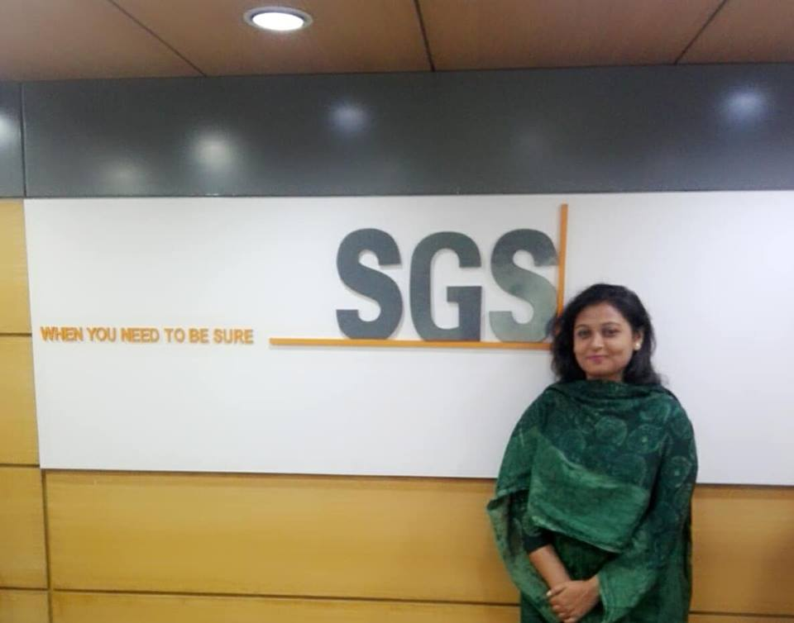

Introduction
The significance of employee engagement can't be overstated – employee engagement systems have been demonstrated to decrease staff turnover, improve productivity and efficiency, retain customers at a higher rate, and make more profits. Above all, connected with employees are more joyful, both at work and in their lives. When you're locked in, it mixes all that you do with reason, energy, and enthusiasm.
This internship report depends on the Employee Engagement and Work Environment of SGS Bangladesh Ltd. Because of a world-wide business, SGS has capacity to understand, grasp and operate in a multicultural world which is basic to its business achievement and long-term sustainability.
SGS provides lots of training, incentives, and benefits to their employees to engage them with their duties. The company spends millions of dollars every year on formal recruitment, training, advancement and engagement programs and to improve employee's way of life inside the company with the desire that their investments will lead to improvements in organizational performance or results criteria. Results criteria have been referred to as "an Ultimate" criteria for progress.

1.1 Origin of the report

I was responsible for the commitment of the employees and for preparing my internship report about the work environment of SGS Bangladesh Limited for conducting my intern work. I worked as an intern for 4 months for SGS Bangladesh Limited. This report has been prepared based on my daily experience of daily activities, recruitment, training and human resources management, and strict supervision.

During this three-month internship, I was supervised by Md. Abul Mohaimen, Assistant Professor of United International University. In my part, my SGS consultant, Mrs. Humayra Akter, led me through the organization to prepare my training relationship.
1.2 Objectives of the report

Broad Objective:
To analyze the employee engagement strategies and work environment of SGS Bangladesh Ltd.
Specific Objectives:
- To fulfill the partial requirement as Internship of BBA program.
- To have an exposure on the working environment of Multinational Corporation (MNC) in Bangladesh.
- Too get clear idea on the strategies a MNC use to engage their employees.
- To gain information of various HR functions of MNCs in Bangladesh.
- To have some practical experience about employee skill improvement program.
- Also to have some practical experience in employees recruitment.
- Trainings help in creating administration skills, inspiration, dependability, better states of mind, and different angles that fruitful workers and administrators.
The report covers the distinctive activities of HR departments of SGS Bangladesh Ltd. also. I has distinguished the major activities of HR activities inside and out however sub segments are not secured here.
1.3 Scope of the report

As we know, every organization maintains some secrecy, and it should be maintain to earn business goals. For this reason, I could not get the full access to the information which is in the decisional level relevant to this report, I have prepared a report which can help to get ideas about the working conditions and employee engagements as well as HR activities of SGS Bangladesh Ltd.

1.4 Limitations of the report

While preparing my Internship report, I had faced some problems:
- Most of the employees and also mine found not enough time as because of the huge work pressures.

- The Annual Report of the SGS Bangladesh limited show as a pdf file, but actually they are in Image form inside the pdf. So collecting relevant from internet found hard for me.

However, I strongly trust that I tried to overcome all the problems and finished this report at my best effort.
- The Report topic “.The employee engagement and work environment of SGS Bangladesh Ltd.”, I was working on, is an secret issue for the company. So, the respondents couldn’t deliver the proper information.
- Though, they have helped me a lot and given their responses in a narrow sense but the issues of proper data is still remained a big question at some points.
- Another most important limitations was, as the respondents were too busy so they couldn’t give me enough time to make them clear about the issue.
At last it can be said that by overcoming those constraints I worked hard to get this internship report done.

1.6 Methodology of the report
I have finished my internship report based on primary and secondary data. My report's goal is providing an analysis of Employee engagement and work environment in SGS Bangladesh Ltd. The analytical framework of the examination is qualitative which is directed through both on the primary and secondary data.

The data are being gathered in two different ways:

1) Primary Source.
2) Secondary Source.

1.6.1 Data Collection

In order to compose the report significant and presentable, I had gathered my knowledge from two sources of data and info. These are both primary and secondary data source.
- Primary Sources:
- Direct communication with respected manager.
- Exposure on different desk of the company.
- Practical deskwork.
- In depth interview.
- Secondary Sources:
- Annual report of SGS Bangladesh Ltd
- Website of SGS Bangladesh Ltd.
- Different manuals and publications of SGS Bangladesh Ltd.
- Different text books, programs, seminar

Chapter 2
Overview of SGS Bangladesh Limited
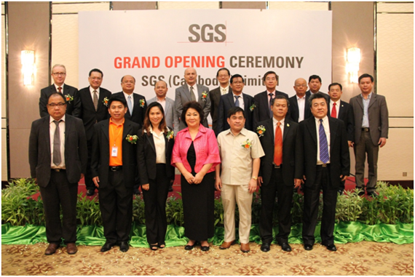

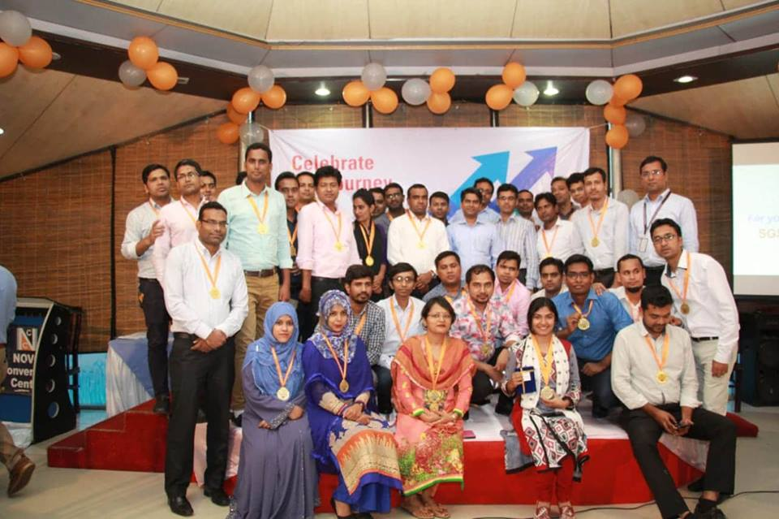

Literature Review

2.1 Employee Engagement

Each company involved in the employee is one of the main problems facing for its employees and hundreds of workers try to work to secure jobs. Employees' commitment is an extraordinary encouragement from all organizations, so that they effectively compete with their objectives effectively. After an employee joins an organization, they must participate in programs that need to be adjusted, such as registration, training and development programs, etc.

Employee level of the staff depends on certain factors or determinants. Job quality, acquired support, supervisor support, reward and recognition, fair trial and delivered judgment This gives them a sense of their emotions, their education and their ability to educate, the balance of karma that allows employees to grant their needs and professional needs, between the manager and the employee. Connection, progress for business development and, finally, teamwork or comp. Work on the planet

Employees tend to practice well, especially those who are locked up. Employee employees affected employees and employees and highly authorized workers with the Association who influence their personal standards may make extraordinary execution of their respective profession. In addition, the motivational position of your association and the attitude of each member of its standard structure will be known as a positive attitude and positive attitude to workers' staff; Employees can express their feelings when they work, which means they have a modest mind about their cooperation with their association. Yet, employees are more likely to increase their performance if they are fully attracted to their profession.

2.2 Work Environment

The working environment as term which is used to describe the recovery situations where the employee perform job. The environment of an office can be prepared of tangible or intangible situations, such as temperature or office utilities, such as PC.

Operating environment may include social networking in the workplace, including collaboration with partners, subordinates and superiors. For the most part, and points inside the content, the staff is qualified for the work environment free of trouble. With the threat of the work environment exists when unsolicited sexual advances directly taken with the performance of the employee or makes the work environment hostile, scary or hostile.

It may also be due to the tangible such as office buildings. Tangible work environment will be problem free related to the construction is destroyed disorder that is often due to poor ventilation or gas poisoning of synthetic compounds used in the conditions of development. Shape play and swing can also be an invitation to frustrated construction.

Overview of SGS Bangladesh Limited
SGS, the world's driving inspection, verification, testing, and Certification Company. This association is perceived as the global benchmark for quality and integrity. Within excess of 70,000 employees, works a system of in excess of 1,350 offices and laboratories around the globe.
SGS's centre services can be separated into four classes:
- Inspection: SGS's extensive scope of world-driving examination and certification services, for example, testing the situation and burden of exchanged merchandise in transhipment, assist individuals with controlling amount and quality, and meet all important administrative necessities crosswise over various districts and markets.
- Testing: SGS's global system of testing offices, staffed by the proficient and experienced workforce, empower individuals to diminish dangers, abbreviate time period to check the superiority, wellbeing, and execution of their items alongside important wellbeing, security, and administrative gauges.
- Certification: SGS empowers individuals to show that their items, procedures, frameworks or services are agreeable to either countrywide or universal guidelines as well as directions otherwise client characterized benchmarks, through certification
- Authentication: SGS guarantees to its services as well as its products conform to world-wide models as well as neighbourhood directions. Joining global inclusion with nearby information, unrivaled experience, and aptitude in practically every industry, SGS covers the whole production network from crude materials to conclusive utilization.
SGS continually looking past clients' and society's desires so as to convey showcase driving facilitiy, anywhere it is required. The company is giving specific corporate arrangements that enhance superiority, security, and profitability. On the other hand, decrease hazard, we enable clients to explore an inexorably directed world. SGS's autonomous services increase the value of its clients' activities and guarantee business supportability.
And also conveying services that advance manageable improvement, SGS's qualities additionally demonstrate a pledge to corporate manageability. For SGS, manageability is tied in with dealing with a long haul beneficial business while considering all the positive and negative ecological, social and financial impacts SGS has on society.

SGS's VISION
SGS means to be the most focused and the most beneficial administration association on the planet. Its center capabilities in inspection, verification, testing, and certification are by and large constantly enhanced to be best-in-class. They are at the core of what SGS. SGS's picked markets will be exclusively dictated by SGS's capacity to be the most aggressive and to reliably convey unequaled support of its clients everywhere throughout the world.

SGS's VALUES
SGS looks to be embodied by its enthusiasm, integrity; entrepreneurialism and its creative soul, as it consistently endeavors to satisfy its vision. These qualities control SGS in everything that SGS do and are the bedrock whereupon SGS is constructed.

SGS's HISTORY
Built up in 1878, SGS changed grain exchanging Europe by offering creative horticultural inspection services. The Company was enlisted in Geneva as Société Générale de Surveillance in 1919. Offers were first recorded on (SWX) Swiss Exchange in 1985. Since 2001, we have just a single class of offers comprising of unlisted shares.
The present structure of SGS, comprising of ten business sections working crosswise over ten land areas, was shaped in 2001. From SGS's beginnings in 1878 as a grain inspection house, SGS has consistently developed into its job as the business pioneer. SGS has done this through ceaseless change and development and through supporting its clients' tasks by lessening hazard and enhancing profitability. So SGS's business grows incline appeared in beneath:

Business and function Dept of SGS Bangladesh Ltd
SGS Bangladesh Ltd began their business in Bangladesh approximately 40 years ago. SGS Bangladesh Ltd has various departmental sections. The sections are given below:

Business and functional Department of SGS Bangladesh Ltd

2.7 Honesty at SGS Bangladesh Limited
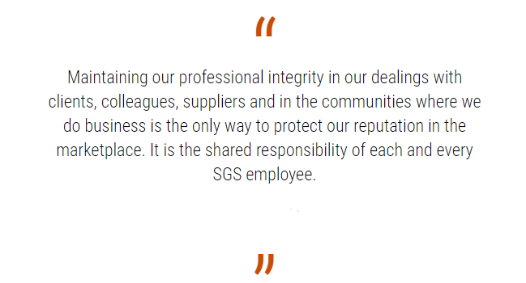
Honesty locates at the core of SGS. They belief that they can motivates their clients as well as shareholders is a secret of their achievement.
Being a pioneer in this industry, SGS holds themselves to the most noteworthy expert conduct. The Code of Honesty characterizes a fundamental standards of expert honesty of SGS Gathering and is a statement of the standards which are delivered all through their association, their organizations and their affiliates.
SGS focused on an ethics where concerns of honesty and expert morals can be elevated as well as examined transparently. Direction as well as provision are accessible to encourage staffs and different partners following up for the benefit of, or speaking to, our association to comprehend the Code and to enable them to settle on the correct choice when looked with a moral difficulty.
SGS is a principal assessment business to execute a universal honesty exercise a platform for its staffs. In SGS agreement package, in view of their SGS concerns of Honesty, exists to guarantee the most noteworthy principles of honesty are connected with its activities around the world, as per worldwide best practice.
Annual training on the integrity of SGS is a temporary reinforcement of the value of the project code. It is managed by every director and supervisor, whose employees have the obligation. An employee has been registered so that all employees complete the preparation every year. Integrity training courses are also organized for administrators and supervisors.
Annual honesty preparation is enhanced by an intuitive online learning program, which coordinates the common values ​​within the code contained in our separate SGS organization. Accessible to the Web in English, French, Chinese, Spanish and Korean languages, it is also used especially among our new employees, which is an essential aspect of their recognition.
The CEO is responsible for updating the systems of staffs and advisors' ethical behavioural management and the alleged workers review the crime. It also defines the pattern of honesty we expect from our partners. Code violations may be sent or received by fax or by email publishing an integral hotline or web-based report.
Expert direct board guarantees the use of honesty code among their associations and informs the administration of all matters related to professional ethics. Likewise, he confirmed the reform of the acquisition or acquisition of business with the representatives.
The Expert Conduct Committee comprises of four members:
Chairman of the Board of Directors: P. Kalantzis
Chief Executive: F. Ng
Board Member: S.R. du Pasquier
Chief Compliance Officer: O. Merkt

2.8 SGS OFFICE DIRECTORY
The SGS organize includes more than 2,400 offices and laboratories and in excess of 95,000 employees around the globe.
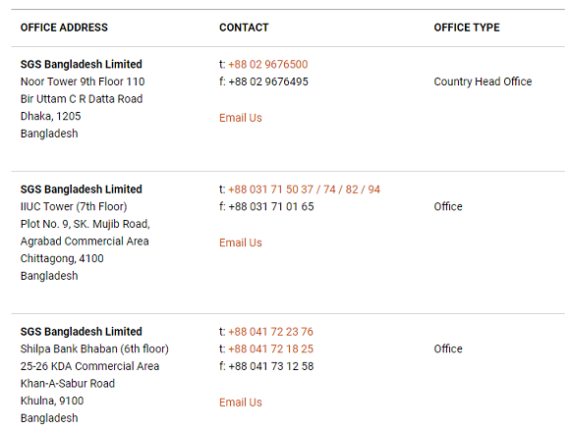

2.9 Aptitude of SGS
SGS Bangladesh Ltd gives around the world, autonomous services that creates a great impact on individuals' lives.
Their universal specialists assist Customers with operating in more proficient and feasible routes by streamlining forms, enhancing quality and profitability, diminishing danger, confirming compliance and expanding velocity to showcase. SGS Bangladesh Ltd has some center administration exercises that cover all industry parts and contact the items and services that shoppers around the globe depend on consistently.

2.10 TESTING SERVICES
As a world pioneer in testing, SGS offer more than 130 years' understanding, giving a wide scope of services to customers around the world.
The SGS global system of laboratories and testing offices, staffed by learned and experienced work force, assist you with reducing dangers, abbreviate time to advertise and show the quality and security of materials, parts or items.
The sectors where SGS performing their services are given below:
AGRICULTURE & FOOD | CHEMICAL
CONSTRUCTION | CONSUMER GOODS & RETAIL
ENERGY | INDUSTRIAL MANUFACTURING
LIFE SCIENCES | LOGISTICS
MINING | OIL & GAS
PUBLIC SECTOR | TRANSPORTATION
ENVIRONMENT | HEALTH & SAFETY
RISK MANAGEMENT | SUSTAINABILITY
TRADE | TRAINING

1. Cultivation and Foodstuff: How SGS can boost your business: Food production and nutrition, of course, is the most important activity in the world. Consumers must ensure protection and superiority at each process. The full range of SGS services can encourage you:
• Cope up risks, improve localization and fulfill your commitment: with personal or global responses to each part of your agriculture and food supply department.
• SGS customer protection: From the point of exchange or domain exchange point of view.
• Compliance with complicated laws: production and exchange, adoption, provincial, national and global rules and agricultural control, including food.
• Ensure proper storage, distribution, pressure and transmission: products, food products and food products.
• Ensure the quality and safety of all through mixed supply disciplines: Crude oil, semi-finished products and recent items in all major areas.
SGS offers remain solitary or coordinated answers for help associations that are engaged with agrochemicals, seed, biofuels, manures, cultivate apparatus, and supplies, monetary and protection enterprises, storage, handling offices, and calculated development, the readiness of new creation for showcase and arranged food items.

- Chemical: SGS services for companies that produce industrial chemicals.
SGS offers an extensive scope of services to their accomplices in the modern chemicals industry. As the world's driving testing, certification, verification, and Inspection Company, it has the information, encounter, and global reach to help its customers in meeting national and universal principles. SGS can enable prepare to staff so they are more inspired, profitable and certain about their vocations. Furthermore, on the off chance that anybody needs additional staff for a specific task, they have a pool of individuals from experienced agents to qualified researchers, close by to help them.
A portion of their services, particularly, incorporate chemical feedstock services and completed item services, (for example, agrochemicals, purchaser chemicals, plastics, and engineered strands, elastic and characteristic filaments, pharmaceuticals and mechanical chemicals) And additionally working with their clients to test, assess, confirm and guarantee particular chemical items, SGS can enable their business to run the more easily, productively and efficiently.
- Construction: Let SGS help you build an even more successful business.
Understanding clients business and project needs are vital to SGS, for SGS to have the capacity to decide how best to increase the value of a client’s development projects. On account of their long involvement and far-reaching learning of development and related building, they have an exhaustive scope of services to give finish answers for client’s projects on time, on the spending plan, securely and to meet client’s prerequisites. Any customer can utilize their authority services independent or expand their current techniques.
4. Consumer merchandise and retail: SGS can assist its clients with ensuring that both your inventory network and the items a client purchases and offers are up to standard.
Quality desires and the scope of safety prerequisites that a client must accomplish turn out to be more complex consistently. To enable a client to meet these prerequisites, SGS buyer merchandise and retail specialists offer an entire scope of services to makers, merchants, exporters, and retailers of purchaser items. The services of SGS incorporates research facility testing, item inspection and counselling, process evaluation and specialized help.
SGS assists a client with reducing risk, enhance productivity and ensure compliance with legally binding or administrative necessities all through a client's store network. SGS gives its client an expansive and natty gritty comprehension of shopper merchandise and retailing to enable a client to construct a more grounded and stronger business with the possibility to develop and outperform their opposition.
5. Energy: SGS has the ability to enable a client to fabricate a more grounded business.
The advanced world would be nothing without the anticipated and dependable production, appropriation and supply of energy. The energy industry is multi-faceted and different, including an extensive variety of orders and processes.
Because of the learning’s and experience, SGS is proficient at helping energy organizations run smooth, productive and dependable organizations. They have specific skill in the accompanying zones:

Chapter 3
Employee Engagement and Work Environment of SGS Bangladesh Ltd

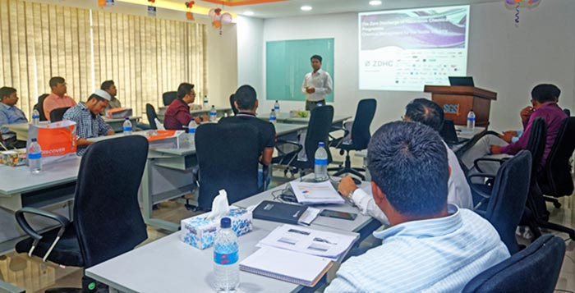

3.1 Employee Engagement
The easiest explanation of employee Engagement is, staffs are included in the maximum definition that the employees are ready to continue their work. Wikipedia has a broad definition: "The relationship between the employee and his staff is a property, a worker who is excited about his work and enthusiasm, and therefore has taken positive steps to promote the fame and interests of the organization.
It can be said that employee engagement is simply the use of discretionary effort by employees. In another way, it’s all about employee connection or productivity or retention. I feel employee engagement is the alignment of individual and organizational goals and values to better drive business results.

3.2 The Relationship between Employee Engagement And Work Environment

An important relationship exists between working environment and employee involvement. Employment status plays a compulsory role for the employees to continue working in the field of employment. A safe working environment can attract new competitors to the pool, which still allows applications to apply in finished locations. Work environment should be secured because the working environment plays an important role. The work environment is a factor that can be used to determine the level of work of each organization. Various levels of work environment can occur due to different parts of the environment. The union that receives its work and expresses concern for the needs and feelings of the workers, makes a positive contribution and approves staff concerns, develops new perspectives and related issues related to the work. It has been described as an administration that encourages stable work environment.

However, strong and relevant relations and stable administration, improved mental security. Government employees feel secure at work described by transparency and power. To let people get new discovery and experience not to mention the results of the stable environment. Work environment affects employee engagement. Similarly, a late audit shows that a meaningful work environment is considered as the main determinant of employee engagement.

3.3 CULTURE OF SGS BANGLADESH LTD
As a worldwide business, SGS Bangladesh Ltd can comprehend, grasp and work in a multicultural world is basic to their business achievement and long term sustainability.
At SGS, they centre on finding the perfect individual for the correct activity. Also, SGS takes a gander at the requirements of every person, to help make the conditions that encourage advancement and augment potential. To this end, they urge their kin to work crosswise over a wide range of capacities, geographies, and cultures all through their professions.
Past self-improvement, SGS also urge all their staff to connect with the business and purchase into their objectives, desire, and corporate values in a way that will motivate them to need to drive the business forward proactively and produce achievement.
SGS is focused on uniting people from various foundations, cultures and thinking styles to fabricate a significant resource of ability and viewpoints, and also life and vocation experiences.

3.4 EMPLOYEE ENGAGEMENT AND WORK ENVIRONMENT OF SGS BANGLADESH LTD
Consistently an expansive extent of employees is welcome to partake in catalyst, SGS's employee survey.
By gathering straightforward review, SGS's pioneers and managers get an exact view of their workplace qualities, issues and change territories (management style, acknowledgment, assorted variety, culture, joint effort, client introduction, and so forth.).
On culmination of the overview and the assessment of its outcomes, activity designs are conceived and executed locally to enhance economically somewhere around one of the needs distinguished.
Over the business, employees and managers are urged to work together and to assume a functioning job in this ceaseless change process. SGS employees are best ready to recognize zones inside their hover of impact and follow up on what makes a difference most to them. 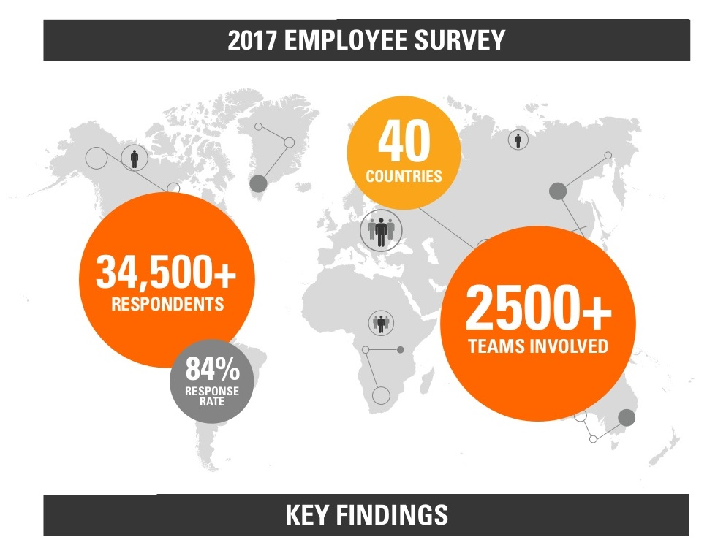

SGS invited their employee in 2017 to participate in a Survey freely. The results After the survey, are describing below:
Clear Direction of SGS: Effective managers and supervisors of SGS, work hard to increase their skills at providing clear direction to their team members. All of the manager and HR Provide guidance for effective direction and delegation in a supervisory setting.
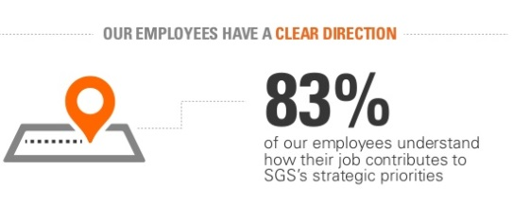

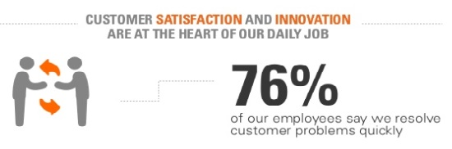
Customer Satisfaction: Customer satisfaction usually abridged as CSAT, all the more accurately CSat is a term as often as possible utilized in marketing. It is a proportion of how goods and services provided by an organization meet or surpass customer desire. #

71% of SGS Bangladesh ltd employees refer that SGS is innovative in developing new products and services in the 2017 survey
SGS Brand Employee’s: SGS Bangladesh best employees are their brand advocates who are also working in SGS now.
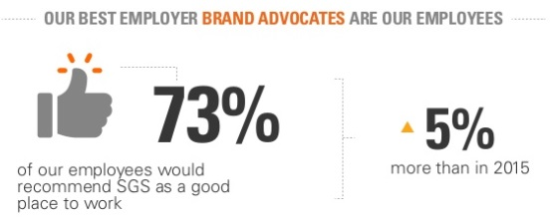
Managers of SGS Ltd: All the managers of SGS, are highly qualified along with a verities of qualities inside them. Such as
- All the managers of SGS are committed to their Company
- Highly creative
- Everyone has enriched by valuable qualities. For example: Flexibility and versatility.
- All are well mannered, highly experienced.

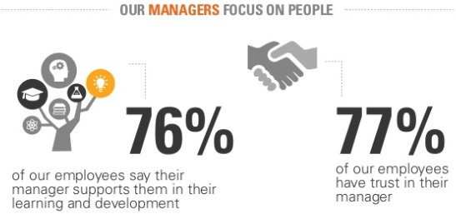

Sustainability at SGS Bangladesh Ltd: Sustainability is profoundly ingrained in SGS corporate culture, and they are a globally perceived pioneer in the field. SGS bridle their scale and aptitude to limit their effect on the environment and boost their commitment to the economies and more extensive social orders in which SGS work.

3.5 VALUE TO SOCIETY
SGS conveys value to society in three different ways:
Sustainability administrations: SGS empower their customers to receive more maintainable business practices and to make more reasonable items, advancements, and administrations
Corporate sustainability programs: internally, SGS use their own social, environmental and economic performance by means of nearby and worldwide activities.
Engagement exercises and external partnerships: SGS consolidate their insight and skill to convey adaptable projects, both inside and with external partners that add the reasonable development.
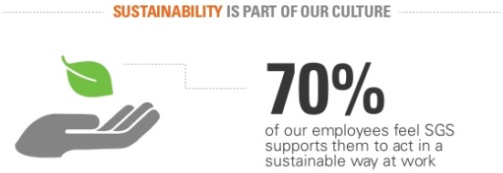
Work Environment: SGS Bangladesh is lawfully in charge of building up and keeping up a good working environment where employees can work safely, without hazard to their physical and mental wellbeing and welfare.

- Friendliness: The relationship between employees and also with the managers and other executives inside of SGS are very friendly. Everyone encourages one another to enrich their potentials
- Well Mannered: Each employees who works inside of SGS, are highly wel educated and well mannered. SGS always hire employee who hold these qualities inside them.
- Technological Instruments: SGS Bangladesh Ltd uses a lot of foreign instrument in their day to day operations. The office rooms are well decorated and very neat and clean. Almost every rooms are under Air Conditions and CC TV Coverage.
All these things creates a great positive impact inside the employees mind, which satisfy them and engage them to perform the duties properly in SGS BANGLADESH LTD.

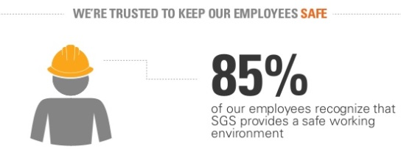

3.6 Employee training is worth investment in

SGS Bangladesh Limited
It is now specified that SGS Bangladesh Ltd generally trusts that without employee they are nothing so improvement of the employee is, at last, the advantages of the company. In this way, they train them and for training purposes, they contribute a lot since it will help in the present and also in the future.
This is imperative that the employees don't feel that they are not treated importantly. By any chance, if the employee quit the association then the association loss will be 1.5 to 2 times of that specific employee yearly compensation. This is the monetary expense yet there are some imperceptible cost like when they leave they take with them gigantic experience. The association has numerous more cost like substitution cost and under this will be included promotional cost, recruitment cost, determination cost, training cost and some more. This sort of turnover is called useless turnover and which turnover is useful for the association is called 'useful turnover'.
3.7 The HR practices occur at SGS Bangladesh Ltd are given below:
- Recruitment and Training
- Performance Management
- Rewards and Incentives
- Benefits
- Employee Relations
- Change Management
- Safety and Health

3.7.1 Recruitment of SGS Bangladesh Ltd
HR department of SGS is in charge of enrolling and choosing hopefuls. They create sets of expectations that blueprint different aptitudes and experience levels for candidates. At that point, HR department goes either for external or inward sources.

Interior Sources of SGS:
The interior source of recruitment are:-
- Promotions: it intends to give a higher position, status, salary and duties to the employee. Along these lines, the vacancy is filled by promoting an appropriate competitor from a similar association.
- Transfers: the exchange implies a change of workplace without change of situation, position, remuneration or duty of the employee. In this sense, the opportunity is found in the exchange of a reasonable candidate by the SGS group.
- Internal advertising: Present employees of SGS are contacted to request the opportunity. In this sense, the recruitment is done within the association.
- Extended leave: SGS can control a leader on extended leave. It is extended once the company finds a problem that is resolved by that specific administrator. After solving the problem, the leaders can extended his leave.

Exterior Source of SGS:
The exterior sources of recruitment are:-
I. Public announcements:
The SGS Human Resources Department publishes this prospect in newspapers, on the Web, etc. As often as possible, they show ads on BDJOBS.com.
This announcement provides data on the organizations activities and features of the applicant. Requests by appropriate candidates are welcome. This source is the most common source of recruitment.
II. Campus recruitment:
SGS organizes meetings on the foundations of management and design schools. Previous year, students who are destined to graduate meet.
Regularly, SGS agrees to participate in various job fairs in different universities. In recent times, they have been interested in the reasonable activities of BDJOBS at Dhaka College. The necessary candidates are selected by SGS based on their school enrollment, interpersonal skills, knowledge, etc. The source is also used to recruit qualified, organized but inexperienced competitors.
III. Recommendations:
SGS can also register candidates based on proposals received from existing managers or sister organizations. In any case, competitors must pass the composite exam.
At the time, the human resources administrators filter the programs and select only the most capable applicants. They frequently select applicants to eliminate people who may not be part of the culture of their company.
The Selection process is completed by composed exam and meeting. The competitors need to go in that exam first. The polls are composed by the departmental needs. Many general learning, explanatory, basic thinking, math, English syntax and so forth are incorporates into the exam inquiries also. If the applicants pass then, the chose competitors need to experience a meeting session. Like along these lines toward the end the coveted applicant is chosen as an employee.
2. Paperwork and Introduction
Maximum Human resource managers guarantee that employees finish a few key business frames on their first day. They need to top off and bring records, for example,
1. Personal data frame
2. Academic and training endorsements
3. National ID or Identification's photocopy
4. Nominee shape
5. Joining Letter
6. Photographs
At the point, when the HR department gets every one of the archives of the employees their data is put into the product HRIS. All data like, employees general information, contacts, scholarly, training, reference, chosen one, experience, productions, leave, participation, performance records and so forth are found in that product.
- Orientation: HR management ordinarily acquaints new employees with individuals in the organization, disclosing to them whom to see for particular issues.
As of late they have begun directing introduction program. In this program the employees all things considered, who are enlisted, are presented with the association. Amid this day long introduction program, managers of all departments tells about their department through power point introduction.
3. Training and Development
HR management additionally deals with the training for new employees.
- The new employees need to confront a multi month probation period. For this period they are given a few destinations. After this period their performance is assessed.

- They have recently propelled 'Sparkle' program for their new employees. In this session their tutors direct them to satisfy their destinations and afterward their performance is assessed.

- SGS gives many training to their employees. Considerably outcast can partake in their training session.

- Some training may just include passing out a training manual and data on organization approaches. Different occasions, HR managers must arrange off-site training through training managers inside their association. These employees also facilitate training sessions for existing employees who need to enhance aptitudes in utilizing PC programming, composing and oral introductions.
4. Compensation:
The HR department of SGS decides remuneration bundles for different employees. Most remuneration depends on review levels. They have grades from A to F. For instance, chiefs have higher review levels than managers, and administrator's rank higher than Asst supervisor or official.
The HR management may think about practically identical pay rates inside the business to determine remuneration ranges. Be that as it may, they should work inside their organization spending while deciding pay rates, benefits and different incentives. All things considered, HR management realizes that, they have to offer aggressive pay rates to help hold quality workers. Remuneration rewards individuals for performing authoritative work through pay.

5. Incentives and benefits
Bosses must create and refine their essential wage and pay frameworks. Likewise, motivating force program, for example, benefit sharing is developing in use. They are additionally giving gave finance, health protection, transport, female uncommon movement stipend, yearly dress recompense and so on to their employees.

6. Performance Evaluations
SGS's HR management, as a rule, creates performance evaluation frames for their associations.
- Inconsistently, the employees are given with their destinations for the entire year. After that period their performance is assessed by the Management by Goals (MBO).

- Those destinations are made both by the employee possess self and their director. Be that as it may, their managers really finish their targets. At the year-end their performance is assessed in light of their destinations. Performance assessments likewise help department managers decide in which zones their employees require change, for example, report composing, working in groups and following headings.
Additionally, regardless of whether the employees require training or not these are suggested by their evaluators.
At last, as per the employees' performance they are compensated or punished with notice too.
7. Safety and Health
All HR departments must guarantee that the working environment is protected. How much HR employees work on safety and health issues is dependent upon the sorts of organizations in which they work.
- SGS takes after Bangladesh Work code for the health and safety issues.
- The as often as possible gives safety training to the majority of their employees.
- They have organized every one of the safety measures in the event of flame.
- They give a slick and clean and a sterile working environment in their office and furthermore in the lab.

8. Managing Legitimate Issues
SGS's HR department knows about prejudicial practices that can exist in the workplace. These issues may relate to religion foundation, race, inappropriate behavior and different practices. Managers devise and execute affectability training to notify organization employees about these issues. Some may even welcome specialists in to examine different subjects amid one-hour workshops.
9. Employee connection exercises
SGS's HR department is organizing distinctive employee connection exercises for 2 or 3 years. They are orchestrating numerous exercises which inspire employees. These exercises are,
- Annual tour;
- Children's specialty consummation;
- Fruits celebration;
- Boishakhi, Ladies day and so on praising projects;
- Movies;
- Fire safety week;
- HR week; et cetera.
SGS provides a lot of Training and Benefits to maintain a well work environment and employee engagement inside the organization; these Training and benefits are given below:

3.8 Employee engagement and work environment
Employee engagement is anything but a Human Resources activity that managers are reminded to do once per year. It's a key activity that drives employee execution, achievement, and consistent change throughout the entire year. Much the same as associations can't make employee strengthening, employee inspiration, or employee fulfillment, engagement is up to the employees who settle on choices and decisions about how included they need to be at work. Employees settle on decisions with respect to their strengthening, inspiration, and fulfillment. These decisions are not up to you, the business.
What is the business' obligation, be that as it may, is to make a culture and an environment that is helpful for employees settling on the decisions that are useful for your business. Furthermore, engaged employees are useful for your business.

3.9 Environment Conducive to Engagement
Consider the accompanying in the event that you require your employees to end up more engaged and associated with their work
• Employee's commitment must be a business process that reflects the search of the relevant workers and subsequently reflects the employee's commitment to the employment relationship.
• Employee participation should highlight the company's results. Staffs are more involved and can see and measure their execution results when they are responsible.
• Employee engagement occurs when the company's goals are closely tied to the employee and how they invest their energy. A visit to the staff and company's main destinations, a visit to the dough, frames and routines of its activities, and a noticeable letter that advises employees to employees.
• Relevant workers have information that their work needs to see how they affect business goals and needs. These objectives and estimations identify with the Human Resources department, however every department ought to have an arrangement of measurements.
• Employee engagement flourishes when associations are focused on management and administration development in execution development designs that are execution driven and give clear progression designs.

3.10 Staff Development
SGS trusts that the connection between fruitful individuals and an effective business is vocation development.
They see development as a common pledge to association development and individual achievement. Fruitful vocation development depends as much on employee's enthusiasm, vitality and drives to learn and develop, as it does on the development openings SGS gives.

3.11 Pathways to training
Each SGS employee is urged to benefit as much as possible from inner portability and open doors for the coordinated effort with partners and expert affiliations. Custom fitted development designs mirror one's goals and our interest in your future.

3.12 Execution management and developing planning
Key to one's development is the execution of management and development arranging. SGS yearly survey enables ones to set achievable focuses, in co-activity with one's supervisor, and recognize chances to create employees abilities.
This procedure empowers SGS to guarantee on-going conveyance and ceaseless change, in the meantime as helping one to accomplish your profession yearnings. SGS mix of successful execution management, presentation to encounters in their field guarantees people, groups and at last the business, recognize what they ought to do, how they ought to do it and assume liability for what they accomplish.

3.13 ONBOARDING
SHINE, our worldwide on-boarding program, directs new employees through the expectation to absorb information of their first days, many months guaranteeing a positive begin that quickens their fruitful progress to SGS.
3.14 THE SHINE on-boarding program
SHINE gives every single new employee a connecting with, far-reaching and strong begin to their work. Through the half-year program, new employees are furnished.

3.15 Compensation and Benefits
Solid, lean and light-footed, SGS can give employees a sheltered and stable environment in which to develop and grow. SGS employees are compensated with aggressive compensation, wherever they are based. We likewise offer a scope of alluring advantages that are focused and fitting to their industry, wherever they are on the planet. Our advantages reflect both the abilities and aptitudes that our employees convey to their exercises and the economic situations in-nation. Commonly, our employee advantages will incorporate retirement designs and therapeutic and human services inclusion.

3.16 Pay for Performance
The huge commitment that SGS employees make to the achievement of SGS are perceived and remunerated through execution drove variable pay designs.

3.17 Adaptable Working Environment
The idea of our exercises requires adaptability in working practices, from adaptable working time through revolution timetables to virtual, worker and ostracize plans to meet our developing worldwide environment. Organization and employees share in the advantages of these adaptable working plans.

3.18 Self-awareness
Our overall nearness implies we give careful consideration to creating reasonable abilities, cultivating wide understanding, empowering proper gifts and enhancing the working existence of our partners around the world. This encourages us to advance our comprehensive and shared culture reliably, building a positive future both for the organization and our employees.

3.19 EMPLOYMENT POLICY OF SGS
At SGS, trust and honesty are major values that we try to actualize in all employee relations. We are focused on shielding the rights and safe working states of every one of our employees. To accomplish this we set ourselves exclusive requirements and mean to surpass what is required by law. Wherever we work together we are guided by these standards and expect a similar level of duty to these values from our accomplices.

Chapter 4
Survey and Results
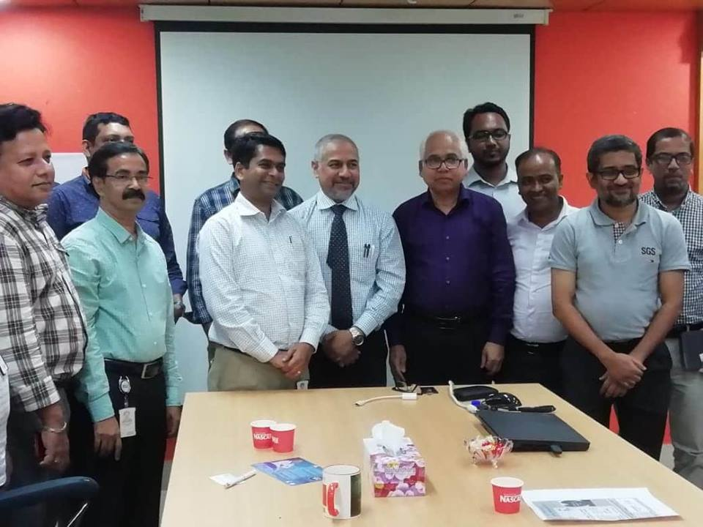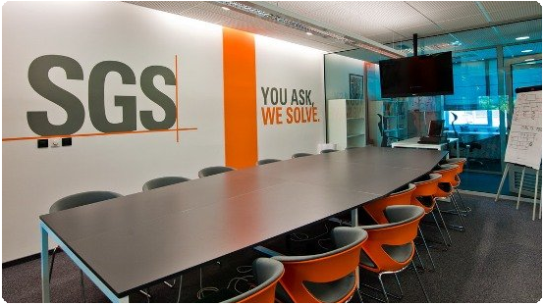
Employee Engagement Survey
I have performed a survey to see the reactions from the employee who are working in SGS Bangladesh limited for years on Employee Engagement and work environment. Total 20 people participated in my survey. I assured them that all of their given information will be taken just to prepare my internship report and I will not disclose it with anyone. Thanks to all of them who took part in my survey in their busy work schedule. The Survey Question and their Average answers are listed below.
Survey Question of Employee Engagement and Work Environment of SGS Bangladesh Limited
Employee name:
Designation:
Date: 20th September 2018
Question | Strongly Disagree | Disagree | No Comments | Agree | Strongly Agree
1. Do you feel proud to work for SGS Bangladesh Ltd?
2. Do you recommend SGS Bangladesh Ltd as a great place to work?
3. Do you think about looking for a job at another company?
4. I see myself still working at SGS Bangladesh Ltd in two years’ time?
5. SGS inspires you to move forward, which you can play elsewhere?
6. Does SGS Bangladesh Limited make the public aware of what is happening?
7. Is your manager an excellent role model for employees?
8. Have SGS Bangladesh Limited executives shown an aspect that inspires you?
9. Do you have access to what you need to do to improve your work?
10. Do you need to improve my work and not to access development?
11. What systems and processes do all employees do to get their jobs here?
12. Do you know what you need to do to succeed in your role?
13. Will you have the appropriate recognition while you do a good job?
14. What is the quality of decision making and daily improvement?
15. Has your manager (or a member of management) shown a true personality?
16. Do you think there is a good career opportunity for SGS Bangladesh Limited?
17. Is it an excellent organization to contribute to your personal development?
18. Do you have good things here?
19. Are there any things you're not doing so well?
20. Do you feel anything else in this survey? If your answer is "yes", please correct in the comments box below.

Comment box: (You can write anything related to this survey. Thanks)

Survey Results (Average)
1. I am proud to work for SGS Bangladesh Limited.
2. I would like to suggest a great place to work with SGS Bangladesh Limited. The work environment is excellent. Inspire and motivate your work.
3. I rarely think about finding a job at another company. SGS Bangladesh Limited gives me the best, in general, I get inspired and I get other benefits. Then, there is no reason to change.
4. Of course, I have been working for SGS Bangladesh Limited for two years.
5. SGS Bangladesh Limited encourages me to play the same role elsewhere.
6. How SGS Bangladesh Limited works in management, how to handle difficult situations, how to perform tasks in a short time, etc.
7. The director of SGS Bangladesh Limited is a reference model for employees.
8. The officers of SGS Bangladesh Limited have expressed the desire to encourage them.
9. Of the 20 employees, 15 responded that they had contact to the things necessary for their work.
10. 20 employees respond that they can learn well and can work to development. Shine training and training programs help all employees of SGS Bangladesh Limited to improve their work.
11. Of the 18 people, most of the 20 systems of SGS Bangladesh Limited effectively support their work.
12. All of them said they have all the answers to make their roles a success.
13. 11 out of 20 employees, said they were doing a good job and receiving proper recognition without having to work for the company.
14. 17 people responded that daily decisions show that quality and improvement are their main priorities.
15. Thirteen people stated that the manager of SGS Bangladesh Limited (or another member of management) showed a sincere interest in my career aspirations.
16. 19 Out of 20 people, SGS Bangladesh Limited has professional opportunities.
17. Everyone thinks that it is an excellent organization to contribute to my development.
18. The excellent work of SGS is as follows: among the most famous companies in Bangladesh, inspection, verification, testing and certification personnel can always contact and learn from entrepreneurs.

Chapter 5
Recommendations and Conclusion
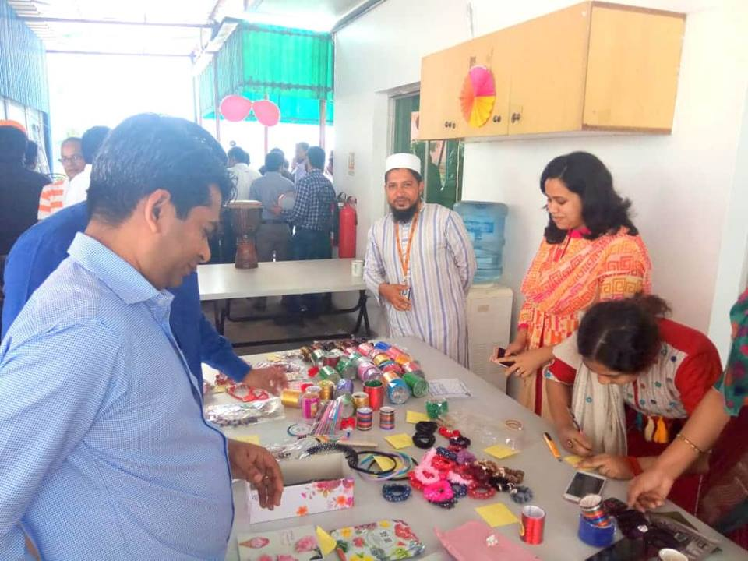

Recommendations
After working 4 months in SGS Bangladesh Limited as an intern, I have observed a lot of areas which relates to my internship topic ‘Employee Engagement And Work Environment of SGS Bangladesh Ltd’. And gathered all the necessary information. Now, I think, it’s my duty to provide some recommendations of this strong and lovely organization, what I think that they should solve.
- SGS Bangladesh Limited should lead a viable Employee engagement program. Since the administrator's suggestion, during the assessment time frame, may not be the precise one, thus HR office sends for audit. That is the reason the HR division must take activities to prepare the chiefs about taking appropriate choices on Employee engagement necessity during performance assessment.

- SHINE training for the managers must be directed legitimately as it is a remarkably new idea, numerous lags can emerge. For this situation, a legitimate supervision to the coaches during the SHINE time frame must be finished.

- The work pressure need to be monitored as it can hamper employee engagement in the office.

- The idea of SHINE need to be expressed to the majority of the employees legitimately.

- More instructional advancements can be inserted in training classroom settings to upgrade employee engagement to work. These lectures might be accessible for understudies to counsel previously or after class sessions by means of the course Web websites. This segment of the course model would make adapting less needy upon time and area, and enable understudies to experience the addresses at their own pace. They can incorporate more pictures and sound clasps of instruments and outfits, showing intuitive playing of instruments and development of gatherings.The Sustainability training can be mandatory as because sustainability training gives a great idea about SGS that help employee’s engagement.

- In Real work environment in SGS Bangladesh Limited, Employees’ need should be checked by the HR, to ensure all employee’ are participate in work happily. It can increase the quality of their works and creates bonding for the company.

- SGS Bangladesh Limited need to increase their work environment safety measures.

- Consistent overview of employees needs to be directed.

- Once they've accumulated all the data of employees' response data, they should take a go through it carefully. At that point, they should consider what transforms, they could change with their employees' criticism and proposals.

- Best way to see an employee engagement at his work, by gauging their lead perceptions and meetings after continuously.

- Employees' need to get support, acknowledgment, or reward for their conduct change from their manager. The employee who usually works after the working hour, they should get overtime bonus, appreciation from the manager in the office.

- SGS Bangladesh also needs to re-examine their pay structure for the employees, basically the employees of their office.However, SGS0 Bangladesh should always monitors their Employee Engagement Programs and Work as well as office environment to make SGS Bangladesh a healthy, efficient and successful organization in comparison to their competitors’ such as ITS LAB or INTERTEK Bangladesh

Conclusion
This internship report proposed to identify employee engagement and work environment of SGS Bangladesh Limited. Results show that the factors influencing employee engagement are reward, work environment and balance in work and family life. Each independent variable has a different effect on the employee's commitment. It has been found that the working environment has had a significant impact on the involvement of workers, because it answers that respondents believe that the environment is more important for the employees to be involved. The work environment will not only be helpful but allow employees to contribute to the efforts of the company. It will make employees committed and enthusiastic about their work and their organization. This study showed that three independent variables reveal a positive relationship with employee engagement. Looking at the report, the biggest impact followed by a balance between work environment, reward and work and family life is followed. It shows that more benefits, work environment and work / life balance, based on the survey of the level of high employee engagement levels, the objectives of the research were achieved and all research questions were answered. In the end, SGS Bangladesh Limited works well for the involvement of employees and maintaining good environmental environment and maintaining a good corporate culture.

References

(1) Websites followed:
https://www.sgsgroup.com.bd/
(2) Annual report: SGS Bangladesh, 2016 and 2017
(3) Employee Engagement Report 2017
(4) Abbey, A., & Dickson, J. W. 1983. R&D work climate and innovation in semiconductors. Academy of Management Journal, 26(2): 362-368.
(5) Amabile, T. M. 1985. Motivation and creativity: Effects of motivational orientation on creative writers. Journal of Personality and Social Psychology, 48(2): 393-399.
(6) Amabile, T. M. 1988. A model of creativity and innovation in organisations. In B. M. Straw, & C. L.L. (Eds.), Research in organisational behavior, Vol. 10: 123-167.
(7) Amabile, T. M., & Conti, R. 1999. Changes in the work environment for creativity during downsizing. Academy of Management Journal, 42(6): 630-640.
(8) Amabile, T. M., Conti, R., Coon, H., Lazenby, J., & Herron, M. 1996. Assessing the work environment for creativity. The Academy of Management Journal, 39(5): 1154-1184

