

United International University

Internship Report on
“Impact of Foreign Remittances in Development of Bangladesh”

Submitted To
Dr. James Bakul Sarkar
Associate Professor
Department of Accounting & Information Systems
School of Business & Economics
United International University

Submitted By
Name : | Monika Akbar
UIU ID : | 114 141 022

Bachelor of Business Administration (141 Batch)

Submission Date: 21st June 2022

Letter of Transmittal
Date: 21st June 2022
James Bakul Sarkar
Associate Professor
Department of Accounting & Information Systems
School of Business & Economics
United International University.

Subject: Internship Report on “Impact of Foreign Remittances in Development of Bangladesh”

Dear Sir,

This is my great pleasure to have the scope to submit the internship report on “Impact of foreign remittances in development of Bangladesh”, the report has been prepared by me under the directions f my internship supervisor. Initially, this report have been drew up to fulfill the requisite of the Bachelor of Business Administration. It has been joyful and enlightening experience for me that this Internship program has given me a boundless scope of enhance my apprehension about foreign remittances, finance, business dynamic, strategic decision and investment decision making of company and real-life context.

I have put my best effort to fulfill the internship object on Impact of foreign remittances in development of Bangladesh. I believe that the report objective will meet your expectation.
In the course of the preparation of the report I have tried to cover all appropriate information and investigation to make the assessment paper inclusive also useful.

Therefore, I would like to submit this report for your kind review and valuable suggestion.

Thank you.

Sincerely your,

___________________
Monika Akbar
ID: 114 141 022
Bachelor of Business Administration (BBA- 141 Batch).
United International University

Acknowledgement

Initially, I would like to convey my sincere appreciation to Almighty Allah for enabling me to finish the internship report on “Impact of foreign remittances in development of Bangladesh”. However, a effort becomes achievable when there is the effect of synergy-the concept that 2 & 2 makes more than 4.My report has also the effect of synergy, without prejudice to my own contribution. “Two heads are better than one”. None can concrete a noble objective alone. This report is an accumulation of many individual’s endeavors.

After that, I would like to reveal my sincere gratitude to my academic supervisor, James Bakul Sarkar, Associate Professor of Department of Accounting & Information Systems, School of Business & Economics, United International University. Without his valuable suggestion and proper guideline supported me a lot to make the report in a well organized manner. In every aspect of the report his whole hearted observation and cooperation wrought my task to be finished within the time.

I am also like to intimate my appreciation to the other official members who assist to complete this report by providing their valuable information in their respective fields and also my parents, friends for their courteous aid and aha moment which accompanied me in accomplishment of the report.

I would adore to my certain appreciation to United International University (UIU) for beneficence such a course that designate me such report; those apprise me with proper understanding which will be very favorable for me in the .

Executive Summary

SCB BD (formally M/S Standard Chartered Bank Bangladesh Pvt. Ltd.) is a banking and financial services company it’s headquarter located in Dhaka, Bangladesh and it’s an entirely owned subsidiary of Standard Chartered. Standard Chartered has been performing in Bangladesh for over a century. Initially, I have get started my task to spell out how they were gross up there payment and the importance of it. Last a decade the bank has been acquiring great quantity of remittance. Here , I also covered about the functions of remittance unit of SCB BD in our country included in the developing international locations of remittance. Moreover, I actually used diagram for displaying flow chart of remittance of final decade. Here, I have been described about Remittance collecting process of Standard Chartered Bank. Remittance receiving procedure is categorized into two fundamental class.

First one is inward remittance and another one is outward remittance. Moreover, Bangladesh Bank have been tied up the limitation of the fees of the other bank for inward and outward remittance. I actually have manifest the sorts of information about outward remittance. SCB BD received remittance from different countries. But the most of the remittance received from USA. Furthermore, the overall performance of the bank is inspected in terms of remittance flows. After that, a diagram has been used to represent the country’s smart wage earners remittance inflows of 2018-2019 . Mainly the remittance is transferring from the formal and informal technology. Then I tried to cover the reason why migrant glimpse informal channel to vessel remittance and the hazards of casual technique. I have also referred to the listing of trade homes via which the bank collect and deliver emittance. explained Proper logic in details have been provided for determinants of remittance.
Effect of remittance in our economic system, financial sectors and in micro-economic level, household level and community level have been represented with cogent illumination.Widely covered the position of some establishments (along with MoF, BB, FEPD and so on) in perspective of remittance and socio economic impact of remittance. Remittance control system have two principal forms which are EFT (Electronic Fund Transfer) & SWIFT (Society for Worldwide Interbank Fund Telecommunication). SCB already has its own strong control mechanism over its remittance management system but as per my finding during the internship period there are some scope for improvement under the remittance management system.
Table of Contents
Letter of Transmittal i
Acknowledgement ii
Executive Summary iii
Chapter-1 Introduction 1
1.1 Background 1
1.2 Objective 1
1.2.1 Broad objective: 1
1.2.2 Specific objectives 1
1.3 Methodology 1
1.3.1 Primary sources: 1
1.3.2 Secondary sources: 2
1.4 Scope 2
1.4.1 Area and Time: 2
1.5 Rationale of the study 2
1.6 Limitations 2
1.6.1 Time constraint 2
1.6.2 Secrecy of Information 3
1.6.3 Others 3
Chaper-2 Overview of Security Exchange Commission 5
2.1 Security Exchange Commission 5
2.2 Expansion Of Standard Chartered Bank 5
2.3 Mission and Vision for Future of SCB 6
2.3.1. Mission 6
2.3.2. Vision for future: 6
2.4 Business Activities Of Global SCB 6
2.5 Product and Service Offering 7
2.6 Organizational Structure: 8
2.7 Organizational Structure for Business Division: 9
Chapter-3 About Foreign Remittance 9
3.1 Importance of Foreign Remittance: 9
3.2 Determinants of Foreign Remittance 9
3.3 The economic condition of the host country 11
3.4 Income varies 11
3.4.1. Dummy energy: 12
3.4.2. Many pregnancies: 12
3.5 Return on investment 12
3.5 Exchange rates 13
Chapter-4 Foreign Remittance in Bangladesh 13
4.1 The flow of remittances to Bangladesh 13
4.2 Submission of application and processing 13
4.3 Country wise Wage Earners Remittance inflows 2018 -2019 14
4.4 The Impact of Foreign Remittance on Our Economy 15
4.4.1 Impact of remittance on consumption: 16
4.4.2. Increase financial savings: 17
4.4.3 Increase capital: 17
4.4.4. Impact of remittance on funding: 18
4.4.6 Impact of remittance on import: 18
4.5 The impact of foreign remittances on our economy 18
4.6 The impact of remittances at the microeconomic level 18
4.7 The impact of foreign remittances on the financial sector 19
4.8 Impact of remittances at Community level 19
4.9 Socio- Economic Impact of Remittance 19
4.10 Role of Different Institutes Considering Foreign Remittance 20
4.10.1. Ministry of Finance 20
4.10.2. Bangladesh Bank 20
4.10.3. Exchange Policy Department (FEPD): 20
4.10.4. Nationalized Commercial Banks (NCBs): 20
4.10.5. Private Commercial Banks 21
Chapter-5 Foreign Remittance Procedure 20
5.1 Foreign Remittance Procedure of SCB 20
5.1.1 Inward Remittance 20
5.2 purpose of internal remittance 20
5.3 Source of Inward Remittance 20
5.4 The role of exchange offices in foreign remittances 20
5.5 Outward Remittance 21
5.5.1. The motive of remittance overseas 21
5.5.2. Different types of outside remittances 21
5.5.3. Private Remittance 21
5.5.4. Home Based Business and Financial Reporting 22
Chapter- 6 The Economics of Remittance Growth 24
6. Economics of Remittance Growth - Bangladesh 24
Chapter-7 Findings, Recommendation and Conclusion 30
7.1 Findings and Recommendation 30
7.2 Conclusion 30
References 32
List of Abbreviation 33

Chapter-1
Introduction

Chapter-1 Introduction

1.1 Background

As part of my Bachelor of Business Administration (BBA). I have selected internship course. This course is a crucial requirement to fulfill the program. Only the classroom knowledge or book materials are not sufficient for the master level student. Through the dissertation course students can experience, analysis specific topic and industry, which helps to enhance knowledge. I have prepared my dissertation report on Impact of foreign remittances in development of Bangladesh.

1.2 Objective

1.2.1 Broad objective:
The money switch unit of Standard Chartered Bangladesh (SCB). Plays a key role, Similarly to different industrial banks in our economic system. The primary objective of the have a look at is referred to beneath:
- Learn about the effect of remittance earnings at the Bangladesh economy.
- To discover the ability remittance income opportunity in Bangladesh;
- Know the impact of remittance on monetary institutions which includes banks and coverage organizations.

1.2.2 Specific objectives
- To study the remittance manner of Standard Chartered Bangladesh.
- To analyze and discover Bangladesh's remittance earnings.
- To find out approximately Bangladesh's earnings remittance.

1.3 Methodology
This report with the specific possessed from numerous sources which are principle sources and additional sources
By gathering data from different sources, I have finished my report. The different sources are primary sources and secondary.

1.3.1 Primary sources:
- Information collection from SCB website.
- Data from various workshop summary.
- Communication and collection information from supervisor teacher.
- Group discussion with classmates and dissertation teammate.
- Discussion with professional expert.

1.3.2 Secondary sources:
- Journals and relevant books and articles.
- Remittance Statistics.
- Business related magazines.

1.4 Scope

The scope of this report has been prolonged to the remittance sports of Standard Chartered Bangladesh (SCB). In my record, I highlighted numerous steps, together with the SCB submission procedure. We additionally mentioned the SCB remittance technique and income after gaining knowledge of from the financial institution group of workers. Therefore, in this report all the aspect of Impact of Foreign Remittances has been covered. Through those the management can take decisions regarding modifying their plans for developing their growth and can strengthen the relationship with the business environment as well as service quality provided by the bank.

1.4.1.1 Area: Impact of foreign remittances in development of Bangladesh is related to inward and outward of remittance flow and the remittance process monitor under the Bangladesh Bank and its directives.
1.4.1.2 Time: For this report I have worked from January, 2019 to June, 2019, during this six months I gathered information from various sectors and modified the data regarding book building.

1.5 Rationale of the study
As remittances are a rustic's lifeline, Standard Chartered Bangladesh (SCB) is anticipated to make bigger its remittance offerings and improve the financial institution’s popularity via remittance flows. Remittances can growth the bank's earnings by way of getting the highest remittance.
I made this report to expose the overall performance of Standard Chartered Bangladesh (SCB) in phrases of remittances and also to find out why the financial institution has been getting decrease remittances in recent years. And the methods in which the financial institution overcomes this trouble.

1.6 Limitations
This internship report is put up with all of the endeavors and with filled with accessible data however there are several obstacles that are clear and went about as a hindrance to direct the exploration. A few requirements are given below,
1.6.1 Time constraint: Six month is particularly restricted period to know and comprehend the Impact of foreign remittances in development of Bangladesh. For the time limitations many matters could not be disclosed in the report.
1.6.2 Secrecy of Information: To avoid the organizational loss in regard of maintaining confidentiality, some parts of the report are not revealed in depth . Data collect from scrutinizing work and restricted force are not allowed to uncover much data in view of company important information.
1.6.3 Others:
- Data insufficiency
- Accessibility issue.
- Sufficient materials, publishers, and journals are not available.

Chapter-2
Overview of Security Exchange Commission

Chaper-2 Overview of Security Exchange Commission

2.1 Security Exchange Commission
Standard Chartered Bank has a chronology of more than century and a half years. The merger of the two separate banks which are the Chartered Bank of India, Australia and China and the Standard Bank of British South Africa.
Initially, the Chartered Bank become established in 1853 when Queen Victoria of England granted a Royal Charter . The key individual in the back of the Chartered Bank became James Wilson has started out The Economist, which continues to be one of the international's pre-eminent courses. He visualized the blessings of financing the growing trade hyperlinks with the regions within the East, in which none of the other economic establishments were present at that point and therefore the Chartered Bank extended two branches in 1858 in Chennai and Mumbai.
Furthermore, the Standard Bank developed into formed by dint of another Scot, John Paterson in 1862. He immigrated to the Cape Province in South Africa and grew a hit exporter there. Coming from the similar tradition, he also anticipated the first-rate probabilities via linking among Europe and South Africa.
The Chartered Bank began it’s working in Chittagong in 1948,shortly,after the creation of Pakistan. The branch was established mostly to make easy the publish battle re-status quo and extension in this a part of South Asia. Afterwards, the consolidation of Chartered financial institution with Standard bank in 1969, the financial institution gradually more invested in humans, technology and establishment as its commercial industry flourished in terms of the united states blooming financial system.
The financial institution built its first branch in Dhaka in 1966 and transferred it’s headquarter from Chittagong to Dhaka after the set up of the Republic of Bangladesh in1972. Currently the financial institution has 25 branches. Amid them sixteen in Dhaka, five in Chittagong ,1 in Narayanganj, Sylhet, Khulna and Bogra respectively. The Head Office is located in 67 Gulshan Avenue, Gulshan, Dhaka1212.
Bangladesh’s activity is below the Middle East and South Asia place, with the regulating office in Dubai. Its correspondent pursuing exists with Sonali Bank, which give its entrance to the country wide. In 1993, there was an organizational reconstructing, which acquired the comprehensive maturation of the bank activity. Along with consequently the quantity of deposit and loan has expanded via more than five instances within five years and as a whole it represents an ordinary upward trend of Standard Chartered Bank’s marketplace dimensions in respect of deposit and advances.

2.2 Expansion Of Standard Chartered Bank
Accession has extended being famous car for expanding the opportunity of the company into new business areas. Companies mostly collect a business activity once they lack critical abilities and seriously frequently they produce to be buying an mandatory corporation that has the ones proficiency and that they can get that at an affordable charge. The possession of Grind lays Bank from the ANZ Banking Group through the Standard Chartered Group on 1st October 2000 became opportunity forced. It has given Standard Chartered an probability to extend into new regions in which it was ineffectual in any respect. Moreover, shopping for Grind lays from ANZ now progressive it from quantity 5 to primary among global banks in India, with a few extra ledges internal the Middle East. Furthermore, it’s bit tough to bitch that Standard Chartered has exaggerated. The financial content is even less compelling for ANZ shareholders, as there are lots of benefits to getting out of a strategically outermost commercial enterprise. This Accession of Grind lays Bank has combined 6000 employees and 4 countries to Standard Charterer’s present agreements of 27,000 employees and 570 offices in 50 nations. The abandon outcome is that Standard Chartered, which went into the 1997 Asian mess with booming business in Hong Kong, Singapore and Malaysia, appears with extra core markets in India and Thailand. However, the contract has made Standard Chartered the largest foreign bank through belongings in India, Pakistan and Bangladesh and the second highest in Sri Lanka and the United Arab Emirates. The financial organization had been seeking to enlarge within the area since the depart of the Asian monetary crisis, and has afterward turn out to be a hit in its enhancements.

2.3 Mission and Vision for Future of SCB

2.3.1. Mission
To build phenomenal value for our clients, investors and staff; through market leadership in contributing inventive compliant products and solutions, and by endorsing and living our basic values.

2.3.2. Vision for future:
“We have a vital role to play in hectic economic and social advancement through the services we provide and by being a positive strength. The achievement of our business counts on this.”
Peter Sands, Group Chief Executive
At SCB, we are determined to attend through instance in the markets in which we perform. As accordingly as providing to fiscal growth through our intermediate industry sports, we need to aid protection the atmospheres and to have an extensive high-quality effect at the societies hence, we live and work. Additionally as we have communicated as a ally with governments and associations in acknowledgment these higher demanding situations, we are analyzing more relatively how the difficulties interact with every different and our middle enterprise aims. By being a high-deriving financial institution, aiding people and companies borrow, store and make transactions, we probably play a position in acquiring money and appealing increase. From the attitude of investors cost introduction, the higher successful a country will develop into , the extra a bump we can be. But long-term boost depends on how well organizing way we all control danger, completing of the social and environmental concerns which can hamper or undermine sustainable boom.

2.4 Business Activities Of Global SCB

Standard Chartered Bank performs in respectively Asia Pacific market apart from North Korea and part of 60% of the Group’s income derive from the Asia Pacific environs. Hong Kong is still dominant implications to the association and provides 30% of the total earnings with round eighty branches in Hong Kong and durable explanation in China, Standard Chartered- a notice arising financial institution in Hong Kong, is admirably based to maintain gambling an analytical part in Greater China’s advancement. An inhabitants Group Executive Director manages the Group’s business there. Retail banking; Collaborative and Institutional Banking are carried out of Singapore every by way of a Group Executive Director resident inside the island state. Standard Chartered is the essential comprehensive fiscal institution in Sub-Saharan Africa, running diverse countries, the maximal extrusive being Kenya, Zambia, Zimbabwe and Ghana. The Group’s applications within the Gulf and south Asia are composed from Dubai. Standard Chartered Bank affords a full variety of products and services to its clients everywhere in the international.

2.5 Product and Service Offering

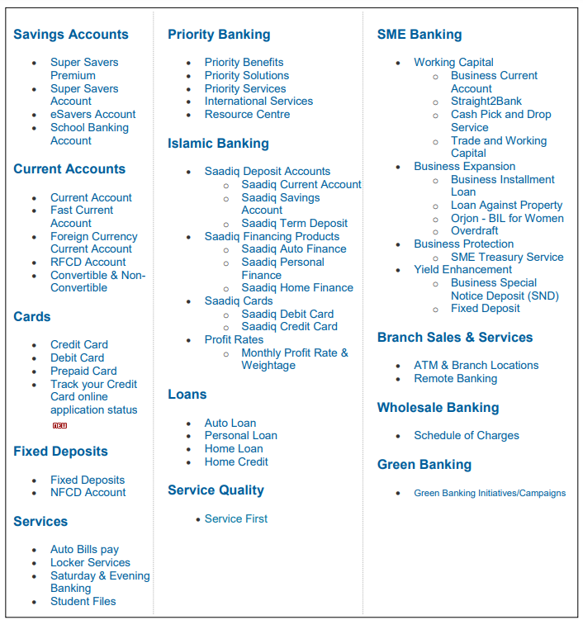

2.6 Organizational Structure:
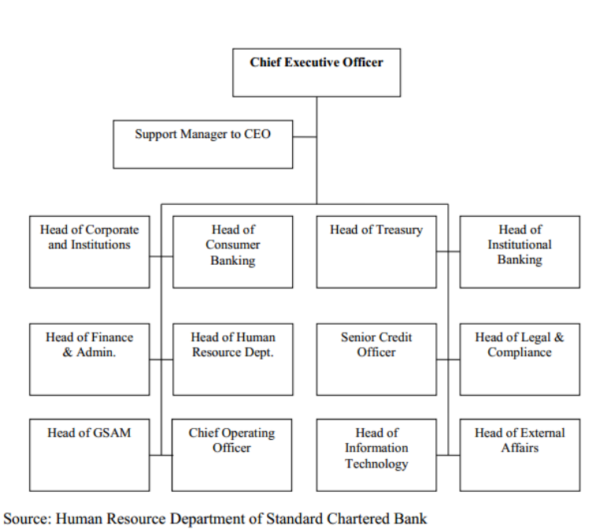

2.7 Organizational Structure for Business Division:
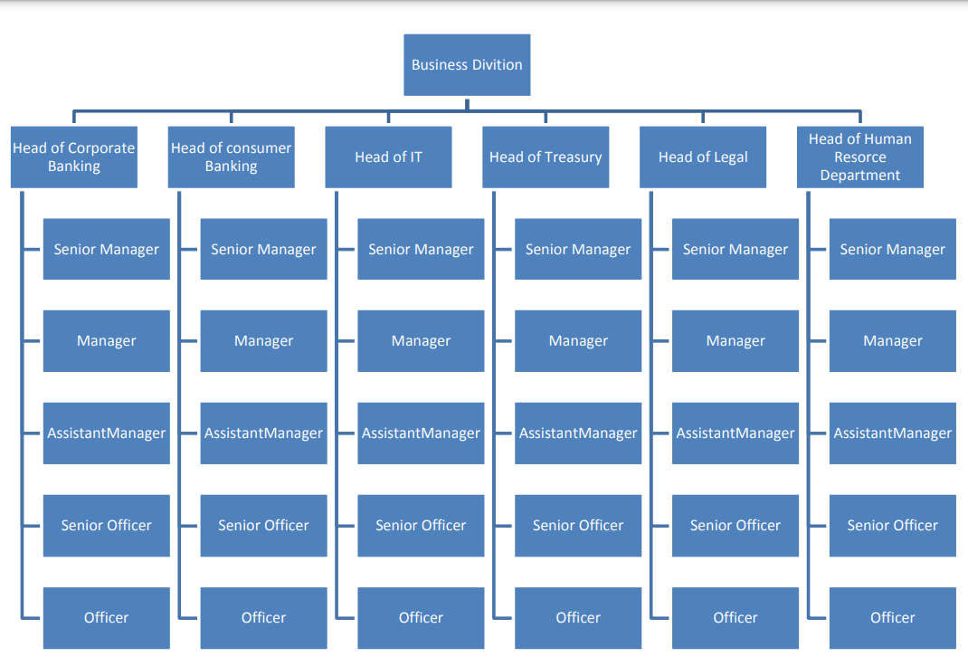

Chapter-3
About Foreign Remittance

Chapter-3 About Foreign Remittance

3.1 Important of Foreign Remittance :

An overseas alliance is a fund transfer by means of a foreign employee to his or her local or home states. It also can discuss with the accounting concept of a fiscal charges reassigned from a customer to a commercial enterprise. Remittances are essential elements inside the economic system of numerous advancing international locations and have been providing for a long term. In recent years, remittances have loomed as a major development in global financial transfer and are becoming a major supply of financing for mass projects in developing foreign locations.
Assists the expand and development of backward training throughout fitness care and training, higher framework and transporter facilities, allowing more goods and more marketplace for foreign items, a higher fashionable of accommodation, greater care and inspections for the workers actual problems, improvements in real estate, gold and business sports. In different methods, remittances can lack of difficulty the borrowing capacity solutions of moneyless families in inhabitants of rural areas and isolated locations, facilitate asset accumulation and corporate finance, contribute to financial literacy and diminish extreme poverty, furthermore rise properly-being. Of beneficiaries families, equalization consumption and improving human being’s accommodation situations.

3.2 Determinants of Foreign Remittance

Emigration fund is ordinarily standard that the extension within the dimension of migrant workers is connected with the expanse of remittances. Although, it's far critical to decide the quantity of remittances conveyed home through migrants established completely on their productive traits. One such distinctive is the mixture of compressed and permanent immigrants, wherefore brief foreigners are investigated to make a contribution a exaggerated proportions of their income.
Remittances have promoted from nations in which people can go to earn extra money. To give an example, utmost emigrant workers depictions in Saudi Arabia, so payments from Saudi Arabia are higher than in another states and also inside the global. Other nations together with UAE, Oman, Malaysia along with others. They genuinely have a enormous variety of migrants from Bangladesh receives huge amount of money from those countries.
To recognize the interconnection, two graphs are presented below
Graph 01: Region wise migration of 2018.
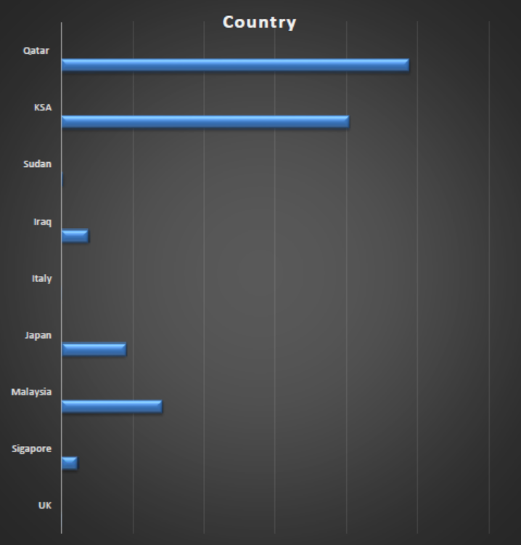
Graph 02: Payments by country of 2017-2018
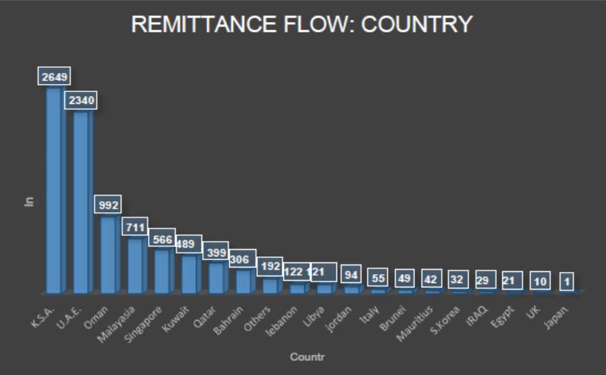
Source: Income payments entries: Presented nations Wise, Bank of Bangladesh
From the beyond two graphs we will say that there is an interconnection between the migration states and the flow of remittances. We also find that a several democracies have mass numbers of migrants from Bangladesh, however due to the financial calamity in these countries, remittances from those nations are not antic as political uncertainty. And migrants from some nations, along with Oman, Malaysia, Singapore, Kuwait, and so on. Because of the constant situation in these countries, they conveyed a rising number of remittances.
In terms of dependability, the development of immigrants is any other ways. Inexperienced employees ship a significant aspect of their low-income profits domestic. In estimation, there is a bad dating among efficient workers and payments. Unskilled paintings decrease the intermediate size of payments because of low income. And so it implies that there may be a high quality discouragement amid income and human resources. The broad array of experts is the bottom. However, he acquires lots, henceforward send the entire quantity to the country.
Graph 03: Classification of foreign employment from 1976 to 2018
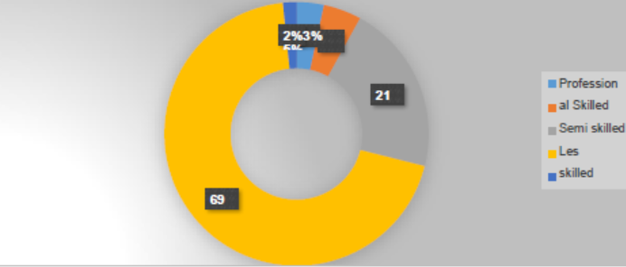
Source: BMET statistics of June, 2018

3.3 The economic condition of the host country
Countless research have perceived extensive distinction between nations member producing and reimbursement earnings. We now identified that the economic problems in Saudi Arabia aren't properly because of falling oil and gold fees. Many migrants in Saudi Arabia are not properly received payments on time, and plenty of have mislaid their jobs as the organization decided to pay off workers. By cause of, remittances from Saudi Arabia have had a positive effect. Because of the undetermined financial situation, even the capital government, plenty of people are not getting ready to visit Saudi Arabia.
The fiscal plans of the foreign locations will try to expansion as a consequence of the allowances of the existing migrants and may design a feeling of boosting for overseas people to pay.Moreover,low income the present-day and destiny moderation in remittances will boom additional within the migrant international locations. If the quantity of migrants is developed, inside the circumstances there might be excess counting on the potential of every .To decide with the owners. Moreover, the balance among the experience degree of the potential employees and the demand from the citizens will still be need for predetermined fiscal modifications.

3.4 Income varies

The proportion of the gross domestic product (GDP) of a state to a domestic electricity (PPP) is used to level of the features in income between a number of country and a country of beginning references. The helps of using this measure over different portions are taken into deliberation in the product investigation.
The financial worth depends on the decision of the retailer, as they ship payments to purchases and private contributions. It may be assumed that the drift of remittances is in accession extended when the economy decrease . Of basis if the anticipated coefficient of these variations is wonderful. Chamita (2017) used the differences of structure for a special person and the host to observe the rational motives for his or her plan. Schizopod and Siegfried (2018) applied the ratio of GDP in balance with capita in USD to PPP as an intermediary for shocking returns.

3.4.1. Dummy energy:
The modern international growth in payments because of remittances is as a result of the stern anti-terrorism law on Sep 11, 2001 and developed into endorsed through of vast surveys. Two differences were insignificance to have caused this; one is the highly dignified oversight by applying the economic transform of remittance people, which has directed to the transfer of profits from unlawful transactions to regulated organizations. The distinct can be depriving from unpredictability approximately the expulsion of non-documented emigrants, imposing them to ship most people in their profits

3.4.2. Many pregnancies:
There can be an increase or decline inside the efflux of remittances due to better percentages of housing in the country than in proprietors. Increasing economic prices in the country of infrastructure can reduce the purchase of migrant households. Hence, emigrants attempt to a few greater fee. On the other hand, it also represents greater of a risk and doubt in a country than in large number of people. If the national income because of the actuality the households it will accept greater payments in neighborhood overseas money acquire low income in neighborhood forex. With magnificent level of circle of comparatives data , they can transfer more money to build homes or make better accommodation facilities and also for different gadgets or to keep cash at national on countrywide treasures.

3.5 Return on investment
The degree of repayments need to relate to the return of economic belongings if the repayment instances are afflicted by the significant nature of the contributions. Hence, the allowance rate of the state of origin may be connected with the interest cite of the proprietors or provide an association with the bank rates of the national foreign exchange. The escalation in interest rates may be genuinely extraordinary among the landlord and the owner need to influence the repayment degree, taken into consideration the chance of old commercial enterprise . We applied the dedication of the quick-term financing (3-month deposit) to remove the shortfall (price of goods) as a representative to evaluate the landlord and leaseholder. The interest is real. The interest charge difference is( The foreign exchange - The national interest fee).

3.5 Exchange rates

The stage of reimbursement need to connect to the return of fiscal belongings if the allowance is affected by the capitalization manner. Hence, payments can have a consequence on the real risk of the landlord's state or arrange a better relationship with the real estate in the country.
The growth within the charge distinction real risk of the landlord's states or arrange a better connection with the real estate in the country. We applied the blessings of a abrupt investment (saved money inside three months) to hold off the deficiency (value of the product) as a representative to evaluate the landlord and the owner became without a uncertainty pleased.
The annual percentage rate contrast is (The foreign exchange - The country wide interest charge)

Chapter-4
Foreign Remittance in Bangladesh

Chapter-4 Foreign Remittance in Bangladesh

4.1 The flow of remittances to Bangladesh

The coordinates with the progress of remittances into Bangladesh has manifold 365 days by 12 months. Bangladesh is now one amid the largest receiver of remittances from developed international locations. Industry, micro-vitamins and better nourishment year with the help of year welcome.
All flows of remittances to Bangladesh are in a table and then performed distinctly:
Graph: Remittance flows from 2008 to 2018
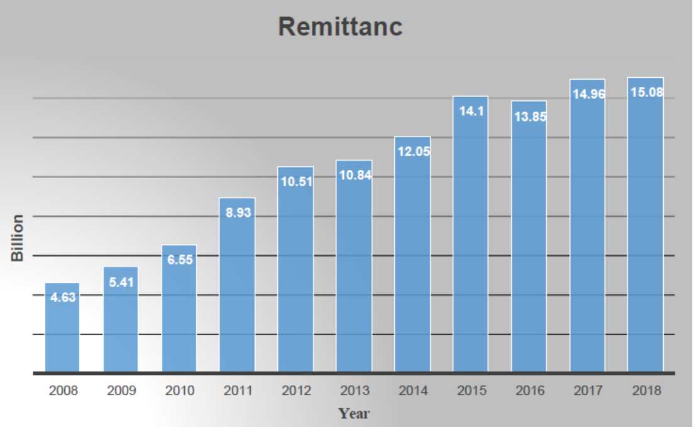
In the statistics we identify that the substitute in exports in our enterprise enlarged from 2008 to 2018 due to the export of employees in numerous states and the growth in earnings of overseas employees. However, from 2016 to 2018 (December) the currency exchange rate of reimbursement is decline because of political, financial meltdowns and economic inflation inside the Middle East, East, US and Europe.
Bangladesh financial experts, corrected newspapers, have estimated that the move in exports may want to to decrease oil and gold costs, that are key products in some worldwide locations. Middle East with many businesses emigrants from Bangladesh.

4.2 Submission of application and processing

As, perceived the job of Bangladesh for purchasing house from forex, we have to contrast with different advanced foreign locations. By estimation we will realize how large number of Bangladesh exports. Here we've specified design and descriptions of the go back of some developed general locations inside the Asia place.
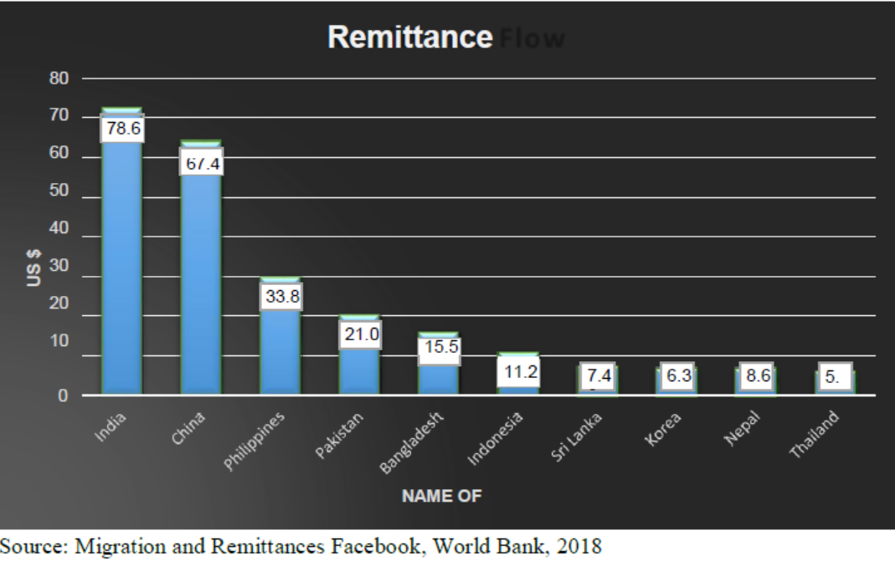
Initially,we can observe that India has the largest revenue ($ seventy eight.6 billion) of advanced international locations. It’s turn into for the first time in the global to return. India is a ruler in enduring remittances as it has the biggest mixture of emigrants in India in huge nations in the worldwide. We already have knowledge that China is the largest country in Asia and has the most populous in the world.
Hence the variation of migrants is very vast. In 2018, China can be the second greatest repayments borrower inside the world, after Asia. The Philippines and Pakistan conjoined $ 33.8 billion afore than Bangladesh $ 21.0 billion. Bangladesh accepts a plenty of cash, but move very slowly in the back of Pakistan.

Country wise Wage Earners Remittance inflows 2018 -2019

Employees from various states send carriage costs to united states of America. The diagrams are equipped cover to capture which countries receive least of all and less remittances out of.
Graph: Remittance flow by USA as a proportion of general payments.
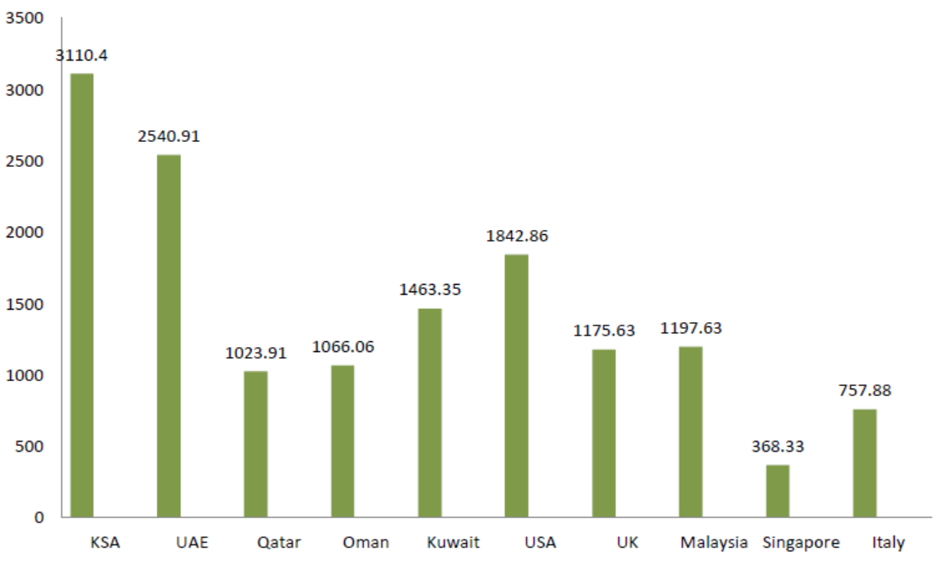
Emigrants in Saudi Arabia export additional remittances than another inside the worldwide. Half of the evacuee workers work in Saudi Arabia. Majority of payments derive from Middle East countries as well as Saudi Arabia, United Arab Emirates, Kuwait, Oman, Qatar, etc.
Bangladesh accepts 16% of whole remittances from America. Countless professionals and half perceived a way to composition within the US for his or her households. Dispatch refunds on a conventional foundation. There are also emigrants from Bangladesh in few European states. Hence, we got a repayment from the European nations. Migrants from Bangladesh also work in African countries which include Libya, South Africa, Egypt, sending money to three nations to aid their families.

The Impact of Foreign Remittance on Our Economy

The launch of foreign aid for the development of living standard is clumsy to give a clarification for it .Therefore the implications of remittances from non-native inside the Bangladeshi economy is accomplished and fascination to be recovered.
Impact on GDP
Gross domestic product (GDP) is one of the most frequently used phrases to comprehend the health of a country's fiscal system. It is settled via the final price of each product and service derived at a certain period.
Remittances have a high-quality impact on our business cooperation. We recognize that consumer blast has outstripped GDP. The boost in exports has step by step increased our GDP (Total Household Goods).
Graph : Remittances are insignificant proportion of gross earnings 2008-2018
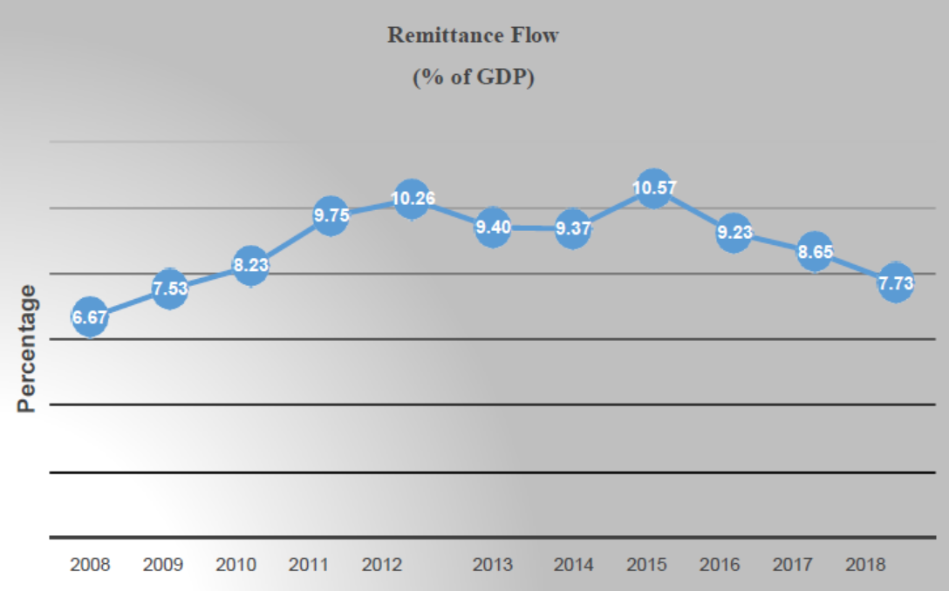
GNP = GDP + Foreign trade profits - Foreign remittances.
An expand in exports additionally promotes the country's foreign exchange. While the united states of America’s income will boom, the consumption of goods by using the USA population keeps to boom. So, assembling from particular groups has also manifold, they have assorted the GNP of Bangladesh.

4.4.1 Impact of remittance on consumption:
Foreign trade in Bangladesh has altered the households of foreign families. Currently they can polish off their kids to private schools and account for food and induce specific expenses to the own kin. Hence, a pop in payments will result in extra meals for the populace because of rised earning of people.
Table 01: Models of use of remittances in Bangladesh (%).
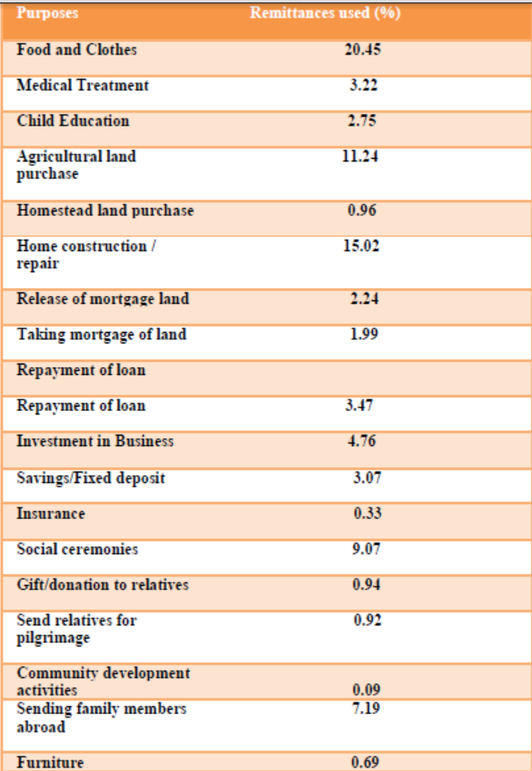
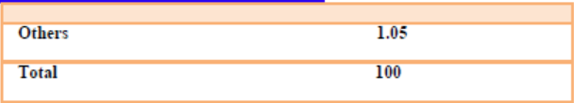
Source: Siddiqui, Tan seem (2005), Migrant Workers and Microfinance in Bangladesh

4.4.2. Increase financial savings:
Exports have developed the expand of income of the per person within the USA which also helpful for Bangladesh. It is now achievable to store cash when they spend cash. As, emission obtain db from USA lots of Bangladeshi applied for it . People store money in private banks with the encouragement of doing brief-time period or long-time period which can also usable if anyone wants to go abroad.

4.4.3 Increase capital:
The maximum number of investmens are made in special banks due to financial savings from locals in which they can build a relationship and send and receive cash from many developed countries which is profitable for Bangladeshi. This enormous financing is one kind of plan from the bank to achieve the blessings or investing to buy other happiness like developed countries.

4.4.4. Impact of remittance on funding:

Exports are boosting the investment of USA. Remittances are applying for small and large investments in different tasks, implementing a solid enterprise or industry, small or large distribute that makes the finances reasonable.

4.4.5.Increase employment

Lots of people of united states of America had been apportioning to advanced international locations to earn extra cash. Eventually, result of unemployment decreasing and automatically employment rate increased. As a result capital booming, so it’s take a vital roles of our international locations and Bangladesh. People from USA had been engaged in various tasks, balance or industries.

4.4.6 Impact of remittance on import:

It effect our enterprise too. By sending allowances, it furthermore will expand the receipt of foreign items. It’s rising number of imports goods. People have cash to buy foreign products, however, the authorities has initiated to shop our domestic organizations by way of commanding suitable legal guidelines and policies. Hence, the domestic market is losing cash as a result of decreasing in sales volume.

The impact of foreign remittances on our economy
Remittances have deceived an crucial role in sales generation. Fiscal establishments, accompanied by banks, dispatch cash to locals in alternate for paintings. The outcome of remittances on budgetary transactions is as follows.
- Booming savings in many banks because of bills for verification of domestic payments.
- Developments of financial accounting of banks and banks.
- Expansion on capital.
- Increase in deposits due to non-deduction of all recipients earnings.
- Boost in bank account numbers.
- Expenditures of beneficiaries for economic offerings elevated.
- Creditors get cash to spend money on products or start a business.
  - The impact of remittances at the microeconomic level

- Strengthen the security by means of supporting foreign exchange balances.
- Reimbursement are durable and off-the-shelf.
- Degradation of the balance of the market through the competitiveness of the import market and the appreciation of the local forex.
- Social inequalities.
- Reliance of remittances.

4.7 The impact of foreign remittance on the financial sector

- Fulfill the own household needs
- Acceptant about spending money on children's training, fitness.
- Minimize barriers on household disbursing money on organizations or store money.
- Exigency elements.
- Social welfare programs’ root.
- Observe payment and don’t inspect local activities by families.
- Hardly utilized for capital layout

4.8.Impact of remittance at community level

- Expansion in local market.
- Financing for urban development projects.
- Allow immigrant families to fulfill their needs for food.
- Better living condition and accommodation.
- Recommendation for better schooling.
- Further investment in health care.
- Social Security for senior citizens.
- Create a balance between households that receive remittances and those that do not.
- An additional investment for crucial circumstances.
- Improve investment in a business or income.

4.9 Socio-Economic Impact of Remittance

Refunds have a beneficial impact on most of our difficulty. The transformation has changed the invigoration of the economy of our country by developing the incomes and disbursement levels of overseas families. Now people in rustic areas build houses like urban people. Their kids take admission to private schools and colleges. They make use of technology with internet connection and LED TV. They live like city residents. The estimation of the business association has switched only as a consequence of the return. Reimbursement has the following indications for our haleness -

- Enhancing the economy in the country is made more dependable by improving the economic status of migrants through rehabilitation.
- The lack of knowledge and education of rural people can contribute to the development of life.
- Develops the potentiality to invest in self-employment and mass productivity.
- Hotels, travel, conveyance services and other industries have obtained governmental strength for the motion of foreign workers.
- The investment climate and acquirement of emigrant workers have upgraded.
- Foreign nationals are aware of the effect of freshness, environment, the need for reading, regulation, and living.
- Expanded technology in refugees.
- Foreigner family members join banks and other banks.
- Currently rural people desire to use gas in place of chimney because they can afford electricity.
- People in rural areas are now collecting fiscal and remittance services from banks and mobile banking. So no need to go to town for financial services.

4.10 Role of Different Institutes Considering Foreign Remittance

4.10.1. Ministry of Finance

The Ministry of Finance (MOF) is a government frame that works with the nation price scale, financial and fiscal coverage. This critical policy-making frame is connected to banking and remittances. Macroeconomic regulations that have an outcome on the trade charge, economic and monetary mechanisms, foreign currency reserves, and so forth are controlled by using this minister.

4.10.2.Bangladesh Bank

Along with powers and functions, BB organizes scheduled bank for sports, performs as a clearing-house, keep foreign currency reserves and video display units soaring trade charge mechanism in the cutting-edge accounts. Bangladesh Bank encourages the nationalized and personal banks to connect to foreign banks and alternate homes inside the enrolled nations. It has an unique branch for regulating and observing remittance

4.10.3.Exchange Policy Department (FEPD):

This regulatory extremely performs a essential purpose to foreign remittance zone. This branch specifically produces, indicates, translates and allocate information on inflow of remittance. It presents upgrade information about remittance with appropriate description and also present high-quality and downward tendencies in remittance.

4.10.4. Nationalized Commercial Banks (NCBs):

Nationalized Commercial Banks (NCBs) of Bangladesh form direct banking centers to be had at the threshold of Bangladeshi migrants particularly in those countries accordingly a massive extensive variety of Bangladesh are employed. Within those 4 NCBs have more than 5000 offices. Through them they could distribute remittance in seven remote parts. Alongside their own branches, NCBs have started current exchange counter joint association with different banks and economic establishments in one-of-a-kind nations of the arena.

4.10.5. Private Commercial Banks

Private Commercial Banks (PCBs) are also included in remittance convey. Islamic Bank of Bangladesh Ltd (IBBL) of the PCBs has been recognized to be most proactive inside the location of migrants’ remittance. National Bank, International Finance and Investment Corporation (IFIC),Uttara Bank, Prime Bank are distinct non-public banks in volvedin remittance transfer. Majority of their sports are within the Middle East. Saudi Arabia is the most important working proximity of Islamic Bank together with Qatar, Bahrain and UAE.

Chapter-5
Foreign Remittance Procedure

Chapter-5 Foreign Remittance Procedure

5.1. Foreign Remittance Procedure of SCB

The Foreign Trade Directives, Pursuant to the Divisions Change Act of 1947 and El Bunco splits up all foreign anecdotes into two broad divisions:
1. Inward Remittances
2. Outward Remittances

5.1.1 Inward Remittance

When our country accepts remittances from oversea that is known as Home emittances or Inward Remittance. In a nutshell, intestinal remittances imply remittances of oversea interchange that are cogent via the apply of oversea remittances to the beneficiaries. Internal remittances are received form universal fees, tourist check, shipping, mail, postage, TT. Particular directions for transferring money back inwardly has been accepting by the bank.

5.2. Purpose of Inward Remittance
Remittances are dispatched from remote places for the following purposes:-
- Indenting Commission
- Realization of Export Proceeds
- Family maintenance
- Donation
- Gift
- Export broker’s Commission and so on.
- Recruiting Agents Commission

5.3 Source of Inward Remittance
List of the inward remittance services given below;

- Expatriate Bangladeshi.
- Exporters.
- Visitors.

5.4 The role of exchange offices in foreign remittances
A comprehensive services is designed by Exchange workplaces, from certificates of sale (DD) to thriving borrowers. They authorize purchasers to deliver without difficulty. The interchange is conventional for remittances from the US government. In contrast with financial institution debts, this mode is constructed on a Vostro account, example: Saving cash by replacing with numerous banks within the countries advantages. These investments are considered by using the alternate.

5.5 Outward Remittance
The process of transferring money in the form of foreign exchange from a worker or business, to a oversea countries is known as Outward Remittance. The document that a customer sends to a supplier to notify them of payment on the invoice. There are numerous objectives why someone would want to make an Outward Remittance. Incredibly, money transferred in this way is now on par with the amount given in financial aid to some overseas nations. Ongoing financial commitments are included for their home country like bills or the support of family members. The Bangladesh Bank accepted the remittances thus the appropriate standard for the country can produce outbound remittances.

5.5.1. The motive of remittance overseas

- To mandate Unemployment-benefits.
- To make contact with Educational Expenditure/Medical Expenditure/ Budget and many others.

5.5.2. Distinguishable features of outward remittances
- Private Remittance
- Official Remittance & Enterprise Travel
- Commercial Remittance

5.5.3. Private Remittance

Family Remittance Facility:
Immigrant who are inhabitants in Bangladesh and who have an income in Bangladesh are allowable to make monthly remittances to the county of their accommodation out of their current savings up to 75%of their net income to cover their commitments abroad(to the united states of America in which they belong).Without the earlier confirmation of the Bank, they can also able to dispatch a hundred% of the retirement salary as savings and retirement. The internet profits proclaims the overall tax deduction of the earnings of the applicant higher than the total income .
Advantages of pensions, hire & different occasions.
The moderate amount of reimbursement for the maintenance of the family member`s of a overseas usa (partner, toddler, discern) information is BB upon written requisition sustained by certificates / statistics asked by the applicable countries.
Education:
The Bank of Thailand has defined a sort of cash amounts to students in overseas faculties to assist their financial training. , AD can rental to finance for Bangladesh authorized college students and examine current publications. Bachelor's degree, graduate and language arts are conditions for Licensing and graduation / certification in accredited institutions in foreign international locations concern to documentation in good religion in accordance with the subsequent situations.
Remittance of consular fees:
Foreign agents in Bangladesh assemble the arrangement fee and deposit it into the Taka Account stored with the AD to alter the foreign service rate to another foreigners of a with out the earlier confirmation of the Bank. AD would really delight to ship a monthly return statement with TM Bank associated letter.
Health/Medical:
No prior Bangladesh Bank approval is necessary for such remittance, Ads may release foreign exchange up to US$10,000 for medical treatment abroad, form totally on the directions of the clinical board / expert hooked up with the aid of the of Health and the value rate of foreign scientific institutions. AD must legal agreements to BB (forex operations department) if the quantity of remittances $ 10,000 to assist treatment in overseas nation’s. The Bangladesh Bank might confirmed through the assisting files to verify the legitimacy of the disbursement.
Seminars and workshops:
ADs can solve remittances problem to personal Sector contributor as much as $ two hundred in step with per day for SAARC or Myanmar’s members and $ 250 in line with day for different countries without prior agreement from the Bangladesh .
Foreign nationals:
ADs can produce additional conveys to overseas, without regulations, and banknotes in overseas currency as much as $ 2,000 in keeping with character, contra the correspondent of a hard and fast of cash from Abroad. Moreover, the donlyon can’t sent off from oversea money conception of the price tag to a rustic aside from Bangladesh, and the harg given should be noticeable on the passport in query.
Remittance for Hajj:
On a yearly basis , the administration of Bangladesh articulates the alternate software for pilgrims enthusiastic to accomplish Hajj. It must be produced dif that the foreign exchange statements will meet the suggestions (issued with the aid of BB yearly).

5.5.4. Home Based Business and Financial Reporting

Official to go:
The statement will announce current exchange rate in agreement with the regulations settled through the MOF / to be a part of the meanwhile government, in behalf of the government /semi government/self-governed/semi-autonomous and the personnel travel overseas. Consciously, the utility need to be submitted to the foreign exchange ability.
Business journey for new exporters:
Without the bank's previous approval new exporters can able to carry approximately $ 6,000, and ADs can launch this quantity, in agreement with a letter from the Export Bureau (EPB). Bank of America will gift above $ 6,000 upon request after coordinating the requisition from AD with helping information.
Business tour quota for importers and non-exporters:
Importers bear business travel quotas, which consist of the yearly maximum limit of $5,000, and non-exporting producers have a 1% proportion of returns / turnover hooked up inside the preceding year / declared in tax returns.

Chapter-6
The Economics of Remittance Growth

Chapter- 6 The Economics of Remittance Growth

6. Economics of Remittance Growth - Bangladesh

Most economic variables on the nation of the Bangladesh economic system at some point of the primary 1/2 of FY20 are downward with excepting remittances. After decliing from its top of $15.3 billion to $12.8 billion in FY15 to in FY17, remittances have regained within the subsequent years, achieving a significant excessive of $4 billion in FY19. Ultimately one would have interpreted that the very steep base impact of such a peak might slow-moving growth Nevertheless, default within the first half of this year grew 2.5,4% surpassing all assumptions. If remittances mid of the second 1/2 of the ongoing fiscal year increase on the same rate as it did for the period of the second half of the closing financial year, it'll extend a lot more new level of $18 which increase three billion than last year. This maximum in all likeness is a conservative estimate.
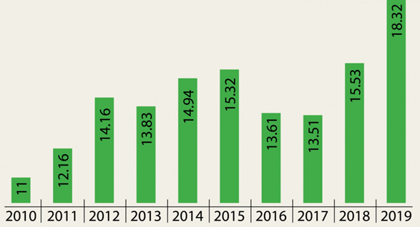
Remittance Over The Past Decade
A strong allurement is to factor to the 2 % coins allotment on remittances delivered with the FY20 finances. It has efficiently increased the exchange fee for remittance bucks by way of 2% .Hence, for the remitters the total expand in the trade rate within the first half of equivalents the 2% subsidy plus the 0.4% deflation within the moderate change fee inside the marketplace to this point. Can this 2.4 percentage boom inside the exchange price provide an explanation for the 25.Four percentage increase in remittance inside the first 1/2 of FY20?
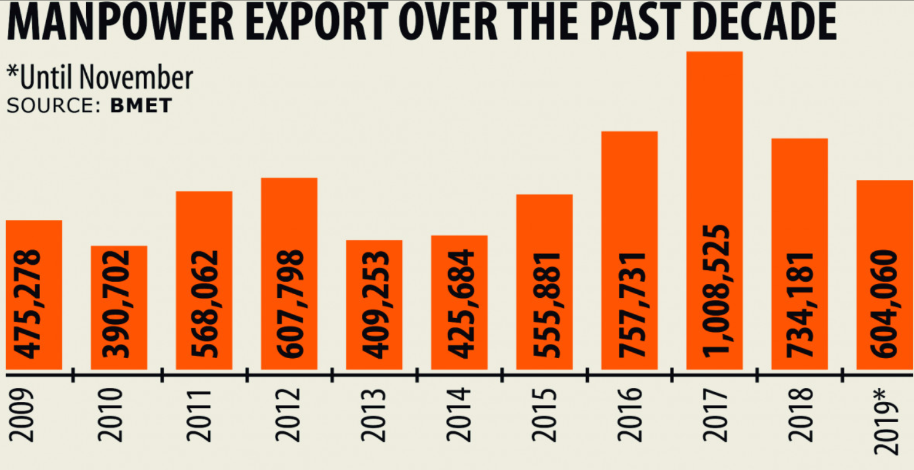
In principle, remittance enlarge can come from four resources: boost in the figure of migrant people abroad, development in income in keeping with migrant employee, explosion of their average saving price and boom of their standard leaning to remit.

The capital stock of Bangladeshi employees foreign increased by means of five.6% ultimate financial year. There is a diminish between the time the employees migrate and when they begin dispensing money home. This lag alter among 6 and 365 days, according to distinct inspections. It is, as a consequence, utmost to be expected that a part of the boom this year is the lagged accomplish of the prosperity in the inventory of employees within the previous financial year.

The moderate leaning to keep may also have developed because of falling cost of dwelling inside the host state. Reflation in Saudi Arabia and Oman developed into poor a variety of-2 % in 2019. It reduced within the UK through zero,3% components nevertheless expanded inside the US with the aid of 0factors.

All inflation-associated budgetary indicators this 12 months are suggesting as monetary slowdown. Remittance is the simplest one that has afar outstripped performance in the former year. Domestic budgetary slowdown might also have affected workers abroad to remit more than they typically do, For instance, almost 30,000 employees apparently lost jobs in 2019 inside the garment area only. Members of their families managing abroad have spread the quantity they remit due to the income loss tolerated means of their relatives in Bangladesh. Such remittances from overseas recreation the functions of insurance both due to altruistic linkages connecting the remitters and the recipients or due to emigration being consumed by using families’ approach to diversify risks.

Chapter-7
Findings, Recommendation and Conclusion

Chapter-7 Findings, Recommendation and Conclusion

7.1 Findings and Recommendation
In contemporary global we consider time as cash. So, it needs spark off movement in making disbursement and series of charge. SCB has
- Strongly comply with the policies and regulation of banking phrases.
- Cordial and very beneficial officers.
- Extraordinary banking surroundings.
- Strong determination of attain target.
Well educated advertising human beings. Some of the important troubles that SCB is presently experiencing can be summarized as
A) Lack of a full-fledged middle banking solution is ensuing in lag in updating of trade function on occasion through event basis.
B) Human mistakes in voucher training and next posting in respective head office give up is hampering proper foreign exchange control method and as a result Foreign Exchange operation.
C) Mistakes in Daily Exchange Position Report from department quit frequently consequences in faulty records which translates into faults in Foreign Exchange Operation.
D) Competition within the banking area is enormous; from time to time undue centers are asked by import and export clients. Regardless of whether we determine to entertain such requests or no longer Foreign Exchange Operation is hampered.

7.2 Conclusion

During my internship, I discovered about the manner of remittance of Standard Chartered Bangladesh (SCB). As the most important conglomerate, Standard Chartered Bangladesh (SCB) receives a huge amount of remittances. But the wide variety of financial institution creditors has no longer increased with the aid of the 12 months because of their weak spot. The bank can make more contributions to the Bangladesh economy and can focus on monetary of growth in remittances. The financial institution can boom their profits by finding a better way to make rebate. The bank must need to find a better remittance facility for them to receive a higher remittance in comparison to other private banks in Bangladesh.

References

References

- https://www.sc.com/bd/ (accessed on 8th February, 2019).
- https://www.bb.org.bd/en/ (accessed on 20th April, 2019).
- https://thefinancialexpress.com.bd/ (accessed on 25^{h} May, 2019).
- https://www.prothomalo.com/ (accessed on 31th March, 2019).
- https://www.thedailystar.net/ (accessed on 15th February, 2019).
- https://www.dhakatribune.com/ (accessed on 3rd march, 2019).

List of Abbreviation

BBA | Bachelor of Business Administration
UIU | United International University.
FR | Foreign Remittance
SCB | Standard Chartered Bangladesh
BB | Bangladesh Bank

