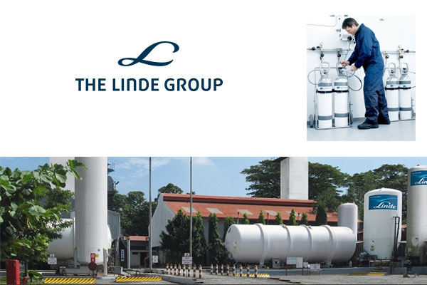

A report on measuring growth, profitability
& performance of Linde Bangladesh



United International University
Internship Report
Course Code: INT-4300

Report on growth, profitability and performance of Linde Bangladesh Limited.

Submitted to:
Nusrat Farzana
Assistant Professor
School of Business &Economics (SOBE)
United International University

Submitted by:
Samiur Rashid
ID- 111 152 042

Date of Submission: 24th April, 2019

Letter of Transmittal

24th April, 2019
Nusrat Fazana
Assistant Professor
School of Business & Economics
United International University
Shatarkul, Notun Bazar, Dhaka

Subject: Report on growth, profitability and performance of Linde Bangladesh Limited.

Dear Madam,
It is a great pleasure for us for being able to hand over the result of my hardship of the report on growth, profitability and performance of Linde Bangladesh Limited. This report is the result of the knowledge which I acquired from the respective course.

I have tried my best to put up a good report with as much information as I could gather during the short time for writing this paper. I am begging pardon for any kind of mistake.

Thank you, for my kind support and help throughout the course, I remain.
We shall be highly encouraged if you are kind enough to receive this report.

Sincerely Yours

Samiur Rashid
111 152 042

Acknowledgement

Whatever I do and what I achieving during the course of my limited time is not just done by efforts but by efforts contributed by other people associated with us directly or indirectly. I would like to express my sincere gratitude and deepest thanks to my honorable course instructor Nusrat Farzana for the freedom she gave us in choosing the organization which I select for my report and her continuous guidance henceforth. Her guidance has been of extreme help to us.
So, her guidelines for the report made it mandatory for us to seek learning from a company, which proved to be very gratifying. I cordially thank the honorable faculty to provide us the opportunity to apply learning in practice.

Executive Summary

This report is based on practices of analysis of growth, profitability and performance of Linde Bangladesh Limited. A well designed and implemented analysis is expected to contribute positively to the creation of a firm's value. The purpose of this report is to examine the trends in working capital management, managerial performance & management decisions and its impact on the performance of Linde Bangladesh Limited by studying the day to day activities.
This report has 6 chapters. First chapter is all about introduction, second chapter is all about overview of the company, third chapter is for theoretical framework and financial performance, forth chapter clears about managerial performance, fifth chapter is finding and recommendation and the last chapter is the conclusion part. All the chapters contain the basic idea based on Linde Bangladesh Limited.

Contents

Chapter One: Introduction 8
Background of the study 9
Purpose of Internship 10
Objectives of the study 10
Methodology 10
Sources 10
Other Sources 11
Scope of the study 11
Limitations of the study 11
Chapter Two: Overview of the company 12
Company Profile 13
Mission 13
Vision 13
Products 13
Production process 14
Actor involved (different parties) 15
17
Chapter Three: Analysis from financial performance 17
Horizontal Analysis 18
Ratio Analysis 19
Liquidity Ratio: 20
Debt-Management Ratio 22
Profitability Ratio: 23
Efficiency Ratio: 27
Reformulation 30
Growth Ratio 31
Income Statement Ratio 32
Balance Sheet Ratio 34
Operating assets ratio 34
Operating liabilities ratio 35
Analysis of profitability 36
ROCE 36
OLLEV 37
FLEV 37
RNOA 38
PM 38
ATO 39
40
Chapter Four: Managerial performance 40
Ability of management to cope with change 41
Nature and effectiveness of the process used to arrive at major decisions to bring about change 42
Sales & Operation meeting 42
Management communication meeting 43
Risk management meeting 43
The efficiency of the mechanisms utilized to implement management decisions 44
The internal methods employed to determine and track valid objectives 44
Procedure for setting goals for employees 45
KPI 45
46
Chapter Five: Findings and recommendation 46
Findings 47
Recommendations 48
Conclusions 49
50
Chapter Six: References 50



Chapter One: Introduction

Background of the study

I have taken a course “Internship” (INT-4399) under Nusrat Farzana (my course instructor). She has assigned practicing preparing a report of a company where I am working as an Intern as a course requirement. I have chosen Linde Bangladesh Limited for my report because I am working here in the ‘Share Department’ and I found Linde Bangladesh Limited as the one of the best manufacturing firm in the country. So I chose this organization to explore new knowledge which will help us in my career options.

In Linde Bangladesh, I’m responsible for handling all share related issues and public function like, dematerialization procedure, issuing duplicate share certificate and mostly job in AGM, Board Meeting, financial forecasting and annual report preparation. It gave me lot knowledge and enhanced my experience because I have no idea on that. Now, I can use this knowledge and experience in my next jobs.

Academic courses and assignments and reports related to the courses benefit me in a real sense when it comes with practical application in my life. Academic courses help students by giving chances to work in practical field and by allowing them to deal real problems in the fields by applying theoretical knowledge which makes the students realize the benefits of the knowledge.

It is known by all that every multinational company plays a vital role in the economic conditions of every country. Manufacturing company is one of the important segments of financial infrastructure of any country. The multinational companies normally transfer investment, increasing employment opportunity and government revenue.

Purpose of Internship
Internship is a program where an internee gets himself benefited by hands-on and real world experience in a particular job field. It enables in terms of:
- Conduct and integrate my knowledge and skills from the class room
- Exploring where further competence needed
- Take steps for gaining competitive advantages under education supervision
- Become better conversant with related work settings types where such competence must be applied

Objectives of the study
The broad objective of this study is to assure the performance of Linde Bangladesh Limited. This study was conducted with a view to achieve some other specific objectives which are given below:
- To gain knowledge about the multinational sector
- To know the financial information
- To find out capital market based on other criteria
- To measure the level of operating expenses
- To know about the marketing and sales policy and other relevant activities
- To find out the causes behind company profit
- To solve the causes and help top level management by providing necessary suggestions
- To find out the management decision
- To find out management control

Methodology

Sources
To conduct this report, a group discussion with different employees from different department was used as primary source which helped to gain information regarding the company’s financial performance. A wide range of charts are used to convert the results in percentage form which will be found in chapter 4 part of the report. With a view of preparing the report, some secondary data were also required which are given below:
- Annual reports
- Study of related books
- Internet (Google)

Other Sources
I was working as an internee in Linde Bangladesh Limited under the supervision of Company Secretary (Abu Mohammad Nisar). I could gather information by getting help from him. He helped me by sorting out all the necessary information that made easy for preparing this report. And the other side, some of the person from Linde Bangladesh Limited took a part in this report by facilitating for gathering information to boosting up the excellence ratings.

Scope of the study
This report provided anonymous information and knowledge about the multinational company sectors. While working in Linde Bangladesh Limited, I got to know the cultures within the firm. The day long working of Linde Bangladesh Limited gave us a depth idea of the working activities of business sector and provided us with information to choose multinational business sectors as career aspect. This report has enriched my knowledge and provided information about the importance of multinational company sectors in economic activities.

Limitations of the study
There are some limitations of this report which are given below:
- The primary source might not be able to provide the correct information due to the security issue and policies & obligations of the multinational company
- The management discussion might be a little bit different because of having extra pressure for upcoming Annual General Meeting (AGM).

Chapter Two: Overview of the company

Company Profile
Linde Bangladesh limited, a listed company that is limited by shares and was leagued in Bangladesh in 1973 under the companies Act 1913. This company became listed entity in Dhaka Stock Exchange in the year of 1976 & in Chittagong Stock Exchange in the year of 1996. The commercial registered office is now 285, Tejgaon I/A, Dhaka-1208. This company is a subsidiary of the BOC Group Limited of United Kingdom that is fully owned by LAG of Germany. Now it has been merged with a USA Company named The Praxair Group Limited. After that this company will become largest Gas manufacturing firm in the world.

BOL & BOC are entirely processed subsidiaries of Linde Bangladesh Limited. These are entities controlled by the company and consolidating financial statements that comprise the company and subsidiaries also.

Mission
Linde Bangladesh Limited leads to build the individual and collective strengths across global footprint in a larger scale. They also are focusing on increasing network density by growing profitability and sustainability in industrial and medical gases.

Vision
Linde Bangladesh Limited wants to be the leader in all the sectors of Business by recognizing and competing in Bangladesh and capture the full value of the merger.

Products
Linde Bangladesh Limited is manufacturing and the supply of industrial and medical gases, welding product & equipment and ancillary equipment’s. They also provide cylinders and insulated evaporators.

Production process
Linde Bangladesh Limited is manufacturing company that is operated profit for 2018 is expected to in surplus in terms of increase in sales due to market expansion.

- Step-1: Customer Analysis
Linde Bangladesh Limited gathers information based on past data focusing on market situation for determining the real customers for their company are.

- Step-2: Demand Forecasting
Linde Bangladesh Limited mostly gets contracts from the vendors based on low-cost and high lead-time considerations. They specializes in high volume, low-cost production of technically simple products and utilizes the world’s largest low-cost labor pool, which allows subcontracting from lead contractors to complete demand based on supply on time at a lower price per unit.

- Step-3: Product quality
Linde Bangladesh Limited ensures the product quality at the time they sign the contract with the vendors. Then they started to develop their product for finalizing the product’s total quality management based on that.

- Step-4: Safety matters
The products of Linde Bangladesh Limited may be dangerous if that are not focusing on safety issue. For that, Linde Bangladesh Limited always tries their best centering on safety related issues.

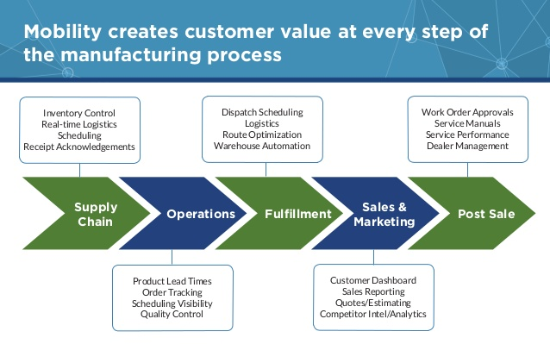
Figure 1: Process of Manufacturing to Sales

Actor involved (different parties)
Different parties are involved in exporting process which has to be faced by Shadow International.

- Banks
Linde Bangladesh Limited completed their transaction through Hong Kong and Shanghai Banking Corporation (HSBC) and Standard Chartered Bank.

- Ministry of foreign trade
The Minister for Foreign Trade and Development Cooperation is a Minister without portfolio tasked with all matters concerning International trade, Export promotion, International development, Development aid and International Environmental policies.

- Customs Administration
Customs is an authority or agency in a country responsible for collecting tariffs and for controlling the flow of goods, including animals, transports, personal, and hazardous items, into and out of a country.

- Internal and external audit
Internal auditors and external auditors are responsible for determining the company’s overall information that will provide to the shareholders and others.

- Nomination and remuneration committee, Audit Committee
NRC and audit committee are responsible for having a look on the company for determining the overall performance and making decision what they have to do following Corporate Governance Code and the guidelines Bangladesh Securities and Exchange Commissions.

Distribution channels and patterns
Linde Bangladesh Limited sells through sales center. They have 11 sales centers spreading all over the country from where customers can collect the products. Basically, they started contracting with vendors for decreasing costs per unit. Vendors took all the responsibility for delivering product to consumers.

Figure 2: Distribution to customers

Documents needed
For buying cylinder number of documents customers needed to have.

- Copy of National ID/Passport/Driving License
- Photocopy of a copy of cheque book
- Current bill of present address
- Doctor’s prescription

Mode of transportation
Linde Bangladesh Limited has own transportation system (trucks). They use land transportation for shifting the product from the warehouse (Rupganj) to the entire sales center. Number of employees from managerial level is responsible for this part.

Figure 3: Transportation mode

Chapter Three: Analysis of the financial performance

Horizontal Analysis
In terms of single accounting period for company’s financial statements can unbolt important about the financial health and overall performance. But comparing the financial statements of more than one period can provide better context and help identify any changes that may signal strengths or weakness. I can compare financial statements for more than one period by using horizontal analysis. “Trend analysis” is also called as Horizontal Analysis that is used to discovering the propensity of the earnings, assets and liabilities over the course of several years. With horizontal analysis, I compare the changes of the amount and percentage of particular items in a financial statement. Horizontal analysis of two sequent periods showing in a financial statement called comparative financial statement.

Horizontal Analysis of Balance Sheet
I choose the fiscal year 2015-2016 as base year. Based on that I calculated the percentages of particular item’s amounts for the fiscal year 2016-17 and 2017-18 for identifying the progress. For the purpose of calculation, here I have shown all the date in million. The horizontal analysis of Balance Sheet is given bellow as a table:

Particulars | 2015  -  2016 | Increase (Decrease) During 2016-2017 |  | Increase (Decrease) During 2017-2018
Particulars | Amount | Amount | % | Amount | %
Cash | 1391203 | 1132356 | (18%) | 1604221 | 41%
Fixed Assets: Property Plant & Equipment | 2543935 | 3218638 | 26% | 3445462 | 7%
Inventories | 768622 | 683575 | (6%) | 842865 | 23%
Investment | 10299 | 10535 | 2% | 10753 | 2%
Total Assets | 5479906 | 5944806 | 8% | 6849227 | 15%
Total Liabilities | 2294973 | 2269148 | (1%) | 2376823 | 5%
Total Shareholder’s Equity | 3184933 | 3675658 | 15% | 4472404 | 22%
Total Liabilities & Shareholder’s Equity | 5479906 | 5944806 | 8% | 6849227 | 15%

Ratio Analysis
A ratio analysis is a quantitative analysis of information contained in a company's financial statements. Ratio analysis is for evaluating various aspects of a company's operating and financial performance such as its efficiency, liquidity, profitability and solvency. These are done to provide perspective and facilitate making comparisons. There are literally hundreds useful financial ratios I can use to evaluate performance. This section will discuss some selected ratios from various perspectives. From various perspectives Ratio Analysis can be dividing into four categories. These four categories are as follows:

  - Liquidity Ratio:
- Current Ratio
- Quick Ratio
- Cash Ratio

  - Debt-management Ratio:
- Debt to equity ratio
- Equity multiplier

  - Profitability Ratio:
- Net profit margin
- Gross profit margin
- Return on asset
- Return on equity
- Earnings per share

  - Efficiency Ratio
- Accounts receivable turnover ratio
- Total asset turnover ratio
- Inventory turnover ratio
- Days sales in inventory ratio

Liquidity Ratio:
Liquidity ratios are financial metrics determining a debtor's ability paying off current debt obligations without raising external capital. Liquidity ratios analyze the company’s ability paying off in terms of its current and long-term liabilities.

- Current Ratio
Current ratio measures that the company has enough short-term assets paying for short term debt.

Particulars | 2015-2016 | 2016-2017 | 2017-2018
Current Ratio | 1.5541 | 1.6699 | 2.0059

The graph above shows the current ratio of Linde Bangladesh Limited Company from the year of 2015-2016 to 2017-2018. I oversee the current ratio in this graph the year 2017-2018 is more favorable.

- Quick Ratio
The quick ratio indicates company’s ability to identify its short term obligation along with its most liquid asset. As a result, the result of the ratio comes by excluding inventory from current asset.

Particulars | 2015-2016 | 2016-2017 | 2017-2018
Quick Ratio | 1.1547 | 1.2354 | 1.4937

The graph above shows the current ratio of Linde Bangladesh Limited Company from the year of 2015-2016 to 2017-2018. I oversee the quick ratio in this graph the year 2017-2018 is more favorable.

- Cash Ratio
The ratio used for determining a company’s cash and cash equivalent asset based on its liability is called as Cash ratio.

Particulars | 2015-2016 | 2016-2017 | 2017-2018
Cash Ratio | 0.7626 | 0.7198 | 0.9747

The graph above shows the current ratio of Linde Bangladesh Limited Company from the year of 2015-2016 to 2017-2018. This ratio is gradually increased. I oversee the cash ratio in this graph the year 2017-2018 is more favorable.

Debt-Management Ratio
Debt-management ratio is a ratio for identifying a company's debt comparing with its total financing. The debt management ratio measures the concession of a company's operations which come from debt without calculating other forms of financing. The debt management ratio measures among a company's risk and default.

- Debt to equity ratio
The debt-to-equity ratio (D/E) is a financial ratio that indicates the shareholders' equity’s relative proportion and debt for financing a company's assets. Closely related to leveraging, the ratio is also familiar as risk or gearing.

Particulars | 2015-2016 | 2016-2017 | 2017-2018
D/E Ratio | 0.1478 | 0.1894 | 0.1635

Debt to equity ratio for Linde Bangladesh Limited is also low. The year of 2015-16 and 2-17-18 are more favorable. It is said that about Linde Bangladesh Limited company is that it has strong enough equity position.

- Equity Multiplier
The equity multiplier is a straightforward ratio used to measure a company's financial leverage. The ratio is calculated by dividing total assets by total equity.

Particulars | 2015-2016 | 2016-2017 | 2017-2018
Equity Multiplier Ratio | 1.7205 | 1.6173 | 1.5314

Equity multiplier ratio for Linde Bangladesh Limited is also low. This ratio is gradually increased 2015-16 to 2017-18. It is said that about Linde Bangladesh Limited company is that it has strong enough equity position.

Profitability Ratio:
Profitability ratios are called as financial metrics that are used by counting the analysts and investors for measuring and evaluating a company’s ability generating income (profit) relative to revenue, balance sheet assets, operating costs, and shareholders' equity during a specific period of time.

- Net Profit Margin
Net profit margin is revenue percentages left after all expenses deducted from sales. The measurement reveals profit amount that a company can subtract from its total sales.

Particulars | 2015-2016 | 2016-2017 | 2017-2018
Net profit margin | 21% | 19% | 18%

Net profit margin of Linde Bangladesh Limited is also low. This ratio is gradually increased 2015-16 to 2017-18. It is said that about Linde Bangladesh Limited company is that it has less enough income position.

- Gross Profit Margin
Gross margin is formulating from the differences between revenue and cost of goods sold (COGS) divided by revenue. Gross Margin is one kind profit margin that calculating by dividing in terms of net revenue

Particulars | 2015-2016 | 2016-2017 | 2017-2018
Gross profit margin | 46% | 47% | 42%

Gross profit margin for Linde Bangladesh Limited is also low. This ratio is accidently decreased in the year of 2017-18. It is said that about Linde Bangladesh Limited company is that it has not strong enough income position.

- Return on asset
Return on Assets is an indicator of measuring how profitable a company that is relative to its total assets. ROA gives an idea to identify how efficient the management is in terms of using its assets for generating earnings. ROA is displayed as percentages from the calculation dividing a company's earnings by its total assets,.

Particulars | 2015-2016 | 2016-2017 | 2017-2018
Return on Asset | 16% | 16% | 15%

Return on asset margin for Linde Bangladesh Limited is also high. This ratio is decreased 2017-18. It is said that about Linde Bangladesh Limited company is that it has average in its position.

- Return on equity
Return on equity (ROE) is the measurement of profitability which calculates a company’s generating profit with shareholders' equity.

Particulars | 2015-2016 | 2016-2017 | 2017-2018
Return on Equity | 28% | 26% | 22%

Return on equity for Linde Bangladesh Limited is also high. This ratio is gradually decreased over the year. It is said that about Linde Bangladesh Limited company is that it has average in its position.

- Earnings per share
Earnings per share are the portion of a company's profit allocated to each outstanding share of common stock. Earnings per share serve as an indicator of a company's profitability.

Particulars | 2012-13 | 2013-14 | 2014-15 | 2015-16 | 2016-17 |  | 2017-18
EPS | 48.55 | 40.75 | 42.74 | 57.90 | 62.60 | 65.96

Earnings per share for Linde Bangladesh Limited are also high. This ratio is gradually 2013-14 to 2017-18. It is said that about Linde Bangladesh Limited company is that it has strong enough in its position.

Efficiency Ratio:
Efficiency ratios measure the ability of a company's using its assets and managing its liabilities effectively. Some efficiency ratios include the inventory turnover ratio, asset turnover ratio and receivables turnover ratio

- Accounts receivable turnover ratio
The receivables turnover ratio is the activity ratio for measuring how a firm is efficient in terms of using its assets. Receivables turnover ratio can be calculated by dividing the net value of credit sales during a given period by the average accounts receivable during the same period.

Particulars | 2015-2016 | 2016-2017 | 2017-2018
A/R Turnover Ratio | 8.7544 | 8.1212 | 8.8214

Accounts receivable turnover ratio for Linde Bangladesh Limited is also high. This ratio is fluctuated over the year. It is said that about Linde Bangladesh Limited company is that it has average in its position.

- Total asset turnover ratio
The asset turnover ratio is an efficiency ratio for measuring the ability of a company generating from sales and its assets by comparing net sales with average total assets.

Particulars | 2015-2016 | 2016-2017 | 2017-2018
Total asset turnover ratio | 0.7793 | 0.8313 | 0.7972

Total asset turnover ratio for Linde Bangladesh Limited is low. This ratio is fluctuated 2015-16 to 2017-18. It is said that about Linde Bangladesh Limited company is that it has average in its position.

- Inventory turnover ratio
The inventory turnover ratio shows how effectively inventory is managed by comparing the cost of goods sold with average inventory for a period.

Particulars | 2015-2016 | 2016-2017 | 2017-2018
Inventory Turnover Ratio | 3.1435 | 3.8507 | 3.7694

Inventory turnover ratio for Linde Bangladesh Limited is stable in its position. This ratio is fluctuated 2016-16 to 2017-18. It is said that about Linde Bangladesh Limited company is that it has average in its position.

- Day sales in inventory ratio
The days sales in inventory are also called simply days in inventory by measuring the number of days the company will take for selling its entire inventory. In other words, the day’s sales in inventory ratio show how many days a company's inventory stock will last.

Particulars | 2015-2016 | 2016-2017 | 2017-2018
Days sales in inventory ratio | 116.112 | 94.785 | 96.8323

Day sales in inventory ratio for Linde Bangladesh Limited are also low. This ratio is fluctuated 2015-16 to 2017-18. It is said that about Linde Bangladesh Limited company is that it has average in its position.

Reformulation

Reformulation is calculated by NOA, NFO & CSE which is calculated from common size balance sheet & income statement.

Particulars | 2012-2013 | 2013-2014 | 2014-2015 | 2015-2016 | 2016-2017
NOA | 278243703 | 331798861 | 274538197 | 424580785 | 404568042
NFO | 12617547 | 39463121 | 17797543 | 64562146 | 33652955
CSE | 377403122 | 397762905 | 409786928 | 359928639 | 370915087

In NOA, Linde Bangladesh Limited is the highest portion on 2015-2016 and 2016-2017. So, it is increasing over the year because of using rational level of operating assets.

In NFO, Linde Bangladesh Limited is the highest portion on 2015-2016 and 2016-2017. So, it is fluctuating over the year because of using rational level of financial assets.

In CSE, Linde Bangladesh Limited uses almost similar to NOA in terms of having less amount of NFO. It has been consistent over the year.

Growth Ratio
Growth ratio is basically based on CSE, operating income and NOA which indicates firm’s financial position.

Particulars | 2013-14 | 2014-15 | 2015-16 | 2016-17
CSE | 5% | 3% | -12% | 3%
Operating income | 11% | -14% | -37% | 17%
NOA | 19% | -17% | 55% | -5%

Growth rate of CSE
The growth in shareholders’ equity is the changes from beginning to ending balances. Growth ratios explain the overall growth as a rate of growth. The part of the growth rate resulting from transactions with shareholders is the Linde Bangladesh Limited’s net investment rate was 3% in 2017 because net cash investment made by the shareholders was positive all over the years.

Growth rate in Operating Income
If I observe the trend of the pattern of changing operating income, I can clearly define the scenario. In the year 2016 the growth rate in operating income was lower than previous years. This decreasing result would easily be estimated from the previous year’s income statements. Due to this the firms encounter decreasing growth in operating income (after tax) in 2016.

Growth rate of NOA
The firm periodically pays off its operating obligations. H. R. Textile Mils Limited’s total OA in 2016-17 was decreased by 60% than the previous year. And the other the rate of NOA is fluctuated every year because of investment.

Income Statement Ratio
Growth ratio is basically based on CSE, operating income and NOA which indicates firm’s financial position.

Particulars | 2012-13 | 2013-14 | 2014-15 | 2015-16 | 2016-17
Operating profit margin | 3% | 3% | 3% | 3% | 2%
Net income profit margin | 3% | 3% | 3% | 3% | 2%

Operating Profit Margin
Operating profit margin identifies the operating profitability per dollar of sales. As each operating item is divided through by sales revenue, the common-size number indicates the proportion of each dollar of sales the item represents. Thus, the number for an operating expense is the percentage of sales that is absorbed by the expense, & the number for operating income is the percentage of sales that ends up in profit.

We can easily get intuitive understanding from the above OPM chart that shows the trend of operating profit. Before 2016-17 operating profit margin was similar to other year that measured persistency.

Net income profit margin
NET CI Profit margin analysis uses the percentage calculation to provide a comprehensive measure of a company's profitability on a historical basis (3-5 years) and in comparison to peer companies and industry benchmarks.

Basically, it is the amount of profit [comprehensive income] generated by the company as a percent of the sales generated. The objective of margin analysis is to detect consistency or positive/negative trends in a company's earnings. Positive net comprehensive income profit margin analysis translates into positive investment quality. To a large degree, it is the quality, and growth, of a company's earnings that drive its stock price.

The firm is very consistent over its fiscal years. Although the present economic downturn causes the industry severely, it somehow manages itself quite well. The investors may find the firm less risky as Linde Bangladesh Limited shows its consistency over the year.

Balance Sheet Ratio

Operating assets ratio
The operating assets ratio is used to eliminate those company assets. These are not contributing to operations. For example, if a rival company has less in the ratio of operating assets, a competitor could use the basis for an internal review in terms of focusing on how many assets should be extracted to arriving at a similar ratio. The result of these actions may be a consolidated investment in assets, with the conclusive assets being converted into cash.

Particulars | 2012-13 | 2013-14 | 2014-15 | 2015-16 | 2016-17
Property plant & equipment | 37% | 46% | 51% | 45% | 49%
Inventory | 12% | 19% | 26% | 20% | 24%
Trade & other receivables | 51% | 32% | 20% | 32% | 23%
Advance & deposits | 0% | 3% | 3% | 3% | 4%

Several issues are to be aware of when using the operating assets ratio. The assets are not counted for assisting in generating revenues that is a subjective decision in terms of considering the some assets in reserve capacity. Such as overdue receivables that are a part of doing business which are not likely to be dispelled on an ongoing basis.

From the above chart I can see the major assets that are essential in operation. Linde Bangladesh Limited made major investment in its property plant & equipment.

Operating liabilities ratio
Operating liability ratio conveys the major operating liability items which are in the balance sheet. The firm searches vital for reinvestigating. The major liability items might be provision for taxation, provision & other liabilities which is from the total operating liability. The firm is quite sincere in making the tax payment regularly. After the year 2012, the firm periodically paid off its trade payables & so I see a big change in the trade payables account in the balance sheet. From this trend I can forecast that the firm will keep provision in taxation in the upcoming year.

Particulars | 2012-13 | 2013-14 | 2014-15 | 2015-16 | 2016-17
Accrued expenses | 4% | 5% | 5% | 2% | 3%
Deferred tax liabilities | 0% | 1% | 1% | 3% | 4%
Trade & other payables | 91% | 89% | 89% | 86% | 84%
Bank overdrafts | 5% | 5% | 5% | 8% | 10%

Several issues are to be aware of when using the operating liabilities ratio. The liabilities are not counted for assisting in generating revenues that is a subjective decision in terms of considering the some assets in reserve capacity. Such as overdue receivables that are a part of doing business which are not likely to be dispelled on an ongoing basis.

From the above chart I can see the major liabilities that are essential in operation. Linde Bangladesh Limited made major accountability in its trade and other payables

Analysis of profitability

Basically profitability is measured by ROCE, OLLEV, FLEV, RNOA, PM & ATO which is formulated from reformulation of balance sheet & reformulation of income statement.

Profitability | 2016-17 | 2015-16 | 2014-15 | 2013-14 | 2012-13
ROCE | 10% | 9% | 12% | 15% | 14%
OLLEV | 10% | 8% | 19% | 19% | 20%
FLEV | 9% | 18% | 4% | 10% | 3%
RNOA | 10% | 8% | 19% | 19% | 20%
PM | 2% | 3% | 3% | 3% | 3%
ATO | 4.0988 | 2.6761 | 5.6493 | 5.3672 | 5.9899

ROCE
Return on capital employed or ROCE is a profitability ratio for measuring a company’s efficiency that generates profits from the capital employed by comparing net operating profit and capital employed.

Here, Linde Bangladesh Limited is going on less efficiency level near to 4% compared to the year of 2016-17 and year of 2012-13. And the other side, the highest level was in 2013-14 by 15%.

OLLEV
Operating leverage is a firm or project that increases operating income by enhancing revenue. A business that generates sales by high gross margin and low variable costs which creates an impact on high operating leverage.

Here, Linde Bangladesh Limited has the highest of level of operating leverage in the year of 2016-2017. It has been increased by 10% over the year compared to year of 2012-13. So, Linde Bangladesh Limited has high variable cost that creates an impact of high operating leverage.

FLEV
Financial leverage is the degree to which a company uses fixed-income securities such as debt and preferred equity. Higher debt financing of a company indicates the higher financial leverage.

Here, Linde Bangladesh Limited is at good position in the year of 2016-17. Because it has only 3% financial leverage where as it has 18% in the year of 2013-14 & 10% in the year of 2015-16.

RNOA
Return on net assets (RONA) is the measurement for analyzing financial performance in terms of showing a company’s efficiency level by using assets to generate earnings.

Here, Linde Bangladesh Limited is at good position in the year of 2016-17. Because it has 20% of return on net asset which means firm uses effectively their assets where as only 10% in the year of 2012-13. Other side, it is growing consistently from the year of 2014-15.

PM
The profit margin ratio is also known as the return on sales ratio. It is a profitability ratio for measuring the earning amount of net income with sales per dollar generated by comparing the net income and net sales of a company.

Here, Linde Bangladesh Limited is at 3% of profit margin compared to year of 2016-17 from the year of 2013-14 which is 2% only in the year of 2012-13.

ATO
Asset turnover ratio is for measuring the company’s value in terms of sales or revenues that is generated relative to the assets value. The asset turnover ratio can often be employed as an efficiency indicator which a company is spreading out the assets in generating revenue.

Here, Linde Bangladesh Limited is at good position in the year of 2016-17. Because it has 5.989 of return on net asset which means firm uses effectively their assets where as only 4.098 in the year of 2012-13. Other side, it is growing consistently from the year of 2014-15.

Chapter Four: Managerial performance

Ability of management to cope with change

Linde Bangladesh Limited is a member of Linde Group which has been maintaining its business since 130 years. They have changed a lot based on current market situation for coping with changes of the market.
- Launched Oxygen plant in Chattogram in 1953
- Launched Carbon-Di-Oxide plant for the first time in 1976
- Started the journey of training program of welding
- Launched 30 TPD ASU plant and manufacturing plant for welding in 1995
- Production line for manufacturing welding in Rupganj in 1998
- Acquired 20 TPD plant in Shitalpur in 1999
- Commissioned ASPEN and LPG bottling plant in Shitalpur and Bogura in 2000
- Moved in the corporate office which was newly built in 2004
- Able to achieve Hundred Crore EBITDA in 2010
- Commissioned third welding production line in 2011 and forth welding production line in 2012 at Rupganj
- Decommissioned LPG plant at Bogura in 2013
- Acquired 100 TPD ASU plant at Rupganj in 2017
Management of Linde Bangladesh Limited is committed to provide the best quality product and services. They are always providing the maximum conditions for employees, customers and stakeholders in terms of health, safety and the environment. They have maintained several procedures for coping with changes which are given below:
- Maintaining positive attitudes
- Recognize that changes are constant
- Stay connected to previous co-workers
- Communicate with others for leaning the new role
- Continuously training and motivating employees
- Providing new skills
- Looking for ways to helping cope with changes

Nature and effectiveness of the process used to arrive at major decisions to bring about change
Linde Bangladesh Limited arranges Sales & Operation Meeting, Management Communication Meeting and Risk Management Meeting for arriving at the major decision in terms of bringing about changes.

Sales & Operation meeting
Sales & operation meeting is for analyzing performance from sales department by setting target. Firstly, sales managers forecast a plan and set a target. After the time period, they have checked it whether it is on the right position or not. It will help to reach at the perfect position.
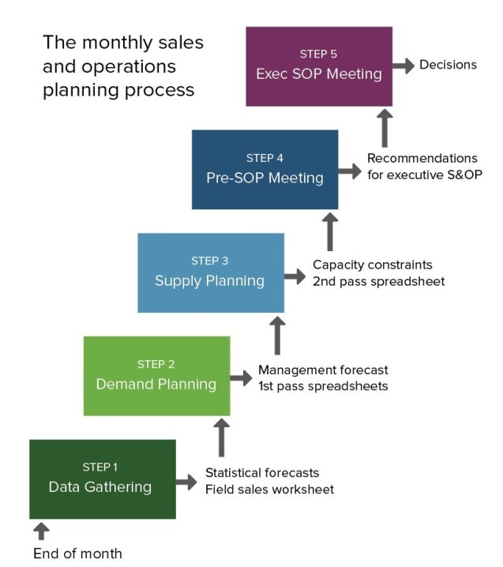
Figure 4: Sales and Operation meeting

Management communication meeting
Management communication meeting is for setting goals for all employees and coming up with a situation for enriching employee’s performance. It will occur for adjusting with current market situation when it is changed suddenly.
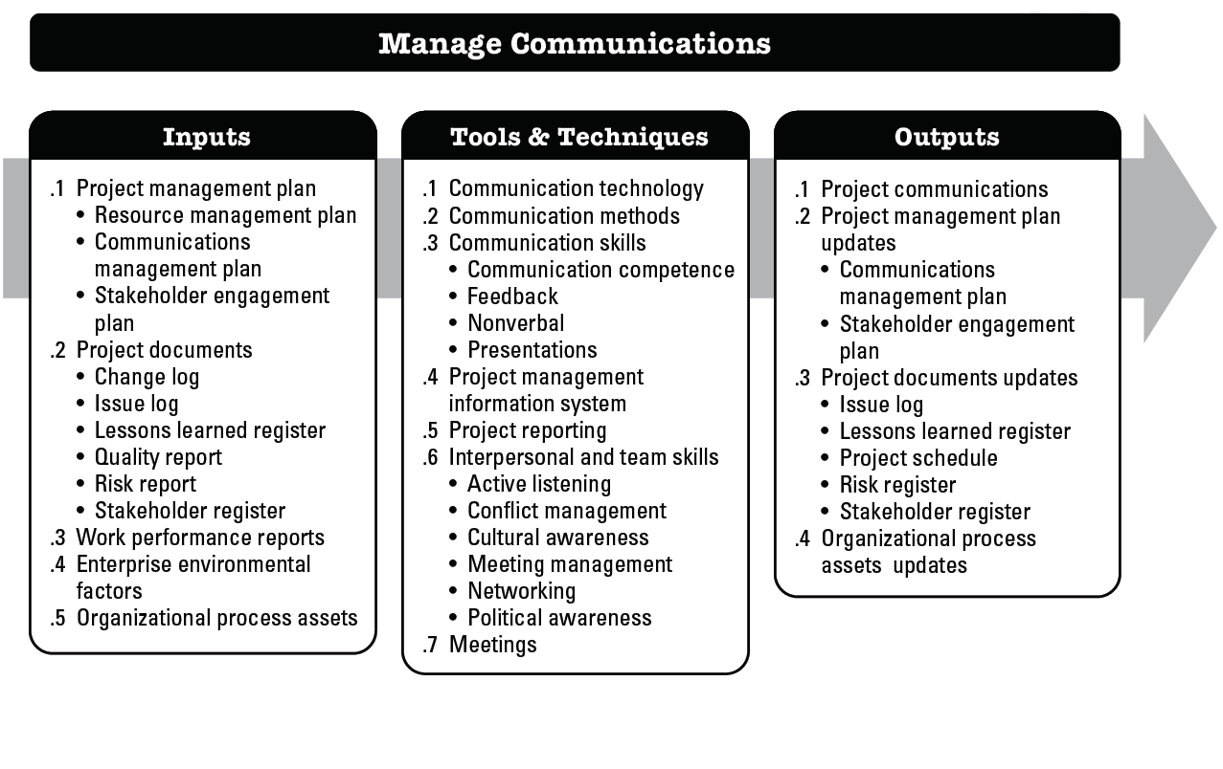
Figure 5: Management Communication Meeting

Risk management meeting
Risk management meeting is for adjusting with risk for overcoming from danger zone. Firstly, management identifies all the risks and rank the risks based on priority. After those top level executives formulates a plan or policy for adjusting the risk by performing this meeting.
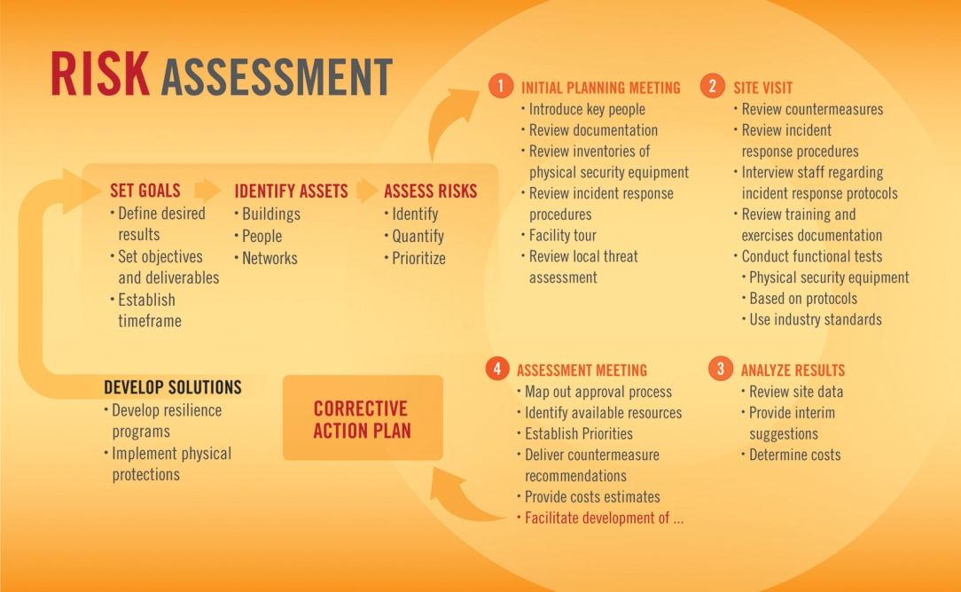
Figure 6: Risk Assessment

The efficiency of the mechanisms utilized to implement management decisions
Linde Bangladesh Limited follows corporate governance mechanisms for implementing their management decisions. They have organized Board meeting, audit committee and so on for adjusting with firm’s risk level and controlling variables.

- Board Size
- CEO duality
- Audit Committee Size
- Board meeting
- Audit Committee
- Existence of nomination committee
- Board gender diversity
- Total Skills based

Controlling variables
- Growth
- Leverage
- Return on assets

Firm’s Risk Level
- Standard deviation of stock

The internal methods employed to determine and track valid objectives
Management of Linde Bangladesh Limited is always monitoring the employee’s performance. They organize training and motivation program for enriching employee’s performance and effectiveness.

Figure 7: Monitoring Process

Procedure for setting goals for employees
- Include employees in goal setting
- Tie goals in working unit
- Set specific goals
- Ask supervisors for setting their goals
- Holding performance meetings
- Gathering ongoing feedback and coaching
- Ensuring focus on relevant areas
- Aligning reward systems with results

KPI
KPI stands for Key Performance Index which has been assigned every employee’s for maintaining his/her activities throughout the performance in a certain period of time.
The effectiveness of the way information is communicated within the company
Linde Bangladesh Limited has systems of managing risk. Under the guidance of Linde Group, the company continually updates and adapts these systems. Board of directors and internal statutory auditor review the effectiveness. The management of the Company formed business risk assessment and built risk mitigation plan for eliminating risks. The audit committee members are supposed to support the Board in terms of monitoring activities of management and dealing with risk management issues.

Figure 8: Risk assortment

Chapter Five: Findings and recommendation

Findings

According to the market situation, we end up with a statement that Linde needs to focus on the share price because their competitors like- British American Tobacco Bangladesh, Rackitt Benckiser, LafargeHolcim are the brands who are in the top position in the top market share. Their share price, cash dividend for each year is better than Linde Bangladesh. So, Linde Bangladesh Limited needs to have a look on that. Alternatively, shareholders are ratty by reason of doesn’t provide proper communication with them. In case of that, this thing creates negative impact on the company.

Linde Bangladesh Limited is profitable company and they are in the position of surplus. But there are some lacking that should be focused on.

- Marketing capabilities
They should focus on market development for increasing the capability of marketing.

- Focusing on Price
Business market is damn competitive for any company. So, they should oversee the price once again for getting competitive advantages because price is one of the major issues on that.

- Creating extra value
They should create an extra value with their product for gaining sustainability and persistency.

- Key financial indicators
They have to focus on key financial indicators for maintaining the optimal level of sales.

- Realistic and meaningful budget
They have to use proper systems and processes for running their firms effectively.

Recommendations

Linde Bangladesh Limited is absolutely running good in the business sector in case of enhancing their profit and earnings per share based on the year of 2017 & in the year of 2016. They also enhanced their demand which helped them to get benefited in the sector of business leadership. But the thing is that they have to follow following things to be stronger in the business sector in the country. They can take several steps for minimizing the problems because they have to survive in the market and profit maximization. In our opinion, they should expand their business development over the next one to two years. And the other side, they should use international standards. They should transfer the ownership of the entire sales center to the vendors in case of getting helps to increase the profit as before. And the other side, they should have a look in the employee turnover ratio in a view of a best employee can reduce the cost and deliver the best by adding extra value rather than other employees.

Conclusions

Linde Bangladesh is one of the growing companies of our countries. It has a history over 13 years built on a heritage of innovation with strong focus on technology. It plays a vital role in the capital market with substantial economic growth. Though it has some limitation like, they are not focusing on key financial indicators for maintain the optimal level of sales, they are not using proper systems and processes for running their firms, they are not preparing a realistic and meaningful budget for measuring tools in terms of success. They have to develop a strong management base in the near future. But despite of all those limitation Linde is growing very well day by day. We can hope that in the near future, it will be one of the leading companies of our country.

Chapter Six: References

