Financial Performance Analysis of Mercantile Bank Limited: A Case Study

Project Supervisor:
Mohammad A Ashraf, PhD
Associate Professor
School Of Business Economics
United International University.

Submitted By :
Abid Ibnul Sad
Id – 111 143 015
BBA Program
United International University
Submission last date :3-2-2019

ss

CHAPTER - 1
INTRODUCTION

Chapter – 1
Background of the study
Over view of Commercial Banking sector in Bangladesh:
Bangladesh is a creating national with a ruined accounting managing framework especially as far as the administrations and client care given by the administration run banks. Recently, private banks are embraced to reflect the setting aside some cash structure of the more made countries, anyway this endeavor is consistently disappointed by incompetent or politically energized government procedures executed by the national bank of Bangladesh, Bangladesh Bank.

Nationalized Commercial Banks (NCBs) were set up in Bangladesh in 1972 through fuse of twelve business banks that were working in without pre Bangladesh empowering the poor access to back, diminishing capital excursion to outside countries, and growing family unit adventure were a segment of the basic objective of this nationalization. That infers an overall population with wealth scattered as reasonably as would be judicious. In any case, with time differentiate those banks has changed their methodologies and systems, which were not fulfilling the class dealing with a record procedures of the council. On an evaluation of the activities of business banks, it has been seen that the advances made by the dealing with a record industry since nationalization was not critical. The nationalized banks couldn't accept the due activity in the execution of government ventures and methodologies. In this way, an example of de-nationalization of banks started from mid-80's.

In the meantime, the procedure of the governing body towards keeping cash industry with respect to money related organization has changed since 1976. That year private division had been depended to expect a more prominent activity in the economy than beforehand. As necessities be, with the true objective to give more credit to close-by theorists the private division setting aside some cash had been exhibited. Government allowed setting up of neighborhood Private Commercial Banks (PCB) despite Nationalized Commercial Banks (NCB) working in the country.
1
This report contain the passing investigation on "Trade Bank Limited". This reports is appropriated numerous parts as per the developments of director of report.

Commercial Bank Limited chief its business and activity vertically from the head office through some particular business divisions specifically

- Corporate and interview Banking

- Retail Banking

- SME Banking

- Treasury and Market risk.

Under a continuous web based keeping money stage, these business divisions are upheld at the back enthusiastic administration conveyance or activities setup and furthermore a keen it spine. Such brought together business fragment based business and working model guarantee particular treatment and administrations to the banks distinctive client portion.

2
Problem statement:
Financial analysis operational and rational way to current overall financial performance way of financial institution. It's additionally help to gauge and judgment making for business process. In budgetary examination strategy proportion investigation is the most generally speaking and normal advancement to help business related accomplice. Under the cash related extent examination process there are phenomenal orders to approach locale of fiscal association. So colleagues endeavor to think to get for the most part business survey from current, liquidity, assets the board and dissolvability extent examination. These extents not simply help to essential initiative process in like manner highlighted on danger escaping and advantage rising related issues. To figure this extent need to take quantifiable data from bank trade activity and distinctive bases. Cash related execution Analysis joins a judgment of an organization's execution with that of various firms in the practically identical line of business, which conventionally is seen by the Central Bank Arrangement. When in doubt the examination is used to control the affiliation's fiscal position so as to recognize its present characteristics and weakness and to propose movement the firm may look for after to misuse the solid point and right any deficiency. With veneration to the Performances of Bangladeshi Banking division, abroad and national masters acknowledged number of studies. This examinations pass on me an uncommon learning to assess bank budgetary execution by using one of the standard pointers which is extent examination the most easy way to deal with overview the execution of a banks is to relate its present extent with the past extent. It gives a needle of the technique for change and reflects whether the banks budgetary execution has upgraded, declined or continued with predictable extra time.
3
Scope of limitation of the study:
Bank is a financial institution. It has been playing an important role economic development to build the country economy. Keeping money area is quick extending in our nation in light of globalization and change of private part. To make due as a key player in this exceptionally aggressive and complex business condition a bank ought to build up its business centering the consumer loyalty's. The field of my examination is the activity of Mercantile Bank Limited. For directing this investigation a general learning of the absolute managing an account framework is essential on the grounds that the bureaus of saving money are connected with one another. The extent of the hierarchical part covers the authoritative foundation, objective, capacity, departmentalization and item and administrations of the Mercantile Bank Limited all in all. The principle part covers the monetary execution examination of The Mercantile Bank Limited. This alludes show how the bank is performing throughout the years from 2006-15.

4

Research objective:
The research objective of the study is to involve the student gather creative knowledge and the new idea make new issuies so that it can help for their study. The research objective of the study is to involve the students with its organizational financial performance The primary objective of the this project is to explain the real life scenarios in the organizational financial ratio analysis of Mercantile Bank Limited (MBL) over 2006-15. This report has conducted
- To achieve the information regarding the banking financial performance and service
- To find out performance of Mercantile Bank Limited MBL over years through ratio analysis.
- To estimate future position of the Mercantile Bank Limited.
Specific objective:
For evaluating a 3rd generation bank I chose Mercantile Bank Limited and evaluate its financial performance from 2006-15 using several ratio.
- To find out the reason behind Mercantile Bank Limited enhancement of performance over the years.
- Tiring to find out the present performance of the bank and predate near future.
- To gather knowledge about the profitability of the bank through profitability ratio.
- Tiring to evaluate the operational efficiency to the bank.
- Lastly my observation from both my working experience and financial performance analysis and recommendation where they need improvement.
5

Limitation of study:
Limitation of the study to make the report realistic accepted this report has been conducted. However, many problems appeared in the way of conducting the study. All given information is not fully complete. Same of the information is company secret and important and only provided to some persons to know about it.

However, I try my best to settle and pass up the report before the due date and hoping it was satisfied. The study considers following limitations:

- Lack of in depth knowledge and analytical ability for writing such report.

- Another limitation of the study is banks policy of disclosing, some data and information for obvious reason, which could be very much useful.

- In case of secondary data collection, there were very few secondary information was available. There were few supporting books, report, journals.

- Lack of experience to analyze the data.

- Gathering information about the banking performance was very difficult. That is why I have to follow more on secondary data like annual report, web sites and some of banking documents.

- Banking sector is a very vast sector where I have a little knowledge about it which limits my report.

6

Chapter- 2
Bank overview

Introduction:
Trade Bank Limited is the storehouse organization in Bangladesh. This is presumed bank in our saving money part. Trade Bank Limited is a third era bank in Bangladesh. Commercial Bank has been set up on May twentieth, 1999 in Head office at 61 Dilkhusha C/A, Dhaka, Mercantile Bank Limited takes authorization from Bangladesh Bank in 1999. Trade Bank Limited began formal business saving money activity from the June 02, 1999. The Patriarch of MBL are offered away to make it somewhat more unique and a grab specific subjectively.

The Permitted Capital of the Bank is BDT 800000 million and appropriated into 80000000 normal offers of BDT 100 each starting at 31 December 2010. The Paid - up Capital is BDT 215841 million of 21584134 regular offers of presumptive worth of BDT 100 each and it has recorded both in DSE and CSE. MBL has made it best to address the issues of 21st century with resources of BDT 44,940.54 million and in excess of 1000 workers. This Bank will accommodate a wide compass of budgetary administrations to its obligation foundation , clients and corporate customers in retail managing an account, corporate saving money and universal exchange.

The entire measure of credit is BDT 39,348 million and the absolute obligation and advances are BDT 31,877.86 million at the most recent year 2012 that center a brilliant execution of MBL. The credit store proportion is to 81.02%. The net benefit after duty proportion is to BDT 540.59 million a year ago 2012.

The bank has 10 office, for example, Human asset division, Credit office, Development and advertising office, Research and arranging office, Information innovation office, General managing an account office, Treasury and currency showcase office.

The introduction of the principle part of MBL Office was held in progressively at Mothijil Branch broadened the skyline of Mercantile Bank Limited to convey its administrations to the esteemed customers all the more successfully. The second Branch was set up at Dhanmondi Residential Area in capital city of Dhaka on August 04, 1999. The third branch was built up at Agrabad in Chittagong on November 06, 1999. MBL has 58 branches everywhere throughout the area in Bangladesh. It has set up to October 07, 2012.
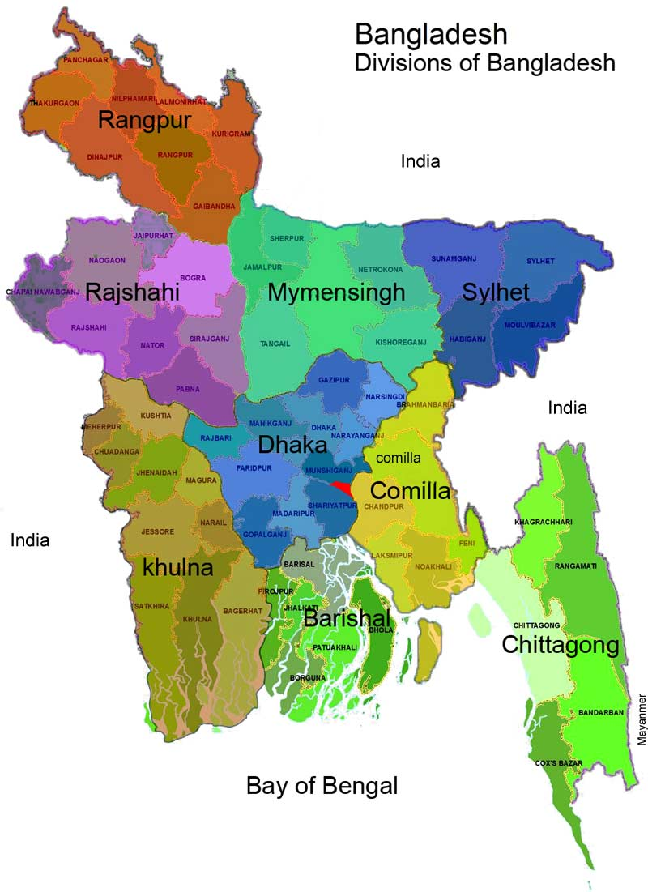

Vision, Mission, Core values and objective of Marcentile Bank Limited (MBL):

Mission of Mercantile Bank:
- To make appropriate corporate occupant

- To make a loaning keeping money establishment.

- It assume money related job in the improvement of the nation.

- It give great money related exchange client and moneylender organization.

Vision of Mercantile Bank:

- To give extreme client administration.

- Continuous advancement in our nation business arrangement.

- To pursue national bank rules control.

8

Objective of Mercantile Bank:
- To securing positive Economic esteem included Earn esteem investigation
- . To make a good banking activities in our country
- To accomplish top 3 budgetary foundation in Bangladesh regarding cost proficiency.
- To make banking innovation system.

Strategies of Mercantile Bank:
Mercantile Bank Limited for the most part pursues top down methodology. Subsequently they take fundamental choices for the organization future. Extraordinarily they pursue the bring together system where the Head Office of the Bank control and screen every one of the exercises of all MBL branches. At last advertising system it fundamentally rely upon 'verbal' as they are as of now all around famous for its long haul administration in the business keeping money industry.

Core values:
Innovation: MBL is update bank. They try to maintain world wide banking system.
Core values: Client amuse implies consumer loyalty. MBL bank has given well support of the client. Therefore client are fulfill their exercises. Since They attempt to convey prompt support of the client.
Social capable: MBL isn't just give client administration and obligation foundation yet additionally help government exercises. It gathers each administration exchange.

Moral esteem: they keep on being capable, moral, genuine, and straightforward in their idea the activity.
Function of Mercantile Bank Limited:

- Mobilization of savings of the people and safe keeping of all types of deposit account and transaction.
- Making advances specially for productive activities and for the other commercial and socio-economic demand.
- Providing good banking services to common people through all branches.
- Introduce modern Banking services to the customer and debt instruction.
- Discounting and purchasing bills to the customer and debt intuition.
- Several information, guidance and suggestions for improvement of trade and industry keeping in view of the overall financial and economic development all over the country.
- Financial operation is not only capital machinery but also working capital.
Financial operation is under small business of self-employed clients.

11

Chapter-3
Methodology

Chapter-3
Methodology

Ratio analysis:
Ratio analysis is a symptomatic device that recognizes issue zones and openings inside an organization. Proportion examination is basic for every business, in light of the way that by discovering extent examination we can understand the business position, business quality and weakness. By knowing this information, the board can figures out how to deal with their target. This report will be centered around money related execution of the organization. This execution will be examination as far as proportion investigation.

Financial Performance Ratio analysis:
- Debt to Equity capital ratio
- Total debt to Total asset
- Net profit margin
- Net operating margin
- Return on Equity (ROE)
- Return on Asset (ROA)
- Expenses Control Efficiencys
- Equity Multiplier

Debt to Equity capital ratio:
The Debt to Equity extent is an utilization extent. Commitment to Equity extent figures the weight of total commitment and money related liabilities parceled by total financial specialist's esteem.

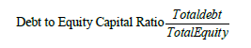
Calculation debt to equity ratio 2015:
= 168213309651 / 15567890966
=10.850

Total debt to Total asset

The commitment to asset extent is an utilization extent that choose the proportion of total assets that are financed by advance managers and commitment holder as opposed to monetary authorities. Finally it can make sense of what dimension of total assets is financed by acquiring differentiated and the dimension of benefits that are sponsored by the theorists.
13
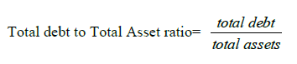

Calculation Of Total debt to Total asset 2015:
= 167286439075 / 182800165670
=.9151

Net profit margin
Net profit margin is the level of income staying after every working cost, intrigue, charges and favored stock profits have been dispensed with from an organization's all out benefit or income.
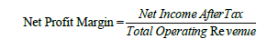

Calculation Net profit margin 2015:
= 1402788540 / 8043009183
= .1744

Net operating margin
The working edge extent is called working by and large income. It is known as a profit extent that gauges what dimension of total advantage is made up by total working compensation. We can express that the working edge extent indicates how much livelihoods are remaining over after all the variable or working costs have been paid. Finally, this extent make sense of what degree of earnings is open to deal with non-working costs like interest cost.
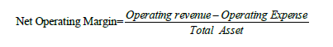

Calculation Net operating margin 2015:
(8043009183 - 4083253786) / 182800165670
=.0216

Return on Equity (ROE)
Return on equity (ROE) can decide the of money related execution of a firm. It can determined by isolating by Net salary after expense and all out value capital.
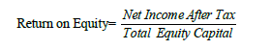
Calculation Of ROE 2015:
= 1402788540 / 15513726595
=.0904
Return on Asset (ROA)
Thee majority of the association the arrival on resources proportion is known as the arrival on all out resources. It can determined Net salary after assessment isolated by complete resource.

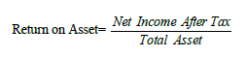

Calculation on ROA 2015:
= 1402788540 / 182800165670
=.0076

Expenses Control Efficiency:

The viability extent is used for researching how well an association authentic uses its advantages and liabilities internal errand works out. An efficiency control extent can figure by complete pay before cost and increment divided by total working pay. This extent can in like manner be made plans to look at the execution of business and theory banks.
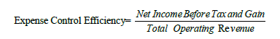

Calculation of Expenses Control Efficiency Ratio in 2015:
= 2661585712 / 8043009183
= .3309
Equity Multiplier
The equity multiplier is an immediate extent used to evaluate an association's budgetary use. The extent is controlled by detaching total assets by total value.A high esteem multiplier demonstrates the association has been using more commitment than incentive to support its leeway purchases.

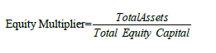

=182800165670 /15513726595
=11.78

Chapter-4
Findings of the study

Debt to Equity capital ratio:
This obligation/value proportion estimates the long haul dissolvability of an organization. It's called budgetary influence of an organization. A high obligation/value proportion shows high hazard; it implies that an organization has been forceful in financing its development with obligation.
 | 2006 | 2007 | 2008 | 2009 | 2010
Debt to Equity capital ratio | 15.49611286 | 14.34171222 | 17.85795926 | 14.40099 | 11.1269
 | 2011 | 2012 | 2013 | 2014 | 2015
 | 10.98814 | 12.90828 | 10.48649 | 11.46865 | 10.80514

From this graph, we can see that Debt/Equity ratio was maximum (17.86) in 2008 and minimum (10.49) was in 2013. The downward trend of the ratio is satisfactory as it indicates the company’s ability to meet its long term debt obligation is 18
increasing and the risk of leverage is decreasing. The recent debt/equity ratio is 10.81 which shows that the ability of the company is rising and the company is doing better.
Total debt to Total asset
This leverage ratio measures the amount of total asset which are financed by creditors. Simply, this ratio shows the percentage of assets funded by debt. The low debt to asset ratio is satisfactory for the company as it indicates the low risk involved with it. If the company has already leveraged all of its assets and can barely meet its monthly payments as it is, the lender probably won’t extend any additional credit. This ratio helps both creditors and investors to get the idea of company’s financing structure.
year | 2006 | 2007 | 2008 | 2009 | 2010
Total debt to Total asset | 0.939379658 | 0.934818227 | 0.93532246 | 0.935069095 | 0.917435435
 | 2011 | 2012 | 2013 | 2014 | 2015
 | 0.917124981 | 0.92907987 | 0.912941215 | 0.919755199 | 0.915132864

From this graph, we can see a downward trend of the debt to total asset ratio. It indicates the portion of total assets funded by creditors is increasing and the leverage of the company is decreasing. It is a good sign of the company as the company’s solvency to pay ong term debt is increasing.

Net profit margin
Net profit margin mainly deals with the ratio of per unit net income for sales. This ratio is calculated by dividing net income with net sales.
year | 2006 | 2007 | 2008 | 2009 | 2010
Net operating margin | 0.037275617 | 0.026229359 | 0.02827734 | 0.028892225 | 0.031059526
Year | 2011 | 2012 | 2013 | 2014 | 2015
 | 0.030043602 | 0.02175265 | 0.027627174 | 0.026179523 | 0.021661662

From this graph, we can see, the company’s recent performance is not satisfactory. The net profit margin is falling from 2013 and it continues till 2015. If you look back the historical performance for the last 8 years, we can see company has been facing up and downs since 2007. The highest net profit margin was 24% in 2010 and the lowest one was 7% in 2014.

21
Net operating margin:
For each unit of sales, how much operating profit a company can generate. The ratio is calculated by dividing operating profit with sales.
year | 2006 | 2007 | 2008 | 2009 | 2010
 | 1,873,770 | 2,138,633 | 615883381 | 807516869 | 1425338409
Year | 2011 | 2012 | 2013 | 2014 | 2015
 | 0.287718257 | 0.224168631 | 0.271125744 | 0.146548641 | 0.174410909

From this graph, we can see, the company’s recent performance is not satisfactory. The net operating margin is falling from 2013 and it continues till 2015. If you look back the historical performance for the last 8 years, we can see company has been facing up and downs since 2007. And the lowest net profit margin was in 2012.

22
Return on Equity (ROE):
This Return on Equity ratio helps us to get the condition of return for per unit of equity. The higher ratio indicates the good condition of the company. Moreover, the split of ROE into NPM, TAT and Equity Multiplier help us to understand, the ratio is actually representative of the company’s good condition or the increased riskiness of the company.
year | 2006 | 2007 | 2008 | 2009 | 2010
 | 0.000831814 | 0.000730082 | 0.19444863 | 0.013051777 | 0.19835251
Year | 2011 | 2012 | 2013 | 2014 | 2015
 | 0.18042827 | 0.124712303 | 0.15656914 | 0.086677354 | 0.09042241

From this graph, we can see, the company’s recent performance is not satisfactory. The ROE of the company is falling. The decreasing trend of ROE can be due to the lower NPM for the recent years, moreover, the lower TAT or the equity multiplier.
23
The lowest ROE was observed in 2009 and the highest ROE of the company was observed in 2010.
Return on Asset (ROA)
The efficiency of the company is measured with this ratio. This ratio deals with the profitability of the company relative to the total assets.
year | 2006 | 2007 | 2008 | 2009 | 2010
 | 5.04249E-05 | 4.75881E-05 | 0.011011934 | 0.012204313 | 0.016356858
Year | 2011 | 2012 | 2013 | 2014 | 2015
 | 0.015063766 | 0.008892747 | 0.013630719 | 0.00695541 | 0.00767389

From this graph, we can see a roller coaster ride of return on asset and this trend had impact on the return on equity. Due to the decreasing trend of ROA, the return on equity of the company was also decreasing.
24
Expenses Control Efficiency
2006 | 2007 | 2008 | 2009 | 2010
0.403939249 | 0.608908301 | 0.452645892 | 0.47617966 | 0.86028546
2011 | 2012 | 2013 | 2014 | 2015
0.497303959 | 0.38905861 | 0.443387455 | 0.285378864 | 0.330919144

The satisfactory picture of the performance of the company is observed here. The decreasing trend of the expense control ratio helps us to understand, the company has greeter control on the cost of the company and the company is doing great. The lowest and most efficient ratio is observed in 2014 and the highest and less efficient ratio is observed in 2010.

25
Equity Multiplier
The equity multiplier is a financial leverage ratio that helps us to get a view of the company’s assets which are financed by the equity of the company.
2006 | 2007 |  | 2008 |  | 2009 |  | 2010 |  | 2011
16.49611286 | 15.34171222 |  | 17.65799086 |  | 1.069439687 |  | 12.12656566 |  | 11.97763356
2012 |  | 2013 |  | 2014 |  | 2015
14.02404682 |  | 11.48649157 |  | 12.46186659 |  | 11.7831241

The greater the ratio indicates the greater efficiency. The decreasing ratio indicates the company are using leverage with equity for the company.

26

Chapter - 5
Conclusion

Conclusion:
Standout amongst the most ideal approaches to pass judgment on an organization's income wellbeing is to investigate its proportion examination. The better an organization can deal with its working capital the lower organization's need of borrowing. Overall all execution of proportion investigation at MBBL BANK is exceedingly extraordinary. The endeavor is particularly beneficial. There is open inside wellspring of save in view of attractive proportion of period in the midst of the period under examination. The liquidity position of the association is in like manner especially attractive due to great turnover of current assets, stock obligated people and cash changes. The association recognizes incredible office of cash credit and other at this very moment advance anyway the gaining proportion of the association is low. There is no obstacle in repayment of current liabilities out of the working advantage.
Ratio analysis of MBBL BANK has been doing very significant to the company. It has lots of challenges as competition raises in the market and also has lots of possibility of developing in several areas. If challenges can be faced technically by maintaining continuous support system. Teams and dealers then the credit management practice of this company can be more effective to the overall development of the Bank performance.
It is essential to term MBBL as an impetus for financial development and to give vital help to their improvement. A long haul approach by all worried for the improvement of NBFIs is vital. Given suitable help, MBBL will have the capacity to assume an increasingly huge job in the monetary advancement of the nation.

Bibliography
1. Annual Report (2017), Marcantile Bank Limited, Dhaka
2. Annual Report (2016), Marcantile Bank Limited, Dhaka
3. Annual Report (2015), Marcantile Bank Limited, Dhaka
4. Annual Report (2014), Marcantile Bank Limited, Dhaka
5. Annual Report (2013), Marcantile Bank Limited, Dhaka
6. Annual Report (2012), Marcantile Bank Limited, Dhaka
7. Annual Report (2011), Marcantile Bank Limited, Dhaka
8. Annual Report (2010), Marcantile Bank Limited, Dhaka

