UNITED INTERNATIONAL UNIVERSITY
Internship Report on


Supervised By
Mosabbir Uddin Ahmad
Assistant Professor
Submitted By
Faria Alam
111 161 048
BBA (Major in Finance)

DATE OF SUBMISSION
12.03.2021

Letter of Transmittal

Date: 12.03.2021
Mosabbir Uddin Ahmad Sir
Assistant Professor
School of Business Studies
United International University
Subject: Submission of Report on “National Bank Limited”
Dear Sir, with due respect I inform you that, I am your student (ID 111 161 048), School of Business Studies in United International University. The Report is prepared on “National Bank Limited”. For preparing the report, I have given my best effort to with relevant and proper information that I have gathered from National Bank Ltd. and from others sources during my internship program from September 18, 2020 to January 18, 2021. .I pray and hope that, the mistake of the report may have, will be kindly excused. Lastly, I seek your kind consideration for evaluating this report. Thanking you very much indeed.
Sincerely Yours Student,
Faria Alam
111 161 048

Letter of Endorsement

This is to certify that Faria Alam ID:111 161 048 has prepared her internship report titled “National Bank Limited” in Shimanto Shomvar branch of National Bank Limited, under my supervision and guidance. I do thereby grant & approve the design and contents of this internship report. This is for the partial fulfillment of her four years BBA program, major in finance in United International University.

Mosabbir Uddin Ahmad
Internship Advisor
Assistant Professor
School of Business & Economics
United International University

Acknowledgement

The submission of this report- National Bank Limited, “Shimanto Shomvar branch”- is a great opportunity for me. The success of this assignment depends on the contributions of number of people especially who have shared their empathy and valuable guidance and suggestions to make this report better.
This assignment made me really feel interested. I must thank a few people who helped me and encouraged me to grow my interest.
First of all I would like to thank our honorable instructor Mr. Mosabbir Uddin Ahmad sir, faculty of BBA, United International University, for his proper guidance and care. Without his valuable guidance, instructions and suggestions I couldn’t have completed this assignment properly.
I obviously would like to show gratitude and special thanks to the Almighty for giving me such patience and power for completing this assignment smoothly. And lastly, I am thankful to my loving parents without whose support I would not have come this far.
Lastly, I want to say that, I really enjoyed every moment while preparing this report, and submitted it for your kind assessment.

Executive Summary

The internship is designed to bridge the gulf between the theoretical knowledge and real-life experience. It is designed to have a practical experience while passing through the theoretical understanding. The report is the result of three months internship program with National Bank Ltd Shimanto Shomvar Branch. Today, necessity of a Bank as a financial institution is undeniable. These institutions play a vital role in the field of financial stability of a country. Banking sector is one of the stable financial institutions of a country economy.
In the first chapter I have discussed about the Introduction & history of the private banking sectors of Bangladesh. On the following chapter, I have stated the core values along with mission, vision, goal & CSR of NBL. In chapter 3, I have discussed basically about my experience in NBL, that is, my jobs and responsibilities on the bank. After that, I have described about office politics in various organizations and also depicted how NBL minimize this.
Lastly, I have expressed my observations about NBL’s whole structure and based on this, I have given recommendation & conclusion.

Contents
Letter of Transmittal 2
Letter of Endorsement 3
Acknowledgement 4
Executive Summary 5
Chapter 01 8
1. Introduction 9
Origin of the Report 9
Limitations 9
1.2 History of Private Banks in Bangladesh 9
1.3 Current Banking Sectors of Bangladesh 10
Chapter 02 14
2.1 History of National Bank 15
2.2 Organogram of NBL 16
2.4 Mission of NBL 17
2.5 Vision of NBL 17
2.6 Goal 17
2.7 Core Values 18
2.8 Strategic Focus 19
2.9 Products & Services 20
2.10 Corporate Social Responsibility 21
2.11 Organizational Hierarchy 22
Chapter 03 24
3.1 Internship Role & Responsibilities 25
3.2 Accounts Opening Department 25
3.3 Accounts Department 28
3.4 Loan Sanction Department 30
3.5 Cheque Clearance Department 31
Chapter 04 32
4.1 Workplace Culture 33
4.2 Communication 33
4.3 Expectations vs Reality 34
4.4 Office Politics 35
4.5 Measurements Taken by NBL 36
Chapter 05 37
5.1 Observation 38
5.2 Limitations & Recommendations 38
Chapter 06 40
6.1 Conclusion 41
6.2 Bibliography 41

Chapter 01

1. Introduction

Origin of the Report
As part of my undergraduate program, I am currently working as an Intern in a renowned banking institution named “National Bank Limited”. Till the period of my internship, I have been working in several departments. I had spent most of the time working in Accounts opening Department. I have prepared my report pointing on the General Banking Department of National Bank Limited. In this report I have tried to represent all of the bank’s facility which is provided to the respected customers. Simultaneously, I have discovered some findings and based on that I have given my recommendation.
As part of my BBA program, I had to complete a 3 month long internship program. After I finished my course work, I was designated to complete my internship program in National Bank Limited. As per the instruction of my internship supervisor, Mr. Mosabbir Uddin sir, I was devoted and keen to learn the banking operation of NBL. During the tenure of my internship program, I worked in almost in most of the departments of banking. However, I have worked more vigorously in Account Opening department in particular. Based on my learning and practical experiences on my internship program, I have prepared this report.

Limitations
As my designation was continuously being changed on the tenure of my internship, I could not observe the whole working method of NBL. One more thing about this Shimanto Shomvar branch is, it is a VIP branch. So, the comprehensive working process of a general branch is not expressed here.

1.2 History of Private Banks in Bangladesh

As per Bangladesh Bank Nationalization Order in 1972, all of the commercial banks operating in Bangladesh and officially owned by the Bangladeshi and Pakistani citizens were restructured into 6 nationalized banks , namely Sonali, Agrani, Janata, Rupali, Pubali and Uttara Bank. And the foreign banks were enlisted as not a part of national organization.
Before 1982, there were no private banks in Bangladesh. Back then, banking sector was run by the state banks. In 1982 Arab-Bangladesh Bank Ltd. started their journey in Bangladesh. In the following year, National Bank Limited was established along with other 5 banks. The growth rate and development of financial institutions was extremely slow in our country until the government started the decentralization process in 1983, initially the Uttara Bank in 1983, Pubali bank and Rupali Bank in 1986.
At first, comparing to the NCB’s, private banks were lagging behind. The overall banking system showed health improvement since 2002 as the gross Non-performing Loans (NPL) fell from 28% to 14% whereas net NPL decreased to 8% from 21%. As a result the profitability ratios improved. However, the four NCBs showed as high as 25% of non-performing loans. They had large capital shortfalls in 2006 with a risk-weighted capital asset ratio of just 0.5 percent while the required rate was 9%. On the other hand, the ratio was 10% for PCB’s.

1.3 Current Banking Sectors of Bangladesh
From 1970s to now, banking sector of Bangladesh has developed a lot through a lot of ups and downs. Bangladesh Bank, being the central bank of the country, has been controlling all the banks and its financial policies. The Bank is responsible for planning and implementing the government’s monetary policy, issuing currency, maintaining foreign exchange reserves, controlling and regulating all other banks of the country. It serves the people in many ways. They are-
- The banknotes are issued in such a way that owner can easily detect whether the note is genuine or fake by observing some special marks.
- If one has deposited his/her money in scheduled banks, and have not made transaction for last ten years, he/she can check account from 'Claim your money' link.
- Concerned stakeholders including institutions, customers can directly write complaint to director if they are facing any issues with the bank.
Under Bangladesh bank there are a lot banks which are being operated in Bangladesh. The comprehensive list is given below---
Nationalized Commercial Banks (NCBs)
1. Sonali Bank
2. Janata Bank
3. Agrani Bank
4. Rupali Bank

Local Private Commercial Banks (PCBs)
1. Pubali Bank
2. Uttara Bank
3. National Bank Ltd.
4. The City Bank Ltd.
5. United Commercial Bank Ltd.
6. Arab Bangladesh Bank Ltd.
7. IFIC Bank Ltd.
8. Islami bank Bangladesh Ltd.
9. Al Baraka Bank Bangladesh Ltd.
10 .Eastern Bank Ltd.
11. National Credit & Commerce Bank Ltd.
12. Prime Bank Ltd.
13. South East Bank Ltd.
14. Dhaka Bank Ltd.
15. Al-Arafah Islami Bank Ltd.
16. Social Investment Bank Ltd.
17. Dutch-Bangla Bank Ltd.
18. Mercantile Bank Ltd.
19. Standard Bank Ltd.
20. One Bank Ltd.
21. EXIM Bank
22. Bangladesh Commerce Bank Ltd.
23. Mutual Trust Bank Ltd.
24. First Security Bank Ltd.
25. The Premier Bank Ltd.
26. Bank Asia Ltd.
27. The Trust Bank Ltd.
28. Shah Jalal Bank Limited (Based on Islamic Shariah)

Foreign Banks
1. American Express Bank
2. Standard Chartered Grindlays Bank
3. Habib Bank Ltd.
4. State Bank Of India
5. Credit Agricole Indosuez (The Bank)
6. National Bank of Pakistan
7. Muslim Commercial Bank Ltd.
8. City Bank NA
9. Hanvit Bank Ltd.
10. HSBC Ltd.
11. Shamil Islami Bank Of Bahrain EC
12. Standard Chartered Bank
Development Banks
1. Bangladesh Krishi Bank
2. RajshahiKrishiUnnayan Bank
3. Bangladesh Shilpa Bank
4. Bangladesh Shilpa Rin Sangstha
5. Bank of Small Industries and Commerce Bangladesh Limited.
Other Banks
1.Ansar VDP Unnayan Bank
2.Bangladesh Samabai Bank Ltd. (BSBL)
3.Grameen Bank
4.Karmasansthan Bank

Chapter 02

2.1 History of National Bank

With over 50 years of its establishment, NBL has its wonderful past, significant present, promising future and under occur and upcoming projects and activities and desires. It was established as the first private sector bank fully owned by the entrepreneurs of Bangladesh. NBL has been emerging as the largest private sector Bank with the flow of time after facing many ups and down. The board members consist of creative businessmen and leading industrialists of the country. At present, NBL is operating 213 branches and 14 sub branches countrywide.
The need & significance of National Bank Limited in the private sector was an important event in the Banking sector of Bangladesh. When the nation was suffering from severe recession, the government took the challenging & effective decision to allow the private banking sector to revive the economy of Bangladesh. Several enthusiastic & dynamic entrepreneurs came forward for establishing a bank with a view to revitalize the economy of the country.
National Bank Limited was created as the first fully authorized Bangladeshi owned Bank in the private sector of Bangladesh. From the very beginning, it was the firm & strong determination of National Bank Limited playing an important role in the national economy.
The then President of Bangladesh Justice Mr. Ahsanuddin Chowdhury inaugurated the bank officially on 28th March, in the year 1983, but the first branch at 84, Dilkusha Commercial Area, situated at the capital Dhaka started commercial operation on March 23, 1983. The next branch was inaugurated on 11th May 1983 at Khatungonj, Chittagong.
NBL is the first Bangladeshi bank which came with agency setup with the world renowned Western Union in order to make ease quick and safe remittance of the significant foreign exchanges which is earned by the expatriate Bangladeshi nationals. This actually facilitated the expatriates so that they can and will remit their income to the country with much easily, confidently, safely and in a speedy way.
NBL is also the first between the local banks to introduce worldwide master card in Bangladesh. Simultaneously, NBL has also introduced the Visa Card and Power Card which is a revolution in the history of Bangladesh. The Bank is currently equipped with the latest information technology services of ‘swift’ and ‘reuters’. NBL has been covering its small loan project for disbursement of free livestock loans among the farmers of Barindra area in Rajshahi district for making their livelihood improved and easier.

2.2 Organogram of NBL
Branch Manager

2nd Officer
Senior Principal

General Banking
Accounts
Opening

Advance Department

Junior Officers

2.4 Mission of NBL

Efforts for enlargement of their working by improving new dimensions to domestic banking services are being continued relentlessly. Alongside, NBL is also putting highest priority in ensuring transparency, accountability, and improved clientele service as well as to their commitment to serve the society, through which they want to get familiar to the people of all categories and spheres. Making a room & an everlasting place in the hearts of millions of the people as a caring companion in uprising the national economic standard through continuous improvement and diversification of NBL’s clientele services in accordance with national and international requirements is the ultimate goal they want to achieve.​

2.5 Vision of NBL

By ensuring the optimum standard of customer services with best application of latest information technology, customer satisfaction making contribution to the national economy and establishing NBL is working firmly in domestic and worldwide as a front ranking bank. This includes:
- To be a financially viable banking sector
- To be an independent community bank that is committed to improving the quality of life of the local community.
- To get the best of employees, stakeholders and the community by operating with integrity and fairness at all the times.
- Satisfying the needs by offering a myriad of products that are driven by a sales and service philosophy of the customers.
- To have skilled & talented employees who are empowered to build long-term relationships with their customers.

2.6 Goal

As a significant banking sector, National Bank wants to contribute on the country’s national economy, by increasing its profitability through professional and disciplined growth strategy for its customer and by creating corporate culture in international banking area.

2.7 Core Values

Teamwork: NBL believes in teamwork. Their workforce does their job in a systematical approach. It helps to achieve their goal in an efficient manner. This helps solving problems and a great thing about this, employees get to know each other very well.

Integrity: NBL practices honesty and consistency which helps them to make a positive impact on their customers. It also helps the employees to build morality within themselves and be ethical.
Continues Improvement : NBL always try to improve themselves. They manage various kinds of training programs to develop their employees.
Performance Driven: Performance Appraisal method is followed by NBL. They evaluate their work process and employees by following 360 degree performance appraisal method. In this method, employees who are performing well are rewarded incentives and those who are convicted of poor performance are sent in training.
Quality: NBL builds portfolio with quality assets and provides hassle free service timely.

2.8 Strategic Focus

2.9 Products & Services

Deposit Product |  | Credit Products |  | Services
Saving Deposit |  | House Building |  | Internet Banking
Term Deposit |  | Lease Financing |  | Service Location
Current Deposit |  | Overdraft |  | Credit Card
FC Deposit |  | Trade Finance |  | Debit Card
Monthly Earning Scheme |  | SME |  | ATM card
NBL Monthly Savings Scheme (NMS) |  | Consumer Credit Scheme |  | Shopping Card
Millionaire Deposit Scheme (MDS) |  | Agriculture Finance |  | Visa Card
Luxury Savings Deposit Scheme

2.10 Corporate Social Responsibility

National Bank Limited has a great moral and ethical image among its competitors. From contributing to the national economy to fighting against the Covid-19; It has emerged as one of the most beneficiary organization. The bank has contributed in-
- Providing relief to the homeless due to the natural calamity of the country by standing beside the homeless..
- In 2007, National Bank Limited donated Forty Lac taka to help the victims of flood, Tk. 20 Lac as relief of landslide victims, Fifty Lac taka for cyclone victims to the relief fund of the Chief Advisor and the Army Chief. The Bank has also taken a project for post flood rehabilitation at Patuakhali.
- NBL is contributing in the prime minister’s fund.
- NBL has always maintained their CSR in various ways. It has encouraged various kinds of exhibitions, festivals and other seminars organized by different private or public especially by the amateur sectors. In 2010 NBL has donated approx. Nine lac taka in diverse projects.
- In the pandemic, it has tested their employees free of cost.

2.11 Organizational Hierarchy

Chairperson (Owner)
↓
Directors (Owners)
↓
Managing Director (MD)
↓
Deputy Managing Director (DMD)
↓
Executive Vice President (EVP)
↓
Senior Vice President (SVP)
↓
Vice President (VP)
↓
Assistant Vice President (AVP)
↓
Senior Principal Officer (SPO)
↓
Principal Officer (PO)
↓
Officer

Junior Officer
Organizational Hierarchy

Chapter 03

3.1 Internship Role & Responsibilities

As part of my BBA program, I am doing 3 months of internship at National Bank Limited, Shimanto Shomvar branch, Dhaka. I feel fortunate enough that, I am experiencing to work in all the departments of the bank. At the very first of my joining, I was appointed on the accounts opening department, under the supervision of Mrs. Yahnoor madam. I was getting familiar with the process and requirements of accounts opening by getting know the basics and beautiful supervision of my supervisors. After some days, I got the opportunity to switch my department to loan sanction where I was under the supervision of Salina Afroz. One thing I would like to mention here, NBL does not have any specific guideline for Interns. So, I was able to switch my departments independently.

3.2 Accounts Opening Department

On my joining day I was given a brief idea on different types of accounts (SB, FDR, and CD) and schemes (MDS, MES, SBIS, CDS and NMS). Gradually I came to learn how to suggest customers saving/investment options depending on their requirements and expectations of return. However, it did not take my supervisor to put much effort on the communication skills and within 2 weeks of joining, I started attending customers by myself. My responsibilities were
- Communicating with customers and knowing their requirements. I had to inform them about all the services and which one will be profitable for him/her
- After informing them about the services, I used to inform the customers about the requirements. Then after gathering the credentials I used to take the signature of the customers and fill the form myself.
- Fill up Know Your Customer (KYC) form and calculate the level of risk (depending on bank’s past relationship with the customer, the volatility of products or services customers sell, their association with high ranked Gov. employee/ministers etc.) the account can put on the bank.
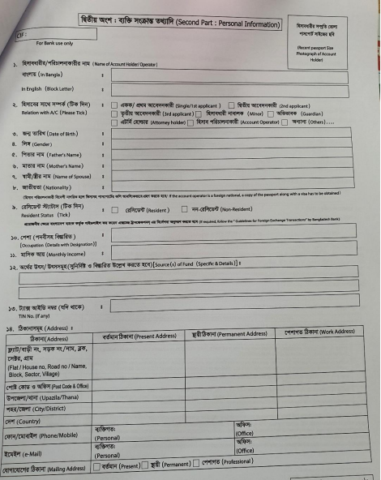

- Make entry of new cheque books received from head office into register book, stamps them to validate and list out requests for new cheque books by old customers.
- Sometimes I had to call the customers if any of their sevices like card or book have arrived.
- Stamp hundreds of papers with different seals everyday throughout all divisions and pass them to respective persons for signature.

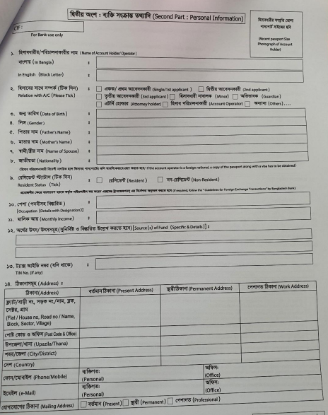

3.3 Accounts Department

It is the most crucial and significant department of the bank. This department handles decision making, verifying documents, validating credentials, managing VIP customers, making a communication among the branches etcetera. These are the most crucial part of any banks. What I used to do here-
- Making a print out of the previous day transactions.
- Creating a list of customers, who have applied for cards and other credentials and serve them.
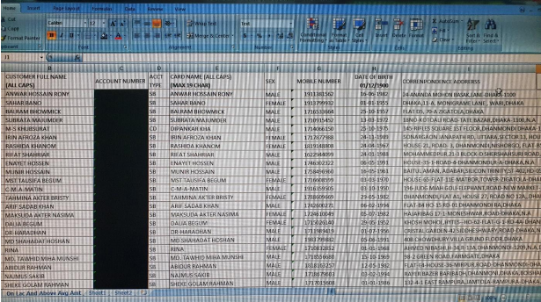

- I used to do a lot of excel works. I recorded guarantee cases (bank works as a guarantee to government institutions on behalf of the person/organization who received the public service work like road construction, sewage clearance etc.)
- I had the opportunity to sit on the decision making process of NBL and learnt a great deal from my experienced subordinates.

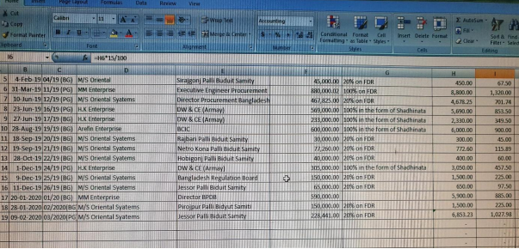
KYC FORM

3.4 Loan Sanction Department

- Make excel file entry on monthly loan situations, like how many loans were given in agriculture or SME or personal or for other areas.
- Print out monthly loan situations so that letters could be sent to customers on payment update.
- Go to the accounts departments and talk to the senior subordinates whether they will approve the loan or not.
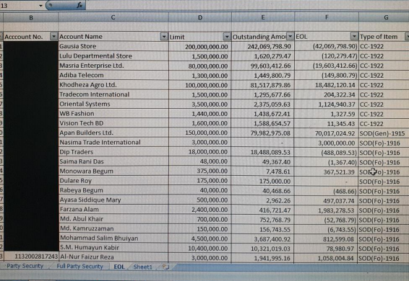
- Checking the credentials of the customers whether they are valid or not.

3.5 Cheque Clearance Department

- I had to check and categorize different types of cheque.
- I was given the responsibility to fill up the cheques properly and look through to the cross cheques and general ones
- A picture of my preparing a voucher is shown below
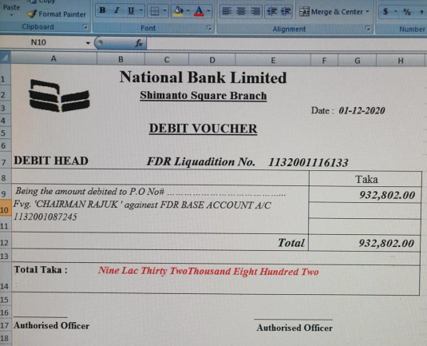

Chapter 04

4.1 Workplace Culture

A workplace culture is defined as the shared values, beliefs, attitudes, approaches and the set of assumptions that people in an institution share. This is actually designed by individual upbringing, social and cultural context. In NBL, there are employees of diverse culture. With all these elements NBL’s smimanto shomvar branch is continuing their journey. I would like to discuss some cultural elements of national bank’s workforce.

4.2 Communication

These are the practices mentioned in the diagram are followed by National Bank Limited in their communication process. On the tenure of my internship period, I have observed that, their communication channel is really very strong while other barriers are very low. My observations were-
- Employee’s opinions are very gently greeted.
- Communication with upper level managers are really easy.
- As peer evaluates each other, there is a solidarity among the employees.
- Employees are always encouraged and that’s the reason they feel motivated.
- Any sort of conflicts are handled in a professional manner.

4.3 Expectations vs Reality

4.4 Office Politics

The term “office politics” is the most common term in any official institution. Employees who do not believe in hard working are seen indulging in office politics. These sort of activities only create chaos and dispute in an office environment. Middle management employees often try to take more control on decision making. Employees often try to flatter their superiors to foster their power, position and promotion.
Some employees try to keep a hand on distribution of limited resources (e.g. better working desk), others try to take advantage of ambiguous situations due to unclear rules and policies. In banks, employees mostly tend to play politics at the time of personal evaluation, when there is high performance pressure.
The effects of office politics are given below:
- Diminishes overall performance of employee
- Employees are anxious most of the time.
- Pay less attention
- Politician’s close agents get priority.
- Organizations fail to achieve target in the set time.

- Spoils the ambience
- Relationship among employees hampers.
- Information gets manipulated.
- Attitudes of employees change and they lose interest

- Demotivate Employees
- When employees see non performers become apple of the eye of seniors by flattering them, hard-working employees get demotivated.
- Employees do not show any creativity as they are not appreciated.
- Workers stop sharing information.
- Organizational turnover increases.

4.5 Measurements Taken by NBL

National Bank emphasizes for a good and better environment for their employees. It strongly demotes office politics. In shimanto shomvar branch I have seen some measurements taken to eliminate office politics. They are-

Chapter 05

5.1 Observation

On the tenure of my internship period, I have observed some positive sites of Shimanto Shomvar branch which will cause efficiency (managerial term, not financial) and work satisfaction among employees. But it’s noteworthy that some of these factors vary from branch to branch. The factors are following:
- Adequate training sessions
- Large enough office space
- Adequate numbers of employees to handle work pressure
- Diversified workforce
- Strong supervision
- Adequate numbers of electronic devices, e.g. computers, printers, Xerox machine and bank
- note counter
- Proper allocation of resources to cut down cost
- Efficient customer service and so on.

5.2 Limitations & Recommendations

Albeit NBL runs their operation efficiently, they have some limitations. What I observed there are-
- Slow Internet Connection: Though it is the national problem of Bangladesh, NBL must overlook this problem as their works are completely internet based. Their computers are not so upgraded. That’s the reason they can only access to their internal software not the other ones. . It restricts transfer of information among employees as e-papers. NBL does not see it as an issue because employees do not share files with each other through the internet, rather they print it and report to their seniors. If modifications are required, they come back and work on the file in the same computer.
- Customer’s Dissatisfaction: Sometimes customers are seen bothered due to slow service of the employees. There is no automated service. As a result customers have to stand in the queue for several minutes.
- Lack of advertisements and branding: Branding is the most important term for any sectors in the competitive market. The bank hardly focuses on any promotional activity. It seems like the bank is not investing in attracting a new customer base. NBL should form a group of market specialists to regularly administer market activities and make long term strategies to attract new customer base and introduce new services to meet growing demand of customers. So in my opinion NBL should focus themselves in this sector.
- A very few ATM booths: Nowadays, it is essential for banks to build booths in the significant areas. Unfortunately NBL is really lackadaisical in this category. So, it is highly recommended to build some booths to meet customer demand.

Chapter 06

6.1 Conclusion

The internship program is designed to introduce students with the job sector where they can gain practical experience and connect it with theoretical knowledge. National Bank Limited tries to make interns ease at work from the first day and works are taught under the supervision of seniors. Interns get the opportunity to work on their workplace and customer relationship skills.
National bank is a renowned and one of the largest banks of Bangladesh. The bank has always focused on efficient management, innovation in service quality, building sustainable customer loyalty and transparency in banking. The ultimate goal is to contribute in the growth of the economy of the nation.
I was fortunate enough to complete my internship program under National Bank Limited. During my 3month experience, I had the opportunity to realize the working procedures and challenges of working in a commercial bank. I have come to learn from opening accounts for customers to prepare excel files to record bank’s everyday activities. This work experience has developed my social skills as well as technological skills and paved a way for achieving my future career goals.

6.2 Bibliography

Islam, M. A., Siddiqui, M. H. & Islam, M. R. (2014). Growth of Private Commercial Banks in
Bangladesh. International Journal of Economics, Finance and Management Sciences. 2 (1). 53-
67. doi: 10.11648/j.ijefm.20140201.17. Retrieved on 12th December 2020 from
Growth of Private Commercial Banks in Bangladesh (researchgate.net)
Manna, M.M.H. (6th July, 2012). Internship Report. History of Banking in Bangladesh (Part 2).
Retrieved on 12th December 2020 from https://www.reportbd.com/articles/1618/1/-History-of-Banking-in-Bangladesh-Part-2/Page1.html
Our Mission and Vision. National bank Limited. (2017). Retrieved on 12th December 2020 from
National Bank Limited (nblbd.com)
Sharma. S & Gautam. Omvir. An Empirical Analysis on Office Politics in Indian Organizations.
(July 2014). Human Resource Reflection. 1(3). P.87-88. ISSN: 2348-7518. Retrieved on 13th
January 2021 from
AN EMPIRICAL ANALYSIS ON OFFICE POLITICS IN INDIAN ORGANIZATIONS (researchgate.net)

