
Content Management and Supply Chain in E-commerce



Submitted To
Mofijul Hoq Masum
Assistant Professor
School of Business & Economics
United International University

Submitted By
Bipasha Hossain
ID: 111 152 162
Department: BBA (Major in Accounting)
School of Business & Economics
United International University

Date of Submission: 14.05.2020

Letter of Acknowledgment

At first, I would like to thank almighty of Allah that accomplishing my internship report on time.
Internship is essential for a business graduate student and it is the most important requirement to finish my BBA program. For that reason, I have to give a special thanks to my faculty members who’s helped me for completing all the BBA Program Courses.
I am thankful to my honorable internship Supervisor Mofijul Hoq Masum, Assistant professor, UIU Business School most warmly and sincerely. This report may not be possible to do without his support and help. I easily understood his excellent guiding method. His guidelines generating an eagerness to finish my appointed job ardently and passionately.

Then I would like to express my gratitude to Mr. Nafees Mainuddin (Entrepreneur, Operation Manager), Mr. Nazmul Hossain (Manager, Business development) for giving me the chance to work at ShopUp. Without their help and support, I can’t finish my internship program successfully.

Letter of transmittal

14 May, 2020
Mofijul Hoq Masum
Assistant Professor
School of Business & Economics
United International University

Subject: submission of Internship report on “ShopUp (content management and supply chain e-commerce) “
Dear Sir,
It is my gratitude to represent the internship report that is crucial part of my BBA Program. I had been assigned to work at ShopUp head office, where I have observed and studied different practical aspects of new organization. I would like to say it has been a great experience for me to work at ShopUp which has enhanced my practical knowledge regarding E commerce sector in Bangladesh. I have tried my best level to keep a diligent effort for the preparation of this report.
I will be highly obliged to you if you accept this report and provide your valuable evaluation. I shall be glad to give an answer to any queries that you may have in this regard.

Yours Faithfully
Bipasha Hossain
ID: 111 152 162
Major in Accounting
School of Business & Economics
United International University

Declaration

I declare that the internship report on “Content Management and Supply Chain E-commerce”. I have inquired some interviews of Head of supply department in ShopUp and some employee for the purpose of collecting required data.

I represent that the whole report is my own made and organized so this report does not interrupt any rule of replication. I have prepared this report of my scholastic motive of BBA program.

Bipasha Hossain
ID: 111 152 162
Major in Accounting
School of Business & Economics
United International University
Date: 14.05.2020

Table of Contents
Executive Summary 1
List of Acronyms: 2
Chapter 1 3
Introduction 3
1.1 Background: 4
1.2 A Brief Introduction of the Organization: 4
1.3 Objectives of the Report: 5
1.3.1 Broad Area: 5
1.3.2 Specific Area: 5
1.4 Rational of the Study: 5
1.5 Scope and Limitation of the Report: 6
Chapter 2 7
Organizational Overview 7
2.1 Industry Scenario: 8
2.1.1 Global Economic Situation: 8
2.1.2 Bangladesh Economy: 8
2.1.3 Scope 8
2.2 Historical Profile: 9
2.2.1 Vision: 9
2.2.2 Mission: 9
2.2.3 Organization Core Value: 9
2.2.4 Organizational Structure: 10
2.2.5 Operational Culture: 12
2.3 Operational Activities of the organization: 12
2.3.1 Project Finance: 13
2.4 SWOT Analysis: 13
Chapter 3 16
Methodology 16
3.1 Data Design: 17
Primary source: 17
Secondary source: 17
3.2 Analytical tool: 17
Chapter 4 18
Findings and Analysis 18
4.1 Analysis of the Industry: 19
4.1.2 Main Competitors: 19
4.1.3 Ratio and Trend Analysis: 21
Chapter 5 28
Experience During Internship Tenure 28
5.1 Experience during my internship: 29
5.1.1 Job Description 29
5.1.2 Function of department: 29
5.1.3 Period of Employment: 30
5.1.4 My Working Hour: 30
5.1.4 Remuneration: 30
5.1.5 Work Place: 30
Chapter 6 31
Conclusion and Recommendations 31
Recommendation: 32
Chapter 8 34
Appendix 34
References: 35
Appendix: 35
Appendix A 35
Appendix B 36

Executive Summary

Bangladesh has recently growing e-commerce segment. There are many E- commerce sector already existing in the market. ShopUp is successfully competing with rapid market growth in Bangladesh. But it is very difficult to retain the place in competitive market. To make the customer satisfaction, every department must be responsible. ShopUp has to give attention to each customer.
Internship is like a learning for job. Students get ideas about the organizational environment through work performing. In the report I discussed about organization details like introduction and background of organization, Organization SWOT analysis, mission and vision, functional activity of supply chain, findings and analysis of industry, main competitors and ratio and trend analysis based on my visualization. I also discuss about my working experience and learning at ShopUp.
Finally, I enclosed my report though conclusion and recommendation for ShopUp which ShopUp can be used if they want. Working in ShopUp was a great experience for me because I got practical knowledge of my office daily task, new challenges and also had some difficulties. These things increase my knowledge how to deal with problems and will support my future career.

Key words: Supply Chain; E-commerce, Management

List of Acronyms:

B2B (Business to Business)
B2C (Business to Consumer)
C2C (Consumer to Consumer)
C2B (Consumer to Business)
B2A (Business to Administration)
C2A (Consumer to Administration)
SME (Small and Medium Enterprise)

Chapter 1

Introduction

1.1 Background:
Online transaction is related to the term of E-commerce. The new era of communication of technology has a great impact of business. E-commerce sector growth has speeded all prospects of Bangladesh. This is changing the Bangladesh economy of aggregate investment. Bangladesh is mostly density populated country in the world and living in a small area around with 160 million people. With the uplift of living standard and fast-pace town life, this has greatly shifted shopping behavior of consumers.
In 2016 ShopUp commenced its departure and from then it has remarkable development in the business. The concept was come from some people who had imbed ShopUp and they are the founder of this growing business. They still contribute a lot to uphold this platform providing such as new notions. This invents a tremendous performance for the company and also run their business easily.

1.2 A Brief Introduction of the Organization:
In Micro- entrepreneurs of E-commerce industry, ShopUp is popularly known the name to all and there are also enlisted for company brand name Shopfront Limited.

Figure1: Logo of Shopfront Limited

In Bangladesh Shopfront Limited is the largest FinTech E-Commerce Company and this is able to grow millions of micro- entrepreneurs. Initially, ShopUp started with providing industry stakeholder’s entrance to finance services which is basically designed to the stakeholders. With the short time, ShopUp is growing and included various services as well. This company is also working as a distribution channel and this company wants to spread service all over the world as they do not want to limit their services only for the merchants of E-commerce. ShopUp want to one platform and spread all over the Bangladesh so that people get all necessary resources to their daily business smoothly.
Sequoia Capital and Omidyar Network fund ShopUp. ShopUp has a slogan-
‘One Stop Platform for All Small Business”

1.3 Objectives of the Report:

1.3.1 Broad Area:
The broad objective of this report is to acquire how the general activities and services of e-commerce is implementing and also gain experience on different function activity at ShopUp.

1.3.2 Specific Area:
There is some specific objective and this specific objective are-
- To acquire basic knowledge of content management works.
- To get a clear notion about the processing mechanism, payment entrance, delivery of product.
- To know about the company’s rules, culture and legal issues.
- To understand how to get faster information and raise service.
- To learn the main competitors of this company.
- To recommend some possible solution for improving subsist limitation in the ShopUp.

1.4 Rational of the Study:
Internship is a specific period of work experience and it helps to get real life experience and gain to knowledge about work place. As I have selected ShopUp at Mohakhali Head office for my internship, I have written this report about Content management of supply department of this branch. This report includes a detailed summary of all the responsibility of content management team and how it implemented by E commerce. Thus, this internship will help me to understand the corporate culture life and also help me to finish my graduation. In this report I discuss about the work that I have done ShopUp at Mohakhali DOHs of Head office as an intern. The topic of my report is “The responsibility of Content Management” because I have work in the Supply Department”.

1.5 Scope and Limitation of the Report:

Every academic and professional have some scope and Limitation in reporting. The scope and limitations of this report are:
Scopes
- Content Management is the prospective topics
- My honorable supervisor from the University and ShopUp Company are very cooperative in the case of data collection and interpretation.
- Problems and query are very real and related issues, so it is favorable for future career enlightenment.

Limitations:
It is very difficult to know about a company perfectly in short period as internship is only three months period. There are some Limitation which is given below:
- Being an intern, there is limited access to gather specific information.
- Employees unable to give company’s actual interior facts.
- Company have shortfall of data sources and in consequence it is difficult to collect data.
- The agreement was covert, so face some difficulties to make the report during collecting data.

Chapter 2

Organizational Overview

2.1 Industry Scenario:
E-commerce business is very prosperous in Bangladesh and compatibly developing web population last couple of years. The peregrination was initiated in 2016 and from then the company is growing every day. The company founder still give very much effort to set this place in e-commerce sector. It provides online vender stage where they get a path to conduct the business easily.

2.1.1 Global Economic Situation: ShopUp creates a global economic situation as well as nation economy. If we see FinTech platform design that is based on online sales and credit assessment process for small business owner, it raised USD $1.62 million (SGD 2.23 million) in 2018, November 12. So, the world economy is growing day by day.
2.1.2 Bangladesh Economy: ShopUp currently has 28000 micros, small and medium enterprise its platform but the majority is leading female entrepreneurs. 35% increase that means it is reaching 18.1 million from 2008 to 2017.
2.1.3 Scope: Online business is basically purchasing and vending of goods, over the internet. This business occurs as B2B (business to business), B2C (business to consumer), C2C (Consumer to consumer), C2B (consumer to Business). It basically deals with online items. E- Commerce is web-based business designed which actually happen when buyer buy something from online store. E-commerce simplify the growth of online business and this can be categorized:
- Online Marketing
- Online advertising
- Online Sales
- Delivery of product
- Product service
- Online Payment
- Online Billing

2.2 Historical Profile:

2.2.1 Vision: ShopUp has inner vision which is shared with the personnel so that it makes them more connected with its company. It does not have any publicly stated vision statement but it has a simple vision of being a “Unicorn”.
This unicorn is privately held as a startup and this value over $1 Billion (Wikipedia)
ShopUp is the first one which want to be included Unicorn in Bangladesh as there is no “Unicorn” in Bangladesh yet now. ShopUp has already place the next level such as F-commerce and this way it can improve their seller’s life easily.
2.2.2 Mission: ShopUp missions are:
- To occupying micro-entrepreneurs to be faster and better.
- To practice it easy and simple for entrepreneur to gain access a wide range of services.
- To operate as a best distribution channel for big giant organization.
- To make a bridge between big goliath organization and micro-entrepreneurs.
- To generate a great positive impact in the economy through young empowerment and financing
- To make bonding individual team and department for execution of the general ones.

2.2.3 Organization Core Value: In ShopUp, there are higher management and all employees give a greater importance toward the organization core values. Vales are:
- Merchant First
- Think 10X
- Pace over perfection
- Own Your Number
- Disagree and Commit


Figure 2: Organization Core Values

2.2.4 Organizational Structure:

The current organizational structure or chain of command at ShopUp is as follow:
Figure 3: Organizational Structure of Shopfront Limited

Above Figure represents that the general Hierarchy of ShopUp may Change from individual departments’ function of Hierarchy. There are twelve department at ShopUp
Right now. These department are:
- Logistics
- Fulfillment
- Retail Distribution
- Commerce- Supply Offline
- Commerce- Demand Online
- Credit
- Finance and Accounts
- Tech, Product and Data Science
- Human Resource
- IT
- Admin & Procurement

2.2.5 Operational Culture: ShopUp has a great organizational culture. The working culture is very friendly and employee engaging their work at ShopUp. Anyone can speak to the chief officers without any hesitation. Organization established its values and are inherited in the culture of the organization. The upper management and employee support a friendly relation so that employee can feel free to his or her creative ideas.

2.3 Operational Activities of the organization:
ShopUp is e-commerce platform for small business and it uses social media as primary channel to get consumers and sell their products.
Agreement
ShopUp makes a contract paper with their vendor when they agree to purchase. In the contract paper, there are written tenure everything such as subject, issues of product collection, period of payment and guarantee conditions etc. This thing which they are done are called simply PR.

Content Management (Product):
When accomplishing of this agreement, vendor send the product schedule with price to the function conductor. The Function Conductor then give back the product schedule to content team for uploading product in ShopUp website.

Order Approval/ Countermand:
When customer place any order, customer care representative make a phone call for the order approval. When a buyer or client want to withdraw his or her order then buyer can make call to 09678771288 number. After that a customer care delegate revocation the customer’s order.

2.3.1 Project Finance:

Project Finance is timely based financing and it is unique technique for funding large scale corporate projects. As a startup company, ShopUp tries to offer full range of services such as short fund debt. But it is hard to acquire a loan because it needs lot of document as well as need time. ShopUp has such micro finance loan for offering to its trustworthy vendors:
- ShopUp has to follow some steps which they can do this at their house and get a loan in a few clicks.
- When receiving micro loan from ShopUp, it need not any security or bank statement. It only requires that they have to beginning the delivery with ShopUp.
- By deducting small sum from each vend, it payback with debt interest. Therefore the vendor need not be anxiety for repaying on deadline. As a result, seller can pay as they can sell.
- The name of Redx (delivery) which will support the team to make out vends, buyer satisfaction, parcel revocation etc. As a result, they get flexibility for repaying their loan.

2.4 SWOT Analysis:
Bangladesh has many e-commerce segment but ShopUp is renewed e-commerce Company. ShopUp has many sectors and it has some limitation also.
The SWOT analysis of ShopUp is shown below:

SWOT
Figure 4: SWOT Analysis

Strengths:
- Always ensure the quality of products
- Effective mode of payments
- Human resource devoted line
- Business line is enough diversified
- Fantastic working environment
- Strong bonding in a team member
- Able to work under pressure
Weakness:
- Various competitors in e-commerce sector
- Lack of image in e-commerce sector
- Maintaining supplier is very stiff
- Trust issue among the customers as it is e-commerce business
- Lack of management system as it is a startup company

Opportunity:
- High chance to occupy market and the market growth
- Competitive advantages among the market as ShopUp concern about the product quality
- Capturing the market as it works on mixed products

Threats:
- Big competition such as Daraz.com.bd, Khass food, Evaly.com.bd
- New company entries to the industry
- Changes of Govt. Rules and regulation.

Chapter 3

Methodology

3.1 Data Design:
This report is carried out to exploration analysis. Basically the exploration analysis is identifying the market prominence. When the business is growing it requires to analysis for conducting business further. Everyone need to follow some rules and regulation in order to get proper readiness.
Data sources: In this report, I used to both primary and secondary data.

Primary source:
- Primary information was collected by operation manager and workers of the association.
- Key source of information obtained from the conversation with Mr. Nazmul Hossain who is manager of business development.
- Some perception assumed a momentous job to get some true data.
- Actuality fact from representative

Secondary source:
1 Official website information
2 Annual report of shopUp
3. Newspaper
4. E-commerce book by laudon 2017 edition

3.2Analytical tool:
This report used some ratio analysis for getting actual result of company performance. Basically the analysis is used for specific data infliction and data visualization. Ratio analysis is very powerful because it is the comparison process of one numeral in opposition to other. MS excel is very common tool used for this ratio analysis. Some ordinary ratio is applied on the basis of balance sheet, income statement and cash flow statement from the annual financial report.

Chapter 4

Findings and Analysis

4.1 Analysis of the Industry:
E-commerce means mercantile exploit which is run by electric media. There are 6 types of e-commerce that are given below:
Business to business (B2B)
Business to consumer (B2C)
Consumer to consumer (C2C)
Consumer to Business (C2B)
Business to Administration (B2A)
Consumer to Administration (C2A)

This report discussed mainly three type of e-commerce but B2B is usually used in Business purposes. In Bangladesh, the growth rate of e-commerce rate is increasing each year. The daily report publisher marked about 67% has a high prosperity in e-commerce sectors.

4.1.2 Main Competitors:
The industry of e-commerce sector currently increasing stage. There are total 21 authorized shopping website in Bangladesh. As I stated before that ShopUp is new or startup company, so I am finding the most competitors for this company. These companies are selected on the basis of asset size and market capitalization.
- Ajkerdeal.com
- Daraz.com
- Rokomari.com

Ajkerdeal.com:
Ajkerdeal.com is increasing vogue each day. When company hire Masrafi Bin Mortaza Bangladesh National team skipper as a brand ambassador, Ajkerdeal.com got popularity in social media. They are offering all collections of consumer products at a demanding price. They offer discount such as up to 65% or 50% on products.
Daraz.com.bd:
Daraz.com.bd is one of the top shopping websites in Bangladesh as it offers a wide range of products to the customers. They have wide collections such as electronics, fashions, home appliance, books, sports items, décor, beauty and health, baby care necessities, toys, watches, motorbike etc. They have fast delivery services and customer can also track their products processing status.

Rokomari.com:
Rokomari.com established in 2012 and it is very unique website in Bangladesh. They is the first online bookstore in Bangladesh. They offer a wide range of books for all ages people and it gives offer up to 50% discount. They have various collection such as science fiction, literature, history, religion, fairytale, novel, law, politics, health, drawing and business etc. Rokomaeri.com is now one of the leading E-commerce sites in Bangladesh as they offer the cheapest rate on all books. It has return and refund policy for all the books within 3 days from the date they can delivered. If people love to read books, then Rokomari.com is the best store for them.

Particulars | Ajkerdeal.com | Daraz.com.bd | Rokomari.com
Market Capitalization | 840800 | 145083100 | 39904300
Asset size | 19288942 | 92610982 | 23944335

Table 1: According To IMF

4.1.3 Ratio and Trend Analysis:

ShopUp is a completely startup company, so the financial condition of this organization is in the primary stage. So, it has not made more profit since now. As an accounting student, I have to do ratio analysis of this company. For this part I have chosen some basic ratio to emphasis on how well the organization is operating in the market.
But the sad part is that ShopUp does not make their financial statement available for the public. So, for the comparison purpose there are no other information available as ShopUp is a startup company.
For analyzing purposes, I have selected probability, solvency and asset quality ratio so that it helps to evaluate the financial performance.
Return on Assets: ROA shows a company net income or profit and it measures return on investment in assets. ROA provides stakeholders idea about how company effectively using their assets to make net income or profit. Though our company is not listed in capital market.
$$ROA=\frac{Net Income}{Total Assets}$$

Year | Net Income | Total Asset | ROA
2018 | 387500 | 1935300 | 0.200227355
2019 | 574733 | 2138375 | 0.268770912

Figure 5: Return on Asset Chart
Higher ROA presents the business resources is well to generate net income or profit. According to the graph ShopUp has the most constant ROA over the last 2 years. It is important as more consistent ROA represents low risker company. So, we can see that ShopUp in doing well in this case.

Current Ratio:
Current ratio means liquidity ratio that represents how a company can pay short term obligation within one year. It states investor analyst that how a company can maximize the current assets to satisfy its debt and other payables.
$$Current Ratio=\frac{Current assets}{Current liabilities}$$

Year | Current assets | Current liabilities | Current ratio
2018 | 926432 | 277300 | 3.340901551
2019 | 1098375 | 494315 | 2.222014303

Figure 6: Current Ratio Chart

We can see that it has efficiency paid off its short period liability. It was almost 1/3 in 2018 and 1.5/3 in 2019 and this indicate the value is good in terms of ratio.
Debt Ratio:
Debt ratio determines the range of company’s leverage and the debt ratio is also defined the rate of a company’s assets that are financed debt. When a rate of ratio is bigger than 1, it means a considered volume of lend which is funded by assets. We can say that company has more liabilities than assets. When a ratio shows less than 1, it means a greater portion of a company’s asset is funded by equity.
$$Debt Ratio=\frac{Total liabilities}{Total assets}$$
Year | Total liabilities | Total assets | Debt ratio
2018 | 277300 | 1935300 | 0.143285279
2019 | 494315 | 2138375 | 0.231163851

Figure 7: Debt Ratio Chart
By determining the debt ratio of ShopUp, we found that it is less than 1 in both year which means company has more assets than liabilities.

Quick Ratio:
Quick ratio indicates company’s short-term liquidity position and can measure a company’s enable to pay short term obligation.
$$Quick Ratio=\frac{(Current Asset-Inventories)}{Current liabilities}$$
Year | Current assets | Inventory | Current liabilities | Quick Ratio
2018 | 926432 | 392450 | 277300 | 1.92564731
2019 | 1098375 | 484315 | 494315 | 1.232575048

Figure 8: Quick Ratio Chart

By analyzing the quick ratio ShopUp, we can see that the ratio is 1.92 in 2018 and 1.23 in 2019. It means that ShopUp can reimburse all its current indebtedness with quick assets. So, the performance is compatibly good.

Asset Turnover ratio:
The asset turnover ratio indicates the net sales of companies in comparative to the average total assets. When a company have higher the asset turnover ratio, then the company will be more efficient. On the other hand, when a company has lower asset turnover ratio, then the company is unable conducting asset to make vends.
$$Asset Turnover ratio=\frac{Net sales}{Average Total Assets}$$

Year | Net Sales | Average Total assets | Asset Turnover Ratio
2019 | 1500000 | 2036837.5 | 0.736435774
2018 | 1285000 | 1826250.3 | 0.703627537

Figure 9: Asset Turnover Ratio Chart

From the analysis of asset turnover ratio is almost 70.6% in 2019 year and 70.36% in 2018 year. We know when a company has higher the asset turnover ratio, the company will be more feasible. So ShopUp is doing superb well in this cases.
Net Profit Margin:
Net profit margin ratio means the ratio of net profit to revenue for a company. It typically shows as percentage or can also represent in decimal form. The net profit margin express how much of each taka in revenue raised by a company turn into profit.

$$Net profit Margin=\frac{Net profit}{Net sales}$$

Year | Net profit | Net sales | Net profit margin
2019 | 574733 | 1500000 | 0.383155333
2018 | 414645 | 1285000 | 0.322680934

Figure 10: Net Profit Margin Chart
We can see that the net profit margin is 0.3227 in 2018 and 0.3832 in 2019 and this means each taka in revenue collected by a company turns into profit.

Chapter 5

Experience During Internship Tenure

5.1 Experience during my internship:
As an intern, ShopUp gives me a lot of opportunity for practical learning. The organization is very advanced and the environment well decorated. I work in several zone under the Content management team.
5.1.1 Job Description:
Working in a startup company is a great scope and experience for me. Content management at supply chain department is one of the main departments in the organization. So, I had to work very carefully and with responsibly.
The main responsibilities of Content Management are:
- Writing product content, Uploading picture and details in the website and page
- Respondent to the orders and ensure them
- Checking the availability of order products
- Deducting vendee list while adding product ID
- Removing the old picture
- Adding new picture in conformity with availability

5.1.2 Function of department:

Content management team working under the supply chain department. We have four people working in the subdivision:

Figure 11: Flowchart of Function of Supply Department

5.1.3 Period of Employment:
I started my internship 26th January and will be finished 25th April.

5.1.4 My Working Hour:
Saturday to Thursday: 10.00 am – 6.00 pm
Lunch Hours: 1.35 pm – 2.35 pm

5.1.4 Remuneration:
During my internship period, I was receipt monthly paid and remuneration of BDT 5000 per month.

5.1.5 Work Place:
ShopUp head office was residing in Civil House #B/111, Masjid Road, Mohakhali DOHS, Dhaka, Bangladesh. During my internship period, I worked in the head office.

Chapter 6

Conclusion and Recommendations

Conclusion:
The new era of E-commerce industry is developing day by day in Bangladesh. The social media platform becomes now turn into a business place such as e- commerce industry. When completing this report I have come to know many new things about online business and also know the actual corporate life. This e-commerce Company emphasizes both on products and services. ShopUp plays a big role in Facebook, Instagram, YouTube and other social media. ShopUp need to improve their management system and also need to face some challenges with delivers system. ShopUp take leadership within a short period in the E-commerce industry by their mixed product items. There are lots of opportunity and threats from its competitors. But ShopUp uses its strengths properly to beat other competitors so that it can survive in the future business days. ShopUp emphasis on building customer relationship that can help to capture the market in the upcoming days. This company ensure buyer gratification through timely delivery as it has dynamic supply chain management. ShopUp is basically working on their customer loyalty program. So, in the future, it hopes to see better developing of e-commerce sector with excellent structure and also other business catering sector.

Recommendations:

ShopUp is a startup business in e-commerce industry. Within short period of time, it is not possible for being perfect in all department and in procurement. Some recommendation for ShopUp are given below:
- Need to improve management system since it is a startup Company.
- Need to recruit more customer service as sometimes customer can’t reach service providers.
- Need to amplify employees for selling services and for making quickly distribution.
- Need to focus on pricing strategy so that customer can buy product at reasonable price.
- Try to give discount to their loyalty customers.
- Need to increase quality of supplier and sellers also. As a result, Customer can know about the products are from ShopUp.
- Need to focus more on expenses minimization so that they can simplify products, services and other processes.
- ROA of ShopUp is not stable. By maximizing their ROA and reducing asset cost and expenses, ShopUp can generate more revenue.
- Need to focus on quick ratio as company reduces quick ratio from previous year. It is important for a company to pay off their liability within short period of its quick assets.
- Have to retain company debt ratio for the greater equity fund since it has more asset than its liability.
- Need to improve net profit margin performance so that company can gain more revenue through net sales.

Chapter 8

Appendix

References:
Raka, F. F. (2018). Contribution of ShopUp in the e-commerce industry.
Ashraf, S. S. (2017). Barriers in growth of Daraz Bangladesh from customer’s point of view: how to make the online shopping experience better.
Hasan, M. (2019). Internship Report on daraz. com. bd.
Lipu, F. M. (2018). A Novel Approach of Supply Chain Management in E-Commerce Business Considering Bangladesh.
Ahmed, U. (2019). SWOT Analysis of Marketon Global Ltd.
Chowdhury, M. A. (2018). Effectiveness of digital marketing through social media campaign.
Saha, R. (2019). Financial performance analysis of JMI Syringes &Medical Devices Ltd.

Appendix:

Appendix A

Office Address | Civil House-111, Lift-3, Masjid Road, Mohakhali DOHS 50
Phone Number | 09678771288
E-mail | Shopf@.co
Company Slogan | One Stop Platform for small Business

Appendix B


Figure 12: Service provided


Figure 13: Compliment in Facebook page

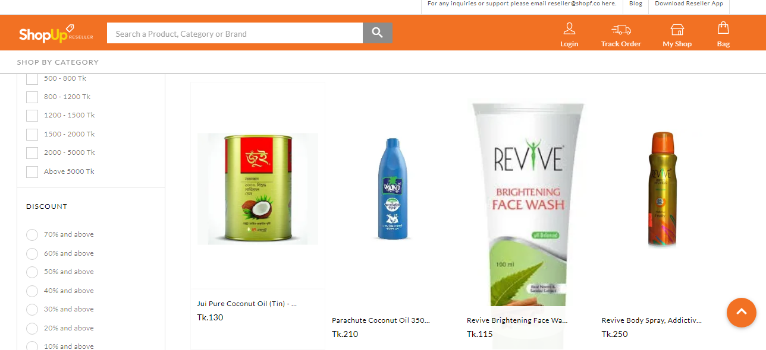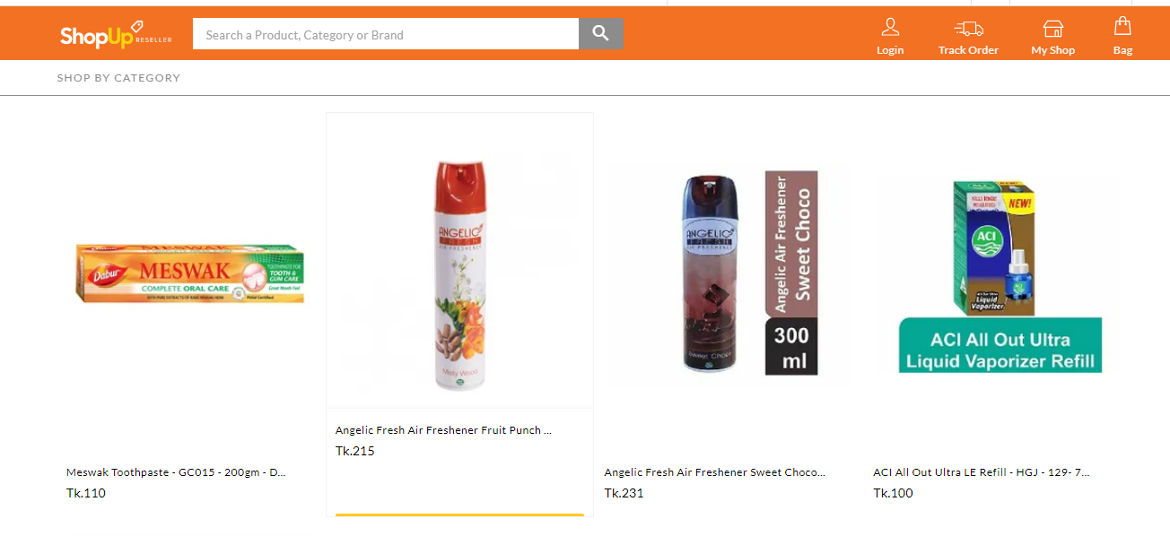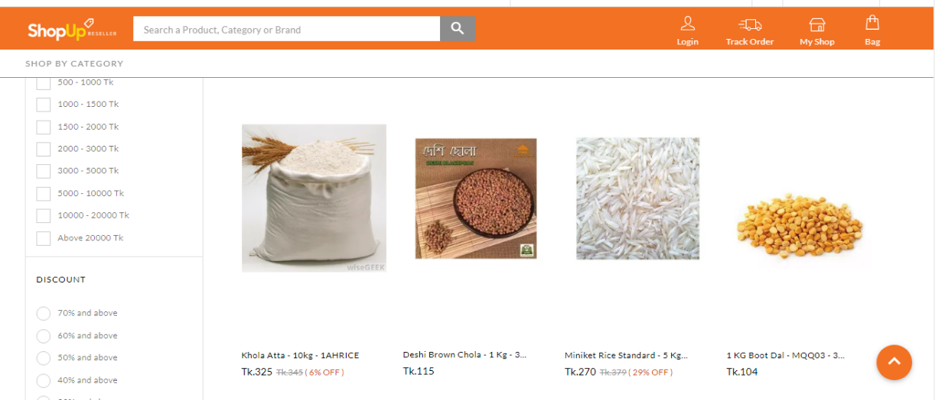
Figure 14: Website and app

