The Branding Strategy followed by bKash Limited



Submitted To
Muhammad Rehan Masoom
Assistant Professor,
School of Business and Economics
United International University (UIU)

Submitted By
Md. Istiaque Hossain
ID: 1111 32 164
Bachelor of Business Administration (BBA)
United International University (UIU)

Date of Submission
25th December, 2018

Letter of Transmittal
To,
The supervisor,
Muhammad Rehan Masoom
Assistant Professor,
School of Business and Economics
United International University
Subject: Submission of project report on ‘The Branding Strategy of BKash’

Dear Sir,
You will be glad to know to that I have recently completed my project report on the branding strategy of BKash. The project report is a requirement to complete my BBA program from United International University and I have learnt various practical knowledge on Mobile e-commerce while creating the report.

I am so grateful for all the help and guidelines you had been provided to me during my project program. All that supports proved me highly helpful and give the proper idea of how a well-written should be.

I want to assure you, I have followed all the guidelines and collected all the information from some valid and relevant source to complete my project report.

I, therefore, pray and hope that you honour would be kind enough to accept my project report and oblige thereby.

Your sincere student,

Md. Istiaque Hossain
ID: 1111 32 164
Bachelor of Business Administration (BBA)
United International University (UIU)


Acknowledgement
At the beginning of my project report, I would love to thanks my Almighty Allah to make me able to complete all the courses of BBA program and come to this point when I am one step far from completing my graduation from United International University.
At first, I would love to share my gratitude for my honorable project supervisor “Md. Rehan Masum, Assistant Professor, United International University”. I had sent an Email to let him know about my desired project topic. He replied and accept my chosen topic very quickly. Thank you, sir, for providing me with all the useful materials and guidelines that helped me a lot to understand a project report.
I would like to show my gratitude to “Mr. Md. Abul Kashem, Marketing Executive, BKash limited” for assisting me with the information and documents that were very beneficial for me while creating my project report.
At last, but not least, I want to thanks all the employees and staffs of Bkash as well as United International University to supporting me during their busy schedule.

Table of Content

Executive Summary 1

Chapter one: Introduction
1. Introduction 4
1.1 Background of the report 4
1.2 Scope of the report 4
1.3 Objectives of the report 5
1. Primary objectives: 5
2. Specific Objectives: 5
1.4 Methodology of the report 5
i. Primary Sources of information 5
ii. Secondary Sources of Information 6
1.5 Limitations of the report 6

Chapter two: Overview of bKash
2.1 Defining Mobile Commerce 8
2.2 History and Background of M-Commerce in Bangladesh. 8
2.3 An overview of bKash. 9
2.3.3 Advantages of bKash 11
2.4 Major Competitors and Key players of M-Commerce 12
2.5 Products and services of bKash 13
2.6 Organogram of bKash 14

Chapter Three: Banding Strategy of bKash
3.1 Performance of bKash throughout last 4 years 16
3.1.1 Performance in the number of customers 2014-2018 16
3.1.2 Performance in average yearly transactions 2014-2018 17
3.1.3 Performance in net profit from 2014-2018 18
3.2 The branding strategies utilizing by bKash 19
3.2.1 Branding through Billboards 19
3.2.2 Wall paint 20
3.2.3 TV Advertisements: 21
3.2.4 Promotional Discounts: 22
3.2.4 Boat Branding: 23
3.2.5 Branding through Agent: 24
3.2.6 Car Sticker: 24
3.3 SWOT Analysis of bKash 25
3.3.1 (S) Strength: 26
3.3.2 (W) Weakness 26
3.3.3 (O) Opportunities 26
3.3.4 (T) Threats: 27

4. Findings of the Report 29

5.1 Recommendations of the Report 31
5.2 Conclusion 32

References 33

Executive Summary
The project report is an essential part to achieve the bachelor of Business Administration (BBA) degree from United International University. In terms of creating project reports, Students do not need to participate directly in the organization as an intern to submit a project report rather they have to observe and collect all the valuable information of any particular company throughout the three months of their project period and submit their final project report to their project supervisor. Meanwhile, a project supervisor is chosen from the university among from the university faculty member who guides him to arrange all the report properly.
My project report is based on the branding strategy information of bKash, the largest Mobile commerce in Bangladesh. bKash has created a strong brand in this recent year by providing the easiest and safest way to receive and send money to anyone with the help of consumers own mobile phone. And it is not necessary to go to a Bank to send or receive the money.
bKash (Bengali: বিকাশ) is a mobile money related administration in Bangladesh working under the supervision of Bangladesh Bank as a subsidiary of BRAC Bank Limited. This mobile money framework began as a joint endeavor between BRAC Bank Limited, Bangladesh and Money in Motion LLC, United States of America. bKash clients can store money into their mobile accounts and afterward get to a scope of administrations, specifically exchanging and getting money locally, making instalments and purchasing mobile recharges. In April 2013, International Finance Corporation (IFC), an individual from the World Bank committee, turned into a value accomplice and in Walk 2014, Bill and Melinda Entryways Establishment turned into a speculator in the organization.
Fortune magazine positioned bKash among the best 50 organizations in the index of "Progress the World" in 2017. As indicated by them, 22% of Bangladeshi grown-ups utilize bKash with around 4.5 million day by day exchanges.
In my project report, at first chapter, I’m going to start with an introduction that describes basic information of my project report as well as bKash. In 2nd chapter, I’m going to share an overview of bKash where I I am going to share the background of bKash, its diversified service, organizational structure and so on. In the third chapter, which is the main part of this report, I’ll analyse all the branding strategies of bKash.
At the end of my report, In Chapter 4, based on my analysis part of chapter three I will share some findings that need to be improved. I will also share some recommendation from my theoretical knowledge to improve the problem that I will disclose in the findings part. All of these recommendations are depending on my own knowledge for the betterment of bKash, So If any officials of bKash feel it necessary, they can apply for the improvement of BKash.

Chapter One
Introduction
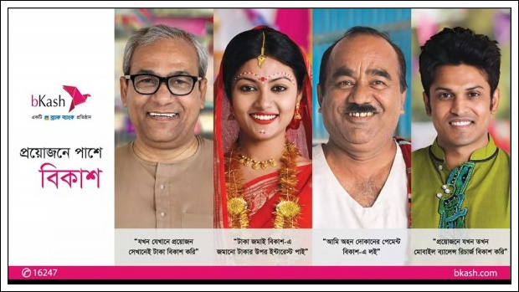

Introduction
Mobile commerce was introduced in 2011 in Bangladesh. bKash is providing one of the top mobile financial service in Bangladesh which is actually a subordinate of BRAC bank limited. From the beginning, bKash is leading the market with the highest number of users. So working on the strategy bKash followed to establish the brand in Bangladesh Mobile commerce would be a valuable report for many organizations, teachers as well as students.

1.1 Background of the report
The project report is an essential part to achieve the bachelor of Business Administration (BBA) degree from United International University. In terms of creating project reports, Students do not need to participate directly in the organization as an intern to submit a project report rather they have to observe and collect all the valuable information of any particular company throughout the three months of their project period and submit their final project report to their project supervisor. Meanwhile, A project supervisor is chosen from the university among from the university faculty member who guides him to arrange all the report properly.
My project report is based on the branding strategy information of bKash, the largest Mobile commerce in Bangladesh. bKash has created a strong brand in this recent year by providing the easiest and safest way to receive and send money to anyone with the help of consumers own mobile phone. And it is not necessary to go to a Bank to send or receive the money.

1.2 Scope of the report
Working and observing on bKash, is a great opportunity for improving my knowledge on financial markets of Bangladesh and it will help me to build my career. The report is going to an important document to the marketing managers of bKash. Any reader can get the overall idea on bKash branding strategy which is very important for any new organizations. At any University, all marketing department’s students as well as faculties can compare their educational learning with my practical learning if they read my report. So, the scope of my project report is huge and help a lot to others in upcoming future.

1.3 Objectives of the report
Objectives part is the most important part of any report as it helps a reader can directly get to know about the parts that are discussed in the report. There are two broad objectives to create this report. They are:
- Primary objectives: To achieve my BBA degree by submitting this project report was really a primary objective to me. But after knowing the organization more closely I’m more interested to share my analysis of the branding strategy of bKash.
- Specific Objectives: These objective are specified and shares the actual reason to create this project report.
- To share an overview of bKash.
- To list the products and services provided by bKash.
- To analyse the branding strategy of bKash.
- To evaluate the growth of bKash.
- To analyse the findings and share some recommendation that may help to improve the branding strategy of bKash.

1.4 Methodology of the report
Methodology means the methods and information sources what I’ve used in my report. I have gathered information from two sources basically. They are:

Primary Sources of information
- Face to face conversation with the bKash agents and the officials.
- Annual reports of bKash and BRAC Bank Limited.
- Collecting strategical documents and manuals from the marketing manager.

Secondary Sources of Information
- Some basic and past data I have collected from their website. Link: www.bkash.com
- A lot of published articles from the internet, helped me to gather knowledge on some unknown terms. This articles name I’ll include in the later appendix part.

Limitations of the report
I have felt in these three months that it is very difficult to gather information without working in the organization. I have to face a lot trouble and limitations to make this report a flawless one. Some of the limitations are listed below:
- Short period of time: The three months of project period is not sufficient to create such an extensive report. Usually, I had to wait several of hours in a day to get a single information.
- Too busy-ness: Employees and agents of bKash are so busy during the office hour that they cannot manage time to spend with me and share information of the bKash.
- Secrecy: A little of information are not shared of bKash branding strategy as the officials were requested me to maintain them as secret.

Chapter Two
Overview of bKash
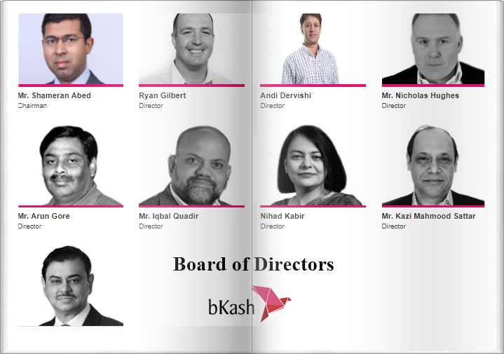

Defining Mobile Commerce
M-commerce (mobile commerce) is the purchasing and selling of goods and services through wireless handheld devices, for example, cellular phone and personal digital assistants (PDAs). Known as a modern-edge online business, m-commerce empowers clients to get to the Internet without expecting to discover a place to connect. The developing technology behind m-commerce, which depends on the Wireless Application Protocol (WAP), has made far more prominent shift in Europe, where mobile devices furnished with Web-prepared micro browsers are substantially more typical than in the United States.
According to Investopedia, Mobile commerce depends on the expanding appropriation of electronic commerce. The quick development of mobile commerce has been driven by various elements, including the interest for apps (Short form of Applications) from an undeniably mobile buyer base; the fast selection of online commerce, because of the goals of security issues; and technological advances that have given wireless handheld devices propelled abilities and significant registering power.
(Source: https://www.investopedia.com/terms/m/mobile-commerce.asp)

History and Background of M-Commerce in Bangladesh.
Mobile banking is another incorporation in the financial segment which empowers banking through mobile devices. Access to formal financial services is fundamentally low particularly for those individuals who live in the remote corner of the nation. These individuals are adding to the rural economy by participating in various financial services. By bringing them under the formal banking system, we can fortify our national economy. In this way, the reason for mobile banking is to give financial services to the unbanked population of the nation which is savvy, quicker and less demanding. As mobile banking offers an issue free exchange, countless are currently utilizing this administration. Mobile financial administration is developing quickly and if the present pattern proceeds with, Bangladesh will be a good example for (Mobile Financial Administration) MFS globally.
The journey of mobile financial administration began in Bangladesh with the starting of Dutch Bangla Bank Mobile Banking. It is the pioneer in MFS area and began its activity on 31st Walk 2011. At that moment, the possibility of mobile banking was extremely new. Be that as it may, individuals embraced it rapidly due to the helpfulness of this administration. Directly after Dutch Bangla Bank, bKash; an auxiliary of BRAC Bank began its adventure that quickened the MFS business of Bangladesh. These two organizations particularly bKash has changed the situation and wound up one of the greatest MFS specialist co-op around the globe inside a brief span. As of now, there is 18 association giving MFS benefit in Bangladesh.

An overview of bKash.
bKash is one of the main Mobile Financial Services on the planet. The essential vision of bKash is to be more prominent financial institution among the unbanked in Bangladesh. bKash now has four shareholders which are as per the following;
- BRAC Bank Limited
- Money in Motion
- International Finance Corporation
- Bill and Melinda Gates Foundation
Subsequent to accepting a license to work from the controller 'Bangladesh Bank' in 2010, the voyage of bKash began in July 2011. In the course of the most recent five years of tasks, bKash has made exemplary progress. The aggregate enlisted client presently surpasses 24 million with a functioning proportion (one financial exchange in multi-month) of 35%. While bKash began off as a send money stage, it is step by step changing itself to a specialist co-op going past simply send money. bKash has been reliably attempting to expand the suite of services to the client by presenting broadcast appointment top-up, mass payment, straight to wallet foreign remittance, accumulation services, merchant payments, and numerous such more client-driven services.
In 2013, there were somewhat more than 75 associations that were utilizing mobile money for payment and there were 600 outlets where bKash was acknowledged as a payment medium. The aggregate exchange in Dec 2013 was around USD 1 million. From that point forward there have been critical endeavours by bKash to understand the clients to additionally infiltrate into the merchant payment field. One of the key usages that were made was "small merchant" payments. Small Merchant is alluded to the ubiquitous "Mom and Pop" shops crosswise over Bangladesh. The retailing business is decently in the incipient stage in Bangladesh where the nearness of sorted out outlets is extremely negligible and the normal ticket size is small and subsequently so as to have a significant effect, digitizing payments in these outlets is vital.
The resultant effect of the different activities by bKash on the payment front can be best depicted through numbers. In June 2016 the aggregate number of associations that utilized mobile money surpassed 700 and the quantity of merchants tolerating bKash payments currently surpasses 30000. The aggregate exchange volume in June itself surpassed USD 7.5 million.
While there has been a huge advancement in the merchant payment field there still remains a monstrous open door further expand digital payments which can occur through the development and important offer both for the merchant and the client.
2.3.1 Mission Statement: By giving financial services that are advantageous, reasonable and user-friendly, bKash plans to enlarge the network of financial incorporation. bKash needs to give an answer for Mobile Financial Services, based on a profoundly versatile Mobile Money stage, enabling the general population of Bangladesh to securely send and get money by means of mobile devices. (bKash, 2017)
2.3.2 Coverage Profile:
Coverage profile of bKash December 2017
Type | Number nationwide | Additional details
Subscribers | 27,000,000+ | Country wide coverage
Agents | 170,000+ | Country wide coverage
ATMs | 300+ | Only BRAC Bank ATM booths can be used to cash out from bKash. Available in major cities in Bangladesh.
Full service branches | 150+ | BRAC Bank branches
Mobile banking offices (bKash Plus centre) | 100+ | Country wide coverage
Merchants | 40,000+ | Country wide coverage

Chart 1: Coverage profile of bKash 2017 (Source: Data Collected from Mobile Money Infosheet: bKash 2017. Available at:
https://www.marketlinks.org/sites/...org/.../mMoneyInfosheet _bKash_May2017.pdf

2.3.3 Advantages of bKash

bkash, as a mobile financial specialist, guarantees it's clients five major advantages which are quick, moderate, secure, advantageous and nationwide. These advantages are depicted in a brief below,

- Quick: bKash guarantees it's purchasers to be the quickest money exchange process. One can send and get money inside minutes through bkash.

- Reasonable: The receiving and sending money through bKash is low of cost comparing with a global standard. It has been an incredibly beneficial point for the general individuals of Bangladesh.

- Secure: Every single exchange of bKash depends on a PIN of a personal recognizable proof number which is exceptionally secure. In addition, the bKash record will be completely secure regardless of whether one lost his or her mobile. So, bKash is promising the best security in the exchange of money.

- Helpful: bKash is profoundly advantageous for its clients. Individuals can send and get money anyplace and whenever. bKash is serving it's buyers 24 hours every day and 7 days seven days.

- Nationwide: bKash has in excess of 160,000 specialists nationwide and in excess of 300 ATMs. So the accessibility of the administration is high nationwide.

Major Competitors and Key players of M-Commerce
The key players of Bangladesh mobile banking along with bKash and their parent company are given below:
Serial No. | Bank Name | Product Name
1 | Duch-Bangla Bank Limited. | Mobile-Banking
2 | BRAC Bank Limited. | bKash
3 | Prime Bank Limited. | EasyCash
4 | Islami Bank Bangladesh Limited. | mCash
5 | Trust Bank | T-cash
7 | Bank Asia Limited. | Mobile Banking
8 | Dhaka Bank | SMS Banking
9 | Mercantile Bank | Mobile Banking
10 | AB Bank | SMS Banking
11 | South East Bank | SMS Banking
12 | First Security Islami Bank | SureCash
13 | United Commerce Bank | SMS Banking

Chart 2: Major Competitors and Key players of M-Commerce

Products and services of bKash
bKash is providing the underneath referred products and services to the majority of its clients,
- Cash In: One can stack cash in their bKash account through any of the bKash operator or ATMs. This procedure is for free for its users.
- Cash Out: Clients can pull back cash from their records from the bKash operators and additionally from the ATMs. bKash charges a low administration charge for this.
- Send Money: Money can be executed starting with one record then onto the next record practically through bKash. The expense is advantageously low and empowers clients to serenely send money.
- Payment: bKash is accessible in most of the market to pay through.
- Buy Airtime: Individuals who utilize mobile need ordinary airtime. bKash empowers its clients to specifically buy airtime from their records.
- International Remittance: bKash has tied up with the Western Union and MasterCard to get money from the foreign nations which have empowered the country individuals to specifically get money from the relatives who are living in different nations.
- Interest on Savings: Clients can earn up to 4% of interest every year on their savings in the bKash account.
(Source: https://www.bkash.com/about/products)

Organogram of bKash
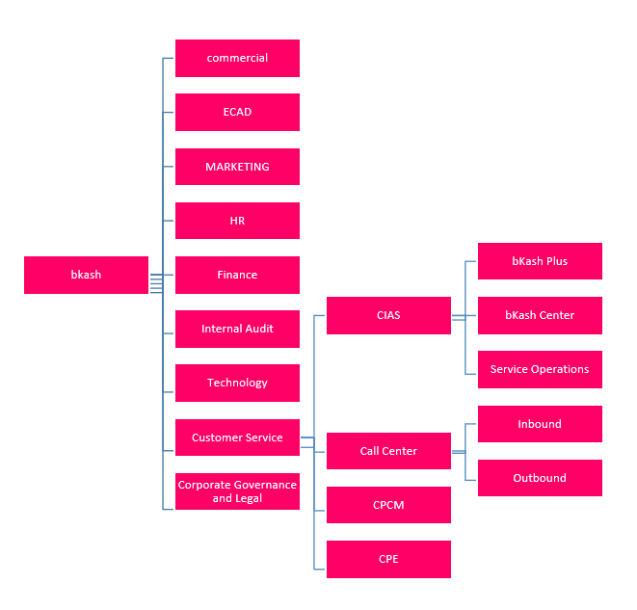
Chart 3: Organogram of bKash

Chapter Three
Branding Strategy of bKash
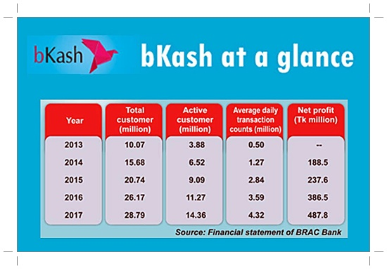

3.1 Performance of bKash throughout last 4 years
The BRAC Bank subsidiary, bKash, also gained steady growth in net profit during the period with the growth of its consumer base and transactions. bKash continues to grow and achieve targets while adapting to the new changes in the industry. Mobile Financial Service (MFS) operator, bKash has displayed steady growth in the amount of customers and transactions during the last four years.

3.1.1 Performance in the number of customers 2014-2018
Year | Total Customer (In Million)
2014 | 15.68
2015 | 20.74
2016 | 26.17
2017 | 28.79

Chart 4: Performance in the number of customers of bKash throughout last four years 2014-2018, all the information collected from The Financial Express Bangladesh (Online financial information site of Bangladesh) Available at:
https://thefinancialexpress.com.bd/stock/bangladesh/company-profile-bkash-witnesses-steady -growth-1533875587

The number of clients expanded progressively from 2014 to 2017. The number of clients rose to 28.76 million of every 2017 while the number of clients was 15.68 in 2014 and the number of dynamic clients was above 14.36 million in 2017. It saw had achieved the most elevated number of clients who opened accounts in 2017 to get mobile financial services.

3.1.2 Performance in average yearly transactions 2014-2018

Year | The Number of Transactions (In Million)
2014 | 1.27
2015 | 2.84
2016 | 3.59
2017 | 4.32

Chart 5: The number of transactions of bKash throughout last four years 2014-2018, (all the information collected from The Financial Express Bangladesh (Online financial information site of Bangladesh) Available at: https://thefinancialexpress.com.bd/stock/ bangladesh/company-profile-bkash-witnesses-steady -growth-1533875587)

A gradual increase showed in the number of transactions of bKash from 2014 to 2017. The company's day to day normal exchange counts were 4.32 million in 2017, 20.2 percent higher than the day to day normal exchange include watched 2016.

3.1.3 Performance in net profit from 2014-2018

Year | Net Profit
2014 | 188.5
2015 | 237.6
2016 | 386.5
2017 | 487.8

Chart 6: The Net Profit of bKash throughout last four years 2014-2018, (all the information collected from The Financial Express Bangladesh (Online financial information site of Bangladesh) Available at: https://thefinancialexpress.com.bd/stock/ bangladesh/company-profile-bkash-witnesses-steady -growth-1533875587)

bKash gained a net profit worth more than Tk 487.8 million in 2017, which was Tk 188.5 million for 2014 and it grows gradually year after year. Increasing in net profit displays the company is doing well in the mobile financial service industry.

3.2 The branding strategies utilizing by bKash
Following 8 years of activity, bKash now has 85,000 agents, just about one in each village iof rural Bangladesh, "this guarantees access to specialists in the remotest part of the nation". The administration was propelled on July 21, 2011. It presently has all most 3 million enlisted clients. Also, 98% of mobile clients in Bangladesh approach bKash. In the course of the most recent few years, they have completed an immense branding action that is the reason, they can make this progress. A portion of their brandings are given below.

3.2.1 Branding through Billboards
Billboard is the best way to communicate with customers in Bangladesh. Presently bkash have 2450 billboards everywhere throughout the nation. This will improve their reach to more individuals. All the billboards have great visualise level and are in the prime area. They cover every single thana of Bangladesh by the billboard. Other than this, their message is a match under stable in the board. A few pictures of bkash billboard are given below:

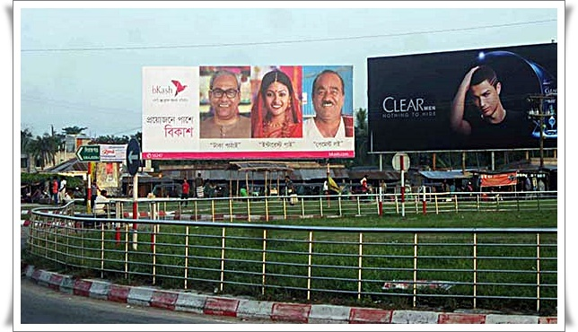

3.2.2 Wall paint
The rural people and the lower class people are the main target of bKash. It has 1, 20,000 Square feet of wall paint all over the country. Still, bKash is trying to implement another 2, 00,000 Square feet of wall paint in all over Bangladesh at the end of 2018. The brand image of bKash will increase more by the help of these wall paints. Some wall paints of it are sharing below:
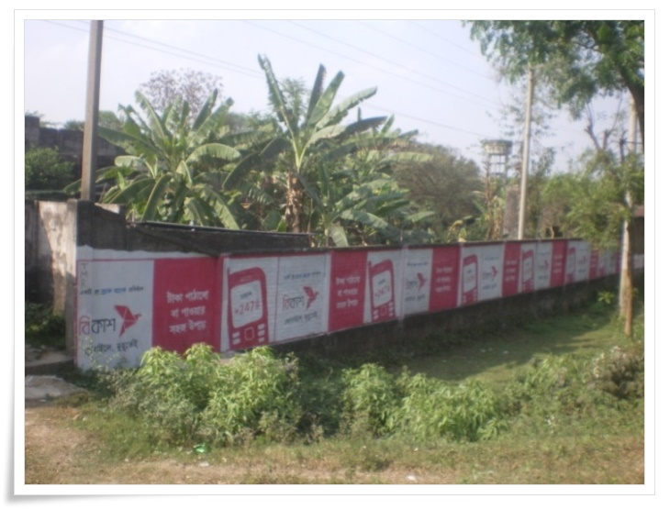

3.2.3 TV Advertisements:
In total of 27 TV Advertisements are published in all around in Bangladesh through television until 2018. All these advertisements are highly directed by well-known producers and directors to create its advertisements. bKash takes various innovative ideas to promote their services and products to the potential and existing consumers through TV advertisements. Usually, bKash share their quality of their service, the increasing number of customers’, various precautions to avoid fraud in these advertisements. Some of bKash advertisements are providing below:

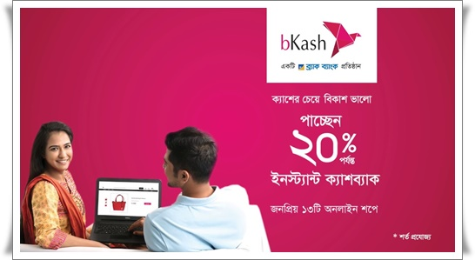

3.2.4 Promotional Discounts:
As the largest mobile provide financial service provider in Bangladesh, bKash usually provides a lot of discounts on purchasing certain products. If customers pay the money using bKash they can enjoy the predetermined discounts from bkash. bKash generally offers these discounts on various occasions. Over the years, bKash has been giving cash back offers to its customers on various occasions including Eid to bring joy, happiness and the opportunities to buy more on lesser prices to their potential and existing customers. A Promotional discount offer of bKash is sharing below:
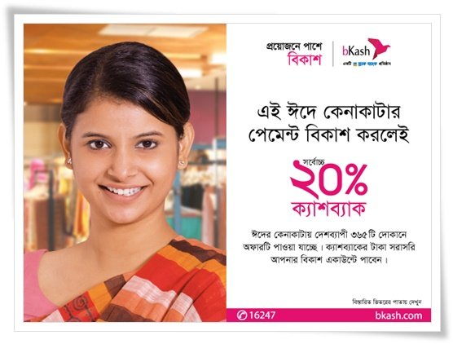


3.2.4 Boat Branding:
As Bangladesh is a river based country, one of the most popular branding strategy performed by bKash is Boat branding. bKash has probably 5800 boats all around the country in different district. bkash usually finance the boat sailor with their parent company, BRAC bank limited, so that they can maintain efficiently their boat and branding bKash logo and promotional offers through their boat. The boat promoting by bKash is sharing below:
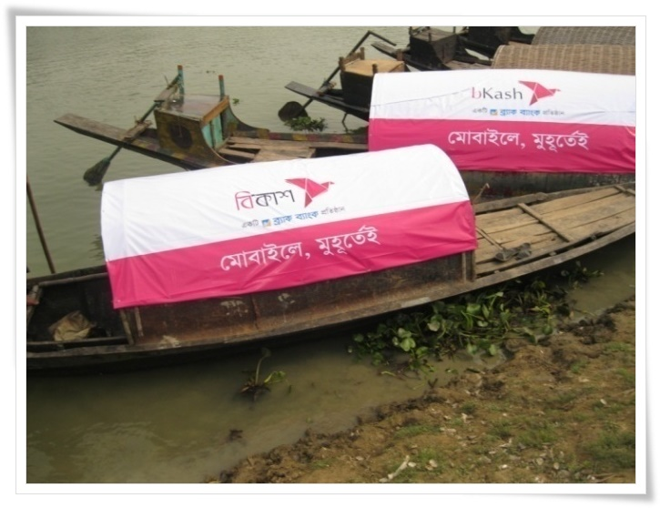

3.2.5 Branding through Agent:
bKash has in total of 85000 agents all over in Bangladesh. bKash guides them to branding different products promotions and provides them various leaf-lets of bKash. These leaf-lets includes festoons, posters with the promotion usually printed in the leaf-let. All these agents tells their customers about the new promotion of bKash. It increases the brand value of bKash and customers can become aware of the new offers of bKash.
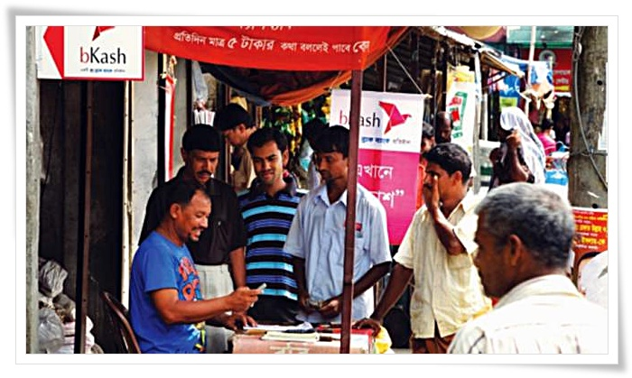

3.2.6 Car Sticker:
bKash’ most important outdoor branding is its branding in private and public transportations. They have almost in total 5, 00,000 car owners who have registered with bKash with some certain conditions to use bKash brandings usually stickers in their personal or company cars. These stickers must be visible and usually located at the backsides of the car. Moreover, bkash is planning to promote through Compressed Natural Gas (CNG) and rikshaw with bKash stickers by providing the owners of these vehicles owners some financial help. An image of bKash car branding is given below:
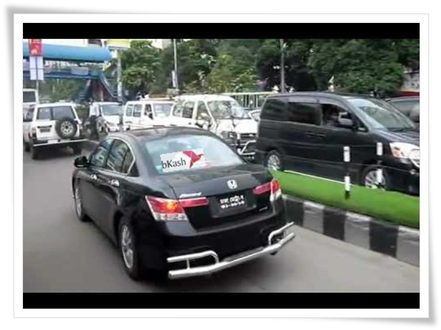

3.3 SWOT Analysis of bKash
A SWOT Aalysis is an easy but very useful way to determine a company’s strength and Weakness, Opportunities and Threats. I creates a broad chance to utilize the upcoming opportunities, plan for the threats and also create awareness of the company’s Strength and weaknesses. Here, to analyse bKash branding strategies, I think, a SWOT analysis of bKash can also provide a clear idea of bKash branding strategies strengths, weakness, opportunities and threats to know the actual position of bKash in the Bangladeshi mobile financial service market.

3.3.1 (S) Strength:

3.3.2 (W) Weakness

3.3.3 (O) Opportunities
According to Bangladesh Telecommunication Regulatory Commission (BTRC) report of October 2018, the total bangladeshi mobile subscribers are almost 156.469 million in Bangladeshi. It is a huge opportunity for bkash to increase its branding strategy to get more customers. bKash has also opportunities to enter in global market as these Mobile Financial Service (MFS) is a recent innovation and there are less competitions around the world.
(Source: http://www.btrc.gov.bd/content/mobile-phone-subscribers-bangladesh-october-2018)

3.3.4 (T) Threats:
One of the principle threats originates from the impression of technology kept up by low-income users. For instance, numerous users erroneously imagine that they require advanced skill to utilize the technology. A comparative issue emerges in that users regularly imagine that advanced English is required to utilize bKash. So it is extremely difficult to persuade low-income users about the undetectable cash idea.

Chapter Four
Findings of the report
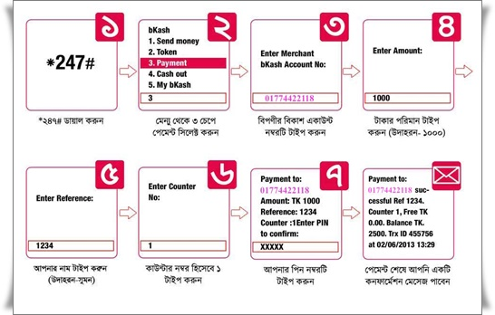

Findings of the Report
After analysing the branding strategy of bKash, I have found some key ideas of bKash branding strategy. All the findings are listed below:
- Though the Dutch Bangla Bank Limited introduced the mobile financial service first time in Bangladesh, bKash is in the leading position in this industry.
- Growth potential of this industry is very high, because the total quantity of mobile users in Bangladesh is 156.469 million.
- bKash has 71% market share, where the pioneered DBBL has only 24% of market share in Bangladesh.
- The large number customers are not happy with the payment service of bKash.
- The server of bKash (*247#) doesn’t perform well all the time.
- bKash targets all types of people of Bangladesh but mostly its discounts are for upper class people as they provide discounts to various high price products.
- bKash has already spread all over Bangladesh, where the competitors of bKash are hardly known by the consumers of other districts than Dhaka City.
- There are great opportunity for bKash to perform their business in the global market.
- bKash could not properly produce talented leaders as agents in rural area of Bangladesh.
- bKash has already used a lot of innovative ideas for their branding strategy and it is still searching to generate more.

Chapter Five
Recommendations and Conclusion


5.1 Recommendations of the Report
- After analysing the branding strategy of bKash, I want to share some suggestions for the betterment of bKash branding strategy. This suggestions will help bKash to compete with its competitors in the future. The suggestions are listed below:
- Mobile financial service is a new technology in Bangladesh which started from 31st March 2011. Dutch Bangla Bank Limited (DBBL) first introduced the mobile financial services in Bangladesh. Most of the people aware about it but not have any clear idea. bKash should start some free training service to its agents so that they can help customers to utilize it efficiently.
- bKash has to concentrate on high growth potential in Bangladesh because the quantity of mobile users of Bangladesh is around 156.469 million and those 156.469 million people can be the potential customers for bKash.
- According website of The Financial Express Bangladesh, bkash has 71% and DBBL have 24% of market share.
- bKash should spread its business globally as there are very few competitors around the world.
- In terms of branding strategy, bkash is more visible than DBBL. bKash needs to concentrate on more innovative ideas of branding strategy.
- The payment service of bkash is not satisfactory, a lot of agents usually not willing to pay little sum of money. But bKash is committed to the customers that they can withdraw any amount of money. So bKash need to provide strict guidelines to their agents so that they do not do such thing with the customers as it is reduce the company’s value and customers can be diverted.
- A lot of customers complained that the server is not functioned properly, bKash need to improve their server for better customer experience.
- bkash provide more facilities to agents and customers such as bkash have Automated Teller Machine (ATM) cash out, payment service.

5.2 Conclusion
It is my tremendous joy to finish the report as a part of the project program. The report is an impression of my work, truthfulness, validity and additionally co-ordination among me and bkash Limited. I attempted my best to give as much as data I could. As the business is its beginning time, organizations will, in general, keep their data private. I view myself as fortunate to have the capacity to work for an organization. Surely, this is extremely remarkable in Bangladesh.
The versatile financing industry is developing at a fantastic pace. While it took just seven years for bkash to achieve 5.5 million, DBBL has 2 million inside seven years. Other than this, the various organizations can possibly expand their market share, on the grounds that the business is in the beginning period. There is an immense open door for the new entrepreneurs in the business.
At the wrapping up it very well may be said the bkash limited is as yet endeavoring to get the market despite the fact that they are the market leader with 71% market share. Anyway, the opposition of this industry grew quickly. But yet bkash is in an agreeable place in this industry but witticism in a protected place. To hold the market leader position bkash has presented new administrations. At Last, I want to say, If they can keep on taking into account the necessities of their clients like they are doing now, they have a splendid future in front of them.

References
Bangladesh Bank. (2018, 5 20). Retrieved, 2018, from bangladeshbank: www.bangladesh-bank.org
Bangladesh Bank. (December, 2017). Mobile Financial Services in Bangladesh. Policy Paper , 15-16.
bKash. (2018). Company Profile. Retrieved 5 23, 2018, from bKash: http://www.bkash.com/about/company-profile
GSMA Mobile and Development Intelligence. (2018). GSMA Mobile and Development Intelligence. Retrieved, 2018, from mobiledevelopmentintelligence.com: https://mobiledevelopmentintelligence.com/
Md Taimur Ahad and Laurel Evelyn Dyson, V. G. (2016). An Empirical Study of Factors Influencing the SME’s. Journal of Mobile Technologies, Knowledge & , 25,26.
Michael U. Klein, C. M. (2016). Mobile Banking and Financial Inclusion: The Regulatory Lessons. World Bank Policy Research Working Paper No. 5664 , 5-10.
The Central Intelligence Agency (CIA). (2016, 5 20). The Central Intelligence Agency. Retrieved 4 22, 2013, from cia.gov/index.html: https://www.cia.gov/index.html
Wadud, M. A. (2017, 3 25). market condition of bkash over the year. (Nur-E-Alam, and team Interviewer)
Bangladesh Telecommunication Regulatory Commission (BTRC), The opportunities for Mobile Banking Industries.
http://www.btrc.gov.bd/content/mobile-phone-subscribers-bangladesh-october-2018)
The Financial Express Bangladesh (Online financial information site of Bangladesh) Available at: https://thefinancialexpress.com.bd/stock/ bangladesh/company-profile-bkash-Coverage profile of bKash 2017 (Source: Data Collected from Mobile Money Infosheet: bKash 2017. Available at: https://www.marketlinks.org/sites/...org/ /mMoneyInfosheet _bKash_May2017.pdf
Products and Services of bKash. Available at: https://www.bkash.com/ about/ products
Definition of Mobile Commerce. Available at: https://www.investopedia.com/terms/m/ mobile-commerce.asp

