Internship Report

Factor Influencing Customers’ Purchase Intention of Online Room Booking Services

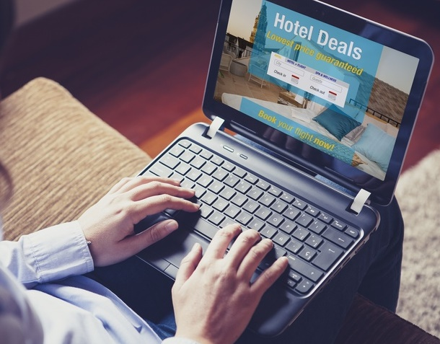

Factor Influencing Customers’ Purchase Intention of Online Room Booking Services

Prepared For

Dr. Khandoker Mahmudur Rahman
Associate Professor
School of Business & Economics
United International University (UIU)

Prepared By

Hasanuzzaman
ID: 111 142 312
School of Business & Economics
United International University

January 14, 2019
Letter of Transmittal

January 14, 2019

Dr. Khandoker Mahmudur Rahman
Associate Professor
School of Business and Economics
United International University

Subject: Submission of the Internship Report

Dear Sir:

I would like to submit my internship report titled “Factor Influencing Customers’ Purchase Intention of Online Room Booking Services”, which has been prepared as a requirement for the completion of the BBA Program of United International University.
Expo Group was formed in 2003 and Infosapex Limited was established in 2016 as a wing of the group and Amarroom.com is a special product of Infosapex Limited.
While working on the report, I have tried to follow each and every guideline that you have advised. It has been a very enlightening experience to work in this new venture and I have thoroughly enjoyed my internship period at Infosapex Limited.

Sincerely,
Hasanuzzaman
ID No: 111 142 312
ACKNOWLEDGEMENT

I would like to thank the internship Supervisor, Dr. Khandoker Mahmudur Rahman who has helped me in every step of my internship. I am very much grateful to Mr. Imrul Hasan and Mst. Distry Islam for giving me the opportunity to complete my internship at Infosapex Ltd. I am sure that their dynamic managerial activities will give inspiration to anybody to build one’s career properly.
I practically work with the team of Amarroom.com, try to share their perception, feelings and on the basis of my realization, I prepared report from my own point of view. Then at last I shall be grateful to those people who read this report and who shall get benefit from this report at present and in future.

DECLARATION

I am Hasanuzzaman, student of School of Business and Economic (Marketing) of United International University, Bangladesh, do hereby declare that the internship Repot on “Factor Influencing Customers’ Purchase Intention of Online Room Booking Services” is an original work and has not been previously submitted for any degree, diploma, title, or recognition.

________________
Hasanuzzaman
ID No: 111142 312
School of Business and Economics
United International University

Table of Contents

1 BACKGROUND OF THE PROBLEM 10
1.1 Introduction 10
1.2 Topic of the report 10
1.3 Origin of the report 10
1.4 Background of the Report 10
1.5 Objective of the Report 11
1.5.1 General objective 11
1.5.2 Specific Objective 11
1.6 Scope of the report 11
1.7 Methodology of the report 11
1.7.1 Primary sources 12
1.7.2 Secondary sources 12
1.8 Limitation 12
2. ORGANIZATION PART 13
Overview of the Organization 13
2.1 Services 15
2.1.5 Mobile Apps Development 17
2.2 Special Products & Solutions 17
2.2.1 Document Archiving Solution 17
2.2.2 Paperless Meeting Management 18
2.2.3 Process Automation Solution 18
2.2.4 Hotel Management Solution 19
3.1 Online Room Booking Portal 20

4. Corporate Clients……………………………………………………………………………………………………………….….…30
5. A quantitative research…………………………………………………………………………………………………………….31
6. Conclusion……..………………………………………………………………………………………………………………….…..…49
7. References………………………………………………………………………………………………………………………………..50

List of Figures
Figure No. | Title | Page no.
Figure 1 | Organization Structure of AML | 14
Figure 2 | Business Process Consulting Model | 16
Figure 3 | Typical Engagement Model | 16
Figure 4 | Mobile Apps Development | 17
Figure 5 | Document Archiving Solution | 17
Figure 6 | Paperless Meeting Management | 18
Figure 7 | Process Automation Solution | 18
Figure 8 | Hotel Management Solution | 19
Figure 9.1 | Website (www.amarroom.com) - Outside | 23
Figure 9.2 | Website (www.amarroom.com) - Inside | 24
Figure 9.3 | Website (www.amarroom.com) - Inside | 25
Figure 10.1 | Ligo Software | 26
Figure 10.2 | Ligo Software | 26
Figure 11 | Flight Booking Process | 27
Figure 12 | Types of Events | 28
Figure 13 | Types of Packages | 29
Figure 14 | Conceptual Framework | 35

Table No. | Title | Page no.
Table 1 | Demographic information of respondents | 36
Table 2,3,4 | Reliability Analysis of Perceived Fairness of Price | 39,40
Table 5,6,7 | Reliability Analysis of Attitude | 40,41
Table 8,9,10 | Reliability Analysis of Trust | 41,42
Table 11,12,13 | Reliability Analysis of Value | 42,43
Table 14,15,16 | Reliability Analysis of Perceived Behavioral Control | 43,44
Table 17,18,19 | Reliability Analysis of Subjective Norm | 44,45
Table 20,21,22 | Reliability Analysis of Purchase Intention | 45-46
Table 23 | Variables Entered/Removed (Regression) | 46
Table 24 | Model Summary (Regression) | 47
Table 25 | ANOVA (Regression) | 47
Table 26 | Coefficients (Regression) | 48
List of Tables

Executive Summary

Infosapex Ltd. is a Software solution, System integration, Consulting and Online booking service provider, which wants to build up its business in Bangladesh IT, Telecom, and Online sector. It offers a unique technical expertise & creative thinking with a wealth of experience consulting, designing and improving various projects worldwide.. Infosapex Ltd. is a concern of Expo Group BD which was established in 2003. Infosapex Ltd. was registered as a Private Limited Company under Companies Act 1994 on 14th February, 2016. Within the short time Infosapex Limited already developed and delivered enterprise solutions to Banks, NBFI and multiple corporate companies.
Amarroom.com is the most reliable online hotel room booking portal in Bangladesh whose motto is Book Now, Pay Later. Hotel room booking, blackout period package, holiday package, and ancillary services are provided by Amarroom.com. It is one of the premium products of Infosapex Limited which aims towards travelling with ease. More than thousands of people are taking service through Amarroom.com since 2016. It is a one stop travel & tour solution service provider by which you can find hotel accommodation and related services easily. It seeks to differentiate itself as one stop solution for all kinds of tour need in the Bangladesh. Amarroom.com has grown its expertise in organizing different corporate events as well. As it is enlisted as official event and tour organizer vendor of multiple giants of our country. Under one roof we are the only online travels and tour solution in Bangladesh that tries to bring new flavor in regular tours & events.

BACKGROUND OF THE PROBLEM

Introduction

Modern business is highly complex due to ever changing customer choice, preference, taste etc, and for the technological and high competition. Day by day the purchase intention via online is increasing including products and services. So, each company has to face so much competition. Providing the superior value, satisfying customers’ needs and wants etc. became meaning to sell the product or servicer for a marketer. To understand the customers (their perception, behavior, attitude), we did a quantitative research by collecting the sample including in this report.

Topic of the report
A topic has to be selected for the report. A well-defined topic reveals what is going to be discussed throughout the report. The topic has been assigned “Factor Influencing Customers’ Purchase Intention of Online Room Booking Services”.

Origin of the report
In today’s world academic education is not enough to enable student compete with confidence and reach his/her goal without having experience of the outside world. The report which has given the opportunity to learn about how a particular company sets its marketing strategy as well as operational process in the market place to satisfy the organizational goal.

Background of the Report

The internship program which is an essential part of the BBA program to complete the degree and exercise a significant importance as it enables a student to familiar with the practical business activities. The student work closely with the people of an organization and learn about the functions of that organization. This program enables a student to develop his analytical skill and scholastic attitude. This report would be base on- ‘Factor Influencing Customers’ Purchase Intention of Online Room Booking Services’.

Objective of the Report

Internship program is a realistic and practical subject to understand the situation nearly. It helps to develop the career in the particular sectors. Two objectives can be measured here.

General objective
To complete the report is the general objective as well as there are some general objectives-

- To find out several factors these can influence the online purchase intention.
- To find out the relationship between customers and hoteliers or any third party.
- To know how to work in practical market or any corporate environment.

Specific Objective
As a marketing student, I do this report which has some specific objectives-
- To analyze the online market situation.
- To analyze the perception of customer who has intention to purchase via online.
- Find out comparative position of the company.
- Identifying the marketing strategy of the company.

Scope of the report

This report has been prepared through extensive discussion with the employees of Infosapex Ltd. client and honorable supervisor. While preparing this report, I had a great opportunity to have an in depth knowledge about online room booking service.

Methodology of the report

For smooth and accurate study everyone has to follow some rules and regulations. The study inputs ware collected from two sources:

Primary sources
- Survey
- Direct observations
- Conversation with the client/ employee

Secondary sources
- Various Articles
- Website of Infosapex Limited
- Website of the Amarroom.com

Limitation

In preparing this report certain limitations were faced:
- Lack of sufficient sources prevented verification of information.
- The analysis presented here may vary with opinions of experts in this field.
- Some aspects of the report may be considered confidential by the organization.

ORGANIZATION PART

Infosapex Limited
Take Your Business to the Next Level


Overview of the Organization
Infosapex Ltd. is a start-up Software solution, System integration, Consulting and Online booking service provider, which wants to build up its business in Bangladesh IT, Telecom, and Online sector. It offers a unique technical expertise & creative thinking with a wealth of experience consulting, designing and improving various projects worldwide. It also provides online room booking service where people can get best deals in Bangladesh. Infosapex Ltd. is a concern of Expo Group BD. A few passionate entrepreneurs wanted to serve the international standard product and service for the purpose of exploration the global market and they build 13 companies under the roof of the Expo Group in 2003. Among these 13 companies, Infosapex Ltd. is one of the renowned companies in Bangladesh. It was registered as a Private Limited Company under Companies Act 1994 on 14th February, 2016. Within the short time Infosapex Limited already developed and delivered enterprise solutions to Banks, NBFI and multiple corporate companies.
Vision:
The vision of Infosafex Ltd. is to create a smart solution for everyday life in every business.
Mission:
The mission of Infosafex Ltd. is providing the critical software solutions and continuously developing the innovative solutions that address the particular needs of our customers.

Official Address:
Head Office: Shamudra Building, House # 16 (4th Floor), Road # 30, Gulshan-1, Dhaka, Bangladesh.
Registered Office: 206/A, Tejgaon Gulshan Link Road, Tejgaon 1/A, Dhaka-1230, Bangladesh.

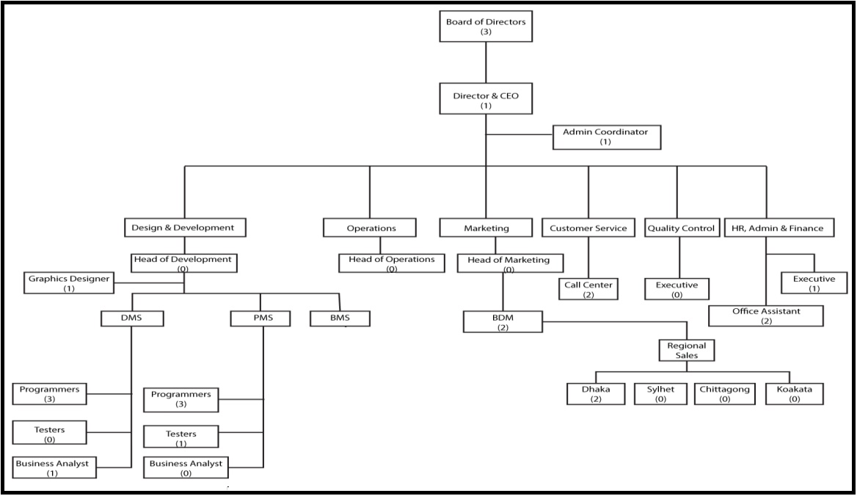
Organization Structure of AML
Figure 1: Organization Structure of AML
Board of Directors
Mr. Mahbubul Anam

Managing Director
Mr. Mahbubul Anam is the Managing Director of Expo Group. He is a Mechanical Engineer from Buet. At present, he is the President of Bangladesh Freight Forwarders Association as well as Vice President of Bangladesh Cricket Board.


Mr. Md. Imrul Hasan
Director & CEO
Mr. Imrul is a young entrepreneur in Bangladesh. He completed his study in Engineering and Computer Science from Bangladesh University of Engineering and Technology. Presently he is the CEO of Infosapex Limited. He played instrumental role in IT and Telecom sectors aboard and Bangladesh.

Services
    - System Integration & Consulting Service
Infosapex Limited offers out of the box system integration and consulting services to our valued customers where they have mesh IT infrastructure with multi-vendors and complex legacy systems. It has experienced technical and domain expert with International and National experiences in IT/Telecom sectors.

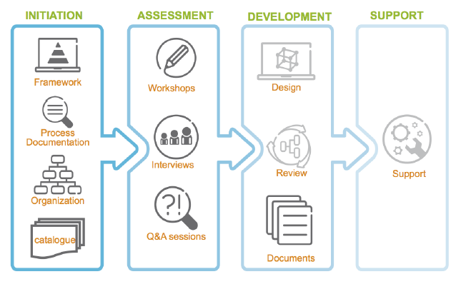
    - Business Process Consulting Model
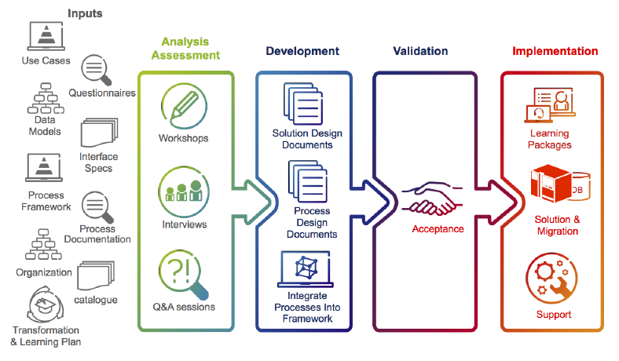
Figure 2: Business Process Consulting Model
    - Typical Engagement Model
Figure 3: Typical Engagement Model
    - Customized Software Solution
Infosapex Limited is a boutique IT solution provider in Bangladesh. It provides customized software for various services such as Invoicing, Billing, Mobile Apps and so on. For a start-up business or an established business, Infosapex will assist you at every stage of the software development life cycle. It will provide you not only custom software but also the total solution from conceptualization to analysis of your business.

Mobile Apps Development
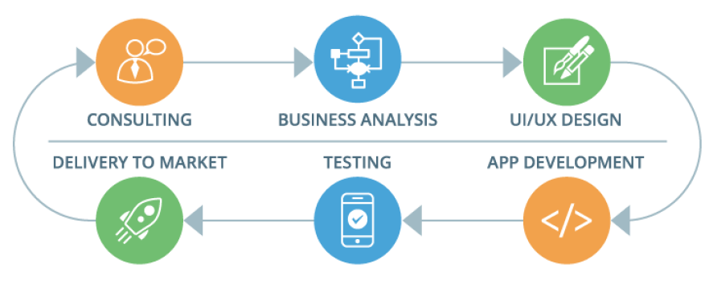
In every business, Mobile apps are very much necessary things. Infosapex provides the high quality standard app for various category. It covers several things like UI/UX designs, Business analysis, Mobile consulting, Backend integration and publication on the App Store, Google Play or Microsoft Store etc.

Figure 4: Mobile Apps Development

Special Products & Solutions

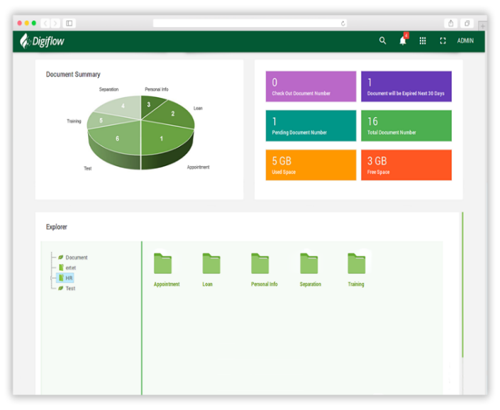
Document Archiving Solution

A big portion between 80% and 95% of corporate information of an organization is kept in reserve or saved in electronic device. According this perspective in this ‘paperless office’, various documents people can storage, usage, and manage of all records, files, forms easily.

Figure 5: Document Archiving Solution

Paperless Meeting Management
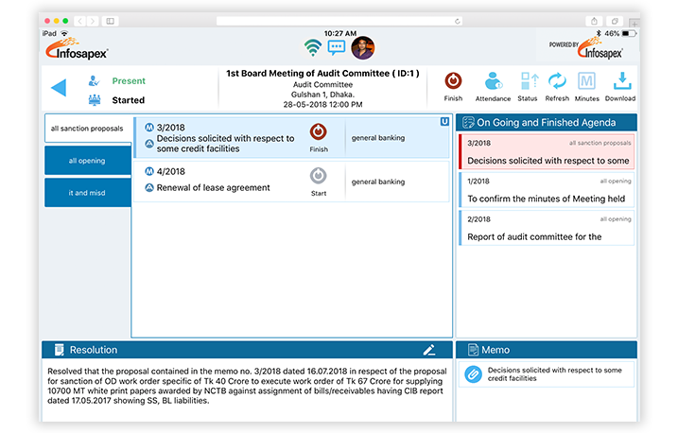
Every organization has to arrange board meeting regularly. This real paperless meeting software helps boards for prepare and hold the board meeting effectively as well as manage the subsequent follow up & follow through.

Figure 6: Paperless Meeting Management

Process Automation Solution
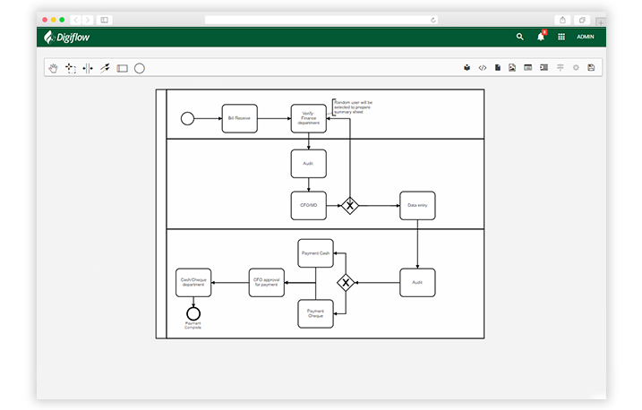

For better performing the corporate work processes and document movement via dynamic workflows as well as designing management forms in digital sector, Process Automation Solution helps a lot.

Figure 7: Process Automation Solution

Other Benefits:
- Improve Business Outcomes
- BPMN Designer to design flexible workflow
- Drag & Drop eForm Designer & KPI Dashboa

Hotel Management Solution
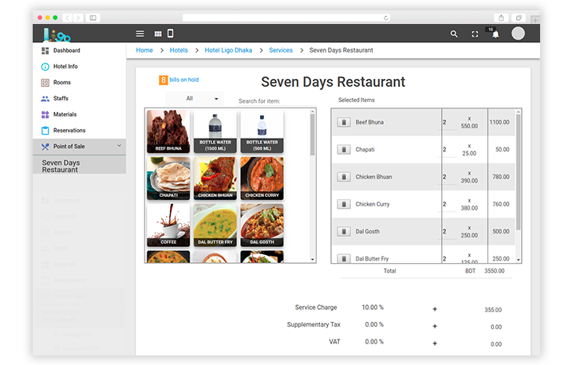
Most hoteliers want to provide their dream hospitality. Infosapex Ltd. opens the doors to manage their hospitality offering an easy as well as all in one software named ‘Ligo PMS’.

Figure 8: Hotel Management Solution
Ligo PMS offers-
- Customizable Room Management and Reservation
- Check-in & Check-out
- Point of Sales (unlimited)
- Total Guest Care
- Material Management
- Housekeeping
- Corporates
- Tariffs and Promos
- Night Audit
- Money Exchange
- Transportation
- Maximum recommended Reports
- Accounting

    - Hotel ERP
Infosapex Limited opens all the doors to organize your premium hospitality offering easy and all-in-one online hotel management software it includes customizable room management and reservation, check-in & check-out, integrated accounting, point of sales (unlimited), total guest care, material management, housekeeping, corporates, flexible tariffs and promos, night audit, money exchange, transportation, maximum recommended reports.

  - Online Reservation Services

Online Room Booking Portal
Amarroom.com is the most reliable online hotel room booking portal in Bangladesh whose motto is Book Now, Pay Later. Hotel room booking, blackout period package, holiday package, and ancillary services are provided by Amarroom.com.
Background of Amarroom.com
Amarroom is one of the premium products of Infosapex Limited which aims towards travelling with ease. More than thousands of people are taking service through Amarroom.com since 2016. It is a one stop travel & tour solution service provider by which you can find hotel accommodation and related services easily. It seeks to differentiate itself as one stop solution for all kinds of tour need in the Bangladesh. Amarroom.com has grown its expertise in organizing different corporate events as well. As it is enlisted as official event and tour organizer vendor of multiple giants of our country. Under one roof we are the only online travels and tour solution in Bangladesh that tries to bring new flavor in regular tours & events.
Why Amarroom?
Amarroom.com is not done with just booking the hotel for you. Your safety and security after you reach there is its prime concern too. They will make sure you get to your hotel and destination with all the necessary documents. Even while your stay in the hotel if any problem arises they are always ready to help. The tour configuration of Amarroom.com are designed to guarantee its customers are acclimatized appropriately, and different options agendas are constantly accessible. They generally keep their correspondence channels open with their visit groups during the tour.
They can ensure to give you the proper guides about your visiting destination safety which is safe for you and which is not. With this in mind, they work genuinely and adequately to give you tour services. They urge you to question them openly if you have the chance that you have any request and query, you are welcome to contribute in arranging of your tour. There are also some special reasons to choose Amarroom.com such as-
Variety
It doesn’t matter if you are a novice traveler or experienced, wherever you want to go or whatever your budget is, Amarroom.com has all the versatile choices available for you. Packages for all the exquisite places to visit in a wide range of hotels and resorts are always available at the click of your hand. Its point is to take you to a very surprising world and which may give you an open door associate with your own particular otherworldly existence.
Experience
It has more than 2 years of experience in this field of hospitality. Their team is always ready for the customers to provide them with the best possible experience while travelling.
Experience of their services are more than satisfactory as they have their dedicated customer care service to take all the necessary feedbacks from the clients whoever visited or taken services from them. They also ensure that customers are satisfied by providing them necessary information’s and insiders about the different places and transportations. As Amarroom.com offers all its clients the best deal in hotel alongside, it also suggests them which will be much more precise and comfortable for their travel experience.

Quality of Service
They are positive about giving you magnificence services and data about your likable destination and tour from their intelligence of many years in travel business. This organization is extremely devoted to give brilliant, proficient and customized benefit. Amarroom.com can ensure you to plan a visit in anywhere in Bangladesh with you want and interest. They have quite long-established settled association with the hotels, restaurant, and transportation, flight booking services for domestic and can provide guaranteed service at a lower price. They believe with their heart that service comes first. That is why their customers always get the topmost priority. Its experienced team tries their best to create a connection with our customers that is reliable and sincere. Their customers are sure to have an unforgettable experience while travelling in Bangladesh, with less to think about. So, they are bound to be back to us again and again and recommend us to their loved ones.

Spirit of Adventure
They as a travel service, develops with each new customers. They are steadiness in learning process. They are the only company in Bangladesh that can take you to the spots you've dreamed off for a long time ago to explore the world. Their activity is to help you to discover full rise of a definitive soul of experience to the top of the world with reliable nature of services.

What They Do?


Hotel booking one of the most cumbersome tasks to do while travelling is to find a decent accommodation. Most people prefer booking a hotel or a resort online now before going to their destination. With their hotel booking service online reservation is easier than ever. They covered almost 300 hotels all over Bangladesh. Their advanced search system will find you the right deal from all the best hotels and resorts located in the most popular and amazing holiday destinations in Bangladesh. Just one click and you are good to go. As for payment, only they are giving you the facility to pay advance as well as pay later, you can pay in online and you are sure to be amazed by the versatility of their payment methods, spread through a huge number of payment services in the most secure and convenient way possible. Moreover, they are partnered with the best hotels which is offering a wide range of packages, deals and discounts according to your need and desire. Book hotels with ease at the top of your fingers according to yours time and price. Whether you travel with yours family or friends, office or loved one we have it all covered.

Department
There are 5 departments in Amarroom.com-
    - HR Department
    - Marketing Department
    - Customer Service Department
    - Accounts Department
    - Operation Department

How It Works?
There are two ways of booking hotel room through Amarroom.com-
i) Online
Step 1:
At first customers have to visit the website - www.amarroom.com
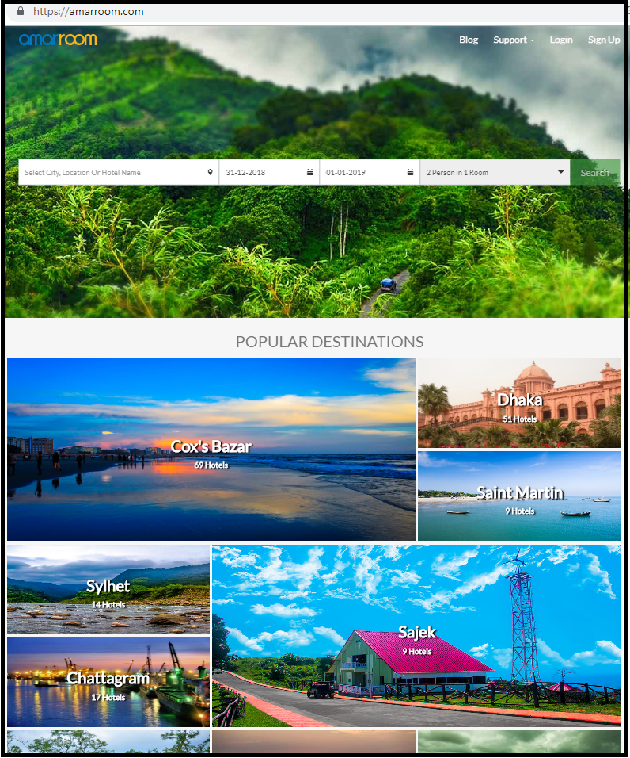
Then they have to select their favorite destination. There are so many tourist places in this website such as Cox’s Bazar, Dhaka, Sylhet, Bandarban etc.
Figure 9.1: Website (www.amarroom.com)

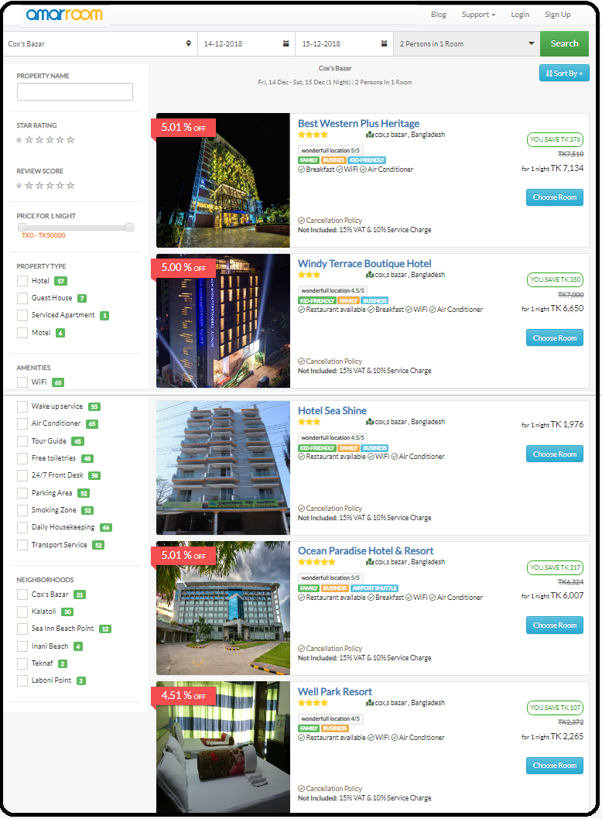
Step 2:
After selecting and clicking the destination, a new window will be opened (figure: 4). In this page, there are so many hotels with hotels amenities such as wifi, air condition, breakfast etc. After that customers have to select the hotel according their preferance.

Figure 9.2: Website (www.amarroom.com)

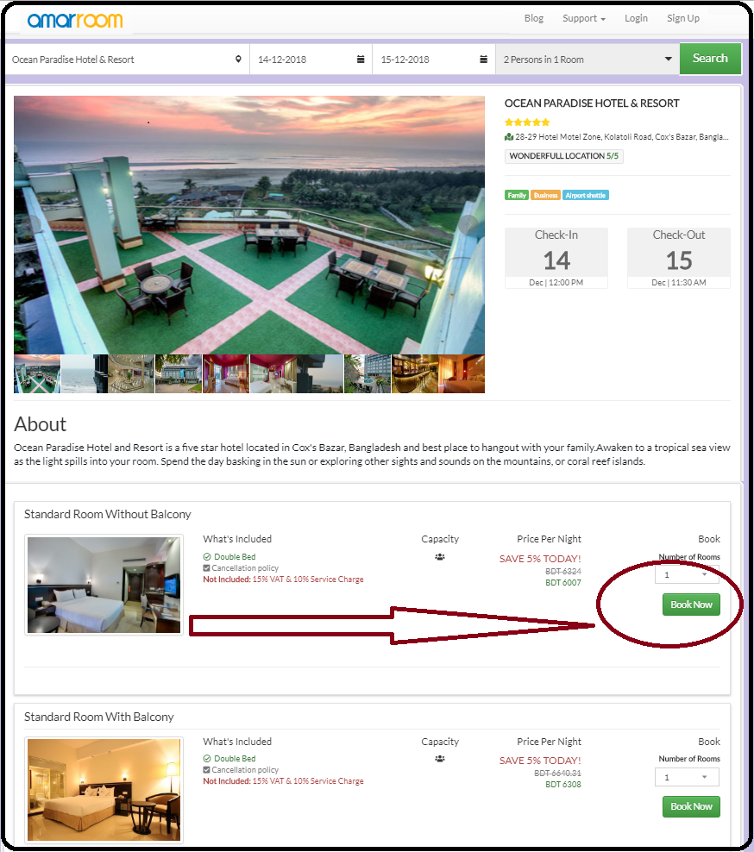
Step 3:
After selecting the hotel, again a new window will be opened for selecting hotel rooms. In this page, there are different types of rooms such as standard room, sea view room, deluxe room, premier room etc. with the prices and various pictures. Here, after choosing room type customers have to click ‘Book Now’ button. Then they have to pay the payment through payment option to confirm their booking.

Figure 9.3: Website (www.amarroom.com)

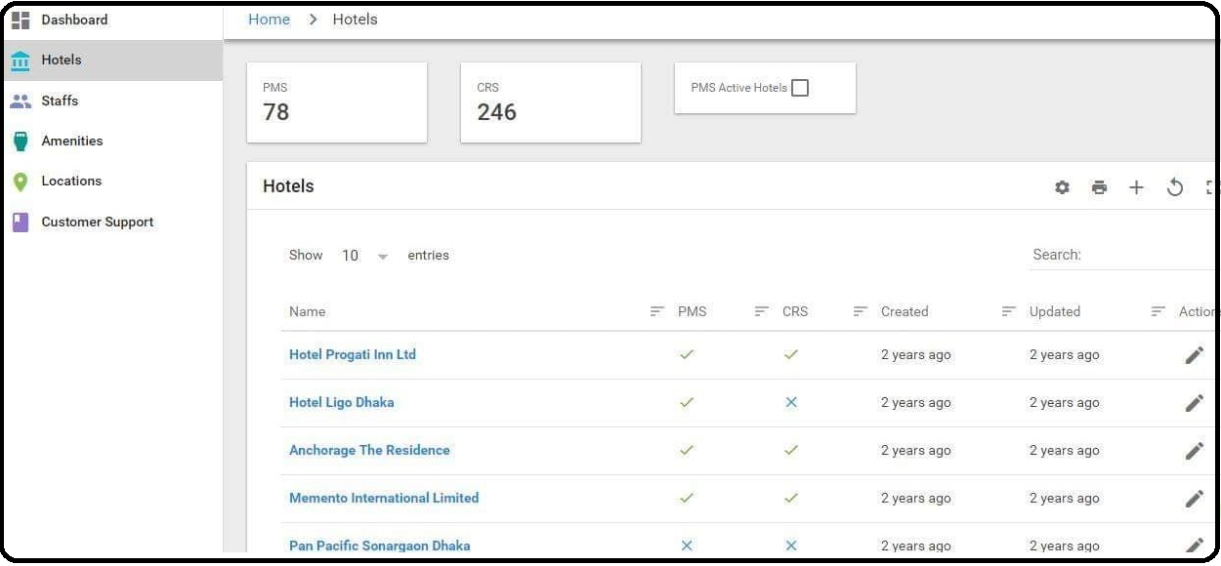
Step 4:
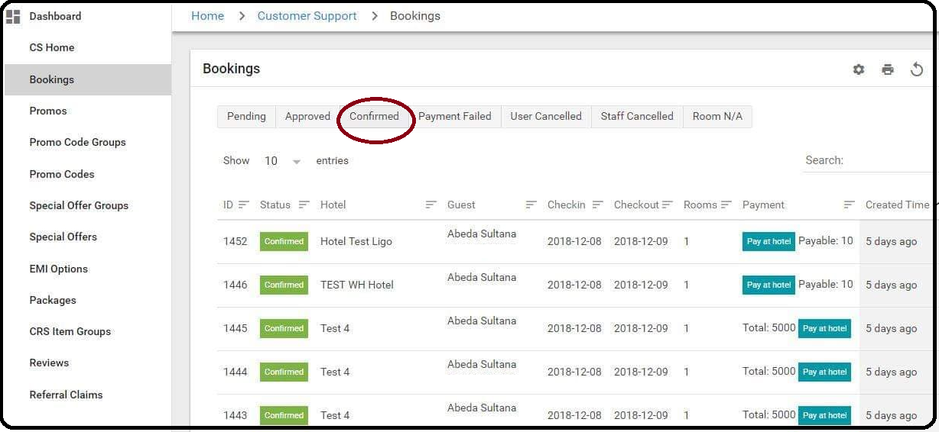
When a customer confirms his/her booking, it will hit the software named ‘Ligo’ which operates the admin of customer service department of Amarroom.com. Figure 10.1: Ligo Software

The figure 10.1 is the original version of ‘Ligo’ software and another figure 10.2 shows the booking list. In this step, admin confirms the booking.

Figure 10.2: Ligo Software
ii) Offline
In this way, customers can book the hotel room through calling the hot line number of this organization. Here basically customers can book verbally and they can pay through bkash, debit card or credit card. The authority of Amarroom.com sends the booking confirmation letter through email after getting payment from the customer.

  - Other Services
Flight Booking
Who doesn’t love to fly? Take flight with their newest service with ease. Book air tickets within Bangladesh with them. It really takes a lot of time to find the best flight according to your date, time and budget. Well not anymore, because their flight booking system can search through all the popularly available airlines to match your preferences and is sure to provide you with the cheapest and affordable option fit for you.
They are connected with popular airlines such as Biman Bangladesh, Regent Airways, Novo Air and US Bangla Airlines. Booking is easier now in one call in our number +8809666-770099, +8801830-888333. So you get to travel with peace of mind and pocket and let us worry about the rest. While travelling with them, their expert team is always ready to assist you with anything you need. They are always just a call away.
How It Works?
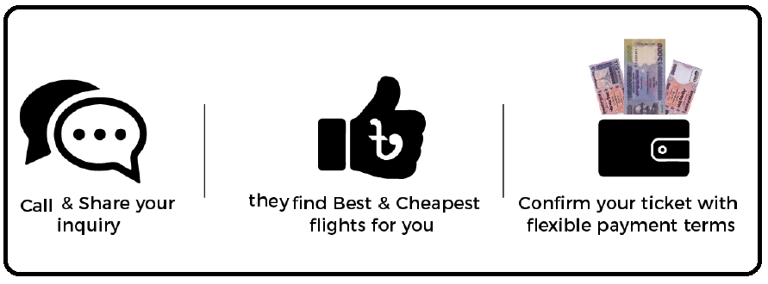
Figure 11: Flight Booking Process
For domestic flights, they provide tickets for almost all airlines all over the Bangladesh at the cheapest rate possible. Furthermore, for large/group bookings we facilitate our clients with attractive discounts that you will find only with them.

Event Organizer
Event management is a fast growing industry in the world. Their teams of experts are well acquainted with the experimental marketing and influencer marketing tactics giving your events a twist to encourage people to talk. They are here to bring out the best from your event with versatility and flexibility that will give you the confidence and increase the efficiency and impact of your event. In the events their wide range of networks can now become yours. Working as a team they try their best to understand your event, whether it is corporate or domestic, resulting in a successful event. They are taking conference hall booking for all kinds of events and they provide all the services to organize an event such as photography, decoration, cinematography, lightings etc. depend on how you want to organize it.

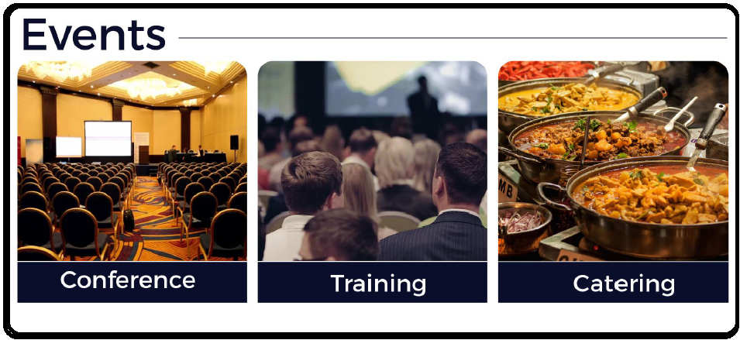
Figure 12: Types of Events
Tour Packages
Plan a tour with family, friends or solo with the wide range of tour packages they offer. Everyone needs refreshment from time to time for mind and body. They make packages based on customers’ wants and desires. For those travel loving people, they are here to offer cheap and affordable packages in Bangladesh. Their local packages include booking hotels and flights within Bangladesh at the cheapest rate available.
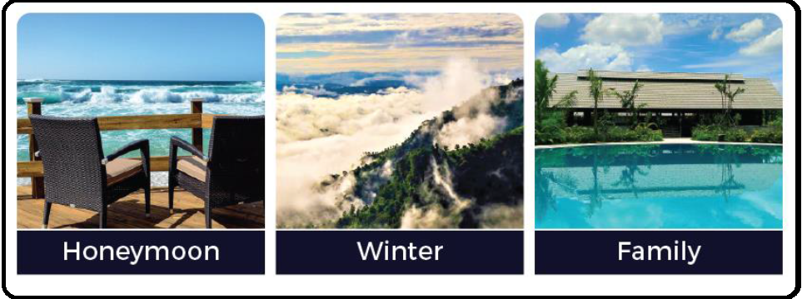
Figure 13: Types of Packages
They have exclusive deals for corporate tours and visits for both training and entertainment purposes.
Then there are packages for your family. Travelling with family is always pleasant. They are here to ease the cost and problems of travelling so that you can spend most of the time with your family and friends and on the way of life when you’re finally find that special someone, grasp our honeymoon packages to escape with them to an unknown world. Whether its summer or winter, rain or spring they always have the best deals and packages for you to the most exclusive places. Even if you are a solo traveler, your tour is their responsibility.

Team Building
Team Building can be the most crucial part of a company where ground breaking ideas emerge as well as the people of the company gets acquainted with each other. So it is very important for any corporate team building to be effective. The work flow should go smoothly with active participation from everyone. To make your team building efficient to get the best output from our special and experienced team of planners are always ready. They cover from corporate training sessions to gatherings as important as annual general meetings. Also they arrange picnic as well. People are searching for the best resort in affordable prices. They make that easier for customers; they arrange resorts for the picnics and other ceremony in cheap and affordable prices. Team events, signing ceremony, logo inauguration are all part of their services.
All of these are offered with a little extra something that all our customers always get. That’s why they have domestic and international clients who are always looking forward to us for all their gatherings.

Corporate Clients

They are providing new connections by working with various types of customers for over 2 years as well as after sales service. They have the experience & skills of their clients' needs. Some amazing clients-

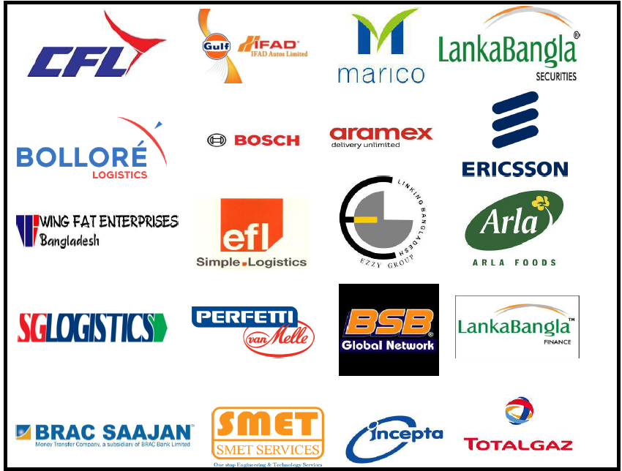

A quantitative research on

Factor Influencing Customers’ Purchase Intention of Online Room Booking Services

Literature Review & Hypotheses Development
Online Booking
Because of advancement of internet technology, hoteliers have focused on making online booking platform so that customers can gather information as well as they can purchase the product/service easily. Through internet, around 148.3 million bookings were made every year (Statistic Brain, 2016). Although there are some disadvantages, 65.4% customers prefer to book their accommodation through online (statistic brain, 2016). So, meeting the demand of era as well as developing this sector more, the study about online hotel room booking is significant.
Purchase intention

Purchase intention is the possibility that customers will purchase the products and services (Dodds, Monroe, & Grewal, 1991). It has been featured topic in marketing research because of functional dimension of behavioral intention (Zeithaml et al., 1996) as well as it focuses the actual purchase behavior (Ajzen and Fishbein, 1980). In the hotel industry, internet becomes a valuable distribution channel (Lehto, Kim, & Morrison, 2006). Customers’ perception is changing day by day as well. In the online hotel booking sector, purchase intention refers booking hotel rooms through the hotel’s website or any third party’s online site (travel agent’s website). Basically customers want to save their time, cost and so on. That is why the online purchase intention is increasing among consumers. From the previous research articles value, price, trust, attitude, subjective norms and perceived behavioral control are driving forces of online purchase intentions (Chiang & Jang, 2007; Chen & Dubinsky, 2003; Everard & Galletta, 2006).

Perceived fairness of Price

Price is the interplay of the force of supply and demand (Dodds et al., 1991). The law of demand says that other things held constant, if price increases, demand will decrease, on the other hand, if the price decreases, demand will increase. So, price can influence the customers’ purchase intention. In online room booking service, generally customers try to compare the price of particular product/service among various service providers because price is more visible than quality (Yoon, Oh, Song, Kim, & Kim, 2014). So, it is a main predictor of customers' purchasing decision making. If price is fair, the intention to purchase will be increased (Grewal, Krishnan, Baker, & Borin, 1998). Sometimes hoteliers or third party offer their products or services with discounted rate for the purpose of attracting the customers and increasing their sales. Now the following hypothesis can be formulated here.
H₁: Perceived fairness of price has a positive effect on online purchase intentions.

Attitude

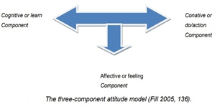
According to Chris Fill (2005) “Attitude refers learning from past experiences as well as refers a linkup between thoughts and behavior”. Attitude reflects the liking and disliking about the particular brand. It is influenced by many factors such as product experiences, mass media, WOM etc. Chris Fill (2005) pointed out hypothetically three components of attitude-

- Cognitive component (learn)
- Affection component (feel)
- Conative component (do)

Finally, Chris Fill proved that only the affective component is the significant which is related with customers’ feeling, mood, sentiment, and emotion about the product or service.
In contrast, attitudes focus customers’ favorable or unfavorable responses and it can be expressed by the cognitive and affective components of behavior (Wu and Chen, 2005). Here a favorable attitude raises intentions to behave as well as an unfavorable attitude decreases such intentions. Customers’ overall attitude toward online room booking service is an important variable for our research, because maintaining attitudes is necessary to formulate sustainable marketing strategies (Buil et al., 2012). Specially increasing the hotel booking intention through online, positive attitude plays a strong role according to previous researches. In the online hotel booking sector, eWOM and online hotel review are strong antecedents of attitude which have an impact on purchase intention. Thus, the following hypothesis can be formulated here.
H₃ : Attitude has a positive effect on online purchase intentions.

Perceived behavioral control

Perceived behavioral control reflects one's perception of ease of doing any action (Yoon, 2011). It is determined by the confidence in the benefits and resources available to execute the action. Ajzen and Madden (1986) in Buchan (2005) mentioned perceived behavioral control as the customer’s trust how easy or difficult the performance of the behavior is likely to be. It focuses two components (Ajzen, 1991; Taylor & Todd, 1995). The first component refers the availability of resources related with the behavior including money, time, and other resources and the second component refers the customers’ self-confidence in the ability related with behavior. It is totally uncontrollable variable for a customer which has an impact on the purchasing intention of online hotel booking service. According to the theory of planed behavior, perceived behavioral control can affect the consumer intentions to perform a specific behavior. Now the following hypothesis can be formulated here.
H₄: Perceived behavioral control has a positive effect on online purchase intentions.
Value

Value refers the worthiness or utility to customer which they can achieve against money. In another word, value can be defined by “what you get for what you pay” (Sirohi et al.,1998). According to Lee and Overby (2004), there are two types of values based on online purchase- utilitarian value and experiential value. Utilitarian value is about functional benefits as well as including service excellence, time savings, and price savings and so on. Experiential value is related with experiential benefits. Both types of values have a great impact on purchase intention of hotel room booking services.
On the other hand, though customer value comprise has been broadly studied (Kim, 2011), its definition and conceptualization are still unresolved (Abdullah, Jayaraman, & Kamal, 2016; Kamal, Zawawi, & Abdullah, 2016). In an experimental study of customer value in the hotel industry, (Nasution and Mavondo; 2008) mentioned that different kinds of hotels deliver different values to customers based on reputation for quality and prestige. According to previous other researcher, purchase intention is a significant result of consumer value (Szybillo & Jacoby, 1974; Dodds et al., 1991; Oh, 2000). Thus, it is logical to make believe that purchase intention is positively related to consumer value. So, the following hypothesis can be formulated here.
H₅ : Value has a positive effect on online purchase intentions.
Subjective Norms
Subjective norms refer the perceptions or beliefs which are influenced by others (e.g., parents, spouse, friends, and teachers) (Buchan, 2005). Basically, it reflects interaction between normative belief and motivation. According to Yoon (2011), it is related to perceived social pressure to perform or not perform a particular action. Based on Ajzen (1975)’s Theory of Planned Behavior, subjective norms directly influence intentions. In online community, online purchase intention is greatly influenced by subjective norms. So, the following hypothesis can be formulated here.
H_{6:} Subjective norms has a positive effect on online purchase intention.
Conceptual Framework
The research model consists of the outcome variable which is ‘purchase intention’ including perceived fairness of price, attitude, brand trust, value, perceived control, subjective norms as ‘predictor variables’. The proposed model is shown in Figure 14.

Online Purchase Intention
Attitude

Perceived
Behavioral
Control
Control

Value

Figure 14: Conceptual Framework
Subjective Norms

Methodology:
Data Collection:
The survey was conducted through online. Our sample selection includes those respondents who reserve the hotel room via online regularly as well as those respondents who are not directly related to reserve the hotel room through online in Bangladesh. A total number of 144 members replied the survey questionnaire. All the questions are measured by five-point likert scale. The five categories are strongly disagree, disagree, neutral, agree and strongly agree and ranging from “strongly disagree =1” to “strongly agree=5”.

Table 1
Demographic information of respondents (N=145)
 | Frequency | Percent (%) | Valid Percent | Cumulative Percent
Gender  Male  Female | 93  52 | 64.1  35.9 | 64.1  35.9 | 64.1  100
Age  18-20  21-30  31-40  41-50 | 5  132  7  1 | 3.4  91  4.8  0.7 | 3.4  91  4.8  0.7 | 3.4  94.5  99.3  100
Marital Status  Single  Married | 131  14 | 90.3  9.7 | 90.3  9.7 | 9.3  100
Education  High school graduate  Bachelor’s degree  Graduate degree | 14  102  29 | 9.7  70.3  20 | 9.7  70.3  20 | 9.7  80  100
Income Level  10000-30000  31000-50000  51000-70000  71000-100000  Missing | 70  7  2  1  65 | 48.3  4.8  1.4  .7  44.8 | 87.5  8.8  2.5  1.3 | 87.5  96.3  98.8  100

From the output shown above, there are 93 males (64.1%) and 52 females (35.9%) as sample, giving a total of 145 respondents and 21 to 30 years old respondents showed more interest (91%). Only 14 of the respondents were married and rests 121 of the respondents were single. Based on education level, most of the respondents (70.3%) have completed their bachelor’s degree and 48.3% respondents’ income levels are in 10000 to 30000.

Questionnaire
Attitude (A)
A1: I prefer to book the hotel rooms online.
A2: I like to book hotel rooms online.
A3: Considering everything, I think booking hotel room online is an excellent idea.
A4: I think online booking of hotel room is beneficial for me.

Value (V)
V1: I think to booking hotel room online gives me good value for the price.
V2: Online room booking is a satisfactory decision given the money paid for it.
V3: After purchasing through online, my overall expected value of room booking is high.
V4: Most of the time, it is a very good bargain to book hotel rooms online.
Perceived Behavioral Control (PBC)
PBC1: I have all the means and ways in my control when I intend to book hotel rooms online.
PBC2: It is entirely up to me whether I intend to book hotel rooms online or not.
PBC3: I have full control in booking hotel room online if I want to.
Subjective Norms (SN)
SN1: My friends and relatives who are close to me will like the idea if I intend to book hotel rooms online.
SN2: My friends and relatives who are close to me will prefer the idea that I book hotel rooms online.
SN3: My friends and relatives who are close to me will appreciate the idea if I want to book hotel rooms online.
Purchase Intention (PI)
PI1: I have intention to book hotel rooms online.
PI2: I intend to book hotel rooms online in future.
PI3: I am willing to book hotel rooms online.
All questions are measured by the following five-point likert scale.
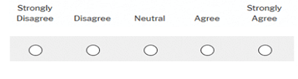

Analysis and Findings
Reliability Analysis

Attitude

Case Processing Summary

 |  | N | %
Cases | Valid | 145 | 100.0
Cases | Excludedª | 0 | .0
Cases | Total | 145 | 100.0
- Listwise deletion based on all variables in the procedure.

Reliability Statistics

Cronbach's Alpha | N of Items
.880 | 3

Item-Total Statistics

 | Scale Mean if Item Deleted | Scale Variance if Item Deleted | Corrected Item-Total Correlation | Cronbach's Alpha if Item Deleted
a2 | 7.0069 | 4.035 | .726 | .866
a3 | 6.7655 | 3.736 | .803 | .797
a4 | 6.8897 | 3.891 | .774 | .824

From the above table, the Cronbach’s Alpha for the three items is .880, suggesting that the items have very good internal consistency reliability. (Value above .7 is considered acceptable and above .8 is preferable in the most social science research situation).

Value

Case Processing Summary

 |  | N | %
Cases | Valid | 145 | 100.0
Cases | Excludedª | 0 | .0
Cases | Total | 145 | 100.0
- Listwise deletion based on all variables in the procedure.

Reliability Statistics

Cronbach's Alpha | N of Items
.813 | 4

Item-Total Statistics

 | Scale Mean if Item Deleted | Scale Variance if Item Deleted | Corrected Item-Total Correlation | Cronbach's Alpha if Item Deleted
v1 | 9.7103 | 6.832 | .536 | .807
v2 | 9.7241 | 6.007 | .745 | .714
v3 | 9.5517 | 6.180 | .628 | .767
v4 | 9.7862 | 5.850 | .632 | .767

From the above table, the Cronbach’s Alpha for the three items is .813, suggesting that the items have very good internal consistency reliability. (Value above .7 is considered acceptable and above .8 is preferable in the most social science research situation).

Perceived Behavioral Control

Case Processing Summary

 |  | N | %
Cases | Valid | 145 | 100.0
Cases | Excludedª | 0 | .0
Cases | Total | 145 | 100.0
a. Listwise deletion based on all variables in the procedure.

Reliability Statistics

Cronbach's Alpha | N of Items
.838 | 2

Item-Total Statistics

 | Scale Mean if Item Deleted | Scale Variance if Item Deleted | Corrected Item-Total Correlation | Cronbach's Alpha if Item Deleted
pbc2 | 3.5172 | 1.154 | .721 | .
pbc3 | 3.5310 | 1.181 | .721 | .

From the above table, the Cronbach’s Alpha for the three items is .838, suggesting that the items have very good internal consistency reliability. (Value above .7 is considered acceptable and above .8 is preferable in the most social science research situation).
Subjective Norm
Table: 17

Case Processing Summary

 |  | N | %
Cases | Valid | 145 | 100.0
Cases | Excludedª | 0 | .0
Cases | Total | 145 | 100.0
a. Listwise deletion based on all variables in the procedure.

Reliability Statistics

Cronbach's Alpha | N of Items
.881 | 2

Item-Total Statistics

 | Scale Mean if Item Deleted | Scale Variance if Item Deleted | Corrected Item-Total Correlation | Cronbach's Alpha if Item Deleted
s2 | 3.3034 | 1.074 | .789 | .
s3 | 3.1448 | 1.194 | .789 | .

From the above table, the Cronbach’s Alpha for the three items is .881, suggesting that the items have very good internal consistency reliability. (Value above .7 is considered acceptable and above .8 is preferable in the most social science research situation).

Purchase Intention

Case Processing Summary

 |  | N | %
Cases | Valid | 145 | 100.0
Cases | Excludedª | 0 | .0
Cases | Total | 145 | 100.0
a. Listwise deletion based on all variables in the procedure.

Reliability Statistics

Cronbach's Alpha | N of Items
.884 | 3

Item-Total Statistics

 | Scale Mean if Item Deleted | Scale Variance if Item Deleted | Corrected Item-Total Correlation | Cronbach's Alpha if Item Deleted
pi1 | 7.0483 | 4.157 | .674 | .924
pi2 | 6.9172 | 3.632 | .878 | .739
pi3 | 6.8759 | 4.040 | .780 | .831

From the above table, the Cronbach’s Alpha for the three items is .884, suggesting that the items have very good internal consistency reliability. (Value above .7 is considered acceptable and above .8 is preferable in the most social science research situation).
Regression

Variables Entered/Removedª

Model | Variables Entered | Variables Removed | Method
1 | SN, FP, PBC, Att, Trust, Value^{b} | . | Enter
a. Dependent Variable: PI
b. All requested variables entered.

Model Summary

Model | R | R Square | Adjusted R Square | Std. Error of the Estimate
1 | .831ª | .691 | .678 | .54810
a. Predictors: (Constant), SN, FP, PBC, Att, Trust, Value

From the above model summary, R square refers that the variation in the dependent variable (PI) can be explained by the variation in the independent variables (SN, FP, PBC, Att, Trust, Value) by 83.1%. Here adjusted R Square is .678 which is less than the R square. The adjusted R-squared increases only if the new term improves the model more than would be expected by chance. and decreases when a predictor improves the model by less than expected by chance.

ANOVAª

Model |  | Sum of Squares | df | Mean Square | F | Sig.
1 | Regression | 92.691 | 6 | 15.449 | 51.424 | .000^{b}
1 | Residual | 41.457 | 138 | .300
1 | Total | 134.149 | 144
a. Dependent Variable: PI
b. Predictors: (Constant), SN, FP, PBC, Att, Trust, Value

The ANOVA table indicates that the model as a whole is significant because significant value (.000) is less than the required value alpha (.05).

Coefficientsª

Model |  | Unstandardized Coefficients |  | Standardized Coefficients | t | Sig. | Collinearity Statistics
 |  | B | Std. Error | Beta | t | Sig. | Tolerance | VIF
1 | (Constant) | .070 | .212 |  | .311 | .750
1 | Att | .180 | .074 | .178 | 2.418 | .017 | .415 | 2.412
1 | Value | .153 | .104 | .121 | 1.387 | .155 | .240 | 3.401
1 | PBC | .162 | .067 | .165 | 2.781 | .005 | .741 | 1.59
1 | SN | .301 | .074 | .383 | 4.750 | .000 | .265 | 2.643
a. Dependent Variable: PI

Attitude
Here, Attitude towards online booking intention has a significant impact because the significant value (.017) is less than the required value alpha (.05). So, people who has positive attitude towards online booking intention like to reserve the hotel room via online.
Perceived Behavioral Control
Perceived Behavioral Control refers the uncontrollable variables. Here Perceived Behavioral Control towards online booking intention is significant because the significant value (.165) is less than the required value alpha (.006) that means PBC has a positive impact on online room booking intention.
Subjective Norms
Subjective Norms towards online booking intention is significant because the significant value (.000) is less than the required value alpha (.05) that means there is a positive impact on online room booking intention.
The relative contribution of the each independent variable can be explained by the β value. Here, Subjective Norms refers the higher relative contribution.

Value
Value towards the online room booking is not significant because the significant value (.165) is greater than the required value alpha (.05). S0, there is a negative relationship between the value and online room booking intention. The reason behind this may be that the respondents of our survey may generally get all the values after online room booking.

Conclusion

As today’s world is so much competitive, marketers must know about customers’ perception, their needs and wants. Marketers can conduct various types of research activities to find out different solutions so that they can provide the higher value to the customer. If it is online, it will be more difficult to differentiate their products or services. So, after knowing customer profile as well as social setup, they have to communicate with customer for the purpose of providing superior value to the customers via online.

References

https://amarroom.com/
https://www.infosapex.com/
Cantallops, A. S., & Salvi, F. (2014). International Journal of Hospitality Management New consumer behavior : A review of research on eWOM and hotels. International Journal of Hospitality Management, 36, 41–51. https://doi.org/10.1016/j.ijhm.2013.08.007
Delgado-Ballester, E., & Munuera-Alemán, J. L. (2005). Does brand trust matter to brand equity? Journal of Product and Brand Management, 14(3), 187–196. https://doi.org/10.1108/10610420510601058
Emir, A., Halim, H., Hedre, A., Abdullah, D., Azmi, A., & Kamal, S. B. M. (2016). Factors influencing online hotel booking intention: A conceptual framework from stimulus-organism-response perspective. International Academic Research Journal of Business and Technology, 2(2), 129–134. Retrieved from http://www.iarjournal.com/wp-content/uploads/IARJBT2016_2_129-134.pdf
Kim, S. Y., Kim, J. U., & Park, S. C. (2017). The effects of perceived value, website trust and hotel trust on online hotel booking intention. Sustainability (Switzerland), 9(12), 1–14. https://doi.org/10.3390/su9122262
Kwabena, Julian, M. & A. (2008). Determinants of Internet Usage in Ghanaian Hotels : The Case of the Greater Accra Region ( GAR ) Determinants of Internet Usage in Ghanaian Hotels : The Case of the Greater Accra Region ( GAR ). Journal of Hospitality & Leisure Marketing, 15(3), 37–41. https://doi.org/10.1300/J150v15n03
Ladhari, R., & Michaud, M. (2015). EWOM effects on hotel booking intentions, attitudes, trust, and website perceptions. International Journal of Hospitality Management, 46, 36–45. https://doi.org/10.1016/j.ijhm.2015.01.010
Lien, C. H., Wen, M. J., Huang, L. C., & Wu, K. L. (2015). Online hotel booking: The effects of brand image, price, trust and value on purchase intentions. Asia Pacific Management Review, 20(4), 210–218. https://doi.org/10.1016/j.apmrv.2015.03.005
Reni, F., & Anggraini, R. (2016). The Role of Perceived Behavioral Control and Subjective Norms to Internal Auditors ’ Intention in Conveying Unethical Behavior : A Case Study in Indonesia. Rev. Integr. Bus. Econ. Res., 5(2), 141–150.

