

United International University

A Project Report On
Supply Chain Management of The Local Cloth Shops of Old Dhaka

Prepared For

Muhammad Rehan Masoom
Assistant Professor - Sociology

Prepared By

Md. Moffassel Haque
Batch: 132 - Summer 2013
Program: BBA
ID No: 111 132 072

Date of Submission:

June 10, 2018
Letter Of Transmittal
June 10, 2018
Muhammad Rehan Masoom
Assistant Professor
School of Business & Economics
United International University

Subject: Submission of Project Report.
Sir,
It’s my pleasure to submit the project report on, “Supply Chain Management of The Local Cloth Shops of Old Dhaka”. This project report is submitted as a part of the partial fulfillment of the BBA program.
This report titled, “Supply Chain Management of The Local Cloth Shops of Old Dhaka”. This report discusses the supply chain management concept, importance of supply chain management and overall import, production as well as retail processes of the local cloth shops of the old Dhaka.
I would like to thank you very much for giving me the opportunity to make the study at Supply Chain Management, which added value to my learning in a real-life experience. Any query regarding the report will be appreciated.

-------------------------------------
Sincerely,
Md. Moffassel Haque
ID: 111 132 072
Department of Marketing
United International University
Declaration
I am Md. Moffassel Haque, ID: 111 132 072 from Summer 13th Batch hereby declare that the presented report titled ” Supply Chain Management of The Local Cloth Shops of The Old Dhaka” is prepared by me. I also confirm that the report is prepared only for the requirement of completion of BBA Degree, not for any other purpose.

--------------------------------------
Md. Moffassel Haque
ID: 111 132 072
Department of Marketing
United International University

Acknowledgement

At first I would like to thank Almighty Allah who has given me the opportunity to complete my report successfully as a mandatory requirement of BBA program.
While preparing the report, I received active co-operations from Jewel Hossain and Al-Wakil Alve. I sincerely express my heart- felt gratitude from their co-operation, which helped me to complete this report and they gave me some important information about their business operations to enrich this report.
I would like to thank and convey my respect to my honorable teacher, my supervisor, Muhammad Rehan Masoom, Assistant Professor – Sociology, School of Business & Economics. for giving me his valuable advice, guidance, time and all the necessary things to complete my report. His continuous supervision has inspired me to make more valuable report based on in depth analysis.

Executive Summery
Supply chain activities usually incorporate everything which is related to sourcing, production, logistics, product improvement and also that information which are required to coordinate business activities
The report topic is ,” Supply Chain Management of The Local Cloth Shops of Old Dhaka”. For doing this report there were many steps and needed to collect information from different sources. First of all, The organization's supply chain are linked together between physical flows and information flows. A superior supply chain management helps an organization to achieve its ultimate goal by enhancing customer service, minimizing operating and improving financial condition. On the other hand, supply chain management also plays important roles for the society. Secondly, Islampur is the largest clothes market in our country and Reid & Fashion is one of the largest importer, wholesaler as well as retailer of Islampur clothes market who imports clothes mainly from China and India. Usually they prefer China for importing clothes because of its easy importing process, but they also import fabrics from India because of their superior product quality. For the purpose of importing fabrics from China, representatives of Reid & Fashion usually visit Lu Thai Textile Co. factory and place their order. After getting the packing list from Lu Thai Textile, Reid & Fashion contacts with the Dhaka Bank for LC and insurance purpose. After all, fulfilling all the formalities when the products reaches in Bangladesh, Reid & Fashion transport those goods at their own cost from Chittagong port to Dhaka warehouse either by Train or by Cargo. Thirdly, Reid & Fashion sells their products to various retailers and SPORSHO is one of them. Basically, SPORSHO purchases their raw fabrics from Reid & Fashion and other fabrics importers of Islampur clothes market, Dhaka and transport those raw materials into their production house at Tangail, then the raw materials are transformed into final products. Lastly, the final products are brought into their fashion house and displayed for retail sales.

Table of Content
1) Introduction: 1
a) Physical Flows 2
b) Information Flows 2
2) The Importance of Supply Chain Management 3
a) Enhance Customer Service 3
b) Minimize Operating Costs 3
c) Improve Financial Position 4
3) Roles Played By The Supply Chain Management For The Society 6
a) Ensure Human Survival 6
b) Protect Cultural Freedom and Development 7
4) Findings 9
5) Conclusion 14

Supply Chain Management of The Local Cloth Shops of Old Dhaka

Introduction:
Supply chain management is mainly concerned about actively managing supply chain activities in order to achieve a worthwhile competitive advantage and maximize customer benefit. It depicts a purposeful effort by the supply chain firms so that they can develop and operate their supply chains more effectively and efficiently. Supply chain activities usually incorporate everything which is related to sourcing, production, logistics, product improvement and also that information which are required to coordinate above-mentioned activities.
Supply Chain Management Concept:
The Supply Chain Management concept is based on two key ideas:
- First of all, when a product reaches an end user, that illustrates the progressive effort of several organizations and together these organizations are known as the supply chain.
- Secondly, while supply chains have existed for a long time, most organizations have only paid interest on what was happening inside their territory. Only a few businesses understood and much less managed, as well as the entire chain of activities that eventually delivered goods to the end user. The result was often futile and disconnected supply chains.

The organization's supply chain are linked together between physical flows and information flows:

Physical Flows

Physical flows are not only the most noticeable elements of the supply chain but also as important are information flows. On the contrary, Physical flows involve conversion, distribution, storage of goods and materials.

Information Flows
Information flows allow different supply chain associates to synchronize their long-term projects and also monitor the day-to-day flow of goods, as well as materials, fluctuate the supply chain.

The Importance of Supply Chain Management
For most of the businesses, Supply chain management is a fundamental part and there is no alternative way to achieve company success as well as customer gratification.
  - Enhance Customer Service
- First of all, Customers expect the correct product mixture and delivery of correct volume from the supplier.
- Secondly, Customers expect products availability at their desired location. (i.e., customers will be dissatisfied if an auto repair shop don’t have availability of necessary parts and cannot fixe their cars in given time).
- Thirdly, Right Delivery Time – Customers expect on-time product delivery from suppliers (i.e., customer satisfaction declines if pizza hut delivery service deliver their foods after several hours or receive the delivery of Christmas presents after the Christmas day).
- Finally, After Sales Support – Customers expect fast after sales services from the service providers. (i.e., customer satisfaction shrinks when an Air Conditioner stops functioning in the summer and cannot repair within their expected time).

  - Minimize Operating Costs
- Diminishes Purchasing Cost – Usually retailers depend on supply chains to deliver costly products as soon as possible, in order to avoid holding costly inventories in stores for a long period of time. E.g. electronics shops imports 60” curved-panel UHD TV’s on a pre-order basis and deliver quickly to avoid excessive inventory costs.
- Diminishes Production Cost – Manufacturers rely on supply chains, so that they can safely deliver required materials to assembly plants to elude material shortages that would disrupt production. E.g. an unexpected materials shipment delay may cause disruption in production of an auto assembly plant of mobile phone and can cost a significant amount of loss per day.
- Diminishes Total Supply Chain Cost – Both manufacturers and retailers entirely rely on supply chain managers for the purpose of designing networks to fulfill customer service goals at the slightest overall cost. Moreover, an effective supply chain also helps a firm to be more competitive in the marketplace. i.e. Dell’s comprehensive computer supply chain approach was involved making computers on the basis of specific customer order and direct shipping to the respective customer. Therefore, Dell was not only able to save millions of dollars by avoiding the holding of large computer inventories rotting in warehouses and retail shops. But also, Dell avoided holding those computers inventories which became technologically obsolete as computer technology evolved rapidly.

  - Improve Financial Position
- Increases Profit Leverage – Organizations value supply chain managers because they help to handle and minimize supply chain expenses. This can increase firms profit significantly. On the other hand, yearly 2.7 billion packages of cereal are consumed by U.S. consumers, $13 million can be saved industry-wide if only 1% of the U.S. cereal supply chain costs can be reduced, as 13 billion boxes of cereal pass through the upgrade supply chain over a period of 5 years.
- Decreases Fixed Assets – Organizations value supply chain managers because they diminish the use of massively fixed properties such as transportation vehicles, warehouses, and plants in the supply chain. The organizations will avoid constructing 4 extremely expensive buildings if a network can be redesigned by supply chain experts to properly serve U.S. consumers from 6 warehouses instead of 10.
- Increases Cash Flow – Organizations value supply chain managers because they accelerate good flows to customers. E.g. if a firm can produce and provide a product to a customer in 10 days instead of 70 days, then it can account the customer 60 days sooner.

Supply chain management not only actively manage the organizational activities but also plays a crucial role in society. Supply Chain Management understandings and competencies can be used to support disaster relief operations, medical operations and handle different types of emergency situations.
Supply chain experts actively participate and get busy whether dealing with an unexpected natural disaster or with a regular product. They creatively work around disruptions, identify problems, and find out how to distribute essential goods to people effectively and efficiently.

Roles Played By The Supply Chain Management For The Society

Ensure Human Survival
- Supply Chain Management Helps Sustains Human Life – For the supply of day-to-day necessary items such as food and water, humans rely on supply chains. Any disruption in this system threatens human life. E.g. Hurricane Katrina flooded New Orleans almost 13 years ago, Los Angeles leaving the inhabitants without a way to get basic necessities. Therefore, a huge rescue of the residents had to be made. Nineteen hundred-thousandths repasts and sixty-seven hundred-thousandths liters of drinking water were supplied in the first weekend of the rescue attempt.
- Supply Chain Management Improves Human Healthcare – For the supply of medicines and healthcare, humans also rely on supply chains. Moreover, the performance of supply chain can be the difference in the middle of life and death during a medical emergency. I.e. Accident victims lives can be saved by transporting them into nearest hospitals for emergency medical treatment through medical rescue helicopters. Additionally, necessary items for treatment such as medicines and equipment will be available at the hospital if supply chains can be executed appropriately.
- Supply Chain Management Protects Humans from Climate Extremes – For the purpose of supplying electrical energy to homes and businesses for air conditioning, refrigeration, heat and light humans rely on energy supply chains. A power blackout or engineering failure can be a threat to human life. E.g. in January 1998, eighty thousand miles of electrical power lines were destroyed because of a huge East Coast ice storm and there was no electricity for thirty-two hundred-thousandths Montreal, Quebec residents. Almost a quarter of all Quebec residents left home to find warmed shelter and 30 people died because of extremely cold weather. Additionally, it includes economic costs of 1 billion dollars in government expenditures, 3 billion dollars in lost business and 1 billion dollars in home damage.
  - Protect Cultural Freedom and Development
- Defending Human Freedom – For the purpose of securities and defending way of lives from outside invaders, a country citizens are highly dependent on military logistics. In order to provide maximum security to normal citizens and soldiers, this logistics strategically locate missiles, tanks, ships, aircraft and other weapons in positions. In addition, superior logistics ensure military victory. E.g. the B-2 Stealth Bomber is a high tech aircraft which is capable of delivering bombs to target without being noticed by enemy radar.
- Protects The Supply of Necessities – A country citizens are highly dependable on supply chain managers to design and handle supply chains of daily necessities such as food, drinking water and medicines to protect goods from tampering. Methods include, GPS ( Global Positioning System), high tech surveillance cameras, RFID (Radio-Frequency Identification) inventory tracking, advanced packaging process are used to prevent unauthorized persons from getting into these crucial logistics systems

  - Improve Quality of Life
- Foundation for Economic Growth –Highly developed societies with advanced supply chain framework are capable of exchanging numerous goods between businesses and consumers rapidly and efficiently. Therefore, the economy develops. On the other hand, the most common thing in poor nations is that the framework of their supply chain is very imperfectly developed or not developed at all.
- Improves Standard of Living – Highly developed societies with advanced supply chain framework are capable of exchanging numerous goods between businesses and consumers rapidly and efficiently. Therefore, consumers can purchase their desired goods with their income, which raises the living standard of the society. On the contrary, in the United States estimated supply chain costs make up 20% of a good’s cost, but in China 40% of a good’s cost. Moreover, in China, these costs make up 60% of a good’s cost, if transport damage is included. The major barrier for Chinese citizens to develop their living standard is the excessive Chinese supply chain cost.
- Job Creation – Supply chain professionals design and operate all of the supply chains in a society and logistics information, packaging, inventory and transportation management and warehousing as well as all other supply chains in a society are designed and handled by the professionals of the supply chain. Therefore, there are many jobs available in this field. E.g. logistics activities represented in 2006 9.9% of all dollars spent on goods and services, which created 10 million logistics jobs in the United States
- Opportunity to Decrease Pollution – Product shipment and packaging are required by the supply chain activities. For the by-product of supply chain activities, some unintentional environmental pollutions may occur because of the generation of carbon dioxide fuel and cardboard wastages. E.g. almost 13 years ago the reason behind 34% United States landfill waste were paperboard and paper. Only 42 million tons of these waste were recycled. Additionally, in 2005 transportation was the main source for 33% of total United States CO2 emission. Supply chain professionals holds the key positions for developing sustainable methods and process as they are the designers of this infrastructure.
- Opportunity to Decrease Energy Use – Both human and product transportation are involved in supply chain activities. By-product of supply chain activities are the main reason behind scarce energy depletion. E.g. currently transportation is responsible for 95% of global oil and 30% of world energy consumption. As the designers of this infrastructure., supply chain professionals are responsible for developing such energy-efficient supply chains which use limited resources.

Findings
  - Import and Selling Process
Islampur Clothes Market is the biggest clothes market of Bangladesh. Islampur bazaar stands on the bank of Buriganga River in old Dhaka nearby Sadarghat. This market started since British period with few shops. In Pakistan period this market started expanding gradually. After the independence of Bangladesh, this clothes market fully established as the biggest clothes market of the country. Now, almost all the fabrics or clothes of whole Bangladesh are transferred from here. It is mainly famous for wholesale and retail business of clothes. There are many business organization who import clothes from different countries and Reid & Fashion is one of them. Reid & Fashion is one of the largest importer, wholesaler, and retailer of Islampur clothes market who imports clothes mainly from China and India. Because of the less complicated import process, they prefer China for importing clothes. Their main clients are Ecstasy, Cats Eye, Richman, Infinity, Yellow, Gentle Park, Colors and many other well known brands as well as garments producers of inside and outside Dhaka. On the contrary, they also operate some physical shops which are also situated in Islampur for displaying and retailing purpose of their products. In order to place the order, they usually visit the factory of Lu Thai Textile Co. Ltd. which is situated in Guangzhou, China. The Company is involved in the production and distribution of middle and high-grade yarn-dyed fabrics and dyeing fabrics for shirts as well as garments products, also the sole supplier of Reid & Fashion. After receiving the order, within two weeks Lu Thai Textile Co. Ltd. sends a soft copy of packing list (Includes material cost, production cost, government tax, shipment cost etc) via email. Moreover, this packing list is also known as Pro Forma Invoice (PI). After receiving PI, Reid & Fashion approaches to Dhaka Bank for LC (LC is short form of letter of credit, also known as a documentary credit, it's a written commitment by a bank on behalf of a buyer that payment be made to a seller provided that the terms and conditions stated therein have been met). After checking PI Dhaka Bank make contracts with China Guangfa Bank (owned by local governments) for LC and Dhaka Bank provides attested LC papers to Reid & Fashion. Agreement between both banks are required here because Dhaka Bank cannot pays to Lu Thai Textile Co. Ltd. directly and total payment will be made in LC ( Buyer make payments to Dhaka Bank > Dhaka Bank pays to China Guangfa Bank > China Guangfa Bank pays to Lu Thai Textile).
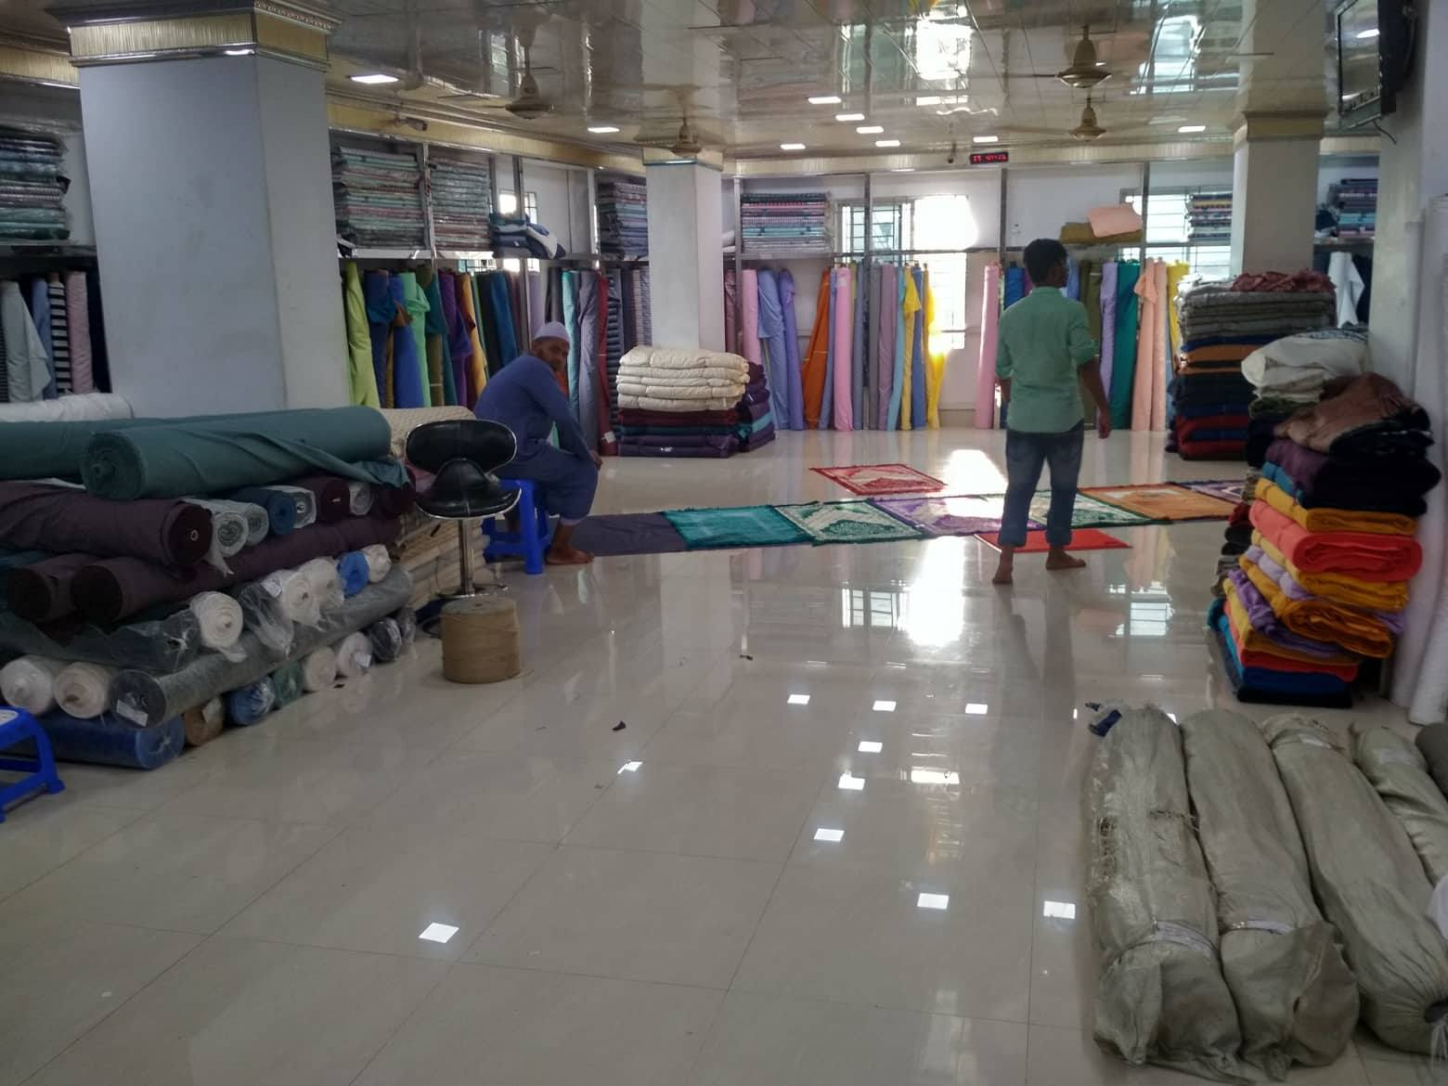
Additionally, for the security purpose of the goods, an insurance must be made and that can be managed by either Reid & Fashion itself or Dhaka Bank. If Dhaka Bank handles this matter of insurance, then they charge extra amount from Reid & Fashion. At this time, Reid & Fashion send those attested hard copies of Dhaka Bank via DHL to Lu Thai Textile Co. Ltd. After receiving hard copies Lu Thai Textile Co. Ltd. forwards those copies to China CNF (Clearing and Forwarding which same as CIF but insurance not included), then China CNF contact with Bangladesh Chittagong CNF for agreement. Finally, Lu Thai Textile start producing goods as Reid & Fashion wanted and transport to China Guangzhou CNF. Now, China CNF starts transporting goods from Port of Guangzhou (HUANGPU PORT) to Chittagong CNF through the Port of Singapore (PELABUHAN SINGAPURA). After all, fulfilling all the formalities Chittagong CNF release goods, and after that Reid & Fashion transport those goods at their own cost from Chittagong to Dhaka warehouse either by Train or by Cargo.
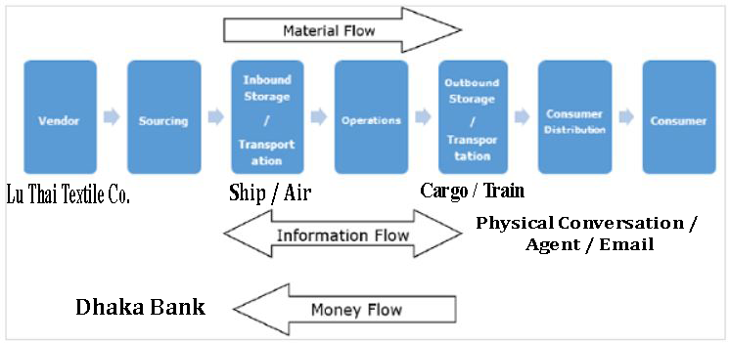

It is also mentioned worthy that, Reid & Fashion not just only import from China because of it’s easy import procedure but also import from India because of its superior fabrics quality within less period of time.

  - Production and Retail Sales
Old Dhaka is the hub of the wholesale and retail business of fabrics throughout the whole of Bangladesh. SPORSHO is one of the renowned retail fashion house of Old Dhaka, who has been providing clothes for almost a decade. They have their own production house established in Tangail, where they produce their own designed clothes and sales through their retail fashion house. Basically, SPORSHO purchases their raw fabrics from Reid & Fashion and other fabrics importers of Islampur clothes market, Dhaka. After purchasing raw materials from Islampur, SPORSHO transport those raw materials into their production house at Tangail, then the raw materials are transformed into final products prioritizing the demand of their customers.
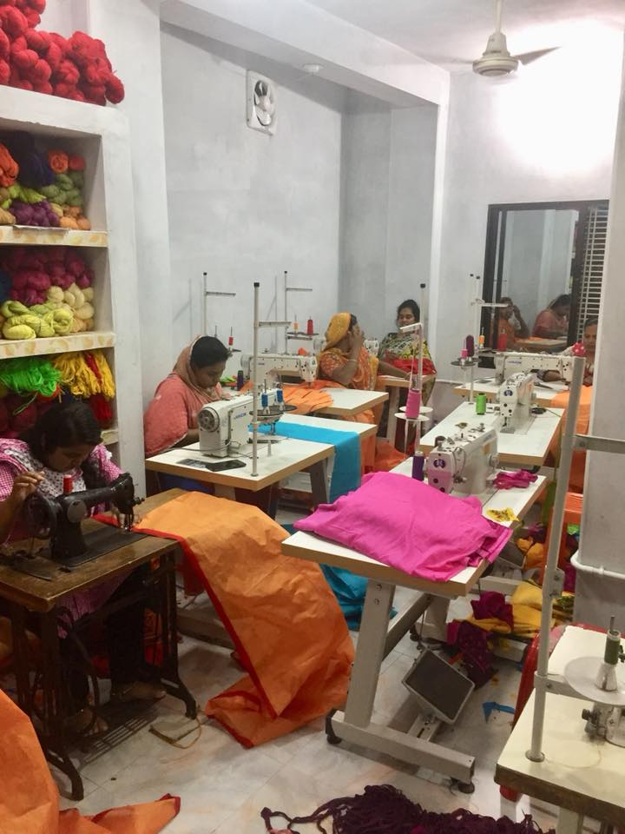
Lastly, the final products are brought into their fashion house and displayed for retail sales. Moreover, SPORSHO doesn’t produce and sell products to any other retailers or fashion houses but they take orders from their customers for customized products only for personal use.
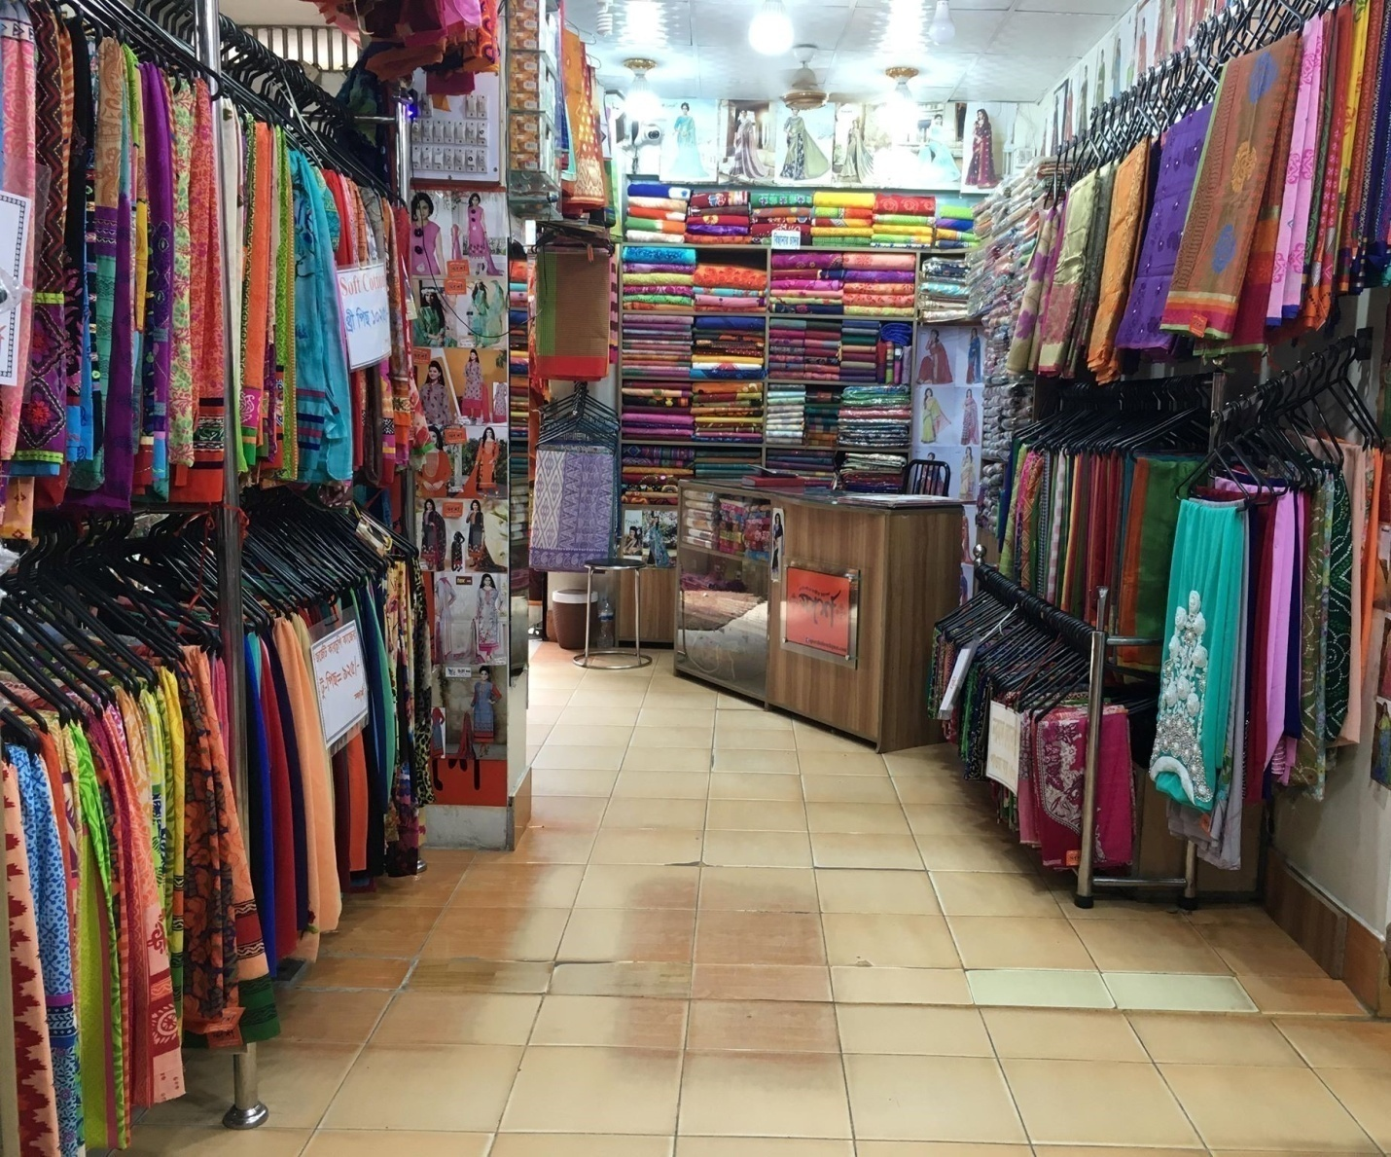

Conclusion
Considering all the above-mentioned pros and cons of Supply Chain Management, it can be said that, if we compare a business with a human body then Supply Chain Management can be considered as the heart of a human body and its activities as blood flow. This is because, heart monitors the blood flows of a human body to keep the body active, same as the Supply Chain Management also integrates the supply chain activities to flourish the business to make it fruitful through achieving its ultimate goal. Moreover, the clothing business of Old Dhaka is dominated by those business enterprises who have been operating their business for a long period of time, and the motto of being successful is the sophisticated Supply Chain Management. As a result. newcomers cannot keep pace with the experienced business enterprises due to their effective operation techniques and supply chain management.

