General Banking Operations and Competitive Position of Dhaka Bank PLC in Bangladesh's Banking Industry

Fatema Yasmin

This report is submitted to the school of Business and Economics, United International University as a partial requirement for the degree fulfillment of Bachelor of Business Administration

General Banking Operations and Competitive Position of Dhaka Bank PLC in Bangladesh's Banking Industry

Submitted to:
Name: Dr. Shakila Aziz
Designation: Associate Professor
Major: Finance and FinTech

Submitted by:
Name: Fatema Yasmin
Id: 111 221 069
Major: Finance and FinTech
Registration Trimester: Spring 2026


School of Business and Economics
United International University
Date of Submission: 22nd July, 2026

Letter of Transmittal
22nd July, 2026
Dr. Shakila Aziz
Associate Professor
School of Business & Economics
United International University
United City, Madani Avenue
Dhaka-1212
Subject: Submission of Internship Report entitled "General Banking Operations and Competitive Position of Dhaka Bank PLC in Bangladesh's Banking Industry."
Dear Ma'am,
With due respect, I am pleased to present here my internship report titled "General Banking Operations and Competitive Position of Dhaka Bank PLC in Bangladesh’s Banking Sector" as part of the completion of the degree program of Bachelor of Business Administration (BBA) of the School of Business & Economics, United International University.
As a part of the internship, I got practical exposure in different general banking activities and got to learn many skills that are useful for my career. This report is an attempt to give a brief analysis of the Dhaka Bank PLC, its position in the banking sector in Bangladesh and the learning that has been achieved during the internship period.
It gives me great pleasure to thank you for your valuable guidance, constant support and useful comments during the process of writing this report.
Yours sincerely,
Fatema Yasmin
ID: 111 221 069
Bachelor of Business Administration (BBA)
Major: Finance & FinTech
School of Business & Economics
United International University

Certification of Similarity Index

Declaration of the Student

I, Fatema Yasmin hereby declare that the internship report titled " General Banking Operations and Competitive Position of Dhaka Bank PLC in Bangladesh's Banking Industry." has been written by me in fulfillment of the partial requirements of the Bachelor of Business Administration (BBA) Degree program of the School of Business & Economics, United International University.
Furthermore, I declare that this report has been written based on my experience gained from the internship program at Dhaka Bank PLC, Banani Branch, under the supervision of my academic supervisor, Dr. Shakila Aziz, Associate Professor of the School of Business & Economics, United International University, and my organizational supervisor, Ms. Tahmina Akter, Manager Operations, Dhaka Bank PLC, Banani branch.
I hereby declare that this report is an original document which has never been presented, either wholly or in parts, to any other university or educational institution for the award of any degree, diploma, or certificate.

Fatema Yasmin
ID: 111 221 069
Major: Finance & Fintech
Bachelor of Business Administration
United International University

Corporate Evidence

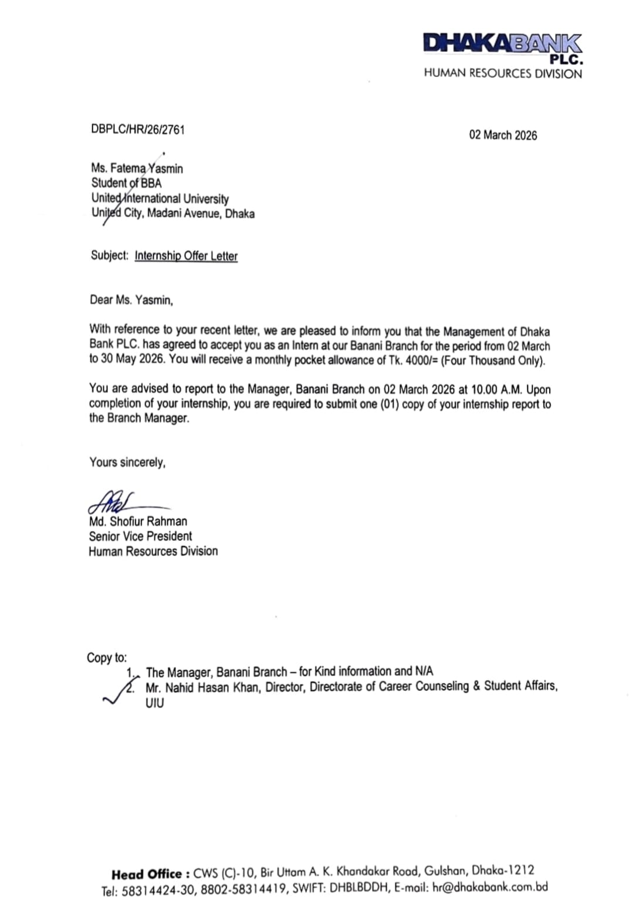

Acknowledgement

First and foremost, I feel very thankful to the almighty Allah for giving me the strength, patience, and guidance to complete my internship and the internship report.
I would like to extend my most heartfelt thanks to my respected supervisor, Dr. Shakila Aziz, Assistant Professor, School of Business & Economics, United International University, for guiding me and providing valuable suggestions and feedback throughout this report. The guidance and directions from her have played an important role in completing this research work.
I am equally thankful to my organizational supervisor Ms. Tahmina Akter, Manager Operations, Dhaka Bank PLC, Banani Branch, for giving me the chance to get practical experience in the General Banking Department.
It is my humble appreciation that goes out to all the officers and employees of Dhaka Bank PLC, Banani Branch, for being so cooperative and patient, and for sharing their practical knowledge and experience with me. Their friendly assistance helped me to understand different general operations in banking and to acquire some practical skills as well.
Finally, it is my pleasure to thank United International University, my teachers, and all those who contributed to making my internship and this report possible.

Execute Summary

This internship report, titled "General Banking Operations and Competitive Position of Dhaka Bank PLC in Bangladesh's Banking Industry," has been written as one of the components towards the fulfillment of the requirements of the Bachelor of Business Administration (BBA) degree program from the School of Business & Economics, United International University.
In this report, my main aim has been to evaluate the general banking operations of Dhaka Bank PLC and analyze its competitive position in Bangladesh's banking industry. The report has been written using both primary and secondary sources of information. While the primary data have been gathered from my practical involvement during the internship at Dhaka Bank PLC, Banani Branch, the secondary information has been collected from the annual reports of Dhaka Bank PLC and Bangladesh Bank.
This report has four chapters. Chapter one covers the background, objectives, methodology, scope, limitations, and significance of the research study. Chapter two entails a detailed company and industry analysis. It provides a brief about the history, product and services offered by Dhaka Bank PLC, operational activities of Dhaka Bank PLC, financial performance and SWOT analysis of Dhaka Bank PLC. The chapter also analyzes the structure, size, trend, maturity, opportunity, and challenges of the banking industry in Bangladesh, emphasizing the increased focus on digital banking, financial inclusion, regulatory compliance, and technology advancement.
Chapter three covers my internship experience at Dhaka Bank PLC, Banani Branch. During the course of the internship, I worked as a trainee and helped in performing different general banking activities. These include opening bank accounts, National Identity (NID) verification, processing of N-Screen, generating savings account statements and Fixed Deposit Receipt (FDR), issuing debit cards, issuing cheque books, pay order service, cheque clearing assistance, and customer communication.
The last chapter gives some recommendations to improve efficiency in operations, customer service, employee learning, online banking service, and risk management. The report concludes that Dhaka Bank PLC has successfully carved out a niche for itself in Bangladesh’s private commercial banking sector due to consistent technological development, customer-friendly services, sound corporate governance, and sustainable business practices. In addition to this, the internship program has helped me gain practical knowledge about banking operations and improve my analytical and communication skills.

\

Table of Contents

Letter of Transmittal I
Certification of Similarity Index II
Declaration of the Student III
Corporate Evidence IV
Acknowledgement V
Execute Summary VI
List of Figures X
List of Tables XI
List of Acronyms & Abbreviations XII
CHAPTER 1: INTRODUCTION 1
1.1 Background of the report 1
1.2 Objective of the report 2
1.2.1 General Objectives 2
1.2.2 Specific objectives 2
1.3 Rationale of the report 3
1.4 Scope and Limitations of the Report 3
1.4.1 Scope of the Report 3
1.4.2 Limitations of the Report 4
1.5 Definition of Key Terms 4
CHAPTER 2: COMPANYAND INDUSTRY PROFILE 7
2.1 Company Analysis 7
2.1.1 Overview and Background 7
2.1.2 Trend and Growth 10
2.1.3 Product / Service / Customer mix 14
2.1.4 Company Operations / Activities 18
2.1.5 SWOT Analysis 20
2.2 Industry Analysis 22
2.2.1 Specification of the Industry 22
2.2.2 Size, Trend, and Maturity of the Industry 25
2.2.3 Industry SWOT Analysis 29
CHAPTER 3: INTERNSHIP EXPERIENCE 33
3.1 Position, Duties, and Responsibilities 33
3.2 Training and development 37
3.3 Contribution to Organization/ Operations 39
3.4 Evaluation 41
3.5 Skills Applied 43
CHAPTER 4: CONCLUSIONS AND KEY FACTS 45
4.1 Recommendations 45
4.2 Key understanding 45
4.3 Conclusion 46
References 47
Appendix-A 48

List of Figures

Figure 1Evolution of Dhaka Bank PLC 9
Figure 2 Customer Segments 18
Figure 3 Industry Trend 28
Figure 4 Training during Internship 37
Figure 5 Skills those were applied during Internship 43
Figure 6 Total Assets of Dhaka Bank PLC (2021-2025) 48
Figure 7 Total deposits of Dhaka Bank PLC (2021-2025) 48
Figure 8 Loans & Advances of Dhaka Bank PLC (2021-2025) 49
Figure 9 Profit After Tax of Dhaka Bank PLC (2021-2025) 49
Figure 10 EPS & NAV per Share of Dhaka Bank PLC (2021–2025) 50

List of Tables

Table 1 Financial Highlights of Dhaka Bank PLC (2021–2025) 10
Table 2 Earnings Per Share (EPS) and Net Asset Value (NAV) per Share of Dhaka Bank PLC (2021–2025) 12
Table 3 Digital Banking Growth Indicators (Selected) of Dhaka Bank PLC 13
Table 4 Product and service mix 15
Table 5 SWOT Analysis of Dhaka Bank PLC 20
Table 6 Structure of Bangladesh's Banking Industry 25
Table 7 Impacts of the five factors on industry 29
Table 8 Performed duties and responsibilities during internship 33
Table 9 Training Areas Covered and Things Learnt from the Internship Experience 38
Table 10 Overall Evaluation of the Internship Experience 42

List of Acronyms & Abbreviations

Acronym | Meaning
AML | Anti-Money Laundering
ATM | Automated Teller Machine
BB | Bangladesh Bank
BBA | Bachelor of Business Administration
BDT | Bangladeshi Taka
DBL | Dhaka Bank Limited (currently Dhaka Bank PLC)
DPS | Deposit Pension Scheme
ESG | Environmental, Social and Governance
EPS | Earnings Per Share
FCB | Foreign Commercial Bank
FDR | Fixed Deposit Receipt
KYC | Know Your Customer
NAV | Net Asset Value
NID | National Identity Card
NPL | Non-Performing Loan
PCB | Private Commercial Bank
RTGS | Real Time Gross Settlement
SME | Small and Medium Enterprise
SOCB | State-Owned Commercial Bank
SDB | Specialized Development Bank

CHAPTER 1: INTRODUCTION

1.1 Background of the report

Internship program represents an obligatory academic prerequisite in order to complete the Bachelors of Business Administration (BBA) degree at the School of Business and Economics, United International University. The main objective of this internship is to close the knowledge gap between classroom theory and real-world application in a professional environment. Through an internship, students obtain practical experience, develop professional skills, learn multitasking, and gain a greater comprehension of organizational processes.
As part of this academic requirement, the internship was conducted at Dhaka Bank PLC's General Banking Department. Hands-on experience with a variety of general banking tasks, such as customer service, account opening procedures, Know Your Customer (KYC) compliance, verification of documents, Cheque clearing procedures, and other daily banking operations has been gained through the internship. This experience provided significant insights into the operational methods of Bangladesh's most prominent private commercial bank, their competitiveness in the banking industry, as well as a practical understanding of banking activities.
The present study is primarily focused on this internship experience and analyzes Dhaka Bank PLC's general banking activities of the general banking department. In addition to summarizing the internship experience and organizational activities, the report upholds to assess Dhaka Bank's competitive position in the banking sector by focusing on specific operational and strategic issues that are relevant to its performance and competitiveness. The analysis offered in this study is mostly based on actual observations, interactions with workers, and data acquired from publicly available sources, including the bank's annual reports.

1.2 Objective of the report

The objectives of the report can be divided into two main categories: objectives.

1.2.1 General Objectives

The objective of this report is to analyze the general banking operations of Dhaka Bank PLC and to assess its competitive position in the Bangladeshi banking sector based on its operations and financial strategies.

1.2.2 Specific objectives

The report's precise objectives are as follows:
- To have firsthand information about the general banking operations of Dhaka Bank PLC.
- To have knowledge of the work done in the General Banking Department during the internship.
- To assess the products, services and operation of Dhaka Bank PLC.
- To assess the SWOT (Strengths, Weaknesses, Opportunities & Threats) Analysis of Dhaka Bank PLC.
- To analyze the current position of Dhaka Bank PLC in Bangladesh’s banking sector.
- To analyze the selected indicators of the competitive position of Dhaka Bank PLC from the data that are available in Annual Reports and other sources.
- To make recommendations for improvement based on the findings and internship experience.

1.3 Rationale of the report

To ensure the country's economic development, financial inclusion, and business growth, the banking sector plays an important role in Bangladesh. In recent years, the industry has undergone considerable transformations owing to innovation, growing customer expectations, and fierce competition. For that reason, private commercial banks work to increase their competitiveness, improve operational efficiency, service quality and introduce innovations in order to remain competitive and sustainable.
Conducting research on the general banking operations of Dhaka Bank PLC is especially topical at this moment because the bank is one of the leading private commercial banks in Bangladesh. It has managed to secure its competitive position by combining traditional banking operations with innovative developments like DBL GO Plus, paying close attention to customer service and operational quality. Studying the bank's general banking operations allows us to understand how commercial banks can respond to industry changes and provide value to their clients.
The current report is based on practical experience during the internship in the General Banking Department of Dhaka Bank PLC. In addition, in this report, the information obtained from annual reports and other publicly available sources will be analyzed. The results of this study can help us to gain more insight into the modern banking operations and to apply theoretical knowledge practically.

1.4 Scope and Limitations of the Report

1.4.1 Scope of the Report

The report is centered on the practical experience gained during the internship in the General Banking Department of Dhaka Bank PLC. Information regarding the organization, operations of the bank, products and services, duties performed during the internship, and practical knowledge gained during the internship period is covered in the report.
In addition, the report includes an assessment of several selected competitive factors of Dhaka Bank PLC compared with other banks, using information gathered from public sources such as the bank's annual reports and other publications. The focus of the report will be on general banking operations, digital banking, and selected indicators relevant to the purpose of the study.

1.4.2 Limitations of the Report

Several limitations were encountered in the process of writing the report, despite thorough efforts to cover all necessary information accurately and exhaustively. These limitations are as follows:
-The strict policy and confidentiality of the banking operations made the collection of information about organizational and strategic issues unsuccessful.
- The limited period of internship did not give the opportunity to gain comprehensive practical knowledge in all operational departments of the bank.
- Employees of the bank were mostly involved in performing their regular work, which made the conversations difficult and time-consuming.
- The competitive analysis included the annual reports and other publicly available secondary sources since the internal comparative information was unavailable.
- The current study covers only the General Banking Department, as the whole internship is done under this department, and other departments of the bank, like Credit, Foreign Exchange, and Treasury, are not discussed here.

1.5 Definition of Key Terms

To provide a clearer idea of the terms mentioned in this report, the following terms are defined below.

- General Banking:
The term General Banking refers to the core banking activities that are conducted on a regular basis. These core banking functions include account opening, cash transactions, cheque processing, customer support, and the issuance of debit cards and cheque books.
- Know Your Customer (KYC):
The Know Your Customer process is the process through which a bank confirms the identity of its customers for account opening or other services. KYC is essential for preventing money laundering and financial frauds.
- N-Screen:
N-screen is a screening mechanism through which a bank verifies the identity of the customer against national and international sanctions lists
- National Identity (NID) Verification:
NID verification is the process where the identity of the customer is verified through the Bangladesh National Identity Database.
- Cheque Clearing:
Cheque clearing is the procedure by which banks collect funds and effect the transfer from the cheque drawer's account to the beneficiary's account using the national clearing system.
- Electronic Funds Transfer Network (EFTN):
EFTN is an electronic method of fund transfer under , where funds can be transferred safely and efficiently between bank accounts without involving any paper documents.
- Real Time Gross Settlement (RTGS):
RTGS is the electronic fund transfer system that facilitates the real-time gross settlement of high-value fund transfers from one bank account to another on a transaction-by-transaction basis.
- Deposit Pension Scheme (DPS):
Deposit Pension Scheme (DPS) refers to a form of deposit-oriented financial scheme that allows people to invest a certain amount of money on a continuous basis for a fixed period of time, thus making savings along with interests and profits at the end of the time period.
- Fixed Deposit Receipt (FDR):
A Fixed Deposit Receipt (FDR) is a type of fixed deposit in which an individual deposits a lump sum for a fixed period to earn a fixed amount of profit. One cannot withdraw money until maturity and in this case the interest rate is predetermined.
- Solvency Certificate:
Solvency certificate is a document provided by the bank indicating the financial standing and current position of a customer’s account. This certificate is usually required in cases like education, business, immigration and many others.
- DBL GO Plus:
DBL GO Plus is the digital banking service offered by Dhaka Bank PLC, through which customers can access internet and mobile banking 24/7. Through this facility, customers can perform various transactions, such as fund transfers, utility bill payments, account inquiries, and other financial services.
- Debit Card:
A debit card is a means of payment that is connected to the bank account of the customer and allows cash withdrawals through ATMs and cashless transactions through POS terminals and online payment portals.
- Non-Performing Loan (NPL):
The term non-performing loan refers to those loans where the customer has not made any payments for the principal or interest within a particular time period.
- Liquidity:
Liquidity refers to a bank's ability to meet its financial obligations in the short term without disrupting its normal business operations. Adequate liquidity is essential to maintaining financial stability.

CHAPTER 2: COMPANYAND INDUSTRY PROFILE

2.1 Company Analysis

2.1.1 Overview and Background

Dhaka Bank PLC is among the top private commercial banks in Bangladesh and known for its customer-centric approach towards service provision, innovations, and financial sustainability. The bank has always been committed to offering modern banking solutions throughout its operational history, along with earning the confidence of the customers. The bank has earned its reputation through innovation, corporate governance, and diverse range of financial services and products.
The bank was registered as a Public Limited Company on 6 April 1995 under the Companies Act 1994 and started operating as a commercial bank from 5 July 1995. It was established in an era when significant changes were taking place in the finance sector of Bangladesh, along with an increasing need for efficient private banking services. The presence of private commercial banks in the 1990s increased the competition, improved customer services, and introduced modern banking systems. The Dhaka Bank was established with a vision of fulfilling these market requirements through modern and customer-oriented banking services.
Dhaka Bank has always been deeply attached to Bangladesh's past and culture. Unlike many other financial organizations that have developed a purely commercial identity, Dhaka Bank has been integrating the historical value of Dhaka city into its branding, publishing activities, branch design, and corporate initiatives. Such kind of identity may be seen as one of the unique characteristics of the bank and an important factor that has improved the relationship between customers and the bank as well as the community. The philosophy of the bank includes the combination of respect to traditions and forward-looking approach to innovations and technologies.
During nearly thirty years of its activity, the bank has had stable organizational development and managed to transform itself from a traditional commercial bank into a modern financial organization that provides complete banking solutions. Although it started by providing traditional banking services, the bank has gradually expanded its activities to include consumer banking, corporate banking, SME banking, Islamic banking, offshore banking, treasury services, trade finance, digital banking, and investment services. In this way, the bank has been able to work with various clients and maintain a diversified business portfolio.
The bank has been steadily expanding its presence across Bangladesh, both physically and digitally. As of the end of 2024, Dhaka Bank had 117 branches (2 Islamic Banking Branches, 35 sub-branches, 3 SME Service Centers), 82 ATMs, 7 Cash Recycling Machines (CRMs), 2 Offshore Banking Units, and also two subsidiaries in the capital market, namely Dhaka Bank Securities Limited and Dhaka Bank Investment Limited which helped the bank to provide also brokerage and merchant banking services along with the traditional banking services. This extensive service network enables the bank to reach its clients in the country's urban and semi-urban areas.
innovations. Given the increasing competition in the industry, Dhaka Bank pays close attention to digital transformation and innovation. The bank has been actively investing in modern banking infrastructure aimed at improving service quality and increasing efficiency. One of such investments is DBL GO Plus, which is a platform of the bank for digital banking. With its help, the customers of the bank can perform their transactions on the internet and through mobile banking twenty-four hours a day. They can transfer money, pay bills, inquire about accounts, and use other digital financial services without coming to the branch.
Dhaka Bank focuses not only on the introduction of new technology but also on such factors as sound corporate governance, proper risk management, regulatory compliance, and responsible banking practices. The organization works according to the rules of Bangladesh Bank as well as international banking norms. Customer-focused services, integrity, professionalism, teamwork, and ethics are key aspects that form the basis of the corporate culture of the organization. Thanks to continuous investments in staff training, innovative technology, and digitalization, the bank increased its effectiveness and improved the quality of services provided to the customers. In addition, the ESG principles are taken into account when implementing strategic initiatives. In the conditions of new challenges faced by the banking industry today, which include increased competition, technological disruption, cybersecurity threats, and changing expectations of customers, the bank managed to enhance its position through the expansion of service range, digital banking, and financial management. Now, having almost thirty years of experience in the banking sector, Dhaka Bank PLC is considered one of the best private commercial banks in Bangladesh.
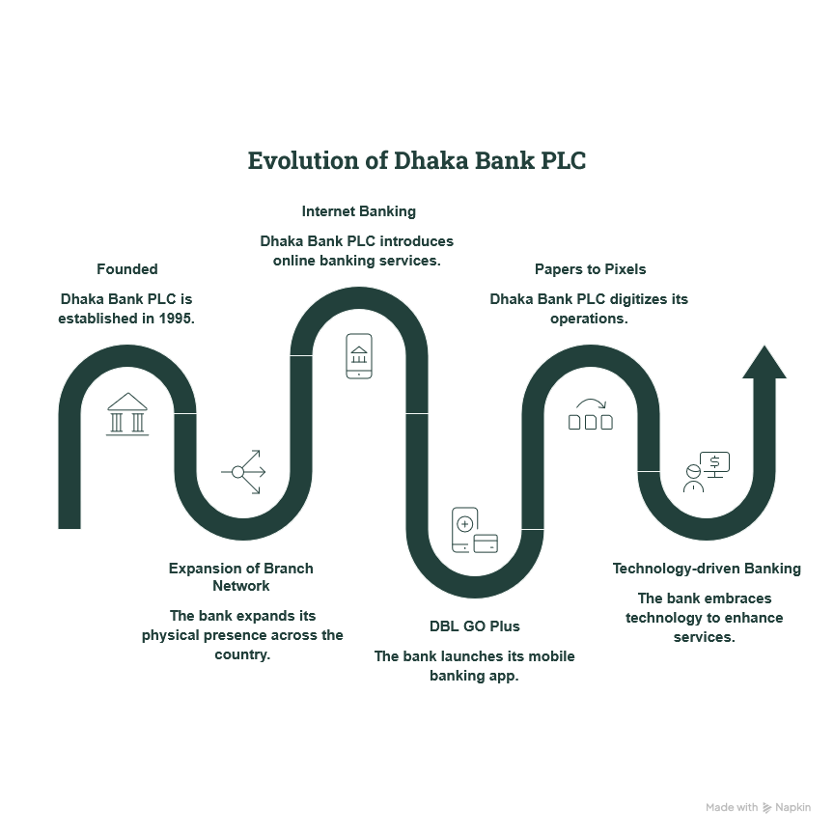
Figure 1Evolution of Dhaka Bank PLC

2.1.2 Trend and Growth

In order to assess the financial performance and growth of Dhaka Bank PLC, an analysis of five years (2021–2025) has been performed using the financial data of the Bank from its annual reports. The following financial indicators have been analyzed: total assets, deposits, loans & advances, and profit after tax. Such financial indicators help us understand the financial position and growth of the Bank within the competitive environment of the banking industry.

Table 1 Financial Highlights of Dhaka Bank PLC (2021–2025)
Financial Indicator (BDT in Million) | 2025 | 2024 | 2023 | 2022 | 2021
Total Assets | 445,206 | 431,459 | 378,639 |  | 335,351
  346,556
Total Deposits | 338,844 |  |  | 243,427 | 230,417
  299,531
  282,079
Loans & Advances | 276,121 | 268,985 |  | 239,686 | 215,459
  256,187
Profit After Tax | 2,688 | 1,251 | 1,732 |  | 2,056
  1,660

Total Assets:
Total assets of the bank show the financial strength and operating capacity of the bank. In five years, Dhaka Bank PLC has experienced consistent growth in total assets of the bank; total assets of the bank have been increased from BDT 335,351 million in 2021 to BDT 445,206 million in 2025 with an overall growth of 32.8% in total assets of the bank.
The growth in total assets reflects growth in business operations and sound financial management by the bank. During 2023 and 2024, , reflecting the growth in earning assets and overall banking operations of the bank, even though the growth rate intotal assets grew faster, reflecting growth in earning assets and overall banking operations, even though the growth rate declined in 2025.
Total Deposits:
Deposits of the bank reflect the source of funding for the commercial banks and also show the customer confidence in the bank. Deposits of Dhaka Bank have increased from BDT 230,417 million in 2021 to BDT 338,844 million in 2025, with an overall growth of 47% in deposits.
It shows the ability of the bank to attract and maintain its customers despite the stiff competition among banks. It helps the bank to be liquid enough to lend its money and also helps in expanding its business operations in the coming days.
Loans & Advances:
Loans and advances are the main earning assets of the commercial banks. During the period of analysis, Dhaka Bank has recorded growth in loans and advances from BDT 215,459 million in 2021 to BDT 276,121 million in 2025, with an overall growth of 28%.
An upward trend in the loan portfolio implies that the bank was continuing to grow its lending business prudently by following an efficient credit policy. This shows that the bank had adopted a balanced credit expansion strategy, which allowed the bank to control its credit risk.
Profit After Tax:
The profit after tax is an indicator that helps measure the financial performance of a bank. Over the period of five years, Dhaka Bank has shown fluctuation in its performance in terms of profitability. From 2021, a decline in profit, following some fluctuations to the most recent fiscal year with a huge increase in profit to BDT 2,688 million.
The robust recovery recorded in 2025 is an indication of better operational efficiency and sound financial management practices. In general, despite the occasional variations, the bank has proved its resilience and ability to become profitable during times of change.

Apart from analyzing the growth in the finances of the Bank, it would be pertinent to analyze the performance of the Bank from the shareholders' perspective and the point of view of technology as well. Earnings per share and Net Asset Value per share indicate the financial power of the Bank as well as its value generation capability for the shareholders, while digital banking figures highlight the capacity of the Bank to cope with the changes taking place on the technological front.

Table 2 Earnings Per Share (EPS) and Net Asset Value (NAV) per Share of Dhaka Bank PLC (2021–2025)
Indicator (BDT) | 2025 | 2024 | 2023 | 2022 | 2021
Earnings Per Share (EPS) | 2.65 |  | 1.32 | 1.63 | 2.28
  1.21
Net Asset Value (NAV) per Share (BDT) | 23.64 | 21.47 | 21.92 | 21.63 | 21.61

Earnings Per Share (EPS):
Earnings Per Share (EPS) is an index that reveals how much profit is generated per share, and it is an important profitability ratio. During the study period, the EPS of Dhaka Bank PLC decreased from BDT 2.28 to BDT 1.21 but then rebounded dramatically to BDT 2.65 and recorded the highest EPS within five years.
The decline of EPS is a temporary phenomenon due to the unfavorable macroeconomic environment, increased need for provision, and difficulties in terms of profit generation faced by the banks. But the rebound in EPS shows good performance of the bank in terms of its operational efficiency, earnings, and financial management. The rebounding of EPS helps investors build confidence in the bank due to its higher profits.
Net Asset Value (NAV) Per Share:
Net Asset Value per share is defined as the net value of each ordinary share after subtracting total liabilities from the total assets. During the study period, Dhaka Bank PLC exhibited a fairly stable Net Asset Value, which ranged between BDT 21.47 to BDT 23.64, showing an overall rise of about 9.4%.
Stability of Net Asset Value implies that the bank maintains a good capital structure even in light of profitability variations. The rise of Net Asset Value during the last financial year shows growth in the shareholders’ equity as well as the financial strength of the company. This increases investors’ confidence, since Net Asset Value signifies the bank's financial strength.
Now, here is an analysis of the digital growth of Dhaka Bank PLC-

Table 3 Digital Banking Growth Indicators (Selected) of Dhaka Bank PLC
Digital Banking Indicator | 2024 | 2025 | Growth
Number of Transactions through DBL GO Plus App | 1,332,385 | 1,568,367 | 18%
Number of DBL GO Plus Users | 106,556 | 171,476 | 61%

In modern times, digital transformation has become one of the primary sources of competitive advantage in the banking sector, and the efforts of Dhaka Bank PLC have been quite effective in this aspect. The number of transactions conducted via the DBL GO Plus app increased by 18%; at the same time, the number of registered users increased by 61%, which is indicative of rapid customer acceptance of digital banking products.
It is worth saying that a great increase in users of digital banking indicates high levels of trust towards the digital platform of the bank and proves the efficacy of its digital banking strategy.
Besides, there is a noticeable trend that transactions within CRM increased by 31% and card transactions by 28%. Moreover, there was an increase of 18% in the number of cards that were issued by the bank. It is clear that customers prefer alternative ways of conducting transactions instead of using a branch. This tendency brings benefits not only also for the bank in terms of improved operational efficiency.
Thus, the ongoing investments in digital innovation and development of DBL GO Plus contributed to the provision of safe and user-friendly banking services. In accordance with the 2025 Annual Report, Dhaka Bank continues to develop its digital ecosystem, enhance customer experience, and improve the cybersecurity infrastructure, as well as introduce new digital solutions.
Overall trend and growth:
According to the financial analysis covering a period of five years, it can be observed that Dhaka Bank PLC has remained on a steady growth path despite the highly dynamic and competitive nature of the banking sector. Growth in assets, deposits, and advances points towards business expansion along with the increase in the customers' trust in the institution, whereas the increase in profitability, EPS, and NAV shows that the bank has been quite resilient in its operations. Moreover, the adoption of digital banking in the form of DBL GO Plus is another step taken by the bank towards meeting the growing demands of the customers.

2.1.3 Product / Service / Customer mix

In general, the Bank's products and services can be classified into retail banking, corporate banking, SME banking, Islamic banking, treasury services, trade finance, card services, and digital banking.
Retail banking is concerned with the financial needs of individuals through various deposit facilities, personal loans, debit/credit cards, internet banking, and remittance services.
Corporate banking provides tailored financial products and services to large businesses, including working capital facilities, term loans, project financing, syndicated financing, and cash management services.
Small and Medium Enterprise (SME) banking offers business loans and advice to help in the growth of the economy and employment creation.
Moreover, the Bank has been offering its customers various products and services through Islamic Banking Branches. Here is a table showing overall products and services:

Table 4 Product and Service Mix
Category | Major Products and Services
Retail Banking | Savings Account, Current Account, Fixed Deposit Receipt (FDR), Deposit Pension Scheme (DPS), Personal Loan, Home Loan, Auto Loan
Corporate Banking | Working Capital Finance, Term Loan, Project Finance, Syndicated Finance, Cash Management
SME Banking | SME Loans, Business Finance, Trade Support Services
Islamic Banking | Shariah-compliant Deposit and Investment Products
Trade Finance | Letter of Credit (LC), Bank Guarantee, Import & Export Finance, Foreign Exchange Services
Treasury Services | Foreign Exchange Trading, Money Market Operations, Liquidity Management
Card Services | Debit Card, Credit Card, Prepaid Card
Digital Banking | DBL GO Plus, Internet Banking, Mobile Banking, Online Fund Transfer, Utility Bill Payment, Mobile Recharge
General Banking Services | Account Opening, Pay Order, Demand Draft (DD), RTGS, EFTN, Cheque Clearing, Solvency Certificate, Account Statement, Debit Card & Cheque Book Issuance

With regard to General Banking operations, Dhaka Bank provides a wide range of services to its customers. Some of these are account opening, cash deposit and withdrawal, Fixed Deposit Receipt (FDR), Deposit Pension Scheme (DPS), Pay Orders, Demand Drafts, Real Time Gross Settlement (RTGS), Electronic Funds Transfer Network (EFTN), cheque clearance, solvency certificate, debit card issuance, and account statement service. Such services constitute the backbone of the Bank's customer service and efficiency. It has been observed during the period of the internship that the General Banking Department constitutes the major customer service center of the Bank where many banking services have been provided efficiently. The major customer groups include-
- Individual Customers: Savings, current accounts, FDR, DPS, consumer loans, debit and credit cards, and digital banking services.
- Corporate Customers: Working capital finance, project financing, trade finance, treasury services, and cash management solutions.
- Small and Medium Enterprises (SMEs): Business loans, working capital financing, and advisory support.
- Government and Institutional Clients: Banking services for government organizations, educational institutions, and other public entities.
- Non-Resident Bangladeshis (NRBs): Remittance services, NRB accounts, and foreign currency-related banking facilities.
- Islamic Banking Customers: Customers seeking Shariah-compliant banking products and services.

Dhaka Bank has been great importance to the development of digital banking solutions recently. Using the digital banking solution of the bank called DBL GO Plus, consumers are able to get different kinds of banking solutions like balance inquiry, money transfer, payment of bills for utilities, recharges, transaction histories, and many other internet banking services anytime and from anywhere. Development in digital banking solutions indicates the Bank's efforts to provide customers with easier access to services, minimize reliance on branch-based transactions, and advance digitalization in Bangladesh.
To sum up, Dhaka Bank PLC possesses a finance. strong product and service portfolio as well as an efficient customer base, which allows it to meet a wide range of customers' financial needs. Dhaka Bank PLC has become competent in the market of Bangladesh thanks to its continuous innovations and customer-oriented approach to services and digital banking.

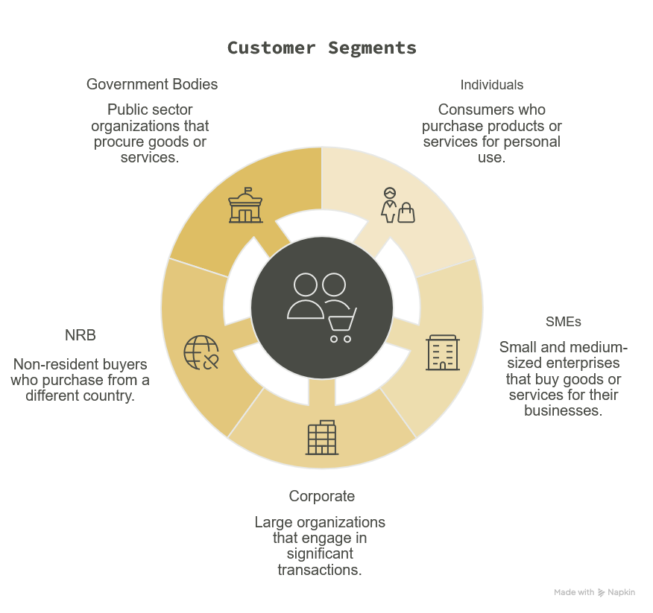
Figure 2 Customer Segments

2.1.4 Company Operations / Activities

Dhaka Bank PLC conducts its banking operations through an extensive network of branches, sub-branches, ATM booths, Cash Recycling Machines (CRMs), online banking channels, and offshore banking divisions throughout the country of Bangladesh. The operations of Dhaka Bank PLC operate in accordance with the guidelines and regulations of the Bangladesh Bank, taking a customer-focused approach towards providing efficient and technology-based banking services. The major operational areas of Dhaka Bank PLC include Retail Banking, Corporate Banking, SME Banking, Treasury, Trade Finance, Islamic Banking, and General Banking.

Out of these, General Banking Division plays a major role in being the medium between the customers and the Bank for performing daily banking operations. It undertakes several operational activities, which are as follows:

Opening of accounts & onboarding (KYC, NID verification, and N-Screening)

Deposit and withdrawal of cash

Management of Fixed Deposit Receipts (FDRs) & Deposit Pension Schemes (DPS)

Management of Pay Orders.

Real Time Gross Settlement (RTGS) and EFTN Management

Clearing of cheques and management of returned cheques

Disbursement of Debit Cards and cheque books

Maintenance of Statements & Solvency Certificates

During my internship period at the General Banking Department of Dhaka Bank PLC, Banani Branch, I had practical involvement in many of these activities. These include helping in opening bank accounts by doing NID and N-Screen processing, giving account statements and solvency certificate to customers, helping customers in issuing and delivering their debit cards and cheque books, calling customers for collecting their cards and cheque books, confirming customers for cheque clearance, and letting customers know about bounced cheques. Besides, some routine work related to administrative and customer service is done to keep the branch functioning smoothly.
Beside conventional branch banking, there has been a great deal of digitization of operations by Dhaka Bank through DBL GO Plus where the customers can perform different banking operations like fund transfer, payment of utility bills, checking the account balance, mobile recharge, and much more anytime through internet banking. The use of digital banking has lowered the dependency on branch banks and increased the efficiency and convenience of customers. Moreover, modern techniques like cash recycling machine (CRM), automated payment system, and digital transactions have been used by the Bank.
All things considered, Dhaka Bank PLC upholds an integrated operating structure that blends cutting-edge digital solutions with conventional banking services. The Bank is able to maintain regulatory compliance, increase productivity, offer effective customer care, and bolster its competitive position in Bangladesh's banking sector because of this balanced operational approach.

2.1.5 SWOT Analysis

Here is a table showing the SWOT Analysis of Dhaka Bank PLC:
Table 5 SWOT Analysis of Dhaka Bank PLC
Strengths (S)  Good brand name along with almost three decades of experience.  -Various banking products and services offered.  -Constant growth in terms of deposits and assets.  -Excellent Digital Banking platform (DBL GO Plus).  -Customer-focused services and strong corporate governance. | Weaknesses (W)  Volatility in terms of profitability throughout the study period.  -Smaller number of branches when compared with other banks.  -Dependence on the domestic market.  -Limited international presence compared to multinational banks.  -Huge investment needed in terms of digital transformation.
Opportunities (O)  Growing demand for digital banking.  - Growth in the areas of SME banking and retail banking.  -Increase in cashless transactions.  -Technology and financial inclusion. | Threats (T)  Competitive pressure from private commercial banks.  -Increased risk of cyber attacks.  -Regulatory changes by the Bangladesh Bank.  -Inflation and economic uncertainty.  -Increasing NPLs in the industry.

SWOT analysis provides a brief overview of Dhaka Bank PLC's strengths and weaknesses, as well as the opportunities and threats that affect its performance and competitiveness in Bangladesh's banking industry. As the results show, despite the company's competitive advantages, there are still challenges and risks that must be continually considered.
Strengths (S):
Firstly, Dhaka Bank PLC has a strong brand reputation, built on almost three decades of effective operations in banking. The Bank is involved in a great variety of activities, which include such types of banking as retail, corporate, SME, Islamic, and digital, which allows meeting financial needs of various customers. Increase in deposits and total assets indicates customers' trust and financial stability of the Bank. Moreover, the development of DBL GO Plus improves the level of digital banking of the Bank, since it enables customers to use safe banking services.
Weaknesses (W):
Though the Bank has many positive features, there are also several internal issues. The environment. The Bank's profitability has fluctuated during the research period, indicating that its profits remain quite sensitive to environmental changes. In addition, compared to some other private commercial banks, Dhaka Bank has a comparatively small number of branches. Besides, the Bank mainly focuses on the domestic market. Finally, innovations in IT require significant investments by the Bank, which may increase operating expenses.
Opportunities (O):
There are several opportunities for Dhaka Bank PLC amid a changing environment. First, there is a high demand for digital banking services and cashless payments, creating an opportunity to develop the Bank's digital banking platform. Second, developments in the sources. Fields of SMEs and retail banking offer opportunities to attract new clients and generate additional revenue streams. Third, with technological innovations and initiatives to make the financial sector more inclusive, the Bank can launch new financial products.
Threats (T):
The Dhaka Bank PLC operates in a highly competitive banking environment, where competition from other private commercial banks keeps market share and profitability under constant strain. The increasing digitization of banking adds another threat in the form of cyber attacks, and hence the need for strong information security is inevitable. Moreover, the shift in regulatory policy of Bangladesh Bank, inflation, and economic instability can all have an impact on the performance and profitability of the Bank. Rising NPLs in the banking sector is yet another threat.

2.2 Industry Analysis

2.2.1 Specification of the Industry

Banks are among the most prominent pillars of the Bangladeshi financial system, playing a pivotal role in sustaining the country's economic growth and development. Banks serve as financial intermediaries that collect savings from households and organizations and lend out these savings for investment purposes. In addition to conducting financial transactions, banks help create capital, develop industries, create jobs, facilitate international commerce, and provide financial services. aspects. As the country continues to develop, banks remain an important aspect in pursuing monetary policy, business expansion, and economic development.
There has been significant transformation in Bangladesh's banking industry since the country's liberation. The country was initially characterized by a large number of state-owned banks. However, the banking industry has developed over time with the addition of private commercial banks and also commercial banks from other countries. Due to financial reform policies, regulatory advancement, technological improvement, and the growth of private sector participation, the industry has become very efficient, competitive, and quality-driven. Today, there are millions of customers served by the banking industry via its vast network of branches, sub-branches, ATMs, agent banking and digital banking.
Bangladesh Bank is the central bank of Bangladesh and regulates the banking industry of Bangladesh. Bangladesh Bank is responsible for keeping monetary stability, supervision of scheduled banks, formulation of the banking rules, issuance of license, maintenance of discipline, management of foreign exchange reserve, and protection of depositors' interest. Besides, it also keeps an eye on prudential regulation of the banks, capital adequacy requirement, liquidity, anti-money laundering (AML) measures, and corporate governance issues. Thus, the safety and stability of Bangladesh's banking industry.
According to the Bangladesh Bank, the existing scheduled banking sector comprises 57 scheduled banks, divided into four broad categories based on their types and characteristics. These categories include State Owned Commercial Banks (SOCBs), Specialized Banks (SDBs), Private Commercial Banks (PCBs), and Foreign Commercial Banks (FCBs). Private commercial banks are the largest category in the industry, holding a leading position in accepting deposits, extending loans, and offering a range of banking products and services. Dhaka Bank PLC is operating as one of the private commercial banks in this very competitive category.
Major types of banks in operation in Bangladesh are listed as follows:

State-Owned Commercial Banks (SOCBs):
The banks are owned by the Government of Bangladesh and provide general banking services, supporting the government's financial policies and the nation's economy.
Specialized Banks (SDBs):
Specialized banks are set up in order to cater to the financing of priority sectors including agriculture, rural development, welfare of expatriates, and industrial development. The main motive behind the formation of specialized banks is to finance the sectors which help in the development of the economy of the country.
Private Commercial Banks (PCBs):
Private commercial banks operate with a profit motive and offer various banking products and services to individuals, firms, and organizations. These banks are usually known for their customer-friendly services, technological innovations, efficiency, and significant role in the development of the private sector.
Foreign Commercial Banks (FCBs):
Foreign commercial banks are branches/subsidiaries of foreign banking organizations in Bangladesh. These banks usually deal with multinational companies, foreign business transactions, foreign exchange transactions, and corporate banking.
Banks provide numerous financial products and services that meet their customers' needs. The variety of financial products and services offered by banks includes savings and current accounts, fixed deposits, loans and advances, trade finance, foreign exchange, remittance, treasury services, credit cards, debit cards, internet banking, mobile banking, agent banking, and financial products related to investments. Payment services . Services offered by banks include RTGS, EFTN, Pay Orders, Demand Drafts, cheque clearance, utility bill payments, digital fund transfers, and more, enabling secure financial transactions nationwide.
In recent times, digital banking has been recognized as one of the most innovative trends of Bangladesh's banking industry. Commercial banks have been increasingly involved in developing digital banking portals, mobile banking applications, internet banking, automated payments system, QR code payment system, and self-service banking technologies. Rising trends of smartphone use, internet connectivity, and digital payment system have made customers prefer technology-oriented banking services. Thus, digital banking has become an important element of competition in Bangladesh's banking industry.
Even though the banking sector has made significant achievements, it still faces some challenges. First of all, one of the challenges is an increasing amount of non-performing loans, which may cause problems related to the profitability, capital adequacy, and ability to provide loans. Additionally, it is hard for banks to manage their liquidity while growing deposits and making credits, especially during uncertain economic times. Inflation and changes in interest rate policy can impact interest expenses, spending, and the performance of the banking sector. Moreover, banks should always issues. They should also comply with regulations issued by the Bangladesh Bank regarding capital adequacy, risk management, money laundering, and corporate governance. With the development of digital banking, cybersecurity, data breaches, and financial fraud have become important challenges.
Moving forward, the prospects of the banking industry in Bangladesh look promising despite these issues. Economic growth, financial inclusion, SME lending, about the development of digital banking, and government initiatives are expected to create many opportunities for the banking sector in the coming years. The use of advanced technology like artificial intelligence, data analytics, cloud computing, and digital payments is expected to increase the efficiency of banking operations. In addition, better regulation, risk management practices, and digital transformation are anticipated to enhance the resilience and sustainability of the banking industry. Commercial banks will continue to have a crucial role to play in the economic development of Bangladesh.

2.2.2 Size, Trend, and Maturity of the Industry

Table 6 Structure of Bangladesh's Banking Industry
Types of banks | Number
 | 6
  State-Owned Commercial Banks (SOCBs)
 | 3
  Specialized Banks (SDBs) | 3
 | 43
  Private Commercial Banks (PCBs) | 43
 | 5
  Foreign Commercial Banks (FCBs)
Total Scheduled Banks | 57
Source: Bangladesh Bank, Scheduled Banks Statistics (2025).
- Industry size:
The Banking Industry in Bangladesh has evolved and become one of the largest sectors as well as most important sector for any financial system. The banking industry comprises 57 scheduled banks under the supervision of Bangladesh Bank and provides financial services to clients through an extensive network, including branches, sub-branches, ATM booths (Automated Teller Machines), agent banking outlets, as well as Digital Banking stakeholders throughout the country. This extensive network enables banking solutions to be extended to urban and rural areas, thereby furthering financial inclusion and facilitating economic activity at every level.
It is the industry that mobilizes the savings of people and directs these resources to productive investments by providing loans and advances. Commercial Banks – Commercial banks are vital to the economy; they finance and also support households, SMEs, corporate firms, as well as industries, agriculture, and infrastructure, which help create jobs in great quantities, promoting industrialization & national development. Moreover, the banking industry supports local and international commerce with payment systems, trade finance solutions, remittance services, and foreign exchange transactions.
Another key area where the banking sector plays an important role is that of employment, as it provides jobs for bankers, financial analysts, IT experts, risk managers, and customer service representatives. With increasing economic activity, it can be anticipated that the need for effective and innovative banking services will Bangladesh.

- Industry Trend:
The banking industry in Bangladesh has seen considerable changes over the last ten years, mainly due to technological advances, regulatory changes, and evolving customer expectations. The first important trend is the rapid rise of digital banking. Banks in the country are making extensive use of mobile banking, internet banking, automated payments, and self-service banking to make their products more accessible, convenient, and fast.
The other important trend is the development of the concept of agent banking that increased access to financial products and services considerably, especially for those who lived in remote and underdeveloped areas. Customers can access basic banking products through authorized agents without visiting physical bank branches.
This phenomenon is evident in the growing use of internet banking, mobile banking, and QR code payment systems as consumers prefer cashless transactions. infrastructure of banks is consistently being upgraded to facilitate online transactions, utility bill payment, payments to merchants, and other types of digital transactions.
Apart from the digitization of the financial sector, green banking is another industry trend. The Bangladesh Bank urges commercial banks to practice sustainable banking by financing green projects, implementing paperless banking, reducing their carbon footprint, and assessing environmental risks before financing projects. As a result, a large number of banks are adopting sustainable development principles while promoting environmentally friendly economic development.
More attention is paid to financial inclusion. Financial inclusion aims to provide previously unbanked and underbanked people with affordable banking products and services. Through digital banking, agent banking, financing for small and medium enterprises, and other government-initiated financial programs, commercial banks continue to expand the scope of formal banking products.
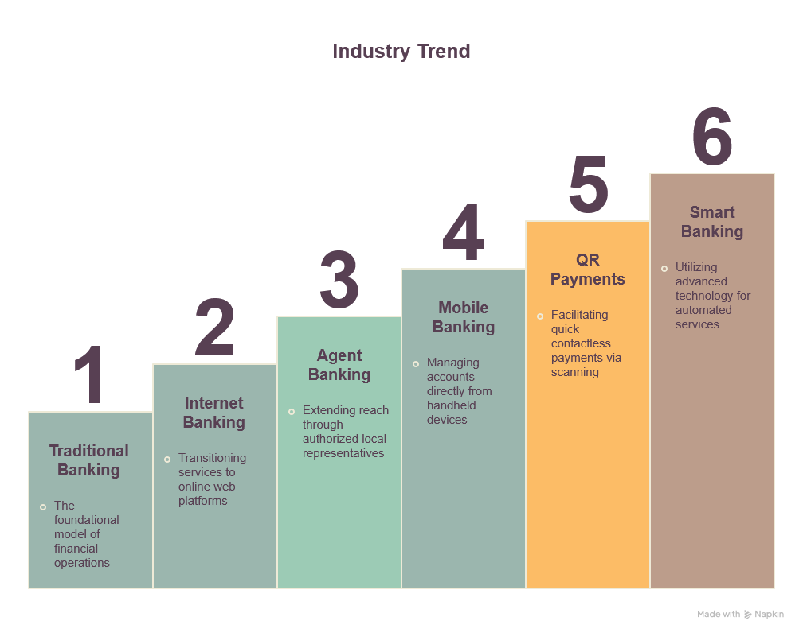
Figure 3 Industry Trend

- Industry Maturity:
The banking sector in Bangladesh can be considered mature, very competitive, and strictly regulated industry. Through time, it was able to build a well-developed institutional environment based on the Bangladesh Bank regulation and supervision. Represented by state, specialized, private commercial, and foreign commercial banks, this industry creates a competitive environment in which all banks continually strive to enhance service quality, operational efficiency, innovation, and customer satisfaction.
The banking sector is becoming more and more technology-based due to a high level of investments in digital solutions, automation processes, cybersecurity, data analytics, and payment systems. This process of digital transformation has completely changed the nature of traditional banking operations and, consequently, customer expectations. Therefore, technological innovations became the main determinant of competitiveness in the industry.
Despite having matured, the banking sector still possesses considerable growth potential. Urbanization, increasing levels of financial literacy and internet penetration, the development of small and medium enterprises, as well as favorable government policies, continue to provide many opportunities for business development. Nevertheless, banks have to deal with quite a number of challenges at the same time, such as non-performing loans, inflation, liquidity, cybersecurity, etc.
Effective corporate governance, appropriate risk management, sufficient capital, and continuous technological investments will always be required to ensure the sustainability of growth and maintain trust in the banking system among the public. Companies that are able to properly combine innovation and financial prudence will have more chances to increase their competitive advantage in the modern banking sector.
Under this highly competitive and rapidly changing banking scenario, Dhaka Bank PLC has been concentrating on increasing operational efficiency, digital banking services, and customer-oriented banking to sustain its competitive edge.

2.2.3 Industry SWOT Analysis

Various internal and external factors affect the competition of Bangladesh's banking sector. Economic situation, technological development, regulations, market competition, and availability of substitute financial services all have an effect on how well and efficiently the commercial banks perform. The discussion below focuses on some major external factors influencing the performance and competitive environment of the banking industry in Bangladesh.
Here is a table showing the impact on the industry in of external economic factors, technological factors, barriers to entry, threats of substitutes and industry rivalry-

Table 7 Impacts of the five factors on industry
Factors | Industry impact
External economic factors | High
Technological factors | High
Barriers to entry | High
Threats of substitutes | Moderate
Industry rivalry | High

- External Economic Factors:
Bangladesh's economic situation affects how the banking sector performs in the country. GDP growth, inflation, interest rates, exchange rates, and monetary policy influence one another, which in turn affects the banking industry and its financial performance. When the economy is growing steadily, companies increase their investments, and people demand more banking products and services.
But the currently the increased inflation has reduced consumers. The consequence of this is that people cannot save money, and also find it difficult to pay back loans taken from banks. Moreover, changes in the policy rate and lending regulations by the Bangladesh Bank affect borrowing costs and interest rates on deposits. Economic uncertainty could lead to high credit risk by influencing the ability of people to repay the loans. Therefore, the importance of proper liquidity management and proper risk management in commercial banks in Bangladesh is paramount.
- Technological factors:
Technological advancement has been among the most significant sources of change in the Bangladeshi banking industry. Banks are constantly innovating in terms of internet banking, mobile banking apps, automated payment systems, artificial intelligence, cloud technology, and other forms of customer service through digital means to enhance their efficiency and satisfy their customers.
The increased penetration of smartphones and internet services has increased customers' preference for digital bank services. This means that banks do not compete only through physical branches; they compete based on the quality and convenience of their digital banking services.
Improving a business's efficiency and expansion, it has also increased the risk of cyberattacks, fraud, and loss of privacy for banks. Consequently, the need for constant investment in information security, digital platforms, and training of staff members has become vital to guarantee safe banking.
- Barriers to entry:
The Bangladeshi banking industry has high entry barriers, thus making it tough for potential rivals to launch commercial banks. The main barrier must meet all the necessary conditions.
Also, launching a commercial bank presupposes a large initial investment, advanced technology, qualified people, a risk management system, and much more. It also takes time and money to gain the customers' trust and create a credible brand image.
Moreover, various regulatory compliance requirements for banks related to capital adequacy, liquidity management, AML measures, corporate governance, and financial reporting increase operational complexity and make new market players reluctant. In this regard, even though there is stiff competition between the existing banks, the potential entry of new commercial banks in the industry still does not seem to be high.
- Threats of substitutes:
The availability of substitute products in the case of Bangladesh's banking industry has become high due to the emergence of MFS services, fintech companies, and digital payment systems. The services of different fintech firms like bKash, Nagad, Rocket, and others enable customers to conduct their financial operations without going to the commercial bank.
Such services include money transfer services, utility bill payments, merchant payment services, mobile recharge, salary disbursement, and digital wallets. interested. The convenience and availability of such services have increased interest in using digital financial services, especially for small transactions.
However, commercial banks still have a huge competitive advantage due to the fact that some of the most important financial services, such as corporate loans, trade financing, foreign exchange services, investment banking, and long-term deposits, cannot be completely substituted by mobile financial service providers. Thus, the total threat of substitutes is medium, and banks should constantly develop their services in the sphere of information technologies.
- Industry rivalry:
There is stiff competition in the banking sector of Bangladesh since there are many commercial state-owned, private commercial, specialized, and foreign commercial banks in the country. The banking sector is highly competitive as there is stiff competition for clients, deposit mobilization, increasing loans and profitability.
Banks in Bangladesh are competing with one another using various methods including competitive interest rates, excellent customer services, innovative banking through digital technology, diversification of financial products, expansion of branches and advancement in technology. In recent times, the level of competition has moved from conventional banking operations into digitalization, where commercial banks are investing huge resources in mobile banking applications, internet banking platforms, automation of payment transactions, and personalized customer experiences.
Financial technology firms and mobile financial service firms have also increased competition in the market environment through innovative digital payment mechanisms. Commercial banks, therefore need to invest in technology to keep their competitive edge.
As far as banks like Dhaka Bank PLC are concerned, there needs to be an integrated strategy to sustain competitiveness.
From the above analysis, it is evident that the Bangladesh banking industry is highly competitive and dynamic. Economic, technological, regulatory, and substitution forces, along with competition from rival industries, always affect the strategies of commercial banks. Even though these forces represent serious threats to banks, they can also be seen as opportunities for banks to become more efficient and technologically advanced, and to improve customer service. Banks that embrace technology, govern themselves Bangladesh's banking industry.

CHAPTER 3: INTERNSHIP EXPERIENCE

3.1 Position, Duties, and Responsibilities

An integral part of United International University's (UIU) Bachelor of Business Administration (BBA) degree, the internship program gives students the chance to obtain real-world experience in a professional setting. I finished my internship in the general banking department of Dhaka Bank PLC's Banani branch as part of this academic requirement. Through the internship, I was able to closely study banking operations and apply theoretical concepts from my academic courses to practical banking procedures.
I was supervised and guided by seasoned General Banking Department personnel during my internship. The department is responsible for providing a variety of daily banking services and serves as the main point of contact between the Bank and its clients. Even though my internship was mostly supportive, it gave me the chance to take part in a number of operational tasks and learn how crucial accuracy, secrecy, teamwork, and customer service are to commercial banking operations.
I was given tasks to support the branch's everyday operations during my internship. Through these activities, I gained a practical understanding of banking operations and contributed to the efficient execution of administrative and customer service tasks.

Being an intern at Dhaka Bank PLC, I have done the following duties and responsibilities:

Table 8 Performed duties and responsibilities during internship
Responsibility areas | Activities performed
Assistance with Account Opening | Under the guidance of branch personnel, I checked customer paperwork, verified National Identity Cards (NID), and performed N-Screen verification to help with account opening operations.
Getting Customer Documents Ready | Prepared and delivered solvency certificates in various formats, delivered saving account statements and FDR statements and other client documentation upon request.
Informing clients | contacted clients to let them know that their checkbooks and debit cards were ready for pickup.
Service of debit cards and cheque books | After completing the necessary verification processes, I helped issue and deliver cheque books and debit cards.
Support in cheque clearing | Before cheques were cleared, customer confirmations were completed, and consumers were notified of returned checks.
Support for Customer Service and Administration | In order to support the General Banking Department's everyday operations, I helped officers with basic administrative tasks, client inquiries, document management, and other operational tasks.

- Assistance with Account Opening:
During the internship, helping with the account opening process was one of my main duties. Under the guidance of branch personnel, this entailed reviewing the documents that consumers had supplied, confirming their National Identity Cards (NID), and carrying out N-Screen verification. Through these exercises, I learned about the Bank's client verification processes and had hands-on experience with Know Your client (KYC) regulations. I also came to understand how crucial accurate customer identification is to guaranteeing legal compliance and reducing operational risk.
- Getting Customer Documents Ready:
It was another very important job to prepare and distribute the various banking documents that the clients required. Some of the banking documents were Savings Account Statements, Fixed Deposit Receipts (FDR) statements, solvency certificates, etc. This has helped me learn more about banking documents, record-keeping, and customer confidentiality.
- Informing clients:
I used to call to inform them that their debit cards and cheque books had reached our branch, and they could collect them. Some clients’ debit cards and cheque books were not collected, which came to the branch months ago, and there was a risk of being destroyed if they didn’t collect them as early as possible; also, there was audit pressure. I contacted those clients and also informed them to collect their debit cards and cheque books in due time.
- Support in cheque clearing:
I supported cheque clearing by first helping prepare the cheques by checking if each cheque contained an accurate date, account number, and mobile number both in the cheque and the deposit slip, then giving them a cross-out. After completing these primary procedures, I used to give confirmation calls to customers before the transaction procedures took place and finally if any cheque got returned, I informed the customers about their returned cheques. I also contacted customers to correct cheques during this process.
- Support for Customer Service and Administration:
I have assisted the officers with various administrative and customer service activities, in addition to performing my operational roles. Some of my duties included documentation, responding to customer queries, sorting documents, and general assistance in the operations process where necessary. From these exercises, I was able to gain an understanding of how branch operations are conducted and how customer service is important in banking.

3.2 Training and development

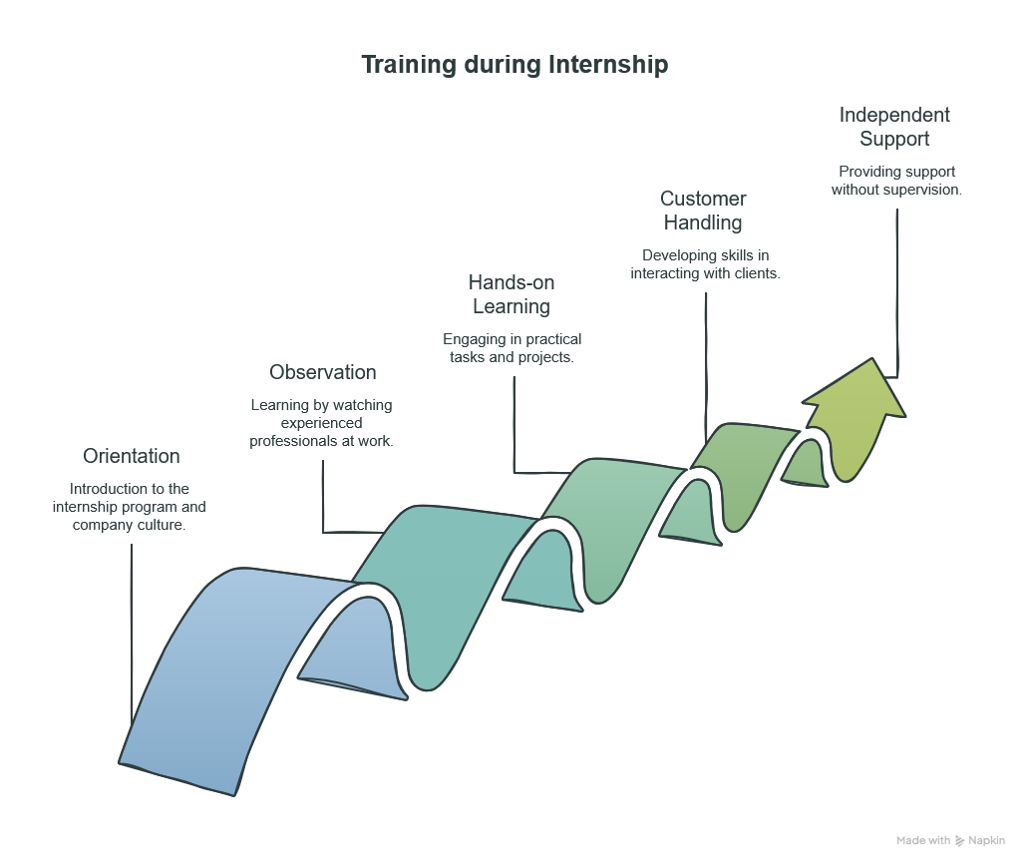
Figure 4 Training during Internship
Experience gained during the internship at Dhaka Bank PLC was extremely useful practical experience which complemented the theoretical knowledge that I had gained during my BBA degree. Even though Dhaka Bank PLC did not have any structured training program for the interns in a class room setting, I was constantly guided by the officers of the General Banking Department about how things were done at the branch level. They gave me a brief introduction about the branch's working environment and helped me perform my tasks at the bank during my entire internship period.
In the initial stage of my internship, I became acquainted with the organizational structure of the branch, workplace discipline, customer service practices, and the workflow of the General Banking Department. Prior to executing any task assigned to me, the concerned officers provided me with instructions regarding the proper execution of each task. This proved helpful for me in building up my confidence in my assigned tasks in a professional manner.
As part of my internship in the branch, I gained exposure to different aspects of general banking. Some of the areas where I gained experience include the process of opening accounts of customers, which includes procedures like document verification, NID verification, and N-Screen processing. I gained experience in preparation of documents like savings account statements, FDR statements, and solvency certificates. Apart from that, I came to know about the procedure of cheque clearance, issuing of debit cards and cheque books to customers.
Through the internship program, I have gained more insight into different banking products, services and payment systems. This is through engaging in conversations with branch officials and through observing processes carried out within the branches. The products include savings accounts, fixed deposit receipts (FDR), deposit pension schemes (DPS), pay orders, RTGS, EFTN and also Bank's online banking system known as DBL GO Plus. Through this, I was able to understand how these services help to satisfy the needs of customers in a way that enhances the effectiveness of bank operations.
Apart from gaining technical knowledge, the internship was highly helpful to me as far as my career development is concerned. Engaging in tasks in an environment that focuses on customers helped me to improve my communication skills, teamwork skills, time management skills, professional ethics, and responsibility under supervision. In addition to this, I learned about the need for accuracy, confidentiality, and customer satisfaction when providing banking services.

Table 9 Training Areas Covered and Things Learnt from the Internship Experience
Area of training | Gained knowledge and experience
Operational activities of General Banking | Knowledge of workflow, processes, and tasks undertaken in the General Banking Department.
Procedures of opening accounts | Account opening process, document verification, NID and N-Screen process as per the KYC criteria.
Customer information documentation | Experience in making savings account statements, FDR statements, solvency  certificates, and other customer-related documents.
Clearing cheque processing | Cheque clearance process, customer confirmation process, and management of returned cheques.
Banking Products & Services | Knowledge about Savings Accounts, FDR, DPS, Pay Orders, RTGS, EFTN, debit cards, cheque books, and DBL GO Plus.
Customer Service | Improvement in communication skills by dealing with customers and fulfilling their needs under the supervision of officers.
Professional Development | Time management, team work, workplace discipline, professional conduct, and confidentiality.

3.3 Contribution to Organization/ Operations

Although the job profile of the General Banking Department was that of an intern, I participated in the daily work of officers in the department by assisting with operational tasks and customer service. Though the job involved no major tasks, it helped me contribute to the smooth flow of work inside the branch and also help officers perform banking activities and customer transactions effectively.
Another major contribution was to the account opening process. This involved assisting branch officials in checking customers' NIDs and verifying them, checking customers' documents, and also doing N-Screen verification. This was done to ensure proper maintenance of customers' details and bank to maintain the bank's KYC procedures before account opening.
Yet another major contribution I made was the preparation and provision of customer documents like savings account statements, FDR statements, and solvency certificates. As these documents are regularly required by customers for personal, educational, business, and financial reasons, preparing them effectively and efficiently helped me enhance customer service and save of the time of branch officials.
Another key aspect of contribution was in assisting in the issuance and distribution of debit cards and cheque books. I called up the clients to inform them of the availability of the banking instrument that can be collected from the bank, and helped in the distribution of those after performing all necessary verifications.
Further, I necessary. I assisted with the cheque-clearing process by performing customer verification before clearance and informing customers of returned cheques as needed. All these tasks helped maintain effective communication between the branch and clients on the one hand, and perform internal verification within the bank on the other hand.
Apart from these operational tasks, I also assisted officers and records, and handling customer queries. All these helped in making sure that the General Banking Department functions effectively, especially during the peak time of banking.
Working during the holy month of Ramadan was a very useful experience for me because the Banani Branch had more work than usual due to increased customer transactions. The Banani Branch works mostly with corporate and business clientsso its workload remains high, making it one of the busiest branches of Dhaka Bank PLC. Although the bank has reduced its working hours during Ramadan, I was still able to work alongside the officers to serve many customers within the limited time available. Thus, the internship experience gave me the opportunity to help ensure continuous service for customers in a busy period and also gave me the skills of multitasking, prioritization of responsibilities, time management, and efficient work under pressure.
Generally, although I had only a supportive role in the branch and did not have much responsibility, the internship helped me make useful contributions to the day-to-day work of the General Banking Department. Having fulfilled my responsibilities accurately, professionally, and responsibly, I helped the branch perform its operations better.

3.4 Evaluation

The internship program in Dhaka Bank PLC proved to be an extremely beneficial one that served as an effective means to connect theoretical knowledge with the practical functioning of the banks. The internship program gave me the chance to see firsthand the application of the theories learned during my entire BBA program in the professional world of banking. The experience gained from working in the General Banking Department helped me get practical experience in customer service, the documentation process, operational processes, and workplace discipline, thus enhancing my understanding of the subject of commercial banking.
One of the best features of the internship was its professional atmosphere that was very helpful to the interns. The officers of the General Banking Department were very cooperative and were always ready to help me out when needed. The supervision by them not only helped me to carry out my responsibilities in an accurate manner but also gave me useful information about the practical working of the bank, customer management, and professional ethics.
Furthermore, the internship helped develop many other professional skills that are important in the banking industry. Customer interaction helped me to improve my communication and interpersonal skills, whereas being responsible for many tasks helped me to organize myself, manage my time, and focus on details. Particularly, working during the busy period of Ramadan, I learned to stay calm and do my job efficiently without compromising on the quality of services provided.
Though this period was full of valuable experience for me, there were some limitations of this internship program. The internship does not allow us to access clients' sensitive personal information or conduct our own core banking transactions due to confidentiality. Therefore, my practical experience regarding some special services of the Bank remained limited.
Overall, I would like to say that my internship with Dhaka Bank PLC has been highly successful in fulfilling its learning goals. It has provided me with practical experience, improved my professional skills, and boosted my confidence in working in a corporate setting. The knowledge and experience I have gained through this internship have laid a solid foundation for my career ahead.

Table 10 Overall Evaluation of the Internship Experience
Evaluation Aspects | Assessment
Learning Opportunities | Very good practical experience of the working of general banking.
Work Environment | Professional, cooperative and supportive.
Supervision | Continuous guidance by senior officials.
Development of Skills | Improvement in communication skills, teamwork, time management and professionalism.
Practical Exposure | Good understanding of the functioning of general banking with little exposure to confidential transactions.
Overall Learning | Extremely useful for career development.

3.5 Skills Applied

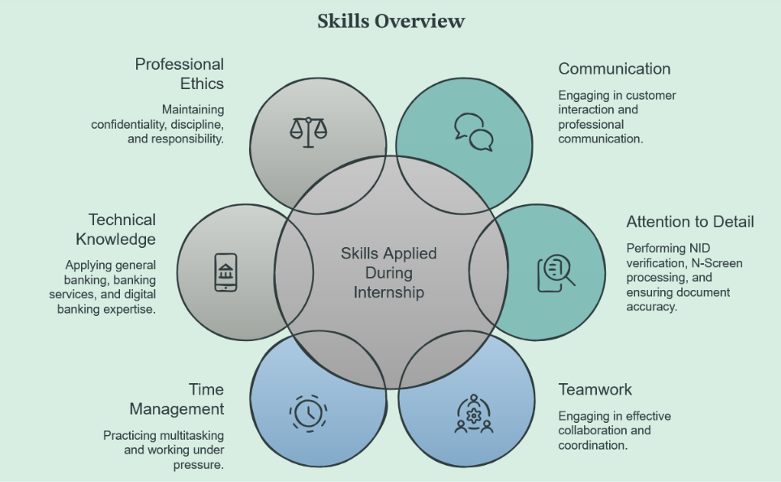
Figure 5 Skills those were applied during Internship

The internship at Dhaka Bank PLC gave me the opportunity to apply theoretical knowledge and enhance my professional capabilities in a practical banking environment. In the course of discharging my duties in the General Banking Department, I enhanced various technical and personal skills needed in a banking career.
- Communication Skills:
Interacting frequently with customers during the process of issuing bank documentation, informing them about collection of their debit cards and cheque books and answering to any other queries enhanced my professional communication and customer services skills.
- Attention to Detail
Verifying the National Identity Cards (NID) of the customers, performing N-Screen verification and making customers' documents demanded great attention to details. It helped me appreciate the need for perfection in the banking business.
- Team Work
Working alongside operation. Officials from other branches made me realize the importance of cooperation and coordination in ensuring smooth operations in the banking business. Helping other officers in their activities enhanced my teamwork capability.
- Time Management and Multitasking
Dealing with multiple tasks, especially during the fasting period of Ramadan, increased my efficiency in handling many things at once.
- Technical Skills
The internship experience helped me gain practical knowledge about the process of banking, which includes opening accounts, processing cheques, documentation, and banking services such as FDR, DPS, Pay Order, RTGS, EFTN, and DBL GO Plus.
- Professional Ethics
My professional experience in , and completing banking taught me the importance of confidentiality, discipline, punctuality, and ethics when handling customer information and fulfilling responsibilities.
In conclusion, the internship has been beneficial for me in improving technical skills as well as professional ethics.

CHAPTER 4: CONCLUSIONS AND KEY FACTS

4.1 Recommendations

From the insights gained from the internship period and analysis done through this report, the following recommendations can be drawn for Dhaka Bank PLC in order to enhance its operational efficiency and competitive advantage:
- Improvement in Digital Banking Services: Continue enhance the services offered by DBL GO Plus to increase usage and reduce reliance on branch transactions.
- Improvement in Customer Awareness: Run campaigns to educate customers on available digital banking services, online security, and the benefits of cashless banking.
- Employee Training: Conduct service. Ongoing training to keep employees up to date on technology, regulations, and customer service.
- Retail and SME Banking: Continue focusing on retail and SME customers for sustainable growth.
- Operational Efficiency Improvement: Continue streamlining bank transactions and automation to times for customers.
- Continued Emphasis on Risk Management: Continue to emphasize sound credit risk management and lending practices to maintain the level of non-performing loans.

4.2 Key understanding

The internship program at Dhaka Bank PLC has offered a number of valuable insights into banking processes as well as the entire banking industry. The main insights that have been gathered through this internship are outlined below:
- General Banking acts as the backbone of commercial banking operations since it performs core banking functions and deals directly with clients.
- The customer is satisfied not only because of financial products but also because of quality service, efficient performance, and proper communication.
- Nowadays, digital banking has become an essential competitive advantage for banks that provide their customers with fast and technological financial services.
- Accuracy, secrecy, and adherence to regulations are the basic elements that need to be considered during all banking operations irrespective of their nature.
- Cooperation, coordination, and effective time management are essential for performing smooth branch operations, particularly during the busiest time.
- Practical experience gained during internships helps to enhance theoretical knowledge.

4.3 Conclusion

The internship experience at Dhaka Bank PLC was an excellent opportunity to make up for the difference between academic knowledge and practical experience. Being employed in the General Banking Department, I acquired practical skills and experience in customer service, documentation processes, communication, teamwork, and professionalism.
According to the results of the organizational analysis presented in the report, Dhaka Bank PLC has occupied a prominent position in the Bangladeshi banking market owing to steady business growth, diversification of banking services, effective corporate governance, and the Bank's digital transformation. Due to the introduction of digital platforms such as DBL GO Plus, as well as the Bank's customer service and high operational effectiveness, its competitive position has been considerably improved.
Thus, the internship experience has positively affected my professional skills, practical knowledge, and professional confidence. It is evident that I have learned how to apply theoretical knowledge in practice. I am confident that this knowledge and experience will form the basis of my future career.

References

Bangladesh Bank. (2021). Annual report 2020–2021. https://www.bb.org.bd
Bangladesh Bank. (2022). Annual report 2021–2022. https://www.bb.org.bd
Bangladesh Bank. (2023). Annual report 2022–2023. https://www.bb.org.bd
Bangladesh Bank. (2024). Annual report 2023–2024. https://www.bb.org.bd
Bangladesh Bank. (2025). About Bangladesh Bank. https://www.bb.org.bd
Bangladesh Bank. (2025). Annual report 2024–2025. https://www.bb.org.bd
Bangladesh Bank. (2025). Financial stability report 2024. https://www.bb.org.bd
Bangladesh Bank. (2025). Scheduled banks statistics. https://www.bb.org.bd
Dhaka Bank PLC. (2021). Annual report 2021. https://dhakabank.com.bd/financial-statements-reports/
Dhaka Bank PLC. (2022). Annual report 2022. https://dhakabank.com.bd/financial-statements-reports/
Dhaka Bank PLC. (2023). Annual report 2023. https://dhakabank.com.bd/financial-statements-reports/
Dhaka Bank PLC. (2024). Annual report 2024. https://dhakabank.com.bd/financial-statements-reports/
Dhaka Bank PLC. (2025). About us. https://dhakabank.com.bd/about-us/
Dhaka Bank PLC. (2025). Annual report 2025. https://dhakabank.com.bd/financial-statements-reports/
Dhaka Bank PLC. (2025). Corporate governance https://dhakabank.com.bd/corporate-governance-guidelines/
Dhaka Bank PLC. (2025). Products and services. https://dhakabank.com.bd/

Appendix-A

Figure 6 Total Assets of Dhaka Bank PLC (2021-2025)

Figure 7 Total deposits of Dhaka Bank PLC (2021-2025)

Figure 8 Loans & Advances of Dhaka Bank PLC (2021-2025)

Figure 9 Profit After Tax of Dhaka Bank PLC (2021-2025)

Figure 10 EPS & NAV per Share of Dhaka Bank PLC (2021–2025)

