Corporate Branding Strategy of Bella Eventos Private Ltd

Ismail Ahmed

This Report is Submitted to the School of Business & Economics United International University in Fulfillment of Requirement for the Degree of Bachelor of Business Administration

Corporate Branding Strategy of Bella Eventos Private Ltd
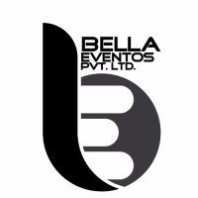

Prepared by
Ismail Ahmed
ID: 111 133 164
BBA Program
School of Business and Economics
United International University

Supervised by

Dr. Kawsar Ahmmed
Professor
School of Business & Economics
United International University

Date of submission: 22/09/2021

Letter of Transmittal
August 22, 2021
Dr. Kawsar Ahmmed
Professor
School of Business and Economics
United International University

Subject: Corporate Branding Strategy of Bella Eventos Private Ltd.

Dear Sir,
It my great pleasure to inform you I like to submit my internship report on “Corporate Branding Strategy of Bella Eventos Private Ltd.” This report is a part of my fulfillment of BBA program. This internship report is prepared under my internship supervisor Prof.Dr. Kawsar Ahmmed.
This report gives me a big opportunity to enrich my real life experience on corporate branding. I have given my best effort to fulfill the object and requirement of this internship report. I hope that this report meet your expectation.
To complete this report I have used more recent information of Bella Eventors private ltd and their corporate branding and it also play most important factor to make this report informative and interesting.
I hope that you will go through my internship report.

Thank you.

……………..
Ismail Ahmed
ID: 111 133 164
Major in marketing
School of Business and Economics

Supervisor Certificate

This is clearly certified that this internship report the title is “Corporate Branding Strategy of Bella Eventos Private Ltd.” Bearing ID: 111 133 164. BBA program major in Marketing. United International University. He is under my supervision.
During the internship time Ismail Ahmed has completed his all assign task and duties carefully with our satisfaction level. I have supervised him from the begging of his internship period.
I will he will success in his life.

………………………
Dr. Kawsar Ahmmed
Professor
School of Business and Economics
United International University

Acknowledgement

At first, I am very thankful to my almighty God to giving me strength and ability to complete this internship report as well as my internship program in Bella Eventos private ltd in schedule time. While I prepared this internship report, I received lots of cooperation from my office supervisor Waseq Uallh Nabil founder and brand manager of Bella Eventos. I sincerely show my gratitude for their active co-operation. It helps me lot to complete this intership report.

Initially I would like to thank my internship supervisor Prof. Dr. kawser Ahmmed. His important guidance and valuable feedback help to complete this report. At first I jumble how I would able to complete this report but his assistance finally I found way to complete this report. His kept me on real track to complete this report in due time.

I would also give thanks to Bella Eventos employee those who help me lot during my internship time and made my internship experience memorable.

Executive Summery

Corporate branding refers to the practice of promoting the brand name of a corporate entity, as opposed to specific products or services. The activities and thinking that go into corporate branding are different from product and service branding because the scope of a corporate brand is typically much broader. Although corporate branding is a distinct activity from product or service branding, these different forms of branding can, and often do, take place side-by-side within a given corporation (Wikipedia, 2021).

This intern report contains the working experience of the marketing and branding department of Bella Eventos. The main issue of this internship report is acquiring a practical knowledge of how Bella Eventos doing its branding in the corporate sector. How they arrange their different event and what the basic marketing strategy they use for their company branding in the corporate sector. I also analysis hoe Bella Eventos give various service to their client. How they marketing their work to the target customer. How they convince their customer by their innovative work. This practical internship program helps me a lot to learn different work of marketing, client relationship, how to work under pressure. My focus was on how an organization doing its corporate branding by using different marketing tools. Finally, based on the internship experience some recommendations are forwarded for Bella Eventos that may improve its present service quality.
Keywords: Corporate branding, Bella Eventos, digital marketing, client relationship, Bangladesh

Table of Content

Letter of Transmittal iii
Supervisor Certificate iv
Acknowledgement v
Executive Summery vi
Table of Content vii
Chapter One ix
Introduction ix
1.1 Background of the report 1
1.2 Rationale of the study 1
1.3 Objective of the report 1
1.4 Methodology of the report 2
1.4.1 Data collection method - 2
1.4.2 Contact method of the respondent- 2
1.4.3 Data analysis technique 2
1.5 Limitation of the report 3
1.6 Scope of the report 3
Chapter Two 4
Company Overview 4
Overview of the event management industry in Bangladesh 5
1.1 Overview of the company 6
1.2 Vision and Mission 6
1.3 Core value of Bella Eventos 6
1.4 Commitment of the Bella Eventos 7
1.5 Organogram of the company 7
1.6 Products and service 7
1.7 Corporate friends of Bella Eventos 9
1.8 Corporate Promotional items of Bella Eventos 9
1.9 Online products scale of Bella Eventos 10
1.10 Our Strength 10
1.11 SWOT analysis of Bella Eventos 11
1.12 My responsibility as a “Marketing Intern” 12
1.12.1 My job 12
1.12.2 Job responsibility 12
1.12.3 Different aspect of my job performance 13
1.12.4 My observation 13
Chapter Three 15
Literature Review on corporate Branding 15
3.1 What is branding 16
3.2 Why branding is important 16
3.3 What is corporate branding- 17
Chapter Four 18
Corporate Branding Strategies of Bella Eventos 18
4.1 Marketing mix strategy of Bella Eventos 19
4.2 Brand positioning 20
4.3 Advertisement 21
4.4 Strategic roadmap for corporate branding 22
4.5 Digital marketing 23
4.6 Important factor in branding at corporate level 24
4.7 Program sponsorship 26
4.8 Alternative branding strategies for corporate branding 26
Recommendation 29
Conclusion 30
Reference 31

Chapter One

Introduction

1.1 Background of the report

Internship is a graduation complete requirement of Bachelor of Business Administration (BBA) of united international University (UIU). Internship program is a partial requirement of fulfil of BBA program of UIU. In present situation our education system not only limited in classroom education and book also. To gain rhetorical knowledge from book is only half way to any subject completion. In modern competitive world practical knowledge is more important to survive and it has no alternative. The best combination of practical knowledge and theoretical knowledge is more important context of today competitive business world.
Now a day an internship program give a fresher student give big opportunity to gain industry experience in physically work in industry. This opportunity give him real life work experience and this work give them basic idea how various industry work in the market. Internship program help a fresher student to build up his next career path. This internship title is Corporate Branding Strategy of Bella Eventos Private Ltd.I have completed my internship program from Bella Eventos pvt. Ltd. I have learned too many things about corporate branding. How they work and how they doing their corporate branding in the competitive market. This real life experience helps me lot to learn about organizational corporate branding strategies. My internship program assign by Bella Eventos brand manager Waseq Uallh Nabil and it’s approved by our most honorable faculty Prof. Dr. Kawsar Ahmmed sir.

1.2 Rationale of the study

Now a day business competition are increasing. Every event management company try to branding them in an innovative way. They are trying to give better service. To meet the client demand and challenging need. They give more focus on better performance and better corporate branding strategies. Under above circumstances, it’s very urgent of Bella Eventos, is a event management company to focus on their improvement. Who is top management they should keep eye on others company branding strategy. They should work on their corporate branding strategy if they survive the market.

1.3 Objective of the report

- To prepare an overview of Bella Eventos Private Ltd.
- To present their short description of corporate branding strategy.
- To identify how they organize their event and what is their requirement.
- To identify the efficiency level of their corporate branding strategy.
- To recommend better strategy and suggest it to implement their policy implementation.

1.4 Methodology of the report

I have tried to use both primary and secondary source for collect branding strategies information to complete this report more informative and presentable.

1.4.1 Data collection method -
Primary source-
- MY practical work knowledge in Bella Eventos private Ltd.
- Face to face conversation with Bella Eventos marketing and branding team.
- Direct conversation with their brand manager.
Secondary source-
- Annual report of Bella Eventos Ltd
- Website from Bella Eventos Ltd.
- Their official file.
- Various books and journal about corporate branding strategies.

1.4.2 Contact method of the respondent-
Few methods are follow to contact with the respondent for collecting data. For collecting data from the respondent I have used interview technique and personal survey method. The survey has been done by person to person basic. Request all respondent to fulfil the survey questionnaire. Contact with respondent in another way by online Google docs. Because due to COVID situation it’s not possible to collect data psychically.

1.4.3 Data analysis technique
This internship report is exploratory research. In this internship report no MCQ question use in this report. Mainly survey was descriptive question type. This report is qualitative research. Because in this report no empirical data use in this report. In this report I have focused only qualitative data not quantitative data. There for statistical tool uses to analysis the data.

1.5 Limitation of the report

I have given my best effort to complete this internship report in due time. But there are some limitation which I have faced when I working on this report. I was internship student of Bella Eventos Ltd. I got some information of Bella Eventos corporate branding strategies. This information is directly observe from their office. Their branding department some information is more confidential that’s I can’t get access them because I was their intern of their office. Furthermore there are time limitation because my internship period is only four month in this short time it’s not possible to learn everything about corporate branding strategies. Their all employee of branding department is too busy with their work that’s why they can’t give me proper time to give my question answer which is needed for complete my internship report. Sometime they think that their answering question can hamper their secret corporate strategy. But I always get help from Waseq Uallh Nabil brand manager in the internship period which is help me lot to complete my report due time.
The limitation are-
- Bella Eventos website is not up to date for my relevant topic information.
- Not available soft copy or report of Bella Eventos on their website or internet.
- Time limitation is other problem. Because Concentration to doing office 9 am to 5 pm and writing report regularly. It was very difficult for me.
- Bella Eventos branding department information was so secret that’s why I can’t include lots of important information in my report.
- Branding related data is very confidential because their office privacy is very strong.
- For their lots of work presser they were very less co-operative.

1.6 Scope of the report

This internship report cover the Bella Eventos corporate branding strategy. This internship report identify how Bella Eventos conducting their corporate branding in the competitive market. Here I will explore their different branding and promotional activity. Since the internship time is limited. It was very difficult to cover the every positive and negative of their branding strategy.This report will help to understand to step by step corporate branding strategy of Bella Eventos Private Ltd.

Chapter Two

Company Overview

Overview of the event management industry in Bangladesh

The word event comes from Latin word “Eventus”. This originally use to explain something big happening which is out of ordinary. Management is the extraction of the Latin word “manidiare”. This word comes from Latin word “manus”. The management word use to reveal that a movement of organizing where some group of people achieve their preferred outcome. Event management is the simple meaning of event. It’s very simple terminology that managing an event it requires a skill, knowledge and talent. At present the concepts of event which means big social gathering, meeting, shows etc. Event management is mainly practice of scheduling, practicing, marketing and evaluating the event.
The event management in Bangladesh consists of different types of event like conference, trade show and sporting event and many more. Event management from fifteen years ago from now is nothing in the Bangladeshi corporate world. But now a day event management getting more popular in Bangladeshi market. Event management in Bangladesh which is born in somewhere in 1990 and this event management firm grow up rapidly. Bangladeshi people doing job in this sector and make their fortune. In Bangladeshi lots of event management company conduct their business. Event management business is going to more popular. Every corporate sector and others sector organize their event by any event management firm.
Event management business is more profitable business in the Bangladeshi context. If any company manage any event successfully. It can be their best promotional tool for their marketing. Event management is the form of any type of project management where innovative creation, development and event execution process is done for the promotion of the event. Many young entrepreneur stated their business by event management. In Bangladesh event management equipment are available in the market that’s why young generation take this business positively. Our government gives business loan among the young energetic business entrepreneur who wants to run their own business. Many young entrepreneur take this opportunity and start their event management company. Bangladeshi young generation use their innovative idea and success their business. This is the actual overview of event Management Company in Bangladesh.

1.1 Overview of the company

Bella Eventos private Ltd. Started their journey march 2016. Bella Eventos means beautiful event. Bella comes from Spanish word. It is event Management Company and corporate gift item supplier. Bella Evenots always dedicated to their work and they give priority to their customer. Bella Eventos moto is “we believe in perfection”. Bella Eventos believe that their client every program is their core responsibility. Bella Eventos give their best effort to doing client program successful so that their client remember their program in entre liofe. Bella Eventos strongly believe that people forget word but they don’t forget beautiful memory.
Bella Eventos has two part. One is corporate or social event or corporate gift supplier. Bella eventos provide their customer all kinds of support like- logistic support, creative making, venue decoration, venue management, various event planning and different celebrity management etc in the client social event depend on their demand. Bella Eventos supply all kinds corporate promotional item, groceries and stationaries products and import item based on customer demand. Bella Eventos has online site for selling this products.

1.2 Vision and Mission

Vision – To become most successful event Management Company and brand next ten years by using best principle and practice though combination of well educate and most experienced workforce.
Mission- Bella Eventos provide 360 degree management service to their client with more affordable and reasonable charge. Determine to meet every customer expectation by innovation idea and quality full service and excellent delivery.

1.3 Core value of Bella Eventos

- Creative and innovation idea.
- Accountability and trust to the customer.
- More professionalism
- Courage
- Brand pride
- Good relation building

1.4 Commitment of the Bella Eventos

Bella Eventos is always dedicated to their client and their work. They always give best priority to their customer choice. Bella Eventos moto is “We believe is perfection”. Bella Eventos believe that their client every program is their core responsibility. Bella Eventos give their best effort to doing client program successful so that their client remember their program in entre liofe. Bella Eventos strongly believe that people forget word but they don’t forget beautiful memory.

1.5 Organogram of the company

1.6 Products and service

Bella Eventos corporate program/Event –
- Various corporate occasion (Products launch, Company annual meeting and annual conference)
- AGM- Company board meeting.
- Different education program and career event (Seminar, various workshop, competition and job fair)
- Company award giving ceremony
- Concert
- Brand house fashion show arrangement
- Corporate picnic
- Sports event
- Annual picnic of college, school and university
- Corporate house road show
- University convocation
- Company CSR activity
- Social campaign
- Exhibition of art and many more.

Service of Bella Eventos-
- Overall event execution planning
- Different stage, reception booth, fair stall, art exhibition, various design and planning, 3D visualization etc.
- Management and different campaign support
- Company branding and their promotional activities
- Competitive market research for the client
- In shop activities
- Promote promotional activity going door to door
- Sales based activation program
- Various company database collection
- University, college campus promotion
- Unique Content creation and giving presentation
- Company sponsorship management
- Celebrity management
- Company advertising campaign
- Script writing and unique storyboarding for making TVC
- Printing work like - Festoon, banner, leaflet, calendar, folder, visiting card and wobbler etc.
- Organizational picnic arrangement – staffing, their venue selection and other service which is volunteer, catering service etc.
- Unique Customized products design based on customer demand. Such as – Mug, T-Shirt, crest, rich band, pen stand, colorful bag and wall clock etc.

1.7 Corporate friends of Bella Eventos

Bella Eventos has lots of corporate friends. They are active client and friends of Bella Eventos. Any kinds of program of this organization has done by Bella Eventos. Now some of corporate friend will mention below

1.8 Corporate Promotional items of Bella Eventos

At present event management company takes lots of creative initiative activity to promote their company to the corporate and others client. They provide their unique promotional products to the customer for attract them. Here some corporate promotional activity item of Bella Eventos –
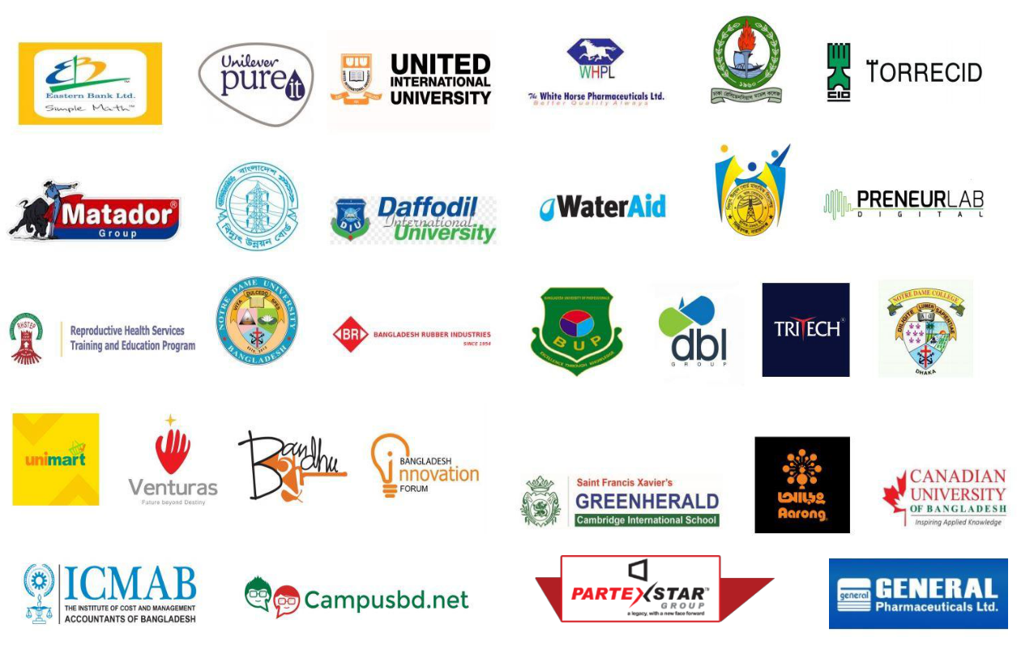

1.9 Online products scale of Bella Eventos

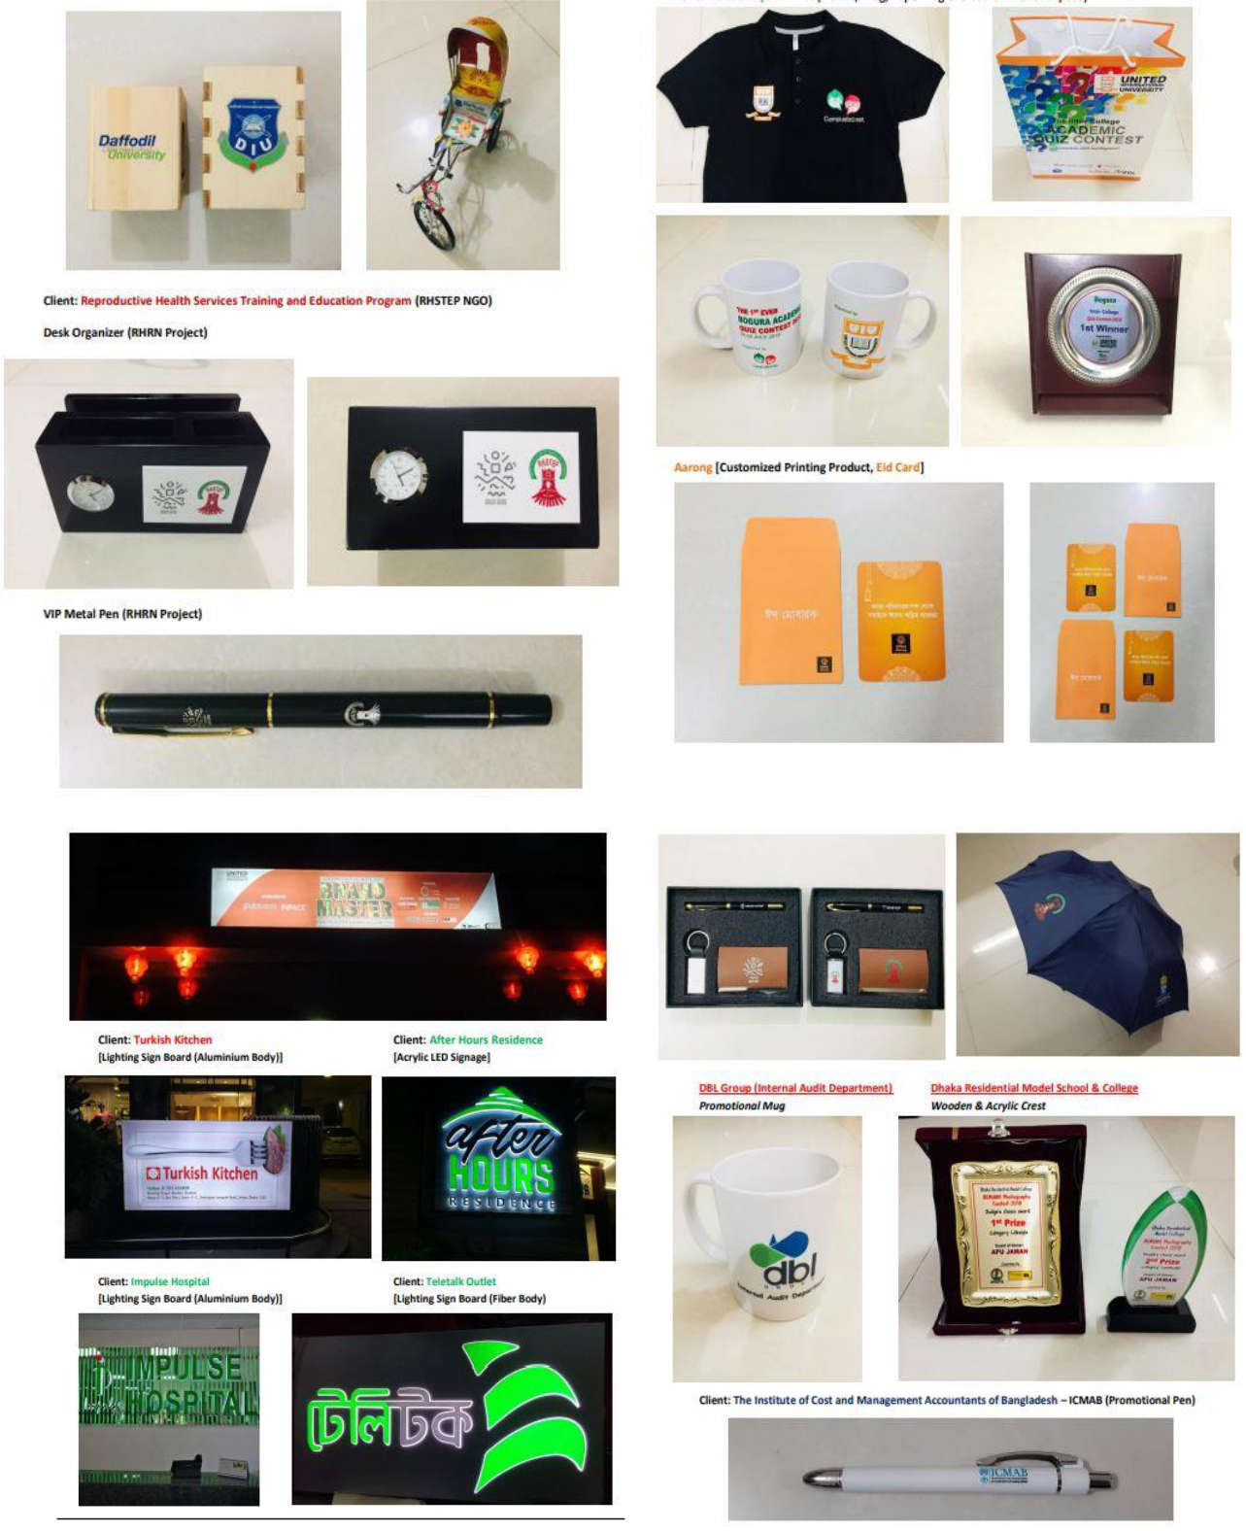
Bella Eventos recently started online selling various category products. Bella Eventos online business page name is “Bella 360”. Bella 360 means they sale all category types products by online. Which is grocery products, computer products, various electronic products and pet food, medical equipment etc. Their future is they will provide all kinds of products which will available on their website.

1.10 Our Strength

1.10.1 Plan for success- Only we understand you and your demand. We making a strong plan for succeed our project.
1.10.2 Creativity and expertise of work- We provide various background of design, advertising, strategic planning for successful event.
1.10.3 Price, Quality and service- We provide quality full service for our customer. Our price is too competitive and reasonable also. We strongly dedicated our service and give guarantee to quality our products.
1.10.4 Providing solution- We give 360 degree exclusive solution to our customer. We have superior capabilities and we are also multi-dimensional event management agency.
1.10.5 Meeting deadline- We strongly maintain our time accuracy. Because we believe that timely work is our strength. If we failed to doing meeting with our client in due time we treated us failure company.

1.11 SWOT analysis of Bella Eventos

Strengths -
- Bella Eventos service quality is very excellent. It’s their big strength. For their service quality they are very popular in the corporate level. Bella Eventos believes in quality not quantity.
- Comparable with others event management company Bella Eventos price is more affordable and reasonable. So that every customer can get their service in the range of their ability. Reasonable and affordable price is their anther strength to attract the corporate customers.
- Bella Eventos has loyal employee. Because a loyal employee can doing everything for their company success. Bella Eventos employee are loyal and more dedicated to their company progress. Loyal employee is company strength.
Weaknesses-
- Event management training program is costly. Bella Evenots arrange various training program for their employee skill development. This training program is too much costly and they spend more money to arrange this but this training program don’t give any result.
- Bella Eventos few employee has no real market experience. So that they can’t work properly. It’s their weakness.
- Bella Enentos don’t create any brand awareness for their branding. So that many corporate don’t know their name. Bella Eventos are weak in to create their brand awareness in the corporate market.
Opportunities –
- In the event management business lots of experience manpower are available in the job market. That why Bella Eventos can easily take this opportunity to hire experience manpower for their company development. It’s a big opportunity for Bella Eventos to get experience people.
- Bella Eventos gets huge support from the government like others company. During COVID situation our government gives many support among the all new business organization. So it’s huge opportunities for Bella Eventos.
Threats-
- Event management business market is highly competitive. Because Bella Eventos is new event management firm. It’s very challenging to survive for Bella Eventos in the competitive market.
- Most of the time Bella Eventos depend their employee. Because can’t possible every time to monitor the field work by the company director. That’s why it’s a big threats for them to believe their employee work.

1.12 My responsibility as a “Marketing Intern”

1.12.1 My job

I was appointed at Bella Eventos as a marketing intern but likely I worked Bella Eventos as a full time employees. At starting my internship. I had go through their seven days training session to develop my skill and work efficiency. Their training helps a lot to increase my confidence in the long run. After this training session my reporting supervisor welcome me in their team. He gave me a short brief about their organization and their work and my job description.

1.12.2 Job responsibility

My responsibility in this job was specially branding and design the entire plan of the event of Bella Eventos. Sometime I was follow up to know their customer expectation and demand. According to the customer demand I had to change our primary plan. I work Bella Eventos branding department. I had visited many corporate house to branding Bella Eventos. I had done many meeting with the corporate client. Before the every event, especially I had looked after the marketing materials which is relate to the branding activity. Here I also keep contact with their corporate customer, supplier, and different stakeholder which is related with their event activity.

1.12.3 Different aspect of my job performance

Working with fully unknown team and new environment and new location it was big challenge for me. Then coordinating with their new department was another new challenge for me. That time hard task for me was communication with their new client and keep continuous communication with them. I had also follow up and look after their all marketing and branding tools which is need for their branding. Such as leaflet, banner, poster those things is totally new for me. Most of the time I had finish my task within a short time. Always I have to more concern about time management and finish the job before the deadline. During my internship time I got many experience about corporate branding and marketing activity. This experience will help to build up my next career.

1.12.4 My observation

The fact is marketing and branding is challenging subject. But where we had learnt only theories and concepts throughout from our undergraduate degree. But in the real business field of marketing very few of them are practically use in the business sector of Bangladesh. As a business graduate it is very important to learn practical knowledge of marketing and branding along with the theories which is taught in our class.
There is another important issue here. In the classroom. We made a team with our close friend or with those classmate whom we maintain good relationship with them. But in the work place it’s not possible to made team with close people or those people we like most. So we should think and consider this matter and we should select member randomly for our class project. This will help us to improve our team work which help us to our future professional life.

Chapter Three

Literature Review on corporate Branding

3.1 What is branding

Branding is the process of giving a meaning of a specific organization, specific company, products or their service by creating and shaping a brand in consumer mind. It’s a strategy which is design by organization so that it help people to quickly identify their brand. Giving them a reason to choose their products over the others competitors. Branding is what your business ness break through the clutter and grab your target customer attention. Branding transforms first time customer to lifetime customer. Branding makes an impact and take any business into the next level. (KELLER)

3.2 Why branding is important

Branding is critical for a business because branding creates overall impact on your company. Branding can change people perception of your brand. Branding helps to drive news business as well as increase brand value to the customer. But branding can do the opposite things if you done it wrong way. Some factor are working for increasing importance of branding-
3.2.1 Increase business value- Branding is more important when they generate their future business. Strongly established brand can increased their brand value and giving more leverage. This branding opportunity make more investing opportunity. Business establish a big places in the marketplace. Branding is the process of brand which incorporate the reputation and brand value. Strong reputation means company strong brand value. This business value means price premium, influence and mindshare. Brand is the business asset of any company.
3.2.2 Generate new customer- Good brand don’t face any trouble referral business. Strong branding means there is positive impression among the customer. They want to do business with you because they already know with your business. Your business are familiar to them. They assume dependability of using your brand name any they can trust you. If a brand is well establish then word of mouth will be their best branding technique. Like a reputation of a person a reputed brand can precedes it. Once a company can establish their certain reputation of brand in the marketplace then uncontrollable propagation started. Word of mouth pass the perception which reinforce the reputation of brand. If brand reputation is positive then customer come to contact with company and show interest to doing business with them.
3.2.3 Improve company employee pride and satisfaction- Employee feels proud when they worked for strongly branded organization. Employees are more satisfied with their job. Working for reputable brand and it held high regard. People working of those company because that are more enjoyable. As a strong brand they must be aware of human interaction. If employees with excellent association with the strong brand then employee will fell motivate and happy to working.
3.2.4 Create trust in the market place- A brand reputation can spoil down if they fail to gain their client trust in the market place. If you more trust a brand then it better your perception of it. The strong things of its reputation and the brand itself. For company branding organization should searching a right way to gain certain level of customer trust. This trust is done by only establishing more realistic and more attainable promise that the brand certain way in the market. They deliver products on the promise. The company promise is delivered then the trust automatically build up the stakeholder mind.

3.3 What is corporate branding-

Corporate branding is very big term which cover the all marketing affairs of their professional company and they associated with each other. Corporate branding is a core value of a business. Corporate branding is that how they represent their corporation in the world. How they present itself it’s their own employees. Employee, stockholder, company partner, employee plays important role in shaping the image of company brand. Successful company use their logo, company slogan, which is represent their company products or service. These can their identity, promise and their tradition. (shahri, 2011)

Chapter Four

Corporate Branding Strategies of Bella Eventos

4.1 Marketing mix strategy of Bella Eventos

Marketing is key process to represent your business to the people or company. Those who might be your customers. Sometime company come to market with different innovative idea and various service but they fail because lack of their marketing strategy. Marketing mix is the key aspect for company or marketing professional. They uses it to branding their products or service. Bella Eventos uses this aspect to branding their service in the various corporate field.
4.1.1 Products- Bella Eventos is event Management Company. Our products is intangible service. Bella Eventos provides various types of service.
- Event management- Bella Eventos is an event management company. Our first service is event management service to the client. We do design our event planning according to our customer demand and we execute our plan.
- Creative solution- We do blend of creative strategy for promotional activity in front of the corporate house. Bella Eventos creative team implement new innovation idea for branding Bella Eventos service which can different from others.
- Technical support- Bella Eventos IT expert team is always ready to provide any type of IT related service.
4.1.2 Price- Pricing strategy of Bella Eventos follows reasonable pricing. Because Bella Eventos is new event management company. We have to cope-up with giant event management firm. We also cope-up with competition our service and price lower than our competitors for branding our organization.
4.1.3 Place- Bella Eventos head office is located on the west Dhanmondi, Dhaka 1209. Our office convenient place for our customer and any corporate house. They can easily reach us by Facebook, Instagram , our website etc. Any time they can work order from our office.
4.1.4 Promotion- For promote our work `and corporate branding we utilized different promotional and creative tools. Bella Eventos uses digital media, social platform for branding their work. Sometime Bella Eventos arranges various contest in different occasion like 16 December quiz competition. But if we want to increase their brand awareness to the various corporate organization we should more focus on our customer service and potential customer. We should give more concentrate on this area.

4.2 Brand positioning

Brand positioning for corporate branding is another important element. Bella Eventos follows some steps for positioning their brand in the corporate sector.
4.2.1 Customer service brand positioning- Bella Eventos promote their friendly customer service for differentiate themselves from others event management company. Others event Management Company try to strongly highlighted their service system. The most intangible benefit for branding Bella Eventos is their customer service in the corporate level. Bella Eventos thinks that a happy customer turn into a big brand promoter of their company in the other corporate sector.
4.2.2 Convincing based brand positioning- Convincing based brand positioning strategy of Bella Eventos are trying to the customer of the corporate sector why the Bella Eventos service is more convenient than their others competitors. Bella Eventos convenience their corporate customer based on their wide accessibility, transparences, trustworthy, better and innovative service and their non-stop support. Bella Eventos convenience their corporate customer because of their innovative planning and beautiful event decoration and good customer feedback from previous work.
4.2.3 Price based brand positioning- Bella Eventos uses price based positioning for their company to the corporate level. Their price based strategy represent their service as the affordable service. Bella Eventos positioning their service at cheapest price in the market for generate big customer base in the corporate sector. Because no others event management company spend more than Bella Eventos have to. Bella Eventos thinks that offering lowest price service is an easy way to branding their company in front of various corporate company.
4.2.4 Quality based brand positioning- Bella Eventos implement this strategy because they emphasis their quality service to their customer for their branding. Their quality of service shown them they are best event Management Company. Their quality of service shown that they uses high quality materials for their event management implementation so that they can branding their company in the corporate level in a positive way.
4.2.5 Differentiation based brand positioning- Bella Eventos try to make themselves differentiate from their competitors because of their uniqueness. They differentiate themselves from traditional company for their qualities of service. Bella follow this branding strategy for positioning their company in the corporate level as a innovative and unique event management company so that customer and other corporate house easily attract their service.

4.3 Advertisement

Business organization looking to branding their company by advertising. They need to choose which type of advertising should be fit for their company depend on their budget and target customer. Bella Eventos branding their company following some advertising –
4.3.1 Social media advertising- Social media advertising is very popular now a days for branding the company in the corporate level and to the customer. Because this advertising cost is very affordable and easily reach to the target customer. There are some social media platform which is used Bella Eventos for branding then to the corporate house

Facebook- Facebook is the great choice for business organization. Bella Eventos also use this platform for branding their organization. Its widespread adaption and relatively low cost Bella Eventos use this platform. Most of the corporate people use facebook and at least they log in their facebook ID once per day. Because facebook has different unit for giving advertisement like video, page like, various customer offer and event response. Bella Eventos use this unit for corporate branding through facebook.

LinkedIn- LinkedIn advertising is bit expensive than other social platform. But for corporate branding is more effective. Bella Eventos use this platform for their corporate branding. Because corporate professional people use this platform. It’s a great option for Bella Eventos to doing business to Business (B2B) service. Bella Eventos target corporate professional people to giving linkedIn ad.


4.3.2 Mobile advertising- Mobile advertising is digital advertising. Which serve advertisement on mobile device. Because maximum corporate use smartphone. Bella Eventos give mobile advertisement for their corporate branding. Bella eventos give mobile display ads, mobile search ads and mobile video ads of their event management related work to catch the customer eye on them. Mobile advertising serve only target customer mobile screen only.
4.3.3 Broadcast advertising- Modern advertisement like mass marketing is TV, radio. This advertising method is very popular for branding your company. Broadcast advertising is much costly for any organization. But this advertising is more effective. Bella Eventos shoe their event management work by the broadcast advertisement to doing their corporate branding. They give their advertising on radio and TV when any international cricket match and football match live telecast on TV and Radio. Bella Eventos thinks that this time is best for their corporate branding.



4.3.4 Print advertising- Print advertising is costly than social media advertisement. But bella eventos give ads on print media. Because every corporate house keep newspaper for their office staff. It’s a good way for their company branding. They give ads on various magazine. They give broachers and flyers to the people on different location. They give ads their event management photos on newspaper, magazine, and flyers. So they can reach mass people.


4.3.5 Out of home advertisement- Many company give outdoor advertising for proportioning their company products and service. Like that Bella Eventos gives outdoor advertisement for branding their company. Bella Eventos gives billboard ads, transit ads (bus shelter, train ads etc) for branding their company service to the people.

4.4 Strategic roadmap for corporate branding

4.4.1 Brand awareness- Bella Eventos creates brand awareness for branding them in the corporate level. They post their content in the popular blogging site so that they can branding their service. Bella Eventos post many social awareness video on social site. So that people can see their massage and know their name. In this COVID 19 situation Bella Eventos gifts mask and hand sanitizer to the corporate customer for branding them.
4.4.2 Day out plan- Bella Eventos organize some event for one day planning. They go to various corporate house and university. They organize come contest and give small gift who win the contest. They decorate photo booth. They capture photo free in cost. They edited their photo free of cost. By this way Bella Eventos organize one day planning for their corporate branding.
4.4.3 Bella Eventos Event discount- Bella Eventos gives huge discount in the special day like independent day, mother language day, eid and others big occasion for their corporate branding.

4.5 Digital marketing

Bella Eventos promote their brand through uses of various digital platform. Now a day’s digital marketing is best way to reach the target customer and corporate branding. Bella Eventos uses following ways to branding their company to the corporate level.
4.5.1 Bella website- Bella Eventos thinks that their website is digital storefront and its work as a company location. Bella Eventos website is very update. Because when a customer wants to know their service, their products, their hours of event related works and contact information then they Google their website. Where any customer will found their every details of work and information easily.
4.5.2 SEO- Search engine optimization is another digital marketing tools to promote branding activity to the corporate level. SEO ensure that your company easily found on search engine. Bella Eventos branding their event activity through SEO. Because SEO is very popular for branding their company activity to the corporate level. Bella Eventos design their website with SEO mind so that people easily found them when they seek information on search engine.
4.5.3 Email marketing- For doing corporate branding email marketing is another popular way. Because email marketing is more professional. Bella Eventos promote their corporate branding through email marketing. Bella Eventos knows every corporate people uses email and their good platform to branding their company to the corporate level. Online email is good way to reach corporate people those who don’t use social media. When Bella Eventos launch any new event they add their photos, video, relevant information and send their target customers.
4.5.4 Content marketing- These days simply advertisement is not enough to branding your company and its service. Because market is too competitive. That why Bella Eventos promote their company service to the corporate level through content marketing. To make loyal customer, returning customer base Bella Eventos thinks content marketing is very important for them. Where direct marketing only emphasis only sales but content marketing focus on trough videos, photo, blog post where people read about company activity. That why Bella Eventos focus on content marketing for branding them in the corporate level.
4.5.5 Social media marketing- Bella Eventos promote their branding through social media marketing. They advertising their company through Facebook, Instagram, and Twitter. Because everyone use social media. They upload their event management photo, video, live their event. In Instagram they upload their HD photo and video. In the page Bella Eventos upload their all work in their Facebook page.

4.6 Important factor in branding at corporate level

Some infortant factor helps to any company to branding them in the corporate level and their target customers. Now will describe some important factor which must have to a company for branding to the customer.
4.6.1 Brand Identity- The first thing to discuss your brand identity to corporate level and your customer. What is your image, what is your goal? It should be clearer to your audience. Your brand name should be more inventive. An inventive name will help you to instantly stand out to your target corporate customer. Any company needs a beautiful name which is reflect their company to the corporate level. You have to think about your geographical location, founder and the word which is more associated with your company. Make sure your brand name should be noticeable from your different competitor. Your company logo is visual presentation of your company. Your company logo should be simple, memorable and appropriable. It should be more eye catching. Ensure that you will use your logo for long term. A company tagline is a big part of your company.it should be short and it can be represent your brand activity to the corporate customer.
4.6.2 Engaging content- A big part of your company is your content. Content is king but present scenario customer not only satisfied with content they expect more. For branding your company to the corporate level you have made your content creation is an excellent way. If you share video, photo, written content but remember this it should be more relevant to your company work. You made a content and try to deliver short message of your work to the corporate customer then it will be help you branding your company.
4.6.3 Brand loyalty- Brand loyalty is more important for branding. Keep your customer must have satisfied for being brand loyalty. Then they will automatically branding your company. A better branding will help customer loyalty. Because loyal customer support you always. They spread positive message to people they know in the corporate level. They are act as your brand ambassador.
4.6.4 Company purpose-Every company has a business purpose and they made it. The benefit you offering and what will make you unique from others. These are important to focus when you describe your work for branding. Your business purpose should be more specific. So that it can differentiate from your competitor. Bella Evenots business purpose is provide best quality service to their customer so that their event should memorable for them for long run. As a company your expression should be deeper so that you wish to make your customer event more memorable.
4.6.5 Consistency of work- The main consistency of your brand should avoid talking about those things doesn’t relate your company work. If you added a picture or video of your event related work. What is mean by this video or does it your company work related message, does it funny? Everything must have consistency for corporate branding your company. Consistency contribute any company for their recognition.
4.6.6 Brand personality- Brand personality is human character associated with the brand. Any company if the branding their company in the corporate level they should focus on their brand personality not only on brand image. Brand image is how to your brand look and brand personality means the way your brand sounds. Every brand has their unique voice for the corporate branding. For corporate branding you have to determine your brand voice and brand personality. For making brand personality strong you have to set few things. Your brand mission, concept and vision of your company, service etc. Another important things research on your target customer to make your brand personality.
4.6.7 Brand Image- For corporate branding company image is more important. Because every customer looking for best image brand for doing their business or work. Brand image is unique association of customer mind that where brand is stand and what promise the brand makes for their customer. Brand image is important factor to affecting the brand branding activity. Bella Eventos has good brand name in the event management company. Their unique event planning and quality service creates an excellent brand image in the corporate level. It helps them to doing their branding in the corporate level.

4.7 Program sponsorship

Bella Eventos are very conscious to branding their company in the corporate level and their target customer. They participate lots of sponsorship program for their corporate branding. Bella Eventos few program sponsorship are given below-
4.7.1 College and University program sponsorship- Bella Eventos gives college and university program sponshorship. Because lots of people attend them. It’s a big platform for them. They sponsor university case competition and others sports related program. Because media coverage this program. Lots of young peole attent the program and they are their potential customer.
4.7.2 Cricket sponsorship- Bella Eventos doing cricket sponsorship in various cricket sponsorship. Because mass peole enjoy cricket game. Lots of people show their name in the list of sponsorship. In the break time media show Bella Eventos name and their service on the TV screen. It’s a big branding for Bella Eventos.
4.7.3 Fashion show sponsorship- Sometime brand house arrange fashion show program. Lots of corporate house has a brand house. That’s why Bella Eventos sponsor their fashion show program. By this way Bella Eventos doing their corporate branding. Many corporate people attend this program and a big chance to Bella Eventos to link with them.
4.7.4 Drama series and TV show sponsorship – Bella Evetos sponsor various drama series and TV show. Because mas people watch TV program. It’s a big opportunity and big platform to capture huge customer and corporate branding. Media give TV advertisement and show Bella Eventos name. That’s why show everyone their name and their service.

4.8 Alternative branding strategies for corporate branding

Bella Eventos follow some alternative branding strategy for their corporate branding. Here I will describe some alternative branding strategies of Bella Eventos.
4.8.1 Networking- Networking is the first things `and best way to start for branding. Bella Eventos associated their company with nearby company. That’s why many referrals comes from Bella Evebots client. Bella Eventos keep good touch for their client for branding their company. Bella Eventos doing networking with many business pioneer so that they are first on their mind when any corporate company need any event coordinator for their event. For long run communication Bella Evenots uses social media like Facebook, LinkedIn for branding their company.
4.8.2 Socialize- Using social media Bella Eventos connect their target customer and various corporate customers. This social media platform helps Bella Eventos to get right attention to the corporate level. Who work with your organization many corporate customer customer follow it on the social media. That’s why Bella Evetos never underestimate the word mouth power branding. Bella Eventos know that 70% customer depend on their peer recommender for buying any service. That why Bella Eventos hire some volunteer to talk influencer how the event is going to be more attractive.
4.8.3 Live your event- Now a days live telecast is more popular for branding company service to the corporate level. Facebook is big platform to spread your company service. A live Stream is more popular and new trend for branding where Bella Eventos can direct interaction with their direct customer and they invite them. Bella Eventos use this opportunity. Bella Eventos give their corporate customer big message why they don’t miss their event. Bella EVentos show their every innovative work by their facebook live stream. Most of the marketing professional think that live broadcast of any event can help to impact on their company branding.
4.8.4 Pop up & page landing- Bella Eventos create pop up in their event website to their target customer for dedicated event page. Pop up is very annoying but it work effectively. Bella Eventos use their content in the landing page. Pop up works as a key factor for determine to brand their activity to the corporate level.
4.8.5 Promise good time and service- Bella Eventos uses multiple medium to show their target corporate customer what an excellent time they are enjoying from their event. Bella Eventos shows promotional video, photos and their content which is their great resource to branding their company to the corporate level. It’s like a beautiful move when their event trailer comers to Bella Eventos social media site and their website. Then people start talking about their work and they can’t wait more for see the full event. In this way Bella Eventos branding them in the corporate level and customers. Bella Eventos give a visual text to their audience they give the best effort to make their event more memorable, decorate and good time and service.
4.8.6 Online and local listing- Bella Eventos doing online local business listing for branding their company. They listing their local company website in their office region. So that they can branding their company free of cost. Bella Eventos head office located at dhanmodi. They listing some local office which is also locate at dhanmodi. It can be difficult to figure out which company need service. Simply Bella Eventos go to the list and promote their business in the local business organization.
4.8.7 Use business card- Bella Eventos uses business card for branding them in the corporate level. They give it their customers for making a good impression. Bella Evenots gives their business card at their networking event, their client business meeting, corporate visit or other suitable situation and corporate people. Business card is best strategy for branding business planning. Bella Eventos provide business card to their all employee so that that they can leave their business card. Because personal contact plays a vital role for formation business relation. That’s why Bella Eventos done this.
4.8.8 Trade show- Trade show and work exhibition is good opportunity for branding company service to the corporate level. Sometime Bella Eventos arranges trade and photo exhibition for their branding. Event fair will let you to show your company work and doing network with your customers. Bella Eventos attend trade and photo exhibition and walk the fair in order to interact with the corporate people and their target customer

Recommendation

Now I will give some recommendation based on my internship experience.
- Bella Eventos arrange lots of training session for their employee skill development. This training cost is too high for them. Few training is unnecessary for employee. They should reduce their training program so that they save money for others development.
- Bella Eventos branding department need more experienced people for branding their service, their products to the corporate level. That’s why they need more experienced and more qualified employee those who are experienced in corporate branding.
- At present event management market is too competitive. Every company try to branding their company by a unique way. They try to increase their brand value to the customer. They should offer discount, boost up their promotional video, offer corporate offer. In this way Bella can improving their brand value to the customer.
- If Bella Eventos capture the most of the corporate sector they must monitor their competitor branding strategy. How their competitors branding them in the corporate market. To follow their strategy Bella Eventos should take more unique branding strategy.
- Bella Evenots needs hire more experienced content writer. In their branding department they need more experienced hand.
- To survive in the competitive market Bella Eventos need to develop their own branding strategy. Like how they reach the corporate level, change their advertising strategy, should focus on digital marketing. By following this way they can develop their corporate branding strategy.
- Sometimes Bella Eventos don’t bargaining with their vendor. As a result they fail to earn more profit. For earing more profit they must be bargaining with their vendor.

Conclusion

Bella Eventos gave me an excellent place for doing my internship. Where I was able to gain many practical knowledge of branding and marketing. I had worked their different areas and my job responsibility help me to develop my skill. As a marketing intern it was my best experience to observe the all process of their branding and marketing activity closely. The experience of branding activity and their planning event for different company and brand was extremely good for me. My supervisor help me during my learning process with patiently. He teaches me and give my key responsibility. Some task wouldn’t be possible to help my co-worker. Other employee always motivate me for my work so that I could give my best effort to complete my responsibility. Hence my future career plan is set I will be working branding and marketing sector.

Reference

www.bellaeventos.pvt.ltd

KELLER, K. A. (n.d.). KOTLER AND KELLER MARKETING MANAGEMENT 4TH EDITION PDF. E-BOOK.
shahri, M. h. (2011, September Monday ). THE EFFECTIVENESS OF BRANDING STRATEGY IN MULTI-BUSINESS COMPANIES. Australian Journal of Business and Management Research, 1(5), 51-59.
Bella Eventos file and documents.

