
Internship Report on
The Banking Industry of Bangladesh
&
The City Bank Limited

Submitted to:
Dr. Md Mohan Uddin
Professor
School of Business & Economics
United International University

Submitted by:

Rifat Suria

ID: 111 141 207
BBA
United International University

Date of submission: 02.02.201
Letter of Transmittal
Date: 02.02.2019

To
Dr. Md Mohan Uddin
Professor
United International University
School of Business and Economics

Subject: Report Submission on “The Banking Industry of Bangladesh and The City Bank Limited”.

Dear Sir,

I am pleased to present u my internship report on ‘’The Banking Industry of Bangladesh and The City Bank Limited’’ which I have done under your instruction. I am grateful to you for giving me the opportunity to work on such a topic for which I have learned so many things and gathered an enormous knowledge about our banking industry. This internship and my report are a part of my BBA program, so it is very important for me.

To make this report I have conducted discussion with some of the officers of the bank and also used my personal observation. I have collected my required data, documents etc. from them and tried my level best to put it on my report.
Your acceptance and appreciation are very important and it will motivate me a lot. I would like to clarify all the things if there is a need of any explanations. Would you please accept my internship report and oblige me thereby?

Thank you.

Sincerely yours,

Rifat Suria
Id: 111 141 207
BBA
United International University

Acknowledgement
At first, I would like to express my gratitude to almighty Allah for special blessings in completing my internship report. The Internship report titled as “The Banking Industry of Bangladesh and The City Bank Limited” -which has been prepared for the requirement of BBA degree.
I am very pleased to my supervisor Dr. Md Mohan Uddin, Professor, School of Business and Economics, United International University, for his instructions and support in completing my internship report and suggestions from the very beginning of starting this report.
Lastly, I would like to express my gratitude to all the employees of The City Bank Limited. Specially Abdullah Al Faisal (card manager), Zafor Hasan Chowdhury (Branch Manager), Tanvir Ahmed (CSM), Mesbahur Rahman (Branch Operation Manager) who helped me throughout my internship period and taught me about corporate life.

Executive Summary

This report is on Analysis of the Bangladesh Banking Industry and Analysis of The City Bank Limited. This report is prepared for the requirement of my BBA program and supervised by Dr. Md Mohan Uddin, Professor, United International University. The general objective of this report is to give an overview of the banking industry of Bangladesh particularly The City bank limited and the internship experience. There are also some specific objectives which are to present the scenario of the banking industry of Bangladesh and The City Bank Limited and the internship experience of the author with some recommendations for those three particular topics.
This report is divided into five chapters. The first chapter will present the introduction part that means the introduction of this report, objectives of this report and the significance of this report. The second chapter will present the Bangladesh Banking Industry. It will include some of the selected issues of the banking industry. Then the third chapter will present some information about The City Bank Limited at which I have completed my internship program. The fourth chapter is about my overall internship experience at The City bank Limited. And the last and fifth chapter is about my recommendations for the organization The City Bank Limited and some recommendations for my self-improvement.
The key findings of this report are the present scenario of Bangladesh banking industry with that the performance of The City bank limited. The banking industry of Bangladesh is growing day by day but now what the challenges they are facing and what the world has to say about our banking industry. Another finding is a particular banks function from the observation and experience of the author.
Table of Contents
Chapter 1 : Introduction .......................................................................................................1
Introduction ................................................................................................................... 2
1.1. Background ……………... ...................................................................................... 3
1.2 Objectives of the Report ......................................................................................... 5
1.3 Significance of the Report ................................................................................... …6

Chapter 2: Analysis of the industry ................................................................................. 7
Analysis of the industry ................................................................................................ 8
2.1. Specification of the industry ................................................................................... 8
2.2. Size, trend and maturity of the industry ................................................................ 14
2.3. Seasonality ........................................................................................................... 18
2.4. External economic factors .................................................................................... 20
2.5. Technological factors ........................................................................................... 22
2.6. Political, legal and regulatory factors ................................................................... 24
2.7. Barriers to entry .................................................................................................... 26
2.8. Supplier power ..................................................................................................... 26
2.9. Buyer power ......................................................................................................... 27
2.10. Threat to substitutes ........................................................................................... 27
2.11. Industry rivalry .................................................................................................... 28
2.12. Summary of challenges and opportunities ......................................................... 28

Chapter 3: Analysis of the organization ................................................................ 31
3.1. Overview and History ........................................................................................... 32
3.2. Trend and Growth ................................................................................................ 36
3.3. Customer Mix ....................................................................................................... 41
3.4. Product/ Service Mix............................................................................................. 42
3.5. Operations ............................................................................................................ 50
3.6. SWOT analysis ..................................................................................................... 56
3.7. Steps/strategies to meet the challenges and opportunities................................... 62

Chapter 4: Internship experience .............................................................................. 63
4.1. Position, Duties and responsibilities ..................................................................... 64
4.2. Training ................................................................................................................ 64
4.3. Contribution to departmental functions ................................................................ 65
4.4. Evaluation ............................................................................................................ 66
4.5. Skills Applied ....................................................................................................... 67
4.6. New Skills Developed .......................................................................................... 67
4.7. Application of Academic Knowledge ................................................................... 68

Chapter 5: Recommendations ................................................................................... 69
5.1. Recommendation for improving departmental operations ................................... 70
5.2. Recommendations for improving self- performance ............................................ 72

Conclusion ......................................................................................................................... 73
References ......................................................................................................................….75

Chapter 1
Introduction
- Introduction:

Internship is an indistinct requirement of graduation. It provides a great opportunity for any student to get some important and brilliant ideas about the practical field. It is also a challenging experience to make Internship Report which increases intellectual abilities as a skilled graduate. As par the requirement for the completion of BBA program, I was assigned for internship at The City Bank Limited for the period of three months. As Banking Industry have emerged as the most important player of our economy and they also offer a passionate environment for career development so I intend to prepare my internship report on banking industry.
In this report, I have shown an analysis of the industry, analysis of the organization, internship experience, some important recommendations, lastly conclusion and references. As an intern to enrich the practical knowledge and experience, every student is needed an institution for academic purpose. From the knowledge of internship experience, an internship report should be made after completing the internship. I have completed my internship program at The City Bank Limited. I have done my work on the practices of general banking activities of the bank.
This internship report entitled “Industry Report on Banking Industry of Bangladesh and The City Bank Limited” under the instructions of my honorable intern supervisor Dr. Md. Mohan Uddin, PhD, Professor and Director of MBA and EMBA programs of UIU Business School,” for the requirement of the partial fulfillment of the BBA program at United International University.

  - Background:
Economic growth is the key indicator of government’s performances; hence, economists always trying to help policy-makers in this field through accurate identifying of dynamisms and factor affecting this indicator. On the other hand, financial and monetary markets play a dynamic role in directing existing funds in economy toward producing and industrial sectors to improve economic growth. In this regard, some economists believe that expanded financial markets are driving force of economic growth is countries.
In recent years, economic growth and financial development have been the subject of comprehensive research. In the economic growth process, their influential functions on financial liberalization placed the basis for the renewed interest in the role of financial intermediation. A new light on the link between financial and economic development shed the emergence of the endogenous development theory. There is a tend to grow quicker countries with better development financial system. There is a requirement to control for social, Institutional and political disparities and here, existing experimental studies focus on the influence of financial development to all over the country. Moreover, Country level economic studies show that small, regional and locally owned-banks may act very differently from large, national and non-locally owned-banks while cross country experimental studies are not capable to capture the influence of banking system specificities on local economic development. In rural areas, local banks could improve financing opportunities to medium and small size enterprises and service entrepreneurship in developing countries where economic growth is hampered by unsatisfactory and inadequate access to financial services. At that point we can assume that political governance and macroeconomic environments such as- industrial policy, banking regulation, education, health policies and monetary and exchange rate policies are relatively same among all the regions. The limited presence of equity markets as source of finance and only for the largest corporations is bank-based as proved the financial system in the Bangladesh. Background of the banking industry of Bangladesh are shown in the following figure 1.1.
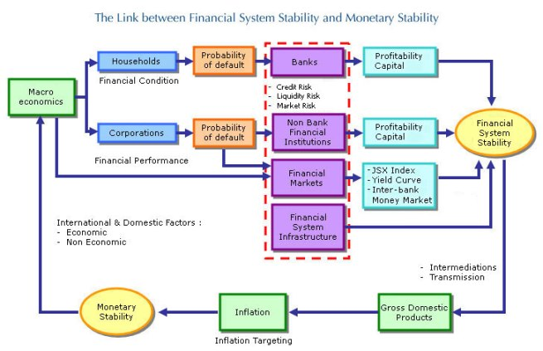

Figure: 1.1: Background of Banking industry of Bangladesh.

In the figure 1.1, therefore, it is expected that bank is the primary source of funding for the majority of economic activities and not through financial markets. This conduct us to concentrate on structural differences in the banking industry among areas in order to provide deeper insights into the finance-growth connection. Financial intermediaries are subject to common functional needs including-capitalization, capital adequacy, limitations on single borrowers and shareholders and restrictions on bank branching.
In 1972, Nationalized Commercial Banks were established in Bangladesh through merger of twelve Commercial banks. These banks were working in pre-independent Bangladesh permitting the poor access to fund, increasing domestic investment and reducing capital flight to foreign countries were some of the basic objective of this nationalization. Those banks have changed their strategies and policies with time change, which were not satisfying the class banking policies of the government. The progresses made by the banking industry since nationalization was not remarkable, it has been observed on the basis of the activities of commercial banks. The due role in the accomplish of government policies and programs that the nationalized banks could not play. Therefore, from mid-80, a trend of de-nationalization of banks started.
From the perspective of GDP growth, Bangladesh’s economic development has been quite inspiring in the last two years, which was seven-plus percent both years, according to figures from government and other sources.
A single bank is linked with other banks for payment system and other functions of bank. The failure of a single bank not only affects its stockholders and depositors rather it affects rest other banks and even all rest other business. The failure of a single bank generates an economic emergency situation and is considered as a disaster for the economy.

1.2. Objectives:
The objectives of this report are the following-
- To analyze the Banking Industry of Bangladesh.
- To analyze The City Bank Limited,
- To describe the internship experience.

  - Significance of the Report:
The significance of this report is more because it will help me to develop my future career as a reference document. This report will include the analysis of the banking industry, analysis of The City Bank limited, my internship experience and my recommendations for improving departmental operations and recommendations for self-performance. As an intern of The City Bank Limited and it’s really a good experience to do internship. From this internship report, I will acquire knowledge and judge to myself which is important to build up my future goal. I have gained practical knowledge regarding corporate environment through internship and I will apply this knowledge first in real world experience through this report.
Moreover, this report may be helpful for many policy makers, industrialists or business persons. They can take current information in this report which will help them to generate profit for their companies and they can also observe present market scenario of Bangladesh. So, the significance of this report on Banking industry of Bangladesh and The City Bank limited is very much.

Chapter 2
Analysis of the Banking industry

2. Analysis of the Banking industry

The industry analysis report sheds light on the economic health of the company, underlining the understanding whether it will be valuable for the stakeholders to invest in such a company and offering recommendations or corrective actions to take in case of any untoward developments in the company. For economic success, banking system of a country can be said as a barometer. For modern trade and commerce, well-developed banking system is essential. The banking industry of Bangladesh has played a pivotal role in mobilizing savings and providing funds to various sectors of the economy. Throughout this journey, the sector has experienced several challenges similar to those experienced by many developing countries in their early years of development.

2.1. Specification of the industry:
I am doing my internship at The City Bank Limited and it is under the banking industry.
Banking industry plays a crucial role in the economic development of the country. The largest banks in the industrial world have become more complex financial institution at the starting of the 21st century. Those banks offer a wide diversity of to international markets and controls billions of dollars in cash and assets. To identify new business positions, to accomplish advanced strategies, to flourish customized services and to capture new market opportunities- bank are working and supporting by the modern technology. The banking industry will become more complex by further diversification of the financial industry, deregulation, consolidation, globalization.
Even though, all over the world, the banking industry does not function in the same way. So, most of the bankers assume about corporate clients in terms of the following:
Commercial banking:
Commercial banking that includes services like- cash management, credit services, deposit services and foreign exchange. Cash management services includes-money transfer, bank reconcilement and payroll services. Credit services includes-commercial loans, asset-based financing, line of credits. Deposit services are- checking and savings account services.
Investment banking:
Investment Banking is the banking that includes- equity private placements, placements of debt securities with institutional investors, an arrangement of services from asset securitization, acquisitions, corporate restructuring to securities underwriting and coverage of mergers.
With six state commercialized banks, two state-owned specialized banks and three foreign banks, the banking industry in Bangladesh started after independence.
After independence, the banking industry in Bangladesh started with six state commercialized banks, two state-owned specialized banks, and three foreign banks. In the 1980s, the banking Industry of Bangladesh significantly extended with the access of private banks. At present, banks in Bangladesh are primarily of two types:
- Scheduled banks: Scheduled banks are the banks which get license under bank company act, 1991.

- Nonscheduled banks: Nonscheduled banks are the banks that are established for a certain and special objective and execute under the acts that are enacted for meeting those objectives. banks that are established for a special and definite objective and operate under the acts that are enacted for meeting those objectives. All the functions of scheduled banks which cannot be performed by nonscheduled banks.
- Ansar VDP Unnayan Bank
- Karmashangosthan Bank
- Grameen Bank
- Jubilee Bank

In Bangladesh, there are 56 scheduled banks that operate under full control and supervision of Bangladesh Bank, which is authorized to do so by Bangladesh Bank Order of 1972 and the Bank Company Act 1991. Classifications of the scheduled banks are the following types:
- State-owned commercial banks (SCBs): In Bangladesh, there are six State-owned Commercial banks which are fully or majority owned by the government of Bangladesh. These are the followings:

- Sonali Bank Limited
- Janata Bank Limited
- Agrani Bank Limited
- Rupali Bank Limited
- BASIC Bank Limited
- Bangladesh Development Bank Limited

- Specialized banks (SDBs): For specific objectives like agricultural or industrial development, there are established three specialized banks which are also fully or majority owned by the government of Bangladesh. These are the following-

- Bangladesh Krishi Bank
- Rajshahi Krishi Unnayan Bank
- Probashi Kallyan Bank

- Private commercial banks (PCBs): In Bangladesh, there is a total of forty-one Private commercial banks are in operation right now. And they are majorly owned by private entities. These banks are classified into two types-
Conventional PCBs:
At present, thirty-three conventional PCBs are functioning in the industry of Bangladesh. They are performing the banking operations on conventional way like-interest based operations. These are-
- AB Bank Limited
- Bangladesh Commerce Bank Limited
- Bank Asia Limited
- BRAC Bank Limited
- City Bank Limited
- Dhaka Bank Limited
- Dutch-Bangla Bank Limited
- Eastern Bank Limited
- EXIM bank Ltd
- IFIC Bank Limited
- Jamuna Bank Limited
- Meghna Bank Limited
- Mercantile Bank Limited
- Modhumoti Bank Limited
- Mutual Trust Bank Limited
- National Bank Limited
- National Credit & Commerce Bank Limited
- NRB Bank Limited
- NRB commercial Bank Ltd
- NRB Global Bank Limited
- One Bank Limited
- Premier Bank Limited
- Prime Bank Limited
- Pubali Bank Limited
- Shimanto Bank Ltd
- Standard Bank Limited
- The Farmers Bank Limited
- Trust Bank Limited
- United Commercial Bank Limited
- Uttara Bank Limited
- Union Bank Ltd

Islami Shariah Based PCBs:
In Bangladesh, there are eight Islami Shariah-based PCBs in the banking industry. And they perform banking operations according to Islami Shariah-based principles like Profit-Loss Sharing (PLS) mode. These are-
- Al-Arafah Islami Bank Limited
- EXIM Bank Limited
- First Security Islami Bank Limited
- Islami Bank Bangladesh Limited
- Shahjalal Islami Bank Limited
- Social Islami Bank Limited
- Foreign commercial banks (FCBs): There are nine Foreign Commercial Banks that are operating in Bangladesh as branches of banks that are combined abroad. These are-

- Bank Al-Falah Limited
- Citibank N.A
- Commercial Bank of Ceylon PLC
- Habib Bank Limited
- HSBC
- National Bank of Pakistan
- Standard Chartered Bank
- State Bank of India
- Woori Bank

Bangladesh Bank is the central bank for our country. Bangladesh Bank controls, supervises, and look after the scheduled banks in the private commercial banks as well as the nationalized commercial banks. Before liberation, it is formed by combining the business of the twelve banks doing business in Bangladesh as per table 2.1 given below:

Table 2.1: Banking History of Bangladesh
Existing Bank | New Bank | Authorized Capital (Lac Tk.) | Paid-up Capital (Lac Tk.)
The National Bank of Pakistan, The Bank of Behawalpur Ltd. | Sonali Bank | 500 | 200
The Premier Bank Ltd., The Habib Bank Ltd., The Commerce Bank Ltd. Agrani Bank | Agrani Bank | 500 | 100
The United Bank Ltd., The Union Bank Ltd. | Janata Bank | 500 | 100
The Muslim Commercial Bank Ltd., The Standard Bank Ltd | Rupali Bank | 500 | 100
The Austrasia Bank Ltd., The Eastern Mercantile Bank Ltd. | Pubali Bank | 500 | 100
The Eastern Banking Corporation Ltd. | Uttara Bank | 500 | 100

Twelve Banking corporations who were doing business in Bangladesh after the liberation. And they were nationalized by the Government of the People’s Republic of Bangladesh under president’s order no.26 of 1972 entitled The Bangladesh Bank Order, 1972 on March 26,1972.

2.2. Size, trend and maturity of the industry:

2.2.1. Size:
Banking Industry’s size can be measured by different ways such as- Volume of production, Total revenue, number of customers and so on. Moreover, the measurement of market size is quite wired for the banking industry as both the total amount of deposits and advances are taken into consideration.

2.2.2. New Trends of Banking Industry:
For the deregulation in the financial sector, there has been a growing convergence among the activities of investment and commercial banks over the past decades. At present, there have direct competition among some investment and commercial banking institutions in money market operations, bond underwriting, project finance, financial recommended work and private placements. In addition, the modern banking industry has brought larger business variations in Bangladesh. In the industrialized competitive world, some banks are coming into the insurance business, investments, underwriting of securities and portfolio management. As a result, all these variations have made banks an important entity in the global business community.
Moreover, some important new trends of the banking industry in Bangladesh are the followings-
- New generation:
People who born between 1976 and 1990 they are very different to their parents. The way the generation corporate with each other is leading a change in behavior in all generations. And also, the corporate world is leading a shift in behavior in all generations. The generation are becoming progressively wealthy and rich. Over the next decade or so, they will contribute significantly to a bank’s P & L. The generation are very much more likely to purchase from the internet with online banking or mobile. They will care about brand and ethical values in banking industry.

- Role of internet:
The hulks of the internet are coming. And their final strategy in there is no hiding. Apple take a seat on cash reserve of $100bn and are to invest in new markets under pressure. Many others like Google, Pay Pal are dropping their toe into the water with payment and mobile wallet solutions. As Near Field communication is available, banks will see their transactional income decrease speedily. And other peer to peer payment services become the custom. Through acquisition or innovation these companies will move to other zones, when they achieve serious mass in this space. Banking provides many services like online dealings through internet and it allows them to control their financial accounts at any time. The banks manage the internet in banking that permits the clients to perform all the activities using a secured website.

- Data:
It is a key to understand a customer for future competitive advantage. There already have access to a much larger and deeper pool of customer data than just their financial communications (example- Sainsbury Nectar and Tesco Club card) in many of the competitor brands. Through proper combination, these are powerful tools to better understand customers, risk profile customers, generate sales and also can update the development of new products and solutions. Banks will require to develop knowledge of their individual customers from channel interaction and social media, to move beyond their limited customer insight for success.

- Islamic Banking Trend:
In spite of the world-wide economic downturn, Islamic Banking practices have been acquisitioning admiration and showing steady growth at an astonishing rate of 10-15% annually in recent years. All the rules and regulations of the Islamic banks base on the Shariah law of Fqih al-Mowasalat (Rules of transactions). Bangladesh signed the charter of Islamic development bank in August 1974. And, dedicated itself to recognize its financial and economic system as per Islamic Shariah.
In Islamic banking, one of the most distinctive practices is the loaning of money interest free. The charging of interest on loaned is prevented by Shariah law in Islamic banking. Islamic bankers have considered various programs to comply with these laws that allows for the lending of money, compliance with Shariah law and making of bank profits. In Bangladesh, some Islamic banks participate in micro lending programs. But some banking controllers find that this practice is not in accordance with Shariah law.

- Trend of Electronic Banking:
For banking service, E-banking is the latest delivery channel in Bangladesh. E-banking refers to various types of services via computer or mobile through which a bank’s customer can request information and carry out most retail banking services. The generation of electronic banking are three types such as first generation, second generation and third generation. These are showed in the following figure 2.1
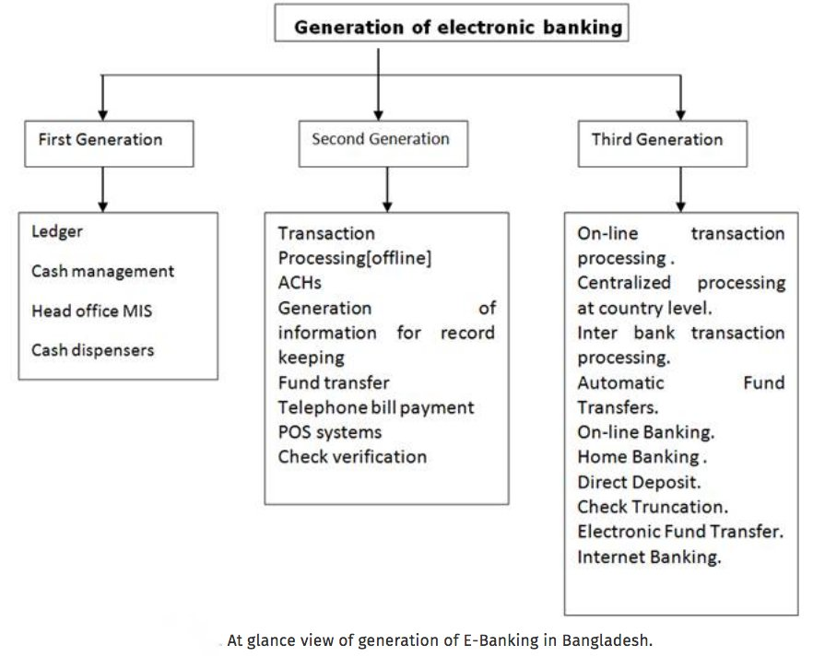
Figure 2.1: Generation of e-banking in Bangladesh
In the Figure 2.1, there have been discussed first, second and third generation of electronic banking. E-banking can also be said as the following terms-
- Internet or online banking.
- Telephone Banking.
- Mobile banking.
- PC or offline banking.

2.2.3. Maturity of the banking Industry:
At present, the maturity of the banking industry in Bangladesh is in the growth stage. New private banks are coming up, new branches are opening within two or three months, new customers are coming to open an account in different banks almost every year. As a result, according to July 30, 2001 there are 4 nationalized commercial banks, 5 specialized banks, 30 local private commercial banks and 12 foreign commercial banks operating in Bangladesh. Moreover, as on July 30, 2001 there are 27,881,322 numbers of deposit accounts and 7,462,785 numbers of advance accounts in the banks.

  - Seasonality:
The issues of seasonal trends are important factors of the banking industry, including retail and investment banks in Bangladesh. Agricultural commodities and certain retail industries is most commonly connected with seasonality. Demand for capital, the commodity banks trade in, may appear surprising in a diverse, well established capital markets, global economy with wide spread are the existing most important seasonal difference.
In Bangladesh, it is rational to assume that there are important seasonal variations in the borrowing and funding needs for certain industries. And it would appear that the combined demand for capital across the entire range of individuals and industries would be comparatively stable all over the course of a year. However, the monthly volume of new loans are easily distinguishable seasonal trends for the banking industry as measured primarily.
A time of annual lows in late January and February is followed by a surge in loans that begins in March and rises sharply through May and generally topping in early June are the basic seasonal pattern of the banking industry in Bangladesh. Through the summer month, demand for banking services typically remains comparatively flat to slightly down from there The Banking institutes’ services stays stable from the beginning of October to the early of January, as a whole tends to experience a stability of increasing in banking business sector. On the other hand, in terms of loan activity and demand for investment services, the annual pattern in the financial industry can be determined by checking the performance of stocks of financial and banking sector, from 1995 to 2015 for over twenty years timeline. In the months of March and April, highest average returns on investment for bank stocks occurred. After that, next timeframe of stock return from October through December, where the history of finance sector sees the most unsuccessful month of bank stock is February. This seasonal pattern, driven by the factors of equivalent seasonality in interest rates of the banking industry of Bangladesh. Interest rates tend to be lower in spring and fall, and much higher in the timeframe of winter and summer, and most of the companies surely trying to acquire major financing in this timeline, where the interest rates are at the bottom of the chart. History says that, the Major home purchasing season is Spring season. This tendency of activity, follows to an increase in home mortgages applications in the months of March, April and May. The last but not the least factor that initiates the seasonal pattern for the banking industry is the increasing demand for investment services that occurs in the winter season. Portfolio and fund managers do a lot of rebalancing in this period when clients make important investment adjustments, such as year ending or year beginning moves are obviously considered to get tax advantages for individuals. The activity of Planning for TAX repayment may be also a major factor for financial institutions and banking sectors as a seasonal growth for the industry.

External economic factors:
Bangladesh is no exception to the economic instability because the world economy is moving towards a recession. So, banking industry in Bangladesh has to operate within such economic environment. There is some great influence in banking sector that affect the banking sector very much. Such as- the money supply and the combined demand of the economy. International standard for which national savings indicates the slow growth in bank deposits and is low in Bangladesh. As a result, this low savings causes low per capita income, high dependency ratio, lack of proper infrastructure in rural areas, urbanization and inflation leading to rise in prices. Due to high food prices, inflation is high. Poverty is high and the productive volume is stressed because of high inflation. Hence, Banking industry is affected by all these facts related to Bangladesh economy as it is executing its business in this country.
In any economy, the banking industry has marked its position as one of the most important financial sectors. Without doubt, a country’s economic capability can slow down or progress depending on the performance of its bank. The banking industry was one of the biggest sectors that contributed to the observed economic meltdowns in both the economic recession of 2008 and the great depression of 1929. So, it is very important to analyze the economic factors that affect the banking sector.
In Bangladesh, there are certain factors that influence the bank, its activities and achievement or. failure. Five external economic factors that may affect banks in every portion of the world have been considered as vital factors-

    - Inflation Rates:
Banks have a tendency to suffer, when inflation is very high. Because of this inflation, there is a tend to affect the value of currency. And this often has a current effect in the banking sector. Uncertainty in currencies causes by inflation, aside from liquidity structures and processes. Inflation also loses client confidence especially foreign investors who can select whether or not to use a particular country’s currency.
2.4.2 The income of the country and its economic level:
Banks succeed during economic boom as compared to recession times. The income of the country affects banks in terms of the volume of capital they can access. Spending and borrowing limits are also controlled by the income of the country and it is a very vital factor within banking industry in Bangladesh. Country which has enough income, banks which face economic obstacle can be recovered by their governments.

    - Economic policies:
Macroeconomic policies have various influences on the banking industry in Bangladesh. Sometimes, a country makes unfavorable policies. If a country makes unfavorable policies, the banking industry loses macroeconomic policies that can make all the difference and difficulty. And the banking industry is bound to lose its essential growth.

    - Laws and regulations:
Every country has needed specific regulatory framework for financial organizations to provide guidance, supervisory or monitoring roles. Some minor decisions of banking such as- opening and closing hours and key decisions like- banking services, interest rates, loan regulations, all are determined by these laws which are very important for banking industry in Bangladesh. A country with strict laws and regulations can restrict business for the banking industry. Some banks can easily lose focus for a liberal regulator in the bid to make more profits. So, the liberal regulator is quite hazardous for any banks. Therefore, it is important to maintain a rational regulatory framework that addresses the requirements of both the bank and its consumer.
    - Exchange Rates across the world:
All over the world is affected by the exchange rates which is very important issue for across the world. There has a cross cutting influence on other currencies and financial markets, strong currencies like US dollar, British pound, European Euro, Japanese Yen and Canadian dollar amongst others in the world. The banking industry can experience problems when the exchange rates for these currencies fallen down.

  - Technological factors:
Technological factors are variables which relate to the existence, accessibility, and development of technology. This could include things from computational power to engine efficiency. It might be unclear how technological factors can directly affect banking industry, unless we take a step back and look at all of the technology that’s used in day-to-day in banking industry. Technology hugely commands the way many things are done, in banking industry of Bangladesh.
General examples of Technological Factors affecting in banking industry of Bangladesh includes:
- The presence of 3D technology
- Computer calculation speed or power
- The capacity of computers to generate truly ‘random’ numbers
- Engine efficiency
- Internet connectivity
- Wireless charging
- Automation
- Security in cryptography.

Observer accounts, transfer funds and pay bills on smartphones are offered by many banks through a mobile app. Cheques can be scanned by smartphones and it can be developed by the bank from their end, at their place. It supports to save paper through this change and the need to operate directly to handle this affair to the branch.
There are also altering the debit cards. Users are demanding to insert their card into debit machines than swiping them, therefore, Chips have been implemented. A tap option has been implemented in different countries, such as Canada. For a transaction to complete, there have no required pin number- just needed tapping the debit card onto the device. To make buying without required interference from banks through these changes which make it easier for the user.
Even banks themselves are using technology at their workplace. Virtual meetings are being incorporated through telecommunicating which replaces the necessity for in-person meetings.
Technology is helping consumers spend and save money with readily existing apps and online services. For many day-to-day transactions, it isn’t essential for users to visit their branch anymore. This, in turn, protects the use of paper and gas expended from driving to and from banking locations.
Legally, banks regard consumer laws, trade agreements, and privacy laws. They also must have top-notch cyber security with the growing use of technology with banking transactions.
Technology has created many opportunities to many kinds of industries with the development in technology and the growth of its usage. Today, conventional teller machines have been replaced by automated teller machines. As a result, whole banking system have been automated promising transparency in the system. It has increased the trust of the customer. Online banking is the common matter in the west and is also gaining popularity in Bangladesh which have been provided by the internet technology and it has been created new paths to work.

  - Political, legal and regulatory factors:
2.6.1 Political factors:
The political volatility that the country has suffered throughout history and still has not only affected the general conditions of Bangladesh but also the foreign investors and multinational countries. The central bank of Bangladesh controls all the activities of foreign banks and all local banks as the political environment in the country affects its activities. The international investors hesitate to keep money as they are scared of frauds (e.g. recent corruption activities in SONALI Bank) for the political volatility and the culture of Bangladesh as it is famous for its bad and unorganized trends. Also, other political ferocity’s such as “HORTAAL” also hampers banking activity.
In the case of licensing new banks, the terrible consequences of the finance ministry’s overreach can be perceived. “The private banks that were given licenses on political consideration a few years back had unsuccessful to perform totally. And claims of money laundering through some of these banks which were brought forth a number of times,” said by renowned economist Dr. Debapriya Bhattacharya. Moreover, the nine new banks were given four conditions by the Bangladesh bank before going to operation and they have failed to fulfil the four conditions and are now they pushing the Bangladesh bank to reduce those conditions. Despite some of these banks having been connected to loan scams, aggressive lending and violations of banking rules and regulations among different issues, posing threats to the banking industry according to the Bangladesh bank’s own valuation- the Bangladesh bank could not fully monitor these banks. Because these banks were owned by politically powerful people. According to Dr. Debapriya Bhattacharya, “not only were no preventive measures taken, but the government essentially went on to increase the control of the family members of bank owners through amending the banking law and regulations”.

2.6.2 Legal factors:
As investment have slowed down, the growth of the economy in Bangladesh has reduced for the instability of the legal system and lack of independence of the judiciary. The conditions of the law and order in the banking industry of Bangladesh have become from bad to worse for some illegal factors. For this reason, many investors who have already invested face threats and insecurity. Moreover, the potential foreign investors have backed out. The banking industry of Bangladesh is impacted by several laws. Oversight and regulations are very high in banking industry because legal risks are immense. In Bangladesh, numerous laws have been introduced to regulate this banking industry. The Government should introduce customer concerns and social responsibility also as a legal factor in banking industry of Bangladesh.

    - Regulatory factors:
Bangladesh Bank which is the central bank put on administrative controls over the banking industry. Banks that have a minimum paid up capital and reserve funds- Bangladesh bank needs this type of banks. Moreover, Bangladesh bank needs that banks that have no company, person or family own more than 10% of bank share personally, jointly or both. Bangladesh bank may change the policy regarding the reservation of risk-based capital of asset at any time with prior government sanction. The policy to control advances may be determined by the Bangladesh bank by banking corporations. To appoint new CEO, General Manager or Managing Director- Bangladesh bank has direct authority. The board of directors of a banking corporation is also replaced by the Bangladesh bank. Moreover, Bangladesh bank works as an official liquidator. It has direct authority to provide guideline to a banking company. And when Bangladesh bank feels that there may be in public interest, that time it takes away directors.

  - Barriers to entry:
In banking Industry, there are few barriers to entry-
2.7.1. Establishment criteria:
In Bangladesh, establishing a new bank is subject to many criteria, such as- minimum capital, licensing requirements.
2.7.2 Fixed investments:
A new bank will need to have an IT infrastructure, branch network, ATMs, internet banking. These will cost a lot of money.
    - Staff:
As a new bank, there will need experienced staff to start with. Bank will need to be able to poach these personnel from their existing jobs with the correct amount of incentives. Hence, more money.
    - Competition or Saturated market:
The market is already developed many times over by the existing banks. Bank will need to be able to make a difference. This can be through their product offering, marketing, services, pricing or something else. But a bank has to decide and plan for this from before the beginning, as this will be the basis of their strategy.

  - Supplier Power:
The bargaining power of depositors and investors has increased through information technology in banking industry of Bangladesh. There have authorized depositors of the development of online banking and mobile banking. To determine which bank is providing the highest interest rate and deposit money to there, depositors can quickly use the internet for getting their services, while customers do the contrary (lowest interest rate) in searching for loans. Therefore, the number of alternatives for depositors have increased together with the price sensitivity in the banking industry.

  - Buyer Power:
Bargaining power of customers is comparatively high. High substituting costs are the main factor that is affecting the power of buyers, but the individual doesn’t pose much of a threat to the banking industry of Bangladesh. There are some services like banking needs, savings, checking, mortgage etc. If a person takes services from one bank, then it can be an enormous hassle for that person to switch to another bank to get banking services. They will often times lower the price of switching to try and influence customers to switch another bank, though most of the customer still choose to stick with their current account. The power of the customer in banking industry of Bangladesh also has greatly increased through the power of the internet. To relate the prices of opening or holding accounts, internet has reduced the cost and greatly increased the comfort for customers.

  - Threat of substitutes:
In Bangladesh, many of the financial activities and transactions are done by substitute financial organizations in the leasing field. But these financial and leasing organizations are comparatively too small in size. The profit margin of commercial banks can be shrunk by these organizations.
The main player of these organizations are Industrial Development and Leasing company Ltd. (IDLC), Industrial promotion and development corporation (IPDC) and United Leasing company. Many companies in the country are offered industrial leasing by these organizations. Moreover, a merchant bank named Vanik Bangladesh Ltd. are offering credit services and investment counselling among its other financial activities which is also threat of substitute for banking industry in Bangladesh. But there are some of the actions of the bank like exporting or importing have no substitutes.
.
  - Industry rivalry:
The banking industry is considered extremely competitive. The financial services industry has been around for hundreds of years and just everyone who requires banking service already has them. Because of this, banks must effort to trap the customers or clients away from competitor banks.
Over the same group of customers of the foreign and local banks now have a tendency to compete directly with one another. For the same customers and market share in the banking industry, it is determined that foreign banks are the direct opponents of local banks. In addition, there have a long-term trust relationship of the local banks with their customers, which still offer them an edge. As the banking system is very transparent one, emulation is very easy, so the fight between the competitors are increasing day by day because the local banks are very fast to replicate. Customers who are currently the customers of the multinational banks, the upper middle and the middle-middle class segment are captured by the local banks. And local banks are continuously trying to capture these customers. They are charging comparatively low interest rates and higher interest payback rates compare to government bank. As they have extremely lowered the switching costs, they are very strong threats to the customers of the banking industry in Bangladesh.

  - Summary of challenges and opportunities:
The banking industry of Bangladesh is currently in a deep crisis. The amount of default loan is growing day by day. On the other hand, currently this sector is in serious liquidity crisis due to some reasons. Political interferences in several levels, corruption & unethical practices, and unhealthy competition among banks are further increasing the crisis. The lack of good governance, accountability, and transparency are in all over the place in this sector. Some challenges of the banking industry of Bangladesh are given below:
- Liquidity crisis of private commercial banks in Bangladesh.
- Withdrawal of cash from private commercial banks.
- Decrease export revenue and Increase import cost.
- Decrease of foreign remittance because illegal network of mobile banking.
- Money laundering.
- Abnormal competition of deposit collection among banks.
- Absence of following proper guidelines in case of loan sanctioning and disbursement.
- Absence of sound monitoring of loans.
- Lack of good governance, accountability and transparency.
- Immoral practices or corruption
- Excess number of banks in such small country of Bangladesh
- Weakness of laws.
- Unbalanced capital market.
- Unbalanced political situation.
- Lack of confidence of general people on banks.
- Low remittance.
- Weak monitoring from central bank (Bangladesh bank)

There are enormous possibilities of the banking sector in Bangladesh. Some opportunities of the banking industry of Bangladesh are given below:
- Banking industry of Bangladesh has a great opportunity to become a main sector of the national economy.
- Bangladesh has vast number of populations. This advantage may accelerate development and growth of Bangladeshi banking industry.
- Bangladeshi banking industry is very much capable to ensure proper superiority of the product services as per necessity of the global market.
- There are ten foreign banks active in Bangladesh, but no Japanese bank yet. So, there are enormous prospect for Japanese bank to open their branch in Bangladesh.
- Banks perform roles that cannot be carried out by businesses on their personal.
- Banks have contact to traders, financial institutions, and markets that companies or individuals could not probably reach.
- By using their skills and contacts, banks can get the best probable transactions for their clients.
- Easy contact to information on global customs and standards of regulation, supervision, monetary management and other central banking functions
- Exploit independence of Bangladesh Bank and technical supports from Development Partners
- Innovation of new instruments and development of new technology in the banking system
- Increased autonomy and authority provided by changes in laws and regulations in Banking industry of Bangladesh.

Chapter 3
Analysis of the organization

  - Overview and history:

3.1.1 Overview of the City Bank:
Bank is an organization which is service oriented. It emphasizes on its developed services for survival and prosperity with the wide networking and geographical area coverage. Company act and Banking company act both are covered by the private sector commercial banks operated under the legislative framework. Solvency and profitability are also the main objectives of the bank like all business entities. However, banks also have social responsibilities besides the primary objective of profit making. A brief overview of the City Bank Limited is enumerated in the following-
In City bank task are divided into different jobs according to the requirements and work specialization can be seen e.g. in the dealing of debit cards a single person is not involved in the process. There is a CRM (customer relation manager) and a CRO (customer relation officer) while CRM deals with validation of debit cards and CRO deals with the transaction relating debit cards.
In case of City bank I can see two major forms of departmentalization i.e. functional and geographical departmentalization. First of all, they have divided into departments according to the functions i.e. dealing with cash, banking operation, sales and receive that they provide for each of the above categories there is a separate department as can be seen in organizational charts then for the completion of these functions. This shows that City bank is highly departmentalized organization however the two type’s i.e. product and process departmentalization is not present. In City bank cross functional teams are not made departments works on their own.
The sponsor directors of the bank are successful group of prominent local and non-resident of Bangladesh investors who have earned high credentials and excellent reputation in their respective fields of business at home and abroad. The board of directors of the bank consists of 23 members. Mr. Aziz Al Kaiser a noted industrialist is the present chairman of the bank. Presently, a team of experienced professionals headed by the MD and CEO manages the bank. Span at the top-level management is fairly narrow and MD has a Dmytro look after all the operations of the bank.
.

3.1.2 Historical background of the City Bank:
In Bangladesh, City Bank is one of the oldest private commercial banks. Among the oldest five commercial banks, City Bank is a top bank which started their operations in 1983. On 27th March 1983, the bank started its journey through opening its first branch at B.B. Avenue branch in Dhaka city. Thirteen local businessmen who braved the enormous uncertainties and risks with courage that made the establishment and forward march of the bank possible. The journey was introduced with only Taka 3.4 crore worth of capital by those sponsor directors.
Privatization of Banking is an outcome of the deliberate policy change by the government of Bangladesh in the late 1970. The emergence of The City Bank Ltd. at the juncture of liberalization of global economic activities, after the URUGUAY ROUND has been an important event in the financial sector of Bangladesh. The company philosophy- "A Bank with fastest- service" has been precisely the essence of the legend of Asian Success. The Government of Bangladesh has The City Bank Ltd., as a scheduled bank in the private sector is pursuance of the policy of liberalization of banking and financial services in Bangladesh. The bank was incorporated as a public limited company on 14th March 1983 under Companies Act1913. The bank (head office) was inaugurated by the honorable President of the country Mr. Hussain Mohammad Ershad. Mr. Deen Mohammad was elected as the first Chairman of the board in the bank.
Traditional, decentralized, geographically managed, profit model or branch-based business are not followed by the City Bank. Through four distinct business divisions the bank manages its business and operation vertically from the head office. These four divisions are-
- Corporate and investment banking.
- SME banking.
- Retail banking.
- Treasury and Market Risk.
.

3.1.3 Vision of the City Bank:
The financial supermarket with a winning culture offering enjoyable experiences.

3.1.4 Mission of the City Bank:
- Offer a wide array of products and services that differentiate and excite all customer segments.
- Be the “Employer of choice” by offering an environment where people excel and leadership are created.
- Continuously challenge processes and platforms to enhance effectiveness and efficiency.
- Promote innovation and automation with a view to guaranteeing and enhancing excellence in service.
- Ensure respect for community, good governance and compliance in everything they do.

Values of the City Bank:
They believe their Vision and Mission can only be fully achieved when the expected behavior of their employees is clearly defined. Their core value-system encompasses the following:
- Results Driven
- Engaged and Inspired
- Accountable and Transparent
- Courageous and Respectful
- Customer Delight.

3.2 Trend and growth:
The trend and growth of The City Bank limited are shown below through the several important tables and figures.
We can determine the growth of the City bank through comparing with different years data of the balance sheet and the income statement in the following table-
Table 3.1: Balance Sheet and Income Statement
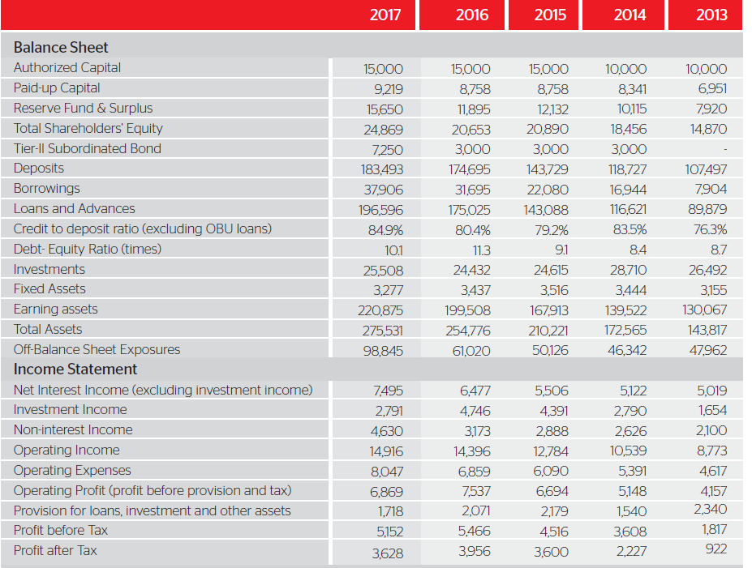

In the table 3.1 we can see from the balance sheet, in 2013, total asset was 143,817 which is increased by 275,531 in 2017. Shareholders Equity is increased from 14,870 to 24,869 and Deposit is increased from 107, 497 to 183,493 in 2013 to 2017. Moreover, Credit to deposit ratio is also increased from 76.3% to 84.9% and Debt-Equity ratio is increased from 8.7 to 10.1. Therefore, the growth of the city bank is increasing with an increasing rate.
In the table 3.1 we can see from the Income statement, in 2013 to 2017, Net Interest Income is increased from 5,019 to 7,495; Investment Income is increased from 1,654 to 2,791; Non Interest Income is increased from 2,100 to 4,630; Operating income is increased from 8,773 to 14,916; Operating Expenses are increased from 4,617 to 8,047; Operating Profit is increased from 4,157 to 6,869 and Provision for loans, investment and other assets are decreased from 2,340 to 1,717. So, Profit before Tax is increased from 1,817 to 5,152 and Profit after Tax is increased from 922 to 3,628. As profit is increasing with an increasing rate, so the growth of the City Bank Limited is high in this competitive era.
Net interest income (NII) has continued to increase and, over the period since 2013, has grown by, on average, 8.3% per annum. In 2017, Net Interest Income grew 15.7% due to a growing loan book, portfolio mix oriented to higher profit segments and expanding margins. In 2017, their loans and advances grew 12.3%, outpacing deposit growth of 5.0% for the year. Their net interest margins stood at 4.3% in 2017, mainly attributable to:
- A favorable and comparatively lower-cost deposit base with CASA representation of 35.9% of the deposit book
- Capability to re-price and recalibrate the loan book in tandem with the movement in deposit rates.
- Greater focus on capital distribution to those customer segments from whom they could derive a higher profit.

We can know the trend of the City Bank from foreign exchange business, share information and distribution network. These three elements are shown in the following table –
Table 3.2: Foreign Exchange business, Share Information & Distribution Network
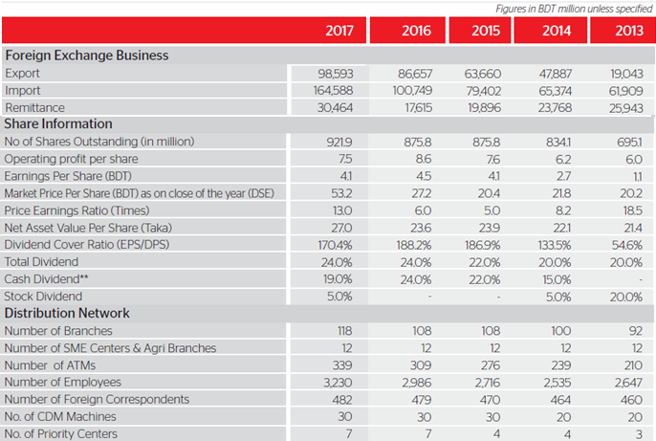

In the table 3.2, from Foreign Exchange Business, the trend of the City Bank is comparatively high in the remittance part than the export and import part from relatively 2013 to 2017.
We can easily get the trend of the City Bank from share business information in the table 3.2. Here, no of share outstanding (in million) is 921.9 which is increased in 2017 from relatively 2013 to 2017. In 2015 and 2016, there no. of shares outstanding is being same and less than the 2017 which is 875.8. Operating profit per share was increased in 2016 which is 8.6 between 2013 to 2017. Earnings per Share is also increased in 2016 among 2013 to 2017. But their Market price per share is increasing relatively from 2013 to 2017. Price earnings ratio was more in 2013 and it is changing with inconsistently. Net asset value per share is increased in 2017 than the other years. So, total dividend is increased in 2017 and 2016 between 2013 to 2017 which is 24.0%.
In the table 3.2, we see from the distribution network that number of branches, number of SME centers and Agri branches, number of ATMs, number of employees, number of correspondents, no. of machines and no. of priority centers are increasing over the years. So, the trends and growth of the City bank is high.
Moreover, we can get the trend and growth of the City bank from performance at a glance in the following figure-
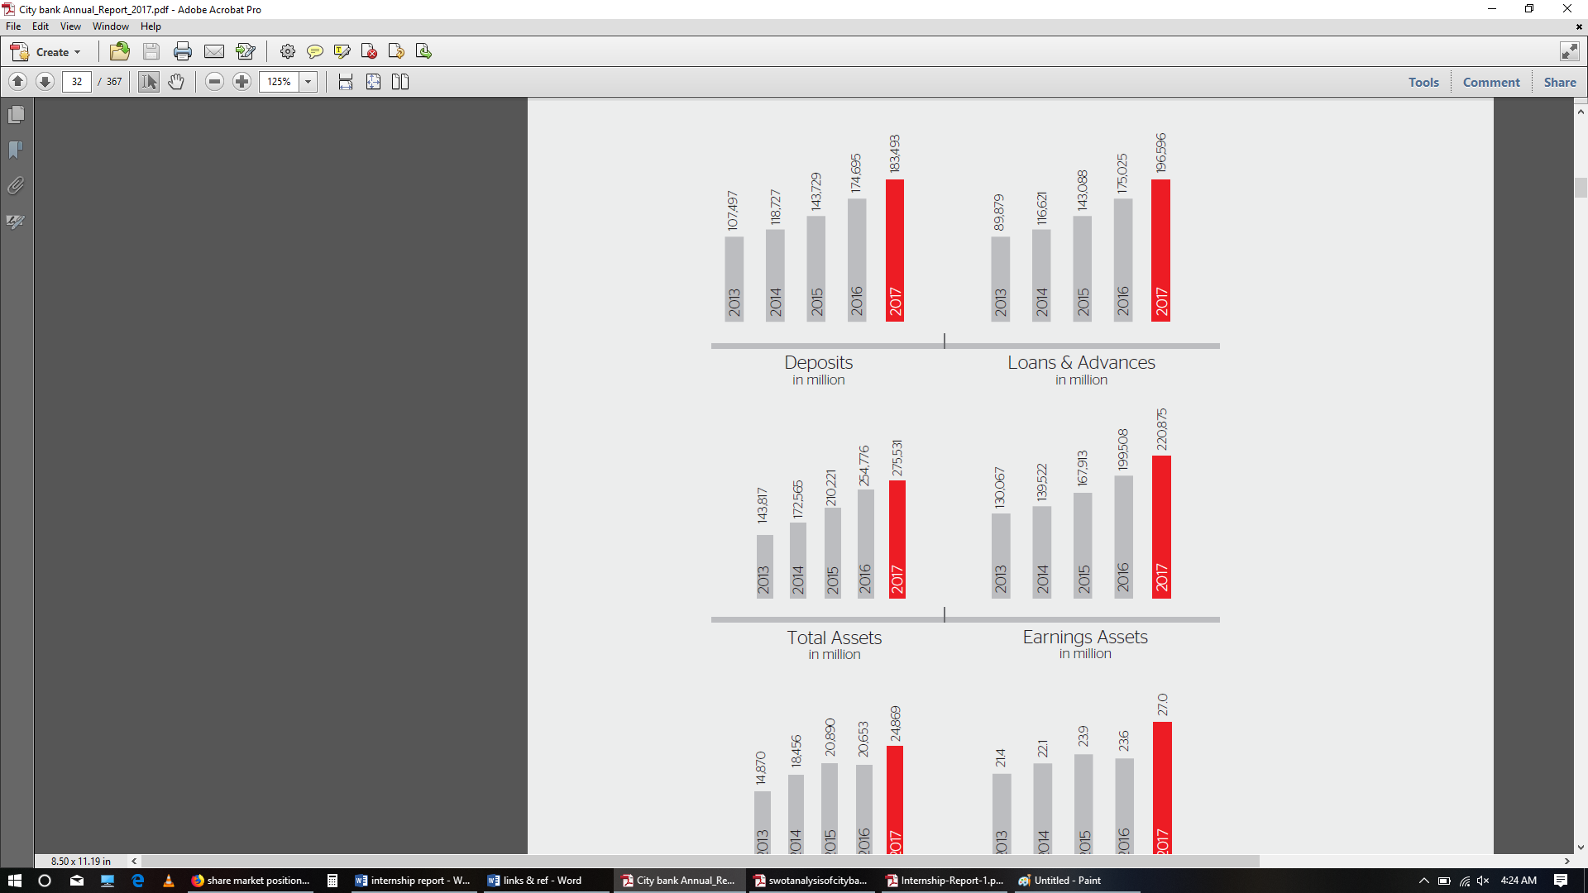
Figure 3.1: Performance of deposits, loans and advances, total assets and earning assets.

In the figure 3.1, we see that the deposits, loans and advances, total assets and earnings assets- all are increased in 2017 between 2013 to 2017. So, from these above, we can easily determine that the trend and growth of the City bank is high.
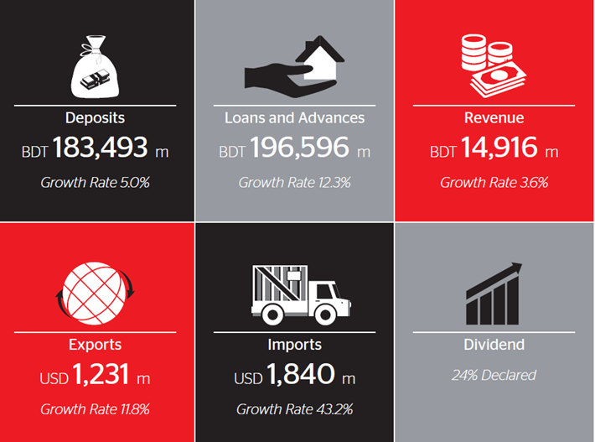

Figure: 3.2 Growth Rate of deposits, loans and advances, revenue, exports, imports and dividend.

In the figure 3.2, there have mentioned the growth rate of the City bank in 2017. The growth rate of deposits rate is 5.0%; loans and advances rate are 12.3%; revenue rate is 3.6%; exports rate is 11.8%; imports rate is 43.2%; dividend rate is 24%.

Despite a challenging business environment, From the above figures, we see that the Bank’s activities delivered relatively strong headline net interest income and operating income growth in 2017. This was mainly attributable to the strength and resilience of their balance sheet and their diversified book across Bangladesh.

“In 2017, we achieved results the right way, focusing on providing simple, personalized and innovative services. With sustained profitable growth in the last 10 years, we have created a time-tested and proven business model, leading the transformation of Bangladesh’s banking sector. Driven by our ability to reinforce the size and quality of our balance sheet, we have established ourselves as a relevant, meaningful and holistic banking platform for our customers. Going ahead, we will continue to focus actively on anticipating customer needs for proactive participation in their journey of progress and, in doing so, will encapsulate our core objective in four simple words that have a profound impact: ‘More banking, Less bank.” (Mohammed Shoeb, Chairman of the city bank, 2017).

3.3 Customer mix:
Customer mix of the city bank that means their target customers for their particular products.
The customer mix of the city bank is given below:
- Corporate Clients.
- Small and Medium Enterprises.
- Non-Banking Financial Institutions.
- Banks Individuals Clients.
- Retail Clients.
- Institutional Clients.
- Govt. and Non-Govt. Organizations.

3.4. Product/service mix:
The City bank limited has different types of products and services. These are the following –
3.4.1. Cards:
Over the last few years, there has been a big change in the mind and the approach to banking among customers. For instance, credit cards, once considered only for the elite people, are today a means of fulfilling the different needs of Bangladeshi citizens, especially among the ambitious millennials. The City Bank always strive to offer best-in-class services innovative lending products and financial solutions to customers to meet their personal financial necessity. With a view to cater to the needs of any credit worthy individual, they launched VISA Consumer Credit Card on 14 April, 2004 and the American Express Consumer Credit Card on 7 November, 2009.
2017 has been a great year for City Bank, especially for its Cards Division. The year marked the first time when the Bank introduced its first co-branded credit card, the Bank, partnering with one of the biggest organized grocery retail chains in the country.
Innovative products and efficient services have always been the marks of their success and, in line with this mindset, the central area was e-commerce, marked by a visible shift in market dynamics towards digitalization. They almost doubled their e-commerce acquiring volumes with the aid of around 900 online merchants. In the year under review, they partnered with several major government service entities such as DESCO, BRTA, IVAC and many more to widen the benefits of the online payment facility among the cardholder base. To provide stronger financial flexibility and purchasing power, they doubled the customer’s maximum credit limit of their unsecured credit cards.
In an effort to provide their customers with the best services and benefits, they re-form their American Express credit card’s value pillars. For the first time in the country, their Platinum Card members could enjoy a year-long ‘Buy-1-Get-2’ dinner offers at select restaurants.
The year 2017 stood as a milestone in their hard-hearted commitment to give the highest level of security for their cardholder members and, as such, they adopted the EMV chip-based cards. EMV chip-based cards provide more security than traditional mag-stripe cards.
The City Bank also added 310 merchants under ‘FlexiBuy’, 0% interest installment purchase program for American Express cardholders. Walton, Fair Electronics Ltd, Oppo Bangladesh, Bangladesh Specialized Hospital etc. were a few other big names that were on-boarded in this program in 2016. They also signed up several new merchants such as Holy Crab Bangladesh, Bangladesh Eye Hospital, Orion Footwear, Bread & Beyond, Chows, A & W Restaurant, W Fine Dine, Koyla Restaurant, Golden Tulip, The Grand mark Dhaka, Sairu Hill Resorts etc. under ‘SELECTS’, a platform through which they offer flat discounts round-the-year to American Express cardholder members.
Reforming CitymaxX, the American Express Account Card, was another highlight of 2017. This is also the first time ever that the Bank offered exciting BOGO and e-commerce offers for its CitymaxX customers. In order to enhance consumer experience, they have also started delivering CitymaxX cards to customer address instead of delivering to the branch, on a pilot basis.

3.4.2 SME Banking Service:

SME-Small Business, a part of City Bank’s SME Banking service, is a modern, segregrated and growth-oriented division that has spread across the country. The main objective of the SME-Small Business unit is to understand the business activities of every small entrepreneur and accept it to the next level. They expect to implement this vision through an unwavering focus on their philosophy which is ‘Business too will grow beside your dream”.

City Bank launched its operations as the first private commercial bank of Bangladesh. Realizing the important opportunity that existed in opening up the formal banking sector to SMEs, a segment that was earlier considered to be un-creditworthy, City Bank engaged on the journey to bridge this divide and catalyze the growth and transformation of the sector. Gradually,
under the landmark “Financial Sector Reform Project”, the Bank also restructured the department to ensure more focus on the SME sector.

The SME Branch Banking segment participated in various events and conferences throughout the year. It also participated in the widely-attended ‘Women Entrepreneurs Seminar and Product Display’ at Bangladesh Bank Training Academy, organized by Bangladesh Bank. Some of the SME Branch Banking segment’s other initiatives and acquirements include:

- Installation of women entrepreneurs/SME help desks across the Bank’s branches countrywide.

- Participation in REHAB fairs (housing finance fairs) in Dhaka and Chittagong.

- Introduced three new SME products – SME Secured, SME Unsecured and Women Entrepreneur loans
- Participated in an open loan disbursement program organized by Bangladesh Bank in Kishorgonj, Noahkhali, Faridpur and Barisal.
The principal goal of SME-Small Business is to increase financing in the SME segment (cottage, micro and small entrepreneurs, women entrepreneurs, agro-based and agricultural product processing industries, etc.) by building up unit offices across the country.

Their sacrificed officers will be involved in financing and re-financing facilities with/without collateral, prioritizing women entrepreneur loans and rural and under-developed
territories through their selective unit offices. Additionally, their BDT 10 account aims to bring the under-privileged in rural areas under the formal banking network.

Three individual categories of SME banking of the City Bank Limited are the following-
- Medium segment SME Service.
- Small segment SME Service.
- Agro SME Service.

3.4.3 Agent Banking service:

As a pioneering bank in Bangladesh with a strong focus on customer service, City Bank started Agent Banking in the country. Agent Banking is a system of giving full-ledged banking services to the unbanked population through involving agents under a valid agency contract, rather than on the basis of a cashier.

City Bank develops this channel to extend to the unbanked segments of the society, especially across geographically-dispersed locations, as well as to existing customers with a wide range of banking products and services. City Agent Banking is available in Hobigonj, Gazipur, Noakhali, Naogoan, Narshindi, Bogura, Gaibandha, Rangpur, Kurigram, Dianjpur, Comilla, Manikganj, Dhaka, Meherpur, Tangail, etc.
Some important services of the City Agent Banking Model are the followings-

Characterizes a modern banking solution:
Modern banks use smart tabs instead of computers. At their Agent Banking segment, they apply biometric tabs under a closed network that guarantees 100% secured banking.

Ensures customer convenience:
Rural customers find it tough to recall their account numbers. Hence, to solve this challenge, City Bank has introduced a customer account number search through mobile phone number inputted alongside the account number at its Agent Banking software.

Effects rural entry:
The principal objective of Agent Banking is to enter rural areas where the population is generally beyond the reach of the formal banking network. A large majority of their City Bank outlets are located in rural areas.

Ensures better service:
Customer issues or complaints are either resolved instantly or within a maximum of three days.

NRB remittance service:
For providing instant remittance services, Agent Banking has the ability to process remittances in under 5 minutes.

REB Bill Collection:
In many cases, City Bank continues with its bill collection service without imposing a service charge to give the original banking flavor to customers.

Customer equality:
City Bank believes that all its customers are equal and have the right to take the same facilities, as those distributed at the branches. Keeping this in mind, Agent Banking customers accept the same or even better services in terms of interest rates, account maintenance fees, etc.

Smart dealings:
Rising customer awareness about smart and appropriate technology, City Bank provides customers all types of debit cards (Master, VISA and Amex) free-of-charge for the first year.

3.4.4 Wholesale Banking Service:

The City Bank Limited also offered wide range of services under the wholesale banking service, those are given below:

- Long term Finance
- Midterm Finance
- Structured Finance
- Cash Management
- Project Management

In 2017, public sector and PPP groups of Corporate Banking division onboarded new power projects with a cumulative generation capacity of 1,142 MW and extended trade credit facilities of around USD 494 m to these projects that will be vital for the country’s long-term economic development.
Structured Finance unit accomplished financing arrangement of USD 79.44 m for two power plants of 169.5 MW generation capacity; this unit also booked 4 power plant projects in 2017 for financing arrangement of USD 271 m and BDT 9,000 m, which will generate 725 MW of electrical energy.

A total of 8 new-to-bank corporate customers were booked by the manufacturing cluster with a total credit facility of BDT 8,900 m.

From 2012 to 2017, the Bank expended about USD 26 m in green financing, of which USD 18 m was invested in energy- efficient projects. These projects will decrease energy consumption by 152,522 MWh/year and CO₂ emissions by 42,749 t/year.

3.4.5 CBL Subsidiaries:

The City Bank limited have subsidies two different individual business organizations:

- City Capital Resource
- City Brokerage

3.5 Operations:
The functions of Branch Operations Managers are mainly established to authorize all non-cash transactions, ones including both financial and non-financial. Besides, reporting, audit handling and AML activities monitoring, is also instructed to them. However, their reporting line is kept separate from the branch which is directly connected to the head office. Thus, to enhance head office monitoring systems technically as well as logistically, the BOM group is sub-divided into departments and team members start reporting to their department’s Heads. Guidance, monitoring and controlling become more effective under leaders who supervises their respective departments.
Various operational activities of various department of the City Bank are given below-

3.5.1 Operations of card department:
The Card Operations department works as a back-office of the cards business to ensure service superiority as well as to perform activities that include:
- Card application data capture and customer data maintenance process.
- Card-PIN emboss, printing, logistics, dispatch and file protection process.
- Billing and notification, card maintenance and value-added services process.
- Commercial operations and maintenance procedure.
- Settlement and accounts process.

Moreover, many different operations are accomplished in card department. These are the following-

Prompt PIN generation through IVR:
Paper PIN generation for cards has been reformed with an automated solution comprising PIN generation through IVR. Card members can generate their PIN 24 hours, which decreases PIN-related paper and delivery costs, eliminates risks and ensures compliance of Central Bank ICT approvals of ‘first PIN’ change mandate and increases customer satisfaction.

Non-EMV phase-out of credit cards:
City Bank credit cards (Amex and Visa) are now EMV cards to facilitate customer convenience through ensuring secured transactions. This feature prevents fake transactions at stations (ATM and POS). To obey with the International Payment System command and Bangladesh Bank guidelines, all magnetic-striped credit cards were converted to EMV cards during the year.

Pre-approved Amex Gold Card campaign:
City Bank launched a pre-approved Amex Gold Credit Card offering for existing deposit (CASA) customers, on behalf of a high potential segment to increase card volumes. The campaign was run for two months with 1,044 cards delivered to customers.

CitymaxX campaign:
As per the prevailing practice, all newly-issued debit cards are sent to the respective parent branch and customers have to collect their cards from these grounds. This generally poses some challenges about timely delivery, activation and usage of these cards, which ultimately hampers the business. CitymaxX, officially termed as ‘Account Card’, is a debit card with a unique financial worth proposition that differentiates it from competing products. To improvement the card business for debit card activation and usage, a campaign was conducted in which 1,500
CitymaxX cards were issued to select accountholders having Visa or MasterCard debit cards and also introduced the procedure to deliver the newly-issued debit cards to the individual customer’s address as mentioned in the system. This campaign acted as a pilot before the new process was executed on a full-scale.

Automation and digitization:
Loan origination system’s (LOS) combination with the card system represents an computerized solution for credit card issuance. The process low of secured or unsecured credit cards in LOS starts with the primary interview and pre-assessment at source. The source enters the scanned application which goes through a verification process at C&C for credit valuation through LOS. sanction, the loan is disbursed through Customer ID and Card product making in the card system.

Digital archiving of card Files
To ensure easy access to card files and avoid physical file movements, the file is scanned and uploaded into DMS to meet the necessities of stakeholders (i.e. credit and collections and customer service). Decrease in turnaround time for file movement Digital archive of application form allows easy and quick access for users to pursuit for information. Centralization of billing and notification system A centralized system has been developed to create all types of statements (e-statements, hardcopy statements, SMS and on-demand statements) for easy and suitable operations, which has reduced human involvements, chances of error and TAT. Launch of Agora-Amex co-branded card City Bank presented the first co-branded card, Agora Amex co-branded card, with strong value propositions considering present market needs and made with offering a wide range of services.

Agent Banking debit card issuance:
As part of the Agent Banking platform, a debit card has been launched in contradiction of the account to allow paperless transactions for customers located in remote areas.
BEFTN auto debit for foreign transactions:
BEFTN auto debit facility for foreign transaction payments was introduced to facilitate customers with the decision of making credit card payments through auto debit with a non-City Bank account. Customers who have transaction accounts in other banks are considerably benefited from this solution as they previously had to make these card payments from the branch which they can now easily sign up into the BEFTN auto debit service to make payments.

3.5.2 Operations of Remittance department:
Transmission of money from one place to another is called Remittance.

Customers of a bank want to transfer his fund or money to anywhere within the country they can ensure it through the remittance section of the bank remittance section of general banking contracts with only local remittances. Three modules of remittance are given below:

Mail transfer:

Where there is no telex machine or telephone line then this system is used. It is the minimum used technique for transferring fund as it is time hard and risky for mail may miss. When the handover of fund from one branch to another takings place by mail but most of the time over telephone it is called MT. procedures of issuing.

Pay order:

It is like cash but not just cash. It is a instrument which is issue from a certain branch of a bank and must be Encashed from the same branch. Unlike cheque there is no possibility of defaming pay order because before issuing bank pay order bank takes out money of the pay order in advance. It is not a negotiable instrument because it cannot be sanctioned or crossed.

Demand draft:

This is an order to pay money drawn by one office of a bank upon another
office of the same bank for a sum of money in any place. Which is outside of the clearing house area of issuing branch. It is a negotiable instrument. It can be crossed or not, for payment of DD bank checks the test code first declared on the draft. If test code approves then the bank makes payment. This issuing bank sends an advice about the DD to the paying branch for further confirmation. Demand draft is an instrument covering an order by the issuing branch upon another branch known as Drawee branch to pay certain amount to the payee or to his/her order on demand.

3.5.3 Operations of Cash Department:

For General Banking, Cash Department is the most important part. To communicate with the clients this cash department work as a media through which cash receives and cash pays directly. Cash is the most liquid asset. It should be deal very cautiously. So, this department is truly handed with concentrated care. This department starts the day with cash in vault. All cash receipts and payments are accomplished through this department. I was not authorized to deal with cash department section. At the start of the banking hour the operation of the cash department begins. Transactions are begun with taking money from the vault by the cash officer which is known as the opening cash balance. Vault keeps in a much-secured room. Branch Operation Manager and cash officer are responsible to keep the key of the room under control. The amount of opening cash balance enters into a register. Transaction of the extra money remains in the cash counter after whole days is put back in the vault which is known as the closing balance. In this section money is received and paid.

Cash Receipt:
Depositors deposit money in their account through this section. This section also receives cash from customer for opening pay order, bank draft telex transfer etc. This bank’s all cash receipts are taken by this department.

Cash Payment:
This section receives the cheques from the depositors for payment in cash.
After receiving cheque first, the cheque is analyzed whether it is a valid one. Cash officer judges the amount both in figure and word date of the cheque and signature etc. then finally authorized officer compares the sign on the cheque with the sample sign, and check whether the balance in the account is sufficient. If the things is satisfactory, then payment is made against the cheque.

3.6 SWOT analysis:
SWOT analysis includes an organization’s internal strength and weakness and external opportunities and threats. I have explored some internal strength and weakness and also explored some external opportunities and threats of the City Bank Limited. These are the following:

3.6.1. Strengths:
The City bank’ s has some powerful strengths. The reason of these strengths is the following:
- Fostering world-class security:
Their technology interface is enhanced through dynamic in-built security, which is safer than a one-time password. Moreover, their ISO:9001 certified backed back office and PCI-DSS certification have built additional layers of security for customer transactions.
- Online supply chain agility:
Their speedy and uncomplicated funds disbursement process ensures high levels of supply chain agility for their customers.
- Financial fulfillment:
At City Bank, through providing a wide range of banking access points to their customers, they are able to ensure holistic financial fulfillment.
- Good Relationship with Customers:
One of the main strengths of CBL is they maintain a good relationship with their customers. They treat their customers very friendly. That’s why, customers don’t want to leave the bank.
- Core Competitive Advantages
There are few banks/NBFIs that segregate emerging businesses from the traditional corporate and SME business segments. At their Commercial Banking division, they are contrarians in the logic that they possess a isolated and dedicated focus on emerging business clients. Young and interested team of relationship managers whose hard work and drive to make a difference to their customers’ business represents a competitive edge and a core difference. The division holds a specific sales and relationship model for the accurate identification of target segments across various geographic locations.

- Experience:
The City Bank ltd. has been in the industry for about 25 years. This long time of existence in the industry has helped CBL to gain in-depth knowledge about the industry trends as well as helped to build up strategic corporation with many corporations which most other banks could not achieve in the shorter time.

3.6.2. Weakness:
Weakness of the City bank’ s is given below:
- There are total 272 ATM booths of The City Bank Limited located in 39 districts in Bangladesh. These number of amounts is so poor for the vast population across the country. Many clients criticize that ATM booths are not available in some areas or one booth is so distant from another.

- The City bank is really only for large corporate customers, or extremely wealthy business owned individual clients. They could not their service for all classes of people. It is a big weakness for them.

- They do not provide proper motivation to their employees. As a result, employees are detached to do their assigned work. Moreover, there have no enough job rotation system at The City bank Limited. These are considered as the weakness of The City bank.

- There are lacking of experienced employees in junior level management. As a result, customer service is performed in very slow motion. It is considered as weakness.
- In Rural Area, there are no Large Branch Network. It may consider as a major weakness of The City Bank Limited.

- At the City Bank, they have high concentration on large loans. They only focus on large loans which can be considered as their weakness.

- At the City Bank, there have Inadequacy of training, professionalism and shortage of specialists. Their improper workload distribution is resulting in dependency on few experienced staffs. The pattern of senior management staff is skewed aging. These are also considered as the major weakness of The City Bank Limited.

3.6.3. Opportunities:
The City Bank limited has the following opportunities-
- At City Bank’s Treasury division, they propose to grow the business according to the Bank’s overall strategies and growth targets. In order to attain this ambition, they expect to broaden their product base to expand market reach, implement automation to reduce Turnaround Time (TAT) and increase efficiency and implement good industry practices related to business, product compliance and risk management. In addition, they also expect to improve the quality, efficiency and capabilities of their human resources comprehensive and undiluted regulatory and risk compliance.

- By 2020, they want to make City Bank’s Commercial Banking division the best performing commercial banking division in the banking industry of Bangladesh in terms of customer experience and compliance.

- Once the reformation exercise is complete, the SME Banking division will emphasis on portfolio growth. Since 2018, the business lines of SME-S and SME-M will be separate and they will more focus on portfolio growth by around 90% to a projected target of BDT 60,000 m within the year 2020 in SME-M. They expect to allocate fresh SME-S loans from the year 2018 onwards, leveraging their loyal unit offices to make their sector robust, disciplined and entrepreneur-friendly. Overall, they predict setting up 120 SME unit offices by the year 2020 that will also enable them to spread their most applicable offering under the SME-S Banking platform.

- In an innovative and far-reaching initiative, they are working to take their SME-S clients under their digital banking platform, City touch, that will allow them with convenience and ease of banking. Along with increasing the City touch platform, they are also bringing in two new digital initiatives aimed at empowering the SME-Small segment entrepreneurs to support them to grow and develop into the medium-segment and beyond. One such initiative is an e-commerce shop-builder to build websites for retail corporations that cannot yet afford to build e-commerce platforms on their own. Another such platform is a bulk buying business support platform that allows small merchants to buy business supplies at lower-than-market rates.

- Their recently launched Agent Banking model has been very well-received by their customers, as reflected in the results of their internal inspection team which found that over 95% of customers are very happy with their facility levels. Encouraged by the validation of their model, they are now planning big. In the next 3 years, they expect to establish 1,000 outlets around the country, open 300,000 accounts, mobilize BDT 5,000 m of deposits and develop as the numerous Uno Agent Banking enterprise in all parameters in Bangladesh.

- Going forward, at City gem, their goal is to capture market share and drive business growth whereas maintaining a world-class value proposition and undiluted standards of service quality, exclusivity and personalization.

- Business dynamism makes better opportunity to help their valued customers. At City Bank’s Trade Services Division, they are dedicated to be the partner of choice for their internal and external customers by providing proactive trade solutions. Over the next 3 years, some of the far-reaching initiatives planned include the creation of a separate trade module, development of a new anti-money laundering software, offer exclusive advisory services to their top-tier customers and launch trade products relevant for SMEs.

3.6.4. Threats:
The City Bank limited has the following threats-
- Observing a board target market:
The target market of the City Bank Limited is consisted of lower-class consumers to consumers with high net worth. A project named ‘Celtic Project’ is designed only for the elite class of people of Bangladesh. Sufficient service with least training might not be provided to these different customers by the existing employees. Because the upper class is more different than the lower classes in the case of expecting service quality.
- Increasing competition for market share:
Competition is increasing day by day in banking industry for market share which is the biggest threat for The City Bank.

- Unstable political situation:
The global and local unstable political situations sometimes hamper the activities of The City Bank. Sometimes it becomes uncontrollable threat.

- Different margin for opening L/C:
The margin for opening L/C is different for different customers. The margin is more for new customers while the margin is less for corporate and reputed customers.
Moreover, the following threats for The City Bank can be happened-
- Government continuous pressure to reduce interest rate.
- Frequent fluctuation of domestic currency worth against US Dollar.
- Political crisis and decaying country image as exporter.
- Rapid increase of private sector Bank in number and size.

3.7 Steps/strategies to meet the challenges and opportunities:

- The City bank should have to create assets from which they draw interest income for Supporting employment and inclusive growth opportunities.

- They should have to generate costs for the sourced funds that enables lending.

- They should have to generate income through fees and other commissions

- They should have to generate income from other sources, including from investments.
- CBL’ s should have to invest in infrastructure, including IT, enhance their capabilities and efficiency levels that enable them to deliver relevant products and services that meet customer needs and strengthen their competitive position.

- The City bank should have to invest in their Human Resources enable them to retain their intellectual capital while also providing their employee with world-class training programs and exposures.

- They have to increase their market share so that they can overcome the challenges of increasing competition.

- The margin for opening L/C of The City Bank should have to be more for corporate and reputed customers.

- Sufficient ATM booth will have to be established.

- CBL’ s will have to excess not only for large corporate customers but also enough excess to general customers.

Chapter 4
Internship experience

Internship experience
4.1 Position, duties and responsibilities:
I was assigned by The City Bank HR personnel’s as an intern in the Gulshan Avenue Branch. There I have performed various duties and responsibilities. In City Bank, I worked in the general banking division. There I did work in customer service department and this department is consisted of card department, foreign exchange department, clearing and check department in the branch. As an intern of the City Bank, I was responsible for the management of the EQM machine. Here, my duty was to guide him or her to the right service zone with the right token when a customer enters in the bank. Moreover, my other responsibilities were- Account and FDR Opening Form Fill up, Card Delivery, Pin Delivery, Destruction, Loan Paper Fill Up, Reconciliation, Account Closure, Nominee, Signature or Address Change of Existing account etc.
4.2 Training:
After joining in The City Bank, I have got two training. It was formal training. The first training was held on the first day of joining regarding rules and regulations of the internship course. The second training was held on the middle of the internship, it was also regarding rules and regulations of the internship.

4.3 Contribution of departmental functions:
Functions of The City Bank are distributed into various department. My contribution of departmental functions is the following-
4.3.1. Card department:
My main contribution was in card department. Here, most of the time I engaged to serial different types card with counting that how much card received and how much card delivered a day. I have filled the endorsement from. I have done the work of data entry of these card’s account number, date, serial number etc. As an intern of the City bank I was also assigned to play assistant role to this service area. For example, by delivering debit credit cards to the customer, keep the tracker of the regular cards received from the currier and reconcile of the cards. There were four register books for maintaining the cards; two is for new issue cards and other two for lost and stolen card. In the both cases cards and pins maintain by two separate individuals for safety purpose.
4.3.2. Check department:
In check department, my contribution was in call center service and check book related activities. I did call the customers and know them that their check book has been ready so that they can collect their check book.
4.3.3. L/C department:
In L/C department, I have helped the manager of L/C department to organize the different papers of L/C’ s file.
Moreover, I have played many other roles to help all the managers of all other department whenever they feel any need.

4.4 Evaluation:
Working at the bank as an intern sometimes I worked perfectly but sometimes made some mistakes. I gave my full attention on my work and my work has been admired by all. They always motivate me even if I have done any mistakes. My interactions with other colleagues was impressive which was praised by my supervisor of the City Bank.
Moreover, my supervisor of the City Bank evaluated me formally through performance evaluation grade sheet which was given me from the City Bank’s HR. It includes-

Table: 4.1: Performance Evaluation
Grading: Excellent = 5; Very good = 4; Good = 3; Average = 2; Below Average = 1
Serial no. | AREA | 5 | 4 | 3 | 2 | 1 | Remarks
1 | DRESS CODE
2 | INTEREST IN ASSIGNED TASKS
3 | ABILITY TO LEARN
4 | ABILITY TO WORK WITH OTHERS
5 | ABILITY TO COMMUNICATE
6 | ABILITY TO WORK INDEPENDENTLY
7 | ABILITY TO MANAGE TIME
8 | ABILITY TO WORK UNDER PRESSURE
9 | PRESENTABILITY & DEPENDABILITY
10 | PERSONALITY & MATURITY
Total points

In the table 4.1, my supervisor evaluated me by giving four (= very good) out of five. And I was very pleased about it. In a word, I got all from my colleagues and supervisor was motivating.

4.5 Skills applied:
As an intern I had very limited task in The City Bank. There I have applied my skills of Microsoft word, excel. Moreover, I have also applied my communication skills in The City Bank to communicate well with employees and to handle customers.

4.6 New skills developed:
I have developed lots of new skills from the internship experience in the City Bank. How each and every work is done by the officers systematically as well as very carefully which I learned from the bank after joining as an intern. My new skills which are developed from this internship experience are discussed below:

- I have experienced the scenario of corporate life which makes me turn into work for eight hours continuously. It’s a big development for myself.

- I have developed my knowledge regarding how does a branch plays its role in banking industry.

- From the internship I have learned how to provide service to customers, how to talk with them, how to deal with customers, and understand their needs and demands.

- From the City Bank I have learned how to build strong corporate relationship and how continue it for long term.

- How to cooperate with colleagues while I was working with them together, I have developed it from the internship of the City Bank.

- My concentration skill has developed from this internship and I have learned to give full concentration on work to complete it in time.

- My self-confidence has developed to complete any work properly and to overcome my challenges which I have learned from the internship program.

4.7 Application of academic knowledge:
As an intern at The City Bank my application of academic knowledge had very few. Sometimes I had to convert US dollar amount in BDT when clients wanted to know at that day’s specific rate. I have used my knowledge of income statement, balance sheet in branch operation manager’ s department. Moreover, I have used my knowledge of consumer behavior to handle different types of customers.

Chapter 5
Recommendations

Recommendations

5.1 Recommendations for improving departmental operations:

There are some important steps that should be taken to implement to improve departmental operations in order to ensure a quality service of the City Bank limited. These are the following-
- Some loans can come with higher fees than other forms of borrowing. There is some confusion regarding the loan pricing and hidden charges among customers. Here’s what to watch out for and what to do if I think I have been charged unfairly. So, The City Bank Limited should notify the consumers about the different prices, hidden charges and particular product’s installment size etc.
- More SME Service Center and branches are needed for customers in their locality which will assist them regular transaction with banks. So, The City Bank should have to establish more SME Service Center and Branches in customer’s locality.

- Agriculture is the backbone of a country. As per the central bank's policy, banks have to establish aside at least 2 percent of their total loans for the agriculture segment. So, The City Bank Limited should increase their more concentration on providing Agro loan.

- The City Bank Limited should emphasis on prompt client service in customer service department for not only generating profits. Their cheque book delivering process is so lengthy. In fact, it takes 7-8 days or more to get a cheque book after giving requisition for a cheque book.

- Sometimes customers open bank account for their early and fast service in the case of carrying a debit card, but it is reached on customers hand after 7 to 10 days or more. So, it takes more time to issue the debit card and activation of it. Debit card may be given to the new account holder within a short period and it should be activated as early as possible. So, the City Bank should more focus on it.

- Many branches of The City Bank Limited, there have no required locker service. So, for the increasing number of customers they should develop enough locker service.

- As banking is a service organization, customer service is a very difficult task. Employees have to handle different types of customers always under pressure. Adequate training is needed for employees to work so that they can handle clients under pressure. For instance, The City Bank should arrange various valuable and effective training programs.

- Their numbers of ATM booth are so limited all over the country. Therefore, they should have to increase the merchant locations of ATM booth for customer’s convenience and easy transactions across the country.

- More cash and deposit balances should be maintained properly by the City Bank Limited. Moreover, to attract more customers they should make other type of deposit which is dissimilar from other banks.

5.2 Recommendations for improving self-performance:

I have observed some problems of myself while I was doing internship at The City Bank. So, I have some recommendations for improving self-performance-
- Sometimes I did mistake because of my poor attention to do my assigned work. So, I would recommend myself that I should have to more attention regarding any assigned task.

- Sometimes I get nervous when I am in a new situation which spoils my performance. So, I would recommend myself to be more confident and to work on this routine which will improve my performance.

- Throughout my internship program, many times I had late to go office. So, I would recommend myself that I have to be regular for coming office in time.

- I should make asking questions more to the different manager so that I can gain knowledge about different activities in detail.

- I should have to give full attention on work to complete in time.
- Moreover, I have to Learn how to work under pressure and tackle the critical situations.

Chapter 6
Conclusion

6 Conclusion:
If banks do not function in according to commercial standard, no financial system will be operated. As an outstanding business is done by the banking industry especially the private banks, so many modern people are more concerned regarding securing their valuable assets. And they are also getting high quality and timely services. Therefore, there has been established lots of new commercial banks and banking industry has been very competitive through these banks. In according to the need of the market, now banks have to organize their operation for the increasing customers. To cover any kind of financial services anywhere in this world this banking sector has trenched its wings wide enough in this competitive world. In Bangladesh, City Bank is the most promising bank. The City Bank is trying to increase their products and services everyday although they provide a wide range of products and services to their valuable customers. Through remitting of funds both local and foreign, the City Bank Limited is helping the economy of Bangladesh significantly. They provide bridge financing loan, working capital loan to its corporate clients for helping people. The City Bank Limited has gained National and International recognition for significance performance. It should redesign all sorts of banking strategies to be more user-friendly, attractive and impressive. Therefore, if they more focus on some of the problems that I have mentioned they can develop themselves more. Importance of my internship program is a lot because this is my first-time real-life working experience. My internship report is also important because I have put my personal observation there and also tried to study our banking industry using my academic knowledge.

References:
- https://www.thecitybank.com/AnnualReport/annual_report_%202016.pdf

- https://www.thedailystar.net/business/city-bank-plans-big-it-celebrates-35yrs-1559674

- https://www.financewalk.com/industry-analysis/

- Asian Development Bank. Financial soundness indicators for financial sector stability in Bangladesh;2015; ISBN -5 (Print), 978-92-9257-084-2 (e-ISBN).

- Fresh Omar Jamal; Banking sector and its impact on our economy; The Daily star; February 20, 2018

Reference Books:
- Bangladesh Electronic Funds Transfer Network (BEFTN) Operation Rules, Bangladesh Bank, August 2010.

- Operation Management, William J. Stevenson (8th Edition).

