

Internship Report
On
General Banking Activities Of
Standard Bank Limited

Submitted to:
Mohammad Tariq Hasan
Assistant professor
School of Business & Economics
United International University

Submitted by:
Sadia Mahajabeen
ID: 111 141 114
BBA

Date of submission: 5-01-2019

United International University
Letter of Acknowledgement

All acclaim to be Allah to whom all Dignity, Honor and Glory are expected, the master of the world, The Almighty Omnipotent for his support to me in finishing this entry level position report.

The report titled "General Banking Activities of Standard Bank Ltd" has been prepared to satisfy the necessity of BBA Degree. Through this entry level position program, a huge learning and experience has been accumulated which is exceptionally momentous from 7th October 2018 to 7th December 2018 while setting up this report. Amid the program, it gave an incredible breadth to understand the professional workplace.

This report couldn't be proficient without association of a few people. It is particularly lucky to get nearly and genuine direction, guidance and co-activity from different individual. Without precise data, it couldn't be breaking down and introduced the report appropriately in spellbinding way.

For most it gives me massive delight to offer my sincerest thanks and feeling of my most noteworthy Faculty and scholarly Supervisor Mohammad Tariq Hasan sir, Dept. of SOBE for his kind endorsement of my work on the venture alongside his vital heading.

On account of The Standard Bank Limited, Principal Branch and every single other official and officers for giving important data and stretching out significant time to feature the issues through exchange.

Letter of Transmittal

5th January 2019
To
Mohammad Tariq Hasan
Assistant Professor
School of Business & Economics
United International University
Dhaka

Subject: Submission of Internship Report on “General Banking Activities Of
Standard Bank Limited’’

Dear Sir,
I am happy to present my internship report on "General Banking Activities of Standard Bank Limited." for the incomplete satisfaction of the level of BBA in Department from United International University. This report is a consequence of my down to earth work that I have directed amid determined time of my temporary job program. Every one of the works exhibited here is finished with most extreme genuinely and genuineness.
The report contains the vast majority of the insights in regards to managing an account exercises, which is found out through a three-month entry level position program at SBL. This program took in the contrasts between the hypothetical information and useful experience. The report is set up under supervision and direction of chief. It is wanted that it will coordinate with the desire and prerequisites.

Sincerely yours
Sadia Mahajabeen
ID - 111 141 114
BBA, School of Business & Economics
United International University

Declaration

This to be announced that this report entitles "General Banking Activities of Standard Bank Limited", has been showed as a piece of temporary job customs. It is a bounden part to submit entry level position answer to finish BBA program. It involves the consequences of direct research work, scrutinized under the supervision of Mohammad Tariq Hasan, Assistant Professor, Dept. of SOBE, United International University.

I moreover bear witness to that the work itemized in this temporary job is remarkable and is no part or some different understudies for the complete of BBA have submitted whole of the report.

……………………………….
Sadia Mahajabeen
ID – 111 141 114
BBA, School of Business & Economics
United international University

Executive Summary

For every bank general banking area is the center of it. This area brings a large portion of the benefit of a bank. The essential target of this report is to assess the general banking practices of Standard Bank Ltd. This report gives a thought regarding the operation, activity, techniques, arrangement, strategy, and the executives of Standard Bank Ltd (SBL). At first, I have given a presentation about the report, foundation of the report, goals of the report, impediments of the report and extent of the examination. From that point onward, I concentrated on the procedure which I used to set up this report contains both essential and optional sources of information.
At that point this report covers the history and foundation of SBL, objectives, vision, mission and point of SBL. I have depicted authoritative structure, items, administrations and SWOT investigation. At that point I have depicted the discoveries of the examination that I gained from the period of my internship about general banking of SBL. Besides, in this report I prescribed a few recommendations that may diminish every one of the issues that I referenced. I endeavored to exhibit all the managing an account exercises that I have found amid my internship program.

List of Tables

Table No. | Table Name | Page No.
Table 3.1 | Company overview | 13
Table 3.2 | Credit Rating | 16
Table 3.3 | SWOT analysis | 20
Table 4.1 | Benefits of Savings deposit account | 25
Table 4.2 | Requirements of savings deposit account | 25
Table 4.3 | product details of SBL bondhon savings | 25
Table 4.4 | product details of SBL savings premium | 26
Table 4.5 | product details of SBL savings premium Plus | 26
Table 4.6 | product details of SBL Super Savers Savings | 27
Table 4.7 | product details of SBL Golden Age Savings | 27
Table 4.8 | product details of SBL Women Savings | 28
Table 4.9 | product details of SBL Classic Savings | 28
Table 4.11 | Product details of Sarbojonin | 29
Table 4.12 | Maturity Amount Chart of Projonmo | 30
Table 4.13 | Product details of Projonmo | 30
Table 4.14 | Maturity Amount Chart of Ghoroni | 31
Table 4.15 | Product details of Ghoroni | 31
Table 4.16 | Maturity Amount Chart of Lakhopati Plus | 31
Table 4.17 | Product details of Lakhopati Plus | 32
Table 4.18 | Maturity Amount Chart of Millionaire Plus | 32
Table 4.19 | Product details of Millionaire Plus | 32
Table 4.20 | Maturity Amount Chart of Kotipoti Plus | 33
Table 4.21 | Product details of Kotipoti Plus | 33
Table 4.22 | Commissions of OBC | 39
Table 5.1 | SME Banking definition | 55

List of Abbreviation

SBL | Standard Bank Limited
KYC | Know Your Customer
DPS | Deposit Pension Scheme
SME | Small & Medium Enterprise
SND | Short Notice Deposit
ATM | Automated Teller Machine
FDR | Fixed Deposit Receipt
OBC | Outward Bills for Collection
IBC | Inward Bills for collection
PO | Pay Order
DD | Demand Draft
TT | Telegraphic Transfer
NCB | Nationalized commercial bank

TABLE OF CONTENTS

CHAPTER 01 1
INTRODUCTION 1
1.1 Introductory Discussion 2
1.2 Objectives of the Study 2
1.2.1 Broad Objective: 2
1.2.2 Specific Objectives: 3
1.3 Rationale of the Study 3
1.4 Coverage of the Study 3
1.5 Scope of Study: 4
1.6 Limitations of the Study 4
CHAPTER 02 5
METHODOLOGY OF THE STUDY 5
2.1 Types of Study 6
2.2 Sources of Data 6
2.2.1 Primary sources of data 6
2.2.2 Secondary sources of data 6
CHAPTER 03 8
ORGANIZATIONAL BACKGROUND & INDUSTRY PERSPECTIVE 8
3.1 Evolution of Banking Industry 9
3.2 Banking in Bangladesh 9
3.3 Organization Profile 11
3.3.1 History & Origin of Standard Bank 11
3.3.2 Company Overview: Standard Bank Ltd. 13
3.3.3 Vision of the Standard Bank 14
3.3.4 Mission of the Standard Bank 14
3.3.5 Core Values of the Bank 14
3.3.6 Strategic priorities of Standard Bank 14
3.3.7 Credit Rating of Standard Bank 15
3.3.8 Functional Divisions of Standard Bank 16
3.3.9 Company Organogram 18
3.3.10 Managerial Hierarchy of Standard Bank Ltd. 19
3.3.11 Branding 19
3.3.12 Branches of the Standard bank 20
3.4 SWOT Analysis 20
CHAPTER 04 22
ANALYSIS PART ON GENERAL BANKING 22
4.1 General Banking 23
4.2 Account opening section 24
4.2.1 Savings Deposit account 24
4.2.2 Current Account 34
4.2.3 Short Notice Deposit account 34
4.2.4 Fixed Deposit Account 35
4.2.5 Regular Income program 35
4.2.6 SBL 10-taka account 36
4.2.7 SBL 1.5 times income program 36
4.3 Closing account 37
4.4 Clearing section 37
4.5 Cash Section 37
4.6 Dispatch Section 38
4.7 Bills Collection 39
4.8 Remittance Section 39
4.9 Card Section 40
CHAPTER 05 42
ANALYSIS PART OF LOAN SECTION 42
5.1 Credit & Advance Department 43
5.2 Credit Management and performance analysis 43
5.3 Performance Guidelines 44
5.3.1 Guidelines for Lending 44
5.3.2 Credit assessment and Risk grading 44
5.3.3 Approval Authority 45
5.3.4 Duty segregation 45
5.4 Credit management tools 45
5.5 Loan disbursement procedure of SBL 46
5.6 Loan schemes of SBL 48
5.6.1 Corporate banking 49
5.6.2 Retail Banking 50
5.6.3 SME Banking 55
5.6.4 Social and environmental infrastructure finance 58
CHAPTER 06 59
RECOMMENDATION & CONCLUSION 59
6.1 Recommendation 60
6.2 Conclusion 61
CHAPTER 07 62
REFERENCE 62
7.1 References 63

CHAPTER 01

INTRODUCTION

1.1 Introductory Discussion

“Commercial banks play a vital role in any country as they serve as an intermediation between the households and the economy sector” (Haider, 2011). “They keep the savings of the public and finance the development of business and trade. Furthermore, numerous studies argue that the efficiency of financial intermediation has impact on economic growth while others indicate that bank insolvencies can result in systemic crises which have adverse consequences for the economy as a whole. Thus, the performance of banks has been an issue of major interest for various stakeholders such as depositors, regulators, customers and investors” (Chowdhury & Ahmed, 2009).
During the last two decades, the banking sector all around the world has experienced major transformations in its environment. The bank, at present, don’t really just lend and receive payments like other financial institution, they conduct all type of commercial banking activities including customer services related to local and foreign remittances but its core business is trade financing. “The banking system, as we all know, processes payments. These payments are potentially immensely valuable bits of information that, properly understood, form a mosaic that can help make comprehensible the financial status of firms making and receiving these payments” (Gallo, Apilado & Kolari, 1996). This information is particularly valuable in bank lending to smaller firms. So, everyone should aware of the banking activities and way of operating to acknowledge their privacy and ease the service operation between banks and customer.

1.2 Objectives of the Study

1.2.1 Broad Objective:

The broad objective of the study is to investigate General Banking Activities of Standard Bank Limited at principal Branch. The main purpose of this topic is to present practical knowledge of bank and its orientations.

1.2.2 Specific Objectives:
- To fulfill the partial requirement in the Bachelor of Business Administration (BBA) degree.
- To cover a comprehensive analysis of overall activities of Standard Bank Ltd.
- To understand general banking and deposit mobilization activities of SBL, principal branch.
- To assess credit exercises of SBL, Principal branch.
- To understand the process of loan disbursement.
- To assess foreign exchange activities.
- To measure consumer loyalty level.
- To ask code and direct.
- To determine the most important attributes of service quality
- To know the official standards and headings.
- To obtain the overview knowledge of banking system of Bangladesh.

1.3 Rationale of the Study

This report is being relegated as a part of the BBA. In the BBA program of the Department of Business Administration of United International University (UIU) internship is an important part of academics. Here, one report is important to legitimize my work in internship. To set up this report, I serve my internship program in Standard Bank Limited (SBL), Principal Branch. By experiencing numerous offices, I have accomplished bunches of reasonable experiences. So, in this report, I have shared General Banking segment of Standard Bank Limited. Finding the issues and related proposals may help workers of the bank to embrace better approaches for moving toward the clients and even the administration could think about their regions of enhancement. My BBA program is a total mix of hypothetical and useful information which will assist me with defining and build up my profession.

1.4 Coverage of the Study

Throughout the report, two noteworthy territories in commercial bank has been secured which are:
(a) General banking section.
(b) Loan section.

1.5 Scope of Study:

In this internship report, the study of general banking activities of Standard Bank Ltd. Principal Branch is thoroughly depicted. From this report one can see how the general banking activities of SBL principal branch is executed and how it throughout the year.

1.6 Limitations of the Study

Regardless of having the wholehearted exertion, there exists a few restrictions, which went about as boundary. The constraints were -

- The study was constrained just to the Standard Bank Ltd. Principal Branch.
- Another Problem was time requirements. The time of Internship Program was just for three months. In this case, this time isn't sufficient for a total and productive study.
- The bank was a bustling one having substantial surge of individuals, whom officers need to manage. So, designation of time for an intern is especially extreme for the officers of the bank.
- Authority limited a few issues internship program as like not entering the Foreign exchange service area.
- In instance of secondary data collection, there was limited data accessible. There were few supporting books, reports diaries and so forth.

CHAPTER 02

METHODOLOGY OF THE STUDY

2.1 Types of Study

To complete this report, I have gathered some primary and optional data. I continued through a work plan. I physically visited and talked about with administrators' senior officers of SBL. The present study depends on hypothetical analysis. It takes three months to gather exact data about SBL.

2.2 Sources of Data

Gathered information and data were arranged, prepared and analyzed critically with the end goal to make the report more productive and intentional. The study impute were collected from two sources-

2.2.1 Primary sources of data

Primary data were mostly derived from the discussion with the employees and from personal experience during internship period. It is collected in the following manner-
- Face to face conversation with officer.
- Face to face conversation with client.
- Practical desk work.
- Direct investigation of different records, papers and documents.

2.2.2 Secondary sources of data

I have used different types of secondary data throughout the study. Those are as follows-
Internal sources-
- Annual report of SBL
- Printing materials like broachers news
- Prior research report
- Department wise operational manual of bank.

External sources-
- Website of SBL
- Bangladesh Bank report
- Different books on Banking etc.
- Related links available in the internet.
- Different circular sent by Head Office of SBL.

CHAPTER 03

ORGANIZATIONAL BACKGROUND & INDUSTRY PERSPECTIVE

3.1 Evolution of Banking Industry

The idea of banking has been around for a considerable length of time and has needed to evolve with changing human needs. In today’s digital age we have seen a noteworthy change in the financial services industry. What was for many decades a largely unchanging industry, is presently continually developing, with numerous banks battling to keep up. The practice of safe-keeping dated back to 2000BC. Antiquated cultures had methods for keeping and storing wealth. They supported this through lending fees and charges. Merchant banks were the first banks, with merchants trading in commodities like grain, crediting it to ranchers and merchants who carried merchandise between urban communities.
The Bank of England was the original bank to issue permanent banknotes in 1965. These were at first transcribed and issued on deposit or as a credit. They would pay the carrier the estimation of the note on demand. By the 18th century, banks offered clearing facilities, security speculations, cheques and overdraft insurance. Cheques were broadly utilized from the point on, and changed the manner in which money was exchanged.
Developments in communications enabled banks to drastically increase size and geographical spread. With the ascent of computers came credit and debit cards, making cheques unimportant. The initial adaptation of a credit card was issued by oil companies and retail chains. They were utilized to make client loyalty and enhance customer services. In 1969 the first Automated Teller Machine (ATM) showed up in New York at Chemical Bank. This innovation transformed the banking industry, as customers never again needed to visit a bank for basic financial transactions.
With the rise of the internet, electronic fund transfers and internet banking was introduced. Online banking was authoritatively presented by standard banks in 1994. Early adopters saw the advantage and convenience of it straight away, but numerous customers stayed reluctant on the ground that they didn’t believe the security features.

3.2 Banking in Bangladesh

Economic history demonstrate that improvement has begun wherever with the banking framework and its commitment towards financial advancement of a country is the most astounding in the underlying stage. Schumpeter viewed the banking system as one of the two principle operators in the entire process of advancement (Dorfman & Schumpeter, 1954). Keynes additionally underlined the role of banking services during economic improvement of a country, while She was tending the House of Lords regarding International and Monetary System (Dymski, 1988). Besides Alexander Gerashchenko in his popularly known “Gerschenkron's Hypothesis” clarified “the banking framework as the key player at certain phase of the industrialization procedure” (Barsby, 1969).
The financial sector in Bangladesh involves the cash and capital markets, insurance, annuities, and micro finance. Amid the first decade of independence, financial system of Bangladesh has been experiencing profound emergencies. Historically, the execution of the banking sector of Bangladesh has been powerless because of frail asset quality, insufficient provisioning, negative capitalization in fundamentally critical state banks and limited productivity. Until 1982 there were six nationalized commercial banks (NCBs) in Bangladesh, which are Sonali, Agrani, Janata, Rupali, Pubali and Uttara Bank. Banks were now and again used to lend to politically critical financial areas and foundations and additionally politically connected persons. Therefore, lacked adequate checks and balances as viable models of corporate governance, bringing about elevated amounts of related party loaning.
Including the Bangladesh Bank, the national bank of Bangladesh, there are 4 state-claimed commercial banks (SCBs), 4 state-claimed specialized banks (DFIs) which are devoted to farming and institutional loaning, 9 foreign commercial banks (FCBs), 30 domestic private commercial banks (PCBs) and 31 non-bank financial institutions (NBFIs). Bangladesh Bank has administrative and supervisory purview over the whole banking sub-sector in addition the NBFIs. The greater part of the institutions in the monetary section are characterized by a blend of public and private ownership.
Modern banking system assumes a crucial job for a nation’s monetary improvement. In the course of the most recent couple of years the banking world has been experiencing a ton of changes because of deregulation, technological advancements, globalization and so on. These adjustments in the banking system also gotten progressive changes in a nation’s economy. Present world is changing quickly to confront the test of aggressive free market economy. It is all around perceived that there is a critical requirement for better, qualified administration and better-prepared staff in the dynamic worldwide financial market. Bangladesh is no exemptions of this pattern. Banking Sector in Bangladesh is confronting challenges from various points however its prospect is splendid later on.

3.3 Organization Profile

3.3.1 History & Origin of Standard Bank

Standard Bank Limited (SBL) was joined under the initiative of Lion Mr. Kazi Akramuddin Ahmed, Founder chairman who had a long dream of coasting a commercial bank, which would add to the financial improvement of our nation. The Standard bank Limited set up as a Public Limited Company on May 11, 1999 under the Companies Act, 1994 and the bank achieved classy progression from its business assignments on June 03, 1999. SBL has introduced couple of new items utilizing a credit card and store plans. It furthermore goes for Corporate and Retail Banking and so forth. The Bank in like manner appreciated store Syndication with various Banks. Through all these heap exercises SBL has made a positive effect in the Market. The Bank saw an impressive enhancement in its general business execution amid the year 2006. It was incorporated as a public Limited Company on May 11, 1999 under the Companies Act, 1994 and the Bank accomplished tasteful from its business task since June 03, 1999. Standard Bank limited has presented a few new products and expanded loans and credits to different sectors of our economy.
The authorized capital and paid up capital of the bank are Tk. 3000.00 million and Tk. 1292.96 million respectively. The Bank received the certificate of incorporation no. C37864 (2164)/99 under the companies Act (Act-xvill) of 1994. It also received the certificate for commencement of business on the same date by the section 150(2) under company's Act. Apart from the Head Office in Dilkusha C/A, it started its first local branch in Dilkusha C/A simultaneously in order to provide all kinds of banking support to the clients. They opened their second branch in Khatungonj Branch in Chittagong. At present the bank has 106 branches across the country. It renders a wide range of commercial banking operations to its clients inside the domain of the Bank Companies Act, 1991 and in accordance with the mandates and approach rules set somewhere around Bangladesh Bank. Lion Mr. Akramuddin Ahmed, organizer executive who had a long dream of gliding a business bank, which would add to the socio-economic development of our nation. He had a long experience as a good banker. A group of highly qualified and successful entrepreneurs joined their hands with the founder chairman to materialize his dream. Indeed, all of them proved themselves in their respective business as most successful star with their endeavor, intelligence, hardworking and talent entrepreneurship. Standard Bank has made substantial headway in terms of business growth, profitability and establishing its image as one of the leading private sector banks.
The sponsors of the bank are a renowned group of Industrialists and Businessmen with a proven track record. They represent reputed industrial and business houses of the country. Lion Mr. Kazi Akramuddin Ahmed is the present chairman of the bank.
The bank drives an extensive variety of commercial banking operations. This inside business of the Bank involves exchange fund, term finance, working capital and corporate finance. The Bank is likewise giving individual credit; administrations identified with neighborhood and outside settlements and a few items related administrations. The plan of the bank, which is intended to enable the fixed income group to amass in raising standard living is aggressively estimated and has been generally valued by the clients. The bank has made progress in all divisions and wind up with the most noteworthy consistently working benefit, which is 19% higher than that of the last year. The accomplishment has been conceivable on account of the capable administration, devoted and submitted administrations given by all dimensions of the board and staff or more all the trust and certainty that the esteemed customer had rested in the bank.

3.3.2 Company Overview: Standard Bank Ltd.
Table 3.1
Company overview
Name | Standard Bank Limited
Incorporation | 11-May-99
Commercial operation | 3-Jun-99
Slogan | "Setting a new standard in banking"
Type of Company | Commercial bank
Main Business | Providing Term loans to small scale enterprise and operating full-fledged commercial banking service
Total equity | Taka 13410 million
Paid-up capital | Taka 7918 million
Total asset | Taka 175699 million
Loans and advances | Taka 128228 million
Deposit | Taka 134730 million
Profit after tax | Taka 1238 million
Number of branches | 125
Number of employees | 2076
Logo | 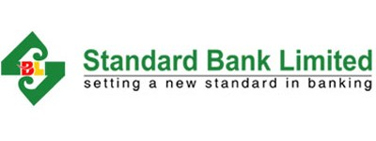

3.3.3 Vision of the Standard Bank

“To be a modern bank having the object of building a sound national economy and to contribute significantly to the public Exchequer.”

3.3.4 Mission of the Standard Bank

“To be the best private commercial bank in Bangladesh in terms of efficiency, capital adequacy, asset quality, sound management and profitability.”

3.3.5 Core Values of the Bank

Shareholders: By ensuring fair return on their investment through generating stable profit.
Customer: To become most caring bank by providing the most courteous and efficient service in every area of our business.
Employee: By promoting the well-being of the members of the staff.
Community: Assuring our socially responsible corporate entity in a tangible manner through close adherence to national policies and objectives.

3.3.6 Strategic priorities of Standard Bank

The maxim of the Standard Bank Limited is to find new inventive banking in an automated and modernized environment. It goes for giving one stop benefit and sets itself up to confront the new challenges of globalization and 21st century. So, the main strategic priorities the bank has taken are as follows:
- To take a stab at feasible business development by guaranteeing consumer loyalty through quality and timely administrations.
- To guarantee capital stewardship by safeguarding and amplification of various types of capital; like intellectual, natural, financial, organizational, social; all of which add to long haul esteem creation.
- To give solid spotlight on to a great degree cost-proficient and green administration through internet banking, electronic fund transfer, automated cheques clearing, e-bank statement, sms alert etc.
- To guarantee viable and effective risk management sustainable business growth.
- To guarantee very much expanded credit portfolio through organized fund and extension of Corporate, SME, Agriculture and Retail business.
- To mount state-of-the-art technologies and adopt innovative ideas for financial inclusion.
- To attempt cooperative energies between new information and human capital for manageable financial development.
- To increase brand visibility by creating positive image of the bank.
- To be a trend-setter in serving the society and remain responsive to the environment.
- To guarantee sound corporate administration.
- To quicken advance towards financial incorporation with innovation by up-degree of web, Mobile banking and Agent banking.
- To include an incentive for all partners.

3.3.7 Credit Rating of Standard Bank

Reconnaissance rating of Standard Bank Limited was reaffirmed to “AA” (articulated as double A) in the long term and “ST-2” in the short term by Credit Rating Information & Services Limited (CRISL). The rating has been done by a top to bottom investigation of the operational & financial execution of the bank alongside the entirety of its pertinent quantitative and subjective elements. Financials of the bank and other prevailing components up to the date of rating was the main premise of the assessment

Table-3.2
Credit Rating
Credit Rating | 2018 | 2017
Long Term Rating | AA | AA
Short Term Rating | ST-2 | ST-2
Outlook | Stable | Stable
Validity | 30 June, 2019 | 30 June, 2018

3.3.8 Functional Divisions of Standard Bank

- Board & share division
- System & operation division
- Internal control & compliance division
- Treasury division
- Human resources division
- International division
- Public relation & brand communication division
- Information Technology division
- Credit division
- Corporate Investment division
- SME division
- Risk Management division
- Credit monitoring division
- Agri/rural credit division
- Retail banking division
- Card division
- Anti-money laundering division
- Branch management & operation division
- Law & recovery division
- Islami Banking division
- Credit administration division
- Complaint cell
- Disciplinary & appeal division

3.3.9 Company Organogram
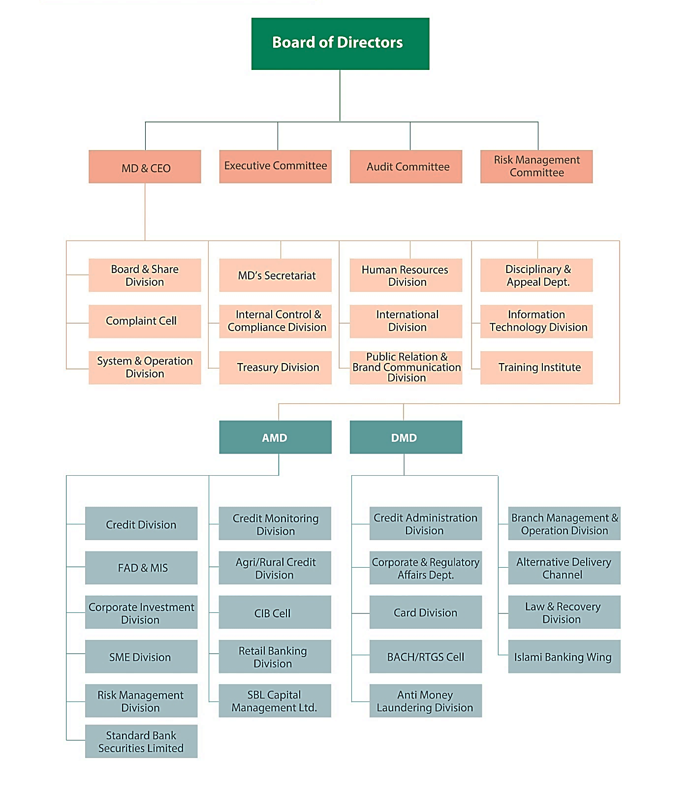
Fig- 3.1
Company organogram of standard bank

3.3.10 Managerial Hierarchy of Standard Bank Ltd.

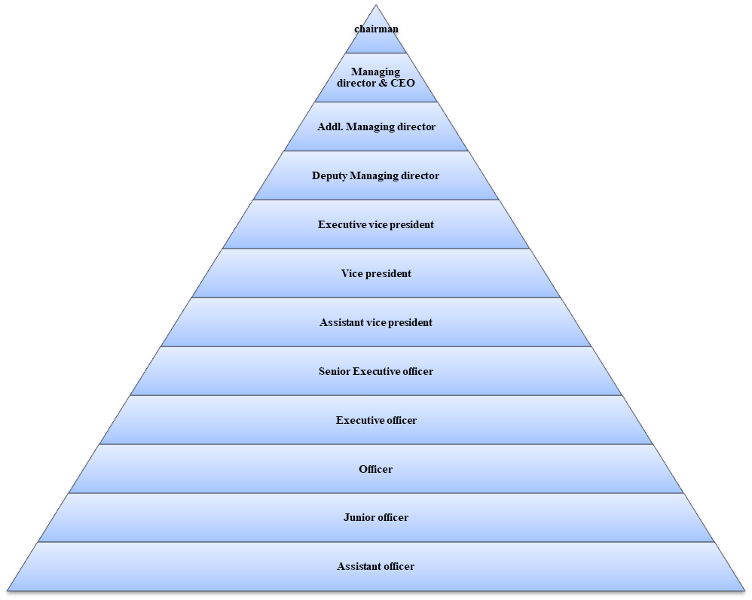
Fig: 3.2
Managerial hierarchy of SBL

3.3.11 Branding

To increase brand visibility by creating positive image of the bank, SBL is undoubtedly gaining momentum in its day-today activities to implement the slogan "Setting a New Standard in Banking" by strengthening the Bank's financial capability to an international standard, increasing the brand image, and practicing high degree of planned corporate good governance. During the year under report, ten (10) new branches have been opened and state-of-the-art IT services has been introduced to offer better banking services to the existing and prospective clients.

3.3.12 Branches of the Standard bank

Total of 125 Branches are established from the year 1999 to 2018 in various districts of Bangladesh. More Branches are being opened considering potentialities and demand of the economic needs of the concerned areas. Besides, offshore banking unit has been launched since 2015 and have opened branches in various important cities in the world, specially in USA, Spain, England and so on. Its ultimate goal is to cover more areas with technology-based delivery channels. Moreover, expansion of ATM, mobile banking service and agent banking services prove the improvement of the operational efficiency.

3.4 SWOT Analysis

Each organization is made out of some internal qualities and shortcomings and furthermore has some outer chances and dangers in its entire life cycle. The brief explanation of Standard Bank Ltd. Internal strengths and weaknesses, and external opportunities and threats as I found in the past three months, are given below. As anyone might expect, in the focused field of marketing era SWOT analysis is an unquestionable requirement base on Product, Price and Promotion of a financial organization like commercial private bank. From the SWOT analysis we can make sense of running scenario of the bank.
Two variables are considered in SWOT analysis as prime movers.
- Internal factors which incorporate strengths and weaknesses.
- external factor which are opportunity and threat

Table-3.3
SWOT analysis
Strength | - Company Republication  - Sponsors  - Top management  - Leadership  - Market share profitability  - Strong financial resources  - Facilities and Equipment  - Impressive Branches  - Interactive Corporate Culture  - Team work at mid-level and lower level
Weakness | - Failure in Vision  - Advertising and Promotion  - Poor Recruitment  - Reference appointment  - Low remuneration package  - Human Resources Department  - Centralized Decision-Making  - Lack of qualified system operators and computer operators  - Small Market Share  - High Concentration on Fixed Deposits  - Disguised employment
Opportunity | Diversification  - Product line proliferation  - ATM  - On-line banking  - Introduction of SBL’s own savings scheme
Threat | Multinational bank  Contemporary banks  Upcoming Banks  No new deposit creation

CHAPTER 04

ANALYSIS PART ON GENERAL BANKING
There are three major divisions of Standard Bank Limited (principal branch). These divisions are-
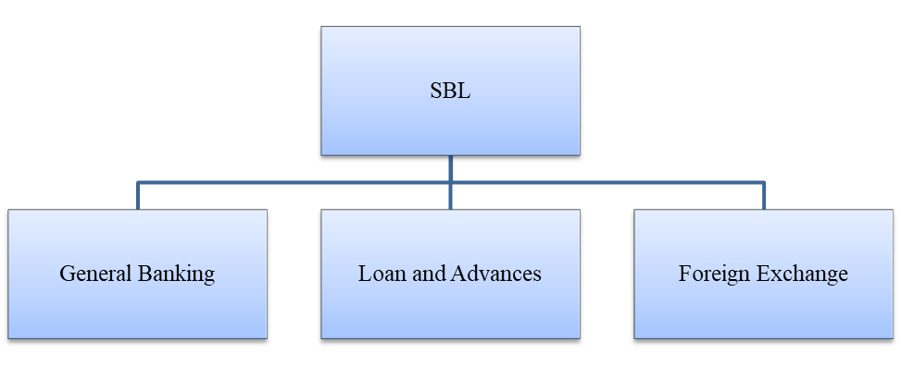
Fig: 4.1
Different departments of SBL

4.1 General Banking

General banking is the heart of all the banking operations of SBL. This department provides day-to-day services to the customers and create banker client relationship by opening diverse sorts of account and by giving prompt services to the customers. I have completed my internship in principal branch of SBL and during that time, I found the general banking department as the busiest and most important department of the branch. Certain tasks are performed by the Officers of this department which are given below-
- New account opening
- Closing account
- LBC/ OBC collection
- Remittance section
- Clearing section
- Cash section
- Dispatch section
- Card Division

4.2 Account opening section

Opening an account is the first step for customers to establish relationship with bank. It is the establishment of banker customer contractual relationship. This is one of the most imperative sections of a branch, because by opening accounts bank prepares funds for investment. Various rules and regulations are maintained and various archives are taken while opening an account. A customer can open distinctive types of accounts through this department.
- Savings Deposit
- Current Deposit
- Short Notice Deposit (SND)
- Fixed Deposit account
- SBL regular income program
- SBL 10-taka account
- SBL 1.5 times income program (SIP)
- NFCD account
- RFCD account
- Foreign currency account
- Non-resident Block account
Besides SBL has Islamic banking wing and customers can open their account with special features in this section.

4.2.1 Savings Deposit account

Saving account is for those having surplus reserve, not needed to draw Cash frequently, being provident stores for future. This is an interest generating account. Account holder gets interest in their account if certain A/C working norms are clung to. Both individual and association can open this sort of accounts, but this type of account is not ideal for business people/organization.
Benefits and requirements for this account are given below:

Table: 4.1
Benefits of Savings deposit account


Table: 4.2
Requirements of savings deposit account
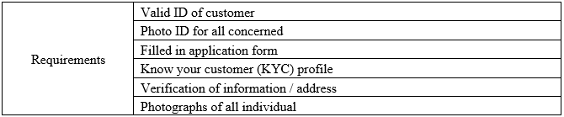
There are several deposit products which are operating under deposit accounts. SBL saving deposit products are given below:
- SBL Bondhon Savings
Table-4.3
product details of SBL bondhon savings
Customer type | Individual / Joint
Company Account | Not allowed
Age limit | 18 years and above
Minimum initial deposit amount | Tk. 100
Maximum deposit amount | Tk. 25000
Interest rate | 5%
Interest posting cycle | Monthly
Minimum balance for interest earning | Tk 100
VAT | As per govt. rule
ATM card issue fee | Free
Cheque book issue fee | Free
Fund transfer | Allowed

- SBL Savings Premium
Table 4.4
product details of SBL savings premium
Customer type | Individual / Joint
Company Account | Not allowed
Age limit | 18 years and above
Minimum initial deposit amount | Tk. 1,00,000
Maximum deposit amount | Unlimited (compliant with BB regulations)
Interest rate | Daily Avg. Balance | Rate
Interest rate | <1,00,000 | 0%
Interest rate | 1,00,000 – 4,99,999 | 3.0%
Interest rate | 5,00,000 – 9,99,999 | 3.50%
Interest rate | 10,00,000 and above | 4%
Interest posting cycle | Quarterly
Minimum balance for interest earning | Tk 1,00,000
VAT | As per govt. rule
ATM card issue fee | Free for first time
Cheque book issue fee | Per leaf tk. 3+15%vat
Closing charge | Tk. 200+15%vat

- SBL Savings Premium Plus
Table 4.5
product details of SBL savings premium Plus
Customer type | Individual / Joint
Company Account | Not allowed
Age limit | 18 years and above
Minimum initial deposit amount | Tk. 5,00,000
Maximum deposit amount | Unlimited (compliant with BB regulations)
Interest rate | Daily Avg. Balance | Rate
Interest rate | <5,00,000 | 0%
Interest rate | 5,00,000 – 9,99,999 | 3.50%
Interest rate | 10,00,000 –19,99,999 | 3.75%
Interest rate | 20,00,000 and above | 5%
Interest posting cycle | Quarterly
Minimum balance for interest earning | Tk 5,00,000
VAT | As per govt. rule
ATM card issue fee | Free for first time
Cheque book issue fee | Per leaf tk. 3+15%vat
Closing charge | Tk. 200+15%vat

- SBL Super Savers Savings
Table 4.6
product details of SBL Super Savers Savings
Customer type | Individual / Joint
Company Account | Not allowed
Age limit | 18 years and above
Minimum initial deposit amount | Tk.25,00,000
Maximum deposit amount | Unlimited (compliant with BB regulations)
Interest rate | Daily Avg. Balance | Rate
Interest rate | <25,00,000 | 0%
Interest rate | 25,00,000 – 49,99,999 | 5.50%
Interest rate | 50,00,000 –99,99,999 | 5.80%
Interest rate | 1,00,00,000 and above | 6%
Interest posting cycle | Quarterly
Minimum balance for interest earning | Tk 25,00,000
VAT | As per govt. rule
ATM card issue fee | Free for first time
Cheque book issue fee | Per leaf tk. 3+15%vat
Closing charge | Tk. 200+15%vat

- SBL Golden Age Savings
Table -4.7
product details of SBL Golden Age Savings
Customer type | Individual / Joint
Company Account | Not allowed
Age limit | 60 years and above
Minimum initial deposit amount | Tk. 1000
Maximum deposit amount | Unlimited (compliant with BB regulations)
Interest rate | 6% on any amount
Interest posting cycle | Quarterly
Minimum balance for interest earning | Tk 3,000
VAT | As per govt. rule
ATM card issue fee | Free For First time
Cheque book issue fee | Per leaf tk. 3+15%vat
Closing charge | Tk. 200+15%vat

- SBL Women Savings
Table -4.8
product details of SBL Women Savings
Customer type | Individual / Joint
Company Account | Not allowed
Age limit | 18 years and above
Minimum initial deposit amount | Tk. 1,000
Maximum deposit amount | Unlimited (compliant with BB regulations)
Interest rate | Daily Avg. Balance | Rate
Interest rate | <15,00,000 | 4.50%
Interest rate | 15,00,000 – 24,99,999 | 5%
Interest rate | 25,00,000 –39,99,999 | 5.25%
Interest rate | 40,00,000-59,99,999 | 5.50%
Interest rate | 60,00,000 and above | 6%
Interest posting cycle | Quarterly
Minimum balance for interest earning | Tk 3,000
VAT | As per govt. rule
ATM card issue fee | Free for first time
Cheque book issue fee | Per leaf tk. 3+15%vat
Closing charge | Tk. 200+15%vat

- SBL Classic Savings
Table- 4.9
product details of SBL Classic Savings
Customer type | Individual / Joint
Company Account | Not allowed
Age limit | 50 years and above
Minimum initial deposit amount | Tk. 1000
Maximum deposit amount | Unlimited (compliant with BB regulations)
Interest rate | 5.50% on any amount
Interest posting cycle | Quarterly
Minimum balance for interest earning | Tk 3,000
VAT | As per govt. rule
ATM card issue fee | Free for First time
Cheque book issue fee | Per leaf tk. 3+15%vat
Closing charge | Tk. 200+15%vat

SBL Scheme Deposit Products:

- SBL DPS (Sarbojonin)
Table: 4.10
Maturity Amount Chart
Monthly Deposit | 3 years Matured Amount | 5 years Matured Amount
500 | 20,600 | 37,600
1,000 | 41,200 | 75,200
2,000 | 82,400 | 150,400
2,500 | 103,000 | 188,000
5,000 | 206,000 | 376,000
10,000 | 412,000 | 752,000
Table 4.11
Product Details
Product Name | SBL DPS (Sarbojonin)
Customer type | Individual/Joint
Link Account | Mandatory
Age limit | 18 years and above
Period | 3 years,5 years
Interest Rate | 9%
Interest Application Cycle | At Maturity
Installment Amount | 500,1000,2000,2500,5000,10000
Installment Frequency | Monthly
Deposit Instalment Defaulter Condition | The account will be automatically closed if customer fails to give five installments.
Pre-mature Encashment Allowed | Yes
Closing charge for premature Encashment | Tk.200+15% VAT (for existing)

- SBL DPS (Projonmo)
Table 4.12
Maturity Amount Chart
Monthly Deposit | 3 years Matured Amount | 5 years Matured Amount | 7 years Matured Amount | 10 years  Matured Amount
500 | 20,700 | 38,100 | 58,900 | 98,100
1,000 | 41,400 | 76,200 | 117,800 | 196,200
2,000 | 82,800 | 152,400 | 235,600 | 392,400
2,500 | 103,500 | 190,500 | 294,500 | 490,500
5,000 | 207,000 | 381,000 | 589,000 | 981,000
10,000 | 414,000 | 762,000 | 1,178,000 | 1,962,000
Table 4.13
Product Details:
Product Name | SBL DPS (Projonmo)
Customer type | Joint
Link Account | Mandatory
Age limit | Below 18 years with guardians
Period | 3 years,5 years,7 years,10 years
Interest Rate | 9.50%
Interest Application Cycle | At Maturity
Installment Amount | 500,1000,2000,2500,5000,10000
Installment Frequency | Monthly
Deposit Instalment Defaulter Condition | The account will be automatically closed if customer fails to give five installments.
Pre-mature Encashment Allowed | Yes
Closing charge for premature Encashment | Tk.200+15% VAT (for existing)

- SBL DPS (Ghoroni)
Table 4.14
Maturity Amount Chart
Monthly Deposit | 4 years Matured Amount | 6 years Matured Amount
500 | 29,000 | 48,000
1,000 | 58,000 | 96,000
2,000 | 116,000 | 192,000
2,500 | 145,000 | 240,000
5,000 | 290,000 | 480,000
10,000 | 580,000 | 960,000
Table 4.15
Product Details
Product Name | SBL DPS (Ghoroni)
Customer type | Individual/Joint
Link Account | Mandatory
Age limit | 18 years and above
Period | 4 years,6 years
Interest Rate | 9.50%
Interest Application Cycle | At Maturity
Installment Amount | 500,1000,2000,2500,5000,10000
Installment Frequency | Monthly
Deposit Instalment Defaulter Condition | The account will be automatically closed if customer fails to give five installments.
Pre-mature Encashment Allowed | Yes
Closing charge for premature Encashment | Tk.200+15% VAT (for existing)

- SBL Lakhopati Plus
Table 4.16
Maturity amount Chart
Period | Monthly Installment | Amount Payable at Maturity
3 years | 2,500 | 103,000
5 years | 1,350 | 102,000
7 years | 900 | 106,000
10 years | 550 | 107,000

Table 4.17
Product Details
Product Name | SBL Lakhopati Plus
Customer type | Individual/Joint
Link Account | Mandatory
Age limit | 18 years and above
Period | 3 years,5 years,7 years,10 years
Interest Rate | 9.50%
Interest Application Cycle | At Maturity
Installment Amount | 2500.1350,900,550
Installment Frequency | Monthly
Deposit Instalment Defaulter Condition | The account will be automatically closed if customer fails to give five installments.
Pre-mature Encashment Allowed | Yes
Closing charge for premature Encashment | Tk.200+15% VAT (for existing)

- SBL Millionaire Plus
Table 4.18
Maturity amount chart
Period | Monthly Installment | Amount Payable at Maturity
3years | 24,500 | 1,014,000
5 years | 13,500 | 1,023,000
Table 4.19
Product Details
Product Name | SBL Millionaire Plus
Customer type | Individual/Joint
Link Account | Mandatory
Age limit | 18 years and above
Period | 3 years and 5 years
Interest Rate | 9.25%
Interest Application Cycle | At Maturity
Installment Amount | 13,500 and 24,500
Installment Frequency | Monthly
Deposit Instalment Defaulter Condition | The account will be automatically closed if customer fails to give five installments.
Pre-mature Encashment Allowed | Yes
Closing charge for premature Encashment | Tk.200+15% VAT (for existing)

- SBL Kotipoti Plus
Table 4.20
Maturity Chart
Period | Monthly Installment | Amount Payable at Maturity
3 years | 242,000 | 10,016,000
5 years | 132,000 | 10,004,000
7 years | 89,000 | 10,027,000
10 years | 52,000 | 10,074,000
Table 4.21
Product Details
Product Name | SBL Kotipoti Plus
Customer type | Individual/Joint
Link Account | Mandatory
Age limit | 18 years and above
Period | 3 years,5 years,7 years,10 years
Interest Rate | 9.25%
Interest Application Cycle | At Maturity
Installment Amount | 52000,89000,132000,242000
Installment Frequency | Monthly
Deposit Instalment Defaulter Condition | The account will be automatically closed if customer fails to give five installments.
Pre-mature Encashment Allowed | Yes
Closing charge for premature Encashment | Tk.200+15% VAT (for existing)

4.2.2 Current Account

Current account is essential for client bank relationship. Any person age above 18+ years or any organization can open this type of account. No interest is payable in the account but oblige high frequency and high volume of transaction. It is most suitable for business people and organizations. The benefits and requirements are given below
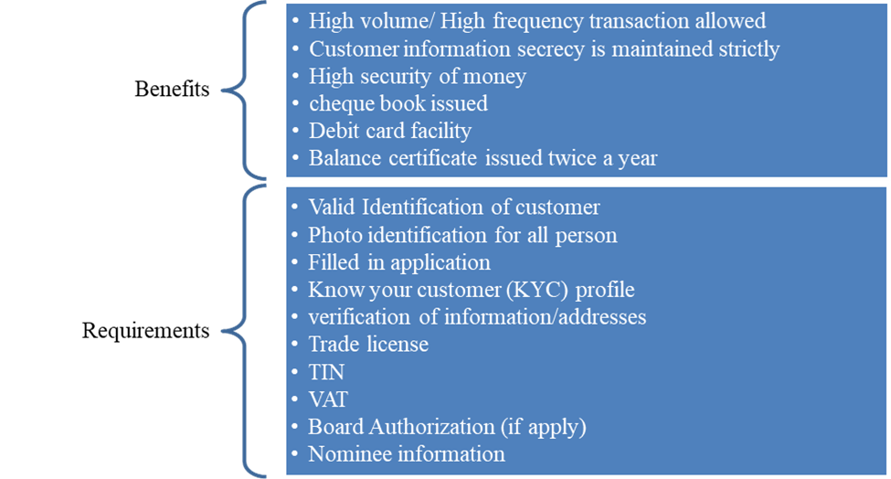

4.2.3 Short Notice Deposit account

This is a one kind of special current account and it carries interest at certain rate. The interest rate will be prescribed by the bank according to certain level of balance in the account. All benefits, requirement and regulations for current account will be applicable for this type of account.

4.2.4 Fixed Deposit Account

The account is for those having surplus reserve available for a considerable amount of time and might want to invest to have return on their collected assets. Interest at certain rate is paid after a certain period of maturity at the end. Rate of interest can be changed as per market scenario. The benefits and requirements are given below:
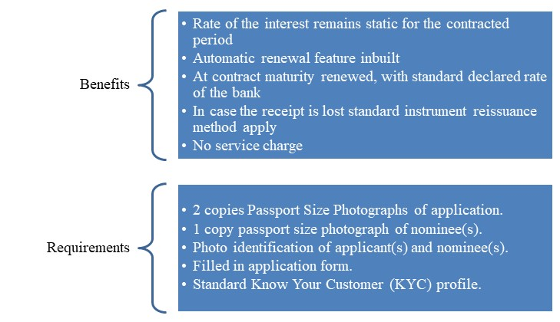

4.2.5 Regular Income program

For those having necessity of regular fixed income for a period, this account is most suitable for them. A fixed amount of money is given every month for the contracted period without touching the main deposit. However, if there should arise an occurrence of premature encashment, withdrawn sum will be deducted from the deposited amount for settlement. There are some conditions and restriction applied and the benefits and requirements are given below
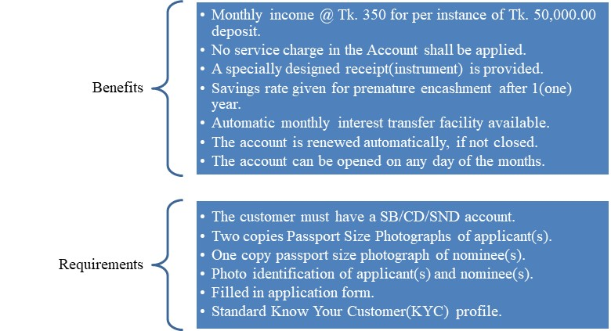

4.2.6 SBL 10-taka account

To reach the poor, marginally poor, destitute/disaster affected/landless section, small business people and small income occupants, financial inclusion has been viewed as an important function of banks. This is an explicit kind of account for Ultra Poor unbanked section of the society. This special type of account is directed by Bangladesh Bank.

4.2.7 SBL 1.5 times income program

This account is more suitable for those having surplus reserve money for longer period and want to put their money in a safer mode without hurting the liquidity of cash. The term for this scheme is 5 years. After the term 1.5 times amount of money will be given. If premature encashment occurs within 1year then there will be no interest and after that standard FDR rate will be followed. The requirements are as like as Fixed deposit account.

4.3 Closing account

Upon the demand of a client, an account can be closed. Subsequent to accepting an application from the client to close an Account. The client ought to be asked to draw the last cheque for the sum remaining to the credit of his a/c. After cutting the amount closing and other incidental charges and surrender the unused cheque leaves, account will be officially shut down. The closing charge varies for the type of account and schemes. An authorized officer will finally pulverize the unused leaves of the cheques. The bank can also close the account of a customer or restrict the operation of the account by these circumstances:
- Death of customer.
- Customers’ insanity and insolvency.
- Order of the court (Garnishee order)
- Specific charge for fraud forgery.

4.4 Clearing section

Pay order (P.O), Demand Draft (D.D), cheques and collection of cash from other banks on behalf of its customer are a basic function of a clearing department. With this system bank can collect customers fund from one bank to another. There are two types of clearing:
- Outward Clearing
When the bank receives cheques for drawing money to other banks.
- Inward Clearing
When the bank receives cheques for collecting the money from other banks.

4.5 Cash Section

As a fiscal association, bank acknowledge surplus money from the general population as store and give them opportunity to pull back the equal with cheque and so on. But among the banking activities, cash office plays a basic occupation. It does the essential function of a business bank for example, receiving the deposit and paying the money on interest. As this division deals directly with the clients the notoriety of the bank depends much on it. The functions of a cash department are described below:
Cash Payment: Cheque is used only for cash payment. This is also called payment on demand. At the time of making payment in cash the respective officer has to check the following things on the cheque:
- Date should be current and verified
- Seal must be there if it is a business cheque
- Verification of the sign of the account holder
- Amount should be written both numeric and word

Cash Receipt: Receive deposits from the depositors in form of cash. So, it is the “mobilization unit” of the banking system. It collects money only in its receipt’s forms. Some mandatory fields to check are:
- The deposit slip must written properly
- Amount of money is given by the clients

Cash packing: After the banking hour cash is packed according to the denomination. Notes are counted and packed in bundles and stamped with initial.

4.6 Dispatch Section

Dispatch incorporates all correspondence, letters, articulation and returns and wires. This dispatch is called mail in other way. The dispatch is principally partitioned into two classifications.
- Inward dispatch
It implies what are gotten from the outside.
- Outward dispatch
It implies what are sent to outside.

4.7 Bills Collection

In present day banking, the system has turned out to be mind boggling the extent that smooth transaction and safety is concerned. Client does pay and get the bill from their partner as a result of exchange. Commercial bank's obligation is to collect bills for their client. There are two types of bills for collection. They are:
- Outward Bills for collection (OBC)
Normally there are two ways to collect bills other than local clearing house
    - OBC with different branches of other banks
    - OBC with different branches of the same bank
Commissions for OBC
Table-4.22
Commissions of OBC
<1,00,000 | 0.15%
1,00,000-5,00,000 | 0.10%
5,00,000 and above | 0.05%

- Inward Bills for collection (IBC)
At the point when the banks collect bills as an agent of the collecting branch, the framework is known as IBC. For this situation the bank will fill in as an agent of the collection bank. The branch gets a forwarding letter and the bill.

4.8 Remittance Section

Conveying cash is troublesome and unsafe. This is the reason cash can be exchanged from one place then onto the next through banking channel. This is called remittance. Remittance of assets are a standout amongst the most vital parts of the commercial banks in rendering services to its client. The categories of remittance are given below:

The main ways used by standard bank ltd. of remittance of funds are:
- Pay order (P.O)
- Demand Draft (D.D)
- Telegraphic Transfer (T.T)
The foreign remittance is under division of foreign exchange division. SBL incorporate with Western Union, MoneyGram and RIA for their foreign money transfer. Other than that, SBL operates via branch and authorized banks in different cities in USA and throughout Europe. So, customer resides in these countries can easily send money to our country using these branches.

4.9 Card Section

Standard Bank Ltd. has both credit card and debit card facility. There are two tier of credit card in SBL. They are:
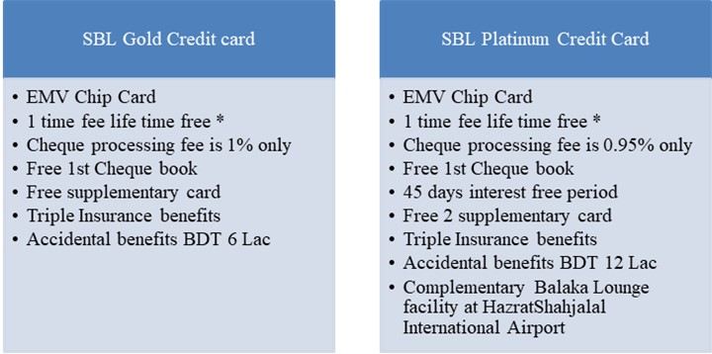



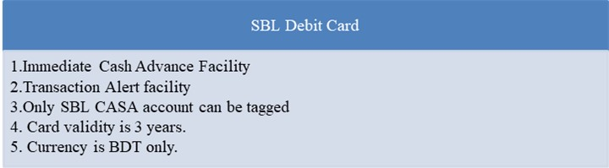
SBL Debit card is provided free for any current or savings account holders. This card can be used at National Payment Switch of Bangladesh (NPSB) network.

Besides conventional cards, SBL facilitates travel card for Hajj, named VISA Hajj Card and ordinary travel prepaid card can be also issued, named as VISA TRAVEL which serves traveler with ease payment solutions in any country.

CHAPTER 05

ANALYSIS PART OF LOAN SECTION

5.1 Credit & Advance Department

Bank's essential work is to make a channel through keeping cash from the surplus unit and give fund to borrowers. In this manner the need of credit division in bank occurs. The credit division is an essential part of a bank. The achievement of this office keeps an extraordinary impact over the benefit of a bank. Disappointment of this office may lead the bank to enormous misfortunes or even to liquidation. Standard Bank's credit office likewise endeavors to carry out their responsibility consummately. Credit and Advance office has four segments they are-Loan, Statement, Recovery and Bank Guarantee.

5.2 Credit Management and performance analysis
As Standard Bank is giving credit facility out of its aggregate accessible assets, it needs to deal with these credits proficiently. A proficient credit management system contains numerous things and this cover the pre-authorized activities to post-sanction activities. Acknowledge the board is vital as it helps the banks and financial institutions to comprehend different components of risk associated in various credit transactions.

A sound credit performance analysis incorporates in addition to other things safety of assets contributed opposite benefit of the bank. Empowering greatest number of little loans is superior to anything focus in a specific kind of advances, which guarantees adequate liquidity with minimum frequency. To analyze the credit performance there are some objectives that standard bank follows. They are:
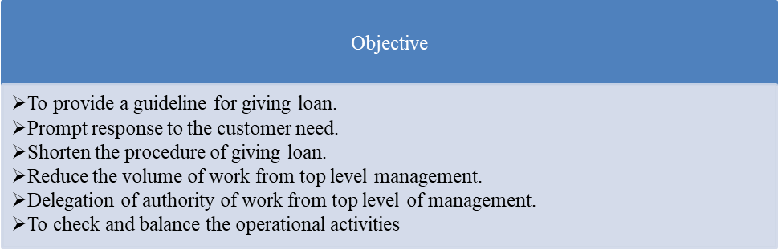

5.3 Performance Guidelines

When someone or some company applied for loan the credit management department of SBL must follow some guidelines before sanctioning the preferred loan. These are the following procedures:

5.3.1 Guidelines for Lending

These guidelines are as follows:
- Industry and Business Segment Focus
- Types of loan facilities
- Single borrowers/ group limits/ syndication
- Lending caps
- Discouraged business types:
    - Military equipment/ weapons finance
    - Highly leveraged transactions
    - Finance of speculative investments
    - Logging, mineral extraction/ mining, or other activity that is
    - ethically or environmentally sensitive
    - Lending to companies listed on CIB black list or known
    - Counter parties in countries subject to UN sanctions
    - Lending to holding companies.

5.3.2 Credit assessment and Risk grading

An intensive credit and risk appraisal ought to be directed before the sanctioning of advances, and at any rate every year from that point for all facilities. Credit Applications should synopses the consequences of the risk evaluation and incorporate, as a base, the accompanying subtleties:
- Loan purpose
- Amount and type of loan (s) proposed
- Environment or social risk inputs
- Loan structure (tenor, covenants, repayment schedule, interest)
- Security arrangement
- Any other risk or issue
- Risk triggers and action plan-condition prudent, etc.
As Bangladesh Bank’s guidelines of classification of loans and advances, the Lending Risk Analysis (LRA) is the basis of risk grading.

5.3.3 Approval Authority

Approval authority for lending is assigned to Branch manager by the Managing Director (MD) or the board committee. The authorities are reviewed annually by the board.

5.3.4 Duty segregation

The following lending functions are segregated by the bank:
- Credit approval/ risk management
- Relationship management/ marketing
- Credit administration

5.4 Credit management tools

SBL use Credit Risk Grading (CRG) and Financial Spread Sheet (FSS) as tools for credit management. These tools help the bank to watch over different ways of risk involved in credit transaction. The manual of lending risk analysis (LRA) are followed by Bangladesh bank from 1993 and it’s mandatory for all the banks operating. In recent years SBL has upgraded well defined risk management system which provides much more accurate and timely grading. Small briefing of CRG and FSS are given below:
- Credit Risk Grading (CRG)
The Credit Risk Grading matrix enables use of uniform models to credits, to guarantee a typical institutionalized way to deal with survey the nature of individual obligor, credit portfolio of a nit, line of business, the branch or the bank in general. The CRG output would be important for individual credit choice, wherein a borrower or a specific exposure or facility is evaluated. Alternate choices would be identified with pricing (credit-spread) and explicit highlights of credit office. These would to a great extent comprise obligor level investigation.
- Financial Spread Sheet (FSS)
Financial Spread Sheet gives a speedy technique for evaluating business patterns and productivity. It also
    - Assess the borrower's capacity to reimburse
    - Realistically Broadway the patterns of business
    - Allow correlations which will be made inside industry

5.5 Loan disbursement procedure of SBL

The followings are procedure of SBL authority before disburse or authorize loan to applicant.
- Credit information
Standard Bank gathers credit data about the candidate to decide the credit value of the borrower. From the following sources SBL collects information
    - Personal investigation.
    - Confidential report from other bank Head Office/Branch/chamber of the commerce.
    - CIB Report from Central Bank
- Getting personal information
The applicant must fill a specific form which is given by the credit and advance department authority. The information list is given below:
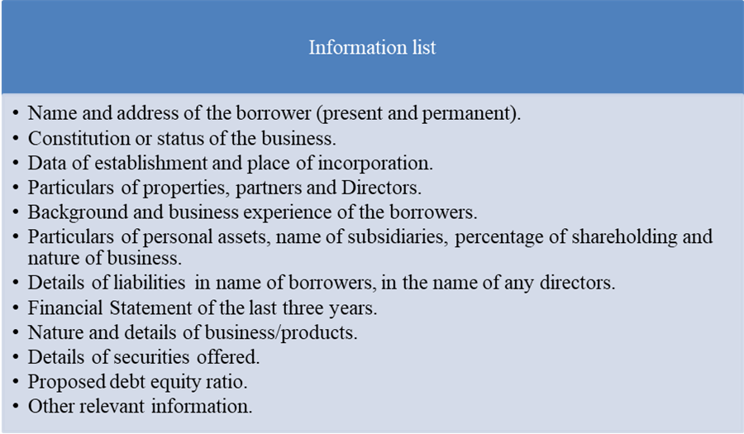

- Analyzing the information
SBL begins analysis whether the application is fitted with the lending policy. The bank goes for tools like LRA and FSS if the loan applicant asks for 50,000 taka or more. If the amount is equal or higher than 1 crore then it’s a must to fully use LRA, FSS and CRG which is mandated by Bangladesh Bank and must be authorized by the head office.
- Proposal analysis
The Project Proposal is analyzed and decision is made after the proper analysis result. The credit and advance division is in charge of the examination. After fundamental evaluation of the credit venture the last endorsement is get from the supervisor. In the event that the advance sum crosses a specific sum, chiefs send the project to the head office for conclusive endorsement. Potentiality of the project and different risk projection is found out by the experts of the division. There are some predetermined variables which are the basis of this analysis. These are:
    - Safety
    - Profitability
    - Security
    - Purpose of the loans
    - Sources of repayment
    - Diversification of risk
    - Liquidity
- Collateral evaluation
Standard Bank is exceptionally wary about valuation of the security. The bank authorities at the same time assess the guarantee of the gathering offered by the private firm. The valuation of the insurance expands the precision of its esteem evaluated. There are 3 types of value of the collateral. They are:
    - Current market price
    - Distressed price
    - Price after 5 years
- Final decision about the loan
In the event that the loan choice stays with the branch level, that branch endorses the credit and on the off chance that the affirming specialist is Head Office, the choice goes to the branch by wire or fax. For the project, if such arrangement is kept in the authorize gets, the Standard Bank authorities go to the venture zone to see how the advance is used. On the off chance that no such statement to manage the credit is included, even, the bank can see the execution of the venture.

5.6 Loan schemes of SBL

SBL divided their loan products according to different banking schemes like
- Corporate banking
- Retail banking
- SME banking
- Agri banking
- Social and environmental infrastructure finance

5.6.1 Corporate banking

Standard bank has classified corporate financing into 2 categories. These are:
- Short Term Finance
The short-term finance consists of
    - Cash credit (hypo)
Cash Credit (Hypo) famously known as CC(Hypo) that requires for the most part to fund acquirement of crude materials/stock in-exchange. Cash Credit account resembles current account with a limit up to which one can pull back from the bank. Cash credit is ordinarily authorized for a time of one year where a customary limit is endorsed against products to meet everyday costs of business.
    - Time Loan
To meet dire money necessity of the business worry in the method of working capital fund for securing local crude materials/stock in exchange. Time credit is given for an explicit period coordinating with the working cycle i.e. 30 days for trading and 90 to 180 days for manufacturing concern.
    - SOD (general)
A normal limit is authorized to meet everyday costs of business with SOD. This type of credit is given to the business where upkeep of stock all the time is unimaginable. Time of SOD(Gen) is normally one year and inexhaustible subject to palatable business exchange. The record is balanced by the deal continues or from claim wellspring of the client.
    - SOD (FO)
At the point when overdraft is permitted against lien of FDR or other money related instruments, it is named as Secured Overdraft (SOD). Secured Overdraft (SOD) facility to the borrower might be permitted for the most part in the accompanying ways:
- Overdraft-against FDR for the sake of borrower
- Overdraft-against Scheme for the sake of the Borrower

- Long Term Loan
The long-term loan consists of
    - Term Loan
This type of loan is offered to meet credit prerequisite for any legitimate purposes that typically require long haul portion installment and not straightforwardly identify with revenue generation. Sources of reimbursement will be the business continues of claim source of the client.
    - Lease financing
Under lease financing SBL cover gear/vehicle financing. It is a term financing repayable through rent rental as equivalent regularly scheduled payments (counting main and interest). Ownership of rented out gear/vehicle under the lease understanding covering complete dangers that has a place with the Bank.
    - Hire purchase
This is likewise given to obtain gear/vehicle. Responsibility for hardware/vehicle to be obtained under the Hire-Purchase understanding covering far reaching dangers has a place with both the Banker and the client. Contract Purchase office is repayable by storing level with regularly scheduled payments (counting essential and intrigue sum).

5.6.2 Retail Banking

Retail banking is divided into the followings:
- SBL Auto Loan
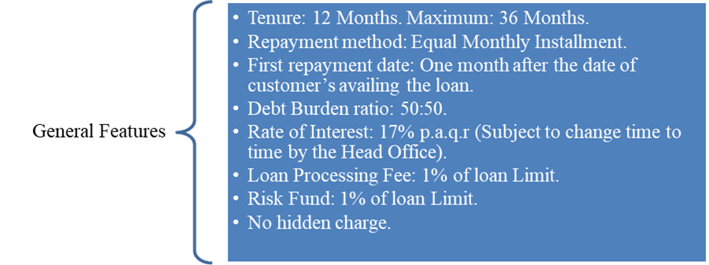

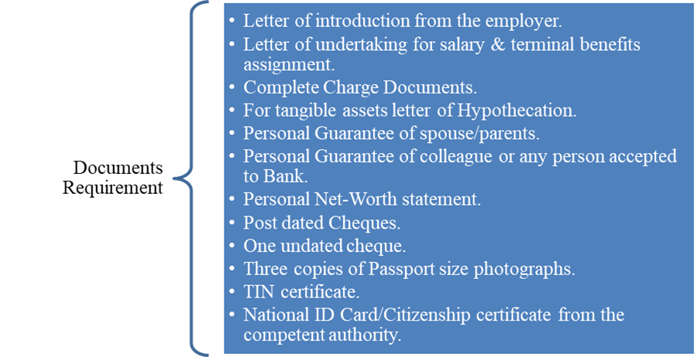
- SBL House Renovation Loan
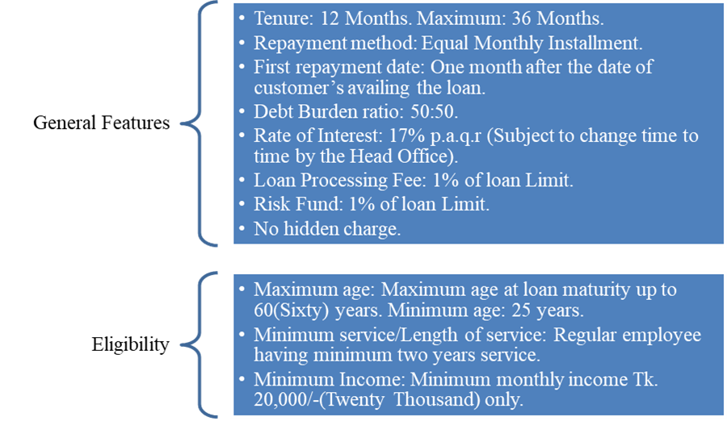

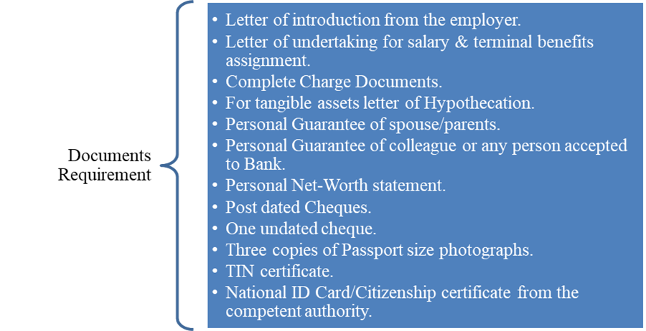
- SBL Medical Treatment Loan
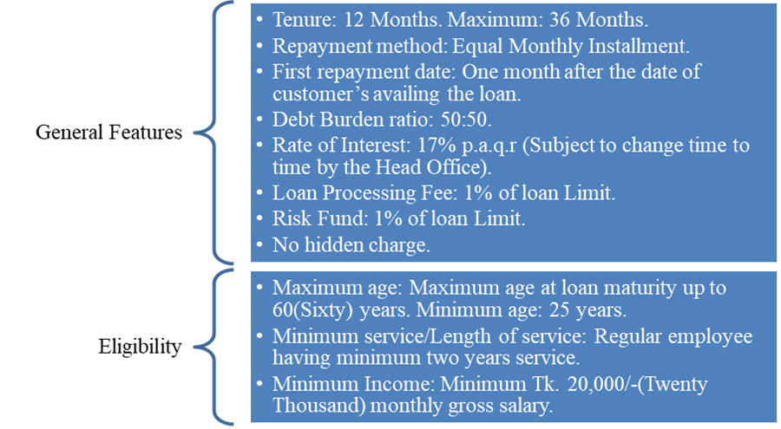

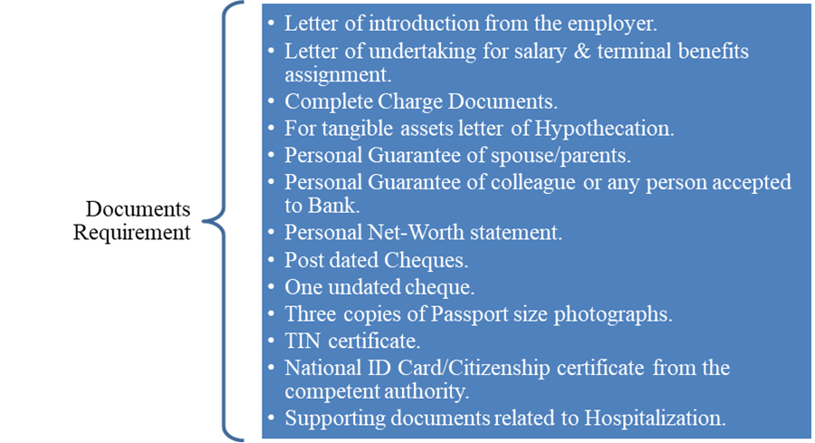
- SBL Hajj Loan

- Household Appliance Loan

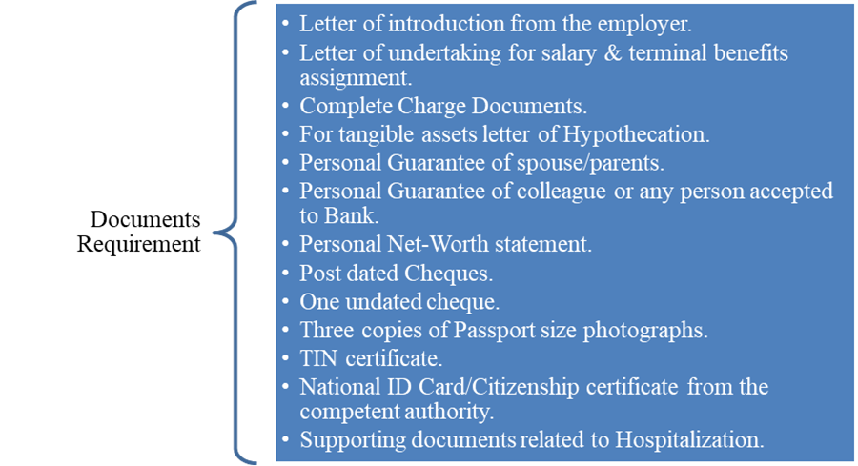

5.6.3 SME Banking

The definition of SME by the Bangladesh Bank is given below:
Table 5.1
SME Banking definition
Business segment | Sector | Business size (TK.) fixed asset other than land 7 Building | Employed manpower
Cottage enterprise | Manufacturing | Up to 500,000 | 10+
Micro enterprise | Manufacturing | 500,000-5,000,000 | 10-24
Micro enterprise | Service | Less than 500,000 | 10
Micro enterprise | Trade | Less than 500,000 | 10
Small enterprise | Manufacturing | 5,000,000-100,000,000 | 25-99
Small enterprise | Service | 500,000 - 10,000,000 | 10-25
Small enterprise | Trade | 500,000 - 10,000,000 | 10-25
Medium enterprise | Manufacturing | 100,000,000- 300,000,000 | 100-250
Medium enterprise | Service | 10,000,000- 150,000,000 | 50-100
Medium enterprise | Trade | 10,000,000- 150,000,000 | 50-100

To help Small and Medium Enterprises, Standard Bank Limited has broadened its system up to the provincial frontier with a nationwide reach of Branches, SME and Business Centers, Alternative Delivery Channels (ADC) etc. The SME products are explained in brief below:
- SBL Babbosha Shachal
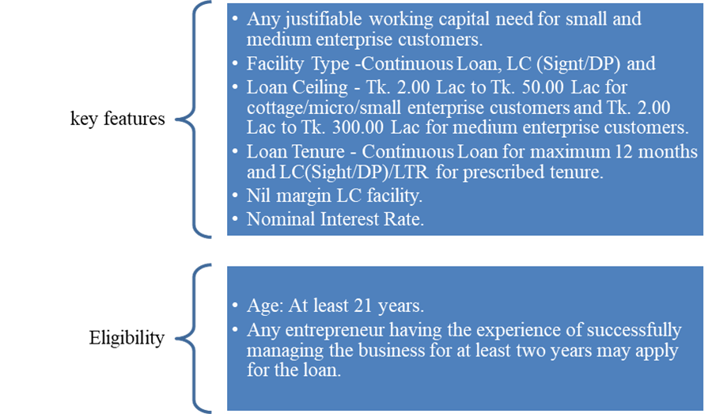
- SBL Babbosha Unnayon
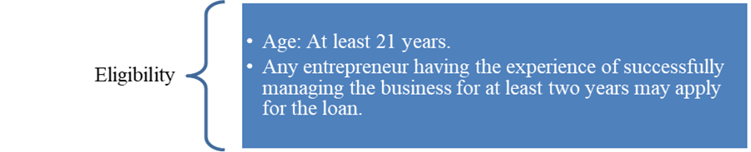

- SBL Babbosha Shommriddhi
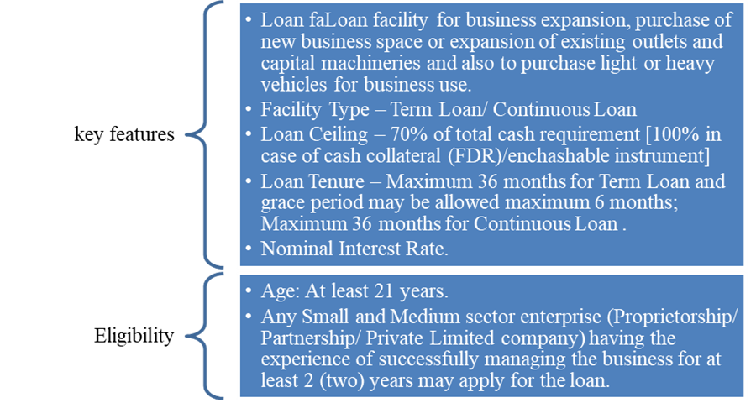

- SBL Karma Uddogh
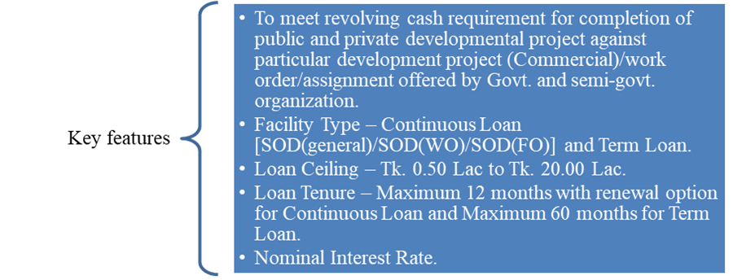
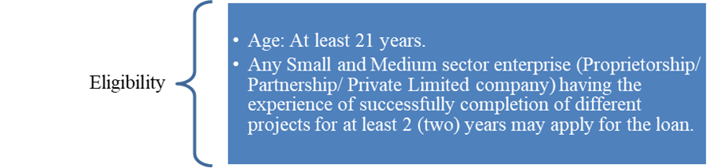

- SBL Nari Anuprerona- Women Entrepreneurs' Loan
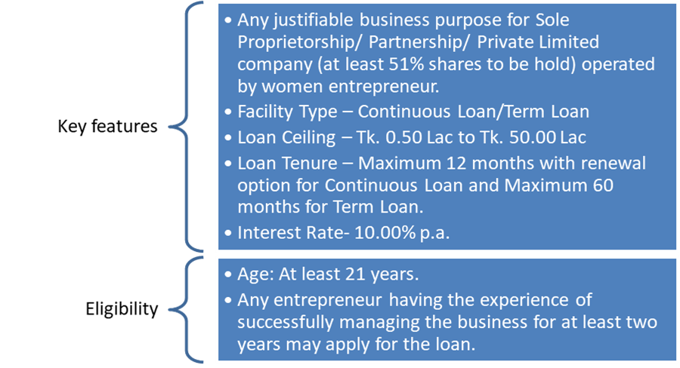

5.6.4 Social and environmental infrastructure finance

Standard Bank Limited (SBL) Corporate Banking offers focused item and provide services to corporate customers with a mean to contribute reinforcing the financial infrastructure of the country. With a dream to give viable and key budgetary solution for the manufacturing, service oriented and business concerns, SBL has designed its Corporate Banking Department with assortments of products and services which incorporates General Corporate Finance, Foreign Trade Finance, Project Finance, Working Capital Finance, Syndicate Finance, Work Order Finance, Real Estate Finance, and so on.

CHAPTER 06

RECOMMENDATION & CONCLUSION

6.1 Recommendation

Standard Bank Limited is an entrenched bank in Bangladesh. It is giving high caliber services to the client since 1999. In any case, it has a few limitations that are referenced previously. A few proposals are made to defeat these issues which are demonstrated as follows:
- Increased supervision of managerial personnel is much needed for assessing whether the target is met or not.
- Bank ought to give accentuation on IT foundation to convey better service to the clients, they ought to acquaint new software to handle tremendous number of customers.
- To persuade the representatives of SBL the bank ought to rebuild the compensation structure of the workers by setting singular focus for every representative for a specified period.
- Bank ought to present 'Night banking’ like BRAC bank if conceivable. At that point client will be profited and fulfillment level will consequently increase.
- Standard Bank Limited should bring down its loan interest rate, which is appeared to be high in the majority of the cases.
- The bank likewise charges loan handling fee on different kinds of advances, for example, commercial house building loan, transport loan and so forth. It is an additional weight for the borrowers, so bank ought to decrease the rate and if conceivable ought to dispose of it.
- For "Imported Merchandise Loan" the bank ought to classify imported items based on their temperament which will encourage both the borrower and financier to decide the greatest term of the credit.
- SBL should create enough marketing about their services and so bank should establish a fully separated marketing dept. or any outsource with any marketing activation agency.
- Employees who are qualified and skilled should be promoted based on their performance level. Performance appraisal should be introduced in the bank so performance of every worker can be monitored.

6.2 Conclusion

In this three-month internship program at Standard Bank Ltd. principal branch, I learned many aspects of present working environment and gathered experience by working with the skilled officers in the branch. They are very helpful and environment is very up to date with modern things. This experience will help me a lot in my career in job market.

There are 48 commercial banks with numerous numbers of branches and the competition is very high in aspect of this industry. In this circumstance, SBL is playing vital role in economy of Bangladesh. The majority of the customers are satisfied as there are no delayed services of gimmick and rest assured their property is in safe hand. SBL provides easy loan for poorer groups of people in rural areas and with minimal interest rate SMEs are helped by the bank. The company is listed as AA in Bangladesh Bank which is truly showing they are in the right path. If we look at their annual report of recent years, the number shows the positive margins which means their growth is increasing every year.

Every company has their drawbacks and as like SBL has their too. There management must be more emphasized and more intuitive. There is lack of training programs of officers. Company must encourage their employees for higher target success but I did not see such things in principal branch. Despite these shortcomings, their success is blooming in every way. Within short time the bank shows their success and I wish the bank all success prosperity in their field.

CHAPTER 07

REFERENCE

7.1 References
Upcoming Banks

Sheikh Kabir Uddin Haider. (2011). Genesis and growth of the NGOs: Issues in Bangladesh perspective. International NGO Journal, 6(11). doi: 10.5897/ingoj11.025
Chowdhury, T., & Ahmed, K. (2009). Performance Evaluation of Selected Private Commercial Banks in Bangladesh. International Journal of Business and Management, 4(4). doi: 10.5539/ijbm.v4n4p86
Gallo, J., Apilado, V., & Kolari, J. (1996). Commercial bank mutual fund activities: Implications for bank risk and profitability. Journal of Banking & Finance, 20(10), 1775-1791. doi: 10.1016/s0378-4266(96)00024-6
Dorfman, J., Schumpeter, J., & Schumpeter, E. (1954). History of Economic Analysis. Political Science Quarterly, 69(4), 603. doi: 10.2307/2145638
Dymski, G. (1988). A Keynesian Theory of Bank Behavior. Journal of Post Keynesian Economics, 10(4), 499-526. doi: 10.1080/01603477.1988.11489704
Barsby, S. (1969). Economic Backwardness and the Characteristics of Development. The Journal of Economic History, 29(03), 449-472. doi: 10.1017/s0022050700072429
Ahamed, L. (2014). Lords of finance. New York: Penguin Books.
Ohio State Univ Pr. (2015). Great Debate on Banking Reform.
The following website was accessed on November 20, 2018: https://www.standardbankbd.com/
The following website was accessed on November 22, 2018: https://www.bb.org.bd/
Table:32

SWOT analysis

Strength

•

Company Republication

•

Sponsors

•

Top management

•

Leadership

•

Market share
profitability

•

Strong financial resources

•

Facilities and Equipment

•

Impressive Branches

•

Interactive Corporate Culture

•

Team work at mid
-
level and lower level

Weakness

•

Failure in Vision

•

Advertising and Promotion

•

Poor Recruitment

•

Reference
appointment

•

Low remuneration package

•

Human Resources Department

•

Centralized Decision
-
Making

•

Lack of qualified system operators and
computer operators

•

Small Market Share

•

High Concentration on Fixed Deposits

•

Disguised employment

Opportunity

•

Diversification

•

Product line proliferation

•

ATM

•

On
-
line banking

•

Introduction of SBL’s own savings scheme

Threat

•

Multinational bank

•

Contemporary banks

•

