Service Quality and Customer Satisfaction at the
United Hospital Ltd.

Latifur Rahman Alvee

This report is submitted to the School of Business and Economics, United International University as a partial requirement for the fulfillment of Bachelor of Business Administration Degree.
Service Quality and Customer Satisfaction at the
United Hospital Ltd.

Prepared by,
Latifur Rahman Alvee
ID: 111 142 282
Department: BBA
Major: Marketing
School of Business & Economics
United International University

Supervised by,
Dr. Kawsar Ahmmed
Associate professor
School of Business and Economics
United International University

This report is submitted to the School of Business and Economics, United International University as a partial requirement for the fulfillment of Bachelor of Business Administration Degree.
LETTER OF AUTHORIZATION

Dear Reader,
The report prepared on “Service Quality and Customer Satisfaction at the United Hospital Ltd.” was authorized and supervised by Dr. Kawsar Ahmmed, instructor for “Internship” on October 5, 2019.

The report extensively covers all the aspects.

Sincerely Yours,

_____________________________
Latifur Rahman Alvee
ID: 111 142 282
School of Business & Economics
United International University
ACKNOWLEDGMENT

A report of this nature is often the product of the time, effort, and dedication of a large number of people, many of whom always remain in the background. Many individuals have helped me by making valuable comments throughout the development of this report.
First of all we want to thank The Almighty Allah. Then I would like to begin by thanking our honorable Associate Professor, Dr. Kawsar Ahmmed, who provided me all kind of help, supports and advices in preparing this report. Without his inspiration and guidance, it could be very difficult to prepare this report.
Then I am very grateful to the United Hospital Ltd. for providing me the opportunity to complete my internship program. This report would have never seen the day of light without the sustained co-operative behaviors of the members of United Hospital Ltd. who have helped me to collect the information what are needed. I also like to thank all the staffs of United Hospital Limited, GM Sir, DGM Sir, Hanufa Ma’am, CEO Sir, Arif Bhaiya, Nadira Apu, Rifat Apu, Monowara Apu, Aziz Bhaiya, Kwasar Bhaiya, Tania Apu and the rest of the team for their affable hospitality.
I prepared the report on the basis of knowledge, data form the office and field, ideas and understanding of the internship program. I tried to make it precise and concise as well as in formative. Finally, I wish to extend my heartfelt thanks to the Faculty Members for their encouragement and valuable suggestions. I also like to show my gratefulness to Nazi, Tushar, Atiq, Melon, and Arshad for helping me exploring in various articles related to this report.
In spite of sincere and devoted efforts, there might be some mistakes in the study report. I take the entire responsibility for such unintended errors and omissions.
Lastly, we would like to thank our other respective family members & friends from UIU who have helped us in many ways.

Letter of Transmittal

October 5, 2019
Dr. Kawsar Ahmmed
Associate Professor
School of Business & Economics
United International University
Subject: Submission of Internship Report

Dear Sir,
With due respect to you, I am honored to submit my internship report titled “Service Quality and Customer Satisfaction at the United Hospital”- As a part of our BBA degree requirement. The observations and result of my study are embodied on this report. In addition to my careful study, this report has been a worthwhile review allowing me to go for in-depth analysis about real situation.
I have completed this report, which is a valuable experience as, I found the study to be quite interesting, beneficial and insightful. I have given my hundred percent effort for making this report. If further information is required, I will be glad to provide that any time of your convenience.
Finally, I would like to thank you for providing me the opportunity to work on such an interesting topic. I eagerly hope that you will find this report worth reading & I believe that this report will meet your approval. Hope you will appreciate my hard work and excuse the minor errors.

Sincerely Yours,

____________________________
Latifur Rahman Alvee
ID: 111 142 282
School of Business & Economics
United International University
Declaration of originality

I hereby declare that this report is my own original work and is the result of my own investigations and experiments. To the best of my knowledge, no part of this dissertation has been published previously or written by another person nor it has not been submitted anywhere for the award of any degree.
No part of this Report has been previously submitted to any other University/College/ Institutions/ Organization for any academic certificate/degree/diploma/qualification. The work I have presented does not breach any existing copyright and no portion of this report is copied from any work done earlier for a degree or otherwise.
This research was conducted to fulfill the requirements of BBA Program associated with Department of Business Administration, United International University, United City, Madani Avenue, Badda, Dhaka,

______________________________
Latifur Rahman Alvee
ID: 111 142 282
School of Business & Economics
United International University

Certificate of Supervisor

The Internship Report entitled on “Quality Service and Customer Satisfaction at the United Hospital” has been submitted to the Office of Placement & Alumni and Dept. of Business Administration in partial fulfillment of the requirements for the degree of Bachelor of Business Administration, Major in Marketing by Latifur Rahman Alvee bearing ID No: 111-142-282, Program: BBA.
The report has been accepted and may be presented to the Internship Defense Committee for evaluation. He has prepared the report by himself under my direct supervision and it is a record of authentic aspects.
I wish him every success in his future endeavor.

_______________________
Dr. Kawsar Ahmmed
Associate Professor
School of Business & Economics
United International University
Executive Summary

Satisfying customers has always been a challenge for any fields whether it is banking, hospitality, sales and marketing, or even healthcare. Only thing that matters to a customer is that the quality. Service quality is the customers’ expectations of a service considering the image of that organization. When customer’s experience of a service matches with his expectations, he becomes satisfied and loyal to that particular service provider. So, it is very important for organizations to evaluate customers’ perceptions towards quality. So, for a renowned and leading hospital like United Hospital Ltd. in the country, evaluating customers’ perception is also important. This hospital has achieved people’s faith and respect over the years through its successful operations.
For measuring customer satisfaction, this study used service quality dimensions to study each variable for a better knowledge. Data were collected for evaluation by using survey questionnaire and fifteen completed questionnaire were collected from the executives of United Hospital Ltd. I chose only those respondents who are eligible for the study and who are the permanent staffs of this hospital. From their responses, I have come to a conclusion that the customers are satisfied with hospital service. So far from the overall data analysis and findings, authority of the hospital should hire more expert consultancies so that patients do not have to wait for much longer which will increase the hospital’s reliability more.

Keywords: Service Quality, Patients Satisfaction, United Hospital Ltd., Bangladesh

Contents
C H A P T E R - 1 0
Introduction 1
Motivation of the study 1
Objectives of the Study 1
Limitations of the study 2
Significant of the study 2
Organizing the Remaining Chapter 2
C H A P T E R - 2 3
Introduction 4
United Hospital Ltd 4
History of United Hospital 5
Core Strengths 5
Core Competencies 6
Mission Statement 6
Vision 6
Departments 7
Services 9
Allied Health 10
Facilities Available 10
SWOT Analysis 11
Board Members 12
Operational Team 13
Literature Review 15
Service Quality 15
Importance of service Quality 15
Maintenance of Service Quality 16
Study Variable 16
Theoretical Framework 17
C H A P T E R - 3 21
Introduction 22
Population and sample for the study 22
Measurement 22
Reliability 22
Responsiveness 23
Assurance 24
Empathy 25
Tangible 26
Perceived Customer Satisfaction 27
Data collection procedure 27
Data Analysis 28
Findings 28
Discussion 28
Recommendation 29
Conclusion 30
References 31
Appendices 32

C H A P T E R - 1
Introduction

Introduction
This report is about Service Quality and Customer Satisfaction at the United Hospital Ltd. It is a study based on Healthcare Industry of United Hospital Ltd. This report contains analysis, data, theoretical discussions, and graphical representations of the study variables. It contains some important issues, such as Service Quality Dimension to measure the quality of service in organizations. This report also includes the scale calculated the variation between expectation and performance as a way to link the gap in quality between the service performed and service accepted.

Motivation of the study
As a mandatory part of my academic purpose, I took the opportunity to conduct this internship report about the “Service Quality and Customer Satisfaction at the United Hospital Ltd” with the help of my honorable internship supervisor Dr. Kawsar Ahmmed, associate professor of United International University. He has encouraged me to do this report by collecting necessary. He also helped me a to write this report and gave me appropriate guidelines time to time. Staffs of the United Hospital Ltd have also helped me in a various way and also inspired me to write an informative and constructive report by providing me necessary information.

Objectives of the Study
I have conducted this study to evaluate the customer satisfaction level at United Hospital Ltd. The main objective was to find out what customers care about the most. This study has also been conducted to achieve the following objectives too:
- To understand the customer satisfaction level by using the SERVQUAL tool
- To assess the management of the service quality to the needs of their customers
- To demonstrate some recommendation in service quality and customer satisfaction through the use of the SERVQUAL tool

Limitations of the study
While I tried to make this report a flawless one, some conciliation had to be made due to some limitations and obligations. As
- Time limitation.
- Limited sample size due to limited respondents.
- Respondents sometimes don’t give us enough time for their busy work schedule.
- Insufficient Information.
- Due to secrecy respondents don’t want to share all information with us.
- Lack of secondary information

Significant of the study
The purpose of the report is to make a bridge between theory and practice which will be helpful for United Hospital Ltd to know its position in terms of satisfying its patients. From this report they will also be able to know the services which are the most important for customers and which United Hospital Ltd lack the most and thus upgrade the quality of their service.

Organizing the Remaining Chapter
This report contains two more chapters whereas chapter 2 includes the overview of the organization, some literature review of service quality, study variable and theoretical framework of the variables and chapter 3 includes and introduction, population and sample for the present study, measurement of the study, data collection procedures, data analysis, findings, discussion, recommendation and a conclusion. This report also contains reference and appendices at the end of it.

C H A P T E R - 2
Overview of the Organization
Overview of United Hospital Ltd
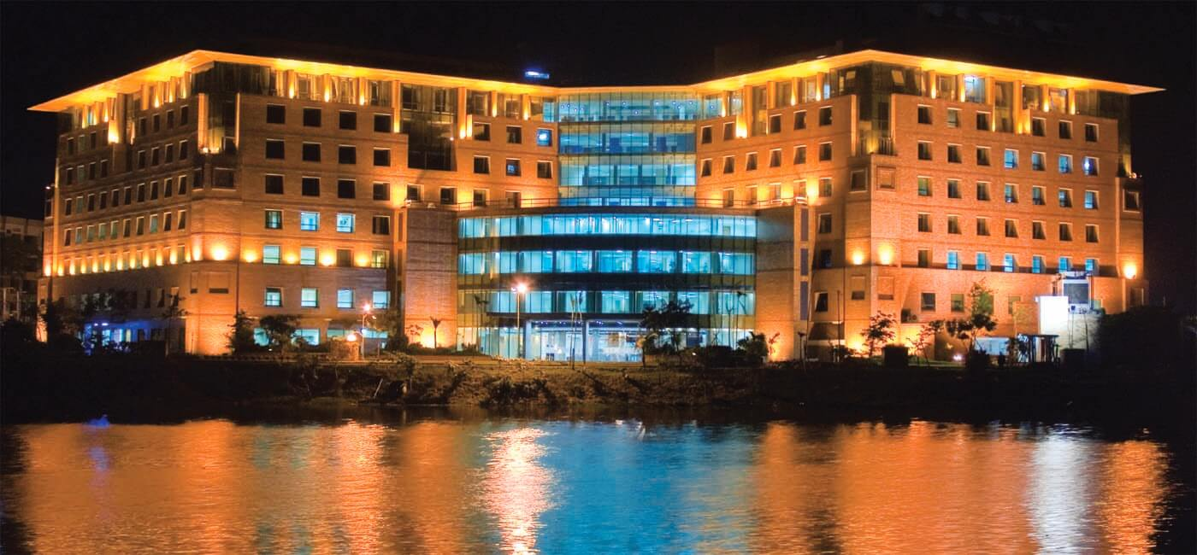

Introduction
Hospital is a health facility where patients receive treatment. It’s an institution for the care and treatment of the acutely sick and injured. So for this reason, hospitals are needed across different regions. United Hospital Ltd. is one of the best hospitals that strives each day to be the top healthcare provider, not only in Bangladesh but within the Asia-Pacific division.
For a burgeoning population of 160 million, healthcare service in Bangladesh is inadequate. A notable number of people needed to travel abroad for treatment resulting in high costs until United Group took the provocation and set up a referral hospital in the state to provide international standard treatment facilities in an evolving and growing private sector industry.

United Hospital Ltd
United Hospital Ltd. was initiated as a multidisciplinary. UHL has the capacity of 450 beds, and situated over a total area of about 450,000stf on 24 August 2006. This hospital is situated besides the picturesque Gulshan Lake and is one of the largest private sector healthcare facilities in Bangladesh. As a multi-disciplinary Hospital, UHL is committed to provide the best health service. This hospital has the best doctors and modern equipment. UHL also provides catering according to the needs of the varied patient base.
Currently it does have the world class equipment and also bringing all the new equipment for most of the major departments it has and also for them to open soon. Its target is to provide all the health care services in the world. United Hospital initiated far-reaching cancer care centre first time in Bangladesh with state-of-the-art equipment, technology and a team of experienced dedicated doctors & experts. United Hospital introduced PET-CT Scan, Medical Cyclotron and Linear Accelerator with IGRT, IMRT, and Respiratory Gating & Rapid ARC technology first time in Bangladesh. Besides, united Hospital introduced SPECT/CT first time in private sector. It also has one of the country’s most modern Radiology & Imaging and Laboratory facilities. To ensure that the clinical departments can function and provide uninterrupted and smooth service to patients the hospital has its own facilities for power generation, water treatment, kitchen, laundry and secured underground parking for over 350 vehicles.

History of United Hospital
United Hospital Ltd. was incorporated as Continental Hospital (Pvt.) Ltd. on 10th April, 1975. Incorporation capital was BDT1.00Crore TK. Later on CHL signed an agreement with CP Kukreja International Pvt. Ltd, New Delhi, India in October 1993. It signed the Project Management Agreement with Indian Hospital Corporation in the same month in 1993. In 23rd September, 1999, it signed the Management Agreement with International Healthcare Group of UK. After a few years on 21st January 2004, United Group took over the management of the CHL and converted public to private limited company in 29th August, 2004. Then the authorized capital raised to BDT 200 Crore TK. Then United Group changed the name of the hospital from Continental Hospital Ltd to United Hospital Ltd. on 28th July, 2005 and the construction commenced in October 2004. Hospital formally inaugurated in the year of August, 2006.

Core Strengths
- Multidisciplinary team round-the-clock: This is designed to address the needs of patients within 24 hours of admission.
- Spiritual Service: We provide spiritual services for patients from different religions, as and when required.

Core Competencies
In mid 80s, a group pf prominent doctors conceived United Hospital under the name if Continental Hospital Ltd. By early 90s, after some progress in the construction, the dream of the initiators was fulfilled when United Group finally took over it and took the responsibility of completing the project that had been waiting to see the light for sixteen years.

Mission Statement
Their number one priority is to provide us with high quality healthcare in a friendly and compassionate environment. They are committed to …
- Quality: Operating at the highest standards of safe and ethical practices and demonstrating continuous improvement.
- Effectiveness: Selecting the most appropriate services to produce desired health outcomes.
- Integration: Providing clear pathways by ensuring collaboration, consultation, effective communication with health service providers.
- Caring for the Community: Promoting health and providing care based on a commitment to the wellbeing of patients.
- Caring for Our Staff: Caring for the welfare of our staff and developing a culture of trust and training for personal growth.
- Research and Training: Providing an environment that promotes personal development, learning, research.

Vision
United Hospital Ltd. was born with a vision to provide a comprehensive, one-stop healthcare solution for the people of Bangladesh. Their vision is:
- To be the hospital of choice for patients, physicians and employees in Bangladesh because of their preeminent patient care and teaching programs.
- To be well recognized as a technology leader in Dhaka.
- To be a prominent community member known for meeting the healthcare needs of the entire community through incomparable patient care and wellness programs.

Departments
The departments currently functioning in the hospital including:
- Accident & Emergency  - Anesthesia  - Blood Bank  - Cardiology  - Cardiothoracic & Vascular Surgery  - Cardiothoracic Anesthesia  - Critical Care  - Dental & Maxillofacial Surgery  - Dermatology & Venereology  - Endocrinology & Diabetology  - ENT  - Gastroenterology & Hepatology  - General & Laparoscopic Surgery  - Internal Medicine  - Hematology  - Trauma Centre | - Lab Medicine  - Neonatology  - Nephrology  - Neurology  - Neurosurgery  - Nuclear Medicine  - Obstetrics & Gynecology  - Ophthalmology  - Orthopedics  - Paediatrics  - Physiotherapy  - Plastic & Cosmetic Surgery  - Psychiatry  - Medical Oncology  - Respiratory Medicine  - Urology
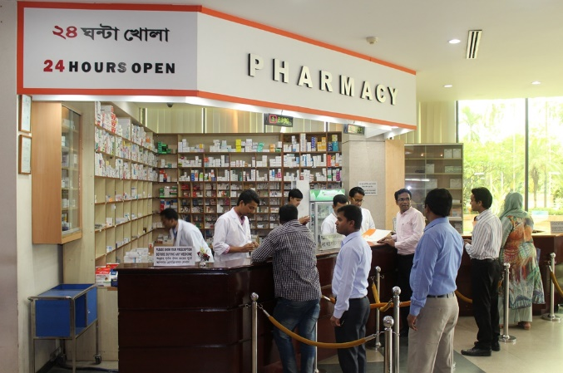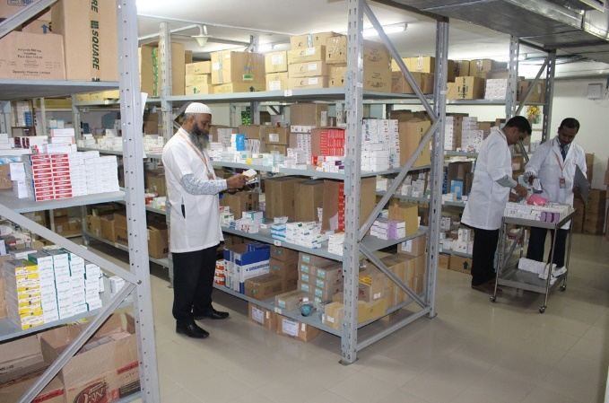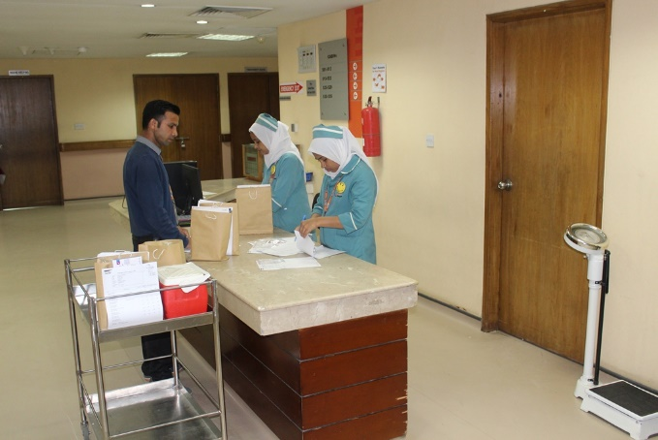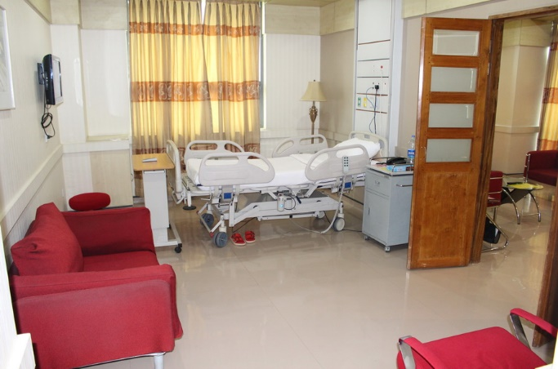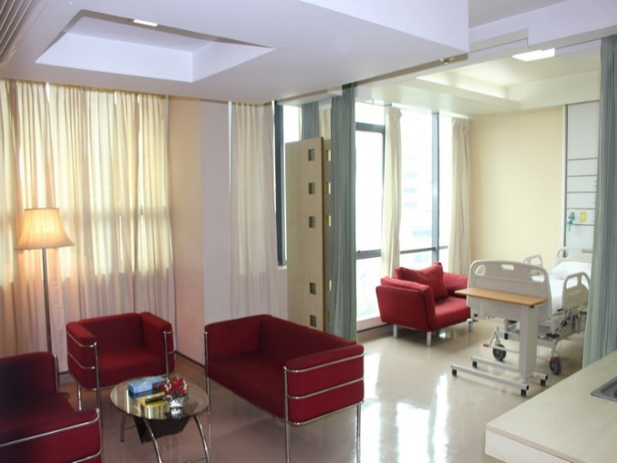

Services
Their number one priority is to provide patients with high quality healthcare in a friendly and compassionate environment. Some of the major equipment installed and services/facilities available in the hospital to provide patients with “better than the best” service are:
- Flat Panel Digital Cath lab | - 24 hour ambulance Service
- Modular Operation Theatres | - 24 hour Angioplasty for Heart attack patients
- Critical Care (ICU/CCU/HDU/CICU/KTICU/NICU/PICU) beds | - Cardiac Surgeries
- Fresenius 4008S Dialysis Units | - Total Knee and Hip Replacement and Arthroscopy Surgeries
- Multifiltrate CRRT for critically ill patients | - Kidney Transplant
- PET-CT Scan | - Critical Brain & Spinal Surgeries
- Medical Cyclotron | Endoscopy Facility
- Linear Accelerator | - Digital Mammography
- Spect-CT | - Mobile X-Rays
- 500 Slice CT Scanner | - EEG and EMG Machines
- High Definition MRI System 1.5 T | - Central Sterilization supply Facilities (CSSD)
- 24 hour Emergency Service | - CCTV facility for the whole hospital
- 4D Portable Ultrasound | - Blood Bank

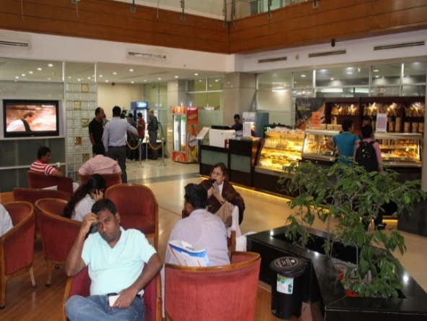
Allied Health
- Physiotherapy
- Vaccination
- Pharmacy
- Dietetics & Nutrition
- Nursing

Facilities Available
- Total 450 beds  - 24-hour Trauma and Emergency Care  - 24-hour Ambulance services  - OPD with all specialties  - 12 Operation Theatre | - 24-hour diagnostic services  - 24-hour Pharmacy  - 24-hour Blood Bank  - Physiotherapy Centre  - Vaccination Centre

SWOT Analysis
Strengths | Weakness
- Founder is the United Group with sound management and financial support  - Management partnership with KPJ healthcare Berhad of Malaysia.  - Larger premises with 450 beds.  - State-of-the-Art equipment.  - Provides modern day healthcare facilities.  - Integrated hospital information system.  - Own Blood Bank and Incubator facility.  - Doctors and physicians with oversea degrees. | - Not projecting to the general public.  - Poor visibility of the hospital location.  - Exterior of the building perceives as a five starred hotel.  - Webpage is poorly constructed.  - Has not yet focused on promotional activities.
Opportunities | Threats
- Extensive promotional activities.  - Online appointment services.  - Introducing more specialties i.e. Eye-care, Microbiology, Geriatrics etc.  - Hiring Foreign Physicians.  - Geographical expansion by launching information centers.  - Multi-lingual help desk and hotline services.  - Social responsibilities and social awareness program.  - Ambulance service with a standing physician.  - Helipad and helicopter ambulance services. | - Renowned competitors.  - Competitive pricing.  - Increased Tax rate on imported equipment and on income.  - Restriction on recruiting foreign doctors and rules on recruiting local physicians.

Board Members
Mr. Hasan Mahmood Raja  Chairman  United Hospital Limited |  | Mr. Ahmed Ismail Hossain  Vice Chairman  United Hospital Limited
Mr. Faridur Rahman Khan  Managing Director  United Hospital Limited |  | Mr. Akhter Mahmud Rana  Director, United Hospital Limited
Mr. Khandaker Moinul Ahsan Shamim  Director, United Hospital Limited |  | MR. Abul Kalam Azad  Director, United Hospital Limited
Mr. Najmul Hasan  Director, United Hospital Limited |  | Mr. Moinuddin Hasan Rashid  Director, United Hospital Limited
Mr. Malik Talha Ismail Bari  Director, United Hospital Limited |  | Mr. Nasiruddin Akhter Rashid  Director, United Hospital Limited
Mr. Fahad Khan  Director, United Hospital Limited |  | Mr. Wasekul Azad  Director, United Hospital Limited
Mr. Nizamuddin Hasan Rashid  Director, United Hospital Limited |  | Mr. Khaled S. Ahmed  Director, United Hospital Limited
Major (Dr.) Md. Rezaul Haque (Retd)  Director, United Hospital Limited |  | Mr. Abdul Awal Mintoo  Director, United Hospital Limited
Mr. Saifur Rahman  Director, United Hospital Limited |  | Mr. Nasiruddin Ahmad Chowdhury  Director, United Hospital Limited
Mr. Humayun Kabir
Director, United Hospital Limited

Operational Team
Md. Faizur Rahman
Chief Executive Officer
United Hospital Limited

Dr. Abu Sayeed MM Rahman  Chief Clinical Development & Governnance  United Hospital Limited |   Dr. Mahbub Uddin Ahmed  Chief Clinical Services  United Hospital Limited
Brig. Gen. Shahidul Islam Ldmc psc (Retd)  Chief Operation and Administration  United Hospital Limited | Dr. Shagufa Anwar  Chief Communication & Business Development  United Hospital Limited

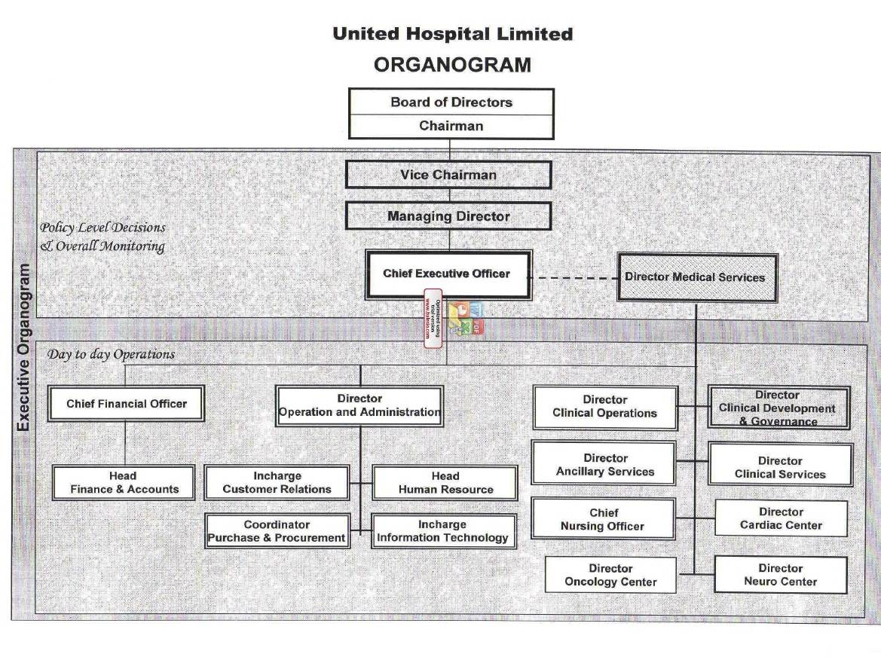

Literature Review

Service Quality
From the viewpoint of business administration, service quality is an achievement in customer service. It is an assessment of how well a delivered service conforms to the client’s expectations or comparison of perceived expectations of a service with perceived performance. Basically, service quality is the evaluation of what a customer expects from a service or from an organization and what he actually experiences from it in consideration of the image of that organization. Theory says, customer satisfaction and customer loyalty are connected to each other.

Importance of service Quality
The importance of service quality has a massive impact on every field. It is a crucial element in a company’s ability to cultivate profitability and to become success in business. Service quality does not only construct loyalty for both the company and the product but it also guarantees a company’s activity in today's diversified and competitive market. Service quality is the most important component to evaluate the outcome of a customer’s expectations and his experience of any business. Service quality is always important to both customers and companies whether it’s a manufacturing, a service or even a retail firm. The benefits service quality brings to an organization are –
- High customer satisfaction and retention
- Positive word of mouth
- Reduction in operating cost
- Low staff-turnover
- Share price acceleration
- Increase in profit as well as improvement in the overall financial performance.

Maintenance of Service Quality
Over the years, service researchers have recommended that the customers mostly asses the quality of services based on their perception of the technical outcome, the action by which that outcome was conveyed, and the quality of the physical surroundings where service is conveyed. One of the ways to maintain service quality is to trace customers’ perceptions of service quality of a certain company compared to its competitors by evaluating service quality. One of the most popular tools for evaluating the service quality is the SERVQUAL tool which gives the chance for a company to evaluate its service quality performance on the basis of five. It permits the company to categorize the consumers into distinct sections based on their respective SERVQUAL scores. Every organization should conduct SERVQUAL surveys every year which will make it easier to compare in a yearly basis along with the changes in customers’ perception and expectations. Through it, any organization can determine actions towards improvement to cope up with customers’ perceptions and expectations over time which will bring the success in the company. But customers might lose their motivation to answer correctly if the survey is conducted too often.

Study Variable
This study has been conducted to understand the “Service Quality and Customer Satisfaction at the United Hospital Ltd.” For this study, five variables have been selected from service dimension to measure perceived customer satisfaction as follows –
- Service Reliability
- Responsiveness
- Assurance
- Empathy
- Tangibility
To measure customer satisfaction, 5 point Likert scale has been used in the survey questionnaire considering 1 as “Strongly Disagree” to 5 as “Strongly Agree”.

Theoretical Framework

Satisfaction and service quality have specific things in common. Satisfaction tends to be a broader concept, whereas service quality focuses specifically on service dimensions.

Relationship between Perceived Customer Satisfaction and Service Reliability
Service Reliability is the ability to deliver the service as promised and accurately. Customers want to count on their service providers. When customers really feel that they can count on to that particular service provider, service reliability tends to rise up which increases customer satisfaction in the end and it only happens when service providers can really delivery what they promised to deliver.

Customer
Satisfaction
Service
Quality
Service
Reliability
Service
Reliability

Service
Quality

Customer
Satisfaction

Relationship between Perceived Customer Satisfaction and Service Responsiveness
Service Responsiveness is the willingness to help customers and provide prompt service. Customers like promptness in service providers. When customers get their services done fast and in a right way from providers, service responsiveness tends to rise up which increases customer satisfaction in the end and it only happens when service providers can really delivery the service on time.
Customer
Satisfaction

Customer
Satisfaction

Service
Quality

Service
Responsiveness
Service
Responsiveness

Service
Quality

Relationship between Perceived Customer Satisfaction and Service Assurance
Service Assurance dimension of service quality highly depends on employees’ ability to convey their credibility, trust and confidence in the firm. Customers expect that the service providers are experts. Even a service provider is expert but customers don’t feel that, their confidence, and assessment of that provider’s service quality will be lower which will decrease customer satisfaction.
Service
Quality

Customer
Satisfaction

Service
Assurance
Customer
Satisfaction

Service
Assurance

Service
Quality

Relationship between Perceived Customer Satisfaction and Service Empathy
Service Empathy is the priority, caring, paying personal attention, and providing services to customers from an organization. The core of empathy is conveying the feeling that the customer is unique and special but if customers don’t feel that, their assessment of that provider’s service quality will be lower which will decrease customer satisfaction.

Service
Quality

Customer
Satisfaction

Service
Empathy
Customer
Satisfaction

Service
Empathy

Service
Quality

Relationship between Perceived Customer Satisfaction and Service Tangibility
Service tangibility means the appearance of the products, equipments, staff, and communication facilities. As services are tangible, clients derive a perception of the quality of their service from a comparison of the tangible services they provide.
Service
Quality

Customer
Satisfaction

Service
Tangibility
Customer
Satisfaction

Service
Tangibility

Service
Quality

C H A P T E R - 3
Analysis And Findings

Introduction
Knowing patients ' understanding of healthcare quality in the healthcare industry is most crucial as patient satisfaction has become an essential challenge to all medical operations in the context of increasing consumerism. A widely used as a means of measuring customers’ perceptions of service quality is the SERVQUAL model. It was first developed by Parasuraman et al. (1998). This model includes five dimensions as such reliability, responsiveness, assurance, empathy, and tangibility. This article examines the notion of the quality of service in a medical environment using the SERVQUAL model. I have chosen to conduct research on “Service Quality and Customer Satisfaction at the United Hospital Limited” by looking at current operations, policies and processes."

Population and sample for the study
I have chosen all the United Hospital Ltd. staff that are working in the corporate office to be my study population. Among the population. I selected fifteen respondents as sample for my study. I selected only them who were appropriate for this case. Among them, some of them are working for a nice period with the company and some of them have been working here from the start.

Measurement
In order to evaluate the study variables, I gathered information from a survey questionnaire. The questionnaire contains 26 questions and I have split them into five different areas in accordance with the factors of the research. For the measurement, I used 5-points Likert Scale. Each question has five options starting from “(1) Strongly Disagree” to “(5) strongly Agree”.

Reliability
To measure the reliability variable, 5 items were used on five point Likert scale. Total items for reliability are given in the following table.
Whenever patients request for medicare service UHL provides it at the promised time
Whenever patients request for medicare service UHL performs it right first time
Whenever patients request for different services UHL staffs provide such as promised
Always UHL maintains on error-free records of services
Whenever patients experience problems, UHL staffs handle it in a constant manner
The first variable was, “Whenever patients request for Medicare service UHL provides it at the promised time” and a majority was satisfied out of 15 participants.
The second variable was, “Whenever patients request for Medicare service UHL performs it right first time” and a majority was satisfied out of 15 participants.
The third variable was, “Whenever patients request for different services UHL staffs provide such as promised” and a majority was satisfied out of 15 participants.
The forth variable was, “Always UHL maintains on error-free records of services” and a majority was satisfied out of 15 participants.
The fifth variable was, “Whenever patients experience problems, UHL staffs handle it in a constant manner” and a majority was satisfied out of 15 participants.
The reliability of the hospital is therefore proved and patient satisfaction from the study impacts favorably.

Responsiveness
To measure the responsiveness variable, 4 items were used on five point Likert scale. Total items for responsiveness are given in the following table.
Whenever patients need service UHL staffs give prompt service
Whenever patients ask for service UHL staffs serve them readily in agood manner
Always UHL staffs are willing to solve patients problem
Always UHL keeps patients informed as to when service will be performed
The first variable was, “Whenever patients need service UHL staffs give prompt service” and a majority was very satisfied out of 15 participants.
The second variable was, “Whenever patients ask for service UHL staffs serve them readily in a good manner” and a majority was very satisfied out of 15 participants.
The third variable was, “Always UHL staffs are willing to solve patients problem” and a majority was very satisfied out of 15 participants.
The forth variable “Always UHL keeps patients informed as to when service will be performed” and a majority was very satisfied out of 15 participants.
The hospital is therefore demonstrated to be responsive to the patient and has a positive effect on the satisfaction of the patient.

Assurance
To measure the assurance variable, 4 items were used on five point Likert scale. Total items for assurance are given in the following table.
The behavior of all employees at the UHL instills confidence in patients when they interact
Patients always feel safe in their transaction with UHL
Always employees of UHL have the knowledge to answer patients questions
Every time employees in UHL are consistently courteous with patients
The first variable was, “The behavior of all employees at the UHL instills confidence in patients when they interact” and a majority was very satisfied out of 15 participants.
The second variable was, “Patients always feel safe in their transaction with UHL” and a majority was very satisfied out of 15 participants.
The third variable was, “Always employees of UHL have the knowledge to answer patients’ questions” and a majority was very satisfied out of 15 participants.
The forth variable was, “Every time employees in UHL are consistently courteous with patients” and a majority was very satisfied out of 15 participants.
It is therefore demonstrated that the hospital retains its patients ' assurance and has a positive impact on patient satisfaction.

Empathy
To measure the empathy variable, 5 items were used on five point Likert scale. Total items for empathy are given in the following table.
All employees at UHL pass transactions in a caring manner
Always UHL staffs have patients best interests at heart when they are asking for service
UHL has convenient operating hours to all its clients without spending much time on long queues
All employees of UHL understand patients specific needs with a specific attention
Whenever patients request for a service, UHL staff gives individual attention
The first variable was, “All employees at UHL pass transactions in a caring manner” and a majority was very satisfied out of 15 participants.
The second variable was, “Always UHL staffs have patients best interests at heart when they are asking for service” and a majority was very satisfied out of 15 participants.
The third variable was, “UHL has convenient operating hours to all its clients without spending much time on long queues” and a majority was very satisfied out of 15 participants.
The forth variable was, “All employees of UHL understand patients specific needs with a specific attention” and a majority was very satisfied out of 15 participants.
The fifth variable was, “Whenever patients request for a service, UHL staff gives individual attention” and a majority was very satisfied out of 15 participants.
Therefore, the hospital has proved to be empathic and has a positive impact on patient satisfaction.

Tangible
To measure the tangibility variable, 4 items were used on five point Likert scale. Total items for tangibility are given in the following table.
UHL has modern equipment necessary for excellent medicare services
Employees of UHL are professionally dressed
The interior and exterior of UHL is visually appealing and spacious
Materials and equipment associated with the services are visually appealing
The first variable was, “UHL has modern equipment necessary for excellent Medicare services” and a majority was very satisfied out of 15 participants.
The second variable was, “Employees of UHL are professionally dressed” and a majority was very satisfied out of 15 participants.
The third variable was, “The interior and exterior of UHL is visually appealing and spacious” and a majority was very satisfied out of 15 participants.
The forth variable was, “Materials and equipment associated with the services are visually appealing” and a majority was very satisfied out of 15 participants.
Therefore it has been shown that the hospital is extremely tangible and affects patient satisfaction strongly.

Perceived Customer Satisfaction
To measure the perceived customer satisfaction variable, 4 items were used on five point Likert scale. Total items for perceived customer satisfaction are given in the following table.
Patients are fully satisfied with UHL medicare services
UHL always fullfills patients' expectations
UHL has never disapointed patients so far
Patients experiences with UHL services are excellent
The first variable was, “Patients are fully satisfied with UHL Medicare services” and a majority was very satisfied out of 15 participants.
The second variable was, “UHL always fulfills patients' expectations” and a majority was very satisfied out of 15 participants.
The third variable was, “UHL has never disappointed patients so far” and a majority was very satisfied out of 15 participants.
The forth variable was, “Patients experiences with UHL services are excellent” and a majority was very satisfied out of 15 participants.
So it is proven that the hospital is knowledgeable about customers’ perceived expectations and it maintains it which positively influences patient satisfaction.

Data collection procedure
I collected the data from fifteen respondents who were the permanent staffs of United Hospital Limited. One by one, I gave them a paper copy of the surveys, and I then asked them to assist me search by replenishing them.

Data Analysis
Since I had gathered all questionnaire information and each survey was accompanied by a Likert scale of five points, to produce answers. I then placed the answers in Microsoft Excel to measure the outcomes needed as such to analyze and compare the research variables listed in this document. Even if the number of the respondents was very limited, I used qualitative method to get a better understanding and achieve precise and reliable outcomes.

Findings
From the graph which is given below, we can see that the patients or customers of United Hospital Ltd. are satisfied with the service it is providing.

Discussion
It is often hard to be successful in medical terms because a patient recover is not always in the hands of doctors no matter how experienced they are, so we can see that respondents marked reliability a but lesser. UHL's achievement in the maintenance of a relationship on reliability, responsiveness, assurance, empathy and tangibility is apparent from the means of each questionnaire.
From the chart above, we can see that UHL staffs are trying their best to satisfy their patients with their medical services and hospitality so far. We can see that service reliability and empathy is a bit lower than other four variables but overall customers are satisfied with UHL.

Recommendation
It was a great experience for me getting the opportunity to work in United Hospital Ltd. for three months. Among my journey, I felt like some changes can be done which are given below:
- The Authority should go for the extensive promotional activities.
- They should update the website.
- There can be an online option for appointment service.
- To increase reliability more, Foreign Physicians can be hired.
- Geographical expansion by launching information centers is important.
- Authority should provide Multi-lingual help desk and hotline services.
- The authority should undertake this matter of considering patients from all classes by making the services more affordable for everyone.

Conclusion
United Hospital Ltd. is among the largest providers of health care since its establishment. It has a massive capacity for patients. As a multi-disciplinary hospital, it provides the best healthcare in the country with the best doctors and modern equipment. This hospital already has world class equipment and it is also bringing all the new equipment with the new departments it will open soon along with the major departments which are already existing. This report mainly tries to figure out whether customers are satisfied with its services or not in terms with service reliability, responsiveness, assurance, empathy, and tangibility in Bangladesh's competitive hospital industry. There is a severe cut throat competition going on currently in this sector. United Hospital Ltd. has to go for different tools as market forecasting, diversification etc.
I enjoyed a lot during my internship working with United Hospital Ltd. and I learned a great deal of knowledge through my experience. I really want United Hospital Ltd. in the future to be able to play a crucial role in Bangladeshi health industry.

References
- Services Marketing, Integrated Customer Focus Across the Firm, 7th Edition, Valarie A. Zeithaml, Mary Jo Bitner, Dwayne D. Gremier
- http://www.uhlbd.com/
- https://www.scribd.com/doc/140370687/Internship-Report-on-United-Hospital-Limited-Nazmur-Rahman-October-to-December-2012
- https://www.assignmentpoint.com/science/medical/report-on-united-hospital-of-bangladesh.html

Appendices
Service Quality and Customer Satisfaction
at United Hospital Ltd.
Service Reliability |  | 1 | 2 | 3 | 4 | 5
R1 | Whenever patients request for Medicare service UHL provides it at the promised time
R2 | Whenever patients request for Medicare service UHL performs it right first time
R3 | Whenever patients request for different services UHL staffs provide such as promised
R4 | Always UHL maintains on error-free records of services
R5 | Whenever patients experience problems, UHL staffs handle it in a constant manner
Responsiveness |  | 1 | 2 | 3 | 4 | 5
RES1 | Whenever patients need service UHL staffs give prompt service
RES2 | Whenever patients ask for service UHL staffs serve them readily in a good manner
RES3 | Always UHL staffs are willing to solve patients problem
RES4 | Always UHL keeps patients informed as to when service will be performed
Assurance |  | 1 | 2 | 3 | 4 | 5
A1 | The behavior of all employees at the UHL instills confidence in patients when they interact
A2 | Patients always feel safe in their transaction with UHL
A3 | Always employees of Uhl have the knowledge to answer patients questions
A4 | Every time employees in UHL are consistently courteous with patients
Empathy |  | 1 | 2 | 3 | 4 | 5
EM1 | All employees at UHL pass transactions in a caring manner
EM2 | Always UHL staffs have patients best interests at heart when they are asking for service
EM3 | UHL has convenient operating hours to all its clients without spending much time on long queues
EM4 | All employees of UHL understand patients specific needs with a specific attention
EM5 | Whenever patients request for a service, UHL staff gives individual attention
Tangible |  | 1 | 2 | 3 | 4 | 5
TAN1 | UHL has modern equipment necessary for excellent Medicare services
TAN2 | Employees of UHL are professionally dressed
TAN3 | The interior and exterior of UHL is visually appealing and spacious
TAN4 | Materials and equipment associated with the services are visually appealing
Perceived Customer Satisfaction |  | 1 | 2 | 3 | 4 | 5
PCS1 | Patients are fully satisfied with UHL Medicare services
PCS2 | UHL always fulfills patients' expectations
PCS3 | UHL has never disappointed patients so far
PCS4 | Patients experiences with UHL services are excellent

