CREDIT RISK MANAGEMENT IN SME FINANCING
IDLC Finance Limited

Prepared by
Name: Rahat Sultana Tiptee
ID: 114151047

Supervised by
Dr. James Bakul Sarkar
Associate Professor, School of Business & Economics
United International University

Submitted in Partial Fulfillment of the Requirements for the Degree
Bachelor of Business Administration



September 15, 2019

Letter of Transmittal

September 15, 2019
Dr. James Bakul Sarkar
Associate Professor, School of Business & Economics
United International University

Subject: Submission of Internship Report
Dear Sir,
I am submitting my internship report on Credit Risk Management on SME Financing, a study of IDLC Finance Ltd, Dilkusha Branch under your co-operative supervision. This topic was assigned to me as a partial requirement to complete my BBA Program. I have observed the operations of this department, Relationship Management, and Credit Risk Management Department. I enjoyed working here to complete my requirement of study. Throughout my journey in IDLC, I tried to collect the necessary information to prepare my internship report and would utilize them to enrich the report as informative as possible. I sincerely believe it will satisfy your requirements. Along with it will also serve the purpose of my internship program.
Consequently, I am submitting my internship report for your concern. Hopefully you will be able to discover my hard work, well researched, informative approach. Moreover, I will be happy to express my experience about working here with you if I find an opportunity. I express my heartiest gratitude to you.

Thanking You
With Best Regards
Rahat Sultana Tiptee
ID: 114151047

Table of Content
Letter of Transmittal ………………………………………………………………………..2
Executive Summary………………………………………………………………………….5
Chapter-2 (Introduction) …………………………………………………………………...7
2.1. Topic……………………………………………………………………..........................7
  - Organization……………………………………………………………………………...7
Chapter-3……………………………………………………………………………………..8
Company Profile……………………………………………………………………………..8
3.1. Historical Background…………………………………………………………………..9
SWOT Analysis……………………………………………………………………………….15
Financial Performance Analysis……………………………………………………………..20
3.2. Industry Scenario………………………………………………………………………..23
Chapter-4……………………………………………………………………………………..24
4.1. Primary Source……………………………………………………………………….....24
4.2. Secondary Source………………………………………………………………………..24
Chapter- 5…………………………………………………………………………………….25
5.1. Type of Data……………………………………………………………………………..25
5.2. Scope of the Report……………………………………………………………………...26
5.3. Limitation of the Report………………………………………………………………..26
Chapter- 6…………………………………………………………………………………….27
6.1. Literature Review……………………………………………………………………….27
Chapter-7…………………………………………………………………………………….28
Findings of the Study………………………………………………………………………..29
7.1. Explanation of Interview……………………………………………………………….29
7.2. Intern Roles and Responsibilities………………………………………………………30
7.3. Experience Achieved from Internship…………………………………………………36
7.4. Difficulties during Internship…………………………………………………………..37
Research Design……………………………………………………………………………..38
Credit Risk Management in SME Financing………………………………………………39
Analyzing of the Study………………………………………………………………………45
Chapter- 8……………………………………………………………………………….……48
8.1. Conclusion………………………………………………………………………….……48
8.2. Recommendations………………………………………………………………….……49
Chapter-9 (Appendix)……………………………………………………………………….50
Pictures of Internship Journey…………………………………………………………………..52

Executive Summary
Financial Leasing companies deal with tangible assets. The legal owner of the asset is the leasing companies but the ownership is effectively conveyed to the lessee. SME stands for Small and Medium size organization which plays a vital role in the business field now a day. Financing in SME is a pleasure for leasing companies and at the same time this is an advantage for entrepreneurs. In this report many things related to credit risk management and SME financing has been described. First of all, the organization IDLC’s introduction has been given with the analysis of porter’s five forces model and the SWOT Analysis. Then the part of tasks and responsibilities what I did there has been explained with an observations and also some problems I faced during my internship and how I did overcome those has been also mentioned. After that the offered SME loan products by IDLC has been mentioned as the report belong with SME. How the SME team of IDLC choose proper client and what are the things they investigate before sanctioning a loan are also in this report which I gathered by interviewing two employees of IDLC. Also some financial analysis has been given to compare IDLC with another top ranking leasing company United Finance. The overall scenario of leasing companies in Bangladesh has been explained in this report. According to the objective the recommendation has been stated.

Abbreviations
IDLC: Industrial Development Leasing Company
NBFI: Non-Banking Financial Institution
CIF: Customer Information File
CIB: Credit Information Bureau
CRM: Credit Risk Management
CAD: Credit Administrations Department
RM: Relationship Manager
SME: Small and Medium Sized Enterprises
OCAS: Online Credit Appraisal System
NID: National Identification Number

Chapter- 2
Introduction
  - Introduction of the topic:

I have prepared this report on the topic of Credit Risk Management in SME Financing and Credit Information Bureau under Credit Risk Management department. This report has been made as a requirement for the completion of the BSS program under the supervision. In IDLC, I was placed in the Credit Information Bureau Department under Credit Risk Management Department for my internship. Undoubtedly, the journey was so enjoyable for me. I started my internship program on 5th May and completed on 8th August. This 3 months working experience will help me a lot in building my future career. Here, I was able to make some practical information, which I have learned from my daily works in the company. My main focus was on the performance and major business affairs, analysis of activities of the company in my report. This report has been made as the course requirement of the BBA program. Hopefully, I will be able to provide a clear view about the activities and role of Credit Risk Management in SME financing and Credit Information Bureau in dropping the risk associated with the lease and loan.

  - Introduction of the organization:
IDLC has placed to the biggest multi-product multi segment Non-banking financial institution in Bangladesh and one of the blue chip companies on local stock markets. In 1986, IDLC has started its journey with only five employees which have today turned into $750 million multi product business such as corporate, SME, Retail and capital market segments. It is today representing 43 branches and booths in 20 cities with over 1,400 staff. The Company is leading to sustainable practices and strong financial performance. IDLC has been constantly recognized by independent bodies for the values underpinning its business and is proud to be a standard bearer for the Bangladesh financial sector. The IDLC devoted to continuation the highest standards of ethics and obedience by its employees. Each employee working in the Company’s follows the code of conduct which is highly recommended and also it plays all of its CSR activities.

Chapter- 3
Organizational Background & Industry Perspective
(a)Company Profile:
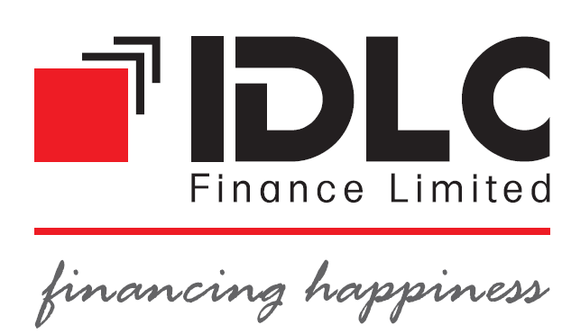
IDLC Finance Limited, formerly known as Industrial Development Leasing Company of Bangladesh Limited, initially established in Bangladesh in 1985 through the collaboration of International Finance Corporation (IFC) of the World Bank, German Investment and Development Company (DEG), Kookmin Bank and Korean Development Leasing Corporation of South Korea, the Aga Khan Fund for Economic Development, the City Bank Limited, IPDC of Bangladesh Limited, and Sadharan Bima Corporation.
Although we primarily started with Lease Financing as our core product, IDLC has became the leading multi-product Non-Bank Financial Institution of Bangladesh, with almost equal focus in Corporate, Retail and SME sectors. Moreover, IDLC has a significant presence in the Capital Markets. Our merchant banking arm, IDLC Investments Limited, a wholly-owned subsidiary of IDLC is a premier brand for investment banking in the country. Our stock brokerage arm, IDLC Securities Limited, another wholly-owned subsidiary of IDLC is also amongst the top five brokers in the country.
IDLC plays a revolutionary role in introducing the financial techniques suiting ever-changing requirements of its customers. They are constantly growing their presence to make sure the best quality of service for customer satisfactions. The joyful fact about the company is, it has been received “A+” rating given by Credit Rating and Information Services Ltd. And it is the highest rating for any financial institution.
3.2. History of the IDLC Finance Ltd

Historical Background

In 1984, IDLC was formed by the launch of IFC of the World Bank. This company was created via association of International Finance Corporation, Aga Khan Fund for Economic Development, Kookmin Bank, German Investment and Development Company, Korea Development Finance Corporation, The City Bank Limited, Bangladesh Limited and Sadharan Bima Corporation. Industrial Development Leasing Company (IDLC) is the prime Non-Banking Financial Institution (NBFI) in Bangladesh. It offers financial services in the variety of small and medium enterprise (SME) finance products, Retail finance and also Deposits and Treasury products, Supplier and Distributor Finance, Corporate and structured finance solutions. The IDLC group offers stock broker and asset management services via its three subsidiaries such as merchant banking, IDLC Investments Limited, IDLC Securities Limited and IDLC Asset Management Limited.

3.4. Vision
We will be the best financial brand in Bangladesh.
3.5. Mission
We will spotlight on quality expansion, sustainable business practices, and superior customer experience and so on.

Products and Services
There are different types of products and services in the Consumer Division, corporate division, SME Division and the Capital Market where they propose their products. They have controlled Finance, under this there are Advisory Services, Fund raising, Securitization of Assets and also Fees and Charges. But in Corporate Division, they have Corporate Finance like Lease Financing, Term Loan Financing, Working Capital Financing, Project Financing and Specialized products.

Branches
IDLC has total 38 branches all over the Bangladesh. The branches are, Dilkusha, Uttara, Gulshan, Nandankanan, Dhanmondi, Mirpur, Agrabad, Narshingdi, Narayanganj, Savar, Keraniganj, Bogra, Sylhet, Kushtia, Jessore, Khulna Natore, Bhulta, Habiganj, Tongi, Imamganj, Comilla, Joydebpur, Natore, Mymensingh, Rangpur, Chowmuhani, Elephant Road, Rajshahi, Barishal, Faridpur.
Philosophy of IDLC
IDLC utilizes their proper financial knowledge and perfect investment vehicles for increasing the growth of people’s asset. To achieve that they have some purpose like
- People are conscious of financial knowledge and planning
- Helps them to make plans through suitable investments vehicles
- Make people feel confident of a wealthy future ahead.

Key Milestones of IDLC Finance Limited
Year | Achievements
2018 | - First Position in Overall Category and First position in Integrated Reporting and Financial Services Sector-Winner of SAFA Award, among 8 countries in the SAARC region.  - In Non-Banking Financial Institution Category, Winner of ICMAB Best Corporate Award-2016 (First Position).
2017 | - Opening of Barishal branch  - Under the Non-Banking Financial Institution category, Winner of the 4th ICSB National Award for Corporate Governance Excellence, 2016  - Opening of Elephant Road Branch  - Winner of the 17th ICAB Natioanl Award for Best Presented Annual Report and Integrated Reporting 2016  - Opening of Noakhali (Chowmuhani) Branch  - Opening of Rajshahi Branch  - “Khushir Kheya” the first ever volunteer based CSR initiative by a corporate entity launched by IDLC  - IDLC’s first Open End Mutual Fund-IDLC Balanced Fund launched in 2017  - IDLC was the Winner for Best Presented Annual Report 2015 by SAFA  - First ever LEED certified environment friendly branch in financial industry of Bangladesh at World Trade Centre, Agrabad, Chittagong  - Highest Tax Payer in Non-Bnaking Financial Institutions Category for 2016-2017
2016 | - IDLC Asset Management Limited was established in 2016
2014 | - Khulna and Bhulta Branch was opened in 2014  - Initiative taken for opening Kushtia Branch in 2014
2012 | - IDLC’slogo changing and rebranding happened in 2012  - Jessore branch was opened
2011 | - Mirpur and Tongi branch was opened  - A wholly-owned subsidiary of IDLC and IDLC investment limited, commences operations
2010 | - Narayanganj, Savar, Nandankanon, Comilla, Narshingdi and Keraniganj branch was opened  - Relocation of Merchant bankingdivision at Eunoos Trade Centre
2009 | - Branches was opened in Sylhet by IDLC Finance Limited and IDLC Securities Limited  - Gazipur and Imamgonj SME Booth was opened
2008 | - Relocation of Dilkusha Branch at Eunnos Trade Centre  - Relocation of Dhanmondi Branch
2007 | - “Managed Cap Invest” was launched which is known as Discretionary Portfolio Management Services  - From the previous Industrial Development Leasing Company of Bangladesh limited the was named to IDLC  - IDLC Securities Limited Chittagong branch commences operations
2006 | - At Bogra SME-focused branch was opened, Uttara branch was opened  - In the port city of Chittagong Merchant Banking branch was opened  - At its own premises at 57, Gulshan Avenue, Dhaka-1212Company’s Registered and Corporate Head Office was relocated
2005 | - Between IDLC and SBI Capital Markets Limited, India an MoU for strategic alliance was signed  - With the objective of SME development, with contribution from the Canadian International Development Agency (CIDA) of the Government of Canada Local Enterprise Investment Centre (LEIC)

IDLC Executives
There are approximately 1400 employees working in IDLC.

Mohammad Mahbubur Rahman, FCA, Director

Monower Uddin Ahmed, Independent Director
Arif Khan
CEO,
Manging Director

M. Jamal Uddin, Deputy Managing Director

R A Howlader, Director

Aziz Al Mahmood, Chairperson

Porter’s Five Forces Model

Porter’s Five Model

Barriers to entry: Low
- Licensing Requirements: The licensing requirements for NBFIs are not that tough as compared to the banks.
- Many alternatives: The consumers have many options to choose for availing credit.
- Large number of NBFIs: Consumers have large spectrum to choose from.

Threat of substitutes: Moderate
- Banks: NBFI is made from the concept of helping each and everybody even who cannot have an access to the banks, whoever the person is; poor or underprivileged.
- Unorganized money lenders: Unorganized money lenders have a strong presence in the rural markets that is why they are a big threat to the NBFIs in the rural areas.

Bargaining power of suppliers: High
- Many alternatives: The suppliers in this case are the depositor’s to the NBFIs funds. The suppliers have many alternatives.

Intensity of rivalry: High
- Undifferentiated Service: Though the service defined by the NBFIs are almost same as banks but there is a low level of differentiation
- Marketing Strategies: Due to the increased rivalry among the NBFIs there has been use of aggressive selling and intensive marketing strategies by the company to get market share.

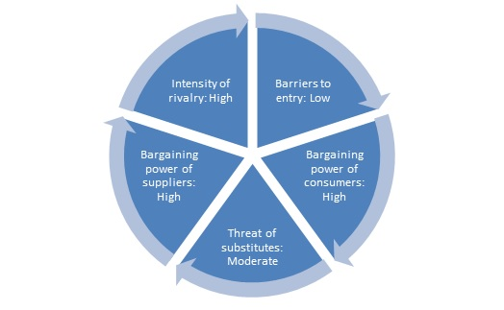

IDLC CODE OF CONDUCT AND ETHICS

- Employees shall act with integrity, competence, dignity while dealing with customers, prospects, colleagues, agencies and the public
- Employees should represent themselves in a more professional and ethical manner which will have a positive impact on IDLC employees, their profession and on IDLC at large
- Try to preserve and improve the competence of the business

- Practice reasonable care and exercise independent professional judgment.

They should not confine others from performing their professional obligations
- They should obey all the applicable laws, rules and regulations
- Reveal all conflicts of interest
- Their professional services should comply with IDLC policies and relevant technical and professional standards
- They should respect the confidential issues and privacy of customers
- They should not engage themselves in any kind of dishonesty, fraud, deceit or other unethical issues.

SWOT Analysis of IDLC

Strengths:
1. Reputation and brand image: IDLC is a well reputed leasing company and already earned the brand image for the customer acceptance. This has established in 1985. Since 1985 IDLC is introducing very new and innovative services and made the ability to meet up the demands of a large corporate client.
2. Board of director: IDLC has a strong board of director, who has a very good image in corporate world and also has strong background around this country. They have contribution in many sectors like decision making, setting objective.
3. Product portfolio: IDLC has a diverse and amazing product portfolio for their customers.
4. Human Resources: This is one of the major strengths of IDLC. The Company has competent management team. The overall work force of the company is considered as key resources for the organization. IDLC personnel are motivated, competent, energetic and creative.
5. Training: IDLC provides effective training to their employee. In a year they arrange five or six training session to make sure the skilled performance of their employee.
6. Service: IDLC finance Limited is increasing their performance each year because of their unique services. IDLC provides hassle free service and also here is no hidden cost, all the costs are visible so that customers can have the idea about their cost.
7. Operational Efficiency: IDLC Finance Limited provides customer friendly solutions to meet their demand, so that the sanction and disbursement of the loans can be hassle-free.
8. Employee Empowerment: Every employee has their individual opinion for every task and the organization has equal level of acceptance for their employee.
9. Working Environment: IDLC Finance Ltd has a friendly working environment. Everyone is very co-operative and helpful.

Weaknesses:
1. Cost of fund: IDLC has a bit higher cost for operating the activities compare to the banks because of being an NBFI.
2. Management: In recent times there is a huge change in management. As a result, there will be some changes in the organization too. As a result of this employees take time to adopt the tasks and the environment.
3. Volume: Although IDLC has department called Credit Risk Management to monitor the asset quality of the company, still the company sometimes provide loans to customer for the sake of extra profit.
4. Diversification: IDLC has too much diversification of product and services offering, which can be a great threat to the central part of the organization.
5. Liability Marketing: IDLC still employs lower number of workforces for the aggressive liability marketing in comparison to banks and NBFI.

Opportunities:
1. Liberalization: The continuity of liberalization has a positive impact on economy and for the NBFI.
2. Foreign Investment: There are a lot of foreign investments in various sectors the NBFI also have a good chance to get into it.
3. Local banks Inefficiency: One of the major reasons for growing of leasing company in Bangladesh is local banks inefficiency of providing project loan. This phenomenon still persists. Local banks are unable to fulfill the demand of consumers. This is good for NBFI because it’s creating an opportunity.
4. Geographic Areas: There is a huge prospect for this organization as day by day consumers are increasing as well as their demands. Expanding the business will create an opportunity for this organization. IDLC already started their process and started planning how to expand their business.
5. Consumers Demands: Now-a-days people are more interested to take loan such as apartment loan, car loan etc. As the demands of taking loans are increasing rapidly it creates a big opportunity for IDLC.

Threats:
1. Banks and other NBFI: The competition between banks and NBFI is getting higher than before as now a day’s banks are also involved in handling leasing stuffs.
2. Regularity control of government: The legal framework of Bangladesh is somehow not very friendly all the time which may create unexpected obstacle in regular operations.
3. Payment overdue: This can be a big threat for any organization. This happens when clients do not pay their EMI in a regular basis.
4. Intend to switch: If a customer has intention to switch from IDLC to any other NBFI that could be obviously a threat for IDLC Finance Limited.
5. Fake documents: There are many cases where customers provide fake documents which may cause serious problem to this organization.

Subsidiaries
There is some Subsidiaries of IDLC Finance Limited. They are:
- IDLC Securities Limited:
IDLC Securities Limited is a stock broking company with headquarters in Dhaka Bangladesh. The company is a wholly owned subsidiary of IDLC Finance Limited which was formed by a joint initiative of some international and local institutions.
- IDLC Investments Limited:
IDLC Investments Limited is a merchant bank; this is also wholly owned subsidiary of IDLC Finance Limited. It has started as the merchant banking division of IDLC in 1999. As separate company as per the requirement of Bangladesh Securities and exchange Commission it emerged in 2010 later on. The firm provides Investment Banking, Portfolio Management, Margin loans and Securities Research services to its clients which include both corporations and individuals.
- IDLC Asset management Limited:
This is also wholly owned subsidiary of IDLC Finance Limited. Consists of mutual funds offered under asset management services offered to individuals and institutions.

3.11. Organizational Structure
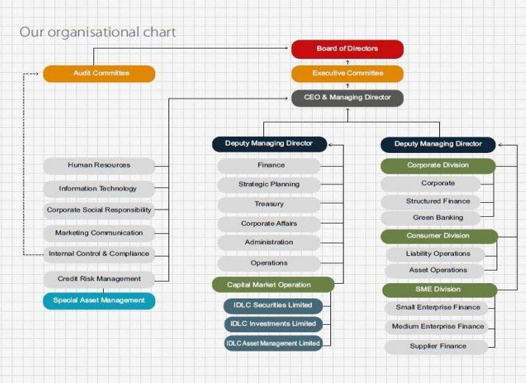

Financial Performance Analysis
Year | ROA (IDLC) | ROA (United Finance)
2015 | 1.73% | 1.78%
2016 | 1.96% | 1.51%
2017 | 1.71% | 1.07%

Return on Asset (ROA) shows the percentage of profit a company earns in relation to its overall resources. The higher the ROA better the management. This is more appropriate to compare for a same level of companies. IDLC has better performance in the year of 2016 compare to 2015 and 2017. United Finance’s ROA gradually decreases from 2015 to till 2017. So, compare to United Finance IDLC has a better performance in ROA.

Year | ROE (IDLC) | ROE (United Finance)
2015 | 18.46% | 12.72%
2016 | 19.68% | 10.67%
2017 | 14.97% | 8.48%

Return on Equity (ROE) is a measure of financial performance by dividing net income by total stock equity as shareholder’s equity is equal to a company’s assets minus its debt. This is thought as a return on net assets. In 2015 and 2016 IDLC has good performance than 2017. United Finance is doing bad compare to IDLC as their ROE is gradually decreasing and in a large quantity as shown above. Rising ROE proves that a company has ability to generate profit without needing much capital.
Year | Operating Profit Margin (IDLC) | Operating Profit Margin (United Finance)
2015 | 123.91% | 122.99%
2016 | 125.66% | 126.39%
2017 | 126.19% | 132.07%

Operating Profit Margin measures the percentage of profit a company can produce from its operations. This is a profitability or performance measured ratio. This may differ across companies or industries. IDLC is doing good year to year as the percentage is increasing. United Finance has also significant performance as their ration is also in an increasing form. Compare to IDLC United Finance has better performance as united finance has increasing ratio than IDLC. The profit margin ratio indicates how much profit a company can make after paying their variable costs of production such as wages, raw materials etc. For this reason, the higher Operating profit better the performance is.

Year | Net Profit Margin (IDLC) | Net Profit Margin (United Finance)
2015 | 39.91% | 44.32%
2016 | 42.41% | 40.58%
2017 | 41.58% | 34.92%

After the deduction of all expenses which percentage of revenue left is known as Net Profit Margin? This measurement reveals the profit amount of a business which derives from its total sales. IDLC has done good in the year 2016 than 2015 as the ratio of net profit margin has been increased. Again in 2017 it is in a moderate condition. United finance has not a significant performance as their ratio is in a decreasing form. Compare to IDLC, United Finance has poor performance as the ratio of united finance is not higher than IDLC and also has decreased year to year. A higher net profit margin indicates a company has more efficiency to convert sales into actual profit.

Year | Capital Intensity Ratio (IDLC) | Capital Intensity Ratio (United Finance)
2015 | 22.45 | 25.02
2016 | 21.68 | 26.80
2017 | 24.34% | 32.63

Capital Intensity ratio measures the amount of capital needed per currency of revenue. A higher capital intensity ratio for a company means that the company needs more assets than a company with lower ratio to generate equal amount of sales. In terms of capital intensity ration IDLC has better performance compare to united finance as united finance has increasing amount of capital intensity ratio. Separately the ratio is fluctuating for both IDLC and United Finance.

(b) Overall Scenario of IDLC Financing Limited
Leasing company was first introduced in Bangladesh in the early 1980s. Industrial Development Leasing Company of Bangladesh Limited (IDLC) is the first leasing company in Bangladesh. Lease financing determines the direction of financial behavior of a company. Now a day’s lease financing is so well known for developing a company’s financial resources and obviously for profit maximization or maximization or owner’s equity. Lease financing is so central to a company’s management as it explains why it is better for an organization for financial solvency for lease financing. First Lease Finance Investment Limited (FLFIL), Apex Investment, Bay Leasing and Investment Limited, Industrial Development Leasing Company (IDLC), Phoenix Finance and Investments Limited, United Leasing Company Limited (ULCL), Lanka Bangla Finance Limited, Investment Credit are the first ranking players in Bangladesh based on the performance in leasing industry. Basically lease is a contract between the owner and the user of assets for a certain period uses the asset in exchange of making periodic rental payments without purchasing it.
Though Bangladesh is small but it is a densely populated country where people mostly depends on agriculture or farming for leading life. Due to globalization and liberalization the country is shifting towards industrialization and business. So, this is a very positive turn for the leasing industry in Bangladesh. The scenario in Bangladesh is better than before but to develop leasing business in Bangladesh convenience and flexibility is needed in financing. Commercial banks and Non-Banking Financial Institutions (leasing companies) are known as the traditional lending institutions in Bangladesh. The leasing companies can aware the entrepreneurs very well about the loan products and the importance of it than any other institutions. There are many writings about how the foreign countries are managing their financial system in terms of lending and borrowing both. On those writing there was a vital point to note that people of many countries are still depending on their relatives for taking money for starting their business or running their existing business. From this point of view Bangladeshi leasing companies are doing so great by holding people’s trust and letting them run their business in a decent way. For example, leasing companies are very keen to give the finance for their client, even there are many special loan products only for Women entrepreneur or for many specific fields like IT or Agriculture and so on. Under leasing companies there are so many advantages to take like saving time, scope of profit maximization which makes the leasing industry more attractive now a day. The payment system is also very flexible for the clients as the down payments are not high and the loan tenure are for a long time. So, overall the scenario of leasing industry is good and seems sustainable in Bangladesh based on their performance. People started relying on them as well as the companies are able to make commitment for their work. This is an easy solution for entrepreneur and also for the existing businessmen.
Chapter- 4
Objectives of the report
4.1. Primary Objective:
- To fulfill the partial requirement of BSS program for carrying out the BBA degree.
- To present my three month internship experience in IDLC Finance Ltd. through a formal report.
- To gain realistic experience and view the application of theoretical knowledge in the actual corporate world.

4.2. Secondary Objective:
The secondary objective of this study is to find out the area of investments of IDLC in SME sector and most importantly the secondary objective of this study is, to find out the scope where IDLC can invest more in SME sector to enhance their SME attractiveness. My supervisor of IDLC wants something that they may utilize later on for improving their SME sector’s activities.

Some other Objectives are:
- To translate the theoretical concept into real life experience
- Learn to analyze the financial concepts practically
- To make difference between real life business method and theoretical study
- Stand in a position by finding the problems of SME sector in terms of investing and how can an organization improve that.

Main Research Question:
The main research question is “Credit Risk Management in SME Financing”. If only the study is about credit risk then there is a lot to write, discuss and analyze. The study will be specifically focused on SME financing. SME adds extra value in country’s economy both in public and private sector.

Chapter-5
Methodology of the Study

5.1. Methodology of the Study
There are many sources those have been used for the whole study. Information has been collected from the website which is known as online source and the accessible employees of IDLC. I found some hardcopies from my organization from where I found the financial reports to get the financial analysis more precisely. I have collected some preceding internship report to have the practical knowledge of writing the report from my University library. So, the report has shown more in the prejudiced way.

Primary Sources:
The primary data sources are the employees of IDLC and the inside database they use for their day to day purposes.

Secondary Sources:
IDLC Finance Limited official website, PDF records, journals, articles and university’s library.
I interviewed two employees of IDLC Finance Limited and gathered required information. It was an unstructured interview for us. I faced some problem as the topic is not directly related to my department, when I started meeting information related to my study. My work was related to Credit Information Bureau and the topic is related to Credit Risk Management and SME department. When asking random people about my queries, I was in trouble. After that one of our senior Sir sent me to the CRM department for asking all my questions. I went to them and two of them helped me by answering all my questions. I had brief conversation regarding topic related issues. The people of IDLC were very ready to lend a hand and friendly to gather genuine information.

5.2. Scope of the Report
This report starts with illustrating some light on the company’s mission, vision, core values historical background, its shareholding structure, organizational structure etc. I have also provided Porter’s Five Forces analysis to figure out the present industry situation of IDLC Finance Limited.
In the second part all the sectors have been presented based on the findings and experience time, viewpoint, observations. This report is accomplished after providing some possible recommendations for enhancing the efficiency and affectivity of the department’s activities.
There are some subsections e.g. my tasks, assignment and participation in the organization, lessons learnt and experience gathered from internship etc. Here I also discussed about the difficulties faced during internship and ways of overcoming them influence of internship on career plan etc.
5.3 Limitations of the report
Though I got many advantages, help, and support from many sources but at the same time there were many boundaries of restrictions and limitations while preparing this report which has postponed my works. These limitations are as per the following:
    - Struggle in getting to information on its inward operations.
    - Non-availability of some former and most recent information.
    - Some data were withheld to hold the classification of the association.

Chapter- 6
Literature Review
The study which has been chosen for the review attempts in order to provide some knowledgeable understanding about the access of SME financing. Though this article has written based on the SSA countries but some basic subjects are always stable for SME financing. This is based on the West African sub-region to see whether there are similarities or differences in the determinants of SMEs access to finance across the SSA (Sub-Saharan Africa) countries. To show the actual thing related to the financing this article included both subjective and objective measures. By using the data from World Bank’s website this article stated there are some certain things on which the access varies; like the size of the business, ownership, strength of legal rights, the depth of credit information and obviously the experience of the top level managers. This study has focused on strong implications of policy. There is an important thing to look at, SMEs are by nature unable to give any collateral which is very easy to provide for the other companies like banks or firms. This may one of the reasons to not get the easy access for loan. This study added why financing in SME is riskier in SSA countries. This proves in many countries or in many places still SME is not in a favorable position. To show the proportion and the condition of scope and the access SME financing this article has shown some financial analysis. (Quartey, 2017)

This article is about the access to finance and related issues specially being an SME owner or managers. Research shows that there are similarities as well as differences between SME financing in both UK and China. At the first hand people are more reliable on their family or relatives for financing their business exclusively. Then it may be from their immediate family. After two years of business respondents relied on their own funding or savings which they made while they were running their business. After five years of uninterrupted business or economic activity, most of the owner or managers in UK finance their business by borrowing funds from banks or any financial institution compare to China. In China people are mainly depended on their immediate family from where they seek the financial support. So, by analyzing this scenario it is under stable that SME financing is more appropriate and active in UK than China. The scenario is doing business may vary in China though the financing system of UK seems more preferable. The research concludes by saying that the financing preferences may vary by the people who are in business. The seeking of financing help from banks or related organization may add a better value to a business than a family. (Javed Hussain, 2013)

This study models shows five performance indicators based on 80 potential factors derived from various fields like firm characteristics, finance, informality, innovation, infrastructure, taxes, regulations, trade and workforce concerning small and medium sized enterprises. Regarding statistical significance and magnitude between small and medium sized enterprises the factors vary. As an example, the percent of using firm’s internet for the purpose of interact with clients/suppliers has a positive effect on medium sized enterprises than small enterprises. An adverse impact on small enterprises is visible when it is financed by equity or stock sales. Though the initiative of doing small and medium enterprises is being encouraged by the policymakers but this is being said that SME’s role in private sector growth is often underrated. To develop evidence based understanding on SME’s performance in emerging and developing economies is the main objective of this study. Also this report seeks to identify the problem arises in terms of SME financing and the performance of SME. The factors those are affecting the performance of medium enterprises differ from those of small enterprises. (Ndeye Ndiaye, 2018)

This article showed how the development of small and medium enterprises has a growing trend in Indonesia and also in Pekanbaru. SME has very meaningful role to play in the national economy and create new jobs for unemployed people. Also the purpose of this study is to identify the effect of entrepreneurial competencies on business performance and also threats and opportunities. This has been shown that small and medium sized enterprises have positive and significant effects. This cannot be denied that the empowerment of SME sector has to face many challenges. Competition in today’s business world is increasing day by day. By keeping pace with large business small businesses are doing so well in their respective fields. SME is one of the supporting economic growths in Indonesia. SMEs are found in more challenging situation and that is why this business has more accurate approach to solve so quick problem and hold a stable position.SME businesses can be succeeded in any other fields like restaurant business, agricultural business, manufacturing, electricity, gas and so on. (Diana Eravia, 2015)

Chapter- 7
Findings of the Study
Internship Experience and Observational Details

7.1. Explanation of Interview (6th May, 2019)
I had discussion with two people, one of them was Md. Dalilur Rahman, Senior Executive Officer; Credit-SEF and another one was Abdullah Al Rafi, Assistant Manager; Credit-SEF. Mr. Rahman explained the reasons of not sanctioning a loan or sanctioning a loan. The way or method they use to select a proper client has also stated within the conversation hour. I asked random question and they answered those in a very organized way. I had a chance to hear directly about a case of bad loan. The team of SME gave loan to a client who had such a business where delivery matters. It was a business where supplier supplied products and then they sold those products to retail customer. Another thing is, the road was not very suitable for communication. After some time, the supplier of the products was unwilling to go for the supply because of bad communication system. The road was so for the vehicle. The supplier are dissatisfied and denied continuously for supplying goods. The business went bad and the Product seller was unable to repay the loan amount. For this case it became a bad loan. So, this is not an example of willful defaulter. This happened because of the improper communication system. The environment was not in favor of the businessman. This is one of the reasons but this may happen for many reasons. The moral is, when the team of SME gave the loan to the businessman they did not know this will happen to the borrower. The interviewee said if there is any minimum chance to become a loan defaulter then that is easier for them to mark rather than any other issues. This is possible as they check the CIB report for the clients. So, overall the study has been conducted through the interview and with the help of my IDLC supervisor along with the guideline of my University’s supervisor as well. The proper following of the guidelines about the study has worked a lot which helped to conduct the study so well.

7.2. Interns Roles and Responsibilities

Job Nature
My internship program started at Credit Information Bureau (CIB) department in IDLC Finance Limited, in Dilkusha Branch from 03rd October, 2018. All my activities were conducted under the Supervision of Shazzadul Karim. My main responsibility was creating CIF (Customer Information File) and CIB (Credit Information Bureau) report.

Job Responsibilities in Credit Information Bureau (CIB)

Collecting a Form Called Undertaking & Collecting NID
Undertaking is a form that includes customer information which is made by Relationship Manager (RM). RM sends us through email, then we print it and check whether the copy contains wrong information or any mismatches.

Creating Customer Information File (CIF)
CIF stands for Customer Information File. It’s a six-digit account number and has 2 steps of creating this.

Searching for the existing file:
After getting CIF request, at first I had to check whether the account is already existing or not. For this purpose, I used a search engine called OBI. There were some fields for NID number, Date of Birth, name and so on. I fill those tabs one by one with relevant information and then search for the CIF number.
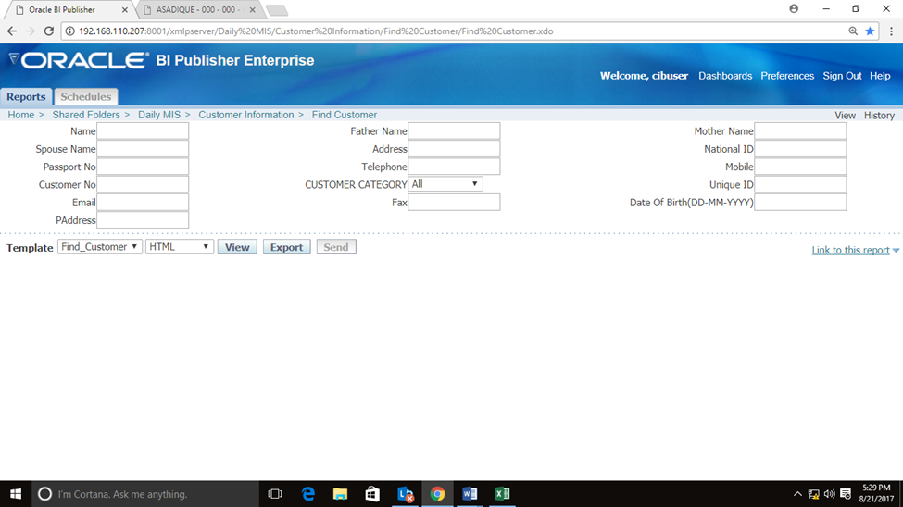
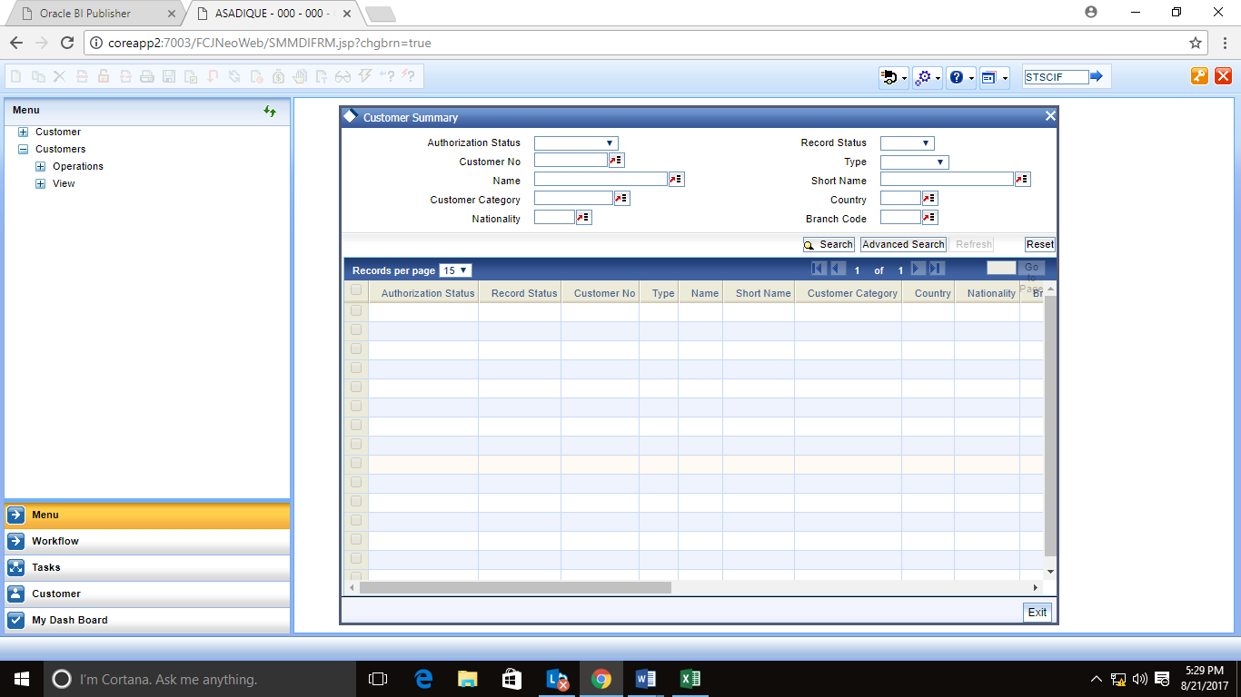

Create an Account:
I have created two types of CIF. Individual CIF and Corporate CIF.
Individual CIF:To create an Individual CIF we must need customer NID (National Identification Number). If voter ID is not available, we use customer passport or birth certificate and also mobile number and proper address. We got the information from the Relationship Manager (RM) through OCAS (it’s a software). To verify the National Id card (NID) we have access in Election Commission website. There are many defaulter accounts who uses false NID to create an account. So we need to verify the NID.
Some pictures of steps are given bellow:
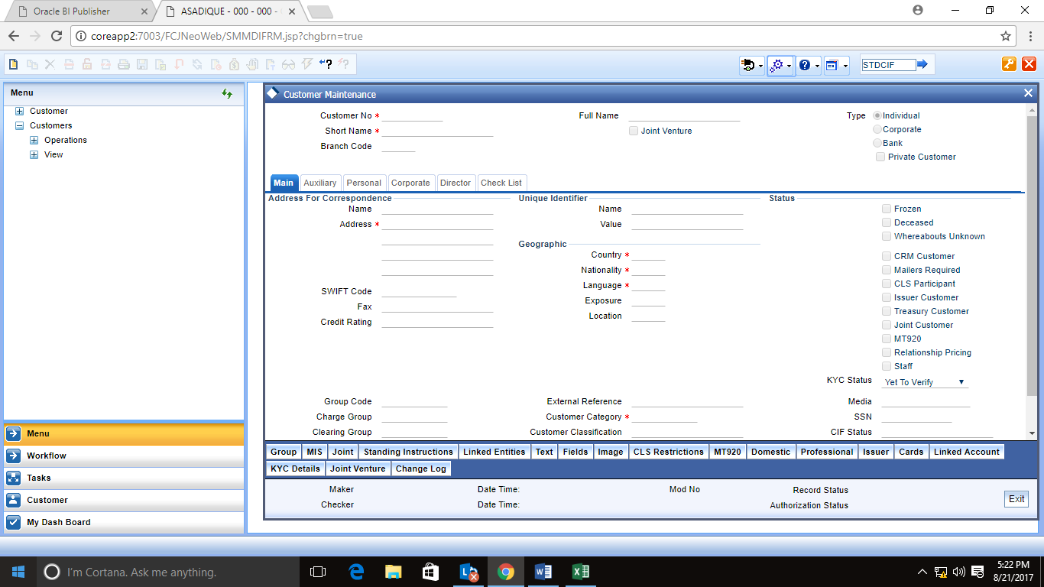
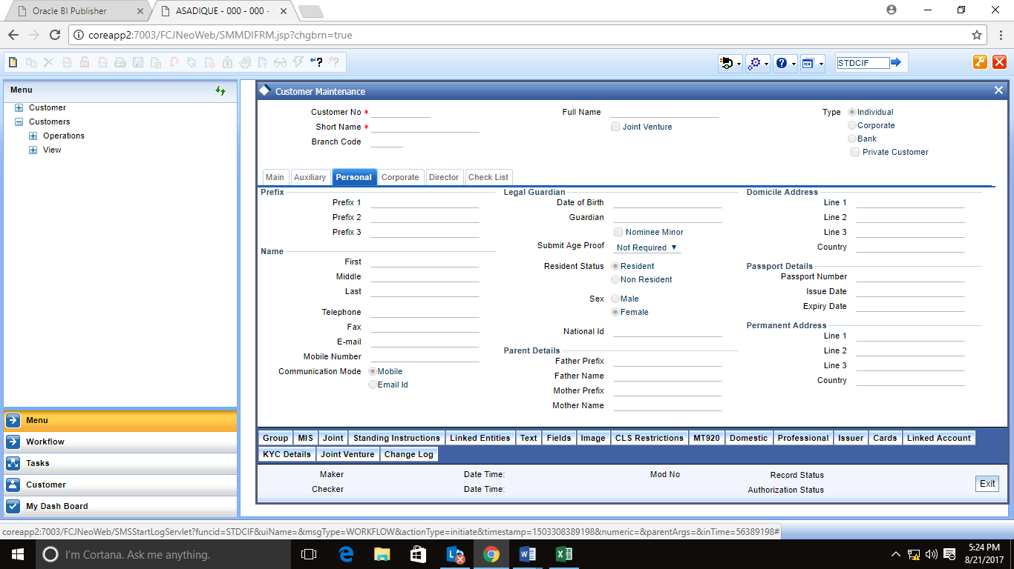
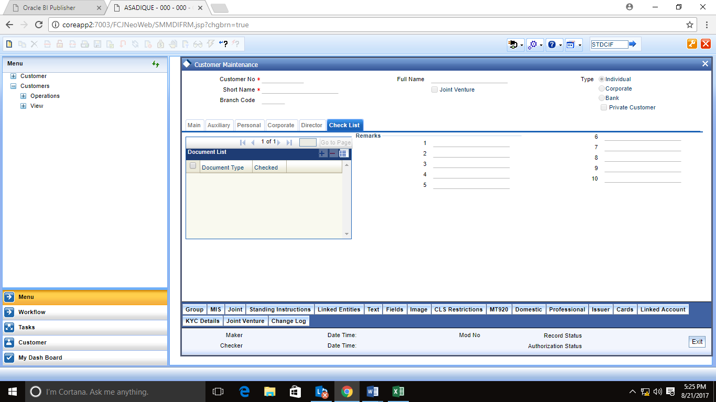
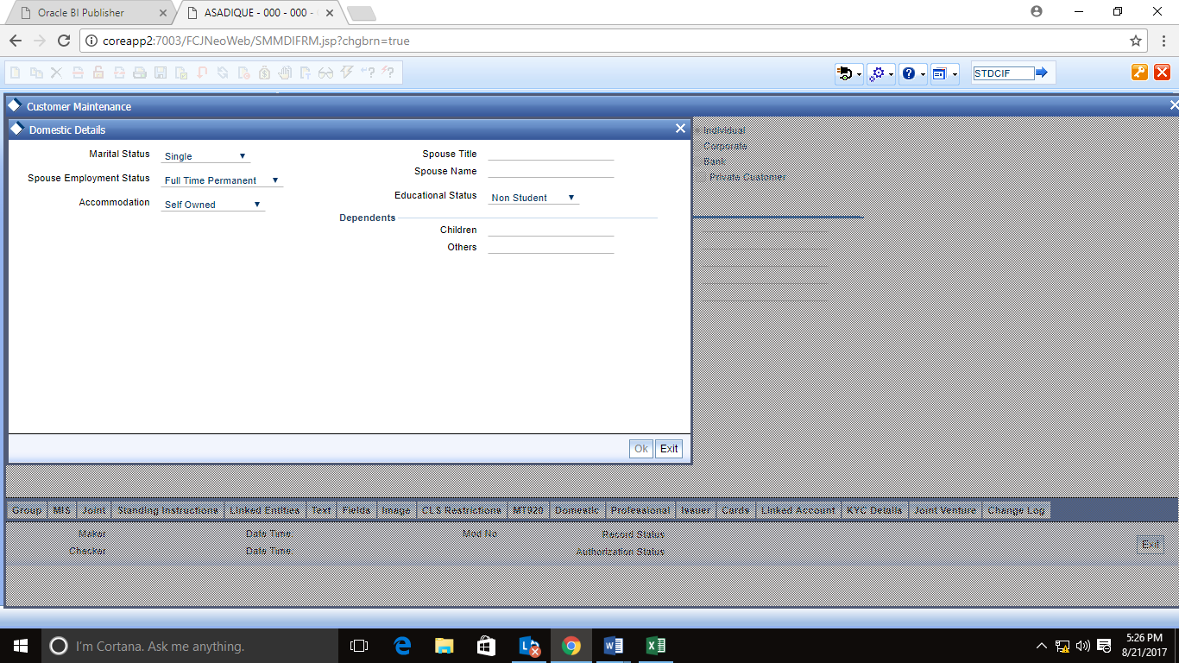

Corporate CIF:
To create a corporate CIF we have to check the trade license. In this case we use TIN (Taxpayer Identification Number) of the corporation instead of NID number. The steps are almost same as individual CIF. The difference is in this case we have to link the proprietor name with corporation.
We create CIF not only of loan seekers but also of guarantors as well as entire directors of the corporation.
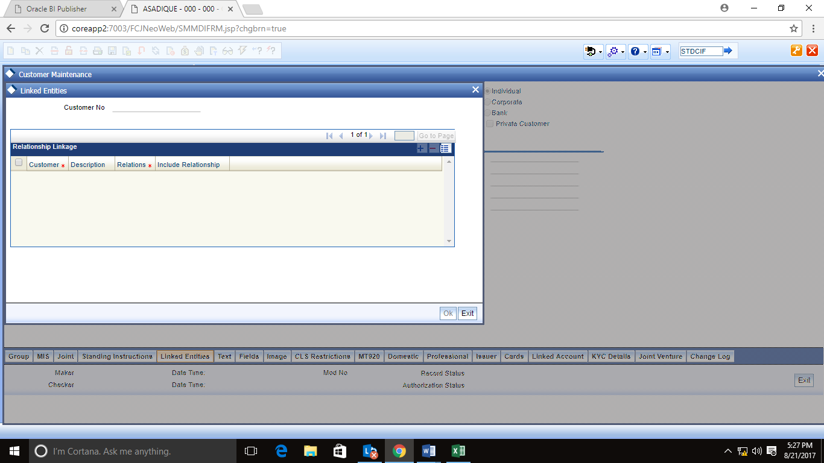

Account Number
We get an account number when we finish creating CIF. Account number is very important to start a loan process. Any disbursement or Bangladesh Bank can inquiry the customer by the CIF account. When someone applies for loan, Bangladesh Bank check the details of applicant searching by the CIF number.

Authorizing
After creating CIF it should be authorized by the second person. 2nd person review the whole account and find whether there is any problem or not. If s/he finds any problem, s/he will ask the creator for the modification of that account, if not then it will be authorized.

Ready Error 2
Another responsible work I have done which is called error 2. Error 2 is like there is any wrong information about the customer in the assigned taskbar. Because of wrong information Bangladesh Bank or CRM can’t disburse any loan. To correct an Error 2, I need customer original NID, TIN certificate and also I had to prepare 2 set of documents, one set is for office and another copy for Bangladesh bank.

Creating a Credit Information Bureau Report (CIB)
CIB holds the customer loan information. To create a CIB report we need NID, TIN and the amount of loan that customer wants to have. From this report we come to know the loan details of applicant. We can get information whether the loan is classified or unclassified, whether there is any default risk or not. Based on this report the loan is sanctioned. CIB reports are done in the Bangladesh Bank website.

Pipeline of Incoming Files
Maintaining pipelines of incoming Files was a daily task for me. It is a prime spreadsheet, which include vital information of the incoming files. The consisting information in the pipeline were receiving month of the file, name, branch, CIF Number, sales channel, profession of the client or loan applicant, cluster (for Home Loans), STM (Sales Team Manager) of the loan, RM (Relationship Manager) of the loan, type and amount of loan, and receiving date of the file for each specific file.

Pipeline Checking and Receiving the Incoming Files
My duty was to separate the attached CPV (Consumer Point Verification) requests from the files, during preparing Pipeline entries for the incoming files. My next task was to test the BS Channel and Register Book of the NS, which comes along with the submitted files. When the testing procedure is complete, I had to put a sign of my name there to make sure the reception of all the submitted files carefully from the department’s end. I tartan some significant fields of the files e.g. whether seal of STM or CIF of the applicant and co-applicant and reference of loan application, etc. was given properly. I used to back the files to the respective BS (Branch Sales) or sales channel – NS (National Sales), if any of these was misplaced. I used to put a seal on the file cover, if I got everything right. It was 10:00 A.M. and for the holy month of Ramadan it was 11:30 A.M. Files submitted after Cut Off time was accepted in the next day instead of the submission day.

Updating the Pipeline and Distributing Files
I have separated them on the basis of their type after preparing the entries of incoming files in the Pipeline e.g. Home Loan, Personal Loan and Car Loan.

Details of Received Files
In every morning, my task was emailing the details of all the received files.

Preparing Asset Details of Clients
When there was too much pressure of files I used to take the responsibility of preparing asset details of the clients. These asset details were actually necessary for deciding which assets could be used as mortgage of the loan.

CIB Reports
I used to find it by CIB tracking number of the client from a list, which is uploaded in the public folder by a designated employee of the department. My key responsibility was to provide information to the Credit Analysts about whether the client’s Credit Information Bureau Report has been accepted or not.

Performing Appraisals
A routine task of mine was creating Performing Appraisals. It means modifying loan application associated information in Microsoft Excel sheets.

7.3. Experience achieved from Internship
Internship is a program that helps us to gain new things and achieve in hand experience. Under this development aspect I have gained knowledge about my company and department. It has helped me to improve myself in many ways. The first thing that I want to mention is I have become more prompt and proficient. I carefully observed how the persons in my department used to tackle such situations. I learned that prioritizing tasks according to their deadline and importance is the key to tackle such pressure situations successfully. In corporate world often an employee has to engage himself/herself in multiple tasks simultaneously. I implemented this technique in my task and accomplished my tasks as an intern fruitfully. Besides, I want to mention that this internship has broaden my view and the help I got from the colleagues is not actually a matter of discredit rather it gives a signal to others that I have the willingness to learn and work perfectly. “How to self-motivate under stressful situation?” this is another learning outcome during my internship in IDLC Finance Limited. Without any doubt this self-motivation thing matters a lot in the corporate world. The reason is in the corporate world stressful situations appear on a regular basis and his/her actions in such situations are observed by the people around him/her. Lastly I want to say that this internship has boosted up my confidence level to a significant extent.
Inspection during Internship
I have fruitfully enhanced the following skills during my internship by my own and with the support of my colleagues:
- Work under Pressure: As an Intern, I was assigned diversified tasks and asked to finish them immediately. In this situation I took guidance from my colleagues when I was clueless about the task. This has taught me how to handle myself and work effectively and efficiently even under pressure.
- Corporate Culture: It was a matter of pleasure to work with many qualified and experienced employee and learn the ins and outs of a corporate culture. This will help me in my near future life.
- Operating FLEXCUBE: My task was to preparing entries through FLEXCUBE. After using it for several times I became very efficient in using it. This software mostly used in banking industry, which is made by second leading software making company in the world named Oracle Corporation.
- Practical Knowledge of NBFI (Non-Banking Financial Institutions): I had little knowledge about NBFI and about their operations. That was an advantage for me to work. During my internship, I got myself acquainted with various aspects of a NBFI.
- Communication Skills: I had to communicate both verbally and electronically with different people from different teams and departments on a regular basis. It has enhanced my communication skills to a great extent.
- Team Skills: I had to work in a team of interns consisting of two members. As our task was individual, we helped each other whenever we faced any problem. To finish our tasks accurately and in time we had to coordinate and divide tasks among ourselves. Such experience has sharpened my ability to work in a team environment.

Interactions with my Supervisor and Coworkers
In IDLC Finance Limited, my internship supervisor was Mr. ShazzadulKarim. At the very beginning stage of my internship I was so worried about my tasks. But he suggested me not to take so much pressure and provide enough guidance and support so that I could work without hesitation. He was so supportive that from beginning to end of my internship he helped me so much whenever I suffered from any problem. He always helped me affectionately. During my internship I visited my University several times for different purposes. As I had a self study course, I had to meet my faculty and in every single case I took permission from him for half day leaves. In all cases my leave application was approved. Moreover, he used to give me advices and suggestions about my work.
All the employee of my team were so helpful, friendly and cooperative that I can’t even express. In the introduction part, one of them introduced me with everyone of my department and they treated me so affectionately. Their cooperation has helped me to gather a lot of practical knowledge from my internship. I was able to put extra effort to improve my works due to their appreciation. Despite being an intern I was invited in several parties e.g. birthday party, promotion celebration party etc. arranged by the department personnel. I have learnt a lot of things from them.
My department employee was so professional that I liked to work with them. They always advised me to ask work related questions and seek help from them without any hesitation so that I can work freely. So whenever there was less work pressure I used to ask questions to them about their regular tasks.
7.4. Difficulties faced during my Internship & how I have overcome them
From my three month long internship in IDLC Finance Limited, I have achieved precious knowledge and experience from my team. But I suffered from many problems since I encountered some difficulties. I tried my best to overcome them as soon as possible. The very first difficulty I faced coping me up with the corporate environment of the company, as I have never involved in this type of environment before. In the first day of my internship I was able to put a great sense about myself among my supervisor and colleagues through just a short conversation. With the time I adjusted myself with environment with the help of my department personnel. I was liable to make mistakes at the beginning stage of my internship. The feedback and advice from my supervisor and team members helped me to rectify myself and prepare myself to go with the flow.
One of the difficulties faced by me was when I had to deal with my instability. Sometimes it had a bad impact on my works as well. My senior colleagues used to say that it was very hard to convince everyone in the corporate world. Sometimes Later I increased my focus in my works and cope myself with such issues to perform better. Besides, Creating Account with smart card instead of NID is another difficulty. There is no system of giving input with smart card. So I need to collect the NID number of that particular smart card from the site of Bangladesh Election Commission. It kills time.

There were some other problems regarding my inefficiency in multi tasking. It was not easy for me to focus on two or more things at a time and sometimes I made mistakes. I learned that in corporate culture it is very typical for an employee to deal with several tasks at a time. Sometimes server was getting down. So the software didn’t work properly and gave wrong outcome for which I had to suffer. Following the advice from my seniors I adopted the technique of prioritizing my tasks on the basis of their deadlines and significance.

Research Design

Topic: Credit Risk Management in SME financing

Why this topic is important
The topic is credit risk management in SME financing. It is important to know separately what is credit risk management and what is SME financing before explaining the importance of it. Credit risk is the uncertainty of not getting back the money that has been given to the client or failing to meet its obligations on agreed term now about the SME financing. As we know SME stands for Small and Medium sized Enterprise; financing in this sector is being encouraged now a day because of some extra advantages like this is easy to commence, easy to finance, easy to focus, large turnover, large profit margin and so many. This is a field where improvement will work a lot. If the acceptance of working in this sector once gets the acknowledgement broadly then this can be one of the comfortable area to work in. There are many more advantages those must be stated here like in this sector faster decision can be made, fewer employees is needed for this operations, better access of loan is the most attractive advantage and also the country’s unemployment can be removed by this whatever that is a low percentage. The people of SME take this unemployment as an advantage, as they do not need skilled people from the beginning. The SME team trained the employees as they want and fit for separate work. By this, the SME team can make the best use of the unemployed people. The purpose for which SME loan has been demanded can be closely monitored in some cases, for example the lender can visit their places to look at how actually they are using the money for. In most cases the money has been given for the purchasing of raw materials or for establishing a mini business like grocery shop or a restaurant or a boutique shop and so on. Another thing is SME does not need any critical business structure to operate their business. These are the things why this topic is important and SME is important for an organization as well. This is a best fitted job for them who does not want to work in a routine job again does not want to be in a big business and that is why this will be a best suited and mostly wanted field to everybody in near future. The contribution of SME is not negligible though. SME provides a lot to the economy. Compare to the large industry the contribution of small industry is not that bad.

My organization IDLC wanted me to work on this topic as they think they have scopes to improve in SME sector. They want to go in extra miles in SME financing field. Through my report the organization wants to see the real condition of leasing industry in Bangladesh and the condition of SME financing and the comparison by analyzing some ratios. I have accepted this topic and understood the importance of this topic and finally working on it. For the above mention reasons the topic is important to be discussed. The findings of the report may help my organization by providing the desired information. Similarly, I will be benefitted by learning the analysis of the organizations performance, condition and so on.

Offered SME loan from IDLC:

Small Business:

SME term loan:
Loan Limit: Up to BDT 2 crore
Loan Tenure: 13 months to 60 months
Loan without any collateral for more than 25 lac

- Eligibility to get the loan: Business must be a going concern with minimum operational experience of 2 years and age must be between 20 to 60 years

PURNOTA (Women Entrepreneur Loan):
Minimum Loan amount BDT 3 lacs
Maximum unsecured loan amount up to BDT 25 lac
Loan tenure: 13 to 60 months
Flexible repayment based on cash flow of business
Under Bangladesh Bank refinancing scheme loans up to BDT 50 lac at 9% interest rate

- Eligibility to get the loan: Minimum 1 year of business experience and age is between 20 to 60 years.

Supplier Finance:

Factoring:

There is more than 80% of financing against demonstrated invoices
Client cash flow cycle’s period is credit (at least180 days)
Payment transfer from the buyers
Loan Limit: Any amount this is defensible with sales (and contemporary on management approval)
Loan tenure: approximately 1 year from the approval date

- Eligibility to get the loan: Must have frequent sales on credit to corporate buyers; at most 2 years of constant business operation and experience; age has to be between 22 to 60 years; business within service range of IDLC branches.

Distributor Finance:
The credit limit is based on sales volume and IDLC management approval
100% advance payment to the corporate on behalf of the distributor
Credit period is maximum 180 days
Security required above BDT 2.00 Million credit limit
Standard charge and fees apply (annual processing fee, discount on lifting order value, interest calculates daily)
Loan limit: Based on corporate suppliers’ comfort and sales of the distributor
Loan tenure 1 year from the sanction date
Eligibility to get the loan: Must receive recurring lifting orders from corporate entities
Minimum 3 years of continuous business operation and experience
Maintain minimum 1 year of uninterrupted business relation for approved suppliers
Age between 21 to 60 years
Business within service range of IDLC branches

Work Order Loan:
The credit limit is based on sales quantity and IDLC management approval
At least 60% of advance financing against verified work orders
Client cash flow cycle’s period is credit (at least180 days)
Security requisite above 1.00 million Credit Limit
Regular fees and charges apply
Loan limit: Any amount that is acceptable with sales
Loan tenure: 1 year from the approval date

- Eligibility: Must have recurring sales on credit to corporate buyers; Minimum 2 years of continuous business operation and 3 years of business experience; age between 21 years to 60 years; Business within service range of IDLC branches.

Revolving Short Term Loan:
Loan Limit: The load limitation is more than BDT 1 Crore.
Loan tenure: more than 1 year
Flexible repayment structure according to the cash flow of the business
Flexible disbursement method based on the specific needs
Flexible drawdown throughout the contract period

- Eligibility: Minimum 3 years of business experience; age is between 30 to 60 years.

Partially Secured Loan:
Loan Limit: Up to BDT 1 crore
Loan tenure: 13 to 60 months
Flexible Repayment based on the business cash flow
- Eligibility: 2 Years of continuous business operation (Supported by Trade License); Age should be between 20 to 60 years.

Seasonal Loan
Up to BDT 75 lacs loan amount
Up to 1-year loan tenure
Payment mode available in EMI and seasonal payments
Eligibility: Minimum 2 years of continuous business experience and age should be between 20 to 60 years.

ABASHAN (Commercial Housing Loan):
Loan amount: Up to 2 Crores
Loan Tenure: up to 15 years
Expedient repayment method through Equated Monthly Installments (EMI)
- Eligibility: Rental business with at least 1 year of continuous operation

Commercial Vehicle Financing: Loan Limit:
Up to 80% of the price of the vehicle
Loan Tenure: Up to 5 Years

- Eligibility:Minimum 2 years of continuous business operations; age should be between 20 to 60 years.

IDLC Startup Loan:
Loan Limit: More than 25 lacs
Loan tenure: more than 5 years
Grace period of 3 to 6 months
Repayment method: EMI or structured payment
- Eligibility: Business must be less than 3 years old; age within 18 to 45 years; had no previous ownership experience in any preceding business.

UDBHABON:
Minimum loan amount: BDT 5 lacs
Unsecured loan up to BDT 25 lacs
Partially secured loan up to BDT 1 crore
Loan tenure: Minimum 13 months to 60 months
Easy repayment through EMI
Special facilities for the members of BASIS
- Eligibility: Age is between 20 to 60 years; minimum 2 years of continuous business operation (1 year for women entrepreneur)

Medium Business Loan

Medium Business Term Loan:
Loan limit as per business requirement
Flexible loan tenure
Structured repayment mode
Competitive rate of interest

Lease Finance:
Loan tenure: At least 5 years
Financing for both local and foreign system
Customizable repayment form
Competitive pricing
Tranquil guaranteed requirement
Ownership lies with IDLC during loan tenure
Ownership is transferred to you upon full and final resolution of competence

Commercial Vehicle Financing:
Exposure of broad range of PASSENGER VEHICLE and CARGO VEHICLE
Single Vehicle Finance, Fleet Finance & Finance under guarantee
Minimum Documentation
Flexible Financing Tenure Ranging from 12 to 60 months
Competitive pricing & no additional Collateral requirement

Commercial Space Loan:
Loan Limit as per contribution of debt equity share
Stretched loan tenure
Structured repayment mode
Competitive rate of interest

Working Capital Loan (Short term Loan):
Renewable loan limit
Loan tenure at most 360 days according to business cash cycle
Structured repayment form
Several drawdown and adjustment ability within the loan limit
Competitive pricing & guaranteed requirement
No premature payment charge

IDLC project financing:
Stretched loan tenure
Structured repayment mode
Competitive rate of interest
Bundle product offerings to ensure full finding of project

Analyzing of the Study

Checklist of activities before sanctioning a loan
- Report: The SME team can check the CIB report of last 1 year, where they see if the client has other loans in other banks or not. If the client has other loans how is he/she performing to repay the loan amounts.
- Trade License: The trade license is being checked to ensure that at least 2 years has passed after issuing the trade license.
- Feedback: Before sanctioning a loan the team also gather market feedback whether the applicant has any bad report in the market or not. For example, already IDLC has given a loan to a cosmetics seller in Bashundhara City and the other applicant is also conducted his/her business in Bashundhara city in the same floor. So, the team will hear from the cosmetics seller about the new applicant’s characteristics and some other thing.
- Defaulter: If a person has been announced as a loan defaulter from any other bank the person will suffer to get loan.
- Loan hider: If the applicant hides about his/her another loan, the person will be in trouble later on.
- Income and Expenses: The income and the expenses should be in a balanced way of the applicant. If the expenses are more than the applicant’s income, then the loan can be declined.
- Application: Any sales person from any business applies for this kind of loans and there is a high chance to be declined the loan as this does not fulfill the criteria of getting SME loan.
- Mismatch: If the loan amount mismatches in any documents has a chance to be declined the loan.
- Bank Statement: The bank statement should be as per the requirement of the organization. Otherwise, it has a chance not to be approved the loan.
- Permanent Residence: If the applicant has permanent residence in Dhaka he/she will get the preference in terms of getting loans.
- Guarantor: The most important criteria to be checked is the guarantor. A person who has active loan in other financial institutions will be the appropriate guarantor for any loans.

Reasons for loan default:
- Willful Defaulter: I came to know the reasons why any loan become default loan by taking interview from 2 employees of IDLC and they stated that the percentage of willful defaulter are more in many case.
- Over leveraged: If the team of SME invests in any over leveraged business they don’t get the repayment of the loan. In most cases it happens when the team choose wrong client for giving the money.
- Nonproductive Investment: A business that will never produce anything is not a suitable area to invest. If investment occurs there, then loan amount will not be repaid.
- Business/Product type: The type of business or the product on which investment will be occurred matters in terms of getting loan. In a same way, when an organization will give loan the business type or the product type also matters.
- Situational: Sometimes it is situational problem not to repay the interest of loan amount timely.
- Improper Supply System: When supply system is not properly working for those business where the supply of raw materials matters most the businessmen remain in problem and unable to repay the interest amount on time.
- Government Intervention: This is an action carried out by the government or the public entity that affects the market economy with the direct objective of having an impact in the economy. At that time the problem of not getting the interest amount of loan occurs.

Chapter- 7
Conclusion
Businesses operated by taking huge amount of loan from banks or from relatives. Before establishing the loan system of SME, people who didn’t want to run big businesses; used to run businesses in different form for the need of money. After the establishment of SME loan people are more interested to run businesses and the amazing businesses started running in a very good way. If the strategy of lending money can be hold there are lot more amazing things to come. To hold this, first of all the leasing companies or the related companies have to aware the borrower about the competitive challenges they have to face. Secondly, the companies can help SMEs to meet challenges by understanding the strength and weaknesses and also help them to overcome the challenges. They need to learn some inputs to upgrade their themselves. Inputs like market information, finance, training infrastructure development, R&D, technical skills as well as skills and links with institutions for support services.

Recommendations
Recommendations
To develop the strategy of SME and to fulfill the objective of this study there are some recommendations which mentions where SME can invest more/ what are the scopes to make improvement in this field. Here are some recommendations which may follow the leasing companies.
- Hire skilled personnel to avoid the risk factors and make the ground more profitable.
- Bangladesh Bank should continue the refinancing system to encourage the entrepreneur in the business field.
- If the system of getting trade license, registration of enterprises, getting patents or trademark become easier than the number of taking loan will increase which will eventually help SME to reach into a standard level.
- A separate organization can be built by the participation of public and private banking industries for small business investment and lending money in SME field.
- Another amazing work can be done to encourage and improve the SME sector. Public fund can be made under some regulations from where businesses will get money directly and the further formalities will be done accordingly.
- Disaster or seasonal loans can be provided.
- Seeking for international funds.
- The sector of special SME loan like Women Entrepreneur loan in IDLC which is known as “PURNOTA” another one is “UDBHABON” can be increased to enhance SMEs beauty.

Chapter- 8
Appendix
Bibliography
- Wikipedia. (2018). IDLC Finance Limited.
- wikipedia. (2018). IDLC Asset Management Limited.
- Mohajan, H. K. (2012). The Lease Financing in Bangladesh.
- IDLC Finance Limited Official Website
- IDLC Finance Limited Executive List
- Annual Report of IDLC 2015, 2016, 2017
- Annual Report of United Finance 2015, 2016, 2017
- Quartey, P. (2017). Reviewof Development Finance. Financing the growth of SMEs in Africa: What are the contraints to SME financing within ECOWAS.
- Javed Hussain, C. M. (2013). SME financing
- Diana Eravia, T. H. (2015). Procedia - Social and Behavioral Sciences. The opportunities and Threats of Small and Medium Enterprises in Pekanbaru: Comparison between SMEs in Food and Restauran Industries, 88-97.
11. Ullah, D. (2006). SMEs in Bangladesh and Their Financing : An Analysis and Some Recommendations. 57-72.

- (Financial Report Annual
- report of IDLC Finance Ltd. of 2018
- Journal
Koranteng1,E. O., F. O., M. O., & Ntiamoah, E. B. (2016). A Case Study of Selected Co-Operative Credit Union in Ghana, Research Journal of Finance and Accounting, 197-203.
- Book
Garrison, R.H. Noreen, E.W, & Brewer, P.C. (2010), Management Accounting, NY, McCraw-Hill Irvin, 13th E.
- Article
Sarkar, J.B, & Ahmed, H. (2007), “Disclosure on corporate governance by listed company in Bangladesh”, ‘The Cost and Management, ‘No. 1 Volume XXXV January- February
- Websites
- http://idlc.com/financial-highlights.php
- http://idlc.com/
- http://iiste.org/Journals/index.php/RJFA/article/viewFile/28544/29291
- www.secbd.org

Pictures of my Internship Journey
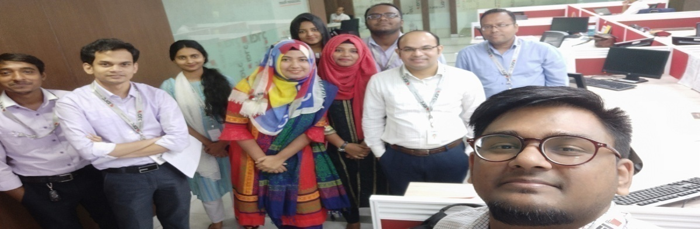
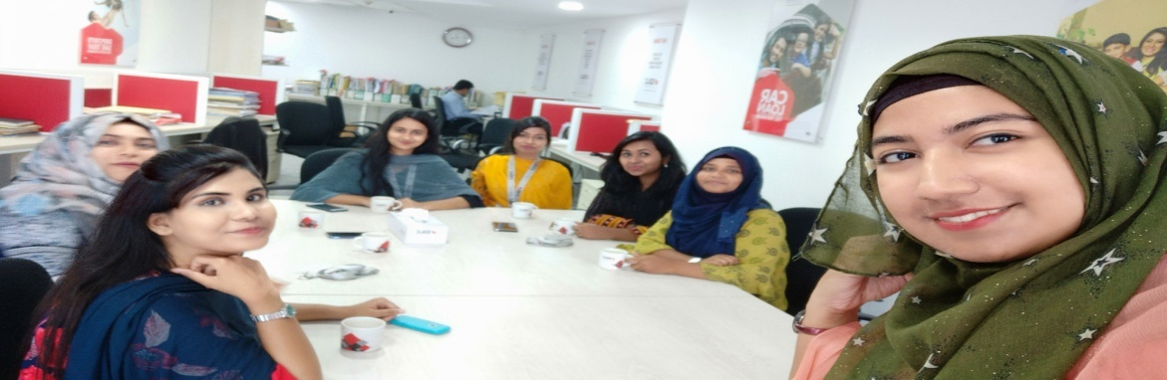
Sharing my First Salary with poor Kids by giving Clothes:


