
United International University

Internship Report
On
Stygen



Topic: “Overall Activities of Stygen”

Supervised By:
Dr. Seyama Sultana
Assistant Professor
SCHOOL OF BUSINESS AND ECONOMICS
United International University

Submitted By:
MD. YEASIN ARAFAT
111 151 616
United International University

Date of Submission: 08/02/2020
Letter of Transmittal

Dr. Seyama Sultana
Assistant Professor
SCHOOL OF BUSINESS AND ECONOMICS
United International University
Subject: Submission of Internship Report.

Madam,
I would like to submit my report on “Overall Activities of Stygen.” prepared as a part of the requirement for BBA program of United International University.

I have successfully completed my internship program at Stygen and I worked there as Business Development Executive. Working on this report was a great learning experience for me as I got to learn the differences between practical and theoretical work. I hope you will find the report to be objective, systematic and reliable.

I would like to thank you for all the support and guidelines that you have provided, which I hope to continue getting in the future.

Sincerely yours,
MD. YEASIN ARAFAT
ID: 111 151 616
Email: arafattanjil@gmail.com
Phone: +8801675338228
Declaration

I declare that the report on, “Overall Activities of Stygen.” Is based on my work experience in Stygen and I have taken some interviews of the CEO and some employee for the purpose of collecting required data.
I state that the whole report is my own made and this report does not break any rule of copy-right. This specific report never has been published or submitted to any other University/College. I have prepared it for the academic purpose of Bachelor of Business Administration degree which requires practical work experience.

MD. YEASIN ARAFAT
ID: 111 151 616
Email: arafattanjil@gmail.com
Phone: +8801675338228
Acknowledgement

Firstly, I would like to thank Almighty Allah for making me able to complete my internship and my graduation. Then I must express my deep gratitude to my University supervisor Dr. Seyama Sultana Assistant Professor, UIU for her guidance in complaining the internship program successfully. I would like to place my gratitude to the HR of Stygen for giving me the opportunity to complete my internship in their esteemed organization.

I would also like to thank my host organization supervisor Mahdi Hasan Sagor, CEO, who has helped me to learn many new things during my internship program.

During the preparation of the project work I got huge support from my co-workers, friends, my supervisor, who gave their ideas and time in the process of completing the report to be true to myself I must say that without their help it would be very hard for me to go through the entire process. I am thankful to all of them.

Executive Summary

For the purpose of completing Bachelor of Business Administration program this report is prerequisite. I have completed my three months internship at Stygen. There I was able to understand about the e-commerce industry of Bangladesh both theoretically and practically. The report is based on the work experience throughout my internship period at Stygen.
In this internship report I tried to discuss about my work experience and learning at Stygen. According to my internship supervisor I tried to show all the activities of Stygen in the report. Here, I also discussed about all the strengths, threats of the organization and marketing strategies that the organization follows to grow in the e-commerce industry.

Table of Contents
Letter of transmittal 3
Declaration 4
Acknowledgement 5
Executive summary 6
Table of contents 7
CHAPTER 1: INTRODUCTION 9
1.1 Organizational Profile 10
1.2 Data Collection Methods 11
1.3 General Information of Stygen 11
1.4 Product folio of Stygen 12
CHAPTER 2: COMPANY PREVIEW 16
2.1 Mission, Vission, Goal of Stygen 17
2.2 Organizational Structure 17
2.3 Backgroud of the organization 16
2.4 Departmental activities 18
2.5 Overall Activities of Stygen 21
2.5.1 Seller Acquisition Process 21
2.5.2 Quality Check of Product 21
2.5.3 Order Confirmation 22
2.5.4 Payment Methods 22
2.6 Offers on Stygen 23
2.6.1 Pohela Boishakh Offer 23
2.6.2 Flat Discount during Eid 24
2.6.3 Ten10 Campaign 25
2.7 SWOT Analysis of Stygen 26
CHAPTER 3: INTERNSHIP EXPRIENCE 28
3.1 Job description 29
3.2 Period of Employment 29
3.3 Remuneration 29
3.4 Work Station 29
3.5 Specific Responsibility of the Job 29
3.6 Responsibilities 30
3.7 Experience during my internship 30
CHAPTER 4: CONCLUSION AND KEY FACTS 31
4.1 Recommendations for improving departmental operations 32
4.2 Key Understanding 33
4.3 Conclusion 34
Reference 35

CHAPTER: 1
INTRODUCTION

  - Organizational Profile
Overview of the Organization
Stygen is known as online gift item platform. The organization starts its operation 3 years ago in 2017. At first, they introduce their Facebook page in 2017 named Stygen. In 2018, Stygen introduced its e-commerce site stygen.gift to make a huge place in the e-commerce field in Bangladesh.
Stygen keep their customers trust and maintain great client relation. Because Stygen’s target customers belong to all income class and age. The organization focus on customer service to retain their customer and attract new customers.
The Company has over 690 gift items as product. Such as, watch, wall clock, flower, cake, showpiece, chocolate, books, teddy bear, home décor items, etc. The organization deliver all over Bangladesh through Pathao parcel, E-courier, Sundarban Courier, SA paribahan. Stygen ensure great delivery process to make customers happy and satisfied.
Stygen tries to provide delivery to the customer’s doorstep. That’s why Stygen believe and the slogan is “The best gift solution in Bangladesh”

  - Data collection methods:
I collect information from 2 sources.
- Primary source:

- Practical experience during my internship period.
- Discussed with company’s CEO and my supervisor (Mahdi Hasan Sagor) about the company.
- About operation of the organization I talked with the Head of operation department.

- Secondary source

- Visiting Stygen’s website. (Stygen.gift)
- Reading organizational policy book.

1.3 General information of Stygen:
Company Name : Stygen
Industry : E-commerce
Foundation : 2017
Founders : Mahdi Hasan Sagor
Owners : Mahdi Hasan Sagor
Employee : 15
Corporate Office : House: 65, Level-2, Road: 03, Block: B, Niketon, Gulshan-1,
Dhaka
Phone : +880 1971 971 520
Email : contact@stygen.gift
1.4 Product folio of Stygen:
Stygen works with almost 700+ gift items in the e-ecommerce industry, few are shown below-
Books | 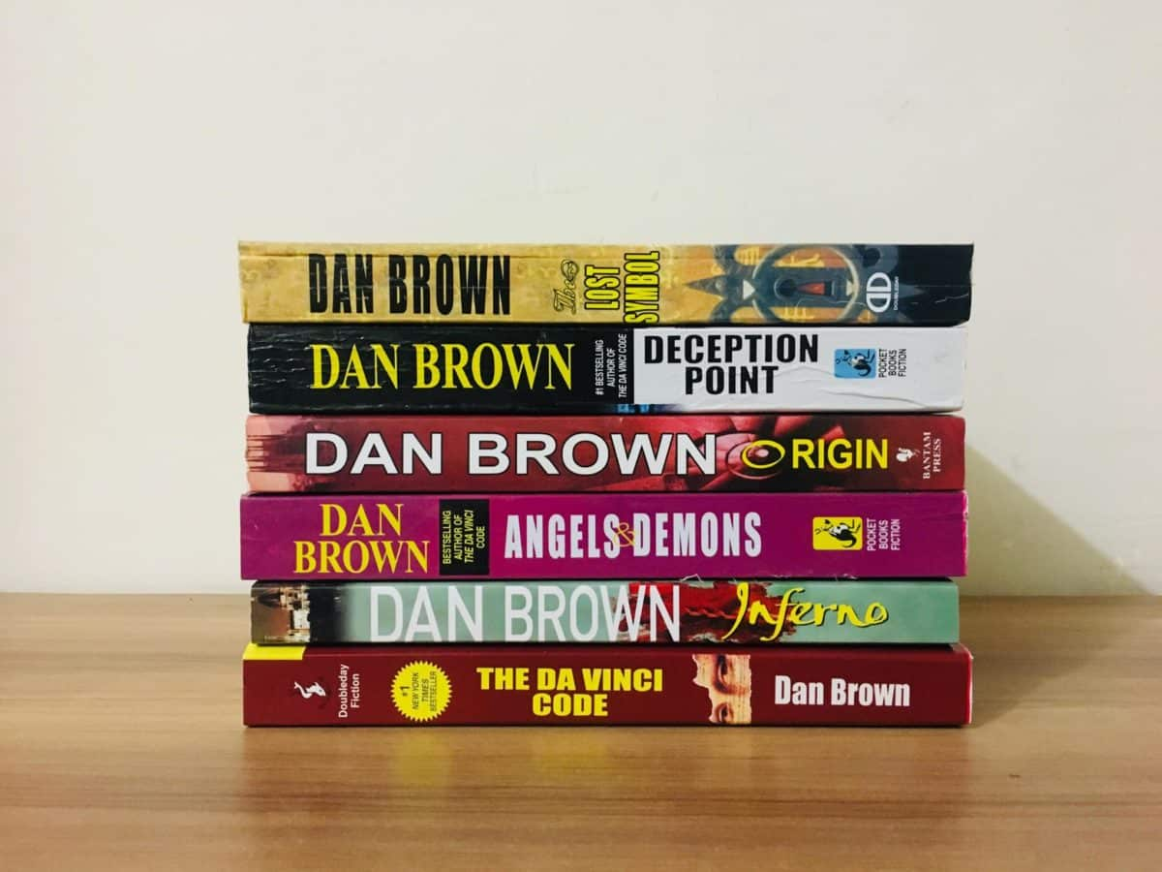
Teddy Bear | 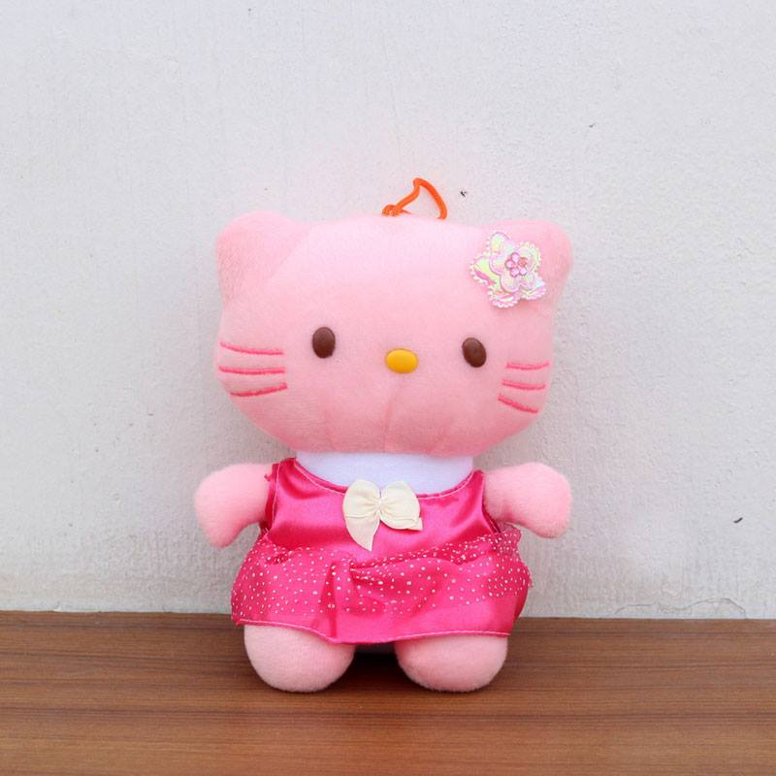
Motorcycle Accessories | 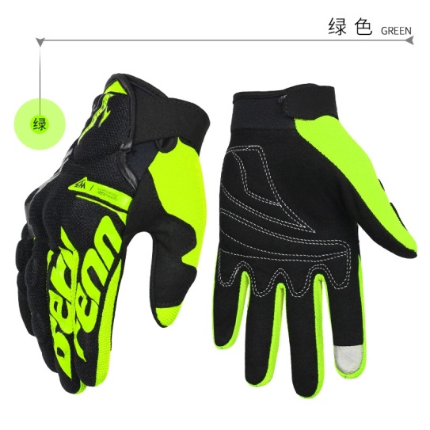
Water Bottle | 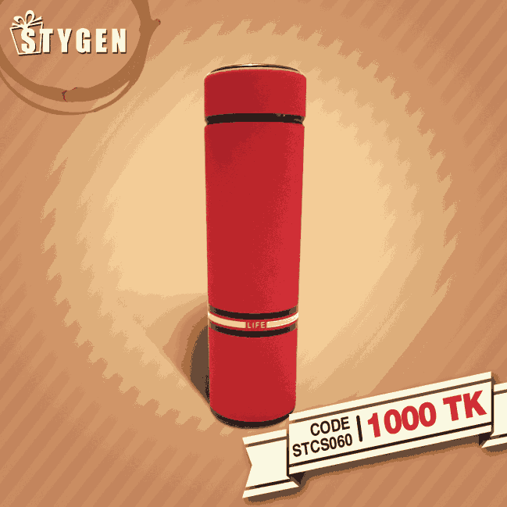
Decorative Wall Clock | 
Alarm Clock | 
Watch For Man | 
T-Shirts | 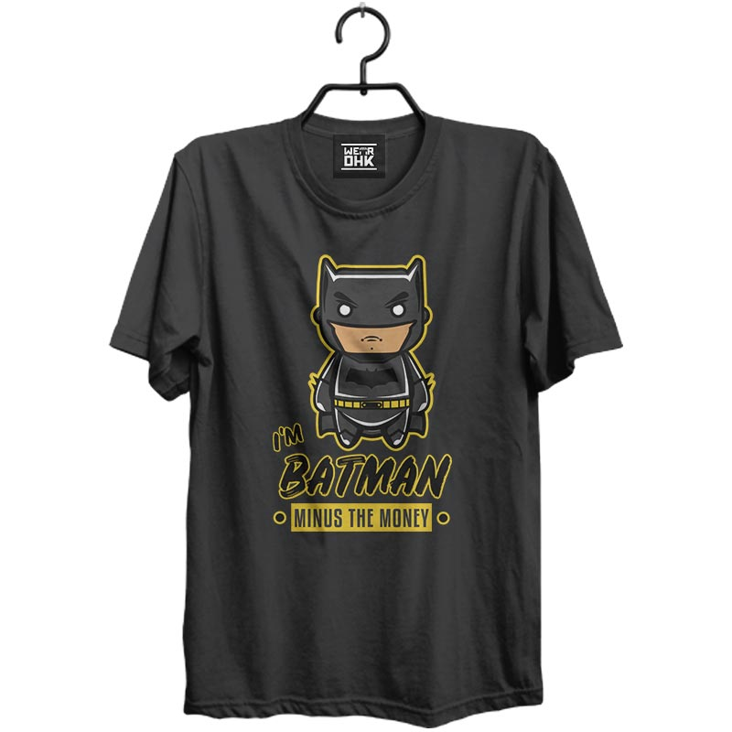
Mobile Accessories | 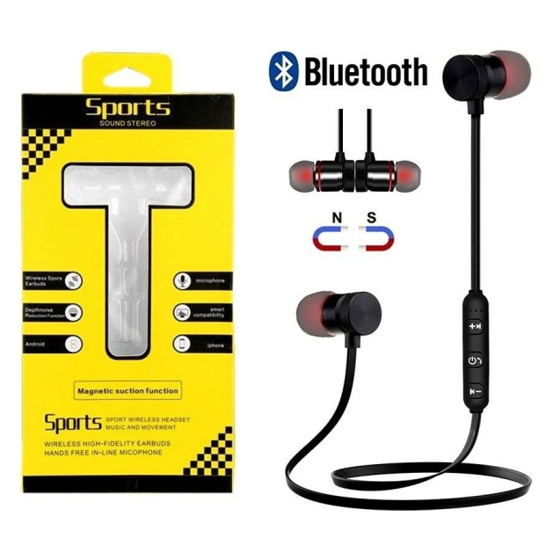

CHAPTER: 2
COMPANY PREVIEW

2.1 Mission, Vision, Goal of Stygen:
Mission:
Stygen wants to ensure providing consumer quality gift in a reasonable price.
Vision:
Stygen’s vision is to become number one gift e-commerce company in Bangladesh.
Goal:
Stygen’s first goal is to establish more opportunity in e-commerce sector specially the gift items.
Slogan:
“Best gift solution in Bangladesh”

2.2 Organizational Structure:
Stygen is one of the renowned sites in ecommerce industries in Bangladesh. Right now, Stygen is following “Corporate structural model” for its business. Since Stygen is a modern e-commerce business, corporate structural model is the best solution to apply.

2.3 Background of the organization study:
Stygen is known one of the renowned companies in our country. In the gift items sector Stygen is very much promising and favorable.
Stygen’s market share is based on 100% gift items. To conducting the e-commerce operation, Stygen needs a large number of manpower.
Stygen uses its employees or manpower properly to satisfy customers and get competitive advantages over the competitors. Stygen provide employees training based on their job duties to make them more productive.

2.4 Departmental activities:
I intern in Stygen as a Business Development Executive, I’m doing the report based on Overall Activities of Stygen. Stygen manage the whole departmental activities creativity. The below description shows how Stygen planned and executes its departmental activities, others activities will be discussed in the next chapter named Overall Activities of Stygen-

- Head of Marketing:

- Focus on marketing plans and events
- Execution of marketing operation
- Controlling promotional activities
- Making budget for promotional activities

- Sr. Manager:

- Regular inspection product sector.
- Follow up supply and demand ratio.
- Follow up current market trends and report it to the CEO (if anything needed)
- Maintain service quality with try to increase brand value.

- Procurement officer:

- Communication with suppliers
- Data analysis
- Data handling
- Purchase all gift items
- Supervising stuffed

- Executive digital:
- Prepare promotional campaigning like University events host concert and also become brand partner.
- Focus on brand segmentation.
- Digital marketing campaigns.
- Attract new target market.
- Communicating with the marketers
- Generate new marketing & promotional ideas.

- Business Development Executive:

- The job for the Business Development Executive is to manage the suppliers & distributors.
- Manage marketing & promotional activities
- Business Development Executive also take part into purchase requisition and operations.

- Customer Service Agent:

- Answering phones calls from customers, responding professionally and responsibly.
- Giving Customers required information by using company’s resources.
- Solving customer complaints
- Providing information to the customers about the service and the product
- Follow up complicated customer calls.

2.5 Overall Activities of Stygen
2.5.1 Seller Acquisition Process
Stygen does not make or produce any kind of product of its own. The company generally works as a medium or shop assistant. Stygen basically a market place where different suppliers & sellers sell their product, Stygen doesn’t buy any product from suppliers & sellers. For this reason Stygen is to acquire these suppliers & seller. It depends on the market demand, Stygen search products and suppliers and their products appear in the website (Stygen.gift). The organization follows some terms and conditions which need to be followed by all parties. First Party is the seller r the suppliers and Stygen work as second party. Before the business agreement several meeting held between both parties to conduct the business functions. After the MoU signing ceremony, Stygen upload all products to the websites what both parties agreed with. The organization uploads all products with price and details. Only Stygen can make changes in the website, suppliers or seller has no direct access in the website. If suppliers or seller needs any changes on the product price or description, they need to contact to the business development department of Stygen.

2.5.2 Quality Check of Product:
After finishing the contact agreement Stygen uploads product details, Suppliers or sellers need to send sample of every product for quality check to Stygen. Here, Quality Check team check everything of the product that suppliers or sellers gave in about the product to Stygen. If everything matches well them Stygen continues to the work, if it’s not then the product will be rejected and will get off from the website. Stygen ensures the same product as the description in the website. On the other hand, If suppliers or sellers gives legit details as the product, then all the product will be live in the Stygen website. After the approval of the product suppliers or sellers need to store at least 100 units of every product to the Stygen’s hub.

2.5.3 Order Confirmation:
After appearance in the website, the consumer can order product. Everyday almost 20 thousand potential customers visit Stygen’s website and almost 6-8 thousand become the actual customers.
After placing the order, customers get a phone call from the operation team of Stygen, If customers confirm the order, Stygen send a notification to both customer & seller that the order is confirmed so that the customer can be sure and the supplier can calculate about the unit of the product that had been given to the Stygen hub. After confirmation of the order the customer cannot cancel the order. That’s why Stygen take full payment in advance if the order is outside of the Dhaka city, In the Dhaka City Stygen provides Cash on Delivery service.

2.5.4 Payment Method

To the suppliers & sellers:
Stygen follows 15days payment method. If any product gets sold the seller will get the bill within 15days of the selling date. Stygen give the bill through bank account, bkash, nagad, rocket account of the suppliers or sellers.

For the customer:
The customer can pay through cards, bkash, nagad, and rocket. They provide Cash on delivery in the Dhaka city, but full amount of the order needs to pay in advance if Outside out Dhaka city.

2.6 Offers on Stygen
2.6.1 Pohela Boishakh Offer:
Stygen gives unique offers on Pohela Boishakh like-
- Stygen gives 15% discount on every orders which is above 1000tk on Bengali New Year.
- The campaign runs by Stygen all over the month on Pohela Boishakh.
- Stygen gives free home delivery during this Pohela Boishakh campaign.
Though Stygen is not only the e-commerce site in Bangladesh but Stygen is the only company in the gift items e-commerce industry who are giving this sort of offers. Stygen basically gives these discounts to get people to buy gifts from e-commerce sites. Discount also attracts people and encourages people to buy.

2.6.2 Flat Discount during Eid:
During the Eid season Stygen gives Flat discount on almost all kind of gift items because in Eid time it’s the best time to buy gifts. Stygen ensures big size of sell during that season. Since 2018, Stygen successfully runs this campaign during the Eid time.
Stygen gives this discounts like:
- Stygen gives 20% discount on every orders which is above 1000tk on Eid.
- The campaign runs by Stygen before 2 weeks of Eid coming.
- Stygen gives free home delivery during this campaign.
- Stygen sells gift products on this campaign, some lift style product also included in this campaign.
- Stygen mainly focuses on those products that have great selling records all over the year.

2.6.3 Ten10 Campaign:
Ten10 is a marketing campaign of Daraz. From 2019 Stygen started to take part on this campaign. Stygen gives sell all kinds of products in a huge discounted price.
Stygen offer some features of this campaign like:
- This campaign is held by Daraz Bangladesh Ltd. in October of every year.
- The Ten10 campaign lasts only on 10th of October of every year.
- Stygen sell all sorts of gift items during this Ten10 campaign.
- Stygen Gives 35% discount during this campaign of Daraz.

2.7 SWOT Analysis of Stygen:
Stygen is one of the renowned e-commerce sites which is focusing on gift items only in Bangladesh. Stygen have many sector so it has some boundaries and limitations also. On the other hand, since Stygen focuses on gift solutions its strength of this organization.
The SWOT analysis of Stygen is showed below:-

Strengths of Stygen:
- Market commander in gift item e-commerce sector: Stygen is renowned gift solution website in Bangladesh. They deliver district and upazila wise, all over Bangladesh. Stygen has smooth policy for return the product and get paid back for canceled orders.
- Pioneer in e-commerce industry as gift solution provider: Stygen is the pioneer of the e-commerce world which is totally focusing on gift items only. Stygen gets advances over other e-commerce site for providing unique service like serving gift products.
- Advanced gift solution: Stygen provides customs very fixable over using advanced technology for ordering and canceling the order. Any customer can get deliver the product in a different destination on different date as well.

Weakness of Stygen:
- Maintaining suppliers or sellers is very tough.
- Limited hub is also a weakness of Stygen.
- Various competitors in e-commerce sector.
- Lack of image in e-commerce industry.
- Trust issue among the customers since it’s also a e-commerce business.
- Lack of gift items suppliers and sellers.
- Lack of maintenance in the operating sectors.

Opportunity of Stygen:
- High chance of market growth: Market Growth rate is high since Stygen is total a gift item based business. Stygen tries to focus on quality of the product and to deliver the product on time.
- Selling gift products: Online gift solution is becoming famous day by day. So it’s a great advantage for Stygen to grow.
- Quality of product: Since Stygen already concern about the product quality it will get a competitive advantages among the market.
- E-commerce industry: There are few e-commerce sites, who work on gift items. So Stygen has nice opportunity to capture the market.

Threats of Stygen:
- Competition: Stygen got few competitions with other e-commerce sites like Daraz.com.bd, Khass food, Evaly.com.bd. There are threats to Stygen because they got extra-ordinary pricing strategy. Since Stygen collect all products from suppliers or sellers, the company can’t offer any price as wish like there companies do.
- Entrance of New organizations to the industry: If a new company entries to the industry, who also wants to focus on gift items. It will be threat to Stygen.
- Govt. Rules and regulation: Govt. rules and regulation is also a threat to business. Govt. can chance rules anytime that can affect the e-commerce industry.

CHAPTER: 3
INTERNSHIP EXPERIENCE

3.1 Job description:
I worked in the Business Development team as an Executive. Here, it is one of the main departments in the organization so I had to work carefully and responsibly.

3.2: Period of Employment:
I did Internship at Stygen but worked as an Executive of Business Development. I started my intern 20th October 2019, and finished 19th January 2020.
My working Hours was:
Sunday to Friday: 10.30 am – 6.30 pm
Lunch Hours: 1.35 pm – 2.35 pm
3.3: Remuneration:
During my internship period I was getting paid a monthly gross remuneration of BDT 5,000 per month.

3.4: Work Station:
Stygen’s head office was situated in House: 65, Level-2, Road: 03, Block: B, Niketon,
Gulshan-1, Dhaka. Throughout my internship period my worked in the head office.

3.5 Specific Responsibility of the Job:
I was working as executive in Business Development sector.
For the first 1 month, my specific duty was to uploading product details to Stygen.gift and communicating with the suppliers or sellers for more information if needed.
From the 2nd month of my internship period, I work for acquiring suppliers and sellers. In this time, I acquired- Unilever Bangladesh, Walton bd, Vision electronics, Sindabad.com, Reckitt Bangladesh, as seller of Stygen.
Finally 3rd month, I directly took part in the recruitment process of Stygen. I took part in the interview sessions with the CEO of Stygen in the recruitment process.

3.6: Responsibilities:
The following are the responsibilities of my internship period –
- The job for the Business Development Executive is to manage the suppliers & distributors.
- Manage marketing & promotional activities
- Business Development Executive also take part into purchase requisition and operations.

3.7 Experience during my internship:
As an intern Stygen give me lots of opportunities to learn. The organization is very advanced and the environment is well decorated. I actually played various role during the internship.
I work in several departments like-
- Operation team
- Development team
- Recruitment team

CHAPTER: 4
CONCLUSION AND KEY FACTS

4.1 Recommendations for improving departmental operations:
Now Stygen is one of the big gift e-commerce service providers among Bangladesh. From first day of the operation they are improving day by day. Still there are many problems in different sectors that need to overcome. I have some recommendation for Stygen to overcome that lacking –
1. Stygen sells products on behalf of vendors and they get 20% percentage from the selling price. This percentage needs to reduce to create competitive E-commerce culture.
2. Stygen needs to work on their delivery system. It takes 2-7 days to deliver a product to the customers, for delay delivery cancelation of orders is becoming higher. To increase successful delivery this time needs to be 1-3 days.
3. Needs to recruit more Customer Service Employee. Stygen has only 2 Customer Service Employee, that’s why often customers can’t reach to the service providers with their problems.
5. Stygen needs to provide doorstep delivery outside of Dhaka city. At least in divisional cities. Outside of Dhaka, all the customers’ needs to collect the product of their own form the SA paribahan or Sundarban courier service.
7. Checking the product before sending them to the customers is important. Sometimes vendor send Stygen intact product and they send it to customers but customers find that product wrong. The ordered product is not same as the delivered product.
8. Stygen needs to increase Quality suppliers and sellers. Ultimately customer knows that the products are from Stygen.

4.2 Key Understanding:

Some key understandings are given below from the report-
- Stygen’s operations.
- Workstation environment of Stygen.
- Ordering process of the organization.
- Delivery process of Stygen.
- Payment process for both Seller & customers.
- Product Acquisition process.
- Product Return Policies.
- Client service of Stygen.

4.3 Conclusion:
In Bangladesh, this is the era of E-commerce industry. E-commerce industry is growing gradually day by day. Social media platforms are now turn into a business place for e-commerce industry. Stygen plays its role by using Facebook, Youtube, Instagram all other social media. Stygen entered into the market in the perfect time when some external and internal factors are in favor of e-commerce industry. Though Stygen needs to face some challenges with delivers system and customer’s purchasing behaviors. Within a short time Stygen take leadership in the e-commerce industry by their USP which is selling gift items. Stygen made it only because of the right decision of marketing strategies. There are lots of opportunities and threats from competitors but Stygen can use its strengths to beat the competitors in the coming business days. Stygen focuses on customer’s relationships that can also help Stygen to caption the market in the up-coming days.

Reference
- Stygen.gift (2017) [online] Available at: http://Stygen.gift

