Internship Report
On
E-Customer Satisfaction & Challenges: An Example from Meena Bazar




E-Customer Satisfaction & Challenges: An Example from Meena Bazar

Submitted to

Dr. Md. Shariful Alam
Associate Professor
School of Business & Economics
United International University

Submitted By
Shovon Ahmed
ID: 111-151-216

Date of Submission: 30.11.2019

Letter of Transmittal
To
Dr. Md. Shariful Alam
Associate Professor
United International University
Subject: Submission of Internship Report.
Dear Sir,
I’m glad to submit the internship report on the topic you’ve assigned me which is “E-commerce customer’s satisfaction & challenges”. While preparing this report I tried my level best to follow your and my organization’s supervisor’s instructions.
The entire report is based on the practical knowledge I have gained from my 3 months of internship program while working in MeenaClicks, The knowledge I’ve gained from here will add a huge advantage to my career.
It would be highly grateful if you kindly receive this report and I will be pleased to answer to any of your queries regarding this report.
Thanking You
Sincerely
Shovon Ahmed
ID: 111-151-216

Acknowledgement
First of all, I would like to express my gratitude to my instructor, Dr. Md. Shariful Alam Faculty of School of Business & Economics, at United International University, who has made me capable and helped me throughout the completion of my internship report on “E-commerce customer’s satisfaction & challenges”. I have been consistently under his supervision and guidance to complete my report perfectly.
To complete a report successfully usually requires assistance and guidance from a number of people, and thereby I would like to offer my gratitude to a number of people who have assisted me throughout my entire project. I would also like to thank the authorities as well as my colleagues of Meena Clicks for giving me the opportunity to do my internship at their renowned company. The experience and knowledge that I gained while working there has been of great help in understanding the key elements related to my study as well as the survival at the corporate world. I would truly grateful to our executive officer Mr. Adnan Chy, for his guidelines and suggestions throughout my internship journey.
Finally, I am very fortunate to have my friends and family who has provided unbiased help and support in the preparation of this report with their assistance and provide sources of information. Their helping hands were truly unparalleled.

Executive Summary
MeenaClicks as the new upgraded online foundation of Meena Bazar which has been propelled for the current year. Meena Snap is the stage from where clients can do their shopping for food on the web. It is basically a web based business site which represents considerable authority in staple goods and individual consideration: this extents from crisp natural product and veggies, meat, poultry and fish, basic food item things, family unit and individual consideration decision. It’s a platform for exciting discounts on fresh and dry groceries. The inventory model of “MeenaClick” has the advantage of zonal delivery from Meena Bazar brick and mortar stores. It has call center support, a team of 10 delivery supervisors, 35 bikers and an online query management team to provide excellent customers service. The average delivery time ranges between 2-4 hours. MeenaClick product portfolio mainly consists of the groceries that are sold in Meena Bazar outlets. However, work is ongoing to extend the portfolio to become a one-stop online shopping destination. The main target customers of MeenaClick are the nuclear families, working couples and smart homemakers. Shortly, MeenaClick wants to diversify to an extended audience through innovations in distribution models. Gemcon Group changed into a leader in the retail market of Bangladesh with its superstore chain-Meena Bazar-that has become a rule superstore chain by the genuineness of its quality things, organization, and inventive trademark responsibilities. Meena Bazar is set for quick enlargement in the coming years, slackening up reasonable worth both to its purchasers and getting ranchers. As a market Meenabazar's course of action works with ECR (Electronic Cash Enrollment center) machine and amass 100% Tank (Worth Included Obligation) from their client and store the total to the Organization. Meena bazar is one of the most huge Tank payers in this segment. Not just this, Meena Bazar has been giving enormous measures of occupations through their stores.

Table of Content

1. INTRODUCTION: 10
1.1 Brief Introduction of the Organization 10
1.1.1 MeenaClick 11
1.2 Objective of the Study 11
1.2.1 General Objective 12
1.2.2 Specific Objective 12
1.3 Rational of the Study 12
1.4 Scope of the Study 13
1.5 Limitation of the Study 13
2. Methodology of the Study 15
2.1 Primary data: 15
2.2 Secondary data 15
2.3 Internship role and responsibilities: 16
3. About superstore in Bangladesh 18
3.1 History of MeenaClicks: 19
3.2 Terms & Policies and Service Reminders 19
3.2.1 Product Returns Policy: 19
3.2.2 Refund Policy 20
3.2.3 Order Policy 20
3.2.4 Product Promotion Policy 20
3.2.5 Cancellation Policy 20
3.2.6 Service Reminders 21
3.2.7 Communication Protocol 21
3.2.8 Third Party Orders 21
3.2.9 To Know Ongoing Offers: 22
3.3 Vision, Mission and Values: 22
3.3 Five Forces Model 23
3.3.1 Bargaining power of buyers: 23
3.3.2 Bargaining power of suppliers: 24
3.3.3 Threat of new entrants: 24
3.3.4 Threat of substitutes: 24
3.3.5 Rivalry among existing competitors: 24
3.4 7’Ps of MeenaClick 25
3.5 Segmentation, Targeting, positioning (STP): 27
3.6 SWOT Analysis 28
4. Findings and Analysis of the Study 32
4.1 Analysis: 32
4.1.1 Employee satisfaction or dissatisfaction: 32
4.1.2 Outlet: 32
4.1.3 Hub: 32
4.1.4 Product Differentiation: 33
4.1.5 Delivery and Man power Issue: 33
4.1.6 Customer demand: 34
4.2 Findings: 34
4.2.1 Frequently Asked Questions and Answers: 35
Conclusion: 38
Recommendation: 39
References: 40

Table of Figure
Figure No. | Figure Name | Page No.
01 | Five Forces Model | 23
02 | 7ps | 25
03 | Product Line | 25
04 | STP | 28
05 | SWOT Analysis | 28
06 | Map of Hub Location | 33

Chapter 01
Introduction

1. INTRODUCTION:

1.1 Brief Introduction of the Organization

“Gemcon Group” launched their first superstore at Dhanmondi on 1st November 2002 that name was Meena Bazar. Meena Bazar is the brand name of Gemcon Group Food and Agricultural Products Limited. Meena Bazar is one of the largest retail supermarket in Bangladesh. At presents Meena Bazar has 18 outlets in Bangladesh. There are seventeen (17) outlets in Dhaka city area and another outlet is in Chittagong. In Dhaka city, there are two (02) outlets situated at Dhanmondi 27 no. and Dhanmondi old 15 no. , two (02) outlets at Mohammadpur Housing Limited and Asad Avenue, two (02) outlets at Uttara 11 and 14 no. sector, two (02) outlets at Mirpur 15 no. and Pallabi, one (01) outlets at Mogbazar, wari, Shantinagar, Banasree, Azimpur, Zigatola, Elephant Road, Paltan area. And another outlet is situated at East Nasirabad in Chittagong city. The main target of Meena Bazar us to ensure fresh products and good quality food for the customer’s daily life. It also produces different types of food items, including organic products, dairy items, sweets, confectionary items, herbal beauty products, tea etc. Meena Bazar offers more than 15,000 items including grocery, cosmetics, stationery, toys, baby items, beverage and food ,dairy products, electronics and many others household essentials. They also give multiple promotional offers to their buyer’s in various festivals occasions like Eid-Ul-Fitar, Eid-Ul-Adha, Puja, Pohela Boishakh, New Year and Crismasday etc. Meena Bazar has a huge space on a single floor and it is located near residential areas in Dhaka city as a way to be convenient to the buyers. To preserve profit, Meena Bazar tries to keep up for the low margins with a high sales volume. Additionally, they also sell upper margin items. Although Meena Bazar is devoted to deliver the top-quality goods to the buyers and it is now consuming more to serve Bangladeshi consumers better.

1.1.1 MeenaClick

“MeenaClick” is the online platform for Meena Bazar. It is one of the leading retail super shop chains in our country. On April 18, 2017, Meena Bazar started a re-branded e-commerce site which called it “MeenaClick.com”. All the products are available in the website. Moreover, the brand grocery products delivery will be limited in Dhaka and Chittagong for now. It’s a platform for exciting discounts on fresh and dry groceries. The inventory model of “MeenaClick” has the advantage of zonal delivery from Meena Bazar brick and mortar stores. It has call center support, a team of 10 delivery supervisors, 35 bikers and an online query management team to provide excellent customers service. The average delivery time ranges between 2-4 hours. MeenaClick product portfolio mainly consists of the groceries that are sold in Meena Bazar outlets. However, work is ongoing to extend the portfolio to become a one-stop online shopping destination. The main target customers of MeenaClick are the nuclear families, working couples and smart homemakers. In the near future, MeenaClick wants to diversify to an extended audience through innovations in distribution models.

1.2 Objective of the Study

This report is purposed to explore the E-commerce customer satisfaction and challenges. The objective of the study may be viewed as:
- General Objective
- Specific Objective

1.2.1 General Objective

This report is arranged basically to satisfy the necessity of Bachelor of Business of Administration degree prerequisite, Major in Marketing, United International University and get a general thought on consumer loyalty on MeenaClick E-commerce stage.

1.2.2 Specific Objective

- To relate the practical knowledge with theoretical knowledge.
- To know the customer satisfaction level and identify the challenges of “MeenaClick” in E-commerce sector.
- To identify the promotional tools of MeenaClick
- To have a clear knowledge of current scenario of MeenaClick.
- To get the practical idea about organizational environment, strength, weakness, opportunities and threat.
- To find out the strategies related to product, price, place and promotion of MeenaClick
- To have gather the knowledge about their service.

1.3 Rational of the Study

This internship is done for finding some solution and result, for knowing some unknown information. This study reveals the following benefits.This study assist the company to know their strength and weakness regarding their marketing practices. I learnt so many things from internship. I have been working as E-commerce executive.

1.4 Scope of the Study

I got an appointment letter for my internship work in Gemcon Group (Meena Bazar). I worked as an E-commerce executive and try to explore and understand this sector. All the employees of this department help me to understand their activities. I also very grateful to all the employees because they assist me to arrange this report. I have learned many unknown things and gain some knowledge during my internship period. We know that Meena Bazar is a well retail shop in our country and they are working as MeenaClick.com for the past few years to provide the best shopping experience to its customers and have got a very good response so far. They are also doing well in terms of delivery system. Basically, this report is covered by the E-commerce customer satisfaction and challenges which is included on “MeenaClick”.

1.5 Limitation of the Study

The limitation that I found while doing this report are given below:
- Time constraint.
- Due to the limitation of my internship, I could not able to good research.
- The employees were very busy with their own work that’s why they could not give me much time.
- Lack of information
- Because of the company policy I could not give all the information that I wanted to give.

Chapter 02
Methodology of the Study

2. Methodology of the Study

This report is an informative type of report. Information used to prepare this report has been collected from formal & informal sources.
There are two types of data used here to prepare this report. These are:
1. Primary data
2. Secondary data

2.1 Primary data:

Essential information have been gathered through leading an overview on the client of different outlets through organized poll.

2.2 Secondary data

Secondary data have been collected from internet, brochures, catalog and many others sources
Sample design:
- Target Population: The customer who have already been purchased and used the product of Meena clicks in the area of Dhaka zone were taken as population for the study.
- Sample Size: The total sampling size of the study is 100.
- Sampling technique: The convenient sampling technique has been used to collect data
- Analytical tools: SPSS & MS EXCEL.

2.3 Internship role and responsibilities:
I joined Gemcon food and agriculture Items ltd as a Web-based business official in 2019. As a customary worker of the organization I got the chance to work for various parts of Meena Bazar. During this period, I worked in both the head office and outlet. For my temporary job report, I have conversed with numerous workers and clients from head office just as the outlets. I have procured careful information in each capacity of this organization. We realize that now daily's Internet business faces numerous difficulties and each organization gives uncommon consideration to their own site. As an ordinary representative of the organization, I am especially anxious to think about consumer loyalty of my organization. That is the reason I have picked my temporary job theme about this.
As an Internet business official I should play out the accompanying exercises dailies:
- I uploaded the products pictures on the website and also described that product as well.
- Receiving mail and phone calls from employees and customers of various outlet regarding their daily contingent needs.
- Sometimes I visited different types of super shop and tried to understand their product pricing and quality.
- On a regular basis me and my colleague communicated with the outlet employees and briefing them accurately.
- Communicating with manager and perform accordingly.
- Always Visiting the outlet and find out the activities of the outlet.
- Talking with the customer and identify their demand.
- Deal with Daraz & Jadroo.
- Managed Vendor from Bluebox(Facebook Page).

Chapter 03
Organizational Background and Industry Perspective

3. About superstore in Bangladesh

The way of life, inclination and requests of shoppers are evolving quickly. Superstore culture is assuming an indispensable job in the regularly changing obtaining example of customers. With the present shopping practice, superstore has turned into a need by offering one of a kind shopping background. Superstores have effectively made an achievement in the urban way of life with the possibility of "every single fundamental component under one rooftop". Superstore is a one-story enormous zone comprising of the day by day products. Superstores have endeavored the gigantic development drive to draw in the customers as far as status and accommodation. An ascent in a decent number of sorted out retailing superstores, offer the buyers clean things at an aggressive cost. The extension of superstores will broaden the selections of purchasers and lift their spending design. Superstores made introduction, effectively drawing in purchasers, a segment of shoppers who are effectively diverting to chain stores from the saturated market. Dhaka based Public square currently runs 4 outlets, Meena bazar 16, Ruler Bazaar 2, Nandan 5 separately and Swapno runs 40 outlets in Dhaka city. Bangladesh Rifles likewise runs 11 stores in the capital. In excess of 600 retail outlets are relied upon to be set up in the following five years trying to draw in more purchasers. The development of outlets will support customer's certainty and help to make a business opportunity for makers. In the beginning of business around 500 buyers would visit a super store outlet day by day. Be that as it may, presently in excess of multiple times, customers are going to an outlet consistently.

3.1 History of MeenaClicks:

"MeenaClick" is the online stage for Meena Bazar, is one of the main retail super shop chains in our nation. On April 18, 2017, Meena Bazar propelled a re-marked internet business website called MeenaClick.com. Every one of the items are accessible in the site. Besides; the brand basic food item conveyance will be restricted in Dhaka and Chittagong until further notice. It's a stage for energizing limits on crisp and dry staple goods. The stock model of "MeenaClick" has the upside of zonal conveyance from Meena Bazar physical stores. It has call focus support, a group of 10 conveyance administrators, 35 bikers and an online question
Supervisory group to give amazing client assistance. The normal conveyance time goes between 2-4 hours. MeenaClick item portfolio predominantly comprises of some food supplies that are sold in Meena Bazar outlets. Be that as it may, work is progressing to stretch out the portfolio to turn into a one-stop web based shopping goal. "MeenaClick" primarily focuses on the family units, working couples and keen homemakers.
Sooner rather than later, "MeenaClick" needs to enhance to an all-inclusive group of spectators through advancements in conveyance models.

3.2 Terms & Policies and Service Reminders

3.2.1 Product Returns Policy:
The following are the conditions for products returns:
- Customer can return the products within 7 days from purchase date.
- The products must be unused, unknown, unwashed and without any flaws. Fashion products can be tried on to see of they fit and will still be considered unknown. If a product is return to us an inadequate condition, we reserve the right to send it back to you.
- The product must include the original tags, user manual, warranty cards, freebies & accessories.
- The product must be returned in the original & undamaged manufacturer packaging/box. If the product was delivered in a second layer of MeenaClick packaging, it must be returned in the same condition with return shipping label attached.

3.2.2 Refund Policy
If you have made online pre-payment/card payment against your order & their products which are not available in stock, we will offer you product replacement options within the same price range. If for any reason, you decline to take products replacement then the order will be canceled & we will start the refund process. Please make sure to make your refund request by calling our help line at 09678666111. Meenaclick will retain full right over the refund payment medium, given that it reaches you in correct amount. The refund process we usually take approximately 28 banking days to complete from request date. That means you will receive your refund within 28 banking days of conveying the refund request through our call center help line.

3.2.3 Order Policy
There will be order limits set for certain products to ensure every customer can avail the necessary products for daily consumption. Additionally, if a customer of occupant of the same premise is identified to have placed more than three orders by using more than three mobile numbers or email addresses, MeenaClick authority reserves the right to cancel the remaining orders. Meenaclick is not a market place for business to business (B2B) transection. It is instead an online shopping platform for personal consumption & uses. Thus, we highly discourage shopping with reselling or commercial motives.

3.2.4 Product Promotion Policy
Delivery of promotional product or product with special offer is subject to stock availability. If the product is out of stock, then we request you to replace with another product which is in stock. You may also cancel the order if you want.

3.2.5 Cancellation Policy
- We reserve the right to except or reject your order for any reason, including if the requested product is not available, if there is any error in the price or the product description posted on the site or an error in your order. We also reserved the right to cancel any order without giving any reasons. We also have the right to suspend or remove a user account without giving any notice or justification to the user. We will keep every unverified order for six hours & make several attempts to verify. If there is no response, after that time the order will be automatically canceled.
- Store pick up orders to be canceled if customer cannot be reached for over 6 hours or if customer does not pick within 72 hours.
- Special note- all store pick orders need to be verified for nothing preferred pick up time.

3.2.6 Service Reminders
- Only call center will contact customers; customer needs to be communicated through the call center only.
- No extra cash should be charged to customers by riders.
- Consequence; cancellation of provident fund & employment termination.
- Product exchange against complaints
- Grocery; no questions asked
- Third-party products: If meets our product return policy requirements
- Customer signature in money receipt
- Proper product handover during delivery
- Customer needs to be informed in advance by CS if ill amount exceed invoice amount (Before starting delivery)
- Reasons: Fresh produce items are sold in KG & grams based on weight machine; product changed or exchanged.

3.2.7 Communication Protocol
- Regarding delivery: 1st line- supervisor, 2nd line- Kazi Enamul Haque
- Issue resolution/gift: - Kazi Enamul Haque
- Regarding products, prices & promotions: 1st line- Adnan Chy, 2nd line- Shovon Ahmed
- Regarding payment gateway: Naim Hussain
- Regarding IT/Platform: Naim Hussain
- Any grievances/managerial problems: Naim Hussain

3.2.8 Third Party Orders
- Will be placed by call center agents.
- Daraz & Jadroo order panel access will be given.
- CS will confirm tentative delivery time (according to third party dashboard) to customers during order verification.
- Products will be delivered to nearest outlet by third party delivery man.
- Pay in cash to third party delivery man during product receiving.
- Priority delivery needs to be done to customers by MC rider.

3.2.9 To Know Ongoing Offers:
- Check website sliders
- Check Facebook

3.3 Vision, Mission and Values:
Vision:
The vision of MeenaClick’s is to “Defining standards in innovation and services”
Mission:
- MeenaClick serves the requirements of purchasers and business in
- Development fragments productively by giving.
- Quality products and services to our buyers.
- A satisfactory working place toward our employees.
- Fair, respectful and consistent working relationship to our suppliers and channel partners.
- Profitable and responsible growth to our shareholders.

3.3 Five Forces Model



The model of five powers is extremely conventional however solid actualize for discerning the business condition. This model is extremely useful and significant for the explanation that it causes
Rivalry among existing competitor’s

Bargaining power of buyers
Bargaining
Power of suppliers
Threat of
Substitutes
Threat of
New entrants
Figure 01: Five Forces Model
us to perceive the both quality of our present aggressive circumstance and the intensity of a position we are taking into consideration going on.

3.3.1 Bargaining power of buyers:

However "MeenaClick" is an internet business website, the bartering intensity of purchasers are commonly high on the grounds that Meena Bazar is a major brand and they sprung up and there is not really any exchanging expense for the purchasers. Presently a day's numerous retail and super shop attempting to hold that clients and therefore they contribute more innovation and client support. Then again, many retail brands entered this segment and making weight. So because of this explanation the bartering intensity of purchasers are high, and their dealing force incorporates brand picture, value, Item quality, and client care also.

3.3.2 Bargaining power of suppliers:

In this area, the bartering intensity of providers are commonly high on the grounds that fewer providers. That is the reason Meena Bazar can only with significant effort deal with them. Then again, there is high exchanging cost joined with a transition to another provider. At times the dealing intensity of providers are low since every one of the guidelines and guideline set by Meena Bazar and therefore the providers must take all the implicit rules. The set of accepted rules incorporates item quality, work, wages and maintainability also.

3.3.3 Threat of new entrants:

I think, risk of new contestants is high since now daily's kin are coming in to this division and they are progressing admirably. In addition, in this division they needn't bother with more put resources into innovation, workers and showcasing also. Then again, the purchasers can without much of a stretch change to new firms due to the low exchanging expenses. They can likewise enter this area with numerous capitals and update innovation which is a danger of "MeenaClick".

3.3.4 Threat of substitutes:

"MeenaClick" has two dangers of substitute's item. The first is the contending e-retail business and second one is physical retailers. Here and there "MeenaClick" offer an item however the item isn't accessible in stir and after that client go for option. Then again, substitute's item is less expensive than other superstore and there are no exchanging expenses. Along these lines, the client can without much of a stretch change from "MeenaClick" to other physical retailers or e-retailers.

3.3.5 Rivalry among existing competitors:

The degree of contention among existing contenders are high since now a days in this Web based business segment there are numerous superstores who are confronting the profoundly aggressive circumstance. All the superstore has comparative system and guidelines. Then again, Shwapno.com legitimately goes up against "MeenaClick" which has a critical surely understood web based business site. Chaldal.com, KhaasFood and others internet business site likewise a contender of MeenaClick. So "MeenaClick" confronted solid challenge from other existing internet business superstore.

3.4 7’Ps of MeenaClick

Product: The new product line that we focus for our customer. Our products are very unique and acceptable to all. The main theme of our every products is different various types of groceries product are available to our outlet. Though this is very common in abroad, in a developing country like Bangladesh it will changes the buying behavior of customers. We are also offer home delivery services for our clients. From the growth phase to the decline phase of this product we will try to give the customers fresh and healthy food that is very easy to make and eat. Figure 02: 7’ Ps
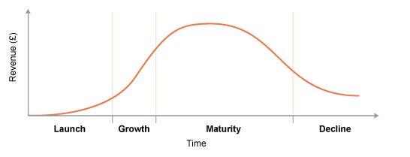

Figure 03: Product Line
In MeenaClicks, they always follows this products criteria which are actually used to their customers. Such as, groceries items,all types of vegetables,mens & women,fasion,baby item, electronics devices and accessories, home décor, home and life style,all kinds foods.

Price:
Meenabazar set their price as customer get it to the others shop.so price is very flexible to the customers. We also set some discount price that is very popular to our customer. Our regular member evaluation showed that our price is very flexible.so we set price for our customer.
Promotion: The third element of 7 ps is promotion.promotinal activities are very crucial for any company.meenabazar usually success in this case. There so many promotional activities have already taken to higher its selling.
Meenabazar use 4 type of promotion:
- Advertising.
- Sales Promotion.
- Personal Selling.
- Publicity.
In meenabazar they provide different type of promotional activates such as: Exclusive offer, winter offer, summer offer, Super Tuesday, and membership for customer by which they can get free offer and discount.
Place: Place convert to distribution or methods and location that is use for product or service will reached to the customers.we design our location as if our each and every target customer will get our products.meenabazar also concern for products supply chain management. To ensure fresh products to target customer meenabazar distribute its product to the potential location.
Meena clicks already planned for 106 hub for different places in Bangladesh. This hub will be cover 64 districts within 2027.
People:
People is another element of 7ps .in meenabazar ,We will have trained up our employees who will be appointed for customer services so that our customers can get a satisfactory behavior from us.

MeenClick is a sister concern of Gemcon group.so its each and every employee is very good enough. They always try to grow up this company. Their huge dedication will help to achieve their mission.
Process: Each food item will be expired in a certain time. At the last day of expiration, the company will provide fresh foods in its own vehicles. This is how the customers will get to know that we are offering them fresh foods after every unit ends.
When it comes to home delivery, we will not take any charge from theme if the delivery place is near to our outlets.
Meenabazar already achieved more than 50 % market share from their previous planning. From the process strategy it will be in the peak point in the future.
Physical Evidence: Physical proof alludes to everything your clients see while associating with your business. This incorporates: the physical condition where you give the item or administration. The format or inside plan.
Meena Bazar Decorate it’s each and every outlet with well physical evidence and their product category are also decorated by the same way.

3.5 Segmentation, Targeting, positioning (STP):

Segmentation: Segmentation is the process by which we can identify our customer into a group. Meenaclicks also maintain this segmentation strategy. They group their customer by the income indicator, they also segment their customer by, Age, Gender, Location, and geographical region.as well as they also focus on Psychographic segmentation, Behavioral segmentation.
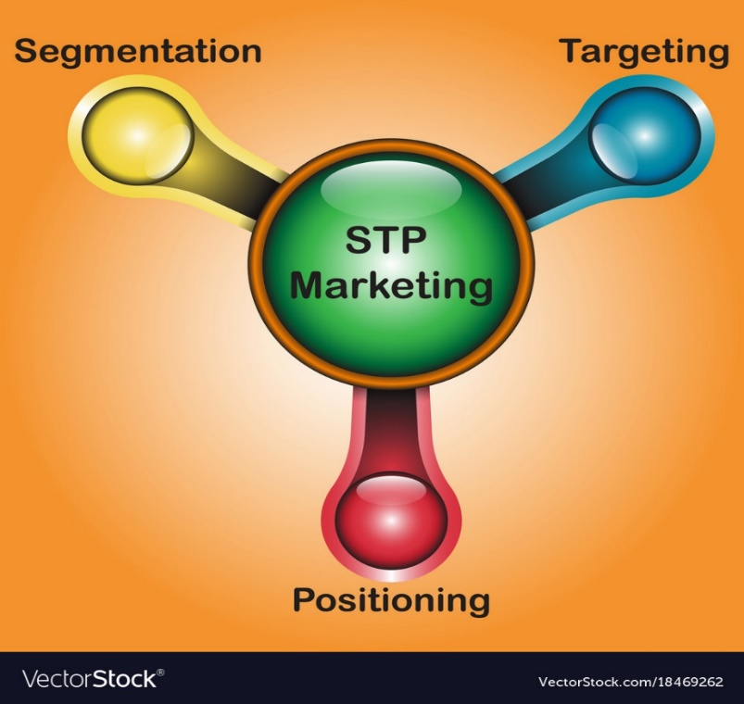
Targeting: targeting is the process by which organization create the smaller group from the segmentation group. Meenaclick target its customer into different type of group such as consumer market, industrial market, and reseller market and so on.
Positioning: positioning strategy is the process when company choose one or two essential key for the future concentration. MeenaClicks also positioned itself .and it will be the superior one after 10 years.

Figure 4: STP

3.6 SWOT Analysis

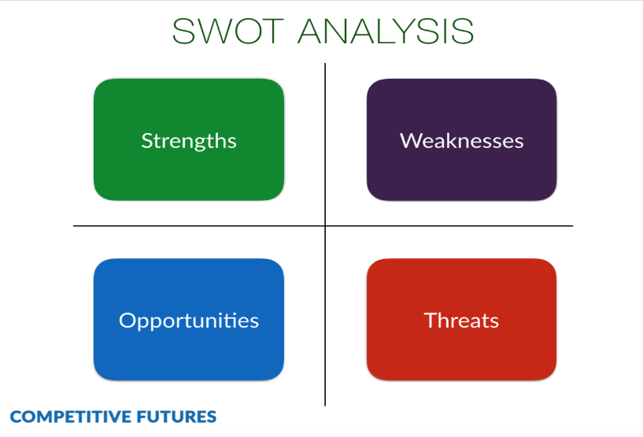
It essentially involves the organizations inside quality, shortcoming, outside circumstances and dangers too. SWOT examination gives an organization close of what they can really perform in future and how they can take an interest among their exhibited rivals. This examination will be incredibly useful and fundamental to perceive the current state of the organization

Figure 5: SOWT Analysis

Strength:
- Value and Own online website.
- Good quality products and all the food items are fresh and living.
- Outlet has good parking facilities and free home delivery service.
- Membership card facilities.
- Month end and festival offer.
- Skilled employees and trained workers.
We know Meena Bazar is a very much rumored super shop in our nation. Everybody realizes this name also. They likewise have an online site which name is "MeenaClick". Client can without much of a stretch request their item or nourishment from this site. Then again, they offer Participation card which is helpful for the clients since they get different kinds of offer or rebate from Meena Bazar.
Weakness:
- Only few outlets.
- Pricing strategy.
- Poor corporate social responsibility.
- Lack of e-commerce technology and process.
We know Meena bazar is a backup of Gemcon gathering and Gemcon gathering is a major organization in our nation. There is an enormous opening for work in this organization. Presently a day's "MeenaClcik" assumes a significant job in internet business area. Step by step their market development is expanding a direct result of their item quality and administrations too.

Opportunity:
- Availability of workforce
- Availability of raw material
- Online market growth
- Huge number of customers
- Increasing amount of non-food product.
We know Meena Bazar is an auxiliary of Gemcon gathering and Gemcon gathering is a major organization in our nation. There is an immense opening for work in this organization. Presently a day's "MeenaClcik" assumes a significant job in internet business division. Step by step their market development is expanding a direct result of their item quality and administrations also,

Threats:
- Increasing of new competitors
- Growing bargaining power.
- Rising commodity price.
- Political empower.
Presently a day's numerous E-web based business superstore are expanding in this part. What's more, they are the contenders of "MeenaClick". With the goal that the dealing intensity of client is developing. Then again, Meena Bazar can't open another outlet for political issue.

Chapter 04
Findings and Analysis of the Study

4. Findings and Analysis of the Study

4.1 Analysis:
At the point when I was doing my temporary position at Gemcon gathering (Meena Bazar) as an online business official, I broke down a portion of the variables of Meena Bazar. In any case, the most significant elements are recognized from the report dependent on the examination are as per the following:

4.1.1 Employee satisfaction or dissatisfaction:
There are relatively few workers in Internet business division of Meena Bazar. At the point when I chatted with the brand chief of Web based business, he revealed to me that he was not fulfilled for his work as a result of worker lack. Just couple of quantities of representatives are working here.

4.1.2 Outlet:
Despite the fact that Meena Bazar has numerous purchasers, yet their outlets are not many. They have no outlet outside Dhaka. They have just a single outlet outside Dhaka. In Dhaka city they have 17 outlets which are lacking for the client request.

4.1.3 Hub:
Meena clicks is growing day by day.Meena clicks is going to open 106 hub in Bangladesh.it will cover 64 districts. For this reason MeenaClicks research about its market and potential customers as well as location.
Hub Category: We divided our Hub into 4 category. This category are as follows.
Category | A | B | C | D
Numbers of Hub | 16 | 25 | 36 | 29
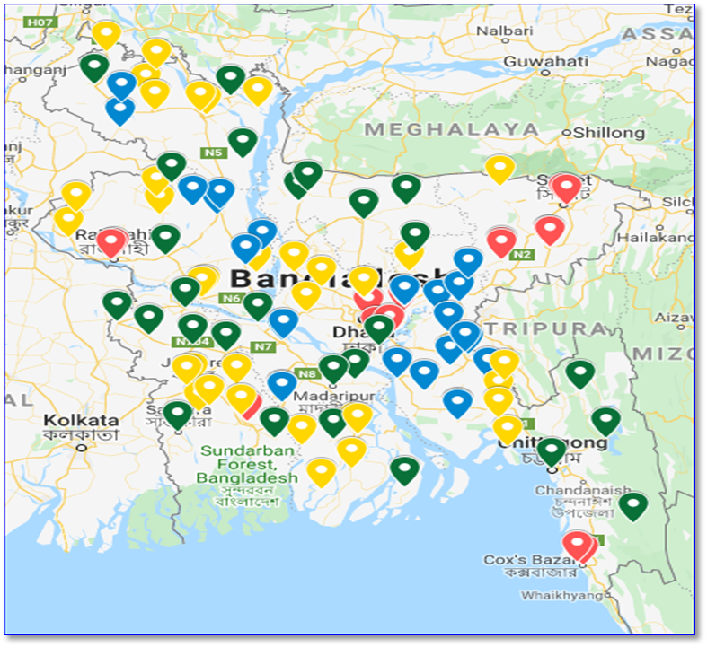
Location: The following location will cover within 2027 and 15 Hub will be completed in the years of 2020.
Figure 6: Map of Hub Location

4.1.4 Product Differentiation:
Meena Bazar has not so many brands for a similar product. They have only few known brands and rest of their own product that’s why customer is not able to get more products

4.1.5 Delivery and Man power Issue:
Conveyance and labor are the greatest issue for the "MeenaClcik". Here and there the Client doesn't get their item what they need. Since the conveyance items are not a similar quality which they advertised. They conveyed an inappropriate item to the client. Then again, at times the client gets harmed item from the conveyance young men. It happens when the separation is excessively long from the out late. Commonly, the client doesn't get their item in time. They get their item after lengthy timespan in light of the fact that the deficiency of labor. "MeenaClick" needs more staff to convey the item appropriately.

4.1.6 Customer demand:
Now and then the client doesn't get their item according to their interest. The store doesn't have the all item. The merchandise or items are not exactly their needs. Here and there they don't get what they need.

4.2 Findings:

- The employees of Meena Bazar are very much conscious about proving better service to the buyers.
- Meena Bazar is not among the first retail super shop in our country but also keeps the good position for customer satisfaction among the all superstores in Bangladesh
- Meena Bazar always provides good product and services to the buyers.
- In competitive market, customer loyalty is very essential, and Meena Bazar
- Always ensure about giving their customer loyalty. On the other hand, the important part is that the numbers of customers are satisfied with their offer.
- Most of the customers who regularly buy from Meena Bazar are happy by the goods and services provided by Meena Bazar.
- There are not many employees in E-commerce sector of Meena Bazar and their website is not update as well
- Their home delivery service was not good because of lack of communication, fake customer and sometimes customer mistakenly gives them wrong address.
- Sometimes products are not available in the outlet because of poor supply.
- Their riders are not expert in delivery.

4.2.1 Frequently Asked Questions and Answers:

1. Could you elaborate on what Meena Click does? What products does it specialize in, etc.
Meena Bazar is a well reputed retail supermarket chain in Bangladesh. It started its operation in 2002 and has completed a long journey of 15 years of operations. Meena Bazar runs outlets in Dhaka & Chittagong. It provides convenient shopping experience, friendly customer service. Meena Bazar is a subsidiary of Gemcon Group. Apart from the retail chain, Gemcon Group is involved in the production of organic products, dairy items, prepared food & herbal products.
Meena Click as the new enhanced online platform of Meena Bazar which has been launched this year. Meena Click is the platform from where customers can do their grocery shopping online. It is mainly an e-commerce website which specializes in groceries and personal care: this ranges from fresh fruit & veggies, meat, poultry & fish, grocery items, household and personal care choice.
2. What prompted the promoters of the company to launch Meena Click? What other countries is it present in and what other countries are on the cards?
The main concern was to provide a service which promoted the ease of online grocery shopping. Meena Bazar is the first retail store in Bangladesh to launch their own platform from where people can shop online, this platform is recognized as “Meena Click.” Meena Click is operating worldwide at present. Users can order from any part of the world and we will deliver them to Bangladesh. This is for the convenience of NRBs who would like to order online for delivering to their near ones residing in Bangladesh.
3. How would you define the online grocery market in Bangladesh? How big is the market? Who are the major players? What is Meena Click's market share?
The online grocery market is evolving and has yet to grow further. To avoid being stuck in traffic, people are now more into online shopping and delivery service. The market is huge but due to some technicalities, the entire grocery market is still struggling with the service being promised of. Yet the scopes are high and have been growing over time ever since.
Currently, Chaldal, Direct Fresh, are some of the major players other than Meena Click.
4. Could you provide some growth numbers of Meena Click? Monthly GMV, targeted GMV, etc
Since the launching of the e-commerce website, we have attained a double digit growth rate in sales and users on a monthly basis.
5. Any investors in the company? Details?
The investment is made by the board of Gemcon Group.
6. Have you been in touch with the online grocery players in the Indian ecosystem? Any plans to expand to India?
Currently, there is no plan as such. At present, our plan is to cater the local demand efficiently in Bangladesh.
7. What are the challenges in the ecosystem in Bangladesh?
The market is huge but due to some technicalities, the entire grocery market is still struggling with the service being promised of. People have been trying to get more engaged in the new e-commerce trend but when it comes to raw and fresh foods, people prefer wet market more than the images on the websites. Yet the scopes are high and have been growing over time ever since. We are aiming for the next generation to take over the decisions of household grocery shopping which has been gradually into effect now.

Chapter 05
Conclusion and Recommendations

Conclusion:

At long last, I need to state that "MeenaClick" has a major open door in the Web based business area. They should scan for the new probability in undiscovered market and development their activity in tapped commercial center. We know "Meenaclick" in an outstanding Web based business site in our nation and it is the online stage for Meena Bazar, is one among the biggest retail super shop in our nation. Meena Bazar super shop may be more prominent progressed by method for executing actualities time. It has thought to expand their business with the guide of structure a couple of various stores in various places in our nation where clients can purchase their item through web. Each store show should be actually better than affirm fantastic and fast office for the people will have delivery to get to the shop. "MeenaClick" keeps on being developing and it has immense chance to improve progressively more as they have possibilities. They need to verify that they convey the top of the line help of the purchaser. Purchasers have a few demands that the organizations need to do progress of time of the solicitation. Web based business has a tremendous open entryway in our nation. Web based business is a prosperous area in Bangladesh and my view acknowledge as valid with that "MeenaClick" will accomplish at the peak of the web item and administrations shipping business division very soon.

Recommendation:

Inside the creating subject of superstores in Bangladesh, mammoth components have been perceived. Among them, the most extreme basic components are right off the bat, the uncommon of items; besides, costs offered by the superstore; thirdly, the circulation channels utilized by the superstore and therefore the limited time endeavors. Meena Bazar is one of the capacity parts in this zone. In the view of different discoveries, following suggestion might be made;
- MeenaClick” might be focus on their delivery system which is not good at all.
They need more updated website and many delivery persons to ensure fast delivery service. They should more focus on their customer as well because customers are king of all businesses.
- They also need more employees in E-commerce because those who have not
enough for this sector. “MeenaClick” has huge number of potential customers and the employees cannot maintain them because of shortage.
- They should hire good expert rider for delivery purpose because most of their rider are not good or well experienced for product delivery.
- “MeenaClick” needs a potential team for operational activities because they
Can work efficiently. A potential operations team can easily manage all the activities which is important for E-commerce sector.
- Meena Bazar has only 18 outlets in Bangladesh which is not enough for their
Customer. They should open more outlets in Dhaka and outside of Dhaka as well.
- Meena Bazar should give more offers for their buyers because they are not happy for their promotional offer. They should promote their product more on social media and invest in promotional offer which will attract to the customer

References:

Bappy, A. R. (2015, April 05). E-commerce business opportunities and challenges in Bangladesh. Retrieved may 5, 2019, fromhttp://dspace.bracu.ac.bd/xmlui/bitstream/handle/10361/10148/16164015_MBA .
pdf?sequence=1&isAllowed=y group, g. (n.d.). Retrieved May 5, 2019, from https://gemcongroup.com/

Islam, A. (2016, December 14). Customer Satisfaction of Gemcon Group: Retrieved April 04, 2019, from http://dspace.bracu.ac.bd/xmlui/bitstream/handle/10361/8437/14164076_MBA. p df?sequence=1&isAllowed=y\

Pratap, A. (2018, October 08). Five Forces Analysis of the Ecommerce Industry. Retrieved May 5, 2019, from https://notesmatic.com/2017/11/five-forces- analysis-ecommerce-industry/

vishnoi, L. (2019, April 15). 10 Problems That Every E-commerce Faces and Their Solutions 2019. Retrieved April 04, 2019, from https://acquire.io/blog/problems- solutions-ecommerce-face

