Analysis of Apptriangle Limited and
Software Industry

Himely Hafiz Pushpo

This report is submitted to the school of Business and Economics, United International University as a partial requirement for the degree fulfillment of Bachelor of Business Administration

Analysis of Apptriangle Limited and Software Industry

Submitted to:
Dr. Seyama Sultana
Associate Professor
Department of Marketing
School of Business and Economics
United International University

Submitted by:
Himely Hafiz Pushpo
111163112
Marketing
Trimester: 14

School of Business and Economics
go
United international university

Date of submission: June 26, 2022

Letter of transmittal

June 26, 2022

Seyama Sultana, Ph.D.
Associate Professor
United International University

Subject: Submission of an Internship Report on “Analysis of Apptriangle and Software Industry”

Dear Madam,
It is with great delight that I offer you with my report entitled "Analysis of Apptriangle and Antivirus Software Industry in Bangladesh" which you have assigned to me. I'd want to express my gratitude for your assistance and support in drafting the report.
I did my best to complete the report with all the essential information and recommendations. I've tried every conceivable method to finish the report. I'm hoping that this report will live up to the hype.
Please reach me if you have any difficulties reading any portion of my report or require any support, Himely Hafiz Pushpo (Cellphone Number: 01751306201, Email: hpushpo163112@bba.uiu.ac.bd).

Yours sincerely,


Himely Hafiz Pushpo
111 163 112
School of Business and Economics
United International University

Certification of similarity index

Declaration of the student

I, Himely Hafiz Pushpo, hereby certify that the internship report titled "Analysis of Apptriangle and Software Industry" is entirely established on the information and activities of Apptriangle, a reputable Bangladeshi IT organization. It is a one-of-a-kind product that I created after three months of labor in Apptriangle.
I further affirm that the report was written only for the purpose of meeting my academic requirements and not for any other reason. It is not permitted to be employed in the favor of the organization's adversary.



Himely Hafiz Pushpo
111 163 112
BBA
(Major in Marketing)

Acknowledgement

First, I would like to express my gratitude to The Almighty Allah for enabling me to complete this report entitled “Analysis of Apptriangle and Antivirus Software Industry of Bangladesh”.
I would like to thank Dr. Seyama Sultana from the United International University in Dhaka's School of Business and Economics for his feedback and opinions, motivation, and participation throughout the work.
Throughout my internship, I was lucky to receive assistance and participation in the creation of this report. I'd want to express my appreciation to Mr. Ali Mortuza Bilash, Director, Apptriangle, for patiently teaching me about all elements of IT and encouraging me along the way. Mr. Moshiur Rahman, Director, Apptriangle, has mentored and assisted me in knowing about the IT support service sector, which was a completely new world to me. Mr. Minhazul Alam, Apptriangle's Technical Specialist, has taught me the ins and outs of technical support firsthand, and I'd want to convey my deepest appreciation.
I'd also want to express my gratitude to my Apptriangle coworkers for their help and guidance throughout my internship. I was able to create a thorough report thanks to their continuous and helpful remarks. Their suggestions will be incredibly useful to me in my future career.

Executive summary

Technology service provider Apptriangle is known as an IT enterprise in the IT sector. Although Apptriangle began its journey in 2017, its full operations didn't begin until May 2020. In the initial stage, only foreign organizations' support services were addressed. It was the sole alternative accessible during the COVID-19 shutdown since the work could be done remotely. Following August 2020, it expanded its operations into Bangladesh's domestic market and provided Microsoft services, antivirus software, cloud computing, software development, and SSL certificates.

A newcomer in the IT industry is called Apptriangle. Unlike their rivals, they have been in the business for three years. I received an internship from this company, which I successfully completed. My own personal experiences and the collection of documents from this firm served as the sole sources of data for this study.
Finding out about Apptriangle's performance and expansion is the report's main goal. The numerous components of an IT business are thematically examined in this paper. Additionally, we conducted a growth study that considered sales, profits, the number of clients, the number of staff, and the cost of acquiring new customers.
As I concentrate on the sales, I'll concentrate on how I've earned a client's confidence and how I market the items.

Table of contents for Internship
Table of Contents
Letter of transmittal 3
Certification of similarity index 4
Declaration of the student 5
Acknowledgement 6
Executive summary 7
Table of contents for Internship 8
List of Figures 10
CHAPTER I: INTRODUCTION 11
1.1 Background of the Report 11
1.2 Objectives of the Report 11
1.3 Motivation of the Report 12
1.4 Scope and Limitation of the Report 12
CHAPTER II: COMPANY AND INDUSTRY PREVIEW 13
2.1 Company Analysis 13
2.1.1 Overview and History 13
2.1.3 Customer Mix 14
2.1.4 Product & Services Mix 15
2.1.5 Operations 16
2.1.6 SWOT Analysis 16
2.2 Industry Analysis 17
2.2.1 Specification of the Industry 17
2.2.2 Size, Trend, and Maturity of the Industry 17
2.2.3 External Economic Factors 18
2.2.4 Technological Factors 18
2.2.5 Barriers to Entry 18
2.2.6 Supplier Power 19
2.2.7 Buyer Power 19
2.2.8 Threat of Substitutes 20
2.2.9 Industry Rivalry 20
CHAPTER IV: INTERNSHIP EXPERIECNE 21
4.1 Position, Duties, and Responsibilities 21
4.2 Training 21
4.3 Contribution to Departmental Functions 21
4.4 Evaluation 22
4.5 Skills Applied 22
4.6 New Skills Developed 22
4.7 Application of Academic Knowledge 22
CHAPTER V: CONCLUSIONS AND KEY FACTS 23
5.1 Recommendations for Improving Departmental Operations 23
5.2 Key Understanding 23
5.3 Conclusion 24
Reference 25

List of Figures

Figure 1: Support Service Areas | Page 15
Figure 2: Offerings | Page 15
Figure 3: SWOT Analysis | Page 16

CHAPTER I: INTRODUCTION

1.1 Background of the Report
This report provides in-depth details on an IT firm. Apptriangle is the company I'll be talking about in this paper. The internship program at Apptriangle is now over. The internship lasted three months, from September 1, 2021, to December 10, 2021. This study is primarily based on my actual experience and direct information obtained while working at this business. I developed an awareness of the procedures and operations used in the IT sector by planning few events, displays, and fairs.
The report titled “Analysis of Apptriangle and Antivirus Software Industry of Bangladesh” has been prepared as a course requirement of the Bachelor of Business Administration Program, School of Business and Economics, United International University.
Ali Mortuza Bilash, Moshiur Rahman, and Rana Mustafiz founded the technology solution provider Apptriangle in 2017. The first goal was to offer superior services based on experience and knowledge to become a leader in the IT industry. Following that, Apptriangle saw a good market reaction that significantly above expectations as time went on. Then, Apptriangle expanded its offerings to include software development, a ready-to-eat meal delivery service for corporations, and other services. They want to maintain the positive momentum and advancement that have been made so far to guarantee our continued existence.

1.2 Objectives of the Report
The primary goal of the study is to analyze and assess the software industry and the business "Apptriangle." This study's goal is to look on few different facets of the promotion of antivirus software. The report helped in my professional growth by teaching me about a unique characteristic of the antivirus software industry.

1.3 Motivation of the Report

I am interested in an internship with Apptriangle Limited because their company constantly exceeds expectations in the Software Industry in Bangladesh, especially with email security & antivirus. I'm confident that the internship with Apptriangle Limited allow me to use my knowledge of marketing to know more about how marketing software industry is growing.

1.4 Scope and Limitation of the Report
This report has given me the opportunity to gain a better knowledge and study of Apptriangle and antivirus software industry of Bangladesh and the marketing department (Sales). This report examines all the elements that contribute to Apptriangle's success and growth in the industry. In this report, the features of an IT business are conceptually explored.
There are various drawbacks to the study:
• The most significant restriction is time. Longer study may have yielded more significant results.
• Lack of reliable data on Bangladeshi IT businesses
• A new field for the researcher to investigate.
• There are insufficient data on the market size and share.

CHAPTER II: COMPANY AND INDUSTRY PREVIEW

2.1 Company Analysis

2.1.1 Overview and History
Apptriangle is a new startup company established in May 2020. It is an IT firm which operates in and under IT industry of Bangladesh. As we know, the IT industry is quite new comparing to other industries of Bangladesh. But the sector is booming and has a tremendous growth rate since all organizations are accepting the benefits and advantages of being digitalized. Also, our government is pushing the industry hard and has a vision to make the whole country digitalized which eventually fueling the market to flourish.
Apptriangle has two branches of it. One is here in Bangladesh and another one is Australia. At the first phase, it started the journey in the global market as a support service provider. Initially, it was the primary business of Apptriangle. Apptriangle used to have different offerings like- Service Level Agreement (SLA), Manage Service & On Demand Support Service. These supports services are performed remotely by our certified Level-2 engineers.
During the COVID- 19 pandemic and lockdown in Bangladesh, Apptriangle could not go further. However, the withdrawal of lockdown by the Government opened the window for Apptriangle. The directors decided to expand the business into the local market. First, 2-3 months were very crucial as the name was new among the clients. Also, as a new vendor, Apptriangle was struggling to build trust and confidence. We do heavy branding just to make sure clients know the name and the expertise that we hold. We started to promote ourselves on different social media platforms like- Linkedin, YouTube & Facebook. Then, we started email clientele and physical visits. In that procedure, we also did telephone marketing to introduce Apptriangle.
Sometimes clients started to know about us and recognize us an expert and experienced vendor. Along with previously mentioned support service, Apptriangle now offers Microsoft services, Antiviruses, Training Programs for professionals, SSL (Secure Sockets Layer), Software Development and Website Building. In last few months, it has gained confidence of many governments and private organizations served by Apptriangle.

2.1.2 Trend and Growth
“Our plan is to transform into a high-tech nation. We have plan for the industries and sectors which is still not open to digital transformation. It is our highest priority to introduce digital apps for the naïve sectors which is not still a very technology driven industry. We will make sure that every manual process used today will be replaced with a digital platform to run on. Apptriangle has different missions set to achieve the goal. Our missions are-
- To authorize our clients, community, and partners with best of services and products
- To alleviate struggles and rehabilitate comfort with technology.
- To build a High-Tech Nation to Provide Global Technology Service.

2.1.3 Customer Mix
As the motive is to reach every corner of Bangladesh with Technology service, we have already acquired confidence and trust of some renowned organizations in both public & private sectors.
Some of our valuable customers are-
- Drik Trust
- Studio Mason
- Anwar Group
- Pandekar Energy
- Fair Distribution Limited
- Sonali Life Insurance Limited
- Pakija Technovation Limited
- Rupali Insurance Company Limited
- Bangladesh University of Engineering & Technology (BUET)

2.1.4 Product & Services Mix

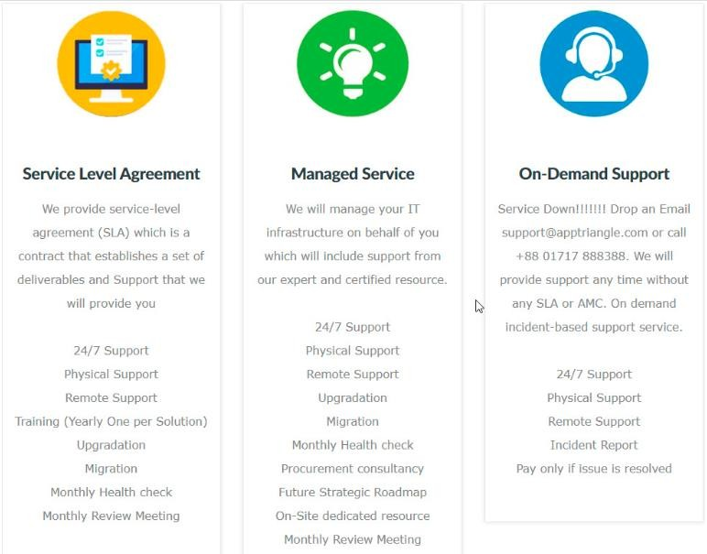

Figure 1: Support Service Areas

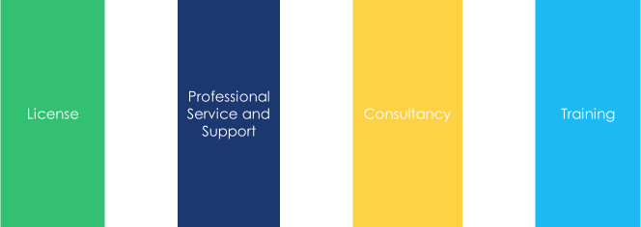
Figure 2: Offerings

2.1.5 Operations

Apptriangle is a service-based, it has Microsoft certified level ll system engineers that address technological problems for various businesses employing Microsoft services. We learn about these multinational corporations and their problems from this. Using this relationship, Apptriangle persuaded them to sign SLA (service level agreements) and on-demand support services agreements, as part of which Apptriangle will provide IT services remotely as needed for a certain period. In this manner, Apptriangle began its commercial venture with clients from all around the world before expanding into the regional market. Therefore, Apptriangle's key strength is its global presence, which maintains it one step ahead of other businesses.

2.1.6 SWOT Analysis
SWOT analysis combines the strengths, weaknesses, opportunities, and threats that an organization faces. The internal elements of an organization are the strengths and weaknesses, while the exterior portions are the opportunities and dangers. This is one of the most widely utilized tools for creating business suggestions and plans throughout the world. It also offers us a clear picture of the company's status.
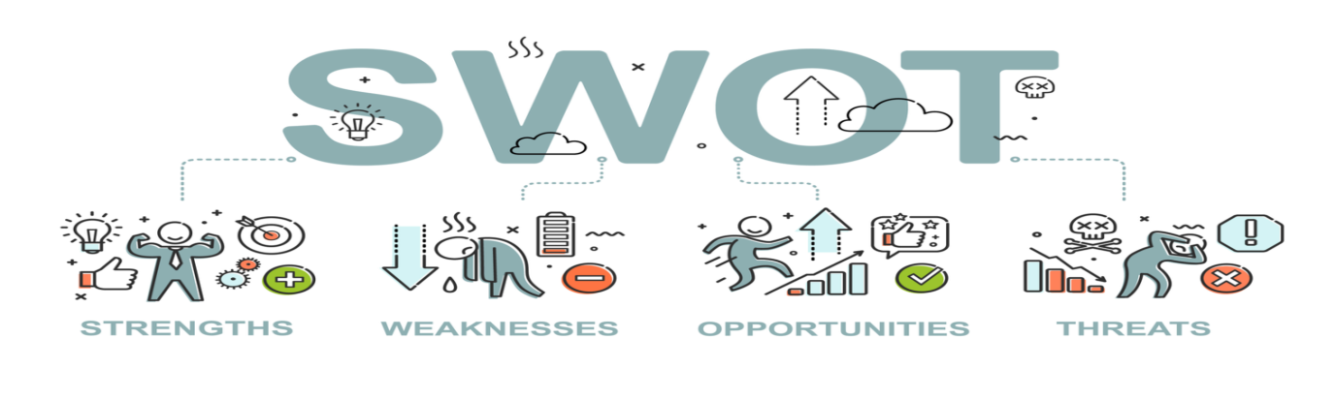
Figure 3: SWOT Analysis
Here, in this SWOT analysis section the primary objective of mine is to associate Apptriangle in developing a full awareness of all the factors to make critical business decisions.

2.2 Industry Analysis

2.2.1 Specification of the Industry
The past several decades has seen a newly announced in this area, leading to the current results. Such an improvement, which was first extremely unfavorable, gives it maturity. However, given how much it contributes to the national economy, it can no longer be disregarded or avoided. It is expanding work opportunities daily and helping to solve the young graduate’s unemployment issues. The way to succeed in a software development firm is to enhance the software process to achieve high quality. In compared to other nations, Bangladeshi software companies have not had significant expertise in this specific field. Business development refers to the ideas, initiatives, and practices that contribute to an organization's successful growth. This involves increasing sales, diversifying the firm, forming strategic alliances to increase profitability, and making wise business decisions.

2.2.2 Size, Trend, and Maturity of the Industry
Business development refers to a broad number of ideas, strategies, and projects that an organization's owner and management implement to strengthen the business. Increased profitability, business expansion, alliance formation, and sales growth are a few examples of business development objectives. Sales, marketing, production, human resources, accounting, finance, product development, and inventory management are just a few of the departments in a company that are impacted by successful business growth. Business strategists should be familiar with the company's present revenue streams as well as emerging market opportunities, expansion prospects, and competition developments. Sales, marketing, project management, product management, and contract management are just few of the industries that promote company growth. Additionally, there is a lot of alliance-building, bargaining, networking, and money-saving efforts. All these many divisions and functions are guided and coordinated by the company's growing goals.

2.2.3 External Economic Factors
Software is lot more than just the computer you use at work. Apps are software. Data is software. Cloud computing is software. Every industry experience growth and technological advances thanks to it. Lot of Americans and American companies are empowered by software, which daily enhances our lives in both significant and subtle ways. The significant, positive influence software has on our country's economy each year comes along with all this advancement. Software gives jobs for a wide array of specialists in today's workplaces, from software engineers and web designers to futurists, project coordinators, administrative assistants, and accountants. These figures include both employments directly supported by the software sector and jobs it directly supports through indirect and induced effects.

2.2.4 Technological Factors
The software industry is dynamic and evolving quickly. The knowledge workers use computers to communicate and try to simulate a real-world event in abstract computer software. The advancement of software technology, new hardware, and other process techniques do not make this procedure any simpler. Today's software developers must be able to understand and apply new technologies. The core values held by employees are reflected in an organization's culture.

2.2.5 Barriers to Entry
The barriers to entry in the software industry have multiple components:
- Financing the initial development of the program without any incoming income to offset the expenses.
- An established company that can assist you in fast developing your product so that you always have a competitive offering pairing certain products with others. How various Maps or search engines are embedded into apps and operating systems as default.
- Network or scalability may be even more crucial for software components (messaging apps, social media, or search engines).
- This does not imply, however, that the software industry cannot be overtaken or disrupted, as has happened several times with other current firms.

2.2.6 Supplier Power
- Strong Technical Partnership
Apptriangle is in official partnership with Microsoft, Kaspersky, Trend Micro, Amazon Web Service, and other global technology service providers which give them competitive advantages.
- Experience Workforce
It has certified Microsoft Level-2 engineers with over 8 years of experience in this field that ensures the best of support services to the clients.
- Diversification
Apptriangle has different business wings like software firm, Meal365 (food delivery service) to support the main business and gain customer’s confidence.

2.2.7 Buyer Power
Because Apptriangle is a service-based nation, it has Microsoft certified level ll system engineers that address technological problems for various businesses employing Microsoft services. We learn about these multinational corporations and their problems from this. Using this relationship, Apptriangle persuaded them to sign SLA (service level agreements) and on-demand support services agreements, as part of which Apptriangle will provide IT services remotely as needed for a certain period. In this manner, Apptriangle began its commercial venture with clients from all around the world before expanding into the regional market. Therefore, Apptriangle's key strength is its global presence, which maintains it one step ahead of other businesses.

2.2.8 Threat of Substitutes
Growing Competition
India, China, and Sri Lanka, three neighboring states, are making significant investments in this expanding industry. As a result, their IT-related businesses have an edge in the international market, but Bangladeshi businesses struggle to compete and capture sufficient market share.
World-wide Competition
The location or distance does not worry us anymore because the world is digital, and the limits cannot restrict our ability to interact with the outside world. Therefore, the market is also unconstrained by a particular region. As a result, the competition landscape has significantly expanded for all enterprises operating in the IT sector.
Entering of Giant Groups
The IT business is currently receiving a lot of attention from large corporate groupings, who view it as a field with exciting potential and growth. Due to increased competition, various unethical tactics are used to gain market share.

2.2.9 Industry Rivalry
Industry rivalry commonly presents as fight for power and the use of diverse strategies (for example, price competition, advertising battles, product introductions). When businesses experience competitive pressure or sense a chance to strengthen their position, this competition frequently becomes more heated. In most sectors, a company's competitive actions will be felt by the competitors, which will subsequently take action to counter those efforts. Due to the interdependence of businesses, the industry might be harmed by the pattern of action and reaction.

CHAPTER IV: INTERNSHIP EXPERIECNE

4.1 Position, Duties, and Responsibilities

Business Development Department has a variety of tasks to do due to a shortage of human resources. As follows:

• Marketing: To reach our target clientele, my team and I devised and implemented marketing tactics.

• Sales: We play a crucial part in representing Apptriangle by marketing technological services.

• Finance: We track transactions, analyze our financial performance, and deal with exchange rates.

4.2 Training

To adjust to new industry, I did receive courses in Microsoft and other similar topics. To understand more about the product offered by my organization in details, I take courses relevant to Microsoft and cyber security.

4.3 Contribution to Departmental Functions
An internship is necessary to finish the BBA program. Additionally, a temporary job gives an intern the chance to get experience in a professional setting. It is a period when an intern may understand and learn how to function as an assistant. I've been able to apply my abilities effectively as a result. I got the chance to take part in a range of tasks as an intern.

4.4 Evaluation
In my review of my "3 Month Internship," I must admit that working with Apptriangle was an amazing experience, and I am speechless in my appreciation. I really enjoyed working on a range of tasks. I will always be grateful to Apptriangle for giving me such amazing opportunities. The entire three-month study time was quite hectic, and every day I learnt something new and important. The work I put in over the course of these three months at each employment was incredibly worthwhile. My supervisors provided excellent oversight; they were very encouraging and did not hesitate to help me learn new things, exchange expertise with me, and schedule meetings with me.

4.5 Skills Applied
- I found it easy to create daily reports because to my familiarity with Microsoft Word, PowerPoint, Excel, and few other tools.
- During a field trip to an unfamiliar location for me, my resilience skills came in helpful, but I managed it well.

4.6 New Skills Developed
To adapt to the new industry, I did receive training in Microsoft and other similar topics. To understand more about the product offered by my employer in depth, I take courses linked to Microsoft and cyber security.

4.7 Application of Academic Knowledge

Because of my educational background, I became very punctual both at work and in my studies after I discovered how important it is to maintain track of time when working. During my market visit, I also used my marketing expertise and knowledge of creating customer value in marketing to the Apptriangle's sales approach.

CHAPTER V: CONCLUSIONS AND KEY FACTS

5.1 Recommendations for Improving Departmental Operations

To improve their performance and growth, Apptriangle must make the necessary adjustments as soon as possible. Because Apptriangle is enrich with technological resources and supported by a global technical support network, it has a promising future. Along with making changes, it is important to maintain the parts that are currently functioning well in order to be sustainable over time.
Apptriangle is unable to effectively distribute the whole number of tasks among several departments. There are now too few departments—only two. Certainty several duties, it is nearly given that an employee's true productivity and creativity would decline.
They need more staff members. Their commercial scope is bound by the minimal resources they have. They now employ three engineers, and while they are working on a project, they are limited for a few days to weeks. They are now unable to accept any new projects. Potential business is lost as a result.

5.2 Key Understanding

Information systems and marketing tactics should be employed more effectively in the future for improvement. Strong and regular advertising is occasionally required to increase brand value among client groups, but they have not seen any recent action from them. They will need expert guidance and thorough planning for a better result.

5.3 Conclusion
This is the ideal time for Apptriangle to focus on developing a strong brand image because they are a new company on the market. The effective use of marketing and communication channels is essential for this goal. To ensure that workers can utilize their maximum ability in manufacturing, it is also necessary to vary job duties and departments.
This report's primary goal is to discuss the Bangladeshi antivirus software and apptriangle industries. Along with this, I have also highlighted all the procedures, partners, and sectors linked to company development. Along with my work experience and lessons I have learned, I have also talked about how the customers are given items and training.
To get more coverage in Bangladesh, the company can keep its expertise element while putting more emphasis on other factors like reputation, communication, and promotion. To attract more consumers, the company may now give priority to these elements.

Reference

Apptriangle. (n.d.). Apptriangle. Retrieved from Apptriangle: http://www.apptriangle.com/
Indeed Editorial Team. (2021, June 10). How To Build Business Development Skills. Retrieved from Indeed: https://www.indeed.com/career-advice/career-development/business-development-skills
Lee Frederiksen, P. (2021, April 12). Business Development Strategy: A High-Growth Approach. Retrieved from Hinge: https://hingemarketing.com/blog/story/business-development-strategy-a-high-growth-approach
Seth, S. (2020, September 2). Business Development: The Basics. Retrieved from Investopedia: https://www.investopedia.com/articles/personal-finance/090815/basics-business-development.asp

