


“An internship report on SWOT analysis of Inpace Management Services Limited”
Prepared For
Dr. Khandoker Mahmudur Rahman
Associate Professor &
Director, BBA Program
School of Business & Economics
United International University (UIU)
Prepared By
Saju Ahmed
ID - 111 142 231
School of Business & Economics
United International University
17th August, 2019

Letter of Transmittal
17th August, 2019

Dr. Khandoker Mahmudur Rahman
Associate Professor &
Director, BBA Program
School of Business and Economics
United International University
Subject: Submission of the Internship Report
Dear Sir:
I would like to submit my internship report titled “SWOT analysis of Inpace management services ltd”, which has been prepared as a requirement for the completion of the BBA Program of United International University.
While working on the report, I have tried to follow each and every guideline that you have advised. It has been a very enlightening experience to work in this new venture and I have thoroughly enjoyed my internship period at Inpace. The authority of Inpace has also extended their cooperation whenever required.
Sincerely,
Saju Ahmed
ID No: 111 142 231
ACKNOWLEDGEMENT
I would like to thank the internship Supervisor, Dr. Khandoker Mahmudur Rahman who has helped me in every step of my internship. I am very much grateful to on-site supervisor Mr. Masum Ahmed for giving me the opportunity to complete my internship at Inpace.. I am sure that their dynamic managerial activities will give inspiration to anybody to build one’s career properly.
I also want to thank all the team members at the client service department and the marketing department at Inpace, for their support that I have been provided for preparing my report. I practically work with them, try to share their perception, feelings and on the basis of my realization, I prepared report from my own point of view. Then at last I shall be grateful to those people who read this report and who shall get benefit from this report at present and in future.

DECLARATION

I am Saju Ahmed, student of School of Business and Economic (Marketing) of United International University, Bangladesh, do hereby declare that the internship Repot on “SWOT analysis of “Inpace management services ltd.” is an original work and has not been previously submitted for any degree, diploma, title, or recognition.

________________
Saju Ahmed
ID No: 111 142 231
School of Business and Economics
United International University

Table of Contents
Executive Summery………………………………...…………………………………………… X
1 BACKGROUND OF THE REPORT 1
1.1 Introduction 1
1.2 Topic of the report 2
1.3 Origin of the report 2
1.4 Background of the Report 2
1.5 Objective of the Report 3
1.5.1 General objective 3
1.5.2 Broad Objective 3
1.5.3 Specific Objective 4
1.6 Scope of the report 4
1.7 Methodology of the report 4
1.7.1 Primary sources 5
1.7.2 Secondary sources 5
1.8 Limitation 5
2 ORGANIZATION PART 6
2.1 Overview of the Organization 6
2.1.1 Vision 7
2.1.2 Mission 7
2.1.3 Organizational goal 7
2.2 Organogram 8
2.3 Portfolio 9
2.3.1 Event management 10
2.3.2 Brand management 11
2.3.3 Youth Marketing 11
2.3.4 Print media advertisement 12
2.3.5 Promotion 12
2.3.6 Entertainment Marketing 13
2.3.7 Digital Marketing 14
2.3.8 Web design 14
2.4 Clients Of Inpace Management Services Ltd. 15
2.4.1 EPSON 16
2.4.2 DELL 16
2.4.3 Lenevo 17
2.4.4 Cisco 17
3 Project Part 18
3.1 SWOT analysis of Inpace Management Services Ltd. 18
3.1.1 Strengths 19
3.1.2 Weakness 22
3.1.3 Opportunities 23
3.1.4 Threats 24
4 Findings 27
4.1 Market Condition of agencies 27
4.2 EPSON Branding 28
4.3 Payroll Management: 30
4.4 Attendance Management 30
4.5 Shift Management 31
4.6 Leave Management 31
4.7 When IMSL Works for a client? 31
4.8 Working process between client and IMSL 32
4.8.1 Clients Problem 32
4.8.2 Internal Briefing by Account executive 32
4.8.3 Conducting Research 33
4.8.4 Planning the campaign 33
4.8.5 Reaching presentation 34
4.8.6 Final Approval Presentation (Client’s presentation) 34
4.8.7 Censorship certificate 34
4.8.8 Producing the advert(s) 34
4.8.9 The campaign appears 35
4.8.10 Controlling 35
5 Recommendation 36
5.1 Conclusion 38
6 Appendix: 39

Table of Figures
Figure 1 Inpace Management Organogram 7
Figure 2 Portfolio Of Inpace Mangement 8
Figure 3 Some Of Inpace Clients 13
Figure 4 Promotional Campaign of Dell 14
Figure 5 SWOT Analysis Of Inpace Management 17
Figure 6 One of IMSL’s strength 18
Figure 7 Clients do business on due 22
Figure 8 Market Condition of Agencies 23
Figure 9 EPSON shop Branding 24
Figure 10 Payroll Mangement 25

Executive Summary

Inpace management services is one of the leading event management firm in Bangladesh. It has been operating in the market for more than a 20 years. Inpace is basically an organization focused on IT industry. It has been working the international giants for a long time. Their major activities are branding and advertising. They brand different brands through different activities like promotional campaign, road show and organizing corporate events. They sometimes work for merger and partnering. They have been ruling the event management industry for a decade.
The report is the evaluated result of the Inpace management’s overall condition. Inpace has strong market growth and a good reputation among industry, still they have to face some problem though it’s a nature of business. So inpace has enough solution to overcome those problem. On the other hand they have expanded it market by entering into the consumer market. Inpace always coped up by following the market’s business trend. They kept upgrading their services and created opportunities for their future business. They also have created other department to expand their services like digital marketing.
Inpace has a dedicated department for some of their core clients, they have number of department working together to achieve the organizations goal. Among them the major department is client service department. This department has various types of work to do, and their work is complex too. I was under the client service department and I got to learn the actual work of clients’ service department. Under the client service department there are 4 other each department has three or four employees. Each of the department works day and night to satisfy its client.
There are some very important issues and information that I have learned about during the internship period. I could not share those issues and information because of being too much confidential. However I have tried my best to work with all the important activities and to provide all the valid and legal information in the report.

BACKGROUND OF THE REPORT

Introduction
Bangladesh has ranked to developing country in this year and this achievement has opened this possibility of economic growth as well as improvement of every business industry. In 21st century, it’s an era of technology and innovation. Everything is changing so rapidly, and the industries also changing. Many things become possible now only because of the help of technology and innovation. Inpace management always been the different and creative agency among all. It has choosen to work with IT industry, and has been working with the international IT giants for a long time. They choose IT industry just not because it is profitable industry, a company can make profit from any industry if it has that capabilities and resources. Inpace management choose the industry to make Bangladesh more technologically innovative giving the phrase, ‘Digital Bangladesh’ it’s worth.
Inpace Management is meaning to satisfy the expanding need of integrated marketing support, promotions and PR activity of IT based companies in Bangladesh. Inpace management guarantees most solid and imaginative accomplice in promoting, providing the best estimation of value to the customer. Created showcase correspondence with expert brilliance, quality administration by differing conscious inventiveness to the customer.
The primary administrations that Inpace management is eminent for: Management Consulting, Human Resource Management, Event Management, Computer Graphics and DTP, Market Communication, Brand Management, Media Consultancy and administrations, Public Relations and Corporate Promotions. Business Advertising is a strategy for showcasing correspondence used to motivate, empower, or impact a crowd of people to make or keep on taking some move.
Most usually, the favored outcome is to drive consumers conduct as for a business proposing. Promoting is the non-individual correspondence of data typically made up for and generally convincing in nature about items, administrations or thoughts by distinguished backers through the various media. Publicizing is generally done by an outsider known as advertising agency. An advertising agency is an administration based business focused on creation, creation, forecasting, and control advertising for its customers.

Topic of the report
In order to prepare a report to complete my internship program, I have to select a topic which is relevant. So I chose “SWOT analysis of Inpace management service limited” which is most relevant topic to my internship program because it summarize the whole Inpace’s condition.

Origin of the report
This report will the evidence that I have utilized my educational information which I can put to use in the genuine business world. Possibly having a degree isn't sufficient on the off chance that I can't put it any utilization for the advancement of the financial world. This report shows that although Inpace has a good reputation in market still it has to face many threats form the various parties because of some weakness. And they are not only overcoming the threats but also creating new opportunities for their future business.

Background of the Report
I got to work with Inpace company’s employees for the purpose of my undergraduate’s last course. The course was for three month means I got to work there as an internee for three month. In these 3 months I got to learn many things about the corporate world. I saw the internal process of an organization. Learn from the supervisor, employees who’s working there. I experienced and learn to know about corporate events, promotional campaign and so on, So this report would be based on- SWOT analysis of Inpace management services ltd.

Objective of the Report
Internship program is a realistic course, here we got to learn everything practically. The internship program provides me the following things.

General objective
The general target of this study is to finish the report. Clearly, the report would lead us towards what data we need from the market. In this way, it is significant for us to have goals of our own to complete the report.
- To know and learn how the corporate world runs and how to cope up.
- To know how agency run their business and learn their activities.
- Gather experience for the future job.

Broad Objective
- To have an overview of the whole organization of Inpace.
- To meet academic requirements.
- To prepare my internship report.

Specific Objective
- To identify the Strength, weakness, opportunities and threats of Inpace.
- To know about the practices of clients service department of Inpace.
- To bring out the indicators of successful promotional campaigns.

Scope of the report
During the whole internship program, it was a great learning to know how client’s service department runs. This report will give the clear idea about the activities of client service department. From planning to execution every steps are explains in this report clearly. Client service has to do variety of task, all most everything is related to client service department in event management firm. This report explains how a promotional campaign planned, designed and executed. How an advertisement is made based on clients requirement and the procedure of advertisement publishing. How top level to logistic team work for the organization is clearly explains in the report.

Methodology of the report

The study is distinct in nature and contains the information which have been gotten from Inpace during the internship program. The explanation behind leading this investigation is to give an outline of Inpace’s client service department and the apparatuses utilized by them to achieve business procedures. It brings about favoring subjective methodology generally. The essential information utilized in this examination are required to comprehend the key elements and markers of event management. What's more, the optional information are displayed through various tables, figures and charts.

Primary sources
- Various promotional campaign and corporate event.
- The managers of clients service department.
- Face to face conversation with different clients.
- Direct observations
- Supervisor, colleagues.

Secondary sources
- Official website of Inpace.
- Reports of the employees started working there as an intern.
- Various online journals.

Limitation
Limitations had to face to prepare the report:
- Limitation of time for preparing the report.
- Unable to access the confidential data.
- The unavailability of related information and data.
- Unable to collect data as intern.

ORGANIZATION PART

Overview of the Organization
Inpace Management Services Limited is one of the leading Marketing agencies in Bangladesh. IMSL is an organization that works with tech products concerned with making life easier. It is an international organization originated in 1997. The reason behind establishing this was making Bangladesh more technologically innovative giving the phrase, ‘Digital Bangladesh’ its worth.
Inpace management services Bangladesh, situated at Concord Tower, Suit-601 & 1401, Banglamotor, Dhaka-1209, is an association that works with tech items worried about making life simpler. It is an international association started in 1997. The explanation for setting up this was making Bangladesh all the more mechanically creative giving the expression, ‘‘Digital Bangladesh’’ ' its value. As far back as its foundation, this association prepared in excess of 270 experts. This association is arranged towards the tech-based items identified with various global brands, for example, Cisco, HP, Epson, and Dell and so forth. In general, Inpace Bangladesh contains mainly of 39 staff dedicated to supervising, organizing, allocating as well as on the overall activities of all of its centers, at present, Inpace Communications has stretched out its exercises to numerous new and advanced product sectors. By this time the company also focused on its promotional events and it also published many internal publications in which the activities of the organization are covered. It has also been working on to become a platform to diminish the barrier between the rural and the urban people by providing the services regarding technological advancement. The Government of Bangladesh is giving monitory help both as money and gifts. In addition, research and scholastic foundations, firms and other global associations have approached to influence a commitment in taking care of any sort of issues which is going about as a limit to momentum innovation in this nation. Inpace has been repaid with different national and worldwide acknowledgments.

Vision
To build a perfectly communicated client-company relationship.

Mission
The attained information and knowledge through research and analysis can be implemented to provide a better solution for branded clients regarding integrated marketing and promotions.

Organizational goal
- Directing examination through field work.
- Examining the conditions.
- Giving quick solution
- Giving long term solution.
- Setting up and advancing measures.
- Preparing and improvement of human resources.

Organogram

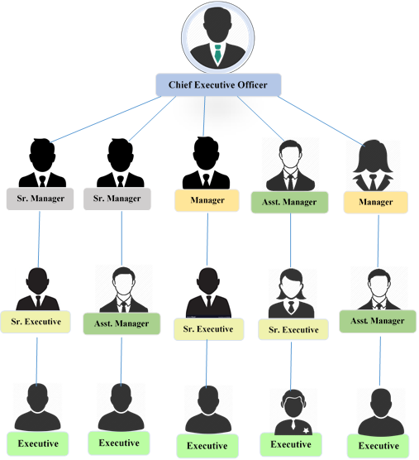

Figure 1 Inpace Management Organogram

Portfolio


Inpace Management Provide:
- Event Management
- Brand management
- Promotion
- Youth Marketing

- Digital Marketing
- Web Design
- Print Media Advertising
- Entertainment Marketing

Figure 2 Portfolio Of Inpace Mangement

Event management

Events management is one of their key service they provide throughout the years. They have the strong reputation for this service. Inpace arrange the corporate meeting, merger or acquisition programs, partners meet or entertainment, shows, exhibition and functions when the clients wants. In an event 3 department work together to make the event successful. Without one of them event can’t be done, 3 departments are-

Client service department

In the clients service department they initially come out with the ideas, they propose the idea to clients if client approved they start planning about the event, and start finding the possible ways to make the event look unique. Then they book the venue based on client requirements, select food menu within given budget, book other thing related entertainment purpose if client requires. Usually clients give gifts to its partners after the program that is also designed and arrange by the clients service department. So they invite partners through email first and give them calls to ensure for the program. Main thing is, all the visitors, partners as well as the clients are handle by the client service department.

Logistics Department

Logistic is the heart of an event as they manage the whole physical activities of the event which include stage set up, lighting, speakers, gift distribution and other components which require a lot effort to handle. They implement the whole this which is designed and planed by the clients service department. So from the program starting to end everything is controlled by the logistics department.

Creative Department

This team might not work directly on the occasion of event but their work give meaning to the event, what actually the clients want to deliver to their client through the program. Their work start form the invitation card designing. They design the posters, banners, branding banner in led and videos for the program.

Brand management
Brand management is a broad concept, Inpace is well known among international clients for the branding activities as it’s been giving this service since 1997. International companies always do invest a huge amount of money in their branding purpose. Inpace is doing business with international companies where its clients are from IT industry. The main activity they do for companies is shop branding, retails shop or authorize Brach of the client company. Inpace visits the shops around the Bangladesh and fine out the scopes of branding like new sign age , sticker, light box, selves even they decorate shop if clients approve . They find out the scope send it to clines with budget , approved project are implement by the inpace branding team.

Youth Marketing
In this case inpace communicate the young generation, age range of 17-30 years, the people who are in college and university. The directly goes to the college and university students and arrange meeting or campaign to communicate with them. Students of college and university holds a certain amount of market that company wants to capture, so here inpace pay the key role.

Print media advertisement
They advertise through various kinds of media including on the web, print, TV, out-of-home and radio. Advertising on Tv is not one of their regular basis work through but they provide this service based on client needs, when clients wants to increase their sales or for their promotional purpose they hire inpace to do that. Client service department generate idea about the ad, creative department make the design and the layouts of the ad such as slogan, text, color, papers including the dress, scripts and cinematography for commercial. And client’s service department’s works doesn’t end here, they select the medium of the ad, where to set the billboard, after that they talk with the clients about compensation by showing the reach and benefits of the advertisement they are going to do, once they get approval the clients service department go for implementation.

Promotion
Promotion and marketing is one of their core service they provide, mainly inpace is mostly popular for their service. Inpace is providing this service science 1997. They have very good reputation for branding and marketing among the whole industry as well as clients. As they initially started their business with IT industry but they have moved up to that position and started giving services among consumer market. They provide this service in three quarter as per client requirements. Their most of the clients are international so clients usually do the branding and marketing activity tree time in a year.

Point of sales management
In some cases promotional team directly get associate at the point of sales, to sale the product as fast as possible by making the customer loyal to product. Only point is not the sale the product fast but to make the customer purchase again in the future by responding to the customer query fast.

Product launch
At the time of launching a product it’s create an impression of the product as well as the company. So promotional team gives their best to left the best impression among the customer so that they buy in the future. They showcase the new product in every best possible way to look attractive to the customers.

Road show
Road shows now a days a very common form of promotion as it generate a huge among of sales increase. Road shows create immediate response in sales. Inpace crate ideas for road show and they try to make shows unique and entertaining so that they get good amount of customer engagement.

Fair & Exhibition
Inpace organize a certain amount of fair and exhibition throughout the year depending on the market condition. Fair and exhibition showcases the product and it help to generate sales as well as companies brand image.

Entertainment Marketing
Here customers are targeted by providing entertainment programs like computer games, quiz shows, cheese tournament etc. games and shows are the easiest way to communicate with people, and people easily get involved with what they like. So this simple trick is applied to the marketing system to communicate with people and to satisfy clients.

Digital Marketing
Digital marketing is now become a compulsory thing for the companies to promote something, increase brand image and sale. Easiest and quickest way to aware the target customers. Digital marketing works much more effectively than traditional marketing. So for this companies invest in digital marketing a lot. The department of digital marketing of inpace management wasn’t that strong enough before but now they are giving their full effort by hiring experienced employee to catch new clients. Currently they are working with some companies and the clients are satisfied with the service. The creative teams plays an important role as well, they make the creative which is a very important part of digital marketing. There are some skims for the clients- monthly basis and yearly. An agreement will be set between both the service holder and provider. How many post want to post in social media will be set by the clients and based on that charges will be set.

Web design
Websites are the identity of the companies because it provides all information about the company, in inpace they design web based on client’s requirement. It department totally established the websites as per client requirement, clients service department also help the IT department to make the website look more unique and easy to use.

Clients Of Inpace Management Services Ltd.

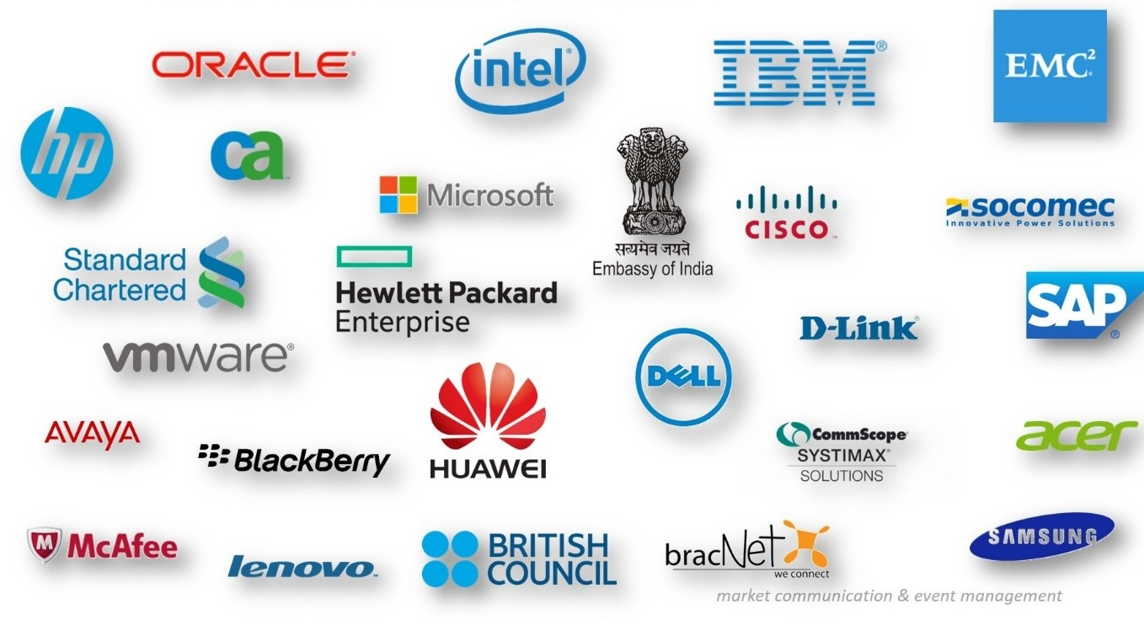

Figure 3 Some Of Inpace Clients

Here are the list of some core clients of Inpace MSL:

EPSON
Currently EPSON is one of their core client, they are making their bigger portion of revenue from epsion. Epson is the one best printer company of the word, proving the best printer since 1942. They have almost capture the whole Bangladesh market in the printer segment because of their quality product and compare to the other printers in market their printer is less expensive.
Inpace does all the promotional activities of Epson all over Bangladesh, from store branding to launch a new product, inpace look all the activities. Inpace visited all the retail shop and partners shop of the Epson and provide a list of branding opportunity of these shops, provide the ideas for promotion.

DELL

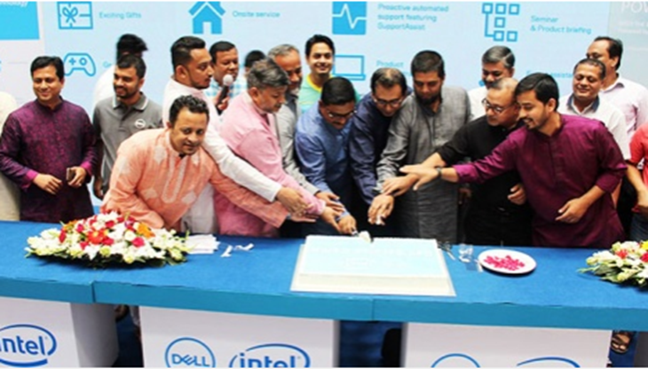
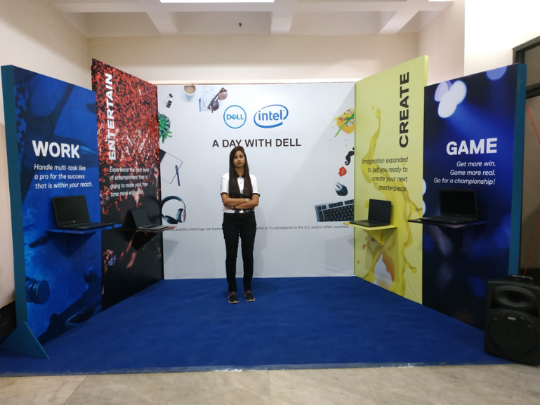
Figure 4 Promotional Campaign of Dell
Dell is one of their core client when it comes to computer market segment and they have a strong relation with inpace. Inpace is the only company who does all the promotion and marketing activities of dell. They have been doing business with inpace from the 2000.

Lenevo
Lenevo is one of their giant client. Inpace has separate department only for Lenevo because inpace has to do so many branding and promotional activites of lenevo throughout the year. They do the promotional activities and branding in three quarters, at the beginning of the year, middle of the year and end of the year.

Cisco
Cisco is a revelation for the IT industry, there are a lot of business we cannot thing without server and security system, and cisco is number one in this sector ensuring the best security server all over the world. Inpace is the only company doing all the branding and promotional activities of cisco.

PROJECT PART

SWOT analysis of Inpace Management Services Ltd.
Swot analysis is a very useful tools to evaluate the overall condition of an organization. it gives the clear idea about an company’s strengths, weaknesses, opportunities and threats. Sometimes it is difficult to evaluate the organization overall strength and weakness because of the organizational structure. In some cases the overall strength of Inpace is difficult to evaluate, because the inner strength includes many things like capital, asset, number of employee, skillful employee, company brand image and equity. It also depends competitor’s capabilities. Weakness include the thing that competitors have and taking advantage of having it or will take advantage in the near future.
Every company has opportunity no matter how big it has become, company has to create opportunity to survive in the market because a company cannot survive in the market in the long run with the same technique. So it has to adapt the new challenges by taking it as an opportunity. And every problem is in opportunity. So in this situation inpace has create many opportunity for themselves, like they did not work on any consumer market before because they were very much focused on IT sectors, but nowadays most of the consumer market are getting into the promotional and branding phase which was not seen before. So inapce has taken the opportunity, they have started to work in consumer market.
On the other hand threats can come from various sectors such as competitors, customers, environment, suppliers, even from the own organization. So Inpace has to face threats from some sectors, which is mainly form the client and competitors. Clients are the things based on that business grows, so core clients are very important form event management firm because they gives you the earning opportunity through the year. Competitors are always in the intention to take the client, so sample mistake can cost a client, So Inpace is very much concern about their client and gives it top priority to the client service department. They set a manager and a dedicated team for a specific client. This is how Inpace build a management system to overcome major threads.
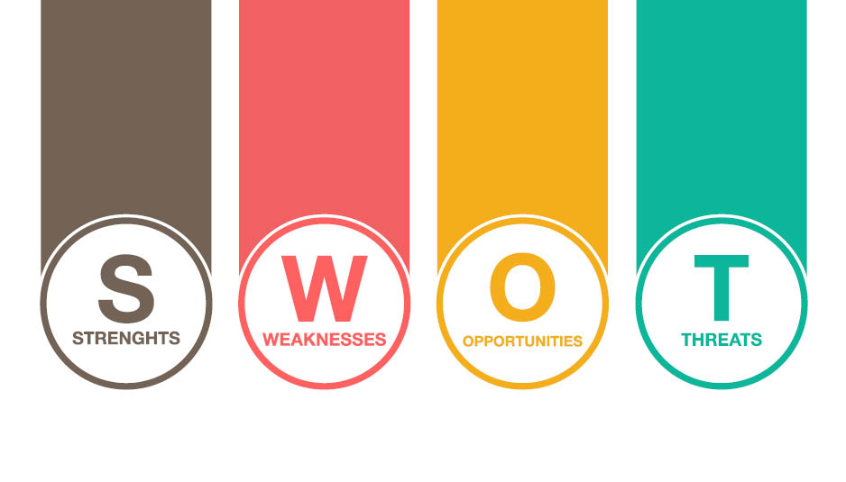
Figure 5 SWOT Analysis of Inpace Management

Strengths
- Industry’s best creative and strategic planning team.
- Ability to deliver good production value on creative execution.
- Strong relationship with media houses.
- Have international experts.
- Operating 20 years in the Industry.
- Skilled manpower
- Expertize manager for core clients.
- Knows nooks and corner of the market
- Good reputation among international clients of IT sector.

Inpace management has the best strategic planning team because of the expertise of the managers. The managers play the vital role in the making strategic planning in Inpace. They are highly expertise and experience in event management and clients’ service. They been working in sectors for more than years. They have seen the market grow and change, and they know the nooks and corner of the market. Other the other hand, creative department is the heart of agency. They might not directly involved in the execution process but they work day and night behind the scene. The head of creative department is Samir Sharkar. He is extremely hard working and dedicated employee of the Inpace management. He always has given the best and something different in the field of creativity. The theam under him is the biggest strength of inpace.
Inpace always provide the best value to its clients at a lower cost, this makes Inpace different than other agencies. Inpace has been providing the quality service and great value at lower cost than competitor. Where every agencies are charging high in the name of good quality service.
It’s been 20 years Inpace has been serving in the industry, it gives Inpace strong links with the media house. Relationship is the key factors for doing any kind business. And for agencies maintain good relationship with media house is quite difficult.
Inpace management has the support of international experts which most of the agencies don’t have. The managing director of Inpace is planning to start his business abroad because he is been doing this business and monitoring inpace from usa. He has strong link up with many international experts.

Figure 6 One of IMSL’s strength

Not every company can run business smoothly for a long time with consistent performance and good reputation but Inpace has completed this phase. It has been operating for 20 years and maintained its consistency and reputation.
Inpace management has always served the IT sector and most of the IT companies are international so dealing IT giants is not every company’s cup of tea. So it’s a biggest plus point for inpace because they don’t need to thing for other industry.

Weakness
- Doesn’t have in-house capability of different production and activation related activities.
- Higher cost to client (due to higher personnel cost).
- Limited Clients.
- Finding new clients.
- Higher operating fixed and operating cost.
- Under qualified employees in some sectors.

There is no company in the world who hasn’t a weakness, and Inpace management has some. The major weakness is agency business is cost management. Cost management in event firm is really high because there is a lot of variable cost is there. The thing a company doesn’t have to outsource and outsourcing is always costly. For agency business you must have some outsourcing cost which is unavoidable. Like for a promotional campaign you need lot of equipment as well as manpower which you can’t own permanently, that will be more costly because the depreciation cost will be higher and many equipment cannot be usable after one project. We only see the thing we have shown but promoting and advertising is not everything we see. There is a lot homework done before its execution. Agency need to gather information, need to research on the market before going to the final step which leads to higher cost.
In the logistic department Inpace has some under qualified employee which they have maintained from the beginning, for the logistic department higher qualification is not mandatory though but sometimes it creates problem in the time of emergency.
As Inpace currently doing most of the business with IT firms for that hey have limited clients which is the biggest weakness of inpace because if two or three clients stop doing business with Inpace, then Inpace will be in great danger.

Overcome:
As they have enough capital so they can invest on buying necessary equipment for
Different Production and activities. Although they already have started investing on those
projects. Higher Cost can be avoided by minimizing personal cost. They also started
replacing under qualified Employees with qualified employees. They are very much
concern about their weakness and will Overcome soon.

Opportunities
- Nowadays every local companies are getting into the promotional activities.
- More IT companies are coming in Bangladesh.
- Increased demand of digital of marketing.
- Further penetration of different media.
- Increased competition in many consumer market requires more promotional activities.

Before finding opportunity we need to look for problem, because every problem creates an opportunity. For now the biggest problem in the industry is competition among companies, mostly in consumers market. So every company is investing a lot on promotion which creates a lot of opportunity for the agencies.
More company is coming into Bangladesh soon which is biggest opportunity for Inpace because every new comer in the market always follows the competitors, so there is a high chance that they are going to come to Inpace for their promotional activities.
Digital marketing has now become the crucial part of market as it is. Now a days it becomes so popular that every company is investing in this sectors. So Inpace has created a department for digital marketing so it is going to benefits Inpace.
There was a time digital marketing is just a part of marketing but now it has become a core part of marketing. Even the strongest brands very concern about digital marketing. So it’s a great opportunity for inpace to make a strong identity on this sector because they already have a strong identity in the market which will help it get clients easily.

Threats
- Competitive market.
- Getting clients to pay on time.
- Rapidly changing industry.
- Decreased demand of traditional marketing.
- Dealing foreign client is slightly difficult.
- Negotiation conflict with foreign client.
- Changing clients’ attitudes towards company.
- Slowed down economy and high inflation rate creates budget conflict.
- Many MNC clients have centralized their communication activities.

Threats are common in business, and for the business like event management firm it’s like a day to day activity.
It can come from any parties of the business. The biggest threats for Inpace management is now tough competition because of the rapidly changing environment. it’s a very easy process to start a event management firm because there are no barriers, anyone can come. So this easy entry makes the market so complex that makes difficult for the companies to survive.
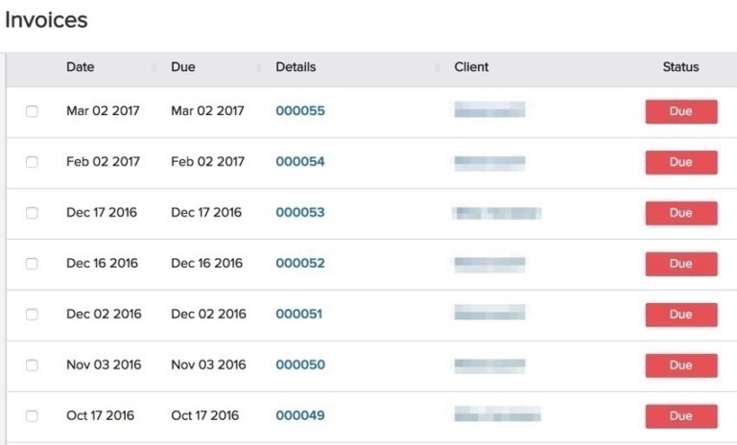
Figure 7 Clients do business on due
For event management firm it is very common scenario that client will not pay on time. Most of the payment remains due. In some cases clients takes to look to pay. So it’s a biggest threats for company. Sometimes company face financial problem because agency has some fixed cost as well as they need pay the bill they of outsourcing firm who works for inpace.
Negotiation conflict is another threats agencies face. In every sector we have to negotiate to get the expected thing. But in the agencies they sometime don’t negotiate and do more for less which, because negation might cost them the client they think and its true. Clients go and higher other firm because they have bunch of alternative.

Overcome:
Every company has some threats even the no one company has to face threats. In comparison to other agencies in Bangladesh, Inpace has less threats than others because it has been operating in the industry for more than 20 years. They have their fixed clients and working technique. The way Inpace performing in the market and making its employees more compatible by giving trainings, they will overcome most their threats into opportunity. They also create some other department based on current market situation. So Inpace has that strength to overcome market and competitor threats.

FINDINGS

Market Condition of agencies

Figure 8 Market Condition of Agencies
.

The above table shows the market condition of the different agencies. The table shows the number of year’s operation in the market and number of clients that agencies have. Based on two variable 5 agencies have been evaluated. So from the above research I can say that current condition of all the agencies good and comparably Inpace has lower clients, and they have lower number of clients because they only operating the the IT industry . More clients will not always give the company more profit, because in Inpace, 50% of its rev enue come from it 2 clients so it is not necessary that company needs to have higher number of clients to make profit, but it’s a plus point if a a company have lots of client. so inpace can increase their clients by entering in the consumer market.

EPSON Branding
One of their core clients is EPSON, Epson is no 1 in Bangladesh in the printer’s segment. And Inpce does all the activities of Epson Bangladesh such as event management, BTL marketing and branding. They does all the activities throughout the years and from them the major activity is branding the store of its dealers and core sellers. So the way Inpace does the store branding is quite difficult and done in some steps.
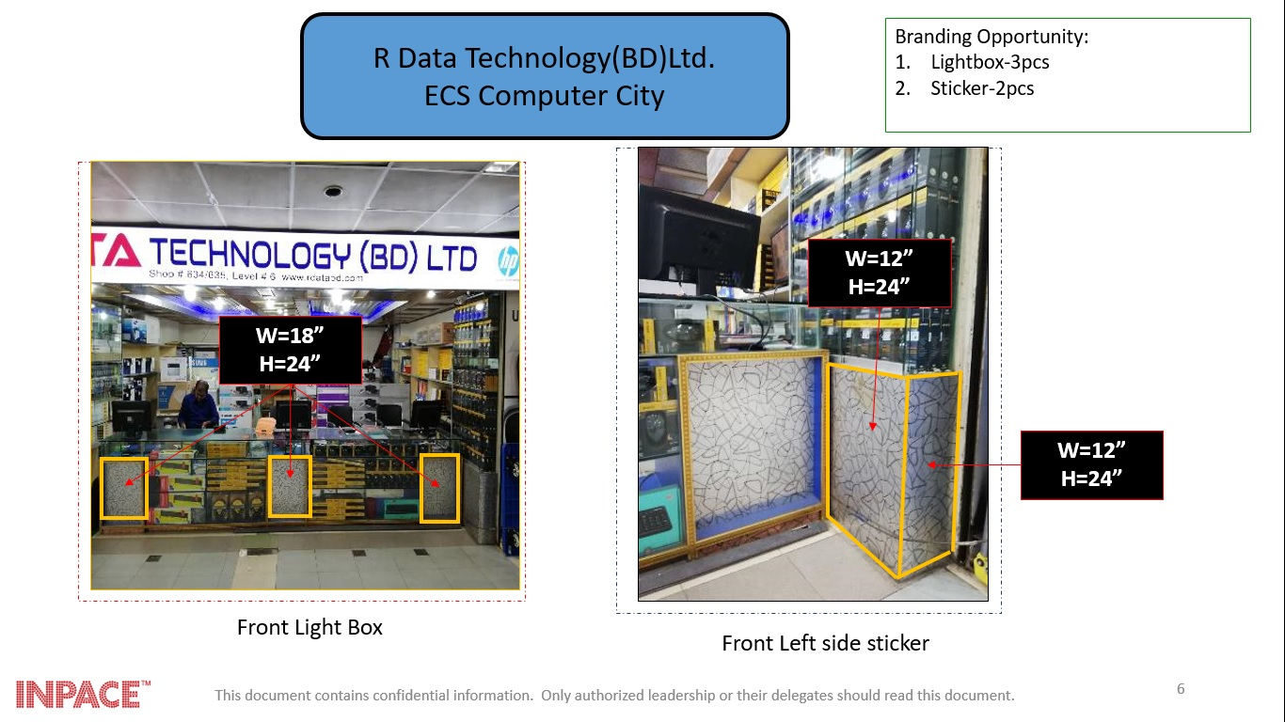
Figure 9 EPSON shop Branding

At first they collected the list of dealer and reseller name of Epson, then a few branding team was made for every city. Each team go to different city. First they go and visit the shop and find out the branding opportunity, after that they take the measurement of those branding areas.
In the 2nd stage they make a list of table of each and every equipment requirement for the branding including price. A team of Epson see the pictures and approved the names of shop including branding opportunity.
So the logistic unit will go for implementation and done their work.

Payroll Management:
Inpace has slightly different payroll policy than other organization, sometime they change their policy based on the market situation, the CEO of the organization Md. Rahat khan has set the policy.
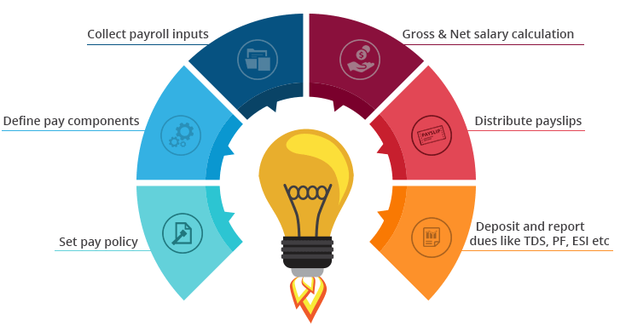
Figure 10 Payroll Mangement

Attendance Management
Inpace doesn’t strict to their attendance management in some situation and it is tough for an event management firm to track all the attendance the employees. To overcome the problem Inpace build a finger print based attendance system to track the attendance. Employee who works out side the organization for a day, gets a day leave.

Shift Management
Shift is not common in Inpace though but in some situation they follow this policy. For a event management firm maintain too many event expert is tough because the logistic head is always have to be present in the event.

Leave Management
Leave management is follows in every organization, Inapce has role that no can leave the office before 6 Pm no h/she has work or not. But in the time event employees can leave anytime based on the work and manager requirement.

When IMSL Works for a client?
There are situation that company or company’s product need to have, considering those factors Inpace starts to work for them. The major reasons are given below:

- If the company has positive image in the market.
- If the product quality is good and not harmful.
- Have enough financial support for their product and company.
- Creative and working freedom
- Trust and partnering

Working process between client and IMSL
The working process between both the parties are not similar to other organization, it is quite delicate. These process are hard to describe but explained briefly below:-

Clients Problem
First of all Inpace wants to know the problem that the companies are facing, based on the problem the decision are taken. The common problems IMSL hear from the clients are:
- Sudden decrease is sale, and continuously getting low.
- Threats of a new competitor or current competitors.
- Want to launch new product in the market.
- Market rumor etc.
Problem gives the solution, so first of all Inpace finds out the solution. For that agency need to have the clear idea about the client company as well as the industry where the client company is operating. So Clients Company have to give the full freedom to take decision regarding the problem and for this clients has to have fait on agency.

Internal Briefing by Account executive
Account executive, the head for managing discussed the probable solution for the problem. So based on the problem the design the campaign. A group is assigned to the problem. The group briefed generally contains,
- Media planners
- Creative directors
- Finance Department
- Client service department

Conducting Research
Client service department works on this project, they do many market research to find out the problem as well the solution. And they gather information about:
- Current image of the company/ product.
- Current promotional info
- Complaints of customers
- Prescriptions of customers.

Planning the campaign
Planning’s are generally done by the top level management, they seat all the criteria for the campaign. The things they generally plans are,
- The main purpose of the campaign.
- Promotion Type, ATL or BTL
- Weather the promotion will be TVC or printed.
- Advertisement’s Budget
- Media planning

Reaching presentation
A presentation will be given based on the total project after setting all the criteria for the campaign. Presentation will be given in details so that clients understand clearly without any confusion.
- The actual goal will be shared to the targeted people.
- Will be aired on the TV channel, at least 5 channels.
- Will be published on the top magazines.

Final Approval Presentation (Client’s presentation)
After all this agency takes the final permission of the. After the approval they directly go for the execution as per client’s requirements and top management plan.

Censorship certificate
Before broadcasting on the TV and radio an approval has to take from the TV and Radio authority. They will give an approval certificate after checking

Producing the advert(s)
After getting the approval from the censor board, Process of making advertisement starts. Creative department select the design, color, logo etc based on the top management plan.
They create three different versions for the three different phase of the campaign which are,
- Introduction
- Memorizing
- Promotional

The campaign appears
The time span between the briefing of the account executive by the client and the campaign appearing can be as little as six or eight weeks for a simple photographic newspaper execution, to twenty weeks plus for an animated TV commercial, personal selling drive, sales promotion campaign, event sponsorship, public relation activities.

Controlling
Like other process even the campaign has controlling process. Campaign will be monitored by the agency, it can be for week, month or 6 month, then the outcome will be compared to the expectation. So if the outcome is positive then the campaign might stop but if its negative then agency will find out the reason behind the campaign failure.

RECOMMENDATION
Inpace manage services Ltd. is mainly an event management firm to me, although they claim it as an advertising agency and Branding firm but their 80% of the work is based on BTL marketing. They should focus on the other sectors of the marketing like integrated marketing, because in recent time’s integrated marketing process has become the most popular among marketers, it is not focused on single marketing tool rather than give different marketing tools to attract consumers.
In this way in the present world Ad agency have turned into a significant player of the correspondence procedure as they are the person who can give ceaseless help to the advertisers to grandstand their message to the buyers in the best and reasonable ways As Bangladesh is a developing business sector for advertising industry, Inpace need to make some move to adapt up challenge.. Some recommendations are suggested bellow:

- Constructing of an extensive long term plan
- Proactive arrangement for competitors move.
- Sufficient amount of the research should be done.
- Need to rethink and comprehend the customer relationship.
- Motivating employees frequently.
- Enhance the asset ability
- Development of new worker and the executives aptitudes
- Enhance the coordination
- Reporting and control connections
- Commitment of senior executive.
- Obtain employees commitment.
- Continuous improvement of working environment.
- Invest the require amount for of organization structure.

CONCLUSION
Bangladesh is developing country. It’s been 31 years of advertising. The world of advertising has been changed now. The advertising industry has been playing a vital role in the industry. The industry is growing faster because we have learned to think differently. Our way of working is also now changed. We have strong and skilled human power. So all we need is the support from other industry as well as the government. We need more expert people who will only work for the betterment of the industry. With the help of expert and some academic training we can do much better than now. This report can be concluded with the following decisions,
- Bangladesh needs more creative experts and some academic support.
- Encouraging the young generation to work for this industry.
- We need a strong support from the government as we all from the rich organization of the country.
- Technological advancement for the advertising industry.
- Coping up with the other country and learning from their advertising activities.
- More competition should be held all over the country to encourage new comers and new ideas.
This study has helped me to gain the in depth knowledge of the advertising world, how the industry runs. Got to now the activities of branding actually how a organization increase organization brand value. The idea, planning and work behind a events, retail solution, database management, PR. All the activities done in an agency. So I hope the recommendation I made this will help Inpace to overcome some of its problem and create new opportunities. Finally, I believe Inpace will take proper initiatives to make their business more successful.

APPENDIX:
References

(2019, July 24). Retrieved from www.aboutadvertising.com
Inpace. (2019, 7 23). Retrieved from www.inpacebd.com
Top Agencies. (2019, July 24). Retrieved from https://www.sortlist.com/advertising/bangladesh-bd
Wiki. (2019, Jun 10). Retrieved from www.wikipedia.org
Word Stream. (2019, July 24). Retrieved from https://www.wordstream.com/blog/ws/2017/12/20/swot-analysis

- Other secondary sources like marketing journals, business magazines, Newspapers etc.
- Facebook page and other social media regarding the activities of Inpace.
- Various journals, previous business plan and campaigns ideas.

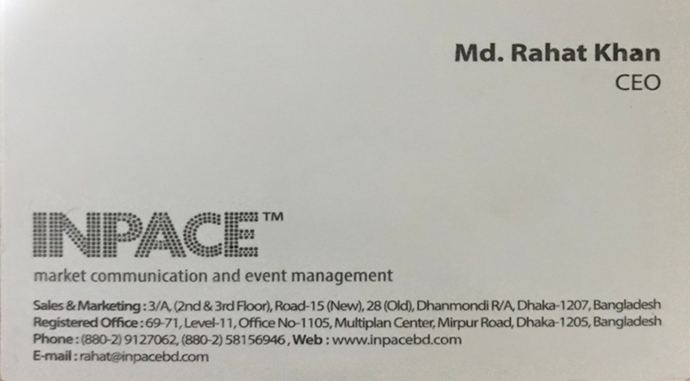
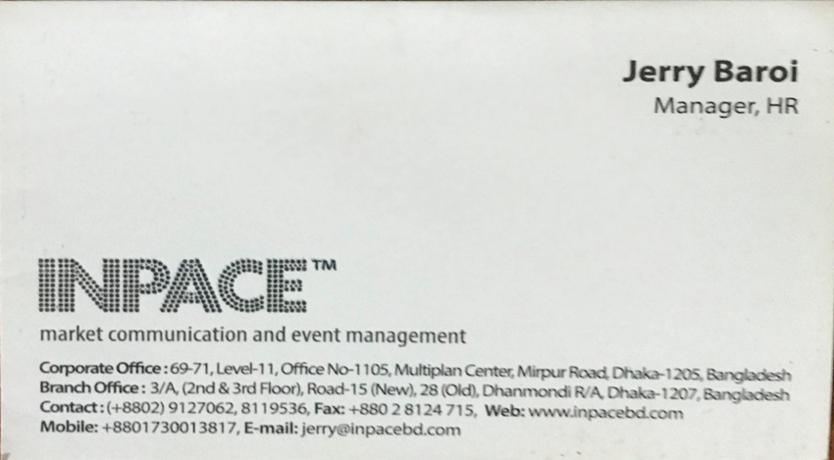
- Business cards of the CEO and HR manager of Inpace Management services Limited.

