An Analysis of General Banking Operations and Card Division of UCB Bank – A Study of Customer Service Efficiency.

Abida Sultana Tinni

This report is submitted to the school of Business and Economics, United International University as a partial requirement for the degree fulfillment of Bachelor of Business Administration

An Analysis of General Banking Operations and Card Division of UCB Bank – A Study of Customer Service Efficiency.

Submitted to:
Name: Dr. Shakila Aziz
Designation: Associate Professor
Major: Finance and Fintech

Submitted by:
Name: Abida Sultana Tinni
Id: 111 221 005
Major: Finance and Fintech
Registration Trimester: Spring 2026


School of Business and Economics
United International University
Date of Submission: July 6, 2026

Letter of Transmittal
July 6, 2026
Dr. Shakila Aziz
Associate Professor
School of Business & Economics
United International University
United City, Madani Avenue, Dhaka-1212
Subject: Submission of Internship Report entitled “An Analysis of General Banking Operations and Card Division of UCB Bank – A Study of Customer Service Efficiency.”
Dear Ma’am,
With due respect, It is a great pleasure to submit my internship report entitled “An Analysis of General Banking Operations and Card Division of UCB Bank – A Study of Customer Service Efficiency.” This report has been prepared as a requirement for completion of Bachelor of Business Administration (BBA) of majoring in Finance & Fintech at United International University.
During my internship program at the United Commercial Bank PLC., Uttara Branch, I had the opportunity to work internally with both the General Banking and Card Division. This report reflects both my academic understanding and practical experience, focusing on customer service efficiency. I have tried my best to present the findings in a clear, logical, and academically appropriate manner.
Finally, I would like to express my gratitude to you for your valuable guidance and support throughout the internship and report preparation.
Sincerely,
Abida Sultana Tinni
ID: 111 221 005
Major: Finance & Fintech
Bachelor of Business Administration

Certification of Similarity Index

Declaration of the Student

I, Abida Sultana Tinni, certify that the report “An Analysis of General Banking Operations and Card Division of UCB Bank – A Study of Customer Service Efficiency” is my own work and has been prepared as part of the requirement for completion of Bachelor of Business Administration (BBA) of majoring in Finance & Fintech at United International University.
The information composed in this report has been gathered based on my experiences, observations and analysis of data during my internship at UCB PLC. I certify that, to the best of my knowledge, the information in this report is accurate and the reflection of my evaluation of the bank’s operations and efficiency of customer service.
I confirm that any data, information or material sourced from other sources have been properly acknowledged with academic standards and I take full responsibility for originality of this report.

Abida Sultana Tinni
ID: 111 221 005
Major: Finance & Fintech
Bachelor of Business Administration
United International University

Corporate Evidence

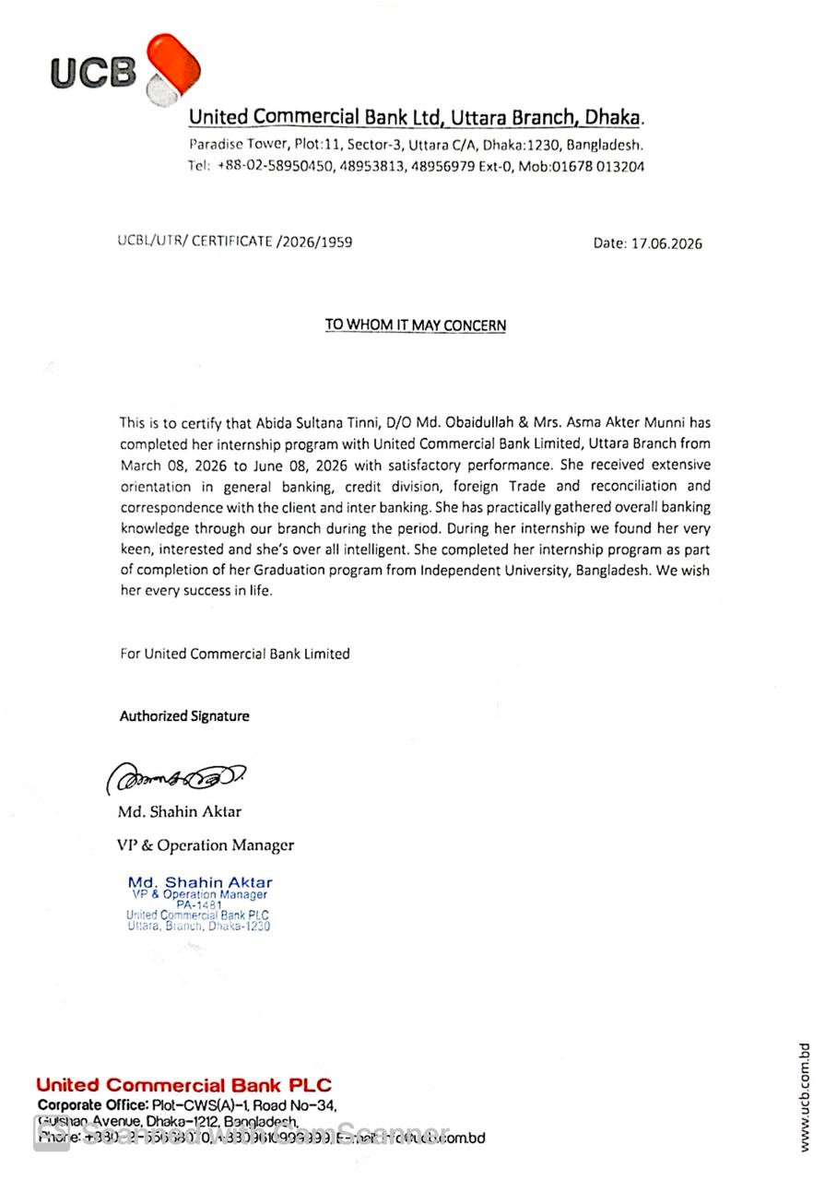

Acknowledgement

First and foremost, I express my sincere gratitude to almighty Allah for giving me the strengths and patience to reach me this stage of my life.
I would like to express my heartfelt appreciation to my respected academic supervisor, Dr. Shakila Aziz, Associate Professor at United International University, School of Business & Economics, for her continuous guidance, valuable suggestions and support throughout the preparation of this report. Her direction helped me to complete this study effectively.
I am also highly grateful to the management of United Commercial Bank PLC, especially the Uttara Branch, for giving me the opportunity to complete my internship. I would like to express my sincere gratitude to Md. Shahin Aktar, VP & Operation Manager, UTTARA Branch, United Commercial Bank PLC; and Ibtesam Mirza, First Assistant Vice President (FAVP) & GB-In-Charge, UTTARA Branch, United Commercial Bank PLC for their guidance, support and mentorship throughout the tenure of this internship. I am also very grateful to the Front Desk Officers for their constant cooperation, patience and sharing of their practical experiences on the daily operations of banking. They were able to provide valuable inputs and knowledge for the completion of this report in the areas of banking operations. Their support enabled me to get insights on the real-life banking activities, especially General banking and Card services.
My sincere thanks to my family for their moral support, motivation and patience throughout this journey. Finally, I would like to express my appreciation to the customers for their feedbacks on my internship since it was important for assessing the efficiency of service.

Executive Summary

This is an internship report of the general banking activities and card division of United Commercial Bank PLC (UCB) in its Uttara branch more specifically to examine the efficiency of customer services in the Uttara branch of United Commercial Bank PLC. The report is prepared as part of the Bachelor of Business Administration program of United International University and is based on the observation of the internship, analysis of the service, data of complaints, mystery shopping, and evaluation of the customer service.
With its extensive branch presence, comprehensive financial services, and ongoing efforts in digital transformation and monitoring customer service, UCB has secured a solid reputation in the private commercial banking sector in Bangladesh. Operational efficiency, customer experience, complaint resolution and service quality measurement are all areas in which the bank is committed to enhancing its operations and is continually working on, as evidenced by the various reporting tools including mystery shopping and Net Promoter Score (NPS) which are highlighted in the annual report. These projects are part of the bank's strategy to compete effectively in today's tech-savvy, customer-centric banking landscape.
During the internship, hands-on experience was obtained in various general banking functions like account opening, handling enquiries, cheque handling, deposits, complaints and card related issues. This helped to connect theory with practice in banking and to gain insight into the practicality of service delivery at the branch level. The report also uses the SERVQUAL model to evaluate the quality of service in the parameters of reliability, responsiveness, assurance, empathy, and tangibility(“(PDF) SERVQUAL,” 1988)
The results indicate that UCB gets better results in terms of core banking accuracy, professionalism of staff and resolution of complaints. The bank also has high credibility in providing services as it obtains the proper transaction and handles the customers in a safe manner. The results of the study, however, reveal some areas that need to be improved. These include slower response times in peak hours, waiting times for service at service counters, service variability between service branches, and some technical issues with the digital and card services. The complaint data further indicates that card and ATM-related issues account for a significant portion of service concerns, showing the importance of maintaining strong digital and operational support systems.
The overall conclusion is that UCB has a strong base in customer service and operational performance, having potential to further strengthen through increased responsiveness, decreasing service delays and further improving service execution in branches. The internship also proved to be a significant learning opportunity, providing hands-on experience of banking operations, customer behavior, and service quality management. In the end, it piqued my interest in a career in banking and finance.

Table of Contents
Letter of Transmittal III
Declaration of the Student IV
Corporate Evidence V
Acknowledgement VI
Executive Summary VII
List of Figures X
List of Tables XI
List of Abbreviation XII
CHAPTER 1: INTRODUCTION 1
1.1 Background of the Report 2
1.2 Objectives of the Report 3
1.3 Methodology of the Study 3
1.4 Rationale of the Report 4
1.5 Scope and Limitations of the Report 5
1.6 Definition of Key Terms 6
CHAPTER 2: COMPANY AND INDUSTRY PROFILE 7
2.1 Company Analysis 8
2.1.1 Overview and History 8
2.1.2 Trend and Growth 10
2.1.3 Products, Services & Customer Mix 14
2.1.4 Customer Mix 18
2.1.5 Company Operations / Activity 19
2.1.6 SWOT Analysis 23
2.2 Industry Analysis 26
2.2.1 Specification of the Industry 26
2.2.2 Size, Trend, and Maturity of the Industry 27
2.2.3 Industry SWOT Analysis 28
CHAPTER 3: INTERNSHIP EXPERIENCE 32
3.1 Position, Duties, and Responsibilities 33
3.2 Training & Development 34
3.3 Contribution to Organization / Operations 36
3.4 Evaluation (SERVQUAL Analysis) 37
3.4.1 Introduction to SERVQUAL Model 37
3.4.2 Complaint Management Analysis 38
3.4.3 Complaint Category Analysis 38
3.4.4 Mystery Shopping Analysis 38
3.4.5 Customer Experience & NPS 39
Overall Efficiency Evaluation 40
3.5 Skills Applied 42
CHAPTER 4: CONCLUSIONS AND KEY FACTS 45
4.1 Recommendations 46
4.1.1 Recommendations for UCB PLC 46
4.1.2 Recommendations for General Banking Division 47
4.1.3 Recommendations for Self-Development 47
4.2 Key understanding 48
4.3 Conclusion 49
REFERENCE 50
Appendix-A 51

List of Figures

Figure 2.1: UCB Core Values 8
Figure 2.2: UCB Journey 10
Figure 2.3: Financial Insight of UCB PLC 11
Figure 2.4: UCB Centralized Operational Flow Model 20
Figure 2.5: Operational Workflow of UCB PLC 21
Figure 3.1: Service Quality and Complaint Management Performance 40

List of Tables

Table 2.1: Peer Comparison of Key Financial Indicators, 2024 12
Table 2.2: Retail Banking Products and Services 14
Table 2.3: Card Division Products and Services 15
Table 2.4: Corporate Banking Products and Services 15
Table 2.5: SME and MSME Banking Products and Services 16
Table 2.6: Islamic Banking Products and Services 17
Table 2.7: Digital Banking Products and Services 17
Table 2.8: Women Banking Products and Services 18
Table 2.9: Imperial – Priority Banking Products and Services 18
Table 3.1: SERVQUAL Dimensions 38

List of Abbreviation

Acronym/Abbreviation | Full Form
ATM | Automated Teller Machine
BBA | Bachelor of Business Administration
BDT | Bangladeshi Taka
BS | Balance Sheet
CSE | Chittagong Stock Exchange
CRAR | Capital to Risk-weighted Asset Ratio
DBBL | Dutch-Bangla Bank Limited
DPS | Deposit Pension Scheme
DSE | Dhaka Stock Exchange
EBL | Eastern Bank Limited
ECB | European Central Bank
EPS | Earnings Per Share
E-KYC | Electronic Know Your Customer
FDR | Fixed Deposit Receipt
GB | General Banking
ICT | Information and Communication Technology
IFIC | International Finance Investment and Commerce
KYC | Know Your Customer
MFS | Mobile Financial Service
MSME | Micro, Small and Medium Enterprise
NPL | Non-Performing Loan
NPS | Net Promoter Score
PAT | Profit After Tax
PCB | Private Commercial Bank
PLC | Public Limited Company
POS | Point of Sale
RMG | Ready-Made Garments
SERVQUAL | Service Quality Model
SME | Small and Medium Enterprise
SQD | Service Quality Department
SWIFT | Society for Worldwide Interbank Financial Telecommunication
UCB One | UCB Internet Banking and Mobile Banking Platform
UCB PLC | United Commercial Bank Public Limited Company
UClick | UCB Mobile Banking Platform
UNet | UCB Internet Banking
UPay | UCB Fintech Mobile Financial Service
VISA | Visa International Service Association

CHAPTER 1: INTRODUCTION

1.1 Background of the Report
The banking sector in Bangladesh acts as the backbone of the national economy, facilitating trade, investment and financial stability. The industry is a dual-tier system consisting of State-Owned Commercial banks (SOCBs) and Private Commercial Banks (PCBs). While SOCBs have historically provided a large scale of reach, they often face challenges related to legacy operational inefficiencies and higher ratios of non-performing loans. On the other hand, PCBs like United Commercial Bank PLC (UCB) has capitalized for its commitment to balance its established legacy- dating back to 1983- with aggressive digital transformation. As nowadays customer’s shifting their interests by prioritizing efficiency, technology, service responsiveness. To remain competitive, a bank must strike a delicate balance between profitability and risk management, customer satisfaction and regulatory compliance, innovation and security not just simple deposit- taking and lending. To meet these evolving expectations, UCB PLC has focused on the digital transformation, service automation, and customer-centric banking. The UCB Annual Report 2024 reports that the bank placed greater emphasis on enhancing its digital banking capabilities, complaint handling processes, and service quality monitoring, as part of its efforts to boost efficiency and customer satisfaction.(UCB Profile - United Commercial Bank (UCB)). UCB PLC achieve an 18% deposit growth parts of 2024 demonstrates a strong level of public trust and competitive advantage compared to industry averages(United Commercial Bank (UCB), 2024). For a finance student, understanding these complexities need more than just academic study; it requires direct immersion in the professional environment.
Although my education in Finance has given me a solid theoretical grounding in banking operations, financial analysis, and banking regulations, such theoretical knowledge does not fully encapsulate the subtleties of real-world banking. I gain firsthand knowledge of this institutional approach through my internship at UCB Uttara Branch. It gives an anchor to the abstract and practical aspects of banking transactions. Having been directly involved in the front desk operations and the Card Division, I have gained significant insight into the daily mechanics of a leading private bank. This report focuses on the two most visible touchpoints of the bank: General Banking (the foundation of the bank-customer relationship) and Card Services (the driver of modern retail banking). Furthermore, this report goes beyond a mere summary of assigned duties and the requirements of BBA program, it provides an analysis of the general banking industry and the strategic positioning of UCB PLC, accessing how UCB translates its corporate mission into tangible service excellence through the five core SERVQUAL model dimensions of reliability, responsiveness, assurance, empathy, and tangibles(Ananth & Ramesh, 6 December,2010).

1.2 Objectives of the Report
Broad Objective: To analyze the efficiency of general banking and card services through both a strategic and operational lens.
Specific Objective:
- To evaluate customer service through internship experience and identify recurring customer pain points and process bottlenecks, thereby providing an “insider’s perspective” on service delivery.
- To understand the UCB bank’s professional approach to maintain and strengths customer relationships through efficient service delivery as a strategic means to create value and fulfill UCB’s vision of being the ‘Bank of First Choice’.

1.3 Methodology of the Study
This study utilizes an inductive, mixed-methods research design that balances quantitative financial trend analysis with qualitative operational assessments.
- PRIMARY EMPIRICAL DATA
- Direct observation during a 3-month branch internship
- Customer touchpoint tracking & queue velocity observation
- Informal focus discussions with General Banking & Card staff

- SECONDARY CORPORATE DATA
Quantitative financial analysis involves computing year-over-year (UCB Annual Report 2023-2024) growth rates, operational ratios, and asset-liability movements. Qualitative dimensions are framed using the SERVQUAL methodology pioneered by Parasuraman, Zeithaml, and Berry, which measures structural service quality gaps by assessing how banking infrastructure, personnel behavior, and operational responsiveness impact the client experience.

1.4 Rationale of the Report
In the highly competitive banking environment of Bangladesh, customer satisfaction increasingly depends on service quality rather than just product availability. This report is significant since it provides an “on-the-ground” perspective of how UCB manages its diverse portfolio to explore how UCB’s motto, “United in Integrity, Growing Sustainably.” Furthermore, this report is essential for the following reasons-
- It bridges the gap between BBA theoretical frameworks and practical complexities of day to day commercial banking operations.
- It explores how the integration of tech-enabled services like UCB One reduces the burden on traditional “General Banking” and enhances overall branch efficiency.
- This study enables the development of professional ethics, transparency and interpersonal skills requires to thrive in a modern financial institution.
This report is my formal academic requirement for my degree however it is the culmination of my work as an operational contributor at the UCB Uttara Branch. It is a high-level test of the integrity of UCB and its capacity to provide outstanding customer service. Moreover, the value of this report is that it is true to life – it combines academic rigor and firsthand experience, and so offers an overall picture of how the bank can stay competitive in the harsh marketplace.

1.5 Scope and Limitations of the Report
Scope of the Report: The scope of this report has been focused on the operation and service quality of United Commercial Bank PLC with specific focus on the Uttara Branch of the bank. The report covers two main aspects of banking activity:
- General Banking Operations: It comprises of analysis of basic activities that involve account opening, change of classes, issuance of chequebook, pay order, handling of customer queries, complaint resolution etc.
- Card Division Services: The complete lifecycle management of debit, credit and prepaid card portfolios, focusing on issuance, secure delivery, activation support and the professional handling of customer objection.
This study is represented by my direct participation in these workflows, ensuring that the analysis remains rooted in the practical, real-world execution of banking strategy.

Limitation of the Study:
1. Since it was only three month internship period so it was not enough to make a comprehensive study of all banking departments.
2. Confidentially policies limiting access to sensitive internal documents, performance data, and strategic report.
3. Some operational data used in this report was obtained from the bank’s annual report, such secondary data may not fully capture real-time operational performance or recent changes.
4. The information collected from customer feedback and employee observations in the internship is partly self-reported and could be a different view from what it really was.
5. This analysis combines qualitative observation data that, by its nature, represents an observer's professional, but subjective, interpretation of service delivery.
This study does not rely on customer survey responses, but rather an observation of the results. Therefore, the analysis reflects the service behavior and operational practices observed during the internship and does give a practical view on service efficiency. But it might not be a true reflection of the total perceptions, satisfaction or expectations of all customers.

1.6 Definition of Key Terms
- General Banking: For banking sector, this department deals directly with clients by creating accounts, accepting deposits, fund transfer, clearing checks, and issuing pay orders etc.
- Card Division: In banking, it refers to the various types of cards that are issued by banks and financial institutions to facilitate transactions
- Customer Service Efficiency: A measure of how effectively the bank delivers its financial products and services, characterized by accuracy, speed, professionalism and the successful resolution of customer inquiries.
- Customer Satisfaction: SERVQUAL model, a widely used model measuring service quality across five dimensions(“(PDF) SERVQUAL,” 1988). Such as
- Tangibility- Tangibility concerns the physical aspects of a service: facilities, equipment, employees and communication.
- Reliability- This is the extent to which the organization provides services in a correct, efficient, and on agreed manner.
- Assurance- It is the employees' knowledge, skills and professionalism that contributes to the trust and confidence of customers.
- Empathy- Individual attention to customers and understanding what they need, what they have problems with and what they expect.
- Responsiveness- It is the willingness and ability of an organization to assist the customer promptly and quickly.

CHAPTER 2: COMPANY AND INDUSTRY PROFILE

2.1 Company Analysis

2.1.1 Overview and History
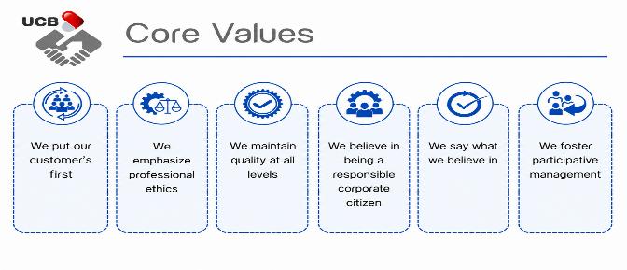
United commercial bank PLC (UCB) is a pioneering first generation private commercial bank in Bangladesh and it was founded with specific and sustainable philosophy. The bank as envisioned in its Vision aims to be the Bank of the first choice by maximizing value to our clients, shareholders and employees and contributing to the national
Figure 2.1: UCB Core Values

economy with social commitments. The vision is implemented by its own Mission which is to provide financial solutions that will create, manage and grow the wealth of our clients, as well as enhancing the lives of the communities we serve.
Based on a list of uncompromising Core Values, UCB has embarked on its journey in mid-1983. A consortium of dynamic entrepreneurs, renowned industrialists, and the Bangladesh Government launched it with an initial paid-up capital of BDT 35.50 million(“United Commercial Bank (Bangladesh),” 2026). Since its birth, the aim of the bank was customer service excellence, with both the economic contribution and social commitment.
UCB has over the course of its 42-year history developed into a diverse financial conglomerate. As of December 31, 2024, the bank has established one of the largest networks of private sector banks, having established 231 branches, 177 sub-branches, and 855 agent banking outlets(United Commercial Bank (UCB), 2024). UCB has made a remarkable imprint on the private sector banking industry by providing a personalized service, creative strategies, a dynamic problem solving attitude and effective administration, showing a firm dedication to the economic development of the nation.
True to its mission of wealth management and creation, UCB has diversified its operations by having five wholly-owned subsidiaries:
- UCB Stock Brokerage Limited (Stock brokerage services)
- UCB Investment Limited (Merchant banking)
- UCB Asset Management Limited (Institutional/individual fund management)
- UCB Fintech Company Limited (Mobile financial services under the brand "Upay"
- UCB Exchange (SG) PTE. Ltd. (Remittance business in Singapore)
Another way through which the leadership of the bank has extended its services is in Shariah compliant banking through the establishment of UCB Taqwa, which is an extension of its core value of placing the customers first by supporting various financial requirements. UCB has a long history of being listed on the Dhaka Stock Exchange (DSE) since 1986 and the Chittagong Stock Exchange (CSE) since 1995, making it one of the leading listed companies in Bangladesh. Its success is rooted in a relationship-driven heritage that uses advanced CRM and digital tools to personalize services, while acting as a catalyst for entrepreneurship by providing collateral-free startup loans and dedicated support for women-led MSMEs. Its path has been marked with a steady pursuit of a balance between profitability and social responsibilities, through financing the RMG sector in the country, leading the way on green banking, all in its quest to become the Bank of the first choice

.

2.1.2 Trend and Growth

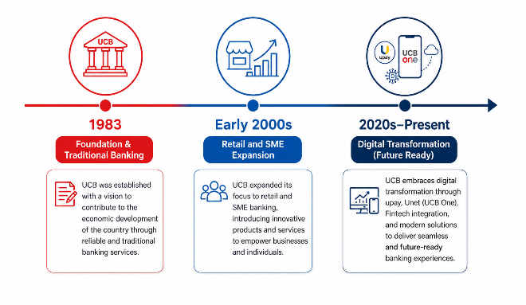
- Historical Growth Timeline: The timeline above visually shows the significant milestones in the development of UCB Bank- since its creation in 1983, the digital
Figure 2.2: UCB Journey
transformation of the bank in the 2020s(United Commercial Bank (UCB)). Every period of the timeline marks a drastic change of the UCB in its strategic priorities, operational focus, and market direction. UCB PLC is at the forefront of digital banking, offering online platforms and mobile applications that streamline financial transactions for RMG businesses. UCB offers a comprehensive suite of services to its RMG customers from a single point of contact. Continuing on this development, the subsequent analysis describes the way UCB has developed over the years due to expansion, innovation and diversification of its services. Combined, these stages indicate the steady growth trend of the UCB Bank, as it advances through the traditional banking background to the current digital transformation staged with the help of strategic investments, diversification of the products, and customer-driven innovation.

- Performance Evolution:
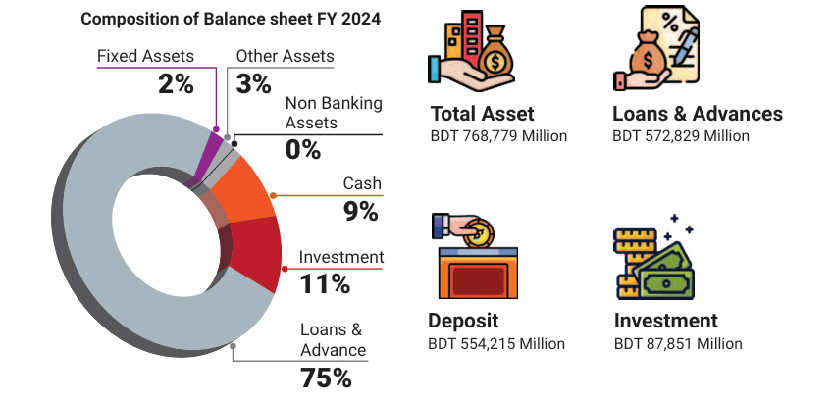
Figure 2.3: Financial Insight of UCB PLC
According to UCB Annual report 2024, the bank experienced strong deposit growth, with deposits increasing by approximately BDT 5,245 crore, indicating gained customer trust. Then their total assets stood at almost BDT 768,779.48 million, demonstrating expansion in lending, investment activities, and overall business operations(United Commercial Bank (UCB), 2024 ) . UCB maintained profitability though there were economic pressure. Moreover, the bank has significantly expanded its digital footprint. The number of active users of it digital banking platforms increased consistency, indicating a shift toward technology-driven service delivery.
- Peer Comparison of Financial Performance, 2024

Table 2.1: Peer Comparison of Key Financial Indicators, 2024
Source:(United Commercial Bank (UCB), 2024)
The table above shows a comparison of UCB and its peers based on key financial performance indicators for 2024: UCB's loan growth, deposit growth and balance-sheet growth were moderate, as was its operating profit which also made significant strides. However, the bank's PAT growth was negative while the earnings per share were very low as compared to the peers, indicating relatively poor asset quality and profitability as reflected by the relatively high NPL ratio. Additionally, UCB's CRAR is less than some of its competitors, signifying a reduction in its capital cushion and the capacity to absorb losses. Finally, the comparison shows that continued improvement in operations occurred at UCB, while financial pressures stemmed from asset quality and capital adequacy concerns remained.
However, the bank sometimes face difficulties such as maintaining profitability under macroeconomic pressure and improving service efficiency in high-demand areas.
- Strengthening Risk Management and Government Frameworks: UCB has been working on strengthening its risk management and government framework. The bank has taken the most up-to-date risk assessment modelling, enhanced its internal control system and has even adhered to the regulatory directives issued by the Bangladesh Bank(Bangladesh Bank). All this work has added up to a healthy finance, and reduced the credit risk of the institution and enhanced the transparency of the institution as a whole. The presence of good governance also has increased the stakeholder confidence and sustainable business development.
- Improving Customer Experience & Service Quality: UCB has done a great job of being very customer centric when provisioning services. In a bid to make banking more convenient and speedy, the bank has been actively investing in digital banking channels, digital platforms, automation and modernization of processes. It is not only that mobile banking apps have enhanced the quality of services, but also ATM services and easier account management have done wonders. This has helped to enhance customer satisfaction, thereby improving customer retention and gaining a competitive edge in the banking industry.

2.1.3 Products, Services & Customer Mix
United Commercial Bank PLC (UCB) provides a broad range of banking products and financial services to cater to various customer groups including retail customers. There are several types of businesses or firms that SMEs can be: Corporate organizations, high net worth individuals, women entrepreneurs and non-resident Bangladeshis (NRBs) (Products & Services - United Commercial Bank (UCB)). The bank's products and services are tailored to support its efforts to be customer-centric and assist with its digital transformation and financial inclusion goals.
Retail Banking Products and Services
This is one of the major operational segment of UCB. Bank provides different types of deposit schemes, loan products to individual customers to support savings, investment, and personal financial management.
The major segments of UCB's primary banking services are:
Deposit & Loan Products |  | Services
Savings Account | Personal Loan | Locker Service
Current Account | Home Loan | SMS Banking
UCB Shadhin Savings Account (designed for students and young customers) | Auto Loan | Internet Banking
Fixed Deposit Receipt (FDR) | Education Loan | Mobile Banking
Money Maximizer Deposit Scheme | Corporate Loan | ATM Services
Deposit Pension Schemes (DPS) | SME Loan
Table 2.2: Retail Banking Products and Services
It is aimed at individual customers to secure their financial needs on a day-to-day basis and to encourage savings.
Card Division Products and Services
The card division is an important part of UCB’s retail banking operations. The bank offers various debit and credit card products to support cashless and digital transactions.
Card Products | Card Services
Visa and MasterCard Debit Card | Online Payment Facilities
Credit Card (Classic, Gold, Platinum, Signature) | ATM and POS Transactions
Prepaid & Business Cards | Card Activation and PIN Generation
Priority Pass | Online Payment Facilities
 | OTP Authentication and Transaction Alerts
Table 2.3: Card Division Products and Services
The expansion of card services reflects the increasing demand for digital payments and modern banking facilities in Bangladesh.
Corporate Banking Products and Services
UCB provides a comprehensive range of corporate banking products and financial solutions to support business operations and industrial development.
Corporate Products | Corporate Services
Term Loan | Letters of Credit (LCs)
Corporate Deposit Schemes | Treasury and Cash Management Services
Working Capital Finance | Offshore Banking Services
Project Financing | Treasury and Cash Management Services
 | Import and Export Financing
Table 2.4: Corporate Banking Products and Services
These services support domestic and international business activities and contribute significantly to economic growth.
SME and MSME Banking Products and Services
Small and Medium Enterprise (SME) banking is an important focus area for UCB. The bank offers specialized financial products and services to promote entrepreneurship and business development.
SME Products | SME Services
SME Term Loan | Business Advisory Support
Cash Credit Facility | Trade Financing
Overdraft Facility | Digital Banking Facilities for SMEs
Agricultural Loan
Women Entrepreneur Loan
Table 2.5: SME and MSME Banking Products and Services
This segment contributes to employment generation and economic development in Bangladesh.
Islamic Banking Products and Services (UCB Taqwa)
UCB operates Islamic banking services under the brand name UCB Taqwa, offering Shariah-compliant financial products and services.

Islamic Banking Products | Islamic Banking Services
Mudaraba Savings Account | Shariah-based Financing
Islamic Fixed Deposit Scheme | Islamic Investment Management
Islamic Investment Products | Islamic Trade and Business Services
Islamic Trade Finance Products
Table 2.6: Islamic Banking Products and Services
The Islamic banking segment has experienced steady growth due to increasing customer demand for interest-free banking solutions.
Digital Banking Products and Services
UCB has significantly invested in digital transformation to improve service efficiency and customer convenience.
Digital Products | Digital Services
Upay Wallet (Mobile Financial Service Account) | Real-Time Fund Transfer
UNet, UCB One Internet Banking Access | E-KYC Account Opening
UClick Mobile Banking Platform | Online Banking Transactions
 | E-commerce Payment Gateway
 | Mobile Recharge and Bill Payment
Table 2.7: Digital Banking Products and Services
These digital services support the bank’s strategy of promoting technology-driven banking and cashless transactions.
UCB AYMA – Women Banking Products and Services
UCB AYMA is a specialized banking initiative designed to support women empowerment and financial inclusion.
AYMA Products | AYMA Services
AYMA Savings Account | Dedicated Banking Facilities for Women
AYMA DPS | Debit and Credit Card Facilities
Dipti SME Loan | Digital Banking Access
Jyoti Overdraft Facility | Lifestyle and Merchant Discounts
Table 2.8: Women Banking Products and Services
This initiative aims to encourage women entrepreneurship and financial independence.
UCB Imperial – Priority Banking Products and Services
UCB Imperial is the bank’s premium banking segment for high-net-worth individuals.
Imperial Products | Imperial Services
Imperial High-Yield Savings Account | Dedicated Relationship Manager
Premium Deposit Products | Priority Banking Services
Wealth Management Solutions | Airport Lounge Access
 | Exclusive Lifestyle Benefits
 | Premium Debit and Credit Card Services
Table 2.9: Imperial – Priority Banking Products and Services
These services provide personalized financial solutions and exclusive banking experiences for premium customers.

2.1.4 Customer Mix
UCB serves a diversified customer base, which supports balanced growth and revenue stability. The major customer groups include:
- Retail Customers
- Corporate Clients
- SME and MSME Clients
- Women Entrepreneurs
- High-Net-Worth Individuals
- Rural and Unbanked Population
- Non-Resident Bangladeshis (NRBs)
This diversified customer segmentation enables UCB to maintain market competitiveness and expand its operational reach across different economic sectors(United Commercial Bank (UCB)).

2.1.5 Company Operations / Activity
The company, United Commercial Bank PLC (UCB) conducts its operations under an integrated operation framework which integrates traditional banking operations with a technology driven infrastructure. The bank has a predetermined way of doing business in order to provide efficient service, adhere to regulations and satisfy customers in all banking sectors.
Operational Framework
UCB operates through several divisions namely, General Banking, Credit, Foreign Exchange, Card Division, Treasury, Information Technology, Human Resources and Risk Management(United Commercial Bank (UCB), 2024). These divisions are interdependent and ensure that the banking operations run smoothly and there is effective coordination between the branches and service channels. To prevent structural overlap with product offerings, UCB’s operations focus on how services are managed rather than what is sold.
Figure 2.4: UCB Centralized Operational Flow Model

Branch and Distribution Network
The bank has a wide network of branches, sub-branches, ATMs booths, agent banking points and digital services throughout Bangladesh. This network will allow UCB to deliver banking services to customers in urban and rural areas and will help UCB to promote financial inclusion.
Technology Integration
UCB uses the latest core banking systems, automation tools, centralized data sources and cybersecurity to boost operational efficiency. The bank has rolled out digital platforms and automated operational processes to enhance transaction processing speed, ensure secure banking operations, and provide better customer experience.
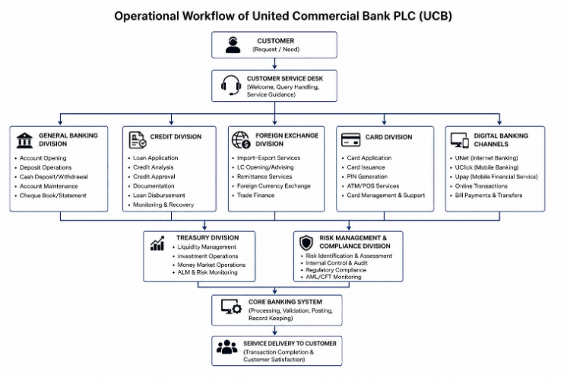
Management and Organizational Structure
Figure 2.5: Operational Workflow of UCB PLC
UCB has a hierarchy of management from the Board of Directors to the Managing Director & CEO, senior management, divisional management, branch management to operational staff. This provides accountability, effective supervision and efficient decision making within the organization
Risk Management and Compliance
The bank has an effective risk management and compliance regime in place to manage its operational, financial and cyber risks. UCB has taken all the guidelines and banking principles from the Bangladesh Bank and international banking practices to ensure transparency, financial stability and sustainable operation.
Service Quality and Customer Experience Management
UCB has established a dedicated Service Quality Department (SQD) to monitor customer experience, complaint handling, and service delivery standards across the bank. The department works to improve customer satisfaction through complaint management, mystery shopping evaluation, Net Promoter Score (NPS) monitoring, and service process improvement(United Commercial Bank (UCB), 2024).
According to the UCB Annual Report 2024, the SQD performs:
• Complaint management and resolution
• Regulatory compliance monitoring
• Mystery shopping evaluation
• Training and coaching
• Root cause analysis for service improvement
The bank also utilizes multiple complaint channels including:
• Call center
• Website
• Branch complaint box
• Email
• Social media platforms
These systems improve operational responsiveness and customer relationship management.
Subsidiaries and Associated Companies
UCB has multiple subsidiaries and associated companies for the various business activities it engages in, such as UCB Stock Brokerage Limited, UCB Investment Limited, UCB Asset Management Limited, UCB Fintech Company Limited (Upay) and UCB Exchange (SG) PTE Limited.
UCB's operational structure is a good support for the bank to continue being efficient, on a good control, technologically adaptive and customer-oriented banking in a very competitive banking sector.

2.1.6 SWOT Analysis
The SWOT analysis of United Commercial Bank, PLC highlights the strategic position of the Bank in the competitive banking sector of Bangladesh. UCB is one of the most established and market-shaping private commercial banks, offering a wide range of banking products and services, and having developed digital capabilities. But the bank is also under pressure in a time of industry competition, governance issues and financial duress as it undergoes the current banking sector restructuring.
Strengths of UCB PLC.
- Strong Brand Reputation and Nationwide Network- UCB was founded in 1983 and has earned a great reputation and customer base in the banking sector in Bangladesh. The bank has over 230 branches and sub-branches throughout the country and thus can effectively cater to its retail, SME, corporate and trade finance customers. It has a strong branch network, which helps facilitate easy access to customers and nationwide business operations.
- Digital Banking- A key strength of UCB is its expanding digital banking capacity as it has developed its mobile financial service platform UPAY and UCB One. These platform has seen a surge in the number of customers and transactions, in line with the government's dream of a cashless and digitized economy. UCB also offers internet banking, mobile banking, ATM services and card-based payment systems to enhance customer convenience and service efficiency.
- Diversified Banking & Financial Services- UCB operates in various banking segments with its retail banking, corporate banking, SME financing, offshore banking, trade finance and priority banking segments represented by its subsidiary UCB Imperial. Further, the bank's other businesses such as brokerage, investment and asset management generate diversified revenue streams other than loans.
Weakness of UCB PLC.
- High Non-Performing Loans (NPL) - The major drawbacks of UCB are high level of classified and non-performing loans. The NPL problem has led to higher provisioning needs and adverse impact on profitability, liquidity, and capital adequacy. It also reflects the shortcomings of the existing credit risk management and loan recovery systems.
- Declining Profitability and Provisional Shortage- UCB's financial performance took a dramatic turn for the worse in recent years because of greater provision for bad debts. There were also shortfalls in provisioning and capital resulting in pressures on dividend declarations, confidence of the shareholders and long-term financial stability at the bank.
- Governance and Service Efficiency Challenges- The bank's reputation and customer trust have been impacted by past governance failures, management inefficiencies and operational constraints. Moreover, the bank still faces operational challenges like delayed complaint handling, system downtimes and quality of customer service.
Opportunities of UCB PLC.
- Expansion of Digital Banking- With the growing penetration of smartphones, Internet services, and digital transactions in the society, UCB is good to have scope to extend its internet banking, mobile banking, and fintech based financial services such as Upay and UCB One. The digital banking can help cut down the operational cost and enhance customer service and speed.
- Growth of SME, Green, and Islamic Banking- The demand for SME financing, sustainable finance, women entrepreneurship financing, Islamic banking services are growing which can be a huge business opportunity for UCB. Bangladesh Bank's policy intervention for green banking and financial inclusion is also conducive to future expansion possibilities.
- Governance Reform and Capital Strengthening- UCB can benefit from opportunities for transparency, operational efficiency and investor confidence arising from recent restructuring of the board and professional management efforts. Capital reinforcement programs can help boost the bank's financial health and aid in the bank's long-term recovery.
Threats of UCB PLC.
- Regulatory and Financial Pressure- Bangladesh Bank's stricter loan classification and provisioning policy is in accordance with international standards. A continuing challenge to UCB's profitability and capital management is the regulatory requirements.
- Intense Industry Competition: The private commercial banks such as City Bank, Eastern Bank PLC and the other major banks that are competing with UCB through digital banking, card services, customer experience and product innovation. At the same time, digital financial service companies such as bKash and Nagad, and fintech firms are contributing to non-swansong competition in the field of digital financial services.
- Macroeconomic & Cybersecurity Risks- Banking sector risks remain high due to inflation, exchange rate volatility, liquidity tensions and economic uncertainty. The fast-growing digital banking services also means greater exposure to cybersecurity risks, online fraud, and data security risks.
In general, United Commercial Bank PLC has a solid market presence, has spread wide-ranging banking operations and has enhanced its digital banking capability with Upay and other banking technology-based services. The bank is now in a difficult restructuring phase, however, with a high proportion of NPLs, provisioning pressures and governance issues. Thus, UCB's long-term sustainability will largely rely on financial stability, governance enhancement, customer service efficiency and the ongoing implementation of digital transformation programs to stay competitive in a changing banking landscape in Bangladesh.

2.2 Industry Analysis
In this industry analysis, the banking sector in Bangladesh as a whole is analyzed in detail, including the United Commercial Bank PLC. The analysis is based on the prevailing economic, regulatory and technological scenario in Bangladesh in 2024-2025 and captures the key industry trends impacting the banking operations and efficiency of customer service.

2.2.1 Specification of the Industry
The financial sector of the Bangladesh is one of the most important sectors of the national economy and is the backbone of the financial system of the country. The industry plays important roles like deposit mobilization, credit allocation, trade financing, remittance management and investment facilitation. The capital market in Bangladesh is still comparatively underdeveloped and therefore, financial intermediation and business financing relies heavily on banking sector. It is under the supervision and regulation of Bangladesh Bank, which is the central bank of the country and is responsible to ensure monetary stability, regulation of financial institutions and sound banking practices. Bangladesh’s banking ecosystem is composed of 61 scheduled banks, classified into four key categories(Banking Industry in Bangladesh, 2025):
State-Owned Commercial Banks (SOCBs): Government-run institutions focusing on public welfare and rural financial access.
Private Commercial Banks (PCBs): The most dynamic players, known for innovation and customer-centric services.
Foreign Commercial Banks (FCBs): Institutions serving multinational corporations and facilitating cross-border trade.
Specialized Banks: Targeted banks focused on specific sectors like agriculture and industry.
As of 2024, the banking sector’s total assets have exceeded $180 billion, contributing around 3.5% to the national GDP. A major achievement has been a notable increase in financial inclusion—with more than 60% of adults now accessing formal banking services, largely through mobile banking platforms. The banking sector has been evolving into a technology-driven sector as digital banking, mobile finance, online payments, and card payments have grown in recent years. To stay competitive in the changing financial landscape, banks are increasingly investing in technological innovation, service quality, customer relationship management and operational efficiency.

2.2.2 Size, Trend, and Maturity of the Industry
As of 2024, the banking industry of Bangladesh has become one of the largest contributors to the country’s financial and economic activities. The sector is made up of about 61 scheduled banks, of which over 11,000 branches are spread throughout the country. The assets of the banking sector were more than USD 180 billion, and played a key role in the national economic development and GDP.
The industry is in a late-maturity phase in terms of institutional growth, client reach and product offering. The sector is currently in a process of extensive restructuring, however, as pressure increases on the financial markets, governance changes and interventions by the regulators to enhance financial stability and transparency of operations.
The one trend that stands out is digital transformation in the industry. Internet banking, mobile application, ATM services, QR payments and online fund transfer system are becoming the go-to choices for customers, rather than their branch banking counterparts. The advent of mobile financial services like bKash, Nagad and Rocket has helped drive the pace towards "cashless" and "branchless" banking. Likewise, the United Commercial Bank PLC has developed its own digital financial services platform – Upay, which it uses to boost the availability and convenience of digital banking.
Expansion of agent banking is another pertinent trend that has further proved to enhance financial inclusion by providing financial services to the rural and underbanked. Customers can now deposit and withdraw funds, and make remittance payments and payments to utilities without going to a physical bank branch.
The regulatory environment on loan classification, capital adequacy and governance standards is also becoming more demanding for the industry. The banking system has revealed itself to be more vulnerable to non-performing loans (NPLs) with the implementation of international frameworks like Basel III. The central bank has, therefore, pushed for restructuring efforts, such as mergers and acquisitions, to strengthen the financial health and sustainability of the sector.
In the overall picture, the banking sector of Bangladesh is matured but is going through a continuous transformation due to digitalization, regulatory changes, and customer friendly financial services.

2.2.3 Industry SWOT Analysis
Strengths
- Large Domestic Market- The banking sector in the country, Bangladesh is enjoying the advantage of having a huge population base, and many people are unbanked or underbanked. This gives banks ongoing opportunities to extend their reach, to grow deposits and to drive financial inclusion and play a role in rural–urban financial inclusion.
- Strong Remittance Inflow- Foreign remittances are million dollars in inflow to Bangladesh every year from the expatriate workers. These remittances boost the liquidity of the banking system, build foreign currency reserves and deposit growth of commercial banks.
- Growth of Digital Banking- The fast pace of digital banking development. Great progress has been made in digital banking services in the industry such as internet banking, mobile apps, online fund transfers, ATM networks, and real-time payment systems. Mobile financial services like bKash and Nagad have paved the way to cashless payment system and branchless banking.
- Expansion of Agent Banking- This is the expansion of Agent Banking. In rural or semi-urban areas where the presence of the traditional bank is limited, agent banking has facilitated access to financial services. This increase has bolstered financial inclusion and given banks new business lines.
- Growth of Islamic Banking- The growing preference of Islamic financial services has fostered growth of Islamic banking operations. Hence, Islamic banking windows are being established by many mainstream banks as a new segment to draw this market.
Weaknesses
- High Non-Performing Loans (NPL) - High rate of NPS is one of the major weaknesses of the banking sector. The high NPLs result in loss of profitability, loss of liquidity, increase in provisioning and shrink in the banks' capital adequacy.
- Governance and Compliance Issues- Some banks have low corporate governance and political influence in loan approval process, and have weak risk management practices. All of these have a negative impact on transparency and public confidence in this industry
- Liquidity Pressure- Poor asset-liability management, high concentration risk of loans and economic volatility are some of the reasons that make several banks have liquidity crunch. Stress on liquidity makes it less able to lend and/or flex operations.
- Operational Inefficiency- Slow customer service, long waiting time, delayed complaint processing and ineffective operational systems are still some of the operational inefficiencies that many banks are still struggling with. These are the areas which the company is lacking, which directly affect the customer satisfaction and the quality of service.
- Cybersecurity Vulnerabilities- Banks are increasingly adopting digital banking services and it puts them at risk of cyber threats, online fraud, phishing attacks, and data security risks. There are still banks that don't have the advanced cybersecurity infrastructure and monitoring systems.

Opportunities
- Fintech Integration & Digital Banking- The widespread adoption of smart phones, internet services and e-commerce opportunities provide opportunities for banks to enhance their digital banking platforms, online transactions and fintech collaborations. Technology can be utilized to enhance the efficiency and customer convenience of financial services.
- Agent Banking Expansion- Agent banking offers cost-effective service to the rural and previously unbanked, whether in terms of operating costs or geographical reach. This helps to foster financial inclusion and customer expansion.
- Growth of SME Financing- Finance for Small and Medium Enterprises (SMEs) is still one of the fastest growing segments in the banking sector. To boost the revenue generation and business expansion of banks, Bangladesh Bank has urged banks to expand their lending to SMEs, which have immense potential.
- Islamic Banking Development- Due to the growing demand for Islamic banking products, Islamic banking opportunities are available for banks to grow their Islamic banking products and diversify their customer base. The concept of green banking and sustainable finance.
- Green Banking and Sustainability- The concept of green banking and sustainable finance. Growing awareness of environmental sustainability and social responsibility has led to the opportunities for sustainable investment projects, women entrepreneurship financing, green banking and renewable energy financing.
Threats
- Intense Industry Rivalry- Bangladesh has a very competitive banking sector as there are numerous private commercial banks in the market. Pressure on profitability and market share is coming from banks' competition based on interest rates, digital services, card facilities and service quality.
- Threat of Substitutes- The mobile financial service providers are on the rise, offering services that resemble traditional banks, for example, bKash and Nagad. Fintech and digital wallets limit their customers' reliance on branch banking. The unstable economy and inflation.
- Economic Instability and Inflation- The inflation, exchange rates fluctuation, and the economic uncertainty are all factors that drive up the borrowing rate and default risk in the banking sector. All of these have a negative impact on lending and the ability of customers to repay loans.
- Regulatory Pressure- Banks have to follow the many regulations set by Bangladesh Bank in the regard of capital adequacy, provisioning, anti-money laundering and loan classification standards etc. Operational flexibility can be lost due to compliance costs and pressure.
- Cybersecurity and Fraud Risk- Digital financial services are becoming more common, posing a greater risk of hacking, online fraud, and phishing attacks and data breaches. Cyber security continues to be one of the biggest risks in contemporary banking operations.

CHAPTER 3: INTERNSHIP EXPERIENCE

3.1 Position, Duties, and Responsibilities
During the internship period at United Commercial Bank PLC Uttara Branch, I worked in the General Banking and Card Service division. The internship experience provided practical exposure to customer service operations, digital banking support, card services, and operational workflow management.
While working as an intern, responsibilities assigned for helping customers, providing a support to the banking operations and help the employees perform their service activities efficiently. The assigned roles were tightly related to the dimensions of the customer service as part of the questionnaire survey, due to the study's focus on the efficiency of customer service.
Major Duties & Responsibilities
- One of major responsibilities was assisting customers at the front desk regarding account services, cheque books, ATM cards and digital banking support.
This hands-on experience was used to gain insight into the effectiveness of customer guidance in minimizing customer waiting time and enhancing service quality.
- Assistance was provided during the account opening process through:
- Verifying KYC documents
- Assisting customers in filling up forms
- Checking required documentation
- Providing guidance on account processes
- Support was provided to employees during customer transaction processing activities including deposits, encashment and pay order services.
Operational support also included organizing documents and maintaining workflow during busy hours
It facilitates operational coordination, minimizing service delays and enhancing transaction accuracy.
- In the card service sector part I was assigned for
- Assisting customers with debit & credit card application
- Guiding customers regarding card activation and PIN generation procedures
This experience brought to light the significance of prompt card services in enhancing consumer satisfaction and the convenience of banking.
- Customer Guidance and Problem Handling Support. The branch was very busy with customers coming in to discuss problems relating to:
- Card activation problems
- Transaction errors
- Documentation confusion
- ATM-related difficulties
Information was given to assist customers in contacting the right service representatives. This experience was a demonstration of the impact of excellent customer support on customer satisfaction and trust in banking activities.

3.2 Training & Development
The internship program facilitated hands on learning about the banking operations, compliance process, and digital banking system and customer service management.
The training was mainly through observation and accompanied by hands-on experience.
Core Banking System (CBS) Learning
Practical experience was also obtained with the Core Banking System, which is applied to:
- Customer account verification
- Transaction monitoring
- Customer information management
The CBS is an important part of the integrated banking services in the branches.

KYC and AML Compliance Training
Learning outcomes achieved about:
- Know Your Customer (KYC)
- The Anti Money Laundering (AML) procedures are the procedures which are implemented to prevent financial fraud.
- Customer verification standards
Compliance activities are necessary in order to minimize the occurrence of fraud and ensure the security of the operation.
Customer Service Training
Through observations of expert officers, knowledge was gained about:
- Customer communication
- Complaint handling
- Service delivery techniques
The service quality perception of the professional employee behavior has a great effect.
Digital Banking and Card Service Learning
Practical knowledge was gained on:
- ATM operations
- Card activation systems
- PIN generation procedures
- Mobile banking services
The experience highlighted the increasing importance of technology-based banking services.

3.3 Contribution to Organization / Operations
United Commercial Bank PLC Uttara Branch was the place where I did my internship, and in that period, several contributions were made to assist in the daily banking activities and customer service. Before customers approached service desks, they were helped to complete forms, understand banking processes, and compile necessary paperwork. This assistance was found to be helpful in minimizing the waiting periods for customers while assisting in improving the efficiency of banking services during peak customer loads. Assistance was also given in the areas of opening an account, opening a card and providing information on digital banking. Customers were provided guidance on how to use the UCB ONE mobile banking application, ATM services, SMS banking and how to activate their card. The activities enabled customers to gain insight into the self-service banking channels and thus minimized the dependency on manual services. Furthermore, support was offered in arranging customer documents and keeping the operational flow in order at busy periods. This helped staff complete their daily work activities and ensured efficient and effective coordination between their work activities in the branch. Though the internship period was short, these activities helped in making the branch more convenient, efficient and quality in the provision of services to customers.
I also performed a Customer Service Efficiency Survey to gauge customers' satisfaction with banking services, in addition to the operational support. The survey was carried out using a systematic survey technique and a structured questionnaire was used on Google Forms with 5 Likert scale.
The survey aimed to use SERVQUAL Model to measure the customer perception of the service quality dimensions: reliability, responsiveness, assurance, empathy and tangibility.
The findings from the collected data facilitated the identification of customers' satisfaction level, the strengths and gaps of the bank's services. This contribution was extremely helpful in understanding the areas that need improvement to increase the efficiency of service to the customers and overall customer satisfaction.

3.4 Evaluation (SERVQUAL Analysis)

3.4.1 Introduction to SERVQUAL Model
The SERVQUAL Model is one of the most popular service quality measurement models that emerged to measure the customer's expectations and perceptions about the service quality offered by the organization. The model has five dimensions of service quality(“(PDF) SERVQUAL,” 1988).
Tangibility- Tangibility is related to the physical features of the banking facilities, equipment, technology, employees, ATM booths and digital platforms.
Reliability- Reliability is the ability of a bank to provide services as promised without mistake.
Responsiveness- Responsiveness refers to employee responsiveness to the request, complaints, and service related issues that customers raise quickly and efficiently.
Assurance- Assurance is a combination of professionalism, security, trustworthiness and the confidence customers have in employees and banking services.
Empathy- Empathy is personalized attention, care and understanding that is given to customers by employees at the bank.
In order to analyze the customer satisfaction and to find the gaps in banking operation, the SERVQUAL model was used in this internship report.
Mapping SERVQUAL dimensions as follows:
The survey questionnaire has been broken down into the SERVQUAL dimensions to assess various components of customer service quality(Ananth & Ramesh, 6 December, 2010).
SERVQUAL Dimension | Survey Focus Area
Tangibility | ATM facilities, branch environment, mobile banking performance
Reliability | Transaction accuracy, timely service delivery
Responsiveness | Waiting time, complaint resolution speed
Assurance | Employee professionalism, customer trust, transaction security
Empathy | Ease of account opening, personalized customer support
Table 3.1: SERVQUAL Dimensions

3.4.2 Complaint Management Analysis
During the year, a total of 6,391 complaints were received, and 100% of them were addressed. Of these, 62.85% were solved in less than 7 days, 20.05% in 8-14 days and 17.10% took more than 14 days to deal with(United Commercial Bank (UCB), 2024). This means that there was a high level of responsiveness in the complaints handling process with no complaints left unsolved. The overall turnaround time (TAT) was satisfactory, with a proportion of complaints being resolved after 14 days indicative of some cases needing longer investigation or co-ordination. Operational efficiency: High resolution rate is indicative of good complaint management, but there is scope to reduce resolution time and speed up service.

3.4.3 Complaint Category Analysis
Based on the complaint category analysis, the percentage of Card & ATM related complaints was 52% of the total complaints, while the percentage for General Banking complaints was 35.6%(United Commercial Bank (UCB), 2024). This suggests that the most common type of complaints was related to cards, perhaps as a result of growing customer reliance on electronic banking channels and ATM transactions. A large percentage of these complaints indicates that service reliability in card and ATM transactions is still a major concern in need of resolution. The large proportion of complaints about general banking, meanwhile, continues to highlight the ongoing role of the quality of the day-to-day service in bank branches.

3.4.4 Mystery Shopping Analysis
A total of 224 branches were rated and 72% of them passed while the remaining 28% needed improvement (United Commercial Bank (UCB), 2024). The results indicate that, overall, the level of service consistency was found to be acceptable throughout the branch network with most branches providing a satisfactory level of service. However, the percentage of branches that need improvements shows that there are service gaps at the branch level which could potentially impact overall customer experience. The findings also indicate that employee professionalism needs to be a focus as part of ongoing development, especially with regards to the behavior of the employees in the service, the quality of the communication and the ability to meet customer service standards in all branches.

3.4.5 Customer Experience & NPS
UCB uses Net Promoter Score (NPS) as a key indicator to measure customer satisfaction and loyalty.
This can be useful for the bank to know the percentage of customers that are likely to recommend their services, helping to foster customer retention. It also facilitates ongoing satisfaction monitoring enabling management to pinpoint strengths and deal with service weaknesses in a timely way. Overall, NPS is a customer-centric approach that ensures customers' feedback is at the heart of improving services and managing relationships.

Overall Efficiency Evaluation
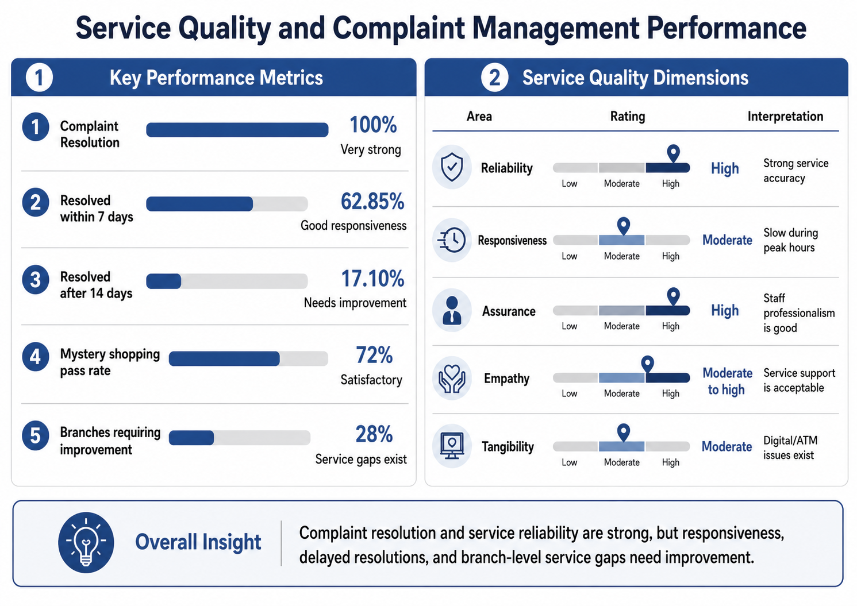
Overall, the effectiveness of UCB is rated as average with some areas of service being more effective than others.
Figure 3.1: Service Quality and Complaint Management Performance
The complaint management data reveals the handling of 6,391 complaints, with a resolution rate of 100%, indicating the bank's steadfast dedication to service recovery and management. Meanwhile, only 62.85% of complaints were settled in under 7 days and 17.10% in over 14 days, suggesting that while the bank is responsive, it is not necessarily quick enough to maintain a consistent level of service to customers. This translates to the bank's performance to be good in resolving problems, albeit the time to resolve such problems is still a bit slow, which is needed to enhance the overall efficiency.
The mystery shopping findings confirm this finding. In the 224 branches assessed, 72% passed and 28% needed improvement, indicating that although service standards are kept in many branches, this is not yet consistently throughout the network. The importance of this branch-based variation is that it indicates how the service standards will be applied by the employees in real interactions with customers, in addition to the policies they have. That is, the operational structure of the bank is good, but the operational quality is not uniform across branches.
The operational patterns are explained further from the SERVQUAL survey results. Customers' satisfaction level was high, particularly in terms of the reliability of core banking functions such as transaction accuracy and error-free service delivery. Assurance also garnered favorable ratings, with customers rating their professionalism, security and courtesy. The two dimensions suggest credibility and the customer's trust in the bank, which is considered one of the most important dimensions in the service quality of the banking sector.
But the shortcomings were sensitivity and, to some degree, tangibility. Lower ratings were allocated for responsiveness due to long wait times, slow problem solving and delays at busy times. Some also said they had experienced minor technical difficulties with digital banking – this impacted their view of tangibility and convenience of service. This implies that the key difference in efficiency is not in terms of accuracy or professionalism, but in the speed and ease with which services are provided when under pressure.
These findings are practically related through the internship observations. Systems were very busy during peak times, which put stress on staff, and during busy times there was not enough staff available to attend to multiple customer enquiries in a timely manner. Service speed was also impacted by delays in the system caused by software, ATM and internet banking. The reason for the customers being satisfied with the staff's behavior, but not with the waiting time and the way complaints were dealt with, is the above operational constraints. So, it is not that staff aren't working hard enough; it is more that there is a combination of workload pressures, process delays and mismatch in staffing at the branches.
Taken together, the evidence shows that UCB is efficient in structure but still improving in execution. The bank demonstrates strong complaint resolution, reliable transaction handling, and good employee professionalism, all of which support customer confidence. Yet the data also shows that operational efficiency can be improved further through faster complaint resolution, stronger peak-hour staffing, better system stability, and more consistent branch-level service delivery. Thus, UCB should be considered a bank with solid service foundations and clear potential for higher efficiency through process refinement and better standardization.

3.5 Skills Applied
These skills were learnt and practically applied during my internship at United Commercial Bank PLC and the activities conducted under customer service, were the result of applying the SERVQUAL model to analyses the level of service:
The use of Academic Knowledge: The information I have attained in the course of finance, banking, and management will be used to familiarize myself with the process of opening accounts, clearing cheques, transfers of funds, and paperwork.
Customer Service and Communication Skills:
I developed skills in communication through direct interaction with customers on account opening, banking services, card related issues, and transaction inquiries. Developed professional communication skills and positive customer relationships in a banking setting.
Banking Operations Knowledge:
The banking internship gave a practical experience of banking operation such as deposits, withdrawals, pay order, account opening, services of bank cards, operation of ATMs and digital banking. Learned how businesses in a general banking and card division work.
Gained experience collecting data and managing surveys:
I got hands-on experience in designing a Google Form and a structured questionnaire with a 5-point Likert Scale with which I conducted a Customer Service Efficiency Survey. Learned how to systematically gather customer responses, and also be accurate while gathering data.
Analytical/Research Skills:
Analytical skills were developed by analyzing customer satisfaction data using the SERVQUAL Model. I gained knowledge on how to detect service deficit, understand customer expectations and how to interpret the results of reliability, responsiveness, assurance, empathy and tangibility.
- Problem-Solving Skills:
On my internship I witnessed several customer service issues including delays with the wait, card delivery issues, and transaction-related customer complaints. I developed an understanding of how bank staff resolve customer issues and offer solutions that are effective in an operational environment.
- Technical Skills
I acquired hands-on experience in debit and credit card functioning, card activation, pin generation system, ATM functioning, POS transactions and mobile banking application like UCB One. I also learned about banking security features like OTP verification and transaction alerts.
- Teamwork & Coordination Skills:
I developed effective working relationship with bank officers and other bank personnel for facilitating smooth banking operations. I gained more knowledge of how to coordinate activities, take instructions and participate in team-based tasks in a professional setting through my internship.
- Time Management Skills:
The internship helped me to learn how to work under a stress environment in the banking sector in an efficient manner in the crowded banking hours. I gained an understanding of the importance of completing tasks on time and working on several jobs at once, with several customers.

- Professional Behavior and Ethics in the Workplace:
Professionalism, punctuality, discipline and ethical consciousness were developed in the internship. I know the importance of confidentiality, following organizational policies and being responsible towards the customer and banking information.

CHAPTER 4: CONCLUSIONS AND KEY FACTS

4.1 Recommendations
From the practice experience that was gained while undertaking the internship and the analysis made as a whole in this report, there are a number of recommendations that can be proposed for the improvement of the performance of United Commercial Bank PLC and improvement of the efficiency of its service delivery. These recommendations are also designed to enhance the quality of customer experience and contribute to the bank's sustainability in the banking sector.

4.1.1 Recommendations for UCB PLC
UCB PLC has already proved itself as a reputable private commercial bank in Bangladesh with good financial performance and a growing number of customers. But, to maintain its competitive edge in the changing banking landscape, bank needs to persist on service innovation and operational improvement.
Firstly, the bank needs to continue to invest in the digital banking facilities and ease-of-use service channels. Improved mobile banking apps, internet banking capabilities and card payments will increase convenience for customers and attract more young and tech-savvy customers.
Secondly, UCB should improve its complaint management and service tracking. The bank handles complaints well, but speedier turnaround and follow-up would make customers happier and eliminate delays in service.
Third, banks need to focus more closely on the consistency of service at the branches. The results of the mystery shopping suggest that the quality of the service is not consistent among all branches; therefore continuous staff training, monitoring and performance evaluation should be kept to ensure the quality of the service is more consistent.
Lastly, UCB should continue to increase their customer focused activities and enhance the reliability, speed of transactions and accessibility of services in the digital space. This will not only improve the efficiency of operations but also bolster the bank's reputation as a modern and reliable financial institution.

4.1.2 Recommendations for General Banking Division
The General Banking Division is one of the major banking divisions as it directly deals with the customers and provides banking services like opening of account, cheque handling, deposit etc. There are a number of ways to increase the efficiency of this division.
First, there is a need to introduce more automation in general banking functions, which are routine in nature. Digital systems can help streamline operations like document verification, cheque processing, and account-related updates, making them faster and more accurate.
Second, it is possible to enhance the customer service by training the employees regularly in communication, service behavior and problem solving. Customers look at the bank on the basis of their interaction with the branch personnel; therefore it is important to behave professionally and provide timely assistance.
Third - Bank should enhance the management of queues during peak hours. Excessive wait time leads to dissatisfaction and lowers service efficiency – improving branch customer flow can have a major impact on the branch experience.
Fourth, the bank should promote the use of electronic banking channels like internet banking, debit cards and mobile banking channels. This would lighten the pressure on the branch counters and render service delivery more efficient.

4.1.3 Recommendations for Self-Development
The internship at UCB was a very valuable experience as it gave me more exposure to the banking environment and made the academic learning more applicable. There are, however, a number of areas that could be improved to facilitate future career progress.
Firstly, it will be very useful to have more technical knowledge in relation to banking procedures, loan procedures, card services, trade finance, risk management etc. This would help to develop a better awareness of banking functions and enhance professional preparedness.
Secondly, communication and interpersonal skills need to be improved. These skills are essential to deal with customers, colleagues and present a professional image in the workplace.
Third, there is a need to strengthen analytical ability particularly in financial analysis, service evaluation and operational assessment. These skills are needed for successful operation in banking and finance related occupations.
Lastly, the ability to use digital and technological banking software, excel, and Fintech applications would be beneficial in relation to banking today. These skills will be even more crucial for success in the future as the industry grows more technology dependent.

4.2 Key understanding
This internship report offers some significant insights into banking functions and efficient customer service provided by UCB. An important finding is that service quality can be affected not only by financial strength, but also by speed, consistency and professionalism in the delivery of the service. A bank could have a good year but if the services are not delivered efficiently at the branch level, then the satisfaction of customers will not be achieved.
Responsiveness is another important thing to understand as it is related to customer satisfaction. From the complaint management data, it is observed that UCB is successful in resolving complaints, however, the time taken to resolve complaints can impact the customer experience. It means efficiency should be measured not just by the outcome, but also by turnaround time and service conveniences.
Another inference from the SERVQUAL analysis is that dimensions of reliability and assurance are one of the better dimensions for the bank and responsiveness is a dimension that needs to be improved on. This indicates that customers are confident of the accuracy and professionalism provided by the bank, but they look forward to quicker service, improved queue management and better management of the pressure during peak hours.
The internship also showed that the efficiency of the operations will rely on both Human and Technology factor. While the professionalism of staff, the discipline of the branches and the handling of customers is important, so too are system delays, digital service interruptions and varied branch performance. Thus, employee development, process improvement and digital reliability must go hand in hand for better customer experience.
The conclusions from this study are that in general, the platform of UCB is good, but more improvement is needed to provide a better banking environment, which is more consistent, responsive and customer-friendly.

4.3 Conclusion
The banking sector is one of the key sectors of Bangladesh's economic development and private commercial banks are contributing a lot to the financial growth, investment support and modernization of banking services. UCB is one of top private commercial banks in the country and has been a bank that has been performing well in terms of financial performance, service innovations and customer oriented banking practices.
The main objective of this internship report was to observe the overall banking activities and card division of the UCB and the bank's service quality and operational efficiency. The study was an opportunity to learn the banking functions practically and to link with classroom to actual banking works.
The results indicate that UCB performs overall very well regarding efficiency and professional management as well as complaint handling, reliability of service and customer trust. Meanwhile, the report also flagged areas for improvement, particularly regarding responsiveness, branch-level consistency, and reliability of digital services.
As a whole, this internship was a beneficial learning experience. It has enhanced my knowledge of banking and built up my interest in a future career in the banking and finance industry. The experience also demonstrated that UCB's basic capabilities are good, but service efficiency and customer experience must remain a focus in future to stay competitive in this changing banking landscape.

REFERENCE

Ananth, A., & Ramesh, R. (6 December, 2010). SERVICE QUALITY GAP ANALYSIS IN PRIVATE SECTOR BANKS- A CUSTOMERS PERSPECTIVE.
Bangladesh Bank. Retrieved https://www.bb.org.bd/en/index.php/about/guidelist
Banking industry in Bangladesh. (2025, May 13). https://recombd.com/banking-industry-in-bangladesh-trends/
(PDF) SERVQUAL (1988): A multiple- Item Scale for measuring consumer perceptions of service quality. ResearchGate. Retrieved June 30, 2026, from https://www.researchgate.net/publication/225083802_SERVQUAL_A_multiple-_Item_Scale_for_measuring_consumer_perceptions_of_service_quality
Products & Services—United Commercial Bank (UCB). Products & Services - United Commercial Bank (UCB). Retrieved June 30, 2026, from https://www.ucb.com.bd/banking/
UCB Profile—United Commercial Bank (UCB). UCB Profile - United Commercial Bank (UCB). Retrieved June 30, 2026, from https://www.ucb.com.bd/know-ucb/ucb-profile/
United Commercial Bank (Bangladesh) (2026). In Wikipedia. https://en.wikipedia.org/w/index.php?title=United_Commercial_Bank_(Bangladesh)&oldid=1359605942
United Commercial Bank (UCB) (2024). United Commercial Bank (UCB). Retrieved June 30, 2026, from https://www.ucb.com.bd/

Appendix-A
Survey Questions
This survey had been ready to present the outcomes of the Customer Service Efficiency Survey for UCB Bank. It is concerned with customer satisfaction, speed of service, staff's reaction, and efficiency in banking.
i. How happy are you with the time you wait to be served by the bank official at UCB Bank?
(1 = Very Dissatisfied, 2 = Dissatisfied, 3 = Neutral, 4 = Satisfied, 5 = Very Satisfied)
ii. How satisfied you are with the ease and simplicity of the Account Opening processes at UCB?
(1 = Very Dissatisfied, 2 = Dissatisfied, 3 = Neutral, 4 = Satisfied, 5 = Very Satisfied)
iii. What is your experience of the speed and accuracy of the bank staff in processing your transactions (deposits, withdrawals, pay orders etc.)?
(1 = Very Dissatisfied, 2 = Dissatisfied, 3 = Neutral, 4 = Satisfied, 5 = Very Satisfied)
iv. What is your level of satisfaction with the professionalism/knowledge of the staff with UCB's banking products?
(1 = Very Dissatisfied, 2 = Dissatisfied, 3 = Neutral, 4 = Satisfied, 5 = Very Satisfied)
v. How satisfied you are with the time UCB took to provide you with your card once you applied.
A score of 1 indicates that the person is Very Dissatisfied, 2 indicates Dissatisfied, 3 indicates Neutral, 4 indicates Satisfied and 5 indicates Very Satisfied.
vi. Were you able to activate your card and get your PIN (ATM, SMS, and Call Center) easily?
(1 = Very Dissatisfied, 2 = Dissatisfied, 3 = Neutral, 4 = Satisfied, 5 = Very Satisfied)
vii. What is your satisfaction with the performance and reliability of UCB ATMs and POS terminals of card transactions?
(1 = Very Dissatisfied, 2 = Dissatisfied, 3 = Neutral, 4 = Satisfied, 5 = Very Satisfied)
viii. Are you happy with the security measures (OTP, transaction alerts, etc.) afforded to your UCB card?
(1= Very Dissatisfied, 2= Dissatisfied, 3= Neutral, 4= Satisfied, 5= Very Satisfied)
ix. Do you find the mobile application of the UCB One account/cards management easy to use and convenient in terms of speed?
(1 = Very Dissatisfied, 2 = Dissatisfied, 3 = Neutral, 4 = Satisfied, 5 = Very Satisfied)
x. How satisfied are you with the bank's response and speed in addressing any problem that you had (e.g. lost your card, transaction error, etc.)?
(1=Very Dissatisfied, 2=Dissatisfied, 3=Neutral, 4=Satisfied, 5=Very Satisfied)
xi. Have you been able to resolve your most recent problem with the bank without having to do multiple follow-ups?
• Yes
• No
xii. Would you recommend others to use UCB Bank?
• Yes
• No
xiii. Overall, would you rate the efficiency of UCB Bank as higher, lower, or the same as other banks you have done business with?
(1 = Very Dissatisfied, 2 = Dissatisfied, 3 = Neutral, 4 = Satisfied, 5 = Very Satisfied)
(Optional) If you have additional comments or suggestions, please include them. (Open)

