An Internship Report On

“Barrier of Online Shopping in Bangladesh”





Internship Report On

“Barrier of Online Shopping in Bangladesh”

Submitted To:
S M Asif Ur Rahman
Assistant professor
School of business & Economics
United International University
Submitted By:

Name ID
Md. Joynal Abedin Joy 111 141 228

Date of Submission: 20-12-20
Letter of transmittal

December20, 2020
S M Asif Ur Rahman
Assistant professor
School of business & Economics
United International University
United city, Madani Avenue, Badda, Dhaka
Subject: Submission of Internship Report
Dear sir,
With due respect, I am really pleased to inform you that I am happy to submit an internship report on “Barrier of online shopping in Bangladesh”.

In this report you will find what I have defined as my learning perspective and I am really grateful to you for giving me the opportunity to work on this report that I have taken as a great opportunity through the internship program to develop practical knowledge.

Sincerely yours,
Md. Joynal Abedin Joy
ID: 111 141 228
United International University

Letter of Authorization
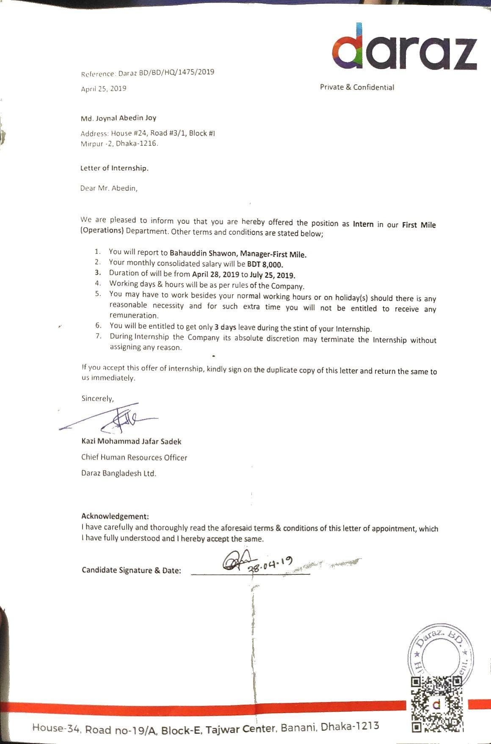

Acknowledgements

With the help of friends & almighty Allah, I have completed this report by completing the internship period. I want to express my sincere gratitude to my principal SM Asif Ur Rahman, Assistant professor, School of business & Economics, United International University for his support and supervision. I would also like to thank Md. Bahauddin Shawon, Manager, Daraz Bangladesh. Under his supervision I have completed my internship. He helped me in many ways to enrich my knowledge on e-commerce site. Through his encouragement & support during this program he helped to learn new thing so that I can compete in my professional life properly in the near future. I would Like to thank my other colleagues at Daraz who help me during this period. I am also thankful to United International University because I am standing here today on the eve of graduating successfully.

Executive Summary
The internship report actually based on a 3-month internship program that I successfully completed on Barrier of online shopping in Bangladesh.
Had a great experience working on this issue. Because I’m a student of Major Marketing, who has extensive discussions and relationships with the digital marketing space. As a marketing student, I have been really helpful in working on this topic. In this report you will see how different variables affect online shopping culture. This project discusses every possible discussion related to online shopping. You can easily get an idea of ​​how customers are being affected, how they respond to online shopping, how they are familiar with the service, how they do not neglect to purchase the service. Above all, it will provide a powerful overview of the barriers to online shopping.

I gathered all the data and realistic work experience from the design field. It also provides a great chance to work on it. In promotional events, I have always attempted to concentrate on the actual marketplace and intellectual work. Graceful data collects how consumers are influenced, how they communicate with their preferred goods and services.

Table of Content

Chapter- 1
Introduction | 8
History of E-commerce | 9
Current situation of e-commerce in Bangladesh | 10
Motivation of the study | 11
Objectives and limitations of the report | 12
Chapter-2
Literature Review | 13
Methodology | 13
Limitation | 14
Company overview | 14
Chapter-3
E-commerce trade still poor in BD | 19
Factors of liking & disliking of online shopping | 20
Modes of payment preference | 21
Online purchase and risk analysis | 22
Chapter-4
Job description | 25
Critical observation | 26
Chapter-5
Research findings & interpretation | 27
Analysis of the survey result | 28
Conclusions | 32
References | 33

Chapter 1

Introduction
Internship is a part of educational program of Bachelor of Business Administration (BBA) in United International University. The actual goal of internship program is to provide a student a work experience and an opportunity to implement of academic knowledge in the real situation.
In our daily busy life online shopping is one of the best solutions for us. Although people prefer to shop from various physical store but it is very easy to shop through online. Online shop save time for us because people are too busty in these modern days to go outside for shopping. Online platform is a place where people from all over the world can buy their necessary product according to their needs that’s why online shopping is growing day by day. Like the physical store every detail of a product is described through text including image. Many stores also provide details information link.
On the other hand, there are many customers who actually hates to wait for the product to ship that’s why the researchers need to be more conscious about the customer behavior and unique nature of online shopping. Satisfied buyers are more successful than competitors in a business that meets customer needs with more satisfaction. The goal of online shopping is to provide the best service and create satisfied customer because satisfied people influence other people to buy through online. The Govt. of Bangladesh is trying to influence people to involve in online activities to make our life activities easier. People are getting educated day by day and they are involving in more digital activities. Now many people prefer online shopping to fulfill their daily needs. Bangladesh is developing day by day and almost one forth number of people in our country use internet right now that’s why there is huge possibilities for e-commerce companies to perform better in the near future.

Brief History of E-Commerce
In 1950, many companies began using computers to store and process internal transaction records and in the 1960 businesses that works with in large-scale transactions started exchanging their transaction information on their credit cards. Some company and organization decided to foam the Transport Data Coordinating Committee (TDCC) for securing transaction data. In 1999 the American National Standards Institute established a new committee to develop a Uniform Electronic Data Interchange (EDI). Online shopping was introduced in 1979 by Michael Aldrich in the UK. Mintel France was introduced in France by telecommunications and in 1982 was used for online ordering. It was the world’s 1st recorded B2C online home shopper that was established by Mrs. Jane used the Gateshead Tesco system in 1984 for buying groceries.

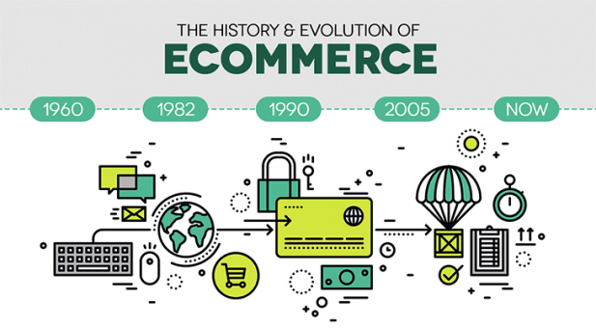

Figure- History of E-commerce

In 1987, Serge started writing different software so that they can sell their products online through an electronic merchant account. In 1990 Tim Tim Berners-Lee wrote the 1st web browser the World Wide Web by using a Next computer. Snyder und Terra Zipping introduced The Shop of the Future: How Technologies in the near future will change the way we shop and what we buy. The Netscape Navigator browser was introduced under the Mozilla code name, Pizza Hut also started offers pizza orders on its web page, the first online bank was opened, started to deliver flowers and magazine subscriptions through online, and started making adult content commercially available, for example cars and bikes. On that time Bezos launched Amazon.com and the first commercial free 24-hour, Internet-cable radio stations, Radio HK and Net Radio broadcasts, Dell and Cisco strongly started using the Internet for commercial transactions. On the other hand, in 1995 eBay computer programmer Pierre was founded as the auction web Omidier
Online users are increasing developed countries have increased e-commerce day by day. In 2011, US ecommerce and online retail sales reached 19 billion. In 2012 Amazon.com was acquired by Dyers.com's parent company, QuidsC.com, for 12.45 million, a 12 percent increase over. with Amazon and other obligations. GSI Commerce known as a company of specializing in creating, developing and managing online shopping sites for the brick-and-mortar business. After that it has been acquired by eBay for 2.4 billion.

Current situation of e-commerce in Bangladesh:
E-commerce means any transaction through online for purchasing anything. There are 6 e- trade types:
- Business to business - B2B
- Business to consumer- B2C
- Consumer to Consumer- C2C
- Consumer to Business- 2B
- Business to Administration- B2A
- Consumer to Administration- C2A

We will discuss the three types of e-commerce from the knowledge that I gathered. Specifically, we will discuss the B2C business model because this model is usually practiced all over the Bangladesh.
E-commerce is business growing every year in Bangladesh. The Daily Observer publish a report in 2011 that Bangladesh e-commerce recorded a growth of about 67.67 percent in the first quarter.
The number of internet user is increasing in Bangladesh rapidly in every year. When more and more people will use internet, they will have more excess in different sites. From my previous experiences I can understand that the number of internet user will increase in the near future and e-commerce base company will lead the industry in the near future. Although service that is expected by the customer is not delivering properly that’s why there is huge opportunity for new companies to capture the market by fulfilling customer demand.

Motivation of the Study
I did my internship at Daraz Bangladesh Limited where I learned about the barriers of online shopping That’s why I have decided to write a report on the barriers to online shopping. I got a lot of things that complimented me. I just found out that online shopping in Bangladesh is under threat due to some barriers.
customers not willing to use PayPal and debit credit cards to pay for purchases which is the main problem for e-commerce companies in Bangladesh. There are 5.0 million debit cards and 1.0 million credit cards user in the country of 160 million people. However out of that only 1 percent of debit card holders use their cards through POS machines or online. The remaining 99 percent activate them only at ATMs. There are some reasons for this like-

1. Low level of awareness and lack of customer-friendly infrastructure
2. High card fees and merchant pass costs
3. Reluctance of banks to promote in-store and e-commerce transactions
4.Tax IDs also need to be used to issue credit cards
That’s why the potential audience is limited to 2 million people.

Objectives and limitations of the report

Research Objectives:
The purpose of the report's research can be interpreted in two forms
• General or Broad Objective
• Specific Objective

The purpose of the study

The main purpose of this report is to figure out the actual service quality of e-commerce companies in Bangladesh. It can be said by analyzing some of Facebook pages of several companies that customers are not fully satisfied with the quality of service is provided by online shops or e-commerce companies.

There are several reasons-
• Late delivery
• Poor customer service
• Poor after sales service
• Or low-quality products
• Prices higher than offline stores etc.

In this report I tried to find out the actual reason behind this issue. There were some limitations behind this. For example- I do not have access to all the data of the companies that’s why I tried to merge all things from customer feedback, from surveys. For actual information I have to work on market behaviour, market competition, market growth etc.

Limitation of the Report:

Daraz is truly a great place to acquire real knowledge where I tried my best to make this report properly but I had some problems with my report that’s are given below-

- Accessibility of information is the main problem 1 find in this study, since a lot of information is confidential.
- As we know, the duration of internship is only 3 months This is a very short time for any kind of study, which was not enough.
- While doing the internship, in many parts of my investigation, my experience got stuck due to lack of experience.
- Since this is the first time I've done a report like this. the report in general has been difficult to organize.

Chapter 2

Literature Review

Methodology:

Total report is totally based on my internship experience during the internship period. I have to understand customer perspectives, customer realization, interviews few staff I have work with and collect data from internal and external sources of different companies.

Primary sources:

- Survey report
- On the job experience during internship
- Findings from different interview
- Global and internal reports

Secondary sources:

1. Daraz com. bd
2. Publications of different newspapers and internet resources

Scope of the report-
As I have an interest on this sector that’s why I have an intention to work on this sector. Through internship I got an opportunity to know this sector properly. By doing different survey during the internship period I have understand different perception of customers and behaviour properly. Doing internship in an e-commerce company was a great decision to understand this sector.

Limitations

There were some limitations to this study-

- The company could not provide all the information of the companies due to the constraint in the company's policy.
- Inability to do in-depth research due to time constraints.
- It was not easy to understand the actual market by analyzing 30 people only and it was not possible to work with large number of people because of time limitation.
- Although all suggestions were book based and what I have learned by working in the company. May be there are many other ways to research e-commerce.
- As I have worked with those people whom use high speed of internet and good knowledge of technology but I was unable to reach other people who do not have this type of facility that’s why their choices can be different and this could turn this report into another point.

Company overview

About Rocket Internet

The three brothers Marc, Oliver and Alexander Samwer, created Rocket Internet in 2007. Their headquarters are based in Berlin. In over 50 nations, they have their own ventures. They are one of the fastest growing incubators for start-up companies. Operating in developed countries known as Rocket.

Some of their ventures are given below-

- Hellofood, Food Panda, Delivery Hero
- Lamoda, Zalora, Jabong, Namshi

The market value of the company was approx. In april 2015, the company reported 6 billion euros. This company divided its business into three operational zones.
For example-
- Asia Pacific Internet Group
- Africa Internet Group
- Middle East Internet Group

As Bangladesh is a fast-growing market in south Asia that’s why they have started more than 7 initiatives in Bangladesh.

Daraz BD Overview

Daraz has started its journey in 2015 to the Bangladeshi people which is a (B2C) business model which looked like Amazon. Now Daraz online shopping is the best e-commerce site all over the Bangladesh. Daraz operates its operation in more than five countries right now. Many strong brand like - Yellow, Symphony. Body Shop, Huawei, Samsung Walton, Forest, 6 Degree Mobile, Black and White Apple, LG, Fastrack. Mac, Nikon, Ecstasy, Panasonic Doors many others work with Daraz. Now all the well-known expensive brands and many sellers on its website.

Mission:

The company wants to become the one of the world's largest e-commerce site outside the United States and China. The company is applying different type of business model in the real market and trying to grow up day by day.

Vision:

Company vision is to get the highest market share of consumer in online shopping platform.
Goal:

The main goal of the company is to provide the best product at the best price for the consumer and the company want to achieve this goal as soon as possible.
The 7p:

Product:

Daraz works with different type of products and it is a B2C business platform. For example- Men's fashion. women's fashion, Phone and Tablets, Cameras, Computing, gaming, Home appliances, Home and living, Sports and travel, Beauty and health, Baby products, Grocery item etc.

Price:

Daraz is an online marketplace and product price can be different depending on seller. Thousands of sellers available in Daraz website and according to seller differences price can be different. Sometimes company offer different type discount on the other hand, seller offer discount for the customers.


Location:
Daraz is an online shop where purchase can be performed by using website that’s why it is an online or virtual marketplace.
Promotion:
Promotional activities in Daraz mostly done on online by promoting their Facebook page, Instagram or mail. They provide advertisement in the newspapers regularly. They also follow some personal method of selling where their agents work for them to get more order from customer. They also approved new marketing opportunities. In recent time, their Facebook ads activities is increased significantly.


Figure: Daraz Promotion

People:
More than 1000 people work on Daraz Bangladesh and the company are growing every year. They do their deliveries through their own delivery system & third party.
Physical Evidence:
Daraz do not have any physical shop but people can buy different brand product from the website.
For example-
- Bata
- Yellow
- Apex
- Samsung
- Huawei
- Miyako
- Shimizu
- Sony
- Dorjibari
- Beauty Bazar
- Pearl
- Timezone
- RB
- P & G
- Microsoft
- LG
- Redmi
- Noir
- Walton
- Vision
- Sports world
- Body shop and many more.

Process:
People can buy through online in a easier way and less time consuming than going to the store. Daraz use different type of software to make the customer buying experience easier and maintain the buying process. Such as-
- Sales center
- CRM
- Warehouse module
- Distribution module

Sales center:

Seller get helps from daraz software to update their stock and price by coordinating with acquaintances from the drawer. The business development team easily get all the updates of product stock form the website which help business development team work properly.

CRM:

It helps the customer service department to efficiently deliver inside and outside calls. It also included some other software such as Zendesk, LMS, internal and customer communication agents

Warehouse Module:

Daraz has developed a warehouse module system by which product can be stock, process and deliver to customer.

Delivery module:

In a delivery module system product is delivered to customer. In this process product is distributed according to the process.
- Order place through website
- Customer service
The product order is received through online and inform the quality control team to the delivery to the delivery team to deliver the product.

Daraz Organogram:

E-commerce company is far different form many other companies exist in the world. As most of the work done from the website, many working procedure is fully automated that’s why online shopping is different than others company.

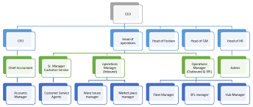

Figure: Daraz Organogram

Chapter - 3

Weak trade system in E-commerce industry in Bangladesh
Online sales are very low rather than other countries in south Asia according to the world bank study. Total global online shopping is about 16% of total purchase occurs by consumer. In developed countries online shopping percentage is around 60% of total purchase in developing like Bangladesh is around 13% of total sale. In 2015, online shopping in China is around 15% of total retail sales. In the developed market like Korea and united states online purchase has large impact on total purchase.
In Bangladesh ecommerce was introduced in 2014 to the people of Bangladesh. In 2015 online sales is around 15 percent in China and United Kingdom, 11 percent in Korea 1.06 percent in India, 0.7 percent in Bangladesh.
Payments platform, logistic, financial services and IT services is weak in Bangladesh which is a barrier for e-commerce in Bangladesh. There is some other problem like border supply, taxes and export barrier. Consumer in Bangladesh is not interested to pay through bank card even retailers also interested in cash on delivery system rather than card system.

Regional traders can expect more gains in exports, employment and more productivity growth if the key barriers to e-commerce are addressed. As it mentioned, Bangladesh could have achieved 20%. growth in job creation and about 23% growth in export sales. According to the report, global retail customers spent 23 trillion in 2013. about 25 percent more than in 2016, and about 10 percent in 2015. Entrepreneur AKM Futuim Masroor said that a very small portion of the country's total population uses online purchasing platforms.

Ingredients for choosing online shopping

42% of male suppliers like online shopping due to the convenience of home shopping on the other hand, about 29% of male respondents said that they order from online because they get more discount from online shopping, 12% of male thought it is an easier way to shop online and 17% Male respondents like to shop through online they can use all the option of payment gateways. 38.34% of women shop online for cash on delivery system, 25% for the convenience of ordering the remaining 23.35 (13.33% of female) for discount offers and available options, respectively. Both male and female responder have shown almost same attitude for the the purpose of online shopping. Both prefer the discount factor and the home delivery option. Women like online shopping most because of different type of discount rather than man. These studies confirm a study by Rastogi (2010) and Katawatawaraks and Wang (2011).
Ingredients for disliking online shopping

We also asked respondents if there is any situation that influence them not to shop through online. It was shown in the graph that 48% of customers hate online shopping because they are not able to feel the product quality through picture which is only possible only by touching it. On the other hand, about 24% of men said that product price is higher than local market in many cases. 16% of male responder dislike it because of bad after sale service and 12% of male respondents dislike because of bad product return policy.

Among female respondents, 45% dislike online shopping because they are unable to get the feel of touching it. 23% dislike its high price rather than local market price. 16% dislike it bad return policy and 15% female dislike it for after sales service respectively.

As people is not able to get the feel of touching product through online shopping it is still primary reason of disliking online shopping. Many companies is still competing to provide better service. All the companies exist in the market need to improve the product return policy, product quality, higher pricing issue.

Payment preferences

E-commerce company in Bangladesh offer different payment options like cash on delivery, debit card, credit card etc. Most of the respondents close to 76% dealing with cash on delivery, whereas 15% are paying though debit card, 1% respondent are paying through credit card & 5% people are paying through online mobile banking. In our country most of the people prefer cash on delivery system mostly as a method for online payment. In developed countries most of the cases customer to pay through credit card for online payment. As Bangladesh is a least developed financial sector that's why credit card user is less than developed countries.



Figure: Modes of payment in online shopping

Online shopping satisfaction

People who shop through online 50% of them are satisfied and 17.5% are dissatisfied. Out of that, 26.12% are not satisfied or dissatisfied. Few people not more than 3.75% of regular online shoppers are highly satisfied and 0.63% highly dissatisfied.

Satisfaction levels play an important role in Shopping through online. Satisfied customers normally tend to shop online more frequently. It should be reminded that only 3% of online shoppers are highly satisfied which shows that there are still concerns that prevent customers from using online shopping frequently. In many cases, dissatisfied and neutral customers of online shoppers move to satisfied or highly satisfied sections and companies need to take steps to make online purchases easier and which is done through better information, quality services at the time of purchase and at subsequent purchases.

On-line purchase risk analysis

While there are many benefits to shopping online such as time shaving, instant information, there are suit some concerns to keep people away from new types of shopping. It has discovered that people feel more risky shopping through online than the traditional shopping malls. Most of the people who don't shop through online are the ones who lie most at risk.

Risks generated by incomplete basic systems

Credit system

Credit problems are a problem outside of online shopping: This problem is taken seriously by both the buyer and the seller. The damage caused by Internet fraud is still growing rising from 10310 in 1999 to 5,695 per person on an average. This is indicative of a completely deteriorating situation and uncertainty surrounding the scope of online shopping. The proportion of victims of fraud is very high in the background of incomplete basic systems.

Arrangements for issuance of bank credit cards

The on-line payment service has to be clearly improved to facilitate on-line tariffs but professionals believe that credit card payments are still somewhat limiting the development of online shopping on the other hand, when ones want to open a credit account, they have to go to the bank themselves which is a real barrier to online deals.

Network security system

The security problem has always existed since the day it started entering people lives. People have a lot of concerns about online shopping like personal information, bank account information and capital protection during the transaction process. These are all spooky because of online shopping.

Logistic delivery system

In traditional shopping you can get in home what you bought already in minutes. On the other hand, in on-line shopping you have to wait after ordering. Now a days, the logistics company can serve but at least one hour within the city, although at least 2 days but are not free for the customer. so, we should consider it that additional charge is appropriate or not.

Risk due to the real and virtual interface of the network

Vague product information

People can only order product by text and image. but some reasons are very clear as to the cause of the misunderstanding. When someone received their product through online transactions. they complained that what they bought was different from what they actually saw on online. So, sellers have to take back what they sold.

Risk of unavailability

Information spread very quickly but product is not available at the same time. The supplier follows traditional way who cannot deliver the product synchronously with the data that’s why they are unable to provide products according to the data is provided. Sometimes order quantity is so high that supplier is unable to source the product.

Good risk of forgery or theft

The undisputed identity of both parties is the bed of counterfeit products because of counterfeiting. Some Frequenter said that so called cheap branded products are not because of low prices, but Moreover we can fill the gap of product diversity, and even expand the second-hand market. many times, people will find stolen things without awareness So it is a channel that saves time and effort for illegal contracts.

The threat of net terrorism

With the growing number of net-users criminals are standing to use the Internet to provide their services. Even if the system does not collapse, they can have a devastating effect by destroying extensive information Electronic business Decay for monists to urge due so huge profits and poor security.

Lack of knowledge of immediate fulfilment

When the business day came, people have been enjoying the happiness of achieving the deal after shopping from online, when customer did not get the product on time then a little bit of joy diminishes.

Impact on risk taking on-line shopping decisions

Purchasing decision making process

Five way of buying are-
- confirmation
- data collection
- project evaluation.
- purchasing decision and
- post-purchase behaviour

But sometimes it be a complete one, with the purchase of a low participation degree. Some other steps can be avoided.

Consumer psychology statistics on ecommerce sites

Have you ever considered that the biggest consumer concerns are barriers to buying online For example, if the page on your website is slow to load, what the customers actually think about your videos or what influences their decision to buy online vouchers is, of course, the best way to ask the customer directly through the customer panel or through usability testing, But as a quick alternative, check out the research We’ve compiled in the new Voucher Cloud.

The results will tell you the ‘statistics and habits’ of a few click’s more than 31% of customers are willing to buy a product after watching a video because it increases their confidence and 41% will not feel comfort for shopping if there is privacy.



Chapter 4

Job Description

The job description of the internship contains the following details:

Term of service:

I was employed as an intern at the company for three months. After completing the internship, I have joined here as an executive.

Working Hours:

I have worked 5 days in a week (Sunday to Thursday) from 9 A.M. to 6:30 P.M. Friday and Saturday were my weekends. I have continued my relationship with Daraz after ending my internship. They appointed me as an executive after finishing my internship with utmost sincerity.

Work Station

Daraz Bangladesh Ltd, Kamal Ataturk Avenue, Dhaka 1213

The nature of my work

As a customer service executive my job responsibility was handling different customer issues. I received their call, confirmed their order and placed it to the right person who delivered. After the delivery man received the product I kept track of him and ensured that the delivery was done successfully on a right time.

Moreover, I transferred different calls to the digital team where I had to deliver the customer's online messages and emails. My responsibility was to contact other departments if there were any issues with the product delivery and return as well. Also, I had to maintain follow up with customers and resolve pending issues.

Challenges and experiences

Most of the questions of customers are as ambiguous as postmodern philosophy! Sometimes it gets impossible to understand what they are talking about. They even can tell about specific information. Sometimes the whole conversation goes wrong and they become so angry and throw inauspicious words towards me. Most of them don't want to show a little modesty and patience at all. Due to mentioned predicaments solution of the problem takes time and sometimes remains unsolved.

Resolving can also be a challenge when coordinating with other departments becomes difficult. Because not everyone seems to be cooperative and many times the given information is not prepared properly.

Consequently, misinformation can lead the whole conversation into misunderstanding. Nevertheless, the good part is, it gave me the experience of maintaining critical situations within multiple departments. In addition, I got to know various problems that customers face and how they react to the specific problem. Being in the centre of the problem dealing I got experienced in question dealing and critical thinking. Furthermore, It was a proactive opportunity to learn about customers' minds, how they think and why they're thinking in a specific way. This experience helped me to understand the e-commerce sector and the benefits and strategies of the process to make me think about how it could be better from our country's perspective. Basically, it's a highly insightful experience that enables me to acquire the skills and learning skills needed for this industry.

Critical Observations and Recommendations

1. Dealing with customers on time should be the predominant concern for the ecommerce sector. Company should ensure to its customers that they value their customer's time. It will enhance the company's reputation and brand image as well. Moreover, it will assist to forge a strong and loyal customer base with whom the company could maintain a long-time relationship which will pave the way of maximising profit.

2. Companies should monitor information that has been uploaded into the website by their seller. There should be strict rules and regulations under which every seller would be obedient to follow otherwise they should get punishment. If the seller puts information of one kind on a website and delivers a different kind of product to its customer, it may ruin the company reputation and through word of mouth it can spread dramatically which will take the company to an outrageous situation. Indeed, authentic information should get top most priority which will pave the way of success & reliability.

3. Companies should respect their customers complaints or feedback or any kind of questions regarding help & support with top most priority and shortest possible time. Customers get disappointed if they find no reply after seeking assistance. Being neglected they lost their reliability from the company and never got back again. So, solving the problem of the customers should be a major concern so that customer satisfaction can be maintained properly.

Chapter 5

Research Findings & Interpretation

About the Project:

Overall, the project taught me a lot. It was an outstanding journey with some odd situations. Although there were some peculiar issues, it gave me an opportunity to observe the working environment of a global company. The overall journey was not so easy at all. I have to heard huge amount of complaints every day and resolve them. However, when I got praise from higher authorities, it made me feel motivated.

An organization is nothing but its customers. There is no profit if there is no customer. I became interested in identifying the problem with the process. I also wanted to understand the infrastructural problems of the process or the obstacles to the growth of the organization due to company policy. I had a few restrictions on access to reports and information on 26 vendors So, to get valid information I have done a survey on Daraz Bangladesh customers.

Analysis of the Survey Results:

Survey: Online survey through email

Q1. Which of the following words would you used to describe daraz.com's product?

(54 responses)

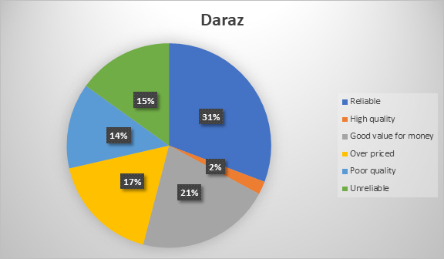

As we can see when we asked customers about their opinion about the products, they have bought from Daraz. 29.6% people said the product was reliable, 20.4% said it was good, 1.95 said the products quality were high. However, 16.5% people said the products were unreliable, 13% said they quality were poor, and 17.7% said it was too expensive.

51.9% people shows positive feedback for the product. 48.2% shows negative reaction to the product.

This is actually reflecting to the results from the company point of view; it shows that the company has failed to tell their customers that their products are of good quality. If this 48.2% of the population not willing to shop again, this is a big loss for the company.

Q2. What is your desirable product delivery time? (30 responses)

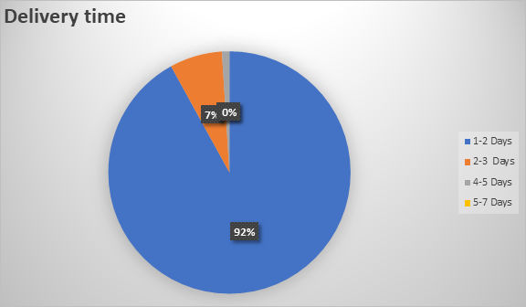
Product delivery time

92% people's want delivery within is 1-2 days. 7% of them said 2-3 days. That means customers don't like delay after making an order.

Companies which are not responsible about their promises cannot sustain in the marketplace. Those companies who don't look after of their customers' time and money, they are unable to make loyal customers. In Bangladesh few online companies have no focus on right time delivery which is extremely unexpected. Only advertisements would not help to establish brand image. Moreover, it will not confirm their commitment which will lead to customer dissatisfaction. There are enormous complaints available on shipment delay. Most of the customers want their product at home within 2 days, while online companies take 4-5, sometimes 7 days unfortunately. It reduces customer trust and customer satisfaction as well.

Q3. Which payment method do you prefer most in terms of online shopping?

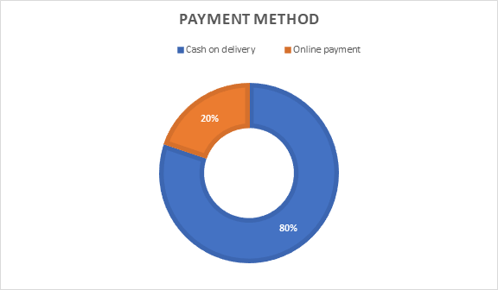

80% people prefer cash on delivery whether 20% people like to use online payment service.

There are some problems of payment methods available nowadays. However, sometimes mobile financial services like bKash, Rocket offer discounts on online payment. If no discount keeps available on payment, cash on delivery is preferable most of the time as a payment method.

Q4. Do you think online shops charge higher prices than offline shops?

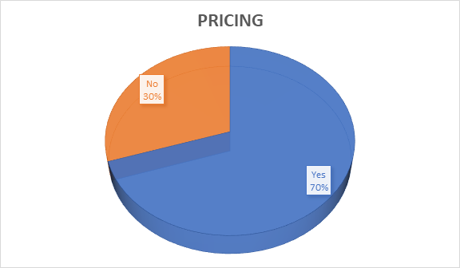

70% of people think online shops charge higher yes and 30% people don't think online shops charge higher prices than offline shops.

If we look into the conventional ways of shopping, online shopping charges higher prices. It has an effect on customers. By providing the same product quality online sellers are taking high prices which is one of the major reasons of customer dissatisfaction.

Conclusion:

I have taken marketing as a major subject and I have an interest on e-commerce that’s why I have selected Daraz for internship where I can gather the knowledge of e-commerce and marketing. I was lucky that Daraz has provide me the opportunity to work with them which was an e-commerce-based company. It was an initiative of Rocket Internet that develop new business idea. There are lot of talented people working around me. Every day I was learning new things, how to make decisions, how to bring the best from one. After finishing the internship, they have offered me a job and I accepted it. I accept the offer to develop my career in the near future. Online shopping or e-commerce folks, whatever the business, it should be more service oriented. Companies need to provide the best service for their customers to fulfill their needs and Daraz is doing their job perfectly. There are many opportunities for the e-commerce-based companies in Bangladesh. Companies need to do their job properly to satisfy their customer only and the result will come automatically.

References:

1.Journal Cogent Business & Management

2.infographic on consumer buying psychology

3.https://www.ukessays.com/essays/marketing/barriers-to-online-shopping-and-purchases-marketing-essay.php

