"Gaps in translating IAS 1 into practice: An examination of Financial Statements of Bangladeshi companies".


United International University
QUEST FOR EXCELLENCE

Project Report On:
“Gaps in translating IAS 1 into practice: An examination of accounting practices on Financial Statements of Bangladeshi companies”
Course Code: AIS 4441
Supervised By:
Ziaul Karim
Assistant Professor
School of Business & Economics (SoBE)
United International University

Submitted By:
Rezwana Siddique
ID: 114 163 012
Bachelor of Business Administration in Accounting Information Systems (BBA in AIS)
Trimester: FALL 2020
Date of Submission: March 26, 2021

Acknowledgement

I am grateful towards Almighty for bestowing his kindness on me, and I finally got the knowledge, strength, time, resources to conclude this project within the limited time frame. I am humbly thankful towards people who helped me during this process; without their contributions, this work could not have been completed properly.
I earnestly acknowledge my gratefulness towards my instructor, Ziaul Karim, Assistant Professor of BBA Program, School of Business & Economics (SoBE), United International University for his discreet guidelines without which it would not have been possible for me to complete this report. He had given me many insightful consultations on how to make a quality report. The topic had its limitations as the things I learnt until now had to be used very much prudently. Sometimes it was even harder to relate many aspects I learnt from the class lessons throughout my undergraduate life. However, he came up with unique ideas on how to look at the obstacle from an out-of-the-box view. Last but not the least, I show my gratitude towards my family, especially my mother for her support and also some of my friends for their inspiration during this period.

Letter of Transmittal
March 26, 2021
To,
Ziaul karim
Assistant Professor (SoBE)
United International University
Subject: Submission of Internship report on "Gaps in translating IAS 1 into practice: An examination of Financial Statements of Bangladeshi companies".
Dear Sir,
Here I present to you the project report I have prepared “Gaps in translating IAS 1 into practice: An examination of Financial Statements of Bangladeshi companies” as per the university authority selecting you as my supervisor. I have tried my utmost to provide all the necessary contents in this report, that includes lists, figures, tables, details, graphs etc. I have projected the requirements which you have specified. I applied most of the concepts which I have learned during my under-graduation period. Additionally, data have been collected from the selected companies for research purpose which may have its limitations because of those companies’ terms and conditions. References and more data were collected from various sources in order to complete my report.
I gave my full effort to make it an exceptional work and also finish it in due time. So, I profoundly expect that this report will meet my desired result. I tried to make this report as detailed as possible. Moreover, I tried my best to give this report a neat look for better understanding. However, if you have difficulty grasping any part of my report, then I welcome you to contact me through the given information (Email: rsiddique163012@bba-ais.uiu.ac.bd, Cellphone: 01676642481). Lastly, I, once more express my gratefulness for your effort and support and all the generosity you have showed me.
Sincerely,
Rezwana Siddique
ID: 114 163 012 (BBA in AIS)

Declaration

I, Rezwana Siddique, a student of BBA in Accounting & information System, bearing ID: 114 163 012, would like to announce that this report titled “Gaps in translating IAS 1 into practice: An examination of Financial Statements of Bangladeshi companies” is an authentic and original work prepared by me. This report has been made under the guidance of Ziaul Karim, Assistant Professor, School of Business & Economics, United International University.
I have prepared this report as it is the final requirement to get the degree, BBA in AIS. I solely prepared this report for submitting it to the United International University as a part of the Internship/Project course (AIS 4441) and my work will not be submitted to any other university, institutions, journals, newspapers, articles, etc.

Abstract

In recent days, the complication in business has made accounting bookkeeping more difficult than before. The use of technology, tools and software have been a major breakthrough for accounting professionals. However, the basics of accounting lessons are used too in order to take managerial decisions. This study has aimed at finding out the reasons most accounting people find it hard to render accounting transactions and prepare an error-free financial statement.
A set of samples has been used and a questionnaire has been prepared to reach the conclusion. Whether the problem in financial statement preparation arises because of lack of practice in any professional’s academic period or it arises as a result of the general rules and regulations set out by the board or committee. The Questionnaire consists of questions regarding these problems. Through the use of descriptive statistics, it has been found that the survey questionnaire was consistent and reliability was tested with the use of Cronbach’s alpha. It has also been found that the majority of people who use accounting software for daily records find few statements such as balance sheet, cashflow statement and shareholder’s equity statement to be difficult to prepare.
The goal of this study is to understand the practical aspect of preparing financial statements in light of IAS 1 and have a general idea of what can be instigated for eradicating this deficiency. Expectantly, this research will help others to further dive into this problem and come up with better solutions.
Keywords: IAS 1, Financial Statements, Gaps in translating, Theory and practice

Table of contents

Table of Contents
Acknowledgement iii
Letter of Transmittal iv
Declaration v
Abstract vi
Table of contents vii
Chapter-1 (Introduction) 1
1 Introduction 2
1.1 Background of the study 2
1.2 List of the organizations 3
1.3 Purpose of the study 3
1.4 Problem statement 4
1.5 Scope of the Report 5
1.6 Research Questions 5
1.7 Research Aim 5
1.8 Research Objectives 5
1.9 Significance of the Study 6
1.10 Structure of the Study 6
Chapter-2 (Literature Review) 7
2 Literature Review 8
Chapter-3 (Methodology) 15
3 Methodology 16
3.1 Introduction 16
3.2 Philosophy of the Research 16
3.2.1 Reasoning for positivism approach 17
3.3 Research Approach 17
3.4 Research Type 17
3.4.1 Reasoning for Correlational research 18
3.5 Research Strategy 18
3.6 Sampling Procedure 18
3.6.1 The Sampling method 19
3.6.2 Sample Size 19
3.7 Data Collection 19
3.8 Data Analysis Tools 19
3.9 Presentation of the Data 20
3.10 Reliability and Validity 20
Chapter-4 (Analysis) 21
4 Analysis 22
4.1 Introduction 22
4.2 Demography variables of the survey respondents 22
4.3 Cronbach’s Alpha for Reliability 24
4.4 Analysis using Descriptive Statistics 25
4.5 Analysis using Charts 29
4.5.1 Gender 29
4.5.2 Age 30
4.5.3 Level of Education 30
4.5.4 Level of Employment 31
4.5.5 Accounting practicing years 31
4.5.6 Accounting bookkeeping 32
4.5.7 Use of Accounting Software 32
4.5.8 Relation between theory and practice 33
4.5.9 Automated vs Traditional bookkeeping 34
4.5.10 Use of accounting knowledge for recording 34
4.5.11 Most frequently used statements and documents 35
4.5.12 Difficulty level of the statements and documents 36
4.5.13 Journal in practice 36
4.5.14 Ledger in practice 37
4.5.15 Trial balance in practice 38
4.5.16 Cashflow statement in practice 38
4.5.17 Shareholder’s Equity statement in practice 39
4.5.18 Income statement in practice 39
4.5.19 Balance sheet in practice 40
4.5.20 Whether way of teaching accounting should be changed 40
Chapter-5 (Findings, Conclusion & Recommendation) 41
5 Findings, Conclusion & Recommendations 42
5.1 Introduction 42
5.2 Findings 42
5.3 Conclusion 43
5.4 Recommendations 43
5.5 Limitations of the study 44

List of Figures:
Figure 1 Layout of the study 6
Figure 2 Generally Accepted Accounting Principle 9
Figure 3 Accounting principles 10
Figure 4 Accounting and accounting rules in Bangladesh 11
Figure 5 Overall trends of Disclosure 12
Figure 6 Presentation of financial statements 13
Figure 7 Commonly used Data collection Method 17
Figure 8 Response chart of the questions 24
Figure 9 Defining the Cronbach’s alpha 25
Figure 10 Gender of the respondents 29
Figure 11 Age of the respondents 30
Figure 12 Education status of the respondents 30
Figure 13 Employment status of the respondents 31
Figure 14 Practicing years of the respondents 31
Figure 15 Accounting bookkeeping 32
Figure 16 Accounting software usage 32
Figure 17 Theory & practice relationship 33
Figure 18 Bookkeeping method 34
Figure 19 Use of accounting knowledge to prepare statements 34
Figure 20 Frequently used financial statements 35
Figure 21 Level of difficulty of each statement 36
Figure 22 Journal-Practice vs Theory 36
Figure 23 Ledger-Practice vs Theory 37
Figure 24 Trial Balance-Practice vs Theory 38
Figure 25 Cashflow Statement-Practice vs Theory 38
Figure 26 Shareholder's Equity Statement-Practice vs Theory 39
Figure 27 Income Statement-Practice vs Theory 39
Figure 28 Balance Sheet-Practice vs Theory 40
Figure 29 Change in accounting lessons 40

List of Tables:
Table 1 Demography variables of the survey respondents (Gender) 22
Table 2 Demography variables of the survey respondents (Age) 23
Table 3 Demography variables of the survey respondents (Education status) 23
Table 4 Demography variables of the survey respondents (Employment status) 23
Table 5 Demography variables of the survey respondents (Academic experience) 23
Table 6 Finding mean score of the responses 26
Table 7 Finding medians of the responses 27
Table 8 Finding mode of the responses 28
Table 9 Finding standard deviation of the responses 29

Chapter-1 (Introduction)

- Introduction
- Background of the Study
- Background of the Organizations
- Purpose of the Study
- Problem Statement
- Scope of the Report
- Research Questions
- Rationale of the Report
- Limitations of the Report
- Structure of the Study

1 Introduction

1.1 Background of the study
The roots of accounting can be traced back to as early as 2000 to 3300 B.C. in the middle east in Egypt and Mesopotamia. However, it did not spread until the Europeans started to use it for regular business purposes. As time flew, the emergence of accounting e.g., double-entry bookkeeping, journals, ledger, trial balance, financial statements have skyrocketed. The simple formulas of accounting used a century back cannot be used nowadays anymore because of the complexity of today’s typical companies and business structure. We are getting improved versions of every object, products, service or study or law so, accounting principles were changed, modified or revised according to the needs of today’s world too. There are many inconveniences every organization faces while implementing the accounting principles given by accounting standard committee. In fact, many studies have proved that often times the lack of proper implementation of accounting standards proves to be fatal for any companies. For instance, applying the accounting standards may show in the financial statements that the company is doing poorly but in reality, they may be doing well, which the accounting standards are not comprehending. Taking the example of Entergy, one of the fortunes 500 companies which have made the list for the last 25 consecutive years, during their 3rd quarter back in 2019 applying the GAAP the company showed losses. GAAP, sieved out the profit from one of the business segments the company had sold. Surprisingly the accounting lessons that are taught in academic levels have little or no relation to the real-life situations’ companies face. Even if the theories are applicable in real situations, there is a lack of practical lessons for the learners to actually show them how the theory can be transferred into practice. Furthermore, standards are nothing but an indication that a problem must be solved in this exact similar way. However, the real-life situations are far-fetched from those theories written on accounting books and standards given by boards and committees. This limits individuals’ professional judgements to flourish. Most developed and developing countries are still teaching ancient accounting standards which have little or no practical implications. As a result, especially the students of accounting find it hard to cope with the job after graduation. Accounting professionals who have memorized all the standards and rules by heart still find it difficult to apply some of the concepts into practice. These are enough proof to say that there is a major problem that is standing between the thorough knowledge of accounting and using it practically. Organizations in Bangladesh are far behind in comprehending the root of problems while using the accounting standards for their daily operations. Even the top companies listed in the fortune 500 face problems to define the theory into practice. On the contrary, nominal organizations, especially accounting firms, financial institutions (Banks, Insurance etc.) find it difficult to translate theoretical accounting into practice.

1.2 List of the organizations
- NGO
- Bikroy.com
- Digital Ride Ltd.
- SSTS
- National Bank Limited
- Good Heal services (pvt) LTD
- Be Fresh
- Al Arafah Islami Bank Ltd
- UB Health Care
- UNNATA BANGLADESH
- Moynerbag Welfare Complex
- Self Development Bangladesh
- Moynerbag Hosiania Ideal Academy
- Al Amin Poultry Firm
- Abrar Enterprise
- IFIC Bank Ltd.
- Rich Insight Global
- SSR School & college
- Dhaka Fiber Ltd
- Synesis IT
- JA AC Firm
- Abrar fashion
- AVALON PROPERTIES LIMITED
- Business Software Solutions Ltd.
- ASF Service Point

1.3 Purpose of the study
Profitability of any organization depends on proper management and the financial position in the market. Investors get interested in finance only when they know that the profitability of the company is good enough. Hence, the financial statements of any company are the key indicators of any company’s profitability and liquidity position. However, if there is a problem in interpreting those financial statements, then it means that while preparing them, some errors occurred. Each financial statement is prepared in light of the accepted accounting principles. Besides, the core intention for preparing these financial statements is so that people outside the organization can interpret it easily to make future decisions. Financial institutions need these financial statements to take loans in need from the central bank along with other tasks. Unless the people preparing the financial statements know how to properly execute the accounting process, the result will be devastating. Not only the financial statements will show wrong data, additionally, it may give a false indication about the organization. This study has been conducted in order to find out what causes these financial statements or in general book keeping of an organization to deteriorate so much, in some cases give false information. Finding the problem is the crucial part, once the problem has been found, then the solution will come easily. Organizations in Bangladesh, especially financial organizations, instead of hiring professional accountants, struggles to keep proper books of accounts or prepare financial statements. The reason apparently is the appropriate implementation of theoretical accounting into practice.

1.4 Problem statement
Accounting has been around for centuries; it has changed its way of functionality with each passing year to cope with the magnitude of change that is arising. From abacus to today’s tally, QuickBooks accounting has changed many forms. Nevertheless, professionals still find it hard to comply with the accounting standards into the daily operations of any organizations. It is due to the lack of practice during those professionals’ learning periods. Numerous studies have been conducted to find out the gaps in carrying out theoretical accounting into practice, however, those studies were based on generalization. This study has selected out a few companies to gain an in-depth knowledge about why the deficit occurs in the first place.
In order to make the accounting process smooth a good understanding of how to translate the theory to practice is essential, and this study will be proven to be helpful to the accounting people. As soon as the root problem is identified about what is causing the problem, then it will be easier to make a better use of the accounting knowledge accounting people have gathered their academic life. Moreover, this study can also be helpful towards non-accounting people as many organizations in Bangladesh hire employees to do accounting who do not have sufficient accounting knowledge.

1.5 Scope of the Report
This report has been generated using a survey questionnaire, which covered 20 organizations selected randomly. It included MNC, Financial institutions, NGO etc. The questions were designed to answer the problems while preparing financial statements. As only questionnaire limits the scope of any study, personal interview was conducted too for a better understanding. This helped me to know the appropriate format on how to generate a survey-based questionnaire. Moreover, this study also helped me to communicate and comprehend the real scenarios of accountants. I prepared this report from scratch, which was difficult at the same time challenging as well. I can easily conduct any survey now after this study.
This study will be helpful to further study as it included real life accountant’s opinion. The theoretical accounting, we learnt has its limitations and this study will be helpful to point those out. For instance, which financial statements are difficult to use in real life and whether they are prepared exactly the way they are taught to us.

1.6 Research Questions
Questions that have been identified by this study are:
- What are the complications behind translating theoretical accounting into practice?
- Why does the deficit in practical accounting arise?
- How difficult is it for professionals or non-accounting people to follow the accounting bookkeeping process?
- How do organizations (selected) in Bangladesh generally record the accounting bookkeeping?

1.7 Research Aim
This study aims to find out the difficulties some organizations face while practically recording financial statements adjunct to the theoretical accounting standards.

1.8 Research Objectives
On the ground of the above-mentioned contexts and backgrounds, this study’s objective is to find out the problems companies in Bangladesh face while translating theoretical accounting into practice while keeping their accounting records. The following are the solid objectives of this research and listed below:
- To review literature of accounting standards and the lack of proper reporting.
- To determine how accounting people use theoretical accounting into their practical accounting bookkeeping.
- To give recommendation to the accountants and accounting people to accurately record accounting transactions into their daily operations.
- To find out the loopholes of accounting bookkeeping.
- To measure the extent till which accounting practice deviates from theory accounting.

1.9 Significance of the Study
Many organizations around the world used creative accounting in an unethical manner. Creative accounting can be used to a limited extent, but over use of it is not only unethical but also illegal. The reason for creative accounting often is the result of not being able to properly interpret accounting standards for practical use. Knowing the correct and accurate process of accounting bookkeeping can eliminate this unethical practice as well as prepare error-free financial statements.

1.10 Structure of the Study
This study has five parts and each part has been sub divided into more parts which are shown below:
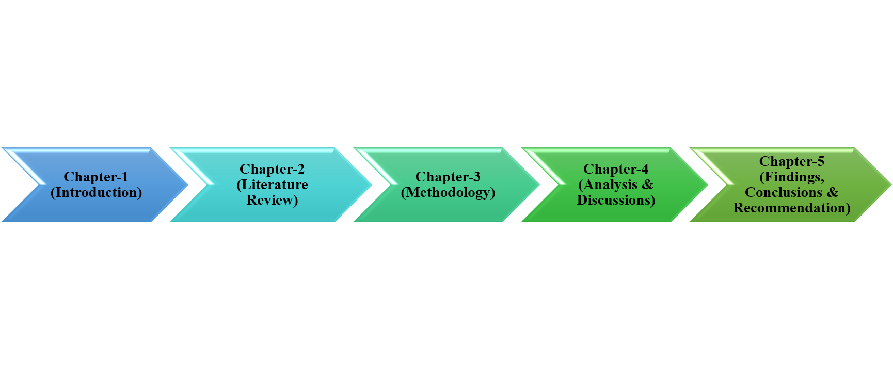
Figure 1 Layout of the study

Chapter-2 (Literature Review)

- Literature Review

2 Literature Review
Accounting is the usage of financial data to more eagerly mirror the financial presentation and situation of an entity in the horizons of financial values however different from the soul of values. To draw in stockholders and partners: Stockholders take investment choice of purchasing, keeping, and marketing of investment reliant on performing the entity destined by accounting numbers. If the businesses go into raise capital and an initial public offering (IPO), they include the meaning to inflate values and the accounting principles to persuade depositors to buy shares (Mohammad Safiuddin., 2018). Higher-income brings about a higher value of income tax. It is designated that to evade the burden of tax, managers may go for using accounting events to decrease tax liability and the profit ratio. When the expected aim cannot be gained in a specific period, administrators have the meaning to provide the expenses in a certain period so less expenditure is considered in the time frame to be charged, and in this manner, income can be considered in the following time frame.
IFRS has a substantial commitment to the consistency of financial considerations around the globe. It becomes simpler for depositors to get the obligatory information and make contrasts among a few choices related to the investment. Likewise, it is stated that it will likewise assist with reducing the cost of data for international business organizations on account of the financial construction. Utilization of relative accounting values for a financial reporting of the company assures likeness of the information as an important type of monetary decision making (Hasan & Rahman., 2019). Besides, it needs harmonization of accounting values to settle many arrangements of incoherent financial explanations which are followed by the local values on an international scale. The business reporting of the business organization under the IFRS framework is less involved in the management of earnings contrasted with the firms' reporting within the consideration of local GAAP. It needs a higher depiction in financial consideration comparative with most public accounting values; it links an augmented disclosure to increase the quality of accounting and decreased asymmetry of information between controlling investors and outside capital suppliers.
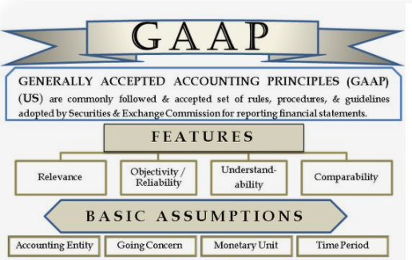
Figure 2 Generally Accepted Accounting Principle
Financial reporting is envisioned to give quality data and material to the client about the claims, financial considerations, and variations of a reporting entity. Earnings management is considered as a group of managerial selections to work on the financial principles by hiding the true short terms financial consideration to increase the firm's esteem. It is designated that the country's explicit institutional factors, for example, design of the capital market, creation of firm's ownership, financial market, and tax system, may assume a part in the consequences (Masud et al., 2017). The nature of an external auditor is an important consideration to regulate the resourceful conduct of the administrators. The audit quality is remarkably subject to the independence and competency of the external auditors which might be recognized with the immensity of the business organization.
The allowance method suggests recording bad debt expense in the year when sales happen. The stage of allowance might be considered on net deals or debt claims balance. It relies upon the previous uncertain debt history. If an entity exploits a resource because of revenue expenditure, this will prompt an overstatement of resources and misrepresentation of the reality of expense (Mohammad Safiuddin., 2018). It will recognize revenue when it is workable or acknowledged. The reception from clients for goods to be offered later or managements to be made later is a liability till the entity transfers the products to render or clients' facilities to clients. Presently, if the attributes of entity advance record to the account of deal, it will prompt understatement of liability in the balance sheet and overstatement of income in the income statement.
Financial considerations are introduced and organized for external clients by units from all over the world. It has been reached out to reporting of the business organization in terms of finance. Though the financial explanations may seem similar from the country-level if there are separate contrast because of a variety of lawful circumstances and social economy and by various nations having in consideration the provisions of various clients of financial announcements when setting public provisions (Fernando & Lawrence., 2014). Simultaneously, the lack of adoption IFRS progressively transcends the serious difficulties to the soundness of the insurance. It is stated that the advancement of more powerful insurance guidelines and laws has so become basic to directing financial growth onto a way of sustainability of the business organization. Diverse business firms of Bangladesh give numerous kinds of insurance strategy which assists with developing the industry, individual, foreign investment, commitment to GDP.
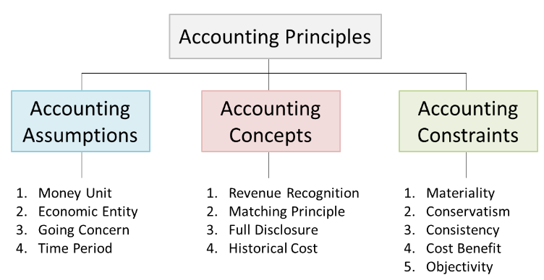
Figure 3 Accounting principles
A set of International Accounting Standard in Bangladesh will permit new prospects of advancement because of the relative study of the extents of profits set up dependent on the profit-and-loss account and balance sheet among the businesses being in the competition become pertinent. It is designated that considering an advantage of a single group of high calibers, internationally acknowledged accounting values is that stockholders can consider a set of financial dictions of companies and comprehend the financial consequence (Dey et al., 2018). It allows the outline of a policy that includes remeasuring assigned insurance liabilities dependably in every period to imitate the interest rates of the current market.
Actually, accounting theories give an overall casting by the accounting specialists can be judge and similarly manage the best approach to improvement of the unique system and the related principles. Responsibility advancements and the corporate governance aware companies about the duties they ought to have all their partners, to the society and the climate (Osho & Ayorinde., 2018). As the partners of the entity interact with others, they settle on choices that need pertinent information about the governance and performance of the entity. Investors require information about the danger and profitability of the entity in a request to settle on investment selections. Moneylenders, in making lending choices, additionally require the data about the capacity of the entity to reimburse loans and then the interest of income.
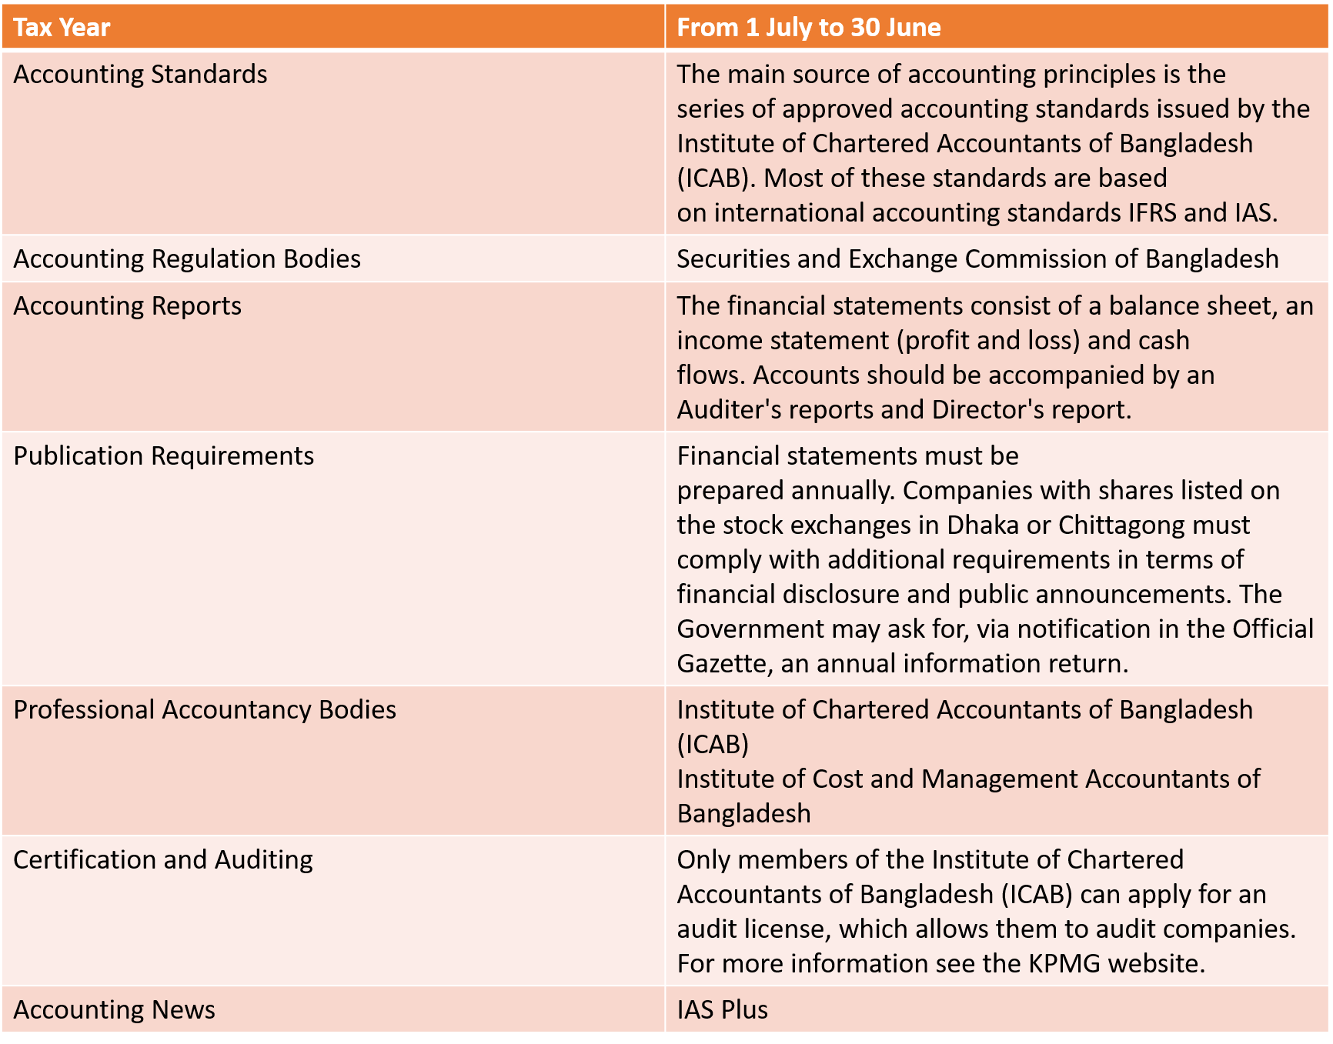
Figure 4 Accounting and accounting rules in Bangladesh
In an emerging country, the prospect of Bangladesh can sort out the proposals the practicing of IFRS 4 may accumulate that. It is stated that the agency issues between investors and management can be considerably decreased through the usage of IFRS as augmented transparency makes a manager act more in the notice of investors (Md. Mirajur Rahman., 2017). The augmented transparency guaranteed by IFRS similarly could cause a comparable increase in the productivity of constricting among moneylenders and firms. Recently, there have been a few high-profit corporate dissatisfactions, monetary scandals, and financial emergencies that have underlined the position of transparency and the requirement for disclosures and corporate governance. It is designated that the interesting corporate disclosure helps the business organization and its partners and the economy overall. The corporate disclosure has its expenses, there is a propensity among the organization not to reveal their subjects completely yet just to consider the advantages and the expenses involved.
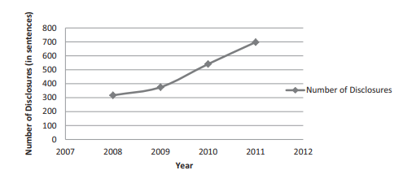
Figure 5 Overall trends of Disclosure
The obligatory character of reporting is measured at the public or even provincial level even the government specialists or professional governments, being experienced in the vast majority of the nations by all the business organizations despite their size, their financial, legal, or public accounting system, the favorite sources of finance and other influences with sway on disclosure strategy. For valid information, it is stated that it should be liberated from material errors (Masud et al., 2017). Material things are those that might change the sensation of the clients of the financial statements. It should not be retained from loan specialists and moneylenders.
Full exposure is reliably the astute choice. IFRS causes that accountants who plan monetary explanations should practice judgment in handling the inescapable variabilities of materiality and valuation. They are dependent to use alarms in making these decisions (Fernando & Lawrence., 2014). Accounting specialists should be prudent in the approach by seeing all the real factors and information, both emotional and financial, to convey financial expressions that meet the dependable quality essential of IFRS. The people act to augment their own management lobbies and utility on values related to accounting principles in view of their own personal circumstances, for instance, managers have inducements to pick accounting values that report lower earnings because of tax, and administrative and political arrangements.
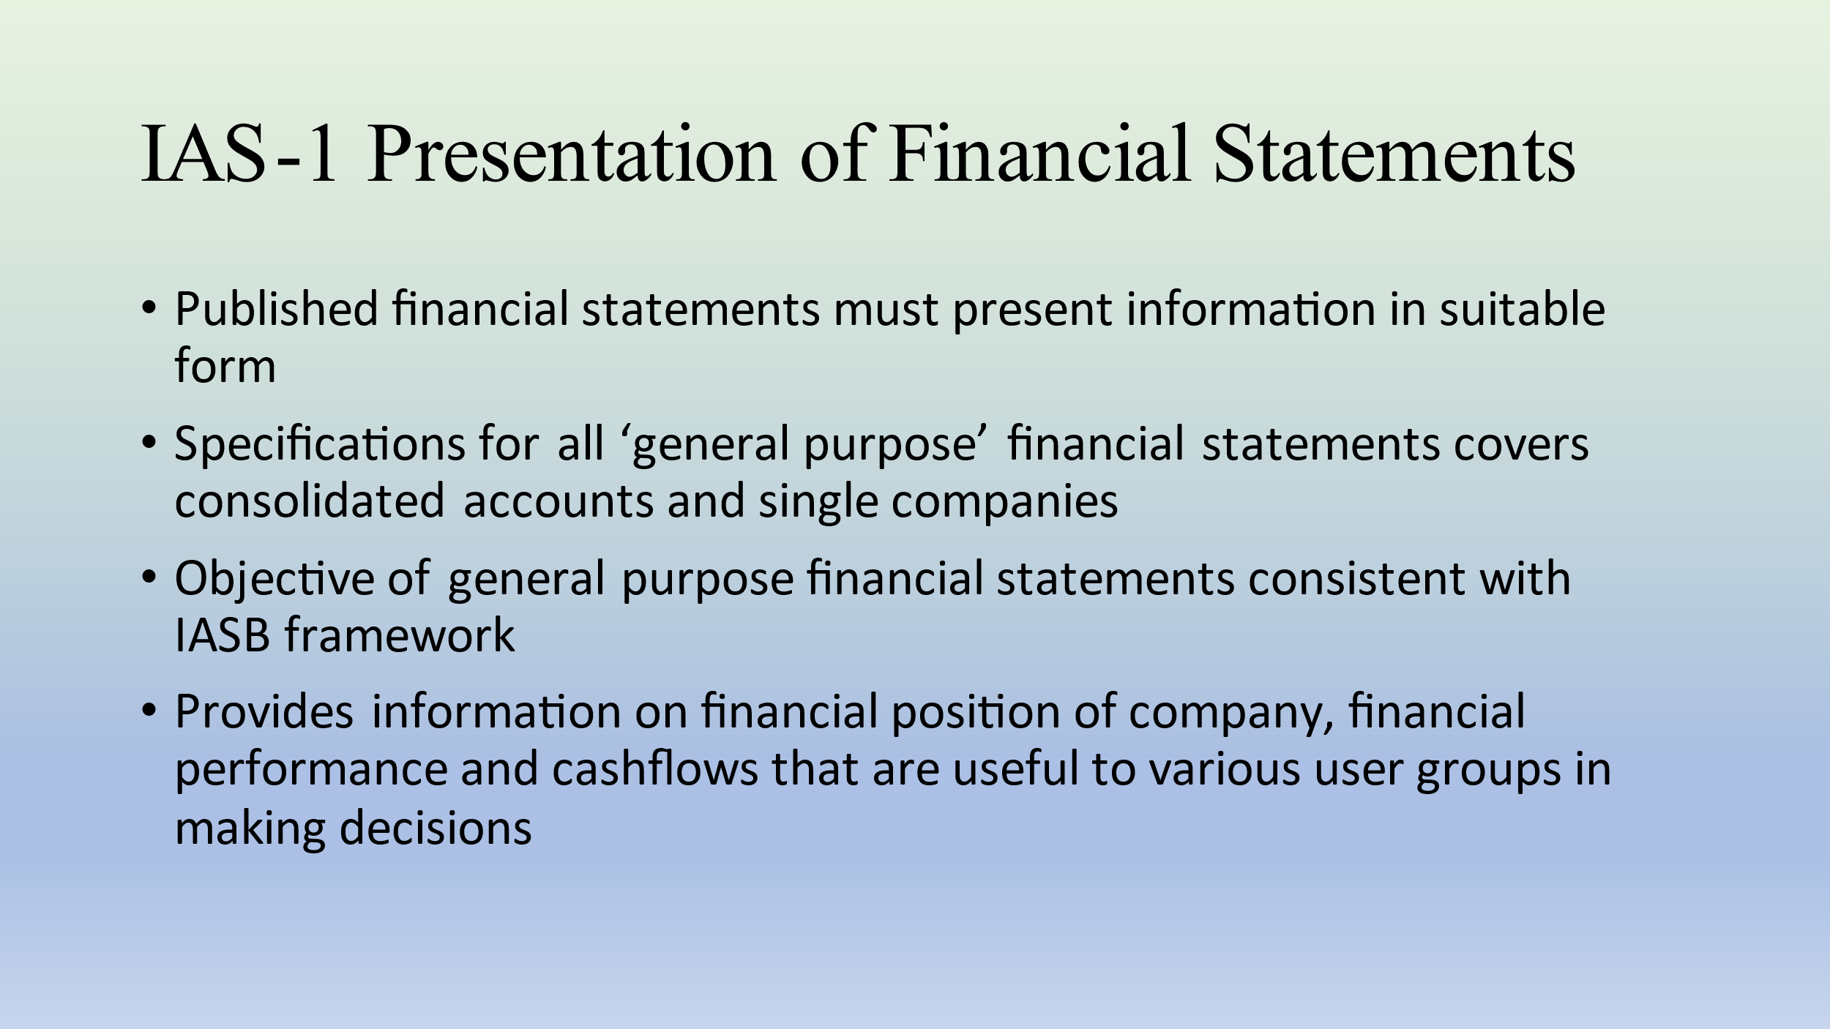
Figure 6 Presentation of financial statements
The administrators who have considerations for the accounting principles or their compensation that is joined with the accounting performance of the business organizations will include accounting technique in a manner which will imitate improved accounting analyzes that they would be; in such manner, approaches for devaluation, they would treat innovative work costs and uncollectible allowance in a way which will reward the managers. An ideal profit picture can affect the investors, and a solid position of liquidity can affect loan bosses (Dey et al., 2018). As well, it can provide association government controllers and the moderators with ammunition during talks related to bargaining. It is referred that the managers may have variable thought processes in reporting income numbers. As companies become bigger and all the more administratively noticeable, representatives and controllers commit more consideration concerning them. The bigger the firm, the almost certain it is to get dependent upon recommendation.
Businesses that are administratively clear may try to report low-income, to keep away from the inspection of controllers. It uses institutional theory to comprehend the frameworks used by various organizations and companies in firm-explicit settings of industry. This theory explains how administrations use constructions and comparative practices to make them obvious as an enduring business in the administrative bodies and consider the considerable authenticity (Md Shafiqul Islam., 2020). Another basic supposition is that the business organizations receive new frameworks and standards to get outer authorization in the type of the decreased expense of capital. It additionally sees what corporate governance means for the revelation of information in the annual reports of the corporate government. Disappointment or achievement in business organizations is basically prejudiced by the choices taken by the leaders. Subsequently, executives in big businesses have the inducement to reveal information identified with various extents.
The progression of accounting has been prejudiced by many components and for that details related to the financial accounting guidelines and practices have varied across nations. The accounting arrangement of Bangladesh has influenced by monetary, political, tax, lawful, and financial systems. The financing and taxation system in Bangladesh will influence the demand for information related to accounting values by the financial reporting standards and the guidelines (Nasrin Islam., 2019). Industry in Bangladesh is constrained by unfamiliar companies to maintain International Financial Reporting Standards (IFRSs), in wording the accounting system influenced to receive the particular estimation controls especially financial reporting standards. It is designated that not only to compute the profit of a business yet, in addition, but also to draw in bankers, investors, suppliers, clients, and related partners an organization must plan and disseminate the information related to finance. It is important to reveal all relevant financial information considered being decided. For contracts of long-term development, they can perceive income under the level of completed contract strategy or completion method.
In the level of fulfillment strategy, it will perceive income depends on the progression of the development that means the ratio of the level of completion. Thus, gross profit and revenues will appear in a time of development measure. Under the completed contract approach, it will perceive no profit or income until it completes the contract. Hereafter, the decision of various strategies offers to ascend to the various consequences (Hasan & Rahman., 2019). The extent of adaptableness of choosing various plans ought to be limited and the conditions under which it can apply every technique ought to be determined. The constancy of accounting strategies ought to be upheld so that through the long-term same approaches and strategies are considered. The entity can go amiss from it if just it is supportive for the clients not for the individual improvement.

Chapter-3 (Methodology)

- Methodology
- Philosophy of the Research
- Research Approach
- Research Type
- Research Strategy
- Sampling Procedure
- Data Collection
- Data Analysis Tools
- Presentation of the Data
- Reliability and Validity

3 Methodology

3.1 Introduction
This chapter is dedicated to interpreting the methodology of regulating the research. The methodology part has been organized to discover out the way research was designed, the way research was approached, the philosophy of the research, research strategy, the data collection technique, the sampling process, the tools used for data collection and, last but not least, the way data has been presented.
The following are the manner by which this research has been conducted:
- Primary Data: This study has focused on finding out the issues of practical accounting, so interviewing the subject was crucial for the completion of this study. I have personally visited the selected organization and apart from conducting the questionnaire survey, I have privately asked questions to those participants to get a better and thorough understanding of the problems they are facing.
- Secondary Data: Many articles, magazines, journals, newspaper, websites, financial reports were investigated in order to have ample knowledge about this study.

3.2 Philosophy of the Research
In order to properly conduct a study, it is essential to understand the philosophical issues. How data should be collected, analyzed and later can be used, it is given by research philosophy. For the purpose of business studies, there are basically four main types of philosophy, they are as follow:
- Positivism: Positivist approach basically focuses on the view that whatever fact is derived after observation is accurate and must be considered.
- Pragmatism: The Pragmatic approach entails that one view can never present the broader picture and reality may take many forms. If the concept is pertinent, then it may be applied to the subject.
- Realism: The Realist approach derives from the fact that reality is fully autonomous from the human mind.
- Interpretivism: Interpretivism, unlike other approaches above, takes human interest into consideration before taking actions.

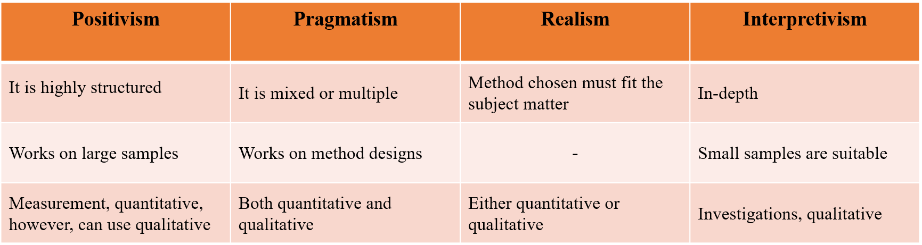
Figure 7 Commonly used Data collection Method

3.2.1 Reasoning for positivism approach
In the context of this study, after thoroughly analyzing the four research philosophies above, it can be said that the most appropriate one is the positivism approach. The reason for choosing this one is because this study is based on a survey questionnaire which is highly structured and the sample size is also fairly larger. Moreover, this study is a quantitative study, which means it is based on analyzing statistical numbers of respondents of the survey questionnaire. This study will find out the problem between theoretical and practical accounting more specifically the gaps between these two, that is why the positivism approach is most suitable for this study.

3.3 Research Approach
There are three approaches, basically, these are quantitative, qualitative and mixed approach. For the purpose of accurately defining the subject or topic of this study, a quantitative approach was most suitable. The reason being there is a questionnaire that was prepared and later analyzed for this study, so some variables needed to be sort out from those.

3.4 Research Type
There are 4 types of quantitative research, these are as follow:
- Descriptive research: In a descriptive approach the state of an identified variable is measured and then after collecting all the data a hypothesis is usually set. However, in the beginning, the researchers do not fixate on any hypothesis, rather they develop one after that.
- Correlational research: In a correlational approach, independent variable are identified without any manipulation. In this type of approach these variables must occur in their natural habitat and then a conclusion is drawn after studying. Statistical data are used to find out the relationship between variables.
- Causal-comparative research: This type of approach aims towards at finding the cause-and-effect relationships between variables or among them. However, if two variables are selected one must be independent and the other must be dependent.
- Experimental research: Experimental research, aka true experimentation, is made on a group of variables where all the variables are manipulated except one.

3.4.1 Reasoning for Correlational research
Aforementioned, in a correlational research approach no variables are manipulated, they are independent of each other, and a conclusion is drawn after gathering and analyzing data. In this study also statistical data has been collected in order to find out the gap that arises between practical and theoretical accounting. Here, practical accounting is one independent variable and theoretical accounting is another independent variable. The relation gaps between these two can be found after determining the extent of the relationship between these two. After conducting the questionnaire survey, no data was manipulated from the respondent’s feedbacks, rather it has been only used to draw a conclusion on the hypothesis that was determined. This is the reason why the correlational research approach is the most appropriate for this study. Although correlational research approach can also be called one type of descriptive research, nevertheless, in a descriptive research no hypothesis is determined beforehand of collecting data.

3.5 Research Strategy
As a means to find out the gaps between practical and theoretical accounting, both the case study and survey must be used to draw up a conclusion on this matter. On that account, both of them have been used. First, with the aim of achieving the framework the case study was built. The case here is that there is a gap between theoretical and practical accounting. After that, survey has been used to find out the opinion of the accounting practitioners to justify the case solidly. A questionnaire was set followed by a face-to-face interview with the respondents. Both of these methods proved to be helpful to this kind of study.

3.6 Sampling Procedure
In order to get the most accurate picture of the situation the sampling procedure is crucial. Below is described how it was done.

3.6.1 The Sampling method
For the purpose of this study, a probability sampling method has been chosen where all eligible individuals are selected, then, this probability sampling method has been subdivided into clustered sampling method. The reason for choosing clustered sampling method is because this study is focusing on a particular group of individuals, meaning the whole sample group has been subdivided into another group who have more or less adequate knowledge about accounting (Both theory and practical accounting) also who can actually identify the problems that arises while translating the theoretical part of accounting into practice.

3.6.2 Sample Size
In this study, 10 randomly chosen organizations from Dhaka city were selected. Although the organizations were randomly chosen, but the respondents were selected based on their accounting knowledge, compatibility and competency. Which means the individuals who are on the duty to handle the finance and accounts of an organization must be the respondent of the questionnaire.

3.7 Data Collection
For collecting data, common platforms like articles, magazines, newspaper, internet, websites etc. were used. Along with them I have conducted a survey on different organizations and gave them a questionnaire to fill in. The questions were divided into two parts; part 1 consisted of 5 questions regarding the demographic factors, e.g., gender, age, education status, employment status and academic years; part 2 consisted of 15 questions about their accounting competency. I had to visit each organization in order to conduct an interview and hand out the survey questionnaire. However, some of the organizations were functioning remotely due to the lockdown imposed by the Government, so I opened an online portal in which all the questionnaire was uploaded and sent to those organizations. An Interview was not needed, even so it helped me to comprehend the matter in more depth.

3.8 Data Analysis Tools
So as to achieve the result of this study, many tools like Microsoft word, Microsoft excel, Microsoft PowerPoint were used commonly. In addition, descriptive statistics such as determination of mean, median, mode, variance and standard deviation was used to find a conclusive hypothesis of this study.

3.9 Presentation of the Data
The report must be submitted via e-mail to the designated supervisor, either the PDF will be submitted or the original copy of the report must be submitted, or both should be submitted.

3.10 Reliability and Validity
Cronbach’s alpha is a measuring tool by which the strength of the consistency of a given scale is measured, and for this study it has been used. Usually, a score between 0.65 and above is considered acceptable and anything less than 0.5 is unacceptable. Whether the questions were consistent with each other to find that out Cronbach alpha has been used.

Chapter-4 (Analysis)

- Introduction
- Demography variables of the survey respondents
- Cronbach’s alpha for Measuring Reliability
- Analysis using Descriptive Statistics

4 Analysis

4.1 Introduction
In this chapter the data analysis, which have been collected through questionnaire on gaps in translating IAS 1 into practice has been presented. The questionnaire aided to find out what an organization’s accountants think about the practical use of IAS 1. The survey consisted of 20 questions, where 5 questions are about demographic factors and other 15 questions are study-related. Whether these accounting practitioners find the connection between learning in theory and preparing statements practically. The analysis of this chapter has been segmented into two parts. In the first segment the demographic variables are shown along with the Cronbach’s alpha which has been used to test out the reliability and validity of the questionnaire. In the second part, the reply of each question by each respondent has been analyzed using charts and descriptive statistics.

4.2 Demography variables of the survey respondents
Demographic variables may influence the response up to a high degree. From the survey it has been shown that age, gender, employment status, academic experience, level of education can highly influence the response of the survey. Usually more experienced people who have completed their post-graduation and have been practicing accounting for more than 15 years responded that there is a relation between theoretical and practical accounting. While less experienced and younger people responded that there was no relation between theoretical and practical accounting. Why this disarray arose in the survey will be explained further in this study. Below are the demographic factors which highly influenced the responses of the study.

Gender
 | Frequency | Percent %
Male | 24 | 96%
Female | 1 | 4%
Total | 25 | 100%
Table 1 Demography variables of the survey respondents (Gender)

Age
 | Frequency | Percent %
Under 18 | 0 | 0%
18-24 | 1 | 4%
25-34 | 7 | 28%
35-44 | 9 | 36%
45-54 | 8 | 32%
55 & above | 0 | 0%
Total | 25 | 100%
Table 2 Demography variables of the survey respondents (Age)
Education status
 | Frequency | Percent %
SSC/ O-Level | 0 | 0%
HSC/ A-Level | 0 | 0%
Graduate | 10 | 40%
Post-graduate | 15 | 60%
Doctorate | 0 | 0%
Total | 25 | 100%
Table 3 Demography variables of the survey respondents (Education status)
Employment Status
 | Frequency | Percent %
Part-time | 2 | 8%
Full-time | 23 | 92%
Total | 25 | 100%
Table 4 Demography variables of the survey respondents (Employment status)
Academic experience
 | Frequency | Percent %
Less than 1 year | 0 | 0%
1-5 years | 4 | 16%
6-10 years | 7 | 28%
11-15 years | 5 | 20%
15 years & above | 9 | 36%
Total | 25 | 100%
Table 5 Demography variables of the survey respondents (Academic experience)
From the above demographic data, it can be easily interpreted that most respondents were male. Age variable played an important role here because from the study it has been seen that most respondents were aged 35-44 years (36%) and the second highest range is 45-54 (32%). In terms of education status, most respondents were post-graduate (60%) and then on the second highest was graduate (40%), there were no respondents who were at doctorate or SSC/HSC level. Employment status showed only 2 people were part-time employee, other 23 respondents were full-time employees. In the academic experience section, the highest number of respondents is from 15 years & above range (36%) then the second highest range is 6-10 years (28%). This factor is the most crucial part because responses to the other questions related to the study varied drastically depending on the number of years a person practiced accounting.

4.3 Cronbach’s Alpha for Reliability
For assessing the reliability and validity of a questionnaire, Cronbach’s alpha has been used for this study. It measures the extent until which the data are consistent. The survey questionnaire has been prepared in a way so that there was consistency among the given questions. From 20 questions, 10 questions were in sync with each other, and for those 10 questions Cronbach’s alpha has been measured. The score of the Cronbach alpha is 0.76, which is under an acceptable range. It means there is consistency in the questionnaire. The other 10 questions were about demography which was earlier discussed. The following chart shows the Cronbach measurement chart:
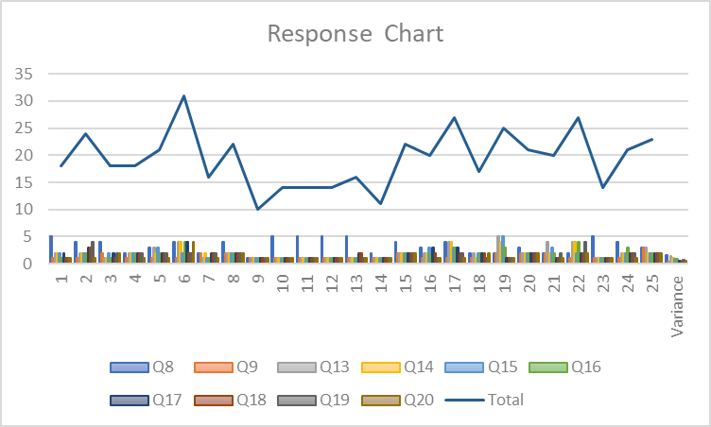
Figure 8 Response chart of the questions

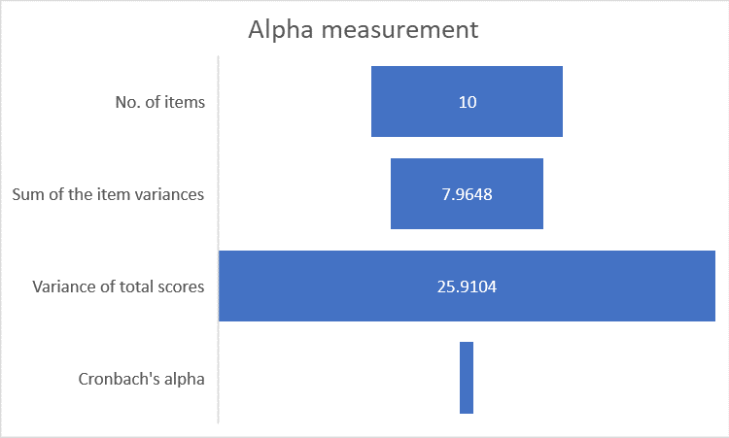
Figure 9 Defining the Cronbach’s alpha
To find the Cronbach’s alpha the given below formula was used.
$$α=\frac{k}{k-1}\left(1-\frac{∑V_{i}}{V_{t}}\right)$$

4.4 Analysis using Descriptive Statistics
For summarizing the data subsequently after collection descriptive statistics are used. Generally, mean, median, mode and standard deviation are used and for this study these 4 descriptive statistics has been used too. These parameters are most significant in order to find out the characteristics of any given data. The following table describes the basic descriptive statistics of this study:
Survey Questions | Question Number | Number of Respondents | Mean
1. There is no relation between theoretical & practical accounting | Q8 | 25 | 3.4
2. I find it easy to use accounting software than traditional accounting bookkeeping manually. | Q9 | 25 | 1.36
3. Recording Journals in practice is same as how I learnt in theory. | Q13 | 25 | 2.16
4. Recording Ledgers in practice is same as how learnt in theory. | Q14 | 25 | 1.96
5. Preparing Trial balance in practice is same as I learnt in theory. | Q15 | 25 | 1.96
6. Preparing Cashflow statement in practice is same as I learnt in theory. | Q16 | 25 | 1.88
7. Preparing Shareholder’s equity statement in practice is same as I learnt in theory. | Q17 | 25 | 1.88
8. Preparing Income statement in practice is same as I learnt in theory. | Q18 | 25 | 1.64
9. Preparing Balance sheet in practice is same as I learnt in theory. | Q19 | 25 | 1.72
10. The accounting related lessons that are taught in schools, colleges and universities should be changed and made more practical to real life scenario. | Q20 | 25 | 1.4
Average= |  |  | 1.94
Table 6 Finding mean score of the responses
As the scoring of the responses from the questionnaire has been chronologically numbered, where 1=Strongly Agree, 2= Agree, 3= Neutral, 4= Disagree, 5= Strongly Disagree, the mean score of all the responses gives a value of 1.94. The mean score of all the mean indicates that most respondents replied affirmatively, hence, the mean score turned out be 1.94.

Survey Questions | Question Number | Number of Respondents | Median
1. There is no relation between theoretical & practical accounting | Q8 | 25 | 4
2. I find it easy to use accounting software than traditional accounting bookkeeping manually. | Q9 | 25 | 1
3. Recording Journals in practice is same as how I learnt in theory. | Q13 | 25 | 2
4. Recording Ledgers in practice is same as how learnt in theory. | Q14 | 25 | 2
5. Preparing Trial balance in practice is same as I learnt in theory. | Q15 | 25 | 2
6. Preparing Cashflow statement in practice is same as I learnt in theory. | Q16 | 25 | 2
7. Preparing Shareholder’s equity statement in practice is same as I learnt in theory. | Q17 | 25 | 2
8. Preparing Income statement in practice is same as I learnt in theory. | Q18 | 25 | 2
9. Preparing Balance sheet in practice is same as I learnt in theory. | Q19 | 25 | 2
10. The accounting related lessons that are taught in schools, colleges and universities should be changed and made more practical to real life scenario. | Q20 | 25 | 1
Average= |  |  | 2
Table 7 Finding medians of the responses
From the above responses it can be interpreted that the average respondents mostly gave their reply with 2= Agree. However, for question number 8, the median here is 4, which indicates that most respondents disagree that there is no relation between theoretical and practical accounting.
Survey Questions | Question Number | Number of Respondents | Mode
1. There is no relation between theoretical & practical accounting | Q8 | 25 | 4
2. I find it easy to use accounting software than traditional accounting bookkeeping manually. | Q9 | 25 | 1
3. Recording Journals in practice is same as how I learnt in theory. | Q13 | 25 | 2
4. Recording Ledgers in practice is same as how learnt in theory. | Q14 | 25 | 2
5. Preparing Trial balance in practice is same as I learnt in theory. | Q15 | 25 | 2
6. Preparing Cashflow statement in practice is same as I learnt in theory. | Q16 | 25 | 1
7. Preparing Shareholder’s equity statement in practice is same as I learnt in theory. | Q17 | 25 | 2
8. Preparing Income statement in practice is same as I learnt in theory. | Q18 | 25 | 2
9. Preparing Balance sheet in practice is same as I learnt in theory. | Q19 | 25 | 2
10. The accounting related lessons that are taught in schools, colleges and universities should be changed and made more practical to real life scenario. | Q20 | 25 | 1
Table 8 Finding mode of the responses
Survey Questions | Question Number | Number of Respondents | Standard Deviation
1. There is no relation between theoretical & practical accounting | Q8 | 25 | 1.26
2. I find it easy to use accounting software than traditional accounting bookkeeping manually. | Q9 | 25 | 0.57
3. Recording Journals in practice is same as how I learnt in theory. | Q13 | 25 | 1.21
4. Recording Ledgers in practice is same as how learnt in theory. | Q14 | 25 | 1.02
5. Preparing Trial balance in practice is same as I learnt in theory. | Q15 | 25 | 0.93
6. Preparing Cashflow statement in practice is same as I learnt in theory. | Q16 | 25 | 0.93
7. Preparing Shareholder’s equity statement in practice is same as I learnt in theory. | Q17 | 25 | 0.78
8. Preparing Income statement in practice is same as I learnt in theory. | Q18 | 25 | 0.57
9. Preparing Balance sheet in practice is same as I learnt in theory. | Q19 | 25 | 0.84
10. The accounting related lessons that are taught in schools, colleges and universities should be changed and made more practical to real life scenario. | Q20 | 25 | 0.71
Average= |  |  | 0.24
Table 9 Finding standard deviation of the responses
Standard deviations show to what extent there is variation from mean. In the above table it can be seen that the standard deviation is very low in most cases, which is an indication that data are closer to the mean.

4.5 Analysis using Charts
In this section of the analysis the responses that has been recorded is thoroughly examined using pre-judgement and the data itself. Below each question’s response has been shown:

4.5.1 Gender
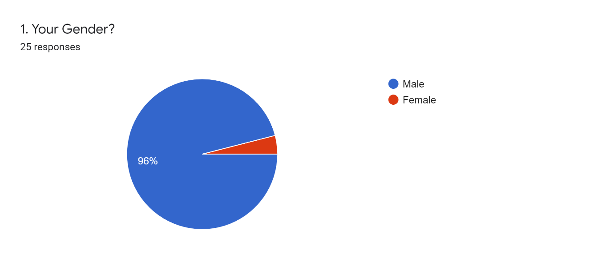
Figure 10 Gender of the respondents
Out of 25 participants who took the test, 96% of the respondents were male and only 4% was female. The responses were mostly similar as it was taken by similar gender group.

4.5.2 Age
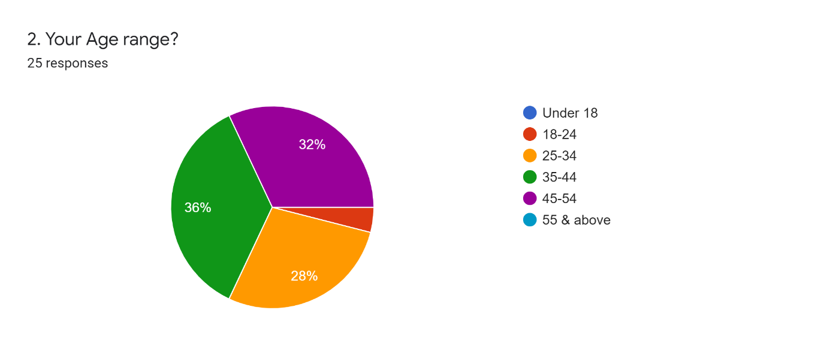
Figure 11 Age of the respondents
The highest group of respondents that participated in the survey were aged 35-44 years old. This is a crucial part of the demography factor because it shows that most of them are experienced individuals. The second highest group was aged between 45-54 years old.

4.5.3 Level of Education
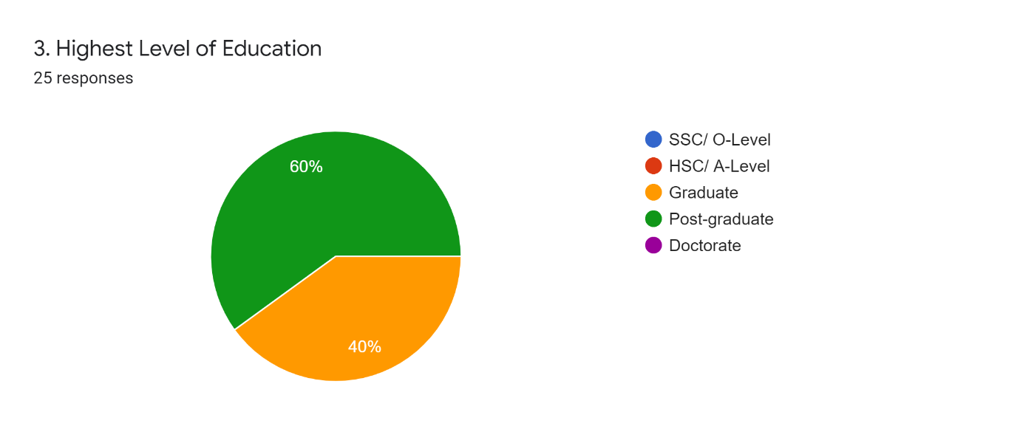
Figure 12 Education status of the respondents
Most of the participants are post graduate with about 60% and 40% being graduates. These individuals were all affiliated with the subject of accounting. Either they majored in accounting or their education line was fully accounting.

4.5.4 Level of Employment
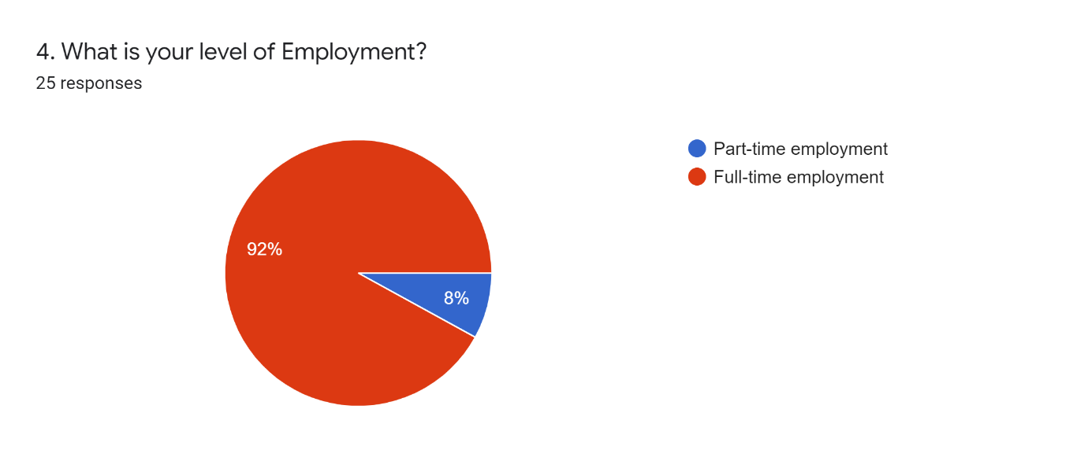
Figure 13 Employment status of the respondents
About 92% or 23 participants were full time employee in the organization’s they were working for. Only 8% or 2 individuals were part time employees.

4.5.5 Accounting practicing years
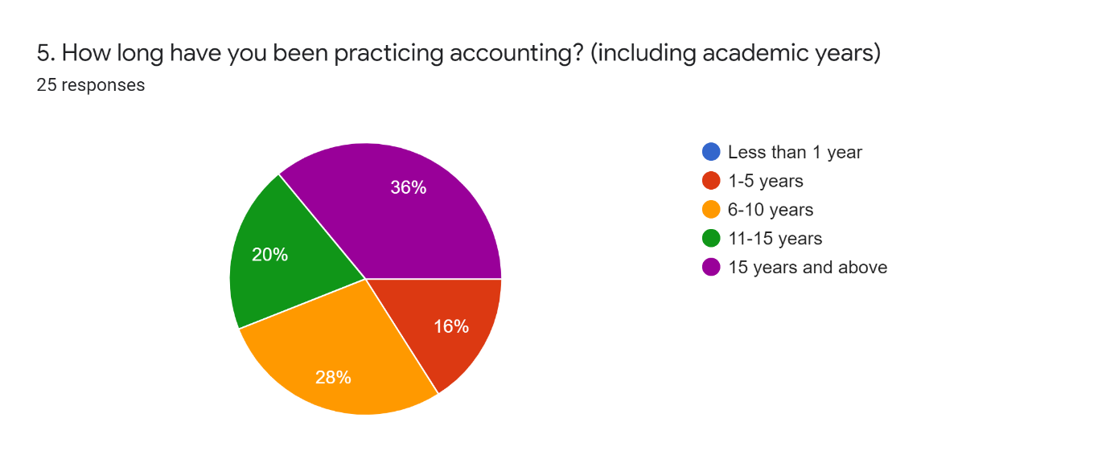
Figure 14 Practicing years of the respondents
The majority of the respondents in the survey practiced accounting for more than 15 years. This indicates that they have been affiliated with accounting for a longer period of time, and their responses are vital to this study. The more experienced any individual is, the more there is a possibility of getting a well grasp of the problems they face preparing the financial statements. More accurately, which statement is hard or easy to prepare.

4.5.6 Accounting bookkeeping
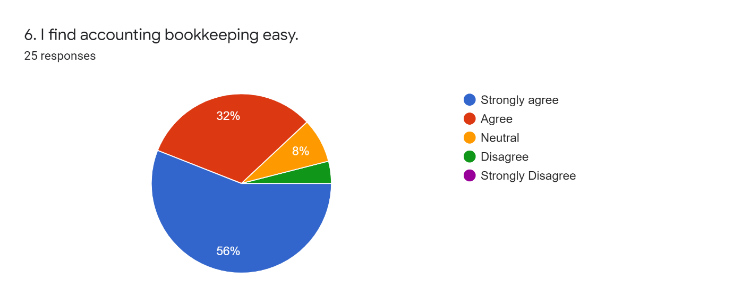
Figure 15 Accounting bookkeeping
The sixth question in the survey was about whether accounting bookkeeping is easy or not. The majority of participants, about 56% or 14 respondents, strongly agreed. This has proven to be linked to the question that is followed by this question. As most participants have been practicing accounting for more than 15 years or so, that is why the answers were mostly affirmative. It has been noticed in the survey that those participants who practiced accounting for 1-5 years replied negative in this question. So, it can be interpreted that the more the practice year is, the more people find accounting bookkeeping easy.

4.5.7 Use of Accounting Software
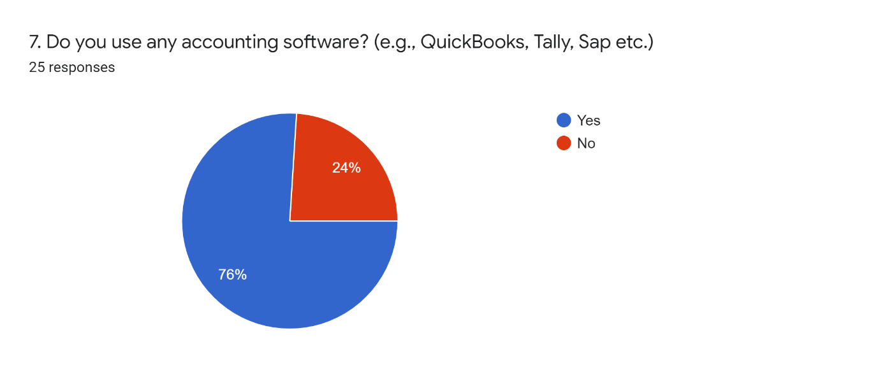
Figure 16 Accounting software usage
Aforementioned that the sixth question’s answer is linked to this question, and from the graph it can be seen that the majority of people use accounting software for bookkeeping. Out of 25 participants, about 19 individuals replied that they use accounting software. However, the other 24% or 6 participants replied that they do not use any accounting software. Later in the questionnaire it has been seen that those who did not use any accounting software found accounting bookkeeping hard. Which means accounting software makes the bookkeeping easy than manually keeping records.

4.5.8 Relation between theory and practice
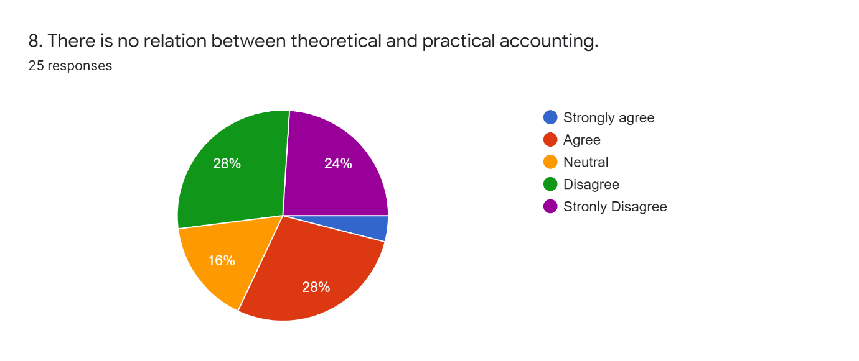
Figure 17 Theory & practice relationship
The eighth question of the survey entails whether the participants believe there is a relationship between theoretical and practical accounting in general. This part showed a conundrum as the highest number of people either answered agree or disagree, both at 28% or 7 respondents. The second highest range answered strongly disagree (24%), followed by neutral (16%). On that account, it can be projected that the majority of the people answered negative to this question. It means there is a relationship between theoretical and practical accounting.

4.5.9 Automated vs Traditional bookkeeping
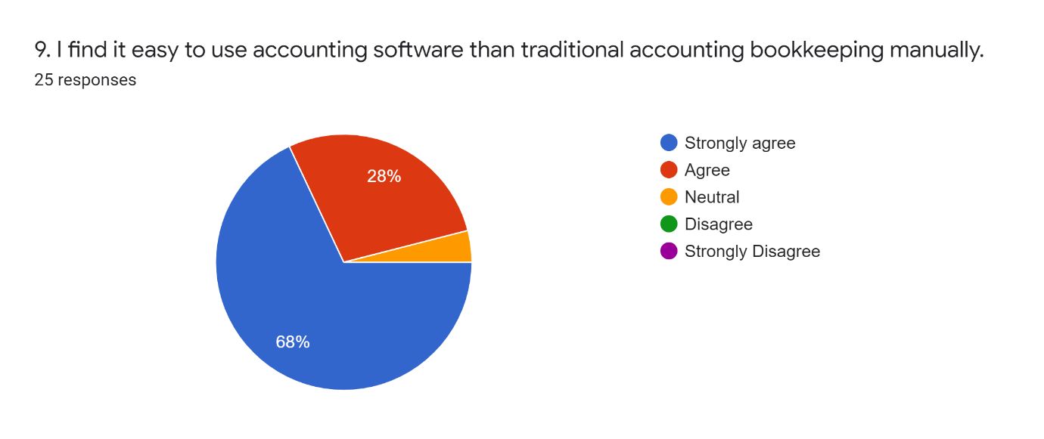
Figure 18 Bookkeeping method
In this question respondents mostly answered that they find accounting software more useful than manually reporting. About 68% or 17 respondents out of 25 replied positively that they find it easy to use accounting software for bookkeeping rather than manually. None of the respondents disagreed with this question. However, only few respondents replied neutrally.

4.5.10 Use of accounting knowledge for recording
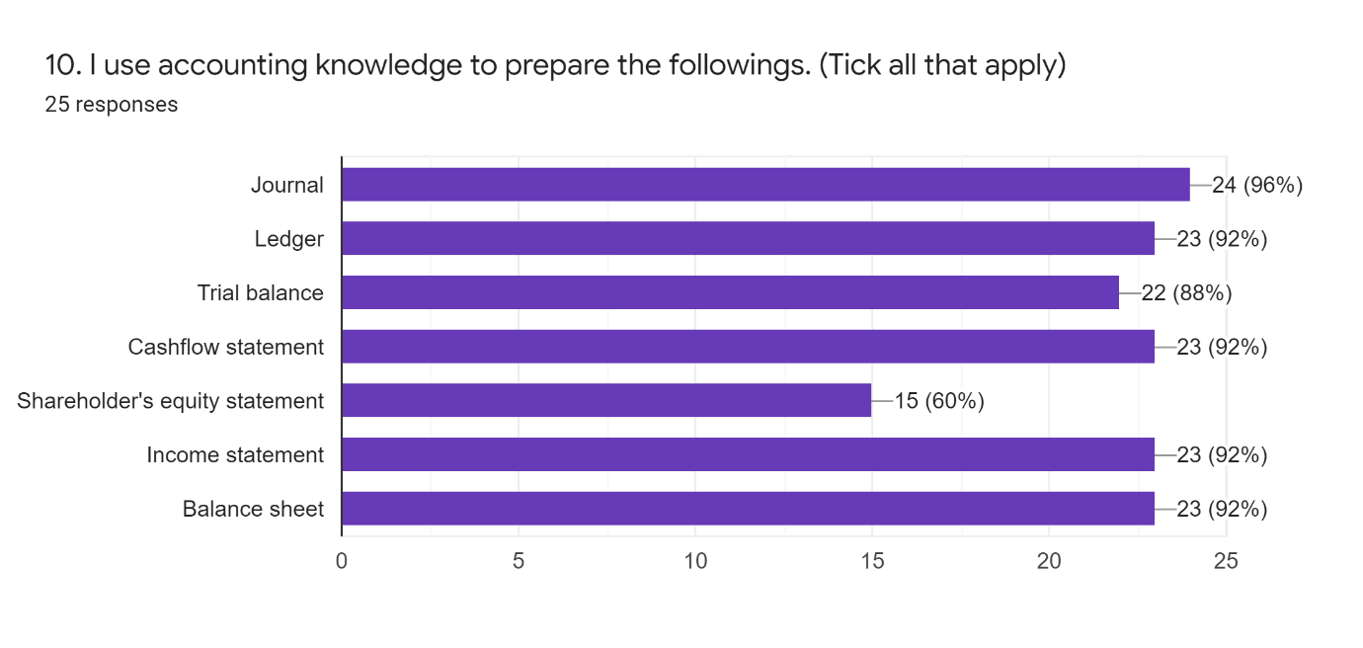
Figure 19 Use of accounting knowledge to prepare statements
The tenth question entails which statements are prepared using the accounting knowledge participants gathered in their academic or professional years. Almost every participant prepared journal, ledger, cashflow statement, income statement and balance sheet. Trial balance is prepared by 88% or 22 respondents. However, the number of people who prepare shareholder’s equity statement is significantly low, only about 60% or 15 respondents. So, it can be interpreted that the shareholder’s equity statement has less implication in real-life business dealings or the organization’s overall operation.

4.5.11 Most frequently used statements and documents
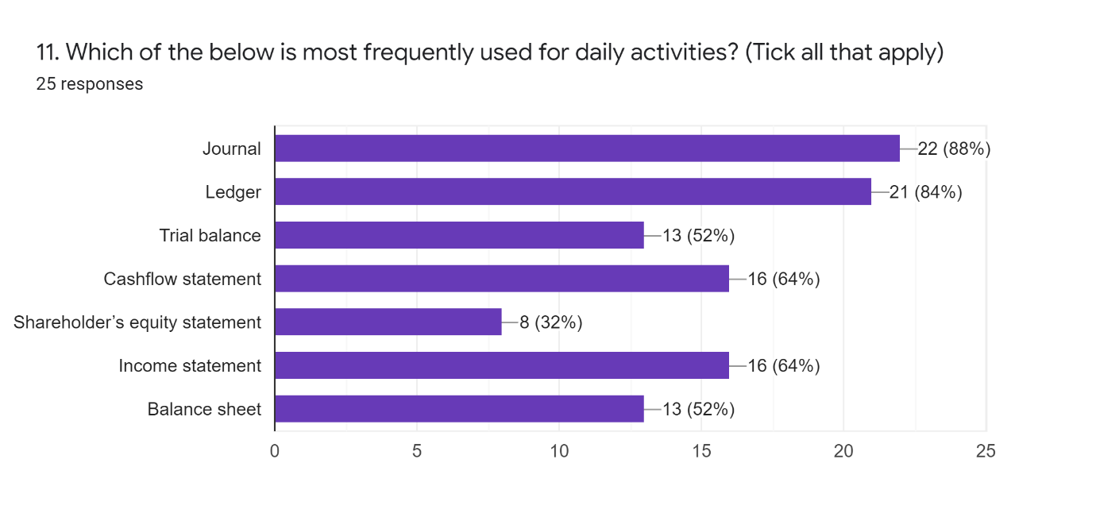
Figure 20 Frequently used financial statements
In the eleventh question it was asked which of the financial statements or recording documents they use most frequently and, in conjunction with the previous answers, it can be seen that most frequently used is journal, ledger and income statement for daily operations. Likewise, the least prepared statement is the shareholder’s equity statement with only 8 participants out of 25 responding affirmatively. The reason fewer participants chose balance sheet is because it is prepared annually or semi-annually in most of the organizations. With very few people preparing it on a daily basis.

4.5.12 Difficulty level of the statements and documents
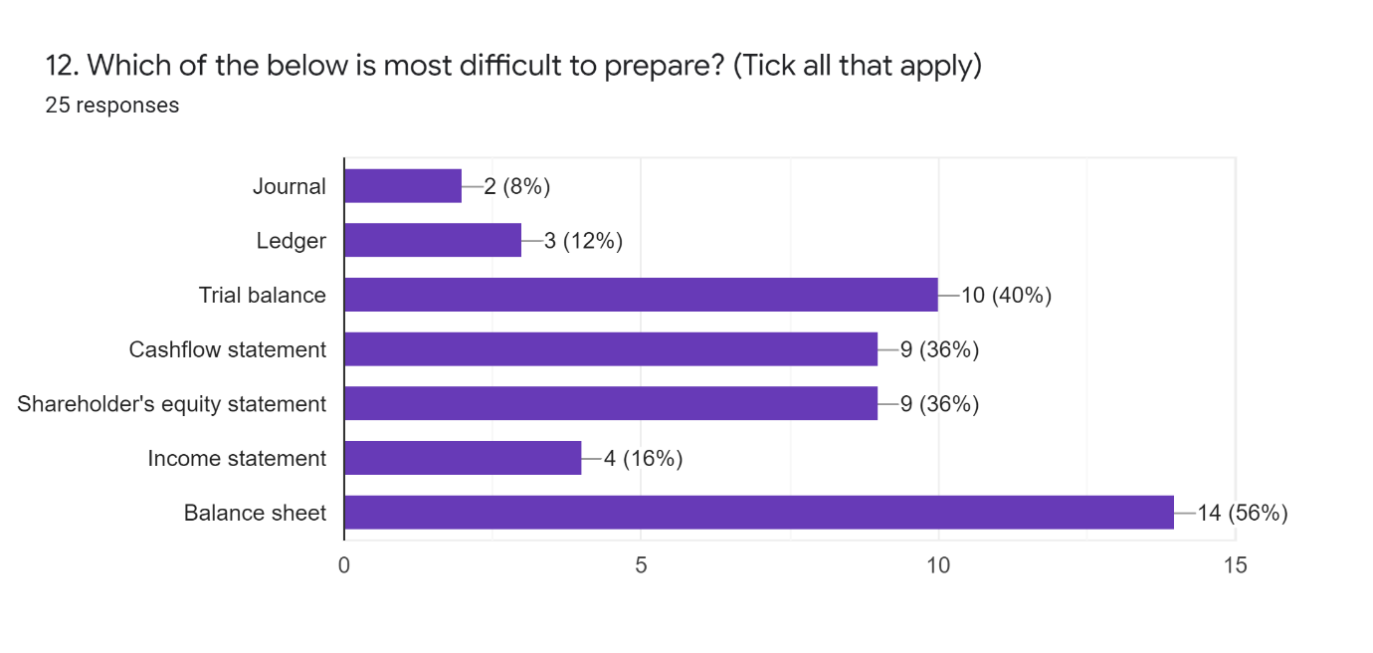
Figure 21 Level of difficulty of each statement
In this question it was asked which one is most difficult to prepare. Surprisingly, most participants replied the balance sheet as the most difficult statement to prepare. Followed by the trial balance on the second highest range in difficulty level. The least difficult according to the survey response is the journal and then the ledger. These two are pretty basic for day-to-day operation, which makes it easier to prepare for the respondents.

4.5.13 Journal in practice
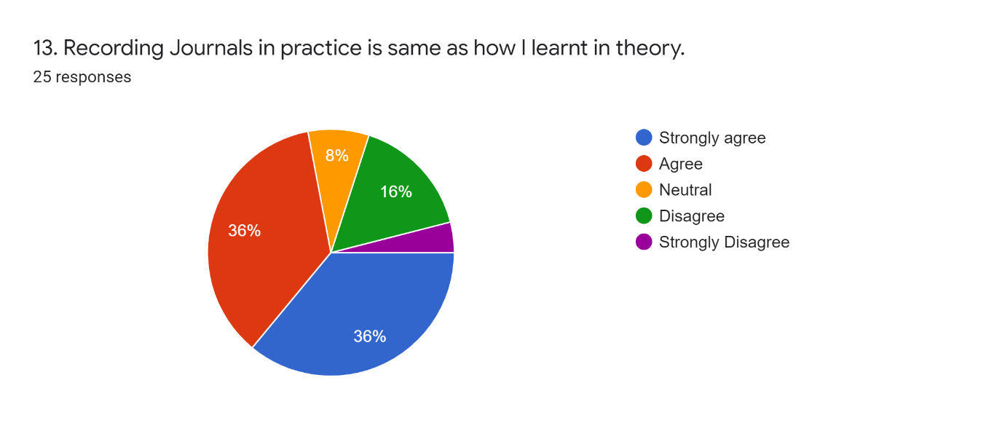
Figure 22 Journal-Practice vs Theory
From this question and onwards it is about whether the theoretical learning of the financial statements and documents are the same as the practical application. Most people either strongly agreed or agreed with this question. Out of 15 respondents, 18 people replied affirmative to this question. Therefore, it can be confidently said that the practical application of the journal is the same as it is learnt in the theoretical aspect. Nonetheless, 5 people out of 25 responded negatively, which means they find no relation between practical and theoretical journal recording. The individuals who replied negative are mostly graduates who have been affiliated with accounting for a short period of time. Thus, the more any individual has been practicing accounting, the more they seem flexible with journal preparation.

4.5.14 Ledger in practice
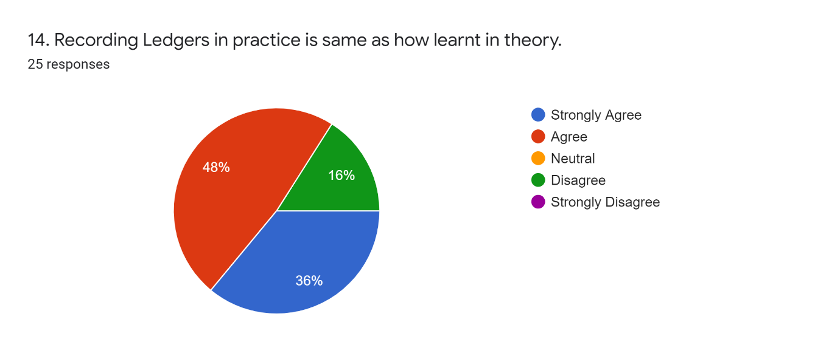
Figure 23 Ledger-Practice vs Theory
Here too, like the previous question, most participants answered strongly agree or just agree. Ledger preparation usually flows from a journal, so, if most respondents find journal recording in practice the same as in theory then perceptibly, they will find ledger preparation same in practice as in theory too. Here too, 16% people disagreed with the hypothesis like in the previous question. Therefore, it can be concluded that the journal and ledger are highly affiliated, and both are same in practice and theory too.

4.5.15 Trial balance in practice
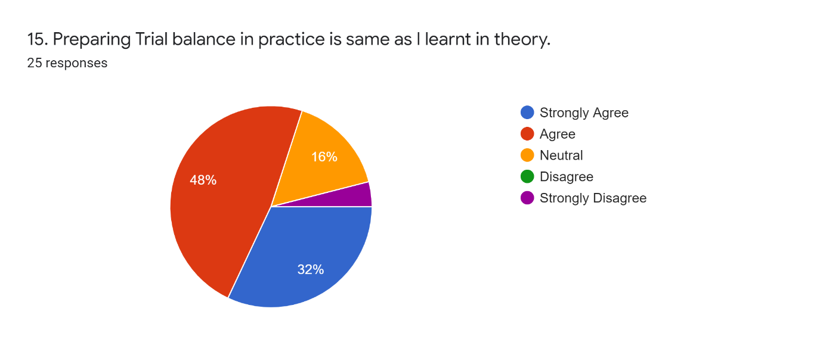
Figure 24 Trial Balance-Practice vs Theory
The fifteenth question is about trial balance. Most participants here responded that they find preparing trial balance in practice same as they learnt in theory. Trial balance is pretty straight in nature. It is a cross check of the ledger amount that was found.

4.5.16 Cashflow statement in practice
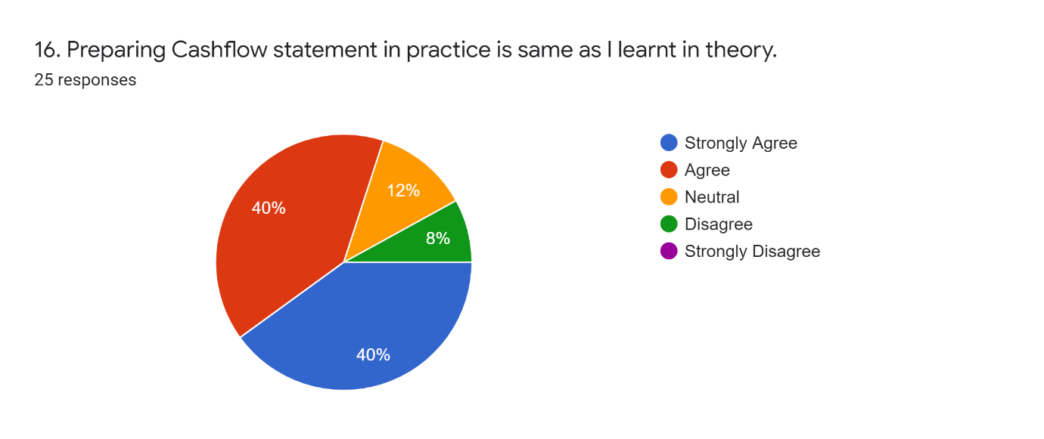
Figure 25 Cashflow Statement-Practice vs Theory
One of the substantial and mostly used statements in any organization is the cashflow statement. This statement helps to find out the liquidity of an organization. While asked, 16 out of 25 participants replied that they prepare cashflow statement often. 20 out of 25 respondents replied that preparing a cashflow statement is the same as they have learnt in theory. While only 3 respondents replied impartially.

4.5.17 Shareholder’s Equity statement in practice
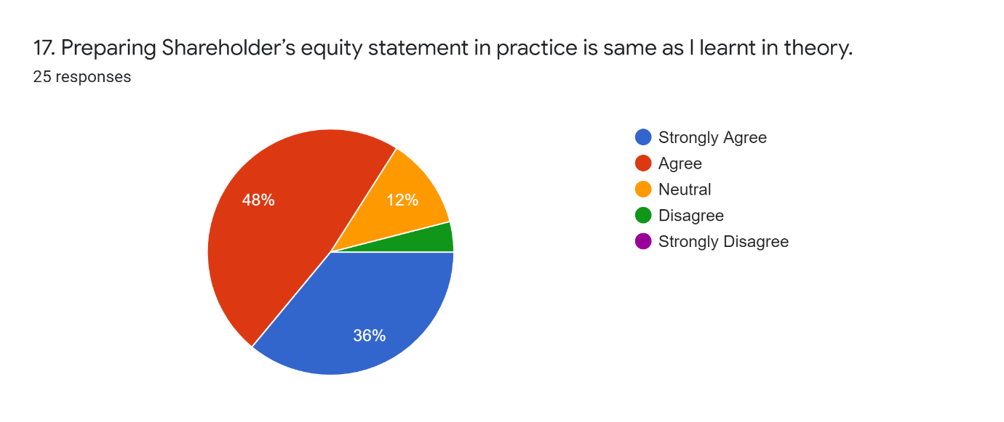
Figure 26 Shareholder's Equity Statement-Practice vs Theory
Surprisingly, participants answered positively to this question. Aforementioned few questions did not portray a positive result from the participants. This hypothesis conveyed an affirmative result, which is inconsistent with the previous answers. Most people answered previously that they don’t use the shareholder’s equity statement as much and is also one of the difficult statements to produce in practice. However, here 21 partakers out of 25 replied they found preparing shareholder’s equity statement in practice similar to what they learnt in theory.

4.5.18 Income statement in practice
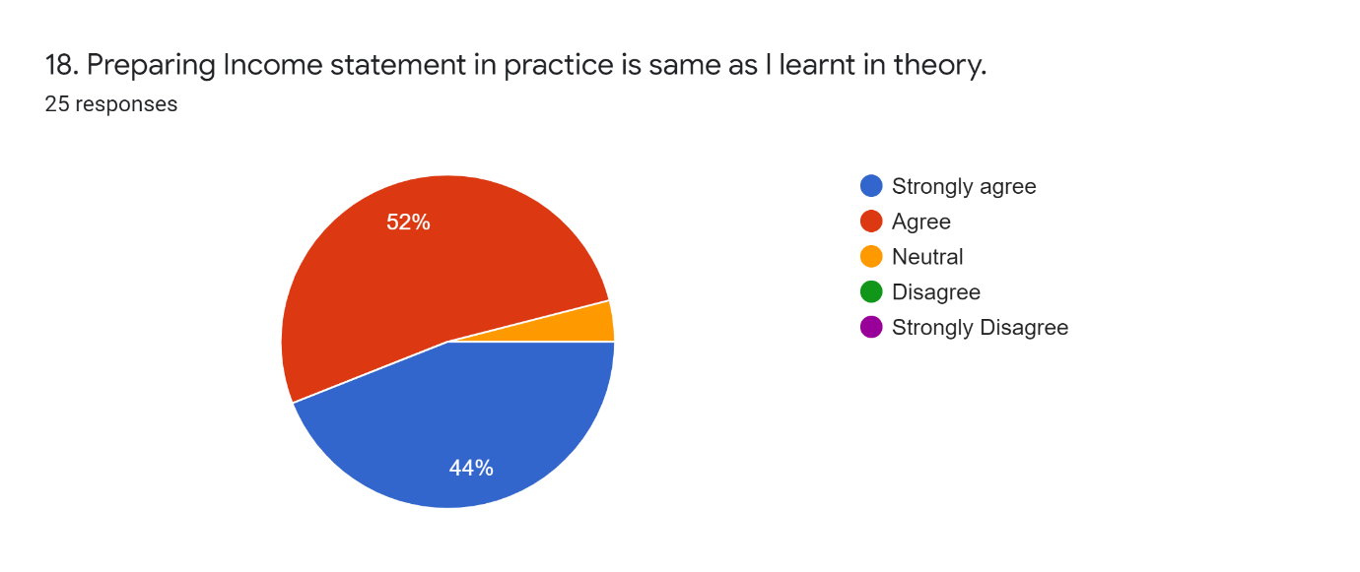
Figure 27 Income Statement-Practice vs Theory
The eighteenth question is about whether the test subjects find preparing the income statement same in practice as they learnt in theory. Astoundingly, 24 respondents out of 25 replied positive to this. Which means the income statement that we learnt in theory is similar to prepare in real life too.

4.5.19 Balance sheet in practice
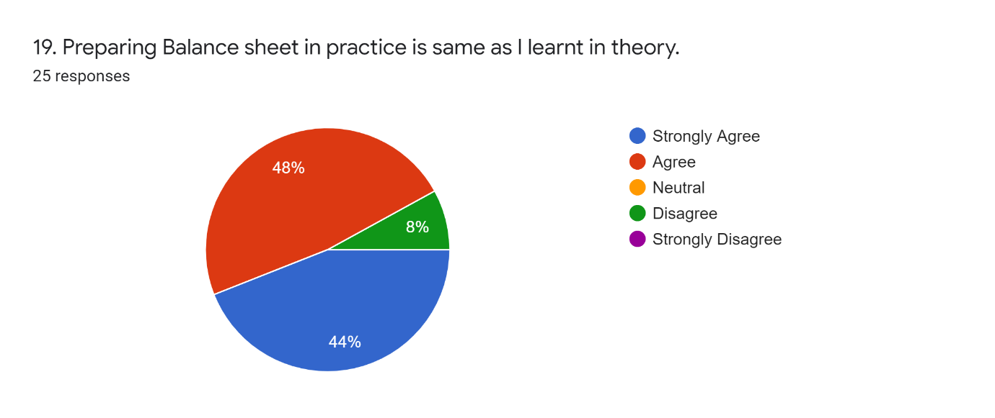
Figure 28 Balance Sheet-Practice vs Theory
The second last question of the survey is about the balance sheet, which for any organization is a must to prepare. 23 participants or 92% replied agree or strongly agree to this question. Beforementioned, it was seen that most of the respondents replied that the balance sheet is the most difficult to prepare out of all the other statements. However, they also agreed that it can be prepared using the knowledge they have gathered in their professional life and academic life. Only 2 people replied negative to this question out of 25.

4.5.20 Whether way of teaching accounting should be changed
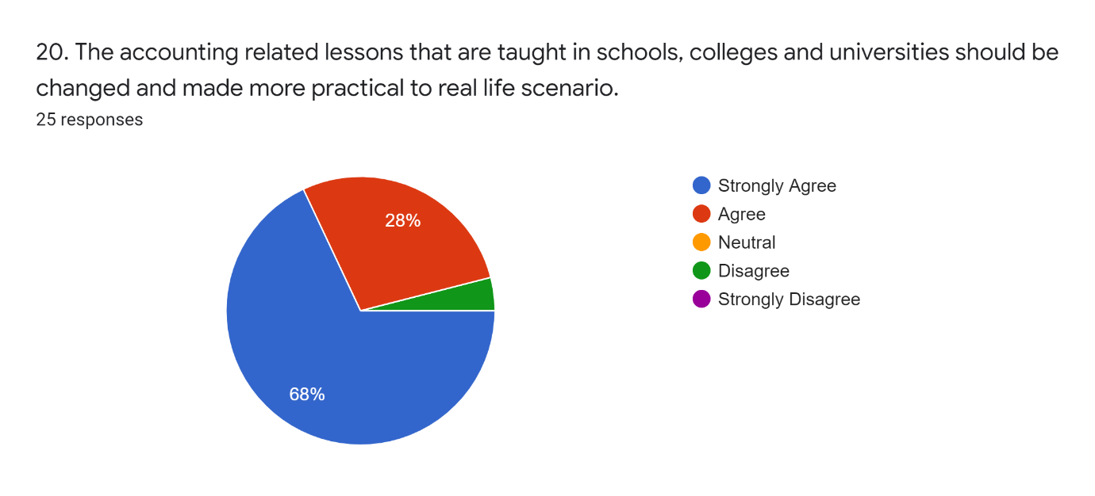
Figure 29 Change in accounting lessons
The last question was tricky for the participants to answer. 24 respondents out of 25 replied that the accounting lessons that we learn in schools, colleges and universities must be changed. From the above graph it can be seen that the majority strongly agreed to this query.

Chapter-5 (Findings, Conclusion & Recommendation)

- Introduction
- Findings
- Conclusion
- Recommendation
- Limitations of the study

5 Findings, Conclusion & Recommendations

5.1 Introduction
In the previous chapter of this study, the survey questionnaire result was analyzed using various tools of statistics and charts. In the analysis we have seen the opinion of twenty-five organizations which were selected randomly. The reliability of the survey questionnaire was tested using Cronbach’s alpha, which showed a promising result. After that, descriptive statistics have been used in order to interpret the data in a more meaningful way. In this chapter, findings of the study will be discussed. It will flow from the analysis that was done in the previous chapter. Next the conclusion and recommendation will be derived from the study as a whole. The limitations will also be discussed in this section.

5.2 Findings
In this part of the chapter the noteworthy results of this study will be discussed. Firstly, the result of the study derived from the survey questionnaire to attempt an understanding of what the accounting people of an organization think about reporting and preparing financial statements. From the demographic question of the survey, it was found out that the most accounting people are male aged between 35-44 years old and have experience over 15 years. The demographic factor deemed to be important here because the following questions of the survey varied significantly on these factors only.
The second factor that was considered for this study was the descriptive statistics. Cronbach’s alpha was used as a means to find out the validity and reliability of the study. The calculation gave a result of 0.76 alpha, which is under an acceptable range. The 0.76 alpha signifies that the questions of this study have a consistency among the measurement range. Next, the mean of the questions gave a result of 1.94, this represents that most questions were answered affirmatively, as score=1 indicated strongly agree in the survey questionnaire. The standard deviation gave a result of 0.24, which means the result of each question is much closer to the mean.
The third part of the analysis portrayed charts of the actual survey responses. From there it was deduced that most test takers think the practical accounting bookkeeping is not much different from theoretical accounting. However, the reason this gap in translating IAS 1 into practice arises is because of some of the statements, e.g., balance sheet, income statement and shareholder’s equity statement, these are a little bit tricky to prepare in practice than it was taught in theory. In the real-life scenario, sometimes accountants need to go for judgement based on their experience and intuitions. From few brief one-on-one interviews with the accountants, this matter was cleared up. Majority of the respondents replied that the accounting lessons that we learn in our academic years are not similar to real-life actual transactions. It gives us the general idea that it is true, however, the real-life picture is not the same.

5.3 Conclusion
This study was conducted in order to find out the deviation that arises while translating IAS 1 in practical life. Translating here might be a tricky word, but for the purpose of this study it represents the statements most participants find complicated or smooth to prepare. Conclusively, the questions that was pointed out in the introduction part has been answered throughout the study. For instance, the main complications in translating theory into is the lack of practice. The more professional any individual was the less chances there was for a gap. Most organization in Bangladesh uses the traditional methods for accounting bookkeeping. The difficulty of bookkeeping has been reduced due to introduction of several accounting software. Nowadays even people without any accounting knowledge can get the idea on how to record accounting related transactions.
Some random organizations were selected to find out the answer to this query. A survey questionnaire was sent to each of those organizations, and it was required to be filled in by an accountant or people working in the accounting department of the organization. The survey questionnaire was mixed with demographic questions and financial statement-related questions. It tested out the competency of those people related to accounting. It was found that most accountants think that the way accounting is taught should be changed. On the personal interview, they answered the reason being that it mostly falls under rules and rigid frameworks which in real life is not possible to implement. That is the reason for the misstatement and misinterpretation occurring in big, medium or small organizations.

5.4 Recommendations
This research found out some fragility in the process of accounting bookkeeping and preparation of financial statements. So, below some recommendations will be indicated for better understanding the concept:
- Use of accounting software should be made priority in the academic years or learning period.
- As modernization is causing any simple organization to become more complicated, which results in complication in accounting-related transactions, so, during the learning period one should look beyond the strict framework of accounting principles.
- Managerial judgement and intuitions must be utilized while dealing with accounts records and financial statement problems that arise in the daily operation of an organization.
- The usual rigid framework of preparing financial statements must be made more graspable and lucid.

5.5 Limitations of the study
Humans are error prone, so it is hard or impossible sometimes to produce any research report without any limitations. The biggest constraint of this study was the lack of information from the participants and the small sample size. Most of the organization’s people were reluctant to give a one-on-one interview. Also, the small set of organization was not enough to get the full picture or condition. Nevertheless, this study can be used to understand the problems that general accounting people face. Some crucial questions like which of the statements are more complicated and mostly used etc. have been answered in this study. This study can also be used for further study.

References:
Dey, R. K., Hossain, S. Z., & Rezaee, Z. (2018). Financial risk disclosure and financial attributes among publicly traded manufacturing companies: Evidence from Bangladesh. Journal of Risk and Financial Management, 11(3), 50.
Fernando, S., & Lawrence, S. (2014). A theoretical framework for CSR practices: Integrating legitimacy theory, stakeholder theory and institutional theory. Journal of Theoretical Accounting Research, 10(1), 149-178.
Hasan, M. T., & Rahman, A. A. (2019). Conceptual framework for IFRS adoption, audit quality and earnings management: The case of Bangladesh. International Business and Accounting Research Journal, 3(1), 58-66.
Islam, N. (2019) THE ROLE OF CULTURE ON THE ACCOUNTING SYSTEM OF BANGLADESH.
Islam, M. S. (2020). Investigating the relationship between integrated reporting and firm performance in a voluntary disclosure regime: insights from Bangladesh. Asian Journal of Accounting Research.
Masud, M., Kaium, A., Bae, S. M., & Kim, J. D. (2017). Analysis of environmental accounting and reporting practices of listed banking companies in Bangladesh. Sustainability, 9(10), 1717.
Osho, A. E., & Ayorinde, F. M. (2018). The General Tenets of Positive Accounting Theory Towards Accounting Practice and Disclosure in Corporate Organizations in Nigeria. Journal of Economics and Sustainable Development ISSN, 2222-1700.
Rahman, M. (2017). Financial Reporting Practices in the Insurance Company in Bangladesh: An Evaluation of the Implementation of IFRS 4, Insurance Contract. J Account Mark, 6(218), 2.
Safiuddin, M. (2018). Creative Accounting Practices by Bangladeshi Companies: A Study on Recent Share Market Crisis in Bangladesh. Australian Academy of Accounting and Finance Review, 4(1), 15-21.
Masum, Bhuiyan, M. H. M. N. U. B. (2011). Accounting Practices in Small Business: A Portray from Bangladesh. The Cost and management.
Masum, Hasan, Miraz, Wahab & Chowdhury. (2020). FACTORS AFFECTING THE SUSTAINABILITY REPORTING: EVIDENCE FROM BANGLADESH. International Journal of Mechanical and Production DOI: 10.24247/ijmperdjun2020792
Mondal H, Mondal S. (2017) Calculation of Cronbach's alpha in spreadsheet: An alternative to costly statistics software. J Sci Soc 2017; 44:117-8
Jansen, P. J. (2018) Bridging the gap between theory and practice in management accounting: Reviewing the literature to shape interventions. Accounting, Auditing & Accountability Journal ISSN: 0951-3574
H. McCredie. (1957). The Theory and Practice of Accounting. The Accounting Review, 32(2), 216-223. Retrieved March 14, 2021, from http://www.jstor.org/stable/241474
Baldvinsdottir,Mitchell & Norreklit, G. H. F. (2010). Issues in the Relationship Between Theory and Practice in Management Accounting. Management Accounting Research 21(2):79-82. https://doi.org/10.1016/j.mar.2010.02.006
Slaheddine, Y. S. (2014). The Relationship between Accounting Theories, Financialization Process and Neoliberalism. Slaheddine, Int J Econ and Manage. https://doi.org/10.4172/2162-6359.3.1000166
Watts, R. L., & Zimmerman, J. L. (1990). Positive accounting theory: a ten-year perspective. Accounting review, 131-156
Abel Obeng Amanfo Ofori. (2019), Financial Accounting Theories Effects on Accounting Practice. Int J Recent Sci Res. 10(12), pp. 36630-36636. DOI: http://dx.doi.org/10.24327/ijrsr.2020.1012.4962
Ofori, Kyeremeh, Nkwantabisa & Kudjo. (2019). FINANCIAL ACCOUNTING THEORIES EFFECTS ON ACCOUNTING PRACTICE. International Journal of Recent Scientific Reserach. https://doi.org/10.24327/ijrsr.2019.1012.4962
Osho, A. O. (2020). The Emergence of Accounting Theory from Practice Towards General Accounting Theory in a Corporate Organizations in Nigeria. Journal of Economics and Sustainable Development, ISSN 2222-2855 (Online).
Sorter, G. H. (1969). An" events" approach to basic accounting theory. The Accounting Review, 44(1), 12-19
Malmi, T., & Granlund, M. (2009). In search of management accounting theory. European Accounting Review, 18(3), 597-620
Gaffikin, M. J. (2008). Accounting theory: Research, regulation and accounting practice

