An Internship Report on

Revealing the Communication Mix of Spectrum Engineering Consortium Ltd.

Submitted To
Dr. Md. Shariful Alam
Associate Professor
School of business and economics
United International University

Submitted By
Hossna-Ara Chowdhury
ID: 111 123 126
BBA Program

United International University

Date of Submission: 6th April 2019
Acknowledgement
The acknowledgement starts with thanking my Almighty Allah for making me able to complete the 4 years of BBA program, to the opportunity to work in Spectrum Engineering consortium Ltd as well as to complete my internship report.
At first, I would like to show my gratitude to my honourable internship supervisor Dr. Md. Shariful Alam, Associate Professor, Faculty of business and economics, United International University for all the efforts he had shared beside his busy schedule. The internship outline and the guidance, I received from him, helped tremendously to prepare my report and to make my study a valuable one.
Secondly. I want to thank to my office supervisor Nazmul Hossain, Traineee Executive, and enterprise product unit, Spectrum Engineering Consortium Limited who helped me a lot to understand my intern responsibilities and helped me by providing relevant information. Without his supports and directional advices, it was hard for me to complete the study.
I want to thank all the employees and staff for helping to perform my responsibilities as an intern in Spectrum. They often shared informative ideas of Spectrum that helps me to gather data for the report. I am so grateful to all that they manages time for me during their busy schedule.

Letter of Transmittal

To,
Dr. Md. Shariful Alam
Associate Professor
School of business and economics
United International University

Subject: Submission of Internship Report.

Dear Sir,
You will be glad to know that I have successfully completed my internship program from Spectrum Engineering Consortium Ltd. which is a pre-requirement of BBA program. Spectrum Consortium Engineering Ltd. is one of the largest IT companies in Bangladesh to provide peace of mind and quality products and services to its value-oriented clients around the world. Spectrum has been a major player in the development of IT infrastructure in many industries in Bangladesh over the past 20 years. It was a great opportunity for me to get a chance to work in the organization as an intern.

While working as an intern, I also collected information for my internship report on the title of the report named “Revealing the communication mix of Spectrum Engineering Consortium Ltd” so that I can prepare and submit my internship report in time.

It would be very tough for me if I had not get the guidelines and support from you to prepare my internship report. The format of the report helped me to understand the report steps and to prepare such an extensive report. I want to ensure you that I have used all the valid and relevant information so that the report can portray a clear idea of the marketing communication mix of Spectrum.

I, therefore, pray and hope that your honour would be kind enough and accept my internship report and oblige thereby.

Sincerely Yours,
Hossna-Ara Chowdhury
ID: 111 123 126
BBA Program
United International University (UIU)

Executive Summary
Internship is a pre-requirement of United International University to achieve Bachelor of Business Administration (BBA) degree. Students have to go through a practical working experience inside a real organization where they need to learn how a real organization works by working as an intern for three months.
It was a great opportunity for me to attain the intern opportunity in Spectrum Engineering Consortium Ltd. as it is one of the largest IT companies in Bangladesh to provide peace of mind and quality goods and services to its value-oriented clients around the world. Spectrum has been a major player in the development of IT infrastructure in many industries in Bangladesh over the past 20 years.
During the internship period I have learned and observe how the company promote itself to the Bangladeshi market as well as to the abroad. Then, I have decided to reveal the ideas of marketing communication mix of Spectrum in my internship report. The title of study also suited with my BBA-marketing concentration. So, it meets my educational experience with the real life experience.
Marketing is a broad business function that includes product research and development, marketing and distribution processes and awards, and communication or promotion. The communication mix refers to specific methods used to promote the company or its products to specific customers. Some representations of the communication mix include five elements, while others add sponsorship for the sixth event.
The report is concentrated on the communication mix of one of the largest IT company of Bangladesh and deliver the ideas how the company called Spectrum Engineering Consortium Ltd promotes the company into the Bangladeshi and international market. The First chapter is going to share the basic ideas of this report that includes information about IT industry, scope of the report, core objectives and limitations of the report. The Second chapter is the methodology part of the study and the Third chapter is going to portray the organizational overview of the report. Most importantly, in the Fourth chapter, the communication mix of Spectrum have been discussed with the five element of the communication mix.
Last but not least, in the fifth chapter I have shared some suggestions for the betterment of the spectrum’s promotional mix. I hope the suggestions will help marketing executives of Spectrum to improve the company’s communication mix.

Subject Keywords: Communication mix, marketing mix, SWOT Analysis, Spectrum Engineering Consortium Ltd.
Table of Contents

Subject Keywords 1
List of Acronyms 2
Chapter one: Introduction
1.1 Introduction 4
1.2 Objectives of the study 4
1.4 Scope of the study 5
1.5 Limitations of the study 5
Chapter Two: Methodology
2.1 Data Design 8
2.2 Data Analysis 8
2.3 Analytical Tools 8
2.4 Model Specification 8
a. SWOT Analysis 8
b. Marketing Communication Mix 8
Chapter Three: Oranization overview of Spectrum
3.1 Background of the IT industry in Bangladesh 10
3.2 Organizational Background of Spectrum 11
3.3 Vision 12
3.4 Mission 12
3.5 Values of Spectrum 12
3.6 Products and services of Spectrum 12
3.6.1 Product Mix: 13
3.7 Operations of Spectrum 14
3.8 SWOT Analysis of Spectrum 14
Chapter Four: Revealing the communication mix of Spectrum
4.1 The Concepts of the marketing communication mix: 18
4.2.1 Name of the Company: 20
4.2.2 Logo: 20
4.3 Highlights of the Communication Mix of Spectrum 20
4.4 Revealing the communication mix of Spectrum 22
4.4.1 Internet Marketing: 22
4.4.2 Public Relation: 22
4.4.3 Personal Selling: 24
4.4.4 Direct Mail: 26
4.4.5 Sponsorship: 27
Chapter Five: Recommendations and Conclusion
5.1 Recommendations 29
5.2 Conclusion 30
Chapter Six
Reference 32

Subject Keywords

Communication Mix | Promotional Mix | Spectrum
IT Company | Marketing | Internship report
UIU | BBA | Advertising
Promotion | Public relation | Direct Marketing
Personal selling | Discount | Internet Marketing

List of Acronyms

Acronyms | Full form
UIU | United International University
BBA | Bachelor of Business Administration
SECL | Spectrum Engineering Consortium Ltd
BDREC | Bangladesh Research and Education Centre
AMMS | Audit Management and Monitoring System
HEMIS | Higher Education Management and Information System
FTTH | Fiber to the Home
ERP | Enterprise Resource Planning
CSR | Corporate Social Responsibility

Chapter one
Introduction



1.1 Introduction:
Spectrum Engineering Consortium Limited is one of the biggest IT organizations in Bangladesh to give quality and true serenity to its esteemed clients around the world. Spectrum has been a noteworthy player in creating IT framework in numerous businesses in Bangladesh in the course of the most recent 24+ years. The objective of including client request examination and giving an answer has made Spectrum the best of its sort in this aggressive IT showcase. Spectrum Engineering Consortium Ltd. is one of the main IT framework integrators in Bangladesh. It has served more than 900 nearby and global customers since 1995. Through the activation of more than 200 exceptionally qualified assets and a long haul association with the world's driving innovations, an organization with organizations, for example, Prophet, Microsoft, Cisco, Emerson, VMware, NetApp, Genband, and so on. Spectrum has extended its portfolio both inside and outside of the market.

1.2 Objectives of the study:
The objectives of the report displays key points that helps the reader to get an immediate idea of what are the outcomes the report is created for. This objectives can be divided into two parts.
- Primary objectives: The primary objective is to achieve the BBA degree from United International University through the submission of this internship report that consists my real life experience in Spectrum.
- Specific objectives: This part is going to share the specific goals that to be carried out by the later study.
- To analyse the company named “Spectrum Engineering Consortium Limited”.
- To reveal the communication mix of Spectrum Engineering Consortium Limited.
- To find out problems and suggest measurement to improve the problems.
1.3 Rationale of the study:
The marketing communication mix, which is also called promotional mix, is the use of methods that a particular company follows to promote the company or its products to specific customers. Some representations of the communication mix include five elements, while others add sponsorship for the sixth event. The main five parts of the communication mix are advertising, sales promotion, direct marketing, personal selling and public relation. There is no need for a company to follow all the parts of communication mix. Most of the company’s follow the promotional activities according to their target consumers, target and potential markets as well as measuring of their capital that they need to invest in promotional activities for their own business strategy to get consumers attention. The Spectrum Engineering Consortium Ltd is a large IT company in Bangladesh and the report is to reveal the communication mix of the company.

1.4 Scope of the study:
The report on revealing the communication mix of Spectrum Engineering Consortium Ltd will highly effective to share knowledge of how a Bangladeshi IT company executes their promotional activities to their target and potential market. The marketing department of Spectrum can improve their communication strategy though the recommendation of the study. Other competitor of Spectrum can know the promotional activities performed by Spectrum as well. This may help them to improve their strategy too. Most importantly the study will help to the university students and faculties to compare the educational learnings with the real life experiences of mine.

1.5 Limitations of the study:
Several problems I have to go through while preparing the report. Collecting and acquiring data was found very hard for me as there were lack of information, publications, and annual reports of Spectrum Engineering Consortium Limited. The limitations are listed below:
- Confidentiality: As an IT company, Spectrum maintains high security to most of their inside organization and interns are highly requested not to show confidential information in their study from the beginning of the internship program at Spectrum.
- Lack of noteworthy resources: Spectrum do not publish their annual report and there are almost no information exist in the web except their own websites.
- Short period of time: Creating this extensive internship report in this 3 month duration and at the same time performing all the intern responsibilities at Spectrum was very tough.

Chapter Two
Methodology of the study



2. Methodology of the study

2.1 Data Design:
The report designed by descriptive research technique which is describing the characteristics of the population or phenomenon studied. The methodology emphases more on the "what" of the research subject than on the "why" of the research subject. Moreover, it emphases mostly on describing the nature of a demographic segment, without focusing on the "why" of a particular phenomenon. Added that it "describes" the subject of the research, without covering the "why" it occurs.

2.2 Data Analysis:
The study is used both qualitative and quantitative data. Here, quantitative data measures the actual numerical values and the qualitative data measures the general discussion of the communication mix of Spectrum Engineering Consortium Limited.

2.3 Analytical Tools:
The report is created by MS Word. All the tools and charts are used in the report are the defaults tools of MS Word and MS Excel.

2.4 Model Specification:
The report is created using two popular marketing model named SWOT Analysis and Marketing Communication Mix.
a. SWOT Analysis: The SWOT analysis conducted to find out the strength, weakness and the opportunities, threats of Spectrum Engineering Consortium Limited and to analyse the inside or outside factors of the company.
b. Marketing Communication Mix: This model analyses 5 parts of the promotional activities of a company. They are:
- Advertising
- Sales Promotion
- Direct Marketing
- Public Relation
- Personal Selling.
Using this model, the report will reveal the communication mix of Spectrum Engineering Consortium Limited.

Chapter Three
Organization overview of Spectrum Engineering Consortium Ltd

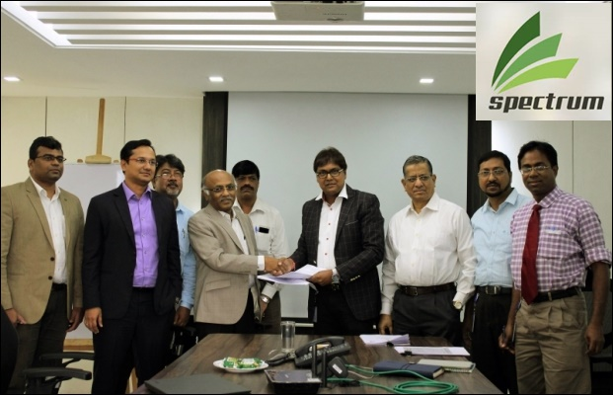

3.1 Background of the IT industry in Bangladesh
Information Technology (IT) provides quick and calm access to essential information for the country's development. A lot of enormous IT companies are opening daily around the world and the country is building IT platforms, developing and promoting their IT industry. Even the Asian countries create an environment in which these entrepreneurs create an environment that puts international IT companies to invest in these environments. The existing giants of Microsoft, Apple, Samsung etc, they invest heavily in Asian countries to take this economic advantage. Apart from Bangladesh, its large minority activists (cheaper from India, Malaysia, and China) can also benefit from these initiatives, but it is a platform that has a foreign investment with a national IT infrastructure and an efficient workshop.

For many years, the "Digital Bangladesh" has achieved significant results in the Information Technology sector and other initiatives are underway. However, to fully utilize the opportunities provided by the worldwide expansion of information technology, the order of Bangladesh Foreign Directors to accelerate the development of the information technology sector to attract the attention of the competition. Other Asian countries are technically advanced / well invested. At the same time, our entrepreneurs should be encouraged to create computer companies here. These two attempts will create thousands of jobs in the information technology sector and by 2021 Bangladesh will become a middle-income country.

The idea (which works but has created millions of dollars with billions of dollars of minimal expertise / low wages and foreign currency) is to repeat the success of the ready-made garments sector and to attract young people especially in the development of a high-power computer. With millions of dollars of foreign currency, thus increasing the pace of Bangladesh's growth.

In the digital era, the emerging Asian countries like India, China, Malaysia, and so on, chose digitization to take advantage of the proposed facilities and to reach the countries ahead of technology. These countries have invested heavily in the information technology sector, providing significant benefits in terms of job/income and growth. For example, the growing increase in the information technology sector in Malaysia, fully supported by the government, has created 900 new IT companies, including 98,000 new jobs, 200 foreign companies created the center. Regional. Malaysia, which represents billions of dollars. Make investment dollars and significant new jobs. In India, there has been an improvement in the information technology sector through greater foreign investment, which has contributed significantly to the growth of India's GDP. It is estimated that the outsourcing sector represents the world market of 500 billion dollars; 140 billion dollars in exchange for 140 billion dollars in India

Bangladesh can create experiences of these countries for designing and implementing rapid IT promotion strategies as per our resources/objectives. The government can consider the following strategy for integrating the ongoing "Digital Bangladesh", which uses this sector as a platform for faster and sustainable growth in Information Technology. With the injection of $ 1.0 billion a major investment for five years ($ 200 million years), the government can speed up progress in the region. These strategies can intensify efforts in specific areas:
- Accelerated training/computer skills.
- In order to establish information centres (R & D, services), international technology organizations/investors encourage the information technology sector (Google, Intel, etc.).
- Support Bangladeshi entrepreneurs to set up IT companies by providing funding/incubation, sales assistance/business development/marketing.

The proposed two strategic results of the strategy can create sustainable growth in Bangladesh to achieve its objectives: Creating a high paid IT job, which leads to the expansion of small IT companies in Bangladesh, foreign exchange through foreign direct investment generates a massive flow.

However, a lots of IT companies, for instance: Spectrum Engineering Consortium Bangladesh, have started their journey in Bangladesh since 2010 and afterward. The government of Bangladesh has played an important role in the development of the policy for improving infrastructure in the ICT sector. Digital Bangladesh believes that, through the development of information technology sector, there are also the right mental places to move forward with the government's agendas for economic growth. However, ICT initiatives and implementation of existing and new programs to make Bangladesh a middle income country is closely related to economic development and overall strategies for poverty reduction. 2021.

3.2 Organizational Background of Spectrum
The Spectrum Engineering Consortium Limited is one of the largest IT companies in Bangladesh that provides quality and tranquillity to standards-based customers around the world. Over the last 24+ years, pioneer developer of Spectrum IT infrastructure in many sectors in Bangladesh. Its goal is to analyse customer demand and provide the best solution for the market. Spectrum Engineering Consortium Limited is one of the leading system integrators in Bangladesh. Since 1995, he has served more than 900 customers locally and globally. More than 200 long-term qualified partnership facilities with sophisticated technology Association with the company Such as Oracle, Microsoft, Cisco, Emerson, VMware, NetPassion, Jenband, etc. With the co-ordination of all these companies, Spectrum has developed its portfolio around the world.

3.3 Vision
The Vision of Spectrum Engineering Consortium Limited is "Being a respected Bengali company all over the world by combining human and technological skills to create value for businesses.”

3.4 Mission
The mission of Spectrum Engineering Consortium Limited is to provide the convenience of infinite information flow through innovative ICT infrastructure and services to organizations of all over the world.

3.5 Values of Spectrum
To be a globally recognized company, Spectrum has set some policy and values. These are given below:
- Promote an environment where new ideas and creativity are cultivated and opportunities are the engine of success for our employees.
- Exceeds the expectations of the clients for the timely delivery of the budget.
- Commitment to innovation and improvement to ensure the creation of value for customers.
- We constantly strive to improve, strengthen our equipment, services, and products.

3.6 Products and services of Spectrum
Spectrum provides the organization's several kinds of IT services. It helps with analysing vertical solutions with large amounts of data to display real-time data, which are used to create new data. Spectrum can develop and design real-time analytical solutions with or without the data warehouse and an offline analysis platform.

Spectrum has a long history and experience "real-time business accelerators in real time" that integrate data analysis, analysis, and modelling and predict the basis of its celebrated trend, create visual analysis/visualization in real-time "real-time" monitoring for the main business index. Spectrum is able to design and size changeable solutions that handle all of the huge amounts of data sources Inclusion of retarding system, the applications, and social sources, data warehouses and data network or passing information between the registers lines.
Through its extensive experience on the Bangladeshi Financial Sector, Services and Public Communications, Spectrum offer its customers the best mathematical domain analyst, model, database of statistical models of the domain, default domain information, maths and neutral models, and the state of the art visualization are the services the company is providing to their customers.
3.6.1 Product Mix: The Length, width and depth of the product mix of Spectrum is shared below:

Chart 1: The Length, width and depth of the product mix of Spectrum

3.7 Operations of Spectrum
The operations of the Spectrum Engineering Consortium Ltd are shared below:

Chart 2: Operations of Spectrum

3.8 SWOT Analysis of Spectrum
A SWOT (Strength, Weakness, Opportunities, and Threats) analysis is often used at the beginning or end of a strategic plan. The framework is considered as powerful support for decision-making because it enables an entity to uncover success opportunities which were previously ineffective or they could highlight the threat before being over-compromised. For example, this exercise can identify a marketplace where a business has a competitive advantage or helps companies achieve success by identifying a path that maximizes their power and warns of threats that may reduce their achievements.

- The Strength of Spectrum

- The Weakness of Spectrum

- The Opportunities of Spectrum

- The Threats of Spectrum

Chapter 4
The Communication Mix of Spectrum Engineering Consortium Ltd


4.1 The Concepts of the marketing communication mix:
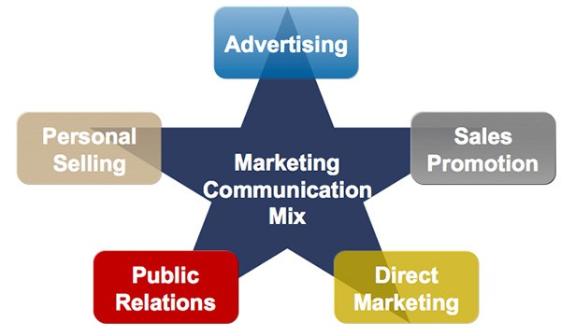
Marketing is a global function which includes research and product development, marketing and distribution processes and standards, as well as communication or promotion. The goal of the communication or promotional mix is ​​to specify specific procedures used to promote the company or its products to the specific customers. Promotional mixes contain some elements, few theorist describes that the model consists of five elements and others add sponsorships as a sixth element.

- Advertisement (AD)
According to Kotler, Burtons, Brown, Armstrong (2015), advertising is usually the most important element of communication mix. Advertise is generally a message that communicates with a company through ways to reach a targeted customers. Since these are more paid messages, companies allow a big marketing budget in ad functions. While it may be costly, advertisers have the ultimate control over sending messages such as carrying a TV or radio station, publishing or publishing websites for publication.
(Source: P Kotler, S Burton, K Deans, L Brown, G Armstrong (2015), Book: Marketing Management, Available at: socioline.ru/files/5/283/kotler_keller_- _marketing_management_14th_edition.pdf)
- Personal sales and direct marketing
According to Lovelock & Patterson (2015), personal sales are sometimes combined in direct marketing elements. However, many companies rely heavily on sales forces that it is important to consider this material separately. Distribution channel providers use vendors to promote products for the recovery of commercial operators. Retailers promote the value of consumer products and services in commercial activities. Sell ​​merchandise companies selling high-end products and services determined to buy buyers.
(Source: C. Lovelock, P. Patterson – 2015, Book: Service Marketing, Available at: https://books. google.com.bd/books?id=BqyaBQAAQBAJ)
- Public relations and messages
Sometimes public relations are like advertisements that are related to messages that they primarily communicate through the media. The main difference is that you do not pay the time or place required for the message. For example, a company referring to a television service or news agency is not provided with history and does not provide brand visibility. The difficulty is not always checking for a message. Someone can invite them through press releases and invite media coverage, but media can reject the story.
- Direct marketing to targeted customers
Direct sales marketing can be a mix of promotion and personal sales. It is an interactive communication with customers where the company wants to spread a message or needs feedback from its target customers. This direct marketing is sent to subscribers of common layout clients. This message is sent to customers with special offers or calls to action, often with limited time offers or the introduction of new products. Mailing clubs, online and paper surveys, and other examples of informal direct marketing communication.
- Discount and promotion
According to Belch (2004), promotional activities or sales discounts are similar to advertisements because they are often circulated by payment. However, sales promotions are actually offering a reduced price to a buyer. These coupon percentages can include discounts and discounts. As well as advertisements for the promotion of coupons and mailing, customers use exotic signs and signs to attract customer attention to discounts.
These communication tools increase revenue and cash flows, attract new customers and exclude additional stock.
(Source: George Eugene Belch, 2004, Book name: Advertising and Promotion: An Integrated Marketing Communications Perspective, Available at: Irwin/McGraw-Hill series in marketing)
- Sponsorship and presence of events
According to Burnett (2003), event sponsorship is often excluded from the five-element promotional mix. Add it in different model ads. Sponsored by an institution when it carries on to participate in espionage, entertainment, non-profit or community events. Sponsorships may include the benefits of distributing specimen, gifts, and literature, mentioning the name of the event and representation of events related to standing representation.
(Source: John J. Burnett, 2003, Book name: Core Concepts of Marketing, Available at:e

https://books.google.com.bd/books?isbn=0471469483)

4.2 The Branding of Spectrum Engineering Consortium Limited
4.2.1 Name of the Company: Spectrum Engineering Consortium Limited

4.2.2 Logo: This is an original text logo of Spectrum. In this logo, these 3 arrows indicate voice, data, and video. To correctly transfer the information, these three components are necessary. Basically, these three parts are commercial information. So, to see this logo, customers can easily understand the purpose of this activity. So, this is a brilliant branding logo with the company name of Spectrum.

4.3 Highlights of the Communication Mix of Spectrum
Promotional activities are conducted to let the consumer know about the existence and characteristics of any product. Advertising gives consumers information and advice. The brand name is popular through advertising. In addition to advertising, personal sales are also useful for customers to purchase specific products.
Spectrum Engineering Consortium Limited (SECL) does not generally advertise in print or electronic media but maintains a very good relationship with the customer. The main promotion of Spectrum boosts sales as customers face positive words. Spectrum believes in the quality of trustworthy quality that satisfies customers and creates positive words on the mouth of Spectrum Services and participates in various government projects. Spectrum generally uses online platforms for its advertising. Spectrum's main media is, therefore, a positive word for mouth, public relations, and online platforms.

Types of Promotion | Explanation
Advertising | Spectrum usually doesn’t promote through print media or television advertisement.
Public Relations | Spectrum involves developing positive relationships with the existing client organization, media public. The art of good public relations is not only to obtain favourable publicity within the media, but it is also involves being able to handle successfully negative attention.
Sales Promotion | Spectrum usually doesn’t involve using money off coupons or special offers.
Personal Selling | Spectrum uses personal selling tool for sales and marketing like-FTTH (Fiber To The Home) connection services and also for corporate client. Its employees hunt client based on divided areas.
Direct Mail | Direct mail is the sending of publicity material to a named person within an organization. Spectrum uses direct mailing tools for it promotional purpose.
Internet Marketing | Mostly used promotional tools of Spectrum from the beginning of its journey and till now Spectrum is using internet marketing for promotional purpose.
Sponsorship | Here one pays an organization to use the organizations brand or logo. This organization usually has a high profile so that the person who hires the brand logo know that his brand will be seen by a large audience. Most common use of sponsorship is with sporting events. Spectrum does this at small events within Dhaka city.

4.4 Revealing the communication mix of Spectrum
    - Internet Marketing: The Spectrum Engineering Consortium Limited usually don’t promote itself on television or print media rather it mostly promoted the company through the online advertising by hiring Ad-sense, an online management site of Google, that places the advertise of Spectrum on various online social media. An online advertisement of Spectrum consists the image and the message below:

- The message of the advertisement: ‘At Spectrum, we make and engage with technology providers in all departments to ensure that we can supply your clients with the best possible solutions to your unique business needs. We have deep, lasting relationships with leading enterprise application providers. Our dedicated professionals collaborate with these strategic alliances that provide integrated, end-to-end business solutions and support that will help you achieve measurable value faster.’

    - Public Relation: Spectrum involves developing positive relationships with the existing client organization, media public. The art of good public relations is not only to obtain favourable publicity within the media, but it is also involves being able to handle successfully negative attention.
Moreover, the present Bangladeshi government has taken an opportune step to numerically empower Bangladesh and its unemployed citizen with the slogan of Digital Bangladesh. This slogan and subsequent governmental activities have engraved the vision of a technologically advanced and self-sufficient future society for millions of Bangladeshis. With initiatives of the highest levels of government, projects of automation of the public sector, public awareness campaigns and technological improvements in the public sector, this has generated tremendous enthusiasm among the people of Bangladesh especially the young generation that was full of energy and innovation to lead Bangladesh in the footsteps of developed countries.
Spectrum, as one of the largest systems integrators in Bangladesh, is working with the government on this path to a promising future with a proven track record. The main contribution of Spectrum was the implementation of key performance indicators (KPI) such as the national certified data center, customs automation, the national infrastructure for the Bangladesh Railway which is a network project. Bangladesh Research and Education Center (BDREC) with the Eurasian Network, Audit Management and Monitoring System (AMMS) and the Citizen Service (HEMIS) Information System).
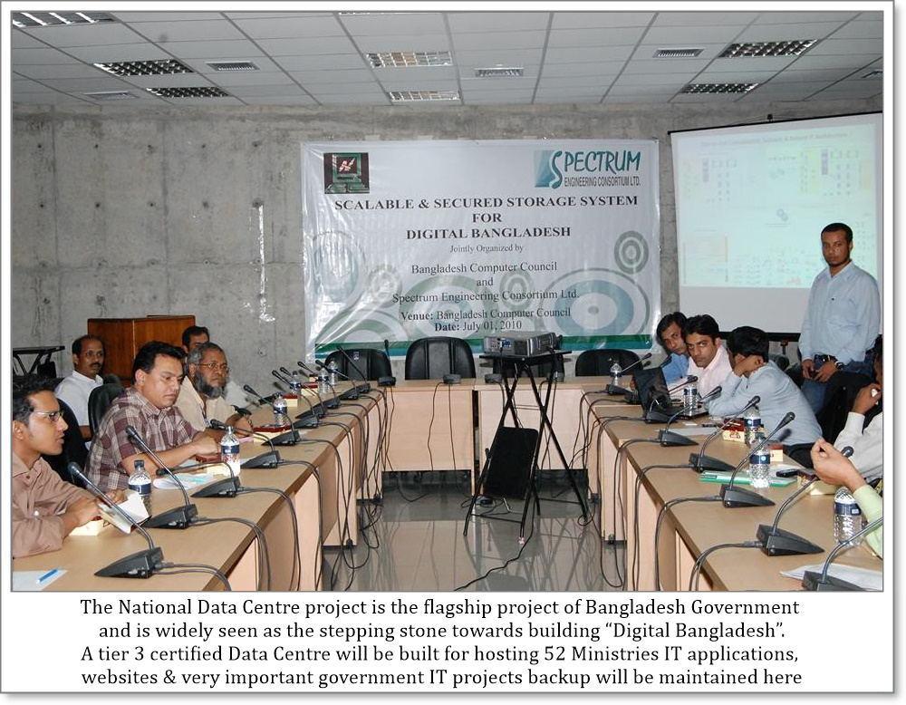
The empowerment of people, transparency and accountability, the development of human resources, poverty reduction and economic growth will be guaranteed, as people will receive improved and faster public services and access to all kinds of information when the digital initiative of Bangladesh reaches its maximum potential. Spectrum wants to continue this path with more and more successful projects thanks to its innovation and technology for the welfare of the people of Bangladesh.
To sustain public relation Spectrum does the following activities:
- Services for citizens: In real time, information availability and 24 × 7 paper services are accessible to regular citizens and accessible anywhere.
- Public infrastructure: With improved urbanization and technology expansion, Spectrum has improved management, distribution, planned development of cities, integrated transportation and traffic system, National Regional Network and information centres.
- Revenue and taxation: Spectrum offers Bangladeshi people the Integration of revenue, taxes and financial management on individual platforms. It helps the administration to raise taxes, budget, manage various financial operations and achieve strict financial discipline.

    - Personal Selling: Spectrum Engineering Consortium Limited uses personal selling tool for sales and marketing like-FTTH (Fibre to the Home) connection services and also for corporate client. The employees of Spectrum are divided into several parts so that they can communicate with the companies that are located into their area. They shares brochures and previous implemented work ideas to encourage the companies to buy its products and services. Most of the time employees manages to get order of ERP –Enterprise Resource Planning. Spectrum usually provides monthly target of personal selling to its employee. The one who can fulfil this targets every month can enjoy a handsome incentives every month.
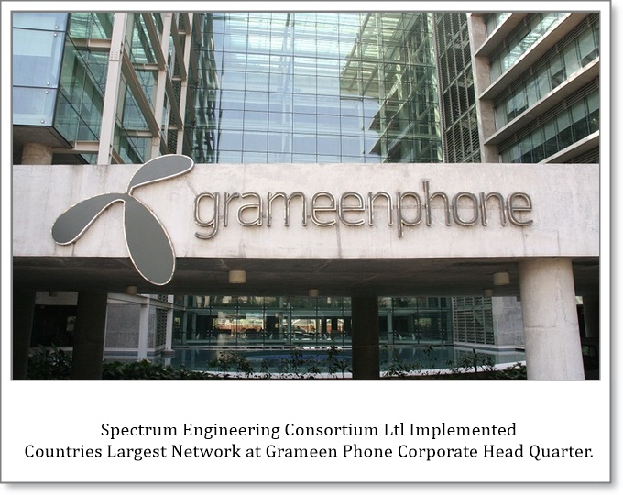
Through the employee promotional activities, Spectrum got the opportunities to build the ERP system of one the largest network provider in Bangladesh named ‘Grameenphone’. Spectrum has also served a lots of other giant companies in Bangladesh, It has built the one stop customer point at Standard Chartered Bank. Spectrum usually promote by showcasing its past services to its potential customers while performing personal selling.
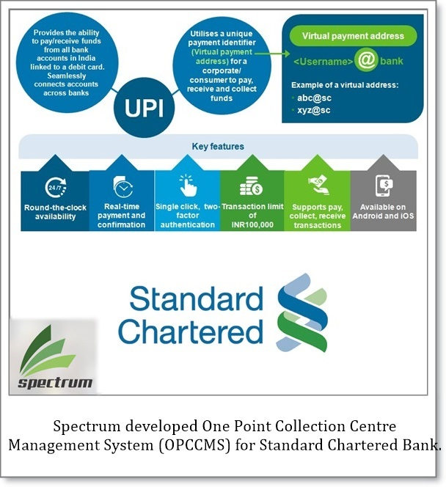
    - Direct Mail: Direct mail is the sending of publicity material to a named person within an organization. Spectrum uses direct mailing tools for it promotional purpose. Whenever a person or company register its business with their email address, Spectrum saves their addresses for future promotional activities. Spectrum usually send weekly mails that contain several information and achievements as a purpose to promote the company to those emails. The previous customers of Spectrum also receive this mails for further service. Moreover, the website name of Spectrum is: www.Spectrum-bd.com that also shares previous achievements to promote the company. The website view of Spectrum is given below:
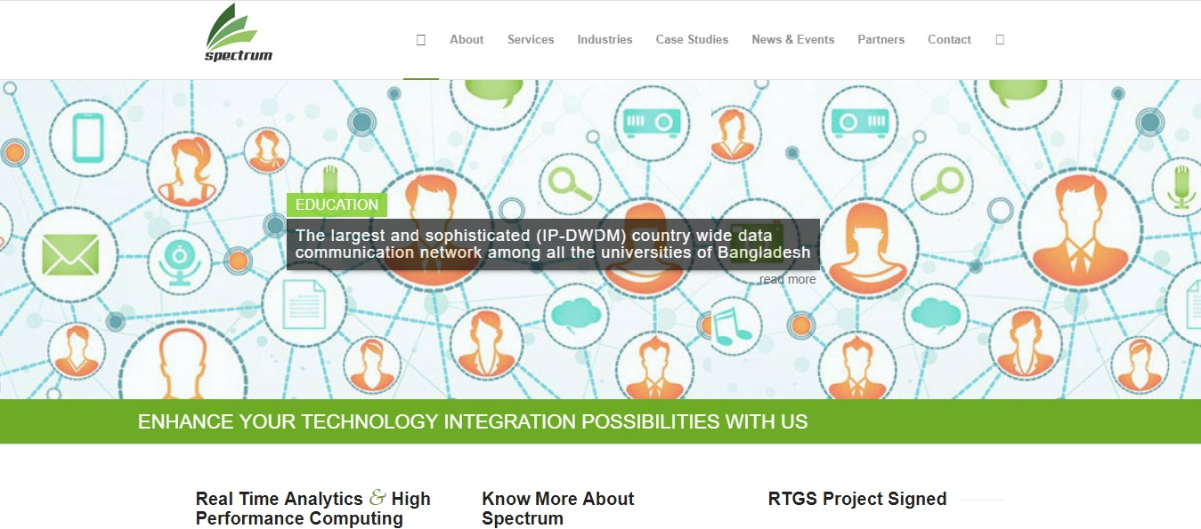

    - Sponsorship: To achieve more awareness of the services and products of Spectrum, the company usually be sponsor in various IT fair, and sports that occurred in the Dhaka city.

Though the promotional activities are very few of such a large IT company in Bangladesh, mostly Spectrum gets the customer through its Internet marketing and for having experience of serving enormous companies of Bangladesh.

Chapter 5
Recommendations and Conclusions
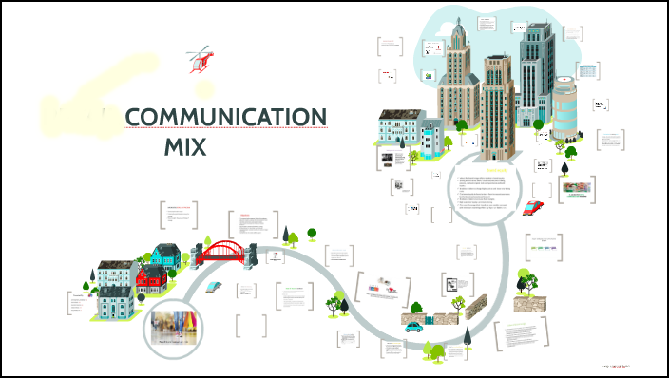

5.1 Recommendations
After analysing the communication mix, I have found few challenges and threats of Spectrum Engineering Consortium Limited that need to overcome immediately. This chapter will deliver few suggestions based on my theoretical learning from United International University so that the IT Company can improve its promotional mix and sustain its business in this competitively growing industry.
- The current market is so competitive. For example, Spectrum should promote its products and services to consumers through a variety of promotional tools to link Spectrum's presence and difference points with target customers and to maintain and search for potential customers.
- The promotional activities are found very limited. A strong communication strategy should be built to become a key player in the market.
- Spectrum can look for a strategic alliance with an ascending or descending party. This means facilitating competition to create a consortium with another organization, in particular, to expand the network infrastructure at the national level, as well as for GP, Banglalink, Fiber@Home, and Summit Communication Ltd.
- Advertising on newspaper or television should be concentrated as most of the competitors of Spectrum are utilizing those media. Moreover, the company doesn’t offer sales promotion or discounts as well. It is not very late that the company has to generate ideas to promote its products through these promotional activities.
- In addition to the promotion, Spectrum must include social marketing (SM) and customer relationship management (CRM) to create a positive image in the customer's mind. Because every company has social bindings and responsibilities. So Spectrum should involve the activities of SM and CRM.
- Spectrum focuses on the quality of the service instead of the price of the services. As a result, the price of the spectrum is higher than that of the competition. To keep existing customers and attract new customers, Spectrum should offer some other value-added services (VAS) such as IP telephony, IP-TV, free email account, free or more affordable domain hosting with Internet / Intranet service.

5.2 Conclusion
The study of this report has reveal the communication mix of Spectrum Engineering Consortium Limited. In spite of being one of the largest IT Company in Bangladesh, Spectrum is not following the promotional mix in Bangladesh. The company is still not publishing any advertising on newspaper or in television. Added that the company is not also offering any discounts on its products. The quality of its services are good, but the price of services are very high. The current government of Bangladesh is highly interested to welcome new IT Companies in Bangladesh as there are huge unemployment crisis is going on. All these reasons is reducing the entry barriers of new IT Companies that can take the place of current market position of Spectrum. So, it is high time for Spectrum to improve its communication mix before its being too late so that the consumers can be more aware of the company and the company can create a competitive advantage in the IT industry.
The title of this internship report was very helpful to understand and apply my marketing knowledge in practical situation. The experience, I have gathered, while preparing the report was precious and I can realize that this promotional mix learnings will help me to determine how to build and showcase a particular brand among the target customers so that I can create a compassion of my products and services to them.

Chapter 6
Reference


Reference
1_ an article of background of IT Companies in Bangladesh. Available at: https://www.thedailystar.net/op-ed/bangladeshs-it-industry-1324174
2_The website of Spectrum Engineering Consortium Limited: www. Spectrum-bd.com
3_P Kotler, S Burton, K Deans, L Brown, G Armstrong (2015), Book: Marketing Management, Available at: socioline.ru/files/5/283/kotler_keller_-_marketing _management_14th_edition.pdf
4_ C. Lovelock, P. Patterson – 2015, Book: Service Marketing, Available at: https://books. google.com.bd/ books?id=BqyaBQAAQBAJ
5_George Eugene Belch, 2004, Book name: Advertising and Promotion: An Integrated Marketing Communications Perspective, Available at: Irwin/McGraw-Hill series in marketing
6_John J. Burnett, 2003, Book name: Core Concepts of Marketing, Available at:e

https://books.google.com.bd/books?isbn=0471469483)

