A Study on the Smartphone Buying Behavior of Consumers in Dhaka City

Rabbi Rahman

This project report is submitted to School of Businesses and Economics, United International University as a partial requirement for the fulfillment of Bachelor of Business Administration Degree requirement
A Study on the Smartphone Buying Behavior of Consumers in Dhaka City

Submitted By
Rabbi Rahman
Id: 111 153 136
Course: Project

Submitted To
Kawsar Ahmmed
Professor & Deputy Director, BBA Program
United International University

Date of Submission: July 1, 2020

Letter of Transmittal

July 1, 2020

Dr. Kawsar Ahmmed
Professor & Deputy Director, BBA Program
United International University, Satarkul, Dhaka

Subject: Submission of Project

Dear Sir:
It gives me a great pleasure to submit my project which I have completed as a part of fulfilling the requirement for the “Project course of Bachelor of Business Administration”, United International University. I have been doing a consumer buying behavior analysis since the last three years now that is why I have chosen this topic for preparing my project as – A Study on the Smartphone Buying Behavior of Consumers in Dhaka City. This project contains a detailed and elaborated analysis on few particular consumers of smartphone buying behaviors. I have prepared this specific project in a more understanding way, so that it be great to realize the true identity of a smartphone buyer in Dhaka city.
This need to be mentioned that without your analytic guidance and support this project won’t be created in time and in this current situation while we’re staying home quarantine. I would be very much glad if you assess my project considering the situation we are living now and the overall limitations of this project analysis.

Yours Sincerely,
Rabbi Rahman
Id: 111 153 136

Acknowledgement
This is high time now to me to express my longest gratitude and sincere submission to the Almighty Allah for giving me the enable position to achieve such huge work of preparing and completing this project.
Then I would like to acknowledge guidance and effort of project and our career counseling center for arranging such a nice program for co-relating theoretical learning with personal achievement and growth. It’s a pleasure to convey my heartiest gratitude and greeting to my honorable supervisor Prof. Dr. Kawsar Ahmmed, Project Supervisor, United International University.
Without his co-operation, it would not be possible to prepare the report into a nice ending.
I would also like to acknowledge and thanks to the internet and few people who helped me understand their buying behavior when choosing a smartphone from their point of view, so that I can grab the knowledge.

In conclusion, I would like to express my extreme appreciation and kindness to all of my parents, teachers and my few close friends for their kind support and sacrifices during the preparation of this very project.

Executive Summary

Smartphone is the part and parcel of our lifestyle nowadays. One person even a lower middle class person in every colony thinks about buying a smartphone or holding it in their hand. The era of technology has come this far to implement and develop new strategies to grab the market of technology for creating a better position in the competitive marketplace. By producing more than hundred million smartphone every year from various manufacturers such as: Samsung, Apple, OPPO, Huawei, Xiaomi smartphone industries gradually gaining on the leading earning positions in the international economy. Even in Bangladesh in the late 2009 smartphone has been establishing its name and becoming a popular word in people’s conversations. There were few good Bangladeshi but Chinese manufactured brands like: Walton, Symphony that have also been trying their best to understand the Bangladeshi smartphone consumer’s buyer’s behavior. There is a huge market and consumer behavior analysis toward this smartphone buying techniques and their overall characteristics while choosing a particular brand from their choice. This device or product to specifically say has a huge market value in current situations. That is why this smartphone buying trend will always be researched and analyzed by the smartphone buying industries.

Keywords: Smartphone Market, Communication, Consumer behavior, Techno Savvy, Bangladesh

Contents
Letter of Transmittal 3
Acknowledgement 4
Executive Summary 5
CHAPTER 1: 8
INTRODUCTION 8
Introduction 9
Origin of the report 9
Scope of the Study 9
Objectives of this Study 9
A BRIEF HISTORY OF “SMARTPHONES IN BANGLADESH” 10
POPULARITY GROWTH 11
RISE OF LOCAL BRANDS 17
CHAPTER 2 20
Literature Review 20
Introduction 21
Specific Objectives 21
Buyer’s Market Competition among the Selected Brands 22
Samsung 22
Apple 23
HUAWEI 24
XIAOMI 25
OPPO 26
Brand Choice 27
Samsung (Largest Conglomerate) 28
Apple (Unique Competency) 28
Huawei (Chinese No.1 Manufacturer) 28
Xiaomi (Budget Beast) 28
OPPO (CAMERA PHONE) 28
VIVO (CAMERA & MUSIC) 29
Brand Choice Criteria 29
Brand Choice in Smartphones 31
Feature 31
Brand Image: 32
Cost or Price 33
Personal Recommendation 33
Durability & Portability 34
Media Influence: 34
Factors Influencing Smartphone Buying Behaviors of Consumers 35
Economic: 36
Socio-Cultural & Family: 36
Technological: 36
CHAPTER 3: 38
Methodology, Data Analysis and Discussion 38
Methodology of data collection 39
Primary Sources 39
Secondary Sources 39
Limitations 39
Analysis & Interpretation of Online Survey Questionnaire 40
CONCLUSION 47
REFERENCES 49
APPENDIX 50

CHAPTER 1:

INTRODUCTION

Introduction
In United International University Business Department every undergraduate student must do an internship or project for three months to gain their BBA degree. Students who have to do project program as a personal research or for analysis, which also help them gain experience and understand the overall view point of doing a research and the boundaries with it. So that the students might get it easier to apply it in their upcoming careers of choice. I have been analyzing and trying to understand the overall user experience and choice while smartphone buying of consumers in Dhaka city from the past 3 to 4 years. That is why to complete my BBA course I have chosen a project with a topic that is: Smartphone buying behavior of Dhaka City consumers.

Origin of the report
Every smartphone brands in the market are trying their best to keep loyal customers. By doing extended researching it is identified that to not only to keep loyal customers but also make them committed for future also. If the behavior of the smartphone consumers are positively used then there can be positive word of mouth spread. Consumer value theory and brand identification has helped smartphone brand to put up with their consumers. If a consumer can recall the brand it’s relates to brand identification and if a consumer can grab the value it falls under value theory.

Scope of the Study
This project report is prepared only for academic purposes, and to achieve the requirement for this project. Scope of this study is to understand the overall smartphone buying behavior of the Dhaka city consumers on their day to day usage, brand identification, features analysis, market price, and design and aesthetic that could make them feel like choosing a particular brand for using that device for a few years.

Objectives of this Study
By verifying and finding out the decision making process of smartphone user or consumers about what makes them so sure to buy a certain product, in this case smartphones. Understanding the smartphone market in Bangladesh and brands strategies to grab those consumers mind.
While preparing this project about smartphone buyer’s or consumers in Dhaka City, I was quite excited to do my analysis about the consumers of Dhaka City. Doing this sort of research would help me a massive in the future career path while choosing bigger decision making process and thinking the large number of consumers at a whole. My goal was to understand the consumers from the heart. I tried my best focus on the matter.
Above all, all smartphone brands do their best in the long whether it’s Dhaka consumers or somewhere else. The real question is there will always be different sort of understanding and buyer’s decision making process when it comes to choosing or buying a new smartphone. As we all know every human being is different from their own point of view, but smartphone especially made every consumers more different in their own unique way.

A BRIEF HISTORY OF “SMARTPHONES IN BANGLADESH”
Technologies have been improved a lot since the last decade. In Bangladesh it is quite popular the word “Smartphone”. There are various brands competing against each other for getting the best out of the smartphone consumer market. Among the few biggest seller in Bangladesh, few are: Samsung, Apple, Huawei, Xiaomi and OPPO. Why these companies fighting so bad in Bangladesh market? Being a populated country, Bangladesh has one of the great varieties of consumer to target. That is why the smartphone sharks trying to get the best loyal customer to make their own.
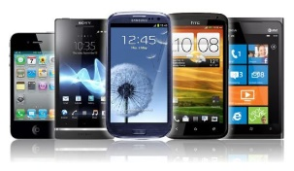
The global Mobile handset market, in recent times, has been influenced by the rise in demand for smartphones. This trend has slowly crept into the Bangladeshi market, as the users make
the mobile handset industry in Bangladesh has traditionally been dominated by the Finnish giant Nokia due to its low cost feature phones. This preference for inexpensive alternatives has kept buyers away from industry giants like Samsung.

Today, it is a non-collusive oligopoly with local brands like Symphony dominating the market. They have successfully competed with international giants like Samsung and Nokia (which still
A survey by Light-Castle on a random sample of different age groups of mobile phone users in Dhaka, based on their preferred operating systems, can be seen below.
Now, we are going to understand a brief history of those five smartphone brands. About how they got target the consumer in Bangladesh consumer market. What is their strategy of choice to focus on is the main question smartphone marketers ask themselves.

POPULARITY GROWTH
Smartphone companies in Bangladesh have been popular since the beginning of their birth. It just didn’t arrive at the right time. Each and every smartphone was released in Bangladesh after months later. That is how the attraction to buy one smartphone has been in every smartphone consumer of Bangladesh.
Even though Bangladeshi consumers was focused mainly on Android like 67% of the market, Symbian touch about 20%, iOS (APPLE) about 11% and Windows OS phones as low as 2%.

According to BTRC, the number of GSM subscribers in Bangladesh has gone up by 34% in the past year and has reached 119.62 million this 2019 November. This is not surprising, given that Bangladesh is trying to elevate its status from a low to middle income nation. The burgeoning upper middle-class segment, coupled with the existing young and dynamic labor force, is driving the shift in demand from feature phones to smartphones. Despite of this, there is room for growth in the market.
According to the GSM report almost 6 million people is the average users of Bangladesh who uses smartphones on their daily basis and searches for a cheaper deal.
The list of phones above has one commonality, similar specifications, and one difference, price variance. Most smartphone prices have followed a downward trend, with brands such as Walton and Symphony trimming down cost production of their manufacturing and making a competitive edge over the well-known names. In the eyes of the sales team, Walton phones were giving phones in the range of BDT 6000 to 14000, which is a very popular amount among consumers who want their phones in that lower price point.
Although, brand loyalty has generated growing demand for Apple and Samsung products, the exorbitant prices have often stunted their sales potential. The marketing campaigns, undertaken by Symphony and Walton, which appeal to the patriotic sentiments, have also boosted sales. So has the fact that they do not have to share profits with shareholders abroad.
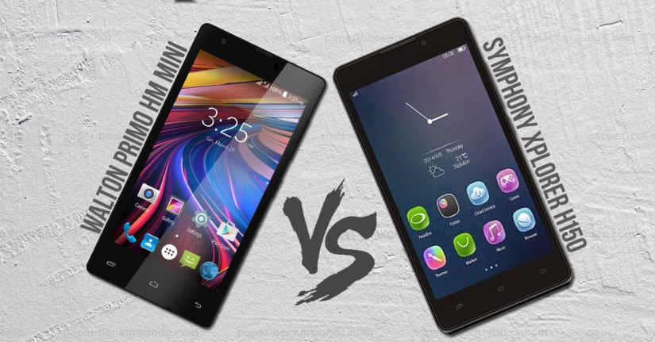
After the fall of Nokia’s Basic phones people got used to use a touch screen smartphone, and another reason was heavy marketing by local brands like Walton and Symphony. As Bangladeshi people fall into the attraction of advertisement by these local smartphone makers, they were competing against the giants with their affordable prices of smartphones.

Even though other smartphone giants who were leading the international smartphone market have been doing there utmost to stay in people’s mind as well.

SAMSUNG
Samsung smartphone gain its popularity in Bangladesh from early 2010. In Bangladesh, people like compact smartphone at time. While having the lead profit maker Samsung decided to serve Bangladeshi smartphone consumer to feel more about their smartphone brand. By introducing more products in the core capital city of Bangladesh, which is Dhaka.
Emerging new possibilities of offer and product benefits has been introduced to consumer with varieties of interest.
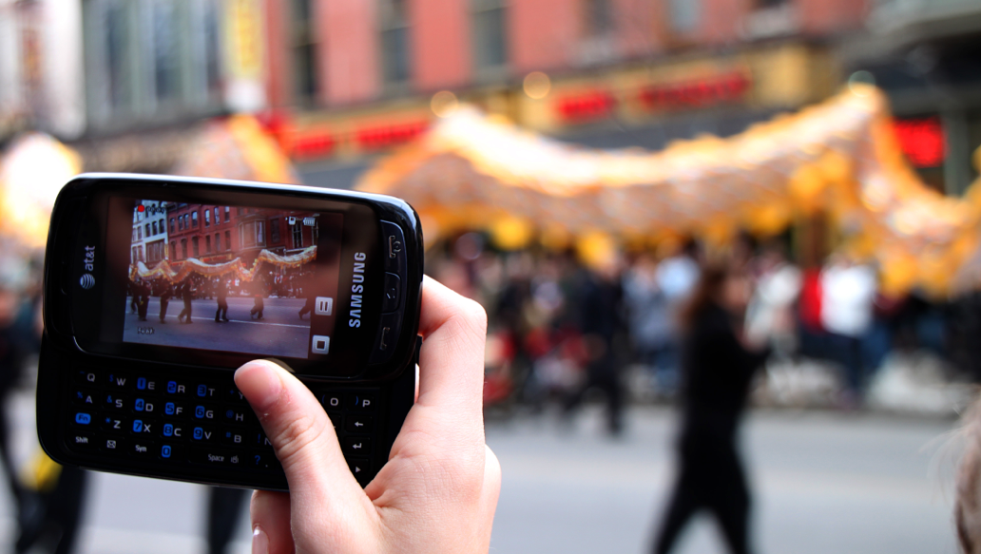
It’s not that consumers were new to Samsung smartphone but it's always better give the consumer better choices to choose from. By keeping the existing market more focused, Samsung introduced new smartphones every year. This has become the trend, which is to introduce a flagship product by the beginning of the year.

In the early 2010, Samsung introduced their flagship model the “Galaxy S”. It was a hit, at Bashundhara City shopping mall. Samsung not only introduced their flagship model the Galaxy S series but also introduced their “Galaxy Y” series. The Galaxy Y series was a moreover a mid-range phone to grab the most of the consumer marketing in Dhaka.
Samsung Bangladesh always was at the core position of people’s mind. Making largest retail outlet at the most popular shopping mall of Dhaka like the Bashundhara Shopping Mall was a huge deal for Bangladeshi smartphone consumers.

APPLE
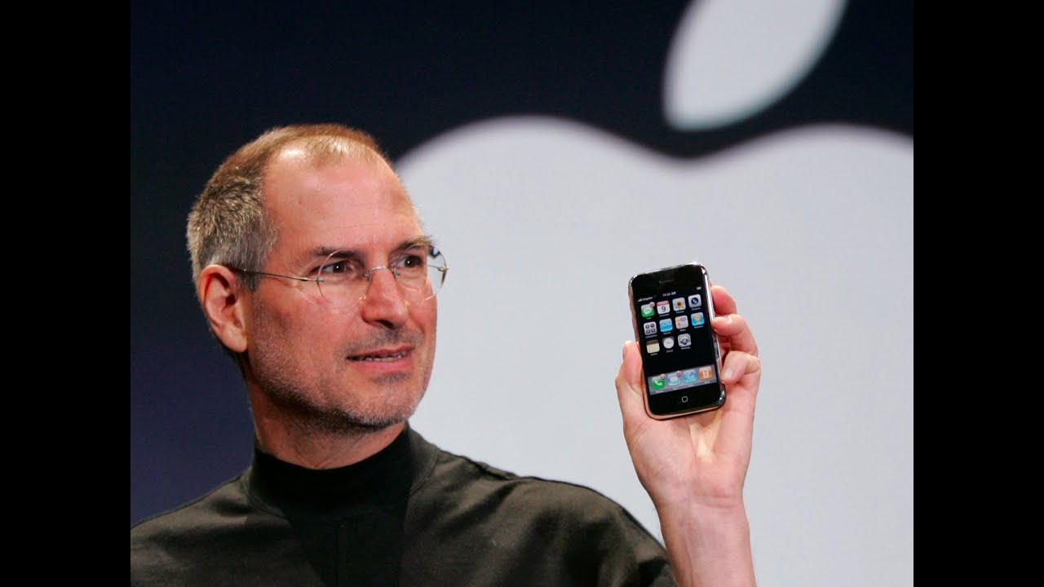
The true smartphone revolution didn’t start until Macworld 2007, when Steve Jobs revealed the first iPhone. Previous phones relied on keypads and could only navigate a watered-down version of the internet. The iPhone’s large touchscreen could flip through websites just like a desktop computer, all while looking sleeker than anything consumers had ever seen before.

Apple basically entered the Bangladesh’s smartphone market in the early 2009. After the release of Apple’s iPhone 4s, Apple gained a lot popularity among the wealthy smartphone market user. Having the basic function of a smartphone but with slight different color and name change Apple gained its popularity in the wealthy teenage user to spread its value among other consumer. Browsing with Apple’s own browser: “SAFARI” was a great motivation. Bangladeshi people loved Apple’s apps icon and Apple’s own unique eco-system.
Apple’s main focus was to deliver the customer of Bangladesh and brand value that they would believe in. Apple’s unique slim and sleek design made Bangladeshi rich consumer addicted to Apple’s new iPhone. It is not just the performance anymore but the look and environment that Apple created is the brand loyalty that is very successful.
Bangladeshi people liked to show-off things and Apple market team took that advantage to focus on less branding in Bangladeshi TV channels and more in the online market like “Facebook, Twitter or Instagram.” That is how Apple’s consumer got more attracted to Apple’s product than ever before after the release of iPhone 5s in 2013.

HUAWEI
Huawei, among other Chinese brands, is considered the first established Chinese smart phone maker with a substantial footprint in Bangladesh.
According to the Technology Market Research Firm, Counterpoint, Huawei, who entered the top 5 smartphone brands list for the first time in the first-quarter of 2016, continues to perform well in the segment, moving into the top three on the list in the third-quarter of 2016 for the first time.
The growth was mainly driven by its affordable Y-series smartphones, industry insiders said.
Huawei, the world's second-largest Android smartphone brand, recently launched its flagship Y6II Prime smartphone in Bangladesh and said it was now eyeing rural markets to capture more of Bangladesh's growing market.
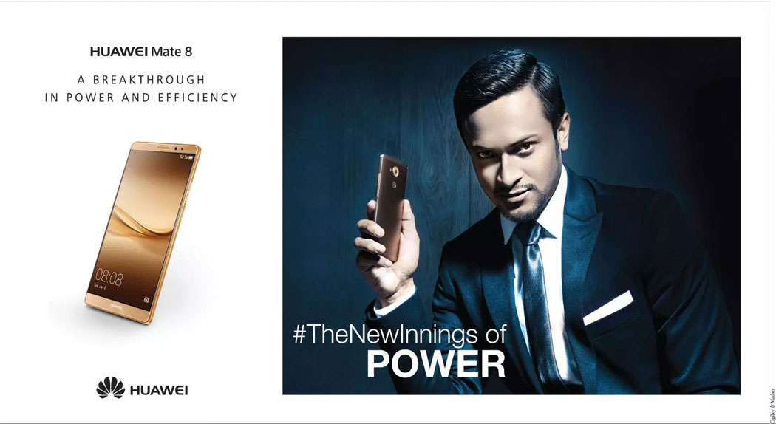
By introducing the best all-rounder Sakib-al-hasan Huawei made true unique move in Bangladeshi smartphone market. Sakib-al-hasan has been playing for national cricket team for a long time and making him as an ambassador for the company was really thoughtful by Huawei Bangladesh.

Huawei Technologies (Bangladesh) Ltd focused mainly on urban and rural area of Bangladesh. Grabbing the best loyal cricket fans and makes them their smartphone user. That was a great and bold move Huawei did since 2015.

XIAOMI
Xiaomi was the first smartphone brand in Bangladesh which focused only on the performance and price. After a great deal of popularity among consumers about Chinese phones, Xiaomi was the first to introduce great design benefits and exclusive price offers that Bangladeshi consumers can’t refuse.
Their main focus was not to gain the most profit but to be in the conservation topic of local users who prefer their smartphone to be great by looks and by internal configuration as well.

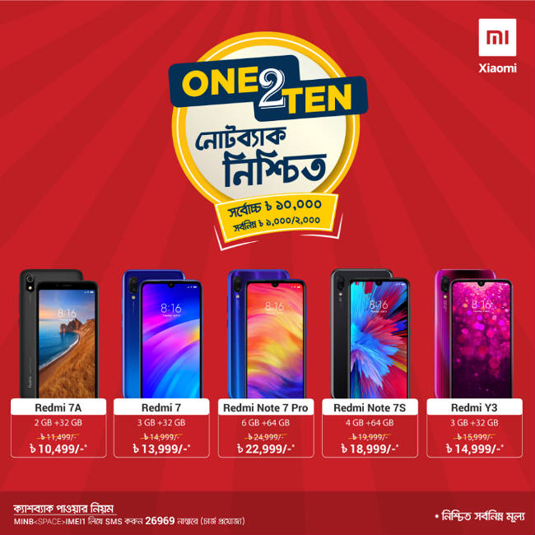

That was Xiaomi’s only strategy to lead the market in Bangladesh after 2014 of release of Xiaomi: Redmi Series. Keeping the best of the best processors in their smartphones and making the least of the least possible rate so that the consumers of Bangladesh might get affected by the price point and performance and battery life efficiency.

RISE OF LOCAL BRANDS
One local brand called Maximus, for instance, posted a nearly eight times volume growth in the March quarter, driven by affordable offerings in the $25-75 (Taka 2,700 > 6,500) price band.
Symphony and Walton, two out of the top five smartphone brands in the country in the first quarter of 2019, were homegrown. In comparison, no domestic brands made it to India’s top five smartphones.
However, this doesn’t mean the threat of foreign brands isn’t looming in Bangladesh. South Korean phone-maker Samsung’s shipments, for instance, more than tripled in January-March, helping it clinch the top spot for the first time in Bangladesh. It beat out former market leader Symphony by eight percentage points.
“New launches and a boost in local manufacturing were the reasons behind Samsung’s growth,” Counterpoint noted. “Expanding its portfolio also helped Samsung, as the newly introduced A-series smartphones dominated in their respective price bands.”
Chinese manufactures endorse the establishment of local smartphone makers as well. With the release of new smartphones by Huawei, Xiaomi, OPPO or others, the Bangladeshi local smartphone makers also released their new flagship in every year. It was simple the strategy that began in 2007 after the release of Apple’s iPhone 3G.
Bangladesh’s government gave a vital role of establishing new and emerging local smartphone by doing great export and import facilities of smartphone parts from china. At least 18% tax drop due to local labor assembly of smartphone and manufacturing.
Consequently, handset imports in Bangladesh plummeted 21% between 2017 and 2018 and more brands are trying to reap the benefits of going local.

Walton
Walton started their journey in Bangladesh from late 2010. Their main focus was having a brand name in everybody’s heart, which would say made in Bangladesh. Keeping the best performance intact, Walton was able to find trust among consumers. Smartphone consumers in Bangladesh liked cheap phones in their hand. Walton was the first company which delivered cheap phones with better durability and design.
Walton’s chief designer of smartphone was ensured enough to focus on consumer mind and grab the best out it. It is necessary to cut corners, for example low ram and low processor speed for running the android operating system.


By engaging more and more with the cricket fans Walton ensured it’s true brand loyalty among smartphones lovers of Bangladesh.
With great sponsorship at the field art and large cricket tournament like BPL or Bangladesh Premier League Walton knew that these was the best possible way to stay in peoples mind whenever the cricket announcement is happening their brand name Walton will also be pronounced well and people will hear and cheer as well.
That is why Walton’s strategy of sponsoring every cricket or football tournament helped them to become the most popular name of smartphone in the sports fan as well.

Symphony
Symphony is the second company in Bangladesh that used the tagline phone from your country Bangladesh. By bringing new face in the Bangladeshi TV advertisement, Symphony attracted customers with their flagship models to compete in the smartphone market.
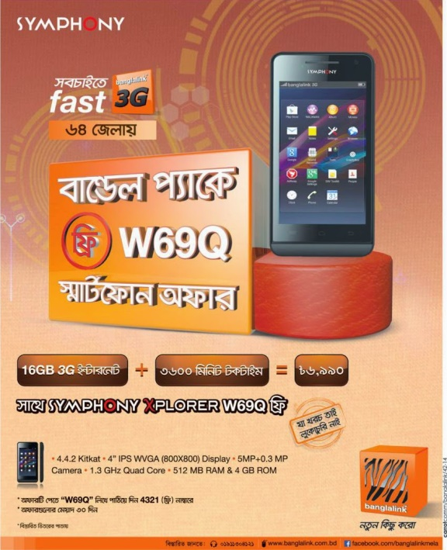
In 2011 they have partnered with various tele-communication companies like Banglalimk, Warid and developed new sorts of strategies to establish market value by offering more service of tele-com partners with their models.

Bangladesh smartphone consumers liked to use internet as much as they liked a new smartphone model in an affordable price point.
That was the best policy taken by Symphony marketers by focusing on what matters most for the Bangladeshi mind of smartphone users. People liked using a touch screen even though it’s not tough enough or performance is not as much as expected.
That is how superior brand loyalty has been established by so many smartphone makers, not only the local brands like Walton or Symphony but also international brands uses their own strategic way of giving “GSM package offers & deals” with their smartphones by making the consumers more interested to buy their devices.

CHAPTER 2

Literature Review

Introduction
In this study I have viewed smartphone buying and consumer uses experience from the consumer perspective. What makes a consumer choose a particular smartphone? Weather it’s their design aspects or internal performance or anything else that has made someone buy that specific smartphone. There could be a lot of aspects to focus on when I was doing this study. For example: “How often consumer wait for new smartphone to arrive. Does a popular brand criteria and features depends a lot while making a buying decision when consumers think about buying a new smartphone?”
I wanted to use face to face means qualitative approaches but couldn’t do it due to the pandemic situation currently, but I was able to do google questionnaire as well for doing a small survey on consumer buying behavior on smartphone. What really consumers thinks when they think about future smartphone as well? These analysis of the study will describe the overall uses and brand choice criteria of a smartphone consumer. There is a personal relationship among the smartphone and the consumers who use those specific smartphone.

Specific Objectives
- By presenting a general sceneario of the current consumers who thrive to buy new smartphones after every once in a while ;
- Gradually identify the buying techniques which makes each consumers or buyers unique and different from one another, when it comes to buying a new smartphone;
- Varify the early buyers behavior especially the history of smartphone uses in Dhaka city;
- Search the extreme change in nature of smartphone buyers whenever they (consumers) are trying to get a device;
- Find out the great factors or framework of analysis among smartphone buyers, for example: Psychological, economic, socio-cultural, environmental & personal that overall influence on a particular smartphone buyer in Dhaka city.
- Get a overview of understanding how exactly consumers chooses a brand and what they feel about the outcome after getting a smartphone.

Buyer’s Market Competition among the Selected Brands
Smartphone brands has been competing among themselves since the born of smartphones. Smartphones like Apple, Samsung, Huawei, Xiaomi and OPPO has their own competing schemes. These unique schemes let the marketers use new tactics and exclusive plans for their particular consumer.
The top five smartphone brands competitive strategies are explained down below:


Samsung
It has been analyzed by researchers that by the end of the 2nd quarter of 2018, Samsung had established its target point as the first smartphone company by their own market share of the smartphone consumer.
This South Korean tech giant has been mostly maintaining their popularity among consumers with the great marketing techniques and exclusive products for exclusive target customers. Their market share bumped from 28% to 30% in 2019. Samsung has seen their popularity among consumer conservations and figured out that most of the consumer liked their mid-range products rather than their flagship models.


Their Galaxy Series smartphones have always been a fascination among the consumers who liked those series. Even their Galaxy A series has been popular among higher mid-range market. Even though with all this going Samsung has recorded a decrease for about 40% in the profit section in the early stage of 2019, but their overall revenue increase at low as only 8%.
This massive hit in the smartphone competition attacked Samsung smartphone makers a lot since the destruction market drop incident due to their Galaxy Note 7. Their current key competency factors are:
- Productivity Growth:
Samsung’s head of IT and mobile divisions head Mr. Tarek said, they need to increase more productivity of their Note 10 series by 27% more than their previous model note 9. As Note 9 was more expensive compared to recently released Note 10.
Release new Galaxy- A series with better cameras and massive battery upgrade for the battery loving consumers.
- New technology uses:
Samsung main focus to target a customer was good with innovation. Consumers of Samsung believes that Samsung can bring them good phones with better quality of technology uses. Which means Samsung invests tons of money in the research and development industry to make the best chipset and displays that matters the most to their beloved consumers.


Apple
There’s only one corporation that fights with the Google’s android market, and that is Apple’s IPhone. IPhone basically runs with Apple’s own creation of operating system known as iOS. The smartphone market is basically dominated by these two OS giants. Apple has the advantage of their own operating system and that is well protected by their patents and copyrights.

Apple doesn’t really compete with other brands in the early stages as they have their huge loyal customers who loves and adores Apple’s products by heart, but there are few tactics of competing in the emerging market that Apple follows, those are:

- Unique Marketing: Apple follows few unique sets of marketing codes that helps them to be the most eye catching in the market. By evolving with Apple’s digital poster’s and security benefits of using IPhone at the buildings of New York Time Square Apple caught a lot of eyes there. Apple also do mass marketing in the popular social media platforms with different elegant looking models holding their IPhone with a glamorous look.

- Key features modifications: Apple’s IPhone users loves their phones and its own build applications as well. Apple offers every year new uses of their applications for example the camera sensors and the software behind it. Above all the features IPhone’s most notable feature is the lightning port and battery life. Apple’s IPhone
engineers created their own lightning port which doesn’t have in any other smartphone in the market, and that works as a huge hit for every year sale for apple.

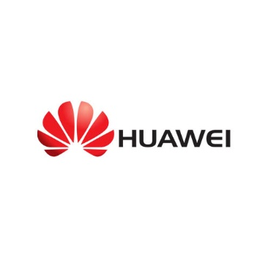

HUAWEI
Huawei is world’s 2nd best smartphone makers by the market share data of 2019. As a transcending company, Huawei hopes for the best for their growth and consumer trust. This didn’t happen very easily. With the help of massive Chinese market investors Huawei was able to invest in their research and development and as well as their communication sector very well.
Huawei is not just a smartphone maker, they have their own gadgets and network improvement devices which triggered Huawei’s overall revenue to compete against the big smartphone corporations in the world.
Huawei’s competition strategies are simple, they are:
- Heavy Investment in R&D: Huawei got most of the shareholders trust and got more investment to figure out how to develop the best possible using smartphones for the consumers. With great marketing and innovative smartphone camera designs Huawei was rising like no other in the market.

- Develop the Communication Sector: The most vital thing that consumers love is having the best connection in a smartphone. Huawei’s innovative communication technology improved that in the best quality connection a consumer can have. By introducing first 5G network technology with best internet and streaming service Huawei built an enormous trust among the smartphone consumers.


XIAOMI
China’s first leading smartphone brand Xiaomi rules the budget consumer smartphone market for the best value. Xiaomi has been offering that from the early 2013. The company’s competition strategy is simple and thorough.
Which is to deliver the best quality smartphone in a lower or cheaper price for everyone to enjoy their smartphone facilities. Xiaomi’s key competitive strategies are:

- High quality & Lower Price: Xiaomi has been offering their best lower price offer as a core strategy in the budget consumer smartphone user market. Xiaomi was very at applying this formula that attracts most of the budget market choice makers want their phones. This lower price segment has tremendous value creation and brand loyalty customer trust generation that build Xiaomi’s image in the market.

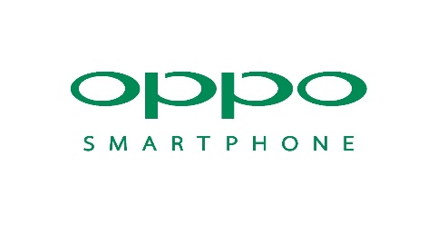
- Cultural Based Marketing: One of the best popularity attraction Xiaomi is doing is getting into cultural based marketing. People loved Xiaomi’s unique of advertising and marketing campaigns. The consumer of the Asian region loved Xiaomi’s different approach in the different region based TV promos.

OPPO
The Chinese brand OPPO has been providing their best competition in the smartphone market since their release of OPPO N series and OPPO R series. They have been competing in the smartphone market since 2013.
This Chinese smartphone brand has been consistent to their competing strategy. After the release of their OPPO N3 a reversible camera mechanism that gained a lot of popularity in 2014. OPPO’s best competitive strategies are explained down below:

- Best Camera in the Market: OPPO has been claiming that they provide the best possible a smartphone camera can capture is available by their smartphones. As we all know some consumers likes to take camera shots and self-portrait shots as well. That is why OPPO’s camera strategy has been risen and loved by the consumer choice.

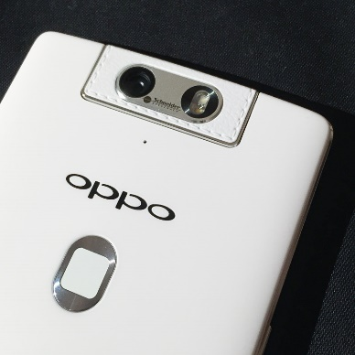
- Exclusive Smartphone Design: The best looking smartphone by design and choice was OPPO. With the budget smartphone choice OPPO has been delivering the most unique design smartphone to their consumers.

Brand Choice
When a consumer buys a smartphone there is a lot of choice to choose from. At first there are different brand names that comes into the consumer mind. For example: Samsung, Apple, Huawei, Xiaomi, OPPO and Vivo. These Particular smartphones has their own identity. Whenever a consumer chooses a brand he or she doesn’t choose a brand by just their names. There is also a lot going in the past evaluation process.
There is two types of segment that is leading the smartphone market, which is the “Google’s Android market and Apple’s IOS” market phones. Both of the firm produces best user experience operating system smartphone that consumer loves and adores while using them.
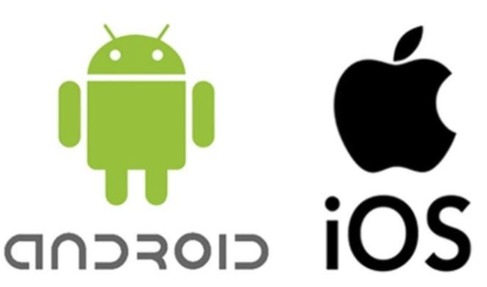

Samsung (Largest Conglomerate)
Samsung is a renowned name in the consumer electronics market. People has their trust in Samsung electronics. Samsung has given their best smartphones from 2010 since their release of Galaxy S series announcement. Samsung also provides mid-range and as well as the high-end products to their consumers. It has been easy from the consumer perspective choose whether they want a high end flagship phone or a low-budget phones.

Apple (Unique Competency)
The name Apple is well pronounced mainly in the rich economy market. As Apple’s IPhone has a popularity in the function and unique application to use, Apple has their own identity settled in the consumer smartphone market. They provide their loyal consumers monthly updates on their IOS devices and maintain good communication.

Huawei (Chinese No.1 Manufacturer)
Huawei is one of the most successful smartphone maker from China, based on their outstanding sales and profit. Huawei follows their own style and rules. They really know how to capture a market based on their customer market segment. By providing different design in their budget smartphone, Huawei has built their empire in the consumer market.

Xiaomi (Budget Beast)
Xiaomi has been producing good performance smartphone with a better price point in the Asian market. They have created a brand value in the consumer mind with their special offer and connecting with the local tele-communication partner. Nowadays consumer doesn’t buys a Xiaomi product based on their smartphone name, they buy it because Xiaomi tries to offer the best.

OPPO (CAMERA PHONE)
One of the most popular smartphone in the young consumer market OPPO has been doing outstanding in their sales number during the past couple of years. OPPO’s slogan is simple yet attractive in front of the young consumers, which is best camera in a smartphone. This slogan made OPPO’s phones famous for selfie lovers and also for random picture shooter of smartphones.

VIVO (CAMERA & MUSIC)
VIVO was very innovative in both design and performance aspect of their phones that they were publishing in the smartphone consumer market. VIVO’s slogan is Camera & Music. They must catch both the camera lover consumers and with great speaker grills in a smartphone they have got interest of the music lovers also. VIVO’s “APEX” series got an innovative design that also made their name in front page of the smartphone market.

Brand Choice Criteria
There are different factors or criteria that makes us choose a particular smartphone brand. These factors are the main specifications of a particular smartphone could be: Smartphone design, Ra, ROM and many more. These criteria’s are explained down below:
BODY: A smartphone dimension explains how a smartphone height, width and depth. These three dimension says that how will it look like when we hold a certain smartphone. For example: height 150milimeter and width of 72 and depth is 8mm. The body also says how durable the phone really is? Weather the phone is waterproof is not based on their IP rating, for example: IP67 or IP68. There is also other networking factor like, is it a single sim smartphone or dual sim? These criteria truly makes a brand attractive in front of a consumer.
DISPLAY: Smartphone’s display matters a lot. As a matter of fact we touch every single day that display which needs to be super crispy to use that phone. It could be an IPS LCD display or AMOLED technology display which is much richer and vibrant in screen quality. A display also says how large the screen size it, for example 5.5’’. There is also pixel density related issues depending on how quality the resolution we are choosing when we are selecting a particular smartphone brand.
PLATFORM: In this category we understand the overall performance and usability experience of a particular smartphone. The operating system that the phone using, the chipset technology, the graphics processing unit to process multi-application and high end games.
MEMORY: Is there any extra storage available in the phone or the internal memory that holds the OS of a particular smartphone. For example 64GB ROM and 128GB storage to keep users or consumers personal things like photos, music or videos.
CAMERA: The camera is the main focus nowadays a smartphone can have. Each and every company tries their best to have the best quality camera in their flagship phones. At first the camera was only available at back but now it is wise to use best camera in front also for better selfies and live video chat. For example: 8 megapixel, 12 megapixel or even more. The better the aperture and depth censor in a camera the better the camera shots possible from a smartphone.
SOUND: Weather the phone has good sound performing quality or not. Is it a loudspeaker phone or a minimal speaker phone? Does the smartphone has dual speaker for good music hearing? In recent trending option, does the smartphone has 3.5mm headphone jack or not? As some companies has diched the 3.5mm headphone jack due to more waterproofing.
COMMUNICATIONS: A smartphone must have good networking censor and Wireless Local Area Network (WIFI) connection. Bluetooth is also a factor as few IPhone didn’t have Bluetooth in their early phones. The GPS connection explains how good the internet connection will have in a particular brand. Is it a micro-USB phone or a USB Type-C phone?
FEATURES: Some companies or brands consider this category as the vital one and some don’t based on their smartphone price in the market. There are lots of feature smartphone could have, for example: Proximity censor, Fingerprint Censor, Gyro, Compass, Accelerometer, heart-rate and other virtual assistance services.
BATTERY: The battery of a smartphone is the main power source that shows to us a smartphone survivability in case of heavy performance or usage. There could technology involved in that category also, for example “Lithium Ion Battery or Lithium Polymer Battery” technology. How fast the phone is charging and how long it is giving the feedback? Some smartphone brand provides wireless charging and newly innovated “POWER SHARE OR REVERSE WIRELESS CHARGING”. The bigger the battery, for example 5000mAh in a smartphone the better the standby time to run or perform more application based on user preferences.
OTHERS: In this category we find out what color the brand is publishing in the market. How much we have to spend to purchase or own that smartphone. Generally the Black & White color are the most common one to choose from a consumer perspective.

Brand Choice in Smartphones
Mobile phone using experience has been changed a lot since the last decade. New technologies emerge every single day with new user experience and innovative performance usability. While using a mobile phone in our day to live have been changed due to newer technological approaches and smartphone innovativeness.
Nowadays, consumers don’t see a mobile phone as a communication device anymore. They see a mobile phone as an attitude or fashion that explains themselves as a person who they really consider themselves to be and that is why the
There are many different possibilities a consumer chooses a smartphone brand before buying one. These choice criteria defines how well or easily a consumer is selecting a particular brand and why exactly that particular brand.
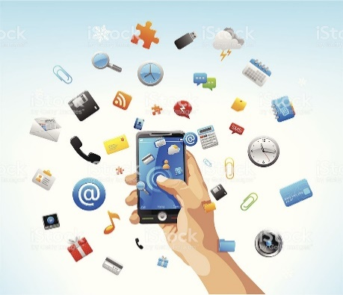
There can be lots of criteria involved, but in the popular criteria choices are like this:

Feature
The features are the main focus of a particular brand. For example: some brand offers more ram and some offer more battery life. This doesn’t happened simultaneously but once a year every company tries their best to publish their best phone with the best configuration available to use by a consumer.
The features also could be the display of that particular smartphone or the camera quality and also the overall design. These few things seems like a no big deal but in the smartphone consumer market it is a pretty big deal. To be precise these few details makes the consumer more attracted towards a specific brand choice.

Brand Image:
A company’s brand image is the overall recognition of that particular brand in the smartphone market. To say that phrase elaborately, let’s think about Samsung or Apple.
These two smartphone makers has a huge market popularity in the smartphone market. Samsung has been making electronic devices from the early 1938 and Apple has been making consumer electronics or especially computers since early 1976.
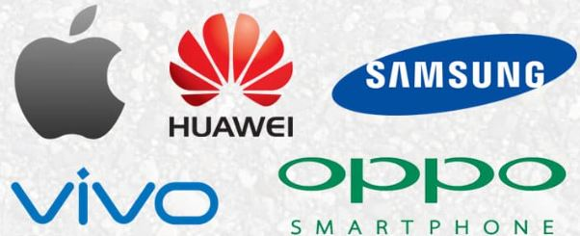

Both the company has built their trust and hope from the eyes of an average consumer. These brand image, their service, and their loyalty and after service has made their top level image in the consumer electronics market from a long time. That is why brand image has a lot value from a marketer’s perspective.
That’s how brand image is developed and created in the market. Through exclusive consumer trust and dedication towards consumer wants smartphone brands create their own and unique way of identification. This is the best way to keep the asset intact and reliable in front of the mass media.

Cost or Price
A smartphone price defines how much value has gone into that particular smartphone. Depending on cost or price of a particular smartphone marketers set or target their customer. Like who’re the suitable consumer for their smartphone given that price point.

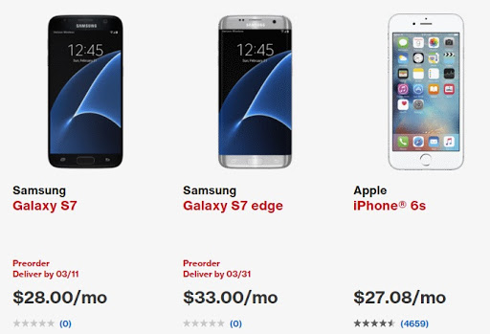

For example if a smartphone costs $500 dollars, it basically falls into the premium mid-range segment and surely a low budget consumer will not get affected by that price point. Eventually that customer won’t buy the smartphone as he or she is looking for smartphone of their own choice that fits their affordable money.
Sometimes smartphone marketers compete with other brands by giving the same performance smartphone with a bit lower price compared to their competitor.

Personal Recommendation
Sometimes we go to market to buy a smartphone with a tip or a personal recommendation by someone close to us. Whenever a close person to us recommends a smartphone we grow a trust in the particular brand and hope that our close people’s information will be accurate and pure. That simply triggers our buying behavior towards a particular smartphone of their preferences. For example, if someone close to us says:
“Apple IPhone’s update is better than any other phones for a long-term using.” This single statement may influence one’s choice change from one brand to another due to their advantage that is explained to us from someone close to us.

Durability & Portability
A smartphone’s durability and their portability can affect few consumers if they’re concerned enough for their smartphones. Some people doesn’t care about their smartphone like others who do. There could be a variety of durability factors, for example: The Screen quality, Build material and many more. Portability can explain how easy it is to carry that particular smartphone, for example: small in size or large, heavy or light, pointy or rounded corner etc. These particular factors defines the true comfort and careful usability of any particular smartphone for day to day uses. The picture down below will explain more about a smartphone durability level of MOTOROLA DROID TURBO 2.
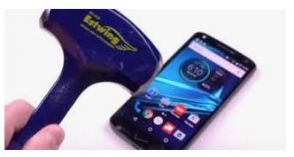

Media Influence:
Television and internet has been in our life from a long time now. They influenced us to buy or stay away from many different choices that we had made in our livelihood.
A simple advertisement with unique marketing tools may trigger our buying decision and make us feel like having a smartphone by our own choice in the right moment like right now. Internet ads also plays a vital role if we are choosing a brand. There could be lot of promotional offer, for example: earphone free with the smartphone or selfie stick free.
That is how brand criteria in smartphone plays a vital roles while choosing a smartphone from a consumer perspective when we actually buy or think about buying a smartphone.

Factors Influencing Smartphone Buying Behaviors of Consumers
There are certain factors that influence consumers when it comes to buying a new smartphone device for their long-term usage or user experience analysis.
These factors are explained in the diagram created below:

As we can see there are simple four major factors that influence the smartphone buying decision making of consumers around Dhaka city. They are: Personal, Economic, Socio-Cultural & Technological factors.

Personal & Psychological:
Every smartphone consumers has their own point of view and own choice making or decision process, when it comes to buying a good smartphone. They have different gender and age. Those consumers might also have unique way of thinking and wants from that specific phone of their choice. Generally the consumers are adult and well enough educated to know and understand the smartphones to use it. They are around 17 to up to 54 who uses smartphone in Dhaka city. Some are students, mostly adults who knows well enough to do thing or two with their devices.

Economic:
In this section we understood buyers or especially smartphone consumer’s economic stage or income rate. Is he or she a earner of their own or just spending their parents cash to buy and roam around with their beloved smartphone. Mostly the consumers are earning around BDT 20k to around 40k monthly to get a hold of these smartphones.

Socio-Cultural & Family:
The socio-cultural factors of smartphone users explains where the consumers are growing up and what cultural benefits they got. Some consumers grew up in rural areas are some are not. The consumers who grew up in high society with high advantage and prestigious opportunities simply doesn’t have a good view in budget smartphones but to expensive ones. In the other hand the consumers who grew up with lower opportunities and had seen poor cultural view points in their lives has more interest in buying a cheap and budget oriented smartphones.

Technological:
The technology plays a vital role in every smartphone consumers lives. Mostly the consumers who are well educated and well known about smartphone configuration websites are more concern about their phones. They need more features with technology filled features but with lesser price. Some consumers are shown that are not aware of the configuration of their smartphone but still want a phone or device to use or to show off.
Above all, it’s understandable that smartphone buying consumers prefer more and more with less and less prices. Mostly it depends on the characteristics and societal benefits the consumers had and build up within their minds whenever it comes to choosing a smartphone for themselves.

CHAPTER 3:

Methodology, Data Analysis and Discussion

Methodology of data collection
I have personally understood a little bit about smartphone buyers, whenever I have visited the supermarket before the pandemic situation in Dhaka city. Due to lack of personal interview or face to face interview in this current situation, I have prepared an online survey technique to get personal opinion about their smartphone usage and buying experiences.
I used both “Primary Sources” & “Secondary Sources” data collection.

Primary Sources
My primary sources was to collect the smartphone buyer’s data from the online survey that I have created with “Google Forms”. I have created a bunch of questions related to my topic and other behavioral factors that makes every consumers unique from their own point of view of buying or using a smartphone.

Secondary Sources
My secondary data collection sources was from the internet and journals and articles related to smartphone users and experience.

Limitations
As theirs this outbreak of Covid-19 going on during this February and March of 2020, which made me unable to collection my data from the urban areas and other locations. There are other limitations that I faced they’re:
- Unable to do live face to face interview to gather their true experience ;
- Most of the users were outside of Dhaka and unable to provide enough data ;
- Some of the website was restricted to provide their sensitive data ;
- Lack of cooperation from the consumers as they are devastated from the current pandemic situation.

Analysis & Interpretation of Online Survey Questionnaire
After the analysis of the online survey questionnaire, I understood that every smartphone consumers has different taste and preferences, when it comes to buying or using a new smartphone for a long time. Some people fall into same category as they share same wants and benefits from a smartphone. Others don’t as they might have different point of view or smartphone that was or was not been up to their choice as they thought they would be.
The first question was:
- Which operating system will you suggested someone?
The answer was: iOS (Apple) & Android (Google)
Almost hundred percent showed Android result as most the survey participants were android device user.
99%
- iOS
- Android

- Which specifications of a smartphone attracts you the most?
Process & GPU 9 (69.2%)
Design 5 (38.5%)
Battery 5 (38.5%)
Camera 6 (46.2%)
Memory 3 (23.1%)
Display 8(61.5%)
Price 5 (38.5%)
0 2 4 6 8 10
What we understand from question two’s answers is that most of the consumers believe that they need good “Processors and GPU”. Some likes design and battery. Camera is one of the vital organs of the smartphone nowadays. Memory is for few memory hungry people. Display is the also a great feature as all of the smartphone interact with the smartphone display. At last the price is concern for some people too.
- After buying a new smartphone, how long you wish to use it before buying a new one?

Figure 15.4% consumers wants to 5 Years
Figure 30.8% consumers wants to use 2 Years.
Figure 53.8% consumers wants to use 3 Years

- Do you want your smartphone a popular one in the market?

Figure 46.2% are saying "Of course" they want their smartphone to be popular in the market, when it comes to buying a new smartphone;
Figure 7.7% are not at all in this opinion;
Figure 46.2% don’t Care and prefer their own choice.

- How often you argue with friends about your smartphone abilities?

- How often you think about privacy or data security of your smartphone?

- Do you want your smartphones to have a futuristic look or ordinary?

- Does YouTube reviewers & celebrity ads has influence when you’re buying a news smartphone?

- In what nature you would consider your smartphone?

- 100% consumers use smartphone as a tool for using many things;

- 0% consumers use it as fashion product to show off in the public or outside.

- Does other’s (other consumers who are already using smartphone) smartphones influence you, whenever you are thinking about buying a new smartphone?

- Do you consider your smartphone as a product or something special?

30.8 - something special
TOOL - 69.2%

As we can see that 69.2% believe that they use their smartphone as a tool use to use a lot of things. 30.8% consumers considers their smartphone as something special.

- Are you protective to your smartphone?
Answers:
69.2%
- 69.2% consumers believes they obviously care smartphones;
7.7%
- 7.7 consumers doesn’t cares about protection;
- 15.4% all the time thinks about protection;
15.4%
- 7.7% don’t even think about protecting it.
7.7%

- Does local smartphone brands only attracts you, whenever you’re thinking about buying the cheapest smartphone?
Answers:
- 61.5% consumers believe that not every time local brands attractions them when they are thinking about buying a new smartphone ;
61.5%
- 38.5% consumers thinks that sometimes local brands like “Walton or Symphony” attracts them to buy their phones based on low price;
38.5

- Do you regret that there’s something better deal with the same price you bought a device recently?
Answers:
- 38.5% consumers is proud with what they have;
38.5%
- 15.4% consumers do regret after buying new phones and seeing good value in another phones which offers less price
15.4%%
- 46.2% don’t regret at all after buying their new phones ;
46.2%

- Will you suggest your own smartphone to somebody else to buy?
Answers:
- 84.6% smartphone buying consumers would definitely suggest their smartphone to someone else and believes their smartphone that they are good to use;
69.2%

- 15.4% don’t consumers don’t believe in their phones and won’t suggest to someone else to buy their phones.
15.4%

CONCLUSION
Consumers of Dhaka city wants a budget phone with a better quality in majority. There are few exceptions but they are few rich people, who are more concerned about their prestige and work environment who needs prestigious or high end flagships with good specifications.
There is and always will a positive co-related with the smartphone and the users of smartphone in Dhaka city. It’s not just a normal basic usage phone to make a phone call from one distant to another, but it’s a matter of choice and personality that makes it look different and more grand breaking while using a device with such powerful abilities that makes us look precious in front of our friends and families.
Most of the International brands like: Samsung, Apple, Huawei, Xiaomi, OPPO does their best in marketing to grab most of the buyers in Dhaka city, Local brands like: Walton and Symphony are struggling but successful in the urban and rural areas for lower-mid class consumers who just needs a smartphone to use day to day task and watch something for recreational purposes.
In the end, I must say that this was truly a great experience doing this project. This buyers’ experience truly explains how buyers of Dhaka City is simply focused and concerned when it comes to usage or making a buying decision of their new smartphone. That is why it would have been better if I had been there when actually the consumers are making sure that they one that particular product to use.

REFERENCES
Ahmed, S. (2019, jan 27). The Independent. Retrieved from http://www.theindependentbd.com: http://www.theindependentbd.com/post/184980
CHOUDHARY, A. (2019, may 30). Counterpoint. Retrieved from https://www.counterpointresearch.com/: https://www.counterpointresearch.com/smartphone-market-bangladesh-grew-45-yoy-q1-2019/
Handley, L. (2019, jan 24). CNBC. Retrieved from https://www.cnbc.com/2019/01/24/smartphones-72percent-of-people-will-use-only-mobile-for-internet-by-2025.html: https://www.cnbc.com/2019/01/24/smartphones-72percent-of-people-will-use-only-mobile-for-internet-by-2025.html
Hossain, S. Z. (2020, feb 24). Dhaka Tribune. Retrieved from https://www.dhakatribune.com/: https://www.dhakatribune.com/business/2020/02/24/4-1-growth-in-local-mobile-phone-market-in-2019?__cf_chl_jschl_tk__=14d4ef3aa53d5dac363862d1fac2116b7f7b1b55-1590505553-0-ARGUd1-7MrT039rMafK477VAG10GtUeLzaKd2KxFI1NX4kCOkf5ql3FZr-fNVJU36pVFH09oGtyrszrnKtV6
husain, I. (2016, january 23). Dhaka tribune. Retrieved from https://www.dhakatribune.com/: https://www.dhakatribune.com/uncategorized/2016/01/23/smartphone-users-on-the-rise
RO. (2018, july 17). GSMAREANA. Retrieved from https://www.gsmarena.com/xiaomi_sets_foot_in_bangladesh_three_phones_are_now_available_in_the_country-news-32263.php:

APPENDIX
Online Survey Questionnaire (Google Form)
Top of Form
SMARTPHONE USER SURVEY
(Answer the questions from your personal point of view)
1.
Which operating system will you suggest someone?
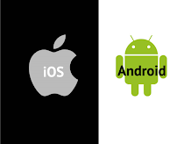
Mark only one oval.
- iOS
- Android
2.
Which specifications of a smartphone attracts you the most?
Check all that apply.
- Processor & GPU
- Design
- Battery
- Camera
- Memory
- Display
- Price
3.
After buying a new smartphone, how long you wish to use it before buying a new one?
Mark only one oval.
- 2 years
- 3 years
- Less than 1 year
- 5 years
4.
Do you want your smartphone a popular one in the market?
Mark only one oval.
- Of Course
- Not at all
- Don't care, I prefer my own choice
5.
How often you argue with friends about your smartphone's abilities?
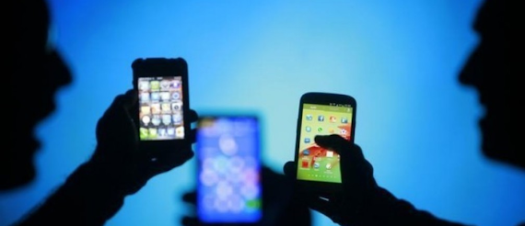
Mark only one oval.
- Most of the times
- Occasionally
- I don't argue about my smartphone

6.
How often you think about privacy or data security of your smartphone?
Mark only one oval.
- Sometimes
- All the time
- Don't even think about it.
7.
Do you want your smartphone to have a futuristic look or ordinary?
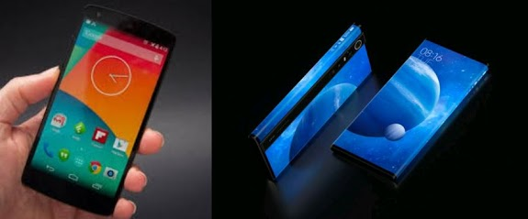
Mark only one oval.
Futuristic
Ordinary
If it does the job, it's ok to use it
8.
Does YouTube reviewers & celebrity ads has influence when you're buying a new smartphone?
Mark only one oval.
- Not always
- Sometimes
- Celebrities uses the best phones
- YouTube reviewers gave the trustworthy suggestions
9.
In what nature you would consider your smartphone?
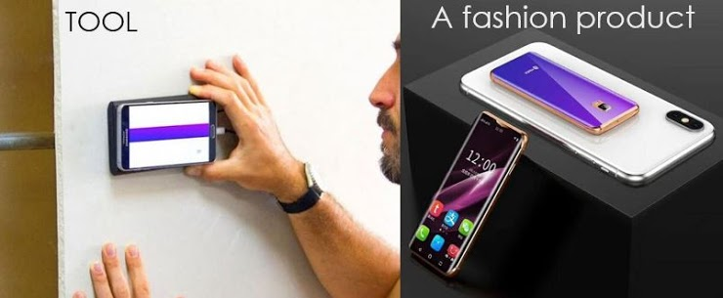
Mark only one oval.
- As a tool to use many things
- A fashion product to show off

10.
Does others smartphones influence you, whenever you are thinking about buying a new smartphone?
Mark only one oval.
- Most of the time
- Sometimes
- Maybe

11.
Do you consider your smartphone as a product or something special?
Mark only one oval.
- It's just a product
- My most precious thing in life
12.
Are you protective to your smartphone?
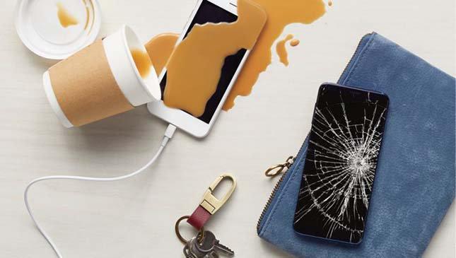
Mark only one oval.
Obviously
- Not at all
- All the time
- Don't even think about it.
13.
Does local smartphone brands only attracts you, whenever you're thinking about buying the most cheap smartphone?
Mark only one oval.
- Not always
- Sometimes
- All the time
14.
Do you regret that there's something better deal with the same price you bought a device recently?
Mark only one oval.
- I do regret
- Don't regret at all
- I am proud of what I just bought recently
15.
Will you suggest your own smartphone to somebody else to buy?
Mark only one oval.
- Yes, I will
- Nope
Bottom of Form

