Customer Engagement Strategy: A Study on Some Selected Companies in Bangladesh

Md Ashiqur Rahman

This project report is submitted to School of Businesses and Economics, United International University as a partial requirement for the fulfillment of Bachelor of Business Administration Degree requirement

Customer Engagement Strategy: A Study on Some Selected Companies in Bangladesh

Submitted by
Md Ashiqur Rahman
ID:111151128
Major: Marketing
School of Business and Economics
United International University

Supervised by
Dr. Kawsar Ahmed
Professor & Deputy Director, BBA Program
School of Business and Economics
United International University

Date of Submission: August 13, 2020

Letter of Transmittal

August 13, 2020

Dr. Kawsar Ahmmed
Professor & Deputy Director, BBA Program
School of Business and Economics
United International University
Badda, Dhaka 1212.

Dear Sir,

I am pleased to present my report that the course requirement and your directions are not complied with. The report 's focus is "Business Communication & Techniques for Customer Engagement." I would like you to know that working on this project has given us extensive experience and expertise on the topics relevant to the study, especially on how business communication is so critical for product marketing and how customer interaction strategies can help build loyal customers and improve retention rates. I have done my utmost to figure out how to make this article both informative and demanding.

We hope you find this report satisfactory.

Sincerely yours,

Ashiqur Rahman Barshan

Acknowledgment

At first I would like to begin by appreciating the Almighty for our acknowledgment. Then I would like to thank our honorable Teacher of the course for his continuous encouragement and tremendous support. So I would like to seize this opportunity to show our sincere gratitude to him. In the absence of insightful encouragement, motivation and support from him, my final report on 'Business Communication and Customer Engagement Strategies' would not have taken the existing form

Finally, I would also like to thank all the faculties who has been so supportive all these years. And has continuously guided and helped me.

Contents
Letter of Transmittal 3
Acknowledgment 4
Executive summary 7
Chapter One: Introduction 8
Introduction on Customer Engagement 9
Importance of Customer Engagement 9
Benefits to the Business: 10
Benefits to Customer: 10
Business communication 11
Main components of a communication process 12
Types of Business Communication 13
Importance of Business Communication 14
Promoting Products through communication 18
Advertising: 19
Public relations (PR): 20
Personal selling: 21
Sales promotion: 22
Direct marketing: 22
Digital marketing: 23
Guerrilla marketing: 24
Chapter two: Customer Engagement Strategies 27
Customer Engagement Strategies 28
Engage customers with In-Product messaging 29
Communicate with VIP customers with promotions specifically for them 30
Obsess over your customers by delivering enormous value 31
Produce digital content to fuel demand from customers 31
Respond promptly to customer calls 32
Make Communication More Personalized 33
Show the Real People Behind Your Brand 33
Chapter Three: Company Cases 34
COMPANY PROFILE: bKash 35
Customer Engagement Funnel 36
COMPANY PROFILE: PATHAO 39
Customer Engagement Funnel 40
COMPANY PROFILE: Grameenphone 45
Shareholders profile 47
Customer Engagement Cycle: 48
COMPANY PROFILE: Unilever Bangladesh 56
Unilever Global: 56
Conclusion: 60
References. 61

Executive summary
Customer Engagement is the incredible relationship between a consumer and a company. It plays an important role in helping marketer understand service performance and customer outcomes. This report is based on customer engagement strategy that some selected organization practice in serving their target customers. Engaging the customer plays an important role in the organization. Without following or creating a proper customer engagement strategy it is impossible to create a loyal customer. The customer engagement strategy helps to earn customer satisfaction. I have used the customer engagement funnel to elaborate how the strategy works and how effective the techniques are. As business, communication has a close relationship with the customer engagement, therefore, detailed discussions on communication their typologies as well as how they affect customer engagement.

Keywords: Customer engagement, customer satisfaction, promotional mix, engagement process, multinational organization

Chapter One: Introduction

Introduction on Customer Engagement

The concept of engagement has been explored in the organizational behavior literature as a means to explain brand.(Bowden, 2009)Clearly, therefore, engagement plays an important role in helping us understand service performance and customer outcomes. Currently, there is no theoretical basis for the measurement of the engagement process in the literature on customer behavior, and most of what has been written about engagement has its basis in practice rather than in theory or empirical research. (Bowden, 2009)

Customer Engagement is the incredible relationship between a consumer and a company. Extremely happy consumers are spending more, encourage more and show greater commitment. Providing great customer service is an important part of the customer loyalty plan.

Importance of Customer Engagement

Customer Engagement is the personal bond between a client and a company. Extremely satisfied consumers are spending more, promoting more and displaying greater loyalty. Supplying high-quality customer service is an integral aspect of your strategy to get your potential customers. Unlike other aspects of your marketing, this one never ends and you must engage your customers as long as you have a product or service to offer. A fully engaged customer represents 23 per cent higher than average revenue. If you do not have a customer engagement plan, you may be losing opportunities to interact and build a relationship with customers. Customer interaction is the direct route to achieving any important business objective. It is the road to all the success a company could want:

- Customer loyalty

- Customer purchases

- Customer-based profits

- Customer ambassadorship for your brand

When you engage your customers, you’re bringing them closer to your brand, business, and organization. And that's where the magic starts to happen because without a plan of engagement, we will definitely be losing chances to connect with our audience and the ability to develop a relationship with them. There is no magic recipe for creating a great customer engagement plan, but a clear focus on who our target audience is, an understanding of their company, pressure points, time constraints, what their suppliers want and expect, on what timetable and how they measure success, is a great way to get started.

Customer Engagement helps the business to maintain competitiveness and do better every day. A business which settles easily is like to fall behind in the race because customers need to be nurtured.

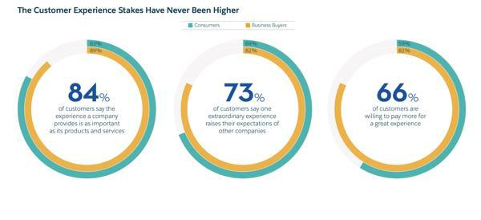
Maintaining customer engagement eventually benefits both end of the parties.

Benefits to the Business:

- Boost Retention Rate

For your customer retention rate, developing a healthy relationship with your customers is important. The further that you involve them, the more likely that they will stick to your product or service. They will not only ask for more, but they will also interact emotionally with your brand, and this is what all businesses want.

- Create an Army of Promoters without Spending a Single Penny

Committed clients will become your champions and impact others and their decisions. You are basically creating an army of marketers by building a relationship with them that will spread the word of your company and you don't even have to pay for that service. And potential customers are much more likely than traditional marketing strategies to believe other people, no matter how offensive or successful they are.

- Never Ignore Negative Feedback

Negative reviews are likely but you can set customer engagement in motion and take advantage of such comments, rather than dismissing them. By answering respectfully and trying to help the unhappy customer solve his problem, others will see that you are concerned about their opinion, and it really matters. Not only will you make them feel respected and significant, but you can also gain valuable information on patterns and consumer behavior.

Benefits to Customer:

Maintaining constant customer engagement, it not only pushes the business to do more but it also benefits the customers. They are the one being nurtured and provided better experiences. For which they get overall improved experiences, receive discounts, Faster resolutions of issues and Problems, Getting the latest information on products or services, feeling valued heard and wanted.

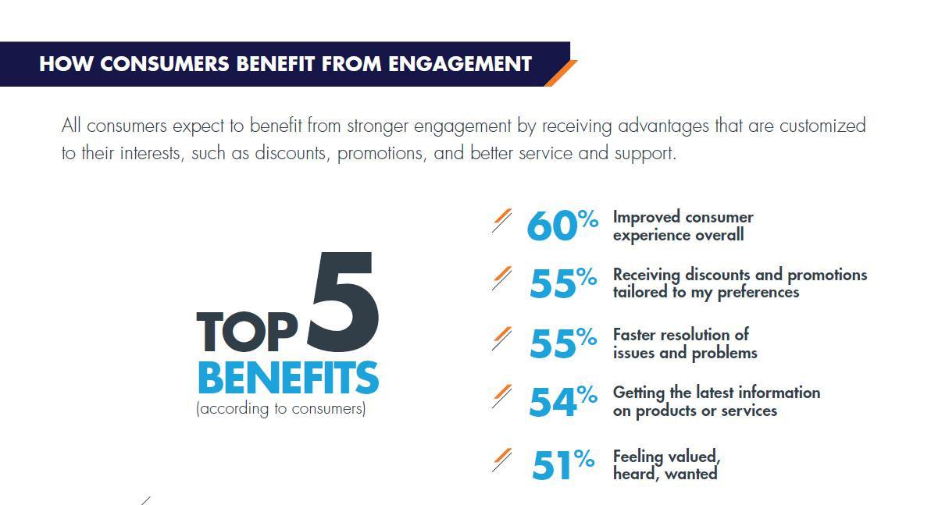

Customer engagement is a truly innovative approach, and while it is not easy and you will certainly not see any results overnight, it pays to invest time and effort. It's a long process that requires patience, but in the end it's one of the cheapest yet most effective ways to advertise your products or services, make a name for yourself and create a special connection between your customers and your company.

Business communication

Communication is neither the transmission of a message nor the transmission of a message itself. It is a mutual exchange of understanding that originates with the receiver. Communication needs to be effective in the business sector.(Guffey & Loewy, 2010) Communication is the essence of governance. Business communication requires a continuous flow of information. Feedback is an important part of business communications. Organizations are very large these days and include a large number of people. The company has various levels of Hierarchy. The higher the number of rates, the tougher the organization’s handling is. Communication here plays a very important role in shaping and handling the men's organizational process. Immediate comments and misunderstandings, if any, can be found. Effective contact between subordinates should be formed and subordinated within an organization, between organization and society as a whole (e.g. between management and trade unions); This is vital to the growth and creation of an organisation. No contact gaps should exist in every company Business Contact is target oriented.(Gibson, 2002; Guffey & Loewy, 2010) A company's rules, regulations, and policies must be communicated to individuals within and outside the organization. Certain rules and norms govern business communication. Business contact in early times was restricted to documents, telephone calls etc. But now with the advent of technology, to support business communication, we have cell phones, video conferencing, emails, satellite communication. Effective business communication helps build an organization’s reputation.(Gibson, 2002)

Business communication can be of two types:

- Oral Communication-It can be formal or informal communication. Business communication is generally a formal means of communication, such as: meetings, interviews, group discussions, speeches etc. An example would be Informal Business Communication-Grapevine.

- Written Communication-Written communication method includes-agenda, reports, manuals etc.

Main components of a communication process

- Context -It influences the context in which the conversation is taking place. It may be a sense of physical, psychological, temporal or cultural significance. In background, any touch goes. The sender selects the message to transmit within a context

- Sender / Encoder-Sender / Encoder is the sender of the message. A sender uses symbols (words, or graphic or visual aids) to communicate the message and produce the appropriate response. For example-a training manager to conduct training for new batch of employees. Sender can be a person or a community or an organization. Opinions, meaning, policy, experience, knowledge, and information from the sender have a significant effect on the letter. The verbal and nonverbal symbols selected are important for determining the recipient's understanding of the message in the same terms as the sender intends.

- Message-Message Is a crucial concept that the sender needs to communicate. It is a symbol that elicits reaction from a receiver. The cycle of contact starts with the decision concerning the message to be sent. This must be assured that the primary purpose of the message is evident.

- Medium- Medium is a means of sending / exchanging a message. The sender must select an appropriate medium to convey the message otherwise the message may not be transmitted to the intended recipients. Choosing the right communication medium is key to the effective and accurate understanding of the receiver 's message. This medium preference for communication varies depending on the functions of the communication. For Example-Written medium is chosen when a message is to be transmitted to a specific group of people, while an oral medium is chosen when the recipient needs spontaneous feedback so misunderstandings are then and there cleared up.

- Receiver / Decoder-Receiver Decoder is the individual the message is meant to / destined / target for. The degree to whom the decoder recognizes the message depends on multiple parameters such as the knowledge of the receiver, their responsiveness to the signal and the dependence of the encoder on the decoder.

- Feedback-Feedback is the major aspect of the effective communication as it lets the recipient determine the efficacy of the text. This allows the sender to ensure accurate interpretation of the message by the decoder. Feedback could be verbal or non - verbal (smiles, sighs, etc.). It can also come in the form of memos, documents etc.

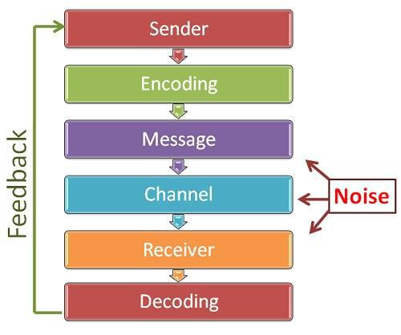

Types of Business Communication

The four basic types of business communication are internal (upward), internal (downward), internal (lateral) and external
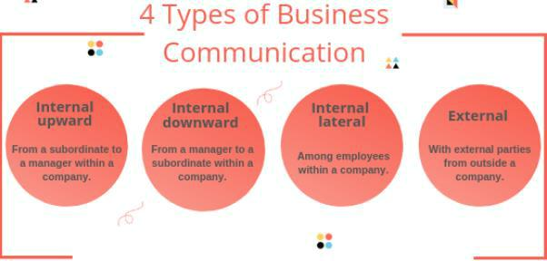

Internal, Upward Communication

This type of business communication is anything that comes down to the corporate hierarchy from a subordinate to a boss, or entity. Leaders need knowledge that flows upwards to get a clear perspective on the company's operations. Much upward-flowing communication is based on structured forms, reports, surveys, models, and other resources to help workers provide the required and complete information.

For example, a financial statement may include the overall amount of proposals, along with the actual sales. This can also ask for input including a review of the problems or achievements which management needs to monitor. Guidelines. There must be no room for confusing the conditions of safety; the language should clarify exactly what will happen.

Internal, Downward Communication

It is any communication type that originates from one or more assistants or superiors. This may be in a text, a memo or a spoken order. Representatives should remain professional and transparent about their contact with subordinates. For example, a memo regarding a new standard practice might include safety criteria and regulatory changes. There must be no room for interpreting safety standards; the term should exactly understand what should occur from within,

Lateral Communication

Lateral contact between colleagues is in-office conversation, texting, and emailing. This may be cross - departmental communication, or simply departmental internal dealings. An example of a cross-department communication scenario is where the procurement officer has a concern regarding a particular order and demands clarification from the sales representative through an email or office communication programmer. People in the same organization may collaborate to include updates on the progress report and organize timetables. Coworkers should also be encouraged to connect in a polite and professional manner when they are at work.

External Communication

Every communication outside the workplace, connecting with clients, prospects, suppliers or associates, is external contact. This may include administrative authorities or local offices too. To draw customer interest, sales presentations or marketing letters have to be entertaining but also factually focused. State the intent and be concisely articulated whether orally or in writing for collaborations or other business management needs while communicating to outside organizations. Value the time it takes for people to get to the stage.

Importance of Business Communication

Through proper communication within the organization, it can create a collective goal in all employee’s minds rather than all moving in different directions and be less productive.(Bovey, Thill, & Schatzman, 2003)

Better communication shows consumers that you understand what they mean, rather than what they just say. In order to explain the rules, procedures and other aspects of the company, effective communication is needed which ultimately allows the customers to walk away without any misconceptions or questions. It leaves no room for error and builds a solid long

lasting relationship between both parties. Speaking politely and efficiently shows that the employee has an understanding of the customer's stuff and it helps the employee get right to the point instead of going off on another topic.(Bovee et al., 2003)

What the customer rate or judge the organization based on the experiences they gather from the service or the product of the organization varies massively. They are classified into three types;

- Detractors

- Passives

- Promoters
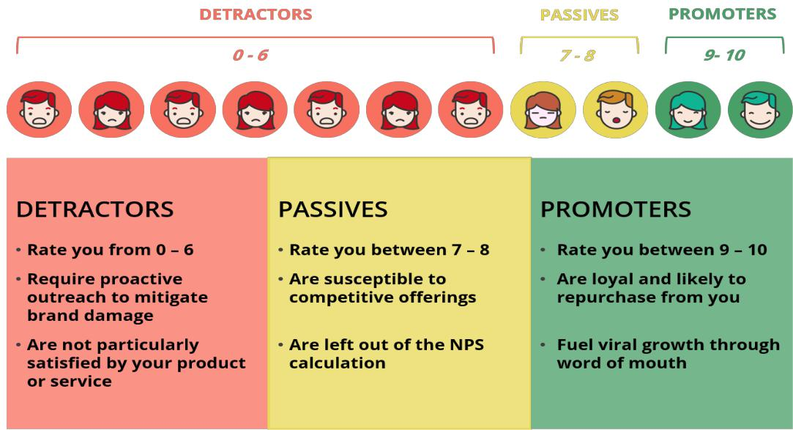

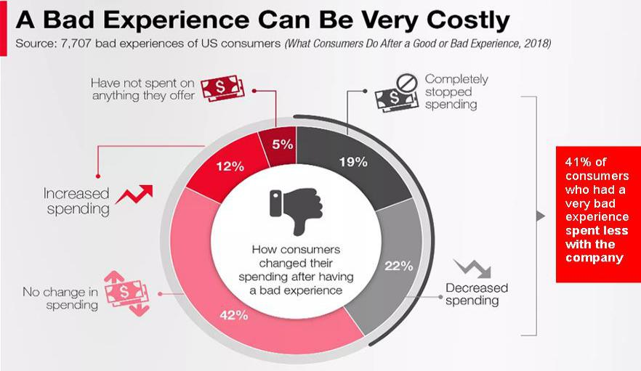
The consequences of not maintaining proper business communication to improve the overall customer experiences are huge and could be unfeasible for the organizations.(Wardrope, 2002)

Every business’s main goal is to increase revenue by all means. A proper business communication can avail the organization that benefits which ultimately will increase the revenue in the following three ways;

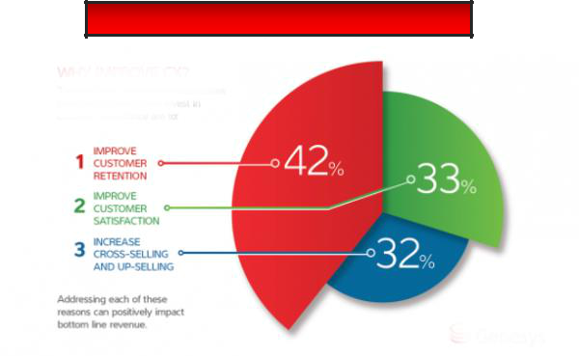
WHY IMPROVE BUSINESS COMMUNICATION

- Customer Satisfaction: Employees in customer-facing roles will be effective with the information they need and customers will sense the high employee morale and will take away positive experience, which in another way is customer satisfaction(Wardrope, 2002). A better customer satisfaction tends to increase the revenue of the business.

The 5C’s of Customer Satisfaction are;

  - Confirm your customer needs (Listen and learn effectively)

  - Coordinate well within your team (Employ a balanced business approach.)

  - Communicate intimately (Communicate regularly with customers.)

  - Consider service and beyond (Delight customers.)

  - Compete in customer service quality (Compete for share of market retention.)

Customer satisfaction can bring out multiple competitive advantages which will help to add value to the organization.

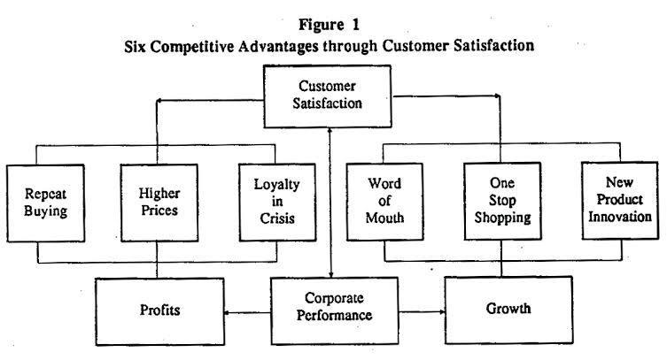

- Customer Retention: Most of the customers switch brand loyalties due to poor customer experience, it is important to lay out what the organization can do for them in order to make their lives easier and more enjoyable. So that the customers trust the organization enough to stick to the brand for a long time.

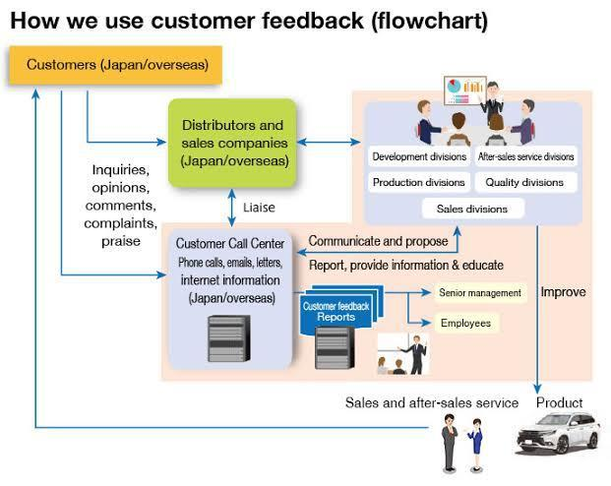
Communicating with consumers to get their feedback is a very important part of the process of communication. Knowing what an organization’s customers need and want is the first step in maintaining the customer as a loyal one, but the trick is to get to know exactly what the customers actually want. Business communication shows the correct route to utilize it.
Effective communication and its result leads to increased customer engagement, which is the evidence that the company appreciates the needs of the customer and always wants to provide more.

Promoting Products through communication

Marketing communication involves all the communications, media, and events a company uses to converse with the market. consequently, encourage target markets to actually embrace their communications and move accordingly. The promotional mix refers towards how advertisers incorporate a number of communication techniques for ads to conduct their advertisement operations. Specific advertisement and marketing strategy approaches have advantages and disadvantages and it needs for skill and experience to effectively line them up. (Wallis, 2010)

It is not even offering a better commodity for itself. Your customers need descriptions about your product or service before they buy it. The manner in which features and benefits are conveyed to your future clients is called a promotional mix. This Business Builder will illustrate how to optimize the promotional mix for the best results for your client.(Wallis, 2010) Without the right promotional blend, by following a scattershot approach, you can squander your limited resources. Promotion needs to advance the overall marketing plan and improve the conversation you want to build with the consumer segments that you most target. In order to establish or install a proper promotional mix there are some steps needed to be followed, such as;

- Specifying Target Market

Your target audience is the group of people who need your product or service or will benefit from that. Knowing other people's attitudes and actions will help you formulate the best message and use the right means to get to them.

Specifying Objectives, we have to assess your answer from your intended audience, such as encouraging them to tap on your website advertisement or sign up product check.

- Design Message

There are two main factors to the design of your communication: content and format.

- Select Promotional Channels

Business people who miss profit goals often excuse the dishonest outcomes by claiming, "We were outsourced," which generally suggests a struggle to prepare and execute the right promotional mix.

The elements or methods of promotional mix are given below;

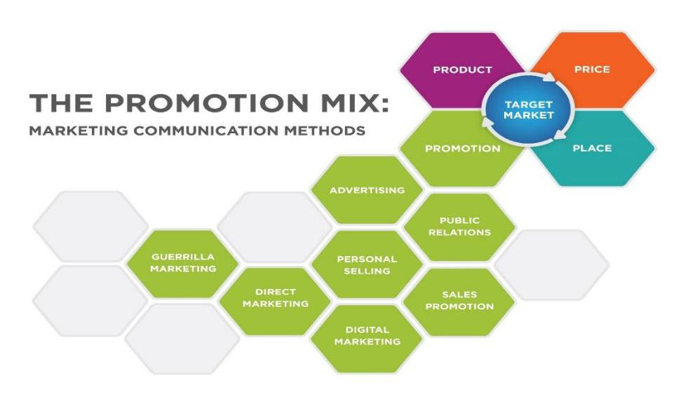

Advertising:
Any paid form in which an established sponsor offers ideas, goods, or services. Historically, mass media such as radio, television, newspapers and magazines have been targeted to a group. Advertising can also target individuals based on their profile characteristics or behavior; examples are weekly advertisements mailed to local residents by supermarkets or online banner ads targeted to individuals based on the places they visit or the parameters of their Internet search. Some of the explanations for ads are as follows:

a. Improved product / service revenue

b. Creating and preserving a label identity or logo of a brand.

c. Communicating a transition to current line of products.

d. Bringing in a fully nice and new product or service.

e. Uplifting brand or business recognition

Therefore, there are several reasons for advertising, and many different media that can be used effectively for advertisements. There may be several types of advertising based on those criteria. The various categories or forms of ads listed below are:

- Print Advertising – Newspapers, Magazines, Brochures, Fliers

The print media has always been a common source of publicity. An advertising of products over newspapers or magazines is common practice. In addition to this, the print media also offers advertising options such as promotional brochures and fliers. Newspapers and magazines often sell the advertising space according to the area of the advertisement, the position of the advertisement (front / middle page) and the readership of the publications.

- Outdoor Advertising – Billboards, Kiosks, Tradeshows and Events

Outdoor advertising is also a very popular form of advertising, using multiple tools and techniques to attract outdoor customers. Billboards, kiosks, as well as several

conferences and trade shows sponsored by the organization are the most common examples of outdoor advertising. The billboard advertising is very popular, but in order to attract the attention of the passengers, it must be really tight and catchy.

- Broadcast advertising – Television, Radio and the Internet

Traditional marketing is a very powerful marketing medium composed of different divisions such as television, radio, or the Internet. Television commercials have been very popular because they were introduced. The expense of to advertising often depend on the length of the advertising campaign, the broadcast time (prime time / peak time) and, of duration, the marketability of the television channel that will telecast the advertising campaign on.

- Public Service Advertising – Advertising for Social Causes

Public service advertising is an instrument that enables advertisements as an effective method of communication to convey socially right advertisements about critical problems and indicators of social well-being such as Hiv, energy efficiency, political fairness, pollution, illiteracy, obesity, etc.

Public relations (PR):
The goal of public relations is to build synergy between an organization (and the topics it promotes) and the "public" or target groups it is trying to reach. This happens through free or earned promotional opportunities: tweets, press and media coverage, receiving prizes, giving lectures at conferences and festivals, and even gaining positive publicity through vehicles that the sponsor does not pay for. Since organizations get the advertising they get instead of paying for the ads, they invest substantial resources on the services , activities and individuals that attract attention.

Public relations techniques

There are many techniques available to influence public opinion, some of which are more effective under certain conditions than others: Consumer communication

- Customer press releases

- Trade press releases

- Promotional videos

- Consumer exhibitions

- Competitions and prizes

- Product launch events

- Celebrity endorsements

Business communication

- Designing brand branding

- Videos of the company and its products

- Direct postal mails

- Homepage

- Business shows

Internal / employee communication

- Newsletters and Magazines in-house

- The Intranet

- Please notice Boards

- Team Conferences

- Contact address

External corporate communication

- Literature from businesses (brochures, videos etc.)

- Planners for Public engagement

- Trade, local, national and international media relations

Financial communication

- Relations among financial media

- Annual and Accounts study

- Stock-market analyst meetings, fund managers etc.

- Meetings of shareholders (including an annual general meeting

Personal selling:

For the purpose of selling products and services, staff selling requires people to develop relationships with target audiences. Personal selling emphasizes face-to-face interaction, understands the needs of the customer and demonstrates how the product or service delivers value. Personal Selling are one of the oldest ways of marketing. This includes the use of a sales force to endorse a push strategy (encouraging intermediaries to buy the product) or a pull strategy (where the position of the sales force can be limited to helping distributors and offering after-sales services).

The main activities of maintaining sales force are;

- Prospecting-trying to find new customers

- Communicating-with existing and potential customers about the product range

- Selling-customer contact, answer questions and try to close the sale

- Service-Providing support and service to the customer during the period up to and including the post-sale period.

- Collection of information-receiving market information for feedback on the marketing planning process

- Allocating-in times of product shortage, the sales force may have the power to

decide how to allocate the available stocks.

Like every other mix, Personal selling benefits the business and the consumers such are;

- Personal sales are a face-to-face activity; thus, consumers get a relatively high degree of personal attention

- The sales message can be tailored to match the customer's needs

- The two-way design of the sales process helps sales team to address customer questions and concerns directly and promptly

- Personal selling is a good way to get across large quantities of technological or other complex product details

- The face-to-face sales meeting offers the sales team the opportunity to show off the product

- Frequent sales force-customer meetings provide an opportunity to build good long-term relationships

Sales promotion:
Price promotions are marketing practices aimed at temporarily increasing the price of a product or service by adding to the basic value offered, such as 'buy one get one free' deals to customers or 'buy twelve cases and get a 10 percent discount' for wholesalers, retailers or distributors.

More than any other aspect of the promotional mix, the promotion of sales is about "action." It's about convincing customers to buy a product. It is not intended to be informative – a function that advertisement is much better suited to. Sales promotion can be directed at:

- The ultimate buyer (the "pull strategy" to encourage purchase)

- The distribution channel (the "move strategy" to encourage channels to store the product).

The methods of Sales Promotion:

- Price promotions: Increased profits from price cuts are at risk of financial loss – these

promotions should therefore be used with caution. The retailer must also guard against the possible negative impact of discounting on the company's reputation.

  - Coupons: The key objective of the coupon offer is to increase the redemption rate

– that is the proportion of customers actually using the coupon. The use of coupon promotions is therefore often best for new products or, perhaps, to encourage sales of existing products which are slowing down.

  - Gift with Purchase: "Buy gift" is a very popular promotional technique. It is also known as the "premium deal" in that the consumer gets something other than the main buy.

  - Competitions and Prizes: Another popular promotion tool with a number of variants. Most competitions and prize promotions are subject to legal restrictions.

  - Money refunds: There, the consumer gets a refund of the money after sending a proof of purchase to the seller. Such schemes are often regarded with some skepticism on the part of consumers – particularly if the process of receiving a refund appears irregular or burdensome.

  - Frequent user / loyalty incentives: Regular transactions can be encouraged by regular consumer opportunities. Perhaps the best examples of this are the numerous frequent flyers or consumer systems used by airlines, train companies, car hire companies, etc.

  - Point-of-sale displays: Research into consumer purchasing behavior in retail stores shows that a significant proportion of sales originate from deals that consumers see in shops. Attractive, informative and well-positioned point-of-sale displays are therefore a very important part of the sales marketing process in retail outlets.

Direct marketing:
This strategy aims to distribute products or services directly to the customer, rather than moving through suppliers. All of those typical digital advertising strategies are collections, email marketing, mailed leaflets, or marketing materials, and home shopping systems for television. Email and Web Advertising are two next decade Direct Marketing channels. The direct marketing cycle covers a wide range of promotional activities that you may be familiar with:

- TV and radio direct response advertisements

- List of Mail Orders

- E-Trade

- inserts for the journal

- Post direct

- Telecommunication

The benefits of Direct Marketing:

Direct marketing lets you sell your products and services directly to the most in need target audience and measure results easily, but there's more to it. Here are some of the benefits which direct digital marketing can offer to your brand:

- Take your planned segmentation and. Some of the main benefits of this form of marketing is that customized ads will reach your particular audience. If you'd rather be competitive, you should spend some time in studies to determine the customers that are most likely to convert and then channel your efforts to actions that are actually taking place work.

- Optimize your marketing budget. Direct online marketing to a particular audience enables you to set realistic targets and boost your revenue on a tight budget. If you plan and execute your campaign correctly, you can produce success with just a small percentage of the typical advertising expenses.

- Increase your sales with current and former clients. In order to keep a value-added partnership alive, digital viral selling allows you to communicate with your potential users, but also to get back in contact with former audience and create new sales opportunities.

- Upgrade your loyalty strategies. Actual communication with your customer will adjust your advertisements, emails and offers for instant binding interactions. To maximize the results, you can merge your direct marketing plan with your incentive program.

Digital marketing:
Marketing strategy covers much ground, from websites to social media search engine, content, and marketing. With technological advancements,

internet marketing methods and tools are developing rapidly, but this paragliding term covers all the ways information technology have been used to advertise and sell businesses, products, services, knowledge and experiences. Digital marketing has a lot to do with the use of computers and other electronic devices, such as smartphones and other apps, for promotions and ads. In a way, you might argue that it fits well with the kind of lifestyle most people have in these days. In reality, in 2012 alone, 4.5 trillion digital advertisements have already been made, only to demonstrate that it's the kind of marketing that most people trust these days.

Characteristics of Digital Marketing:

  - Through linking businesses, products and services to users, digital is a platform that can be accessed through a hardware device, such as a phone. There are a multitude of channel types, but the top six are:

    - Email

    - SMS

    - Social networks:

    - Search engines:

    - NFC

    - Mobile devices

  - b. It is the digital advertising platform that interferes with customers on their online travels – showing ads, paying for SEA, display advertising, fast response codes, video, etc.

  - c. Digital advertising that include channels that contain content that educate, attract and engage customers in a closer partnership with a brand, including as websites, apps, games, forums, and e-learning environments, as well as outlets such as YouTube, Slide Share, Instagram, and Pinterest that contain 'curated content. ‘And ultimately, digital marketing is observable. The term "digital" comes from the same source as the words "digit" and "digits" (Latin word for finger), as fingers are often used for discreet counting. In reality, every digital activity leaves a discreet digital fingerprint in the form of data. The recent boom in digital interaction, computers and technology has been followed by an analogous data explosion.

Guerrilla marketing:
This new marketing communication category includes unorthodox, creative and usually low-cost marketing tactics to engage customers in marketing activity, to generate attention and increase exposure to a company, its goods and/or services. Guerrilla marketing is typically experiential: it creates a new environment, or it creates memorable experiences that customers relate to a product or label.

Successful strategies for the guerrilla publicity industry incorporate the following elements:

- Clever: A good publicity commercial for guerrillas should be innovative in that it helps people consider and interpret ads.

- Compelling: it will catch consumers' attention and make them enjoy the ads.

- Memorable: This will contribute to the desired customer emotional reaction.

- Interactive: It should be social, be it with the local area or clients.

Benefits of Guerilla Marketing:

- I. Minimum budget

- Guerrilla initiatives are usually low-budget and rely exclusively on unorthodox approaches to reaching out to users. Hence the strategy is a cost-effective way to build brand awareness. New technology is more important than Spending with this marketing strategy.

- Chance to go viral

- For today's society for new technology and increasing millions of people using the Internet, consumers can catch a memorable experience and spread around the world. Guerrilla campaigns can go viral easily, and expose themselves to millions of people. Memorable

Guerrilla marketing campaigns are distinctive and unorthodox in nature and display the ability to leave a lasting impression on customers. With a successful campaign, customers are surprised, intrigued, and willing to learn more about the product and/or service. Marketing strategy helps with the recall of products.

In this modern era of the world, almost every elements of Promotional Mix have its own version of Digital Promotional Mix. Which includes Advertising-Digital Advertising (Paid Form of non-Personal Communication by an Identified Person), Public Relations- Digital Public Relations (Building good relationships with the company’s various publics), and Personal Selling- Digital Support for Sales Force (Personal Presentation by the firm’s sales force), etc.

The illustration of segmented Traditional and Digital Promotional Mix system to communicate is given below;

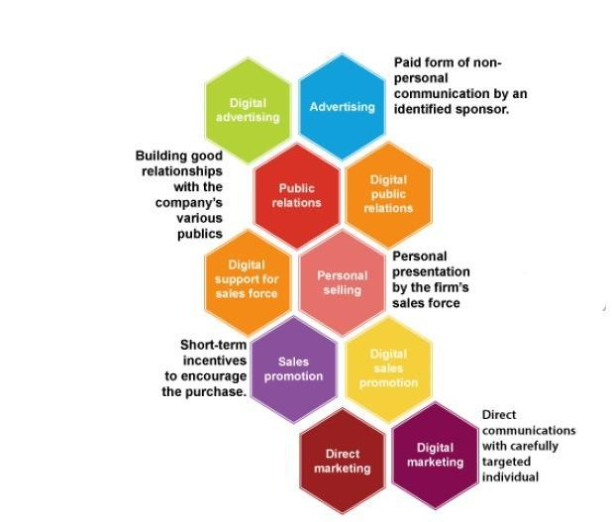

A carefully planned promotional mix ensures several tactics are in place for your company to attract clients, make sales and meet both short-term and long-term objectives. Since each form of advertising has its drawbacks and costs, this means that if you combine these methods together the ads will be more successful. The companies can also use any marketing mix tool depending on the nature of a product and the overall intent of the business.

Chapter two: Customer Engagement Strategies

Customer Engagement Strategies

Customers are based on the best available to your company. If you're selling eBooks, software, training, coaching or a tangible product (e.g., clothing), without loyal customers, both will fail. Many of the brands prefer to pay more attention to lead generation and consumer acquisition.

We forget that, once these ideal consumers are inspired and revamped in their minds, we are likely to turn to rivals – it is only a matter of time. Whether you handle your buyers does matter.(Blai, 2016)

According to Verint, 61% of consumers would tell friends and family about their experiences while 27% reported signing up to the company's loyalty scheme

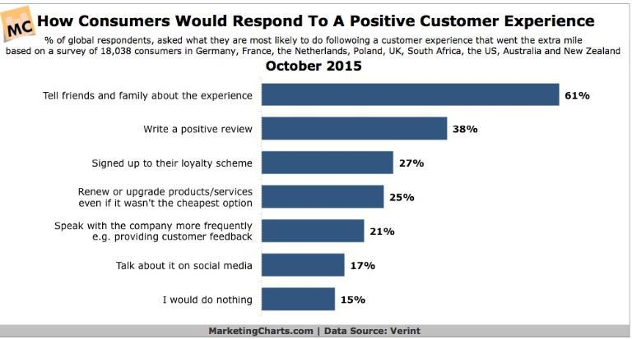

People's attention span is growing. Since these people (customers) come from different sources, monitoring interaction on both the desktop and mobile devices is important.

According to a recent IMRG Calpgemini survey, "a total of 52 percent of web traffic to retail sites currently comes from smartphones and tablets." However, more than a third (36 percent) of online sales are now completed on a smartphone or tablet computer.(Blai, 2016)

More interactions with customers across channels and devices will give them a welcome note to remain loyal

8.1. Use social media as an engagement tool and not simply a platform

Listen up: social networks such as Facebook and LinkedIn are not just platforms for linking people. Of course, such social networks are mainly for that, but if you want better results, you can use them as resources. (Blai, 2016) Customer behavior in this fast changing age will influence the perception of social media marketing. Social networking is powerful. The population of the world as of July 2015 was 7.3 billion people. Or around 2.3 billion people

out of those are committed social media users.

Engage customers with In-Product messaging

When it comes to product messaging (that is, notifying your customers of your new product), you can use several key channels.(Blai, 2016)
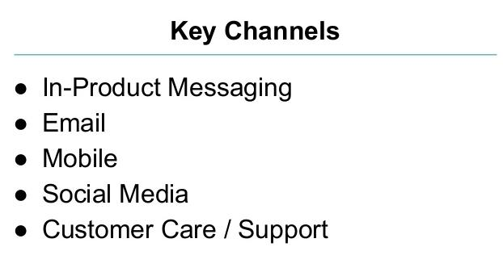

Through sending in-product messages we are improving our conversions. And this is what the buyers nearest to him so like. Material and related content directly delivered to an internet-connected computer or software system for the purposes of informing, gathering reviews, engaging or promoting for that specific consumer or consumer group at substantially higher interaction levels than other digital advertising and internet marketing channels (Blai, 2016).
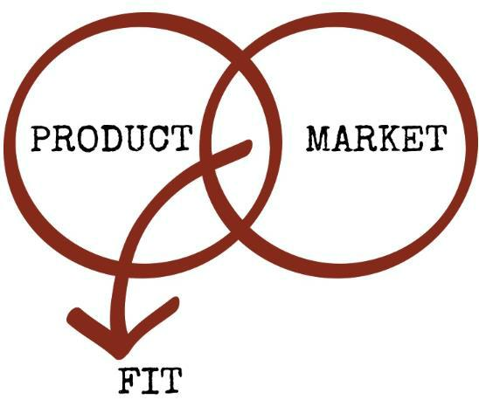

Many startups and tech companies agree that you can take full advantage of in-product messages to drive potential clients through a simple on-board process and then use e-mail to meet consumers who are still stuck on the stage.(Thackeray, Neiger, Hanson, & McKenzie, 2008)

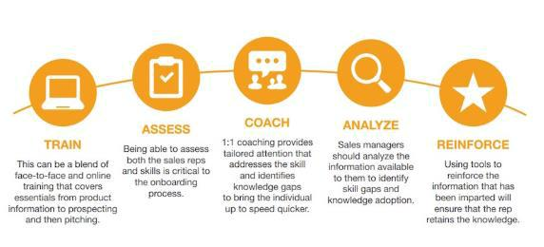

Communicate with VIP customers with promotions specifically for them

The retail market has 3 types of VIP customers:

- Conservative VIP customers: They are regular customers to any corporation. We buy more over a span of years, in general. Doug Fleener says the expenditure is estimated over an 18-24-month period.

- Team VIP Customers: These are significant customer groups, too. According to Fleener, we 're not very major spenders but you can't do without them. Since then we speak with potential customers. Media influencers and pro bloggers fall under that category. You should have expected Tens of potential subscribers and clients, if not hundreds, when they tweet your article or new product.

68 per cent of customers according to LinkedIn data would abandon the business if they do not think you care about them

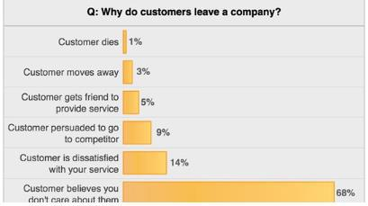

So, it doesn't matter what we think, or how good you say our customer service is, if consumers start feeling ignored, they 're going to turn to, maybe our strongest competitors.

Obsess over your customers by delivering enormous value

No matter your segment or market, once they put customers first and think for their needs, we'll be building an army of brand supporters. Information surcharge has become a major roadblock for customer engagement. Most customers lacking focus might find themselves switching brands.(Thackeray et al., 2008)

Accenture's study found that "46 percent of U.S. customers said they're more likely to switch providers than they were ten years ago." Additionally, recent data indicates that 72 percent of U.S. shoppers want to feel more in charge of shopping than ever before.
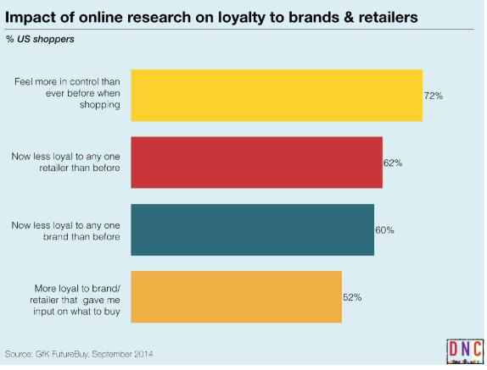

"Obsessed with clients," says Jeff-who is also a pioneer in customer service.

Above all he is concerned about consumer welfare. He is paying attention to customer questions, listening with a focused emphasis and producing excellent results. It explains why, if not the world over, Amazon is the No #1 online shopping destination in the US.

Produce digital content to fuel demand from customers

A analysis carried out by Demand Metric found that immersive content was an successful approach to educating clients.

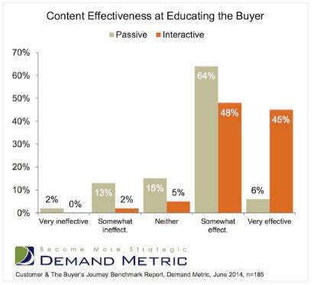

The way to do this is through content marketing. We certainly don't want customers to talk about it. Are we?

In the past conventional marketing techniques have performed well. Many companies still use them today-although with mixed feelings.

Once we come over to the Internet, content is king.

Our one-way ticket to generate more leads, more inbound connections and more sales is our ability to produce the right content.

Respond promptly to customer calls

Revenue yields quick answers. If an airline responded to a customer's Tweet in less than 6 minutes, the customer was able in the future to pay roughly $20 more for that airline. By "calls," We mean communication, not just text or internet calls. Client is total focus. Companies like Dell, Xerox, Starbucks, Apple and many others are leading the way-as they respond to user calls promptly
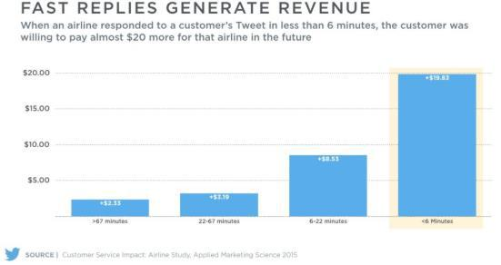

It's going to be a bad customer experience if their service is fantastic but we're late. From the other hand, if the service is good, and the time it will take to produce it suits perfectly, the customer experience would be positive and enthusiastic.

Make Communication More Personalized

Personalization is essential for any effective business plan. And if we want our brand to expand, we need to improve our consumer interaction by means of mental categories; this could prove very lucrative. In reality, Monetate found that 83 per cent of retailers with a budget committed to interactivity will surpass their profit goals. Those are more applicable to our conversations if we tailor our experiences for our customers. The personalization makes them more likely to listen to what you are doing, and engage with it. There are many ways to customize the way you communicate with clients.(Blai, 2016)

Show the Real People Behind Your Brand

As described earlier, people are more interested in communicating with individuals than with brands. We'll need to reassure our consumers as part of consumer engagement approaches that there are real people behind the brand.

When we speak on the website about your workers we will infuse the personality of our company. And we can share a quick but insightful story to help our customers learn their workers a little better

For example, Caterpillar has a dedicated "Meet Our Team" section where customers can read a comprehensive story about each and every employee and their position in the business.
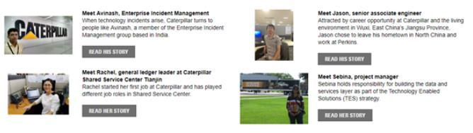

Chapter Three: Company Cases

COMPANY PROFILE: bKash
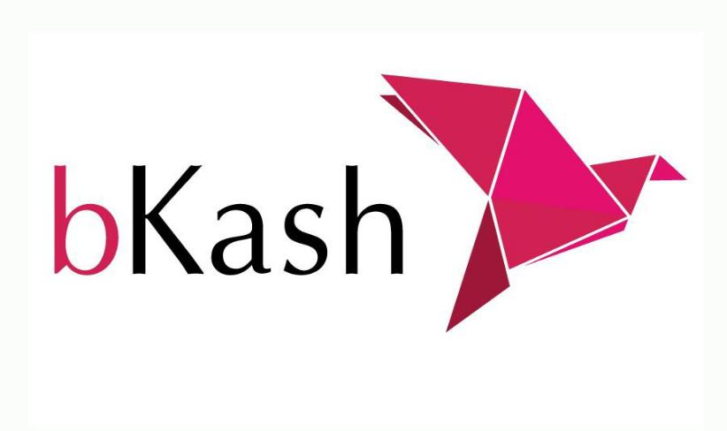

bKash Limited (bKash) is a Banking Mobile Financial Service Provider in Bangladesh operating under a Central Bank (Bangladesh Bank) license and approval, as a subsidiary of BRAC Bank Limited. bKash provides secure, convenient and easy ways for both unbanked and banked Bangladeshi people to make payments and money transfer services through mobile phones. Currently bKash is one of the world's leading providers of mobile financial services. BKash started as a joint venture in 2010, between BRAC Bank Limited, Bangladesh and Money in Motion LLC, USA. In April 2013, the International Finance Corporation (IFC) affiliate of the World Bank Group became an equity partner, and Bill & Melinda Gates Foundation was established by The Organization in March 2014. Alibaba Group 's internationally reputed subsidiary Ant Financial (Ali Pay) became an investor in bKash in April 2018. The ultimate objective of bKash is to ensure access to a wider range of financial institutions for the citizens of Bangladesh. This has a special emphasis on serving the low-income masses in the country by providing easy, accessible and effective services to achieve broader financial inclusion.

Over 70 per cent of Bangladesh's population lives in rural areas where formal financial services are difficult to access. And these are the people most in need of these services, either to get funds from loved ones in faraway places or to get financial support to improve their economic condition. More than 15% of Bangladeshis are linked to the formal banking system while more than 68% have mobile phones. Not only are these phones talking instruments, they can also be used for more critical and complex computing tasks.

In 2017, bKash was listed among the top 50 companies in the annual list of 'Change the World in 2017' by Fortune Magazine as 23rd company to make changes based on social issues.

By offering easy, accessible and efficient financial services, bKash aims to extend the net of financial inclusion. BKash wants to provide a Mobile Financial Services solution, based on a highly scalable Mobile Money platform, enabling Bangladesh's citizens to send and receive money securely via mobile devices. The new CEO is Mr. Kamal Quadir, and the Board of Directors includes Mr. Shameran Abed, as well as the Chairman, Ryan Gilbert, Andi Dervishi, Mr. Nicholas Hughes, Mr. ArunGore, Mr. Iqbal Quadir, Nihad Kabir, Mr. Kazi Mahmood Sattar and Mr. Selim R. F. Hussain (bKash, 2016).

bKash LIMITED has its headquarters in Dhaka, Dhaka, Bangladesh and is part of the Finance

- Insurance industry. bKash LIMITED has a total of 1,000 employees across all its locations and produces 230,75 million US dollars in revenue. There are 2 firms in the corporate family

BKASH LIMITED.

Customer Engagement Funnel
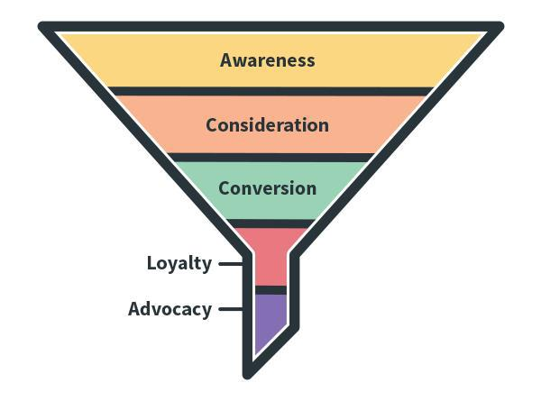

AWARENESS:
The first stage of the marketing funnel is Awareness. At this point, customers come to know your brand and company. bKash has created the awareness with different branding actions such as,

- TVCs: Frequent advertisements about the Product & Service

- Billboards: Clear messages portraying in Large Billboards

- Agent Point: POSM visibility at agent points

- Wall Paints: Wall painting on various places

- Vehicle Branding: Brand stickers and logos on Vehicles

Unique thing about bKash advertising is that, unlike other companies they have targeted the root first (Rural Areas) and while promoting the product they used simple common people to advertise instead of high reached celebrities, so that people can connect easily with the message.

CONSIDERATION:
When a potential customer passes from the perception stage they reach the consideration stage. A deeper connection with your client is founded in consideration and the potential consumer is interested in learning more about your business and its goods or services. bKash came into the market on 2011, they were trying to convince potential customers to use phones as a bank, that too on an analog phone. People were hesitating to trust the brand
but bKash made that happen by showing their features, one at a time. They showed how to use it and why to use it, and if used the money is completely safe.

CONVERSION:
Consumer knows the importance of the company in the conversion period. bKash started thinking about their product and service in this marketing funnel point, and why it is better than their rivals, and why it's good for the customers. They have clarified the advantages of their product and service, and not simply explain their functionality such as, stronger customer care (24/7) services, opening a bKash account is free and if App is installed some money is given to the customer, Available service in major mobile network operators, High technology and simple banking, wider service differentiation etc. With all these advantages and features of their product, customers are being converted to this brand instead of their competitors like Rocket, Nagad, Ucash, Nexas-Pay etc.
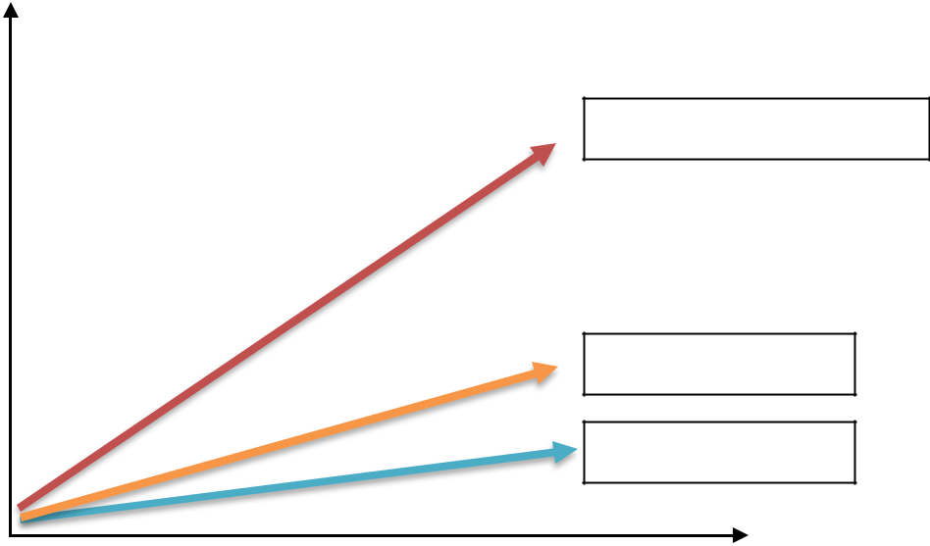

24 million Personal user

3000 Merchants

700 Organizations

2011 2018

The conversion rate can be measured with these numeric values above. Within just 7 years of operation they have attained 80% market share.

LOYALTY:
If your potential customer becomes a current customer, you will have a strategy to increase customer loyalty. If you don't have a strategy, you'll probably waste a lot of effort during the funnel's previous phases, and you'll also lose a lot of customers. bKash has been effectively providing incentives to existing customer and which also attracts the potential customers to consume the service. Such incentives are like,

- Cash-back offers

- Discount offers

- Travel Ticketing

- Instant Payment Method

- Secured Transaction of Money

- Bank Settlement for Merchants

ADVOCACY:
You should hit this funnel stage when the consumers are not only consumers but fans. We are new customers who previously purchased from you but are ready to purchase again. At advocacy level, customers need to be evaluated to find out in which stage are they right now and that can be done by The CX Pyramid,
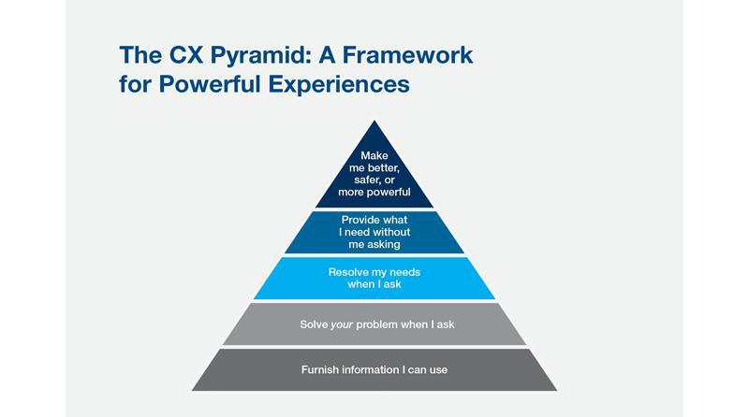

Stage 1: Communication – Provide valuable information to consumers which they can use at the right time in the right channel.

Stage 2: Responsive – React and address the dilemma of the customer rapidly and effectively

Stage 3: Commitment – Listen and be accessible, make an effort to consider and meet the specific needs of the customers.

Step 4: Proactive – Think one step ahead: have needs-solving solutions before customers ask.

Step 5: Transformation – Make consumers feel more motivated than when they work with you.

These 5 above points can be used as an exercise for determining where the consumer has experience

The CEO of bKash once said he wanted bKash to be a verb instead of a noun, the word “bKash me” speaks for itself. The advocacy level of bKash is tremendously praise worthy. Starting from 2011 to currently at 2020, after 9 years of smooth business, bKash has successfully converted maximum portion of the whole country’s population. They currently have 80% market share in this country, that being they have recently celebrated 4500 million BDT transaction every day, which is huge.

COMPANY PROFILE: PATHAO


Pathao was founded in 2015 and is one of Asia's fastest-growing tech startups, committed to developing solutions to mitigate infrastructure issues. Pathao is a Bengali word which means "send" Fahim Saleh, Hussain Elius and Shifat Adnan formed the company. The company operates in three Bangladeshi cities: Dhaka, Chittagong, Sylhet and Kathmandu, Nepal. Pathao has facilities such as ride sharing, food delivery, courier and e-commerce.

Pathao initially began as a traders logistics service provider with the aim of delivering goods to customers without delay. We discovered that using a motorbike would help relay objects comparatively faster than a car or any other vehicle. It started as a hidden community on Facebook where the founders asked their mates if they wanted to make a ride or delivery, and keep track of records in MS Excel. Because when the app was first released they didn't have any developers, developing the software was a huge part of it, and the creators themselves designed the first version. When they realized that there was an unexpressed need for a service that was able to move efficiently and save time and money, they generated the culture that changed the need for urban areas in Bangladesh's transportation mode.

A fast-paced organization, the corporation offers an enormous amount of room for workers to develop professionally as well as take control of the organization's initiatives. Pathao offers an app-based solution through ride sharing, food delivery and e-commerce logistics services with the goal to accelerate the establishment of digital Bangladesh. By harnessing the technology's strength, Pathao aims to offer all services in one platform. Application developer planned to provide on-demand travel, food distribution, and logistics services. The organization offers various services such as rentals of bikes and vehicles, ride-sharing, food delivery, and logistics services, enabling customers to access different services on one platform.

Pathao is designing practical solutions to combat the biggest infrastructure problems in the world. Since Pathao is essentially an online ride sharing and logistics service organization, their main goal is to solve two of the people's major problems across the world. First of all, by providing ride sharing services, they save their time. And the other is delivering their customers' goods within the most appropriate time possible. However, Pathao has another mission that should be mentioned: to improve technology's power to change Bangladesh's face. Very few companies in Bangladesh are working to solve two big problems while

Pathao is trying to find solutions in both the logistics and transport sectors. They make it so convenient that anybody with a connection to the smartphone and internet will take their service. The goal was also not only to concentrate on optimizing income, but also to help to provide to with job opportunities.

Customer Engagement Funnel

AWARENESS:
This first stage is basically the phase where the customer has to feel the need of something and while looking for it, a brand has to come upfront to give them what they need. Pathao has successfully done that. Bangladeshi people are always frustrated about traffic jam and always in need to of going somewhere as early as possible, then Pathao came into the market. People are very satisfied of how easily they can find a ride and move to places. In terms of creating awareness about their brand they have kept on doing advertisement and promotions with the BTL & ATL marketing concepts.

- TVCs: Frequent advertisements about the Product & Service

- Billboards: Clear messages portraying in Large Billboards

- Vehicle Branding: Brand stickers and logos on Vehicles

- Social Media & SEO Marketing: Active promotions on online media

CONSIDERATION:
When a customer is in need of something, they tend to look for information about the available solutions, and this stage two is about giving the customers all the information about the problem. According to Pardot, 70% of buyers look into Google to find the information, and they reach to evaluate the alternatives. Pathao has competitors like Uber, Shohoz etc. Pathao has been trying to reach and win over the alternatives customer choose by giving them continuous offers and campaigns and Parcel/Product Delivery system being their higher strength people consider choosing them. Pathao has comparably less price range than their competitors.
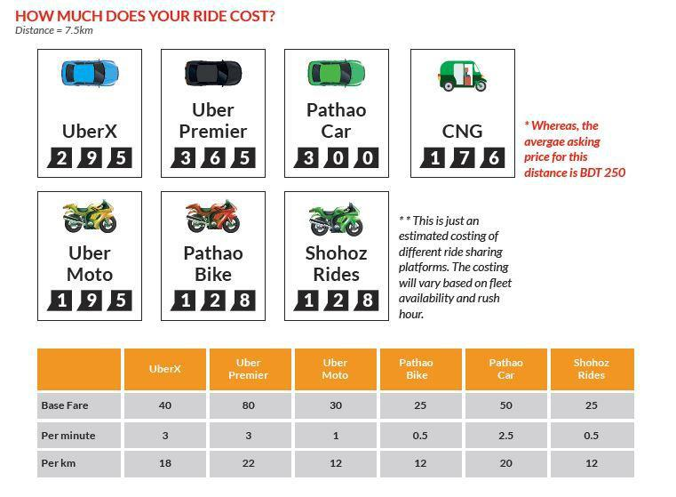

Other than ride sharing & Product Delivery option, Pathao offers Food delivery system as well.

Pathao is like “One App for all” kind of service provider.


CONVERSION: This is the stage where a customer takes a purchase/consumption decision. Case study material, showing a previous or current customer's progress, is very successful, especially when the case studies are applicable to and represent the lead. Building case studies with clients that represent various client profiles, verticals, sizes, etc. Pathao has launched in 2015 and they introduced ride sharing in mid-2016 and since then they have seen tremendous growth in market consumption of the service. As reported in 2018, they have 1 Million active users, 100000 Drivers and 50000 registered bikes within 2 years.

Pathao Rides is competing nail to nail with Uber but Pathao Food Delivery system is leading the marketing with 80% Market share competing with HungryNaki, Shohoz etc.

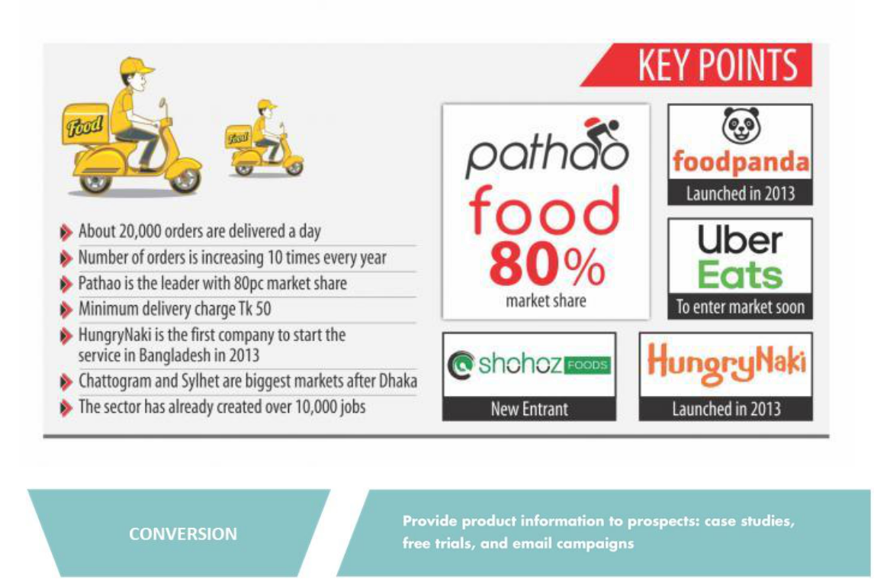

LOYALTY:
When consumers make their first purchase and then repeat purchases, they travel further down the funnel and gain valuable customer status. Pathao has been gaining market share very effectively and at a very fast rate which is the result of their incentives and strategies to hold the existing customers and attract the potential ones. Some of the features are,

- A lot of different campaigns for different TG

- Food Delivery Service

- Product Delivery Service

- Ride Sharing Service

Customer Loyalty doesn’t come without providing them the service they are looking for and being satisfied with it.

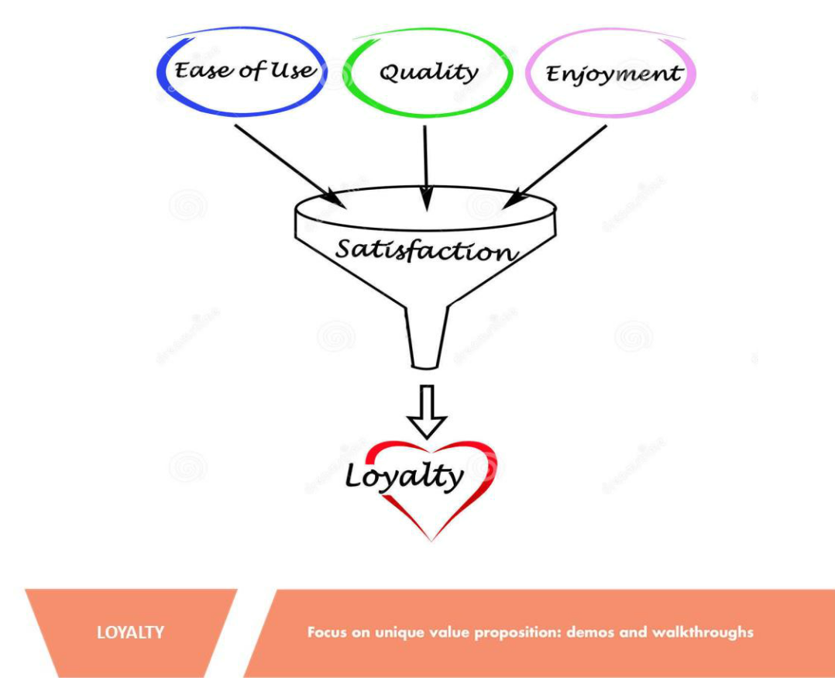

ADVOCACY:
Consumer support requires an unceasing emphasis on customer needs. You should never pull a fast buck over your customers or lie to them to land a deal. In this stage of the funnel, the customers not only are your consumers but also the fans of your product. They are the one who spread and do Word-of-Mouth marketing for your brand. They are the most essential segment of your funnel, here is why;
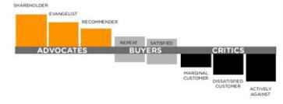

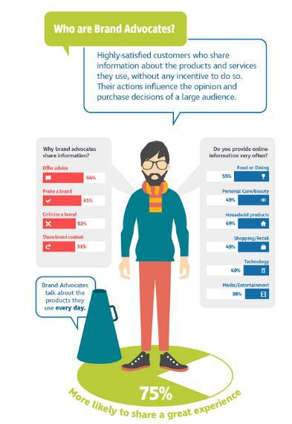

Pathao’s customer share are huge, they are competing single handedly on food delivery service and neck to neck on ride sharing service with Uber , Shohoz etc. Even after all the competitions they are the most used and promoted brand in our country in terms of the service they provide.


COMPANY PROFILE: Grameenphone

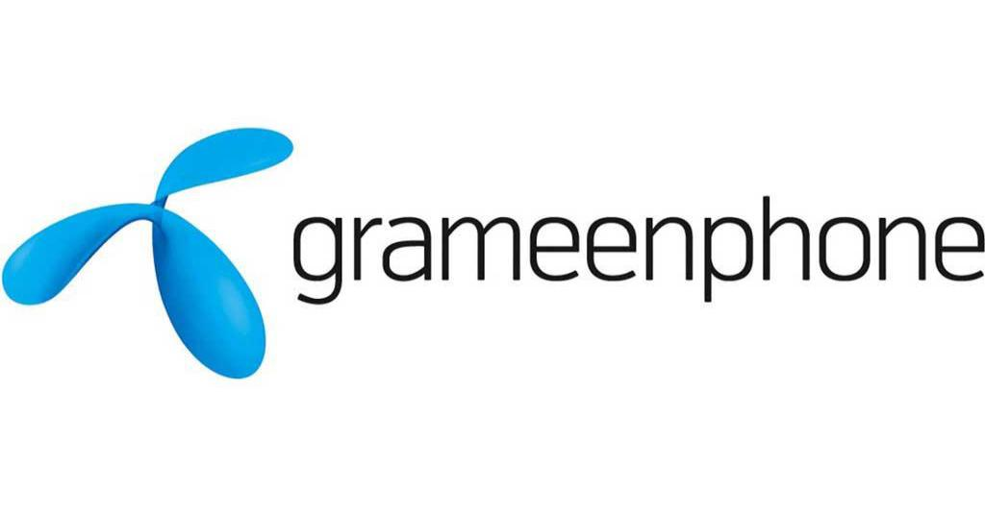

GRAMEENPHONE is a prominent and successful provider of GSM communications solutions across the world. Telenor (55.8 per cent) and Grameen Telecom (34.2 per cent) are joint venture firms. Ltd. Grameenphone. Grameenphone Ltd., the largest telecom company in Bangladesh, received its operating license in November 1996, and started servicing on 26 March 1997. Today, after 15years of continued success, Grameenphone is the largest mobile phone service provider in malaysia, with more than 46.04 million subscribers as of September 2013. Through this research we want to know the consumer 's opinion, the happiness of the standard of service offered by GRAMEENPHONE.

History

Fast after its start in 1997, GP established itself as the world's leading service provider by providing superior coverage and a greater understanding of network quality than its rivals OP aims to introduce mobile banking services across the country once the regulations are in place. Unless we were to make a chronology then it could look like this: November 28, 1996: Grameenphone Ltd. received a cellular license from the Post and Telecommunications Ministry of Bangladesh.

26 March 1997: Grameenphone started service on Independence Day in Bangladesh. June

1998: Grameenphone opened its services in Chittagong, the second-largest city and port in Bangladesh. Between the Dhaka-Chittagong, cell to cell coverage was established. 1999: Grameenphone started operation in the industrial district of Khulna, Bangladesh. Cell to cell coverage between Dhaka and Khulna also brought a number of other districts under protection. 2000: Grameenphone operation commenced in Rajshahi, the academic city of Bangladesh. Operation also started in Sylhet and Barisal and thus received cellular network access from all six training centres for the first time in Bangladesh. August 2003: The user base for Grameenphone has risen to more than one million. Grameenphone became the country's first operator to hit the million subscribers. November 2005: Grameenphone had more than 5 million subscribers registered. November 2006: After almost ten years of operation,

Grameenphone crosses the 10 million subscriber mark. 20 September 2007: Grameenphone

reaches a subscriber mark of 15 million. June 2008: Grameenphone hits milestone of 20 million subscribers. January 2013: Grameenphone Deploys Oracle Communications Network Resource Management Solution to Successfully Transform Inventory Operations. 8 September 2013: Grameenphone receives spectrum of 10MHz for a 3G service. October 8, 2013: Grameenphone commercially launches 3G service.


the Village Phone Program, also launched in 1997, provides a good income-earning opportunity for more than 210,000 Village Phone operators, mostly women, who live in rural areas.

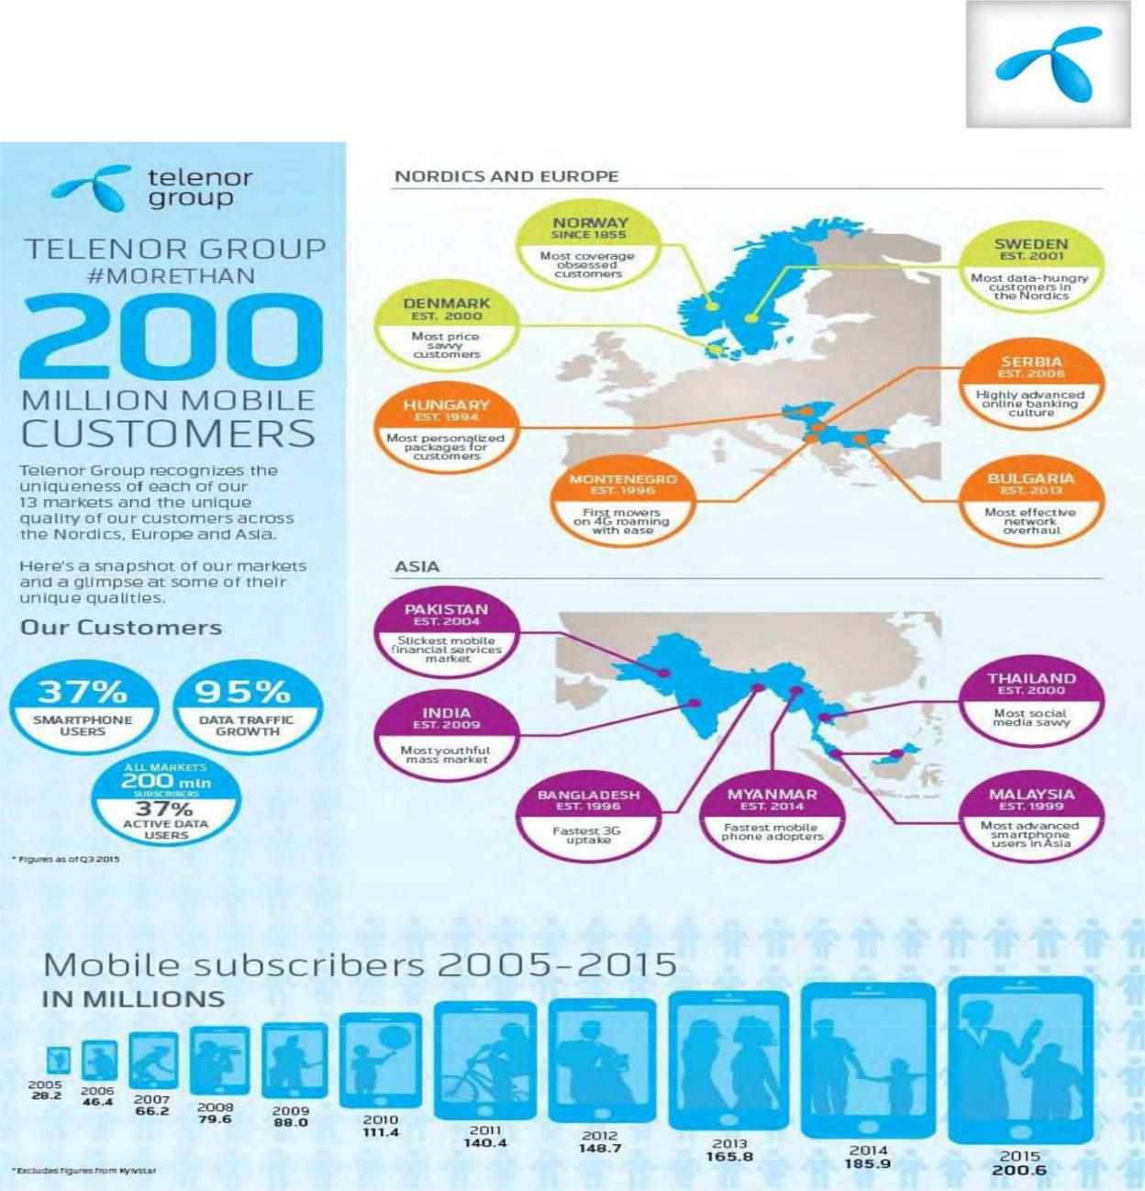

The Village Phone Project is a pioneering program in remote rural areas to provide direct access to telephone service.

Grameenphone considers its workers as one of its most valuable properties. GP has a robust workplace incentive program in place including Gratuity, pension benefits, Group Pension, Family Medical Insurance , Travel Center, Day Care Centre, Children's Education Aid, Higher Education Aid for Workers, in-house medical support and other programs. GrameenPhone launched its services in Bangladesh on 26 March 1997, on the Bangladesh Independence Day. Connection to the company has spread across 300 international roaming partner operators in all of Bangladesh and abroad.

Shareholders profile

Telenor-ownership: 55.80 per cent million daily users worldwide The seventh largest mobile telephone company in the world in terms of subscribers Have operations in 13 countries Strong

growth in services, especially in Asian Operations The dow jones industrial average Index (in which year) defined the sector leader in mobile telecommunications. Telenor has investments in Sweden, Denmark, Hungary Russia, Ukraine, Montenegro, Thailand, Indonesia, not only in Norway and Bangladesh, but also in mobile telephony firms. As of 30 September 2008, Pakistan and Serbia had more than 150 million mobile subscribers worldwide:
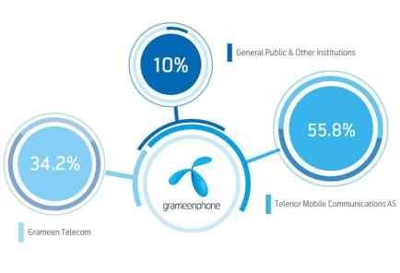

Customer Engagement Cycle:

Connection:
The precondition for relational exchange with emotional bonds is Sellers and customers need to connect. Links can be formed Using both conventional offline approaches such as salespeople and modern online digital services Methods such as the social networking. Social media greatly facilitates the creation of Connections with numerous individuals and a wide variety of companies. Customers could use existing connections with sellers and other customers to fulfill or fulfill a requirement May try new connections with sellers and customers outside its current circle Sellers may also create connections with potential customers before need occurs so as to be able to recommend existing goods.

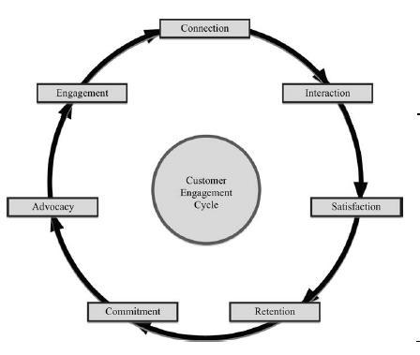

Solutions or even new technologies are created to meet those needs. Sellers seeking customers can also be able to create connections. GrameenPhone is the largest telecommunications firm in our country and there are several approaches they pursue to communicate with clients.

Advertising:

- Newspaper advertisement (print media) Television advertisement

- Radio advertisement and also sponsoring radio shows. Billboard.

- Internet based advertisement.

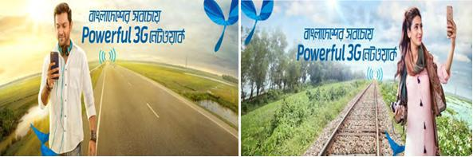

Sales Promotion:

- Price pack/bundle offers. Cash refund offer

- Prizes/gifts for the premium users.

- Discount offers at different shops that has partnership with GP
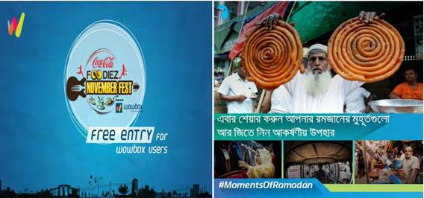

Interaction:

If the customer is paired, he will communicate with seller staff and other customers. Such links were restricted before the internet by available technologies such as Word-of - mouth, letters and telephone to the close family circles, friends, colleagues, and knowledge constrained by location. With Web 2.0, however, restrictions regarding Space and time are rapidly vanishing, and examples such as the global village and the 24/7 Evoked to describe possible real-time interactions among people all over the world. Texting, e-mail, blogging, virtual worlds and social networking Examples of tools which allow for more frequent, faster and richer interactions between. Internet offers sellers the ability to Continue dialog with customers, build on information shared between them Customer groups with shared interests, and widen customer reach and scope Interactions to reach prospective customers or competitors.

GrameenPhone has significantly adopted this interaction strategy through call center service, customer cares, and other post purchase services also through digital marketing and social media.
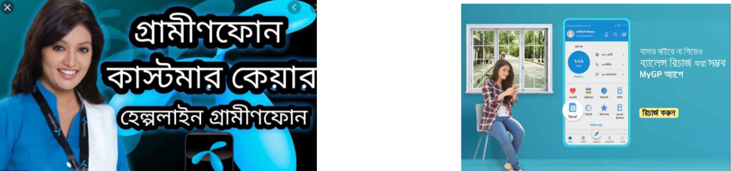

Satisfaction:

Also when there are contacts between a seller and a client, or between representatives of a Group, like sellers and consumers, will please them Connected and continuing to interact with each other and to progress Commitment. Satisfaction is not an end in itself, since customer satisfaction is used Surveys and ratings sometimes imply only an interim step in strategies Achieve the organization’s goals. Satisfaction is a requirement for customer loyalty. But customer engagement doesn't suffice. Being satisfied with interactions during a purchase process can precede or follow Purchase and dissatisfaction can interrupt the cycle at any point and lead to Exit customer. However, satisfaction may not lead to repurchases and a long-term one Relation will not follow. A distinction has been drawn between the different transactions and overall consumer loyalty.

Grameenphone incorporates some strategies to keep their customers satisfied. They are one of the best corporation who have different strategies for customer satisfaction. Some of the strategies that they follow are.

- Ensure customer satisfaction & level of service

- Customer feedback across the organization is shared, recognized & implemented

- Follow up & incorporate feedback into product design and provide information to customers who have suggested

- Ensure best quality Health Line services (789), Study line etc.

- Customer expectation and satisfaction management

- · Running projects to identify gaps in consistency among service channels and touch points

- · Service assurance, usability, Product and process simplification

Retention:

Over time, customer retention may result either from overall satisfaction or high Positive feelings. Overall satisfaction over time is reflected in the repurchase. It means a long-term seller-customer partnership, but not necessarily The feelings are extremely optimistic for each other. On the other hand, it is very positive of a customer Emotions to a seller do not imply a long-term relationship between the customer and the seller.
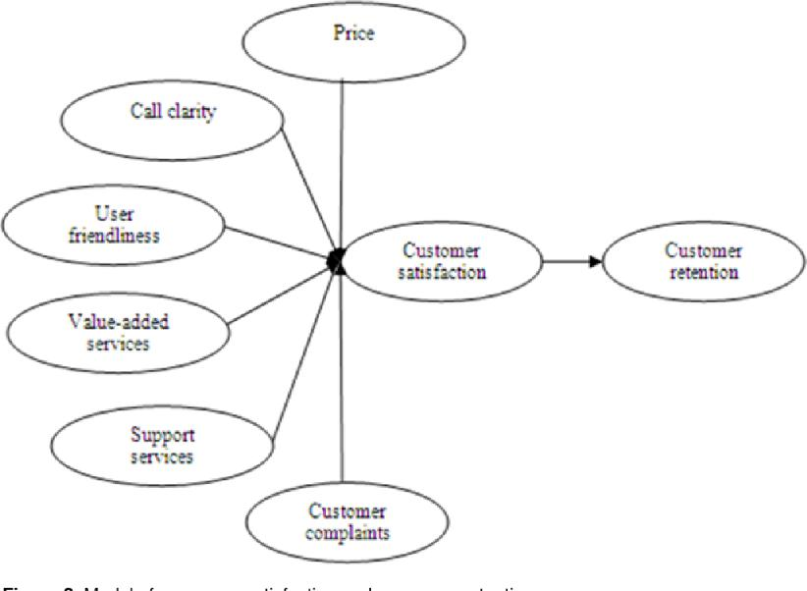

With low price high quality service Grameenphone is leading in the customer retention number. They have the highest number of users and leading the industry for decades. They also manage the customers with their customer management department and also have great support services like call center. Also any problems are dealt with ease and five less trouble to their customers.
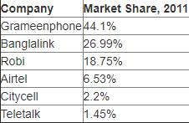

Commitment:

Engagement has two main dimensions in a relationship: affective commitment and Calculative commitment. More Calculative Engagement Rational and results from the lack of choice or the costs of switching. A Customer, for example Whoever likes a particular cuisine, such as Vietnamese or Peruvian cuisine, may patronize a Restaurant nearby due to lack of alternatives,

and dine at the restaurant regularly. Calculative engagement leads to higher customer loyalty and durability Bonds with sellers.

For Grameenphone switching costs are very high for their own users. Because the connectivity and high customer value. Also many users are using the service for so long that it becomes impossible to change the provider. So Grameenphone is taking the advantage. They are also more trust worthy and as they have the shares so the customer have more emotional attachment with them.
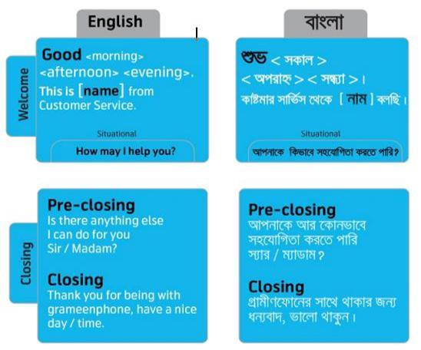

Advocacy:

Delighted consumers will enjoy engaging with others in their social platforms or in a connected atmosphere to spread the word about their good product, brand, or business experience. Loyal clients who lack a psychological attitude The seller's bond which they regularly patronize cannot give unwanted comforts about Product, brand or company to others in consideration of their long-lasting associations Seller or when presented with the opportunity to do so, may offer recommendations So without emotional attachment, on a purely rational basis.

To meet Grameenphone Helpline a GP subscriber must dial 121. Computer-assisted Data base to allow for easy access to subscriber information. Not the one

Operations are conducted manually. The client is first greeted after dialing 121 by an automated and automated process. Then, he / she will have to wait a few seconds. The subscriber then meets the Customer Representative. The CM ends the conversation with a salutation. Unless the question involves general details, it is not appropriate for the customer manager to take advantage of the available system. S / he offers the details and the client keeps his / her phone.

Promoter = Love the Service / Product

We can therefore ask the customer's probability of recommending a product to his friends and family Measuring Love. We don't want to be bothering customers with many questions. We want to make best use of this Practice used internationally, ONE simple issue
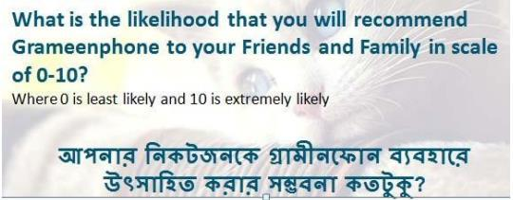

Customer Engagement:

When loyal or pleased customers express their joy or loyalty in contact with Others through their social networks are supporters of a company, brand or organization, the basis for progressing to the next, and perhaps the most critical, process point, client retention. Consumer satisfaction and customer loyalty Are critical for customer interaction. Consumer engagement Requires a work engagement, a calculative commitment or trust as well as Seller and Consumer engagement to put it another way. Customer interaction happens when Consumers have good

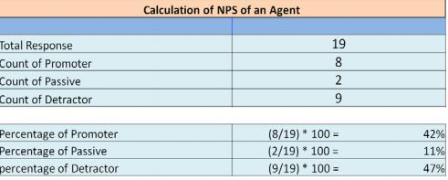

emotional relationships with sellers in exchanges.
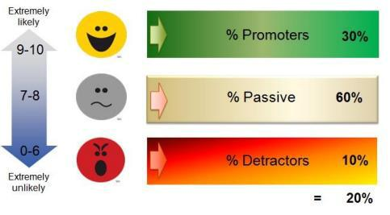

Grameenphone has a very good customer engagement number. We can understand it through the number of star subscriber they have. Grameenphone STAR Subscriber is a special program by which Retain Grameenphone Reward their high-value subscriber, remember their high-value subscribers Grameenphone subscribers thus ultimately ensure customer loyalty through the star system. Grameenphone Star Subscribers will be considered a special collection of high-value subscribers.

So all of this results in higher customer engagement. And Grameenphone has successfully initiated the customer engagement.

COMPANY PROFILE: Unilever Bangladesh

Unilever Global:

Unilever is a British-Dutch company with a foreign colonial background, from which it has slowly built up its capital. Today it operates over 400 consumer brand brands around the world in food, drinks, cleaning agents and personal care products. Unilever recruits more than 174,000 people and had €49,800 billion in worldwide sales in 2013. Unilever has two parent undertakings: Unilever NV in Rotterdam, the Netherlands and Unilever PLC in London, the UK. All Unilever businesses have the same management and work together as a single company. Unilever 's current non-executive chairman N.V. And PLC is Michael Treschow (May 2007), while Chief Executive Officer Paul Polman (January 2009) is. Net revenue in 2014 was €5,515 billion, and total employee numbers in 2015 were 172,000. The key rivals at Unilever include Nestlé and Procter & Gamble2.2 History of Unilever:

William Hesketh Lever was founded in 1885 to found Lever Brothers. Lever founded the worldwide soap factories. He began diversifying into food in 1917, purchasing fish, ice cream, and canned food businesses. Unilever incorporated new technology into the company in the thirties. The company expanded, and new projects in Latin America were launched. The founders' creative spirit and compassionate commitment to their workers and their societies remain fundamental to Unilever's company today.

When the Dutch margarine company Margarine Unie merged with the British soap manufacturer Lever Brothers in 1930 Unilever was founded. Companies competed for the same raw materials, both were involved in the large-scale sale of household goods and used similar methods of distribution. They had operations in more than 40 countries, between them. Margarine Unie expanded in the 1920s due to mergers with other margarine firms. In a history that now crosses Three decades ago Unilever 's success was affected by the big events of the day – economic boom, depression, world wars, evolving consumer habits and technological developments. And throughout they've developed goods that help people get more out of life

— cutting time spent on household tasks, improving wellness, encouraging people to enjoy food, and taking care of their homes, clothes and themselves. You'll see through this time line

How the portfolio of UBL brands was changing? The road to growth strategy at the beginning of the 21st century focused on global high-potential brands and the Vitality project is moving us into a new development era.

Customer Engagement Strategies of Unilever Bangladesh:
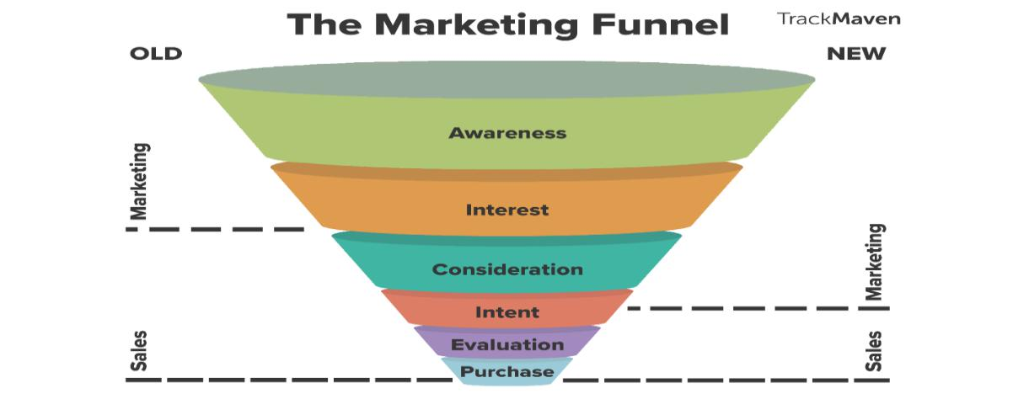

Awareness:

UBL emphasizes the strengths and reference points of the products offered at this stage to convince buyers that their experience is greater than their rivals. This will enable marketing and sales activities to be engaged, delivering a quality product at affordable prices and distinguishing demand-building features. The sales managers and the advertisers play a significant role here

Unilever Bangladesh has initiated two initiatives on mass education, each targeting a particular practice of health and hygiene. The first is the "School-of-5" Lifebuoy Rural Activation, which has reached over 30 million people in Bangladesh to date. This teaches the importance among rural children of daily handwashing with soap to avoid diseases such as diarrhoea. Continuing this operation, Unilever plans to serve an additional five million children by 2021. The

complementary Pepsodent School System, which has been running for over 15 years, helps children to twice everyday brush their teeth to avoid tooth decay and dental illnesses.

Unilever Bangladesh succeeds in addressing this by combining the selling of its basic hygiene brands (soap, toothpaste, water purifiers) with public awareness initiatives aimed at improving the health habits of millions of Bangladeshis. Unilever Bangladesh should inform public about the products of their current practices and the possible negative effects. When customers' behavior improves, they'll also raise their living conditions.

Interest:

UBL uses all 6P components of marketing in the process to attract of our customer, consumer and business communications. UBL marketing and distribution strategies include sales force, advertisement, promotional campaigns, pricing, product selection, sourcing and relationship building with representatives of the company. The organization will use the marketing penetration method to organize their sales and marketing activities Marketing campaigns may be guided or dragged into being on the basis of Unilever's corporate goals, brand image, business dynamics and the current market position.

Consideration:

By market segmentation Unilever Bangladesh divides large heterogeneous markets into small segments that can be targeted with their exclusive commodity more efficiently and effectively service. Together and in combination, different segmentation variables have been attempted to find the best way to interpret the market structure. Such factors are Racial, Demographic, Psychological and Psychographic. Geographic variables are chosen based on Country Area and City Density Parameters. The demographic variable satisfies the criteria of income, occupation, gender, and age. Social class and lifestyle can decide psychographic needs, and sometimes dependent behavioral requirements, UBL pre-sale and post-sale services play a significant role in client retention development. Modern customers find post-sale facilities to be marketing and promotional practices. The impact of negative e-WOM in the present technologically sophisticated age cannot be undermined due to insufficient support service.

Now we'll break down the cycle and see how UBL delivers the product to the final customer from their warehouse

Evaluation:

 | improved | manufacturer | and | customer | relationships
 | Increased | customer engagement by | delivering | premium | quality information.

Brand recognition, credibility and the creation of photos through comprehensive and

 | efficient |  |  | ads.
 | Efficient | collaboration between company, | marketing and research | departments.
 | Wider penetration by sales force.
 | Superior | level | of | service
 | Top | quality | logistical | support

Dependable and fast repair / maintenance

All this facility of UBL helps the customers to better evaluate their product and for this services they get higher purchase rate than Other FMCG. Also the green value chain and higher CSR activities have help them to get more emotionally attracted to the customers.
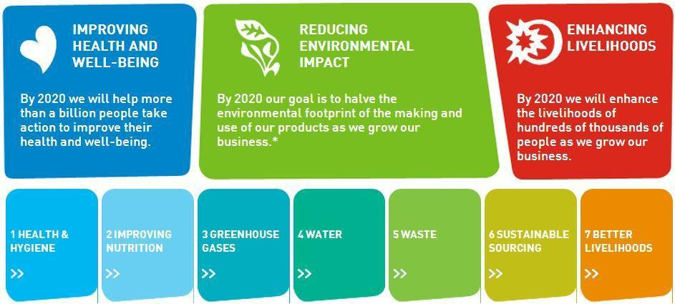

Purchase:

All the strategies have help UBL to increase the purchase rate globally and locally. In Bangladesh they have acquired growth. In this basis, Unilever reported that there is one commodity in 98 percent of households in the country to alter radically the way it produces and markets its products. Popular products of UBL such as LUX which target market is from working class to middle class family, FAIR & LOVELY for young women, AXE for young and stylish men of 18-26 age besides UBL also maintain Low pricing for obtaining maximum profit, Different price lists for different markets along with Reducing products. With this strategy they increase sales for their products. And loyal customer base.
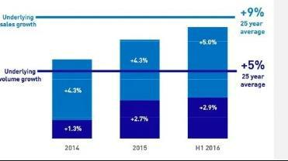

Conclusion:

Customer Engagement is the emotional link between a client and a brand. Highly engaged clients buy more, promote more and show more loyalty. Providing a successful customer experience is an important aspect of your customer service plan. Customer Engagement strategies are very complicated thing to discuss about. Because there are many techniques a company follows that are not stated or shared via internet. I have tried my best to state about the Customer Engagement Strategies and show the real scenarios of how a company engage their customers and what are the major techniques. I have used the Customer Engagement Funnel to describe how the strategy works and how effective the techniques are.

References.

Blai, a. (2016). 13 Easy And Effective Customer Engagement Strategies.

Bovee, C. L., Thill, J. V., & Schatzman, B. E. (2003). Business communication today: Prentice Hall Upper Saddle River, NJ.

Bowden, J. L.-H. (2009). The process of customer engagement: A conceptual framework. Journal of marketing theory and practice, 17(1), 63-74.

Gibson, R. (2002). Intercultural Business Communication: An Introduction to the Theory and Practice of Intercultural Business Communication for Teachers, Language Trainers, and Business People: Oxford University Press.

Guffey, M. E., & Loewy, D. (2010). Business communication: Process and product: Cengage Learning. Thackeray, R., Neiger, B. L., Hanson, C. L., & McKenzie, J. F. (2008). Enhancing promotional strategies within social marketing programs: use of Web 2.0 social media. Health promotion practice,

9(4), 338-343.

Wallis, R. T. (2010). Method and apparatus for promoting products or services: Google Patents. Wardrope, W. J. (2002). Department chairs' perceptions of the importance of business communication

skills. Business Communication Quarterly, 65(4), 60-72.

