INTERNSHIP REPORT
On
SWOT analysis of Rimi International


Internship Report
INT 4399
Sec:A

Topic: “SWOT analysis of Rimi International”

Prepared For
Dr. Khandoker Mahmudur Rahman
Professor
School of Business & Economics
United International University

Prepared By
Sayed Nafis Jawad
111182119

Date of Submission: October 4, 2023
Letter of Transmittal
4th October, 2023

Dr. Khandoker Mahmudur Rahman
Professor & Director
School of Business and Economics
United International University

Subject: Submission of the Internship Report

Dear Sir,

I'm submitting my internship report titled "SWOT Analysis of Rimi International" as part of my BBA program requirements at United International University.
Rimi International is a company based in Japan that deals in exporting used Japanese cars to countries worldwide.
I made sure to follow all the guidelines you provided while working on this report. My internship experience at Rimi International was eye-opening, and I really enjoyed my time there. The company's management was always supportive and cooperative when I needed assistance.

Sincerely,
Sayed Nafis Jawad
ID No: 111182119

ACKNOWLEDGEMENT

I would like to express my sincere gratitude to Dr. Khandoker Mahmudur Rahman, my internship supervisor, who guided and supported me at every step of my internship journey.
I am also deeply thankful to Mr. Abuzar Chowdhury and Mr. Alamin for providing me with the invaluable opportunity to complete my internship at Rimi International. Their dynamic approach to management serves as an inspiration for anyone seeking to build a successful career.
I extend my heartfelt appreciation to Mr. Suzuki Ripon, the Managing Director of Rimi International, and all the individuals within the organization for their unwavering support during the preparation of my report. Working closely with them allowed me to gain insights, understand their perspectives, and formulate my report from a well-informed standpoint.
Lastly, I would like to express my gratitude to those who take the time to read and derive benefit from this report, both now and in the future. Your interest and engagement are highly appreciated.

DECLARATION

I, Sayed Nafis Jawad, a student pursuing a degree in Marketing from the School of Business and Economics at United International University in Bangladesh, hereby affirm that my internship report titled "SWOT Analysis of Rimi International" is entirely original and has not been previously presented for any degree, diploma, certification, or recognition.

________________
Sayed Nafis Jawad
ID No: 111182119
School of Business and Economics
United International University

Contents
1. BACKGROUND OF THE PROBLEM 9
1.1 Introduction 9
1.2 Topic of the Report 9
1.3 Origin of the Report 9
1.4 Background of the Report 9
1.5 Objective of the Report 10
1.6 Scope of the Report 10
1.7 Methodology of the Report 10
1.7.1 Primary Sources 10
1.7.2 Secondary Sources 10
1.8 Limitations 11
2. ORGANIZATION PART 13
2.1 Overview of the Organization 13
2.1 Portfolio 14
2.1.1 Car Export 15
2.1.2 Spare Parts Export 16
2.1.3 Solar Panel 16
2.1.4 Information Technology 17
2.1.5 Gadgets 17
2.1.6 RMG Sourcing 18
2.1.7 EPS Sourcing 18
2.1.7 RPF Sourcing 19
3. SWOT Analysis (PROJECT PART) 22
3.1 Literature Review 22
4. Internship experience 31
5. Recommendation & Conclusion 33
Recommendation 33
Conclusion 34
6. Reference 35

Executive Summary

This report conducts a SWOT analysis of Rimi International Co. Ltd., a Japanese company specializing in exporting used vehicles and spare parts worldwide. It highlights the importance of assessing internal and external factors in today's competitive business environment. The report is based on a three-month marketing internship and aims to analyze Rimi International's competitive position in the automobile industry. Data was gathered from primary and secondary sources, with acknowledgment of potential limitations. Its objective is to assist Rimi International in strategic decision-making for sustained competitiveness in the global automobile industry.
RIMI International, a major Japanese used car exporter, exhibits several strengths, including a dependable and dedicated workforce, strong ties with auction sites, a reputation for reliability, a focus on innovation, reasonable pricing with high-quality vehicles, and a robust monitoring system. However, it faces challenges, such as offering similar products in a mature market, limited market expansion, slow growth, and intense competition from industry giants like SBT and Be Forward. Opportunities lie in expanding into new markets, diversifying into related businesses, capitalizing on the post-pandemic recovery, and enhancing customer retention. Potential threats include the dominance of strong competitors, economic downturns, and the possibility of natural calamities or accidents affecting shipments. To navigate these dynamics, Rimi must prioritize customer-focused strategies, market research, and adaptability in an ever-evolving industry.
The internship experience at Rimi International provided valuable insights into the global used car export industry. The journey began with excitement and a welcoming work environment, offering opportunities to deepen knowledge about cars, engage with diverse customers, and bond with colleagues. The flexible work hours allowed for adaptability in facing challenges, contributing to a rewarding overall experience.
In conclusion, the recommendations outlined aim to further enhance Rimi International's operations by focusing on stocking a wider variety of cars, improving cooperation between local and Japan offices, initiating training programs for new employees, and offering clear career growth opportunities. These strategies can help the company maintain a customer-centric approach, streamline internal processes, and cultivate a motivated workforce, ultimately ensuring sustainable growth and competitiveness in the market.

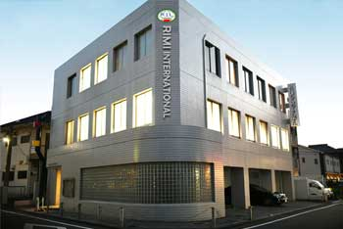
Chapter-1
INTRODUCTION

BACKGROUND OF THE PROBLEM

1.1 Introduction
In today's business environment, competition is intense and constantly changing. To achieve long-term success and effectively manage business operations, it is crucial to assess both internal and external factors, as well as current and future potential. Every business aims to cultivate a loyal customer base, and one of the initial objectives of any business operation is to maximize profits through customer satisfaction. To ensure success through customer retention and satisfaction, a thorough assessment of a company's internal and external factors provides a competitive advantage. In this context, SWOT analysis offers a data-driven, realistic, and factual perspective on an organization's strengths, weaknesses, opportunities, and threats. Rimi International, a Japan-based company primarily engaged in exporting Japanese used vehicles to countries worldwide, operates in the highly competitive automobile sector. To effectively address this competition and its associated challenges, the company must have a comprehensive understanding of its internal and external factors. By focusing on and emphasizing its strengths, weaknesses, opportunities, and threats, Rimi can enhance its existing business practices and maintain a competitive edge over both local and international competitors. Therefore, this study focuses on conducting a SWOT analysis of Rimi International Co. Ltd.

1.2 Topic of the Report
A well-defined topic represents the subject matter which is going to be discussed in the entire report. As it has been already stated that the internal & external factors will be of main concern of this study, the topic has been selected accordingly. The topic titled as “SWOT Analysis of Rimi International Co. Ltd.” has been assigned.

1.3 Origin of the Report
Availability of information of this automobile industry is quite low compared to others & in-depth information is quite rare to be more specific. Preparing this report has given the opportunity to gain knowledge about the company, its products & services, how it runs its business operations in the market to reach the organizational goals & the automobile industry.

1.4 Background of the Report
Internship Program is an essential part of the degree requirement of the BBA program. It holds significant importance as it enables a student to get a real time experience of the business field & to get familiar with the practical business activities. The student gets to observe & work closely with the personnel of an organization & gain knowledge about the functionality of the organization. The program enables a student to upgrade his/her analytical & other skills. For the completion of this internship program, I have been recruited in the “Rimi International Co. Ltd.” Baridhara as a Marketing intern for 3 months. This report will focus on – SWOT Analysis of Rimi International Co. Ltd.

1.5 Objective of the Report
The principal objective of this report is to analyze & make assessment of internal & external factors, as well as ongoing & future potential of Rimi International Co. Ltd. Also, to evaluate the company’s competitive position in the whole automobile industry by assessing the strengths, weaknesses, opportunities & threats.

1.6 Scope of the Report
The report has been prepared through comprehensive discussion with the employees & personnel of Rimi International & honorable supervisor. Preparing this report enabled fantastic opportunity to gain in depth knowledge & information of all the business activities of Rimi International Co. Ltd.

1.7 Methodology of the Report
All the necessary information of the study has been collected from the following two sources: -

1.7.1 Primary Sources
- Direct Observations
- Practically assigned tasks
- Face to face conversations with the Project Supervisor
- Face to face/direct conversations with the employees, clients & other personnel.

1.7.2 Secondary Sources
- Website of Rimi International
- Facebook Page
- YouTube Channel

1.8 Limitations
Certain limitations were there while preparing this report: -
- Many focal points of this report may be considered as confidential by the company.
- Lack of sufficiency of sources confined verification of information.
- Information presented in the report may vary as some of them are opinion oriented.

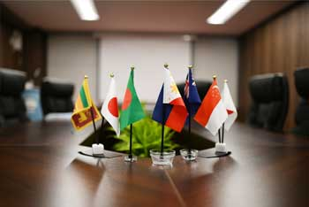
Chapter-2
Organization

ORGANIZATION PART

2.1 Overview of the Organization
This part is regarding the history, vision, mission & organogram of Rimi International.
History
In 2005, a sharp & talented visionary gentleman, company’s current CEO, Suzuki Ripon formed the company Rimi International Co. Ltd. (RIL). He anticipated that his out of the box business views would facilitate in building a firm that would continue to thrive for decades & would eventually become a pioneering organization in the country. Rimi International Co. Ltd. is now renowned in many nations & has come a long way to becoming one of the most recognized business organizations of the country. It is a Japan based company which is primarily concerned with exporting Japanese used cars to almost any country and region in the world, such as, Africa, Bangladesh, Fiji Island, New Zealand, South America, Sri Lanka etc. Rimi International has developed & expanded its business operations in Bangladesh since 2008.
Vision
‘’To be the Best.’’
The company has established its vision towards achieving the target with appropriate decision making. The company always focuses on its customers as well as its partners for achieving its goal & to ensure a win-win situation. The company wants to be the best & most trusted from Japan for providing topnotch service with honesty & sincerity.
Mission
“Creating Trust in the Market.”
In order to reach & implement the vision towards ultimate destiny, Rimi International is striving to become the best amongst the top exporting companies from Japan.
Organogram
An organogram, also known as an organizational chart or organigram, is basically a graphical representation of the structure of an organization & the relationship between & among different people & departments. Organogram of Rimi International is shown in the following figure-

Figure: Organogram of Rimi International.

2.1 Portfolio
The company’s product &/or, service portfolio consists of-
- Car Export
- Spare Parts Export
- Solar Panel
- Information Technology
- Gadgets
- RMG Sourcing
- EPS Sourcing
- RPF Sourcing

2.1.1 Car Export
Rimi International is a Japan based company which exports Japanese used cars to almost any country in the world. As a Japanese used car exporter, the company exports all types of Japanese used cars. The company deals with almost all the major makes of Japanese cars, such as, Daihatsu, Honda, Isuzu, Mazda, Mitsubishi, Nissan, Subaru, Suzuki & Toyota with a large collection of models; that also includes foreign cars manufactured for Right-Hand Drive as well as Left-Hand Drive market. Strong ties with car dealers, Japanese used car auction sites & suppliers is a significant advantage for the company in fulfilling its customers’ needs for premium quality Japanese used cars at very reasonable prices. All the acquired cars go through a steadfast inspection in accordance with strict Japanese regulations to make sure customers get the topnotch quality for what they pay. The company participates in different Japanese used car auctions for the purpose of acquiring used & refurbished cars. A customer can choose his/her desired car from over 30,000 cars at the USS auction site from Rimi’s site, & company personnel can bid on customer’s behalf & ship the ordered vehicle(s) in quickest possible time. Since Rimi International has expanded its business worldwide, the number of its partners with whom the company cooperates with are increasing gradually every year. The company deals with valued customers in different parts of the world, such as, Africa, Bangladesh, Fiji Island, New Zealand, South America, Sri Lanka etc. Though the pandemic era has negatively impacted the business quite a bit, the company aims to meet customers’ needs & to keep them happy & satisfied; that will benefit each other. The company exports Japanese used cars by container & RoRo shipment as per customer order & requirements. Some of the cars Rimi exports are as follows-

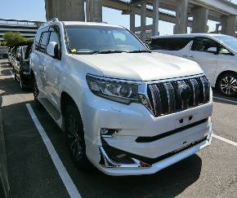

2.1.2 Spare Parts Export
Rimi International is a worldwide portal for spare car parts & accessories. The company has got expertise in exporting spare automobile parts for both passenger & commercial automobiles globally. With over 10 years of reliable experience, the company has continued providing genuine products & quality service which has helped the company expand its loyal customer base. Rimi exports all types of car spare parts of almost all of the major makes of Japanese cars, such as, Daihatsu, Honda, Isuzu, Mazda, Mitsubishi, Nissan, Subaru, Suzuki & Toyota with a large variety of models. The company exports spare parts by container half cut/full cut etc. Some of the parts exported by Rimi International are as follows-
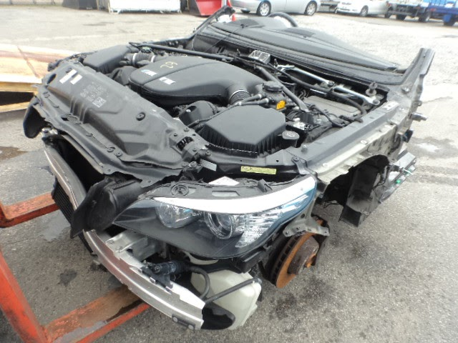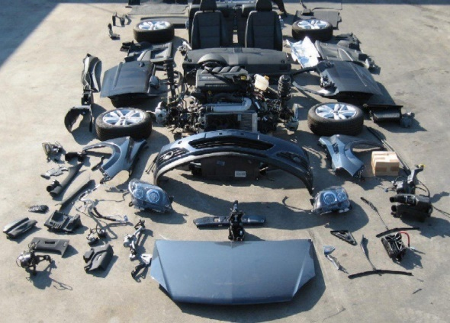

2.1.3 Solar Panel
Rimi International also exports new or used solar panels globally from Japan to support the alternative & renewable energy. The company is providing quality solar panels both brand new & used as a solution towards the ongoing power crisis with solar system, especially for the commercial & domestic sectors with low-cost techniques & tools. Rimi focuses on providing its customers with renewable & alternative energy which will meet up their needs of power demand. The company aims to facilitate & enhance worldwide renewable energy development for the benefit of all of humanity.

2.1.4 Information Technology
In this ongoing Web 2.0 era, information technology has become a part & parcel for day-to-day activities for every sectors. Keeping this in mind, Rimi has built its IT sourcing network globally. The company can source different type of IT sourcing to almost every part of the world. Rimi has affiliated with various top IT companies which are providing quality & fast IT solutions to its customers. Currently the areas in which the company is working on regarding IT are as follows-
- Web Hosting
- eCommerce Packages
- Mobile Application
- Network & Security
- Cloud Service
- IT Audit
- Web Application
- Email Service

2.1.5 Gadgets
Gadgets have now become an essential part of everyone’s life. A day without gadgets has become unimaginable. In this regard, Rimi is providing its customers with latest & best quality gadgets. The company is putting emphasize on feasible, enjoyable, user friendly & completely safe gadget experience of its customers. The company is also concerned with protection of privacy & security of client information. Over 20,000 satisfied clients can attest to the company’s premium level of service & quality. Rimi is dedicated towards improvement & evaluation of its services on a regular basis to ensure superior using experience of its clients. Some of the company’s upcoming gadgets include-
- Smart Watches
- Smart Phones
- Portable Smart Chargers
- EarPods
- Laptops
- Headsets
- Wrist Power Banks etc
.

2.1.6 RMG Sourcing
For more than 6 years, Rimi International has been providing assistance to other companies & organizations in RMG sector globally. The company facilitates businesses to achieve a competitive advantage by providing with topnotch sourcing. Company’s RMG sourcing ground is well developed through years of experience having a significant range of networks & sources in the renowned RMG sector in Bangladesh. The company is focused on all sorts of apparels regardless of customer gender or age groups. Apart from quality service & stable support, the company has built long-term relationships with each of its retailers & importers. Rimi aims to be the trusted sourcing partner with the leading fashion & lifestyle brands. Some of its garments products are as follows-
- Caps
- Jeans
- Jackets
- Kidswear
- Polos
- Shirts etc.

2.1.7 EPS Sourcing
Environment plays a key role in terms of our survival & the existence of planet Earth. It is the sum total of our natural surroundings. Environmental protection has become a matter of highest concern lately because of the threat faced by the environment in recent times. Various human made activities has put the environment under a severe condition. The extent of damage done is too high & has reached a level of almost no return. As a result, the devastating human impact on the environment has to be lessened as much as possible. In this regard, Rimi International is specializing in emission reduction, energy conservation & above all environmental protection. The company is dedicated in manufacturing of high-end environmental protection & energy preservation equipment. Company’s objective is to become a superior environmental protection solution globally. Rimi International offers initial planning, construction, eqipment manufacture, engineering, conceptual design, operation & maintenance. Its services includes electrical power equipment, industrial air pollution control, monitoring devices & systems, solid waste management, water treatment equipment & so on.

Concern Areas of EPS
- Cold Protection
- Insulation/Heat Shield
- Heat Protection
- Insulation/Heat Shield
- Odor Reduction
- Enhanced Air Quality
- Noise Prevention
- Sound Proofing

2.1.7 RPF Sourcing
Elaboration of “RPF” is “Refuse Derived Paper & Plastics Densified Fuel”, which is a high-grade solid recovery fuel initially composed of waste plastics & waste papers from mostly industrial waste for which material recycling is very troublesome. So far RPF has been well accepted by different industries including top paper companies & lime companies as a substitute to fossil fuels such as coke & coal.
The features & benefits of RPF are as follows-
- Stable Quality
The quality is very stable to utilize as materials are industrial waste & the selected non-industrial waste (items compliant with the classification criteria) whose generation history is clear.

- High Calorie
RPF uses waste plastics as raw materials. As a result, it has a high calorific value & it is possible to use it as an alternative for fossil fuels on par with coke & coal.

- Simple measures for the exhaust gas from combustion furnaces such as boilers
As the quality is quite stable with very little impurity contamination, there is almost no generation of dioxin or corrosion to boilers from he generation of chlorine gas. Treatment of the exhaust gas is simple & generation of sulfur gas is minimum.

- Environmentally Friendly
It participates to the prevention of global warming by reducing the use of fossil fuels & CO2 emissions & through improving total energy efficiency.

- Possible to control calorific value
The quantity of heat can be changed by adjusting the blending ratio of waste plastic to waste paper according to the specifications of the boiler & such.

- Good Handling
RPF has the same convenience as pulverized coal, coke & the like as it is solid & has high density. Besides, it also has excellent storage characteristics & transport efficiency.

- Economical when compared with other fuels
RPF is a low-cost renewable energy, currently costing 1/4 to 1/3 the price of coal, and it has about 1/3 the ash ratio of coal as well as about 1/3 the cost reduction for purchasing emissions credits which are expected to become a burden in the future, so it permits reduction of the cost of ash treatment.

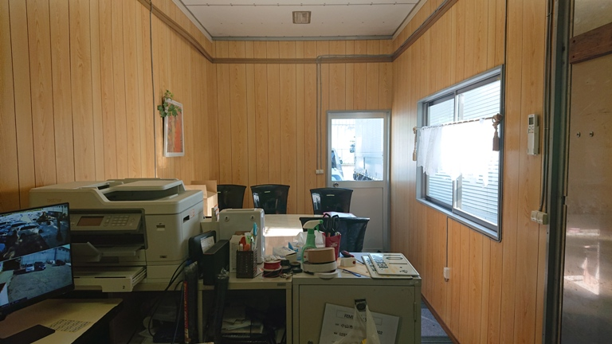
Chapter-3
SWOT ANALYSIS

SWOT Analysis (PROJECT PART)

3.1 Literature Review

Definition
SWOT stands for Strengths, Weaknesses, Opportunities, and Threats. Basically, a SWOT analysis is a way to take a good look at your business. It helps you figure out what your company is really good at right now and helps you come up with a plan to do well in the future. It's like a tool that helps you understand where you're awesome and how you can make smart plans moving forward.
How it helps?
First, it identifies your strongest skills and areas for improvement. This helps you understand where your company excels and where it can improve.
It then shows you your chances of growing and succeeding. These are your possibilities. It's similar to spotting open doors that you can walk through to improve your business.
On the other hand, it highlights the difficulties you may face - the threats. Knowing these things can help you plan ahead of time and find ways to stay strong even when things get tough.
In a nutshell, a SWOT analysis is like having an honest conversation with a friend about your business. It teaches you how to play to your strengths, improve your weaknesses, seize opportunities, and face challenges wisely.
What different authors say about SWOT analysis?
- Authors
Mostafa Ali Benzaghta, Abdulaziz Elwalda, Mousa Mohamed Mousa, Ismail Erkan, and Mushfiqur Rahman
Corresponding Author
Abdulaziz Elwalda, Department of Business Management, Misurata University
SWOT analysis is a crucial tool for organizations to assess their market position and make strategic decisions. It consists of strengths, weaknesses, opportunities, and threats. Strengths are internal factors that drive an organization towards its objectives, while weaknesses hinder success. Opportunities are external factors that align with an organization's goals and offer opportunities to address gaps. Threats are external barriers to achieving objectives. This study aims to assess and synthesize SWOT literature within five fields: general management, education, marketing, healthcare, and agriculture. It provides an integrative historical perspective and contributes to strategic planning understanding.
- Authors
Marilyn M. Helms, Judy Nixon
This study examines the use of SWOT analysis, a strategic management tool, and assesses its usage and changes. Using the AB Inform Global database, academic peer-reviewed articles were compiled. SWOT analysis is widely used in planning, strategic positioning, and teaching by consultants, trainers, and educators. The research focuses on organizations, countries, industries, and is used in business student analysis and teaching tools. The study provides a summary and suggests future research paths.

Why SWOT analysis need to be done for RIMI International?
Doing a SWOT analysis for Rimi International is important for several reasons. It's like taking a closer look at the company's overall picture to make better decisions.

Strengths: By identifying what Rimi International is really good at, you can build on those strengths. It's like knowing your superpowers so you can use them to stand out in the market.

Weaknesses: Figuring out where the company might not be as strong helps you improve. It's like finding cracks in a wall and fixing them before they become big problems.

Opportunities: Recognizing where Rimi International could grow or do better lets you plan for success. It's like spotting a great path to walk on and grabbing every chance to shine.

Threats: Seeing what challenges the company might face helps you prepare and stay strong. It's like knowing what obstacles are ahead so you can navigate around them.

So, a SWOT analysis is like a map that guides Rimi International. It helps you make the most of your strengths, work on your weaknesses, jump on opportunities, and stay strong in the face of challenges.

Overview of SWOT analysis of RIMI International

Strengths
- Dependable Workforce:
From the starting of its journey, Rimi has managed to recruit a group of highly effective & efficient people. This includes all the personnel starting from top to bottom. Their consistency & devotion to the respective fields like shipping, warehousing, public relations has never let the company slip away from its path towards success. Even in the pandemic era they had been the company’s prime supporter & kept fulfilling their responsibilities. Thus, their dependability has always been the company’s number one source of strength.

- Strong Ties with Auction Sites:
As it has been already stated that Rimi International is one of the largest Japanese used cars exporter. The company delivers cars to its valued customers either from available stock or from auction. There are 25 auction houses all over Japan & purchasing a vehicle exactly as the requirement collected from customers often turns out to be a difficult job. However, Rimi has been in this industry for quite a while now so through repeated auctions a strong relationship has been built between the company & the auction sites, such as, TC web, USS auto auction etc. Through years of bidding at the auction sites the company has developed better understanding about auctions day by day, has built good connections with the sites resulting into popularity as exporter & also has been able to meet customer requirements effectively. Thus, strong connections with various auction sites have strengthen the company itself.
- Reliability:
As far as reliability is concerned, the company has been proving itself to its customers for years now. As a token of utmost reliability, Rimi has been able to become part of JUMVEA (Japan Used Motor Vehicle Exporters Alliance). JUMVEA is an organization which ensures used car importers’ & end users’ safety from various fraud & scam. It was established on 14th of September, 1995. To become a member of JUMVEA the companies need to follow a procedure with a series of steps starting from documentation to final membership approval. Thus, by becoming a part of such an organization Rimi has been a symbol of trust & transparency in the entire industry & also among direct & indirect customers.

- Innovation:
Apart from just exporting used vehicles around the globe, Rimi has been constantly working on innovative technologies & ideas. For instance, Rimi has been working on information technology, RMG, EPS & RPF sourcing which has already been discussed in this report. Though most of these are still work in progress, sooner or later such incremental innovations will help strengthen the name & goodwill of the company. Because the world is moving at a rapid pace & without bringing innovative ideas into play it will become troublesome to keep up with that pace. Thus, innovative ideas which Rimi is currently working on will prove to be blessings in disguise in the near future.

- Reasonable Pricing & High Quality:
Rimi International has been ensuring since the very beginning that its customers receive the topnotch quality cars in affordable & reasonable prices. For this purpose, its purchase team carefully inspects the vehicle at least one day before the auction day so that customers get what they’re paying for. After careful observation the bidding is done for the purpose of either stocking or delivering to the valued customers. Compared to other heavyweight exporters, such as, SBT, Be Forward; Rimi tries to offer its customers reasonable price range keeping the market standard in mind. Also, Rimi provides handsome number of discounts depending on vehicle which enables customers to get their desired vehicle in at least $200-300 less than that of competitor; still the amount may vary. Thus, careful consideration in both pricing & quality assurance gives the company added advantage.
- Good Monitoring System:
Starting from receiving requirements to shipment, Rimi carefully monitors that each & every step is carried out in the proper manner so that customers may receive their desired cars in good condition & reverts back to the company out of satisfaction. In this industry, it is often heard that customers get scammed & receives defective vehicles which is not acceptable at all. Often the shipment gets delayed due to negligence. Therefore, Rimi monitors every step carefully & sharply so that customers may receive easy going tension free & topnotch service.

Weaknesses
- Similar Product Offerings:
Rimi is already in a mature market with lots of other competitors. So understandably the company has almost nothing out of the box to offer as far as automobile industry is concerned. Like its major competitors, such as, Be Forward, SBT the company is basically offering used vehicles from Japan. Thus, the competition remains high & more emphasis should be given on the service. Besides quality vehicle topnotch service quality will play a major role here for maximizing success.
- Fewer Markets:
As it has been stated before, Rimi is currently exporting Japanese used vehicles around the world. The company is doing business in regions, such as, Asia, South America, Africa. Some of the major markets of Rimi is situated in countries like Tanzania, Zambia, Kenya, UK, Australia, Japan, Zimbabwe, Tonga, Kiribati, PNG & so on. But judging on hyper competitiveness of the industry, there is still a long way to go for the company; because major competitors are already on a mission to grab more & more market in shortest possible time. Rimi should focus more on their marketing research activities to figure out how to reach out to new market opportunities, customer demand in new markets & eventually expand their operation which will result in higher market share.
- Slow Growth:
Rimi has already reached the maturity stage in terms of its product which is mainly used automobiles. As a matter of fact, the industry has already become fragmented which implies many operators resulting in comparatively fewer market shares. As a result, the industry has become hyper competitive & customers are most likely to switch caused by minor inconvenience. Thus, Rimi is facing a slower growth rate. In this lifecycle stage, changing the scenario magically & to increase market share is quite troublesome. However, the company needs to be more focused about highlighting its overall image & work more on the quality of service. Because in such a state, one small mistake can cause customer switching.

Opportunities
- Expansion in New Market:
Rimi has been exporting used Japanese vehicles around the world in different regions. In countries, such as, Tanzania, Zambia, Kenya, Uganda, Kiribati, PNG, Tonga & so on. But still there are plenty of other countries (markets) where customers are in need of great condition used cars. Now, competitors are always trying to stay a step ahead from Rimi so they are most likely to expand. So, Rimi has to capitalize on this opportunity to expand to new market places as early as possible before the competitors. Despite the fact that the company is operating in a matured market, with proper planning judgement & execution Rimi can quickly grab new markets around the world which will not only add more value to the company but also might give them first mover advantage if too lucky.
- Diversity into New Businesses:
As it has been discussed already, Rimi is operating in a matured industry. The market is fragmented resulting in many operators & limited amount of market shares. In order to sustain in the long run, depending on the used vehicles sales alone will not benefit them much in the future. As a result, the company needs to diversify its line of work. Good thing is, Rimi has already anticipated it & working on different other projects, such as, Information technology, RMG, EPS, RPF. This opportunity to work on something incremental will give them added advantage in the near future. Because besides vehicle sales the company will have something to put their focus & emphasis on if things go south; specially in this hyper competitive market every company should be prepared for anything that comes their way.

- Post Pandemic Era:
During the pandemic era, the world was totally shaken. Specially all businesses stumbled badly. The overall economic situation turned upside down. Those companies which could cope up survived but the others demolished. The automobile industry also faced a terrible period of time. People all over the world was suffering through miserable financial situation & consequently that impacted global sales of cars. But now that the pandemic era has been dealt with quite a success, slowly the industry is seeing the light of hope. Slowly but gradually car sales is increasing globally. So, now is the opportunity for Rimi to put more emphasis on marketing activities so that it may help increase their database of requirements resulting in sales. Also, the online selling platform has got a major boom in the later pandemic era. However, Rimi mostly gets the requirements from customer through online as the company ships globally. So, the company needs to grab this opportunity to regain what was lost during pandemic era & simultaneously reach out to available new customer base.
- Boost Up Existing Customers:
Besides searching for new customers, the company should not forget about the existing base. Because positive word of mouth & customer retention plays a key role in achieving sustainability in the industry. By giving proper attention towards existing customers, asking for their feedback from time to time, providing topnotch after sales service & in many other ways the company can ensure customer retention. If existing customers are satisfied enough, they will eventually end up positively influencing other customers through positive word of mouth. This will ensure the opportunity of getting new customer base over time. Thus, boosting the morale of existing customer base is quite significant.

Threats
- Strong Competitors:
As it has been already stated that the industry has become fragmented. There are other strong competitors existing in the industry, such as, SBT, Be Forward & so on. Such giant companies are in the industry for a long period of time now & have a huge customer base. Simultaneously they have even larger stock of used vehicles so that they may serve the customers almost instantly. Thus, these giant companies pose a big threat to Rimi. To combat this threat, Rimi needs to focus more on customer demand, ensure better & good quality stock & eventually customer retention.
- Economic Depression:
Economic downturn, like the one happened in the pandemic era, is another big threat for the company. Because it impacts the overall industry & especially import-export comes to almost a standstill. For example, recent economic insolvency in Sri Lanka was devastating. In such situation, import-export of such a luxury item like motor vehicle becomes very inconvenient. Economic depression is something which is to some extent uncontrollable. To prevent such situation hampering company’s business operations, Rimi has to be aware of different factors affecting the overall economy like inflation rates of the countries in which the company operates & also keep track of the change in currency rate.

- Natural Calamities & Accidents:
The shipment is basically done through vessels by sea. So, there’s always a slight chance of natural calamities happening while the ship is in a voyage. The chance maybe very low but it’s never zero. For example, in 2005, a cargo ship name Felicity Ace caught on fire with 4,000 expensive cars in it. But such incidents are rare phenomenon. Moreover, sometimes cars get damaged while completing the process of clearing & forwarding at the port. Natural calamities are uncontrollable. However, other accidents can be minimized by taking proper precautions. For example, Rimi can work with professional freight forwarding service which uses good quality equipment & expert employees for the purpose of clearing & forwarding, unloading the vehicles at the port.

Chapter-4
INTERNSHIP EXPERIENCE

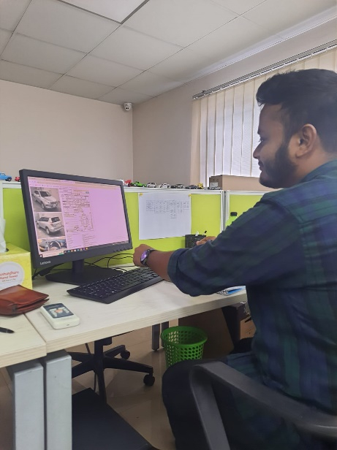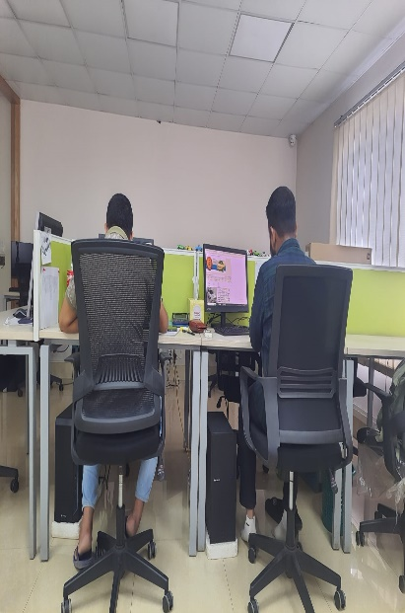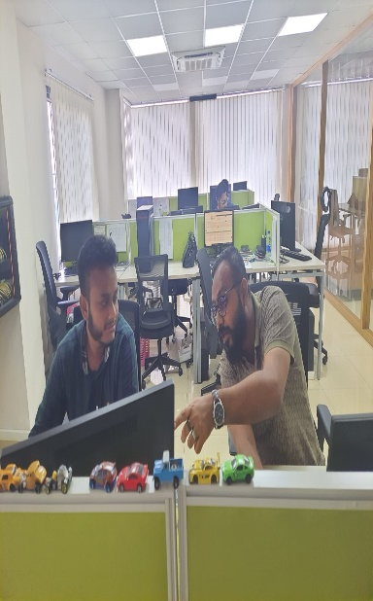

Internship experience

- Starting the Internship:
My journey as a Marketing intern at Rimi International Co. Ltd. began in January, shortly after completing my last trimester. Following a successful interview, I received the appointment letter on January 18, 2023. Two days later, on January 20, I officially began my internship.

- Excitement and Environment:
The company's focus was on exporting used Japanese vehicles globally. As a car enthusiast, I was thrilled to work in such an environment. The office was vibrant, and my colleagues were supportive, creating a welcoming atmosphere that encouraged me to give my best.

- Initial Learning:
I initially explored the company's website to gain knowledge about different car makes, models, stocks, auctions, and more. I explored into reading auction sheets and understanding the bidding process. I also managed an important task of updating the shipping schedule, which required precision.

- Deepening Knowledge:
My primary priority was to expand my knowledge about cars. With my background as a car enthusiast, I was already acquainted with various car types. Consulting my manager and exploring the website enhanced my understanding of chassis, engines, auction grades, and car shapes.

- Database Preparation:
I prepared country-specific databases for countries like Tanzania, Uganda, Zambia, and others, collecting essential data for our operations.

- Customer Engagement:
I engaged with customers through various platforms, reaching out via WhatsApp, phone calls, and Facebook. This allowed me to learn about different cultures and languages, enriching my experience.

- Team Bonding and Culture:
Apart from work, I connected with colleagues through jokes, discussions about football, and celebrating birthdays. We prayed together and attended the mosque for Friday prayers, fostering a sense of unity and discipline.

- Flexible Hours and Challenges:
Initially working from 10 am to 6 pm, my hours changed when I focused on the Singapore market, from 12 pm to 8 pm. Flexible timing helped me handle challenges like heavy rain and traffic disruptions, ensuring I remained motivated.

- Rewarding Experience:
In conclusion, my internship at Rimi International provided a challenging yet rewarding experience. I gained insights into the automobile industry and enjoyed the welcoming work culture.

Chapter-5
RECOMMENDATION
&
CONCLUSION

Recommendation & Conclusion

Recommendation
- Stocking Cars for Improved Customer Service: One of the key areas where Rimi International could enhance its operations is by focusing on stocking a wider variety of cars. Often, customers come in with specific car preferences, but the desired car isn't available, leading to a longer and sometimes frustrating process. By increasing the inventory of available cars, the company can significantly improve customer satisfaction. Having a well-stocked collection of cars means that customers can find what they want more easily, saving time and making the buying process smoother. This can also give Rimi International a competitive edge in the market by being able to cater to a broader range of customer preferences.

- Enhancing Cooperation with Japan Office: Establishing stronger cooperation between the main office in Japan and the local operations is crucial. Clear and effective communication between the two offices can lead to more streamlined processes, better understanding of market trends, and quicker decision-making. Regular updates on inventory, market demand, and customer preferences from the local office can help the Japan office tailor their offerings accordingly. Similarly, insights and updates from the Japan office can provide the local team with valuable information to better serve customers and make informed business decisions.

- Initiating Training Programs for New Employees: Introducing training programs for new employees can have a significant impact on their performance and the overall efficiency of the company. Providing comprehensive training for newcomers can help them quickly adapt to the company's culture, values, and processes. This ensures that they are equipped with the necessary skills and knowledge to excel in their roles. Training programs could cover aspects such as product knowledge, customer service techniques, company policies, and effective communication. Well-trained employees are more confident, productive, and likely to contribute positively to the company's success.

- Offering Career Growth Opportunities: Providing employees with clear pathways for career growth is essential for both their job satisfaction and the company's success. Rimi International can implement a structured approach to career development, which includes identifying individual strengths, setting performance goals, and providing regular feedback. Offering skill development workshops, mentorship programs, and opportunities to take on more responsibilities can motivate employees to perform at their best. When employees see that their dedication and hard work are rewarded with opportunities for advancement, they are more likely to stay committed to the company and contribute their best efforts.
Incorporating these strategies can lead to a more customer-centric approach, improved internal operations, and a motivated workforce at Rimi International. Each of these areas contributes to the company's overall growth, ensuring that it remains competitive, innovative, and successful in the market.

Conclusion
For sustainable long-term growth, it is crucial to have a clear understanding of the company's strengths, weaknesses, potential opportunities, and threats. This self-awareness forms the foundation for targeted improvement strategies. Recognizing these aspects enables the organization to capitalize on existing strengths, address weaknesses proactively, seize forthcoming opportunities, and effectively navigate challenges and potential threats.
Throughout the course of this report, a comprehensive SWOT analysis has been conducted, identifying and analyzing these fundamental aspects. This analysis acts as a compass, guiding the company toward strategic decisions that align with its strengths and opportunities, while simultaneously mitigating vulnerabilities and threats.
In essence, the process of continuous refinement based on these findings is essential for Rimi International's journey toward enhanced overall efficiency. By fine-tuning operations, optimizing strengths, and addressing shortcomings, the company can establish a solid platform for long-term sustainability. This commitment to self-improvement not only positions Rimi for growth but also fosters adaptability and resilience, allowing the company to thrive in an ever-evolving business landscape.

Reference
- MindTools | Home. (n.d.). MindTools | Home. https://www.mindtools.com/amtbj63/swot-analysis#:~:text=What%20Is%20a%20SWOT%20Analysis,successful%20strategy%20for%20the%20future.

- Rahman, K. M. (2016). Strategic Planning and Marketing Models. In Strategic Marketing Management in Asia (pp. 59-110). Emerald Group Publishing Limited.

- Ahmmed, K., Islam, S., Noor, N. A. M., Rahman, K. M., & Ahmed, F. (2019). Toward a theoretical framework of relationship marketing in the business context. Trziste= Market, 31(2), 209-226.

- Rummana, R., Rahman, K. M., Aziz, S., & Nishat, B. (2008, October). Urban pollution in Dhaka city: A tri-partite qualitative model for alleviation and prevention. In Proceedings: International Conference on Sustainable Urban Environmental Practices (p. 297).

- High Quality Japanese Used Cars Exporter | Rimi International. (2017, January 1). High Quality Japanese Used Cars Exporter | Rimi International. https://www.rimijapan.jp/

- Holderith, P. (2023) It’s been exactly one year since the felicity ace caught fire with nearly 4,000 cars onboard, The Drive. Available at: https://www.thedrive.com/news/its-been-exactly-one-year-since-the-felicity-ace-caught-fire-with-nearly-4000-cars-onboard (Accessed: 04 October 2023).
- Benzaghta, M. A. (n.d.). SWOT analysis applications: An integrative literature review. Digital Commons @ University of South Florida. https://digitalcommons.usf.edu/globe/vol6/iss1/5/
- Helms, M. M., & Nixon, J. (2010). Exploring SWOT analysis – where are we now? Journal of Strategy and Management, 3(3), 215–251. https://doi.org/10.1108/17554251011064837

