Anti-Money Laundering Perspective: A Case Study on bKash

Tasnia Zahin Rahman

This report is submitted to the school of Business and Economics, United International University as a partial requirement for the degree fulfillment of Bachelor of Business Administration
Anti-Money Laundering Perspective: A Case Study on bKash

Submitted To
Mohammad Tariq Hasan
Associate Professor

Submitted By
Tasnia Zahin Rahman
111201178
BBA, Major in Accounting


School of Business & Economics
United International University

Date of submission: 03/04/2024

Letter of Transmittal
3rd April, 2024

Mohammad Tariq Hasan, Ph.D.
Associate Professor
School of Business and Economics
United International University

Subject: Submission of Internship Report on “Anti-Money Laundering Perspective: A Case Study on bKash”

Dear Sir,
With all due respect, it is my pleasure and privilege to forward herewith my internship report titled “Anti-Money Laundering Perspective: A Case Study on bKash”. I have prepared this report with information I gathered at bKash Limited while being an intern of the AML & CFT Department of the External and Corporate Affairs Division, and also with secondary information through research from the Internet. I am grateful to my supervisor at work and my senior colleagues for helping me gather this information about the company. I would also like to express my gratitude for your guidance and support during the process of finishing this report.
Your acceptance of my internship report in completing my internship process in accordance with the BBA Department’s regulations would be greatly appreciated. I hope that this report meets all the necessities of the program as well as your expectations and evaluations.

Sincerely,
Tasnia Zahin Rahman
111201178
United International University

Declaration of the Student

I, Tasnia Zahin Rahman (ID 111201178), student of School of Business and Economics, majoring in Accounting, hereby declare that this internship report titled “Anti-Money Laundering Perspective: A Case Study on bKash” has been completed and submitted entirely by me under the supervision of my supervisor, Mohammad Tariq Hasan, Ph.D, Associate Professor of School of Business and Economics, United International University. The report is a requirement to complete the Bachelor of Business Administration degree at United International University and therefore holds requisite credits. I confirm that any material in this report does not have written or published content from a third party, unless properly acknowledged and referenced with details.

Tasnia Zahin Rahman
ID: 111201178
School of Business and Economics
United International University

Acknowledgement

I would like to express my sincere gratitude towards my supervisor Mohammad Tariq Hasan, Ph.D, Associate Professor, School of Business and Economics, United International University for his immense support, guidance and patience throughout the process of completing this internship report. I deeply appreciate all his advices and suggestions throughout my journey, making this a unique experience.
Working at bKash as a bnext intern has been a privilege and a wonderful experience for me. I consider myself very lucky for the opportunity. It has given me the corporate exposure that I was looking for as a fresh graduate. With that being said, I’d like to convey my heartfelt appreciation and thanks to my supervisor at bKash Limited, Shahrear Ahmed, Deputy General Manager of the AML & CFT Department in the External and Corporate Affairs Division. Despite having a busy schedule, he has always taken out the time to give me necessary advices and guidance throughout my internship. At the same time, I would like to thank all my colleagues and seniors of the team and department who guided me and helped me learn, understand and be a part of the corporate culture.
I would also like to thank my family for constantly being my pillar of support during challenging times, and my fellow interns with whom I shared my journey and therefore formed great bonds with. Lastly, I would like to thank United International University for giving me the opportunity to learn about the corporate world firsthand and a chance to grow as a person.

Executive Summary

Anti-Money Laundering and Combatting the Financing of Terrorism (AML & CFT) plays a key role in the fight against illegal financial activities. The Financial Action Task Force (FATF) sets the standards for AML & CFT policies that are followed worldwide. According to this intergovernmental organization, every country should have an authoritative figure which reports back to FATF. In Bangladesh, this figure is Bangladesh Financial Intelligence Unit (BFIU), that publishes circulars containing the rules and regulations, that AML & CFT Departments in every MFS must follow. BFIU is the central agency in Bangladesh to fight against money laundering and terrorist financing. The report discusses ML/TF from Bangladesh’s perspective, why it needs to be combatted and how it is done. It specifically highlights the approaches taken by the AML & CFT Department of the leading MFS in the country, bKash Limited. Additionally, the whole organization’s functions, divisions and structure has been described briefly, along with the analysis of the MFS industry in the country. Lastly, the intern’s experience and learning of the internship tenure at bKash Limited has been described. The purpose of the report is to highlight the approaches taken by bKash’s AML & CFT Department in order to fight money laundering and combatting the financing of terrorism.

Keywords: Anti-Money Laundering, Combatting the Financing of Terrorism, Mobile Financial Service, bKash Limited, Bangladesh

TABLE OF CONTENTS
Letter of Transmittal iii
Declaration of the Student iv
Acknowledgement v
Executive Summary vi
List of Figures and Tables viii
List of Abbreviation ix
CHAPTER ONE: INTRODUCTION 1
1.1 Background of the Report 1
1.1.1 What is Money Laundering and Terrorist Financing? 1
1.1.2 Problem Statement 3
1.2 Objectives of the Report 6
1.3 Motivation of the Report 7
1.4 Scope and limitations of the Report 7
1.5 Definition of Key Terms 7
CHAPTER TWO: COMPANY AND INDUSTRY PREVIEW 9
2.1 Company Analysis 9
2.1.1 Overview and history 9
2.1.2 Company Profile In-format 11
2.1.3 Trend and growth 12
2.1.4 Service mix 13
2.1.5 Organizational Hierarchy/ Organogram 15
2.1.6 Operations 16
2.1.7 SWOT analysis 23
2.2 Industry analysis 25
2.2.1 Specification of the industry 25
2.2.2 Size, trend, and maturity of the industry 25
2.2.3 External economic factors 26
2.2.4 Technological factors 27
2.2.5 Barriers to entry 27
2.2.6 Threat of Substitutes 28
2.2.7 Industry rivalry 29
CHAPTER THREE: METHODOLOGY 31
3.1 Types of data and sources 31
CHAPTER FOUR: INTERNSHIP EXPERIENCE 32
4.1 Position, duties, and responsibilities 32
4.2 Training 32
4.3 Core Functions of CPMCT 33
4.4 Contribution to departmental functions 34
4.5 Evaluation 35
4.6 Skills applied 35
4.7 New skills developed 36
CHAPTER FIVE: CONCLUSIONS AND KEY FACTS 37
5.1 Recommendations for improving departmental operations 37
5.2 Key Understanding 37
5.3 Conclusion 37
REFERENCES 38

List of Figures and Tables

Figures
Figure 1: Money Laundering Process 1
Figure 2: Financial Highlights of 2023 11
Figure 3: Services of bKash 12
Figure 4: Hierarchy of bKash 14
Figure 5: Divisions of bKash 14
Figure 6: Map of ECAD 16

Tables
Table 1: Company Profile 10

List of Abbreviation

FATF = Financial Action Task Force
AML & CFT = Anti-Money Laundering and Combatting the Financing of Terrorism
ML/TF = Money Laundering and Terrorist Financing
PF = Financing of Proliferation
MFS = Mobile Financial Service
BFIU = Bangladesh Financial Intelligence Unit
PSD = Payment Systems Department
ECAD = External and Corporate Affairs Division
KYC = Know Your Customer
CDD = Customer Due Diligence
EDD = Enhanced Due Diligence
CPMCT = Compliance Process Monitoring and Control Team
SCT = Strategic Compliance Team
API = Application Programming Interface
DLT = Distributed Ledger Technology
KPI = Key Performance Indicator

CHAPTER ONE: INTRODUCTION

1.1 Background of the Report

1.1.1 What is Money Laundering and Terrorist Financing?
Money laundering is hiding the source of funds gained unlawfully and replacing their true identity through a complicated chain of bank transfers or business transactions. The idea is to cover up the money's actual source or make it seem as if it came from a credible source. It is usually done in three steps:
Placement – In this phase, money that has been gained illegally or via other ways is put into the financial system.
Layering – Here, that money is moved around to avoid questions about where it came from. This is usually executed by wiring or moving funds through many accounts.
Integration – And lastly, further transactions are made to bring the "black" money into the appropriate financial channel, making it look "white".
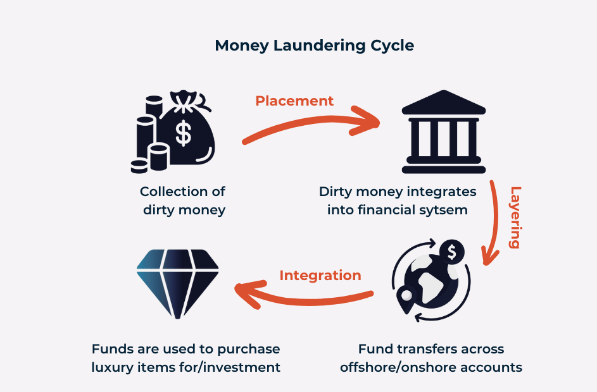
Figure 1: Money Laundering Process

Giving money or other forms of help to terrorist groups or people so they can carry out terrorist acts is known as terrorist financing. The money can come from a number of sources, including reputable companies, nonprofits, illegal operations like extortion, drug trafficking, or kidnapping. As it makes it possible for terrorist organizations to carry out their violent goals, it poses a serious danger to international peace and national security.
According to Money Laundering Act Section 2 of the Money Laundering Act, attempt to commit or committing the following are considered predicate offences:
(1) Corruption and bribery
(2) Counterfeiting currency
(3) Counterfeiting documents
(4) Extortion
(5) Fraud
(6) Forgery
(7) Illicit arm trade
(8) Illicit narcotic drugs and psychotropic substance trade
(9) Trade of stolen goods
(10) Kidnapping, illegal restraint, hostage-taking
(11) Murder, grievous bodily injury
(12) Woman and child trafficking
(13) Smuggling and trafficking of local and foreign currency
(14) Theft or robbery or piracy or sea piracy or air piracy
(15) Human trafficking
(16) Dowry;
(17) Illegal trafficking of customs related crime
(18) Tax related crime
(19) Piracy of intellectual property
(20) Terrorism and terrorist financing
(21) Environmental crime
(22) Sexual exploitation
(23) Insider trade and market manipulation
(24) Organized crime
(25) Obtaining money by threatening
(26) Any other offence which Bangladesh bank declares as predicate offence with Govt. approval.

1.1.2 Problem Statement

1.1.2.1 General Overview of AML Practices Worldwide
The intergovernmental Financial Action Task Force (FATF) on Money Laundering was established by the G-7 in 1989, to create and advance a global response to stop money laundering and terrorist financing (Bangladesh Bank, 2012). FATF approved a set of guidelines that formed an all-encompassing framework for AML and were intended to be implemented globally by nations (Bangladesh Bank, 2012). Being the global standard-setter for AML and CFT legislation, the FATF offers particular suggestions to reduce both agent and consumer risk. According to Turner (2017), regarding risk at the customer level, the FATF offers the following suggestions:
- To handle the ML/TF risks for MFS, nations must adopt a risk-based strategy. Limits on the volume and frequency of transactions in m-money services must be placed based on the level of risk.

- The nations should think about implementing a "progressive" or "tiered" KYC strategy, which might lessen ML/TF vulnerabilities by imposing modest transaction, payment, and balance restrictions. A point-based progressive KYC strategy makes the assumption that a consumer can be trusted more, the more KYC proof they are able to supply. Services will be delivered in proportion to the submitted identity. On the basis of a comprehensive and recorded risk assessment, the reduced risk conditions must be verified.

- FATF considers transactions or commercial interactions that do not take place in person to be potentially riskier. To reduce danger, they advise gathering substantiated identity data.

The World Bank has underlined that while developing the AML/CFT regulatory framework for mobile money, national policy makers must take certain aspects into consideration (Turner, 2017). They recommend that before creating AML/CFT regulations for m-money operations, nations should carry out risk assessments. Identification of all relevant parties within the jurisdiction, comprehension of the goods that are and will likely be supplied, and the possibility of future patterns and trends should be the main objectives of the evaluation (Turner, 2017). Additionally, it should evaluate the kinds, amounts, and nature of ML/TF risk; it should also pinpoint the primary m-money-specific vulnerabilities and take appropriate action to fix them (Turner, 2017).

1.1.2.2 General Overview of ML/TF in Bangladesh
Bangladesh has been bolstering its AML and CFT infrastructure. Bangladesh's Central Bank operates a Financial Intelligence Unit that receives, analyzes, and distributes data on suspicious transactions reports (APG). Bangladesh Financial Intelligence Unit [1] (BFIU) is the leading institution in charge of combating money laundering (ML), terrorist financing (TF), and funding of the proliferation of weapons of mass destruction (Bangladesh Financial Intelligence Unit, 2024). The unit has the authority to oversee the Reporting Organizations' ML, TF, and PF-related actions. In addition, BFIU has been given the duty of coordinating ML, TF, and PF information sharing with its international equivalents (Bangladesh Financial Intelligence Unit, 2024).

Turner (2017) found the following: Bangladesh has experienced numerous forms of abusing MFS, including the collection of ransoms for vehicle theft, abduction/kidnapping, deception by offering a bogus lottery prize, gift, employment, or hidden treasure from 'genier badsha', marriage with an overseas bride, and extortion using the names of prominent terrorists. In the majority of cases, fraudsters exploited accounts with falsified KYC or personal accounts of agents. The MFS-based Hundi (M-hundi) has been identified as one of the primary causes of the recent reduction in the number of international remittances to Bangladesh. Numerous chances for practically anonymous transactions are a major factor in the illicit misuse of MFS.

According to Bangladesh Financial Intelligence Unit (2018), the rising trend of digital hundi and the declining trend of worker remittances are most likely directly correlated. The various central banks have received reports from Bangladeshi exchange houses operating overseas and commercial banks indicating a sharp decline in small-scale foreign remittances in recent years, with the majority of these remittances entering Bangladesh through illicit means such as MFS (Bangladesh Financial Intelligence Unit, 2018). The primary application of MFS is now digital hundi. The country's existing social, economic, and political conditions make it especially susceptible to the unlawful transfer of property outside the country, raising a number of money laundering risks (Latif, 2014).

1.1.2.3 Why Bangladesh must combat ML & TF?
The effects of money laundering can be disastrous for the economy of Bangladesh. The fight against money laundering and terrorist financing boosts financial inclusion. These two are the main factors behind many criminal operations runs by terrorists, including drug trafficking, smuggling, and illicit arms dealing. Government spending rises as a result, particularly in the fields of medicine and law enforcement. Among other harmful socioeconomic consequences, it gives criminals access to the resources that the market, government, and people have. It also causes incorrect allocation of resources and prices of goods is affected.

Money laundering has a significant negative impact on government tax income. It makes it harder to get taxes from citizens, which raises the tax rate. Monetary instability is a risk factor that arises from an uneven asset structure caused by money laundering. Many terrorist attacks that have occurred in the nation are fueled by terrorist finance. The world views Bangladesh negatively as a result of these terrorist assaults. The country misses out on many opportunities for foreign investment and business as a result of this bad perception. Bangladesh can decrease the potential of violence and unreliability and diminish terrorist organizations by combating the financing of terrorism. Money laundering and terrorist financing are serious dangers to national security, so in order to defend national sovereignty, citizen safety and well-being, these operations must be stopped.

It is a requirement from the FATF to implement AML & CFT rules, so in case of not following the requirements, it will affect the reputation of Bangladesh. Consequences might include economic penalties and expulsion from the international banking system. In general, the ethics, safety, and prosperity of a country’s financial system depends on the fight against money laundering and terrorist financing.

1.2 Objectives of the Report
The main objective of the report is to learn about bKash’s Anti-Money Laundering approaches, this is a case study on the leading MFS of Bangladesh, bKash Limited.

Specific Objectives of the Report:
- To give an idea about the current Money Laundering & Terrorist Financing scenario of Bangladesh and why it needs to be stopped.
- To learn about the MFS industry and bKash’s position in it.
- To give an idea of how the many divisions within the organization work along with the organizational structure and background.
- To understand the AML & CFT department’s functions.
- To understand how these functions contribute to the cause of Anti-Money Laundering and Countering the Financing of Terrorism.

1.3 Motivation of the Report
This Internship report is a requirement of the School of Business and Economics at United International University in order to complete the degree of Bachelors of Business Administration. Therefore, it holds a requisite credit which acts as the motivator for this report titled “Anti-Money Laundering Perspective: A Case Study on bKash”.

1.4 Scope and limitations of the Report
This report aims to provide an in-depth analysis of what measures bKash Limited takes for fostering anti-money laundering activities and combatting the financing of terrorism. The scope of this report covers a comprehensive understanding of the functions of all the teams in the AML & CFT department of the organization, and how these functions contribute to the cause overall. References for this report include the employees of the department, BFIU Circulars, news articles, blogs and various papers found online that are mentioned in details at the end. Although this report is ensured to have been written with accurate and reliable data, there are still limitations since the company maintains strict confidentiality and has privacy policy for certain information. Time constraint has also been a limitation as the time that was available to gather the information was only three months, that too had to be done in between work responsibilities.

1.5 Definition of Key Terms
- Financial Action Task Force (FATF) – an intergovernmental organization that fights against money laundering and terrorist financing, and sets certain AML standards that are followed worldwide.
- Money Laundering and Terrorist Financing (ML/TF) – money laundering is hiding the source of illegal money and terrorist financing is funds to support terrorist organizations and activities.
- Anti-Money Laundering and Combatting the Financing of Terrorism (AML & CFT) – refers to the fight against money laundering and terrorist financing.
- Financing of Proliferation (PF) – funds involved in spread of delivery of weapons of mass destruction.
- Mobile Financial Service (MFS) – digital financial services accessible via mobile phone.
- Know Your Customer (KYC) – a process through which identity of customers are verified.

CHAPTER TWO: COMPANY AND INDUSTRY PREVIEW

2.1 Company Analysis

Overview and history

Overview of bKash Limited
bKash Limited was founded in 2010 and has become a pioneer in Bangladesh’s fintech industry, that has reshaped how millions of people access and manage their money. Operating as a subsidiary of BRAC Bank Limited and under the supervision of Bangladesh Bank, bKash has become a trusted organization in promoting financial inclusion and transforming lives across the country. The company’s vision is a cashless society where everyone has access to financial services. Its mission is to provide reasonably priced, easy and safe financial services via its extensive network, and promote the nation’s financial growth by helping individuals and companies thrive.

People now have a simple way to save and manage their money online, thanks to bKash’s safe and easy-to-use digital wallet. This platform is more than just a regular wallet; it makes transferring money very easy. Its range of services also allows customers to shop online and pay from home instantly, it also allows them to pay various household bills and manage bank transactions making financial accessibility very convenient and modern at the same time. bKash has a vast network of around 330,000 agents and 550,000 merchants across the country, that are intentionally positioned in a way to reshape the ease of digital money. These agents and merchants are very important in the process of depositing and withdrawing cash, and e-commerce transactions. bKash consistently makes investments in modern technology and thorough security protocols to guarantee the confidentiality and security of its clients' financial transactions. The platform has been updating its services and coming up with new ones consistently throughout the years. Its expansion into savings, loan and insurance shows its dedication to financial innovation and accessibility.

The organization is dedicated in its commitment to improving the underprivileged and unbanked population in Bangladesh and to advance economic growth. In addition to transforming Bangladesh’s financial industry, bKash Limited has managed to blend into the daily lives of millions of people in the country.

History of bKash Limited
In 2010, Kamal and Iqbal Quadir envisioned transforming the financial accessibility in Bangladesh through the launch of an MFS called bKash. By taking inspirations from successful models in the Philippines, Kenya and other developing economies the Quadir brothers saw a chance to bring mobile banking services to Bangladesh. The Quadir brothers worked with Sir Fazle Hasan Abed, the inspirational founder of BRAC, before bKash was founded in order to find a local partner to help them bring the idea to life. The effect of working together resulted in the alliance between Money in Motion and BRAC Bank, opening the door for the creation of bKash.

The fact that more than 70% of Bangladesh's population lives in rural regions, where traditional banking services are sometimes difficult to reach, served as the foundation for the decision to introduce mobile financial services. In July 2011, bKash launched the three core services—"Cash In," "Cash Out," and "Send Money"—that met the people's urgent demands. By 2012, more than 2 million customers had registered on the platform. New service called “ATM Cash Out” was introduced at the time in collaboration with BRAC Bank. 2013 was the year when about 50,000 Agent points were active nationwide, and 10 million customers were registered by the time. In 2016, bKash Limited was recognized as the no. 1 MFS in the world, and it was also the year that the company launched its product “Remittance”. 2018 was one of the most significant years for the growth of the company since it was the year of the launch of the bKash app, that helped transform the fintech industry in Bangladesh. In 2023, bKash now has reached 7 crore registered customers and recognized as the Fintech Pioneer of the country.

bKash has established itself as a force for change in Bangladesh's financial sector because of its strategic approach to financial inclusion and ability to adapt to the requirements of its users. Through the use of mobile technology, bKash keeps empowering people in underserved and rural regions by giving them access to vital financial services that were previously inaccessible. The way millions of Bangladeshis manage and access their finances are changing as a result of the journey that started with a vision in 2010.

2.1.2 Company Profile In-format
Table 1
Title: Company Profile
Name | bKash Limited
Founder of The Company | Kamal S. Quadir
Logo | 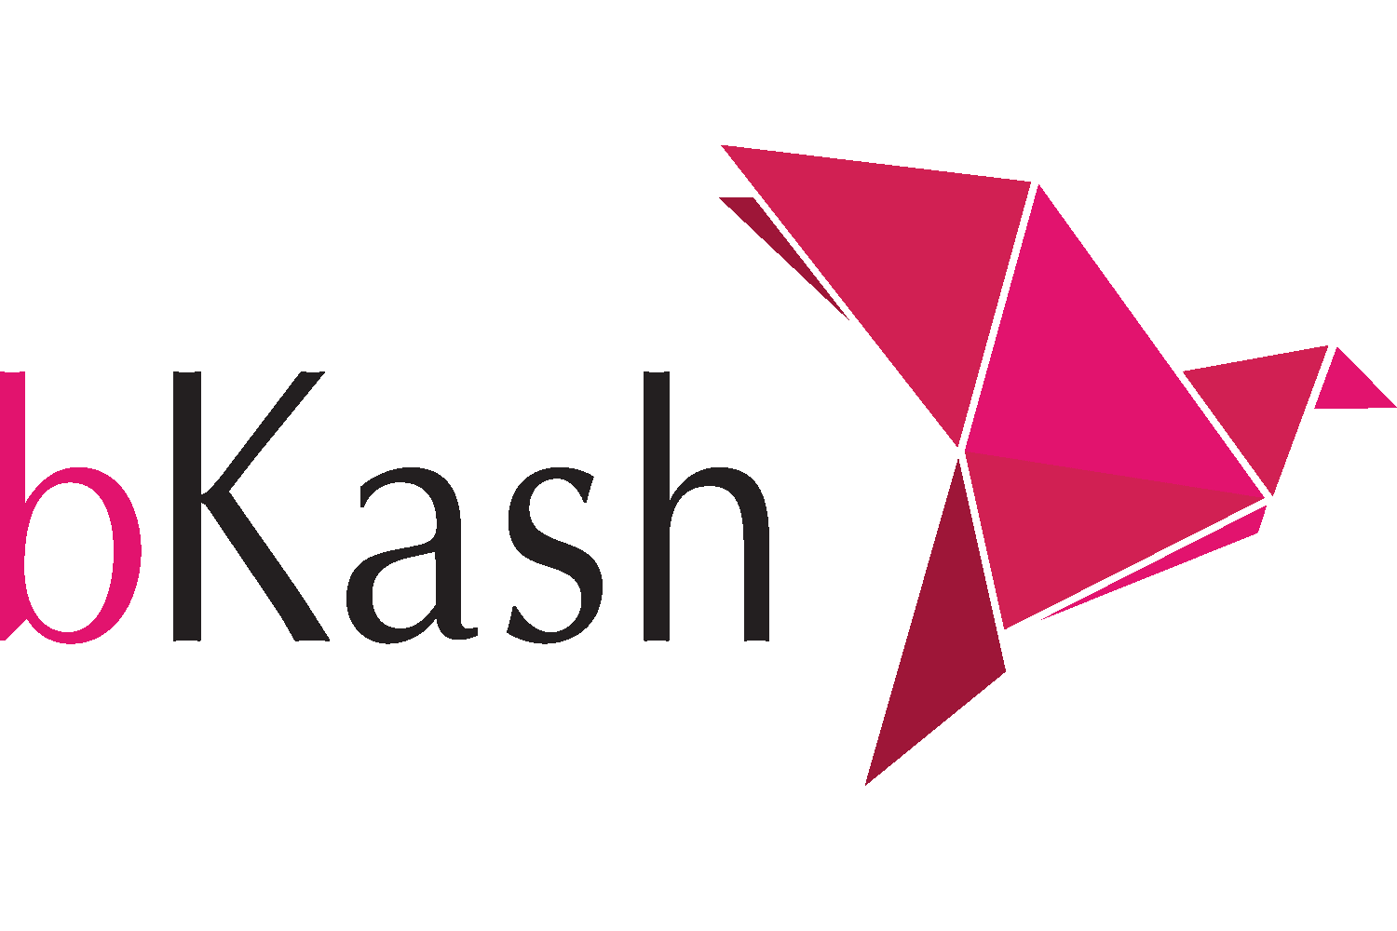
Year of Establishment | 2010
Corporate Headquarter | Shadhinata Tower, 1, Bir Sreshtha Shaheed Jahangir Gate Dhaka Cantonment, Dhaka 1206, Bangladesh
Website | www.bkash.com

Trend and growth

bKash Limited launched its services in 2011, and by 2012 more than 2 million customers had registered on the platform. 2013 was the year when about 50,000 Agent points were active nationwide, and 10 million customers were registered by the time. Fast forward to 2023, bKash has now reached 7 crore registered customers and developed a strong nationwide network of about 300,000 agents and 300,000 merchants. In an effort to improve the nation's cashless digital financial ecosystem, bKash has integrated with banks, other financial organizations, and service providers (Mahmud, 2023). According to The Business Standard blog post “12 years of bKash: an era of empowerment” (2023), the way that banks and bKash transmit money has completely transformed the MFS experience for clients. As of 2023, bKash is linked to 44 commercial banks.

The report from The Business Standard “bKash profit jumps to Tk88 crore in Jan-Sep 2023” (2023) highlights that, since its establishment in 2011, the company has been profitable till 2018, but between 2019 and 2021, it incurred huge losses. The reason of the losses was that, the company had decided to invest heavily on product and technology development to enhance business services and expand the client base. Despite its short-term losses, bKash remained determined on future market dominance. Then in 2022, the company reported its first quarterly pre-tax profit in more than three years. In the first nine months of 2023, the company reported a staggering 2,100% increase in profit due to increased revenue and a jump of 39% in net income (TBS Report, 2023).
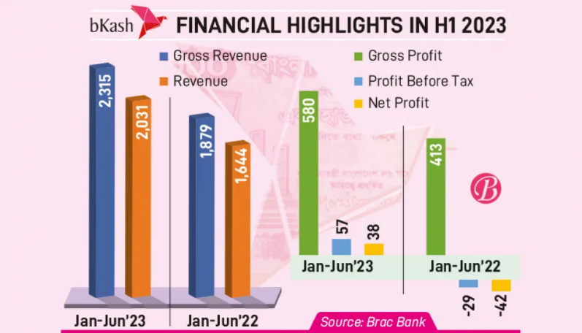

Figure 2: Financial Highlights of 2023

In 2016, bKash Limited was recognized as the no. 1 MFS in the world. 2018 was one of the most significant years for the growth of the company since it was the year of the launch of the bKash app, that helped transform the fintech industry in Bangladesh. bKash’s significant investment on its technology has improved the functionality and user experience of the mobile app, which helped the company succeed. In 2023, despite of facing competitions from other MFS providers like Nagad and Rocket, bKash now has an estimated market share of around 70% being the market leader. The company is now recognized worldwide and is known as the Fintech Pioneer of Bangladesh. Along with dominating the fintech market, it also has a high contribution towards the country’s GDP. Almost Tk. 40 billion in remittances arrived in Bangladesh via bKash in 2022, and in just six months of 2023, bKash handled almost Tk. 30 billion in remittances (TBS Press Release, 2023). To summarize, bKash Limited has shown effective investments, consistent innovation, and a large customer base along its path to success. These factors have strengthened the company's position as a leader in the fintech industry of Bangladesh.

Service mix
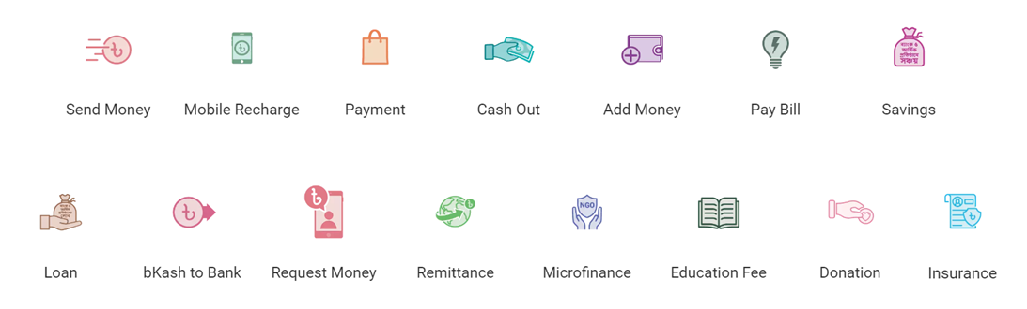
bKash offers a total of 15 services as of now. It started off with just 'Cash In,' 'Cash Out,' and 'Send Money’ and kept expanding its services over time to include additional functionalities. User-requested services such as, mobile recharge, bill payment, and train-movie ticket purchases were integrated into the platform. This evolution was driven by the company's recognition of the diverse financial needs of its user base and a commitment to providing practical solutions.

Figure 3: Services of bKash

The functions of the 15 services are presented briefly below:
- Send Money – Send money from bKash to any number instantly.
- Mobile Recharge – Recharge any number and get the best offer.
- Payment – The fastest way to make online and QR payments anywhere in Bangladesh.
- Cash Out – Withdraw cash anytime from the largest agent and ATM network of Bangladesh.
- Add Money – Add money through bank account or card.
- Pay Bill – Pay electricity, water, gas, internet, telephone, TV, credit card bills and many more.
- Savings – Start savings at banks or financial institutions through the bKash app and grow the money.
- Loan – get a loan from the City Bank through bKash app instantly.
- bKash to Bank – Transfer money from bKash to Visa debit card or bank anytime.
- Request Money – In times of need, request money to one or multiple bKash customers through the bKash app.
- Remittance – Receive money from abroad to bKash account safely.
- Microfinance – Pay savings installment to microfinance institutions through bKash.
- Education Fee – Pay education fee for school, college or university.
- Donation – Donate to extend support toward the underprivileged.
- Insurance - Pay insurance premiums automatically using the bKash app.

2.1.5 Organizational Hierarchy/ Organogram
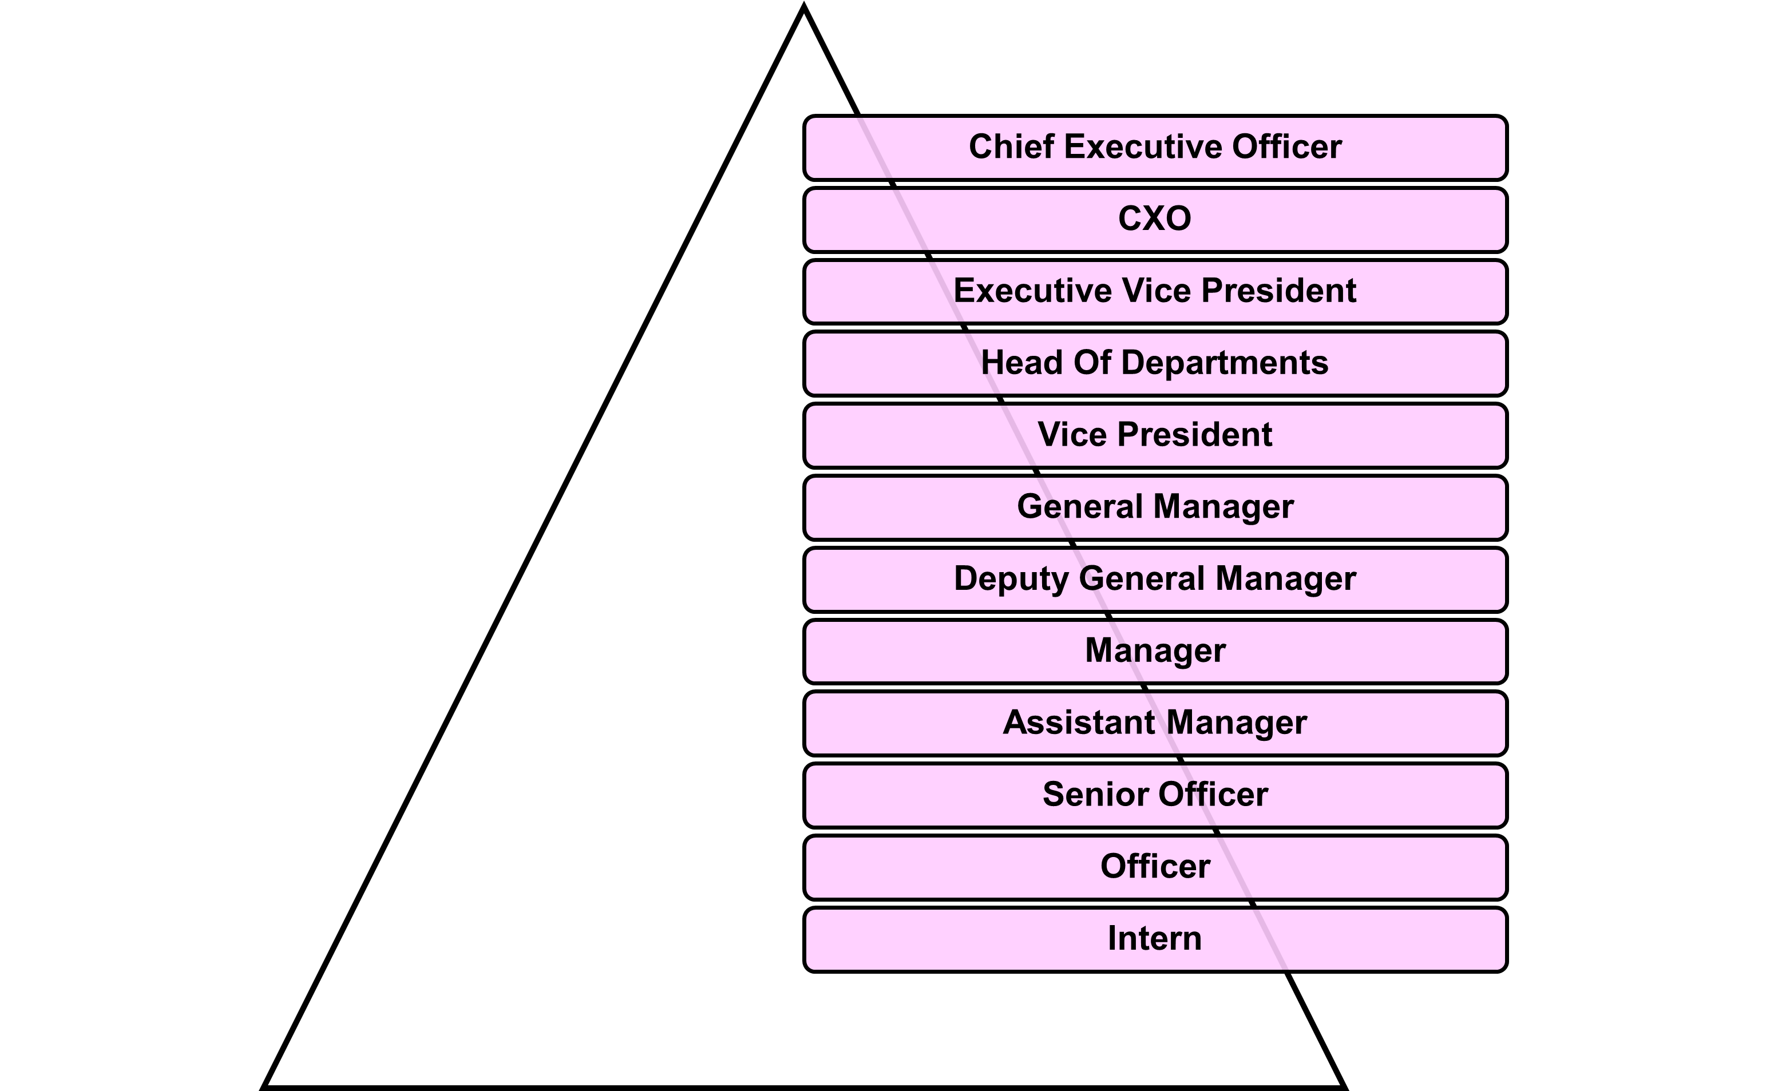
Figure 4: Hierarchy of bKash
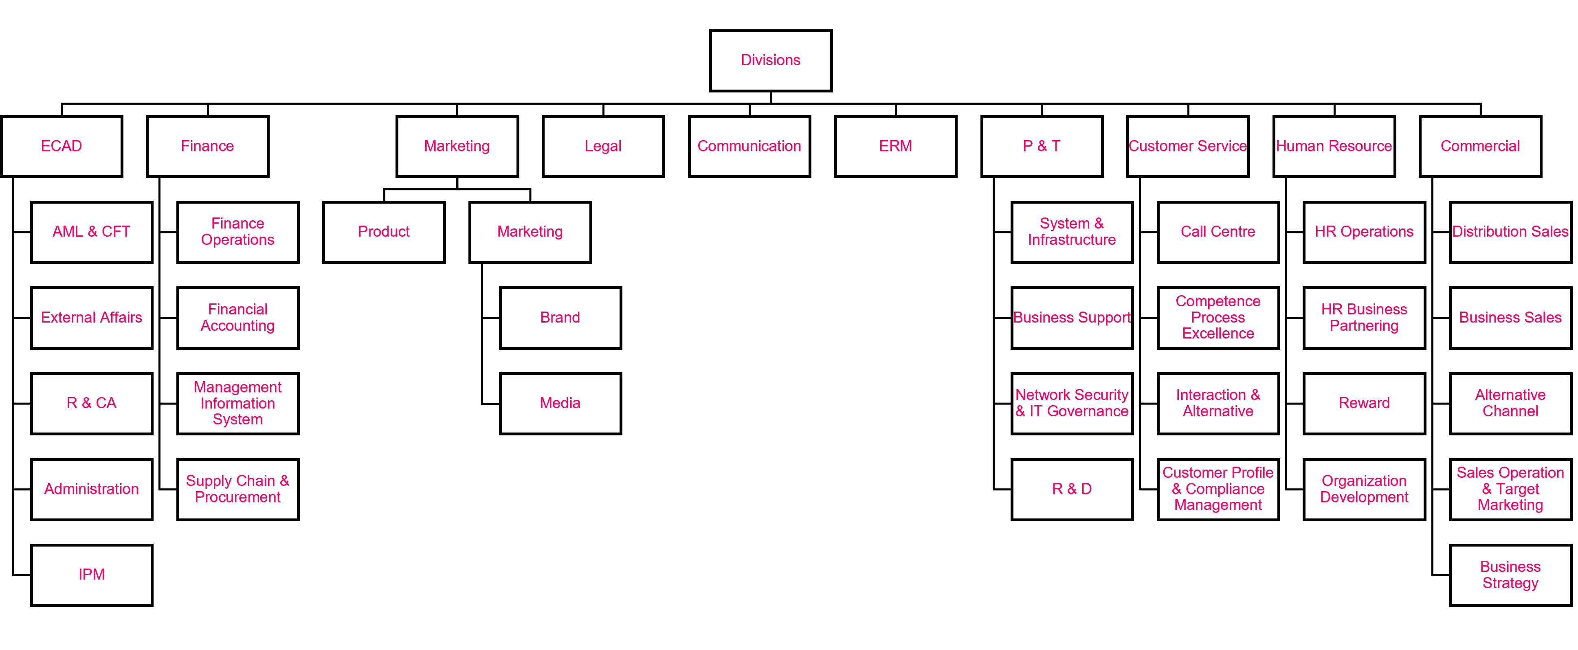

Figure 5: Divisions of bKash

Operations

There are a total of 10 divisions at bKash Limited. They are:
- External & Corporate Affairs
- Finance
- Marketing
- Legal
- Communication
- Enterprise Risk Management
- Product and Technology
- Customer Service
- Human Resource
- Commercial
The functions of each division are given below briefly.

- External & Corporate Affairs Division
The External & Corporate Affairs Division is at the heart of bKash's dedication to transparency and external partnerships. The External and Corporate Affairs Division of bKash Limited consists of 4 departments. The departments are as follows:
- Regulatory & Corporate Affairs (R & CA)
- External Affairs (EA)
- Administration
- Anti-Money Laundering and Combating the Financing of Terrorism (AML & CFT)

The Regulatory & Corporate Affairs department makes sure bKash works within legal frameworks; by being cautious and working with authorities, it keeps the company complying with changing industry standards. External Affairs and Administration department are responsible for managing external connections, establishing a positive company image, and controlling communication as well as improving internal processes, that guarantees effectiveness within the department.

The department of Anti-Money Laundering and Combating the Financing of Terrorism (AML & CFT) actively participates in maintaining integrity, preventing financial crimes, and making a major contribution to the security of the financial system. According to the PSD Circular of Bangladesh Bank, which states the regulations of Bangladesh Mobile Financial Services (MFS), it is mandatory for an MFS to have an AML & CFT Department. Furthermore, it says that this department shall be run based on the detailed instructions and guidelines issued by Bangladesh Financial Intelligence Unit (BFIU) from time to time. AML & CFT department is mainly responsible for implementing measures to prevent and detect money laundering and the financing of terrorism. Some of the key responsibilities and functions of the department are policy development, customer due diligence, transaction monitoring, reporting, training and awareness, compliance audits, risk assessment, and coordination with regulators. These duties are divided and assigned to a total of 8 teams in this department.
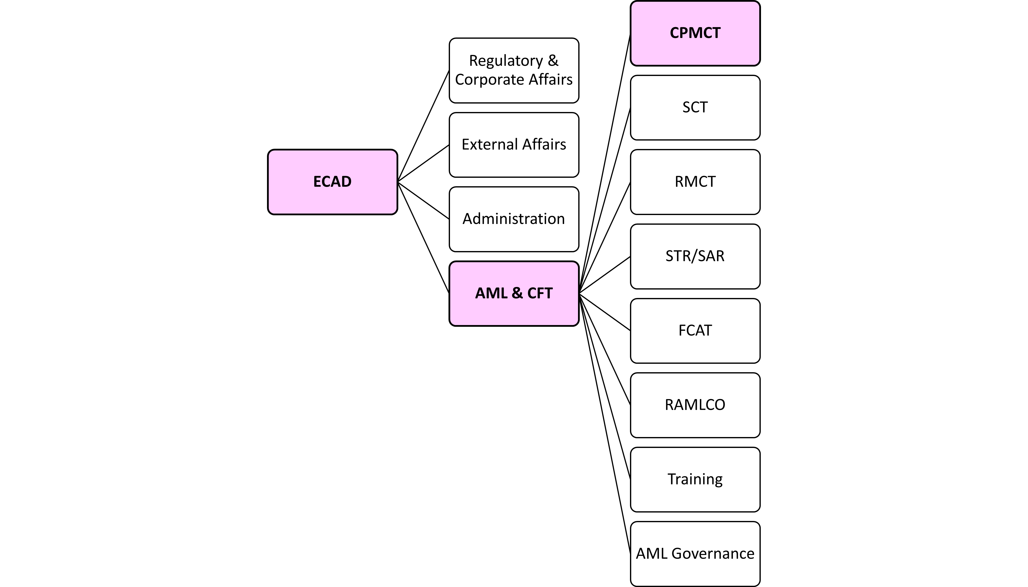

Figure 6: Map of ECAD

Each of the team’s key functions are as follows:
- Compliance Process Monitoring & Control Team (CPMCT):
CPMCT mainly deals with Customer Due Diligence (CDD), Enhanced Due Diligence (EDD) and Governance Issues along with other supporting roles. The team works with customer service, provides feedbacks to them, and develops strategies for further improvement in alignment with compliance.

- Strategic Compliance Team (SCT):
SCT develops policies for the organization keeping the instructions and guidelines from BFIU Circular 20 in mind. The team also assesses potential risks associated with implementing the new policies and comes up with solutions to mitigate them.

- Risk Monitoring & Control Team (RMCT):
RMCT is involved with 24/7 media screening, sanction screening as well as remittance screening. The team also monitors negative media and various gambling sites, they further investigate risks found by the regional team from its field visits.

- Suspicious Transaction Report/ Suspicious Activity Report (STR/SAR) Team:
STR/SAR team monitors and reports suspicious transactions and further goes into comprehensive investigations. The team is involved in filing detailed complaints, generating comprehensive reports, and implementing necessary actions based on the findings of their investigations.

- Field Compliance Assessment Team (FCAT):
FCAT specializes in on-field assessments and therefore, explores suspicious activities firsthand to identify and address problems related to unusual transactions directly from primary sources. Their work contributes to a comprehensive understanding of potential risks at the fundamental level.

- Regional Anti-Money Laundering Compliance Officer (RAMLCO):
bKash Limited has designated RAMLCOs at every area and zones all over Bangladesh based on risk level of the area. The RAMLCOs generate comprehensive reports from their respective zones which involves evaluating the level of riskiness and transaction volumes within each zone. Then, by using the insights gathered from the reports, they develop targeted strategies for the specific challenges to mitigate risks effectively.

- Training Team:
Training Team provides comprehensive training to the merchants, agents, and distributors of bKash Limited. The training programs are aligned with the guidelines and instructions provided by the BFIU.

- AML Governance Team:
AML Governance team plays an important role in ensuring the overall effectiveness of the AML & CFT department. The team’s responsibilities include establishing policies and procedures to guarantee compliance and integrity throughout the department's operations. This team collaborates with all the other 7 teams as well as the regulatory bodies, ensuring compliance to industry standards. These teams together have a major impact on bKash’s ability to uphold the highest levels of security and compliance, as well as risk management in Bangladesh’s MFS market. The specific duties undertaken by each team are essential parts in their contribution to the reliability of the financial ecosystem.

- Finance Division
The Finance division manages a wide range of financial duties, from careful maintenance of financial records to smart financing and investing choices. The division is responsible for managing payroll, taxes, and invoicing as well as other important tasks that guarantee the smooth operation of financial activities. There are 4 departments within, they are:
- Finance Operations
- Financial Accounting
- Management Information System
- Supply Chain & Procurement

- Marketing Division
The Marketing division’s responsibility includes establishing a good image of bKash among investors, current and potential clients, and the mass people in general. This duty goes beyond simple image building and requires to make targeted plans to increase revenue, improve brand awareness, and connect with the company’s desired audience. There are 2 departments in this division, one is Product and the other is Marketing, within which falls two teams called Brand and Media.
- Product
- Marketing – Brand and Media

- Legal Division
bKash's Legal Division looks out for the company's legal interests. They help to protect the board of directors, shareholders, and legal staff, but their main goal is to strengthen bKash's defenses and legal integrity. The legal team at bKash is not just about protecting legal interests; they also work together with other departments to improve customer experience. This collaboration shows the department's diverse function, making it a strategic partner in the overall growth of bKash's operational activities.

- Communication Division
The Communication division oversees advertising campaigns, public relations activities, client gatherings, and the ever-changing social media landscape using a diverse strategy. The foundation of this division is clear and constant communication, which is essential for maintaining unity inside the organization as well as for building partnerships with the outside world. Management, investors, and employees all depend on this team to keep things going smoothly.

- Enterprise Risk Management Division
The Enterprise Risk Management division is in charge recognizing, evaluating, and ranking the risks that might affect the goals of the company. They also create plans and guidelines to efficiently reduce risks that have been identified as well as keep an eye on risk exposure and inform the stakeholders and top management about it. This division puts rules and procedures for risk management into practice to improve decision-making of the organization.

- Product and Technology Division
The Product and Technology division is the face of innovation, developing and improving advanced financial solutions at bKash. The Product Development team is one of the most important in this division, as it is responsible for every new product vision and invention. The division is known for its dedication to continuous analysis; the group proactively forecasts future demands by remaining aware of market trends and regularly assessing client preferences. With this proactive stance, bKash is positioned to be a leader in adapting to changing customer needs and stay one step ahead in the rapidly evolving field of financial technology.
There are 4 departments in this division, they are:
- System and Infrastructure
- Business Support
- Network Security and IT Governance
- Research and Development

- Customer Service Division
The Customer Service division is responsible for interacting with consumers and promptly answering their questions. The support crew shows proficiency in providing quick solutions and a flawless client experience, as they have a comprehensive understanding of the products and services of bKash. The division's mission is that, it will immediately and efficiently handle client issues, converting any problems into chances for positive communication. The Customer Service staff provides exceptional service and helps to build lasting connections with bKash users, thanks to their customer-centric approach. There are 4 departments in this division, they are:
- Call Centre
- Competence Process Excellence
- Interaction and Alternative
- Customer Profile and Compliance Management

- Human Resource Division
The Human Resources (HR) division acts as a central hub as it thoroughly evaluates organizational environment and uses insights to make well-informed judgments about best practices and HR initiatives. The division prioritizes developing company performance and culture above and beyond standard tasks. It plays an important role in guiding the company in the direction of a future in which the workforce and culture are adaptable and in line with broader strategic objectives.

There are 4 departments within the HR division, they are:
- Human Resource Operations
- Human Resource Business Partnering
- Reward
- Organization Development

- Commercial Division
The Commercial division helps the organization earn revenue and growth through partnerships, business development, and client acquisition tactics. They oversee services and accounts for companies that take bKash payments. They collaborate closely with some stakeholders to find new business possibilities, form strategic partnerships, and customize products and services to match changing consumer demands. This division is vital for bKash's ability to penetrate new markets and increase consumer interaction. There are 5 departments within this division, they are:
- Distribution Sales
- Business Sales
- Alternative Channel
- Sales Operation and Target Marketing
- Business Strategy

SWOT analysis

Strengths
The first and foremost strength of bKash is that, it is the market leader of MFS in Bangladesh with a large first mover advantage. It has made a name for itself as the country's go-to digital transaction platform. Due to its security and ease of use, bKash has been able to build a strong brand presence and have gained the trust of millions. Secondly, the company has been able to grow both its customers and services by collaborating with banks, financial institutions and merchants. Lastly, bKash’s network of agents, which is wider than any other MFS in the market is a huge strength for the company, since it allows bKash services to be available even at the most remote areas of the country.

Weaknesses
The platform’s services are still rather limited when compared to regular banks. Any interruption or outage of the mobile network could hamper bKash services since it depends on network and internet. Lastly, bKash and its users are vulnerable to cyberattacks and fraud, and these types of security issues are actually very common these days; users’ bKash accounts get hacked quite frequently by various scammers.

Opportunities
bKash can come up with voice machines with QR codes that accepts payments, which will be used by merchants to confirm payments by customers. This will help to improve security and also help with the recent frauds that have been happening with fake text messages. By adopting advanced technologies like blockchain and artificial intelligence will help bKash increase profitability, boost security, and provide better services to its users.

Threats
Bangladesh’s MFS industry is becoming more and more competitive as new businesses are joining the market. Similar services provided by rivals can result in lower market share of bKash. Also, bKash’s business model and financial performance could be hampered if there is a shift in Bangladesh’s regulatory rules and frameworks that shape or control the MFS industry.

2.2 Industry analysis

Specification of the industry
bKash Limited falls under the Mobile Financial Services (MFS) industry. The MFS industry is referred to the supply of financial services via mobile phones, mainly aimed at people without bank accounts. The growing need for easily accessible financial services, increased use of mobile phones and popularity of digital money have led to a major spike in this industry's global expansion, especially in emerging economies. Mobile money service providers, banks, telecom carriers, and fintech startups are some of the major companies in the MFS sector. The world of MFS is changing due to biometric verification, NFC technology, and QR code payments, that increase customer safety and ease of use. Different countries have different regulatory frameworks and some have also put laws in place to protect consumers in this industry. The industry faces difficulties in resolving security issues and increasing user trust but nonetheless, there are plenty of room to develop, especially in emerging economies where the people are mostly unbanked and the need for financial services is rising. Collaborations among banks, fintech firms, and telecom providers are encouraging innovation and increasing the accessibility of mobile financial services to remote regions.

The MFS industry has a bright future ahead of it because expansion is projected driven by ongoing innovation, technical developments, and government assistance. The safety and effectiveness of mobile financial services might be further improved by developments in blockchain technology and artificial intelligence. MFS has the power to completely change how individuals’ access and manage their funds as use of mobile phones become more widespread and internet connectivity gets better.

Size, trend, and maturity of the industry
The MFS industry in Bangladesh is growing rapidly with millions of users and high number of transactions. Market share has been significantly increased by providers like Rocket, Nagad, and bKash. The sector has grown to be an important part of the financial system, especially for people who lack or have limited access to banking. The MFS industry has a persistent pattern of growth and advancement. The trend in the industry includes providers rolling out new features and services in order to draw in more customers and improve convenience. Furthermore, more and more MFS providers are forming alliances with different merchants, utility providers, and governmental organizations, bringing up new offerings for customers to access via their mobile wallets.

The world of MFS is changing due to biometric verification, NFC technology, and QR code payments, that increase customer safety and ease of use. The MFS industry has a bright future ahead of it because expansion is projected driven by ongoing innovation, technical developments, and government assistance. The safety and effectiveness of mobile financial services might be further improved by developments in blockchain technology and artificial intelligence. MFS has the power to completely change how people access and manage their funds as use of mobile phones become more widespread and internet connectivity gets better.

External economic factors
MFS services and their demand may be affected by Bangladesh’s overall economic situation. Variables like rate of inflation, GDP and unemployment levels are among many that may be the causes. The MFS market is shaped by the rules and regulations set by the government and Bangladesh Bank. So, any change in law regarding MFS will affect the service providers and would bring difficulties in their operation and expansion. Global currency rate fluctuations and change in world trade behavior can also indirectly affect Bangladesh’s MFS market by their effects on the country’s overall economy. Taking everything into account, Bangladesh’s MFS industry is vulnerable to a lot of external economic factors. To successfully overcome these obstacles, companies need to keep an eye on these factors and adjust as necessary.

Technological factors
MFS providers are able to provide this many varieties of services now in Bangladesh because of the rise of efficient digital payment platforms. These platforms make use of technology to guarantee speed of transactions, safety, and convenience. The user-friendly interfaces make it easy to use for everyone, regardless of their socioeconomic backgrounds. bKash was the first MFS to introduce biometric authentication technology in the industry recently to improve security and speed up the authentication process. The use of biometric authentication prevents fraud and illegal access.

Collaboration between MFS providers, banks and other financial institutions are getting more common now because of integration of Application Programming Interface (API). Data analytics and artificial intelligence (AI) technologies are being used by these providers to study customer behavior, detect trends and customize services. Chatbots and virtual assistants driven by AI improve customer service and interaction while also boosting the user satisfaction. Cybersecurity is essential as financial services are getting more digital. MFS companies invest in cybersecurity tools and technologies to stop fraud, secure customer information, and defend against online attacks. Cross border remittances and safe transactions are made possible by blockchain and Distributed Ledger Technology (DLT). So, some companies are investigating on these technologies as well currently to improve transaction security since Hundi has become a rising problem for the country. The MFS industry in Bangladesh is shaped by these technology developments, and the financial system will continue to evolve as long as technological breakthroughs continue.

Barriers to entry
For new entrants in the MFS industry, some tight laws regarding licensing, capital requirements, consumer protection, and anti-money laundering may become an obstacle, since these rules provided by the Bangladesh Bank must be followed by any company wishing to enter the industry. One of the main barriers of entry would be the competition in the market currently. A few big companies, like bKash, Nagad, and Rocket, control the majority of the MFS market in Bangladesh. These companies have become well-known brands, gained consumer trust in the market and have a broad network of agents spread throughout the country. Gaining market share would be difficult for new competitors because of the strong rivalry that these long-standing firms present. Moreover, consumers who are used to using services of the existing providers that are well-established companies with a reputation for dependability and security, may find it difficult to trust newcomers. New entrants may also find it difficult to enter the market since it takes a lot of time and money to set up and maintain a strong network of agents and merchants from the ground up. Another barrier might be limited financial resources, the initial amount needed for infrastructure, technology, and human resources is quite high when setting up a strong MFS platform. Thus, startups and smaller businesses may find it difficult to enter the market because of this high capital demand.

Threat of Substitutes
The threat of substitutes is actually minimal since the MFS system is beneficial and convenient for the majority. However, since Bangladesh has yet to fully embrace the idea of digital money, there are still a few possible threats of substitutes. First of all, even if MFS is becoming more and more widespread, cash is still the most common method of payment in Bangladesh. People are used to making daily purchases using cash, specifically common with people with a lower socioeconomic status. MFS can be replaced by the ongoing use of cash transactions, especially for people who prefer real money or have trouble using digital financial services. Secondly, even though MFS platforms provide official, supervised channels for international money transfers, some people still choose to use unofficial means like hundi because they have cheaper transaction fees. Then, online payment systems like PayPal and international credit/debit cards might be a threat as well since there is a rise of ecommerce and online shopping in Bangladesh. Some people may find these platforms appealing since they make international and internet transactions convenient. Lastly, even though MFS platforms are now offering services like savings and loans, traditional banks continue to offer a broader range of financial services, that customers prefer more since it is suitable for more complex financial needs. The MFS sector in Bangladesh is still expanding despite this possible threat of substitutes because of its distinct benefits, which include accessibility and convenience.

Industry rivalry
The operations of MFS companies can be influenced by the competitive environment in the industry, such as the existence of new fintech firms, traditional banks, and other MFS providers. In order to draw in and keep consumers, competition may force service providers to enhance their products, reduce the cost of transactions, and broaden their range of services.

There are a few big firms that control the majority of the MFS market in Bangladesh, they are− bKash, Nagad, and Rocket, and there is a fierce competition between them. The competition is focused on network coverage, cost, and the standard of customer service since there is a minimal difference in the services offered. The companies also compete fiercely on pricing, providing attractive fee structures, special offers, and discounts. The competition to introduce new offerings and get a competitive advantage in the market frequently gives rise to rivalry as well.

The rivalry between bKash and Nagad
A significant feature of Bangladesh's MFS market is the rivalry between bKash and Nagad. Both companies are well-known in the industry and engage in intense competition for superiority and market share. bKash was Bangladesh's first MFS provider, launched in 2011 and rapidly became the industry leader. Meanwhile Nagad entered the market in 2018, and gradually became an intimidating rival to bKash. Despite it not being a licensed MFS provider yet, Nagad had acquired 6 crore users in just three years of its formation.
Both of the companies provide similar services; the competition frequently centers on launching new services, enhancing user interfaces, and providing low prices. One important aspect in the competition between bKash and Nagad is pricing. It all began when Nagad released an advertising aimed at bKash, the market leader at the moment, for charging excessive prices to its users (Saha, 2021). Following that, bKash made the decision to respond with their targeted marketing material in a serious yet considerate manner (Saha, 2021). To which, Nagad continued to make fun of bKash’s new features in another advertisement (Saha, 2021). This kept going on back and forth until the rivalry between the two companies got to a point where the Bangladesh Bank itself had to interfere and order them to cool off and stop defaming each other in their campaigns.

CHAPTER THREE: METHODOLOGY

3.1 Types of data and sources
The report contains both primary and secondary data. Primary data here refers to the raw data that I gathered myself through observation and discussion. Secondary data refers to the data collected from different sources on the internet. The sources for both types of data are discussed in details below:

Primary Data Source:
- Knowledge from practical work at office i.e., performing Customer Due Diligence.
- Discussions or conversations with senior colleagues of each team of the department.
- Training sessions conducted by the department on AML & CFT issues.
- Training sessions conducted by the HR Team of bKash on organizational structure and culture.

Secondary Data Source:
- Company Website
- BFIU and PSD Circulars published by Bangladesh Bank.
- Guidelines on prevention of money laundering & combating financing of terrorism published by Bangladesh Bank.
- Research papers, newspaper articles, journals, reports and online blogs about Money Laundering and Terrorist Financing.

CHAPTER FOUR: INTERNSHIP EXPERIENCE

4.1 Position, duties, and responsibilities
There was an opportunity to work as an intern of the Control Process Monitoring and Control Team (CPMCT) which is led by Shahrear Ahamed, ACA, CAMS who is a Deputy General Manager in the AML & CFT Department of External and Corporate Affairs Division at bKash Limited. The intern has worked under his supervision for the past 3.5 months.

As an intern, the responsibilities included monitoring and reviewing of the process of Customer Due Diligence which is also known as KYC Sampling. The task was to quality check both electronic and paper KYCs of existing Personal and Non-personal accounts; The intern had a daily KPI to fill for sampling these accounts. Here, Non-personal refers to a number of types of accounts including institutions, agents, merchants, NGOs, and societies, with different guidelines for each type. In addition to quality checking KYCs, the job included documentation of findings. These findings included risk rating of the accounts based on their geographical location and expected transaction limit on a risk rating scale of 1 to 3, 1 being the lowest and 3 being the highest amount of risk.

4.2 Training
The internship tenure started with a 2-day HR training at the Head Office of bKash, which was aimed at getting the new batch of bnext interns familiar with the company structure, culture, departments and policies. Furthermore, extensive training was carried out at ECAD to give the interns an overview of all the team’s functions at the AML&CFT department. Each team’s functions in the department were explained in details and all the line managers and other team members were also introduced during the training. The BFIU circular and guidelines were introduced to the interns as well during this time, and they were given a task to completely read and understand it, as it is important for everyone in the AML & CFT Department to know the guidelines before they start working. Lastly, the interns of CPMCT specifically received another training from the team on KYC sampling.

4.3 Core Functions of CPMCT
CPMCT deals with registration process monitoring of bKash Limited and one of the core functions of it is Customer Due Diligence (CDD). CDD means verifying the customer’s identity based on information, data, and documents obtained from reliable and independent sources, and monitoring account transactions. The collection and verification (KYC) of proper identity/contact information of the customer is a part of the CDD process. The CDD is done for both personal and non-personal accounts. Risk rating of non-personal accounts, and transaction monitoring of personal and PRA accounts are also done by the team.

The CDD process is primarily integrated into CPMCT through Know Your Customer (KYC) forms. The team works with the customer service department and the KYC forms are checked according to the acts and compliances in three levels. Forms are only advanced to the next stage if they are approved. Sampling KYC registrations is primarily done to track and manage the effectiveness of compliance; typical errors are seen and recorded, and recommendations are sent to the training team to ensure that the agents are up to date about the correct procedures for KYC registration. The team comes up with various strategies to mitigate any risks associated with a potential suspicious KYC registration.

Another core function is Enhanced Due Diligence (EDD). EDD means doing a deeper investigation on certain high-risk customers that are found to be making suspicious transactions and therefore, developing and implementing strategies to mitigate the risks associated with the customers. The regional and field officers are involved in the EDD process as it needs on-site and in-person investigation.

CPMCT develops policies and strategies for further improvement of the team in alignment with compliance. The team also co-ordinates and supports the regulators during regulatory inspection by generating reports of accounts registration data. CPMCT is one of the most essential teams at bKash Limited and the AML & CFT department as the company needs to take feedback from the compliance teams for any new product or service that it launches, for example, when bKash wanted to launch product/feature called Savings, it had to take feedbacks or opinions from CPMCT & SCT beforehand, this is maintained as per the rules of Bangladesh Bank. CPMCT looks into the transaction aspect of the product while SCT looks into the policy and procedure aspect of it, then both teams feedbacks are compiled. Other supporting roles of the team include sending awareness notifications to high-risk accounts that are making large number of transactions, or under suspicion of being involved in fraudulent activities like online gambling or betting.

4.4 Contribution to departmental functions
The KYC forms goes through several checkpoints for clearance. They come to the interns as part of one of the checkpoints, after which they await the final clearance of CPMCT and its team leader. Occasionally, human error prevents the previous teams from ensuring accurate results, so the interns double-check and identify any problems that may eventually need to be brought up and communicated to the team leader directly for improved security. This is primarily done to keep an eye on and manage the effectiveness of compliance; any frequent errors are seen and recorded, and recommendations are sent to the Training Team to ensure that the agents are knowledgeable about the correct and updated procedures for KYC registration. Moreover, if the team detects any suspicious accounts, bKash's Customer Service is contacted by phone, and the STR/SAR team is given the case for further investigation.

4.5 Evaluation
This internship has given the corporate exposure to the intern that a typical fresh undergraduate student looks forward to. The ability to make intuitive decisions has been developed through it. The most valuable lessons that were learnt here includes how to multitask, meet targets on time, and maintain a work-life balance through it all. Time management skills were improved and professionalism has been acquired by working in such a dynamic setting. The intern managed to develop a growth mindset by seeking mentorship from the experienced professionals from the department and actively seeking feedback. Moreover, this internship has been utilized as an opportunity for self-improvement and personal growth in the dynamic field of AML & CFT.

4.6 Skills applied
Attention to detail: Attention to detail skill was applied for checking customers’ registration information, relevant documents, account transactions and many other information about agents and distribution houses on the KYC forms in a very short time and thus, the skill was highly improved through it.

Technical Skills: Although all the interns are expected to have basic MS Excel knowledge, the department still took a training session on Excel to help them be proficient at their tasks. A lot can be gained when knowledge is used in a situation where the outcome matters. Discovering several new shortcuts and using them regularly made the intern more skilled and efficient at work.

Communication Skills: Working in an office where all the teams intertwined to work collectively, knowing each other’s functions and responsibilities nonetheless, required everyone, including the interns, to communicate with each other. This is how communication skills were applied and improved as the intern had to make an effort to get to know the colleagues and their work responsibilities amidst day-to-day tasks.

4.7 New skills developed
Compliance Knowledge: By learning about the whole department and each team’s core functions, the circulars from Bangladesh Bank on how the compliance sector in Bangladesh works, and engaging in continuous learning opportunities, the intern has deepened the understanding of AML & CFT principles, regulatory frameworks and therefore gained great knowledge and experience of working at the compliance sector.

Risk Assessment skills: Through risk rating non-personal accounts based on their geographical location and expected transaction limit, risk assessment skill has been gained.

CHAPTER FIVE: CONCLUSIONS AND KEY FACTS

5.1 Recommendations for improving departmental operations
While documenting the findings from KYC quality checking, it has been noticed that agents make a lot of mistakes on the paper KYCs during registration due to being careless. Later on, recommendations are sent to the training team to ensure that the agents are up to date about the correct procedures for KYC registration. So, instead of this, agents should be given a proper and long training session once before they are on-board, so that this process does not have to be repeated every time they make mistakes.

5.2 Key Understanding
Working as an intern at the AML & CFT Department has helped the intern gain knowledge of one of the most significant sectors of the MFS industry, the compliance sector. Participating in the process of Customer Due Diligence, which included KYC quality checking, risk assessment of non-personal accounts, and the documentation of findings has sharpened the attention to detail and gave them insight into the strict guidelines and safety precautions needed to protect financial transactions in an MFS. It has also helped the intern gain proper risk assessment skills. The intern has taken the opportunity that this internship has given and used it to grow personally and advance in the exciting field of AML & CFT.

5.3 Conclusion
Money laundering and terrorist financing operations are growing rapidly in Bangladesh's MFS sector. Huge number of cases have been reported over the last few years. Being the leading MFS in the industry, bKash and particularly the AML & CFT Department, does follow all the guidelines and requirements provided by Bangladesh Bank. But it has yet to apply a quick automated transaction monitoring system in order to lower the rate of ML/TF activities. The company is continuously working on advancing its preventive measures and investing more on technological aspects for mitigating fraudulent activities. The operations or services of bKash has a good effect on the country; but, if certain actions are implemented, the influence may be even higher.

REFERENCES

- Bangladesh Bank. (2012). Guidelines on Prevention of Money Laundering & Combating Financing of Terrorism for Capital Market Intermediaries. Retrieved February 9, 2024, from https://www.bb.org.bd/aboutus/regulationguideline/aml/aml-cft-guidelines.pdf
- Turner, C. (2017. February 20). Study Paper: ‘AML/CFT Regulations for Mobile Money: Global Standards, Practices & Recommendations for Bangladesh’ [blog post]. Retrieved from https://digitalfrontiersinstitute.org/study-paper-aml-cft-regulations-for-mobile-money-global-standards-practices-recommendations-for-bangladesh/
- APG. (n.d.). MEMBERS & OBSERVERS. Retrieved February 9, 2024, from Asia / Pacific Group On Money Laundering (apgml.org)
- Bangladesh Financial Intelligence Unit. (2024, February 9). Retrieved from https://www.bfiu.org.bd
- Bangladesh Financial Intelligence Unit. (2018, April). AML/CFT Regulations for Mobile Money Policy Options for Bangladesh. Retrieved February 9, 2024, from https://www.bb.org.bd/pub/research/sp_research_work/srw1704.pdf
- Latif, A. W. (2014). The effect of tax amnesty on anti-money laundering in Bangladesh. Emerald Insight, 243-255.
- Hasan, M. T., Alam, M. Z., & Huq, M. M. (2011). Credit Rating: A Tool for Evaluating Bank Performance. IST, Journal on Business & Technology, 3, 4(1-2), 184-197.
- Saha, A. (2021. July 17). ‘Battle of Brands: The Power of Creativity’ [blog post]. Retrieved March 28, 2024, from https://knacknation.club/blog/battle-of-brands-the-power-of-creativity/
- bKash Profit Jumps to Tk88 crore in Jan-Sep 2023. (2023, November 01). The Business Standard. Retrieved April 02, 2024, from bKash profit jumps to Tk88 crore in Jan-Sep 2023 | The Business Standard (tbsnews.net)
- 12 years of bKash: an era of empowerment. (2023, July 21). The Business Standard. Retrieved April 02, 2024, from https://www.tbsnews.net/economy/corporates/12-years-bkash-era-empowerment-668966
- Hasan, M. T., Rekabder, M. S. J., Akter, S., & Sayem, S. M. (2009). Basel II: A challenge to and an opportunity for Banking in Bangladesh. ASA University Review, 3(01), 29-47.
- Masum, M. H., Banik, A., Hasan, M. T., Zolkaflil, S., Nazri, S. N. F. S. M., Razali, F. M., & Tarmizi, M. A. (2024). Anti-Money Laundering and Emerging Economy – Evidence from Bangladesh. Journal of Infrastructure, Policy and Development. (| Accepted Articles).

