Internship Report
On
Internal Control System of Aviation Systems Limited (ASL)
A study on Bangladesh Aviation Industry

Md. Shifat Rahman
ID: 111 212 067
Major: Accounting
United International University

This report is submitted to the School of Business and Economics, United International University as a partial requirement for the degree fulfillment of Bachelor of Business Administration

Internship Report
On
Internal Control System of Aviation Systems Limited (ASL)
A study on Bangladesh Aviation Industry

Submitted To
Dr. Mohammad Tariq Hasan
Associate Professor
School of Business & Economics
United International University

Submitted By
MD. Shifat Rahman
ID: 111 212 067
Major: Accounting
Registration Trimester: Summer 25
United International University


School of Business and Economics
United International University
Date of Submission: November 24,2025

Letter of Transmittal
Date: 22, November, 2025

Dr. Mohammad Tariq Hasan
Associate Professor
School of Business & Economics
United International University

Subject: Internship report on “Internal Control System of Aviation Systems Limited (ASL) A study on Bangladesh Aviation Industry”
Dear Sir,
I respectfully say that, you have given me the opportunity to do internship. It is huge pleasure to put forward my internship report on “Internal Control System of Aviation Systems Limited (ASL) A study on Bangladesh Aviation Industry”. I tried my best to construct this report according to the optical standard under your precious direction. It is a best way to acquire knowledge on the field. It will support me to construct up an admirable career in future.
I prepared every attempt to this report and tried my best to accumulate appropriate and insightful information. It is great incident for me while working on this topic. I have tried to make the report bright and inclusive with the scheduled time and limited resources.

Yours Sincerely,
MD. Shifat Rahman
ID: 111 212 067
Major: Accounting

Certification of Similarity Index
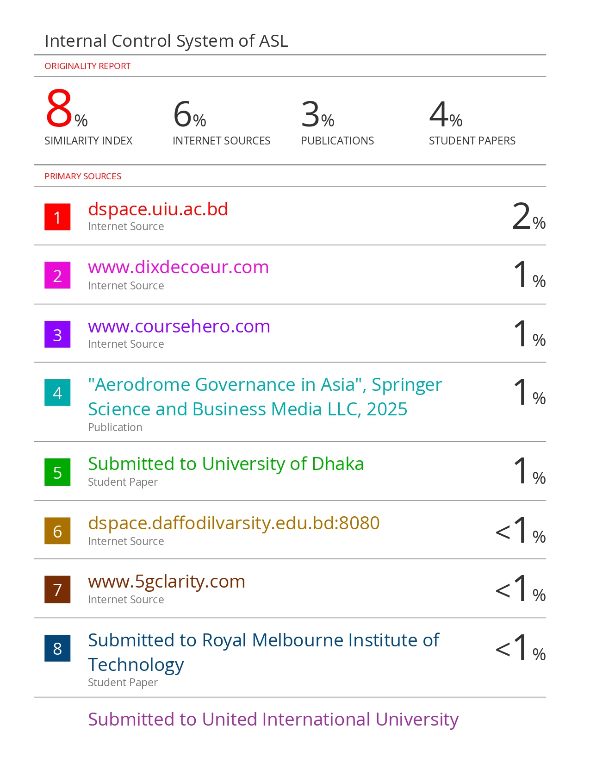

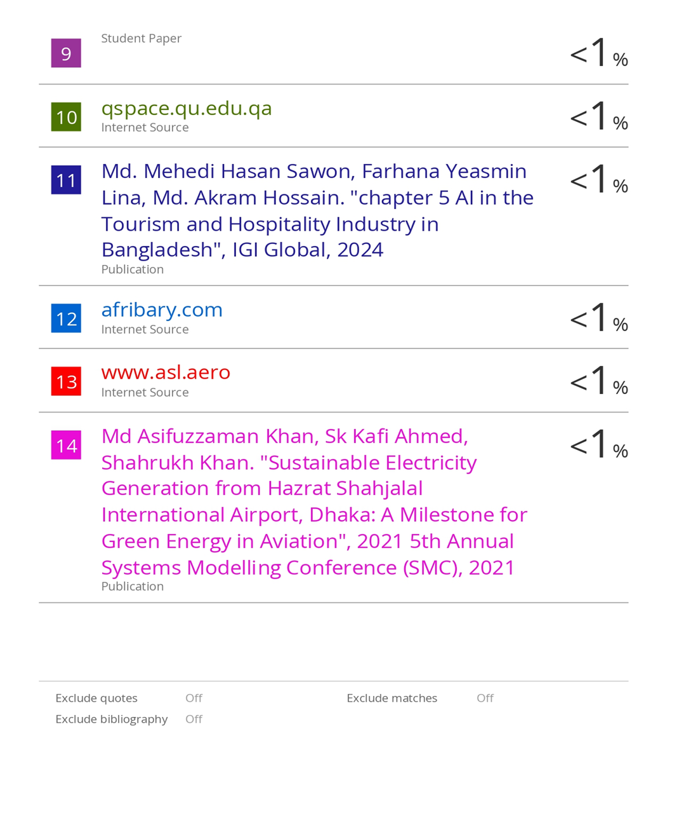

Student’s Declaration

I do hereby gravely announce that the internship report on “Internal Control System of Aviation Systems Limited (ASL) A study on Bangladesh Aviation Industry” has been prepared by myself and has not been before submitted to any other academy.

I, further undertake to indemnify the University against any loss or damage arising from breach of the forgoing obligation.

Yours Sincerely,



…………………..
MD. Shifat Rahman
ID: 111 212 067
United International University

Corporate Evidence

Supervisor’s Declaration

The internship Report permitted “Internal Control System of Aviation Systems Limited (ASL) A study on Bangladesh Aviation Industry” has been prepared by- Md. Shifat Rahman ID: 111212067, Bachelor of Business Administration, United International University.

In preparing this report he spends much time and effort. I wish her every success in life.

………………………………….
Dr. Mohammad Tariq Hasan
Associate Professor
School of Business & Economics
United International University

Acknowledgement

I am Md. Shifat Rahman, I would like to express my heartfelt gratitude to ASL Systems Limited for providing me the opportunity to complete my internship in the finance department of this esteemed aviation support organization.

I want to start by thanking my awesome academic supervisor, Dr. Mohammad Tariq Hasan He’s an Associate Professor at United International University in the Bachelor of Business Administration program. He makes me the right at just the right moments. Plus, his encouragement on my topic was constant and really motivating! Whenever I needed help, he was always there for me.
Next, I’m super thankful to all the people who took part in my surveys. They spent their time with me in the interviews & gave some really helpful answers.
I want to give my heartfelt thanks to my reporting Manager in ASL, Mr. Saddam Hossain Khondokar, for his continuous guidance, support and constructive feedback throughout my internship journey. I would also like to extend my sincere appreciation to Mr. Nazmul Ula, Associate Manager, for his patient supervision, support and valuable insights. My special thanks go to Mrs. Ziliun Sikder and Mr. Nazmul Hossain Atul, Senior Executives, and Mrs. Nusrat Jahan Mim, Executive of finance department for their constant support, cooperation, and friendly assistance during my journey at ASL Systems Limited.

Finally, I genuinely thank Almighty Allah for everything!

Executive Summary

This report provides an in depths analysis on the internal control system of Aviation Systems Limited (ASL), one of the Bangladesh’s leading aviation support and technology solutions provider. This study was a mandatory part of Bachelor of Business Administration (BBA) program at united International University. And this report is based on a three months internship experience in ASL finance department. To gain practical knowledge about how internal control mechanisms functions within a aviation based organization and how these systems contribute to operational efficiency, compliance, and transparency is the main objective of this study. ASL have a major role in the Bangladesh aviation industry through various services like, ground handling, route navigation and permit operation database. ASL POD technology automates the overfly, landing permit process under the regulations of Civil Aviation Authority of Bangladesh (CAAB). This report discovers the organization’s control practices in both financial and technological domains. ASL maintain a strong segregation of duties policy to minimize the fraud and unethical activities and ensure accountability within the finance department. To maintaining system integrity and data security the Technology and Development play a crucial role. Introduce of digital system like POD has significant role to reduce the time, manual errors, improved workflow and enhanced the coordination with the help of regulatory body. In this study identifies some limitations also like slower workflow for multipole audit for one transaction, and lack of communication between the department. To solve those issues, this report recommended several ideas like simplifying the approval chain, organize regular departmental meeting, conduct internal audit in regular basis, and arranging employee training program to improve their work efficiency.

Key words: Internal Control System (ICS), Aviation industry, Bangladesh, Aviation systems limited (ASL), Segregations of duty.

Table of Contents
Letter of Transmittal ii
Certification of Similarity Index iii
Student’s Declaration v
Corporate Evidence vi
Supervisor’s Declaration vii
Acknowledgement viii
Executive Summary ix
List of Acronyms xi
Chapter 1: Introduction 1
1.1 Background and description of the study 1
1.2 Objectives of the Internship Report 2
Chapter 2: Company Profile 4
2.1 Company Overview 4
2.2 Company Profile 5
2.3 Vision, Mission 5
2.4 The Profile of Management Body of ASL 6
2.5 Management & Employee Hierarchy of ASL 7
Chapter 3: Methodology 8
3.1 Approach 8
3.2 Data Collection Methods 8
3.3 Analysis, Limitations, and Ethical Considerations 9
Chapter 4: Discussion on Study Objective 10
Chapter 5: Findings Recommendations & Conclusions 19
5.1 Findings 19
5.2 Recommendation 19
5.3 Conclusion 20
Chapter 6: Internship Experience 21
6.1 Significant Pleasant & Unpleasant Incidences 21
6.2 Internship Understanding 21

List of Acronyms

- Hazrat Shajalal International Airport- HSIA
- Civil Aviation Authority of Bangladesh – CAAB
- Permit operations Database- POD
- Internal Control Systems- ICS
- Maximum Takeoff Weight- MTOW

Chapter 1: Introduction

1.1 Background and description of the study

This is an ‘Internship Report’ prepared as a requirement for the completion of BBA program at United International University. As part of BBA (Bachelor of Business Administration) completion, I completed my three months Internship Program at Aviation Systems Limited (ASL). In educational institute, getting a good education is very important but let’s be honest can be really tough for students to get practical business know-how. Why? Well, it's hard to keep up with those who already understand the world. That's where internships come in! They offer a chance for students to grab some practical experience while working at different places. At United International University, we need to complete a twelve-week internship program. This was not only a requirement but also an exciting opportunity for me!

During my BBA Program, I had the chance to learn how to manage the accounting transaction, how to create the accounting report and I earned theoretical knowledge about how a business organization finance and accounting department manage their work. To gain actual experience and knowledge about how a business organization finance and accounting department manage their work and day to day accounting transaction treatment I joined ASL finance and accounting department as a Intern. In ASL finance department my main job was help my team members to prepare financial report for audit team, record daily transaction in XERO and QORUM software. As my main task was prepare accounting report for audit clearance this task gives me a big opportunity to see the company internal control system (ICS) from closely. And internal control system (ICS) is my topic for this report also.

Throughout my internship report, I will share what it was like to gain knowledge by working closely with the finance team.

1.2 Objectives of the Internship Report

Broad Objectives

The main goals of this study were to develop a clear understanding of how internal control systems function within the Finance, Technology, and Development (Devs) departments. The study aimed to see how these controls contribute to the smooth and efficient delivery of key services such as ground handling, permit processing, and route navigation. It also focused on how these mechanisms help ensure the accuracy of financial information, manage operational risks, and protect IT systems from security threats. In addition, the study sought to identify any challenges the company faces in maintaining effective controls, especially given the highly regulated and sensitive nature of the aviation industry. Finally, it aimed to explore how technology and automation are being used to strengthen oversight and support compliance efforts.

Specific Objectives
To provide a more focused analysis, the objectives were divided by department.

Finance Department

- To understand how financial reporting and budgeting processes align with industry standards and regulatory requirements.
- To examine the systems in place for authorizing transactions and maintaining proper segregation of duties.
- To explore the measures used to prevent and detect fraud, particularly in areas related to ground handling and route operation revenues.
- To assess the role of digital tools and ERP systems in improving financial transparency and accountability.
- To outline the control procedures involved in key financial activities, such as processing permit fees, billing clients, and managing vendor payments.

Technology & Development (Devs) Department

- To review the internal controls implemented throughout the software development lifecycle and data management processes.
- To understand how the department manages system security, including user access controls for platforms related to permits and navigation.
- To assess how project workflows and development activities are monitored to prevent operational disruptions.
- To identify the safeguards in place for integrations with external aviation databases and related tools.
- To evaluate the department’s compliance with IT governance standards and its use of testing and review mechanisms to ensure system reliability.

Chapter 2: Company Profile

2.1 Company Overview

In 1991 ASL Systems began its journey founded by Wing Commander Md. Mahbubul Haq Khan (Retd). ASL Starts is journey as a modest aviation trading company under the name of Aviation Support Limited. Over the years, the company has evolved into a leading provider of innovative aviation and technology solutions, earning a strong reputation for reliability and engineered excellence. With decades of experience, strategic global partnerships, and a deep-rooted passion for aviation, ASL has played a pivotal role in transforming Bangladesh into a recognized regional hub for aircraft operations. Today, ASL Systems continues to serve both commercial and defense sectors, offering integrated ground support and mission-focused IT solutions that align with the company’s core values of integrity, performance, and innovation.

During the 1990s, ASL rapidly earned a reputation as one of Bangladesh’s most reliable providers of aircraft component repair and overhaul services, supporting both commercial airlines and military aviation sectors. Over the past 20 years, ASL has forged strong partnership with international experts to deliver engineered aviation solutions tailored to both national and commercial clients. Inspired by the founder’s lifelong passion for aviation, ASL played a significant role in positioning Bangladesh as a key operational hub for aircraft services in the region. In 1997, ASL launched its Ground Support Division, offering comprehensive, turnkey services for Defense and VIP operators. By the late 2000s, the company had expanded into the technology sector, aiding national efforts to digitize operations through mission-focused IT systems and hardware integration. Today, ASL stands as a leader in both aviation support and technology innovation. Its strong track record, visionary leadership, and commitment to quality have shaped long-standing partnership and reinforced the company’s core values of performance, integrity, and innovation.

2.2 Company Profile

Name of the Company | Aviation Systems Limited (ASL)
Address of the Head Office | House No. 1&3, Road # 21/C, Nikunja-2,  Khilkhet, Dhaka-1209
Address of the Airport Office | Room No-105, ATC Tower Building, Hazrat Shahjalal  International Airport, Dhaka.
Website | http://ww.asl.aero/
E-mail | info@asl.aero
Table1: Company Profile

2.3 Vision, Mission

Vision | ASL aim at being true specialists in the field of aviation services and technologies. ASL deliver commitments through loyalty, trust and value to their clients. ASL aim to become an internationally recognized aviation  company by providing industry leading solutions to their customers.
Mission | ASL view their as partners with their customers and the aviation community. ASL mission is to excel in the industry by combining the most talented work force with professional management practices. Above dominance in this  industry, we want to be the most dependable partner for all their customers.
Table2: Vision & Mission Statement

2.4 The Profile of Management Body of ASL

S/L | Name | Designation
1 | Shaheda Yesmin | Chairperson
2 | Mr. Zubayer Mahbub | Managing Director
3 | Mehnaz Tabassum | Director
4 | Mr. Rakibul Aziz | Vice-President
5 | MR. Zakir Hussain Khan | General-Manager

Table 3: Profile of Management Body of ASL

2.5 Management & Employee Hierarchy of ASL
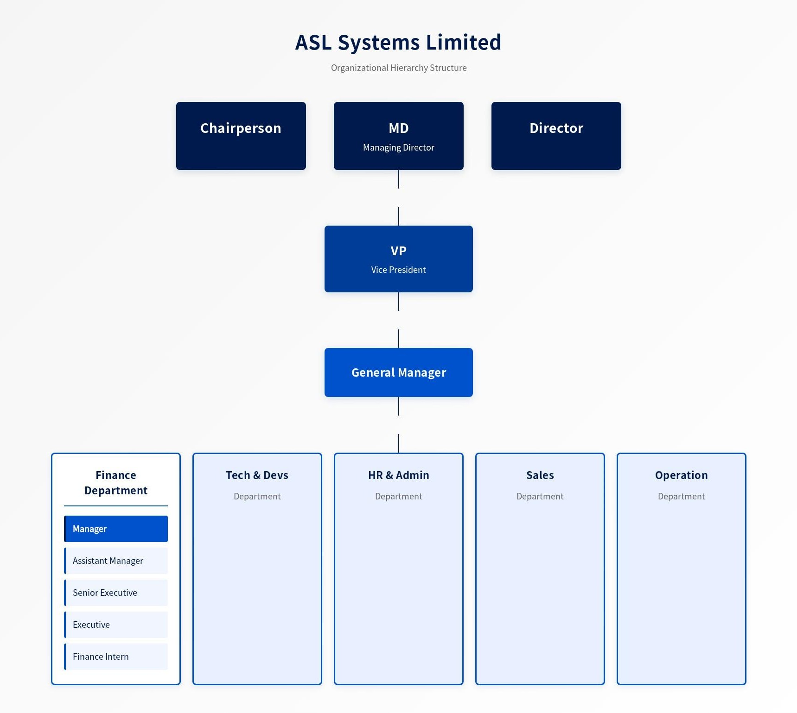

Chapter 3: Methodology

3.1 Approach

This chapter explains the methods used to review the internal control systems within the Finance, Technology & Development departments. The study mainly followed a qualitative approach, focusing on observation, discussion, and interpretation of process rather than solely relying on numerical data. The main objective was to understand the underlying mechanism and rationale behind departmental system. The limitation of study is focusing on routine operations of the Finance and Development departments within aviation support services.

3.2 Data Collection Methods

A combination of participation of day-to-day activities and review of document was used to collect data.
Primary Information: The main source of information came from direct engagement with staff members. Informal interviews and conversations were conducted with personnel from both departments to gain insight into their work practices. Observations of daily activities provided a deeper understanding of how tasks were initiated, approved, and executed. Participation in certain routine processes also offered a hands-on perspective of the internal control environment.
Secondary Information: To complement these findings, internal company documents such as process manuals, Standard Operating Procedures (SOPs), and financial reports were reviewed. In addition, external aviation authority regulations—particularly those issued by the Civil Aviation Authority of Bangladesh (CAAB)—were examined to understand the compliance framework within which the organization operates.

3.3 Analysis, Limitations, and Ethical Considerations

The data analysis focused on identifying recurring patterns within the existing control mechanisms and comparing operational practices across departments. Certain limitations were noted, such as restricted access to confidential financial information and limited visibility into detailed IT security protocols. Additionally, time constraints prevented full participation in comprehensive system audits. Consequently, the findings were based on the information made available and on direct observations conducted during the study period.

Throughout the study, ethical standards were strictly maintained. All information was collected with proper authorization, and confidentiality of business data was preserved in accordance with the organization’s internal policies. Transparency, professionalism, and respect for all participants were upheld at every stage of the process.

Chapter 4: Discussion on Study Objective

POD or Permit Related Internal Control
ASL basically work for unscheduled flight like overfly, chartered, cargo and military operation flight. Every flight has two types of activities 1st and most important getting the permission 2nd ground handling related. ASL work on both of these two fields from beginning of its journey. In Bangladesh aviation industry ASL brings a positive change from manual system to automated permission system. One of ASL significant product is POD (Permit Operation Database). ASL earned most of the revenue from POD sells. So, pod have a huge impact on ASL internal control system (Lane, Bird, Armstrong, Miller, & Brittingham, 1998; Starkova & Boldycheva, 2024).

The Challenge of Traditional Permitting
Getting the permission of overfly and landing for unscheduled flight in Bangladesh is always have been difficult and slow process. The system is old and rely on paper-based document that have to be physically passed from one table to another table for approval. This manual process creates huge human delays, and some time it takes two to four weeks for one permission. This old problem is not only slow but also surrounding of lots of human mistake. Which brings lots of planning problem for airlines. And due to small amount of permission government loses a huge amount of revenue from the aviation sector.

A Digital Solution by ASL System Limited
ASL System Limited built the Permit Operation Database (POD) to solve these challenges. It's a new software that replaces the old paper-based permit system. POD moves the entire process online. It manages everything from the first application to the final approval by the Civil Aviation Authority of Bangladesh (CAAB). The goal of POD was to make a single, fast, and straightforward way for airlines to get permits, making the process quicker and cutting down human mistakes. The Civil Aviation Authority of Bangladesh (CAAB) accept this software and make it mandatory for all its registered agent to use POD for all overfly and landing request (Dias, 2024; Metayer, 2025).

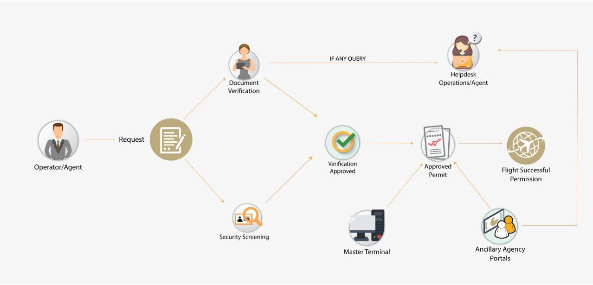
The Procedure or Workflow of POD

The Security Screening process of POD

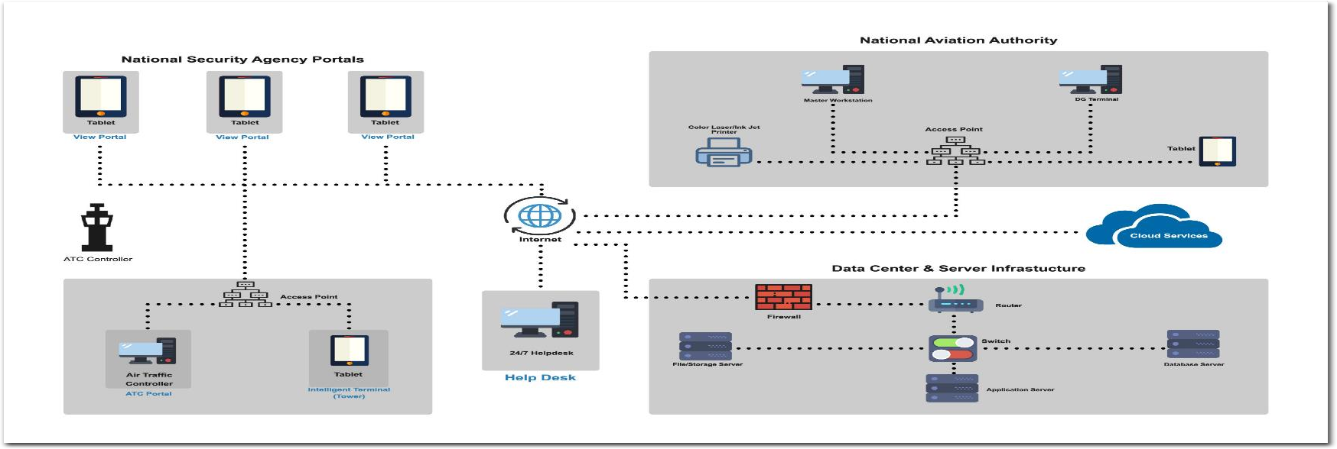

Tech & Devs Team responsibility in POD process
The initial task of pod process in done by tech & devs team. They designed this program and run this program for ASL. They receive all the request from agent and airlines and transfer those requests for initial security screening. After security check they transfer those requests to CAAB for final approval. In this process tech & devs team recorded some important information about the flight like name of the airlines, purpose of the flight, MTOW (maximum takeoff weight), flight number, call sign etc. And they are not responsible for any kinds of financial transaction. The financial part is totally separated from them. After completion of all their process they submit a daily report to finance team and also CAAB. Then finance team start their work based on that report.

Pod report sample

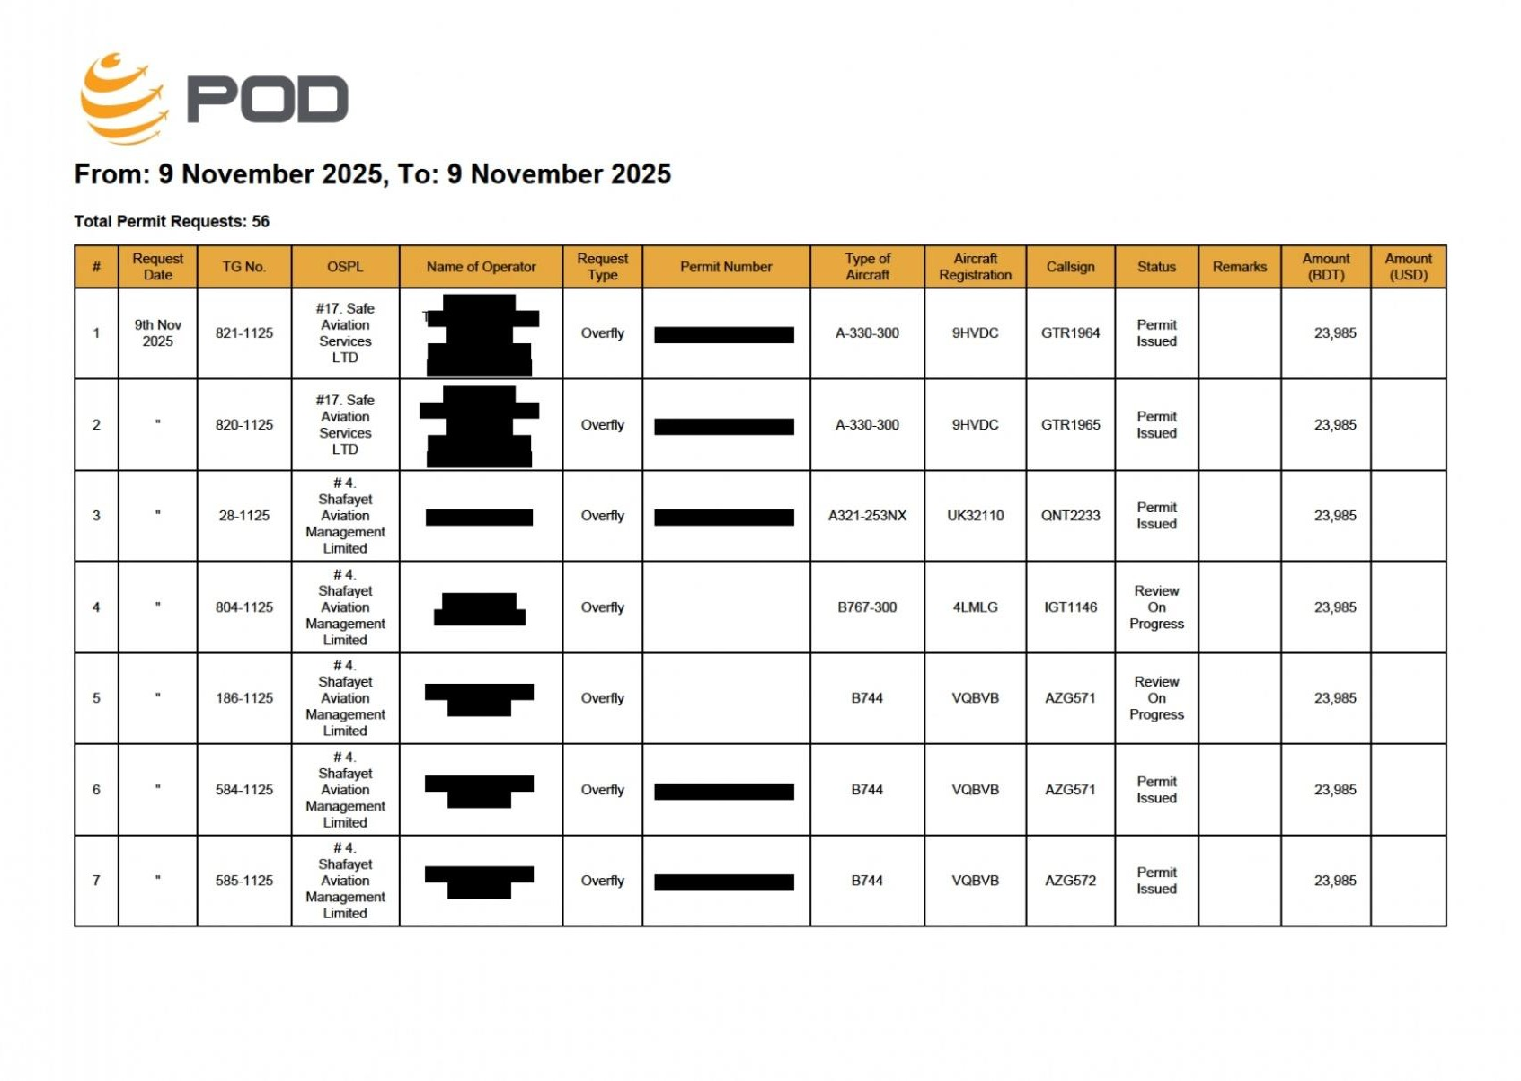

Finance Team responsibility in POD process

As early mentioned ASL earned most of its revenue from POD sells or permit so finance department has an important role on this process. ASL collect all the amount from airlines for CAAB and distribute this amount towards VAT, TDS, CABB portion and ASL royalty. So, there is a huge risk of manipulation of financial data in this process. Here comes the strong internal control system of ASL (Ashif, Mahmud, & Hasan, 2013). ASL mainly focused on segregation of duty system. Not a single person is responsible for a single financial task. To collect and distribute the revenue a group of people including the Director and MD is participate to complete the task. For recording and tracking the financial transaction ASL use XERO accounting software. In this software there is a strong security process to approve any transaction. The airlines or the agent send their overfly or landing fee through ASL several bank account. Then ASL receive those amounts and accumulated them and send into another account. The finance team accumulated all the amount for ASL and create one big transaction to send this amount ASL permanent account. And at least 3 person of finance team participate with this task. And finally, the MD of ASL approve this transaction. This task performs daily basis. After deposit the transaction in bank account the finance team collect the bank statement from the bank and record this transaction in XERO. One team is responsible for record the transaction and upload the bank statement for reconciliation. Another team is responsible for reconcile those transaction (Ashif et al., 2013; Hasan, Miraz, Sumi, & Sarkar, 2021). So ASL maintain segregation of duty here for control (Hasan, Molla, & Khan, 2019). And not only the transaction is recorded also transaction related document like bill, voucher, money receipt, bank statement is uploaded along with the transaction. And finance team submit this financial report to CAAB on monthly basis.

Ground Handling Related Internal Control
The 2nd most important revenue generating field for ASL is provide ground handling related service for unscheduled flight like arranging push-car, lighting, night stay security, accommodation and catering for crew. For complete those task ASL charged a management fee. This management fee is a big part of ASL overall revenue. So, there is also a huge risk of manipulation data and fraud activities. With the help of a case study about ground handling related task try to give a lesson of how that task is perform, and how prevent fraudulent activities.

Case study: Unscheduled landing of Omni Air at HSIA
Omni Air International, Boeing 777-200ER, Flight no: OY854 want to operating a charter flight for US-based logistic firm. Their requirement is urgent, non-scheduled landing permission for cargo offloading and crew rest at Hazrat Shahjalal International Airport (HSIA), Dhaka. ASL System Limited a licensed agent of the CAAB managed this operation. ASL responsibility is to facilitate the landing permit, navigation clearance, and complete ground handling services efficiently and profitably. The flight request come into ASL’S operation desk with a 48-hour notice. ASL authority immediately engaged finance and tech & devs department for complete this flight operation.

The role of Finance Team:
The Finance Team's primary role is to ensure the entire operation is commercially viable, compliant with financial regulations, and that all revenue is collected. Before start any flight related work, the finance team conducts a rapid credit assessment of Omni Air International. As a known international carrier, they are low-risk, but for a new client, this step would be critical. Simultaneously, they prepare a pro-forma invoice or a detailed quotation. This isn't just a single number; it's a breakdown of all expected costs. Those cost can be:

CAAB Fees: Landing, parking, and navigation charges (calculated based on the aircraft's Maximum Take-Off Weight - MTOW).
Ground Handling Charges: A detailed list including ramp services, passenger stairs, cargo loading/offloading, lavatory and water services, and crew transport.
ASL Service Fee: A percentage or flat fee for coordinating the entire process. This quotation is primarily sent to ASL top management for approval if there is any update then finance team update the invoice based on management criteria then the approved pro-forma invoice sent to Omni Air's operations center for immediate approval.
After get a green signal from the client ASL finance team start work about cost management and payment guarantees. Finance team is responsible to manage the cash flow for the operation. Finance team arrange for the pre-payment of the required fees to CAAB to secure the landing permit. For an unscheduled flight, ASL's policy, driven by the finance department, requires arrange 100% money from various source to cover all the budgeted cost they estimate earlier. Though this maximize ASL's financial risk.
Once the aircraft has been serviced and departs, the finance team generates the final invoice. They reconcile the actual costs like longer than expected parking time, or add more catering products against the quotation. Some day after the operation, the finance team conducts a post-flight financial review. They generate a report from Xero to calculate the exact profit margin on the entire service provided to flight OY854. And report this data to ASL top management for approval. This data is vital for strategic decisions, helping management understand which types of unscheduled flights are most profitable and refining future quotation models.

The role of Tech & Devs Department:
The Tech & Devs department is the digital backbone of the operation, ensuring that the process is fast, secure, and efficient through technology. The initial request from Omni Air arrives via a secure email or through an online portal managed by the Tech & Devs team. They ensure the communication channels are encrypted and reliable. Most importantly, they manage the API integration or the secure login to the CAAB's online portal. They are responsible for ensuring that ASL's system can communicate with CAAB's system regularly to submit the landing permit application without any technical issues, which is vital for a time-sensitive request. The department manages the central database where all flight information is stored.
Once the permit is approved, the Tech team ensures that the relevant data (approved landing time, parking bay number, ground handling requirements) is pushed to the mobile devices or tablets used by the ground handling crew. This real-time data flow prevents errors and ensures the ground team is prepared for the aircraft's arrival. Throughout the process, the Tech team provides 24/7 support. If the operations team cannot upload a required document to the CAAB portal, or if the ground crew's app isn't updating, the Tech team is on standby to troubleshoot and resolve the issue immediately. They are responsible for the uptime and performance of all critical software (Miraz, Hasan, Sumi, Sarkar, & Hossain, 2022).
In this case, the Finance and Tech & Devs departments work in perfect synergy. The Finance team cannot generate an accurate quote without the operational data managed by the Tech team's systems. The Tech team cannot get budget approval for a new client portal without a clear financial justification and ROI analysis from the Finance team. Together, they transform a complex, high-pressure request into a seamless and profitable business transaction, reinforcing ASL System Limited's position as a reliable and technologically advanced agent for CAAB.
Measure of Internal Control to prevent fraudulent activities in ground handling
Ground handling services for non-scheduled flights represent one of the most significant revenue- generating activities for ASL System Limited (ASL). However, because these operations involve multiple cost components, third-party coordination, and urgent decision-making, they also carry inherent risks of data manipulation, inflated billing, unauthorized service charges, and misappropriation of funds. To safeguard revenue integrity, ASL has developed a structured internal control framework integrating departmental responsibilities, system-based verification, and financial compliance checks. The case of the non-scheduled landing of Omni Air Flight OY854 at HSIA demonstrates how these controls operate in practice.
Segregation of Duties: ASL always ensure one thing that is critical operational functions are divided across more than one department to reduce the risk of internal collusion and fraudulent decision making. For this case finance team is responsible for cost estimation, invoice preparation, cash flow planning, and final revenue reconciliation. Tech & Devs department manages system access, data recording, and secure communication with CAAB and ground handling units. And operation department is responsible for execute field-level handling activities but do not control financial approvals or billing adjustments.

Evidence-Based cost estimation and approval workflow: Before starting any work, the Finance Team prepares a detailed pro forma invoice. The pro forma invoice is submitted to top management for approval. Any modification or discount must be documented and justified, preventing the unauthorized cost manipulation or informal pricing arrangements.

Pre payments and revenue protection measure: To minimize the risk of unpaid bills or operational loss, ASL maintain a policy of securing full or guaranteed funds before conducting the flight. For this case ASL finance team arranged advance payments to CAAB and aligned funding for service delivery. This policy prevents ASL from the financial loss that could result from post service payment disputes or default by clients.

Post flight reconciliation and profitability review: After complete all the flight related task, the finance team compare initial costing estimation with actual incurred expenses, adjust any differences like extended parking time or additional crew cost, create a final invoice based on documented evidence like CAAB & BFC catering bills only. This reconciliation process ensures transparency and provides management with oversight to detect any unusual cost difference, potential invoice manipulation or operational inefficiencies.

Through well-defined role segregation, secure digital process management, structured financial control, and continuous performance review, ASL System Limited effectively mitigates fraud risk within ground handling operations. The case of Omni Air Flight OY854 demonstrates how these controls support both operational efficiency and financial integrity. By maintaining strong internal control procedures, ASL not only protects its revenue stream but also strengthens its reputation as a reliable and compliant aviation service provider.

Chapter 5: Findings Recommendations & Conclusions

5.1 Findings

During the internship period at ASL System Limited, I get a chance to closely observed the working procedure of ASL. I observed that ASL maintains a structured and also effective internal control system to prevent the fraud and unethical activities. Mainly they strictly flowed segregation of duties policy for ensuring and minimizing the financial and technological risk. They use XERO and Quorum for financial recording and reporting and use POD for permit operations. Use of this technology improves ASL overall efficiency and transparency in financial transaction and permit operations.

Though they have a strong internal control but also some weaknesses still exist. The high level of segregation most of the time slow down the work speed because a single transaction needed multiple approvals. Because of this some time it’s delay the payment to vendor. And it’s difficult to take some instant decision. There is also limited communication towards the departments, which cause delay the internal data transfer and decision making. And another thing is manual verification is still needed for certain financial records, which increases the workload and risk of human error also.

5.2 Recommendation

I want to suggest some solutions based on what I've seen during my time here (as I mentioned earlier). Here’s what I think could help:
They can reduce some unnecessary steps in segregation and approval process while keeping essential check place to reduce the work time. They can arrange some joint and inter department meeting to share insights and ensure smooth information flow. They can arrange periodic internal audits that can identify process delay and that can suggest some practical control improvements. And at last, they can arrange some employee training program on time management and skills that can improve the employee efficiency.

5.3 Conclusion

Internship act similar like a bridge between learning in school and doing real work. Looking back, my time here was really fantastic. I met so many amazing people here who could help me later on job or any types of opportunities. And ASL Systems Limited give me a valuable opportunity to understand how internal control system function in professional aviation industry. ASL System limited successfully run a strong financial system which supported by technology. And that technology ensures transparency and accountability also.

Though some of the control procedure consume time and communication gap affect the work efficiency. But ASL is committed to serve with compliance, accuracy and ethical consideration. With the help of regular system integration and more coordination, ASL can achieve more balanced internal control. And that make the path easy for ASL to achieve their vision.

Chapter 6: Internship Experience

When we conclude our studies, we’ll all step into a professional life. So, interning somewhere is a great opportunity to practice what we actually learned at our classroom while soaking up corporate culture. I was very lucky to get a chance to complete my academic internship at Bangladesh top most aviation service-based company ASL. In corporate culture environment is totally different from our academic institute. Here every desk had a specific job assigned and every person took responsibility seriously. I learned so much while collaborating with my colleague and the helped me to grow professionally & personally. During my time at Nikunjha ASL headquarter more than three months, it was truly fantastic. I loved my task and try to help the organization from my end. And in ASL from the staff to MD sir, I found them friendly and helpful.

6.1 Significant Pleasant & Unpleasant Incidences

Significant Pleasant Incidences: The significant pleasant incident is to see how a company work hard when it’s audit time. And how they work hard to prepare all the transaction related soft and hard copy. Another one is how they seriously handle vat & tax related issues.

Significant Unpleasant Incidences: The significant unpleasant incident is some employee’s behavior is very impolite. They do not help out intern students.

6.2 Internship Understanding

During my internship in a corporate organization. I learn many things beyond my studies. Frist of all I learned how to act in a corporate environment. How to deal with various real life accounting transaction. Secondly, I learned some software technique mainly use of Xero accounting software. Also learned advance level of Ex-cell. Those learning help me in my future career growth.

References

Ashif, A., Mahmud, M., & Hasan, M. (2013). AIS Requirement and Capacity, an Understanding of AIS Alignment: Evidence from Bangladesh. International Journal of Applied Research in Business Administration and Economics, 2(6), 22-31.
Dias, C. A. S. (2024). Smart Airports: Analysing Digital Transformation and Technological Advancements in Aviation.
Hasan, M. T., Miraz, M. H., Sumi, F. R., & Sarkar, S. (2021). A Blockchain Research Review. Financial Risk and Management Reviews, 7(1), 26-35. doi: 10.18488/journal.89.2021.71.26.35
Hasan, M. T., Molla, M. S., & Khan, F. (2019). Effect of board and audit committee characteristics on profitability: Evidence from pharmaceutical and chemical industries in Bangladesh. Finance & Economics Review, 1(1), 64-76.
Lane, F., Bird, R. B., Armstrong, J. L., Miller, C. M., & Brittingham, S. R. (1998). Internal Controls and Compliance With Laws and Regulations for the DOD Consolidated Financial Statements for FY 1997.
Metayer, S. (2025). Digitizing Training Records at XYZ Air Cargo Company: Enhancing Operational Efficiency, Safety, and Compliance Through Digital Transformation in Aviation Training Management. St. Thomas University.
Miraz, M. H., Hasan, M. T., Sumi, F. R., Sarkar, S., & Hossain, M. A. (2022). Industry 5.0: The Integration of Modern Technologies Machine Vision for Industry 4.0 (pp. 285-300): CRC Press.
Starkova, M., & Boldycheva, A. (2024). Internal control in the aviation industry enterprise. Russian Engineering Research, 44(2), 265-269.

Online sources:
ASL Systems Limited. https://www.asl.aero/

Civil Aviation Authority of Bangladesh (CAAB https://caab.portal.gov.bd/

Hazrat Shahjalal International Airport (HSIA https://www.hsia.gov.bd/

POD Aero. (n.d.). Permit Operation Database (POD https://pod.aero/

United International University (UIU https://www.uiu.ac.bd/

OAI Aero. https://www.oai.aero/

