
Internship Report on
Miaki Media Limited


 | Payment Transaction Tracking & Processing of Miaki Media Limited
 | Course Title: Internship
 | Course Code: AIS 4441


Under the guidance of
Ms. Ishrat Jahan
Asst. Professor - BBA Program
School of Business & Economics
United International University

Submitted By
Mst. Shaila Naznin
ID: 114 142 006
BBA in AIS
Fall- 2014


UNITED INTERNATIONAL UNIVERSITY


LETTER OF TRANSMITTAL

12th February 2019

ms. ishrat jahan
Asst. Professor - BBA Program
School of Business & Economics
United International University

Subject: Submission of Internship Report

Dear Ma’am,

With great gratification I am submitting my internship report on “Tracking & Processing of Payment Transactions in Miaki Media Limited” that you have doled out me as a fundamental necessity of Internship program. It is extremely a gigantic prospect for me to gather vast information and handle the topic in a fitting way. I have discovered the examination is quite fascinating, gainful and canny and attempted my dimension best to set up a compelling &creditable report.

I truly, not just foresee that my examination will help to give an unmistakable thought regarding the overall state of “Payment Transaction Tracking & Processing of Miaki Media Limited”, yet additionally optimistic enough to trust that you will discover this present report's value for all the work I have put in it. I welcome your whole question and take pride to answer them.
Yours Sincerely

______________________
Mst. Shaila Naznin
ID: 114 142 006
BBA in AIS



“Acknowledging the debt is not easy for us as we are indebted to so many people”. I take this opportunity in expressing the fact that this project report is the result of incredible amount of encouragement, co-operation, and moral support that I have received from others.”

ACKNOWLEDGEMENT
In the readiness of this Internship Report, I might want to recognize the encouragement and help given to me by various individuals.
I am most thankful to my entry level position director MS. ISHRAT JAHAN for giving detailed input and support all the time on this report.
I would like to express my gratitude to Mr. Anisur Rahman (Senior Executive, Finance), Muhammad Nurul Hassan (Head of HRM) and Kashfia Ahmed (Chairman of Win Miaki) of Miaki Group. Thanks to them for helping me with the relevant information about the Payment Transaction Tracking of Miaki Group that I needed to prepare this report. Without their contribution, it would not have been possible for me to conduct this project work.
I would like to thank my friend Afroza Hossain Anni and Mahadi Hasan Shakib who helped me greatly to complete this paper.
Lastly, I might want to state that I have attempted and soul to set up this report precisely. Be that as it may, there may be a few blunders and senseless oversights because of my bent and time requirement. In such manner, I look for your thoughtful thought and I am learning.


EXECUTIVE SUMMARY

This temporary job report has been set up to satisfy the necessity for the getting BBA in AIS degree. As a piece of our course it is obligatory to engage with an association for a specific timeframe get the commonsense learning following our finishing of BBA in AIS program. As I was a worker of Miaki Media Limited, I was doled out to chip away at “Tracking & Processing of Payment Transactions in Miaki Media Limited” Payment transaction tracking is a computer and manual work. Every company needs to make payment to its vendors on a daily basis. After a certain period of time, the vendor sends a bill for payment. Then the company needs to make a payment request on the basis of source documents. After preparing the payment voucher, it needs to be signed by different persons of different departments.

According to my topic, I will discuss the payment transaction processing of Miaki Media Limited. The entire attempts to finish my examination have been isolated into 5 sections. In section 1 I gave foundation of the investigation. Part 2 covers the foundation of the association. Section 3 covers my activity obligation, part 4 covers discoveries and investigation and part 5 incorporates suggestion and finish of the examination. This section clarify my working in Miaki Media Limited which shows my powerful learning through the temporary job program.


TABLE OF
CONTENTS
Table of Contents
LETTER OF TRANSMITTAL I
ACKNOWLEDGEMENT II
EXECUTIVE SUMMARY III
Chapter One: Background of the Study 2
1.1. Introduction 3
1.2. Origin of the Report 3
1.3. Purpose of the Report 3
1.4. Objectives of the Report 4
1.5. Literature Review……………………………………………………………………….…..4
1.6. Methodology of Data Collection 5
1.6.1. Research Type 5
1.6.2. Primary Sources of Data 6
1.6.3. Secondary Sources of Data 6
1.7. Limitations of the Report 6
Chapter Two: Organizational Background 7
2.1. History 8
2.2. Corporate Information 9
2.3. Vision 9
2.4. Sister Companies 10
2.5 . Nature Of Business Activities……………………………………………………………...11
2.6. Services 11
SMS Services: 11
IVR Services: 11
Call Center Services: 12
WAP Content: 12
2.7. Clients 13
2.8. Global Presence……………………………………………………………………………..14
2.9. Organogram………………………………………………………………………………...14
2.10. Team………………………………………………………………………………………..16
Chapter Three: The Job 17
3.1. Nature Of Job……………………………………………………………………………….18
3.2. Job Description 18
3.3. Different Aspects Job Performance 19
Chapter Four: Findings & Analysis 20
4.1. Findings 21
4.1.1 Tracking Data in Excel File from November2018 to December 2018 21
4.2. Analysis: 22
Chapter Five: Conclusion 26
5.1. Conclusion 27
REFERENCES: 28
APPENDIX 01 29
APPENDIX 02 30
APPENDIX O3 31
APPENDIX 04 32
APPENDIX 05 33
APPENDIX 06 34
APPENDIX 07 35
APPENDIX 08 36
APPENDIX 09 37
APPENDIX 10……………………………………………………………………………………...…38



Chapter One: Background of the Study


Topics to be covered:
- Introduction
- Origin of the Report
- Purpose of the Report
- Objectives of the Report
- Methodology of Data Collection
- Limitations of the Report

Chapter One: Background of the Study

Introduction

A transaction is an agreement between a buyer and a seller to exchange goods, services or financial instruments. In accounting, the events that affect the finances of a business must be recorded on the books, and an accounting transaction will be recorded differently if the company uses accrual accounting rather than cash accounting. Accrual accounting records transactions when revenues or expenses are realized or incurred, while cash accounting records transactions when the business actually spends or receives money. Transaction tracking is a system that protects data by undoing incomplete transactions due to software and/or hardware failures. When a transaction is undone, data is returned to its previous state. Transaction tracking can be manual or computerized.

Origin of the Report

This report has been prepared to make a study on the ““Tracking & Processing of Payment Transactions in Miaki Media Limited”” as a part of the fulfillment of Internship Report required for the BBA in AIS program of the School of Business and Economics of United International University.
The report was prepared under the supervision Mentor MS. ISHRAT JAHAN, Assistant Professor of BBA Program of United International University. I am very much thankful to her for assigning us such types of project work.

Purpose of the Report

The purpose of the study is to make an analysis of the payment transaction tracking of Miaki Media Limited. The study attempted to understand the process from receiving of payment request from vendor to making the voucher for the vendor.

Objectives of the Report

There are two main objectives behind this report.
Primary (or Academic) Objective: The essential target of the investigation is to finished the incomplete prerequisite of the granting of the BBA IN AIS degree from the School of business and financial aspects, United International University.
Secondary (or study) Objective:
- To understand the process of making a payment request
- To understand the process of writing a voucher
- To understand the payment of a voucher
- To understand the process of payment request tracking
- To understand the process of checking the genuineness supporting documents
- To understand how to check the payment request from vendor
- To understand the process of checking, authorizing & signing a voucher

Literature Review
Versatile Payments these days assume a vital job in each exchange at the individual dimension and expert dimension. An expanding number of individuals are using their cell phones for installments, cash exchange, exchange and business consistently. This has prompted a fast development in the improvement of different portable installment models and frameworks. Real research endeavors were embraced lately to manufacture a protected versatile installment arrangement. Flow look into on versatile installment frameworks basically center around the innovative parts of the framework, especially those that are identified with the usefulness and usage issues. Lately, the focal point of the examination has moved to the business parts of versatile installments, for example, client appropriation process, qualities and shortcomings of the current framework including different measurements to be specific transaction costs, size of installments, installment time and security.
A few examinations have been directed till as of late to actualize all the more successfully secure versatile installment framework in differentiated applications. Distinctive portable installment frameworks are concerning precedents cell phone-based framework. Supporter Identity Module (SIM) or Smart card-based framework, Point-of-Sale (POS)- based framework, and Mobile wallet are found in the market [Britto et all 2009]. The Mobile Phone-based framework can be arranged further into Bank Account-based System, Credit Card based System and Mobile Network Operator (MNO)- based System.
The payment system commences with the user generating a single-use certificate of payment at their terminal .The user receives on a second terminal ,for example ,a mobile phone, a confidential password which they then at their main terminal.
A mobile payment method designed to facilitate payment and transaction in addition to credit card and debit card, which includes the steps of receiving a payment request in an operation center from a registered merchant through the communication network, requesting the registered merchant, through the communication network, to inform a customer ID of a customer, verifying a merchant ID of the registered merchant, confirming the payment request, requesting customer to verify the payment transaction, confirming the registered merchant whether the payment request is issued.
The virtual credit cards terminal includes a credit card reader, a processor such as personal computer, and transaction programs for running an interactive terminal window. Upon election to pay by credit card, the merchant launches a java applet program on the purchaser’s personal computer to open an interactive window. Information is entered and sent through a gateway to the purchaser’s credit card bank. The relevant bank processes the transaction and provides the gateway with indication whether the transaction is approved. The gateway serves to coordinate and accumulate information from the purchaser and the merchant.

Methodology of Data Collection

In leading this examination the accompanying strategy was embraced in gathering information and data just as readiness of the reports.

Research Type
This is a Descriptive Research, which briefly reveals the overall activities of Miaki Media Limited and also critically analyzes the “Payment Transaction Tracking & Processing” of this organization. To prepare this report all the necessary information collected from both primary and secondary sources of data.

Primary Sources of Data

In the readiness of this report, information was gathered from various essential sources. The procedures were utilized to gather information are:

Perception while working at Finance office

Casual Discussion with workers and customers

Center Group talk

Secondary Sources of Data
- Internal Sources: Miaki Media Limited Website, Source Documents
- External Sources: Books, Articles, Journals, Web browsing.

Limitations of the Report
Despite the fact that I have given most extreme exertion to set up this paper yet there are a few impediments of the study. Such are as per the following-
- The fundamental compel of the investigation was deficiency of data. Since credit is delicate dept. therefore association worker can't give all fundamental data because of security and other corporate commitments.
- The data sources with respect to this investigation are less expansive. It would be progressively right if the investigation direct with expansive data sources.
- Time will be a major constraint in accumulating all sorts of information in an organized way.
- Scope of our study is so wide that analytical and comprehensive study is not possible.



Chapter Two: Organizational Background

Topics to be covered:
- History
- Corporate Information
- Vision
- Sister Companies
- Nature of Business Activities
- Services
- Clients
- Global Presence
- Organogram
- Team

Chapter Two: Organizational Background

“We started business in 08-Dec-2010 with a vision to become pioneers in providing the best user experience for mobile value added services in the country. We have a reputation of providing innovative content and services for Health, Agriculture, Education and Entertainment through SMS. We have qualified resources for providing the services as per the needs of the market and consumers. We always strive to exceed our customers’ expectations with our commitment towards project delivery and 24/7 support service.”

History

Miaki Media gather is make out the joining of three extraordinary personalities that lounge around a table to see how might one contribute back to society while making a feasible structure lasting into what's to come. Miaki Media Ltd. (MML), is one of the gatherings of organizations of Bangladesh, inseparably with a corporate business person Taro Araya, has made what it effectively names as an advancement center point on consistent "startup mode". Miaki media Ltd. has been effectively working its business from 2-Dec-2010 with a sole circulation specialist of Caterpillar Inc. USA items. BTL has particular business task in Power Engineering, Power Plant, Telecommunication and Commercial division of Bangladesh and accordingly the family driving such development has in its underlying foundations been propelled by supportable business rehearses and a business person mindset. By uniting and getting to be not a carport start up but rather an optimized startup, MML has not just increased the value of the nearby and universal brands yet in addition added to the gathering with a striking impression in the immense media transmission division with an extreme mastery in portable substance and esteem included administration. Miaki Media Limited is appropriately consolidated under the laws of Bangladesh and the Companies Act 1994 and its history is being composed presently.

Corporate Information

Miaki Media Limited (MML)
Miaki Media Limited (MML) is the registered company in Bangladesh, as per the Company Act, 1994. Following are the details legal information of Miaki Media Limited
Legal Name | : | Miaki Media Limited
Incorporation No | : | C-88705/10
Trade License No | : | 03-065694
Tax Registration (TIN) No | : | 277810920594
VAT Registration No | : | 5101124752
Area Code | : | 180303
Establishment date | : | 08 Dec, 2010
Registered address | : | Plot # 68 (old-45),Block # H, Road # 11, Banani, Dhaka.
Miaki Myanmar Limited (MML)
Miaki Myanmar Limited (MML) is the registered company in Myanmar, as per the Myanmar Company Law. Following are the details legal information of Miaki Myanmar Limited:
Legal Name | : | Miaki Myanmar Limited
Incorporation No | : | 752 FC 2015-2016 (YGN)
Establishment date | : | 21st December, 2015
Registered address |  | Bulding-14, 15th Floor, MICT Park, Hlaing Township, Yangon.

  - Vision
We have always succeeded in business by offering consumers another way, a better way and being willing to fight their corner. The world is changing everyday but we have moved with the times and we have always listened to what people want. One thing has remained true; our belief in the power of entrepreneurship and innovation to help us rise to the new challenges that we all face. Our vision is to "CREATE HAPPINESS" with our customers, employees, society and stakeholders. – Surely a vision worth aspiring to. With businesses spanning many sectors and touching many aspects of our customers’ lifestyles we feel that Miaki Media Ltd. is in a perfect position to contribute to this vision. Our goal is to attract the best talent pool with vision, creativity and energy to lead the changes that take place in the communications industry each day.

Sister Companies
 | 
Bangla Track Miaki VAS  Providing media related information service through Call Center | Bangla Track Miaki Green Power  Providing power solutions everywhere in Bangladesh.
 | 
Win Miaki Ltd.  ICT based integrated solution provider for Farmers/ Agriculture | Miaki Digital  ICT based digital service provider

Nature of Business Activities

The prime goal of the organization is to carry on the business identified with ICT (Information and Communication Technology ) based media administrations which incorporates Satellite Communications, Mobile correspondences, Digital Radio and Television , Digital Content Development, Telecommunication Networks, including LAN,MAN, VAN and PSTN, web services, Mobile Services, including voice, information and sight and sound administrations for business and home applications, administrations to Fixed-terminals, Future Service and Systems, Analog to Digital Conversion of Voice Signals, Discrete and Digital Baseband Transmissions, including PAM, PDM, PPM and line coding, Data Transmission over PSTN, including a dialog of modems, Narrowband and Broadband Integrated Services Digital Networks (ISDN), including a discourse of synchronous advanced progressions ( PDH and SDH) and non concurrent exchange mode (ATM).

Services

SMS Services:
- Islamic Services: We provide our clients with Islamic Services for their subscribers. Hadith of the day, Islamic songs, Namaz timing etc.
- Sports: We provide a wide range of sports related content from sport scores to news and upcoming matches.
- Entertainment: We provide entertainment platforms to our clients each with their own specific needs.
- Music: We provide our customers with a variety of music based services ranging from ringtones to live concerts.
- Health: We provide our clients with sms based health tips to their subscribers
- News: We have a wide range of news content that we supply to our clients on daily basis.

IVR Services:
- Islamic service: We provide our clients with Islamic Services for their subscribers. Hadith of the day, Islamic songs, Namaz timing etc.
- Recipes: Everyone loves a nice meal; we deliver recipe service to our client.
- Health tips: We provide our clients with daily health tips

Call Center Services:
- Health line: We are very proud of our Health line call center; this service helps many people around the country in their daily lives.
- Agriculture: Our Agriculture service helps farmers around Bangladesh with tips and weather updates.
- Directory search: This service is for anything else our customers might need. Looking for an address, phone number, restaurant, workshops etc? We provide the answer to any question our customers might have.

WAP Content:

Activities: Animations for your telephone & wide range of classifications to browse.

Backdrops: Time for another foundation? Go to the Wallpaper segment to locate another one!

Subjects: In our WAP entry we offer Themes for a wide scope of cell phones.

Ringtones: Tired of that tune? Look at our ringtone area in our WAP entryway.

Clients

Partners:
 |  | Grameenphone
 |  | Robi
 |  | BDApps
 |  | Icddr,b
 |  | ZuelligPharma
 |  | GIZ

IGNO/Private Sector:
Below are the mention-able renowned organizations with whom we are involved: Hellen Keller International, Bill & Melinda Gates Foundation, World Fish, IFPRI, Oxfam, ACDI-VOCA (PROSHAR), CNFA, Swiss contact-Katalyst, IRRI, Practical Action Bangladesh, JICA, GIZ, BRAC, BRRI, Dhaka Ahsania Mission (DAM), Yonder Music and many more.

Global Presence

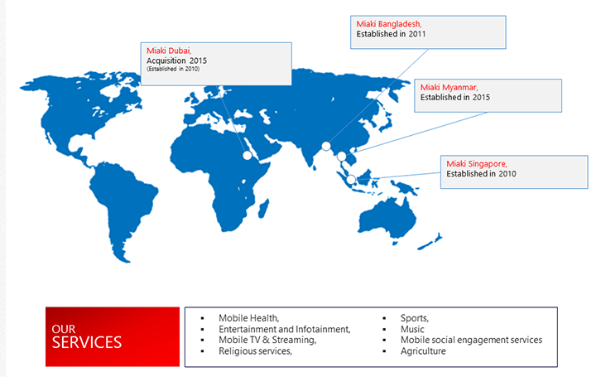

2.9. Organogram
Miaki Media Communications pursue hierarchal organization demonstrate, where Board of Directors are in the highest point of the model with pursued by CEO. CTO, CFO, CRO and COO straightforwardly answered to the CEO. Office leaders of the specific useful territory answer to the relating CTO, CFO, CRO and COO. Miaki Media organogram is given underneath:
MIAKI MEDIA ORGANOGRAM

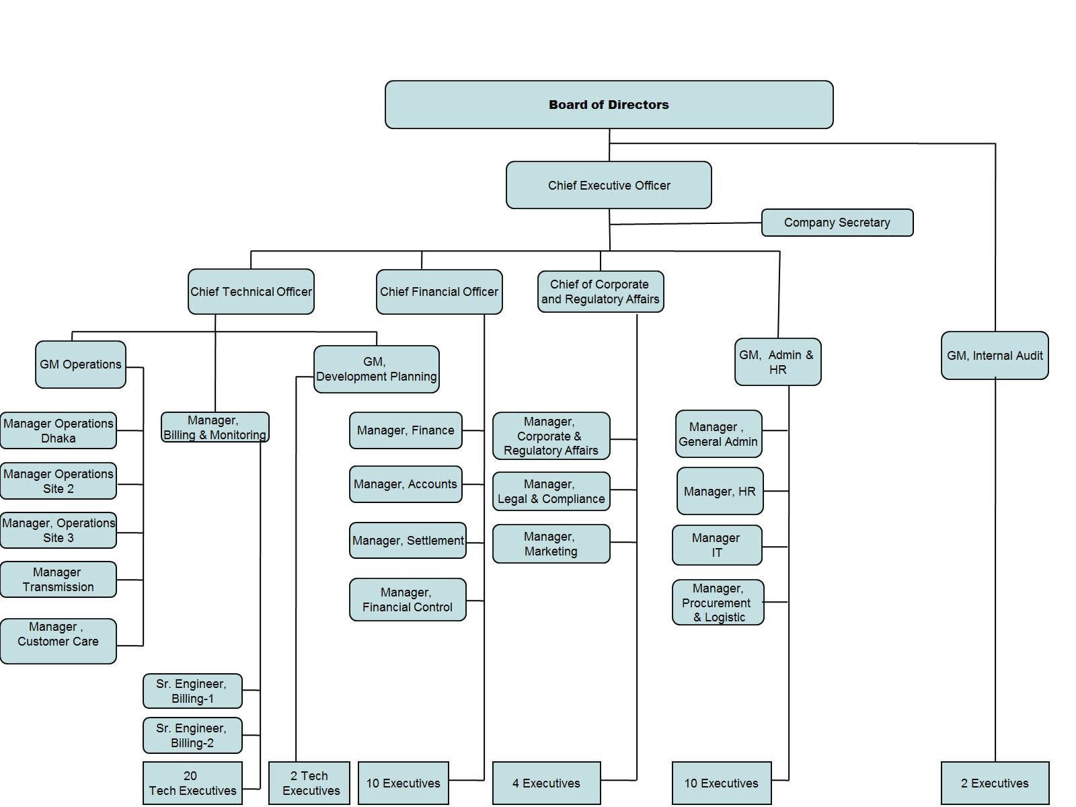

Team


Taro Araya
CEO (The Chief)

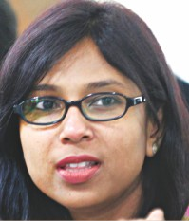

Md. AnisurRahman
Senior Executive Finance



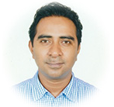



Kashfia Ahmed
Chairmen
Win Miaki Media
SakibRaihan
Head of Operations
Reaz-us Sultan
Key Account Manager
SamiulMashooq
Key Account Manager
RemiziusRemi
Chief Technology Officer




Chapter Three: The Job

Topics to be covered:
- Nature of Job
- Job Description
- Different Aspects of Job Performance

Chapter Three: The Job

Nature of Job
For the entry level position program of United International University, I have connected myself with Miaki Media Ltd. under Finance division. Here I have filled in as an assistant from tenth Nov 2018 to ninth Jan 2019. In the fund division we have 4 individuals including our group chief. We have to work with different divisions including Core organize, Packet bone system, Planning office, NOC, Admin, Finance and Settlement, Marketing and some other office. We have 5 work days in the week with 2 days occasion in the week. Our work routine from 9 A.M to 6 P.M and must be available to come back to work day in and day out for any crisis.

3.2. Job Description
Working with in the charging bureau of Miaki Media Ltd., I can portray my activity with beneath duties. It might fluctuate with some different obligations with different prerequisites:
- Input of payment information in Microsoft Excel
- Making file of the working period
- Printing the Payment Request /vouchers
- Scanning Documents
- Saving the scanned files in hard drives.
- Report to my supervisor
- Tracking the transactions
- Writing the vouchers
- Checking the genuineness of transaction
- Entry the transaction in Quick book
- Entry the transaction in Tally

3.3. Different Aspects Job Performance
My best quality is my persevering ability. I am a diligent employee and attempt to discover the detail for work, task and test that allocated to me. Cooperative person additionally made me more grounded for my position. I acknowledge the change for the duration of the time, circumstance and position. Most recent couple of years works in fund department; payment voucher planning and following experienced me on different installment voucher following and getting ready stage and section the exchange in QuickBooks and Tally Software. Running with my working transporter I have work with different fund the executives which encourage me to do well with the back framework of current position. Have the working encounters on Microsoft exceed expectations information input, Microsoft Word. Mine likewise have the great player to pursue the hierarchy of leadership. By and large I am a decent student and endeavor to accomplish new things as far as work, instruction and expert transporter. My principle obstruction in my expert transporter is the relational abilities, it's not about the skill in English it's something about circumstance subordinate conduct that assistance to comprehend the circumstance and judgment with time and condition premise. Mine have shortcoming of think in the straightway generally thoroughly consider of the circle. It should be increasingly incentives for focused circumstances. Require PC training.


Chapter Four: Analysis & Findings


Topics to be covered:
- Findings
- Analysis

Chapter Four: Findings & Analysis

Findings

Tracking Data in Excel File from November 2018 to December 2018

S.L. No | Pay. Req. Date | Payment Req. Reference | PO/ Contract Ref. No. | Vendor Name | Purpose | Requested Value
June'16
412 | 25-Nov-18 | MMEDIA/PayReq/Y18/170 | Nil | Adgears | For Airtel Tube (BD) subscriber Duration (16.10.18 to 10.11.18) | BDT 1,16,842.00
413 | 25-Nov-18 | MMEDIA/PayReq/Y18/171 | Nil | Dhaka Wasa | Miaki Office Water bill for Oct’18 | BDT 2,503.00
414 | 25-Nov-18 | MMEDIA/PayReq/Y18/172 | Nil | Standard Chatered Bank | For CEO Sir Credit Bill on 24.11.18 | BDT 15,718.71
415 | 25-Nov-18 | MMEDIA/PayReq/Y18/173 | Nil | Spacezero Limited | For CEO Sir House Service Charge for Oct’18 | BDT 12,178.00
416 | 25-Nov-18 | MMEDIA/PayReq/Y18/174 | Nil | MushuiMuhithHque& Co. | For TAX Assessment of Financial year 2014-15 & 2015-16 | BDT 3,96,000.00
417 | 25-Nov-18 | MMEDIA/PayReq/Y18/175 | Nil | Anik Dash Mithun | For Final Sattiement | BDT 8,832.00
418 | 25-Nov-18 | MEDIA/PayReq/Y18/176 | Nil | Petty Cash | For Entertainment Expense | BDT 7,730.00
419 | 27-Nov-18 | MMEDIA/PayReq/Y18/177 | Nil | BD Enterprise | For Office Clearing Service Charge For the Month of Nov’18 | BDT 20,240.00

Analysis:
Here I take one transaction from the file. Then I tracked, verified & processed this transaction.
Transaction Details:
Vendor’s Name | : | BD Enterprise
Purpose | : | For Office Cleaning Service Charge for Month of Nov’18
Date | : | 27th Nov 18
Total Amount | : | BDT 20,240.00 Including VAT

- Step One: At First, Two parties signed a contract at 9th August 2018 for the purpose of security services at Miaki Office. The contract was extended from 9th August 2018 to 8th February 2019. The details of the contact are shown in Appendix 3.
- Step Two: At 1st December 2018BD Enterprise prepared & sends a bill to Miaki Media Ltd that amounted to BDT 20,240.00 for the month of Nov 18 services for payment purposes. The original copy of the bill is shown in Appendix4. Some part is given below.
Item | Description | Month | Rate | Amount in Taka
Manned | BD Enterprise | November | 17,600.00 | 17,600.00
 | VAT (15%) |  | 2640.00 | 2640.00
 | Grand Total |  |  | 20,240.00

Payment Tern: Payment should be made within seven working days from the date of receipt of the invoice.
Please give payment information to:
Bdenterprise365@gmail.com
Note: If you have any query regarding invoice, please inform us within seven (07) days.

With the bill they also send a copy of VAT Challan. The detail of the Challan is shown in Appendix 5. Some parts of the VAT Challan are given below:

Vendor Name | :
Address | :

Taxpayer Identification No:
Area No:
S.L. No | Product/ Service Name | Quantity | Assessable value of supplementary duty | Amount of supplementary duty | Assessable value of VAT | Amount of VAT | Total Value of supplementary duty & VAT
1 | 2 | 3 | 4 | 5 | 6 | 7 | 8

- Step Three: After receiving the bill, at first track the transaction in our excel file.
- Check the validity of the transaction by using the supporting documents such as contract amendment. Check the source document is properly prepared & authorized.
- Check that the amount to be paid is supported by the source documents and regulations of the organization.
- Then after the validity of the transaction, a payment request with some details by using the computer screen is prepared. A sample of the Payment request copy that made for BD Enterprise Ltd is shown in Appendix 2. Explanation of the Payment request is given below:
Date | : | 27 November 18
Reference | : | MMDIA/PayReq/Y18/177
PO Ref. No. | : | Nil
Account Head | : | Office Cleaning Expense
Vendor’s Name | : | BD Enterprise
Purpose | : | Office Cleaning Service Charge for Month of Nov’18

Here: The date of making the payment request is 27th November, 2018.
Reference means the source of finding related data. Explanation of the reference is given below:
MML: | : | Miaki Media Limited.
Pay/Req | : | Payment Request
Y18 | : | Year 2018
177 | : | Means payment Request No. 177

PO reference is a field that facilitates cross-referencing or interlinking between the journal and the ledger in the posting process. Here post reference is nil.
Account head means the title of the account. Here the account head is “Office Clearing Expense” that will be debited as expense.
Vendor’s Name mean who actually provided the service. Here BD Enterprise provided cleaning service to us.
The payment request also includes whether the payment will be made in cash or cheque.
It also includes the total amount that will be paid.
The payment request voucher also includes the place for signing prepared by; checked by 3 persons & approved by.
The detail of the transaction is tracked in the Microsoft Excel File using the Serial No 419;
- After the printing of payment voucher, it is send to the person who is responsible for writing the voucher. The person also signs after preparing the voucher.
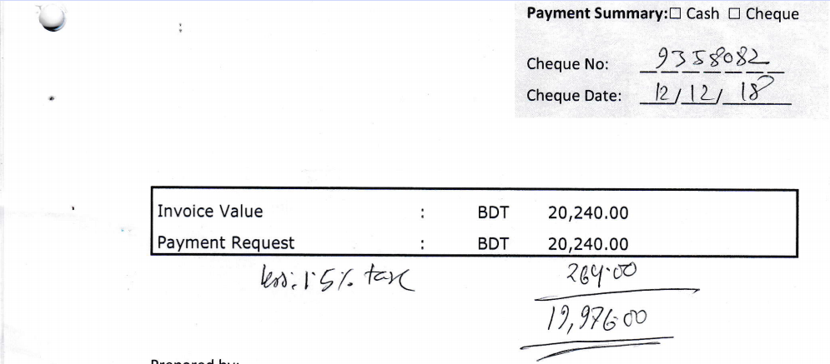
- After examining the genuineness of source documents, relevant rules & regulation, the payment request is confirmed and sent for approval.
- The voucher after examination is approved by authority and sent to the cash section for payment. Here invoice/bill amount is BDT 20,240.00. That is calculated by the vendor or service provider. But as Miaki Media Ltd. already paid BDT 264.00 TDS, then the net pay amount to BD Enterprise is BDT 19976.00.Here BD Enterprise will be paid a sum of BDT 19976.00..
- A check for the approved amount is written by the custodian of check book and arranges the signing of the check by the signatory(S) of check.
- The check is handed over the payee and ensure the signing of voucher by the recipient;
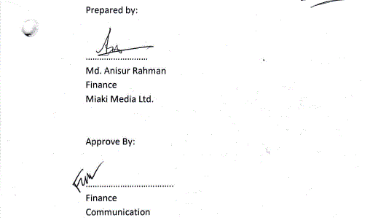
- A sample of this is given below:

After the signing &

- Sample of Excel Tracking file of theses transaction is given below:
419 | 27-Nov-18 | MMEDIA/PayReq/Y18/177 | Nil | BD Enterprise | Cleaning Service :: Miaki Office :: Nov '18 | BDT 20240.00



Chapter 5: Conclusion & Recommendations


Topics to be discussed:
- Conclusion

Chapter Five: Conclusion

Conclusion

A budgetary exchange has been characterized as: a financial occasion that influences the benefits and values of the firm, is reflected in the records, and is estimated in money related terms. Financial exchanges are managed by the exchange preparing framework (TPS) which is composed to deal with like transactions in a like manner. Three exchange cycles handle the three fundamental kinds of exchanges: those identified with the securing of materials, work, and capital resources and the consequent payment of installment (the consumption cycle); the change of materials into merchandise and enterprises utilizing work and resources (the transformation cycle); and the clearance of products as well as administrations and the ensuing receipt of installment (the income cycle).

The beginning of business movement is reflected in the expenditure cycle S the procurement of the sources of info to production: materials, work, and settled resources. Since most business exchanges are led on a credit basis, your content recognizes the physical part of the exchange and the monetary part. This is a counterfeit split and is utilized for clearness only. Considerably more exertion is required when transactions are not led on a money premise.

Four subsystems make up the use cycle:

- Purchases/creditor liabilities includes the ordering of materials and perceiving the related obligation;
- Cash distributions handles the payment on those liabilities; and
- Payroll handles the two undertakings for the buy of work;
- Fixed resources manage the obtaining, support and transfer of property, plant, and gear.

Miaki Media Ltd. payment transactions are falls under expenditure cycle. They need to make payment for services they have been taken from vendors, the assets they purchase from vendors such as (Laptop Purchase from Computer Source), salaries paid to employees etc.



APPENDIX


APPENDIX 01

REFERENCES:

Websites: (The following websites visited on & before 15th Jan 2018)
- http://miaki.co.
- Annual Audit Report
- Internet Searches
- http://win.miaki.co/winweb_02/index.html#content9-2
- Internal Discussions
- https://basis.org.bd/site/memberProfile/1249
- Legal documents
Method and device for electronic payment, uses once only certificated generated by user and validated by return of confidential code sent to user for that transaction by bank | Magicaxess, 27-07-2001
Mobile payment system | Hui Helen Shan-Shan,13-06-2002
Virtual credit card terminal and method of transaction | Synkronos Pty Ltd,30-01-2003
Method and system of securing a credit card payment | Stephane Petit,07-07-2005

Visiting Cards:

APPENDIX 02
Payment Request of Miaki Media

PAYMENT REQUEST

Date | : | 11th Nov 2018
Reference | : | MMEDIA/Pay Req /Y18/177
PO Ref. No. | : | Nil
Account Head | : | Office Clearing Expenses
Vendor’s Name | : | BD Enterprise
Purpose | : | For Office Clearing Service Charge for the Month Of Nov’18

Payment Summary:□Cash □Cheque

Cheque No: __ __ __ __ __ __ __
Cheque Date: ____/____/________



Prepared by:
……………………………….
Md. Anisur Rahman
Finance
Approved by:
……………………………….
Finance
Communication

APPENDIX O3

Source Document: Agreement Between BD Enterprise And Miaki Media Ltd.

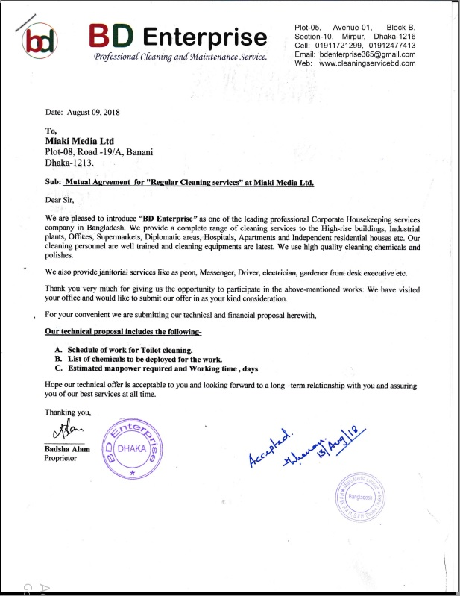

APPENDIX 04
Source Document: Invoice from BD Enterprise
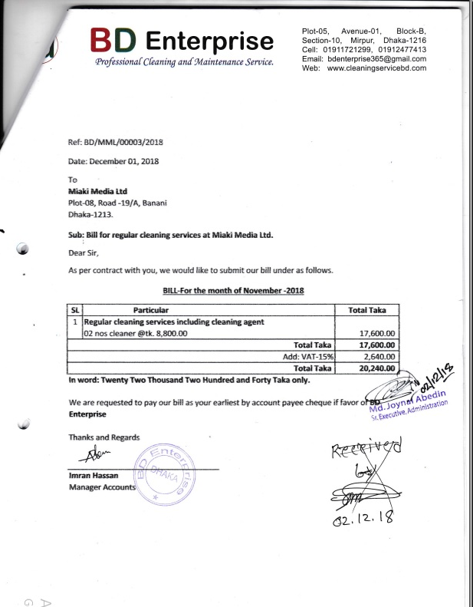

APPENDIX 05
Source Document: VAT Challan from BD Enterprise
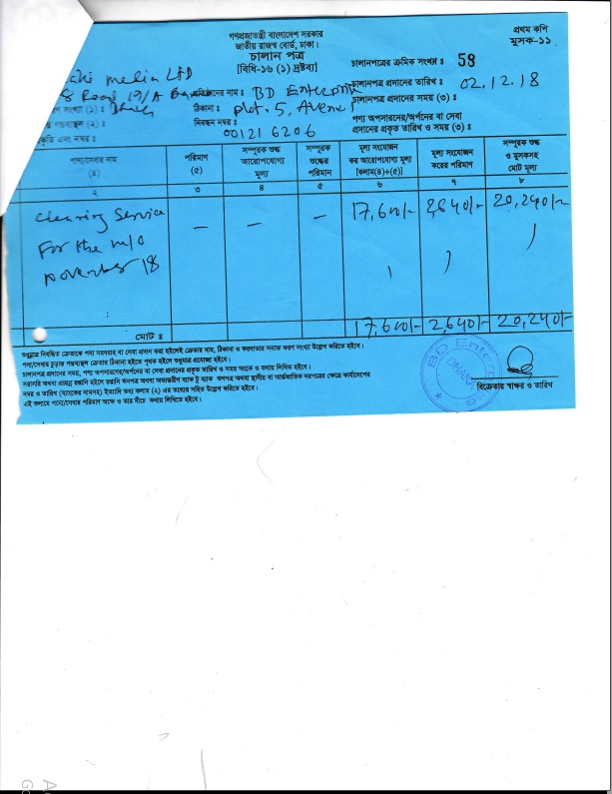


APPENDIX 06
PAYMENT REQUEST

Date | : | 18th Nov 2018
Reference | : | MMEDIA/Pay/Req/Y18/194
PO Ref. No. | : | Nil
Account Head | : | Office Security
Vendor’s Name | : | ABC Secure Solutions Bangladesh (P) Ltd.
Purpose | : | Security & Service :: Miaki Office :: Nov’18

Payment Summary:□Cash □Cheque

Cheque No: __ __ __ __ __ __ __
Cheque Date: ____/____/________



Prepared by:
……………………………
Md. Anisur Rahman
Finance

Approved by:
……………………………………
Fahad Mahmud Islam
Finance

APPENDIX 07
Payment Voucher of Win Miaki

PAYMENT REQUEST


Date | : | 28th Oct 2018
Reference | : | WIN/Pay/Req/Y18/19
PO Ref. No. | : | Nil
Cost Head /Project | : | Cost of Goods Sold
Vendor’s Name | : | Rangs Telecom Limited
Purpose | : | For Recharge From Ranktel to Let ACI Service
Payment Summary:□Cash □Cheque

Cheque No: ______________
Cheque Date: ____/____/________

Prepared By:

……………………………
Md. AnisurRahman
Finance

APPENDIX 08
Asset Purchase Repulsion Entry
Sl. | PR Date | PR Ref. No. | Particular | Amount | Requisitioner | Delivery Date | Delivery Place
1 | 19/May/14 | BMVAS/FAR/Y14/01 | Reverse Osmosis Water Purification System | BDT 70,500.00 | Muhammad Nurul Hassan  Head of Admin  Cell: 01730 730 364  E-mail: nurul.hassan@miaki.co | 20/May/14 | Miaki Banani Office  Plot#08, R#19/A, Block – E Banani, Dhaka-1213
2 | 22/May/14 | BMVAS/FAR/Y14/02 | Laptop:  1. DELL Latitude 3440 Core i5 14" (2pcs)  2. DELL Latitude 3440 Core i3 14" (5pcs)  3. HP 14D008TU Pentium Duel Core 14" (6pcs) | BDT 514,000.00 | Muhammad Nurul Hassan  Head of Admin  Cell: 01730 730 364  E-mail: nurul.hassan@miaki.co | 22/May/14 | Miaki Banani Office  Plot#08, R#19/A, Block – E Banani, Dhaka-1213
3 | 22/May/14 | BMVAS/FAR/Y14/03 | Tally Software | BDT 100,000.00 | Arafat Mahmood  Junior Executive, SCM  Cell: 017 555 1 4994  E-mail: arafat.mahmood@miaki.co | 10/Jun/14 | Miaki Banani Office  Plot#08, R#19/A, Block – E Banani, Dhaka-1213
4 | 7/Jul/14 | BMVAS/FAR/Y14/04 | Hitachi LCD Projector  Model: Hitachi CP-X3030WN 3200 Lumens | BDT 43,000.00 | Muhammad Nurul Hassan  Head of Admin  Cell: 01730 730 364  E-mail: nurul.hassan@miaki.co | 15/Jul/14 | Miaki Banani Office  Plot#08, R#19/A, Block – E Banani, Dhaka-1213
5 | 7/Jul/14 | BMVAS/FAR/Y14/05 | Steel Cabinet (Three drawers with Locker Facility)  Brand: OTOBI  Model: FCOP007MSAA001 | BDT 35,500.00 | Arafat Mahmood  Junior Executive, SCM  Cell: 017 555 1 4994  E-mail: arafat.mahmood@miaki.co | 15/Jul/14 | Miaki Banani Office  Plot#08, R#19/A, Block – E Banani, Dhaka-1213

APPENDIX 09

Tally Software1110000000.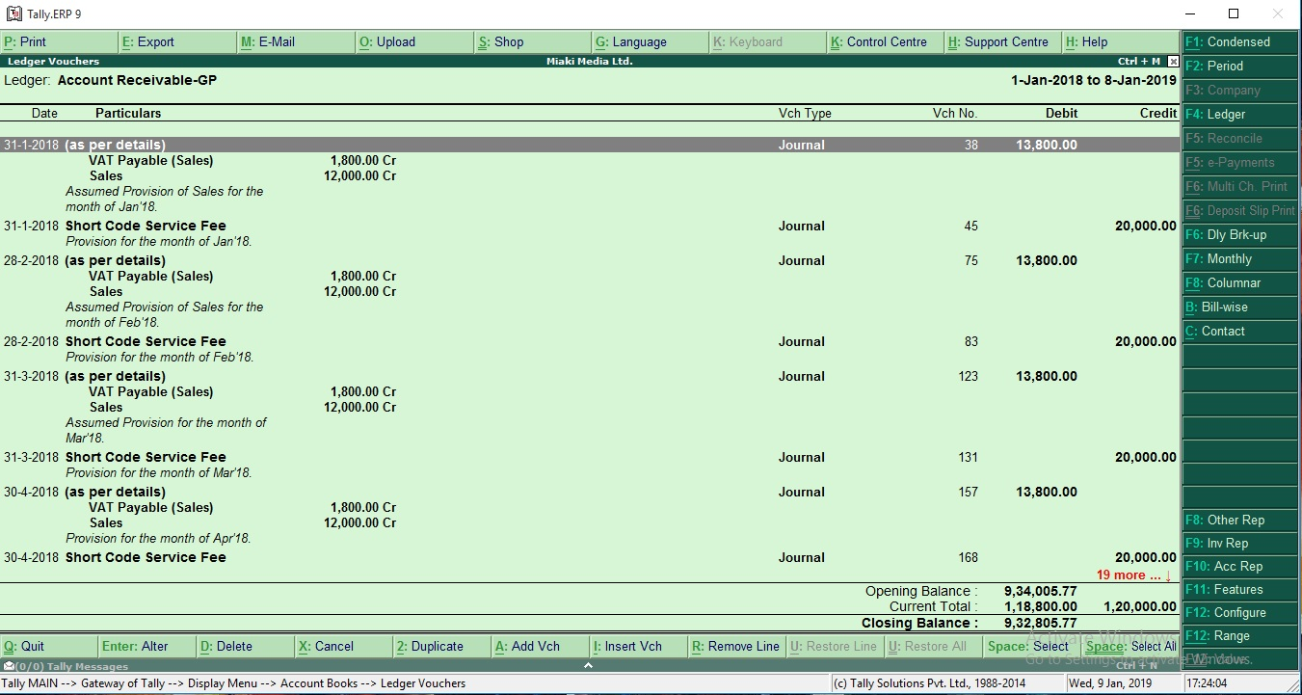e

APPENDIX 10
Quick Book Software
