Internship Report on
Impact of Human Resource Planning on Organizational Performance: Challenges in Covid-19 Situation For Al-Arafah Islami Bank PLC

Name of the student
Maliha Benta Feroz

This report is submitted to the school of Business and Economics, United International University as a partial requirement for the degree fulfillment of Bachelor of Business Administration.

Internship Report
On
Impact of Human Resource Planning on Organizational Performance: Challenges in Covid-19 Situation for Al-Arafah Islami Bank PLC
Course code: INT 4399

Submitted To
Nasrin Akter
Assistant Professor
School of Business and Economics (UIU)

Submitted By
Maliha Benta Feroz
ID: 111 193 101
Enrollment: Spring 2024
School of Business and Economics
BBA Program, Major in Human Resource Management (UIU)
Date of Submission
13th August, 2024

Letter of Transmittal

13th August, 2024
Nasrin Akter
Assistant Professor
School of Business and Economics (UIU)
Subject: Submission of Internship Report.
Dear Miss,
With due respect, I am submitting my internship report on “Impact of Human Resource Planning on Organizational Performance: Challenges in Covid-19 Situation For Al-Arafah Islami Bank PLC” which is part of the Bachelor of Business Administration degree and the INT course 4399.
I am appreciative of the chance to have finished the report according to your guidance. I sincerely appreciate your help, and I have done everything I could to ensure that this report is both educative and acceptable with your instructions and criteria.
I hope you find this report to be satisfactory. I would be really appreciative if you would approve my internship report.
Sincerely

Maliha Benta Feroz
ID – 111 193 101
BBA Program, Major in Human Resource Management
School of Business and Economics
United International University

Declaration of the Student

I am Maliha Benta Feroz, student of Bachelor of Business Administration, major in Human Resource Management, United International University.
I do hereby declare that
- The internship report on “Impact of Human Resource Planning on Organizational Performance: Challenges in Covid-19 Situation For Al-Arafah Islami Bank PLC” is a presentation of my original work.
- A wide range of people contributed to this study by helping to write the report, organize surveys to evaluate the issues and conversations, and gather relevant references for the literature evaluation.
- Nasrin Akter, an assistant professor of business and economics at United International University, oversaw the compilation of this paper as well.
- In addition, I attest that I followed all ethical guidelines when writing the report and that its sole purpose was academic in nature.


Maliha Benta Feroz
ID – 111 193 101
Enrollment: Spring 2024
BBA Program, Major in Human Resource Management
School of Business and Economics
United International University

Acknowledgement
Firstly, I want to express my gratitude to Allah for providing me with the ability to do the duties and responsibilities of my internship as well as to finish my coursework and report on time.
After that, I would like to sincerely thank Nasrin Akter, an assistant professor at United International University's School of Business and Economics, who oversaw my internship, for her insightful advice and helpful assistance. I could not have finished the report on time and accurately without her assistance, direction, support, and collaboration. The idea of doing my internship report under her guidance excites me.
I also want to thank Abdur Rahim, the Branch Operational Manager of Al-Arafah Islami Bank PLC. (VIP Road Branch), for giving me the opportunity to work as an intern at the bank and obtain a great deal of real-world expertise. Furthermore, I want to express my gratitude to the staff of Al-Arafah Islami Bank PLC (VIP Road Branch) for considering the time to complete this survey.

Table of Contents
Executive Summary 1
Chapter1: Introduction 3
1.1 Introduction of the Report 3
1.2 Rationale of the Report 3
1.3.1 Primary Objective 3
1.3.2 Specific Objectives 4
1.4 Scope of the Report 4
1.5 Methodology of the Report 5
1.5.1 Primary Sources 5
1.5.2 Secondary Sources 5
1.6 Limitations of the Report 5
Chapter2: Literature Review 7
2.1 Concept of Human Resource Planning (HRP) 7
2.2 Importance of HR Planning 8
2.2.1 Importance of human resource planning on organization’s performance: 8
2.2.1 Impact of human resource planning process on employee performance: 8
2.3 Relationship of Human Resource planning with organizational development: 9
Chapter 3: Organizational Profile 11
3.1 Organizational Overview 11
3.2 Historical Background 11
3.3 Vision 13
3.4 Mission 13
3.5 Commitments 13
3.6 Products and Services 13
3.7 Financial Literacy 14
3.8 Financial Inclusion 15
3.9 Structure of AL-Arafah Islami Bank PLC 15
3.9.1 Shari’ah Board : 15
3.10 Function and Operation: 16
3.10.1 General Banking Divisions: 17
3.10.2 Customer Service: 17
3.10.3 Department Of Cash: 17
3.10.4 Department of Accounts: 18
3.11 Career Prospect of AIBL: 18
3.12 Selection Process at AIBL: 18
3.12 Core Values 19
3.13 Strategic Partnership 20
Chapter 4: Analysis 22
4.1.1 Gender Respondent: 22
4.1.2Job Category Analysis (Designation) 22
4.1.3 Working Experience 23
4.2 Descriptive Analysis 23
4.2.1 Survey Data Analysis: 26
Chapter 5: Findings, Recommendation, Conclusion 34
5.1 Findings 34
5.2 Recommendations 35
5.3 Conclusion 36
Bibliography 38

Executive Summary

The international trade industry, the economics field, multi-relationships, economy, and way of life are all changing as a result of COVID 19. In order to reduce their chance of contracting a corona condition while still working, an increasing number of employees are turning to virtual workspaces. On the other hand, in the wake of COVID-19, which has rocked every industry and created a new emergency for supervisors and HRM professionals, executives and HRM practitioners face a complicated and tough situation. This study examines the impact of human resource planning on Al-Arafah Islami Bank PLC's corporate efficiency in the context of the COVID-19 pandemic.An outline of the objectives, parameters, restrictions, and methods of the study is provided in the first part. The second section contains the literature review. Essential readings on the topic of this investigation are provided in this chapter. The third part covers Al-Arafah Islami Bank PLC's organizational profile, focusing on its principles of human resource management, organizational culture, and offering of goods and services, as well as the contemporary banking landscape in Bangladesh. The survey and the information analysis on the impact of HRM on organizational performance are the main topics of the fourth and fifth chapters. Twenty employees of Al-Arafah Islami Bank PLC provided data, and the research's results were published. Data study showed that during the pandemic, Al-Arafah Islami Bank PLC's business operations suffered as a result of the HRP. Even though workers have the responsibility for the organization's advancement, they expect to be provided with an atmosphere at work that will enhance their job satisfaction. Based on the evaluation of the study, a number of concerns for Al-Arafah Islami Bank PLC have been emphasized in Chapter 5, along with crucial components like suggestions and important insights. The report's conclusion concludes this section.
Key Words: Human Resource Planning, Organizational Performance, Challenges ,Covid-19 situation, Al-Arafah Islami Bank PLc.

CHAPTER ONE:
INTRODCUTION

Chapter1: Introduction

1.1 Introduction of the Report

A recent study showed that effective handling of human resources (HR) may assist a business in gaining and holding onto a competitive edge globally. Thus, a crucial component of human resources management is planning for human resources, or HPP. Ensuring that the company has access to a workforce that can support and improve its performance is the aim of HRP. By predicting future needs and maintaining a desirable human capital position, HRP helps businesses make sure they have the proper sort and quantity of staff on hand when needed. As a result, HRP is a plan that helps the company hire, use, develop, and retain employees by assessing current staffing levels, forecasting future workforce needs, and developing plans to fill any anticipated manpower shortages. This report's primary goal is to investigate the effects of human resource planning on AL-Arafah Islami Bank PLC organizational performance during the COVID-19 pandemic.

1.2 Rationale of the Report

A report on the internship experience must be prepared in order to fulfill the requirements for the Bachelor of Business Administration program. The subject of the internship report is "Impact of Human Resource Planning on Organizational Performance during the COVID 19 Pandemic: A study on AL-Arafah Islami Bank PLC," and it is completed under the supervision of Nasrin Akter, assistant professor of business and economics at United International University.1.3 Objectives of the Report
The objectives of my report are divided into 2 sections. Following that order:

1.3.1 Primary Objective
The main objective is to examine how AL-Arafah Islami Bank PLC's human resource planning elements affected their organizational performance during the COVID-19 pandemic.

1.3.2 Specific Objectives
In accordance with the following particular goals:
• Develop an understanding of the impact of human resource planning on organizational effectiveness.
• To learn about the 19th COVID pandemic's effects on Bangladesh's private banking sector.
• To examine the HRP components that affect AL-Arafah Islami Bank PLC's organizational performance during the COVID-19 pandemic.
• To offer some suggestions for creating efficient human resource plans that will improve company efficiency in the case of a pandemic.

1.4 Scope of the Report
The study and report are useful because they may be applied to academic assessment and decisions about policy. Human resource managers at AL-Arafah Bank PLC and other human resource professionals may utilize the study's results to create human resource policies and procedures that work. This shows how crucial it is to apply human resource best practices in order to match the capacity and application of employees with the anticipated demand determined by the strategy of the company. The recommendations made by the research for handling succession management concerns might prove advantageous to AL-Arafah Islami Bank PLC. The company is able to keep the right number of employees at all times, maintain roles that are challenging, and retain the skills and knowledge needed to effectively carry out AL-Arafah Islami Bank PLC's goal.
This study may be helpful to academics studying human resources management (HRM) in the same area. It contributes to the structure of existing academic knowledge. In order to achieve the greatest performance out of their staff, management was hoping that these insights would help them better integrate their HR planning methods with their employee performance evaluation systems. There aren't any other known studies on HRP conducted by AL-Arafah Islami Bank PLC. Future investigations in the area of human resource planning might expand on the results of this study.

1.5 Methodology of the Report
Two different sources provided the data for this investigation and analysis. The specifics in is as follows:

1.5.1 Primary Sources
In addition to respondents to a survey intended to collect primary data on the topic, a range of primary sources provided the data for this study. These are some more primary sources:
- Person to person conversations and interactions with AL-Arafah Islami Bank PLC employees (VIP road Branch).
- A comprehensive review of the present state of affairs in the human resources division of a business.

1.5.2 Secondary Sources
The secondary data was collected from the following sources:
- Books, articles, journals, and newspapers that discuss the relationship between organizational performance, human resource planning, and COVID 19.
- The AL-Arafah Islami Bank PLC official site.
- AL-Arafah Islami Bank PLC annual reports (2023, 2022, 2021, 2019 and 2018).

1.6 Limitations of the Report
For my internship report, compiling the data and creating the report proved to be a challenging task. A handful of them are mentioned below:
- A couple of the staff members conducti ng the survey seemed a bit lost. Employees are reluctant to participate in the survey because they fear being judged by their bosses and coworkers.
- Most employees also said they don't have enough time to finish the survey, even not wanting to read the entire questionnaire.

CHAPTER TWO:
LITERATURE REVIEW

Chapter2: Literature Review

In this chapter, previous research on the study's subject is summarized. The concept of human resource planning (HRP), why it is so crucial to business, how planning relates to organizational development, and how HRP impacts an organization's performance have all been divided into subsections that are consistent with the research's objectives.

2.1 Concept of Human Resource Planning (HRP)

Many modern issues, such as expansion, innovation, technology, emerging markets, buying habits, and efficiency, have an impact on employment prospects. To guarantee a pleasant and secure place of employment, an organization or corporation must use professional HR administration procedures. This information will be needed in the future to estimate supply and demand for human resources, ensuring that companies maintain the appropriate staffing level.
Human resource planning is a procedure that determines the amount of labor that an organization will require in the future to accomplish its goals. It also determines the number of open positions and determines if there is an excess or shortage of personnel. (Revathy, 2021)
A business should use HR Planning to transition from its existing workforce position to the ideal workforce position. Planning helps management make sure that the appropriate people are doing the right things at the right time and in the right numbers to maximize long-term advantages for the business and the individual. (Vetter)
According to Gordon Mc Beath "HRP involves dealing with two planning aspects: the requirements and supplies of manpower."
(ARYA)
According to (Griffins L. , 2006) “One way to define human resource planning (HRP) is as an attempt to forecast the potential of business environmental and commercial requirements.”
To fulfill these business obligations and environmental regulations, skilled employees will also be required. HRP is the process of figuring out what kind of workforce a business needs, according to the HRM function. In addition, it is creating actions, concepts, and activities that will enable the organization to fulfill its objectives and goals. The practice of projecting a company's future need for and supply of the right kind of people in the correct amount is known as HR planning. (Aswathappa) As a result, HRP is a critical component of HR management and plays an important role in helping the company achieve its goals and objectives.

2.2 Importance of HR Planning

2.2.1 Importance of human resource planning on organization’s performance:

Planning for human resources is especially crucial for high-tech, new businesses that are growing quickly. A mature company that has to expand into new areas, offer new services, makes acquisitions, or sell off assets must also consider how to find, recruit, or reallocate the people required for growth and competitiveness. (Pearce, 1988-2000). Succession planning and organization development are crucial for meeting both corporate expectations and individuals' requirements for training and career development. This issue of resource reallocation has to be resolved if the labor supply on staff is larger than required.
Effective human resource planning allows organizations to prepare for future challenges and threats to their competitive advantage. (Noe, 2003). According to (Craft, 1980) Human resource planning plays a crucial role in determining candidate qualities and selecting the best match for the firm.

2.2.1 Impact of human resource planning process on employee performance:
Organizations invest in staff training and development to boost productivity. According to (Hassan Danial Aslam, 2013) , providing employees with job-specific training can improve their performance, even without supervision, according to work resource planning discussions. The effectiveness of performance improves following training. Without a competent human resource planning strategy, firms cannot achieve their objectives. Administrative assets help to guarantee ongoing growth and development in addition to the diverse skill sets, skills, and knowledge that people possess in various businesses. (W.G & Speamerfam, 2011). In a study (Zubair & Barnard, 2006) have reported, seven factors that have a good relationship with worker performance. The selection procedure, training, performance reviews, career planning, pay plans, employee involvement, and job description are some examples of variables. Effective system functionality is not the only factor that leads to performance improvement; dedicated and driven human resources also contribute, and this is made possible by the effective use of human resource strategies. (Duseyi & Hammad T, 2009)

2.3 Relationship of Human Resource planning with organizational development:

An organization's prospective outcomes may be measured by comparing its actual results to its expected productivity, which is an indicator of how well it is performing (Shirey, Building the Leafership Development Pipeline, 2008). Utilizing HRP as an evaluation framework, an organization's performance may be evaluated with respect to its aims and objectives, collective choices made by the company, and the manner in which those decisions were carried out. The achievement of a company's goals and objectives may be facilitated by providing staff with a path or route to follow (Boxall M. S., 2001). Organizations with HRP capabilities outperform those without, owing to the numerous HRP initiatives implemented to support the company in achieving its goals (Cohen, Taking Stock II Report on the Reports, 2004). As a consequence, HRP acts as a road map for businesses to identify their most critical goals and choose the best course of action to achieve them. Furthermore, HRP processes take a methodical, logical, and pragmatic approach to developing an organization's recruitment and selection strategy. HRP provides a structure for well-informed choices by disclosing and explaining organizational opportunities and dangers. HRP facilitates the development of high-quality, consistent, and effective performance (William, Human Resource Planning and Management, 1988).

CHAPTER THREE:
ORGANIZATIONAL PROFILE

Chapter 3: Organizational Profile

3.1 Organizational Overview

Al-Arafah Islami Bank PLC has developed into a globally renowned, multifaceted organization that embraces global best practices and chooses to stay at the forefront of technological breakthroughs. This evolution may be seen as a case study of growth from 1995 to the present. In contrast to many other financial organizations, the Bank measures its success based on its accomplishments along the way to being the most complete financial institution in the country, as well as its bottom line numbers.
According of December 31, 2021, the Bank's authorized capital is Tk. 15000.00 million, and its paid-up capital is Tk. 10649.02 million. The Bank is sponsored by well-known Islamic scholars and devout businesses in the nation. Native American stockholders possess all of the paid-up capital.
Beginning of December 31, 2018, the bank has equity of Tk. 2348.32 core, 4247 employees as of December 31, 2021, and 19146 shareholders as of December 31, 2021. Over the years, it has consistently turned a profit and issued an attractive dividend. The bank's instrument for success is the integration of new goods and cutting-edge technology to provide excellent client service. To meet client demands, the bank offers a wide range of well-crafted products and services.
The Bank is dedicated to making a major economic contribution to the country. With 211 branches nationwide, 25 of which are AD, it has positively impacted the nation's socioeconomic growth.
3.2 Historical Background: Islam symbolizes "peace," signifying a completely virtuous and risk-free way of life. The main goal of the Islamic way of life is to succeed in both this life and the next. Thus, in order to attain the highest level of achievement, we should live according to the teachings of the Al-Quran and emulate Hazrat Muhammad (SM).
On June 18, 1995, Al-Arafah Islami Bank was founded with the Islamic values in mind. It is sometimes referred to as AIBL, and its corporate headquarters is situated in Dilkusha, Dhaka. The bank's directors and architects are well-established, devoted, and devout individuals. A.Z.M. Shamsul Alam, a renowned Islamic scholar, an economist, creator, and former bureaucrat in the Bangladeshi government, is one of theirs and the bank's founding chairman. The bank offers investment opportunities, SME banking, microfinance, foreign trade, deposit schemes, and more. Al Wadiah Current Deposit Scheme, Mudaraba Savings Deposit Scheme, Mudaraba Term Deposit Receipt, Mudaraba Short Notice Deposit, and more options are available under the Deposit Scheme. AIBL's investment portfolio includes investments in the transportation, hire-purchase, madrassa, village, small investment, agro-industrial, small company, and women's entrepreneurship sectors, among other sectors. Their SME Banking service caters to SME entrepreneurs in these areas. In addition, the bank offers other services including Internet, SMS, and mobile banking, as well as locker, remittance, ATM, and other services. Currently, the bank employs 1807 people nationwide through its 38 authorized dealers (AD), 89 branches, 8 SME units, and around 54267 shareholders
AL-Arafah Islami Bank PLC
Private Commercial Bank, Headquartered in Dhaka
Form of Business | Banking Service
Key Business Segments | Retail, SME, Wholesale
Number of Branch | 211
Head Office | Al-Arafah Tower, 63, Purana Paltan, Dhaka-1000.
Website | www.aibl.com.bd  www.al-arafahbank.com
Employees | 4,247
Customers | Over 17, 00, 000
Owner | S.Alam Group of Industries
Hotline Number | 16434(Local),+8809611016434(Foreign)
Source:AL-Arafah Bank PLC Website(Sariah Bhittik)

3.3 Vision
To lead Bangladesh's Islamic banking industry and make a major contribution to the expansion of the economy of the country.

3.4 Mission
- Obtaining Almighty Allah's pleasure in this life as well as the next.
- Expansion of banking practices based on Shariah.
- Finest financial services using the newest technologies.
- Prompt and effective client support.
- Upholding strict business ethical standards.
- Balanced expansion.
- Consistent and competitive return on equity for shareholders.
- Cutting-edge banking at a reasonable cost.
- Draw in and keep top talent for your team.
- Offering employees attractive benefits packages.
- Steadfast dedication to the expansion of the national economy.
- Expanding their funding of micro and small businesses.

3.5 Commitments
- In order to maintain our status as the top Islamic bank in Bangladesh, we must continue to develop steadily and with a focus on our customers. We do this by mobilizing deposits and making high-quality investments.
- To provide financial support for large, small, and medium-sized businesses, as well as retail clients, with a personal touch, via our nationwide network of branches.
- Our commercial endeavors are tailored to our customers increasing trade and commercial needs.

3.6 Products and Services
- Al Wadiah current account (CD).
- Mudaraba short notice deposit (SND).
- Mudaraba savings deposit (MSD).
- Mudaraba term deposit receipt (MTDR).
- Monthly installment based term deposit (ITD).
- Monthly profit based term deposit (MPTD).
- Al-Arafah monthly Hajj deposit (MHD).
- Al-Arafah term Hajj deposit (THD).
- Monthly installment based marriage savings investment scheme (MIS).
- Al-Arafah savings bond (ASB).
- Foreign currency deposit (FCD).
- Pension deposit scheme (PDS).
- Cash deposit waqf deposit scheme (CWD).
- Mudaraba lakhpoti deposit scheme (LDS).
- Mudaraba millionaire deposit scheme (MDS).
- Mudaraba (special) pension deposit scheme (MSPDS).
- Mudaraba kotipoti deposit scheme (MKDS).
- Mudaraba double benefit deposit scheme (MDBDS).
- Mudaraba triple benefit deposit scheme (MTBDS).

3.7 Financial Literacy
Financial literacy refers to the knowledge, skills, and understanding of financial ideas and instruments that allow people to make educated and successful decisions about their personal money. It requires a thorough grasp of a variety of financial subjects, such as budgeting, saving, investing, borrowing, and debt management. Financial literacy is critical for promoting financial inclusion, particularly in light of the advent of Digital Financial Services (DFS). For the first time, BB is taking the initiative to issue these Financial Awareness Guidelines (FLGs), with the goal of implementing a wide variety of financial literacy programs for the general public. These principles are meant to be adopted by banks and financial institutions, collectively referred to as Financial Literacy Providers (FLPs), within seven years of its inception.
However, the implementation stream will go on beyond the planned time. BB has undertaken a variety of programs that take advantage of the fact that financial literacy is a precondition for long-term financial stability. Within the numerous measures, distribution of fly-leafs, brochures, pamphlets, leaflets regarding financial services, broadcasting commercials in television and radio on consumer protection, advertisements in the newspaper on information of regulated financial institutions, publicizing video documentary on financial services, streamlining school banking conferences across the country, arranging of banking fair, open credit disbursement in favor of marginalized and low-income AIBL participates in these courses with open arms.

3.8 Financial Inclusion
Financial inclusion refers to the availability and accessibility of financial services and products to all sectors of society, particularly individuals and groups who have previously been excluded from formal financial institutions. It seeks to empower individuals to engage in the formal economy, manage their finances, and enhance their general financial security.

3.9 Structure of AL-Arafah Islami Bank PLC
AIBL's fifteen-member Board of Directors essentially oversees the organization. The Executive Committee, which is composed of the Sponsor Director (Chairman, Vice Chairman), its member, Shareholder Director, Former Officer Director, and Company Secretary, is appointed by the Board. The committee has the authority to monitor and assess key daily operations, such as budgets, investment plans, and other investment-related activities. In addition, the board is in charge of setting the company's policies and evaluating its performance in operations, which includes approving significant capital purchases and deals with investors. In addition, the Managing Director is chosen by the board and is in charge of overseeing all business activities within the parameters of the organization's rules.
3.9.1 Shari’ah Board : The AIBL's Fatwa & Shari’ah Supervision Board is composed of eminent academics with vast backgrounds in economics, law, and banking systems, with a focus on law and finance as dictated by Islamic Shari’ah. The bank's Board of Directors appoints members to the Board. The Shari'ah Board is in charge of developing and producing cutting-edge financial and investing goods and services that adhere to Shari'ah. Additionally, the Board has the authority to give fatwas on any subject that various bank business divisions present to it. The Shari'ah auditors are empowered to guarantee that each transaction is executed strictly in accordance with Islamic banking standard

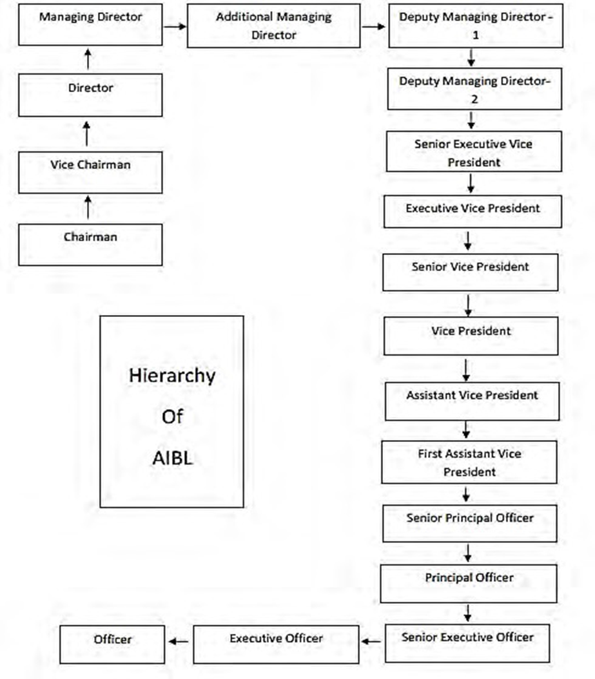
3.10 Function and Operation: There are mainly 3 divisions, these are:
- General Banking Division
- Credit Division
- Foreign Exchange

3.10.1 General Banking Divisions: Three distinct divisions collaborate to achieve the organization's goal.
- Customer Service
- The Department of Cash
- Department of Accounts

3.10.2 Customer Service: Various customer service functions include:
- Account opening;
- Cheque book issuance.
- Issuing of T.T.
- Issuing of D.D.
- Issuing of Payment Order
- Making Online Transfers Available.
- Managing the transfer of funds.
- The clearing house's operation.
- Carrying out standing orders from customers.
3.10.3 Department Of Cash: The cash department performs several responsibilities, These are :
- Including receiving cash from depositors and paying clients when requested.
- Reviewing all sections of the deposit slip to ensure that the name, account number, and amount are written accurately.
- Confirming that the payment check is accessible when it comes time to pay the clients.
- Any money that is collected and paid for needs to be recorded in the receipt and payment register, together with the account number.
- The Cash Officer is responsible for maintaining the cash register.
- Sustaining the daily cash balance.
- The monthly cash balance is prepared.
3.10.4 Department of Accounts: AIBL accounting may be roughly divided into the following two categories:
(1)Bookkeeping in General
(2) Accounting for investments
3.11 Career Prospect of AIBL: One of the relatively few regional banks, Al-Arafah Islami Bank, does not use or profit from the conventional branch-based business model, which is scattered and regulated regionally. The bank manages business and operations from its headquarters using a vertical management strategy, mainly through five segments:
- Business
- Branch Banking
- Safety
- Responsibilities
- Protection
3.12 Selection Process at AIBL: The goal of the AIBL screening process is to find applicants who are a great fit for a certain position. Regarding AIBL, we employ the one that follows selection process:
- Job Posting
- CV shorting and listing
- Written Test
- Interview
- Job Offer
- Medical Test
- Appointment Letter

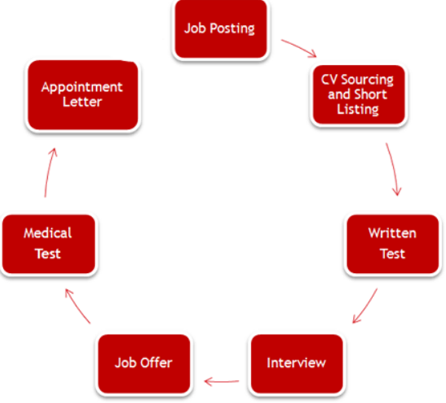
Figure: Selection Process of AIBL

3.12 Core Values

Figure : Core values of Al-Arafah Islami Bank PLC

3.13 Strategic Partnership
They encourage you to meet prospective investors, soar to new heights, and get more than simply cheap funding for a test. They work actively with foreign investors to ensure that you place the utmost importance on corporate governance, standards of sustainability, and creative solutions. They are the best at it out of all of them. Several foreign organizations, such as:
- IFC
- ADB
- FMO
- GCPF have acknowledged the importance of our efforts.

CHAPTER FOUR:
ANALYSIS

Chapter 4: Analysis

4.1.1 Gender Respondent:
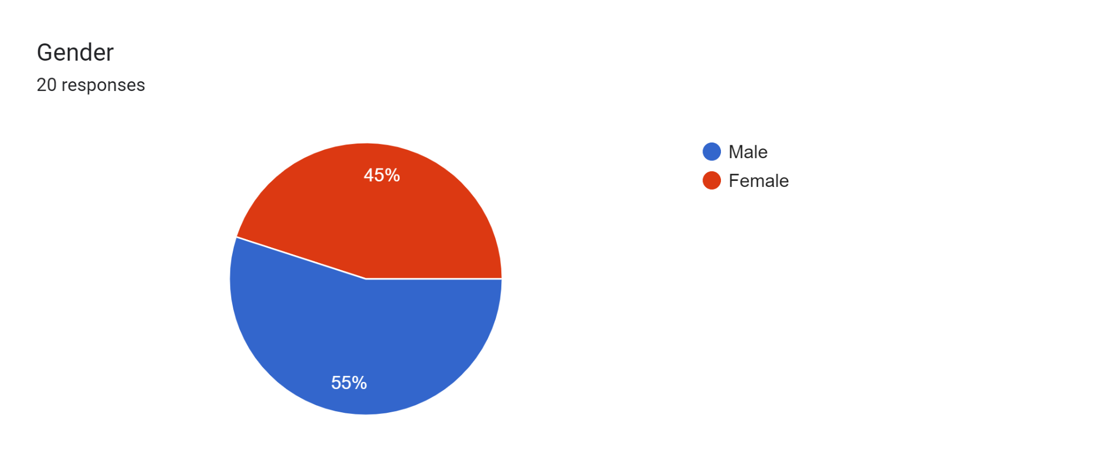
By conducting this survey, we can say that AIBL have the majority portion of male employee than female. It’s also a good practice of following the Bangladesh Bank policy to have equal portion of both gender employee.
Gender-Percentage of Participants: Male >Female

4.1.2Job Category Analysis (Designation)
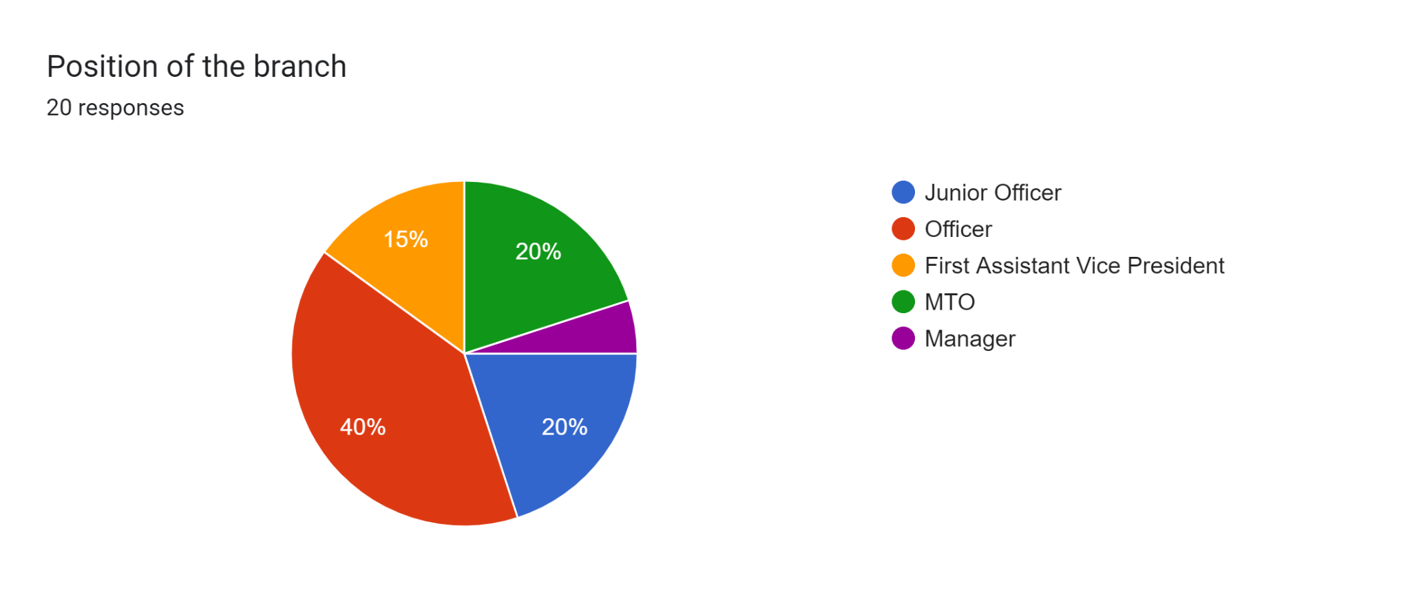

Overall, the branch employs the most people as Officers, followed by an equal number of Junior Officers and MTOs, less First Assistant Vice Presidents, and the fewest Managers.
Position in the Branch (Designation) - Percentage of Participants
Officer and HR Officer > MTO > Junior Officer > FAVP>Manager (HOB)

4.1.3 Working Experience

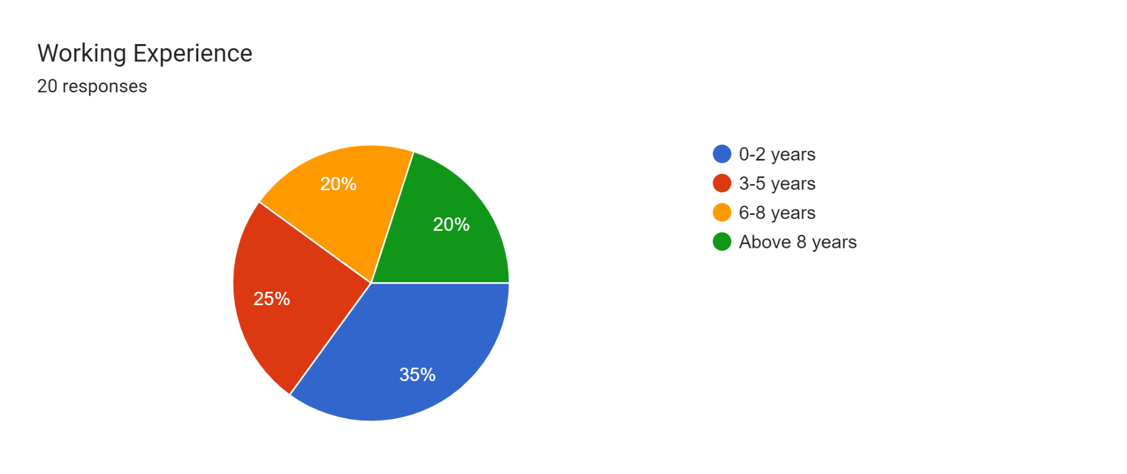
This chart indicates a varied distribution of working experience among the respondents, with a notable concentration of individuals at the early stages of their careers.

4.2 Descriptive Analysis

"The impact of Human Resource Planning on Organization Performance-A study on Al-Arafah Islami Bank PLC" is the topic of the investigation. The report and this study have been examined in light of Bangladesh's present pandemic condition. For the purpose of researching the study's issue, both primary and secondary sources were used.
A survey with a standard level has been created in order to analyze the subject. A sample of AIBL workers was gathered, and 20 employees took part in the survey, with a higher proportion of male respondents than female respondents.
There are 10 statements on the questionnaire, which was created using five likert scales in order to collect data.
To speed up the observer's decision-making process, more pie charts have been displayed in place of the table, which is not very informative.

 |  | Strongly  Disagree  (1) | Disagree  (2) | Neutral  (3) | Agree  (4) | Strongly  Agree  (5)
1. | The HR planning enables a successful hiring and selection process for new employees during the COVID 19 pandemic. | 3  (15%) | 8  (40%) | 3  (15%) | 2  (10%) | 4  (20%)
2. | Organizations develop their human resources (HR) strategy in light of the COVID-19 pandemic by taking into account the abilities, know-how, and gain knowledge of their present employees. | 08  (40%) | 04  (20%) | 05  (25%) | 03  (15%) | 0  (0%)
3. | The organization plans its HR well in order to meet its commercial objectives amid the COVID-19 epidemic. | 02  (10%) | 08  (40%) | 05  (25%) | 05  (25%) | 0  (0%)
4. | The company holds an effective annual performance review session to evaluate employees' efforts during the COVID-19 epidemic. | 04  (20%) | 06  (30%) | 06  (30%) | 03  (15%) | 01  (5%)
5. | The organization provides both new and existing employees with adequate training to enable them to adjust to the new business environment brought about by the COVID-19 epidemic. | 05  (25%) | 04  (20%) | 06  (30%) | 03  (15%) | 02  (10%)
6. | During the COVID 19 pandemic, the predicted KPI is sufficient for all organizational staff levels. | 03  (15%) | 03  (15%) | 05  (25%) | 05  (25%) | 04  (20%)
7. | During the COVID 19 epidemic, the organization's human resource planning process places a high focus on preserving workers' healthy work-life balance. | 02  (10%) | 04  (20%) | 05  (25%) | 07  (35%) | 02  (10%)
8. | Working conditions and job satisfaction are taken into account in the current modifications of the HR planning method throughout the COVID-19 pandemic. | 04  (20%) | 04  (20%) | 05  (25%) | 04  (20%) | 03  (15%)
9. | Everyone on the staff of the company is involved in developing strategic plans during the COVID-19 epidemic. | 05  (25%) | 06  (30%) | 05  (25%) | 02  (10%) | 02  (10%)
10 | The organization conducts customer satisfaction evaluations in order to evaluate its performance during the COVID-19 epidemic | 06  (30 %) | 05  (25%) | 05  (25%) | 02  (10%) | 03  (15%)

4.2.1 Survey Data Analysis:

The questionnaire consists of 10 statements. The ten assertions have been examined and debated below:
Statement 1: The HR planning enables a successful hiring and selection process for new employees during the COVID 19 pandemic.
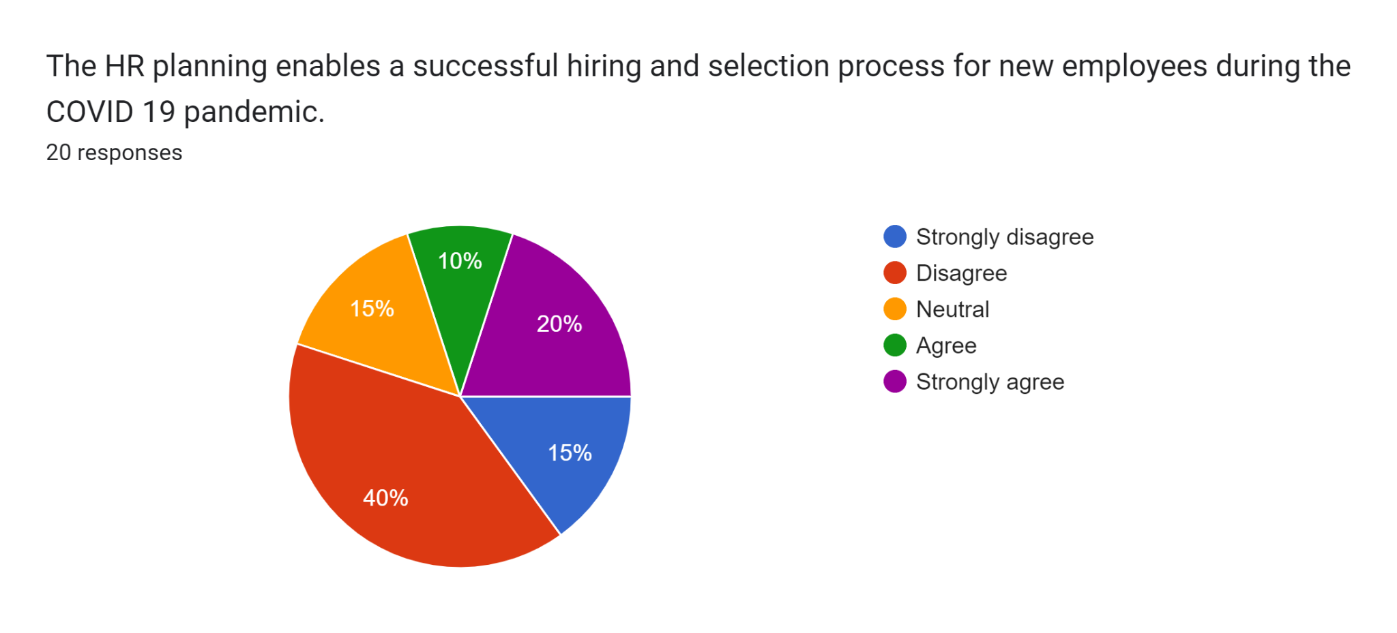
In conclusion, a smaller percentage of people agree or strongly agree that HR planning was effective during the epidemic, whereas the majority of people either disagree or are neutral about it. Those who disagree have responded in the greatest number.
Statement 2: Organizations develop their human resources (HR) strategy in light of the COVID-19 pandemic by taking into account the abilities, know-how, and gain knowledge of their present employees.
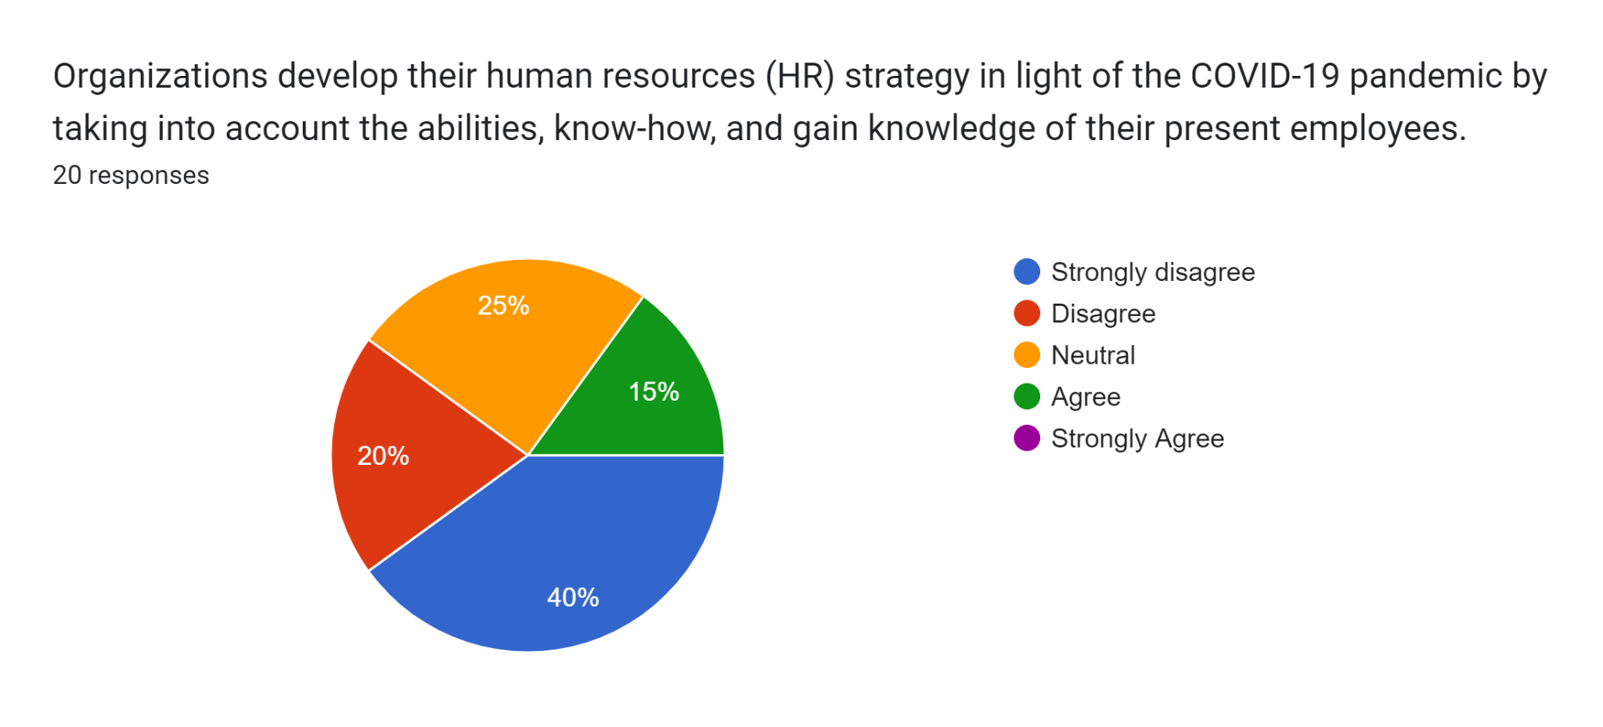
After conducting this survey, we discovered that most people are either indifferent or strongly disagree with the HR strategy's efficacy in light of the pandemic, with those who strongly disagree providing the biggest percentage of responses. There isn't any significant consensus to back up the statement.
Statement 3: The organization plans its HR well in order to meet its commercial objectives amid the COVID-19 epidemic.
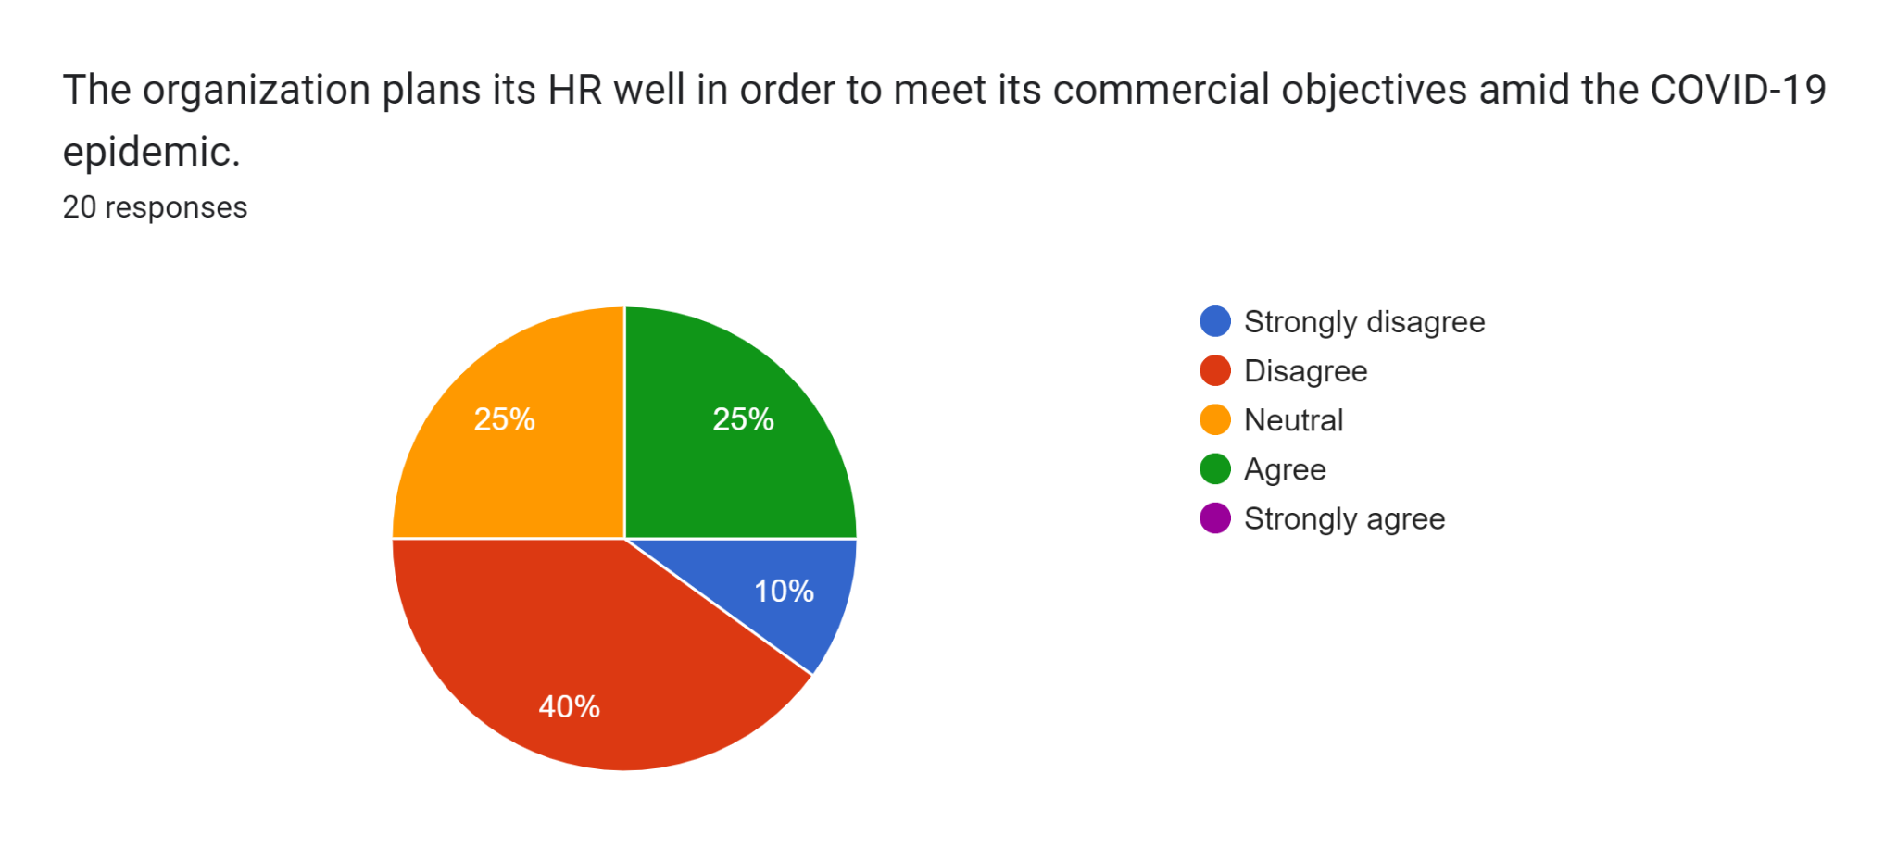

In conclusion, the majorities of people either disagree or are indifferent on the organization's ability to accomplish its commercial goals during the pandemic through its HR strategy, with the majority of people disagreeing making up the greatest portion of the responses. There isn't much consensus about the statement.
Statement 4: The Company holds an effective annual performance review session to evaluate employees' efforts during the COVID-19 epidemic.
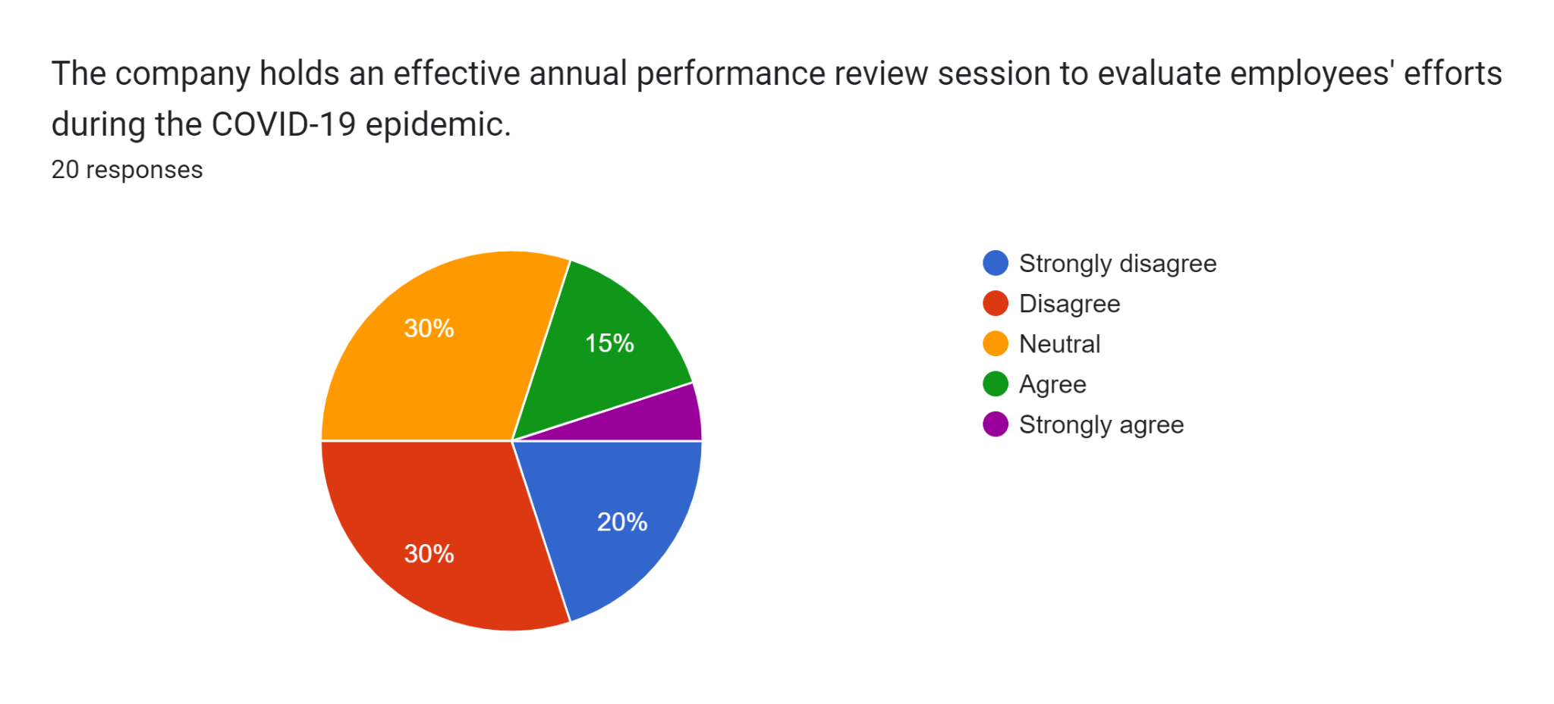
The replies are fairly split overall, with a greater percentage of respondents disagreeing or remaining neutral regarding the efficacy of the performance reviews.
Statement 5: The organization provides both new and existing employees with adequate training to enable them to adjust to the new business environment brought about by the COVID-19 epidemic.
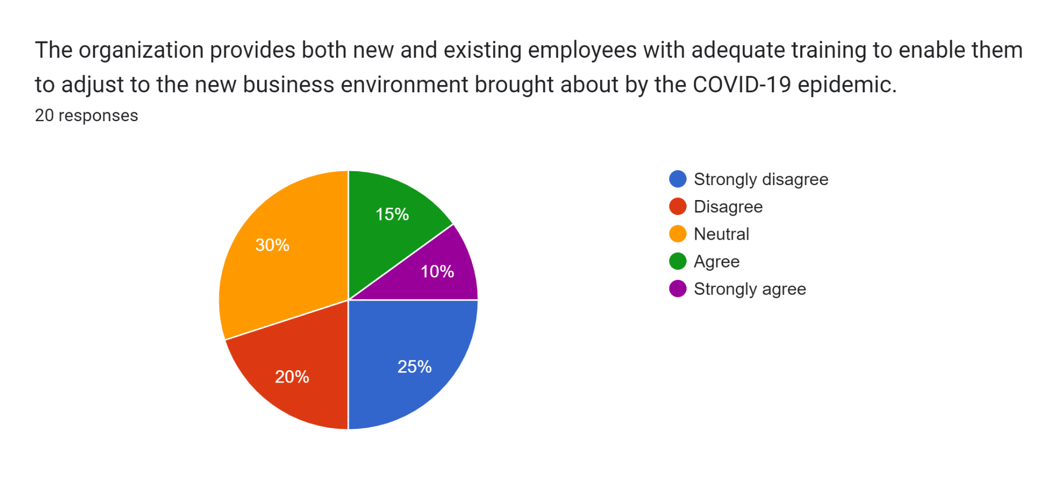
The majority of respondents were either ambivalent or disagreed with the organization's training on its suitability for helping employees adapt to the new business climate during the COVID-19 pandemic, indicating a diverse perception overall based on the responses.
Statement 6: During the COVID 19 pandemic, the predicted KPI is sufficient for all organizational staff levels.
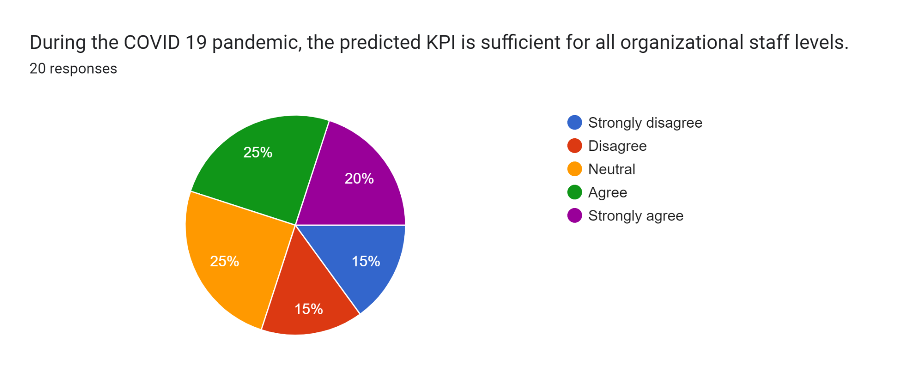
The survey results indicate a wide range of viewpoints, with most participants feeling either neutral or in agreement on the expected KPI's sufficiency during the COVID-19 epidemic.

Statement 7: During the COVID 19 epidemic, the organization's human resource planning process places a high focus on preserving workers' healthy work-life balance.
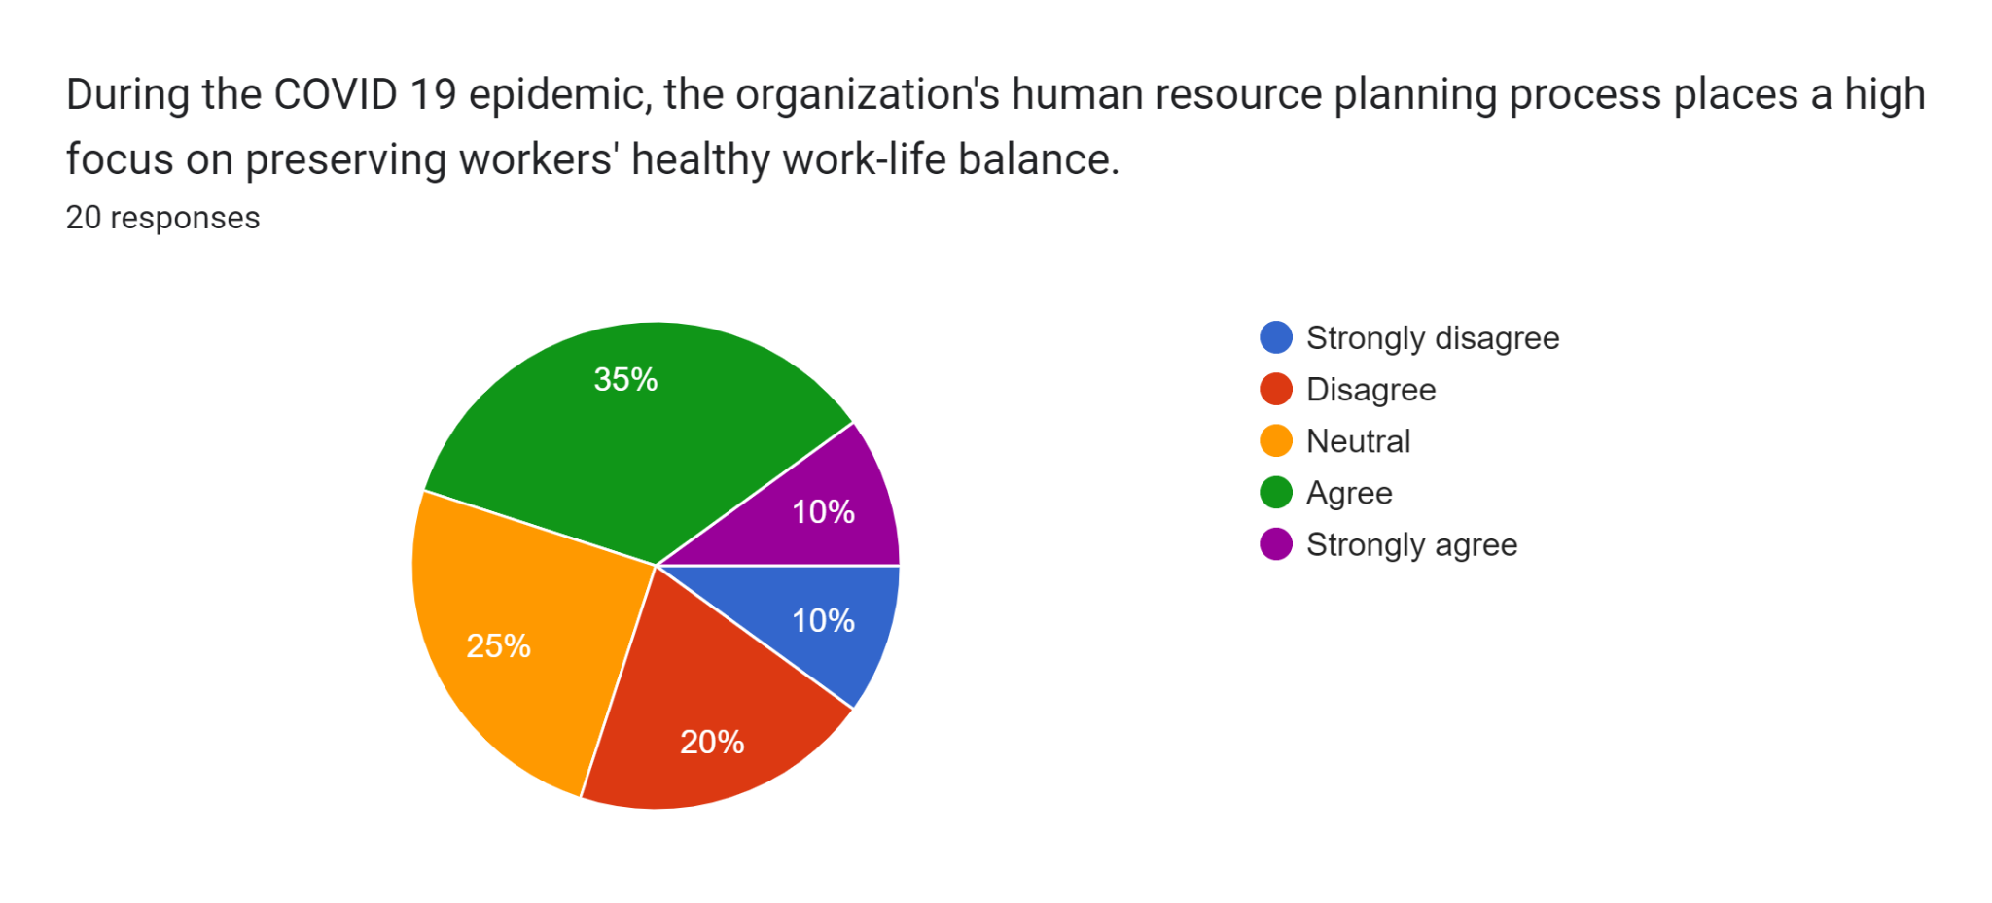

In summary, the majorities of individuals either agree and neutral about the focus on preserving good workers HR planning to give healthy work life balance, with the average response being from those who disagree. There is very limited participant who thinks strong agreement and disagreement with the statement.
Statement 8: Working conditions and job satisfaction are taken into account in the current modifications of the HR planning method throughout the COVID-19 pandemic.
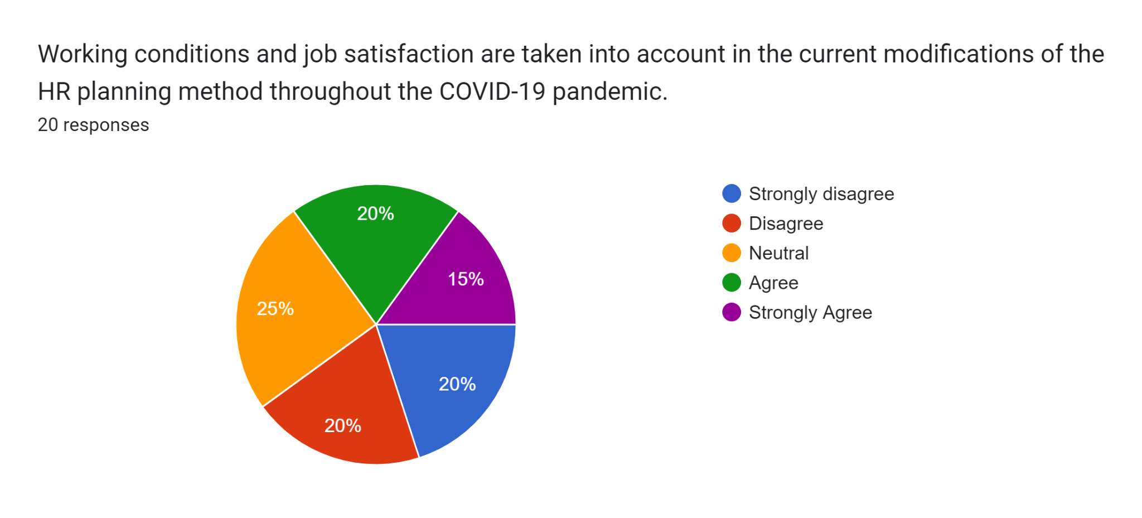
In conclusion we say that 20 respondents surveyed their agreement on the HR planning method during the COVID-19 pandemic, with a significant percentage of neutral respondents having no strong view. The results showed a divide in opinions, with more extreme views represented by a smaller percentage.

Statement 9: Everyone on the staff of the company is involved in developing strategic plans during the COVID-19 epidemic.
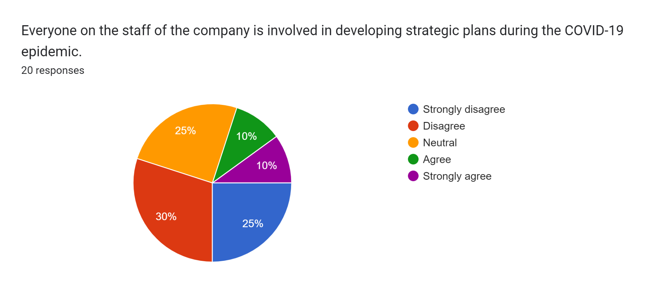
In summary, we see a significant proportion of responders don't agree with the statement. A large number of respondents expressed no opinion at all about the statement. A smaller group feels that the assertion is true, or very true. The replies' distribution suggests that staff members' involvement in creating strategic plans during the COVID-19 pandemic is a source of conflict or ambiguity, with views largely distributed between disagreement, neutrality, and agreement.
Statement 10: The organization conducts customer satisfaction evaluations in order to evaluate its performance during the COVID-19 epidemic
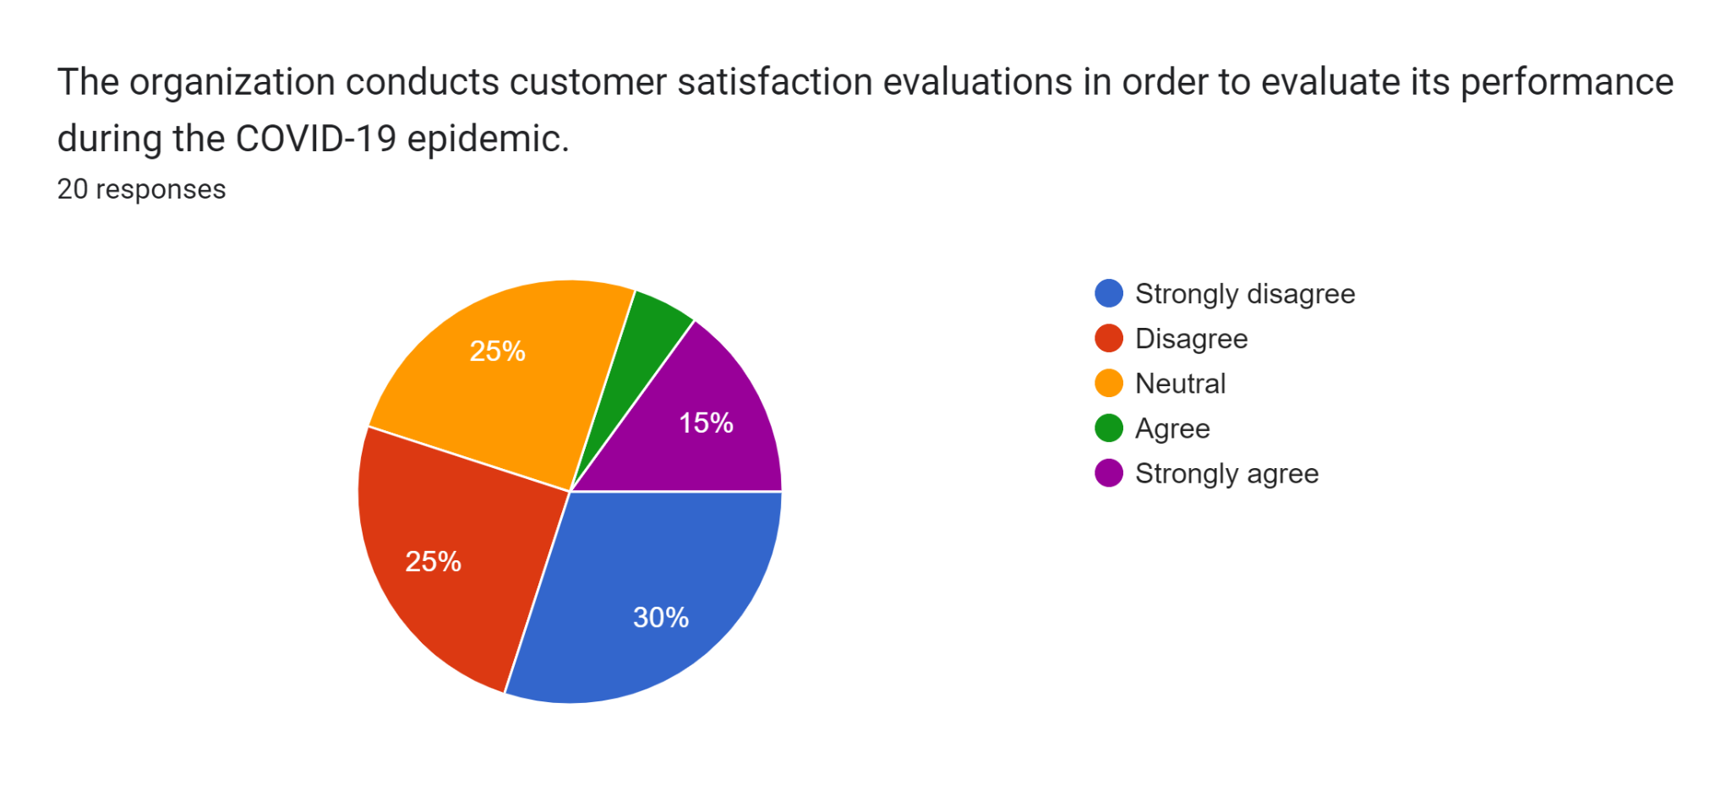
The majority of those surveyed strongly disagree with the statement. The same proportions of respondents disagree or have no opinion. The assertion is supported by a smaller group, and the smallest part supports it strongly. This shows that a significant number of respondents disagree with the organization's handling of these assessments, while a smaller percentage expressed agreement or neutrality.

CHAPTER FIVE:
FINDINGS, RECOMMENDATION AND CONCLUSION

Chapter 5: Findings, Recommendation, Conclusion

Findings

Based on the statements these are the findings that AIBL should be concern of for their low employee retention and get the best efficiency from the present workforce.
- HR planning during the outbreak was widely seen as unsuccessful, with most individuals expressing either a lack of strong opinions or open disagreement.
- There is widespread unhappiness and apathy toward the HR strategy employed during the epidemic, indicating an obvious need for change and review of the approach.
- During the pandemic, the HR strategy was widely seen as ineffectual in assisting the business in achieving its commercial objectives, with many respondents disagreeing or being unconcerned about its effectiveness.
- Many of the participants believe that performance evaluations are ineffective or ambiguous, indicating a possible area for improvement in the performance review process.
- Throughout the COVID-19 a worldwide epidemic, the organization's training programs were not universally considered as appropriate or helpful in assisting employees in adapting to the changing business climate, demonstrating a range of perspectives and the need for a rethink of the training strategy.
- There are many viewpoints on the sufficiency of the KPIs during the COVID-19 outbreak; nonetheless, a major part of respondents were either indifferent or acknowledged that the KPIs were enough, showing a broad acceptance or lack of strong unfavorable opinion on the subject.
- The majority of respondents are indifferent or somewhat supportive of the HR planning's emphasis on retaining good employees and establishing a healthy work-life balance; nonetheless, there is a noticeable average tendency toward dissent.
- There is a range of viewpoints on the HR planning strategy used during the pandemic, and a large percentage of respondents did not express strong sentiments either way.
- There is a range of viewpoints and doubt among responders about the amount of staff engagement in developing strategic strategies during the COVID-19 epidemic. The disagreement and indifferent replies indicate that this subject is contentious or not well-defined inside the company, necessitating further clarification or communication to resolve possible disputes or misunderstanding.
- Respondents expressed broad discontent or distrust with the organization's evaluation process. The majority strongly disagreeing indicates a considerable dissatisfaction with how evaluations are carried out or handled.

Recommendations

- Evaluate the current HR planning procedures to uncover particular flaws that contributed to unhappiness. To get thorough feedback, survey employees and hold group discussions.
- Improve communication channels to ensure that workers are informed about HR choices and strategies. Regular updates and open forums can help reduce confusion and build confidence.
- Refine and enhance performance evaluation criteria to improve their transparency and understandability. Ensure that the evaluation process is seen to be unbiased and beneficial.
- Perform a thorough examination of existing training programs to determine their relevance and efficacy. Use employee input to discover gaps and opportunities for development.
- Assure that Key Performance Indicators (KPIs) are closely associated with company objectives and may be adjusted to changing conditions. This alignment makes them more applicable and effective.
- Put into practice policies and programs that support work-life balance, including wellness programs, flexible work schedules, and mental wellness support.
- Be certain that all performance assessments are fair, transparent, and consistent throughout the business. To reduce prejudice, use objective criteria and include numerous reviewers.
- Regularly review the status of implementation and make necessary modifications. Use surveys and feedback methods to assess employee satisfaction and drive ongoing improvement.

5.3 Conclusion
Based on a comprehensive analysis of several research and noteworthy insights into the present pandemic scenario, workers are at a heightened risk of experiencing mental instability, potentially leading to reduced efficiency at job. It is crucial that people be encouraged to share their daily updates and offer a wide range of advice and ideas in order to boost their productivity and collaboration with others during this period. The person should be responsible for the organization's goals and objectives in this situation of uncertainty. Workers need to be kept continuously updated on the company's progress and new strategic plan. To stop the pandemic scenario from spreading, everyone in the workplace has to adopt safety precautions.
Numerous studies and research projects have demonstrated a strong correlation between organizational effectiveness and human resource planning. Human resource planning (HRP) must be in line with an organization's goals and objectives in order to avoid long-term costs from errors such hiring the incorrect staff or neglecting to account for fluctuations in appointment requirements. Using methodologies for human resource planning, an organization may predict labor demand and analyze the kind, quantity, and sources of labor needed to meet the firm's goals and objectives and succeed. Employee satisfaction and corporate effectiveness are significantly impacted by HR practices and HRP in particular.
This report's findings support the notion that human resource planning benefits both companies and their workforces. Based on the results of the study, Al-Arafah Islami Bank PLC can more easily maintain good organizational performance during a pandemic by using an online recruitment process, offering adequate training facilities, supporting female employees in balancing their work and personal lives, expressing career opportunities, and offering freedom in the workplace.
In regard to this, it can be said that efficient human resource planning is more important for them individually and also more advantageous for the company in terms of achieving its objectives. If Al-Arafah Islami Bank PLC's HRD is able to resolve some of the issues with efficient human resource planning during the COVID-19 pandemic, both the organization's performance and a good work-life culture may be established.

Bibliography
(2020). Integrated Annual Report, City Bank Limited . Bangladesh.
ABout Organization Profile. (n.d.). Retrieved from City Bank Limited: https://www.thecitybank.com/home
Armstrong, M. (2003). A Hand Book of Human Resource Management Practice 9th Edition. Kogan Page Ltd.
ARYA, A. (n.d.). Gyansanchay. Retrieved from https://gyansanchay.csjmu.ac.in/wp-content/uploads/2022/09/UNIT-2-HRP.pdf
Aswathappa, K. (n.d.). Keka. Retrieved from Keka.com: https://www.keka.com/human-resource-planning
Boxall, M. S. (2001). Human resource strategy and competitive advantage: A longitudinal study of engineering consultancies. Journal of Management Studies, 36, 443-463.
Boxall, M. S. (2001). Human resource strategy and competitve advantage: A longitudinal study of engineering consultancis. Journal of Managment Studies, 36.
Cohen, D. (2004). Taking Stock II Report on the Reports. Action Aid International.
Cohen, D. (2004). Taking Stock II Report on the Reports. Action Aid International .
Craft. (1980). Human resource practices and organizational performance: review synthesis and research implications.
Dr. Janes O. Samwel, P. (2018). Human Resource Planning as an Important Practice to Anticipate Future Human Resource Requirements of the Organization. International Journal of Research in Business Studies and Management, 24-30.
Duseyi, S., & Hammad T, A. W. (2009). "Toward a Career_Resilient Workforce”.
Ghazala, I. &. (2012). Journal of Business and Management. 3(6): 06-13.
Griffins, L. (2006). Human Resource Planning . Human Resource Managment Journal, 71-83.
Griffins, L. W. (2006). Human Resource Planning: concept and cases. Human Resource Management Journal, 16(2), 71-83.
Gupta, C. (2008). Modern Human Resource Management. Sultan Chand & Sons.
Hassan Danial Aslam. (2013). Human Resource Planning Practice in Managing Human Resource: A Literature Review. International Journal of Human Resource Studies.
John M. Dirkx, J. W. (2000). Organizational learning, performance, and change: An introduction to strategic HRD. . Cambridge: MA: Perseus.
Kwon, D. (2009). Human capital and its measurement. Forum on Statistics, Knowledge and Policy. . Charting Progress, Building Visions, Improving Life, Busan, Korea,, 27- 30.
Masoom, M. (2020, September 05). What did Corona teach the banks? Retrieved from Bankibarta Newspapaer: https://bonikbarta.net/home/news_description/240460/%E0%A6%95%E0%A6%B0%E0%A7%8B%E0%A6%A8%E0%A6%BE-%E0%A6%AC%E0%A7%8D%E0%A6%AF%E0%A6%BE%E0%A6%82%E0%A6%95%E0%A6%97%E0%A7%81%E0%A6%B2%E0%A7%8B%E0%A6%95%E0%A7%87-%E0%A6%95%E0%A7%80-%E0%A6%B6%E0%A6%BF%E0%A6%95%E
Mohamad, M. C. (2009). Human Resource Practices and Organizational Performance. Journal of Academic Research in Economics.
Noe. (2003). Human resource practices and organizational performance: review synthesis and research implications.
Pearce, G. E. (1988-2000). Inevitable Forces for Change in America.
Reilly, P. (2003). Guide to workforce planning in local authorities, employers’ organization for local government. London.
Revathy, D. B. (2021). Human Resource Management: Exploring the HR Concepts. Gujrat: Krishna Publication House.
Shirey, M. (2008). Building the leadership development pipeline. A 5-step succession planning model. Clinical Nurse Specialist, 22(5), 214-217.
Shirey, M. (2008). Building the Leafership Development Pipeline. A 5-Step succession planning model. Clinical Nurse Specialist, 22(5), 214-217.
Tapash Chandra Paul, P. (2020-2021). COVID-19 Impact in Banking Industry. Bangladesh: MBL Monthly Online Bulletin.
Vetter, E. (n.d.). Keka.com. Retrieved from keka.com: https://www.keka.com/human-resource-planning
W.G, S., & Speamerfam. (2011). “What is human resource planning and the level of importance to an organization".
Website of City Bank Limited- Career. (n.d.). Retrieved from City Bank Limited: https://www.thecitybank.com/career
Website of City Bank Limited- Who We Are. (n.d.). Retrieved from City Bank Limited: https://www.thecitybank.com/who-we-are
William, R. &. (1988). Human Resource Planning and Management. New Jersey: Prentice Hall.
William, R. &. (1988). Human Resource Planning and Management. New Jersey: Prentice Hall.
Woodhall, M. (2001). Human capital: Educational aspects. International Encyclopedia of the Social &Behavioural Sciences.
Zubair, M. A., & Barnard, W. (2006). “seven steps of effective workforce planning”.

