Repositioning Strategy of ACI consumer Brand

Farid Hosen

This report is submitted to the School of Business and Economics, United International University as a partial requirement for the fulfillment of Bachelor of Business Administration Degree.

Repositioning Strategy of ACI Consumer Brand

Prepared by-
Farid Hosen
ID-111 131 387
Major in Marketing
BBA Program

Supervised by-
Kawsar Ahmmed, Ph.D.
Associate Professor
School of Business & Economics
United International University

Date of Submission: 16th October, 2018
Letter of Transmittal
October 16, 2018
Dr. Kawsar Ahmmed, Ph.D.
Associate Professor
School of Business & Economics
Subject: Submission of internship report.
Dear Sir,
With due respect, I would like to take this opportunity to thank you for the guidance and support you have provided me during the course of this report. This report is based on Repositioning Strategy of ACI consumer brand.
I have elaborated on my internship experience in ACI Limited. I have practically worked and observed their working patterns, management and other company activities in order to gain experience about the corporate environment. To carry out the report, I have acquired various papers/documents, and periodicals from my Product Executive as well as from internet. On the basis of these secondary data and practical observations, I have prepared this report.
I would like to appeal you to excuse me any mistake that may occur in the report despite my foremost efforts. I would really appreciate notify me with your thoughts and views regarding the report. I would gladly answer your queries.

Sincerely Yours,

_______________
Farid Hosen
ID-111 131 387
BBA Program
Major in Marketing
School of Business and Economics
United International University

Supervisor’s Certificate
This is to certify that Farid Hosen ID: 111 131 387, BBA Program, Major in Marketing, School of Business & Economics, United International University (UIU) has completed the internship report on “Repositioning Strategy of ACI consumer brand” successfully under my supervision. I have gone through the final draft of the report and approved it for submission.

I wish him every success in life

______________________
Dr. KawsarAhmmed, Ph.D.
Associate Professor
School of Business & Economics
United International University (UIU)

Acknowledgements

My first acknowledgement goes to the almighty Allah for bestowing us the patience and courage to finish this huge task within its deadline.
I want to express my utmost gratitude to my academic supervisor, Ahmmed Kawsar, Ph.D. Sir for supervising and guiding me to present this report. He has counseled me in every step of the report.
Moreover, I am exceedingly thankful to my product executive of Consumer brands at ACI Bangladesh Ltd, Zahirul Islam khan who has assisted me in every day-to-day activity that brought out my inner potentiality. He has provided me with all the necessary information and documents that was required to prepare a rigorous report.
Furthermore, I am also overwhelmed by my fellow colleagues at ACI Bangladesh Limited who have supported me in thick and thin, made me feel at home and communicated practical advice which helped me carry on my duty as an intern.
Finally, I would also like to take the opportunity to thank my family
and friends who have helped me a lot directly and indirectly while making the report.

Executive Summary
This report is mainly concerned with the repositioning strategy of ACI consumer brand where the main purpose of the report was to discuss how to repositioning the consumer brand. Repositioning means to the major alter in positioning for the brand/product. For a successful repositioning, the firm has to change the target market understanding of the market offering and this is sometimes a challenge, particularly for well-established or powerfully branded products.

In this study, the researcher includes the repositioning strategy of ACI consumer brand. In the first chapter of this study, researcher discusses the company and second chapter researcher discuss the overview of the organization and literature review and in third chapter researcher conduct a survey, and try to find out a solution how to repositioning the consumer brand.

Special focus was given on the activities and processes directly or indirectly involved with the repositioning strategy of ACI consumer brand where this study completed by using both primary and secondary data and relevant analysis were presented accordingly. Using the collected data and analyzing them, researcher organized finding followed with a set of recommendations for ACI ltd on the basis of repositioning strategy.

Keywords: Repositioning the consumer brand, target Market, strong brand, Continuous Improvement, ACI Ltd.

Table of Contents
Chapter | Page No
Chapter One
Introduction
1.0 Introduction | 1
1.1Motivation of the Study | 1
1.2 Limitations | 1
1.3 Rational of the Study | 1
1.4 Objectives of the Report | 2
Chapter Two
Company Profile and Literature Review
2.0 Background of the Organization | 2
2.1 Mission & Vision | 4
2.2 Management of the ACI Limited | 5
2.3 Organizational hierarchy of ACI Consumer Brands | 6
2.4 Strategic Business Units of the ACI Limited | 6-10
2.5 A short Brief of ACI Household Insecticide Products | 10-12
2.6 Existing Market position of Consumer Brands & Commodity Products | 12-13
2.7 List of Competitors of Consumer Brands & Commodity Products | 13-15
2.8 Literature Review | 15-19
Chapter Three

Methodology, Data Collection, Analysis and Discussion

3.0 Introduction | 20
3.1 Methodology of the study | 21
3.2 Questinire | 22
Conclusion | 24
Reference | 25
Question Papaer | 26-28

Chapter one
Introduction

1.0 Introduction
For a business studies student an internship stage is a real work experience offered by an employer to exposure to the working environment, often within a separate industry, and relates to business field of study. In this report I have determined on my topic “Repositioning Strategy of ACI consumer Brand”.
1.1 Motivation of the Study:
This report has been as a part of my BBA program and this report I prepared on Reposition strategies of ACI consumer Brand. This report gives me the chance to realize how to reposition a consumer brand and effective analysis of consumer brand and this report is bases on repositioning strategy of consumer brand, which is prepared by individually under the supervision and guidance by Dr. Kawsar Ahmeed PhD Associate professor, school of Business & Economics.
1.2 Limitations
1. Limitation of time: Lack of enough time, it was very difficult to known an organization and make good relation to permanent employees.
2. Limitation of connected to the organization: Most of the time we visited market for data collection, try to see competitor trade promotion, and customer promotion, that’s why we find a very short time to connected to organization.
3. Difficult to collect Data: Most of the data are very confidential for the organization that’s why it was very difficult to collect data.
1.3 Rationale of the Study:
I am doing my internship at ACI consumer brands in the department of Household Insecticides. Household Insecticides is a part of ACI consumer brands. In this section there are three types of products, which are: ACI Aerosol, ACI Cockroach Spray and ACI Mosquito Coil and these products are insect killers and these three products are main products of ACI. I choose to do this report on this section because of this products are not regular household products and this products are not easy to sell because of the chemical uses of this products and sometimes harmful to health, but in ACI these are the star products and they have huge demand in the market. They are also giving hard times to the both forging and other local brands.
As we know this products are sold seasonally or we can say in a way that this products have some pick time of the years when the seals go higher but rest of the years sells stays low but there are some individual areas where sells stays at a pick. Now the thing that clutched my attention is that the consumers are not always loyal they switch brands if the find any other better option same goes for this products consumer don’t go for any specific brand the just go for anything which is given to them by the shop owner, without knowing is it good for their health or not but now I want to find out how the sales promotion are made, how the distribution of this products are done, What challenges may come while promoting this products and how to overcome them.
1.4 Objectives of the Report:
- To get an idea about the overall business position of the ACI limited.
- To observe the branding and marketing gatherings of consumer brands.
- To acquire practical information about the sales and distribution process of the household insecticide products.
- To know about the effective positions of the sales force and the applications of the sales promotion.
- To find out the existing promotional challenges in the functions of the sales and distribution process.
- To provide some possible solutions to conquer from the existing problem.

Chapter Two
Company profile and literature review

2.0 Background of the Organization:
Company Overview (ACI):
Company Name: Advanced Chemical Industries
Nature of Business: Manufacturing, Processing, Retail, And Service
Managing Director: Mr. ArifDowla
Address: ACI Center, 245 Tejgaon Industrial areas. Dhaka 1208
Phone: 880 2 887 8603
Fax: 880 2 8878619 & 8878626
Email: info@aci-bd.com
ACI central goal is to accomplish business brilliance through quality by thoughtful, tolerating, meeting and surpassing client desires. ACI takes after International Standards on Quality Management System to guarantee reliable nature of items and administrations to complete consumer faithfulness. ACI additionally meets all national administrative prerequisites identifying with its present organizations and guarantees that present Good Manufacturing Practices (GMP) as prescribed by World Health Organization is taken after properly. The World Economic Forum has acknowledged ACI as a beginning Member of the society of Global Growth Companies, which is the most respected business organizing association.


ACI was set up as the backup of Imperial Chemical Industries (ICI) in the then East Pakistan in 1968. After independence the organization has been combined in Bangladesh on the 24th of January 1973 as ICI Bangladesh manufacturer Limited also as Public Limited Company and this Company similarly got posting with Dhaka Stock Exchange on 28 December, 1976 and its first exchanging of shares occurred on 9 March, 1994 but later on 5 May, 1992, ICI plc. Stripped 70% of its shareholding to nearby administration. Therefore the organization was enlisted for the sake of Advanced Chemical Industries Limited and posting with Chittagong Stock Exchange was made on 22 October 1995.
Advanced Chemical Industries (ACI) Limited is one of the main combinations in Bangladesh, with a multinational heirloom. The organization has broadened into four noteworthy Strategic Business Units.

2.1 Mission & Vision
Mission of ACI:
ACI main goal is to get better the personal satisfaction of individuals through talented utilization of learning, aptitudes and innovation and ACI is focused on the quest for incredibleness through world-class items, creative procedures and engaged workers to give the most abnormal amount of completion to clients.

Vision of ACI:
To realize the mission ACI will:
- Try to achieve a place of administration at every class of its organizations.
- Attaining high level of productivity in every one of its working through thriving as well as proficient utilization of assets, selection of proper innovation and arrangement with our center capabilities.
- Developing its legislature with empowering strengthening and remunerate advancement.
- Promoting a situation about learning and self-improvement for its representatives.
- Providing items and administrations of good and reliable quality, assuring worth of cash to its clients.
- Give confidence regarding help with subjective change of the administrations of its suppliers and retailers.
- Establish concordant association with the group and advance better-known natural commitment inside of its range.
- 2.2 Management of the ACI Limited:

Mr. M AnisUdDowla | Chairman
Mr. Syed Alamgir | Managing Director
Mr. F H Ansarey | Executive Director, Agribusinesses
Mr. Syed Alamgir | Executive Director, Consumer Brands
Mr. M. MohibuzZaman | Chief Operating Officer, Pharmaceuticals
Mr. PradipKarChowdhury | Executive Director, Finance and Planning
Mr. SabbirHasanNasir | Executive Director, Logistics
Mr. PriyatoshDatta | Director, Quality Assurance, Pharma
Mr. AbdusSadeque | Director, Marketing & Sales, Pharma
Ms. Sheema Abed Rahman | Director, Corporate Affairs
Mr. Md. MonirHossain Khan | Financial Controller
Mr. Imam Ahmed Istiak | Director, Operations, Pharma

2.3 Organizational hierarchy of ACI Consumer Brands:
Product Executive

Sr. Brand Manager

Product Group Manger

Marketing Manager

Asst. Brand Manager

Sr. Product Executive

Brand Manager

Business Director

Board of Director

Executive Director

Business Manager

Product officer

2.4 Strategic Business Units of the ACI Limited:
2.4.1 Strategic Business Units:
- Pharmaceuticals
- Consumer Brands & Commodity Products
- Retail Chain
- Agribusinesses:
- Crop Care Public Health
- Animal Health
- Fertilizer
- Motors
- Crops
- Seeds
2.4.2 ACI has the following subsidiaries:
ACI Formulations Limited
- ACI Logistics Limited
- ACI Pure Flour Limited
- ACI Foods Limited
- ACI Salt Limited
- ACI Motors Limited
- Creative Communication Limited
- Premier flex Plastics Limited
- ACI Agrochemicals Limited
- Fly ban Insecticides Limited
- Apex Leather Crafts Limited
- ACI Edible Oils Limited
- ACI Healthcare Limited
- ACI Chemicals Limited
Joint Ventures:
- ACI Godrej Agro vet Private Limited
- Tetley ACI (Bangladesh) Limited
- Asian Consumer Care (Pvt) Limited

2.4.3 ACI Products and Services of Consumer Brands Division:

ACI Consumer Brands was initiate in 1995 with two major brands of the company ACI Aerosol and savlon. These are two of most important products that are enjoying the leadership position in the market and the separation started to take new businesses through off shore trading as well as local developed. In this process ACI Consumer Brands launched many new products and also glued with Joint Venture business connections to attained international alliances with world well-known companies.

2.4.4 Units under ACI consumer brands & commodity products:

PRODUCT CATEGORY | PRODUCTS | PRODUCT PICTURES
Family Insecticides | - ACI Aerosol and ACI Cockroach Spray  ACI Mosquito Coil | 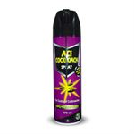  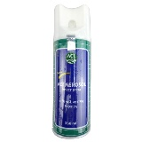  
Antiseptic & Personal Care | Savlon | 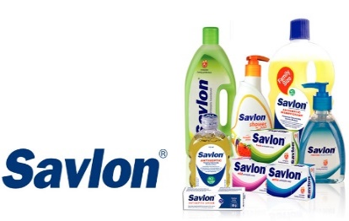
Home Care | - Vanish Toilet Cleaner  - Angelic Fresh Air Freshener | 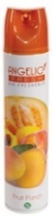  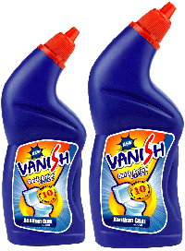
Fabric Care | Smart | 
PRODUCT CATEGORY | PRODUCTS | PRODUCT PICTURES
Female Hygiene | Savlon Freedom Sanitary Napkin | 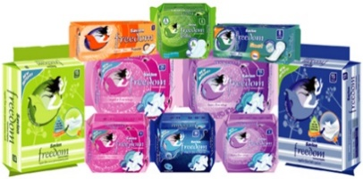
Kitchen Care | Septex, Wonder | 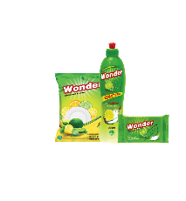  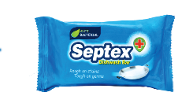
Commodity Foods | ACI Pure Salt | 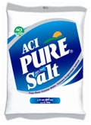
ACI Consumer Electronics | Panasonic | 
ACI Electrical Division | Sparkle | 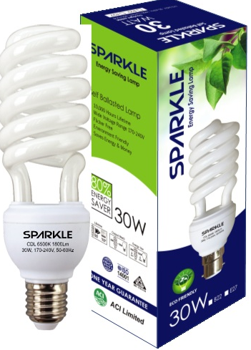
Mobile | Stylus | 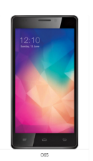

Table: ACI Consumer Brand Products

2.5 A Short Brief of ACI Household Insecticide Products:

ACI Aerosol and ACI Cockroach Spray:
The greatest general problems are people aspects in Bangladesh is the annoyance of insects like mosquito, cockroach and others but many illness like Malaria, Dengue and others are transferred to human body by insects. ACI finds an efficient blend to this problem and offering a range of insect damaging products like ACI Aerosol, Mosquito Coil and Cockroach Killer Spray.
Since its examination in 1967, ACI Aerosol has became the number one priority of consumers in Bangladesh and the performance to ensure the highest quality has helped ACI to be THE MOST EFFECTIVE MOSQUITO KILLER. To meet the limitations of customers of several socio economic groups, ACI Aerosol is more available all around the country of Bangladesh in four different pack shapes and they are: 800 ml, 475 ml, 350 ml and 250 ml.
ACI published its ‘ACI Cockroach Spray’ in June 2008, the first ever locally affected Cockroach killing Spray with an target of giving people free from the threat of Cockroaches and also making the overall system of killing Cockroaches a safer and convenient one as using powder and chalk is harmful for health and effectiveness of the product is very high and it allows consumers free from cockroaches rapidly.

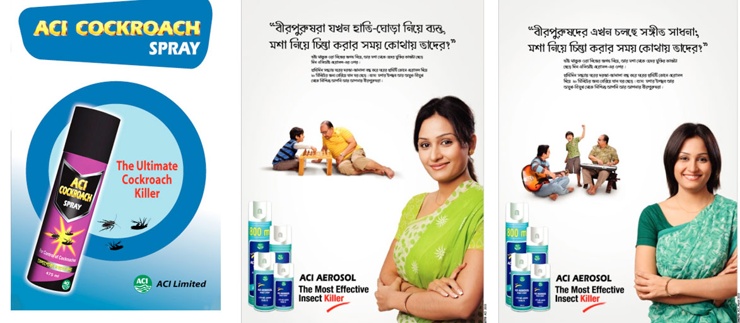

ACI Mosquito Coil:
ACI Mosquito Coil is an important product of the Home Care category of ACI Consumer Brands and ACI Mosquito Coil has several brands created on different shape, color and smell and price. Because consumers’ health and well-being is always a important to ACI we have top quality active components like Metofluthrin and D-Allethrin from Sumitomo business of Japan but none of our Coils have any dangerousmaterials like DDT or Endrin in it.
ACI Mosquito coil has the following brands:
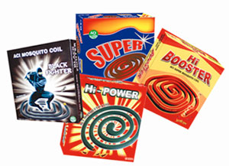
- ACI Hi Power.
- ACI Super.
- ACI High Booster and
- ACI Black Fighter.
Including all its brands ACI Black Fighter has already captured the position of market leader in black coil category.

2.6 Existing Market position of Consumer Brands & Commodity Products:

UNITS | BRANDS | MARKET POSITION
Household Insecticides | - ACI Aerosol and ACI Cockroach Spray  - ACI Mosquito Coil | Market Leader
Antiseptic & Personal Care | Savlon | Market Leader
Home Care | - Vanish Toilet Cleaner  - Angelic Fresh Air Freshener | Second & Market leader
Female Hygiene | Savlon Freedom Sanitary Napkin | Second
Commodity Foods | ACI Pure Salt | Market Leader
ACI Consumer Electronic | Panasonic | Below Ten
ACI Electrical Division | Sparkle | Under Activation
Mobile | Stylus | Under Activation
Fabric Care | Smart | Under Activation
Kitchen Care | Septex, Wonder | Under Activation

Table: Current Market Position of Consumer Brand
Source: Executives of ACI consumer brand

In table we can discovery that ACI Aerosol, ACI Cockroach Spray, ACI Mosquito Coil,Angelic Fresh Air Freshener, Savlon and ACI unadulterated Salt are the principal brands of ACI consumer brand. Then the Second leaders of consumer brand areVanish Toilet Cleaner and Savlon Freedom SanitaryNapkin. Other like Panasonic, Sparkle, Stylus, Smart, Septex and Wonder working their way up to create a place in the obtainable market.

2.7 List of Competitors of Consumer Brands & Commodity Products:

UNITS | BRANDS | COMPETITORS
Household Insecticides | - ACI Aerosol and ACI Cockroach Spray  - ACI Mosquito Coil | Baygon, Hit, Morteen, Good Knight, Eagle
Antiseptic & Personal Care | Savlon | Detol, Lifeboy
Home Care | - Vanish Toilet Cleaner  - Angelic Fresh Air Freshener | Harpic, Fay, Spring, Airwick
Female Hygiene | Savlon Freedom Sanitary Napkin | Senora, Wisper, Monalisa, Joya
Commodity Foods | ACI Pure Salt | Molla, Fresh, Confidence
ACI Consumer Electronics | Panasonic | Sharp, Sony, Hitachi, Walton, General
ACI Electrical Division | Sparkle | Tranastec,
Mobile | Stylus | Walton, Symphony, Micromax
Fabric Care | Smart | Wheel, Rin, Chaka, Tibet, Ghari
Kitchen Care | Septex, Wonder | Vim, Trix, Maxclean, Glitter

Table: List of Competitors of Consumer Brands

As for Household Insecticides their target customers are:

Geographical: They have under attack mostly the crowded cities, local towns and urban area for their selling

Demographic: It’s an all age, gender usage products. But typically in their anxiety we find that a women figure is shown which indicates as a mother figure, so they are targeting mothers to buy the product.

Behavioral and Psychographic: As for this they have divided their products hooked on different categories, shapes, and reasonably priced prices. A coil has the low price ratios, and then comes the Aerosol, which has, different shape and the prices are also been lowered down rendering to the shapes.

2.8 Literature review
2.8.1 Defensive Strategy
Pre- entry strategies:
Signaling: Signaling means when company often uses signaling to announce their intension to take action and when ACI consumer brand introduce a new product they announced it press, press release, speech, deal journal and newspaper. This announcement possibly will serve unusual objective but those are not necessarily mutually exclusive.
Fortify and Defend: Fortify and Defend strategy create barrier to access for competitors where erecting barrier create hinders access by new competitor because they need to incur costs not born by obtainable competitors and the nearly all common barriers to entry include, product separation, capital necessities, and other inputs access of distribution channels and location but ACI consumer brand take this strategies when new competitors are entrance in market.
Cover all Bases: Cover all bases are called product propagation, entail, introduce new product to make sure a full product line and ACI consumer brands always try to keep multiple version of a product in terms of models or product types but on the other hand many firms carry full product lines access to the industry by new entrants.
Continuous Improvement: This strategy calls for a persistent pursuit of development in costs, improvement of new product, better quality, introducing new product and developed at where ACI consumer brand always try to improve their quality try to involve new technology new innovation and added new features among others and also improve the firms marketing mix. They always try to provide superior feature or benefits.
Average Pre –entry strategies: For repositioning strategy ACI consumer brand used pre –entry marketing strategies.

2.8.2 Post –entry Strategies:
Defend Position before Entrant Become Establish: When a company entrants an existing market its aim usually is to get established first in its chosen market segments, consolidate, its position and then start expanding other market segments but when consumer brand launch any physical product they first thinking the market segment, consolidate its position and then start expanding other market segments.
Introducing Fighting Brands: Fighting brands are introduced by organizations to fight a competitor’s brand that threatens one of their major brands but when ACI consumer brand launch ACI black fighter mosquito coil in existing market they charge a lower price than other competitor brands as a result they easily entrant the market.
Engage in Cross- party: The degree of multi market contact between two firms affects the intensity of rivalry and the extent of retaliation amongst firms.
Average post-entry Defensive Strategies: In this post entry defensive strategies ACI consumer brand used most of the defensive strategies for re-positioning the consumer brand.
2.8.3 Offensive Strategies
Lunch a Frontal Attack: This offensive strategy directly attract competitor head on and by going after the customer frontal attack can be pure frontal attack of the attack firm with parallel product, same price, similar support, and allocation because this attack are very perilous however since success is never secure unless the attacker has a obvious aggressive benefit over the defendant and that’s why consumer brand never used this strategy because they have individual distribution channel pricing system.
Launch a Flanking Attack: Basically this attract develop to find opponent weakness as reduce the risk that should be created with other offensive strategy such as frontal attacks and they try to identify the competitor weakness when ACI consumer brand come with a new product in the market they try reduce the risk that should be created with other offensive strategy.
Engage in Strategic Encirclement: This offensive strategy has been used by the company now day to day activities. People within an organization going to verse on that strategy to get the maximum output for better of the company. Organizations are concentrated on their target customer but the amount of buyer is not sufficient if the strategic encirclement is not proper within an organization.
Engage in Predatory Strategy: purpose of taking new competitor out, or inflicting damage on existing rivals and forcing them to get out from the market because consumer brand sometime doing the right thing they charge low price in the market that’s why new competitor cannot come to the market.
Seek Undefended markets: Seek exposed market entails avoid head on contest with well established rival that often lead to hostile price acerbic advertising wars or costly efforts to outspend.
Engage in Underdog Strategy: An underdog strategy involves a small and usually young firm taking on a much larger competitor and it is often employed by an upstart company that does not hesitate to get into a competition with much bigger opponents in order to break their monopoly and offer the market better product, lower prices or both.
Engage in Judo Strategy: This Strategy is an offensive marketing strategy suitable for not big companies willing to take on greater opponents and it is similar to the martial art of judo where opponent uses the heaviness and power of the better enemy to its benefit.
Engage in the pivot and Hammer Strategy: It is a combination of defensive and offensive Strategy and it is a strategy associated with Even Dudik business strategies.
Average Offensive Strategies: In an offensive strategy consumer brand used most of the offensive strategies.

Chapter Three

Methodology, Data Collection, Analysis and Discussion

3.0 Introduction

In this chapter first of all talk about the sample for the current study. Dimension and data compilation and on the basis of supervisors feedback find out some gap in reposition strategy of ACI and based on the gaps repositioning strategy of ACI optional some answer which will be helpful for ACI limited.

3.1 Methodology of the study

This report is descriptive in nature. To prepare a report it is very important to collect data. For this report, information was collecting from both primary and a secondary source of data and the information was collecting from ACI limited corporate office and other secondary fundamentals.

Primary Source:

Face to Face talk with the officer and product executive, and brand manager.

Relevant data and other material as provided by supervisor.

Secondary Source:

Website of ACI limited

Other different Webpages

3.2 Questionnaire
Pre –Entry Strategies:
1. signaling to announce to offer something new positively impact on company’s market position.
2. An attempt to build barrier to entry for competitors act positively on the company‘s position.
3. Product proliferation –offering diversified products is beneficial for the company success.
4. Continuous improvement in costs, product quality, new product development, manufacturing process is a must for market success.
5. Capacity expansion acts as an entry barrier and impact positively on market success.

Post –entry Defensive Strategies
- Defending own position before other company become establish is essential for market success.
- Introducing low priced fighting brand threatens other competitors to enter into the market.
- Competition into multimarket between two firms affects the intensity of competition and market success.
- Attacking a competitor frontally like on price, promotion etc .are more effective for market success.
- Finding other competitors weakness and attacking on those sides are more effective competitive strategy.
- Launching Guerrilla attack – conventional and unconventional strategies gives markers more advantages into the market place.
- Accepting lower profits for the

In this chat pre-entry strategies average is 4.42, post – entry strategies average is 3.67 and offensive strategies average is 3.64. For re-positioning strategies of ACI consumer brand pre – entry strategies is most effective than other strategies.

Conclusion

ACI was founded as the subsidiary of Imperial Chemical Industries (ICI) in 1968 but after independence the company has been incorporated in Bangladesh on the 24th of January 1973 as ICI Bangladesh Manufacturers Limited and also as Public Limited Company and ACI Limited is one of the chief conglomerates in Bangladesh, with a multinational heritage. The company has expanded into four major businesses so that the company can re-position the Brand in the market, must take in mind the vigorous factors that influence the locales in selecting and being loyal to a brand and use to factors to maintain proper communication to retain and grab more customers and this research was done so that ACI Ltd. can get better understanding and formulate better plans regarding consumer brand.

Reference

1…………(N.D)About ACI…Retrieved From..http://www.aci-bd.com/about-us/
2. …………(N.D)ACI Limited…Retrieved From https://en.wikipedia.org/wiki/ACI_Limited
3. ………….(N.D)ACI Corporate Information..Retrieved From http://www.assignmentpoint.com/business/aci-limited-corporate-information.html
4………(N.D)ACI Consumer Product list ..Retrieved From http://www.aci-bd.com/consumer.php
5………(N.D) ACI Business Unit…Retrieved From http://www.aci-bd.com/business-units.php

Questionnaire on

Repositioning Strategies of ACI Consumer Brand

Dear Respondent:
I am a student of BBA program at the United International University doing project on “Repositioning Strategies of ACI Consumer Brand” as a partial requirement for the fulfillment of the BBA degree. For preparing my internship report, I am collecting data from the respected respondents.

This is not a test. Don’t worry or puzzle on individual question. Response quickly and record your immediate thoughts. The information you provide will be treated as strictly confidential. All analyses will be conducted on an aggregate level with no reference to individual responses.

If you have any questions please contact my supervisor Dr. Kawsar Ahmmed (E-mail: kawsar@bus.uiu.ac.bd, Phone: +8801915078285).

Sincerely yours,
Please tick on the appropriate box for each answer
Gender | Male
 | Female
Education | Undergraduate or lower
 | Postgraduate
 | Doctorate, Professional
Name: Farid Hosen
ID: 111131387
Major: Marketing

Please tick (√) on the answer that you think right for a statement

Pre –entry strategies | Strongly  Agree | Agree | Neutral | Disagree | Strongly  Disagree
Signaling to announce to offer something new positively impact on company’s market position.
An attempt to build barrier to entry for competitors act positively on the company’s position.
Product proliferation –offering diversified product is beneficial for the company success.
Continuous improvement in costs, product quality, new product development, manufacturing process is a must for market success.
Capacity expansion acts as an entry barrier and impact positively on market success.

Post –entry Defensive Strategies | Strongly  Agree | Agree | Neutral | Disagree | Strongly  Disagree
Defending own position before other company become establish is essential for market success.
Introducing low priced fighting brands threatens other competitors to enter into the market.
Competitor into multimarket between two firms affects the intensity of competition and market success.
Attacking a competitor frontally like on price, promotion, etc are most effective for market success.
Finding other competitors weakness and attacking on those sides are more effective competitor’s strategy.

Launching guerrilla attack –conventional and unconventional strategies gives marketer more advantage into the market place.
Targeting and surrounding a competitor with the purpose of completely defeating it is essential for market success.
Accepting lower profit for the purpose of keeping new competitors out is good practices for market success.
Targeting undefended markets gives more advantage to a company for success.
Following an underdog strategy by giving promise to offer an attractive alternative to what customer have been buying is effective for market success.
Using the weight and strengths of the larger competitor to its advantage is effective for market success.
Combination of both defensive and offensive strategies is essential for market success.

