An Internship Report on
The Recruitment and Selection Procedures followed by the Human Resource Department of Dutch Bangla Bank Limited


Supervised by
Piana Monsur Mindia
Assistant Professor
School of Business and Economics
United International University
Dhaka, Bangladesh

Prepared by
Sumaya Anwar
111 131 318
School of Business and Economics
United International University

Submission Date
20th April 2019

Letter of Transmittal
To
Piana Monsur Mindia
Assistant Professor
School of Business and Economics
United International University
Dhaka, Bangladesh

Subject: Submission of internship report.
Dear Madam,
You will be glad to know that I’ve recently finished my internship program from Dutch Bangla Bank Limited and during my internship period of last three months, I have prepared my internship report on ‘The Recruitment and Selection Procedures followed by the Human Resource Department of Dutch Bangla Bank Limited’.
As the title of my report is highly related to my HRM concentration area, I have learned many practical lessons while preparing the internship report. The recruitment and selection procedures plays vital roles for any organization. The main objective of a recruitment and selection policy is to guarantee a transparent and fair hiring process that can help Human Resources personnel choose the right candidate based on merit and job relevance. DBBL has a lot of policy that differ its recruitment and selection policy to others.
The study would not be finished properly without the guidelines and support I have received during the internship program. The report format proved very essential to understand the collection of information and to utilize information properly in each stages. Moreover, I want to ensure that all the information are presented in the report is not directly copied from anywhere and the information are valid and relevant to the report.
I, therefore, pray and hope that your honour would be kind enough to accept my report and oblige thereby.
Your obedient student,
Sumaya Anwar
111 131 318
School of Business and Economics
United International University

Acknowledgment
At first, I want to thank Allah for making me able to complete the internship program and reach me to the end of this four years under-graduation, Bachelor of Business Administration program successfully.
Secondly, I want to thank and show my gratitude to my respectable course faculty and internship supervisor Piana Monsur Mindia, Assistant Professor, School of Business and Economics, United International University for all the efforts she provided to encourage me to prepare the internship report. All the guidelines and report format was truly important to prepare the report.
Thirdly, I want to show my gratitude to our intern supervisor at DBBL, Mr. Jayeduzzaman, Assistant officer, Dutch Bangla Bank Limited for all the help and support he provided me while I face any difficulties to perform my internship responsibilities inside the bank. Moreover, he shared a lot of resources and materials on the bank’s recruitment and selection process that were highly important for my report.
At last but not the least, I want to that all my friends and colleagues for their time and helping me to understand all the concepts that were new to me.

Table of Contents
Chapter One: Introduction
1.1 Origin of the study 3
1.2 Scope of the study 3
1.3 Objectives of the study 3
a. Primary objectives: 4
b. Secondary objectives: 4
1.4 Methodology of the study 4
1.4.1 Sample size: 4
1.4.2 Data Collection Process: 4
1.5 Limitations of the study 5

Chapter Two: Introduction of Ducth Bangla Bank Limited
2.1 History of Dutch-Bangla Bank Limited 7
2.2 Mission, Vision, Value statements 8
2.2.1 Mission 8
2.2.2 Vision 8
2.2.3 Core Values of DBBL 8
2.3 Product/Service of Dutch Bangla Bank Limited 8
a. Width of Products mix of Dutch Bangla Bank Limited 9
b. The Length of DBBL products mix: 9
2.4 Organization Structure 11
2.5 Board of Directors 12

Chapter Three: Discussion of HRM functions of DBBL
3.1 The functions of HR department of Dutch Bangla Bank Limited 14
3.2 Recruitment Process of DBBL 15
3.2.1 Regular appointment and selection of employees 15
3.2 The Selection process of DBBL 15
3.3 Training and development of DBBL 15
3.3.1 DBBL training facilities: 16
I. Short-term training: 16
II. Long-term training: 16
III. Training place: 16
3.4 Performance Appraisal 16
3.5 Remuneration management 16
3.5.1 Basic incentives: 17
3.5.2 Special incentives: 17

Chapter Four: The recruitment and selection process of DBBL
4. The Recruitment and Selection process of DBBL 19
4.1 Planning to hire personnel and announcement of vacant positions: 19
I. The management trainee's minimum recruitment qualifications: 19
II. The trainee cash officer's minimum recruitment qualification: 20
4.1.1 Channels of Recruitment: 20
4.1.2 Procedures of internal recruitment: 20
I. Rotation of posts: 20
II. Inventory of skills: 20
4.1.3 Procedures of external recruitment: 21
I. Employee references: 21
II. Advertisement: 21
III. Collection of CV from Universities graduates 21
4.1.4 An Advertisement of recruitment of Dutch Bangla Bank Limited 22
4.1.5 An external recruitment flowchart of Dutch Bangla Bank Limited 23
4.2 The selection process of Dutch Bangla Bank Limited 23
4.2.1 Application Reception: 24
4.2.2 Let the candidates know: 24
4.2.3 Evaluation of candidates through written examination: 24
4.2.4 Interview: 24
4.2.5 Documents Check-ups 25
4.2.6 Authenticity of Reference 25
4.2.7 Health check-ups: 26
4.2.8 Issuance of Proposal Letter 26
4.2.9 Selection flowchart of Dutch Bangla Bank Limited 26

Chapter Five: Findings of the report
5.1 Findings of the Report 28

Chapter Six: Recommendations and Conclusions
6.1 Recommendations 30
6.2 Conclusion 31
Bibliography 32

Executive Summary
The internship report is a prerequisite for obtaining the BBA certificate from United International University. After completing all the courses equivalent to 120 credit hours, each student must choose between an internship and a project program. Students who have chosen the project must observe any company or industry in general and prepare the project report. On the other hand, students like me have taken the internship program to join any specific organization as an intern to gain practical experience and select an organization topic and prepare their internship report with the guidance of their internship supervisor.
It was a great opportunity for me to have the opportunity to work as an intern at Dutch Bangla Bank Limited (DBBL) and prepare my internship report on the topic that is highly related to the Human Resource Management concentration area. The report consists of five elaborate chapters. The first chapter describes the introductory part that includes the general ideas of the report, the second chapter is discussed on the Dutch Bangla Bank Limited that is consist of the bank’s profile, mission, vision of the bank, the products mix of DBBL and the organizational chart of the bank. The third chapter explains the different HR functions the bank is conducting spontaneously. The fourth and the main chapter is discussed the recruitment and selection process of Dutch Bangla Bank Limited.
Finally, the fifth chapter adds some suggestion after analysing the recruitment and selection procedures of Dutch Bangla Bank Limited for the betterment of the HRD as well as the bank from the theoretical knowledge that I have learned from my Bachelor of Business Administration. Hopefully, the recommendations will help the HR managers to improve the recruitment and selection procedures of DBBL.
Chapter One - Introduction of the report

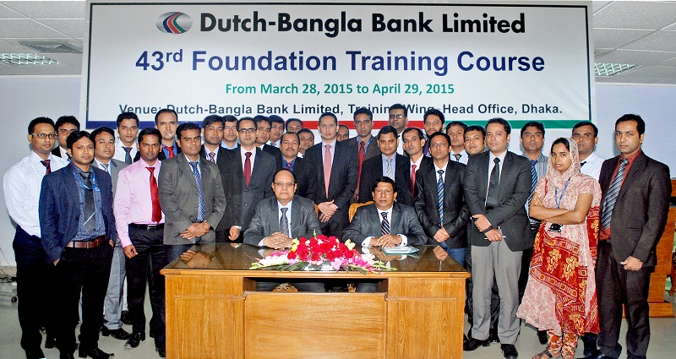

1.1 Origin of the study
The internship report is a pre-requirement to achieve the BBA certificate from United International University. After completing all the courses equivalent to 120 credit hours, each student has to choose between internship and project program. The students who have chosen the project, have to observe any company or industry as a whole and prepare their project report. On the other hand, the students like me have taken the internship program have to join in any particular organization as an intern to earn practical experience and select a topic on the organization and prepare their internship report with the guidance of their internship supervisor.
It was a great opportunity for me that I get the chance to work as an intern in Dutch Bangla Bank Limited (DBBL). During the internship program I have seen and learned the functions and responsibilities of HR department and experienced the recruitment and selection process of Dutch Bangla Bank Limited very closely. Therefore, I requested my honourable internship supervisor to let me work on the title of the report.

1.2 Scope of the study
The scope of the report is to share the HR functions and to provide the concentrated information on the recruitment and selection process of Dutch Bangla Bank Limited (DBBL) to any reader of this report. Dutch Bangla Bank Limited is one of the most popular commercial bank in Bangladesh. Therefore, the HR practices passes several critical phases to acquire and retain the necessary employees of the bank. However, the recruitment and selection process is often important to know for a lot of other organization of the same field. The job applicants may find the report very important to processes to take preparation for the vacant jobs of DBBL. University students and faculties may find the report important to compare my practical experiences with their theoretical learning of human resource management.

1.3 Objectives of the study (Primary and Secondary objectives)
The objectives are the determinants that describe the goals of the report and a reader can easily understand why the report has been prepared. The objectives can be separated into two section that are given below:

Primary objectives:
The primary objective of the report is to complete the BBA program by submitting the internship report as it is a pre-requirement of the under graduation degree from United International University.

Secondary objectives:
The secondary objectives are more specific and provide the actual goals of the report. The objectives are:
- To analyse Dutch Bangla Bank Limited.
- To analyse the functions performed by the HR department of DBBL.
- To analyse the recruitment and selection process of DBBL.
- To recommend suggestions for the improvement of the recruitment and selection procedures of DBBL.

1.4 Methodology of the study
The report methodologies are the techniques and methods that I have used to make the report finished. There are several methods utilized to complete and they are shared below:
1.4.1 Sample size: The report is conducted on two process of Dutch Bangla Bank Limited, recruitment and selection process, both of these two processes are described throughly in the report.
1.4.2 Data Collection Process: The information of this reports are collected from two sources. The sources are:
- Primary sources:
- Formal and informal interviews taken from the bank personnel.
- Practical experiences from my internship program.
- Annual Reports of the Dutch Bangla Bank Limited.

- Secondary Sources:
- Utilising several leaflets and product brochures of DBBL.
- Using several published books of famous writer on recruitment and selection report.
- Online websites of DBBL and other sites and blogs.

1.5 Limitations of the study
While performing the internship program I have passed a lots of difficulties on applying my theoretical learnings into the real responsibilities of the bank. Preparing the report was also hard for few circumstances. The limitations are shared below:

- The duration of the internship program was three months only. It is found very hard for me to manage all the information during this short period of time.
- A lots of information that are very valuable for my report, can’t include in my report as the bank managers don’t want them to publish publicly.
- There are too much work pressure exist all the day long in the bank branch. As an intern I had to perform several banking activities. Meanwhile collecting information of the internship report was tough.

Chapter Two - Introduction of Dutch Bangla Bank Limited
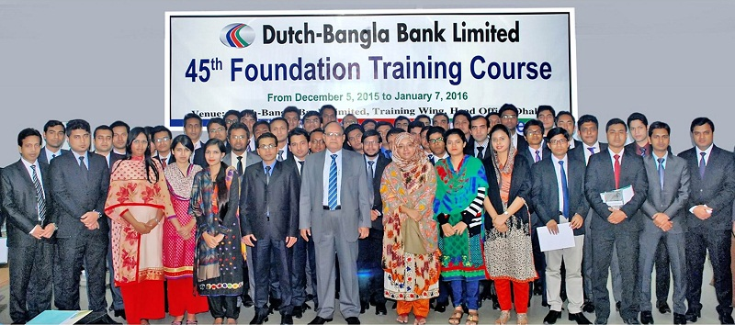

2.1 History of Dutch-Bangla Bank Limited
The Dutch-Bangla Bank Limited is one of the largest commercial banks in Bangladesh. The bank was established under the Banking Companies Act of 1991 and Bangladesh was formed with the primary purpose of conducting all kinds of banking activities under the Companies Act of 1994. Bangladesh Dhaka Stock Exchange Limited and Chittagong Stock Exchange Limited are the public business. It is a European private joint venture in Bangladesh. The joint venture was officially started at the Sena-kalyan Building (4th, 5th, and 6th Floor), 195, Motijheel / A, Dhaka, Bangladesh, headquartered on June 3, 1996. On July 4, 1996, the bank started banking activities through opening its first branch.
Dutch Bangla Bank Limited (DBBL) is a publicly traded company and the international co-sponsor of the low bank registered with Bangladesh under the 1994 Act with the 30% Dutch Community Development Finance Company (FMO) After all, 70% of net capital was provided by large local contractors and manufacturers and the remaining 10% public funds were provided. In the first year of operation (1996-1997), the Netherlands was provided with technical support to strengthen the skills of the Netherlands ABN Amro Bank.
The purpose of DBBL is to provide customers with the delivery of banking services in the following areas: Commercial banking activities (deposit accounts), retail banking, travelers checks, internal and external money transfers, financial services, bank transfer business, property and liability management, liquidity and capital asset management, Information Technology, and the utilization of Human Resources.
DBBL allows Internet Banking to access the customers own personal, professional accounts at any time, at their home, office or on a mobile site. Internet banking gives customers the freedom to choose their own time of work. During this time, you can save money and efforts. It's fast, easy, safe and above all.
Since its creation, DBBL has been active in various social activities, which has expanded with time and its growth. Dutch-Bangla Bank Ltd. is one of the leading online banks in today's fast-growing private sector. The banking sector has played an important role in the private banking sector as well as in the economy of Bangladesh. The Netherlands Finance Finance Company (FMO) is the international sponsor of the Netherlands. The FMO is funded by the Dutch Development Bank of Asia, Africa, Latin America and the private companies of Eastern Europe.
In order to implement all kinds of banking activities inside and outside Bangladesh, Dutch-Bangla Bank Ltd. born in a joint venture as a limited organization established in Bangladesh on June 26, 1995. DBBL has started a business with a foreign bank. With good advice and efficient service of customers, starting with a slogan as a leader in the banking sector in Bangladesh. From the first branch named Motijheel branch, Dhaka, DBBL started its journey from July 4, 1995. All branches are currently offering online banking. DBBL initially started its operations with an authorized capital of Tk 400 million and a paid up capital of Tk 2.04.14 million.

2.2 Mission, Vision, Value statements

2.2.1 Mission
Dutch-Bangla Bank Limited is an engineering and creative organization dedicated to social responsibility. "Single Benefit" is not at the heart of the DBBL banking activities as "man does not live by bread and butter alone".

2.2.2 Vision
Dutch-Bangla Bank Limited holds a dream of advanced Bangladesh, where it is valuable based on art and letters, athletics and sports, health and hygiene, entertainment and music, absence of pollution, education and science, and above all, ethics and morality. Basically, the creativity and creative life of Dutch-Bangla Bank Limited contributed to the full development of this wonderful nation, full human development of life and courage.

2.2.3 Core Values of DBBL
Dutch-Bangla Bank believes its incredible commitment to fulfil its customers' needs and satisfaction and to be the first choice of the banking sector of Bangladesh. Inspired by its clients' assumptions, Dutch-Bangla Bank aims to create a new banking era that protects its famous capitalists "your trusted partner".

2.3 Product/Service of Dutch Bangla Bank Limited
Diversified products and services are offered by Dutch Bangla Bank Limited. These all product mix of DBBL can be shared by two hierarchy of services. They are:

Width of Products mix of Dutch Bangla Bank Limited
The term width of product mix refers that the main section of the services that are provided by the bank. The broad section of DBBL products and services are separated into six broad section shown below in the chart 1.

Chart 1: The Width of DBBL Product Mix

The Length of DBBL products mix:
This part of product mix will show the subsections of each of the broad section of product mix of DBBL. The length of the Dutch Bangla Bank Limited Product mix are:

Chart 2: The length of DBBL Product Mix

2.4 Organization Structure
DBBL follows the hierarchy of command. The organization chart given below shows the hierarchy of command of Dutch Bangla Bank Limited.

Chapter 3: Organization Structure

2.5 Board of Directors
Serial no. | Board of Directors | Designation
1 | Mr. Abedur Rashid Khan | Chairman
2 | Mr. Zaheed Hossain Khan | Director
3 | Mr. Bernhard Frey | Director
4 | Mr. Sayem Ahmed | Director
5 | Mr.Md. Fakhrul Islam | Director
6 | Dr. Irshad Kamal Khan | Independent Director
7 | Dr. Syed Fakhrul Ameen | Director from the Depositors
8 | Mr. Chowdhury M. Ashraf Hossain | Director from the Depositors
9 | Mr. K. Shamshi Tabrez | Managing Director

Chapter Three - Discussion of HR Function of DBBL
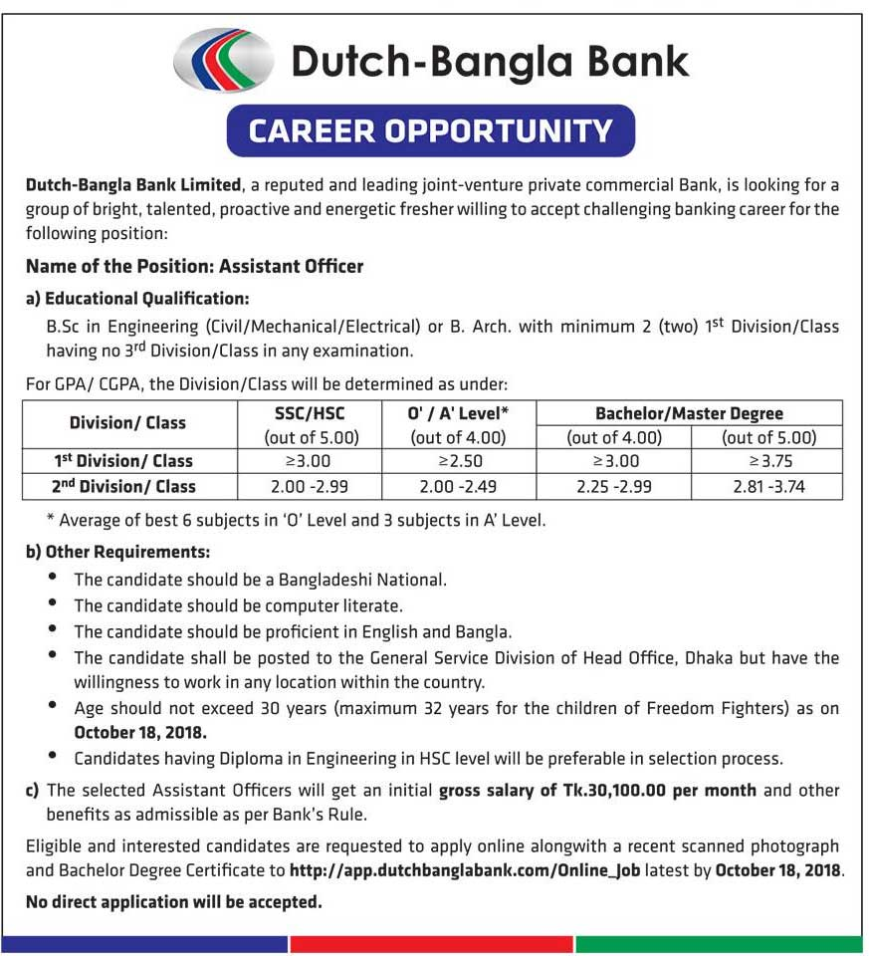

Human Resources Management (HRM) works in organizations that describe the recruitment, management, and guidelines to the employees working in the organization. Employees are the main resource of an organization and without employees, no company or institution can manage their own business. Human resource management department helps to motivate the growing development of people towards greater skills, creativity, and results. It keeps employees as a more responsible person and, therefore, tries to create a climate that helps strengthen their power limits. it expanded capacities and leadership opportunities to improve direct operational efficiency. Fundamentally, the HR department functions for the employees to obtain good results.

3.1 The functions of HR department of Dutch Bangla Bank Limited
The Human Resources Department of Dutch Bangla Bank Limited consists of 15 human resource professionals. The department is made up of one head of the department and 14 human resources employees. DBBL has no specific subdivision, but the various tasks of human resources management are determined by different employees in the HR department under the supervision of the department head. DBBL's Human Resources Division uses software for managing human resources activities and data, this software is called "HR MIS". The Major functions that are performed by the DBBL HRD are:

Chart 1: The functions of DBBL HRD

3.2 Recruitment Process of DBBL
The human resources department of DBBL is responsible for the recruitment of three types of employees:
1. Regular employees
2. Contractual employees
3. Support staff

3.2.1 Regular appointment and selection of employees
Employees list includes: - Trainee Officer, Aust. Officer, Officer, Senior Officer, Executive, Senior Manager, Est. Vice President, Fast Est Vice President, Senior Aust. Vice President, Vice President, Past Vice President, Senior Vice President, Executive Vice President, Senior Vice President, Deputy General Manager Md.
A new or more experienced person can be the regular employee. The R&D process for innovation is slightly different from an experienced person's R&D process. Experienced people do not sit for a written test.

3.2 The Selection process of DBBL
The steps of recruitment process of DBBL are shown in the chart below:

3.3 Training and development of DBBL
After getting selected, the new employee goes to the bank and is directed by a specific HR manager for the learning of the responsibilities. To learn practical work and software, first-year employees should go through "basic training." While the employee is working, if he is facing a problem, they should immediately approach to the Manager/ Branch Manager/ Divisional Line to ask for help. Before being named a permanent employee, the fresher’s are usually taken on one-year entry time.

3.3.1 DBBL training facilities:
- Short-term training: 3-4 day training system from the Bank of Bangladesh; Foreign training by various banking institutions.
- Long-term training: The training of the core team (software launch team) & special training are usually held in abroad (training software on new technologies in the banking sector, the new banking system, etc.)
- Training place: DBBL train fresher’s at the training wing. Other training facilities are organized in different places according to the organizers (Bank of Bangladesh, abroad, etc.)

3.4 Performance Appraisal
The Human Resources Department of DBBL performs the performance evaluation at the end of each year. The human resources department evaluates the individual performance of each employee, while the performance of the group is evaluated by the bank manager.
The performance of each employee is measured according to the standards established by the Division / Branch Manager or in cases of ACR. During the performance evaluation, the human resources department follows a pyramid structure. This structure contains 4 levels, such as - A (top), then B, C, and D (bottom).
A contains 20% of the total number of employees in each department, B contains 30%, C contains 40% and D contains 10%. The human resources department can only assess the capacity of each of the four categories. This means that the Human Resources department can only evaluate 20% of the people employed by A and at least 10% of the employees. This pyramid classification table is created based on its performance, measured according to established standards.

3.5 Remuneration management
Remuneration management is one of the most difficult tasks of the Human Resources department. DBBL's human resources professionals follow a "wage structure" which was suggested by the Bank of Bangladesh. This wage structure contains 55 slabs/stages. Each slab contains a specific amount of salary. The next slab is higher than the previous one and, when the employee receives a promotion, the number of his salary increases.

The salary section also varies with the designation of the employee. For example, a junior officer is practically offered a fifth section of the wage structure that is 15,000 taka, while the Assistant officer is offered the seventh section which is 20,000 taka. Here's how the wage structure works. The DBBL Human Resources department does not conduct a salary survey.

3.5.1 Basic incentives: there are many basic incentives that employees get at a different level in DBBL. The most common incentives are -
1. Performance bonus (once a year)
2. Festival bonus (twice a year)
3. License
4. Regular participation license (once a year) etc.

3.5.2 Special incentives: few special incentives are granted to the top level employees at DBBL:
1. Car loan (once)
2. Apartment loan or home loan (once)

Chapter Four - The Recruitment and Selection Procedures of DBBL

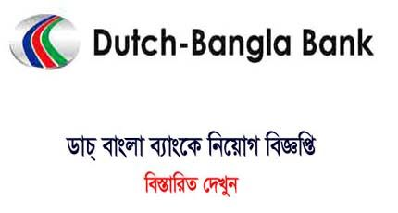

4. The Recruitment and Selection process of DBBL
Dutch-Bangla Bank starts the recruitment process when new employees are needed and ends when applications are submitted. The result is a set of candidates from which new employees are selected. Dutch-Bangla Bank Limited is so large that it requires huge human resources every year to grow its business at different levels. However, for joint commercial operations, they need two categories of personnel. Those indicated below:
- Recent graduates
- Experienced experts
The recruitment process is followed immediately by the selection process, the final interviews and the decision-making process, which conveys the decision and the appointment procedures. Dutch-Bangla Bank Limited follows the following process to recruit candidates:
- Human Resources department Planning and announcement of vacant positions.
- Qualification of the recruitment
- channels of Recruitment

4.1 Planning to hire personnel and announcement of vacant positions:
At DBBL, The head of HR manager is the head who plans the strategy to hire personnel in several vacant position in several deferent ways. Most often, the hiring process begins when the human resources department receives hiring requests from a department or branch of the bank. The Human Resources Office makes decisions about which positions should be covered by staff planning and forecasting. HRD sends a notice to all divisions to suit their personal needs and, after receiving feedback from line managers, HRD makes a decision regarding the vacancy for the employee of the current year 2019.
The required projection is shown below:

The management trainee's minimum recruitment qualifications:
- The candidate must have a master's degree from a UGC approved university.
- The candidate must have at least 3 degrees approved by the government and should be on the first division/class/ equivalent.
- The age of the applicant should be below thirty year.

The trainee cash officer's minimum recruitment qualification:
- Applicants should be under 27 years old.
- The applicant should have a degree in business or social sciences from a recognized university.
- Third division/class/ equivalent is not allowed.

4.1.1 Channels of Recruitment:
Dutch-Bangla Bank LTD hires employees in a general process of recruitment but the candidates has to pass very hard situation during this processes. DBBL recruit its employees through two ways and those that are described below:

4.1.2 Procedures of internal recruitment:
Existing employees are a major source of recruitment in Dutch Bangla Bank Limited. If for approvals, promotions or lateral transfers of work, the internal candidates already know the informal organization issues and have detailed information about their official policies. In fact, for DBBL, this type of recruitment occurs only when recruiting experienced and specialized personnel. For this internal DBBL recruitment, in practice follow the closed recruitment strategy.
- Rotation of posts
- Inventory of skills

- Rotation of posts: Through job rotation, Dutch Bangla Bank Limited exchanges new employees from existing employees. The bank requires people who can perform multitasking activities so the HR department assigns them to another service. They specify the tasks and job requirements and show how to make the request.
- Inventory of skills: DBBL obtains information on the qualifications of the appropriate employees for the vacant position of existing employees through Human Resource Information System (HRIS) which is a database in which all types of information of all employees are stored. Whenever the bank requires any new employee, the HR department of the bank first consults the database and where they receive the information and bring new employees according to their needs. While they recruit for a higher position, in this case, they prefer people with experience, clear knowledge, and high qualifications.

4.1.3 Procedures of external recruitment:
Usually, a job demands something else that cannot be filled with internal sources. In such cases, the human resources department look outside the internal sources and the recruitment of trainers/management interns in DBBL or any junior/intermediate position is done in this way. A total combination of three methods for external recruitment in the DBBL is followed, which occurs directly or indirectly for a different level of recruitment. This level of recruitments are:
- Employee references
- Advertising
- Collection of CV from Universities

Employee references:
The employee reference procedures are followed by DBBL mainly for junior employees, which is not the case for apprentices. Follow these procedures when existing employees refer to a new employee and the new employee is considered an additional trial. For the junior candidate position, this practice is sometimes followed.

Advertisement:
For recent graduates, the main method followed by DBBL is the publication procedure, intended for recruitment. They publish the advertisement in well-known Bengali national newspapers and in English. They use online advertising through bdjobs.com, prothom alo.job.com to recruit candidates. For online recruitment, candidates receive a reference number that corresponds to a unique number created automatically by the online system when the CV is sent. The example of a job offer in the DBBL online protocol is given:

Collection of CV from Universities graduates
The visitors are job seekers who enter the human resources department in search of a job and present their curriculum. Sometimes they are asked to complete an application form to determine their interests and abilities. These applications are kept in an active file until an appropriate opening is shown in the DBBL. These occur mainly due to entry jobs or contract work; for hiring management apprentices, these forms are not used.

4.1.4 An Advertisement of recruitment of Dutch Bangla Bank Limited
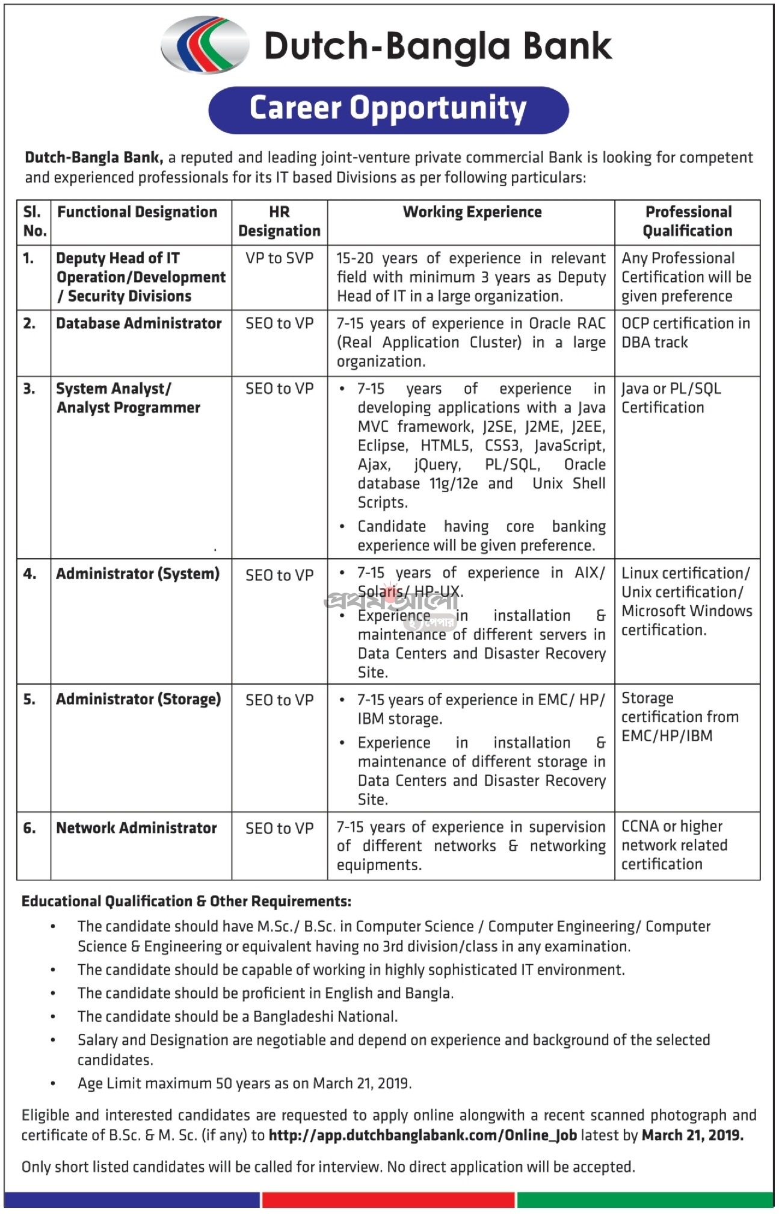

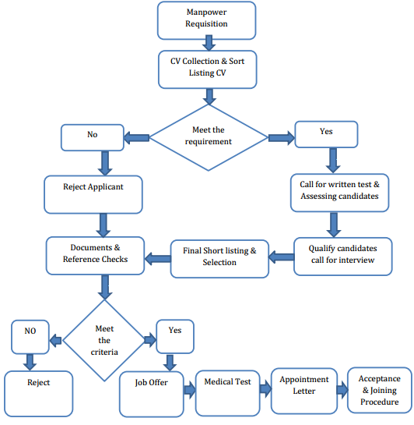
4.1.5 An external recruitment flowchart of Dutch Bangla Bank Limited
Chart 2: DBBL External Recruitment Flowchart

4.2 The selection process of Dutch Bangla Bank Limited
Selection is part of which weigh excess weight for any organization because of the performance of the organization, the cost of employment, the legal issues of selection and the legal obligation. Carefully aware of the importance of the selection, a well-organized selection process for all employees of Dutch-Bangla Bank Limited is applicable, but this process varies according to location. Focusing on DBBL selection process for internal candidates/external/educational institutions, the broad selection process of the organization is explained below:

4.2.1 Application Reception:
After the recruitment process is finished, Dutch Bangla Bank Limited comes with the selection process that started with the receipt of the application form through the online internet form. Once examining the complete information, they decide which candidates will be eligible for the written examination, but before that they measure the reliability of the data given by applicants.

4.2.2 Let the candidates know:
After selecting the shortlist of CVs and the selection of the best candidates, the Human Resources Department approves the candidate for the written test (beginner level) or interview (high level) and let them know through mobile SMS or telephone call. The HRD of the bank issues the admit cards within 10 to 15 days of the examination for written examination.

4.2.3 Evaluation of candidates through written examination:
Dutch Bangla Bank Limited is always concerned about keeping the best applicants. After the candidates were selected in the previous phase, the selected candidates appeared in the written examination written in the Apprentice Examination. Evaluation skills by written test are:
- Analytical power
- Logical reasoning ability.
- Digital power
There are questions based on mathematics and analysis on the question of the test, in which information needs to be processed from information and the ability to relate between the hints of given problems such as questions. In general, DBBL passes a written test for first-class positions for trainer assistant and MTO level. The exam was conducted by the IBA of Dhaka University. The Review Committee examines the feedback script. According to the highest score, the candidates are invited to the interview.

4.2.4 Interview:
The eligible candidate for written examination is called for an interview. The eligible candidates are called through a mobile message in 48 hours before the interview about the date and location of the interview. The information sent to the candidates are the time of the interview and the date, location and salary negotiations. This communications are especially conducted by the Human Resource Management Team. Within DBBL, at least three members of the management committee, one of the management and human resources departments. This first interview is called the primary interview. In case of evaluation of candidates, the standards or skills sought by Dutch-Bangla Bank Limited are:

4.2.5 Documents Check-ups
A selected applicant have to submit a copy of his school and university certificates. If the universities does not provide the original certificate, the bank will accept the test certificate, academic file or evaluation letter.
- Appearance: Formal clothing, physical language, and eye contact.
- Communication skills: interactive interaction with interviewers, introverts
- Creativity: thinking capacity and innovativeness.
- Attitude test: personal sales attitude and enthusiasm.
- Customer service capability: Skills of serving clients.
- Promise: positive commitments to the bank.
- Resolution: basic knowledge of work and some theoretical knowledge.
- Planning and organization skills.
- Management capacity
- Promise / fidelity: work dedicated to the organization.

According to this criterion, the candidate is assigned an evaluation score. The score pattern is:
Evaluation form: 1 = weak; 2 = margin; 3 = good, good; 4 = very good; 5 = exclusive.
Additional qualification for MTO 40 and other positions 35. If the candidate wins 46-50, he is considered exceptional and if he wins from 1 to 20, he is considered a weak candidate. Based on this information, the candidates interviewed consider:

4.2.6 Authenticity of Reference
If the candidate is selected for the candidate, the references provided by the candidate are tested by the HR. The candidate must provide at least two references. If the candidate is new, you must have a reference from your educational institution. But if the candidate is nominated first, the last institution, particularly a supervisor, must have a reference. You will receive a job offer subject to satisfactory comments.

4.2.7 Health check-ups:
DBBL's job offer is to perform a medical examination at the bank's diagnostic center. Applicants must collect letters of human resources and undergo a medical examination. Check the candidate's physical condition for this exam and make sure he is qualified to work. At this stage, if the candidates receive information about any contagious disease and can be treated. Apollo Hospitals, Dhaka has configured the medical configuration for DBBL. To measure the candidate's health and suitability for the work effort, they review the following exams:
- General physical examination (blood pressure, respiration, pulse, etc.)
- Radiographic chest (standard)
- Analysis of urine microscopy/urine routine.
- Blood tests (blood group, hepatitis B, blood sugar)
- ECG

4.2.8 Issuance of Proposal Letter
After the health and reference exams, the candidate's proposal was issued. Then, the candidate receives the final call fo and collects the letters from the human resource department of Dutch Bangla Bank Limited. The job proposal letter specifies all the terms and conditions of the terms.

4.2.9 Selection flowchart of Dutch Bangla Bank Limited

Chart 3: Selection flowchart of Dutch Bangla Bank Limited

Chapter Five - Findings of the Report



5.1 Findings of the Report
Dutch Bangla Bank Limited maintains a strong and lengthy procedures of the banks internal and external recruitment and selection for hiring the new employees. At this stage, I think if the bank improve few shortcomings that is observed and found through the previous analysis of the recruitment and selection process, the HR Department can hire new employees more effectively and efficiently. The findings are listed below:
- Dutch Bangla Bank Limited uses several traditional ways to advertise its job advertisement. Moreover, the bank often advertise through paying the online platforms such as Bdjobs.com and prothomalo.jobs.com. All these platforms are online based and advertise with several other ads. So, it is hard to attract all the applicants at a time.
- The job responsibilities during the office hour is so high. For example, there are a lot of responsibilities are included in hiring a new applicant through recruitment and selection process, but the total recruitment and selection team is very tiny and usually it consists of Six to Eight members of HR Department who find it difficult to accomplish all the works in certain periods.
- The recruitment advertisement of DBBL on social media sites such as Facebook, Twitter are not well developed enough and have not populated with the potential consumers or candidates.
- Dutch Bangla Bank Limited has few research and development department in each division but they are not efficient enough to generate innovative recruitment and selection ideas because of the lack of investment in research programs of the bank.
- The selection process Dutch Bangla Bank Limited is traditional and common to other commercial bank’s selection procedures.
- The recruitment and selection process of DBBL are varied from division to division and there are a lots of illegible employees get chance to work using reference.

Chapter Six - Recommendations & Conclusions



6.1 Recommendations
After analysing the overall HRM functions as well as the recruitment and selection process of Dutch Bangla Bank Limited, I have found some shortcomings in these procedures. This chapter is going to share some suggestions based on my practical experience from DBBL for the betterment of the bank’s recruitment and selection procedures. The recommendations are:
- Dutch Bangla Bank Limited need to establish a permanent online platform for job advertisement. Therefore, applicants can get job advertisements easily.
- The Bank needs to reduce the work pressures by enhancing the works into few more employees as the work pressures were found very intensive during the day hour.
- Dutch Bangla Bank Limited ought to strengthen its social media communication with the general people of Bangladesh so that the bank can directly publish its vacancy post.
- The bank should improve the research and development department so that the department can establish few innovative ideas for recruitment and selection process in a cost effective ways.
- The selection process are found very traditional and large improvement are needed to find-out new methods to get eligible candidates more easily.
- DBBL needs to be conscious and check proper identification while appointing personnel from internal sources as the recruitment and selection process of DBBL are varied from division to division and there are a lots of illegible employees get chance to work using reference.

6.2 Conclusion
Human resources management always works to achieve viability, the development of quality and meet all the needs of the bank. This Recruitment and Selection are made in one of the pillars of human resources management, both corporate and employees.
The study, "The Recruitment and Selection Procedures followed by the Human Resource Department of Dutch Bangla Bank Limited" reveals that employees are the most valuable asset for the progress of the organization. To develop these precious resources, the reasons are many. The "recruitment and selection process" plays an important role in this case. The productivity of an organization is essential, as well as the dynamism of the methods of selection Dutch Bangla Bank Limited has worked on a progressive recruitment and selection process. The human resources managers of Dutch Bangla Bank Limited must now contribute to the bank's success by going beyond the limits of the agreement.
The HRM functions of Dutch Bangla Bank Limited are designed to attract, select and retain qualified personnel to meet the future needs of the organization as a critical function of human resources. Report analysis is essential for both positive and negative practices to manage staff successfully. If the bank takes this analysis into account, it will effectively help DBBL deal with its threats.

Bibliography
(1) Dutch Bangla Bank Limited, website address: https://www.dutchbanglabank.com
(2) Dutch Bangla Bank Limited, Annual Reports 2016-2017, Available at: https:// www.dutchbanglabank.com / investor-relations/financial-statements.html
(3) http://edupedia.educarnival.com/Articles-on-hrm-practices-of-bankingsector-a-case -study -on-DBBL/ [Accessed 15-03-19]
(4) http://www.assignmentpoint.com/business/human-resource-management/report-on-hrm-practices-at-dutch-bangla-bank-limited.html http://www.assignmentpoint.com/business/finance/a-report-on-dhaka-bank-ltd.html [Accessed 28-03-19] •
(5) http:// www. custominsight.com/ employee- engagement- survey/ what- is- employee- satisfaction .asp: http://www.custominsight.com / [Accessed 06-04-19]
(6) Thompson, Strickland, Gamble (2008). Crafting & Executing Strategy http://my.safaribooksonline.com/book/hrorganizationalmanagement/9789332501393/ 1-introduction-to-human-resource-management/ch1_sub6_xhtml [Accessed 10-04-19]

