

Internship report on
Financial Performance Analysis of Shahjalal Islami Bank Limited.



“Financial Performance Analysis of Shahjalal Islami Bank Limited.”
Internship report
(Submitted in partial fulfillment of the requirement of BBA Degree)

Submitted by:
Mahjaben Tasnim
ID: 111 141 178
Major: Finance
Department of Business Administration
United International University

Submitted to:
Ms. Nusrat Farzana
Assistant Professor
United International University

Date of submission:
6 October 2019
Letter of Transmittal
January 2019
Ms. Nusrat Farzana
Assistant professor
United International University
United City, Madani Avenue, Badda, Dhaka-1212

Subject: Submission of the report on “Financial Performance Analysis of Shahjalal Islami Bank Limited”.
Respectable ma’am,
With due respect to state that, I am very delightful to submit you my internship report titled “Financial Performance Analysis of Shahjalal Islami Bank Limited” prepared as a part of the requirement of BBA program of business school. I have successfully completed my internship program in Shahjalal islami bank limited at Elephant road branch and I worked as an intern at general banking, clearing and accounts for three months. Working on this report was great learning experience for me as I got to learn the differences between practical and theoretical work. . I tried my best to gathering as much information and relevant reason as possible. I sincerely thank you for giving me the chance to work on this topic. I hope you will judge this report reliable and systematically.
I would like to thank you for all the support and guidelines that you have provided to me. This report may have some mistakes, will be kindly pardon. I beg your amiable discretion for evaluating this report.
Sincerely yours,
----------------------
Mahjaben Tasnim
ID: 111 141 178
Department- BBA
Major in finance
United International University

Authorized Declaration
This is to endorse that Mahjaben Tasnim is a student of BBA, ID No: 111 141 178, has successfully completed her “internship program“ entitled “Financial Performance Analysis of Shahjalal Islami Bank Limited” for the partial fulfillment of her BBA.
She has done her work according to my supervision and guidance. She has tried her level best to do this report successfully. I think this task will help her in future to create a better career.

………………………………..
Ms. Nusrat Farzana
Assistant professor
United International University

Student Declaration
This is Mahjaben Tasnim, ID: 111 141 178 hereby declare that the report of the internship program titled “Financial Performance Analysis of Shahjalal Islami Bank Limited” is uniquely prepared by me after completion of three month work at the shahjalal Islami bank limited (SJIBL),Elephant Road Branch. This report is only prepared for my academic requirement. It will not publish in any magazine or journal.

Acknowledgement
Alhamdulillah, give thanks to divine mercy and grace time, the life energy that is given to me to complete my task successfully.
I am very much thankful to my internship supervisor Nusrat Farzana maam, Assistant profressor, United International University for his kind cooperation and suggestions for the improvement of this report. Besides I am grated several people and parties. I owe my debt of gratitude towards my supervisors Mahmudul Hasan Maruf, MD Rakibul Hasan and Jamila Akter jesmin of shahjalal Islami Bank Limited for their coherent support and motivation throughout my internship period. Their sagacious guidance and instruction were helpful in accomplishing such an assiduous task.
Moreover, I am thankful to those persons whose endorse and cooperation helped me to done my task properly.

Executive summary
Shahjalal Islami Bank Limited introduced its commercial operation in imitation of Islamic shariah on the 10th may on 2001 under the bank companies Act 1994 and they opened their first branch at 58, Dilkusha C/A, Dhaka. SJIBL is named after the name of a saint Hajrat Shahjalal and served the humanity. They collect the license from Bangladesh bank and thus boosting the GDP of the economy.
This report has been made on the basis of “Financial Performance Analysis of Shahjalal Islami Bank Limited”. It is the outcome of three months basis Internship program in Shahjalal Islami Bank Limited as required by the faculty and supervisor Nusrat Farzana, Associate Professor of BBA Department, United International University. The objective of the study is to analyze the performance analysis of SJIBL, doing ratio analysis, identifying problems and recommendations. Both primary and secondary data were collected for the study.
This paper is intended to provide improve analysis frame work to present the different aspect of performance of the Shahjalal Islami Bank Limited in Bangladesh. The framework of this report analysis the ratio and interrelated ratios of the health of the institution. The different types of ratios are liquidity Ratios, leverage ratio, efficiency and profitability ratio and market position ratios. This report has five chapters. Each chapter has been described properly as a descriptive study. Bank’s profile included with proper details. So that readers can understand the profile properly. In chapter three, the ratio part has been described. Different types of Ratio analysis has done for SJIBL. Tables, charts and figures are added in this report. The ratio analysis part is the crucial part of this report. It has been done very carefully. Findings are added as per the study and work experience. As a part of my BBA program, I used 5 years financial statement data from SJIBL annual report to calculate the ratios. This ratio helps me to find out the past situation of SJIBL which might help them to overcome the past blunder and also help them to better future decision.
After the conclusion part, the appendix is added. Appendix part is the last chapter of this report. Appendix part is divided into two parts. One is the reference which follows the APA method.

Table of contents:
Serial no. | Topics | Page no.
Chapter 1
1 | Introduction | 1
1.1 | Background | 1
1.2 | Report origin | 2
1.3 | Objective | 2
1.3.1 | Primary objective | 2
1.3.2 | Specific objective | 2
1.4 | Rationale of the Report | 3
1.5 | Scope | 3
1.6 | Methodology | 3
1.6.1 | Data Analysis | 3
1.6.2 | Data type | 4
1.7 | Limitations of the Report | 4
Chapter 2
2 | Overview of the organization
2.1 | About the Shahjalal Islami Bank Ltd | 5
2.2 | Nature of business | 6
2. 3 | Vision | 6
2.4 | Mission | 6
2. 5 | Strategies | 6
2.6 | Motto/Slogan | 7
2.7 | Corporate Information | 7
2.8 | Organization Structure | 8
2.9 | Shariah Assembly | 9
2.10 | Service and Products | 9
2.10.1 | General Banking | 9
2.10.2 | Account service | 9
2.10.2.1 | Mudaraba Term Deposit Accounts (Mtd) | 10
2.10.2.2 | Al Wadiah Current Deposit Accounts (ACD) | 10
2.10.2.3 | Mudaraba Savings Deposit Accounts (Msd) | 10
2.10.2.4 | Mudaraba Short Notice Deposit (MSND) | 11
2.11 | SWOT Analysis of SJIBL | 11
Chapter 3
3 | Analysis | 13
3.1 | Financial Performance Analysis | 13
3.2 | Diagram of financial ratios | 14
3.3 | Ratio analysis for SJIBL | 15
3.3.1 | Efficiency and profitability ratios | 15
3.3.1.1 | Return on Asset | 15
3.3.1.2 | Return on equity | 16
3.3.1.3 | Return on investment capital | 17
3.3.1.4 | Expense control efficiency | 17
3.3.1.5 | Operating profit margin | 18
3.3.1.6 | Equity multiplier | 19
3.3.2 | Liquidity ratio | 20
3.3.2.1 | Liquid securities indicator | 20
3.3.2.2 | Earning assets to total assets ratios | 21
3.3.2.3 | Current deposits to total liabilities | 22
3.3.2.4 | Cash position indicator | 23
3.3.3 | Debt ratios or leverage ratio | 24
3.3.3.1 | Debt to asset ratios | 24
3.3.3.2 | Debt to equity ratios | 25
3.3.3.3 | Equity to asset ratio | 26
3.3.4 | Market performance ratio analysis | 27
3.3.4.1 | Earnings per share | 27
3.3.4.2 | Price Earing Ratio | 28
Chapter 4
4 | Findings and recommendations | 30
4.1 | Major Findings | 30
4.2 | Recommendations | 31
Chapter 5
5 | Conclusion | 32
Appendix: Reference & Bibliography

Chapter one: Introduction
- Introduction:
In this report I will discuss the financial performance analysis of Shahjalal Islami Bank Limited. This report is a part of my BBA program. Economic growth is considered the major part of a country in this world. In this country banks are the most vital players of economic growth. It is important because it’s capable of assembling and captivating deposits from savers. It gives loans to exhort investment and production. It also help to extend other economic zones like agriculture, corporations etc. Finally, the banking industry devotes to the arrangements of introductory capital for investment projects. Shahjalal Islami Bank Limited (SJIBL) is the most promising bank in private sector at present. Shahjalal Islami Bank Limited (SJIBL) inaugurated its commercial service in consonance with the doctrine of Islamic Sharia on the 10th May 2001 under the Bank Companies Act, 1991. Day by day the demand of Islamic banking system is popular among the general people of our country so in this report I will try to analyze the major financials operations of Shahjalal Islami Bank Limited as I completed my internship in this bank and familiar with the major operations of Shahjalal Islami Bank Limited. For analyzing performance I will use ratios analysis by using its recent five years data (2013-2017) for understanding the overall condition of this bank. Islamic Banking, in aspect, is not only interest-free banking business, but it also carries accord wise trade commodity thereby developing real earnings and support GDP. They are also more concern about their customer service.

1.1 Background of the report:

Now-a-days development of banking sector everywhere with the banking system and its contribution towards financial development of a country is utmost in the fontal stage. As a mandatory requirement of the BBA program, I did my internship in Shahjalal Islami Bank Ltd for three months. From practical knowledge, we will be able to know real life situations and start a career with some practical experience. This report, “Financial Performance Of Shahjalal Islami Bank Limited”, has been prepared to fulfill the partial requirement of BBA program as a mean of Internship Program. While preparing this report, I had an opportunity to have depth knowledge of all the banking activities.

1.2 Origin of the report:

An internship program is great advantage to co-relate the applied work experience with the conceptual learning because it helps me the great augmentation to work in the organizations with some specific purpose. Gaining work knowledge is the key for boosting ones employability particularly as a business student. As an intern it was a great scope for me to work in this reputed bank. It helps me to acquire my own learning goals without the responsibilities of being a permanent employee. It helps me to develop my skills such as teamwork, formal communications and attention to details. This report in an individual assignment as a part of the internship program for the completion of the BBA program of the faculty of business studies under United International University. My internship program of 3 months has been conducted at Shahjalal Islami Bank Limited. My internship supervisor Nusrat Farzana, Assistant professor of United International University assigned me the topic. The report topic for internship is “Financial Performance Of Shahajlal Islami Bank Limited” with proper guidance from my supervisor.

1.3 Objective of the report:

1.3.1 Primary objective:
The primary objective of this study is to gathering knowledge in different professional skill of the organization and completing the report through those gathered experience.
1.3.2 Specific objective of the report:
- To know about the overall financial performance of Shahjalal Islami Bank.
- To know about the operations of Shahjalal Islami Bank Ltd based on Islami Shariah.
- To know about the products and services offered by Shahjalal Islami Bank Ltd.
- To provide an idea about the Banking sector of Bangladesh.
- To know about the customer service, overall activities related to Retail banking services of SJIBL.
- To identify the problems and recommend suggestions for the successful Retail
banking.
- To know about the current situation of SJIBL.

1.4 Rationale of the Report:

Banks are the life-blood of modern economy. It does financial activities to help economic development of a country and earn profit. In such context, financial performance is very important key work for the bank sector and Shahjalal Islami Bank Limited is also engaged them to help the economy. It plays a dynamic role in the economic development of a nation through of saving and allocation of credit to privates and industrial sectors.

1.5 Scope of the report:
This study focused on the financial performance of Shahjalal Islami Bank Limited. The report is covered on the annual reports of SJIBL from 2013 to 2017. On the basis of performance it is tried to show the comparative position of SJIBL. The scopes can be described as bellow:-

- The Information was collected from the Shahjalal Islami Bank Limited websites, databases and annual reports, Internal Crowd base network and social network.
- This report is limited to the overall description, its services, its financial performance analysis the practical progress of its operation.
- The scope of the study is limited to organizational setup, functions and performances.

1.6 Methodology of the report:
Methodology is a systematic method that applied to a field of the study and its principles associated with a branch of knowledge. Primary and secondary data helps to create this report in effective way. The study is accomplished based on the information collected from balance sheet and income statement from annual report by using a specific methodology.

1.6.1 Data Analysis tools:
It’s a process of inspecting, transforming and modeling data with the goal of discovering useful information, informing conclusion and supporting decision making. Different types of tools such as- Microsoft Word, Microsoft Excel etc. are used for preparing this report. In this report there are two types of data analysis, which are:

A. Trend analysis: It gives an idea that what has happened in the past. The dealer though that could understand what will happen in the future.
B. Comparative analysis: Comparative analysis is a statistical method whereby two or more banks data can be compared and determined their consistency to one another.

1.6.2 Data type:

This report is founded on both on Primary and Secondary data.
Primary:
Primary data on Internet, social media and personal opinion inspection.
Secondary:
- Annual report of Shahjalal Islami Bank Limited.
- Other manual information.
- Newspaper, articles, journals and websites.
- Progress report of the Bank.
- Internet.

1.7 Limitations of the Report:
Observing and analyzing the broad performance of a bank is not that easy. Moreover due to obvious reasons of scrutiny the bank personnel usually do not want to disclose all the statistical information about their organization. However some of the limitations that I have faced while preparing this report are listed as follows:
- The bank officials though helpful in every respect they do not have much time to explain the internal procedures to me.
- Shortage time of the internship program.
- There was shortage of sufficient required information.
- Most of the time I worked in General banking sector.
- As a first time, it was challenging to understand the tasks.

Chapter Two:
- Overview of the organization

2.1 About the Shahjalal Islami Bank Ltd:

Bangladesh is one of those countries where most of the people are Muslim. They love to enshrine their life in Islamic shariah and Sunnah. Naturally, it remains a deep cry in their hearts to live their economic lives in accordance with Islam.

Shahjalal lslami Bank Limited a Shariah Based Commercial Bank in Bangladesh was incorporated as a Public limited company on 1st April, 2001 under Companies Act 1994. It commenced its commercial operation in accordance with principle of Islamic Shariah on the 10th May 2001 under the Bank Companies Act, 1991. This bank follows interest free banking where ‘Riba’ or interest is strictly prohibited. Shahjalal islami bank limited is operating in financial market for the favorable attitude of the government of the people’s republic of Bangladesh.

Shahjalal Islami Bank Limited provides better banking services for personal and corporate customers, covering all segments of society within the framework of banking company act. The professional executives and officer manage the banks operation in different areas with their skilled knowledge. Shahjalal Islami Bank so far introduced a good number of attractive deposit products to broaden the resource base. It contributes greatly to develop our economy and support our GDP. The bank interior decoration is comfortable to work. They are doing better performance in all sectors then the past. They try to impress their clients by organizing better services, effective strategy, update rules and regulation etc. The bank has a strong Shariah Council consisting of prominent Ulama, Fuquah and Economists. They organize a conference to discuss the shariah issues and give necessary guidance to the management on Shariah Principle.

Now a day their financial performance is good then the past and now they grab the leading position in financial institutional sectors in Bangladesh.

2.2 Nature of business of SJIBL:
The SJIBL provides commercial, corporate, investment and retail banking related services to their customer through the bank company act 1991, as follows:

- Guarantees
- Foreign exchange
- Syndicate Finance
- Documentary credits
- Corporate finance
- Others related business
- Discounting bills
- Conducting money transfer

2.3 Vision of SJIBL:
“Would make finest corporate citizen”
To be the unique modern Islami Bank in Bangladesh and to make significant contribution to the national economy and enhance customers' trust & wealth, quality investment, employees' value and rapid growth in shareholders' equity.
2.4 Mission of SJIBL:
“Will become most caring, focused for equitable growth based on diversified deployment of resources, and nevertheless would remain healthy and gainfully profitable bank.” Shahjalal Islami Bank Limited aims to become one of the leading banks in Bangladesh by prudence, flair and quality of operations in their banking sector. The bank has some mission to achieve the organizational goals.
2.5 Strategies:
- To earn the clients faith and try to provide the best service.
- Determine marketing budget for product launching.
- Review and update banks investment policy time to time.
- Develop and monitor banks asset marketing related MIS.
- To integrate all existing delivery channels.
- Design and promote electronic product and services.
- Formulate and implementation of Agent Banking Operation.
- Cultivate a congenial working environment.
- To diversify portfolio both the retail and wholesale market.

2.6 Motto/Slogan:

“Committed To Cordial Service”.

2.7 Corporate Information:

Name of the company | Shahjalal Islami Bank Limited
Legal Form | A public limited company incorporated in Bangladesh on 1st April 2001 under the companies Act 1994 and listed in Dhaka Stock Exchange Limited and Chittagong Stock Exchange Limited.
Commencement of Business | 10th May 2001
Head Office | Shahjalal Islami Bank Tower  Plot No: 4, CWN(C)  Gulshan Avenue, Dhaka-1212.
Fax No. | 88-02-9847607
Telephone No. | 88-02-9845457
E-mail | sjiblho@sjiblbd.com
Chairman | Mr. Akkas Uddin Mollah
Managing Director | Mr. Muhammed Shahidul Islam
No. of Branches | 140
Tax Advisor | M/S K.M Hasan & Co.  Chartered Accountants  87, New Eskaton Road  Dhaka.
No. of ATM Booth | 92
No. of Employees | 3250

2.8 Organization Structure:
Chairman

Board of directors
Sponsors
Managing Director
Deputy managing director
Deputy Managing director
Executive vice president company secretary

Senior vice president
Senior vice president
Vice president
Senior asst. vice president
Asst. vice president
1st asst. vice president
Senior vice president
Executive Officer
Officer
Senior officer
Trainee senior officer
Trainee officer

2.9 Shariah Assembly:

The SJIBL is playing a vital role in guiding and supervising the implementation of Islamic Shariah principles in all activities. The Shariah council of the SJIBL consists of prominent Ulema, Bankers and Economists to advice and guide on the implementation of Islamic Shariah in banks activities. Members of the Shariah Council enjoy a special status in the structure of the Bank and playing a vital role to make the bank as Shariah compliant. They meet frequently and deliberate on different issues confronting the Bank on Shariah matters. As per Article 30 of the Articles of Association of the Bank, Shariah Council for the Bank has been constituted.

2.10 Service and Products:

2.10.1 General Banking:

I have worked in the General Banking Department and it performs the major functions of a bank. I was mainly related into following categories:

- Account Opening part,
- Online Branch Banking Section
- Deposit Schemes Section,
- Clearing Section,
- Collection Section,
- Cash Section,
- Accounts Section,

2.10.2 Account service:

It has 4 type of account service

- Mudaraba Term Deposit (MTD).
- Al Wadiah current Deposit (ACD).
- Mudaraba saving Deposit (MSD).
- Mudaraba Short Notice Deposit (MSND).

2.10.2.1 A. Mudaraba Term Deposit Accounts (MTD):
It follows Mudaraba concept clients open this account for a fix period of time and gets profits. This account is also known as time deposits or time liabilities means these are withdrawal subject for a period of time and not on demand. Tk.1000/- can be deposited.

2.10.2.2 B. Al Wadiah:

Al-Wadiah means the bank is under an obligation to collect money from their clients in order to return on demand and with permission to use the money at their own risk. Banks can get profit or loss from the money but client cannot demand any profit nor to share any loss. The minimum balance to open this account is 5000 taka. This account offers free check book and any number of transactions in a day.

2.10.2.3 C. Mudaraba Savings Deposit Accounts (MSD):

This account is opened under the Mudaraba concept. It is opened by the middle group of people who wants to save money for the future and also earn money from it. This account is suitable for trading persons, Institution and society. This account needs 2000 taka to open, 7% profit is given on June and December and account holder can withdraw in two times per week.

2.10.2.4 D. Mudaraba Short Notice Deposit (MSND):
This account gives more profit then other savings and it is favorable for companies and account holder need to keep his money at least six month to avail the money. This deposit gives profit on half yearly basis.

2.11 SWOT Analysis of SJIBL
SWOT
ANALYSIS
S
Strength
W
Weakness
O
Opportunities
T
Threats

- Strengths of SJIBL:

- Fully Computerized bank service in their all branches.
- Using of money counting machine in cash section
- Employee-Friendly environment.
- A satisfactory number of employees in every branch.
- Using of SWIFT for Foreign Trade.
- A strong relationship with renowned clients.

- Weaknesses:

- Lack of fast working employees.
- Not everyone has that much skill to manage the busy situation.
- High Charges on Bank statement, ATM, and certificates.
- Slow IT process.

- Opportunities:

- Advertise them self by introducing social welfare activities.
- Starting Credit card business.
- Evolution of E-Banking system,
- Successful project of GREEN BANKING.
- Focusing on SME to broaden the loan or investment facilities.

- Threats:

- Political pressure can interrupt the foreign trade.
- Market Pressure for innovation.
- Money fluctuation in the share market.
- The increasing number of competitors in the deposit market.

Chapter Three:
3. Analysis

Financial Performance Analysis of Shahjalal Islami Bank Limited.

3.1 Financial Performance Analysis:

Financial Performance analysis is a process of evaluating the relationship between the component parts of financial statement to obtain a better understanding of the banks position and performance. This process helps to identify the strength and weakness of the bank by buildup the relationship between the balance sheet and income statement. The information is taken from financial statement and others reports which are performed by the professionals and top level management making their decisions from these reports.

The process of testing and comparing the financial information of different year’s ratio analysis is necessary. Data are mainly collected from the annual reports of financial statements. The value should be meaningful. Through ratio analysis, it is easy to understand the position of the company.

3.2 Diagram of financial ratios:
Financial Ratio
Efficiency and profitability ratios
Liquidity ratio
Debt ratios or leverage ratio
Market performance ratio analysis
EPS
Price Earing
Debt to asset ratios
Debt to equity ratios
Return on investment ratios (ROI)
Equity to asset ratio
ROA
ROE
Liquid securities indicator
Earning assets to total assets ratios
Current deposits to total liabilities
Cash position indicator
Return on investment capital
Expense control efficiency
Net operating margin
Equity multiplier

Fig: Group of financial ratio.

3.3 Ratio analysis for SJIBL:

3.3.1 Efficiency and profitability ratios:

3.3.1.1 Return On Asset:

ROA is displayed as a percentage which gives an idea to a manager, investor or analyst that how efficient a bank is at using its assets to generate earnings. Higher ROA ratio is better because it indicates that bank is earning more money with less investment.

Formula: ROA = (Net income / Total assets)

Graphical presentation

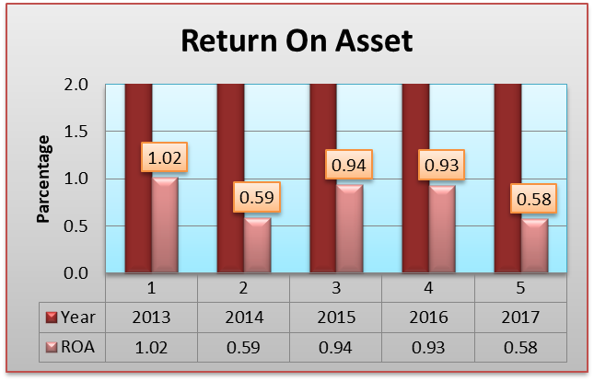
Fig: ROA.

Interpretation:
The ratio measures the bank overall effectiveness in generating profits with its available assets. The graph shows that the banks return on asset has increased 1.02% in 2013. ROA ratios give investors an idea of how effective the bank is at using its assets to generate earnings. Higher ROA ratio is the better. In 2014 ROA have decreased 0.59%. However, the ROA of Shahjalal Islami Bank Limited has increased 0.94% in 2015 and 0.93% in 2016.In 2017 it seems decreasing 0.58%. A low percentage return on assets indicates that the bank is not making enough income from the use of its assets. Unstable economic condition, lower net investment income might be responsible for the poor profitability in 2017.

3.3.1.2 Return on equity:

Return on equity is the most important efficiency profitability ratio and this ratio measures the profit from it shareholders’ Investment in the bank. It also indicates how well banks management is deploying the shareholders' capital. In other words, the higher the ROE is the better.

Formula: ROE= (Net income / total equity) *100

Graphical Presentation

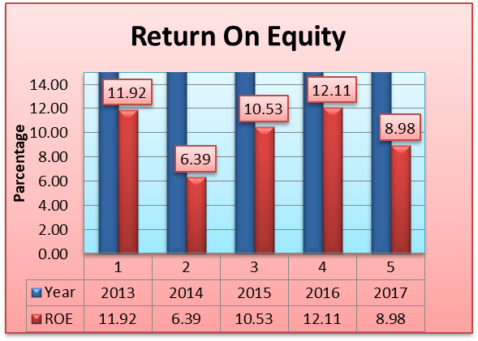
Fig: Return on Equity
Interpretation:
The return on equity measures the return earned on the owner’s investment. The graph shows that the bank return on equity has fluctuated over the years. However, the return on equity has decreased from 11.92% in 2013 to 8.98% in 2017. ROE of 15-20% are generally considered good. ROE is also a factor in stock valuation, in association with other financial ratios. In 2015 and 2016 the ratio was respectively 10.53% and 12.53% which indicates SJIBL was able to gather more customers deposits, able to earn more profit on Bi-Muazzal, able to earn more profit on investment against letter of credit and mudaraba term deposit, able to earn more income from investment in Shares/Securities etc. which ultimately leaded SJIBL to generate more net income.

3.3.1.3 Return on investment capital:

This ratio gives an impression of how well a bank is using its capital to generate returns. Return on investment capital percentage often comparing with weighted average cost of capital to check whether invested capital is being used efficiently or not. If ROIC is 2% or more it means a bank is creating value and less than 2% means destroying value.

Formula: ROIC= (Net operating profit after tax/Invested capital)*100

Graphical Presentation
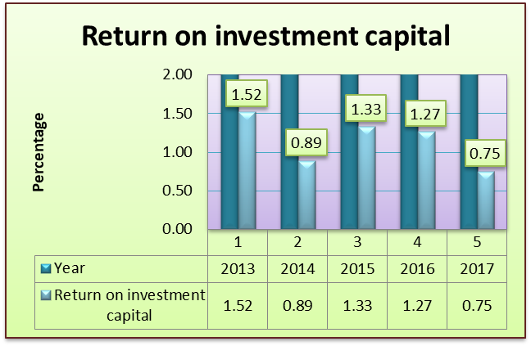
Fig: ROIC
Interpretation:
This graph shows that the bank return on investment capital had been fluctuating over the years. However it has decreased 0.89% in 2014 and 0.75% in 2017. In 2013, 2015 and 2016 it shows that the percentage is increased respectively 1.52%, 1.33% and 1.27% which means they are improving to generate the revenue.
3.3.1.4 Expense control efficiency:

A bank's operating expenses are in the numerator and its revenue is in the denominator, a lower efficiency ratio means that a bank is operating better. If the efficiency ratio increases, it means a bank's expenses are increasing. It is a measure of operating efficiency and expense control and it indicates the percentage operating revenue after the operating expense is deducted.

Formula: Expense control efficiency = Total operating expense / Total operating revenue
Graphical Presentation

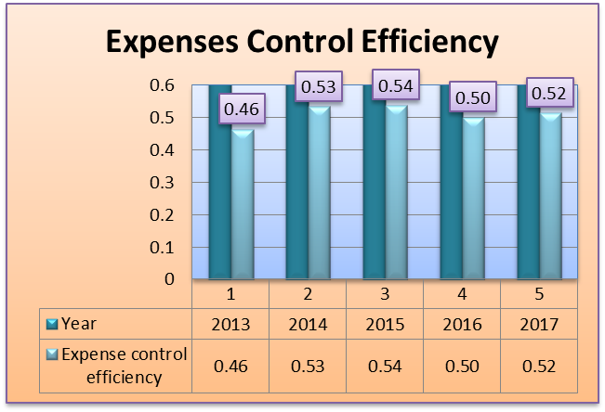
Fig: Expense control efficiency
Interpretation:
From this graph it can be seen that the average expense control efficiency for Shahjalal Islami Banks Limited Increased over the years and in 2015 expense control efficiency was 0.54 is the best option for this bank.

3.3.1.5 Operating profit margin:

Operating margin also known as operating income margin, operating profit margin and return on sales is the ratio of operating income divided by net sales, usually presented in percent. A banks income statement data helps to calculating operating profit margin. It indicates how well the bank operations contribute to its profitability and also manage its indirect cost.

Formula: Operating profit Margin= Operating Profit / Total Revenue.

Graphical Presentation

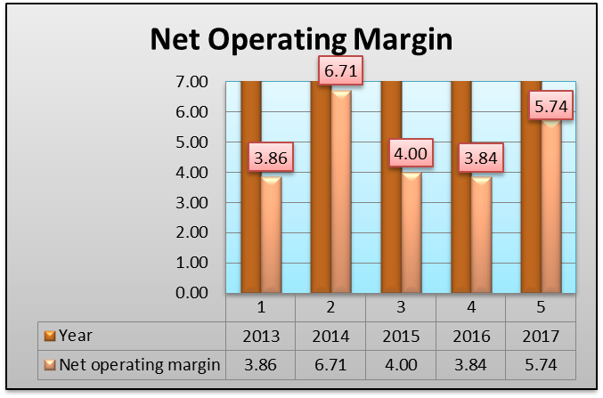
Fig: Operating profit margin
Interpretation:
This data analysis shows that, in 2013 operating profit margin of SJIBL was 3.86 whereas 6.71 were in 2014. It indicated in 2014 SJIBL performed more efficiently among 5 years. The higher income over expenditure than 2013 was the main reason of higher operating profit margin, higher profit on investment, higher income from investment in Securities, commission from brokerage etc. might also be responsible for higher income over expenditure in 2014. In 2015 the operating profit margin of SJIBL decreased to 4.00 and 3.84 in 2016. At last, in 2017 the operating margin of SJIBL increased to 5.74. In 2016 performance was lower because lower income over expenditure for lower profit from investment. Commission, exchange and brokerage etc., might be responsible the performance of SJIBL.

3.3.1.6 Equity multiplier:

This financial leverage ratio shows the banks percentage of assets which is financed by the shareholder. Conversely it also shows the level of debt financing which is used to maintain banks operations. If the bank is rely on only debt financing then it will have to raise more cash flows in order to pay their obligations. Higher equity multiplier means the bank is relying more on debt to finance its assets.

Formula: Equity multiplier = Total asset / total shareholders’ Equity.

Graphical Presentation

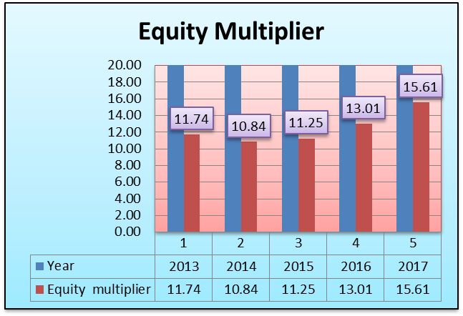
Fig: Equity multiplier

Interpretation:

This graph indicates that equity multiplier have increased overs the 5 years. This is not a good sign. Higher multiplier ratios are risky for the bank because it indicates that more assets were funding by debt to pay banks operations.

3.3.2 Liquidity ratio:

3.3.2.1 Liquid securities indicator:

Liquid securities indicator is another important liquidity ratio for banks. Stocks and marketable securities are the favorable liquid assets which can be converted into cash in relatively short period of time when the bank is in financial crisis.

Formula: Liquid securities Indicator = Govt. securities /Total assets

Graphical Presentation

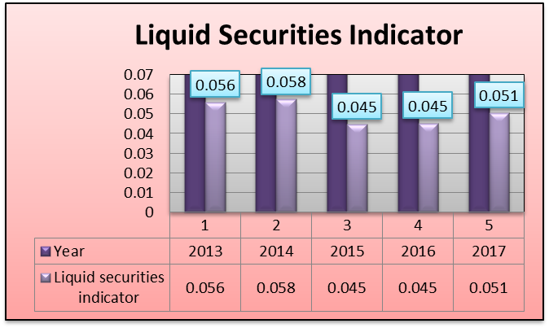
Fig: Liquid securities indicator
Interpretation:
This graph indicates that SJIBL liquid securities indicator is fluctuating over the years. In 2014 it has increased 0.058 then other years. The higher the liquid securities indicator is the better. The reason might be increased in short term securities behind the scenario. However in 2015 and 2016 it has decreased respectively 0.045 and 0.045 but in 2017 it increased 0.051 which indicates, it increase its liquid assets.

3.3.2.2 Earning assets to total assets ratios:

Banks use the earning assets to total assets ratio method as a quick way to determine the percentage of the balance sheet that is working to generate income which is useful for long-term goals such as retirement planning.

Formula: (Beginning earning assets for the year + ending earning assets for the year) ÷2
-------------- Divided by --------------
(Beginning total assets for the year + ending total assets for the year) ÷ 2

Graphical Presentation

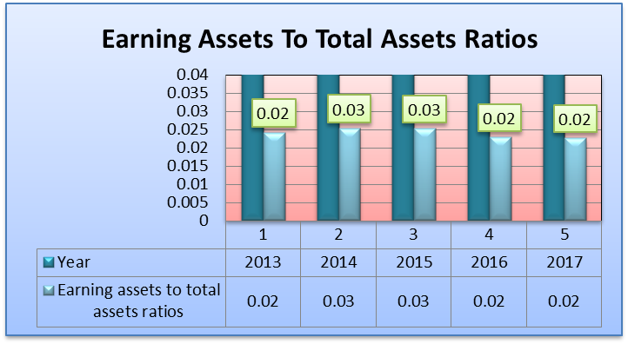
Fig: Earning assets to total assets
Interpretation:

The analyzed data shows that, in 2013 the ratio of earning assets to total assets of SJIBL was 0.02 in 2013 and 0.03 was both in 2014 and 2015. SJIBL performed more efficiently in 2014 and 2015 compared to other years. Higher investment on government and other shares and securities, general investments etc. might be the factors of higher earnings assets. In 2016 and 2017 the ratio of earning assets to total assets of SJIBL was decreased 0.02 both years and SJIBL performed less efficiently among the 5 years.

3.3.2.3 Current deposits to total liabilities:

This ratio is used to assess banks liquidity by comparing banks total loans to its total deposits for the same period. It is expressed as a percentage. If the ratio is too high, it means that the bank may not have enough liquidity to cover any unforeseen. Conversely, if the ratio is too low, the bank may not be earning as much as it could be. This ratio shows a bank’s ability to cover loan losses and withdrawals by its customers. Investors monitor this of banks to make sure there is adequate liquidity to cover loans in the event of an economic downturn resulting in loan defaults.

Formula: Total loans / total deposits

Graphical Presentation

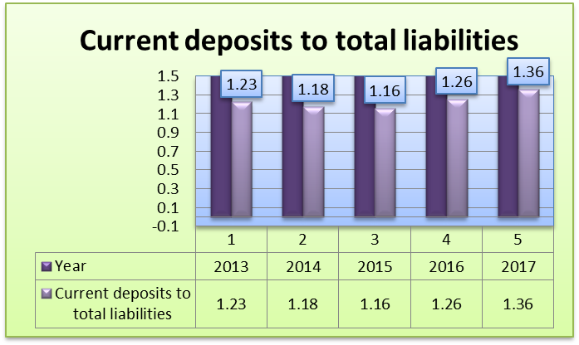
Fig: Current deposits to total liabilities

Interpretation:
This graph shows that, the ratio of current deposits to total liabilities of SJIBL was increasing from 2013 to 2017. Among last 5 years in 2017 the ratio of current deposits to total liabilities increased to 1.36 and it indicated the highest efficiency of SJIBL. Comparatively lower total liabilities for lower bill payable, mudaraba term deposits etc. might be the reason behind the scenario of SJIBL performance in 2017.

3.3.2.4 Cash position indicator:

The cash position is a sign of financial strength and liquidity. It is considered as highly liquid asset such as certificates of deposit, short-term government debt and other cash equivalents.

Formula: cash and balance with the others banks / total assets

Graphical Presentation

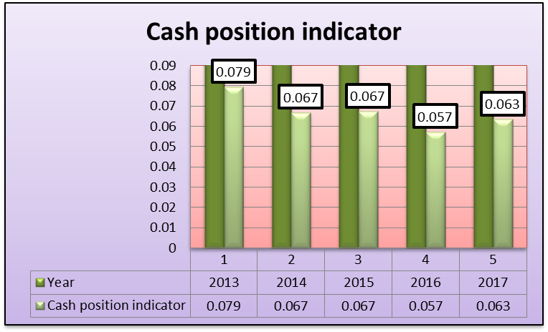
Fig: cash position indicator
Interpretation:

This graph shows that cash position of SJIBL was increased in 0.079 in 2013 after that the ratio remained fluctuated from 2014 to 2017. Economic fluctuation might be the reason of this scenario.

3.3.3 Debt ratios or leverage ratio

3.3.3.1 Debt to asset ratios:

It indicates the percentage of debts a company has against its percentage of assets. It’s a percentage of a bank total asset that was financed by creditors. Generally, the higher percentage of debt to total assets ratio shows the greater financial leverage and the greater the risk.

Formula: Total debt / total assets

Graphical Presentation

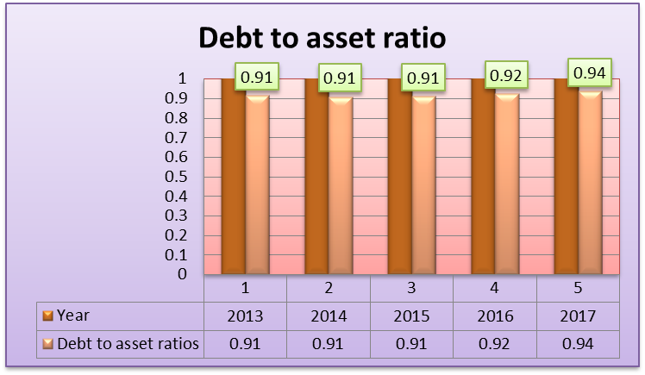
Fig: Debt to asset ratio

Interpretation:
The graph shows that debt to asset ratio of the SJIBL was almost stable at 0.91 in the year of 2013, 2014 and 2015. Among last 5 years in 2016 and 2017 the debt to asset ratio increased to respectively 0.92 and 0.94 it indicated the highest financial leverage of SJIBL.

3.3.3.2 Debt to equity ratios:

Debt to equity ratio is a major performance indicator for every bank. This ratio compares the amount of funds supplied by creditor and the amount of funds supplied by the owner. However, the debt to equity ratio depends on the industry because some industries use more debt financing than others. It is also a financial leverage ratio. It indicates the ability of shareholder equity to cover up all the obligations arising from debts.

Formula: Total debt / total shareholder equity.

Graphical Presentation

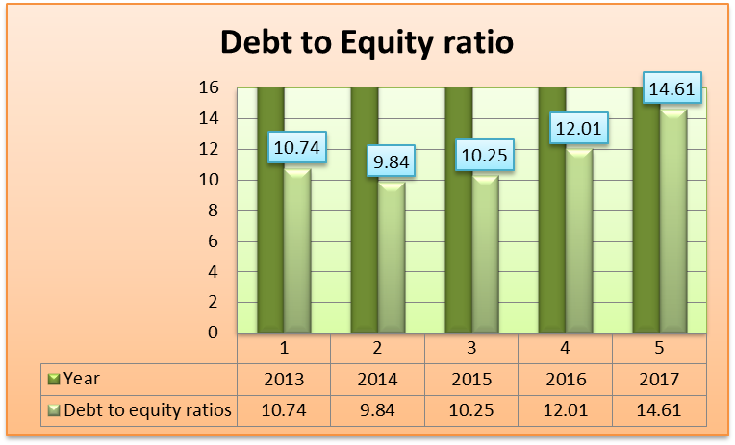
Fig: Debt to equity ratio

Interpretation:

This graphs shows that debt to equity ratio is fluctuating from 2013 to 2016 and 2017 it was increased in 14.61. It indicates that shareholder equity was not enough to cover up the obligations arising from debts.

3.3.3.3 Equity to asset ratio:

Equity to asset ratio is an investment solvency ratio. It indicates how much of the company’s assets are funded by equity shares. It represents the financial health of a company.

Formula: Net worth / total asset.

Graphical Presentation

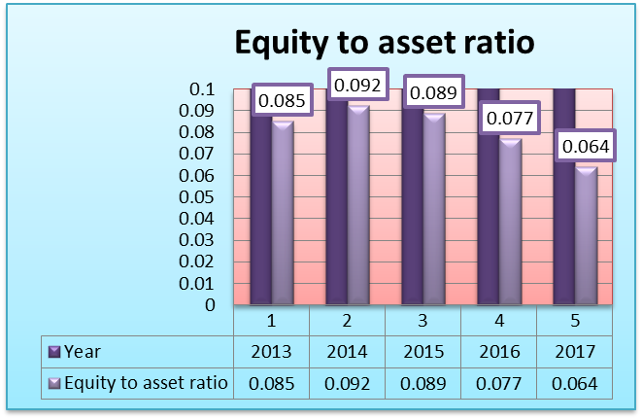
Fig: Equity to asset ratio
Interpretation:

The graph shows that, in 2013, 2014, 2015, 2016 and 2017 of the SJIBL were 0.085, 0.092, 0.089, 0.077 and 0.064 respectively. The Equity to asset of SJIBL gradually decreased after 2015. In 2014 SJIBL was able to earn higher net income among last 5 years. In 2013, 2014 and 2015 the economic condition was quite good and return on deposits rate was higher. This ultimately leaded SJIBL to generate more net income.

3.3.4 Market performance ratio analysis:

3.3.4.1 EPS:

EPS indicates the profitability of a company and market participants use it frequently to gauge the profitability of a company before buying its share.

Formula: EPS = (Net income-preferred dividend) / weighted average number of shares outstanding.

Graphical Presentation

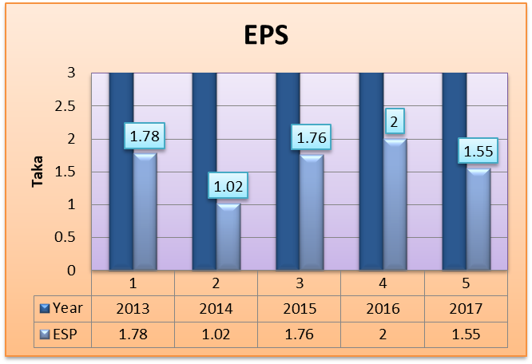
Formula: EPS

Interpretation:

This graph shows that the bank earnings per share have fluctuated over the years. However, the earning per share has decreased 1.02 in 2014.

3.3.4.2 Price-to-Earnings ratio:

It is also known as price multiple. It is banks share price that earns form per share. It is using for valuing a bank to find out whether banks are overvalued or undervalued. The investors are expecting that higher P/E ratio brings higher earnings growth.

Formula: P/E ratio =Market price per share of common stock/Earning per share.

Graphical Presentation

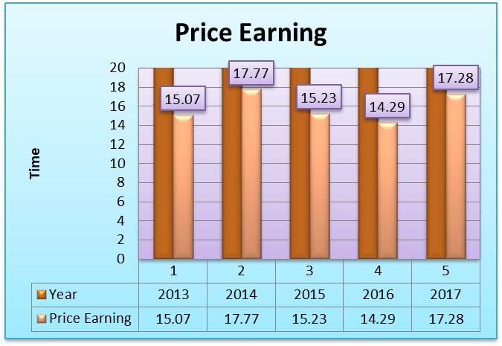
Fig: Price earning

Interpretation:

Price earnings ratio measures the investors’ confidence toward the organization. The price earnings graph represents fluctuation over the years. However, the Price earnings ratio has decreased 14.29 times in 2016. This indicates investors’ confidence on the firm’s has decreased over that year.

Chapter Four
4. Findings and recommendations
I have found some major findings related to SJIBL while preparing the report and the internship period.
4.1 Major Findings:
- It is immensely centralized for making decision.
- The connection between employees and superiors are moderate.
- Sometimes it is quite not possible for employee to give appropriate treatment to their clients.
- In the branch, employees find difficulties at bank’s rush time.
- Sometimes server network become slow which creates distraction to the employees.
- ROA ratio represents a fluctuating situation of the SJIBL. Unstable economic condition, lower net investment income might be responsible for the poor profitability.
- ROE percentage has increased 11.92%, 10.53% and 12.11% so it tells about the good performance of SJIBL.
- ROIC has also increased to generate the revenue.
- Expense control efficiency was increased among the 5 year.
- The net interest margin of SJIBL was gradually increased in 2014 and 2013.
- Equity multiplier ratio has increased and it indicates a bad sign of SJIBL.
- Liquidity ratios are showing a Fluctuating indication of SJIBL.
- Debt to asset ratio percentage has increased and it indicates a bad sign of SJIBL.
- Debt to equity ratio represents that SJIBL performance is getting average.
- Equity to asset ratio shows the good performance of SJIBL in 2014.
- The SJIBL earnings per share have fluctuated over the years.
- The employees have several targets which creates pressure on them.

4.2 Recommendations:
The following recommendations are given below to be considered to perform SJIBL well:
- The decision should be decentralized.
- The bonding between the branches and head office should develop more.
- The branch network system must update more.
- The bank should be faster and dynamic by applying their new technology.
- They should arrange a training program for their employees and give proper service to their clients.
- Recruit more employees in every branch.
- Embroil more high projects will bring their goodwill more.
- SJIBL should conduct a good advertisement for new schemes.
- Working place should be improvised.
- Though Return on Assets of SJIBL shows a fluctuating situation so that it should gain more profitability which may increase its net income against total assets by increasing Investment Income and reducing operating expense.
- Net profit margin of SJIBL in 2015 and 2016 indicated, the lower efficiency compared to 2014 and 2017. For better efficiency SJIBL may increase its investment income by increasing profit on Murabaha, Ijara and Investment against Letter of credit etc.
- Since earnings per share gradually fluctuated over the years. So, SJIBL may increase its net income by improving Investment Income for achieve more profitability.

Chapter Five:
5. Conclusion
Shahjalal Islami bank Ltd is now most dynamic islami banks in the islami banking sector. This bank is equipped with the skilled bankers and managers in all level of management. Shahjalal islami bank limited is performing well in our country. Shahjalal islami bank ltd also follow the rules and regulation which is setting by the government.
As i was assigned to the elephant road branch of SJIBL, I have worked their only three months which help me to understand a very short period for knowing completely about the operations of the bank. Their performance is good in the market. It is a sharia-based bank and they do Interest-Free method of transaction. They started their journey from 2001 and now they are on peak. In this regard, overall the bank must make positive attempt to be more outward looking trend and aware of what is happening. They are giving positive growth to the economy of Bangladesh. SJIBL has a very good relationship with their clients and this thing gives SJIBL much strength.
In SJIBL I have worked for general banking which help me a lot to my study objective and guided me to complete my report. My experience with the SJIBL will help me to go ahead and wish SJIBL for continuous success.

Appendix: Reference & Bibliography
- For referencing of article:
https://link.springer.com/chapter/10.1007/978-3-030-10907-3_6
http://dspace.uiu.ac.bd/handle/52243/466
https://papers.ssrn.com/sol3/papers.cfm?abstract_id=2776474
https://papers.ssrn.com/sol3/papers.cfm?abstract_id=2776474

- For referencing of websites:
http://www.journalofbusiness.org/index.php/GJMBR/article/view/1845
http://www.allresearchjournal.com/archives/2016/vol2issue9/PartE/2-8-91-627.pdf
http://dspace.bracu.ac.bd/xmlui/handle/10361/6131
http://aaber.com.au/index.php/AABER/article/view/20
http://www.academia.edu/download/57088042/April-June-2018_Journal_of_Islamic_Banking_and_Finance.pdf#page=68
http://dspace.bracu.ac.bd/xmlui/handle/10361/12425
https://www.google.com/search?rlz=1C1CHBF_enBD815BD815&q=shahjalal+islami+bank+annual+report+2016&sa=X&ved=2ahUKEwjsuMrMoPTkAhXEfisKHcLNB74Q1QIoAXoECAoQAg
https://www.google.com/search?rlz=1C1CHBF_enBD815BD815&q=social+islami+bank+annual+report+2017&sa=X&ved=2ahUKEwjsuMrMoPTkAhXEfisKHcLNB74Q1QIoBXoECAoQBg

- For referencing of book:
Zaman, M. R. & Movassaghi, H. (2001). Islamic Banking: A Performance Analysis. Journal of Global Business.
Sarker, M. A. A. (1999). Islamic Banking in Bangladesh: Performance, Problems and Prospects. International Journal of Islamic Financial Services.
Islamic banking and finance (2019, April 04). Retrieved April 24, 2019, from
https://en.wikipedia.org/wiki/Islamic_banking_and_finance

