UNITED INTERNATIONAL UNIVERSITY


Internship Report

Financial Statement Analysis of
Greenland Technologies Limited
Submitted to:
MS Zinnatun Nesa
Assistant Professor
School of Business and Economics

Submitted by:
Fardin Khan
ID: 111 161 341
School of Business and Economics

Date of Submission: 29th July, 2021

Letter of Transmittal

29th July,2021
MS Zinnatun Nesa
Assistant Professor,
School of Business and Economics (SOBE),
United International University,
Badda, Dhaka 1212.
Dear Mam,
I am pleased to submit My Internship report in compliance with the course requirement and your instructions. The topic of the report is ‘Financial Statement Analysis of Greenland Technologies limited’. I would like you to know that working on this report has given me experience and knowledge about the topics related to the report, especially about ratio analysis, horizontal and vertical analysis, analysis of profitability, analysis of growth and sustainable earnings. I found the process of making this report both interesting and challenging
I hope you find this report satisfactory.

Sincerely yours,
Fardin Khan

Certification of similarity index

Acknowledgment

At first I would like to start our acknowledgement appreciating the Almighty. I want to thank my, Senior manager, my Audit department team and accounts department team for monitoring me in Greenland Technologies limited for giving me various types of work. By doing this types of work I developed my working capabilities and that makes me so much confident. I think what work I have done in Greenland Technologies Limited that will help me in future. I want to thank my honourable supervisor, Zinnatun Nesa for his patient guidance and immense support. So I want to take this opportunity to express my deep gratitude to her. My report, Financial Statement Analysis of Green Land Technologies Limited would not have taken the present form in the absence of the invaluable guidance, inspiration and cooperation from her.

Executive Summary

In this internship report, the financial statement of Greenland Technologies Limited performance has been analysed, GTL Limited was examined on how it manages its growth and what is the current condition of the company in terms of its financial position. All the data used in the report are secondary data mostly collected from the annual financial reports and financial ratios and graphical representation of the ratios in the report. The report’s first chapter contains introduction and second chapter contains the company profile. The third chapter contains ratio analysis and the ratio analysis was done under two dimensions, these are liquidity dimension, profitability dimension. Total 15 ratios were analysed. Then in chapter four contains theoretical frame work. In the fifth chapter it contains findings, recommendation and conclusion.
Table of Content

Letter of Transmittal | 02
Acknowledgment | 03
Executive Summary | 04
Chapter One: Introduction | 06
Chapter Two: Company Profile | 08
Chapter Three: Internship Diary | 16
Chapter Four: Ratio Analysis
Liquidity Ratio | 20
Profitability Ratio | 26
Chapter Five:
Findings | 35
Recommendation | 36
Conclusion | 37

Chapter: 1
Introduction

By doing internship people can develop their working skill, experience and people can know how to handle difficult situation. If an employee can gain knowledge of different industry then he will enjoy the internship work. So internship gives the chance to students to use the knowledge and do the practical work so that they can gain experience and they can overcome from so many different work. United International University has now given a chance to the students to do internship for commercial graduate. Student can develop capabilities because they provide us lecture room for understanding. Green Land 6 Limited is one of the most reputed group in Bangladesh, on where I prepare my Internship report. Doing internship in this company it helped me a lot because now I have an idea on internal audit and how to control the accounts receivable department.

  - Objective of the Study

BBA Program gives me the idea that how to plan a business. But the workplace environment is very different from what you learn in the program. Accounting internship, you can complete your undergraduate program with in-depth knowledge of how to complete accounting. There are some placement goals:
- Knowing the customer need, want and demand
- Knowing company’s weakness and effectiveness
- Need to understand the performance of GTL in different platform.

1.2 Significance of the Study

After completing the internship training student need to prepare a internship repot based on what task provided in the training. Internship report helps student in so many different area. The area is given below :
- Improve your writing skill
- Internship program work experience.
- Considering the Motives of the internship and whether they are achieved or not during the internship.

By doing internship you can built a huge communication channel by communicating with the customers of the company. It will help you to get a good job if needed. Without internship experience you can not have so much contact.

1.3 Methodology of the Study

This internship report is based on experiance and the support of my elders, colleagues and senior manager of the company.
I collect information to do this repot from one source and the source is secondary source.

- Secondary source

1.4 Limitation of the Study
Every job has different challenges. It will give different types of experiance. Various oblige have made the preparation of this report closely difficult. They are:
- Because of time limitation proper search was not possible
- So many information has not been published for some reason.
CHAPTER 2
Company Profile

2.1 Background of Greenland Technologies Limited

When GTL first start their company they started with only one salesman. Greenland technologies limited is concern of GETCO group. Greenland technologies limited established in 2011.The name of the chairman of Greenland technologies limited is K.M Khaled.K.M. The name of the Managing Director is K.M. Rakib Hasan and the name of the director is K.M. Mobarak Hossain. Greenland technologies limited started their business in 2011 but they operate their business in 2013 . Golam Arham Kibria is CEO of the company. The main products of this company are:

- INGCO
- Karcher
- New Holland

Now 240 employees are working in our company. So the company is growing very first day by day. I can say that if they can grow like this one day they will become the market leader in our country. Greenland Technologies have so many department like accounts department, finance department, audit department, sales department and they have also HR department. Right now our company have so many experience employees who knows how to run the company and how to make profit. The financial support is very good of this company I think this will help them to become the market leader. The profit of Greenland Technologies limited is increasing every year so this will help our economy.

2.2 Vision Statement:

- Our main target is to capture the market and capture the customers.
- Give good quality products to the customers.
- Provide good service in agricultural industry.

2.3 Mission Statement:

Our mission is to develop the Agricultural sector by providing good and innovative products to our customers and we also have a plan for training them and help them to know how to use the agricultural product. That will help to grow GDP.

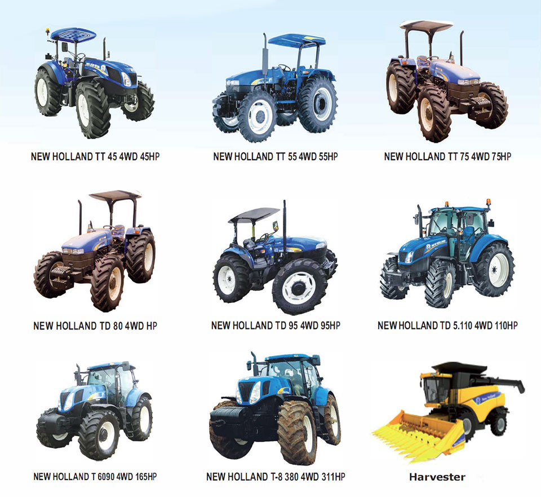

2.4 Hierarchy of the Organization

In Greenland Technologies Limited Chief Executive Officer Controls everything. After Chief Executive officer there are Three General managers. Under General manager there are two parts Manager and Senior Manage. Under the Manager Deputy Manager works. Under Deputy Manager Assistant Manager works Under Assistant Manager executive and junior executive works and intern also works.

2.5 The Total Employee of the company

Our company increasing their business. So they need man power right now for maintain the business. In Greenland technologies limited right now more then 240 employees are working. More then 60 employees are working in the main branch that time I was doing my intern. The communication of the all employee was good when I was working there. They are very helpful with each other. Greenland Technologies Limited gives holiday package for their employee. Now they also start a system that is based on performance. If your performance is good they will give bonus based on everyone performance.

2.8 SWOT Analysis

Every company should know about this because it is very important for every company. It helps to know about what the strength of the company weakness of the company opportunities of the company and threats of the company.

Strength:

- Goodwill in the market
- Financial ability is good
- Know about their customer need want and demand
- Every sales person is skillful
- Technology is good

Weakness:

- Company is new in importing business
- Lease financing experience in not good
- Lack of experience
- Manpower is not enough
- Distribution problem

Opportunities:

- If GTL wants to target the customer they need to advertise.
- Providing agriculture solution GTL can grow their business
- Substantial of ROI
- If GTL can know the farmers need they can they give best solution.
- They can get government help because it is agriculture related business
- Increase farmers awareness
- Technology used in agribusiness

Threats:

- Our company import product from outside so it’s a threat
- Our company sell product in instalment so it’s also threat
- The product quality variation
CHAPTER 3
Job responsibilities as an Intern at GTL
When I joined at GTL I was in audit department. A team of 8 people look after the audit department. My responsibilities was to check the bills of the GTL. There were some rules for checking the bills. Then after some day they sent me outside Dhaka for inventory audit. That was a very good experience for me. Then after one month I joined accounts department. More then 10 people look after the accounts department. They use tally and vanguard software to collect all the information of customer. GTL have to take some risk for this type of cash flows. If any data mistakenly entered into the process then GTL have to suffer a For this. So employees need to be very cunning and they need to be very careful. I’m very much honoured because I got the chance to work at the main office of GTL. The communication was very good of every employees and they are very talented as well. I have learned so many things from them. I started my work at GTL on 18th November and ended up on 19th February 2021.

There were some tasks I was responsible during my internship at GTL
- Posting all types of products customer coding in vanguard
- Collecting all types of information about the customers and the dealers.
- Checking the bills of all employees
- Checking the documents
- Preparing the Excel files
- Data entry in tally software
- The calculation of patty cash
- Receive cash from the sales department

CHAPTER 4
Financial Ratio Analysis
Liquidity RatioITY RATIOS

A Liquidity ratio is a ratio that is used to determine the short term debt obligation of a company. If a company have a ratio of less then 0.75 then the current liabilities is not satisfy. The formula of liquidity ratio is (Current asset-Inventory)/Current Liabilities. There are some ratio that I calculate for my company is given below:
1. Current Ratio
2. Quick Ratio
3. Cash Ratio
4. Cash total to operating expenses
5. Sales to Current Asset Ratio
6. Current asset by total liability
7. Cash to CA

Current Ratio
The current ratio measures the short term obligation of a company within one year. The current ratio tells that how a company can increase their current asset.
Equation: Current Ratio = Current Asset /Current Liability

Year | 2013 | 2014 | 2015 | 2016 | 2017
Current Ratio | 76.04 | 73.35 | 84.23 | 80.12 | 79.06

Here we can see that it’s a fluctuating ratio. The ratio of Greenland Technologies Limited was at a medium pace at 2013 with 76.04% but then it fell down a little at 2014 with 73.35%. Again it rose up the highest at 2015 with 84.23% and the ratio of 2016 and 2017 was more or less same.The current ratio of Greenland Technologies Limited and their short term payment capacity was high at 2015 which doesn’t follow any kind of pattern.

QUICK RATIO
The quick ratio tells that the dollar amount of liquid asset available against the dollar amount of current liabilities of a company.
Equation: Quick Ratio = (CA - Inventory) /CL
Year | 2013 | 2014 | 2015 | 2016 | 2017
Quick Ratio | 43.98 | 52.57 | 50.36 | 48.06 | 52.84

The quick ratio of GTL also doesn’t follow any pattern. It was more or less same at every year. It was at the highest point at 2014 with the rate of 52.57% and lowest at 2013 with 43.98%. In 2017 the ratio was 52.84 which means their half of the current assets can be converted easily to pay down the current liabilities.

CASH RATIO
Cash ratio is the ratio of the liquid assets of a company to its current liabilities. It means the ratio of cash to deposits in a bank (for which minimum values are generally set officially). In other words, cash ratio is the ratio of a company's total cash and cash equivalents to its current liabilities. The metric calculates a company's ability to repay its short-term debt with readily-liquidated cash resources. This information is useful to parties such as creditors when they decide how much debt, if any, they would be willing to extend to the asking party.

Equation: Cash Ratio = Cash+Cash equivalent / CL
Year | 2013 | 2014 | 2015 | 2016 | 2017
Cash Ratio | 4.68% | 5.25% | 4.32% | 4.16% | 4.72%

The cash ratio of GTL has not much change over the five years. It was at its best in 2014 with 5.25% and least in 2016 with 4.16%. The average of 5 years is 4.84 which is greater than 1 so the company has more cash and cash equivalents than current liabilities. In this situation, GTL has the ability to cover all short-term debt and still have cash remaining. However, if the cash ratio is very high, this may also indicate that GTL is not using its capital for its best use, since it could be invested in profitable projects instead of stagnating in its bank account.

Cash total operating expenses

It is calculated by dividing a property's operating expense (minus depreciation) by its gross operating income or cash on hand. The OER is used for comparing the expenses of similar properties. On the other hand, the operating ratio is the comparison of a company's total expenses compared to the revenue or net sales generated.

Equation: Cash total operating expenses= Cash / Total Operating expenses
Year | 2013 | 2014 | 2015 | 2016 | 2017
Cash Total Operating Expenses | 16.56% | 17.20% | 10.25% | 13.57% | 16.58%

GTL had a fluctuating ratio in these 5 years. The percentage of 2013 to 2014 nearby but it declined by 10.25% at 2015. Again it grew up throughout the next two years. The highest growth was at 2014 with percentage of 17.20. This means in 2017 with the cash in hand GTL could pay off 16.58 Percent of its operating expenses.

Sales to Current Asset Ratio
The asset turnover ratio measures the value of a company's sales or revenues relative to the value of its assets. The asset turnover ratio can be used as an indicator of the efficiency with which a company is using its assets to generate revenue. The higher the asset turnover ratio, the more efficient a company. Conversely, if a company has a low asset turnover ratio, it indicates it is not efficiently using its assets to generate sales.

Equation: Sales to Current Asset Ratio= Total Sales / Current Asset

Year | 2013 | 2014 | 2015 | 2016 | 2017
Sales to current asset ratio | 1.89 | 2.00 | 2.32 | 1.84 | 1.84

At the beginning it’s an upward slopping ratio from 2013 to 2015 then again it’s a downward slopping ratio after 2015. So GTL has given its best performance at 2015 with the highest turnover ratio of 2.32 throughout these years which means it had done well because the highest the ratio the more the company is doing well.

Current asset by total liability
The Current Assets to Total Debt ratio measures the company’s ability to cover its total debt with its Total Current Assets. This ratio is also used to estimate the liquidity of the company by showing the company can pay its creditors with its current assets if the company’s assets ever had to be liquidated.
Equation: Current asset by total liability = Current Asset / Total Liability
Year | 2013 | 2014 | 2015 | 2016 | 2017
Current asset by total Liability | 70.25% | 72.50% | 75.22% | 71.20% | 67.40%

This ratio rises from 2013 to 2015 upwards and again it rapidly falls down from 2015 to 2017 at the lowest point. An increasing Current Assets to Total Debt ratio is generally a positive sign, showing that GTL has a better ability to satisfy its debt obligations using its Total Current Assets which is done in 2015 with the highest ratio of 75.22%.

Cash to Current Asset
The cash asset ratio is the current value of marketable securities and cash, divided by the company's current liabilities. Also known as the cash ratio, the cash asset ratio compares the amount of highly liquid assets (such as cash and marketable securities) to the amount of short-term liabilities.

Equation: Cash to CA = Cash / CA
Year | 2013 | 2014 | 2015 | 2016 | 2017
Csah to Current Asset | 6.81% | 7.35% | 6.29% | 5.72% | 7.20%

It’s a fluctuating ratio again with the highest value of 7.35% at 2014 and lowest of 5.72% at 2016. In 2013 GTL has an average growth then it was increased at 2014 again it fell down a bit within 2015 to 2016 and rose again at 2017.

Profitability ratio
Profitability ratios compare income statement accounts and categories to show a company’s ability to generate profits from its operations. Profitability ratios focus on a company’s return on investment in inventory and other assets. These ratios basically show how well companies can achieve profits from their operations. The following Profitability Ratios have been calculated in the report

1. Net Profit Margin
2. Gross Profit Margin
3. Operating Profit Margin
4. Return on Assets
5. Earnings before Tax margin
6. Return on Equity
7. Earnings per share shares
8. Dividend Per Share

Net Profit Margin
The net profit margin indicates that how much net income or profit is generated as a percentage of revenue. The Net profit margin can also represent decimal form.
Equation: Net Profit Margin = Income / Sales
Year | 2013 | 2014 | 2015 | 2016 | 2017
Net Profit Margin | 0.52% | 1.76% | 4.32% | 2.35% | 1.23%

We can see that the graph dramatically fluctuated during the five years’ period. In 2013, the net profit margin was 0.52% wherein 2015 it reached at 4.32% but in 2017 it declined again and became 1.23%. For a high volume, high competition business, a profit margin of 4% may be good but here the GTL Company this net profit margin is not sound for their company.

Gross Profit Margin
Gross profit margin is a metric used to assess a company's financial health and business model by revealing the amount of money left over from sales after deducting the cost of goods sold. The gross profit margin is often expressed as a percentage of sales and may be called the gross margin ratio.

Equation: Gross Profit Margin= Gross profit/ net sales
Year | 2013 | 2014 | 2015 | 2016 | 2017
Gross profit Margin | 28.40% | 30.25% | 31.25% | 29.40% | 28.46%

Here we can see that the graph is downward sloping. The ratio increased from 2013 and reached at 28.20% to 30.25% in 2015 after that it was going to declining. In 2013, the gross profit margin was 28.40 in 2017 it became 28.46%. A good target gross profit margin is around 50% but comparing with that GTL Company has average 30% GMP which is below the requirement
Operating Profit Margin
The operating profit margin tells us that after paying the the variable cost of production how much profit makes on a dollar sales.
Equation: Operating Profit Margin = Operating income/ net sales
Year | 2013 | 2014 | 2015 | 2016 | 2017
Operating profit Margin | 8.50% | 9.40% | 7.45% | 6.87% | 5.75%

This is also a downward sloping graph but there are no sharp changes happened throughout the period. It decreased slowly and reached at 8.50% to 5.75% from the year 2013 to 2017. As the operating profit margin declined it’s not a good hint for the company because to stay in a good position the company should maintain minimum 20% OPM for them.
Return on Assets
It shows us that how company is relative to its total asset. By using return on asset ratio a company can understand that how efficient the management of a company is using its asset to generate earnings.
Equation: Return on Assets = Net Income/ Total Asset
Year | 2013 | 2014 | 2015 | 2016 | 2017
Return on assets | 0.51% | 2.18% | 8.61% | 2.21% | 0.74%

This graph drastically fluctuated during the years. In 2015 it was the pick year for the company they increased their Return on Asset from 0.51% to 8.61%. But in 2016 the company again reduced their ROA from 2.21% to 0.74 %. This fluctuation can take them in a very bad situation and due to this the company may face loss in future.
Earnings before Tax margin
The tax profit margin is the ratio of a company's pre-tax earnings to its total sales. The higher the tax profit margin, the more profitable the company.
Equation: Earning before Tax margin = EBT/ Net sales
Year | 2013 | 2014 | 2015 | 2016 | 2017
Earnings before tax margin | 2.53% | 4.10% | 7.94% | 4.59% | 2.53%

This graph slowly fluctuated over the years. From 2013 to 2015 the ratio increased from 2.5% to 7.94% but from 2016 to 2017 it was decreasing and became 4.59% to 2.53%. The high tax profit margin shows it more profitable as the ratio declined so, this is not good for company growth health

Return on Equity
It tells us that the profitability in relation to stockholders equity. It measures the financial performance of a company.
Equation: Return on Equity = Net Income/ Equity
Year | 2013 | 2014 | 2015 | 2016 | 2017
Return on equity | 2.56% | 11.21% | 31.55% | 9.74% | 3.73%

From the graph we can see the dramatic changes occurred during the period as it fluctuated rapidly. In 2013 it was 2.56% but it certainly reached at 31.55% in 2015.The Company’s overall performance was outstanding in year 2015.But it sharply declined from 2016 and became 3.74% in 2017. Generally, it is considered that good ROE for a company should be 15 to 20 percent but
here the company ROE only 3.73% that is very poor compare to good performance
Earnings per share
Earnings per share is the portion of a company's profit that is allocated to each outstanding share of its common stock.
Earnings per share= Total income / number of shares
Year | 2013 | 2014 | 2015 | 2016 | 2017
Earnings per share | 2.96 | 13.83 | 77.98 | 23.64 | 8.51

The graph fluctuated rapidly from the year 2013 to 2017.In 2013 the earning per share was 2.96 taka wherein 2015 it became 77.98 taka that was very much good for company shareholders as well as the company. Sadly, it’s going to decline again and came up 8.51 taka in 2017. This fluctuation is not good for company as the shareholders lose their trust on them. A consistently rising EPS over the years is a positive sign, and it means the company is making good consistent growth. Whereas there is a drop in EPS, it is a cause of alarm for the investor.
Dividend per Share
Dividend per share (DPS) is the sum of declared dividends issued by a company for every ordinary share outstanding.
Equation: Dividend per Share= Dividend/ number of shares
Year | 2013 | 2014 | 2015 | 2016 | 2017
Dividend per share | 2.47 | 6.81 | 3.36 | 3.53 | 1.39

From the graph we can see it was downward sloping except year 2013.In 2014 it sharply rose at 6.81taka but from the year 2015 to 2017 it was declining and reached at 1.39 taka as the divided per share reduced so, it can spoil the interest of the investor to invest. Many investors who want to get higher dividend if they understand the divided are less than before they may not go to invest that kind of company

Chapter 5
Findings, Recommendation

4.1 Findings

To reach the solution there was no system. When I was doing my internship I noticed some errors and there were some problem in their research. After that they identified some disabilities based on their information that was provided by their senior members of the company and by their staff.

The problems that I found is given below:

- Time Limitation: When I was working there I had to do so many work in a day but the time was not enough for that type of work they did not gave enough time for work. The work pressure was very much when I worked there but the time was limited.

- Limited time in Audit : I visited some of their showroom outside Dhaka for audit. But the time was limited for me.

- Mismanagement: When I was working there I saw their mismanagement so many time. I think that is not good for a big company because you can not run a company when your management system is not good.

- Communication Problem: Green land technologies limited is now facing communication problem. The communication system is not good. So they have to solve this problem as soon as possible.

4.2 Recommendation

- For the best quality of company we have to define the process as precisely as possible.
- Greenland Technologies Limited have to bring new good quality product that will help in agriculture sector
- The company have to give importance to their current asset
- GTL have to increase their net profit ratio and return on Asset ratio
- GTL have to give training to the farmers and tell them about the importance of new technological product.
- GTL need an examine he will tell them how to reduce product price without loosing the product quality.

Conclusion

Greenland technologies limited is one of the largest company of Bangladesh offering a huge product portfolio in agriculture sector. Maintaining a good financial position of such a huge company can be very challenging. Overall it maintains a healthy financial position. Green land technologies limited is earning more than its spending so its overall expense control efficiency is good. Its overall profitability improved both in ROCE and RNOA. Its overall growth in RNOA, ROCE and CSE were also in healthy position. In Greenland technologies limited most of the growth is coming from sustainable part. Though it had some negative earnings but overall financial position is quite good. The forecasted value of Greenland technologies limited was also good condition in 2014.The agriculture industry in Bangladesh is very competitive and there are many big players in the market to obtain as much share as possible. So to stay competitive in the market it is high time Green land technologies limited focuses into making its financial position more lucrative.
In

