United International University
Internship Report Based
On
Performance Analysis of

Prepared For
Mofijul Hoq Masum
Assistant Professor
School of Business & Economics
United International University

Prepared By
Sarif Shaheduzzaman
ID: 111 143 258
Major: Accounting

Date of Submission – 08 Dec, 2019
LETTER OF TRANSMITTAL
Date of Submission: 08 Dec, 2019
Mofijul Hoq Masum
Assistant Professor
School of Business & Economics
United International University
Subject: Submission of the Internship Report.
Dear Sir,

I hereby submitting my internship report, which is a part of the BBA program. This internship report is based on “Performance Analysis of Pharma Solutions Bangladesh Limited”. I have got the chance to gain about different tools and techniques related to this topic. It was an extraordinary joy just as a test to work in such an association and set up this report which has helped me essentially to improve my insight and abilities. I found out about the various parts of associations and the temporary position report allowed me the chance to build up the pragmatic information.
It would be profoundly grateful in the event that you are benevolent enough to get this internship report and give your significant judgment. It would extraordinary delight to me on the off chance that you discover this paper valuable and useful to have an obvious point of view on the issue.
Sincerely,
Signature

08 Dec, 2019
Sarif Shaheduzzaman
ID: 111 143 258
ACKNOWLEDGEMENT

I might want to offer my thanks to Omnipotent Allah who makes me ready to set up this report with great wellbeing and sound personality.
Secondly, I would like to show my gratitude to my supervisor Mofijul Hoq Masum for helping me and guiding me for preparing my internship report. Also, I would like to express my gratitude to Pallab Chakravorty (Operations Director, Operations), T. M. Zulfiquar Ali (Assistant Manager, Key Account Management), Abu Saied Md. Almamun (Head of Finance), Nishat Tarannum (Officer Human Resources), for giving me the opportunity to work at Pharma Solutions Bangladesh Limited. Without their help and support, I can’t complete my internship program successfully.

Finally, I might want to thank my colleagues and associates, who are helping me in setting up this report as well as offer their insight and thoughts regarding corporate life. I delighted in all of the time.

DECLARATION

I thusly announce that the report to be specific “Performance Analysis of Pharma Solutions Bangladesh Limited” is finished by me which depends on my down to earth work understanding.
I likewise pronounce that this report is my unique work and doesn't rupture any current copyright. This specific report has not been recently submitted to some other College/School/Association for scholarly capability/endorsement/certificate or degree.
I have set it up for the scholarly reason for Bachelor of Business Administration degree which requires practical work experience.

Signature

……………
Sarif Shaheduzzaman
ID: 111 143 258
Bachelor of Business Administration

TABLE OF CONTENTS
CHAPTER 1: INTRODUCTION 1
1.1 Introduction to the topic in hand: 1
1.2 Introduction of the organization: 1
1.3 Objectives of the report: 2
1.4 Rational of the study: 3
1.5 Scope of the study: 3
1.6 Limitations of the study: 3
CHAPTER 2: METHODOLOGY OF THE STUDY 4
2.1 Methodology of the Report: 4
2.2 Data collection process: 4
2.3 Sample design: 4
2.4 Analytical tools: 4
CHAPTER 3: ORGANIZATION BACKGROUND 5
3.1 Specifications of the industry: 5
3.2 Historical Background of the organization: 7
3.3 Branch Address: 8
3.3.1 Vision of PSBL: 8
3.3.2 Mission of PSBL: 8
3.3.3 Organizational Structure: 9
3.3.4 Branch Team Operation Structure: 10
3.3.5 Core Values: 10
3.4 Operational activities of the organization: 11
3.4.1 Services: 11
3.4.2 Value added services: 14
3.4.3 Patient Centered Services: 14
3.4.4 Brands: 15
3.4.5 Global Representation: 15
3.5 Organization Supply Chain Process: 16
3.6 SWOT Analysis: 18
3.6.1 Strengths: 18
3.6.2 Weakness: 18
3.6.3 Opportunities: 19
3.6.4 Threats: 19
CHAPTER 4: FINDINGS AND ANALYSIS OF THE STUDY 20
4.1 Analysis and findings: 20
4.2 Horizontal analysis of PSBL: 20
4.3 Vertical Analysis of Dutch Bangla Bank Limited 22
4.4 Ratio Analysis of Pharma Solutions Bangladesh Limited 25
4.5 Key Findings: 32
CHAPTER 5: EXPERIENCES DURING INTERNSHIP TENURE 33
5.1 Internship Experience: 33
5.2 Job Responsibilities: 33
5.3 Personal Observation: 34
CHAPTER 6: CONCLUSION AND RECOMMENDATIONS 35
6.1 Conclusion: 35
6.2 Recommendation: 35
CHAPTER 7: APPENDIX 37
7.1 References: 37

EXECUTIVE SUMMARY
Financial analysis is the technique of estimate the financial strength of an organization by using different mathematical and logical tools. Financial analysis also signifies the whole financial performance of an institution. It is pleasing for check the fiscal situation of the association and causing end for business to get ready. I use ratio analysis as the key tools for performing the financial analysis for my internship report. The ratio analyses give the short overview to the stakeholder. So the stakeholder tries to distillate on different financial ratios to get whole overview of the organization. The ratios analysis not only helps to judgment but also highlighted on risk escaping and profit floating related factors. To analyze this ratio I need to bring together quantitative data from authentic source. Financial statement Analysis includes an evaluation of a firm’s performance with that of other firms in the similar line of business, which usually is recognized by the firm’s industry Classification. I prepare my report on the basis of this ratio analysis and we also used it to regulate the firm’s financial position.
Key words: Performance analysis, Pharmaceutical companies, Ratio analysis

CHAPTER 1: INTRODUCTION

Introduction to the topic in hand:
Submission of internship report is the last necessity to accomplish the Bachelor of Business Administration (BBA) degree from United International University. Every one of the understudies needs to either take internship or project in the last trimester of their BBA program here. The person who decide to fill in as an understudy participate in any association and play out an internship job duty there. They need to set up their internship report on that organization as indicated by the significant focus territory and afterward present the report to their internship supervisor.
The topic I have chosen to work is “Performance Analysis of Pharma Solutions Bangladesh Ltd” which is exceptionally identified with my significant region, and helped me a ton to recognize the utilization of several financial theories and analysis. The Performance Analysis of Pharma Solutions Bangladesh Ltd includes dissecting the financial performance for decision-making purposes and understanding the overall condition over a given period or year. The report’s financial performance is determined through utilizing money related information, which will be exceptionally valuable for the financial specialists, investors, officials, and other invested individuals to take their vital choices.

1.2 Introduction of the organization:
The pharmaceutical industry in Bangladesh is one of the most developed hi-tech sectors within the country's economy. After the promulgation of Drug Control Ordinance in 1982, the local pharmaceuticals companies of our country get rapid support for growth and development of this sector was accelerated however, from then MNC’s are lag behind. There are now about 231 companies in this sector and the approximate total market size is about Taka 76,500 million per year. Bangladesh Pharmaceutical Industry is now heading towards self-sufficiency in meeting the local demand. The industry is the second highest contributor to the national exchequer after garments, and it is the largest white-collar intensive employment sector of the country.
Pharma Solutions Bangladesh Ltd. former Zuellig Pharma Bangladesh Limited (ZPBL) was incorporated in Bangladesh in 2006. ZPBL established its foot-print in Bangladesh in order to help. Pharmaceutical MNCs to utilize instant opportunity. It started operations in February 2007 as a subsidiary of Zuellig Pharma Asia Pacific of which 100% shares belonged to Zuellig Pharma Holdings Limited. In 2007, GSK entered into a partnership with Zuellig Pharma as their Distribution associate. In subsequent years RAK Pharma, Reckitt-Benckiser, Novartis Bangladesh distribution businesses were integrated. In 2015 ZPBL migrated from Zuellig group and was acquired by Rapid Keen Holdings Limited. In mid-2019, Zuellig Pharma has changed its name into PSBL and this success story is continuing and it is strengthening and flourishing day by day.
Pharma Solutions Bangladesh Limited (PSBL) provides highly advanced warehousing, distribution, supply chain and value added services to Global major pharmaceutical manufacturers, such as GlaxoSmithKline, Novartis Pharma, Sandoz, Elanco, Roche Diabetes Care, South West Technologies Limited, Menarini, Marie Stopes, Omron Healthcare Bangladesh and Sebamed.

Objectives of the report:
All reports ought to have a few objectives or targets. Without an objective, no report can be important. I have built up certain objectives and these objectives are abundantly identified with my internship issues. I wish to make my entry internship report with the accompanying goals.
- General Objectives: This report was initially intended to accomplish the BBA degree from United International University. As a student of BBA program I have to work any organization for three months to gain real life situation. Now I have experienced real life knowledge in working as intern at corporate office in Pharma Solutions Bangladesh Limited.

- Specific Objectives:
- To give a general thought about Pharma Solutions Bangladesh Limited.
- To understand and analyse the Performance analysis of Pharma Solutions Bangladesh Limited.
- To analyse a few proposals for Performance analysis of Pharma Solutions Bangladesh Limited with the goal that it can improve financial performance.
- To know strength and weakness of Pharma Solutions Bangladesh Limited.

Rational of the study:
Internship after completing 120 credits is compulsory course for the BBA program of United International University. As I am a student of BBA program. I supposed to intern in such a position where I can get acquainted with the real world. So it’s my academic duty to prepare an internship report after, at 3 month internship. As my supervisor instructed me to prepare an internship report. I prepare this formal report on “Performance Analysis of Pharma Solutions Bangladesh Ltd” so that the organization knowledge can be enhanced.

1.5 Scope of the study:
The reason for the report is to think about the budgetary presentation of Pharma Solutions Bangladesh Ltd. This report gives a concise review of the PSBL by sharing the organization’s strategic standpoint. All things considered, it will share the synopsis of the present market situation of Pharma Solutions Bangladesh Ltd. Aside from this, the administrations sent by Pharma Solutions Bangladesh Ltd will be shared, share the encounters I have gathered, and help PSBL's administrators utilize different pointers and financial analysis to assist them with understanding the financial performance of the organization. This report enables undergrads to investigate the organization performance.

1.6 Limitations of the study:
This report face from a few restrictions:
- The most significant of these was "as far as possible". Time was not satisfactory to complete the report all the more flawlessly.
- Another significant restriction was "the unavailability in numerous segments of the association". I experienced troubles in getting an arrangement from the wanted respondents, just as the fitting reaction from the respondents chosen since it was held for the organization.
- As it is a private organization, it do not publish any annual report and they have provide only two years data from their audit report for their company’s confidential policies. This report additionally experienced insufficient secondary data as it is a private organization.
- Records, productions, raw numbers are not accessible. These restrictions have reduced the purpose of the actual analysis.
- Some valuable data can't be communicated in this report for reasons of privacy as it is a private organization.

CHAPTER 2: METHODOLOGY OF THE STUDY

2.1 Methodology of the Report:
The methodology chapter refers to the methods and techniques I am going to use to prepare the report. The methodologies are listed below:

2.2 Data collection process:
The data utilized in the report are gathered from two sources. The sources are:
- Primary sources:
- Face to face communication with the employees of PSBL.
- Audit reports of the organization.
- From the personal internship experiences.
- Secondary sources:
- From various published journals of Pharmaceutical industries.
- Website of PSBL.
- Several published books on performance analysis and supply chain.

2.3 Sample design:
- Sampling techniques: The study is conducted to measure and compare the performance of PSBL using previous two years of Data. The data will be analysed in horizontal and vertical analysis as well as ratio analysis. All this analysis will follow the quantitative methods.
- Sample size: The performance of PSBL will be analysed by the previous two years financial data taken directly from the audit report as it is a private organization.

2.4 Analytical tools:
Horizontal, vertical and ratio analysis are the fundamental scientific devices that are going to use in the report. The report is led utilizing the Microsoft Word and Microsoft Excel. The bar outlines and pie diagram will be made through Microsoft exceed expectations

CHAPTER 3: ORGANIZATION BACKGROUND

3.1 Specifications of the industry:
Pharma Solutions Bangladesh Limited (PSBL) gives exceptionally propelled warehousing, appropriation, store network and worth added administrations to Global significant pharmaceutical makers, for example, GlaxoSmithKline, Novartis Pharma, Sandoz, Elanco, Roche Diabetes Care, South West Technologies Limited, Menarini, Omron Healthcare and Marie Stopes. In 2017 PSBL had a piece of the overall industry of near 61% of MNC or 4% of complete market with offers of over 90M USD. PSBL serves in excess of 51,000 clients in all channels including specialists, medical clinics, drug stores, centers and wholesalers. Along these lines, paying little heed to measure and the idea of business challenge, we have the information and skill to give a five star stockpiling condition. PSBL has a consistent procedure set up to guarantee that your items are deliberately put away, kept up and shipped all through the whole worth chain to meet consistence commitments. PSBL administrations center on the medicinal services industry and gives a wide scope of administrations of warehousing and conveyance of pharmaceutical items. We have made noteworthy interest in overhauling the foundation and improving conveyance administration capacities.
Figure 1.1: Basic Model of Pharmaceutical SCM
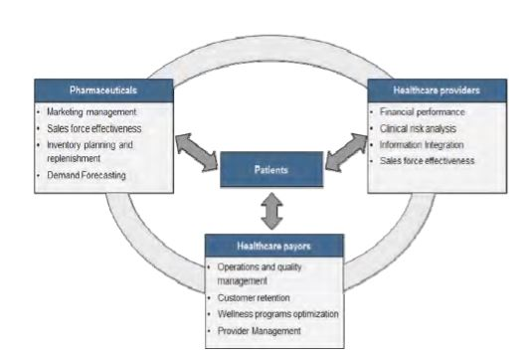
Source: www.slideshare.net/pharma-chain.

In its strictest definition coordination’s alludes to the development of products or materials, regardless of whether inbound, though, or outbound. In some assembling organizations anticipating and arranging will be found inside a coordination’s office, in different organizations coordination’s will be solely dealing with the development and transportation of products and materials. Tasks are a general administration type action guaranteeing that a business utilizes its assets adequately to meet its client responsibilities. Stock Management commonly assumes liability for both the recharging of physical stock, the degrees of physical stock, and obviously stockpiling and issue of physical stock. Stock might be materials and merchandise sourced from providers, work in progress, or completed products anticipating deal/dispatch. Transport the board can include the control of an organization possessed armada of vehicles, gathering, moving, or conveying materials and merchandise, or overseeing transport administrations sourced from an outsider vehicle supplier. Warehousing can include the control of organization stockroom space, or overseeing distribution centre space sourced from outsider suppliers. Appropriation includes the physical dispersion of the organization's items to the sub-merchant or legitimately to the client base. Its strictest definition collaborations insinuates the improvement of items or materials, paying little mind to whether inbound, though, or outbound. In some gathering associations foreseeing and orchestrating will be found inside a collaborations office, in various associations collaborations will be exclusively managing the improvement and transportation of items and materials. Errands are a general organization type activity ensuring that a business uses its advantages satisfactorily to meet its customer duties. Stock Management usually expect obligation for both the reviving of physical stock, the degrees of physical stock, and clearly accumulating and issue of physical stock. Stock may be materials and product sourced from suppliers, work in progress, or finished items foreseeing bargain/dispatch. Transport the board can incorporate the control of an association had task force of vehicles, assembling, moving, or passing on materials and stock, or managing transport organizations sourced from an outcast vehicle provider. Warehousing can incorporate the control of association stockroom space, or administering conveyance focus space sourced from pariah providers. Allotment incorporates the physical scattering of the association's things to the sub-dealer or honestly to the customer base.

3.2 Historical Background of the organization:

Pharma Solutions Bangladesh Ltd. previous Zuellig Pharma Bangladesh Limited (ZPBL) was joined in Bangladesh in 2006. ZPBL built up its impression in Bangladesh so as to help Pharmaceutical MNCs to use moment opportunity. We began our activities in February 2007 as an auxiliary of Zuellig Pharma Asia Pacific of which 100% offers had a place with Zuellig Pharma Holdings Limited. In 2007, GSK went into an organization with Zuellig Pharma as their Distribution partner. In ensuing years RAK Pharma, Reckitt-Benckiser, Novartis Bangladesh circulation organizations were integrated.In 2015 ZPBL moved from Zuellig gathering and was obtained by Rapid Keen Holdings Limited. In mid-2019, Zuellig Pharma has changed its name into PSBL and this example of overcoming adversity is proceeding and it is reinforcing and thriving step by step. Pharma Solutions Bangladesh Limited (PSBL) gives profoundly propelled warehousing, circulation, inventory network and worth added administrations to Global significant pharmaceutical producers, for example, GlaxoSmithKline, Novartis Pharma, Sandoz, Elanco, Roche Diabetes Care, South West Technologies Limited, Menarini, Omron Healthcare and Marie Stopes. In 2017 PSBL had a piece of the overall industry of near 61% of MNC or 4% of all out market with offers of over 90M USD. PSBL serves in excess of 51,000 clients in all channels including specialists, medical clinics, drug stores, facilities and wholesalers. In this way, paying little mind to estimate and the idea of business challenge, we have the information and skill to give a top of the line stockpiling condition. PSBL has a consistent procedure set up to guarantee that your items are deliberately put away, kept up and shipped all through the whole worth chain to meet consistence commitments. PSBL administrations center on the social insurance industry and gives a wide scope of administrations of warehousing and appropriation of pharmaceutical items. We have made huge interest in redesigning the foundation and improving conveyance administration abilities.

3.3 Branch Address:
Branch | Address
Corporate | Haque Tower(4th Floor), 191/A, (Mir Shawqat Shoroni) Tejgaon-Gulshan Link Road, Dhaka 1208
Barishal | N. Hossain complex, Police Line Road, Barishal
Bogura | 528, Dr. Ishaq Lane, Sutrapur, Bogura
Chattogram | 740,M.M Ali Road, Dampara, Chattogram - 4000
Cumilla | 204 Shaheed Shamsul Haque Sarak, Jhaowtala, Cumilla - 3500
Central Distribution Center | Gazirchat South Para (near Rashid Market), P/O: Alia Madrasha, P/S: Ashulia, Savar, Dhaka
Dhaka | 20 Kunipara (Babli Mosjid More), Tejgaon I/A, Dhaka - 1208
Dhaka North | 136, Himerdhigi, Plot #176/177, Tongi industrial area, Tongi, Gazipur
Jeshore | 80,Ghope Central Road, New Town Housing Estate, Jeshore-7400
Khulna | House No # 387, Road # 20, Ward # 24, Nirala Residential Area, Khulna - 9100
Maizdee | Red Crescent Bhaban, Judge Court Road, Maizdee Court,Noakhali - 3800
Mymensingh | 6, Mritunjoy School Road, Mymensingh - 2200
Rajshahi | 263/2 Uposhohor Housing Estate, Rajshahi - 6000
Rangpur | Sajeda Mahal, Civil Station Road, D.C. More, Rangpur-5400
Sylhet | 3, Payra, Dorga Mohalla, Sylhet - 3100

3.3.1 Vision of PSBL:
Bringing highest quality healthcare solution to the community.

3.3.2 Mission of PSBL:
Be the trusted partner that helps healthcare companies realize opportunities in Bangladesh market through innovative and high impact solution.

3.3.3 Organizational Structure:

High Level-Org Chart
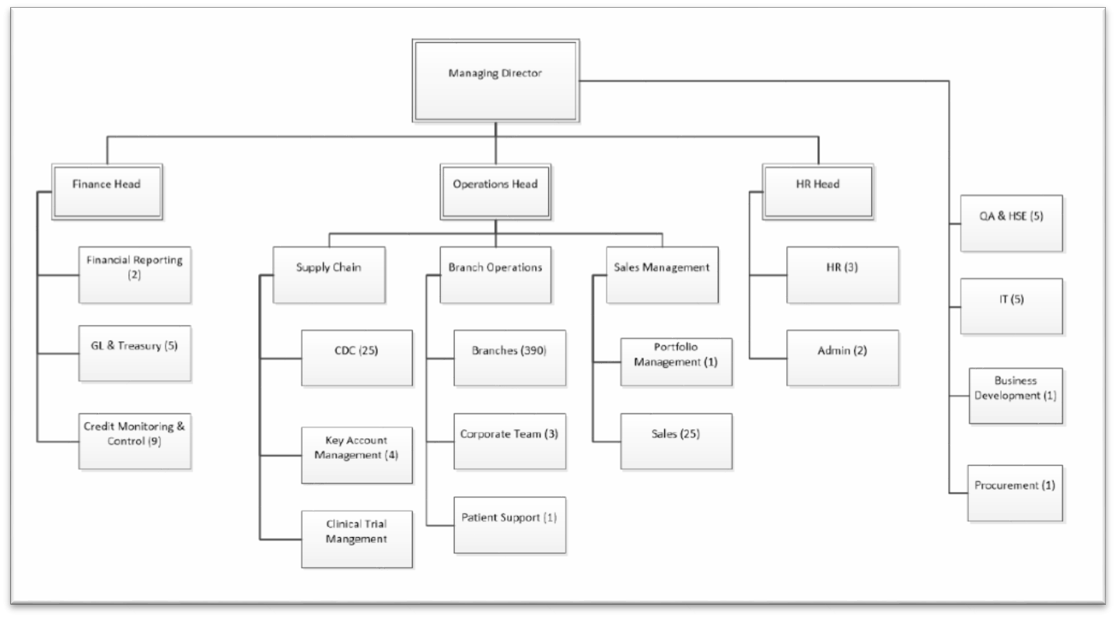

3.3.4 Branch Team Operation Structure:
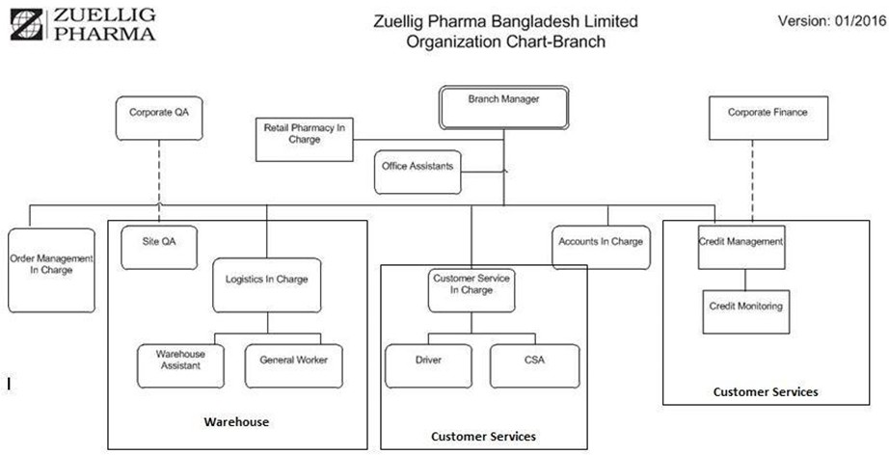

3.3.5 Core Values:
- Teamwork
- Desire for superiority
- Origination
- Individual development
- Truthfulness & belief

At Pharma Solutions Bangladesh Limited they comprehend that their customers' prosperity relies upon unwavering quality and opportune conveyance of products, cost productivity, adaptability, consistence or more all extraordinary client connections. They are likewise sharp about their customers, subsequently our enthusiasm for uniting partners with the goal that they all can serve their networks better and make human services reachable.

Our client driven promoting group remains constantly occupied on new and existing marking exercises. At present, we are the sole advertiser of Roche Diabetes Care's scope of items in Bangladesh. What's more, we are right now associated with the dispersion and offers of the "Omron Healthcare" in Bangladesh. In the years ahead, we are intending to speak to an ever increasing number of worldwide brands in Bangladesh.

3.4 Operational activities of the organization:

3.4.1 Services:
  - Distribution
  - Consultancy
  - IT Services
  - Sales and Marketing

- Distribution:

Figure: Distribution Process

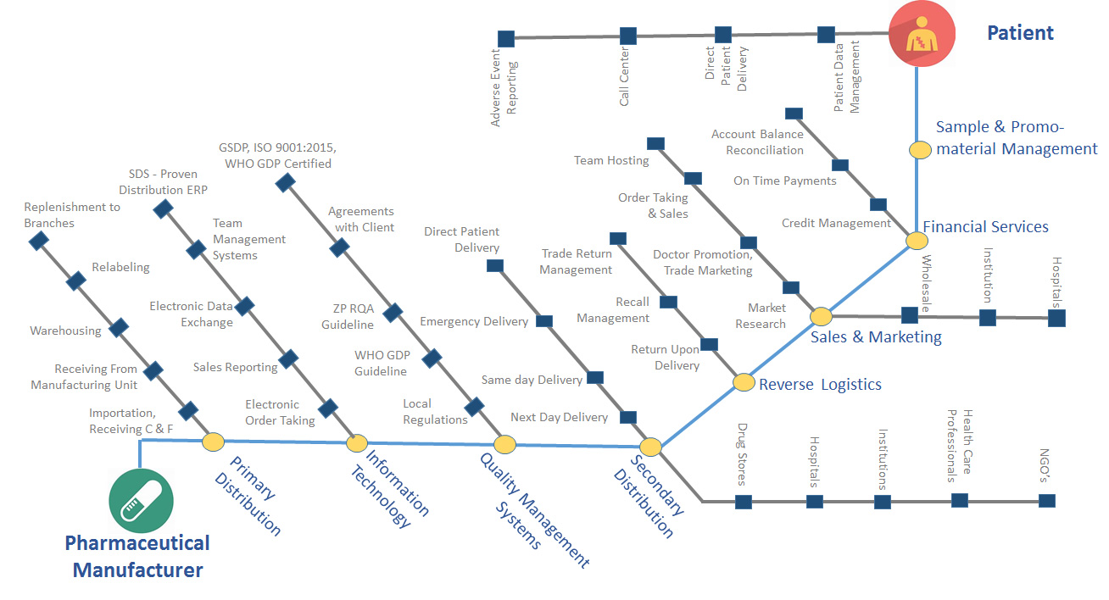
Source: https://www.pharmasolutions.com.bd/services/distribution/
PSBL branches are sensibly arranged in critical urban territories of Bangladesh. Association has 13 branches, 1 cross doc station in action and now have a game plan for 3 Crossdocs at Cox's Bazar, Tangail and Bhairab. PSBL course contains all the 7 divisions in Bangladesh. Association serves in excess of 50,000 customers which incorporate Pharmacies, Doctors, Hospitals, establishments and Clinics. Association regulates 61 % of the hard and fast MNC outcast flow in Bangladesh with a scattering estimation of over 90M consistently. Pharma Solutions Bangladesh Limited works with Global Pharmaceuticals Manufacturers like GlaxoSmithKline, Novartis, Elanco, Novivo Health Care, Roche Diabetes Care, South West Technologies and Menarini
Quality for thing and Safety for individuals are basic to its working practices. Organization is fixated on the movement of its workers through preparing/learning sessions all the time by interior and outer assets as suitable. These are to guarantee affiliation consistence with overall supported techniques and ISO measures.
- Consultancy:
▪ Business development mapping
▪ Distribution development improvement
▪ Skill upgrading and quality progress
▪ Policy and system upgrading and usage according to GSDP rule
It can perceive and fathom client's needs and give wonderful proposition and procedure. Organization can make an understanding of suggestion into extensive briefs and essential undertaking work plans. At PSBL, it can perceive and structure adventure; research issues and make proposition.

Organization recognize new and inventive designs to upgrade customers' advancing business improvement activities and hold common pharmaceutical authority social affairs and understanding. Organization fair-mindedly assesses and gauges how extraordinary brand plans are and how best to improve brands.

PSBL directing organizations pride itself on being incredible crowd individuals and understanding of customer's needs. PSBL base on customers concerns and give game plans. It offers strong, modified and fitness counsel.

- IT Services:
Pharma Solutions Bangladesh is utilizing industry standard IT frameworks for its business activities. The point of Pharma Solutions IT engineering is to create and keep up a coordinated business data model of center frameworks to speak to the business, explicitly intended for pharmaceutical dispersion for Principals. The present engineering has empowered us to bring new administrations on the web, improve the client experience, investigate new thoughts and react to mechanical and administration arranged change.
Giving the most elevated need to the tasks, Pharma Solutions has an IT framework that pursues ISO 27001. Giving the highest need to data resource, all our IT procedures, Policy and SOP's depend on 27001 principles. Company uses ITIL based methodology for IT administration Management.
- Sales and Marketing:
Since initiation Pharma Solutions Bangladesh Limited (PSBL) has been filling in as an effective pharmaceutical wholesaler and specialist organization in Bangladesh. In 2016, PSBL enhanced its activity and Sales and a promoting Division was built up with a goal to give center showcasing and deals bolster administrations to Healthcare organizations around the world for seeking after activity in Bangladeshi market. It’s our center information about Bangladesh Pharma showcase, our business group is prepared to take request from potential retail pharmaceutical stores and can guarantee supply of any item in the human services channel. Pharma Solutions Bangladesh Limited is focused on conveyance of value items in the human services industry. Our authority group have the ability and knowledge to give its clients fantastic social insurance arrangements. With our best in class dissemination foundation, worldwide standard SOP, neighborhood information, IT framework and global system, PSBL is resolved to give a better help customized than singular client's need. We will advance and convey your item quick, and agree to administrative necessities. At Pharma Solutions Bangladesh Limited, our untainted notoriety implies that you can endow your medicinal services and pharmaceutical needs to us.

3.4.2 Value added facilities:

i. Clinical preliminary coordination

ii. Trade return the board

iii. Sample and limited time material administration

iv. Relabeling administrations

v. Importation

vi. Product Registration

Sales group facilitating administrations

3.4.3 Patient Centred Services:

- Retails Pharmacy- Sales to Patient
- Patient Order Supervision
- Pharmacovigilance
- Call Center

3.4.4 Brands:

3.4.5 Company’s Global Representation:
- GSK
- Novartis Pharma
- Sandoz
- Elanco
- Roche Diabetes Care
- Novivo
- South West Technologies Ltd.
- Marie Stopes
- Menarini
- Omron Healthcare
- Sebamed

3.5 Organization Supply Chain Process:
The pharmaceutical generation organize is by one way or another interesting in connection to other stock chains of physical stock in see of its criticalness, importance, stockpiling, transportation, rule and so forward. The going with figures offer assistance understanding the SCM in pharmaceutical zone.
Figure: Pharmaceutical Supply Chain
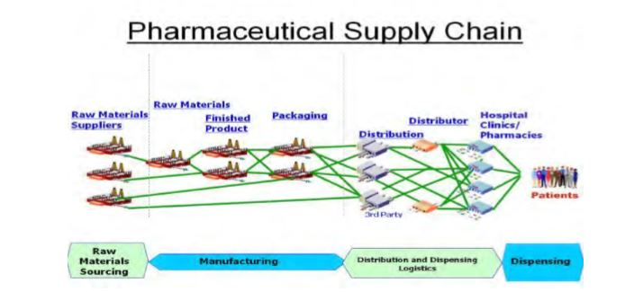
Source: www.slideshare.net/pharma-chain

Figure: Typical Supply Chain Management - Main Components

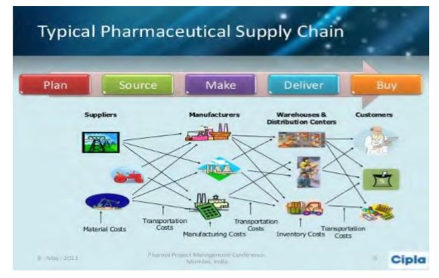
Source: www.slideshare.net/pharma-chain

Figure: Supply Chain Management: Raw Materials to Consumers
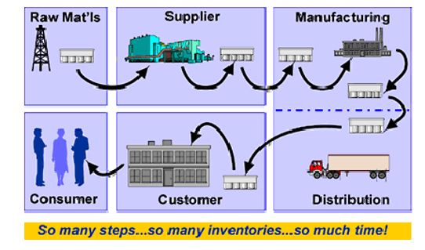
Source: www.slideshare.net/pharma-chain

3.6 SWOT Analysis:
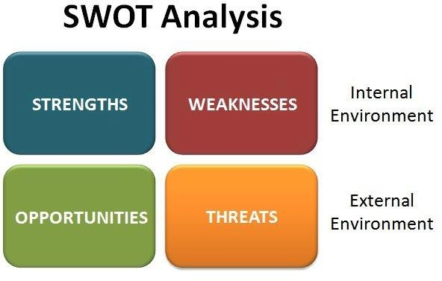

3.6.1 Strengths:

- Sufficient number of significantly experienced and gifted specialists
- Strong corporate organization
- Able to create benchmark
- Reputed Company, and seen brands

3.6.2 Weakness:

- Inefficient obligation resource the executives
- Minimal benefit
- Less sorted out
- Time expending basic leadership

3.6.3 Opportunities:

- Government support
- Exporting abroad, entering worldwide market
- Large piece of the overall industry
- Possible new item units

3.6.4 Threats:

- Number of competitors
- Acquisition and merger
- Insufficient regulation of supply
- Instable conversion scale

CHAPTER 4: FINDINGS AND ANALYSIS OF THE STUDY

4.1 Analysis and findings:

The analysis of financial performance of any organization be imaginative in case the strategies utilized within the estimation strategy is reasonable. I have chipped absent at the going with issues taking later two a long time monetary information from the back division 2017-2018 of PSBL. I have utilized this financial information on MS Excel and MS Word and have dissected the financial performance of PSBL through horizontal analysis and vertical analysis and ratio utilizing charts for each extent which is recollected for each proportions which is recollected for the revelations part.

4.2 Horizontal analysis of PSBL:

Horizontal analysis is utilized in budgetary articulation investigation to relate past information, such as ratio, or line things, over a number of accounting periods. Horizontal analysis can either utilize total comparisons or rate evaluations, where the numbers in each taking after period are communicated as a percentage within the standard year, with the standard sum being listed as 100%. This can be moreover known as base-year analysis.

Horizontal analysis is determined utilizing the accompanying equation:
= (Current year-Base year) / Base year * 100%

Table 4.2.1 Horizontal Analysis of Financial Position of PSBL
Horizontal Analysis of Pharma Solutions Bangladesh Limited
Particulars | 2018 |  | 2017
Assets
Non-current Asset:
Property, plant and assets | 30,307,755 | 2% | 29,817,654
Deferred tax assets | 56,901,809 | 0% | 56,901,809
 | 87,209,565 | 1% | 86,719,463
Current Assets:
Accounts receivables | 185.072,306 | -3% | 191, 608,045
Advance, deposits and prepayments | 13,384,112 | -18% | 16,289,650
Advance income tax | 97,984,275 | 81% | 54,106,296
Receivables from principal | 28,246,120 | 32% | 21,464,917
Others Receivables | 6,030,354 | 147% | 2,445,281
Cash and equivalents | 287,914,854 | 526% | 45,998,129
 | 618,632,120 | 86% | 331,912,318
Total Assets: | 705,841,685 | 69% | 418,631,781
Equity And Liabilities
Equity
Share Capital | 150,000,000 | 50% | 100,000,000
Share money deposit | 30 | -100% | 28,928,330
Retained earning | (129,450,746) | -35% | (200,165,446)
 | 20,549,284 | -129% | (71,237,116)
Current liabilities
Bank overdraft | 53,703,698 | 0%
Payable to principal | 472,822,315 | 19% | 396,674,164
Other liabilities | 91,713,349 | 29% | 70,954,870
Current tax liabilities | 67,053,039 | 201% | 22,239,863
 | 685,292,401 | 40% | 489,868,897
Total Equity and Liabilities | 705,841,685 | 69% | 418,631,781

Table 4.2.2 Horizontal Analysis of Comprehensive Income of PSBL
Horizontal Analysis of Pharma Solutions Bangladesh Limited
Particulars | 2018 |  | 2017
Commission Income | 433,646,667 | 17% | 372,149,761
Operating expenses | (328,368,034) | 0% | (327,263,336)
Operating profit/(loss) | 105,260,633 | 135% | 44,886,425
Interest income | 14,674,707 | 1199% | 1,129,722
Financial cost | (213,783) | -96% | (5,979,545)
Other income/(expenses) | 1,886,733 | -428% | (575,792)
Profit/(loss) before Charging WPPF | 121,608,291 | 208% | 39,460,810
Workers’ profit participation fund | (6,080,415) | 208% | (1,973,040)
Profit/(loss) before income tax | 115,527,876 | 208% | 37,487,770
Income tax expenses | (44,813,176) | 99% | (22s529,429)
Profit/(loss) after income tax | 70,714,700 | 373% | 14,958,341

4.3 Vertical Analysis of Dutch Bangla Bank Limited
Vertical analysis is a technique of financial statement analysis in that each line item is recorded as a percentage of a base amount within the statement. Thus, line items on an income statement can be stated as a percentage of gross sales, while line items on a balance sheet can be stated.
Vertical analysis is premeditated using the following formula:
(Items of the financial statements / Total assets) * 100%
Table 4.3.1: Vertical Analysis of Financial Position PSBL
Vertical Analysis of Pharma Solutions Bangladesh Limited
Particulars | 2018 |  | 2017
Assets
Non-current Asset:
Property, plant and assets | 30,307,755 | 4% | 29,817,654 | 7%
Deferred tax assets | 56,901,809 | 8% | 56,901,809 | 14%
 | 87,209,565 | 12% | 86,719,463 | 21%
Current Assets:
Accounts receivables | 185,072,306 | 26% | 191, 608,045 | 46%
Advance, deposits and prepayments | 13,384,112 | 2% | 16,289,650 | 4%
Advance income tax | 97,984,275 | 14% | 54,106,296 | 13%
Receivables from principal | 28,246,120 | 4% | 21,464,917 | 5%
Others Receivables | 6,030,354 | 1% | 2,445,281 | 1%
Cash and equivalents | 287,914,854 | 41% | 45,998,129 | 11%
 | 618,632,120 | 88% | 331,912,318 | 79%
Total Assets: | 705,841,685 | 100% | 418,631,781 | 100%
Equity And Liabilities
Equity
Share Capital | 150,000,000 | 21% | 100,000,000 | 24%
Share money deposit | 30 | 0% | 28,928,330 | 7%
Retained earning | (129,450,746) | -18% | (200,165,446) | -48%
 | 20,549,284 | 3% | (71,237,116) | -17%
Current liabilities
Bank overdraft | 53,703,698 | 8% |  | 0%
Payable to principal | 472,822,315 | 67% | 396,674,164 | 95%
Other liabilities | 91,713,349 | 13% | 70,954,870 | 17%
Current tax liabilities | 67,053,039 | 9% | 22,239,863 | 5%
 | 685,292,401 | 97% | 489,868,897 | 117%
Total Equity and Liabilities | 705,841,685 | 100% | 418,631,781 | 100%

Table 4.3.2 Vertical Analysis of Comprehensive Income of PSBL
Horizontal Analysis of Pharma Solutions Bangladesh Limited
Particulars | 2018 |  | 2017
Commission Income | 433,646,667 | 100% | 372,149,761 | 100%
Operating expenses | (328,368,034) | -76% | (327,263,336) | -88%
Operating profit/(loss) | 105,260,633 | 24% | 44,886,425 | 12%
Interest income | 14,674,707 | 3% | 1,129,722 | 0%
Financial cost | (213,783) | 0% | (5,979,545) | -2%
Other income/(expenses) | 1,886,733 | 0% | (575,792) | 0%
Profit/(loss) before Charging WPPF | 121,608,291 | 28% | 39,460,810 | 11%
Workers’ profit participation fund | (6,080,415) | -1% | (1,973,040) | -1%
Profit/(loss) before income tax | 115,527,876 | 27% | 37,487,770 | 10%
Income tax expenses | (44,813,176) | -10% | (22,529,429) | -6%
Profit/(loss) after income tax | 70,714,700 | 16% | 14,958,341 | 4%

4.4 Ratio Analysis of Pharma Solutions Bangladesh Limited

- Liquidity Ratio
- Current Ratio:
The current ratio is a liquidity ratio that measures a company's ability to pay short-term obligations or those due within one year. It tells investors and analysts how a company can maximize the current assets on its balance sheet to satisfy its current debt and other payables.
The current ratio may be a liquidity ratio that measures a company's capacity to pay short-term commitments or those due inside one year. It tells financial specialists and investigators how a company can maximize the current resources on its balance sheet to fulfil its current obligation and other payables.
The current ratio formula is:
Current Ratio: Current Assets/ Current Liabilities

Table 4.4.1: Current Ratio
Year | Current Ratio
2018 | 0.90
2017 | 0.68

- Leverage Ratio:

- Debt Ratio:
Debt ratio could be a dissolvability proportion that determinate a firm’s add up to liabilities as a rate of its assets. In a sense, the debt ratio appears a company’s capability to pay off its liabilities with its assets. In other words, this showings how assets the company must offer in arrange to pay off all of its liabilities

The formula for the debt ratio is: Total debt / Total assets
Table 4.4.2: Debt Ratio

Year | Debt Ratio
2018 | 0.97
2017 | 1.17

- Debt to Equity Ratio:
The debt to equity ratio may financial, liquidity ratio which partners a company’s total debt to total equity value. The debt to equity ratio outlines the rate of company financing that comes from speculators. A better debt to equity ratio demonstrates that more leaser financing is utilized than financial investor financing.

The debt to equity ratio formula is: Total debt / Total equity.
Table 4.4.3: Debt to Equity Ratio
Year | Debt to Equity Ratio
2018 | 33.35
2017 | -6.88

- The Equity Multiplier:
The equity multiplier could be a leverage ratio which forms the sum of a firm's assets that are financed by its shareholders by relating total asset with shareholder's equity value. In other words, the equity multiplier shows the rate of assets that are financed or owed by the shareholders.
The Equity Multiplier formula is: Total Assets / Total Equity
Table 4.4.4: The Equity Multiplier

Year | The Equity Multiplier
2018 | 34.35
2017 | -5.88

- Management efficiency Ratio:
- Total Asset Turnover:
The asset turnover ratio forms the esteem of a company's deals or incomes relative to the esteem of its assets. The asset turnover ratio can be reused as a pointer of the competence with which a company is by implies of its assets to produce income. The higher the assets turnover ratio, the more productive a company. Similarly, in case a company encompasses a low turnover ratio, it shows it isn't professionally utilizing its resources to make sales.
The formula of the total turnover index: Net sales (Revenue) / total assets
Table 4.4.5: Total Asset Turnover Ratio
Year | Total Asset Turnover Ratio
2018 | 0.61
2017 | 0.89

- Profitability Ratio:
- Return on Asset:
Return on assets (ROA) is a pointer of how productive a company is comparative to its total assets. ROA flexibilities a supervisor, speculator, or examiner a thought as to how productive a company's administration is at utilizing its resources to create profit. Return onassets is shown as a rate.

The formula for the return of assets is: net income / total assets.
Table 4.4.6: ROA Ratio

Year | ROA Ratio
2018 | 10%
2017 | 4%

- Return on Equity:
Return on equity (ROE) may be a degree of financial performance considered by separating net profit by shareholders' equity. Since shareholders' equity is comparable to a company’s assets short its obligation, ROE may well be thought of as the return on net assets. ROE is measured of how successfully administration is employing a company’s resources to make profit.
The formula of return on equity is: Net income/shareholders equity.

Table 4.4.7: ROE Ratio
Year | ROE Ratio
2018 | 3.44
2017 | -0.21

- Net Profit Margin:

The net profit margin is break even with to the sum of intrigued incited as pay or rate of profit. Net profit margin is the overall pay of a commercial or section. Net profit margin are by and large enunciated as rates, but the number frame can be meant. The net profit margin is the measurement of each dollar gotten by a profitable, and its measurement. Net profit margin is additionally known as net income or net income of a company.

The formula of the net profit margin: Net income/ Revenue

Table 4.4.8: Net Profit Margin
Year | Net Profit Margin
2018 | 16%
2017 | 4%

4.5 Key Findings:

After assessing the financial performance of PSBL, numerous pros and cons have been originating and the outcomes are input below:
a. The current ratio of PSBL has gradually extended more than two years and was its most extreme in the year 2018 that implies the organization has sufficient current assets to regulator its liabilities.
b. The debt ratio of PSBL has gradually extended more than two years and was its most extreme in the year 2018.
c. The debt to equity ratio mirrors the capacity of investor’s worth to cover every single extraordinary obligation in case of a financial emergency. It is found that the debt to equity ratio of PSBL was supreme in 2018.
d. The equity multiplier has maximum in 2018 and 2017 it has showed negative figure because of negative equity balance.
e. Total asset turnover ratio has maximum in 2017.
h. The ROA of PSBL shows that the company is competently by means of it resources or assets to make profits as the ROA was supreme in 2018.
i. The ROE of PSBL is positive and increasing last year that means the company is efficiently providing equity to its owners as well as its depositors. It was maximum in 2018.
j. The net profit margin shapes the portion of how much each dollar of revenue produced by PSBL understands into actual profits. It has maximum in 2018.

CHAPTER 5: EXPERIENCES DURING INTERNSHIP TENURE

5.1 Internship Experience:
I worked in the Operation department as an intern for 06 months in PSBL. During Internship position at PSBL, I was not just got the work knowledge which I expected yet additionally the chance to investigate PSBL's business just as its way of life and qualities, which helped me to additionally see how a set up organization functions. During this time of internship, I have encountered various parts of the activities work, I need to send every day report to our all principals (Stock report, Sales report, SOH report, Customer insightful Sales report, Invoice report). Consistently, I had various things to learn and deal with. My Supervisor and coaches checked on my work during the temporary position. My supervisor gave proposals and criticism on my work consistently, helping me to take every necessary step better. I additionally spoke with my supervisor to tune in to their proposals and remarks on my work. In this procedure of learning, I also communicated with my fellow interns to listen to their suggestions and comments on my work. In this process of learning. In short, my internship knowledge at PSBL was charming, exciting and valuable.

5.2 Job Responsibilities:

As an Intern of Operation Department, I have to perform different activities to ensure a smooth operation of this department. Duties are:
- Daily reporting to our principals: I used to send daily sales, SOH, customer wise sales report, Invoice report, LB report to our principals at everyday morning.
- Order Processing: I used to do in order processing through our company’s software.
- Invoice Entry: I used to make invoice entries daily according to customer.
- Warehousing: I used to make branch transfer, transfer release, picking slip, packing note according to daily sales update.
- Inventory maintenance: I used to preserve the inventory of all branches of our company
- Communication: I had to interconnect with all branches logistics officers and customer service officer.

5.3 Personal Observation:
During the internship tenure in PSBL, I have detected certain aspects which I have alienated it into two (02) parts, which is outlined below and explained afterwards:
Positive Aspects:
- Like all other effective organizations, the workplace of PSBL is extremely amicable and helpful.
- The Operation branch of PSBL is loaded with individuals with massive involvement with their assigned post and dedication towards their organization.
- Even however the pay structure of PSBL is standard, individuals still needs to remain in this association in light of professional stability and its additional offices, for example, free lunch and refreshment, extra time pay and so on
Negative Aspects
- The company is not that much strong compare to the local firms.
- The company do not provide proper training program.

CHAPTER 6: CONCLUSION AND RECOMMENDATIONS

6.1 Conclusion:
Financial ratios analysis is a part of financial statement analysis and through this we can know about the organizations over a significant time performance. In particular it gives us a thought that what can be the organization's exhibition later on. Ratio analysis comprises the calculation of statistical connection between data and it is a very popular method of financial statement analysis. Throughout my analysis, I came to think about the money related quality, operational adequacy and the executive’s viability of PSBL. I have realized that PSBL is performing great, it is monetarily solvents yet there certain dangers which are expanding as of late. On the off chance that the dangers or dangers can be handled appropriately, at that point certainly as like the previous years.

6.2 Recommendations:

- Proper Training and education to Medical Promotion workplace:
Training and academic standards ought to be maintained for MPW specified they will act additional as cooperative problem-solvers instead of as sales professionals. It’s thus necessary that physicians, firms, and policymakers acknowledge this reality and take applicable steps thus on create this relationship as economical and effective as potential.
- Research & Development Setup:
PSBL will invest in R&D setup in Bangladesh as clinical trials. The action in pharmaceutical sector is extremely high as an honest variety of investments have taken place during this sector, however only a few firms have invested with on R&D.
- Customer once, client forever:
Client is a lot of profitable than customer in terms of each group action in addition as positive spoken communication. He himself may be associate opinion leader. So, I’m suggesting to adopt some programs that may let its customers be reworked into client.
a. Mobile Hospital service with free treatment and medication.
b. Health awareness program in geographic area.
c. Modernization of workplace.
- What I actually have nowadays, different can have tomorrow:
PSBL is usually endeavour to keep up the very best product portfolio among the competitors for its development strategy. Holding the heaviest product folio shouldn't be the last word goal the least bit. Stress should incline on however early a replacement product are often launched within the market place than the challenger.
- Segment the present market section:
PSBL is in would like of additional segmentation tools in associate degree current effort to ascertain shut and long term relationships with client.
- Improved Customer Services:
Improvement of customer services is very important for any organization. To compete with the competitor’s service should be improved as online service, 24/7 hours customer response. They should go for business to customer strategy as their one of major strategy.

CHAPTER 7: APPENDIX

7.1 References:

The following web site was accessed on October 24, 2019:
www.slideshare.net/pharma-chain
The following web site was accessed on October 25, 2019:
https://www.investopedia.com
The following web site was accessed on October 25, 2019:
https://www.wikipedia.org/
The following web site was accessed on November 03, 2019:
https://strategiccfo.com
The following web site was accessed on November 18, 2019:
https://www.myaccountingcourse.com
The following web site was accessed on November 19, 2019:
https://www.researchgate.net

