
Internship Report
On
Evaluation of Service Marketing Mix & Service Marketing Triangle Of IFIC Bank Limited

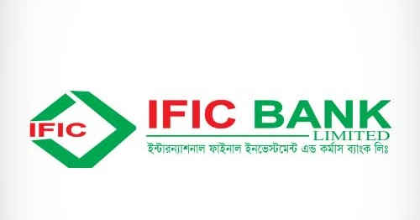


United International University
Course Code: INT4399
Internship Report
On
Evaluation of Service Marketing Mix & Service Marketing Triangle Of IFIC Bank Limited

Submission Date: 22nd September, 2019
Submitted By: Submitted By:
Susmita Dewanjee Tama Muhammad Hasan Al-Mamun
ID: 111-151-493 Assistant Professor
Bachelor of Business Administration School of Business & Economics
School of Business & Economics United International University
United International University

22nd September, 2019

Muhammad Hasan Al-Mamun
Assistant Professor,
School of Business and Economics,
United International University

Subject: Submission of report on “Evaluation of Service Marketing Mix & Service Marketing Triangle of IFIC Bank Limited”.

Dear Sir,
I am very pleased to submit the report of my Internship which I have done at “IFIC Bank Limited”. During this internship period that starts from May 26 to August 25, 2019 I have completed my report on ‘Service Marketing Mix’ and ‘Service Marketing Triangle’. By preparing this report I am competent to enhance my learning, activities and experience in that corporate organization.
I hope you will be kind enough to receive and grant the acceptance of this report. If you have any further inquiry to know any additional information I would be very pleased to clarify it.

Thanking you.
Yours obediently
Susmita Dewanjee Tama
ID: 111 151 493
BBA Program
United International University

Executive Summary

This internship report is based on Service Marketing Mix and Service Marketing Triangle of IFIC Bank Limited. As I am appointed there for three months in the Principal Branch, here I have obtained knowledge how the IFIC Bank provides services to their customers by the use of all elements of service marketing mix. This service marketing mix is basically mixed of 4‘ps’ of traditional marketing mix and extended 3’ps’. The extended three factors are people, process and physical evidence. People are customer, employee and other stakeholders of IFIC Bank. Process are considered as policy, systematic series of provide service, rules & regulations, framework, strategy of doing work. Finally physical evidence are all tangible elements we can see in the organization. This report also done on method of service marketing triangle and the three elements; external marketing, internal marketing and interactive marketing. Through service marketing triangle IFIC Bank interact with their customer, employee and other stakeholder efficiently. The right side arrow in this triangle indicate the relation between organization and customer that is called external marketing in which bank communicate with customer and provide service. The left side arrow is the internal marketing that means promotion of the company’s product/service and objective to the employee. Internal marketing conduct within the organization. The arrow (horizontal) below the triangle shows the marketing practice by the employee on individual customer. This report manifest a detailed information about the organization (bank), methodology that was chosen for this study for data collection process and types of data collected, brief overview of IFIC Bank Limited profile and Banking Industry perspective. I observed their activities in the general banking sector, credit department, retail division and collect some information about foreign exchange from the corporate division of credit department. Study is not complete without realistic details of the organization and real experience in a corporate field. Although I faced some limitation on doing this report, in sum I can say confidently that is I have a great experience of a corporate life and learned many things from the team of IFIC Bank Limited.
Key Words: Service Marketing Mix, Service Marketing Triangle

Contents
Introduction 1
Service Marketing and Service 1
Service Marketing Mix 1
• Product 2
• Price 2
• Promotion 2
• Place 2
• Process 2
• Physical Evidence 2
Service marketing Triangle 2
Internal Marketing: 3
External Marketing: 3
Interactive Marketing: 3
Context of the Study 4
Overview of IFIC Bank Limited 5
Mission, Vision and Objective of IFIC Bank Limited 5
Core Value 5
Integrity 5
Responsibility 5
Commitment 5
Stability and Innovation 5
Transparency 5
Board of Director 6
Organizational Background 7
Organizational Network Hierarchy 8
Hierarchy of the Management of IFIC Bank Limited 9
Risk Management 10
Industry Perspective 12
Objectives of the Study: 14
Methodology of the Study: 14
Findings of the Study 15
Service Marketing Mix 15
1. Product/Service 15
General Banking Product and Service of IFIC BANK: 15
Service of IFIC Bank Limited: 16
Account Opening Process 17
Booth Banking 17
Digital Banking 17
Banking Trade Portal 17
24/7 Customer Care 18
Virtual Banking 18
Retail Banking: 18
SME (Small and Medium enterprise) Banking: 19
Internet Banking: 20
2. Price 20
3. Place 21
4. Promotion 21
5. People 21
6. Process 23
7. Physical Evidence 24
Service Marketing Triangle 25
Internal Marketing of IFIC Bank 25
Recruitment Process: 26
Training and Development: 27
Marketing Strategy: 28
External Marketing of IFIC Bank 29
Role of IFIC Bank: 29
Customer Relationship: 29
Direct Marketing: 29
Advertising: 30
Publications and Reports: 30
Events: 30
Interactive Marketing 31
Source of Communication and channels 31
General Banking Sector of Principal Branch: 31
Retail Banking in Principal Branch 32
Credit Department of Principal Branch: 34
Foreign Exchange Department: 36
Limitation of the Study: 38
Recommendations 39
Conclusion 40
Reference: 41

Introduction

Service Marketing and Service
Service marketing is a specialized category of marketing strategy which means selling and marketing of intangible product that is not physical goods. Service is also refer to wide range of intangible product offerings, it is a support of a company’s core product. Service marketing represent a separate field of study which include both the business to consumer (B2C) and business to business (B2B). Worldwide, the growth of service sector results in increase of attention to the challenges of service sector industries.

Service Marketing Mix
A ‘Marketing Mix’ is simply a model of the most important elements in the marketing of a brand. From the traditional point of view it is composed of the four ‘P’; product, place, promotion and price. Over the years, this model has been quite popular. It was first posited by Edmund Jerome McCarthy in1960 (Basic Marketing: A Managerial Approach) and originally had 12 parameters that were treated as ingredients by the marketer.
Service Marketing Mix defined as mix of some elements, an organization controls that can be used to satisfy or communicate with customers. Traditional four P’s and carefully manage of these four P’s are essential for successful marketing of service. In modern and expanded point of view service marketing mix is not only the mix of the four P’s, it is the mix of additional three P’s; these are people, physical evidence and process. As service is produce and consume simultaneously consumers feel need to physical presence of their so that they can interact directly with the firm’s personnel. Physical evidence of product sometimes used as a differentiator in service marketing. Consumer always search for a certainty or cues that represent they are going to be served at the best level or satisfied level. That is why service marketing mix is consist of 7 P’s and all of this P’s are necessary to ensure optimum service delivery. There are different type of organization that need to develop service marketing mix strategy, these are such as; Banking Industry, Medical service, Legal service, Health Care service, Online service , Website service, Counselling service, Educational Institution, business service, Automotive service, Human Resource service, Hotels and Restaurants and so on. Selling service is quite different than selling product. This require tangible, intangible features and benefits and judge these with emotional experience. Creating emotional relation with the customer is more important to reach the given goal and objective.
Service marketing mix is referred as extended marketing mix. Because it needs more extended marketing strategy and elements. It needs to specially focus on some extra ordinary offerings which create effective solution of people’s problem and make their life easier. Different service organization try to be different by the use of those strategies and elements. Product life cycle and product differentiation also included in the service marketing mix to make service more effective, helpful and attractive to the customer.

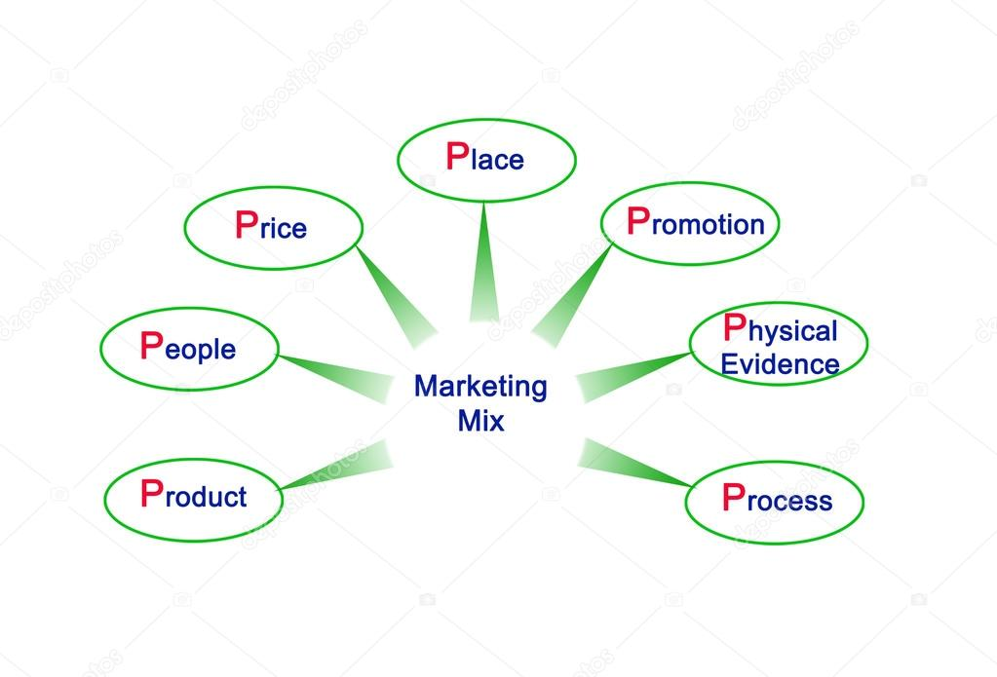
A brief summary of ‘7 p’
- Product: A product is the actual item that is the need and want of the customer which is the solution of their problem. Service is same as that of a product in fact it id consider as intangible product.
- Price: Price is the amount of money which customer pay for a particular product. Price is an important detail of a product. As service is intangible it is different to measure service on the basis of price. Just like goods organizations can decide three types of pricing category for service.

  - Penetration Pricing (low price kept to capture market share)
  - Skimming Pricing (high price initially then lowering of price) &
  - Competition Pricing (pricing at par of competition)

- Promotion: Promotion mix represent the marketing communication techniques, strategies and medium used to convey about the offerings to the customer.
- Place: Where to distribute the product it must be specified before. It can expand in latter depending on the customer demand and market coverage capacity of the business.
- Process: Systematic series of a service, both the customer and service provider must follow it to make a balance between standardization and customization.
- People: People are those who are involved in this service providing and service taking process.
- Physical Evidence: As it is known to all that service marketing is intangible but tangible element is most important to properly deliver the service. If we think about a restaurant which has ambient lighting, nice music along with good seating arrangement all these things are physical evidence which also helps to serves good food.
(https://smallbusiness.chron.com/service-marketing-mix-57548.html, n.d.)

Service marketing Triangle
This report also includes Service Marketing Triangle which is a dynamic method of interact with customer, employee and other stakeholders and creating relationship between them for the purpose of market the service to consumers and employees.
The service marketing triangle breaks down the marketing tasks of the business into three types.
Those are:
- Internal Marketing
- External marketing
- Interactive marketing
Internal Marketing:
Internal marketing refer to the connection between your organization and your employees who provide your services to customers. It needs to prove adequate training to the employee to deliver service with customer satisfaction.
External Marketing:
This is the traditional form of business marketing that goes from organization to the outside customer or potential customer showing customer how the service provided by the business benefit them.
Interactive Marketing:
Interactive marketing is the side of the triangle that shows the relation between employees and customers of the organization with the goal of having highly satisfied customers who become long-term, repeat customers.

Context of the Study

This study is based on the IFIC Bank Limited and their other service relative activities. The full form of IFIC is International Finance Investment and Commercial Bank Limited. IFIC Bank Limited is joint venture of finance company incorporated in the People’s Republic of Bangladesh with limited liability. As banking industry go far away and introduce more and more advanced banking service system to make everyday life easy, all bank trying to make themselves sophisticated about banking service. IFIC Bank is one of the leading bank in Bangladesh which provide different types of banking opportunity to peoples. IFIC Bank limited is the private commercial bank in Bangladesh. The majority of the shares of this bank are owned by Bangladesh Government.
From recent study of Bangladesh Institution of Bank Management 2019 People’s Republic of Bangladesh now holds 32.75% of the share capital of the Bank. Directors and Sponsors having vast experience in the field of trade and commerce own 8.62% of the share capital and the rest is held by the general public.
Service of IFIC Bank is quite expanded and efficiently managed by their experienced employees. As I am working here as a customer service provider in the Principal Branch I am specially focus on their service category they provide. IFIC Bank limited handled the typical banking requirements as usual all banks are doing so, such as; credit, loan provide, account opening, clearing section, cash section, remittance, all type of transaction people can do in this bank. After opening of bank account they honor cheque, takes deposits, issues bank draft and pay order etc. This bank provide also some unique and digital service which brings huge benefits for the customer such as corporate banking, retail banking, SME banking, Internet banking, provide credit card and debit card, special savings scheme Amar Account etc.
Now a days IFIC Bank providing a wide range of financial service, special offerings or products to the corporate client to make long term beneficial relationship and meet all the customer requirements. They have established 74 branches till 2009 January, 1 in different places over the Bangladesh and the head office is located in 61, Purana Paltan Dhaka. Their principal branch is also located in the second floor of that building named IFIC TOWER. Branches helps any organization to expand their activities and make a flow of that activities with efficient management. As their branches are located in different area customers can easily go to their nearby branch to complete their necessary banking requirements. As well under the branch banking system IFIC Bank with the member of branches possesses huge financial resources and enjoys the benefits of large scale operations. The board of director consists of total 13 member. Name of the chairman is now Mr. Salman F Rahman and the vice chairman is Mr. Ahmed Shayan Fazlur Rahman. Executive committee consist of three member. Different types of divisions or department are managed by the appointed highly trained and experienced staff with efficient management. IFIC Bank limited is able to provide large financial resources and wider economical coverage with confidence.
IFIC Bank Limited try to provide fast and errorless service even it is their main objective to provide service to their customer with the help of skilled and dedicated workforce having creative talent. Beside they keep continue to improve economic prosperity of the people and the community.
(https://bibm.org.bd/single_member.php?bank_id=6, n.d.)
(https://www.ificbank.com.bd/, n.d.), (https://www.ificbank.com.bd/investor_relations.php, n.d.)

Overview of IFIC Bank Limited

Mission, Vision and Objective of IFIC Bank Limited

Mission of the IFIC Bank Limited
“Our Mission is to provide service to our clients with the help of a skilled and dedicated workforce whose creative talents, innovative actions and competitive edge make our position unique in giving quality service to all institutions and individuals that we care for.
We are committed to the welfare and economic prosperity of the people and the community, for we derive from them our inspiration and drive for onward progress to prosperity”.

Vision of IFIC Bank
“At IFIC, we want to be the preferred financial service provider through innovative, sustainable and inclusive growth and deliver the best in class value to all stakeholders”.
(https://www.ificbank.com.bd/disclosure.php, n.d.)

Core Value
Integrity: Everything they do in the IFIC Bank with honesty, morally and ethically and without compromising quality.
Responsibility: They promise to provide continuous social service driven by the respect for individual customer. Infect very soon they are coming with 24 hour customer service.
Commitment: they are committed to their customer and other stakeholders to provide excellence customer service and maximization of stakeholder’s value through teamwork.
Stability and Innovation: They always try to stable in a success position from financially as well as customer loyalty. Try to come with new facility for the customers benefit and satisfaction.
Transparency: IFIC Bank do everything with full evidence and they keep all the record safely over 16 years so that customer can get any information about their banking activities transparently.

Board of Director

Chairman
Salman F Rahman

IndependentDirector
Anwaruzzaman Chowdhury

Independent Director
Rabeya Jamali

Govt. Nominated Director
Jalal Ahmed

Govt. Nominated Director
A. R. M. Nazmus Sakib

Govt. Nominated Director
Quamrun Naher Ahmed

Managing Director& CEO
M Shah Alam Sarwar

Company Secretary
Md. Mokammel Hoque

Executive Committee of the Board:

Chairman
A. R. M. Nazmus Sakib

Member
Quamrun Naher Ahmed

Secretary to the Committee
Md. Mokammel Hoque
Audit Committee of the Board:

Chairman
Rabeya Jamali
Members
Anwaruzzaman Chowdhury

Jalal Ahmed
Secretary to the Committee
Md. Mokammel Hoque

Risk Management Committee of the Board:
Chairman
Jalal Ahmed
Members
Rabeya Jamali
R. M. Nazmus Sakib
Quamrun Naher Ahmed
Secretary to the Committee
Md. Mokammel Hoque

Annual Report of
IFIC Bank Limited, 2017

Organizational Background

International Finance Investment & Corporation (IFIC) Bank Limited established at the instance of the government in 1976. It was set up as joint venture between the Bangladesh Government and sponsors in the private sector. Government 49% share and rest of the 51% share held by the sponsors. They started the journey with the objective of working as a finance company within the country and setting up joint venture bank or financial institution abroad. though it was incorporated initially as a public limited company with an authorized of 20 core capital as well as 10 core taka paid up capital but in 1997, February 28 IFIC Bank Limited initiated operation with the comply of 5 core taka capital which is contributed by the private sector entrepreneur of Bangladesh. IFIC Bank Limited experienced both the public and private banking policy. Finally in 1983 when Government allowed bank to make and operate them with private ownership IFIC Bank was converted into full-fledged commercial bank
Their first branch was situated at Motijheel and through the Motijheel Branch IFIC Bank started their banking activities on 24 June, 1983. In 1985 IFIC Bank built up an Exchange Company through joint venture with Sultanate of Oman. This exchanged company was named by Oman Bangladesh Exchanged Company but in letter it is renamed by Oman International Exchange, LLC. Their first overseas branch was established in 1987 at Pakistan Karachi and second one at ‘Lahor’ in 1993. Their next banking operation and exchange relation built up with ‘Nepal’ and ‘Maldives’. These new joint ventures were named ‘Nepal Bangladesh Bank Limited’ and another one is ‘Bank of Maldives Limited’. They started a new joint venture ownership in Nepal again for the purpose of lease financing titled Nepal Bangladesh Finance & Leasing Company Bangladesh.
IFIC Bank Limited started a new journey (in 2005) of modern banking system through the introduction of MISYS solution for the purpose of real time online banking application. After this system they became able to implement core risk management of IFIC Bank. Till that time they was not concerned about effective branding of their bank. In 2006 they took a step to introduce corporate branding. By this they started to obtain many membership as well as concerned with the satisfaction of customer. Different branches in different city and area offering real time online banking facility. According to the details of shareholding as of 30 June, 2019:

Shareholder’s Group | Number of Shares Held | %of Total Shares
Sponsors, Directors &  Government Group | 549,998,126 | 41.08
Institutions Group | 304,748,924 | 22.77
General Shareholders Group | 483,991,685 | 36.15

Organizational Network Hierarchy
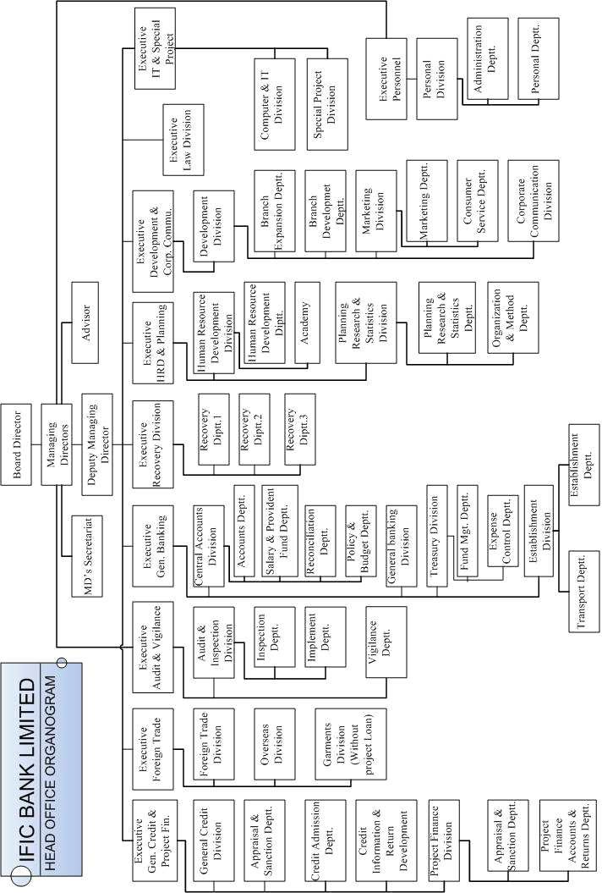

Hierarchy of the Management of IFIC Bank Limited

Risk Management
Risk management is forecasting and evaluation of financial risk. A bank must engage in identifying of uncertain risks arise from different issues in each and every moment of action. In the view of the global recognition towards need of an effective risk management and control systems in financial sector, IFIC Bank Limited versed of the consideration of the issue that it prepare and implement some policies and guidelines on risk management. These are:
- Credit Risk Management
- Foreign Exchange Risk Management
- Asset Liability Management
- Market Risk
- Liquidity Risk
- Internal Control and Compliance
- Operational Risk
- Prevention of Money Laundering
- Reputation Breakdown Risk
IFIC Bank Limited provide service to customer effectively and efficiently even they are now enough able to compete in the banking industry in Bangladesh through the achievement of human trust. They provide service with strong security. They reserve customer fund and their other personal information maintaining strong privacy. From the past to present they accelerating socio-economic development of Bangladesh. Its asset quality, capital adequacy, sound management, profitability and finally adoption of new and modern technology both for machinery and regular banking practicing system attract customer and bring high customer satisfaction. I can nicely tell about the Principal and Head office of IFIC Bank because I am working with them closely and experiencing their experience as well as the environment of the bank.
IFIC Bnak Ltd. achieve many award and take a place reputation in the society. A recent big award ceremony was held in the IFIC Tower Purana Paltan where IFIC Bank got IFIC Bank Literary Award 2015. Poet Asim Saha and writer Wasi Ahmed have been given the Award to the hand of Salman F Ranhman the chairman of IFIC Bank. The Finance minister Abul Maal Abdul Muhith was the chief guest of the ceremony and other reputed figures were present there as special guest. Chairman Salman F Rahman delivered the welcome address.
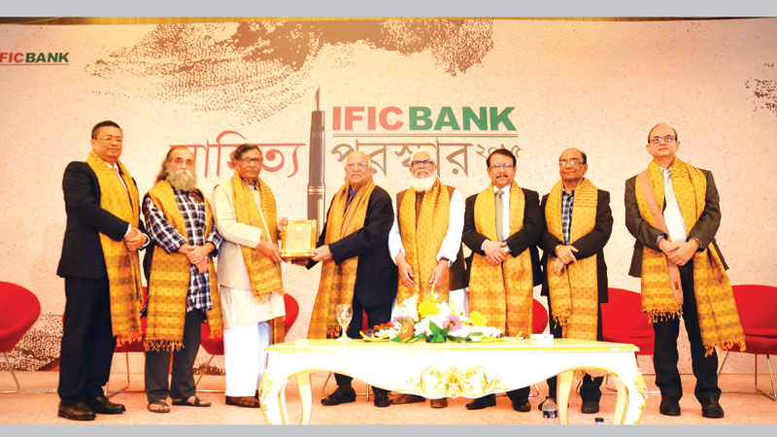
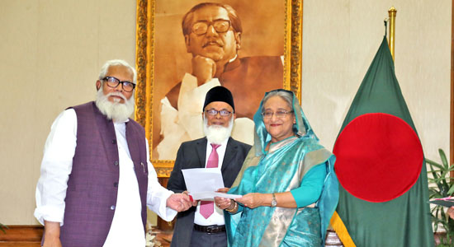
IFIC Bank also work for and contribute in many social welfare instance. Recently on 2 April, 2019 Honourable Prime Minister Sheikh Hsina received a check of 1.0 core taka from the hand of Chairman Salman F Rahman as relief fund of devastating fire in Churihatta in Old Dhaka's Chawkbazar.

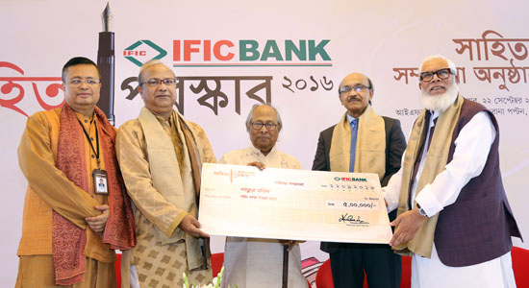
Mr. Hasan Azizul Huq Eminent writer and novelis have been honoured and awarded with the IFIC Bank Sahityaratna Puroshkar as well as writers Khasru Chodhury and Shakoor Majid also awarded Sahityaratna Puroshkar on 22 september, 2018 at IFIC Tower.

A view of their recent condition (2018 highlight):
Particulars  ( In Total) | Amount  (In Million) | Percentage
Deposits | 226,333 | 13.1%
Assets | 283,073 | 11.8%
Loans and Advances | 206,930 | 15.4%
Investments | 31,304 | 12.4%
Mortgage Loan | 29,114 | 11.1%
Market Capitalization | 14,592
Investment in Human Capital | 29  (211 Training Programs,  3,697 Participants)
Capital of risk Assets Ratio (CRAR) |  | 12.63%
ROE |  | 7.36%
Operating Profit | 3,895
Profit Before Tax (PBT) | 2,859
Profit After Tax (PAT) | 1,570
Total Equity | 22,116 | 7.7%

(https://www.ificbank.com.bd/annualreport/Auditor's%20Report%20and%20Audited%20Financial%20Statements_2016.pdf, n.d.), (https://www.ificbank.com.bd/annualreport/Annual_Report_2018.pdf, n.d.), (https://www.assignmentpoint.com/business/organizational-behavior/historical-background-of-ific-bank-ltd.htm, n.d.), (http://www.theindependentbd.com/post/77419, n.d.), (https://www.ificbank.com.bd/investor_relations.php, n.d.).

Industry Perspective

Banking industry is considered one of the most significant sectors in any country’s economic growth. The modern banking industry is a network of financial institutions through which people relate to storing, transferring, extending credit against, or managing the risks associated with holding various forms of wealth.
Development of the banking started from the northern Italy throughout the Holy Roman Empire and in the 15th and 16th century to northern Europe. After this period of time many innovation and developments were happens in the banking sectors and banking system. In past Banking industry was not so tightly monitored and earlier banking was absolute free market operation. But over a period of time introduce of license, different policies, rules and restrictions are make changes the definition and importance of banking to the people and turn into a modern banking. The first modern bank in Bengal was Bank of Hindustan established in 1770 in Calcutta. After that the next renowned oldest bank was the Bank of Calcutta established in 1806 which is gradually renamed State Bank of India in 1955. The first modern bank in Dhaka was Dacca Bank established in 1846. It was established with limited business and did not issue banknotes.
Following to Bangladesh Bank Order, 1972 the Government of Bangladesh reorganized the Dhaka Branch of the State Bank of Pakistan as the central bank of the country, and named it Bangladesh Bank with retrospective effect from 16 December 1971. After independence the name of the central bank of Bangladesh is ‘Bangladesh Bank’. Bangladesh bank holds the chief regulatory authority in the banking sector and established as the Central Bank of the Bangladesh. Bangladesh bank continuously gives its efforts to improve the performance of the banking sector. It also ensures an efficient and resilient financial system all over the Bangladesh.
Bangladesh is one of the developing country over the world with an impoverished banking system. In Bangladesh the banking Industry is consists of several types of institutions. It is renowned that during 20th century changes in the computing system and development in telecommunication brought major changes in whole banking operations and gradually increase in size and geographic spread in the banking industry.
“Banking industry” itself means so many things such as product and service, customers, policy, regulations, operations, risk management etc. We must considered the financial service marketplace which come first to understand the banking industry. Financial service marketplace includes retail banking, product manufacturers, depositors, regulators, other third party such as credit unions, brokerages, other type of banks; private bank, investment bank even the financial technology providers etc. Each and every element in the financial marketplace play their specific role to run the Banking Industry in an efficient way. Banking industry in Bangladesh plays a pivotal role in the developments of the country’s economy. At present banks are not only act as custodian of public money but also are considered as a constitutive agent for maintenance of sound financial position of a country. In today's era most dominant trend in the banking industry is shift from tradition to digital specially mobile and online banking. Consumer are now want convenience, speed and they don't want to have to trek to a physical bank branch to handle their transactions. A study of mobile banking competitive edge in 2018, about 89% respondents disclosed that they use mobile banking more than 83% in 2017. Besides in the present era of modern banking Online banking is extremely convenient to the people and is understandably one of the two main ways that consumers interact with their banks; involves sharing
Customers' financial information electronically and securely, but it is only done on requirements and conditions that customers authorization.
In Bangladesh banks are primarily categorized into two types; they are Scheduled Banks and Non-Scheduled Banks. These Scheduled and Non-scheduled banks are also divided into different types. This is showed by a hierarchy below:

Although there has been many welfare in the banking industry because of the digital banking system but this industry have to face many challenges also. Banking sector in all over the world has been victim for malpractice in the financial (banking) field by a miscreant party and rusted several times by several bouts of deception or fraudulence acts. With regard to these problem there are a big question in the banking activities and Bangladesh is the most victim country for the lack of adequate protection against potential security breaches.
The quality of governance another important factor that can affect the sound and healthy financial indicators such as capacity of earning, asset quality, liquidity, capital adequacy ratio and more. There are a big lacking in the banking sector of Bangladesh. Widespread of corruption in the banking sector hamper and mare the development of trust and create obstacles towards becoming a more prosperous nation. Because businessman, different policy regulator, economists are always pensive about political uncertain circumstance, corruption and other irregularities in the banking industry. Corporate governance probably deteriorated when one or more banks are devoid of transparency, accountability, and compliance. Management in these banks should on the operation of the bank and its branches to ascertain corporate governance within the organization.
(https://cpd.org.bd/wp-content/uploads/2018/12/Banking-Sector-in-Bangladesh-Moving-from-Diagnosis-to-Action.pdf, n.d.)

Objectives of the Study:

- To review the historical development of IFIC Bank Limited
- To evaluate IFIC Bank as a Financial Institution by comparing it to the competitors
- To examine the service marketing mixes of IFIC Bank Limited.
- To evaluate the service marketing triangle in the context of in the context of IFIC Bank. More specifically we will evaluate:

- External Marketing
- Internal Marketing
- Interactive Marketing

- Some suggestion will be recommended for the purpose of improving the service performance of IFIC Bank Limited.

Methodology of the Study:

To achieve the specific objective of the study with accurate details, I had to collect the related data both from primary and secondary sources.

- Primary date are collected from:

  - Observing the activity of the bank.
  - Talking with staffs and other senior employee.
  - Collect date from IFIC Bank Principal Branch, Credit section of principal branch, Retails department of principal branch.
  - Talking with the regular customer of IFIC Bank Limited.

- Secondary data collected from:

  - Web site of IFIC Bank Limited
  - Annual Report of IFIC Bank Limited (2017)
  - Recorded documents of the Bank
  - Unpublished data of their general banking

Findings of the Study
The present findings from my observation and working experience with them IFIF Bank Limited team is significantly related to their banking service, functions, effective management of banking system, benefit by the use of their service system, customer satisfactions and dissatisfaction, even the functional and psychological barriers of the bank.

Service Marketing Mix
Analysis of the result on the perspective of Service Marketing Mix of IFIC Bank Limited:
Service marketing mix represent the mixture of seven ‘P’ of an organization. IFIC Bank Limited also practice those seven ‘P’ with a satisfied manner.

1. Product/Service
A product is a packaged offer provided by the bank which becomes a service when we utilize it. A Bank basically offer variety of service to assist individuals in managing their finance for the customer. All bank provide general banking activities. Beside the general banking IFIC Bank also offer different products. Such as; Commercial banking
Retail Banking
SME Banking
Internet Banking
Trade Finance
Project Finance
Small Enterprise Finance
Consumer Finance
Syndicators

General Banking Product and Service of IFIC BANK:
Some of the basic products are: Opening accounts, checking accounts, savings accounts and transaction accounts, Investment advice, Money transfer & payment processing, debit cards, credit cards, mortgage, personal loan, investment loan, checks, overdraft etc. These are all consider as the products or offerings by the IFIC Bank limited.
A brief overview of the IFIC Products are given below:
Serial | Product | Category
1 | IFIC Savings Account | Savings Account  Smart Savings Account  Super Savings Plus  Sanchita Savings Account  Duronta Savings Account
2 | Current Account | Current Account ( As Usual)  AAMAR Account
3 | Savings Scheme | IFIC Agami  Pension Savings scheme (PSS)  Pay Roll Savings A1ccount  School Savings Scheme- A plus  Millionaire Dream Plan (MDP)
4 | Fixed Deposit | Fixed Deposit Receipt (FDR)  Monthly Income Scheme (MIS)
5 | Special Notice Deposit
6 | Loans are also vary on the purpose. | - IFIC Home Loan  - Education loan  - Marriage loan  - C.R.G Conversion loan,  - IFIC Home Renovation Loan  - IFIC Medical Loan,  - IFIC Holiday Loan,  - IFIC Peshajibi Loan,  - IFIC Easy Loan,  - Any Purpose loan

Service of IFIC Bank Limited:
Apart from the product IFIC Bank Limited Provide banking service to both the customer and employee.
These are: Remittance Services
SWIFT for Foreign trade
ATM Service
Cash Management service
Payment and clearance
Safe deposit locker service
Employee benefits.
Treasury service
Collection services
Asset management
Banking service is a mainly qualitative aspect of the bank which mainly reason for the customer satisfaction and retention. But IFIC Bank focus on both the qualitative and quantitative aspect with efficiently. The Principal Branch provide service to each of their customer with the concern of how they interact with the customer at every step in their banking operation.
Account Opening Process: They have two type of account opening form for open a bank account. One is ‘Individual’ account and the other is ‘Other Than Individual’ account. Those who are want to open joint account they will fill up ‘Other Than Individual’ account opening form.
IFIC Bank Limited introduce a new banking Account named ‘AAMAR ACCOUNT’ with some additional benefit for the customer.
Features of AAMAR ACCOUNT:
- Opportunity of Deposit and Loan (Overdraft) facility is available against a single account
- Slab wise attractive interest rate – Earn more as your Saving’s grow
- Interest is calculated daily and paid monthly.
- Same Card can serve the purpose of Debit & Credit card.
- Same Cheque book can be used for withdrawal of Deposit and Overdraft amount.
- Unlimited number of transactions can be conducted in account
IFIC Bank recently introduce a new banking service opportunity in which is mainly consists of five banking service in a package. Those are: Booth Banking
Digital Banking,
Banking Trade Portal
24/7 Customer Care
Virtual Banking
This age is demand for online banking. This is impossible now to provide quality service to the client without internet. IFIC Bank Limited comes with the huge benefit by this package. This project of IFIC Bank attract more people and help enough to make them as a loyal and regular client. Clients will be able to get all the five services in their nearby booth of IFIC Bank, they need not to go to the bank.
Benefits of this package:
Booth Banking: IFIC Bank located their ATM Booth in different area of Bangladesh. It has 81 ATM Locator in 6 division over the Bangladesh. These six divisions are Dhaka, Khulna, Rajshahi, Chittagong, Barisal and Sylhet. Two Officer assign for each booth. Hear all type of general banking of IFIC Bank get be operated. Customer need not to go for branches for their frequent necessary transactions.
Digital Banking: Digital banking is only workable for internal money transfer of IFIC staff. Salary will automatically credit to their account. By this system account holder can get salary any time by just one click and can operate their account balance sitting at home. IFIC Bank will provide it for customer in later.
Banking Trade Portal: Banking trade portal means an online platform for customer such as buyer, seller, businessman, all people who are related to trade and need banking help though which they communicate to the other party. IFIC Bank will provide this opportunity to their customer and make the trade relationship longer and satisfied. This Banking trade portal also useful for the businessman to conduct the operations of their business instantly. Client can deal in certified products and services within seconds by the order or command on trade portal provided. This system will hopefully make the business people or trade people 100% tension free about getting
24/7 Customer Care: Booths are always 7 days 24 hour remain open for the customer. For this customer can get service anytime from anywhere. This is not only for booth banking service, infect all type of banking facilities are available for customer as their requirements.
Virtual Banking: Virtual banking is the way in which people need not to physically presence in the office or branch or bank. They can access the banking and banking related activities and services through the use of digital information technology. Any financial institution that offer to replace this traditional banking service to online technology service are virtual banking. This virtual banking enable customer to deposit money, withdraw money, online bill payment, check the details of accounts balance or conditions, ATM, use of magnetic ink character recognition code (MICR), Electronic clearing service scheme, electronic fund transfer scheme, RTGS, computerized settlement of clearing transactions, centralized fund management schemes, etc.
When the transaction are made customer can check the transaction real time, he/she need not to wait for this. It also reduce the expenses only low fee charge comparatively. In the traditional system client have to wait for long time for a signature, seal, approval, checking transaction, getting statement of their transaction deposit, withdraw, loan, fund transfer etc.
Digital banking will make their customer’s life more easy and tension free. It will make a smooth flow of the IFIC Banking system. They are recruiting skilled employee through five several exam to operate the booths and available enough training for the employees to make them sophisticated. IFIC Bank Limited hopefully to locate 1000 both banking over the Bangladesh. This project will available for the customer within few months.
There is no risk of loss of money or any fraudulent activities because all booths are tracked by branch office in different places. These booths will divided into a number of portfolio each of them will work under a particular branch. The deposited amount of all booths will safely be transferred by the booth banking to the selected supervisory branch office. They will put it to their volt. Booth officer must be explain all statements or calculation of daily transaction.

Retail Banking:
An important product of a bank we can say that consumer banking which is called Retail ‘Banking’. This basically provision of services for the general public. This is also referred as Wholesale Banking. Retail banking considered as a division of department of a bank which include general savings, transaction accounts, debit cards, credit cards, personal loans, even investment and commercial banking also included in retail banking. IFIC retail banking of principal branch located exactly the same floor beside the principal branch in IFIC Tower. In every day many customer come to take consult from them or come to open bank account or request for several services. Both bank and customer follow a sequential process for any requirement.
How IFIC retail banking unit perform job for serving customer:
- Help customer in account opening form fill up.
- Encourage them with positive word of mouth
- Propose for the loan to the client
- Introduce different types of loan and offer also various benefits and loan repay procedures.
- Preparation of credit card facilities.
Job performed by the retail unit of principal branch in terms of loan sanction;
- Interview with the prospective borrowers face to face or over the phone
- Obtaining of primary required papers/documents from the prospective borrowers as per lawyer or valuator’s requirements.
- Presentation of all loan proposals such as; home loan, salary loan, salary OD, AAMAR Account OD, SOD, general loan etc.
- Obtaining of CIB of individual borrowers from the system.
- Deal with the DST under DST management system
- Communicate/deal with the High Value Customers under High Value Relationship Management System.
- Maintain customer service of On-Boarding under On-Boarding Relationship Management System.
- Visit/valuation of the property proposed to be mortgaged in the event of home loan and SHBL (staff house building loan).
- Preparation of branch sanction for home loan /salary loan/ SOD/Loan General/Aamar A/c/OD/SHBL.

Preparation of Credit card:
- Follow up and monitor of the loan repayment by way of phone call/SMS/e-mail/letter correspondence with the borrowers of all retail loans.
- Realization of monthly installments of Staff House Building Loan/Salary loan manually in every month
- Realization of charges/commission and Excise Duty of Retail Loan.

SME (Small and Medium enterprise) Banking:
In the banking industry the growth of cottage, micro, small, medium enterprises (CMSMEs) have huge role. National economy of Bangladesh depends on a large amount of money from CMSMEs. This is also create an impact on employment generation, GDP growth, poverty alleviation of Bangladesh. Considering this issues IFIC Bank provide collateral free credit facilities to cottage, micro, small, medium enterprise sector to facilitate them. Because micro and small sized enterprise focus on free loan services as they have not enough ability to offer cash or collateral securities to cover the exposure. To capture the target group IFIC bank offer fifteen different products those are; IFIC Krishi Shilpo, IFIC Shilpo Sohay, easy commercial loan, working capital loan, transportation loan, retail loan, women’s entrepreneur’s loan which is known as PROTYASHA & IFIC PRANTONARI, bidder’s loan, project loans, muldhan loan, contractor loan, house building loan, agriculture credit etc. They have two type of SME Liability Scheme one is Monthly Income Scheme (Arjon) and Monthly Savings Scheme (Joma). They also provide lease finance to the customer with a contractual relationship for a specific time period. This helps the customer to managing fund as their requirements for growth of their business houses by purchasing luxury items such as machinery, equipment, bus, track, or any logistical establishment to make their business successful. In last we can say that IFIC SME banking provide a big helping hand to the commercial business people.

Internet Banking:
Customer have a control on their some baking facilities by the use of IFIC Internet Banking service but before it they have to mention this in the account opening form in terms of fill up it. They can access Internet Banking with enough security by the use of individual user name and password in their convenient time, get information about IFIC Bank for their requirement such as transaction details, check book and interest rate inquiry, export statement of account, IFIC offerings etc. They can also change their password any time if necessary.

2. Price
Price is considered by both the bank and client or customer. Both party have to face some mandatory expense. Price is a sensitive issue both for the customer and bank. For the bank price is referred to Bank Rate which is. There are two type of customer; price sensitive and quality sensitive. If we want product with high quality we have to consider the high price of it, because price tell about quality. As IFIC always ensure quality service here price is higher relative to other bank. Price for IFIC client:

Details | Price
Check Book | 140 tk + 21 tk vat ( for 20 leaves)
SMS Banking | 125 tk + 17 tk vat (for 6 month)
Internet Banking | No charge
ATM Banking & Qcash | No charge in Principal Branch ATM
Bank Statement | Minimum 230 tk maximum 575 tk
Solvency | 150 tk + 23 tk vat
Maintenance Charge | 575 (for 6 month)
Pension Savings Scheme (PSS) | Deposit minimum 500 tk with 9.5% interest
Interest (Per Year)
Fixed Deposit Receipt (FDR) | 9.75%
Savings Account | 5% (For Any Balance)
Smart Savings Account | 3%
IFIC Agami | 10% with TIN Certificate, 15% without TIN
IFIC AAMAR Account | 8% (tk 25,000 to tk 1,00,000)  8.5% (tk 1,00,000 to tk 5,00,000)  9% (tk 5,00,001 to tk 10,00,000)  9.5% (above tk 10,00,001)
IFIC Home Loan | 11%
IFIC Salary Loan | 13%
IFIC VISA Classic Local card | 30% For General  28% For Corporate & Payroll Account
IFIC VISA Classic International (dual) card | 30% For General  28% For Corporate & Payroll Account
IFIC VISA Gold Local card | 30% For General  28% For Corporate & Payroll Account
IFIC VISA Gold International (Dual) card | 30% For General  28% For Corporate & Payroll Account
IFIC AAMAR Account Overdraft | 14.50%

Note: These all are more used loan and deposit policy in Principal Branch. Rest of the all loans and deposit types are actually for rural area which are not available or less required by customer who come in Principal Branch.

3. Place
IFIC helping hand located in different places over the Bangladesh for the convenient of customer. They have exchange relation with and transaction operation in Oman, Nepal and Maldive. In past IFIC Bank Ltd has a close business relation in Pakistan which was shut down many years ago. Now they have remain constant their operation and transaction in ‘Oman Bangladesh Exchanged Company’ and ‘Nepal Bangladesh Bank Limited’ in Nepal.
As they are going to take a big step of 1000 booth banking it will be easier to their customer for their daily banking activities. They have 148 branches all over the Bangladesh.
IFIC Principal Branch is located in Purana Paltan which is beside Motijheel and other commercial area. For this it is easy to the commercial business worker for their daily transaction and other banking activities. Around 200 customer daily came to the Principal Branch to take different service and staffs of the Principal Branch always aware of giving fast and errorless service with full customer satisfaction and they are success to their objective.

4. Promotion
In modern age and competitive market economic development of a bank somehow depend on the promotional activities. IFIC Bank Limited never do any aggressive promotional offerings for their own benefit. Infect in previous years from the initial stage IFIC Bank didn’t focus on branding and positioning. But recently to cope with the digital banking industry and meet customer needs and wants they started some new activity that is really benefited customer and make their bank differentiate from other bank. These activities are also attract customer.
2018 highlights one of the best promotional activity, execute of IFIC AAMAR ACCOUNT. It has come with a new opportunity of general people. This is actually savings account. They make it different from current account but customer can deposit and withdraw multiple time in a month with considering 7.5% interest on deposited amount. Huge customers are started to showing interest on opening an IFIC AAMAR ACOUNT for this exclusive opportunity and started to attract potential customer.

5. People
People are those who are internally and externally related to the IFIC Bank Ltd.
Customer: As I have an experience of working directly with the customer I got to learn their mind what is their perception about IFIC Bank. But principal branch is basically helpful for the IFIC staff and different business and organization. Most of the daily transactions are corporate transaction. So corporate people are gather here as it is their nearby branch. Besides general clients are also came here with different kind of requirements.
Employee: IFIC head office has around Six Hundred employee including Principal Branch. As I have discuss the organizational hierarchy in the IFIC background part, here I am giving a brief about Principal Branch where I am working.

IFIC Bank concern about recruiting skilled and knowledgeable employee who are eligible to take high risk to reach their business goal. All banks need quick handed employee and who has good communication skill and supper rick management ability. IFIC also looking for these quality. Recently they are recruiting young generation to develop their banking activities more efficient. For this they arrange many training program even practical exams after training so that employee can develop their knowledge and skill to cope up with the competition and bring customer satisfaction. They focus on talent, hardworking and creative knowable person who can run with flow of digital technology, system and idea. That is why they follow a special and hard recruitment process with eight different step.
IFIC Bank Recruitment process is described elaborately in the Internal Marketing part of this report.
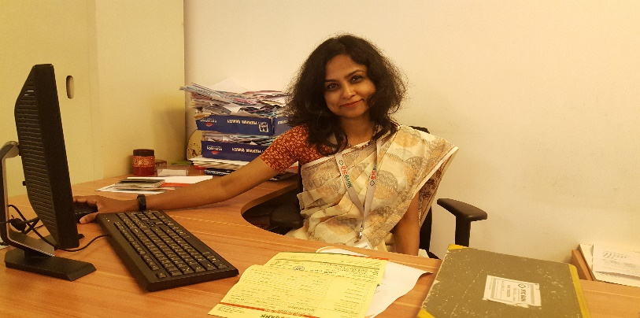
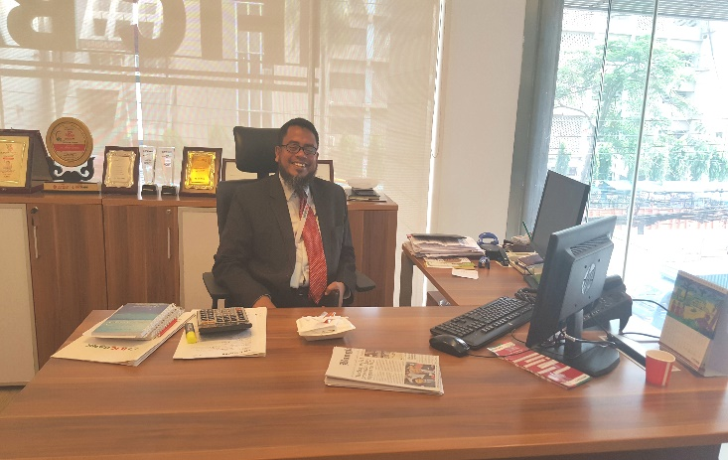
Head of branch Operation &VP Transaction Service Manager

6. Process
From the customer point of view business process define to take the innovative initiative to provide the service in a successful position and continuous improve the process. This is possible through the involvement of people. IFIC Bank design their process according to their desired plan to get a satisfied result. They constantly taking initiatives to offer first class service to the customer as well as enhance customer experience.
IFIC Principal Branch maintain a formal sequential working process in every step. Everything is done by the permission of our Branch Manager MD Rafiqul Islam, Head of Branch Operation Mr. Omar Sharif, Transaction Service Manager Ms. Sylvia Chowdhury and three Separate transaction service in-charge sequentially. I am working under Sylvia Chowdhury mam who operate all the activities of each Transaction Service Officer (TSO) and all transactions from the host computer. She handle all responsibilities of every step of cash office.
From the very beginning to the end service delivery process is important for customer satisfaction. IFIC Bank adopted more and more technological tool to deliver their service to customer which added huge value to the customer service and results in lower the cost, less time, facilitation job for their employees. The most effective step of IFIC is creation of self-service options for customer by the use of their ‘Digital Banking’. Customer who have not sufficient time their hand they seeks help from bank which provide effort and time saving banking services.
IFIC Principal Branch use different types of safe technology such as Magnetic Ink Character Reader, Currency Note Counting Machine, heavy security system in Volt, and arrangement of secure safe guard during money transfer from Bangladesh bank to IFIC Bank Currency, hand held metal detector for body checking. All these are examples of security process of Principal Branch. Nobody can enter into the cash office without access permission.


They have secure documents maintenance process, Data Management System (DMS) department, intra topology networking system by which anybody can share data and information to the other computer entire the principal branch.


7. Physical Evidence
Physical evidence are those element which are tangible in nature and help make the process much easier and smoother. If we think about a bank here physical facility, equipment, communication materials etc. These tangible indicators or physical environment are influential factor in creation of positive perception about the banking service and its performance. It is also a crucial factor in influencing customer’s behavior of future purchase decision. General physical evidence of the bank are furniture, equipment, machinery, checkbook, computers and other devices, staffs of IFIC Bank, pass card, TV as banking related information provider, tokens, pen, pencil, papers and so on. There are some other different types of physical evidence which enhance customer satisfaction.
- Physical décor of IFIC Bank.
- The way of interacting between bank employee and customer.
- Display of current guidelines such as rate of interest on investment,
- Service charges of IFIC Bank different transactions.
- Comfort and safe zone with air condition sitting service for the customer.
- Customer movement inside the branch during waiting in serial
- Conflict management ability
- Modes and content of communication
- Layout of the total service center
- State of the branch premises.
These cues represent the quality of service. The elements and atmosphere of the physical evidence must be capable to attract customer and make positive customer experience. Hassel free execution of transaction is the key to bring customer satisfaction and their positive word of mouth in banking sector.

Service Marketing Triangle

The service marketing triangle elucidate key actors those are involved in marketing of a service business and service marketing activities those are performed by the actors within the service business.

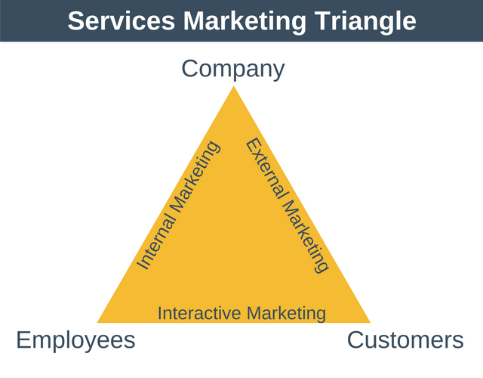
According to the Valarie A. Zeithaml, Mary Jo Bitner, Dwayne D. Gremier (1995) Journal of the Academy of Marketing Science 23“Service marketing is about promises- promises made and promises kept to customers. A strategic framework known as the service triangle visually reinforces the importance of people in the ability of firms to keep their promises and succeed in building customer relationship”. The Triangle shows three interlinked groups Company, Customer, Providers (firm’s employee, subcontractor, outsourced entities) who work together to develop, promote and deliver service to customer. Between these three points on the triangle three types of marketing must be carried out successfully, those are; external marketing, internal marketing and interactive marketing.
(https://expertprogrammanagement.com/2018/03/services-marketing-triangle/, n.d.)

Internal Marketing of IFIC Bank
Internal marketing refer to various kind of offer and promotion which is provided by the organization to their employee. This is only provide within the organization. The purpose internal marketing is to increase employee engagement with the company’s goal. As Bank is a service Institution employees has crucial impact on customer service and retention. Internal marketing helps to implement the Bank’s objective with the help of employee or staff, because it ensures that employees are understand the product itself and make their interest same as organization’s interest. When the employee’s goal and Bank objective are go in the same line with same intension it is very near to reach the pick position of success. That is why internal marketing is very much important for every organization.


IFIC Bank Limited not only focus on their customer but also give attention to their employee. They know that the more employees are engage with the bank the more they will show interest for the Bank’s success. Promotional factors of IFIC Bank product, service and objective for employee are:
According to Gummerson, 1991; “Turning these employees into true part time marketers is a demanding task”.

Recruitment Process:
One of the effective internal process of any organization is employee recruitment. Any organization need right employee who can utilize these promotional offer in practical.
Recruitment source: There are two different source for recruiting process.
- Internal
- External
Internal Source: The Source within the organization boundary is called internal source. Organization itself act as a source of employee such as transfer from one department to other department, promotion of employee from one position to other position. Either job posting or based on experience candidates are recruited internally. Posting notice of job openings on bank’s bulletins board or company website is an effective internal recruiting method. It informs the employee about new job opportunity and invite qualified employee to apply. By analysis the job and other information IFIC Bank recruit the right person for the right position. Experienced employees are asset of any company. To get adequate but relevant employee information IFIC Bank use HRIS and find the best suited candidate and this must be secure and confidential source of internal candidate.
External Source: External source can be different. IFIC Bank use some specific source such as advertisement, employee referrals or recommendation, employee agencies, Universities Recruiting, IFIC website. By this sources any person can apply for getting job in IFIC Bank but qualification and job requirements must be considered before apply otherwise the application has been rejected. Advertisement is the popular method to communicate with the public for the vacancy advertisement. It is mostly used source by IFIC Bank Limited.
Though IFIC Bank follow a formal and standard process for recruiting they sometime face some difficulties to employ appropriate personnel.
- High cost to take hire and replace employee.
- Takes too much cost in eight steps in recruitment process.
- Emerging of huge competitors in the banking industry.
- High turnover problem of IFIC Bank.
- For this reasons they become unable to choose experienced and appropriate candidates.

IFIC bank also take this recruitment issue with high conscious and it proves by their recruitment process. As all the recruitment process and questionnaires are arranged by Bangladesh Bank it becomes very competitive for the candidates. People who apply in IFIC Bank Limited they must go with the eight different step sequentially.
Those are:

Training and Development:
The second important internal marketing practice is to train their employee so that they can learn how to work or provide service to the customer in a right way. In this modern age of banking industry to take the competitive advantage employee must have the ability to learn and act faster than present and potential competitors. This is possible by giving them proper training.
That is why IFIC Bank think their employee as an asset and give then training at the initial stage. As I have did my Internship specially in the General Banking (GB) sector at IFIC Bank Principal Branch I can tell about the GB sector accurately such as how many times, where, when they need to conduct training. As training is a costly and time consuming factor but there are obvious arrangement of training for new employees, when they see any lickings in work of any employee whatever he/she is transaction service officer or in-charge or manager.
They arrange classes for the new recruited employee for one month. In this class they learn theoretically about the bank and different banking activities. The effectiveness of these classes I have heard directly from new recruiting staffs when they came to principal branch as trainee to learn practically from branch in-charge. In every year they provide job circular in Transaction Service Officer (TSO) position. Training facilities is arranged in the Head Office Of IFIC Bank Limited. They use this recruiting process and training system in every time. After all they don’t compromise anything to be success.
Marketing Strategy:
Every product and service has to be marketed which requires a strategic marketing approach. This is actually an effective internal marketing system done by the team of IFIC Bank. IFIC Employee must understand the proper marketing strategy because this bank is run with customer trust, confidence and security. Any activity related marketing strategy will affect these feelings and emotions of customer. Different types of activities are:
- Developing new product and service: IFIC Bank give attention in development. Educated young employees are creative enough and source of idea of new product and development also capable enough to market those product to the present and potential customer. Private Banks are standing by innovative product and service as well as customer’s perception and response. So without innovation and development this is impossible to take competitive advantage and customer response. Only traditional methods and products are less effective to be success in modern banking industry. IFIC Bank motivate employees to develop the product and service and take the responsibility eagerly. Employees are also properly paid for the level of their responsibilities.
- Encourage to Provide Proper Customer Service: Employees must understand that customers are king for their organization. The salaries they have paid that is come from customer’s money. So customer must be treated as king because they helps to generate profit of the bank.
- Internal marketing refer not only communication programs or selling product and service internally, it means effective and inclusive staff management, motivation and leadership that IFIC Bank do properly. IFIC Bank Principal Branch Manager MD Rafiqul Islam, Vice President Mr. Omar Sharif and TSM Sylvia Chowdhury are three successful leader from my observation. Staffs are also motivated happily by them and do full time duty at Saturday and they also get allowance for this extra service.
- Encourage employees to maintain corporate culture and give positive feedback for maintaining this.
- Fostering communication and collaboration among employees to come to a sensitive decision and various problem solving issues and make the work life balance.
- IFIC employee are get promotion by their talent and hard work. This promotion is done by internally. If anyone do his/her responsibility with errorless there are a big opportunity of promotion for him/her. When I started my internship in GB sector I was work under Aman Ul Haque Asif (TSI) who is now Branch Manager Of IFIC Bank Garin-E-Nawaz Branch Uttara by his excellent performance. Before the age of 30 it is quite hard to become a branch manager we all know. This is only possible by the supper level performance. From this I can say IFIC very much conscious about employee’s overall performance and talent.
IFIC Bank Limited treat their employees as internal customer and this internal marketing align employee’s interest to the company’s mission, vision, objective and strategies.
(https://shodhganga.inflibnet.ac.in/bitstream/10603/377/11/11_chapter%206.p, n.d.)

External Marketing of IFIC Bank
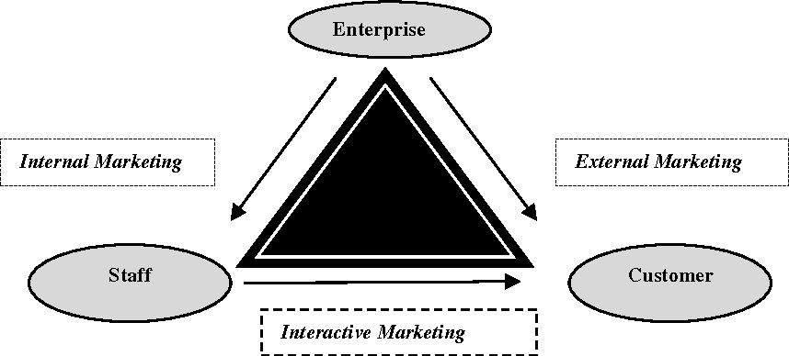
Organization market their product and service to customer is called external marketing of that organization. It is the action of promoting and selling the product or service to the customer, advertising their product to the customer and potential customer.
External marketing is known as traditional marketing that is 4p’s; product, price, place, promotion. It is extended latter with another 3p people, process and physical evidence. On the right side of the triangle is the external marketing. According to the Valarie A. Zeithaml, Mary Jo Bitner, Dwayne D. Gremier, (2018) “External marketing efforts that the firms engages in to develop its customers’ expectations and make promises to customers regarding what is to be delivered” . External marketing is conducted before service delivery.
External marketing activities such as pricing strategy, promotional strategy and how to communicate to the organizations target customer or send the massage to end user. Any organization perform their best to capture the attention of market and interest in the service. People expect bank and other financial institution to communicate with them and allow them about their offerings, policies, new massages for the customer etc. To know about these bank integrate input from email, SMS, phone calls, social media, mail, advertisement and even face to face interaction.
IFIC Bank Limited always focus on personalized communication to each customer to their expectations and make them happy. They market their product and provide service considering customer satisfaction, customer loyalty, customer loyalty is comes from revenue growth and profitability of the IFIC bank.

Role of IFIC Bank:
IFIC give promise to provide best service just in time. They are taking initiatives to provide 24 hour service through digital banking and customer relationship.

Customer Relationship:
IFIC have strong relation with all type of customer. From many big companies or giant customer to retail customer become the regular and loyal customer of IFIC Bank.

Direct Marketing:
IFIC direct marketing is occur in the retail sector. As I completed my internship in principal branch I have limited knowledge about their direct marketing in the retail sector. Customer who come to open an account and take other services they talk to employees of retails office and staffs and front desk executive describes everything in details. They also tell about the products of IFIC bank and the benefits of all product. Staffs are also describe the instructions, requirements, policies and procedures in details to the customer and potential customer.

Advertising:
IFIC provide their advertising in television, website, Facebook page and other social media but it is very limited because they don’t focus on advertising to show off only. They only want to inform the customer about their products, offers and massages. Their recent and attractive adverting is IFIC AAMAR Account and five service in one package.
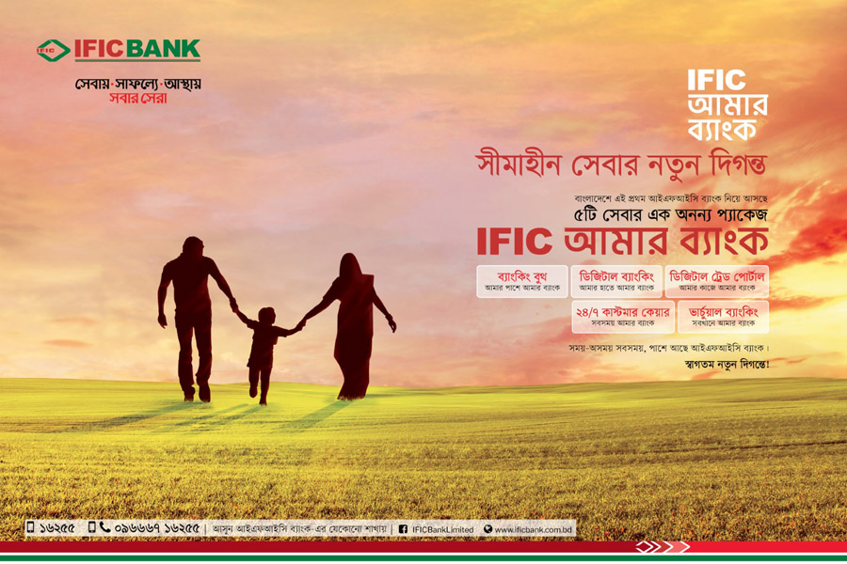

Publications and Reports:
Many different purposes are arise for publication. IFIC Bank Limited publishes different research paper, periodical publications, annual report that contains monetary development and economic review as well as various statistical data. This will also help people to state a perception about the bank. There are some other publications I have found in internet such as A PUBLICATION OF TRAINING & RESEARCH DIVISION, IFIC BANK LIMITED, HEAD OFFICE, DHAKA published on September 2009, Overall Banking Activities of IFIC Bank Limited published on May 16, 2015, IFIC Bank Limited Code of Conduct, different report like The Report on Analyze of Overall Performance of IFIC Bank Limited by The Lawyer and Jurists.
Beside if any job holder want to publish work related or employment related articles they have to take the guidance of IFIC Bank spokesperson before entering into any commitment. The same considerations apply to the publication of material on the world-wide web and social media. No employee can communicate regarding the affairs of IFIC Bank Limited to the press or any other media, nor publish any article containing IFIC data, policy, opinion, comments on bank or other affairs in any newspaper which may involve the bank, it can only be only referred to the spokesperson nominated by IFIC Bank Limited.

Events:
Various events are most effective tools of external marketing that enable bank to provide a unique opportunity to bring a bank’s ideas directly to its employees, partners, clients and customer. IFIC Bank ensure the loyalties of invitees also laud their importance by these event marketing solutions.
Such corporate events of IFIC Bank Limited are:
- IFIC bank Celebrated Periodical Retail Deposit Growth BDT 1100+ Crore at July 29, 2019
- IFIC Bank Limited has hold its Extraordinary General Meeting (EGM) and 42nd Annual General Meeting (AGM) in July 4, 2019 at Officers’ Club in Bailey Road in Dhaka.
- Celebrating even for getting new Deputy Managing Director Mr. Md. Monitur Rahman in September 04, 2018
- IFIC celebrate for getting another Deputy managing Director Mr. Syed Mansur Mustafa in July 10, 2018
- 41st Annual General Meeting (AGM) of IFIC Bank Limited was hold in June 24, 2018 at Officers’ Club in Bailey
- IFIC Bank Holds 40th AGM in IFIC Bank Holds 40th AGM
- IFIC Bank opens 135th Branch at Motijheel, Dhaka in March 09, 2017
- Event of IFIC Bank Sahittyo Purskar 2016 in March 09, 2017

Interactive Marketing
Interactive marketing is one to one marketing practice and two way communication method. Interactive marketing consist of marketing initiatives that are triggered by customers’ behaviors and preferences; for this reason, it is a major shift from traditional campaign-based marketing efforts. Interactive marketing is a customer-centric strategy that involves reacting to customer actions and striving to meet their expectations and demands.
In banking sector a successful interactive marketing means the quality of the service heavily depends on the quality of the buyer-seller interaction during the service encounter. Interactive marketing is basically happens in regular banking services, retail banking, Credit department and foreign exchange department those provide service to their customers or clients. In this report I have describes the all services of IFIC Bank especially principal where I have done my internship. Here I am focusing on how employees in principal branch interact with customer to serve them and other people in an effective way which increase their understanding and make them IFIC customer.
The effectiveness of the interactive marketing relates back to the internal marketing efforts of business. Interactive marketing is also how your employees keep the promises made by your external marketing efforts.
Source of Communication and channels: In banking industry marketing communication and reaching to the people who may become potential customer are more complex than the other industries. Network television and newspaper are the tradition and one way communication which are not interactive communication. Customers are now fond of variety of sources for service related communication. Interactive marketing need in General Banking Sector (from my observation).

General Banking Sector of Principal Branch:
- IFIC Bank cope with the flow of these demand. Digital technologies and ideas such as richer variety of advertising, magazines, websites, direct mail, online advertising, e-mail solicitation, a host of sales promotion etc. are some sources of communication that IFIC employee use to communicate with their Customer.
- In the general banking (GB) sector bank keep enough information about customer and communication way both the account holder and nominee like phone number, email address, NID copy, professional address and phone number, income statement so forth.
- When the checkbook, debit card, credit card and other requirements are ready to provide customer get a SMS alert to collect the necessary things from principal branch. Phone and emails are always open to contact customer within the office hour.
- Anyone who face problem with using ATM Booth such as capture card, not sufficient money in ATM machine bank provide the necessary guideline about ATM booth and come to solution immediately. They also provide ATM Booth along with proper cooling, grounding and power backup (UPS) solution.
- Bank send email or SMS or letter to inform customer about completion of any transferable documents such as SND Certificate, different consolidate Statement such as account statements, loan statement, retail individual statements, credit card statements, brokerage statements, also payment reminder etc.
- IFIC Bank create timely communications with customer and in the customer's preferred language and engagement channels which they choose initially.
Besides the general banking interactive marketing happens more or less in every sector of the bank. Especially branch offices are operate through interacting to the customer and potential customer for market different kind of product and service. Interactive marketing is also
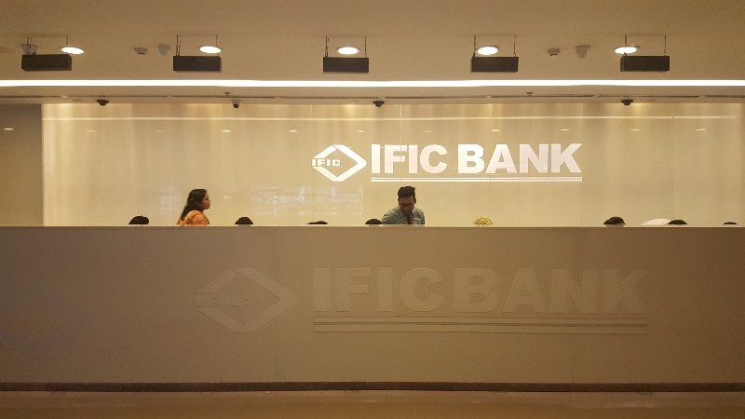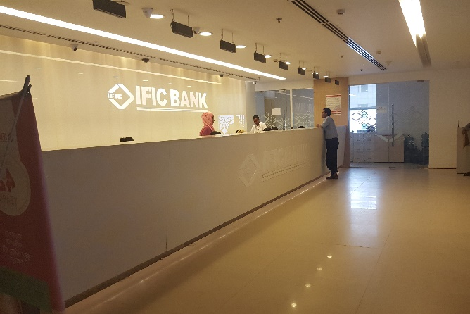
General Banking sector of Principal Branch

Retail Banking in Principal Branch: Retail banking is important division or department of a bank which performs job in serving customer through interaction or dealing with individual customer. Because of the development of information technology retail banking becomes mass banking facility that avail the banking services for individual customer directly from the branch network all over the country.
There are several retail banking unit in the IFIC Bank. Different units are assign for different types of work. Specifically there are some retail products shown in bellow:
Consumer Loan: IFIC auto Loan
Consumer Durable Loan
Parua (Education loan)
Thikana (Home Loan)
Any Purpose Loan
IFIC Marriage Loan
CNG Conversation Loan
IFIC Home Renovation Loan
IFIC Medical Loan
IFIC Holiday Loan
IFIC Peshajibi Loan
IFIC Easy Loan
Deposit Product: saving Account
Car Account
Fixed Deposit Receipt (FDR)
Special Notice Deposit (SND)
Pension Savings Scheme (PSS)
Monthly Income Scheme (Protimash)
School Savings Plan
Two type of card: Debit Card
Credit Card
They also provide NRB, Student File and SMS Banking.

I have elaborately describe about how retail unit play an important role in interactive marketing by performing different job, in the Product/Service part of service marketing mix (page no- 18 and 19 ).
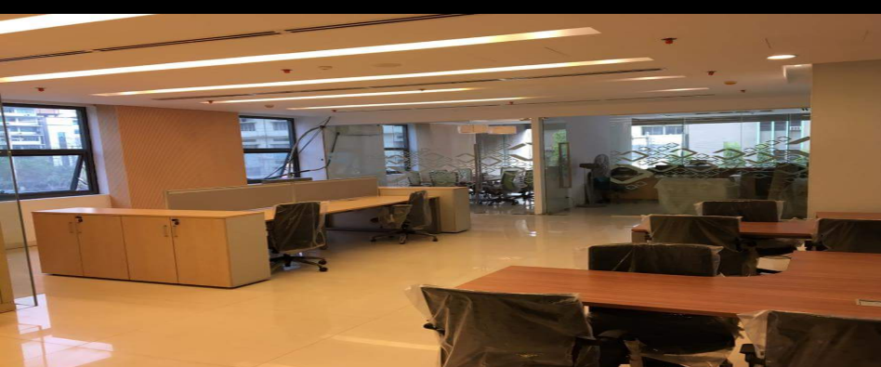
Retail and DST sector of Principal Branch
(https://www.ngdata.com/what-is-interactive-marketing/, n.d.)

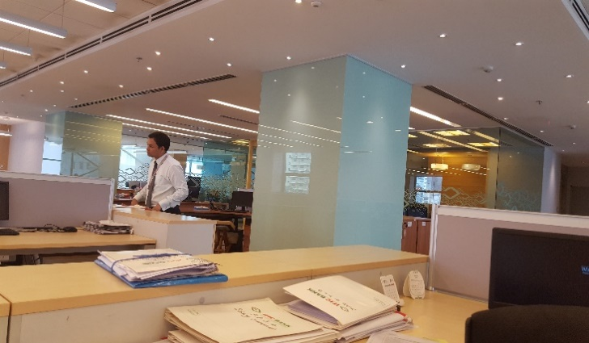
Credit Department of Principal Branch:
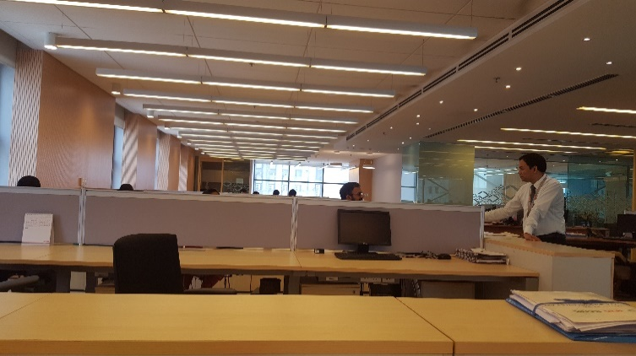
Interactive Marketing has been seen in credit department of a bank. This is the survival and earning unit of the bank. The bank will itself become bankrupt if the credit section doesn’t work properly. To run the credit department in a successful way customer trust and reliance is must be kept. Interactive marketing helps to bring this trust so that customer choose IFIC Bank for taking loan. IFIC bank provide different types of loan to the customer and make a balance in running economic wheals of the bank. Bank provide different industrial as well as agricultural advances, accelerate economic development.

Credit Department of Principal Branch

IFIC Bank Credit Department is divided into three different sector:

Total loans are divided into two category:
- Consumer Finance
- Small and medium enterprise finance

On the basis of nature loan is divided by two category:
- Term Loan
- Short/Demand Loan
There are some significant risk in providing loan and advance. To arise them bank select the right borrowers after analysis of Credit worthiness of the applicant. Information asymmetry may affect both party’s intension. For this they ask for certain information with document and statements.

Information with document and statement:
- Purpose of loan and advances
- Applicant’s Source of income
- To know about the applicant investment of the business and other source of income.
- Market reputation and good will of the applicant
- Financial condition/ bank statement
- Income Tax statement
- Statement of assets and liability etc.
All this process is possible through the proper communication between the bank and customer. Both party can share their requirements and opinion to each other. After a complete interactive communication they have come to an agreement. When customer move to the bank for getting financial help they have some expectation from bank. Bank fulfill customer’s expectation by managing all these things with assurance and with positive word of mouth which build positive feeling about the bank and make them trustworthy. Quality interaction and behaviors between all parties is the creative part of the inactive marketing.
(https://www.assignmentpoint.com/business/internship-report-on-marketing-of-ific-bank.html, n.d.)

Foreign Exchange Department: Foreign Exchange is converting one country’s currency to the other country’s currency. It is decentralized globally. Large international banks are mainly participate in the foreign exchange market. The foreign exchange market is specially works through country’s financial institutions and operates on several levels. All export import business need a solvent issuing bank and advising bank to complete their business transaction with a smooth flow and riskless way. Here needs a "dealers", who are involved in large quantities of foreign exchange trading. Most foreign exchange dealers are banks, so this behind-the-scenes market is sometimes called the "interbank market"
IFIC bank work as both issuing bank and advising bank for their customers. This department provide best and improved service including buying and selling of foreign exchange, granting and issuing letter of credit, dealing in foreign currency notes, currency conversion, travelers check, circular notes and negotiating of export documents and all other matters related to the foreign exchange.
There are some other functions Employees who are related of bank of foreign exchange or foreign business should have knowledge about these.
These are: Rate of exchange
How the rate of exchange works
Forward and spot rate
Method of quoting exchange rate
Foreign exchange trading
Intervention money
Financing of foreign trade

It also provide Remittance service for entering foreign currency into Bangladesh. Without the blacklisted country IFIC Bank provide service to almost all country in export import business. In terms of approval of the letter of credit application credit administration at first grant it after initial inspection and judgment. Bank need to done conversation with the exporter or importer party, collecting of all documents, inspection of all documents before entering in to the agreement.
Different types of letter of credit issued by the IFIC bank to their customer in export import purpose. The most usable letter of credit issued by IFIC are transferable L/C, back to back L/C (most usable), revolving L/C, red clause L/C. IFIC bank play the role as issuing bank for importer and issue letter of credit besides it plays the role of advising bank for the exporter and grant letter of credit which is comes from importers country.
The whole process of L/C IFIC Bank follow is described below:

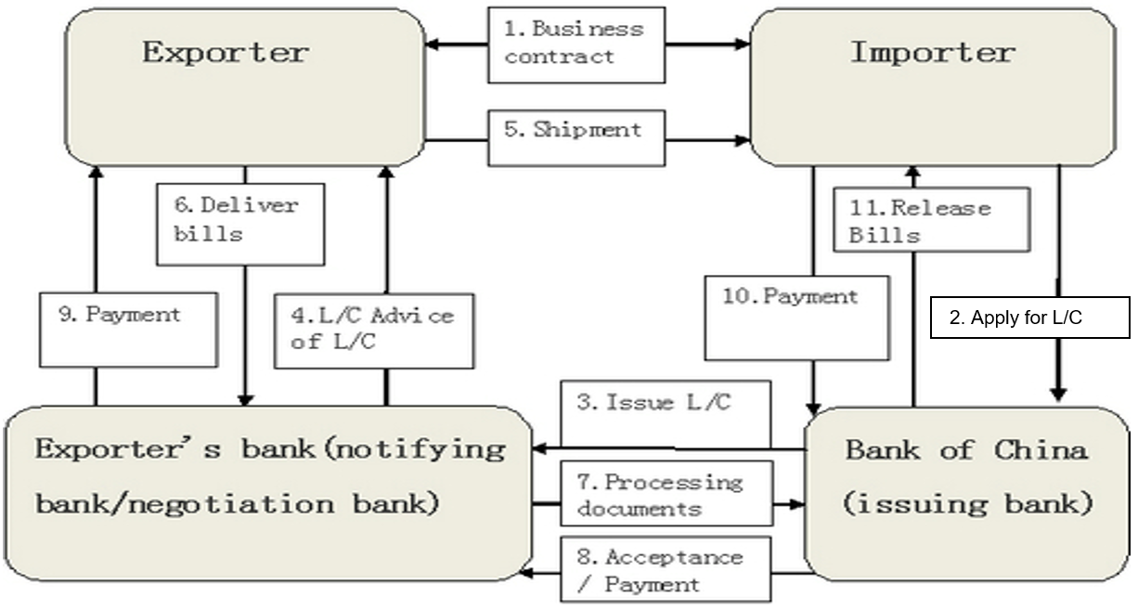
Diagram of L/C Process

- First of all, the buyer (importer) and the seller (exporter) agree to enter into business transactions. Then the seller or exporter needs a letter of credit to guarantee payment of goods.
- After the buyer is agree with the terms of sale arrangement of the seller (exporter) and buyer applies to his/her bank (issuing bank for a letter of credit in favor of the seller (exporter).
- Buyer’s bank (issuing bank) send the letter of credit to the advising bank (exporter bank). It’s very important to note that the advising bank is usually located in the same geographical location as the seller (exporter).
- The advising bank authenticates the credit and forwards it to the seller (exporter/supplier).
- The seller (the beneficiary of L/C) ships the goods in a selected carrier then verifies and develops the documentary requirements to support the LC.
- After shipment exporter avails the required document and delivers the bill to the advising or confirming bank to be processed for payment.
- The advising bank scrutinize the documents for compliance with the terms and conditions of payment.
- If the documents are correct the advising or correspondent bank accept it and will claim the funds debiting the account of the issuing bank.
- The correspondent bank will forward the documents to the issuing bank and payment to the exporter
- The issuing bank will examine the documents for compliance, issuing bank show them to importer with draft to accept it and make payment.
- Buyer arranges for clearance of the merchandise from the carrier, gives up the bill of lading and take receipt of goods. Finally, the importer pay issuing bank addressing to exporter and release the bill.
How employee make people understand all this process and encourage them to do all in this process is one of the major factor of the interactive marketing.
(https://www.lawyersnjurists.com/article/ncc-bank-marketing-strategy-and-management-thereof/, n.d.)

Limitation of the Study:

In undertaking this report a number of problems were faced. Thus there are several limitation in doing this report.
These are:
- The first problem which I want to say that is short time of internship period. Though three months is fix for all but this three month are not enough to know about a bank and come to a conclusion.
- Though I have appointed for Principal Branch of IFIC Bank but this three months I was in their General Banking sector only. They transfer me to the Credit department for one day only. Because of the short time I could not gather enough knowledge and unable to understand their whole process.
- As I was there for one day I could not make understanding and co-operative relationship with employees of credit department. It was a big problem for them to sharing data and information with me.
- Employees are there really busy with customer or with their duties, calls and other activity of the bank that is why they could not manage enough time to co-operate with me and deal with my report.
- During the working hour employee in general banking sector are not allowed to talk about anything beyond their duty.
- Most of the customer of bank are businessman and employee who come here for a short time. They could not have extra time to provide appropriate information to the internet. I also could not get enough scope to talk to them.
- As there is no direct and wide marketing area in the banking sector it takes more time to get marketing relevant information and date of the bank.
- As I am not that kind of professional in market research and have no past work experience I face some problem to data collection, data processing, data analyzing, integrating and presenting all these things.

Recommendations

IFIC Bank Limited should focus on some factor and improve them efficiently. These are:
- IFIC can establish a strong marketing team to implement their objectives with marketing initiatives.
- Though new employees are trained up before posting in a specific branch but they must be prepared more enough in every activity or job in providing service. Because in the principal branch I noticed the lacking in some staff that not everyone knows everything. They have to leave their desk for ask question to other peers or colleague or to the seniors. But I must say that they are cooperative to each other and have unity among all in the principal branch.
- Number of training program should be launched to enhance employee skill. As there are thousands of issues and policies in the banking sector and all of them are sensitive also management must focus more on the employee training to implement all elements of the service marketing to serve the customer just in time.
- As IFIC bank is a reputable bank, huge number of people want to be employed as employee of IFIC Bank. For this reason when job vacancy is announced a large number of resumes are deposited in the CV bank. However, at the time of short listing according to evaluation criteria, there are a greater number of candidates fulfill the qualification requirements test. All the qualified candidates are eligible for the written test but HR does not give opportunity to give written test to all the qualified candidates.
- Reward employees who provide best service to the customer to motivate them for reinforcement and which also motivate others to improve their performance. It ultimately results in customer satisfaction.
- As quality measurement is difficult to judge but IFIC can follow the other competitors in banking industry in case of handling customer. Beside employee turnover is high now and recruitment is also high to fulfill those post managing employees to. For this they have to ensure quality or capable employee as well as motivate and extra compensate to the knowledgeable, skilled and experienced employee so that they don’t think about switch IFIC Bank.
- In the general banking sector to open account sometimes people left some important area in the account opening form. These incomplete information which may become acute during arises any dispute.
- Because of good relationship between branch manager and commercial customers it becomes more difficult to authenticate their information by asking question. Because those customers may disappoint to answering such questions which may in turn brings questions for the employee. Seniors can handle it with cordially and systematic way.
- In the general banking sector of IFIC Bank they need to increase the availability of notes to give the proper service to potential customer.
- Rate of interest is too high in case of advances in several purpose or project. Parties have no financial strength in maximum case. This will create pressure to take the loan. So IFIC can decrease little bit of the interest rate for advances and loan.
- Though they have a big manpower with six hundred employee in the head office but they can turn it to skilled manpower by prioritizing training, mentoring, cross job experience to increase capability of the bank in this competitive market.
- IFIC Bank Ltd. needs to enhance advertising about the product or service and other offering through various media.

Conclusion

International Finance Investment and Commercial Bank Limited (IFIC) which had been started its journey with the commitment that customer satisfaction is first. From 1976 to still they are trying to fulfill it and bring improvement in every spares of banking service. They provide maximum and best service to the customer to achieve the customer satisfaction with their loyalty. They have 148 branch and 81 total ATM booth in the various places all over the Bangladesh. All the branches of IFIC Bank are providing service with efficiency, introducing product and providing thirteen types of credit facilities. They are not only focusing on the present rather they think about the future also and undertaking innovative project for the comfortable of the customer such as 1000 digital booth banking over the Bangladesh. They never compromise anything in case of providing service. IFIC also market those product and service as a helpful hand for both organization and customer. Thus it is recognize as a profitable as well as successful business organization now.

Reference:

(n.d.). Retrieved from https://smallbusiness.chron.com/service-marketing-mix-57548.html.
(n.d.). Retrieved from https://bibm.org.bd/single_member.php?bank_id=6.
(n.d.). Retrieved from https://www.ificbank.com.bd/.
(n.d.). Retrieved from https://www.ificbank.com.bd/investor_relations.php.
(n.d.). Retrieved from https://www.ificbank.com.bd/.
(n.d.). Retrieved from https://www.ificbank.com.bd/investor_relations.php.
(n.d.). Retrieved from https://www.ificbank.com.bd/disclosure.php.
(n.d.). Retrieved from https://cpd.org.bd/wp-content/uploads/2018/12/Banking-Sector-in-Bangladesh-Moving-from-Diagnosis-to-Action.pdf.
(n.d.). Retrieved from https://www.ificbank.com.bd/annualreport/Auditor's%20Report%20and%20Audited%20Financial%20Statements_2016.pdf.
(n.d.). Retrieved from https://www.ificbank.com.bd/annualreport/Auditor's%20Report%20and%20Audited%20Financial%20Statements_2016.pdf.
(n.d.). Retrieved from https://www.ificbank.com.bd/annualreport/Annual_Report_2018.pdf.
(n.d.). Retrieved from https://www.assignmentpoint.com/business/organizational-behavior/historical-background-of-ific-bank-ltd.htm.
(n.d.). Retrieved from http://www.theindependentbd.com/post/77419.
(n.d.). Retrieved from https://www.ificbank.com.bd/investor_relations.php.
(n.d.). Retrieved from https://cpd.org.bd/wp-content/uploads/2018/12/Banking-Sector-in-Bangladesh-Moving-from-Diagnosis-to-Action.pdf.
(n.d.). Retrieved from https://expertprogrammanagement.com/2018/03/services-marketing-triangle/.
(n.d.). Retrieved from https://shodhganga.inflibnet.ac.in/bitstream/10603/377/11/11_chapter%206.p.
(n.d.). Retrieved from https://www.assignmentpoint.com/business/internship-report-on-marketing-of-ific-bank.html.
(n.d.). Retrieved from https://www.ngdata.com/what-is-interactive-marketing/.
(n.d.). Retrieved from https://www.lawyersnjurists.com/article/ncc-bank-marketing-strategy-and-management-thereof/.

